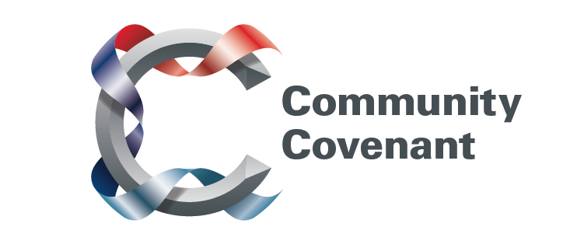

East Midlands

Below is a list of the areas in the East Midlands with an existing Community Covenant Partnership. Hold down the Ctrl tab on your keyboard and click on the links – they will take you straight through to the external council websites. Should you wish to find out more, do get in touch with them. If a name does not have a link it’s because that council has countersigned the Community Covenant above it.

If your local area has not signed up, click here to find out how set up a Community Covenant.

Broxtowe Borough
Leicestershire County
Lincolnshire County
East Lindsey District
Boston Borough
North Kesteven District
Lincoln City
South Holland District
South Kesteven District
West Lindsey
North Lincolnshire
North East Lincolnshire
Mansfield District
Nottinghamshire County
Gedling Borough
Rutland

