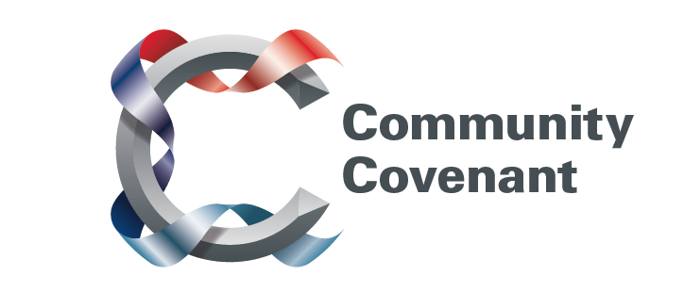

Yorkshire and Humberside

Below is a list of the areas in Yorkshire and Humberside with an existing Community Covenant Partnership. Hold down the Ctrl tab on your keyboard and click on the links – they will take you straight through to the external council websites. Should you wish to find out more, do get in touch with them. If a name does not have a link it’s because that council has countersigned the Community Covenant above it.

If your local area has not signed up, click here to find out how set up a Community Covenant.

Bradford City
Bradford Metropolitan District
Derby City
Derbyshire County
North East Derbyshire
Bolsover District
Chesterfield Borough
Doncaster Metropolitan Borough
Erewash Borough
High Peak Borough
Kingston-upon-Hull City
Kirklees Metropolitan Borough
East Riding
Rotherham Metropolitan Borough
Sheffield City
Wakefield District
City of York
North Yorkshire County
Craven District

