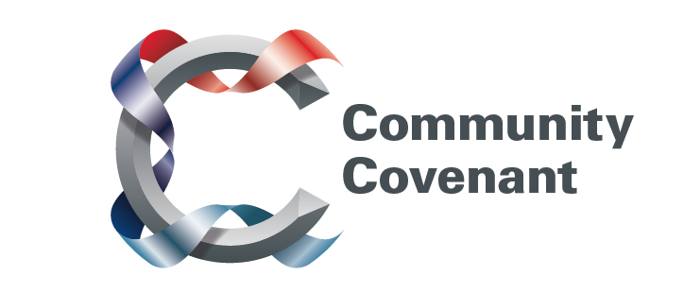

Greater London

Below is a list of the areas in Greater London with an existing Community Covenant Partnership. Hold down the Ctrl tab on your keyboard and click on the links – they will take you straight through to the external council websites. Should you wish to find out more, do get in touch with them.

If your local area has not signed up, click here to find out how set up a Community Covenant.

Barking & Dagenham
Barnet
Croydon
Ealing
Greenwich
Greater London Authority
Hammersmith & Fulham
Havering
Hillingdon
Hounslow
Kensington and Chelsea
Newham
Richmond
Sutton
Wandsworth
Westminster

