

MoD awards grants to two military projects in Dorset
1:00pm Saturday 4th August 2012 in News By Diarmuid MacDonagh
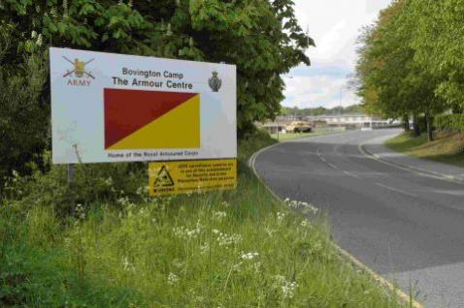
Two Dorset projects working to strengthen relations between military and civilian communities have been awarded grants by the Ministry of Defence (MoD) – and more applications are being encouraged.
Thanks to an injection of £20,000 from the grant programme, people in and around Bovington, Wool and Bere Regis will be able to use a new community classroom, which is being set up by a group of volunteers called the Acorn Group.
The classroom will run courses, in partnership with local colleges, for the whole community – military and civilian. There will be a series of educational and vocational courses, ranging from CV writing workshops and ‘back to work’ basic skills.
Retired Lieutenant Colonel Stewart Burman MBE of the Armour Centre Garrison in Bovington said: “News of the successful award has been very warmly received by the soldiers, families and civilians living in the area.
“It is an exceptional opportunity to assist all people living in and around Bovington.”
Blandford Museum has also won a £5,900 grant for its living history project, recording the testimonies of service personnel and their families.
Sylvia Hixson Andrews of Blandford Museum said: “The nature of a military life means that soldiers and their families are often isolated and separated from their support systems.
“This project will allow the museum to establish a permanent conversation between the residents of both the local community and the soldiers and families living and working at the camp.”
Dorset County Council leader Angus Campbell welcomed the new grants, saying: “These grants will nurture public understanding and awareness of issues affecting the armed forces community, as well as encouraging activities which help integrate the armed forces community into local life.
“Dorset is proud of its long relationship with the military and these grants can only help strengthen that relationship.”
There are over 5,000 military personnel in the county, with an additional 2,000 family members.
There will be two more grant rounds in 2012, with deadlines of August 13 and November 9.

