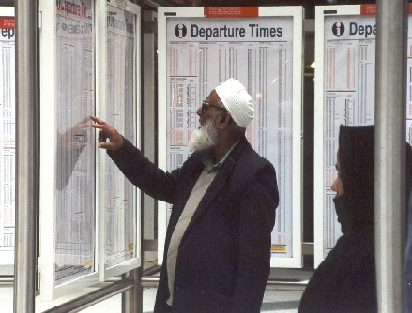

December 2012
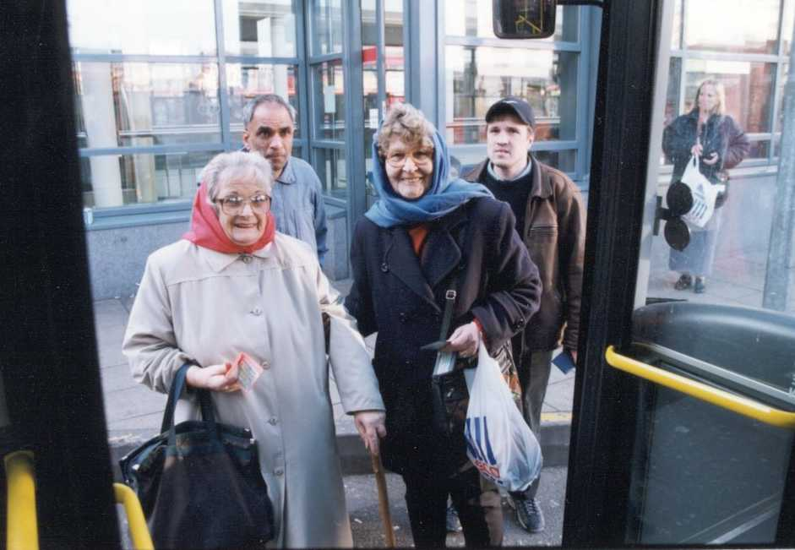

Transport for Everyone: an action plan to improve accessibility for all
The Department for Transport has actively considered the needs of blind and partially sighted people in accessing this document. The text will be made available in full on the Department’s website. The text may be freely downloaded and translated by individuals or organisations for conversion into other accessible formats. If you have other needs in this regard please contact the Department.
Department for Transport
Great Minster House
33 Horseferry Road
London SW1P 4DR
Telephone 0300 330 3000
Website www.dft.gov.uk
General email enquiries FAX9643@dft.gsi.gov.uk

© Crown copyright 2012
Copyright in the typographical arrangement rests with the Crown.
You may re-use this information (not including logos or third-party material) free of charge in any format or medium, under the terms of the Open Government Licence. To view this licence, visit www.nationalarchives.gov.uk/doc/open-government-licence/ or write to the Information Policy Team, The National Archives, Kew, London TW9 4DU, or e-mail: psi@nationalarchives.gsi.gov.uk.
Where we have identified any third-party copyright information you will need to obtain permission from the copyright holders concerned.
Contents

Foreword 4
1. Why do we need an Accessibility Action Plan? 6
2. Improving accessibility 10
3. Providing better information for travellers 15
4. Improving attitudes and behaviour towards disabled passengers 17
5. Accessibility Action Plan 19
6. Working in partnership 24
Annex A 25
Annex B 28
Annex C 29
Foreword


The Department for Transport (DfT) is committed to investing for the next generation, improving people’s everyday experience of transport, putting users at the heart of what we do, and investing in and modernising transport as part of the Government’s wider growth strategy. Our aim is to have a transport network where everyone can enjoy the same convenient, safe, affordable door to door journey experience when going about their day to day business.

Building on the success of the Olympic and Paralympic Games, this Accessibility Action Plan will help identify our priorities for increasing access to services and jobs. In particular, we want to use the legacy of the Games to help improve disabled people’s experience of public transport, and to attract and encourage those people who have not used public transport before or for a long time.

The Coalition Government, with its wider social inclusion agenda, wants everybody to fulfil their potential and have opportunities to play a full role in society. Our aim at the DfT, therefore, is to overcome the barriers that impede or prevent access to the transport system, which includes changing negative attitudes towards disabled and elderly people. In doing so, we recognise the benefits for such people will accrue to all travellers including, for example, parents with pushchairs.

The Government’s wider ambitions for transport will be set out in the Department’s Transport Strategy to be published early next year. The Strategy will set out how the Department’s activities across the different transport modes - such as reducing congestion, improving the local environment, and encouraging healthier and safer life styles - will fit together to deliver our priorities. The Accessibility Action Plan will form an important part of that Strategy. I shall also be publishing in the near future a Door to Door Strategy which will dovetail with our Plan.

This document builds on what we have already achieved, and is part of an ongoing process. It marks a commitment to work with vulnerable people and their organisations, as well as with the transport industry and local authorities, to ensure our policies and actions are taken forward.

I am particularly grateful to all those outside organisations and individuals who have helped us to produce this Plan.

Norman Baker MP
Parliamentary Under-Secretary of State for Transport

Why do we need an Accessibility Action Plan?
- Our commitment towards an accessible and inclusive transport network is mirrored in the Department’s recently published Business Plan 2012-2015 which commits us to:
“develop and publish a Disability Action Plan for improving the customer experience of the disabled passenger, as part of the Government’s wider Disability Strategy”; and

“deliver better access to jobs and key services through an accessible and socially inclusive transport system, by removing the barriers to travel and ensuring that social impacts are addressed in policy development and service delivery”.
- The policy context in which the Accessibility Plan is being developed and implemented is set out at Annex A.
- The need for an accessible and inclusive transport network is reflected in the following facts and figures:
  - There are over eleven million people with a disability in Great Britain.
  - In Great Britain, the most commonly-reported impairments are those that affect mobility, lifting or carrying.
  - Around a fifth of disabled people report having difficulties related to their impairment or disability in accessing transport.
  - The prevalence of disability issues rises with age. Around 6 per cent of children are disabled, compared to around 15 per cent of working age adults and 45 per cent of adults over State Pension age.
  - Although the employment rate gap between disabled and non disabled people has decreased since 2002, disabled people remain far less likely to be in employment. In 2011, the employment rate of disabled people was 48.8 per cent compared with 77.5 per cent of non-disabled people.
  - Disabled people are significantly more likely to be victims of crime than non-disabled people. This gap is largest amongst 16-34 year olds, where 39 per cent of disabled people reported having been a victim of crime compared to 28 per cent of non-disabled people.
  - For each age group, people with mobility difficulties are less likely to travel compared to non-disabled people (see Figure 1).
  - People with mobility difficulties make more trips by local bus and taxi (see Figure 2).
  - People with mental health difficulties find it easier to use buses as opposed to trains.
- Figure 1 below shows the number of trips people make. It shows a significant difference in trips between those with and those without mobility difficulties. The former make fewer trips on average and the difference is greater the older one gets.
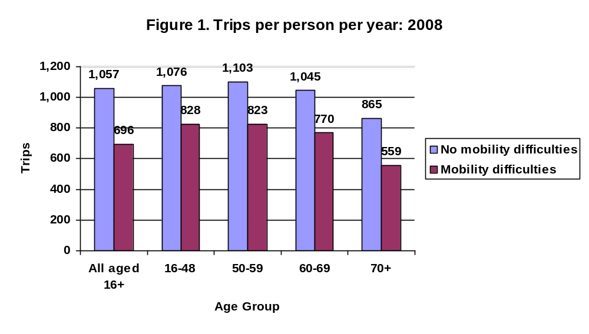Source: National Travel Survey 2010

- Figure 2 shows trips by mode. It shows the importance of buses, taxis and private hire vehicles (PHVs) for those with mobility difficulties, the low use of rail and the continued dominance of the personal car.
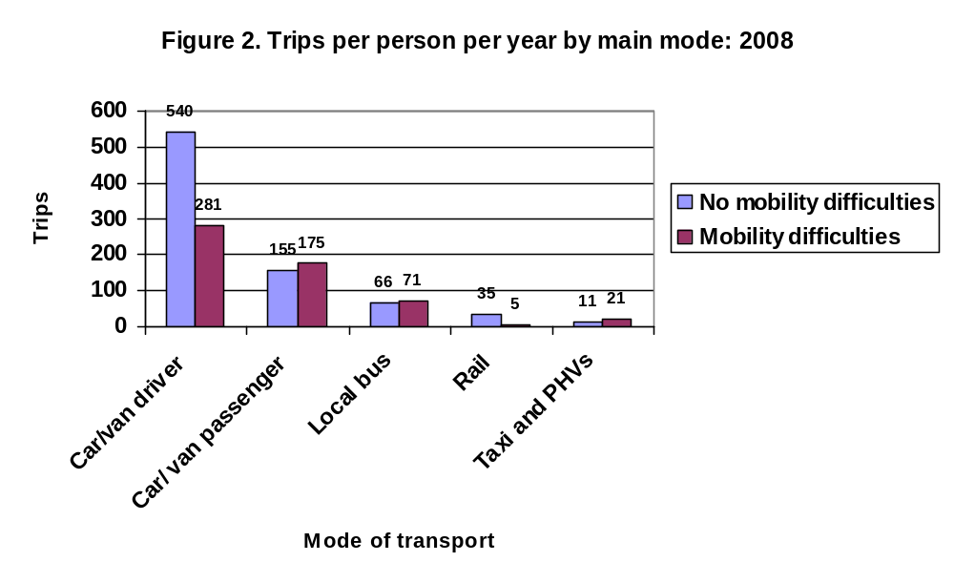Source: National travel Survey 2010

- Disabled people in particular rely on public transport to access jobs, services, facilities, family and friends. While many of the barriers identified by disabled people and non-disabled people in undertaking journeys are the same, the impact can be different.
- There have been significant improvements in the physical accessibility of different transport modes over the years, in particular since the introduction of regulations made under the Disability Discrimination Act 1995.
- However, Figure 3 below shows that there is still a significant way to go. For example, only about two thirds of buses and taxis are currently fully accessible and under half of our trains.

Figure 3. Percentage of fully accessible vehicles: 2011
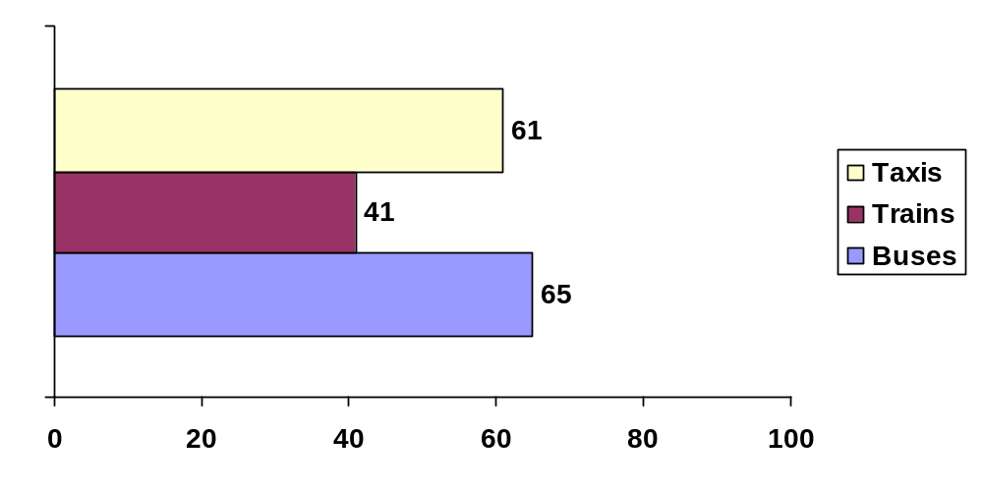Source: Department for Transport, Taxi statistics December 2011; Rail vehicles - Department for Transport, May 2012; Bus Operator Survey October 2010/11.

- Figure 4 below shows that the percentage of disabled people experiencing difficulties in using public transport is on a downward trend, but it is still relatively high.

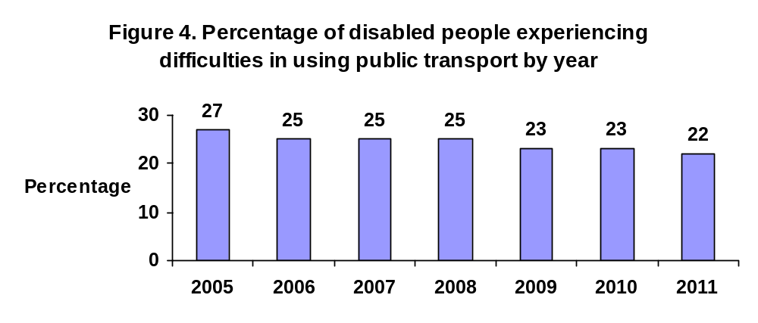
Source: ONS Opinions Survey July 2012

Improving accessibility
- Sections 2 and 4 describe the large amount of work that has already been done to improve accessibility of the transport network. The recent RADAR guide 'Doing Transport Differently' brings together the accessibility measures already in place, encouraging and advising disabled people on how to make full use of them.

Buses

- All buses used on local or scheduled services are required to be fully compliant with the Public Service Vehicles Accessibility Regulations 2000 (PSVAR), by 2015, 2016 or 2017 (depending on the bus type). All coaches used on scheduled services are expected to be compliant by 2020. The numbers of accessible buses to date is set out in the table below. It shows that that the percentage of accessible buses is highest in the larger urban areas.

Metropolitan area status and county / Year | PSVAR  certificate |  | PSVAR certificate or low floor access
Metropolitan area status and county / Year | 2010/11 | 2011/12 | 2010/11 | 2011/12
English metropolitan areas | 60 | 67 | 90 | 93
English Non-metropolitan areas | 55 | 61 | 76 | 81
London | 89 | 94 | 99 | 99
England | 65 | 71 | 86 | 89

Source: Department for Transport, Bus Statistics, 10 November 2012

- Community Transport is also important where other forms of transport are not available. The Local Transport Act 2008 increased the flexibility of arrangements for providing community transport services and expanded the provision around taxi-buses, both of which can help to fill the gaps where commercial transport services are not viable. In 2010/11, a total of £20 million was distributed to English local authorities by formula, with the aim of kick-starting and supporting community transport.

Trains

- Across the rail industry, 6817 rail vehicles (May 2012) – or 41 per cent of the total fleet - are in use which have been built or fully refurbished to comply with the modern access standards. Of this total, 5762 compliant vehicles are in service on the heavy rail network (48 per cent of the total). It is for the rail industry to ensure that all passenger vehicles are accessible by no later than 1 January 2020. All older trains already include improved accessibility where they have undergone partial refurbishments, and are accessible to most people.
- The Access for All programme was launched by the Department in 2005 and, by the time the current programme ends in 2015, we will have spent over £400m providing accessible routes at 154 stations and more minor improvements at over 1,000 other stations. By March 2015, at least 75 per cent of rail journeys will start or end at a fully accessible station compared with about 50 per cent when the programme was launched. To build on this success, we have recently announced a further £100m of new funding to extend the programme from 2015 until 2019.
- After the 2011 Spending Review, the Department introduced a new Mid-Tier Access for All programme for projects requiring between £250k and £1m of Government support. Further details of the successful projects are available at http://www.dft.gov.uk/publications/access-for-all-mid-tier-funding
- DfT officials have been working with the Association of Train Operating Companies (ATOC) and Passenger Focus to introduce a new passenger booking system. Passenger Assist went live early in 2012 following trials.
- On London Underground, the responsibility of the Mayor, 66 stations out of 270 are currently step free from street to platform level.

Taxis

- Taxis and private hire vehicles play an essential role in the lives of disabled people. The Equality Act 2010 includes provisions currently in force to ensure that guide dogs are transported by taxis and private hire vehicles. There are also provisions to ensure that wheelchair users can travel in safety and comfort when using designated taxis and private hire vehicles. The Government is currently considering when to commence these provisions.
- The Law Commission is carrying out a review into taxi and private hire vehicle licensing. The Commission has been asked to look at all aspects of the licensing regime, including how to ensure an accessible fleet is available which is suitable for passengers. The Law Commission will be producing a final report at the end of 2013.
- In 2011, in England, 44,300 licensed taxis were wheelchair accessible (either purpose built, or converted) – 61 per cent of the total. All London taxis are wheelchair accessible. Outside London, the proportion varies from 72 per cent in the West Midlands to 26 per cent in the South East. There were 150,900 licensed PHVs in England as at 31 March 2011. An estimated 3,600 PHVs were wheelchair accessible.

Planes

- Protection for disabled air travellers and persons with reduced mobility is provided by European Regulation. The Civil Aviation Authority (CAA) promotes and enforces compliance with the Regulation, and regular liaison meetings are held with interested parties. The CAA’s new Consumer Advisory Panel has been proactive and is dealing with complaints from disabled people wherever they think their European air passenger rights have not been met satisfactorily.
- During the Paralympic and Olympic Games, the CAA successfully worked with the aviation industry and airports to ensure smooth arrivals and departures for huge numbers of supporters / athletes.
- In 2008, the Department for Transport published a Code of Practice “Access to Air Travel for Disabled Persons and Persons with Reduced Mobility” which sets out the legal framework and gives advice and information.

Ships

- EU Regulation 1177/2010 concerning the rights of passengers when travelling by sea and inland waterway will enter into force across the EU on 18 December 2012. It is the Government’s intention to consult on the UK’s implementation of the EU Regulation shortly.
- A consultation on the application of Part 3 (services and public functions) of the Equality Act 2010 in relation to transporting people by, or a service provided on a ship or hovercraft closed on 7 April 2011. The Coalition Government has undertaken to implement Part 3 of the Equality Act 2010 and we are currently considering how best to take this forward.

Personal Transport

- The private car will continue to play an important role providing disabled people with independence, where other forms of transport are not accessible or available.
- The Blue Badge scheme provides a national range of on-street parking concessions to badge holders and is open to eligible disabled people with severe mobility problems - allowing them to park close to their destination. In 2011, the Government announced wide ranging reforms to modernise the scheme, to tackle rising levels of fraud and abuse, and to ensure that badges are issued more fairly, and ensure that the scheme remains sustainable in the long term for those disabled people who rely on it most. Many of the reforms have now been delivered.
- The DfT will provide £2.8m grant funding per annum until 2014 to 12 mobility centres in England, to support them in providing personal mobility related information and advice to disabled people, to enable them to make choices about their personal mobility.
- In 2010, the Department undertook a consultation into possible reforms of the use on the highway of mobility scooters and powered wheelchairs. In response to the consultation, the Department is looking further into how best we can improve training of users and how current legislation can be better enforced. Improved guidance and information for users was published in March 2012. The Department has also commissioned research with a view to developing a kite marking scheme for carriage of scooters on public transport.

Concessionary Travel

- To support affordability, eligible older and disabled people are now able to travel for free on off-peak buses anywhere in England. Variations of these arrangements exist in the rest of the UK. This right is enshrined in primary legislation and, in the 2010 Spending Review, the Chancellor of the Exchequer confirmed the Government's commitment to protect such key benefits. In addition, the Disabled Persons’ Railcard (DPRC) run by ATOC, offers a third off most National Rail tickets. The Blue Badge scheme mentioned above is also an important concession.
- In September 2012, the Department announced a trial with the rail franchise holder First Great Western. It is taking place on two lines, between Worcester Foregate Street and Swindon via Stroud, and on the line between Westbury and Weymouth. Concessionary bus pass holders who have a pass issued by a Travel Concession Authority in England can claim discounted fares on those two routes without having to purchase an annual Senior Railcard, saving them the £28 fee. The trial period is one year and the concession applies to off-peak travel (from 9.30am to 11pm on weekdays and at all times at weekends and on bank holidays), giving a discount of one third off standard class fares for journeys on the two rail routes. The Department will work with First Great Western to examine the commercial viability of the arrangements, and we will be assessing the study to see whether a wider and more permanent application might be merited. A final report is due in November 2013.
- This could potentially lead to greater numbers of older and disabled people purchasing off-peak rail tickets, and therefore providing real benefits to those who need them most.

Providing better information for travellers

- Travel information is also a key component of the door to door journey, enabling passengers to have the confidence to undertake their planned trip. Much has been done to improve the availability of information in different formats.
- Audio-visual passenger information is provided not only on the 41 per cent of rail vehicles that are fully accessible but, additionally, on large numbers of carriages that are not yet accessible in other ways. By 2020, all rail vehicles will have these systems, which must give destination and next stop information, as well as updates on diversions, delays of over 10 minutes and emergency information. This is an area where the Office of Rail Regulation, as the enforcement body for rail vehicle accessibility requirements, is taking a particular interest. It ensures that equipment provided is used correctly.
- At stations we have been introducing improved information systems for passengers under the Access for All programme, the National Stations Improvement Programme (NSIP), and through franchise commitments placed on individual train operators. Around 2,000 stations across the country now have Customer Information Systems in place and we are determined to build on this further having recently announced £200m to extend Access for All and NSIP until 2019. NSIP is also contributing at least £7m to the development of the Darwin system, which will provide a common source of timetable information for live departure boards and CIS systems.
- In 2011, 22 per cent of buses in the UK provided next stop visual information and 19 per cent next stop audio information. Launched in December 2011, the Department's £70m Better Bus Area Fund provided funding to 24 local authorities working in partnership with local bus operators. It enabled local authorities to apply local solutions to local problems. Applications for funding covered aspects such as real time information systems for passengers and mobile information provision.
- Transport Direct, the Department's journey planning and travel information website, has more than 100 million registered users. The site has gone from strength to strength since its launch in December 2004. It enables users to plan and compare door to door public transport or car journeys throughout Britain. It provides information on a range of transport types (e.g. bus, coach, train, etc.) therefore offering a ‘one-stop-shop’ for transport information. Work is underway on the inclusion of an accessible journey planning capability, where travellers with disabilities would be able to request a step free journey, a step free journey with staff assistance, or a journey where staff assistance is available.
- DfT’s Transport Direct team included a capability within the Spectator Journey Planner for the Olympic and Paralympic Games, to enable disabled people and people with reduced mobility to plan an accessible journey from a range of accessible stations and stops in Great Britain to all the Olympic venues. During the period of the Games, users were able to specify their accessibility requirements (level access, assistance, avoiding the underground) and plan an accessible journey to any venue on the days of operation at that venue. We are seeking to build on this as part of the Games legacy.
- The DfT is building in principles of accessibility into future developments such as the reform of ticketing.
- As part of the Government's Transparency agenda, the Department has committed to making transport datasets available for scrutiny and re-use. This will help improve the efficiency of public services and encourage innovative solutions to transport information systems for passengers (e.g. developing access apps for disabled people such as Parking Mobility and AssistMi).

Improving attitudes and behaviour towards disabled passengers

- Passengers also need to feel safe and secure when undertaking a journey. As the Equality and Human Rights Commission has pointed out in its report ‘Hidden in Plain Sight’, disabled people can face particular problems with harassment on public transport (see Annex C).

Disability Equality Awareness Training

- Staff attitudes can play a large part in passengers’ ability and willingness to travel. Good progress has been made in ensuring that transport staff have the appropriate disability equality awareness training to support disabled passengers and enable them to travel confidently and in comfort.
- The Public Service Vehicles (Conduct) Regulations 2002 make it unlawful for bus operators to disregard the needs of disabled people, including wheelchair users. The Regulations place an obligation on drivers to:
  - Allow a wheelchair user to board the bus when the wheelchair space is unoccupied. The only exception is if the wheelchair is too large or unsuitable to board the bus.
  - Where other passengers are occupying the wheelchair space, including when occupied by parents with buggies, the driver should ask them to move to allow the wheelchair user to board.
- In November 2012, Transport for London launched a new campaign outlining the rules around the use of the wheelchair space on buses. Buggy users and other passengers may use the space if it is not otherwise in use. The campaign aims to ensure that all passengers know and respect this.
- We have supported the development of a disability module extending the Certificate of Professional Competence for bus driver training, which is now available for use by the industry, and the production of a disability equality awareness module for accredited training courses for taxi drivers.
- Disability equality awareness training is also now an integral part of all GOSkills’ NVQ programmes for bus drivers and operators’ own bespoke programmes. We worked with the transport industry to ensure greater disability equality awareness amongst staff during the Olympic and Paralympic Games.
- Over 150 travel training schemes to help people travel independently are now up and running around the country and the Department is looking at how to encourage more travel training across the country. In May 2011, it published guidance on how these can be set up (http://www.dft.gov.uk/pgr/inclusion/tts/traveltrainingguide/).
- All rail companies have to produce a Disabled Persons’ Protection Plan (DPPP) which sets out how the company helps disabled passengers to use their stations and trains.

Safety and Security

- The Department's Secure Stations Scheme is designed to improve security standards at overground and underground rail stations for passengers and staff. While the Scheme is essentially about improving security at stations, it also encourages rail operators to work with partners to improve the whole journey for passengers.
- Participation in the Scheme has continued to grow with 1300 stations currently accredited, including the 17 major stations managed by Network Rail (one of the nine rail operators that have achieved a 100 per cent accreditation of their respective lines).
- DfT has established a Public Transport Crime Liaison Group, a dedicated forum for transport organisations, the police and passenger representatives to discuss their work to reduce crime and anti-social behaviour on transport. The Group is working to raise awareness of transport safety schemes and to make incident reporting easier. We are encouraging the dissemination of good practice, such as Merseytravel’s “Stop Hate” campaign, which has introduced an on-line and telephone based reporting tool for passengers and staff to report hate crime incidents that occur on the public transport network in the area.

Accessibility Action Plan

Headline 1. Improving physical accessibility

Task | Description | Lead | Delivery
1 | Ensure buses and trains comply with accessibility regulations:  - all rail passenger vehicles by no later than 1 January 2020  - all buses used on local or scheduled services by 2015, 2016 or 2017 (depending on the bus type)  - all coaches used on scheduled services by 2020. | DfT / Operators | 2020
2 | Work with the Law Commission on their review of taxi and private hire vehicles regulation, including how to ensure an accessible fleet. | Law Commission / DfT | 2013+
3 | Implement EU Regulation 181/2011 concerning bus and coach passenger rights in accordance with the results of the DfT consultation exercise. | DfT | 2013
4 | Deliver projects for the additional £100m funding for the Access for All programme. | DfT / Network Rail / Operators | 2019
5 | Vehicle and Operator Services Agency (VOSA) to explore scope for better enforcement of regulations concerning accessible features on vehicles. | DfT / VOSA | Under consideration
6 | Continue the Blue Badge reform programme by:  - Introducing new or amended powers for local authorities to tackle Blue Badge abuse and fraud  - Implementing the results of the review of eligibility criteria for the Blue Badge in the context of welfare reform. | DfT / Local Authorities | 2013  2014
7 | Implement results of the consultation on the use of scooters and powered wheelchairs, including incentivising training, and eyesight requirements. | DfT | 2014
8 | Commission research to inform update of the Department’s “Guidance on the use of Tactile Paving Surfaces”. | DfT | 2014
9 | Review and update DfT’s “Inclusive Mobility - a Guide to Best Practice on Access to Pedestrian and Transport Infrastructure”. | DfT | 2014
10 | Examine the scope for more flexible services (particularly in rural areas) by:  - increasing awareness of flexible community transport services  - promoting taxi and car sharing. | DfT / Local Authorities /  Community Transport Association | Under consideration

Headline 2. Providing better information for the disabled traveller

Task | Description | Lead | Delivery
1 | Building on the success of the Games Spectator Journey Planner:  - develop new characteristics for Transport Direct (e.g. to support people with visual or hearing impairments) and extend coverage into more locations and modes (coaches, local buses, partially staffed stations)  - deploy the software developed for London 2012 into existing systems  - encourage asset owners to inform the database of any changes to their accessibility  - seek to ensure any new procurement contracts build in data sharing to facilitate technology developments. | DfT | 2014
2 | Develop costings on Audio Visual (AV) technical options for buses and decide way forward. | DfT / Operators /  Manufacturers | 2013
3 | Identify a suitable award scheme for transport operators to recognise good services or facilities for disabled passengers. | DfT / Operators /  Local Authorities | 2013
4 | Develop a kite marking system for the carriage of mobility scooters (and buggies) on public transport, building on the CPT Code of Practice for use of scooters on buses. | DfT / Operators /  Manufacturers | 2013
5 | Following publication of revised guidance on tactile pavements, encourage training schemes for blind and partially sighted people | DfT / Local Authorities | 2015
6 | Building on the success of the Olympic and Paralympic Games, work with transport operators on staff training and best practice regarding support for disabled passengers. | DfT / Local Authorities / Operators | 2013
7 | Explore ways of developing a ‘One Stop Shop’ for Assistance Bookings on the rail system where passengers can also purchase rail tickets and a Disabled Persons Railcard. | DfT / ATOC | Under consideration
8 | Explore with Mobility Centres scope for developing ‘One Stop Shops’ which offer accessible travel information and mobility advice, in addition to car driving assessments. | DfT | Under consideration
9 | Work with local authorities on the dissemination of good practice on setting up and running more local access groups. | DfT / Local Authorities | Under consideration
10 | Work with Local Authorities and operators to:  - publicise improvements in accessible transport (e.g. through more Open Days)  - share good practice (e.g. through press releases, news bulletins, newsletters, social media sites etc). | DfT /  Operators /  Local Authorities | Under consideration

Headline 3. Improving Attitudes & Behaviour towards disabled passengers

Task | Description | Lead | Delivery
1 | Reduce conflict in shared space areas on public transport by:  - examining the issue of signage and enforcement  - sharing good practice on raising awareness about the needs of disabled passengers on public transport. | DfT / Operators / Stakeholders / Manufacturers | 2013
2 | Improve the collection and sharing of data on harassment by:  - working with the industry and transport authorities to identify how incidents can best be reported and data shared, as well as making people feel more confident about reporting  - refining statistical reporting on disabled people and exploring the practicalities of collating information on high risk areas, and how risks can be reduced. | DfT / Operators  Local Authorities  / BTP / Passenger Focus | 2014
3 | Ensure that the legacy of disability equality awareness training packages for the Olympics are taken forward by:  - looking at training for taxi and private hire vehicle drivers on disability equality awareness, e.g. by formal training or voluntary measures such as guidance or video  - working towards greater involvement of disabled people in disability equality awareness training  - ensuring barriers for hidden disabilities are covered effectively. | DfT / Operators | 2013
4 | Develop with the Traffic Commissioner and operators the scope for a Code of Practice aimed at developing respect for all passengers and staff on the bus network. | DfT / Traffic Commissioner / Operators | 2013

Working in partnership
- To ensure regular feedback on progress on the actions in this Plan, the involvement of transport operators, transport experts, manufacturers, local and central government, as well as users themselves, will be crucial in monitoring progress, identifying areas of particular interest and holding the Department to account. For disabled people and their organisations, it is important that many of the actions benefit from pan disability advice. This is currently provided to the Department by the Disabled Persons Transport Advisory Committee (DPTAC). The Department will be considering how best this should be done in future, should the decision be taken to replace DPTAC in light of the review of Non Departmental Public Bodies.
- The Department will explore how best to work with the Disability Action Alliance on transport matters. The Alliance is being set up following publication of the cross-Government 'Fulfilling Potential' strategy (see Annex A).
- To establish whether this Action Plan is making a difference, the Department will also continue to use existing statistical sources to collect data on, for example, the accessibility of buses and trains, and the take up of concessions and assistance bookings. It will also monitor customer satisfaction through, for example, the Life Opportunities Survey, and work with Passenger Focus.

Annex A
International

The UK ratified the United Nations Convention on the Rights of Disabled People in July 2009.

The Convention covers every aspect of life including work, education, justice and health. Article 9 states that disabled people have the right to be able to access all areas of life including buildings, transport, information and communication. Article 20 refers to personal mobility where disabled people have the right to independent personal mobility including the provision of mobility aids and training in mobility skills. Therefore, these need to be taken into account when developing policies that will affect disabled people and how they lead their lives. The Government submitted its first UK report on implementation of the UN Convention on the Rights of Persons with Disabilities to the United Nations on 24 November 2011, which is available on the ODI website at www.odi.gov.uk/un-report .

The United Nations Economic Commission for Europe (UNECE) also has an interest in developing accessibility standards. For example, it has brought forward a proposal to amend bus manufacturing standards to provide for a joint wheelchair/pushchair space on urban buses and the inclusion of additional signage.

European Union

At the European level, there is an increasing commitment towards removing the economic and social barriers that prevent disabled people from enjoying equal opportunities. This commitment is expressed in the European Disability Strategy 2010-2020 which has accessibility at the heart of it.

The EU Regulation on bus and coach passenger rights (181/2011) will apply from 1 March 2013. European legislation already covers air and rail passengers’ rights, and a separate proposal has also been published in relation to the rights of passengers when travelling by sea and inland waterways.

The EU Rail Passenger Rights Regulation (1371/2007) came into force in December 2009. The Regulation focuses on: the areas of information and ticketing provision rights in case of injury and damage to luggage; compensation and assistance for delays; the rights for persons of reduced mobility; and enforcement.

National

Equality Act 2010

The Coalition Government has a long term ambition for a fair and equal society. The aim is to create equal opportunities for all, devolving power to people, improving transparency, supporting social action and embedding equality.

The introduction of the Equality Act in 2010 (EA) has helped streamline and strengthen anti-discrimination legislation in Great Britain. The EA provides the legal framework that protects people, including disabled people, from discrimination. It replaces a range of anti-discrimination legislation, including the Disability Discrimination Act 1995 (DDA) and subsequent amendments. The Act introduces a public sector equality duty which, among other things, requires public bodies to publish their equality objectives.

EHRC’s Report ‘Hidden in Plain Sight’ 2011

The Equality and Human Rights Commission (EHRC) inquiry report ‘Hidden in Plain Sight’ gives examples of several disability related harassment cases that occurred on public transport. Some of these are listed in Annex C along with the recommendations for transport providers.

‘Fulfilling Potential’ September 2012

In September 2012, the Department for Work and Pensions published two documents which set out its approach to the commitment to enable disabled people to fulfill their potential and play a full role in society.

‘Fulfilling Potential - the Discussions So Far’ summarises what disabled people and their organisations told the Department for Work and Pensions, and actions already planned or underway.

‘Fulfilling Potential – Next Steps’ outlines the strategic narrative and areas for action and sets out the principles that will guide the Government’s future work in supporting disabled people to realise their aspirations, promote a fair and equal society and create more inclusive communities.

Key elements are:

  - a new cross sector disability action alliance, involving disabled people, their organisations, and others from the public, private and voluntary and community sectors, will work together to identify and deliver the change needed to bring about equality of opportunity for disabled people;
  - public service reform which will support disabled people’s independence and participation;
  - a new partnership approach which will see disabled people having much more influence in the design and delivery of services, so they are better able to challenge where things are not delivering the outcomes they need.

Annex B
The DfT’s Agencies produce Equality and Diversity Plans which focus on employment and policies for their employees or on service delivery.

Employment Equality and Diversity Plans:

  - Vehicle and Operator Services Agency - Promoting Equality and Valuing Diversity Delivery Plan 2009 – 2012: http://www.dft.gov.uk/vosa/repository/Promoting%20Equality,%20Valuing%20Diversity%20VOSA%20Delivery%20plan%202009%20-2012.pdf
  - Maritime and Coastguard Agency 2012-2016: http://www.dft.gov.uk/mca/mca_diversity_objectives_2012_-_2016_final.doc
  - Vehicle Certification Agency 2010-2012: http://www.dft.gov.uk/vca/additional/files/recruitment/recruitment-guides/single-equality-scheme-2010-2012.pdf#search="equality action plan"

Service delivery:

  - Driving Standards Agency 2012-2013: http://assets.dft.gov.uk/publications/dsa-equality-objectives/dsa_equality_objectives_2012-13_service_delivery.pdf
  - Highways Agency: http://www.highways.gov.uk/about-us/equality-and-diversity/fulfilling-our-equality-duties/making-a-difference-the-highways-agency-equality-objectives-april-2012-2016/
  - Driver and Vehicle Licensing Agency - Diversity Action Plan 2009 - 2012: http://www.dft.gov.uk/dvla/publications
  - The Department for Transport’s own Diversity Strategy can be found at: http://transnet.dft.gsi.gov.uk/download/18521

Annex C
EHRC’s Report ‘Hidden in Plain Sight’

The Equality and Human Rights Commission published its inquiry report ‘Hidden in Plain Sight’ in 2011.

The report includes examples of disability related harassment cases on public transport. Some disabled people and their organisations raised concerns about the harassment of disabled people by schoolchildren. Seating reserved for disabled people and wheelchair spaces on public transport were reported to be a major cause of harassment, especially where designed to be shared with groups such as pregnant women or people with young children.

The main cause of the problem was perceived by respondents to the EHRC’s research to be the ‘competition’ for the relatively small number of places.
One common theme that was reported by people who experienced harassment on public transport was that the operators’ employees, especially bus drivers, did little to prevent the harassment from occurring, or were even the perpetrators. Disabled people stop using public transport as a result, which leaves them more isolated and socially excluded.

Despite anecdotal evidence that disability-related harassment is a problem on public transport, reporting levels appear low. The British Transport Police recorded a total of only 60 disability-related crimes in the three years 2007-09.

The Association of Train Operating Companies was aware of only 19 recorded incidents which were classified as hate crimes against disabled people on the entire rail network in the previous year, out of a total of 61,000 incidents. The low reporting levels may be because disabled people think that behaviours are non-criminal so no-one will be interested in them. They may also be unclear whom to complain to.

The report made a number of recommendations for transport providers:

  - Transport providers should identify ways to design out potential for conflict in new fleet and transport infrastructure design. For example, they should review their vehicles and waiting areas to ensure that conflicts between disabled passengers and those with pushchairs are minimised. They should also ensure that disabled access provisions are clearly identified and enforced and promptly resolve any disputes regarding these.
  - Public transport operators should develop reciprocal reporting arrangements between providers so that people can report harassment experienced at stops, stations and on transport to whichever operator they encounter. They should also develop systems to allow repeat perpetrators to be refused entry to each other’s vehicles (similar to those already used by licensed premises).
  - Regular disability equality training should be provided for frontline staff on handling disability-related harassment and clear guidance to staff on routes to take when reporting an incident. This should be included as part of core training, before transport staff work with the public.
  - Disabled people should be involved in public transport policy development and transport providers should work in partnership with criminal justice agencies to reduce risk on and around transport provision.
  - Data on high risk areas and subsequent actions to reduce risk should be collated. Based on this data they should provide adequate protection where known high risks exist, in the same way as other provision is made, for example, around football matches.

The Accessibility Action Plan does not cover the Department’s Agencies or its policies regarding its own employees. Details of where to find out more about these can be found at Annex B. The plan should be read in conjunction with the Department’s Equality Action Plan.
Source: Family Resources Survey 2010/11
Source: Family Resources Survey 2010/11
Source: ONS Opinions Survey 2011
Source: Family Resources Survey 2010/11
Source: Labour Force Survey, Quarter 2, 2011
Source: British Crime Survey 2010/11
Source: National Travel Survey 2010
Source: Mental Health & Public Transport, a Report by the Mental Health Action Group, September 2011.
Accessible taxis refer to licensed taxis in England that are wheelchair accessible (either purpose built, or converted); Source: Department for Transport, Taxi statistics (15 December 2011). Accessible trains are those compliant with Rail Vehicle Accessibility (Non-Interoperable Rail System) Regulations (RVAR) 2010 and the Technical Specification for Interoperability for Persons with Reduced Mobility (PRM TSI); Source: Department for Transport, May 2012. Accessible buses refer to vehicles compliant with the Public Service Vehicles Accessibility Regulations 2000 (PSVAR) in England; Source: Bus Operator Survey October 2010/11.
Bus Statistics 10 November 2012: https://assets.digital.cabinet-office.gov.uk/government/uploads/system/uploads/attachment_data/file/14619/bus0603.xls
Rail Vehicle Accessibility (Non-Interoperable Rail System) Regulations (RVAR) 2010 and the Technical Specification for Interoperability for Persons with Reduced Mobility (PRM TSI).
http://www.dft.gov.uk/publications/access-to-air-code-of-practice/
The Transport Act 1985, Greater London Authority Act 1999, Travel Concessions (Eligibility) Act 2002, Transport Act 2000 and Concessionary Bus Travel Act 2007.
Information provided by the RTIG (Real Time Information Group) 2011 Annual Survey on Audio Visual system uptake around the UK.
http://www.equalityhumanrights.com/uploaded_files/disabilityfi/ehrc_hidden_in_plain_sight_3.pdf

