

Statistical Release

Friday 30th March 2012

FIREFIGHTERS’ PENSION SCHEMES MEMBERSHIP DATA ENGLAND 2010-11

This release provides membership information on the Firefighters’ Pension Schemes submitted by all 46 Fire Authorities in England.

The release has been compiled by the Local Government Finance – Data Collection, Analysis and Accountancy division of the Department for Communities and Local Government.

Responsible Statisticians:  Steve Melbourne & Mike Young | Email:  sf3.statistics@communities.gsi.gov.uk.
Contact points:
Press enquiries:
Telephone 0303 444 0444
Email press.office@communities.gsi.gov.uk
Other enquiries:
Telephone 0303 444 4387
Email: sf3.statistics@communities.gsi.gov.uk.

Website: www.communities.gov.uk

Firefighter Pension Schemes membership data England 2010-11
Contents |  | Page
Table 1 | Numbers of pensioners and retirements 2010-11 | 4
Table 2 | Numbers of members and opt outs 2010-11 | 4
Table 3 | Numbers transferring into and out of schemes 2010-11 | 5
Table 4 | Numbers retiring from the schemes 2010-11 | 5
Terminology used in this release |  | 5
Data quality |  | 6
Uses made of data |  | 7
Background Notes |  | 7

Background

The information for firefighters’ pensions within this release covers two schemes in England: the Firefighters Pension Scheme (“the 1992 Scheme”) and the New Firefighters’ Pension Scheme (“the 2006 Scheme”). Both schemes are statutory, tax approved, unfunded, final salary occupational pension schemes.

Regular firefighters employed before 6 April 2006 were eligible for membership of the 1992 Scheme, which was closed to new membership on 5 April 2006. It is a final salary scheme which effectively provides 1/60th accrual in the first 20 years of service and double accrual (i.e. 2/60^{ths} accrual) in the next 10 years of service, giving a maximum pension entitlement of 40/60^{ths}. It has a normal pension age of 55, but provides for members to retire from age 50 years with 25 or more years’ pensionable service.
The 2006 Scheme was introduced for regular and retained firefighters employed since 6 April 2006. It is also a final salary scheme with 1/60th accrual for each year of service, providing a maximum pension of 45/60^{ths}.
The responsibility for policy on both the 1992 and 2006 Schemes in England rests with the Department for Communities and Local Government whilst the administration and payment of pensions and benefits is the responsibility of each of the 46 individual English Fire and Rescue Authorities.

Under the current financing arrangements of both pension schemes, the employer’s contribution together with the employee’s contribution is paid into a locally managed pension fund account. Other sources of pension income (e.g. transfer-in payments, Ill-health Charges) are also paid into the local pension fund. The authority pays pension costs out of this account. The shortfall (cashflow deficit) between the total annual pensions income received and the total annual pension expenditure is reimbursed to each Fire and Rescue Authority through the mechanism of the annual Pension Top Up grant which is paid by the Department for Communities and Local Government.

Table 1 shows the numbers of pensioners at the start of 2010-11, and normal retirements and members who have become deferred pensioners during the year.

If firefighters leave employment or cease paying pension contributions prior to becoming entitled to receive immediate payment of their pension, they become entitled to a deferred pension.

- Of those leaving the schemes, 98% of normal retirements were from the 1992 scheme whereas 69% of deferred pensioners were from the 2006 scheme

T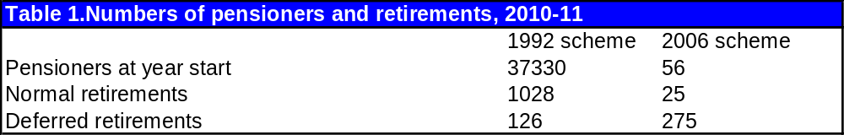e

Table 2 shows the numbers of members and numbers who have opted out at the start of 2010-11, as well as the numbers opting out of the schemes during the year.

Members of the scheme may elect to opt out, thereby ceasing to pay pension contributions while remaining in employment as a firefighter with the FRA. Members of the 1992 scheme who opt out may not opt back in, whereas members of the 2006 scheme who opt out can later opt back into the scheme. Data on members of the 2006 scheme opting in are not collected.

Retained firefighters are personnel contracted to be available for agreed periods of time for fire-fighting purposes, but who could also have an alternative full-time employment.

- Just over two thirds of the total membership of 36,800 are in the 1992 scheme
- At the start of the year, retained firefighters constituted 60% of 2006 scheme members, but 98% of those who have opted out of the 2006 scheme.

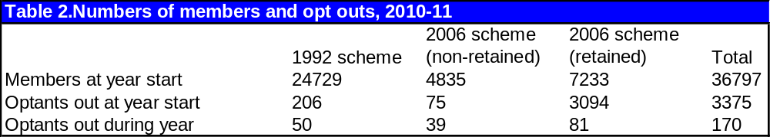

Table 3. shows the numbers of transfers into and out of the schemes during the year 2010-11.

Transferring pension benefits is the process by which a member elects to transfer the value of their pension benefits in an external pension scheme to their firefighters pension scheme; or vice versa where they transfer the value of their firefighter pension benefits to another external pension scheme.

Club transfers involve members transferring their pension benefits within the Public Sector Transfer Club. This is a group of some 120 salary related occupational pension schemes.

- Over 4 times as many members transferred in as transferred out during 2010-11.

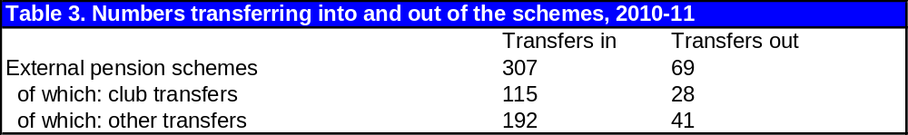

Table 4 shows the numbers of ill health retirements, and how many of these are lower tier and higher tier retirements from the schemes during the year 2010-11.

Ill-health retirement occurs when a member becomes entitled to immediate payment of their pension benefits as a consequence of becoming permanently disabled for undertaking their roles as a firefighter. The lower tier award entitles any member who becomes permanently disabled for undertaking their role as a firefighter to the immediate payment of the pension benefits that they have accrued; the higher tier award entitles any member who becomes permanently disabled for undertaking their role as a firefighter and any other regular employment (defined as a minimum of 30 hours per week over a period of at least 12 months) to the immediate payment of a lower tier pension and also an additional enhanced higher tier pension.

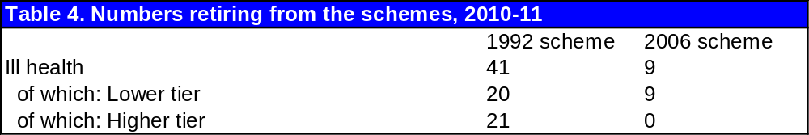

Terminology used in this release

A list of terms relating to local government finance is given in the glossary at Annex G to Local Government Financial Statistics England No. 21 2011. This is accessible at
http://www.communities.gov.uk/publications/corporate/statistics/financialstatistics212011 The most relevant terms for this release are explained below.

Administering authority
A body responsible for administering the Firefighters’ Pension Scheme.

Club transfers and external Pension Scheme transfers

Transferring pension benefits is the process by which a member elects to transfer the value of their pension benefits in an external pension scheme to their firefighters pension scheme; or vice versa where they transfer the value of their firefighter pension benefits to another external pension scheme. The transfer is carried out by transferring the Cash Equivalent Transfer Value (CETV), i.e. the capital value of the pension benefits, from the exporting scheme (the scheme paying the CETV) to an importing scheme (the new scheme receiving the CETV). The CETV will normally purchase a service credit in the importing scheme.

Club transfers involve members transferring their pension benefits within the Public Sector Transfer Club. This is a group of some 120 salary related occupational pension schemes. Further details on ‘the Club’ can be found at the following weblink http://www.civilservice.gov.uk/pensions/transfer-club.

Deferred pension

A person becomes entitled to a deferred pension if they leave employment, or make an election to cease paying pension contributions, prior to becoming entitled to receive the immediate payment of their pension. Deferred pensions come into payment when the member attains age 60 years in the 1992 Scheme; and 65 years in the 2006 Scheme.

Opting out

Members of the scheme may elect to opt out, thereby ceasing to pay pension contributions while remaining in employment as a firefighter with the FRA. Members of the 1992 scheme who opt out may not opt back in, whereas members of the 2006 scheme who opt out can later opt back into the scheme. Data on members of the 2006 scheme opting in are not collected.

Ill-Health Retirement

Ill-health retirement occurs when a member becomes entitled to immediate payment of their pension benefits as a consequence of becoming permanently disabled for undertaking their roles as a firefighter. There are two levels of ill-health retirement i.e. Lower-tier and Higher tier awards. The lower tier award entitles any member who becomes permanently disabled for undertaking their role as a firefighter to the immediate payment of the pension benefits that they have accrued (i.e. a lower tier pension); the higher tier award entitles any member who becomes permanently disabled for undertaking their role as a firefighter and any other regular employment (defined as a minimum of 30 hours per week over a period of at least 12 months) to the immediate payment of a lower tier pension and also a an additional enhanced higher tier pension.

Data quality

The information in this release is based on data returned to the Department for Communities and Local Government by all 46 administering authorities in England on Firefighter Pension Schemes and associated information for the financial year 2010-11 forms.

Figures are subjected to validation tests by statistical staff within the Department for Communities and Local Government once the data have been received.

Finally, the release document, once prepared, is also subject to intensive peer review before being cleared as fit for the purposes of publication.

Uses made of the data

The data in this statistical release are essential for a number of different purposes. A central and immediate purpose is to provide Ministers with information about the Firefighters’ Pension Schemes. The data may also used by fire authorities and their associations.

Background Notes

- Statistical Releases are produced to high professional standards set out in the National Statistics Code of Practice. They undergo regular quality assurance reviews to ensure that they meet customer demands.

- The information for 2010-11 in this Statistical Release is derived from Firefighter Pension Scheme (FPF) forms submitted by all 46 Administering Authorities in England only.

- The Firefighters’ Pension Scheme 1992 is a statutory, tax approved, unfunded, final salary occupational pension scheme. It was closed to new members from 6 April 2006. Membership was limited to regular firefighters appointed on terms under which he/she was or might be required to engage in firefighting.

- The New Firefighters’ Pension Scheme 2006 is a statutory, tax approved, unfunded, final salary occupational pension scheme. It was open to membership from 6 April 2006 by any person taking up employment as a firefighter on terms under which he/she is, or may be, required to engage in firefighting, and whose role includes resolving operational incidents, or leading and supporting others in the resolution of such incidents.

- Both the 1992 Scheme and 2006 Scheme are unfunded schemes. Under the current arrangements both the employer’s and employee’s contributions together with other sources of authorised pension income are paid into a pension fund account. The authority pays pension costs out of this account. Any annual shortfall between receipts and expenditure is met by a top-up grant paid by the Department for Communities and Local Government.

- For press enquiries about this Statistical Release please contact the Local Government press desk on 0303 444 0444 or email press.office@communities.gsi.gov.uk. For other enquiries please telephone Mike Young on 0303 444 4387 or email sf3.statistics@communities.gsi.gov.uk.

- Live tables containing all the local authority level data underlying this release have been published on the Department’s website; http://www.communities.gov.uk/localgovernment/localregional/localgovernmentfinance/statistics/livetables/

- A statistical release on firefighters’ pension schemes income and expenditure was published in July 2011; http://www.communities.gov.uk/publications/corporate/statistics/firefighterpensionjuly2011

- Timings of future releases are regularly placed on the Department’s website, www.communities.gov.uk and on the National Statistics website, www.statistics.gov.uk/hub/release-calendar/index.html

- Further information is also available on the department’s website www.communities.gov.uk/localgovernment/localgovernmentfinance/

- For a fuller picture of recent trends in local government finance, readers are directed to Local Government Financial Statistics England No.21 2011 which is available in hard copy from Wetherby Publications Centre at communities@twoten.com (Tel. 0870 1226 236) and electronically from the Communities and Local Government website http://www.communities.gov.uk/documents/statistics/pdf/1911067.pdf

