

Housing
Statistical Release

17 November 2011
using
Research
Summary
Number 239, 2007

Count of Gypsy and Traveller Caravans - July 2011

Contents

Headlines 1
Introduction 2
Count of Gypsy and Traveller
Caravans:
England 2
Regional totals 5
New affordable residential pitches 6
Accompanying tables 7
Data sources 7
Revisions Policy 8
Background notes 8
User consultation 8
Further information 8

Responsible statistician:
Andrew Presland

Media Enquiries:
office hours: 0303 444 1157
out of hours: 0303 444 1201

press@communities.gov.uk

Statistical enquiries:
office hours: 0303 444 3510
housing.statistics@communities.gov.uk

- The total number of Gypsy and Traveller caravans in England in July 2011 was approximately 18,700.This is about 500 more than the total in July 2010.
- Approximately 6,600 caravans were on authorised socially-rented sites, a decrease of about 200 since the July 2010 count.
- The number of caravans on authorised privately-financed sites was approximately 8,100, an increase of about 400 since the July 2010 count.
- The number of caravans on unauthorised developments, on land owned by Gypsies and Travellers, decreased by about 200 between July 2010 and July 2011.
- The number of caravans on unauthorised encampments, on land not owned by Gypsies and Travellers, increased by about 600 between July 2010 and July 2011. The figure included almost 540 at a festival in Essex.
- The average numbers of caravans per site for those local authorities providing a full return were 21.0 for socially-rented sites, 4.7 for privately-funded sites and 5.4 for unauthorised sites.
- Overall, the July 2011 count indicated that 79% of Gypsy and Traveller caravans in England were on authorised land and that 21% were on unauthorised land.

Introduction

This official statistical release provides summary information on local counts of Gypsy and Traveller caravans in England. These counts record the number of caravans on both authorised and unauthorised sites across England. They are carried out to provide local data on the number of caravans and the seasonal movement of caravans. This is a vital tool in identifying need for site provision and in tackling unauthorised encampments and developments.

The Count of Gypsy and Traveller Caravans publication is compiled from information submitted by local authorities in England. Local authorities carry out a count of caravans on Gypsy and Traveller sites twice a year, in January and July, providing a snapshot of the number of caravans on the day of the count. Information is collected about caravans on authorised socially-rented sites, authorised privately-funded sites, unauthorised developments (sites on land owned by Gypsies or Travellers for which planning permission had not been granted) and unauthorised encampments (on land not owned by Gypsies or Travellers and which do not have planning permission).

We publish information in two main tables:

- Table 1 contains the number of caravans on authorised and unauthorised sites for the last five counts nationally and by region and local authority area; and

- Table 2 contains details of the location and size of Gypsy and Traveller sites operated by local authorities.

A third, much smaller, table provides figures for new affordable residential pitches created since the July 2010 count: more details are given below.

Data from the count are used by other Government departments, local authorities and essential services to plan service delivery. Collection and publication twice a year is essential to reflect winter residence and summer travelling trends and demands on services. Due to the strong seasonal differences between the January and July counts, all comparisons refer to year-on-year changes. Numbers quoted in this release have been rounded to the nearest 100, given that estimates are made for non-responding local authorities and so quoting precise figures might be regarded as implying a spuriously high level of accuracy.

Count of Gypsy and Traveller caravans - England

Total numbers

At the time of the July 2011 count, the total number of Gypsy and Traveller caravans in England was approximately 18,700. Of these, approximately 6,600 (35%) were on socially-rented sites; 8,100 (43%) were on privately-funded sites; 2,000 (11%) were in unauthorised developments on land owned by Gypsies or Travellers; and 2,000 (11%) were in unauthorised encampments on land not owned by Gypsies or Travellers. This information is shown in Figure 1.

Figure 1: Total number of caravans in England, by type of site

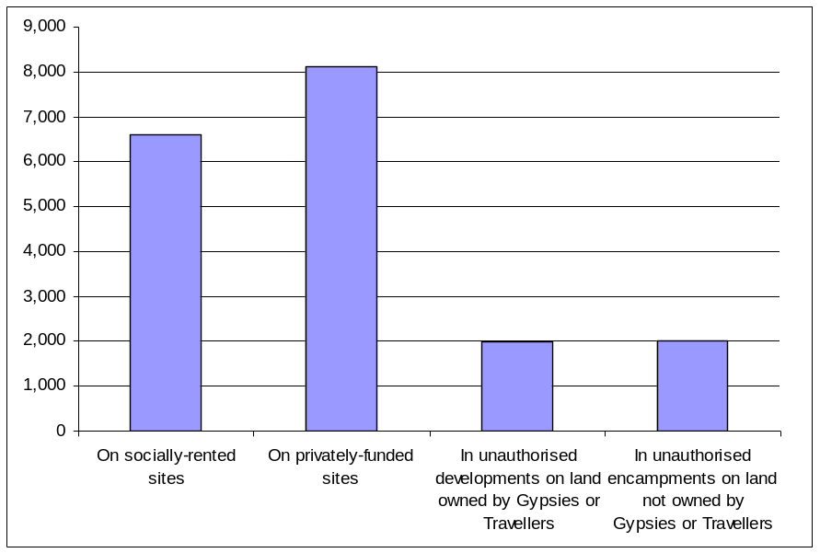

The total number of Gypsy and Traveller Caravans in England has increased in recent years - by 18% since 2005 - as shown in Figure 2.

Figure 2: Total number of caravans in England (July counts only)

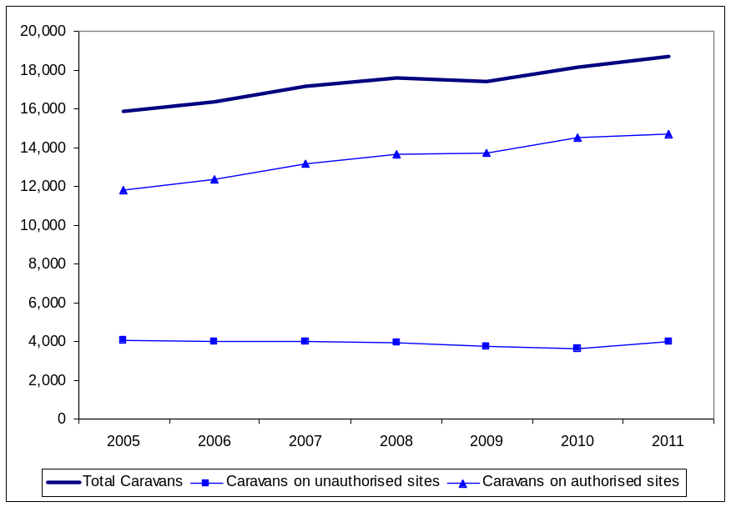

Numbers on authorised sites

As shown in Figure 3, the number of Gypsy and Traveller caravans on authorised sites in July 2011 was approximately 14,700, comprising approximately 6,600 caravans on socially-rented sites operated by local authorities and Registered Providers (a decrease of about 200 since July 2010) and 8,100 caravans on privately-funded sites, an increase of about 400. This therefore represents an overall increase of about 200 caravans over the number of caravans on authorised sites in July 2010 and 79% of all Gypsy and Traveller caravans in England. The average numbers of caravans per site for those local authorities providing a full return were 21.0 for socially-rented sites and 4.7 for privately-funded sites.
Figure 3: Number of caravans on authorised sites in England (July counts only)

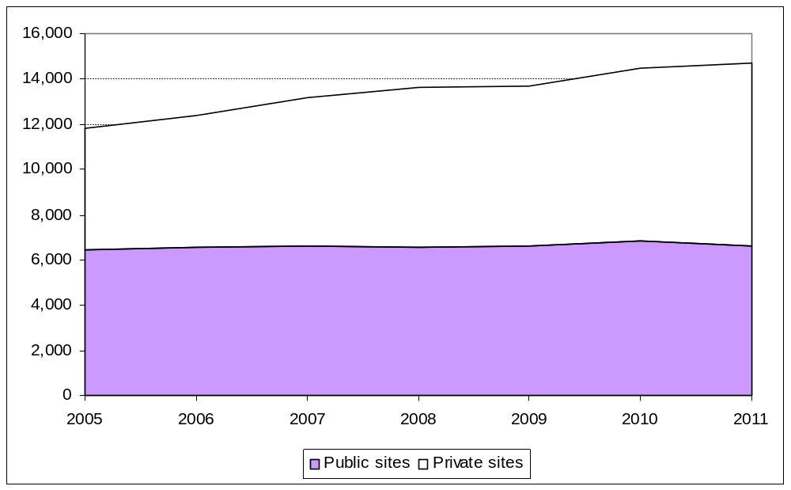

Numbers on unauthorised sites

Approximately 4,000 Gypsy and Traveller caravans were on unauthorised sites, an increase of about 400 from July 2010, as shown in Figure 4. This included almost 540 at a festival in Essex. Caravans on unauthorised sites accounted for 21% of the overall total, up from 20% in July 2010, so ending a gradual downtrend trend in recent counts. There was an average of 4.5 caravans per unauthorised site for those local authorities providing a full return.

Figure 4: Number of caravans on unauthorised sites in England (July counts only)

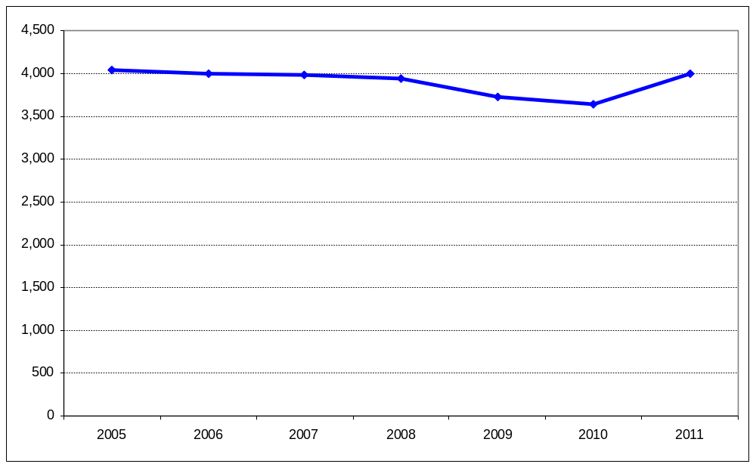

Regional totals

As shown in Figure 5, the regions in the south of England outside London, recorded the highest numbers of caravans at the time of the July 2011 count. East of England had the highest number of caravans (4,700, or 25% of the total), followed by the South East (4,000, or 21% of the total) and the South West (2,700, or 14% of the total). Local authorities in the North East and London recorded the fewest caravans (500 and 800 respectively). The region with the highest proportion of caravans on unauthorised sites was the South West (31%).

Figure 5: Regional breakdown of Gypsy and Traveller caravans (July 2011 count)

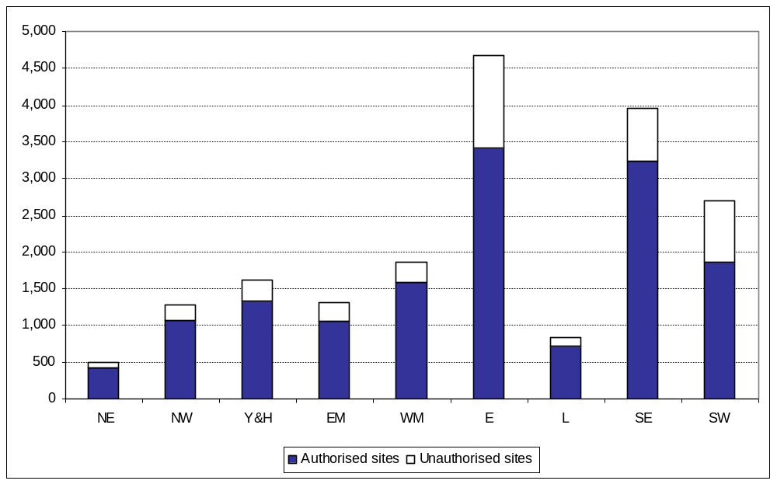

As shown in Figure 6, London had the lowest proportion of caravans on private sites (11%) whereas East Midlands had the highest proportion (59%).

Figure 6: Regional breakdown of authorised sites (July 2011 count)

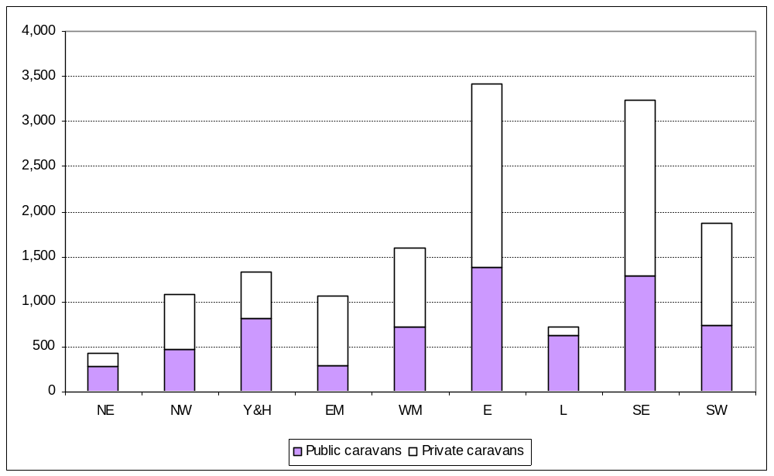

Figure 7 shows that, of all the caravans on unauthorised sites without planning permission, the West Midlands (91%), South East (70%) and East Midlands (64%) and were the regions with the highest proportions of caravans on land owned by Gypsies or Travellers.

Figure 7: Regional breakdown of unauthorised sites in England (July 2011 count)

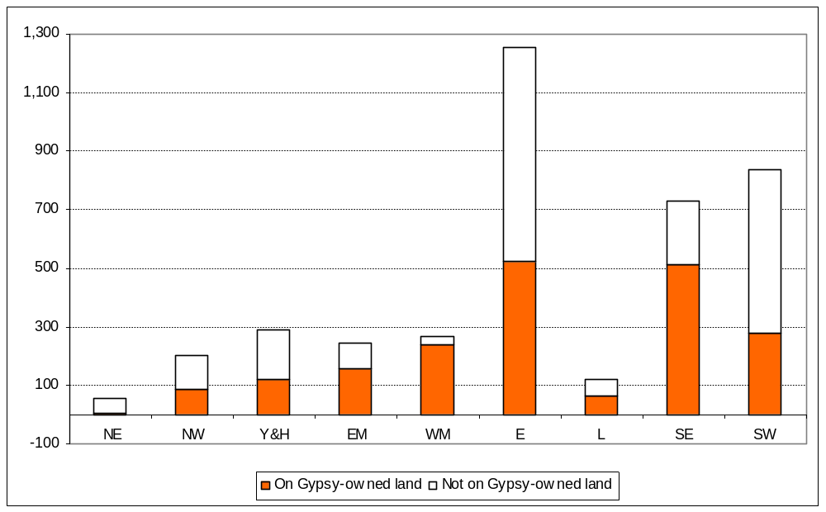

New affordable residential pitches

The July 2011 count also included a count of new affordable residential pitches for the first time, in each local authority area in England. This was done to allow such pitches to be included in the calculation of the New Homes Bonus for individual local authorities. Altogether, local authorities reported that 44 such pitches on socially-rented sites and 3 such pitches on privately-funded sites had been created since the July 2010 count. Details are given in accompanying Table 3, described below. The next count of new affordable residential pitches is expected to take place as part of the July 2012 County of Gypsy and Traveller caravans. More details of the New Homes Bonus are available at http://www.communities.gov.uk/housing/housingsupply/newhomesbonus/.

Accompanying tables

Tables refer to the latest count taken on or around 28 July 2011:

- Table 1: Count of Gypsy and Traveller caravans on authorised and unauthorised sites for the last five counts, nationally and by region and local authority area;

- Table 2: Location and size of Gypsy and Traveller sites operated by local authorities; and

- Table 3: New affordable residential pitches constructed since the July 2010 count.

These tables are available at: www.communities.gov.uk/publications/corporate/statistics/caravancountjun2011

No count of travelling show people caravans took place in July 2011. The first such count took place in January 2011 and, because this is an annual count, the next one will take place in January 2012.

Data sources, definitions, quality and coverage

Local authorities carry out counts of caravans on Gypsy and Traveller sites in England which provide a snapshot of caravans on the day of the count. These take place twice a year, in January and July, to capture information about the number of caravans on:

- authorised public sites – operated by local authorities and other Registered Providers of social housing, including housing associations, trusts and cooperatives.

- authorised private sites – privately funded sites with planning permission;

- unauthorised developments – sites on land owned by Gypsies and Travellers for which planning permission had not been granted; and

- unauthorised encampments – sites on land not owned by Gypsies and Travellers and which do not have planning permission.

The Count of Gypsy and Traveller Caravans publication is compiled from information submitted by local authorities in England. These data are collated by the Department and undergo a process of scrutiny to ensure that the published Count is as accurate as possible. Any instances of discrepancies identified by our key partners between published data and their local knowledge will be followed-up with local authorities in order to resolve them. The count data are subject to the Pre-Release Access to Official Statistics Order, which means that advance access to the statistics is controlled and publicised (see Background Notes). The number of people granted pre-release access to these statistics is six.

There is no statutory requirement on local authorities to submit data for the Count of Gypsy and Traveller Caravans, but the majority of local authorities do carry out the count and provide information to the Department, and those that do not are noted in the published tables. In total, 90 per cent of local authorities submitted returns in July 2011. Where local authorities have not submitted current counts, figures for the number of caravans in the area are imputed from the last available completed return.
Revisions policy

The Department for Communities and Local Government’s Revisions Policy has been developed in accordance with the UK Statistics Authority Code of Practice for Official Statistics, available at http://www.communities.gov.uk/publications/corporate/statisticalnoticerevisionspolicy. The policy covers two types of revisions:

i) Non-Scheduled Revisions
Where a substantial error has occurred as a result of the compilation, imputation or dissemination process, the statistical release, tables and other accompanying releases will be updated with a correction notice as soon as is practical.

ii) Scheduled Revisions
Local authorities can update their returns following publication of the data. At the time of each count the previous returns will be reviewed for revision. Revisions to historic data (all data older than that currently due for scheduled revision) should be made only where there is a substantial revision, such as a change in methodology or definition. Where there are small changes that do not substantially change historic data, internal updates are maintained.

Background notes

- Details of officials who receive pre-release access to the Count of Gypsy and Traveller caravans up to 24 hours before release can be found at: http://www.communities.gov.uk/corporate/researchandstatistics/statistics/prereleaseaccess/

- The next count of Gypsy and Traveller caravans is due to take place on or around 19 January 2012. It will include the second annual count of travelling show people caravans.

User consultation

Users’ comments on any issues relating to the Count of Gypsy and Traveller Caravans statistical release are welcomed and encouraged. Responses should be addressed to the "statistical enquiries" contact given in the "Further Information" section below.

Further information

Media Enquiries: office hours: 0303 444 1157
0303 444 1051
out of hours: 0303 444 1201
e-mail: press@communities.gsi.gov.uk

Statistical enquiries: e-mail: Andrew Presland at housing.statistics@communities.gov.uk
telephone: 0303 444 3510

Communities and Local Government © Crown Copyright, 2011

If you require this publication in an alternative format please email: alternativeformats@communities.gsi.gov.uk.

Please note that the nature of content means that we may not be able to provide the statistical series of publications in all requested formats.

November 2011

ISBN: 978-1-4098-3227-0

