Housing
Statistical Release

30 November 2010
using
Research
Summary
Number 239, 2007

Local Authority Housing Statistics, England, 2009-10

Contents
Introduction……………………….2
Local authority housing stock…….....................................4
Households on local authority waiting lists………….……...…….5
Participation in Choice-Based Lettings (CBL).…...........………...7
Local authority lettings………......8
Decent homes delivery and programme of work on HRA stock..…………………………....10
Anti-social behaviour injunctions ……………………….……….…..14
Scope, Data Collection and Local Government Reorganisation………………….15
Data Quality……………………..16
Uses of the data and Revisions Policy…………….......................17
Official Statistics and Related Statistics………………………....18
Supplementary information........19
Accompanying tables……..…....22
Enquiries………….……………..28

Responsible Statistician:
David Wall

Statistical Enquiries:
Phone : 0303 444 2303
housing.statistics@communities.gov.uk

Media Enquiries:
Office hours: 0303 444 1157
Out of hours: 0303 444 1201
press.office@communities.gsi.gov.uk
Housing Strategy Statistical Appendix (HSSA) & Business Plan Statistical Appendix (BPSA)
- Local authorities in England owned 1.8 million dwellings on 1 April 2010, following a general decline from 3.0 million on 1 April 2000 (chart 1).
- There were 1.75 million households on local authority waiting lists on 1 April 2010, similar to 1.76 million on 1 April 2009. Waiting list numbers have been relatively stable for the last two years, following a general increase from 1.04 million on 1 April 2000 (chart 2).
- 80 per cent of local authorities in England participated in Choice-Based Lettings (CBL) on 1 April 2010, an increase from 61 per cent on 1 April 2009 (chart 3).

- Local authority landlords in England made 155,800 lettings during 2009/10, increasing from 151,700 during 2008/09. This follows a general decline from 354,000 in 1999/00 (chart 4).
- The number of non-decent local authority dwellings across England was 291,600 on 1 April 2010, a fall from 396,900 on 1 April 2009 (chart 5).
- Local authority landlords in England were granted approximately 1,100 anti-social behaviour injunctions in 2009/10 (table 8).

Introduction

This statistical release provides summary information from local authority housing data returns collected in the annual Housing Strategy Statistical Appendix (HSSA) and Business Plan Statistical Appendix (BPSA). This release presents information for the following topics areas from 1999/00 to 2009/10 for England and the regions:
- local authority housing stock;
- local authority waiting lists;
- participation in choice-based lettings;
- local authority lettings;
- decent homes delivery;
- programme of work on Housing Revenue Account stock;
- anti-social behaviour injunctions carried out by local authority landlords.

A full set of HSSA and BPSA data collected from local authorities and associated live tables can be found on the department’s website by following the accompanying links from the summary web page:
Datasets:
http://www.communities.gov.uk/housing/housingresearch/housingstatistics/housingstatisticsby/localauthorityhousing/dataforms/
Associated live tables which are updated with HSSA and BPSA data alongside this release can be accessed from the summary web page:
Live tables:
http://www.communities.gov.uk/housing/housingresearch/housingstatistics/livetables/
The following live tables can be found within Live tables on stock:
Live table 100: Number of Dwellings by Tenure and district; England; 2008/09 – 2009/10 (Provisional)
Live table 116: Local authority stock, by district; England; from 1994
Live table 119: Stock of non-decent homes in the Social Rented Sector; England 2001- 2010
Live table 313: Number and amount of total renewal grants paid under the 1996 Act, by region; England; 1996/97- 2009/10
Live table 611: Local authority vacant dwellings, by region; England; 1989 – 2009
Chart 612: Local authority vacant dwellings, by region; England; 1989 – 2009
The following live tables can be found within Live tables on rents, lettings and tenancies:
Live table 600: Rents, lettings and tenancies: numbers of households on local authorities' housing waiting lists, by district; England; from 1997
Live table 601: Local authority lettings, by region: England; from 1988/89

Important Note: The focus of this statistical release is on social housing that is owned and managed by local authorities. It should be noted this is only part of the story for social housing because housing associations also own and manage social housing stock. Information on housing association data sources can be found in the ‘supplementary information’ section of this statistical release.

Local authority housing stock
Chart 1: Number of local authority owned dwellings in England, 2000 - 2010
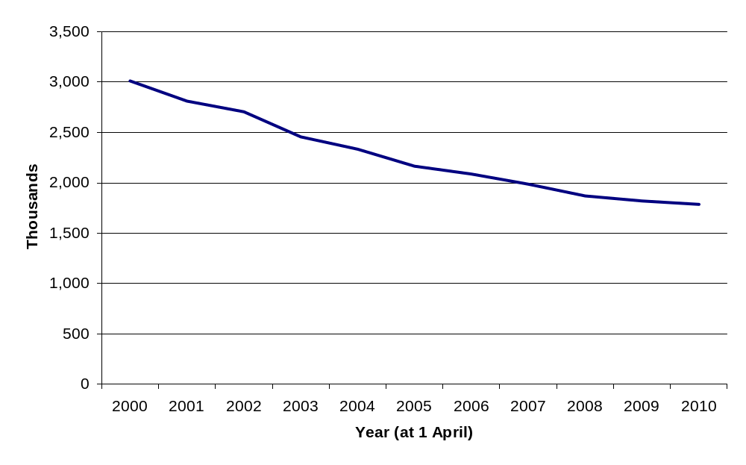
Source: Housing Strategy Statistical Appendix (HSSA) or its predecessor, the Housing Investment Programme (HIP) Returns.

- Local authorities in England owned 1.8 million dwellings on 1 April 2010, following a general decline from 3.0 million on 1 April 2000 (chart 1). This has been associated with Right to Buy (RTB) and large-scale voluntary transfer (LSVT) of local authority stock to registered social landlords. (See ‘supplementary information’ for further details).
- Between 2009 and 2010, there was a decrease in local authority owned stock in all regions (accompanying table 1). The South West reported the largest decrease of 13.1 per cent and the North West reported the smallest decrease of 0.3 per cent. The large decrease in the South West was mainly due to a full stock transfer in Plymouth.

Households on local authority housing waiting lists
Chart 2: Number of households on local authority housing waiting lists in England, 2000 - 2010
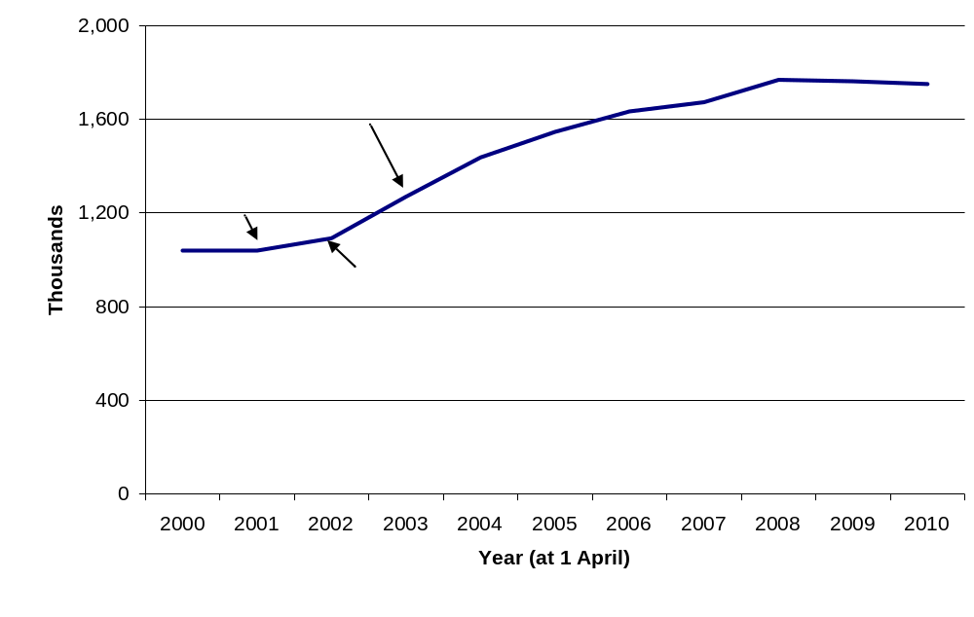 Source: Housing Strategy Statistical Appendix (HSSA) or its predecessor, the Housing Investment Programme (HIP) returns.
- There were 1.75 million households on local authority waiting lists on 1 April 2010, similar to 1.76 million on 1 April 2009. Waiting list numbers have been relatively stable for the last two years, following a general increase from 1.04 million at 1 April 2000 (chart 2).
- Local authorities from time to time, conduct a review of their lists to remove the names of those who no longer want housing. This can lead to a large year-on-year reduction in the size of their list. However, the frequency with which local authorities carry out these reviews varies considerably. Consequently the total number of households on waiting lists can rise year-on-year if only a few LAs have updated their list but can decline if a lot of LAs have updated their lists. In the past year, one local authority carried out a comprehensive review and reported a reduction of over 42,000 households. This indicates that the figure for the total number of households on waiting lists is likely to overstate the numbers of households who still require housing assistance.
- Yorkshire and the Humber reported the largest decreases in their waiting lists and the largest increase was reported by the North West (accompanying table 2).
- From 2003 local authorities have maintained open waiting lists whereby anyone can apply to go on any local authority waiting list. The introduction of open waiting lists coincided with the rise of waiting list numbers. Waiting list figures may also be influenced by the introduction of Choice-Based Lettings schemes (see next section) which can stimulate demand for social housing through advertising and bidding systems for social housing.
- The size of the waiting list is not an indicator of absolute need; it is only useful as a broad indicator of housing demand in an area. Waiting lists may not be wholly accurate and not everyone on the waiting list will necessarily be in urgent housing need. It will also include those who consider social housing as their preferred choice, or one of a number of housing options, and those who decide to get onto the waiting list ladder before they need or want to move house - particularly where the priority system is heavily based on waiting time. Where local authorities and housing associations operate a common register, households registered with the housing association will be included in the data. However, housing associations are independent bodies and can keep their own waiting lists.
Participation in Choice Based Letting (CBL) schemes
- CBL schemes were introduced in England through the Homelessness Act 2002. CBL replaces the traditional way of allocating housing where housing officers seek to match applicants with priority on the waiting list to available vacancies. Instead, CBL allows applicants for social housing (and existing tenants seeking a move) to apply for available vacancies which are advertised widely. Applicants can see the full range of available properties and can bid for any home to which they are matched. The successful bidder is the one with the highest priority under the scheme. (See ‘supplementary information’ for further details).

Chart 3: Participating local authorities in CBL schemes in England, 2002 - 2010
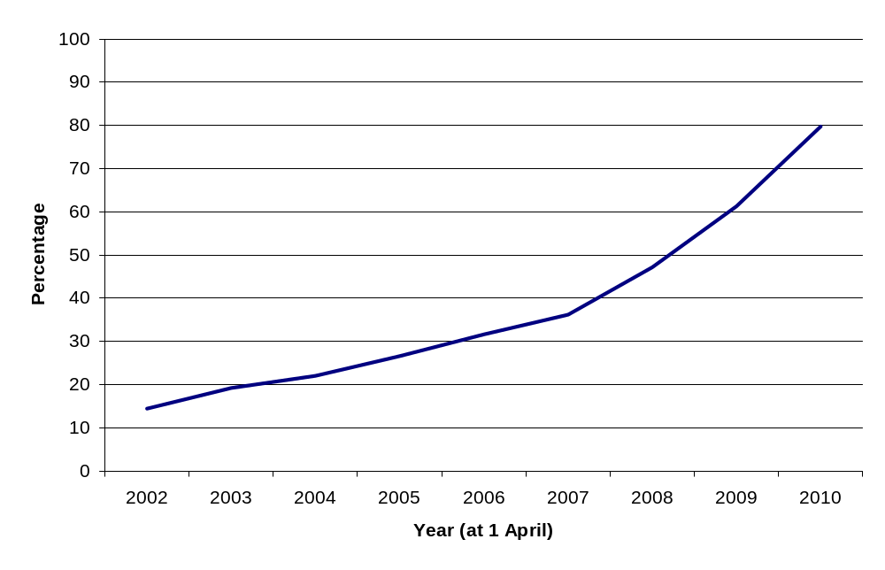
Source: Housing Strategy Statistical Appendix (HSSA) returns.

- On 1 April 2010, there were 260 of 326 local authorities participating in Choice Based Letting schemes across England. This is 80 per cent of local authorities, an increase from 61 per cent on 1 April 2009 (chart 3). One factor contributing to this rise was the impact of the Local Government Reorganisation (see page 15). Prior to reorganisation, of the 37 local authorities that were “reorganised”, only 30 per cent were participating in the CBL schemes in 2009; whereas all nine of the unitaries that were created as a result of the reorganisation are now participating.
- The South West had the highest proportion of participating local authorities at 95 per cent. The East Midlands had the lowest proportion of participating local authorities at 45 per cent (accompanying table 3).

Social lettings made by local authority landlords

Chart 4: Number of local authority lettings¹ made to local authority-owned dwellings, 1999/00 – 2009/10⁴
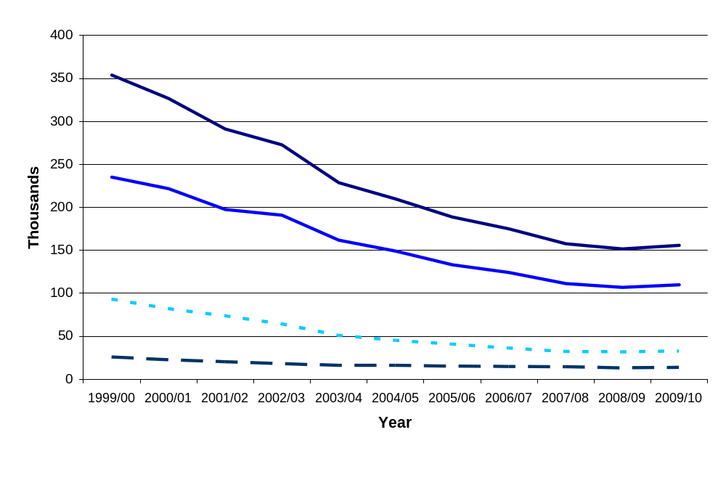
Source: Housing Strategy Statistical Appendix (HSSA) or its predecessor, the Housing Investment Programme (HIP) returns.
Notes:
1. The falling number of lettings is associated with local authorities transferring their stock to registered social landlords (RSLs) through large scale voluntary transfers (LSVT), Right to Buy (RTB) and other sales, and demolitions.
2. In the HSSA an existing let is defined as an internal transfer (ie a dwelling let to a tenant moving within a specific local authority's housing stock). New tenants are therefore defined as tenants new to a particular local authority (and not to local authority housing or social housing more generally).
3. Total lets includes mutual exchanges.
4. Information was collected for 2009/10 using questions which had been restructured from questions asked in previous years. As a result there may be a discontinuity between 2008/09 and 2009/10 and the increase in the number of lettings reported may not represent a true increase.

- Local authority landlords in England made 155,800 lettings during 2009/10. This was a slight increase compared with 2008/09, and follows a general decline from 354,000 in 1999/00 (chart 4).
- For 2009/10, there was a change to the design of the questions on lettings on the HSSA form, in order to improve consistency with the definitions used in CORE (Continuous Recording of Lettings – see the ‘Related Statistics’ section for further details). This may have led to a discontinuity in the figures compared to previous years, so we are not confident that the increase in the number of lettings reported represents a true increase in the number of local authority lettings. For further information see the 'Data Quality' section
- During 2009/10, 109,900 local authority lettings were made to tenants new to the local authority, 32,400 local authority lettings were made to transferring tenants and 13,500 local authority lettings were made through mutual exchange schemes (accompanying table 4).

Decent homes delivery and programme of work on Housing Revenue Account (HRA) stock
- The decent homes standard was established in 2001 and applies to all social housing (see ‘supplementary information’). In order to be ‘decent’ a home should be warm, weatherproof and have reasonably modern facilities.
Chart 5: Number of non-decent local authority owned dwellings: England 2001 - 2010
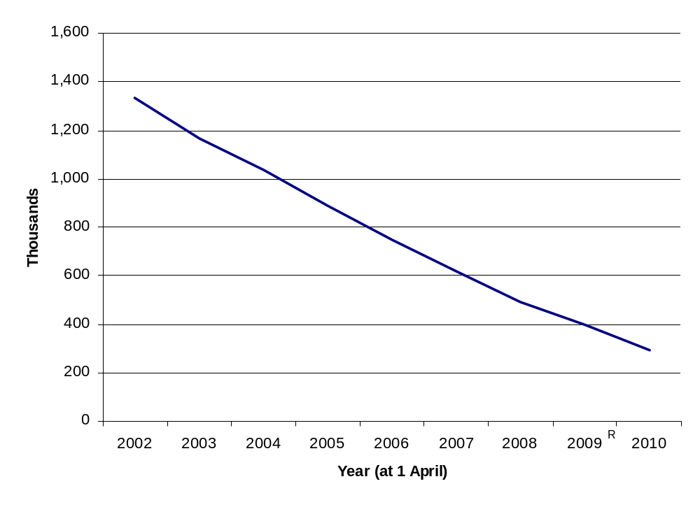
Source: Business Plan Statistical Appendix (BPSA).
Notes: R. One local authority submitted revised figures for the BPSA 2008/09 revised dataset.

- As at 1 April 2010, there were 291,600 non-decent local authority owned dwellings across England, a fall from 396,900 on 1 April 2009 (chart 5). The proportion of non-decent local authority dwellings continued to decline. At 1 April 2010, 16 per cent of local authority dwellings were non-decent, a reduction of 6 percentage points on the previous year (accompanying table 5).
- From the 2009/10 BPSA returns, local authorities have forecast that 215,000 dwellings (12 per cent of current local authority stock) will remain non-decent by 1 April 2011, reducing to 139,000 non-decent dwellings (8 per cent of current local authority stock) by 1 April 2013.
- As mentioned earlier in this release, these local authority figures are only part of the story for social housing. In order to measure the whole social sector, figures from housing associations are also required. (See ‘supplementary information’ for further details.)
- The decent homes programme has brought about considerable energy efficiency improvements with 1.3 million homes receiving new central heating systems since 2001 (table 6). The number of homes that have received double-glazing or improvements to existing windows is similar at 1.2 million and 955,000 dwellings have acquired insulation works.
- Since 2001, 957,000 homes have been rewired to meet fire and safety requirements. Over this 10 year period replacement bathrooms and kitchens have been fitted to 692,000 homes and 931,000 homes respectively (table 6).
Table 6: Housing Revenue Account (HRA) dwellings and expenditure on selected components¹, England, 2000/01 - 2009/10
(1 April - 31 March, each year)
 | 2000/01 | 2001/02 | 2002/03 | 2003/04 | 2004/05 | 2005/06 | 2006/07 | 2007/08² | 2008/09² | 2009/10² | Total
Central Heating
No. of Dwellings | 107,188 | 127,580 | 125,682 | 133,732 | 140,066 | 139,494 | 135,477 | 113,520 | 114,675 | 126,223 | 1,263,637
Expenditure (£m) | 221 | 261 | 279 | 326 | 380 | 426 | 426 | 379 | 391 | 399 | 3,489
Insulation
No. of Dwellings | 111,943 | 105,572 | 119,257 | 138,116 | 111,633 | 89,817 | 81,563 | 64,984 | 59,137 | 73,429 | 955,451
Expenditure (£m) | 62 | 58 | 54 | 59 | 44 | 35 | 33 | 29 | 27 | 44 | 445
Windows
No. of Dwellings | 130,470 | 145,999 | 152,972 | 132,856 | 132,246 | 116,077 | 105,864 | 92,647 | 79,755 | 81,748 | 1,170,634
Expenditure (£m) | 290 | 342 | 341 | 326 | 340 | 353 | 290 | 266 | 229 | 253 | 3,031
Rewiring
No. of Dwellings | 70476 | 67,103 | 80,865 | 95,022 | 93,447 | 105,483 | 116,628 | 109,409 | 107,883 | 110,469 | 956,785
Expenditure (£m) | 73 | 86 | 106 | 123 | 160 | 211 | 246 | 207 | 240 | 258 | 1,709
Bathrooms
No. of Dwellings | 53,004 | 29,416 | 40,550 | 53,910 | 76,612 | 90,331 | 94,971 | 87,392 | 81,910 | 84,017 | 692,113
Expenditure (£m) | 86 | 48 | 79 | 107 | 163 | 228 | 240 | 215 | 218 | 226 | 1,609
Kitchens
No. of Dwellings | 59,985 | 40,595 | 56,322 | 76,323 | 105,555 | 119,223 | 124,250 | 113,629 | 117,016 | 117,714 | 930,612
Expenditure (£m) | 128 | 93 | 152 | 239 | 359 | 500 | 519 | 463 | 480 | 500 | 3,435
Source: Business Plan Statistical Appendix (BPSA) or its predecessor the Housing Investment Programme (HIP) returns.
Notes:
1. Improvement work includes works of a capital nature: installation, replacement or major repair.
2. LA figures for 2007/08, 2008/09 and 2009/10 include imputation for missing/inaccurate data.
Table 7: Capital works on Housing Revenue Account stock (HRA) (installation, replacement or major repairs), England, 2009/10
(1 April - 31 March)
 | Dwellings¹ | Spend² (£m) | Average per dwelling (£)³
Rewiring | 110,469 | 258 | 2,300
Roof Structure | 9,108 | 32 | 3,500
Roof Covering | 36,299 | 146 | 4,000
Chimneys | 7,423 | 7 | 900
Windows | 81,748 | 253 | 3,100
Doors | 93,223 | 95 | 1,000
Structural Works | 34,708 | 134 | 3,900
Central Heating | 126,223 | 399 | 3,200
Insulation | 73,429 | 44 | 600
Kitchens | 117,714 | 500 | 4,300
Bathrooms | 84,017 | 226 | 2,700
Common Areas | 79,161 | 136 | 1,700
Environmental Works | 72,164 | 92 | 1,300
Other⁴ | 192,714 | 590 | 3,100
Total spend⁵ |  | 2,912
Source: Business Plan Statistical Appendix (BPSA), 2009/10
Notes:
- Dwellings can receive works to a number of components in the same year. Where this occurs, dwellings will be counted in each category.
- Rounded to the nearest £million.
- Rounded to nearest £hundred.
- Includes security works and disabled/elderly adaptations.
- The components do not sum to the total expenditure due to imputations used for missing values. Imputations have been made to component parts where either the expenditure or the number of dwellings receiving work for a local authority is known. As a result of this methodology, no imputations have not been made for missing figures to roof structure, chimneys and other categories. For all other components, imputations have been made where possible.

- More dwellings received ‘Other’ works (including security and disabled adaptations) than any other category during 2009/10 and this category had the largest amount of total spend overall (£590 million) (table 7). The highest amount of spend per dwelling was for kitchens (£4,300), followed by roof covering (£4,000).

Local Authority Landlords granted Anti-Social Behaviour Injunctions (ABSIs)
Table 8: Numbers of anti-social behaviour injunctions granted by the courts to Local Authority Landlords in England, 2009/10

(1 April - 31 March)
 | Numbers
 | Anti-social behaviour injunctions
North East | 35
North West | 295
Yorkshire and the Humber | 118
East Midlands | 282
West Midlands | 48
East | 55
London | 160
South East | 43
South West | 87
England | 1,123

Source: Housing Strategy Statistical Appendix (HSSA), 2009/10

- Anti-Social Behaviour Injunctions are granted under Section 153 of the Housing Act 1996. The court may grant an injunction on application of the landlord against different types of unacceptable behaviour. A landlord can apply for an injunction against an individual who is causing nuisance or annoyance to any person and directly or indirectly relates to, or affects, the housing management functions of the landlord.

- In 2009\10, approximately 1,100 anti-social behaviour injunctions were granted on behalf of local authority landlords in England (Table 8). Figures are unchanged from 2008/09.

Scope
The scope of this statistical release is limited to the annual Housing Strategy Statistical Appendix (HSSA) and Business Plan Statistical Appendix (BPSA).

Data collections
- The information collected in the HSSA and BPSA is a combination of snapshot and financial year information. The snapshot information refers to 1 April following the financial year. For example, in the 2009/10 data collections, this is 1 April 2010. Other information refers to financial years, so for the 2009/10 data collection, the reporting period is the beginning of April 2009 to the end of March 2010.
- Both the HSSA and BPSA data collections are non-statutory annual returns. The HSSA is collected from all local authorities (LAs) in England that were in existence over the 2009/10 financial year (326 LAs) while the BPSA is collected from all LAs that owned stock during the year - including ALMOs (174 LAs). Since 2001, the number of LAs that complete the BPSA has become smaller each year because of large scale voluntary transfers of stock from local authorities to housing associations. In 2009/10, fewer local authorities were asked to complete the HSSA and BPSA compared to 2008/09 as a result of Local Government reorganisation.

Local Government Reorganisation
  - On 1 April 2009, nine new unitary authorities (UAs) were created as a result of Local Government reorganisation. Cheshire East UA was formed from Congleton, Crewe & Nantwich and Macclesfield; Cheshire West UA from Chester, Ellesmere Port & Neston and Vale Royal; Bedford UA from Bedford; and Central Bedfordshire UA from Mid Bedfordshire and South Bedfordshire. The remaining five new UAs were each formed from all former districts of the county concerned; Cornwall UA was formed from Caradon, Carrick, Kerrier, North Cornwall, Penwith and Restormel (the Isles of Scilly remains separate); Durham UA was formed from Chester-le-Street, Derwentside, Durham, Easington, Sedgefield, Teesdale and Wear Valley; Northumberland UA was formed from Alnwick, Berwick-upon-Tweed, Blyth Valley, Castle Morpeth, Tynedale and Wansbeck; Shropshire UA was formed from Bridgnorth, North Shropshire, Oswestry, Shrewsbury and South Shropshire; and Wiltshire UA was formed from Kennet, North Wiltshire, Salisbury and West Wiltshire. Consequently thirty-seven LAs ceased to exist.
  - Figures for the HSSA and BPSA are no longer collected on the geographic basis prior to the local government reorganisation. Before the reorganisation there were 354 LAs in England, now there are 326. All information collected on the HSSA and BPSA forms prior to 2009/10 were filled in on behalf of district councils operating under older boundaries.

Data Quality
- The response rates for 2009/10 were as follows.
  - 99 per cent of local authorities provided complete returns for the HSSA. Of the 326 LAs asked to complete the HSSA, 325 completed a full return and 1 did not submit a return.
  - 99 per cent of local authorities provided returns for the BPSA. Of the 174 LAs that owned their stock (as at 1 April 2010), 172 completed a full return, 1 completed a partial return and 1 did not submit a return.
  - All returns undergo validation and cross-checking, and late returns are chased to ensure overall response is as complete and accurate as possible. Anomalous data are highlighted and verified by contacting the local authority. Where the local authority has not responded to the query, an assessment has been made as to the likelihood of the data being correct. Where the figures are highly likely to be incorrect, an imputation has been included for the purposes of producing the regional and national totals, where possible. Data for individual local authorities are as reported by each local authority.
  - In 2009 a reconciliation project was initiated to improve consistency between information collected on lettings, nominations and mobility in section D of the HSSA and information collected by the Continuous Recording of Letting (CORE), which is based on information from tenants starting new social tenancies. Section D of the HSSA was restructured this year and the accompanying guidance notes for LAs were amended accordingly: http://www.communities.gov.uk/documents/housing/pdf/hssaguide200910.pdf.
  - One of the most significant changes to section D is that it now asks local authorities to indicate the number of dwellings let to tenants that are new to social housing (i.e., the tenant’s last tenancy was in non-social housing). Section D no longer asks explicitly for information on tenancies which are neither non-secure nor non-introductory however these may still be captured indirectly within the restructured section D. Following these changes the number of lettings reported has increased slightly and cross-checks with the previous year’s data have revealed a few cases of double counting on the new form, which have been corrected. We will review the guidance notes, in consultation with local authorities, for the 2010/11 data collection.
  - Imputations attempt to take into account missing or incorrect data in order to provide regional and national aggregates. This method has been used in the HSSA data collection process for many years. Since 2008/09, imputation work has been carried out on the BPSA in order to provide more representational regional and national figures.

Uses of the Data
  - The data in this Statistical Release are important for a number of different purposes. They meet the requirements of informed decision-making by the Secretary of State for Communities and Local Government, other government departments, local authorities, other public services, business, researchers and the public. The data collected on the HSSA and BPSA forms provide an important part of the evidence base for the assessment of future housing requirements and are used to inform evidence-based policy decisions, and as a basis for answering Parliamentary Questions and other requests for information by Ministers, local authorities and the general public.
  - Some of the information collected on the HSSA form, such as local authority stock and vacant dwellings, feeds into other statistical products. Information on lettings and waiting lists is used to inform DCLG policy development on social housing, for instance the consultation document Local decisions: a fairer future for social housing, published on 22nd November 2010. Data from the BPSA form is used to monitor progress on decent homes.
  - Local authorities use HSSA and BPSA data for benchmarking which includes comparisons to neighbouring local authorities and to local authorities that have a similar profile, e.g. similar number of dwellings owned. Such benchmarking encourages service improvement, implementation of best practice and drives value for money.

Revisions Policy
- This policy has been developed in order to comply with the National Statistician’s Guidance on the UK Statistics Authority Code of Practice introduced in January 2009.
- The HSSA and BPSA are classified as “Official Statistics - not yet subject to assessment by the UK Statistics Authority”. However they are Official Statistics and we endeavour to meet the UK Statistics Authority Statistics Code of Practice Protocols.
- Where a significant error has occurred as a result of the compilation, imputation or dissemination process, the live tables, annual dataset and statistical release will be updated with a correction notice.
- Any revisions made by local authorities to their figures after the dataset has been frozen, due to either errors found in their submission or failure to meet the deadline, will be validated and kept internally but no changes will be made to the published statistical release. When the statistical release, annual datasets and accompanying live tables for the following year are published, these revisions will be incorporated. Revisions will normally only be made to one year prior to the year that is being published.
- Where revisions have been made, a revised annual dataset will be published on the CLG website alongside the original. This will be done at the same time as the following year’s statistical release, annual dataset and live tables are published. So alongside this 2009/10 statistical release, a revised 2008/09 dataset has been published. This incorporates any revisions that have been made following the publication of the 2008/09 Statistical Release on 26 November 2010, that were received in time for this publication. All of the charts and tables in this Statistical Release and associated live tables have been updated to incorporate the revised 2008/09 figures.
- Where HSSA or BPSA data are kept in live tables, these tables will be updated annually at the same time as the publication of this statistical release. The exception to this is when a significant error has been identified as described previously. In this case, these tables will be updated as soon as the error is found and a note will be placed on the table to notify users of the reason for the change.
- Revisions to historic data (all years before the year previously published) should only be made where there is a substantial revision, such as a change in methodology or definition. Where there are small revisions that do not significantly change historic data, internal updates are maintained.

Official Statistics
- This Statistical Release is published at 9.30am on a date which has been pre-announced on the United Kingdom Statistics Authority Publication Hub.
- The statistics contained within this Statistical Release and other statistics collected in the HSSA and BPSA are due for assessment by the UK Statistics Authority in the first quarter of the 2011 calendar year to become National Statistics.
- A list of officials who have received pre-release access to this Statistical Release up to 24 hours in advance of publication is available on the DCLG website alongside this Statistical Release.

Related Statistics
Social housing statistics are collected and published by governments in other UK countries.

The Scottish Government publishes statistics on social housing which are available through their website:
http://www.scotland.gov.uk/Topics/Statistics/Browse/Housing-Regeneration/HSfS

In particular, they produce a Key Trend Summary. The 2010 edition can be accessed here:
http://www.scotland.gov.uk/Topics/Statistics/Browse/Housing-Regeneration/HSfS/KeyInfoTables

The Welsh Assembly Government also publishes statistics on social housing which are available through their website:
http://wales.gov.uk/topics/statistics/headlines/housing2010/?lang=en

In Northern Ireland, the Department for Social Development produces an annual publication which bring together housing statistics collected by the Department including statistics on social housing: http://www.dsdni.gov.uk/index/stats_and_research/stats-publications/stats-housing-publications/housing_stats.htm

Supplementary information
Housing stock data: Further information on ‘Notes and definitions for housing stock data’ is available from the department’s website at: http://www.communities.gov.uk/housing/housingresearch/housingstatistics/housingstatisticsby/stockincludingvacants/notesdefinitions/
This information explains the different data sources used to calculate total stock figures for England and stock figures by tenure, as well as the associated data sources. For total local authority stock figures, the Housing Strategy Statistical Appendix is the preferred data source. Live table 100 (see Introduction) provides the number of local authority dwelling in each LA district by tenure.
Social housing stock in an area is made up of local authority owned stock and stock owned by housing associations. Information on housing association stock is collected on the HSSA at the local authority level, but the Tenant Services Authority’s (formerly the Housing Corporation) Regulatory Statistical Return (RSR) is often used as the preferred data source - see www.rsrsurvey.co.uk. Since the Tenant Services Authority (TSA) took over as the regulator for social housing on 1 April 2010 local authorities and housing associations have been termed as Registered Providers by the TSA. A new register of social housing providers was formed and housing associations automatically moved on to the new register without the need to apply. Successful applicants for voluntary registration, as well as those organisations which moved across from the previous register, are commonly termed by the TSA as "private registered providers" of social housing.The decline in local authority housing stock has been associated with Right to Buy (RTB) and large scale voluntary transfer (LSVT) of local authority stock to registered social landlords, as well as other sales and demolitions (though on a smaller scale).
Further information about local authority LSVT to registered social landlords can be found in the Live Tables at: http://www.communities.gov.uk/housing/decenthomes/deliveringdecenthomes/housingtransfer/
Further information and data about Right To Buy and other sales of social stock can be found in the Live Tables at http://www.communities.gov.uk/housing/housingresearch/housingstatistics/housingstatisticsby/socialhousingsales/livetables/
Both the Housing Strategy Statistical Appendix (HSSA) and the Business Plan Statistical Appendix (BPSA) collect information on LA social housing stock but with different definitions and for different purposes. Figures presented here (for chart 1) relate to the HSSA. HSSA data are based on the Census definition of stock and report LA owned stock including those owned by other local authorities in the reporting local authority’s area. In contrast, the BPSA is based on the Housing Revenue Accounts (HRA) definition and collects information on all stock owned by the LA irrespective of its location.
Waiting lists: The English Housing Survey (EHS) asks questions on the number of households on housing waiting lists. The numbers reported by households on the EHS are much lower than those reported by local authorities on the HSSA. See the EHS household report, chapter 3: http://www.communities.gov.uk/publications/corporate/statistics/ehs200809householdreport
Choice Based Lettings: The initiative by which new and existing social tenants in England are given greater choice in housing. Choice-based lettings normally involve advertised properties that applicants can bid for. It does not include schemes that solely allow applicants to express preferences, for example with regard to the area or type of property. For more information see the Communities and Local Government website at the following address: http://webarchive.nationalarchives.gov.uk/+/http://www.communities.gov.uk/housing/housingmanagementcare/choicebasedlettings/
Social lettings data: Local authority lettings information is reported on the Housing Strategy Statistical Appendix, and most local authorities, as well as all housing associations, are reporting information on the CORE (Continuous Recording of Lettings and Sales) data collection system - see https://core.tenantservicesauthority.org/.
Lettings made by registered social landlords are collected on CORE returns and the Tenant Services Authority’s (formerly the Housing Corporation) Regulatory Statistical Return (RSR) - see www.rsrsurvey.co.uk.
Decent homes programme: In 2001 the previous government established the decent homes standard for all social housing (set out in guidance, updated in 2006), see link to decent homes guidance: http://www.communities.gov.uk/documents/housing/pdf/138355.pdf
Local authorities report information on decent homes activity through the Business Plan Statistical Appendix (BPSA). Registered social landlords report similar information through the Tenant Services Authority’s (formerly known as the Housing Corporation) Regulatory Statistical Return (RSR) - see www.rsrsurvey.co.uk. In the BPSA, non-decent local authority housing stock includes stock owned by local authorities in other areas (see notes on Housing stock data above).
Information collected by the BPSA and the Tenant Services Authority’s RSR contribute to monitoring the previous government’s Departmental Strategic Objective 2.7 - Percentage of non-decent homes in the social sector. For more information see: http://www.communities.gov.uk/corporate/about/howwework/publicserviceagreements/departmentalstrategicobjectives/dso2/
Estimates on the numbers of non-decent homes are also available from the English Housing Condition Survey - see http://www.communities.gov.uk/publications/corporate/statistics/ehs200809headlinereport
Decent homes figures from different sources are summarised in the DCLG live table 119:
http://www.communities.gov.uk/housing/housingresearch/housingstatistics/housingstatisticsby/stockincludingvacants/livetables/
There are some differences in definitions between the survey and landlord returns. Further information is available in a research note - see http://www.communities.gov.uk/publications/housing/decenthomessocialsector

Accompanying tables

Table 1 Local authority owned stock by Government Office Region, England 2000 - 2010
Table 2 Numbers of households on local authority housing waiting lists, by Government Office Region, England 2000 - 2010
Table 3 Participating local authorities in Choice-Based Letting (CBL) schemes, by Government Office Region, England 2002 - 2010
Table 4 Local authority lettings made to local authority owned dwellings, by Government Office Region, England 1999/00 – 2009/10
Table 5 Numbers of non-decent local authority dwellings: England, 2001 - 2010
Table 1: Local authority owned stock¹ by Government Office Region, England, 2000 - 2010²
(As at 1 April each year)
 |  |  |  |  |  |  |  |  |  |  | Numbers³
 | 2000 | 2001 | 2002 | 2003 | 2004 | 2005 | 2006 | 2007 | 2008 | 2009 | 2010
North East | 276,290 | 233,240 | 226,590 | 207,310 | 189,680 | 169,760 | 165,140 | 154,260 | 139,640 | 129,320 | 128,160
North West | 445,250 | 415,660 | 405,060 | 326,110 | 307,600 | 267,110 | 241,170 | 206,530 | 180,590 | 153,600 | 153,030
Yorkshire and the Humber | 418,760 | 397,060 | 386,130 | 344,220 | 326,330 | 273,260 | 264,640 | 248,150 | 242,850 | 240,980 | 239,820
East Midlands | 265,410 | 256,980 | 241,680 | 225,530 | 218,260 | 214,410 | 211,490 | 208,520 | 193,890 | 187,980 | 186,080
West Midlands | 354,240 | 315,770 | 300,770 | 256,750 | 238,370 | 232,000 | 221,600 | 217,920 | 213,160 | 211,540 | 210,750
East | 278,310 | 272,620 | 251,500 | 230,730 | 225,930 | 205,620 | 195,650 | 187,600 | 164,320 | 164,080 | 163,430
London | 551,010 | 530,020 | 515,980 | 499,710 | 482,840 | 468,320 | 456,760 | 450,880 | 435,540 | 432,940 | 421,650
South East | 252,530 | 234,650 | 225,770 | 220,880 | 205,890 | 198,900 | 202,210 | 193,370 | 182,740 | 182,080 | 181,220
South West | 170,190 | 155,920 | 152,560 | 145,690 | 139,740 | 136,150 | 128,780 | 120,100 | 117,630 | 117,180 | 101,730
England | 3,012,000 | 2,811,930 | 2,706,040 | 2,456,920 | 2,334,630 | 2,165,530 | 2,087,460 | 1,987,340 | 1,870,370 | 1,819,700 | 1,785,850
Source: Housing Strategy Statistical Appendix (HSSA) or its predecessor the Housing Investment Programme (HIP) returns.
Notes:
1. Local Authority owned stock, including stock owned by other Local Authorities in the reporting area.
2. Data before 2004 are more prone to errors as they were validated less rigorously.
3. Rounded to the nearest 10.

Table 2: Numbers of households on local authority housing waiting lists^{1,2} by Government Office Region, England, 2000 – 2010

(As at 1 April each year)
Numbers³ and percentages
 | 2000 | 2001 | 2002 | 2003 | 2004 | 2005 | 2006 | 2007 | 2008^{R} | 2009 | 2010 | Percentage of all  households in area on waiting list⁴ in 2010
North East | 62,120 | 57,020 | 62,260 | 85,420 | 105,950 | 89,750 | 95,360 | 90,570 | 95,400 | 82,520 | 76,950 | 6.9
North West | 116,940 | 112,410 | 121,210 | 160,190 | 177,840 | 200,600 | 217,400 | 212,600 | 234,560 | 237,850 | 253,520 | 8.6
Yorkshire and the Humber | 164,360 | 150,390 | 162,370 | 195,740 | 197,650 | 227,430 | 247,500 | 270,070 | 288,110 | 289,100 | 258,700 | 11.7
East Midlands | 99,860 | 100,610 | 102,050 | 111,100 | 129,270 | 141,040 | 133,820 | 134,420 | 136,550 | 120,900 | 123,780 | 6.6
West Midlands | 96,040 | 92,980 | 95,020 | 107,540 | 120,430 | 137,820 | 126,630 | 121,050 | 150,010 | 161,140 | 157,050 | 7.0
East | 98,070 | 94,850 | 99,490 | 110,970 | 134,310 | 129,180 | 135,440 | 146,250 | 147,850 | 153,480 | 155,900 | 6.5
London | 197,000 | 211,470 | 226,790 | 242,390 | 279,730 | 309,070 | 331,230 | 333,860 | 352,950 | 354,390 | 362,290 | 11.2
South East | 115,900 | 129,920 | 129,230 | 146,880 | 168,730 | 181,200 | 195,700 | 208,420 | 203,160 | 205,370 | 215,370 | 6.2
South West | 88,440 | 89,630 | 94,920 | 110,450 | 123,850 | 131,190 | 151,220 | 157,180 | 161,350 | 158,400 | 148,420 | 6.6
England | 1,038,720 | 1,039,270 | 1,093,340 | 1,270,680 | 1,437,740 | 1,547,280 | 1,634,300 | 1,674,420 | 1,769,940 | 1,763,140 | 1,751,980 | 8.1
Source: Housing Strategy Statistical Appendix (HSSA) or its predecessor the Housing Investment Programme (HIP) returns.
Notes:
1. Excludes households looking for transfers
2. LAs sometimes maintain a common waiting list with Registered Social Landlords (RSL) in their district. No information is available where an RSL maintains a separate list to the LA.
3. Numbers rounded to nearest 10.
4. Latest available mid-year household estimates for the districts used i.e. 2006. See Live Table 403.
R. One London LA submitted a revised figure for 2008.
Table 3: Participating Local Authorities in Choice-Based Letting¹ (CBL) schemes by Government Office Region, England, 2002 - 2010

(As at 1 April each year)
 | 2002 | 2003 | 2004 | 2005 | 2006 | 2007 | 2008^{R} | 2009³ | 2010³ | % of LAs in Region  participating in CBL in 2010²
North East | 1 | 4 | 2 | 2 | 6 | 5 | 6 | 7 | 11 | 92
North West | 12 | 13 | 17 | 20 | 19 | 19 | 21 | 23 | 26 | 67
Yorkshire and the Humber | 4 | 5 | 5 | 6 | 6 | 8 | 10 | 10 | 11 | 52
East Midlands | 6 | 7 | 7 | 8 | 8 | 11 | 12 | 17 | 18 | 45
West Midlands | 4 | 5 | 7 | 7 | 11 | 10 | 16 | 22 | 29 | 97
East | 2 | 4 | 7 | 8 | 10 | 10 | 24 | 34 | 43 | 91
London | 11 | 17 | 18 | 21 | 23 | 28 | 28 | 30 | 29 | 88
South East | 8 | 7 | 7 | 12 | 16 | 20 | 32 | 45 | 58 | 87
South West | 3 | 6 | 8 | 10 | 13 | 17 | 18 | 29 | 35 | 95
England | 51 | 68 | 78 | 94 | 112 | 128 | 167 | 217 | 260 | 80
Source: Housing Strategy Statistical Appendix (HSSA).
Notes:
1. Choice-Based Lettings were introduced though the Homelessness Act 2002.
2. The nature of CBL means schemes often cross local authority boundaries and may therefore also cross regional boundaries.
3. The number of local authorities (LAs) in England reduced from 354 in 2009 to 326 in 2010 following local government reorganisation when 37 LAs were reorganised into 9 new LAs. Each of the nine LAs formed in 2010 reported that they were participating in CBL schemes whereas not all of the respective LAs which were reorganised had reported participation on 1 April 2009.
R. Figures for the West Midlands and South West have been revised since the Statistical Release for 2008-09 due to an error.

Table 4: Local authority lettings¹ made to local authority owned dwellings, England, 1999/00 - 2009/10
(1 April - 31 March, each year)
Numbers
 | New lets | Existing lets² | Mutual exchanges | Total lets^{3,4}
1999/00 | 235,100 | 92,900 | 25,500 | 354,000
2000/01 | 221,800 | 81,900 | 22,400 | 326,600
2001/02 | 197,500 | 73,500 | 20,100 | 291,100
2002/03 | 191,000 | 64,000 | 17,800 | 272,800
2003/04 | 161,900 | 50,700 | 16,000 | 228,600
2004/05 | 149,100 | 45,000 | 15,800 | 209,900
2005/06 | 133,300 | 40,600 | 14,900 | 188,800
2006/07 | 124,300 | 35,900 | 14,600 | 174,900
2007/08 | 111,400 | 32,100 | 14,300 | 157,800
2008/09 | 106,900 | 31,700 | 13,000 | 151,700
2009/10 | 109,900 | 32,400 | 13,500 | 155,800

Source: Housing Strategy Statistical Appendix (HSSA) or its predecessor the Housing Investment Programme (HIP) returns.
Notes:
1. The falling number of lettings is associated with local authorities transferring their stock to registered social landlords (RSLs) through large scale voluntary transfers (LSVT), Right to Buy (RTB) and other sales, and demolitions. Information was collected for 2009/10 using questions which had been restructured from questions asked in previous years. As a result the quality of data is less certain for 2009/10.
2. In the HSSA an existing let is defined as an internal transfer (ie a dwelling let to a tenant moving within a specific local authority's housing stock). New tenants are therefore defined as tenants new to a particular local authority (and not to local authority housing or social housing more generally).
3. Totals may not equal the sum of components because of rounding (to the nearest 100).
4. Total lets includes mutual exchanges.

Table 5: Numbers of non-decent local authority dwellings, England, 2001 - 2010
(as at 1 April each year)
Thousands and percentages
 | 2001 | 2002 | 2003 | 2004 | 2005 | 2006 | 2007 | 2008^{R} | 2009 | 2010
Non-decent local authority stock | 1,477 | 1,335 | 1,168 | 1,036 | 889 | 746 | 618 | 492 | 397 | 292
As percentage of total local  authority stock | 52 | 49 | 48 | 44 | 41 | 36 | 31 | 26 | 22 | 16

Source: Business Plan Statistical Appendix (BPSA) or its predecessor the Housing Investment Programme (HIP) returns.
Notes:
R. One local authority submitted revised figures for the BPSA 2008/09 revised dataset.

Enquiries

Media Enquiries: office hours: 0303 444 1157
out of hours: 0303 444 1201
e-mail: press.office@communities.gsi.gov.uk
Statistical enquiries about the figures contained in this Release:
e-mail: housing.statistics@communities.gov.uk
telephone: 0303 444 2303

Information on Official Statistics is available via the UK Statistics Authority website: www.statistics.gov.uk.
Information about Communities and Local Government is available via the Department's website: www.communities.gov.uk

Department for Communities and Local Government. © Crown Copyright, 2010

If you require this publication in an alternative format please email: alternativeformats@communities.gsi.gov.uk. Please note that the nature of content means that we may not be able to provide the Statistical series of publications in all requested formats.

November 2010

ISBN: 978-1-4098-2070-3

In previous years, local authorities have been asked for their “target” number of non-decent homes. In the 2008/09, this question was changed to “forecast” in order to reflect the need for local authorities to supply their best estimates.

