Title:  Amendments to the Renewable Transport Fuel Obligation for compliance with the Renewable Energy Directive - (6) Buyout Recycling  Lead department or agency:  Department for Transport  Other departments or agencies:
  Impact Assessment (IA)
  IA No: DFT00054
  Date: 10/03/2011
  Stage: Consultation
  Source of intervention:
  Type of measure:
  Contact for enquiries:
  Craig Mills - 020 7944 4895
  (craig.mills@dft.gsi.gov.uk)

Summary: Intervention and Options

What is the problem under consideration? Why is government intervention necessary?
Greenhouse gas (GHG) emissions from transport are significant and impose costs on others through their contribution to climate change; those costs are not taken into account by those that emit them. Using renewable energy can reduce GHG emissions and there are therefore EU and UK renewable energy targets. However, these are not likely to be met by the market alone, because of the extra cost of renewable energy compared to fossil fuels in the near term at least. The UK intends to meet its Renewable Energy Directive (RED) target through the Renewable Transport Fuel Obligation (RTFO). The RTFO has a buy-out mechanism which is partly intended to reduce competition for feedstocks between biofuels and food at times when feedstock prices are high. This mechanism does not create as responsive a demand for biofuels as it could, due to its revenue recycling.

What are the policy objectives and the intended effects?
The RTFO aims to increase the use of renewable energy in the transport sector, in a cost effective way. The RTFO gives fuel suppliers the option to ‘buy-out’ (pay a sum of money) rather than supply biofuel to meet their obligation. The revenue from a buy-out is recycled to fuel suppliers that supplied biofuel. The policy objective behind changes to buy-out revenue recycling is to make the buy-out mechanism more effective in aleviating pressure on food prices in times of high feedstock prices. Removing the recycling of revenue is intended to reduce the supply of biofuel in times of high feedstock prices and thus reduce pressure on food prices.

What policy options have been considered? Please justify preferred option (further details in Evidence Base)
This impact assessment is the sixth in a set of seven impact assessments considering amendments to the RTFO. The policy option considered in this Impact Assessment is removal of the buy-out recycling mechanism. Under this option any revenue resulting from a buy-out would be transferred to HM Treasury. This option is compared to the 'do nothing' option of continuing to recycling revenue to fuel suppliers in the event of a buy-out. This impact assessment identifies the removal of the recycling mechanism as the preferred option, as it would be expected to:
- Allow the buy-out mechanism to be a more effective mechanism to limit biofuel supply, should food prices rise substantially (by reducing pressure on those agricultural markets).
- Have no overall impacts on the costs of the RTFO as the buyout mechanism is not anticipated to be utilised under normal market conditions.

When will the policy be reviewed to establish its impact and the extent to which the policy objectives have been achieved? | It be reviewed  04/2014
Are there arrangements in place that will allow a systematic collection of monitoring information for future policy review?

Sign-off For consultation stage Impact Assessments:
I have read the Impact Assessment and I am satisfied that, given the available evidence, it represents a reasonable view of the likely costs, benefits and impact of the leading options.
Signed by the responsible : Date: 17/02/2011

Summary: Analysis and Evidence Policy Option 1
Description:
6a) Removing the buyout recycling mechanism
Price Base Year 2010 | PV Base Year 2010 | Time Period Years 20 | Net Benefit (Present Value (PV)) (£m)
Price Base Year 2010 | PV Base Year 2010 | Time Period Years 20 | Low: N/A | High: N/A | Best Estimate: N/A

COSTS (£m) | Total Transition  (Constant Price) Years |  | Average Annual  (excl. Transition) (Constant Price) | Total Cost  (Present Value)
Low | Not available | 0 | Not available | Not available
High | Not available | 0 | Not available | Not available
Best Estimate | Not available | 0 | Not available | Not available
Description and scale of key monetised costs by ‘main affected groups’
It has not been possible to monetise the benefits of the preferred option because under normal market conditions, the buy-out mechanism would not be called upon (suppliers would meet their obligations by supplying biofuel).
Other key non-monetised costs by ‘main affected groups’
Biofuel suppliers would no longer receive a share of the buy-out fund if a buy-out was exercised. This fund would instead be transferred to HM Treasury. As this represents a financial transfer within the UK, there is no overall cost to society. There may be some costs of having underutilised biofuel production capacity if buy-out were relied upon but a buy-out is not anticipated so these costs are not expected. There could be administrative costs savings to Government from no longer recycling revenue if a buy-out occurred.
BENEFITS (£m) | Total Transition  (Constant Price) Years |  | Average Annual  (excl. Transition) (Constant Price) | Total Benefit  (Present Value)
Low | Not available | 0 | Not available | Not available
High | Not available | 0 | Not available | Not available
Best Estimate | Not available | 0 | Not available | Not available
Description and scale of key monetised benefits by ‘main affected groups’
It has not been possible to quantify any benefits from this measure as the buy-out mechanism would not be expected to be used under normal market conditions.
Other key non-monetised benefits by ‘main affected groups’
Benefits may emerge from a well functioning buy-out mechanism which ensures buy-out is used to reduce the future potential for biofuels to contribute excessively to high food prices. There could potentially be reduced GHG savings since biofuel supply in times of high feedstock prices is expected to be lower than in the baseline.
Key assumptions/sensitivities/risks Discount rate (%) |  |  |  |  | N/A
A key assumption is that the buyout mechanism is not exercised by obligated parties, since the buyout price is intended to be set at a sufficiently high level for the option not to be economical, except for an unexpected and excessive movement in the prices of biofuel feedstocks that can also be used as inputs for food consumption.

Impact on admin burden (AB) (£m): |  |  | Impact on policy cost savings (£m): | In scope
New AB: | AB savings: | Net: N/A | Policy cost savings: N/A

Enforcement, Implementation and Wider Impacts
What is the geographic coverage of the policy/option?
From what date will the policy be implemented? |  |  | 15/12/2011
Which organisation(s) will enforce the policy? |  |  | RTFO administrator
What is the annual change in enforcement cost (£m)? |  |  | £0m
Does enforcement comply with Hampton principles?
Does implementation go beyond minimum EU requirements?
What is the CO₂ equivalent change in greenhouse gas emissions?  (Million tonnes CO₂ equivalent) |  |  | Traded:  0 |  | Non-traded:  0
Does the proposal have an impact on competition? |  |  | No
What proportion (%) of Total PV costs/benefits is directly attributable to primary legislation, if applicable? |  |  | Costs:  N/A |  |  | Benefits:  N/A
Annual cost (£m) per organisation  (excl. Transition) (Constant Price) | Micro | < 20 | Small | Medium |  |  | Large
Are any of these organisations exempt?

Specific Impact Tests: Checklist
Set out in the table below where information on any SITs undertaken as part of the analysis of the policy options can be found in the evidence base. For guidance on how to complete each test, double-click on the link for the guidance provided by the relevant department.
Please note this checklist is not intended to list each and every statutory consideration that departments should take into account when deciding which policy option to follow. It is the responsibility of departments to make sure that their duties are complied with.
Does your policy option/proposal have an impact on…? | Impact | Page ref within IA
Statutory equality duties

Economic impacts
Competition | Yes | 14
Small firms | Yes | 14

Environmental impacts
Greenhouse gas assessment | No
Wider environmental issues

Social impacts
Health and well-being
Human rights
Justice system
Rural proofing

Sustainable development

Evidence Base (for summary sheets) – Notes
Use this space to set out the relevant references, evidence, analysis and detailed narrative from which you have generated your policy options or proposal. Please fill in References section.
References
Include the links to relevant legislation and publications, such as public impact assessment of earlier stages (e.g. Consultation, Final, Enactment).

No. | Legislation or publication
Renewable Transport Fuel Obligations Order 2007 (as amended) (the “RTFO Order”):
http://www.legislation.gov.uk/uksi/2009/843/contents/made
DEFRA 2007/08 Agricultural Price Spikes: Causes and Policy Implications:
http://www.defra.gov.uk/foodfarm/food/pdf/ag-price100105.pdf
+ Add

Evidence Base
Ensure that the information in this section provides clear evidence of the information provided in the summary pages of this form (recommended maximum of 30 pages). Complete the Annual profile of monetised costs and benefits (transition and recurring) below over the life of the preferred policy (use the spreadsheet attached if the period is longer than 10 years).
The spreadsheet also contains an emission changes table that you will need to fill in if your measure has an impact on greenhouse gas emissions.
Annual profile of monetised costs and benefits* - (£m) constant prices
 | Y₀ | Y₁ | Y₂ | Y₃ | Y₄ | Y₅ | Y₆ | Y₇ | Y₈ | Y₉
Transition costs
Annual recurring cost
Total annual costs
Transition benefits
Annual recurring benefits
Total annual benefits
* For non-monetised benefits please see summary pages and main evidence base section



Evidence Base (for summary sheets)

Introduction

- Transposition of the EU Renewable Energy Directive (RED) into UK law means that changes are required to the current Renewable Transport Fuel Obligations Order (RTFO Order) in order for the UK to be compliant. These are being consulted on and are described in full in the accompanying consultation document.

- This Impact Assessment is one of seven consultation stage impact assessments and is to be considered alongside the consultation document. It focuses on one particular aspect of the RTFO: the process of distributing (recycling) any funds accrued due to suppliers buying out of their obligation to supply biofuel under the RTFO.

- The suite of 7 impact assessments is:
- Mandatory Sustainability Criteria
- Reporting & Verification
- Non-Road Mobile Machinery
- Minimum Obligation Threshold
- Double-Certification of Waste-Derived Biofuels
- Buy-out Recycling
- Partially Renewable Fuels

- This impact assessment examines the costs and benefits of removing the buy-out recycling provision in the RTFO Order. This impact assessment is not concerned with the level of the buy-out price, which is currently set at 30 pence per litre of renewable fuel.

- There are significant uncertainties in the analysis presented, not only because of the long timeframe considered (to 2030) but also the underlying costs, benefits, fuel prices etc. The analysis is presented to 2030 to capture the potential long-run effects of the policy options. Such uncertainties mean that the analysis is intended to be illustrative only. This is a consultation stage IA only, therefore, if consultees have any additional evidence and analysis that they consider would improve the assessment presented here, they are invited to submit it in response to the consultation.

- The structure of this IA is as follows: it will set out the problem under consideration and the rationale for government intervention, before then explicitly stating the policy objectives of this intervention. The policy option is described and the methodology for analysing the costs and benefits of the policy option is explained, including the key assumptions and areas of uncertainty. Wider impacts and relevant specific impact tests are described in the annex. The impact assessment concludes by describing the preferred option.

Background: overview of the current RTFO

- The RTFO Order came into effect in 2008. It places an obligation on all owners of fossil fuels at the duty point (termed obligated suppliers) to ensure that a certain volume of biofuel is supplied (or a substitute amount of money is paid — see paragraph 9). The obligation is calculated as a percentage of fossil fuel supplied and the level of the obligation increases annually to reach a level of 5% in 2014 and subsequent years.
- The RFTO is currently administered by the Renewable Fuels Agency (RFA). The RFA is being restructured, so for the purposes of this Impact Assessment the administrator/enforcer for this policy will be referred to as the RTFO administrator.
- Owners of biofuel at the duty point are awarded one Renewable Transport Fuel Certificate (RTFC) for each litre of renewable fuel supplied. Suppliers of fossil fuel demonstrate compliance with the obligation by ‘redeeming’ an appropriate number of certificates at the end of the year. Alternatively they can choose to ‘buy out’ by paying a substitute amount of money. The buy-out price is set in the RTFO Order per amount of obligation not met with certificates and is a legally legitimate way of a fossil fuel supplier meeting their obligation (the buy-out price is currently set at 30 pence per litre of renewable fuel).
- RTFCs can be traded between suppliers creating flexibility within the market to find the most cost effective way of supplying biofuels — this mechanism helps to minimise compliance costs and hence pump price increases.
- The buy-out price is set at a level that is expected to only be used in adverse circumstances (such as the loss of biofuel supply capacity). It therefore provides a mechanism to limit the potential costs to the fuel supply industry and hence the rise in the cost of fuel to motorists. It also acts as a safety valve to remove the demand for biofuels in the event of a large rise in the difference between biofuel and fossil fuel prices and hence has the potential to help address the competition in demand for feedstocks from uses as food and biofuels in times of high food prices.
- The current buy out is calculated to cap pump price increases to around 1.5 pence per litre (at a 5% biofuel supply obligation). Currently, the buy-out fund is recycled back to the owners of certificates in that year.

Problem under consideration

Introduction

- Global agricultural commodity markets periodically experience high and volatile prices which has welfare implications, particularly in developing countries. The current RTFO buy-out mechanism is not as effective as it could be in reducing biofuel demand in times of high feedstock prices (which is one of the buy-out mechanism’s key objectives). This is because the revenue recycling mechanism has the potential to increase biofuel suppliers’ willingness to pay for biofuel during times of high feedstock prices. This section of the impact assessment considers how buy-out mechanism could be made more effective in this respect.

The Buy-out Price

The decision to supply biofuel

- Under the RTFO, obligated suppliers have the option to either supply the biofuel which is required to meet their obligation or pay what is referred to as the “buy-out price” which allows them to opt out of supplying biofuel and instead pay an amount per litre in line with what they should have supplied in biofuel. An obligated supplier’s decision as to whether to buy out or not is illustrated graphically in the following charts:

Figure 1: The decision to supply biofuel
Cost
(ppl)
Fossil fuel
Buy-out price
Biofuel

Price of fossil fuel + buy-out price > cost of biofuel NO BUYOUT

Figure 2: The decision not to supply biofuel
Cost
(ppl)
Fossil fuel
Buy-out price
Biofuel

Price of fossil fuel + buy-out price < cost of biofuel BUYOUT

- If the cost of supplying biofuel is less than the combined cost of supplying fossil fuel and paying the buyout price, the obligated supplier will opt to supply biofuel and will not buy out. (Figure 1). If the cost of supplying biofuel is greater than the combined cost of supplying fossil fuel and paying the buyout price, the obligated supplier will buy out and not supply the biofuel (Figure 2).

- The buy-out price therefore determines the shape of the UK biofuel demand curve. Figure 3 illustrates the UK biofuel demand curve with a 30ppl (pence per litre) buyout price and an obligation level of 1.8 billion litres for a given obligation period.

Figure 3: UK biofuel demand curve as determined by the buy-out price
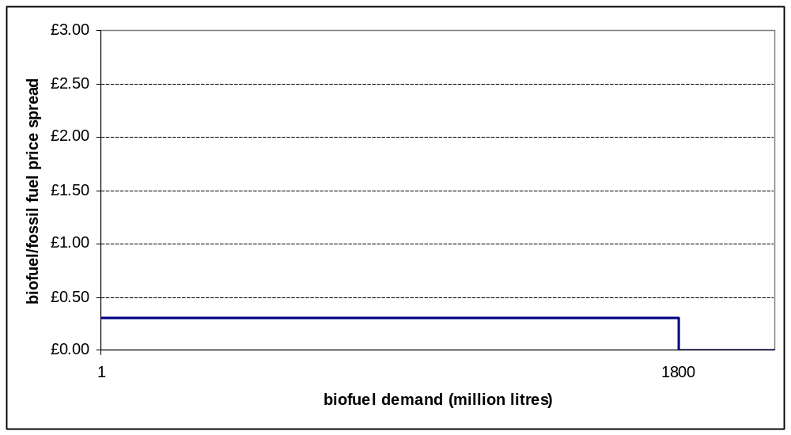

- When the additional cost of supplying biofuel (the biofuel/fossil fuel price spread) is greater than 30ppl (the current buy-out price level), there is no demand for biofuel (and buy-out will be fully utilised to meet obligations). When the additional cost of supplying biofuel is lower than 30ppl, there is demand for 1.8 billion litres of biofuel (as this is the cheaper way to meet the obligation than buy-out).

- The buy out price has 3 desired effects:

- It acts as a compliance incentivisation mechanism
- It limits the impact of the RTFO on pump prices
- It can potentially relieve pressure on food prices during times of tight supply and high prices.

1) Compliance mechanism

- Compliance with the RTFO is incentivised by the “buyout price” – an amount which must be paid by obligated suppliers if they fail to meet their obligation to supply biofuel under the RTFO. For every litre that a supplier falls short of their obligated supply they must pay the buyout price, which is currently set at 30 ppl (i.e. if an obligated supplier fell 400,000 litres short of their obligation to supply biofuel they would have to pay 400,000*£0.30 = £120,000). In effect, the buyout price acts as a penalty for non-supply of biofuel.

2) Limiting the impact on pump prices

- The buy-out price also acts as a cap on the costs of the RTFO (which are ultimately passed through to final consumers of transport fuel) as a rational obligated supplier’s maximum willingness to pay for biofuel is determined by the buy-out price. If the additional cost of supplying biofuel is greater than the buy-out price, obligated suppliers would be assumed to opt for paying the buyout price rather than supplying the fuel at a higher cost. Therefore the cost of the RTFO to the consumer is capped at the buyout price multiplied by the size of the obligation. An annual obligation level of 1.8 billion litres with a 30ppl buyout price has maximum potential cost of £540m.

3) Relieving pressure on food markets during times of tight supply and high prices

- The buy-out price also has the potential to reduce pressure on agricultural commodity markets in times of tight supply and high prices. If there were a price spike in crop-derived biofuel feedstock markets (e.g. wheat, corn, vegetable oils, etc), the cost of crop-derived biofuel production may rise. If it rises to a level where it is cost effective for obligated suppliers to buy-out, UK biofuel-driven demand for feedstocks would be expected to drop, easing pressure in these markets.

Buy-out Fund Recycling

- Under the current RTFO any money paid into the buy-out fund is recycled at the end of the obligation period. At the end of an RTFO obligation period those suppliers who discharged their obligation through redeeming RTFCs and any suppliers that have chosen to surrender RTFCs receive a share of buy-out fund. Suppliers’ share of the buy-out fund is proportional to the number of RTFCs they redeemed/surrendered. This sharing of the buy-out fund is referred to as “recycling".

Figure 4: UK biofuel demand curve as determined by buy-out fund recycling
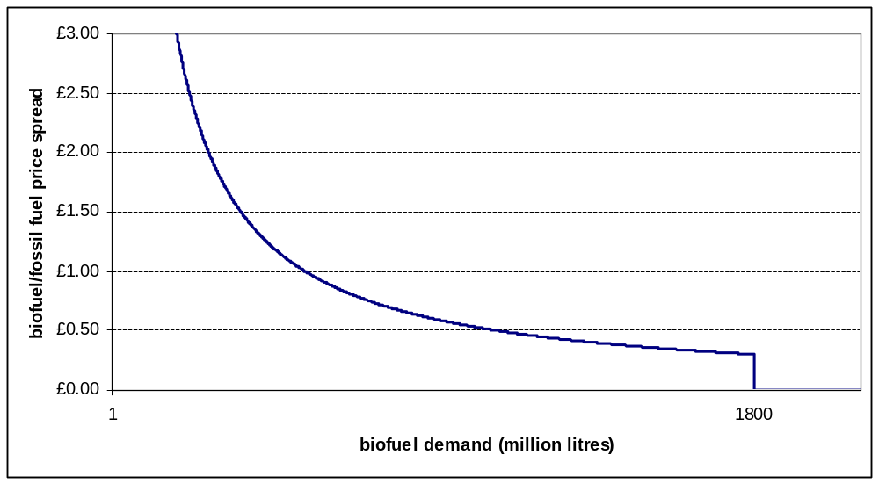

- At lower levels of supply, recycling of the buy-out fund creates an additional financial incentive over and above the buyout price. This is because as the volume of biofuel supplied falls, the size of the buyout fund increases meaning that suppliers are willing to pay more to supply biofuel as they expect to receive an increased payment from the buy-out fund (that recycled revenue would in effect off-set come of the cost of supplying biofuel). Suppliers’ willingness to pay is shown in the demand curve in Figure 4. However, the weight of this impact on suppliers’ decisions is limited by the uncertainty of how much biofuel other suppliers will produce. Suppliers have access to information that allows them to monitor the level of the buy-out over the year and hence form a view of the overall buy-out pot, though not how much they will receive.

Rationale for intervention

- As the recycling mechanism has the potential to increase obligated suppliers’ willingness to pay for biofuel during times of high food prices, it diminishes the potential for the buy-out price to relieve pressure on food markets during times of high prices and tight supply, but has no effect on the overall cost to consumers. In order to improve the ability of the buy-out price to relieve pressure in food markets when prices are high, it is proposed that the recycling of the buy-out fund is removed. Instead we propose that any money paid into the buyout fund is transferred to HM Treasury.

Policy objective

- The objective of this policy change is to improve the effectiveness of the buy-out mechanism to provide a trigger for the reduction in supply of biofuel in order to relieve pressure on relevant markets, where this is being caused by biofuels targets.
Description of options considered (including do nothing)

- We have identified and explored an option of removing the revenue recycling provision, in which case any buy-out fund would be transferred to HM Treasury. Only one option has been considered in addition to the ‘do nothing’ as it only appears appropriate to transfer the buy-out fund back to the firms affected by the regulation (as now) or to Government (as in the option). No alternative ways of recycling the buy-out fund to the regulated firms appears to avoid the concerns raised in this IA and provide a fair approach. Proposals of alternative options are welcomed from consultees.

Baseline

- The policy option considered in this impact assessment is assessed against a ‘do nothing’ baseline where the buy-out fund recycling continues.

Option 6a) Removing the recycling mechanism

- Under the proposed option, monies received from buy out would be transferred to HM Treasury, instead of being recycled. This would align the maximum willingness to pay for RTFCs by supplying biofuels with a price determined by the buy-out price level (see Figure 3). In turn, this would be in line with the intention of retaining flexibility in the RTFO to mitigate any possible future effects of biofuel supply on food prices during food price shocks.

Costs and benefits of removing recycling

- Removing the recycling mechanism will only have an impact in the event that obligated suppliers opt to buy out under the RTFO. The buy-out price has been set at a level where buy out is not anticipated to occur under normal market conditions. The buy-out price is kept under review to find the right balance between providing incentives for compliance and ensuring pump prices are capped at an acceptable level. Since the introduction of the RTFO, RTFCs have been trading within a 8.5ppl to 24.1ppl band, which is lower than the current buy-out price of 30ppl.

- At the time that this assessment was prepared, there has only been one incidence of RTFO buy-out. The value of that fund was £219,732.90 for the 2009-2010 obligation period, which represents failure to supply 732,443 litres of biofuel (less than 0.001% of overall supply). The Department understands that at the time the buy-out payment was made, RTFCs were trading at prices significantly below the buy-out price. It is not known why the obligated supplier(s) opted to buy-out of their obligation rather than purchase and subsequently redeem RTFCs (when the latter is expected to have been cheaper).

- As it is not possible to accurately estimate buy-out levels or indeed whether or not buy out would occur in the future, the following cost benefit analysis will set out potential impact in qualitative rather than quantitative terms.

Costs

- In the event of buy-out without a recycling mechanism, the money from the buy-out fund would no longer be transferred to obligated suppliers who have redeemed or surrendered RTFCs (who would have in turn increased spending on supplying biofuels) at the end of the obligation period. Instead, the revenues would go to HM Treasury. Given that buy-out is not anticipated under normal market conditions, it is not possible to quantify how much money this might amount to over the period to 2030.

- Removal of the buyout recycling implies a potential transfer (in the event of buyout taking place) of funds from suppliers obligated under the RTFO to HM Treasury. As this transfer occurs within the UK there is no expected net cost to society.

- There may also be costs to biofuel producers of having underutilised refining capacity during periods of high biofuel prices. Given that buy-out is not anticipated under normal market conditions it has not been possible to quantify these costs.

Benefits

- The key intended benefit of this policy change is to allow the buy-out mechanism to more effectively reduce the pressure that may be caused on relevant markets by biofuels targets. Curbing biofuel demand by suppliers in such circumstances will have two beneficial effects. More feed-stocks would be expected to be available for food consumption (rather than using some of those crops to produce biofuel) and less demand would therefore ease pressure on prices. It is not possible to quantify the extent of these potential impacts, as no buy out is anticipated under normal market conditions.

- If the recycling fund is removed, it is possible that less biofuel will be supplied when biofuel prices are high (in excess of the buy-out price). If less biofuel is supplied under option 6a (relative to the baseline) then GHG savings delivered by the RTFO will be lower. It is not possible to quantify the extent of these potential impacts.

Administrative burden and policy savings calculations

- Less administrative effort would be required to transfer the recycling fund to HM Treasury than to distribute the buy-out fund amongst obligated suppliers. However, even if buy out were used, this impact is expected to be very small and has not been quantified. Furthermore, as no buy out is anticipated, the expected value of potential administrative savings is also zero.

Risks and Assumptions

- The analysis in this impact assessment is based on the assumption that a buy-out is unlikely, since one would not be expected in normal market conditions. Higher feedstock prices or lower oil prices would increase the differential in costs of supplying biofuel compared to fossil fuel and could trigger a buy-out if the buy-out price remained constant. However, the buy-out price is periodically reviewed and could be amended to account for changes in market conditions. Only unexpected and excessive changes in market conditions are likely to trigger a buy-out.

Wider Impacts

- No significant wider impacts are anticipated, since recycling of any buy-out funds would only occur if the buyout option was used in the future, and this is not expected to occur under normal market conditions, in line with policy intentions.

Summary and preferred option

- The preferred option is to remove the recycling mechanism from the RTFO, as this is expected to increase the flexibility of the RTFO so that biofuel demand is more responsive (i.e. demand falls) if food prices were to increase significantly.

- This legislative change would be made alongside the other proposed changes presented in this suite of impact assessments in December 2011.

Annexes
Annex 1 should be used to set out the Post Implementation Review Plan as detailed below. Further annexes may be added where the Specific Impact Tests yield information relevant to an overall understanding of policy options.

Annex 1: Post Implementation Review (PIR) Plan
A PIR should be undertaken, usually three to five years after implementation of the policy, but exceptionally a longer period may be more appropriate. A PIR should examine the extent to which the implemented regulations have achieved their objectives, assess their costs and benefits and identify whether they are having any unintended consequences. Please set out the PIR Plan as detailed below. If there is no plan to do a PIR please provide reasons below.
Basis of the review: [The basis of the review could be statutory (forming part of the legislation), it could be to review existing policy or there could be a political commitment to review];
A review of all the RTFO amendments proposed in this consultation exercise will be conducted in April 2014.
Review objective: [Is it intended as a proportionate check that regulation is operating as expected to tackle the problem of concern?; or as a wider exploration of the policy approach taken?; or as a link from policy objective to outcome?]
The objective of the review will be to evaluate whether the RTFO amendments are performing as intended.
Review approach and rationale: [e.g. describe here the review approach (in-depth evaluation, scope review of monitoring data, scan of stakeholder views, etc.) and the rationale that made choosing such an approach]
The review will consist of an analysis of the impact of the RTFO amendments and will draw upon collected market data and stakeholder views.
Baseline: [The current (baseline) position against which the change introduced by the legislation can be measured]
Detailed data on the RTFO which is currently gathered by the RFA will be used to form the baseline.
Success criteria: [Criteria showing achievement of the policy objectives as set out in the final impact assessment; criteria for modifying or replacing the policy if it does not achieve its objectives]
Success will be determined by the existence of a well functioning obligation which is flexible in the event of severe supply shocks in food markets.
Monitoring information arrangements: [Provide further details of the planned/existing arrangements in place that will allow a systematic collection systematic collection of monitoring information for future policy review]
The RTFO administrator collects detailed data on RTFO performance.
Reasons for not planning a PIR: [If there is no plan to do a PIR please provide reasons here]

Annex 2 – Competition Assessment
- Removal of buyout recycling is not expected to cause any adverse competitive impacts.

Annex 3 – Small Firms Assessment

- Removal of buyout recycling is not expected to have an adverse impact on small firms.

Race, disability and gender Impact assessments are statutory requirements for relevant policies. Equality statutory requirements will be expanded 2011, once the Equality Bill comes into force. Statutory equality duties part of the Equality Bill apply to GB only. The Toolkit provides advice on statutory equality duties for public authorities with a remit in Northern Ireland.
The Renewable Transport Fuel Obligations Order 2007 (SI no 2007/3072) as amended by the Finance Act 2008 and the Renewable Transport Fuel Obligations (Amendment) Order 2009 (SI no 2009/843)
The RTFO defines obligated suppliers as those suppliers that own relevant hydrocarbon fuel (broadly, fossil fuel that is used to power road vehicles) at the time when the requirement to pay excise duty takes effect. In practice, obligated suppliers are suppliers of road grade petrol and diesel, for example multinational oil companies, fuel traders and fuel importers.
The duty point is the point at which fuel becomes liable for UK road transport duty, administered by HMRC. This is usually as fuel leaves UK refineries, import terminals or inland terminals supplied by pipeline.
Redeeming is the term used to denote an obligated party returning certificates in order to demonstrate that they have met their obligation.
These “price shocks” can be caused by a number of factors including supply interruptions (for example caused by severe adverse weather) and rising commodity prices (e.g. oil – which is a major agricultural input). In 2007/08, a major agricultural price spike led to hunger and food riots in a number of countries throughout the developing world. For a detailed analysis of the 07/08 price spike see the following report produced by DEFRA/HM Treasury: www.defra.gov.uk/foodfarm/food/pdf/ag-price-annex%205.pdf
Source: NFPA online RTFC auction data http://www.nfpas-auctions.co.uk/etoc/trackrecord.html

