Title:  FORMTEXT Lorry, bus and coach examination fees - location differentiation  Lead department or agency:  Vehicle and Operator Services Agency of the Department for Transport - VOSA  Other departments or agencies:  Driver and Vehicle Agency of the Northern Ireland Department of the Environment - DVA
  Impact Assessment (IA)
  IA No: DfT00074
  Date: 20/4/11
  Stage: Consultation
  Source of intervention:
  Type of measure:
  Contact for enquiries:
  John.MacLellan@vosa.gsi.gov.uk
  0117 954 2531

Summary: Intervention and Options

What is the problem under consideration? Why is government intervention necessary?
Annual testing and related examinations of lorries (HGVs) and buses and coaches (PSVs) are required by EU law to improve road safety. They are conducted by staff of the Vehicle and Operator Services Agency (VOSA) either in test facilities provided by VOSA; or in facilities provided by other, mainly private sector, providers. In the past, VOSA charged more to test at non-VOSA facilities. Currently the fees charged by VOSA are the same regardless of location type. However, vehicle presenters who choose to use non-VOSA test facilities are still contributing to the cost of VOSA facilities which they do not use whilst also having to meet the costs of the facilities they actually use. This may also discourage some from considering using non-VOSA test facilities which are, in other ways, to their benefit.

What are the policy objectives and the intended effects?
The fee changes in this IA are 1 step in a series of changes with the combined aim of carrying out tests at locations which are more convenient for customers by expanding private sector test facility provision. Sub-objectives of the series of changes, over several years, are to:
- ensure that VOSA costs are fully recovered
- encourage more tests at non-VOSA test facilities;
- encourage the establishment of more non-VOSA test facilities and reduce VOSA’s test facilities;
- limit the increases in fees at VOSA facilities to acceptable levels in any one year.

What policy options have been considered, including any alternatives to regulation? Please justify preferred option (further details in Evidence Base)
We have compared all options to the “do nothing” option (i.e. continue to charge the same fees regardless of test location). Option 1: full location cost differentiation in 2011/12 – i.e. charge the full cost of providing VOSA test facilities only to customers that opt to use those facilities and to charge additional costs of servicing non-VOSA test facilities only to those that opt to use those facilities. Option 2: partial location cost differentiation in 2011/12 – i.e. limit increases to a level which, if repeated in the succeeding years would deliver full cost recovery over 3 years if all other factors were to remain unchanged.
VOSA is consulting on the basis of Option 2 being its preferred option because:
• it limits the immediate impact on customers using VOSA test facilities, giving them time to adjust
• it means that fees in 2012/13 and beyond will be more stable to reflect changes to VOSA costs as the market for test facility provision develops.

Will the policy be reviewed? It be reviewed. If applicable, set review date: /
What is the basis for this review? . If applicable, set sunset clause date: /
Are there arrangements in place that will allow a systematic collection of monitoring information for future policy review?

Sign-off For consultation stage Impact Assessments:
I have read the Impact Assessment and I am satisfied that, given the available evidence, it represents a reasonable view of the likely costs, benefits and impact of the leading options.
Signed by the responsible : | Mike Penning | Date: | 20 May 2011

Summary: Analysis and Evidence Policy Option 1
Description:
Full location cost differentiation in 2011/12
Price Base Year 2010 | PV Base Year 2011 | Time Period Years 10 | Net Benefit (Present Value (PV)) (£m)
Price Base Year 2010 | PV Base Year 2011 | Time Period Years 10 | Low: n/a | High: n/a | Best Estimate: -15.5

COSTS (£m) | Total Transition  (Constant Price) Years |  | Average Annual  (excl. Transition) (Constant Price) | Total Cost  (Present Value)
Low | NA |  | NA | NA
High | NA |  | NA | NA
Best Estimate | 0 |  | 6.3 | 54.2
Description and scale of key monetised costs by ‘main affected groups’
1.) Annual HGV & PSV test fees for customers who choose to use VOSA test facilities are estimated to increase by 11.6%. This is a transfer from business to VOSA. Total estimated cost to businesses using VOSA test facilities is £3.2m per year. 2.) Annual HGV & PSV test fees for those who choose to use non-VOSA test facilities are estimated to decrease by 4.8%. This is a transfer from VOSA to estimated at £1.3m per year. 3.) VOSA costs to service additional non-VOSA sites are estimated at £1.8m.
Other key non-monetised costs by ‘main affected groups’
Changes to fees for Reduced Pollution Certificates; Low Emission Certificates; notifiable alteration examinations; and voluntary checks have not been monetised. These are optional services and are only used if customers believe that they benefit from the service.
Users of VOSA test facilities will pay the full cost of providing those facilities.
BENEFITS (£m) | Total Transition  (Constant Price) Years |  | Average Annual  (excl. Transition) (Constant Price) | Total Benefit  (Present Value)
Low | NA |  | NA | NA
High | NA |  | NA | NA
Best Estimate | 0 |  | 4.5 | 38.7
Description and scale of key monetised benefits by ‘main affected groups’
1.) Annual HGV & PSV test fees for customers using non-VOSA test facilities are estimated to decrease by 4.8%. This is a transfer from VOSA to business. The total estimated benefit to businesses using non-VOSA test facilities is £1.3m per year. 2.) Annual HGV and PSV test fees for those who choose to use VOSA test facilities are estimated to increase by 11.6%. This is a transfer from business to VOSA. The total benefit to VOSA is estimated at around £3.2m per year.
Other key non-monetised benefits by ‘main affected groups’

Key assumptions/sensitivities/risks Discount rate (%) |  |  |  |  | 3.5
Key assumptions are that: 1) the mix of test locations averages 50/50 for the estimated 850,000 tests per year - risk is that this assumption will prove unreliable since the rate of change is affected by many unpredictable effects in the market; 2) costs to VOSA of servicing non-VOSA sites will rise in direct proportion to the number of tests carried out there – risk is whether and when the assumed cost rises will materialise; 3) no reduction in VOSA estate costs in 2011/12 because disposals will lag behind reduced test volumes – not regarded as a risk; and 4) impact on the PSV industry will not be significantly different to that on the HGV industry.

Direct impact on business (Equivalent Annual) £m): |  |  | In scope of OIOO? | Measure qualifies as
Costs: 3.2 | Benefits: 1.3 | Net: -1.9

Enforcement, Implementation and Wider Impacts
What is the geographic coverage of the policy/option? |  |  | - mainly GB part UK
From what date will the policy be implemented? |  |  | Autumn 2011
Which organisation(s) will enforce the policy? |  |  | VOSA in GB - DVA in NI
What is the annual change in enforcement cost (£m)? |  |  | nil
Does enforcement comply with Hampton principles?
Does implementation go beyond minimum EU requirements?
What is the CO₂ equivalent change in greenhouse gas emissions?  (Million tonnes CO₂ equivalent) |  |  | Traded:  nil |  | Non-traded:  nil
Does the proposal have an impact on competition?
What proportion (%) of Total PV costs/benefits is directly attributable to primary legislation, if applicable? |  |  | Costs:  n/a |  |  | Benefits:  n/a
Distribution of annual cost (%) by organisation size  (excl. Transition) (Constant Price) | Micro  NQ | < 20  NQ | Small  NQ | Medium  NQ |  |  | Large  NQ
Are any of these organisations exempt?

Specific Impact Tests: Checklist
Set out in the table below where information on any SITs undertaken as part of the analysis of the policy options can be found in the evidence base. For guidance on how to complete each test, double-click on the link for the guidance provided by the relevant department.
Please note this checklist is not intended to list each and every statutory consideration that departments should take into account when deciding which policy option to follow. It is the responsibility of departments to make sure that their duties are complied with.
Does your policy option/proposal have an impact on…? | Impact | Page ref within IA
Statutory equality duties |  | 20

Economic impacts
Competition |  | 20
Small firms |  | 20

Environmental impacts
Greenhouse gas assessment |  | 20
Wider environmental issues |  | 20

Social impacts
Health and well-being |  | 20
Human rights |  | 20
Justice system |  | 21
Rural proofing |  | 21

Sustainable development |  | 21

Summary: Analysis and Evidence Policy Option 2
Description:
Partial location cost differentiation in 2011/12
Price Base Year 2010 | PV Base Year 2011 | Time Period Years 10 | Net Benefit (Present Value (PV)) (£m)
Price Base Year 2010 | PV Base Year 2011 | Time Period Years 10 | Low: n/a | High: n/a | Best Estimate: 0

COSTS (£m) | Total Transition  (Constant Price) Years |  | Average Annual  (excl. Transition) (Constant Price) | Total Cost  (Present Value)
Low | n/a |  | n/a | n/a
High | n/a |  | n/a | n/a
Best Estimate | 0 |  | 2.2 | 19
Description and scale of key monetised costs by ‘main affected groups’
1) Annual HGV & PSV test fees for customers who choose to use VOSA test faciities are estimated to increase by 4%. This is a transfer from business to VOSA. Total estimated cost to businesses using VOSA test facilities is £1.1m per year. 2) Annual HGV & PSV test fees for those who choose to use non-VOSA test facilities are estimated to decrease by 4%. This is a transfer from VOSA to business. The total cost to VOSA is estimated at around £1.1m per year.
Other key non-monetised costs by ‘main affected groups’
Changes to fees for Reduced Pollution Certificates; Low Emission Certificates; notifiable alteration examinations; and voluntary checks have not been monetised. These are optional services and are only used if customers believe that they benefit from the service.
Impact on bus/coach (PSV) operators is likely to be of similar order to that on HGV operators.
Users of VOSA test facilities will pay a higher proportion of the cost of those facilities.
BENEFITS (£m) | Total Transition  (Constant Price) Years |  | Average Annual  (excl. Transition) (Constant Price) | Total Benefit  (Present Value)
Low | n/a |  | n/a | n/a
High | n/a |  | n/a | n/a
Best Estimate | 0 |  | 2.2 | 19
Description and scale of key monetised benefits by ‘main affected groups’
1) Annual HGV and PSV test fees for customers using non-VOSA test faciities are estimated to decrease by 4%.This is a transfer from VOSA to business. The total estimated benefit to business using non-VOSA test facilities is £1.1m per year. 2.) Annual HGV and PSV test fees for those who choose to use VOSA test facilities are estimated to increase by 4%. This is a transfer from business to VOSA. The total benefit VOSA is estimated at around £1.1m per year.
Other key non-monetised benefits by ‘main affected groups’

Key assumptions/sensitivities/risks Discount rate (%) |  |  |  |  | 3.5
Key assumptions are that: 1) the mix of test locations averages 50/50 for the estimated 850,000 tests per year - risk is that this assumption will prove unreliable since the rate of change is affected by many unpredictable effects in the market; 2) the increased cost to VOSA of servicing non-VOSA sites assumed in the testing transformation business case will not materialise in 2011/12 – risk that the assumption is incorrect; 3) no reduction in VOSA estate costs in 2011/12 because disposals will lag behind reduced test volumes – not regarded as a risk; and 4) impact on the PSV industry will not be significantly different to that on the HGV industry.

Direct impact on business (Equivalent Annual) £m): |  |  | In scope of OIOO? | Measure qualifies as
Costs: 1.1 | Benefits: 1.1 | Net: 0.0

Enforcement, Implementation and Wider Impacts
What is the geographic coverage of the policy/option? |  |  | - mainly GB part UK
From what date will the policy be implemented? |  |  | Asap after April 2011
Which organisation(s) will enforce the policy? |  |  | VOSA in GB - DVA in NI
What is the annual change in enforcement cost (£m)? |  |  | nil
Does enforcement comply with Hampton principles?
Does implementation go beyond minimum EU requirements?
What is the CO₂ equivalent change in greenhouse gas emissions?  (Million tonnes CO₂ equivalent) |  |  | Traded:  nil |  | Non-traded:  nil
Does the proposal have an impact on competition?
What proportion (%) of Total PV costs/benefits is directly attributable to primary legislation, if applicable? |  |  | Costs:  n/a |  |  | Benefits:  n/a
Distribution of annual cost (%) by organisation size  (excl. Transition) (Constant Price) | Micro  NQ | < 20  NQ | Small  NQ | Medium  NQ |  |  | Large  NQ
Are any of these organisations exempt?

Specific Impact Tests: Checklist
Set out in the table below where information on any SITs undertaken as part of the analysis of the policy options can be found in the evidence base. For guidance on how to complete each test, double-click on the link for the guidance provided by the relevant department.
Please note this checklist is not intended to list each and every statutory consideration that departments should take into account when deciding which policy option to follow. It is the responsibility of departments to make sure that their duties are complied with.
Does your policy option/proposal have an impact on…? | Impact | Page ref within IA
Statutory equality duties |  | 20

Economic impacts
Competition |  | 20
Small firms |  | 20

Environmental impacts
Greenhouse gas assessment |  | 20
Wider environmental issues |  | 20

Social impacts
Health and well-being |  | 20
Human rights |  | 20
Justice system |  | 21
Rural proofing |  | 21

Sustainable development |  | 21

Evidence Base (for summary sheets) – Notes
Use this space to set out the relevant references, evidence, analysis and detailed narrative from which you have generated your policy options or proposal. Please fill in References section.

References
Include the links to relevant legislation and publications, such as public impact assessments of earlier stages (e.g. Consultation, Final, Enactment) and those of the matching IN or OUTs measures.

Evidence Base
No. | Legislation or publication
VOSA Annual Report 2009/10
http://www.dft.gov.uk/vosa/repository/2009%20-%202010%20VOSA%20Annual%20Report%20and%20Accounts.pdf
VOSA Business Plan 2010/11
http://www.dft.gov.uk/vosa/repository/2010-2011%20VOSA%20Business%20Plan.pdf
Impact Assessment on funding the national register of licensed operators of goods vehicles, buses and coaches at:
http://www.dft.gov.uk/consultations/dft-2011-11
Impact Assessment on restructuring fees for applications for bus and coach operator licences at:
Annex C to this consultation
Ministerial statement to Parliament about the future of testing services provided by the Vehicle and Operator Services Agency – J Fitzpatrick, 3 July 2008
http://www.publications.parliament.uk/pa/cm200708/cmhansrd/cm080703/wmstext/80703m0002.htm#08070362000020
Ensure that the information in this section provides clear evidence of the information provided in the summary pages of this form (recommended maximum of 30 pages). Complete the Annual profile of monetised costs and benefits (transition and recurring) below over the life of the preferred policy (use the spreadsheet attached if the period is longer than 10 years).
The spreadsheet also contains an emission changes table that you will need to fill in if your measure has an impact on greenhouse gas emissions.

Annual profile of monetised costs and benefits* - (£m) constant prices
 | Y₀ | Y₁ | Y₂ | Y₃ | Y₄ | Y₅ | Y₆ | Y₇ | Y₈ | Y₉
Transition costs | 0 | 0 | 0 | 0 | 0 | 0 | 0 | 0 | 0 | 0
Annual recurring cost | 2.2 | 2.2 | 2.2 | 2.2 | 2.2 | 2.2 | 2.2 | 2.2 | 2.2 | 2.2
Total annual costs | 2.2 | 2.2 | 2.2 | 2.2 | 2.2 | 2.2 | 2.2 | 2.2 | 2.2 | 2.2
Transition benefits | 0 | 0 | 0 | 0 | 0 | 0 | 0 | 0 | 0 | 0
Annual recurring benefits | 2.2 | 2.2 | 2.2 | 2.2 | 2.2 | 2.2 | 2.2 | 2.2 | 2.2 | 2.2
Total annual benefits | 2.2 | 2.2 | 2.2 | 2.2 | 2.2 | 2.2 | 2.2 | 2.2 | 2.2 | 2.2
* For non-monetised benefits please see summary pages and main evidence base section

Evidence Base (for summary sheets)

GENERAL ISSUES

Fees covered by this Impact Assessment
  - This Impact Assessment (IA) covers fees for the following services:
- For lorries (including their trailers) (Heavy Goods Vehicles – HGVs):
    - annual testing
    - approval of “notifiable” alterations
    - applications for Reduced Pollution Certificates (RPCs) – to enable lower rates of vehicle taxation
    - applications for Low Emission Certificates (LECs) – to enable free entry to the London Low Emission Zone
    - voluntary checks.
- for buses and coaches (Public Service Vehicles – PSVs)
    - annual testing – note that the fees for PSV annual tests may also be affected by small increases to contribute to the funding of the National Register of operators and their transport managers needed to meet EU Regulations which are dealt with in a separate IA (reference 3)
    - applications for Reduced Pollution Certificates (RPCs) – to enable lower rates of vehicle taxation
    - applications for Low Emission Certificates (LECs) – to enable free entry to the London Low Emission Zone
    - voluntary checks.

Geographic Coverage
  - Fees for RPCs apply throughout the UK and are charged by VOSA in GB and the Driver and Vehicle Agency (DVA) in Northern Ireland. All other fees covered by this IA apply only in GB (i.e. England, Scotland and Wales) and are charged by VOSA.

Background
  - The Vehicle and Operator Services Agency, (VOSA) is a Government Trading Fund within the Department for Transport. Its activities include roadworthiness testing of lorries, buses and coaches; encouraging and enforcing safe and legal operation of those vehicles; specialist inspections of vehicles; managing the MOT scheme for testing cars and other light or private vehicles; and supporting the Traffic Commissioners in their statutory functions (e.g. in respect of licensing of operators of lorries, buses and coaches). Proposals for fees in 2011 form part of VOSA’s wider financial management strategy which is outlined more fully in its published Business Plans (reference 2) and Annual Reports (reference 1). Whilst work to produce the Business Plan for 2011/12, which is normally published around the start of the financial year, is in progress, the 2010/11 plan is to break even by reducing expenditure by about £5.6m (2.3%) compared to 2009/10. This, however, still leaves a retained deficit in VOSA’s accounts which must be cleared by a combination of further reductions in expenditure and/or increases in the general level of fees. However, VOSA is not proposing to apply any increases to the general levels of statutory fees for 2011. Thus, adjusted for inflation, the levels of statutory fees will decrease in real terms. VOSA must make efficiency savings to absorb this decrease, and also to start recovering the retained deficit. For 2011/12, customers will benefit from VOSA’s efficiency improvements and the real terms decrease in fees.
  - With the exception of a few privately owned HGVs such as horseboxes, the customers for the services covered by this IA are businesses ranging from single vehicle operation to large companies with operations on a global scale including other transport modes (e.g. rail). On the freight side there are currently some 92,000 operator’s licences issued. The average operator has 4 vehicles, but the range is from 1 to several thousand. On the passenger side, there are about 9,000 licences issued with an average fleet size of around 9, but the range is from 1 to many thousand.

History
  - Statutory annual testing of HGVs was introduced in Great Britain in the late 1960s. All tests were carried out by employees of predecessors to VOSA, at Government provided test stations, since, at that time, the sort of facilities needed to test vehicles were virtually nonexistent. VOSA currently provides some 84 such stations stretching from Lerwick in Shetland to Redruth in Cornwall.
  - Statutory annual testing of PSVs, which had been subject to a less formal regime since the 1930s, started in the early 1980s. PSVs were also tested by VOSA staff but tests were carried out at a mix of Government HGV test stations and test facilities provided by 3rd parties – largely PSV operators, which VOSA accepted as being suitable (i.e. non-VOSA test facilities referred to as Designated Premises or DPs).
  - From the early 1990s, VOSA started offering HGVs the option of tests at suitable non-VOSA test facilities, some of which were repairers rather than operators of vehicles. Also from that time, VOSA started making an additional charge for testing at non-VOSA facilities. The additional charge was to cover the cost of travel and lost time from sending staff out to these non-VOSA facilities.
  - Those providing non-VOSA test facilities were free to present only their own vehicles for test, or to allow others to present vehicles at their facilities. The relationship between the facility provider and VOSA was informal in that VOSA gave no guarantees about service provision but had no guarantees that their staff would be fully utilised. The organisation owning the premises could charge other presenters for the use of the test facility in addition to the statutory test fee payable to VOSA. This charge could be in the form of a fee for the use of the facilities (referred to as a “pit fee”) or could be included as an overhead in charges for other service which the facility provider was supplying to their customers.

Problems under consideration
  - Annual testing and related examinations of lorries (HGVs) and buses and coaches (PSVs) are required by EU law to improve road safety and the environment. They are conducted by staff of the Vehicle and Operator Services Agency (VOSA) either in test facilities provided by VOSA on behalf of the Secretary of State or in test facilities provided by other, mainly private sector, providers. Those presenting vehicles for test are free to choose where they wish their test to be carried out. However, their choice is limited because the overall capacity of non-VOSA facilities is insufficient to meet overall demand, and some parts of GB have no such facilities. VOSA is engaged in a programme to provide testing at locations which are at or nearer to where vehicles are maintained and to roll back Government provision of testing facilities. Currently the fees charged by VOSA are the same regardless of location type. Vehicle presenters who choose to use non-VOSA test facilities are therefore contributing to the cost of maintaining VOSA facilities which they do not use whilst also having to meet the costs of the facilities they actually use. Those who choose to use VOSA test facilities are contributing to the cost (e.g. travel time and cost) of less efficient use of VOSA testing staff servicing non-VOSA test facilities. This may also discourage some from using non-VOSA test facilities which are, in other ways, to their benefit.
  - The changes proposed are a further step to progressively adjust the balance of fees between different customers depending on the service delivery method they choose.
  - The changes also affect examinations of HGVs following specified “notifiable” alterations; and of both HGVs and PSVs for the issue of Reduced Pollution Certificates and Low Emission Certificates since these examinations are carried out on the same facilities and often at the same time, as annual tests.

Other elements in fees charged by VOSA for HGV and PSV tests
  - Part of fees for full annual HGV and PSV tests, but not partial retests, is used to cover the costs of encouraging and enforcing compliance. This is referred to as the “enforcement” element of the fee. In the case of PSVs, an additional small element (the “O licence” element) of the fee for full annual tests covers the ongoing costs of maintaining operator’s licences. Fees for HGV notifiable alterations, Reduced Pollution Certificates and Low Emission Certificates have neither enforcement nor O licence elements.
  - The changes covered by this Impact Assessment affect only the “testing” element of the fees concerned and figures quoted cover both HGVs and PSVs – the enforcement and O licence elements of test fees are not being changed. Thus, a 4% increase in the testing element of the annual test of a 2 axle HGV means that the fee charged for the test, including the enforcement element only increases by 3.2% under option 2. The fee tables at Annex 2 show all elements of each fee as well as the overall fee to be charged.

Other fees and charges affected by changes in this IA
  - Fees for appeals against refusal to issue an HGV or PSV test certificate have been treated in the same way as tests at VOSA. Fees for HGV notifiable alterations will be treated in the same way as fees at VOSA. This is because the fees are paid at the time of application and particularly for notifiable alterations, no decision has been taken at that time as to whether a physical inspection will be necessary. Examinations to determine applications for Reduced Pollution Certificates and Low Emission Certificates are carried out both at VOSA and non-VOSA sites, often at the same time as annual tests.
  - VOSA carries out some marginal activities to enable vehicle operators who may not have access to specialist equipment (roller brake testers, diesel smoke meters and headlamp beam setters) to bring their vehicles to a VOSA test station for checks using that equipment. VOSA also carries out voluntary “tests” to annual test standards for some customers whose vehicles do not come within scope of statutory annual testing or who wish to monitor their vehicle condition more frequently. These services are normally provided at VOSA facilities so will also be subject to the same increase as tests at VOSA facilities. In addition, VOSA does not intend to absorb inflation for these services so proposes to increase these charges in line with the RPI for November 2010 of 4.7% (which is the most recently published data at the time that the consultation is being prepared). This sort of check is also available from commercial suppliers and there is no compulsion to have the checks carried out, let alone to use VOSA for them. Since customers are free to choose whether to use VOSA’s service or go to other providers, this change has not been monetised in this Impact Assessment.

Northern Ireland
  - Unlike all other fees covered by this Impact Assessment, Reduced Pollution Certificate fees also apply in Northern Ireland where examinations are carried out by the Driver and Vehicle Agency (DVA), which is an Executive Agency of the Department of the Environment. DVA carries out similar functions in Northern Ireland to those of VOSA in GB. They also operate driver testing and licensing and vehicle licensing functions in Northern Ireland. DVA only carry out vehicle examinations at their own test facilities so their fees are treated in the same way as those for examinations at VOSA test facilities in GB.

Rationale for intervention
  - EU Council Directive 96/96/EC requires periodic roadworthiness tests of specified vehicles. The directive requires roadworthiness tests to be carried out by the State, or by a public body entrusted with the task by the State or by bodies or establishments designated and directly supervised by the State. In Great Britain this testing for HGVs and PSVs is carried out by the Vehicle and Operator Services Agency (VOSA) which is a Government Trading Fund within the Department for Transport. The provision of test facilities has also been primarily by Government, though, as described elsewhere in this IA, increasing levels of private sector provision has evolved over time. This increasing private sector involvement and evaluation of its potential continuation has now reached the point at which it is possible to start rolling back the level of Government provision of testing facilities in many parts of the country.
  - In addition, since most of the fees concerned are set in Regulations only by Government intervention can they be altered.

Policy objective
  - The fee changes described in this IA are one step for one of a series of levers aimed at changing behaviour of customers of VOSA’s main HGV and PSV testing services. The reasons why we wish to create this change and the levers we are progressively applying are described in the following paragraphs. The primary objective of this series of changes is, progressively and over several years, to provide customers with tests at more convenient locations by expanding provision of test facilities by the private sector. Sub-objectives within this progressive change process are to:
  - ensure that the fees charged by VOSA for those services which it provides at least cover the costs of service provision;
  - carry out more tests at more convenient locations closer to where vehicles are maintained by encouraging more use of non-VOSA test facilities;
  - encourage the creation of more non-VOSA test facilities to provide a competitive market and increase the opportunities for tests closer to maintenance locations and reduce the number and size of VOSA test facilities;
  - where individual fees increase as part of this progression, limit increases to acceptable levels in any one year; and
  - make fees relate more closely to the costs of the particular delivery method.

The change process in which we are engaged
  - Following a review in 2008 of how statutory (annual) testing of HGVs and PSVs was delivered, the Minister (Jim Fitzpatrick) announced to the Commons on 3 July (reference 5) that VOSA had been tasked with providing tests at locations which are more convenient to customers. Delivery of this is referred to as the Testing Transformation. To reduce the costs to the transport industry of annual testing, VOSA is planning to carry out more tests at non-VOSA test facilities located, primarily, where vehicles are maintained; and to reduce its own testing estate as alternative provision becomes available.
  - The decision to encourage more tests at locations where, or nearer to where, vehicles are maintained was based on a Business Case developed in accordance with Treasury investment appraisal principles set out in The Green Book - Appraisal and Evaluation in Central Government. The business case showed a net benefit to customers of around £8m in 2011/12 rising to around £43m per annum by 2020/21. A major contribution to this benefit comes from reduced vehicle downtime and reduced costs for vehicle presenter’s staff time and vehicle mileage to bring vehicles to VOSA test locations.
  - The option of testing at non-VOSA locations nearer to vehicle locations was not available to all since the overall capacity on those facilities was insufficient to meet demand. The geographic coverage was also variable over the country so whilst in some areas the capacity of non-VOSA facilities was near to sufficient; in others no non-VOSA facilities were available. There were also issues with some vehicle presenters looking only at the visible cost of test fees or sticking to the traditional ‘bring the vehicle to the tester’ approach; rather than considering the overall cost of presenting the vehicle for test when deciding where to have their tests carried out.
  - Additionally, had the previous service delivery model been continued, VOSA’s testing estate costs would have increased dramatically to fund an estimated £70m of estate developments over the next few years. This is because VOSA’s current testing estate was largely built or adapted in the late 1960s. Whilst test equipment has been replaced regularly, the fabric of many buildings is now worn out; some test stations are in locations which are not convenient for the road network as it has developed and/or are in areas which are now more residential, leading to environmental issues.
  - In addition to the above benefits, the new delivery model is seen as an opportunity to roll back Government provision of test facilities and create new opportunities for the private sector whilst maintaining the independence and integrity of the inspectors by keeping them within a Government Agency.
  - The aim is to achieve an ordered transition from public sector provision of testing facilities to private sector provision whilst maintaining accessibility of testing and not unduly disadvantaging those who do not yet have a realistic choice between VOSA and non-VOSA facilities. The pace of that change will depend on a number of factors, many of which are outside VOSA’s control.

The levers to achieve change
  - There are a number of levers which VOSA can use to encourage the development of the market. The main levers are:
  - increasing the number of non-VOSA test facilities to provide more locations and encourage a competitive market in the provision of such facilities giving customers greater choice by, amongst other things, replacing the informal arrangements with DPs by a formal contract with new Authorised Testing Facilities (ATFs) setting out the responsibilities of VOSA and the ATF;
  - helping customers to understand that the test fee is only part of the full cost of testing; and
  - reducing, by closure and/or consolidation, the availability of VOSA facilities as the market in non-VOSA facilities develops;
  - progressively altering differentials between the fees charged by VOSA for testing at VOSA and non-VOSA facilities.
  - However, use of those levers needs to balance their effects in areas where development of a market in test facility provision is reasonably advanced and VOSA can withdraw from the market in the near future, with ensuring that those customers in areas in which there is not yet a significant market are not unduly disadvantaged. VOSA also needs to consider that there may be areas in which there may never be a market. For these reasons, the levers are being used progressively.
  - This IA deals only with one lever – fee differentials – and the monetisation covers only one step – the changes proposed for 2011/12 – in its application.

The fee differential lever
  - Under the charging structure introduced in the early 1990s, the cost of providing the VOSA testing estate was spread across all tests, and an additional charge was made by VOSA for testing at the non-VOSA test facilities to cover VOSA’s costs to send staff out to test and the lower number of tests which could be completed. This gave a differential which favoured tests at VOSA facilities.
  - As part of the change in service delivery method, it was decided to progressively move from that fee structure to one in which the cost of the VOSA facilities is met by those using them and that any additional costs of servicing non-VOSA facilities should be met only by users of non-VOSA facilities. This process was started in April 2009, when the supplements charged for testing at VOSA sites were halved. In April 2010, the supplements were removed completely. The proposals for 2011/12 included in this Impact Assessment start to reverse the differentials and are a further step in this direction. The table below illustrates the progression for a 2 axle HGV motor vehicle assuming that VOSA’s preferred Option 2 is adopted following consultation.
Table illustrating progressive changes in differentials between tests at VOSA and non-VOSA test facilities
Year | Differential  (extra cost of test at non-VOSA) | Total change in differential
2008/9 | £13
2009/10 | £7 | £6
2010/11 | £0 | £13
2011/12  (preferred option) | -£5 | £18
2012/13 and beyond | See paragraph 31 below

  - VOSA’s wishes to increase these differentials further in future years whilst ensuring that costs are at least covered. The eventual size of the differentials and the rate of progress towards them will be affected by a number of factors over many of which VOSA only has limited influence. Key amongst those factors are:
  - the rate at which availability of non-VOSA facilities grows;
  - the rate at which test customers move from VOSA to non-VOSA test facilities;
  - the rate at which VOSA facilities can be reduced in size or closed;
  - the rate at which surplus VOSA facilities can be disposed of;
  - whether the surplus sites are VOSA owned or leased and the book value of owned sites compared to the proceeds from their sale;
  - whether VOSA’s costs of supporting non-VOSA test facilities match the assumptions made in the business case for testing transformation
  - what arrangements are made in future for the provision of test facilities in areas where no private sector market for the provision of facilities develops.

Options Considered
  - Compared to “do nothing” we have considered the following options for fees covered in this Impact Assessment:
- OPTION 1 – full location cost differentiation in 2011/12 – i.e. restructure fees to move to full differentiation between tests at VOSA and non-VOSA facilities in 2011/12. This option estimates the maximum differential that could be applied in 2011/12. However, it is difficult to predict what differentials would be in 2012/13 and beyond because of the factors mentioned above. Under some scenarios there could be difficulty in even maintaining the Option 1 differentials, let alone increasing them
- OPTION 2 – partial location cost differentiation in 2011/12 – i.e. restructure fees to move towards full differentiation but limiting to 4% the increase of those fees which will rise.
  - The fundamental difference between the 2 options is in the pace at which the progressive change in fees to relate them more closely to delivery method moves. VOSA’s preferred option is Option 2 since it delivers a further step in a longer term evolution whilst minimising the potentially destabilising medium term effects from the factors discussed earlier.
  - Whilst it could be argued that we should accept a greater risk of future reduction of differentials and adopt greater differentials on 2011/12, VOSA considers this inappropriate because of:
  - The need to ensure that VOSA covers its costs.
  - The patchy nature of existing non-VOSA facilities which means that in some areas customers have no option to use non-VOSA sites and could be disadvantaged by the larger rises in fees at VOSA facilities needed to accelerate differential changes.
  - The reduction in VOSA estate costs will lag behind the increase of tests at non-VOSA facilities because downsizing of the VOSA estate will only happed when adequate alternatives are likely to be available in a catchment area; and only then can redundant sites be sold off. If differentials favouring non-VOSA facilities were increased too rapidly and had then to be reduced it could damage trade confidence in predictable change making future progress towards the use of non-VOSA facilities more difficult.

The importance of the fee differential lever
  - It is not practicable to quantify with any certainty the extent to which one year’s changes in the fee regime, in isolation from the other levers described above, past changes in differentials and the prospect of further changes in differentials, will encourage the changes in customer behaviour needed to realise the benefits of wider availability of non-VOSA facilities. Indeed it is probably true that the differential of £5 for a 2 axle HGV created by the Option 2 proposals is unlikely to create much change in itself. However, taken in the context illustrated in the table in paragraph 30 which shows a change in differential of £18 over 3 stages combined with the effect of the other levers mentioned and with the prospect of further increases in differentials in future, VOSA is confident that it will deliver the desired change in a sustainable manner in the medium term.
  - At the end of 2008/9 around 21% of tests were carried out at non-VOSA premises. Provisional figures indicate that this had increased to around 32% by the end of 2010/11. However because other levers mentioned in paragraph 26 were also being applied it is not possible to determine what proportion of that change in behaviour is attributable to the fee differential lever.
  - VOSA’s intent to move towards differential pricing in which VOSA’s charges for tests an non-VOSA facilities are lower than for tests at its own facilities has been openly stated in past fee consultations and in discussions with those organisations investing in providing non-VOSA test facilities. If we failed to continue to move in this direction, not only would we lose the effect of this lever in 2011/12, but it would damage the credibility of our commitment to the process. This would make those considering investing in non-VOSA test facilities less likely to do so and could jeopardise the continued growth in choice of test locations at more convenient locations.
  - Progress towards more local availability of testing facilities can also be illustrated by the facts that before the start of the Testing Transformation Programme, about 20% of tests were carried out at some 220 non-VOSA test facilities. At the time of writing this has risen to around 30% of tests at 267 non-VOSA facilities.

Costs and benefits of each option

Distribution of annual costs by business size
  - It has not been possible to complete these boxes on the “Summary: Analysis and Evidence” pages for either option because neither VOSA nor DfT holds any data on the size of businesses operating commercial vehicles. To gather such data would impose a disproportionate burden on businesses to supply the data and on government to collect and analyse the data.
  - To illustrate this, for HGV operators the data we hold relates to the maximum number of vehicles which a business is authorised to use; and the number of vehicles which it currently operates which it intends to use for more than 1 month (which are “specified” on its licence).
  - An operator with 2 vehicles authorised on its licence and 2 “specified” could be:
- a business whose sole activity is vehicle operation with a handful of employees; or
- a large supermarket chain with thousands of employees which contracts out most of its transport activities but has a couple of vehicles of its own which it uses for special purposes.
  - An operator authorised to operate several hundred vehicles may only have 1 or 2 currently “specified” on its licence could be:
- a business which is currently small with a handful of drivers but has contracted or hopes to expand;
- a business which employs several hundred drivers and other staff but, because of fluctuating demand or its business model, uses mainly vehicles on short term hire which do not need to be “specified” on its licence; or
- a business which employs only a few managers and 1 or 2 drivers, uses mainly vehicles on short term hire and uses mainly drivers employed by an employment agency rather than by itself.

Key assumptions, sensitivities and risk
  - The following key assumptions have been made in considering both options evaluated in this Impact Assessment:
  - On average over the year 2011/12 50% of the estimated 850.000 tests are assumed to be conducted at non-VOSA test facilities. The accuracy of this assumption is dependent on the combined effect on the levers described in paragraph 26 and external factors beyond VOSA’s control. Over the full evaluation period, it is certain that the proportion of tests at non-VOSA facilities will not remain at these levels. However, it is impossible to predict how the figures will vary. For this reason we have assumed that the split remains constant over the full 10 year appraisal period the purposes of monetising the costs and benefits. The risk is that, in the short term, if fewer than 50% of tests are conducted at VOSA facilities VOSA’s income will be higher than expected. If more than 50% of tests are conducted at non-VOSA facilities there will be a shortfall in VOSA’s income. The table below is an impact analysis which illustrates the effect on annual income from the preferred option (Option 2) if the assumed 50/50 split of test locations is incorrect. As can be seen, each 5% more or fewer tests at non-VOSA alters VOSA’s HGV and PSV test fee income by around 0.4%. Any variation will be taken into account in future fee reviews, both in terms of balances carried forward and assumptions on split of test locations until the next fee review. VOSA aims to carry out fee reviews annually, but this is not always possible.
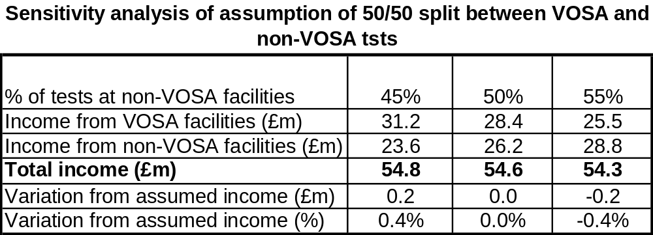
  - No reduction in VOSA estate costs in 2011/12. The largest element of estate cost reduction will come from closure of sites and their disposal. The size and timing of the reduction is dependent on many of the factors outlined in paragraph 30. VOSA considers it unlikely that the estate cost reductions from any closures during 2011/12 will have any significant effect on costs during that year. The same factors make it extremely difficult to predict which sites will close and when they will close. For the purposes of monetising the costs and benefits, VOSA has not assumed any reductions over the full appraisal period. Future periodic reviews of fee levels will take account of these savings as they materialise.
  - The impact on the PSV industry will not be significantly different to that on the HGV industry. Annex 3 to this IA illustrates the effect on HGV operating businesses of various sizes, both in cash terms and relative to their overall operating costs. Because of lack of public domain data it has not been possible to carry out similar calculations for the PSV industry. However, as explained in paragraphs 69 and 70, the estimated total fee change proposed for the worst case PSV operator is less that the cost of 7 litres of diesel at forecourt prices.
  - Assumptions on the additional costs to VOSA of servicing non-VOSA facilities differ between options. Option 1, which is the more aggressive transition to differentiating fees by location type, assumes that the testing transformation business case assumption (see paragraph 48) on the additional cost of servicing non-VOSA facilities is correct. The risk is that if those assumptions are overly pessimistic, fees at non-VOSA facilities could have been reduced further widening the differential more rapidly and that VOSA will over recover the cost. This would lead to further reductions in future years. Option 2 assumes that the testing transformation business case assumption does not materialise in 2011/12. The risk here is that if the extra costs do materialise to any extent in 2011/12, VOSA will under recover its costs and have to increase fees in future years. However since the premise for option 2 is that fees for tests at VOSA facilities will be increased further in future years it is improbable that the differential proposed in this option will be eroded in future.

Do nothing
  - If nothing were done on fee differentials the other levers mentioned in paragraphs 26 would still be used, however as mentioned in paragraph 37 this would be cause some to doubt VOSA’s intent to continue to move tests to locations more convenient to customers. It would also mean that those presenting HGVs and PSVs for test, etc, at non-VOSA test facilities would continue to bear the same proportion of the costs of the VOSA testing facilities as at present. The movement, which started in 2009/10 with progressive removal of supplements, charged for tests at non-VOSA facilities, towards better relating costs to service delivery methods would stall.
  - The main benefits of moving tests nearer to where vehicles are maintained or based (i.e. taking the tester to the vehicle rather than the vehicle to the tester) include reduced staff and fuel costs for the vehicle presenter, reduced vehicle downtime and reduction in the need for future fee increases to fund further modernisation of VOSA’s testing estate. These benefits have not been monetised in this IA since it is not possible to determine what proportion of these longer term benefits can be attributed to the fee change proposed in this IA in isolation from past and future fee changes and the other levers. Failure to continue progressing fee differentials, even if only temporary, may discourage some customers from exploring the benefit of testing closer to maintenance locations; and hamper VOSA’s efforts to move more tests to non-VOSA facilities, delaying the planned reduction in the cost of VOSA’s testing estate or even lead to increased VOSA costs to keep worn out test facilities operating for longer than would otherwise have been the case.

OPTION 1: full location cost differentiation in 2011/12
  - Under this option, fees are restructured in 2011/12 to charge the full cost of VOSA test facilities to customers that opt to use VOSA facilities and to charge the full cost of servicing non-VOSA facilities to those using non-VOSA facilities.
  - Table 1 below shows the estimated VOSA costs attributed to the HGV and PSV testing accounts and those costs which can be attributed to VOSA and non-VOSA facilities.
Row | Description | 2010/11 projected | 2011/12 planned
 | Proportion of tests at non-VOSA facilities | 27% | 50%
 |  | (£m) | (£m)
A | Total costs attributed to HGV and PSV testing accounts | 54.6 | 56.4
B | Additional costs for servicing non-VOSA test facilities (compared to VOSA test facilities) | 2.2 | 4.0
C | Costs of VOSA testing estate | 8.5 | 8.5
D | Base costs – i.e. non-location specific costs (A - (B + C)) | 43.9 | 43.9

Table 1
  - Row B shows the projected cost in 2010/11 which assumed that about 27% of tests would be carried out at non-VOSA facilities and the planned cost in 2011/12 assuming around 50% of tests are carried out in non-VOSA facilities. The cost is for additional staff needed to service non-VOSA facilities (because of travelling time and less efficient layout of some facilities) and of travel costs of the testing staff. It is derived from estimates in the Testing Transformation business case that such costs are around £81k for each 1% of tests at non-VOSA facilities. One element within the Testing Transformation project is a more formal relationship with the non-VOSA facility providers which includes incentives to encourage the facility providers to use VOSA staff in a more efficient manner than had been the case. Initial experience with those facility providers who have moved to the more formal arrangement suggests that this cost may not grow at the predicted levels. However since the new arrangements only started to operate in the early part of 2010, it is unclear whether this lower than expected cost increase is as a result of the enthusiasm of the early adopters or an indication that the business case estimate was overly cautious. The aim in option 1 is to move to full cost differentiation, therefore, for the purposes of this option, the business case estimate has been assumed to be correct in the absence of widespread evidence to the contrary.
  - In respect of row C; major reduction in the cost of the VOSA estate cannot be achieved until sites can be shut and disposed of. Even once a site has been shut, it may take some time to end the lease of the premises; or to find a buyer and complete the sale. For owned sites, the difference between book value and proceeds of sale will vary from site to site. At the time of writing, VOSA has announced its intention to close its test facilities at Birmingham, Mitcham, Glasgow, Liverpool and Gloucester during 2011. It has not reached any final decisions on the future closure programme, which will be determined by how the market in non-VOSA test facilities develops. It is unlikely that any significant proceeds of sale of VOSA sites will be available to contribute significant cost reductions in 2011/12. Thus, in 2011/12 the cost of the VOSA testing estate will have to be spread over a decreasing number of tests, so each test will have to contribute a higher proportion of this cost.
  - In respect of row D; as explained in paragraph 3 above, much of the benefits from VOSA’s efficiency improvements will have to go to recovering the accumulated deficit – customers will, however, benefit because VOSA will not pass on the effects of inflation. This means that for 2011/12 row D is to be treated as a fixed cost.
  - Table 2 below shows how the VOSA costs attributed to HGV and PSV testing accounts would be recovered under Option 1.
 |  | 1 | 2 | 3
 |  | Do nothing | Option 1
Contribution from |  | (£m) | (£m) | % change
VOSA facilities | Base cost (i.e. without location specific costs) |  | 21.9
VOSA facilities | VOSA testing estate costs |  | 8.5
VOSA facilities | Total cost | 27.3 | 30.4 | 11.6%
non-VOSA facilities | Base cost (i.e. without location specific costs) |  | 21.9
non-VOSA facilities | non-VOSA support costs |  | 4.0
non-VOSA facilities | Total cost | 27.3 | 26.0 | -4.8%
 | Total to recover | 54.6 | 56.4

Table 2
  - Column 1 shows the “do nothing” option in which the costs are split equally between the 2 delivery methods based on the assumed 50/50 split of test locations.
  - Column 2 splits only the base costs on a 50/50 basis and attributes the location specific costs to the relevant locations.
  - Column 3 shows the percentage change in costs for each location type, which would be reflected in fee changes under Option 2.
  - The actual percentage changes for individual fees would differ because of the other elements in the fees (see paragraphs 12 & 13) and because fees are rounded to whole Pounds. Part 1 of Annex 2 shows the effect on individual fees of option 1.
  - Part 2 of Annex 3 shows the overall effect on HGV operating costs of the changes proposed in option 1. The model illustrates only the effect of the fee changes proposed in this IA. For those choosing to use VOSA test facilities, the typical annual fees paid to VOSA would increase by £8 (0.014% of operating costs) for the operator of a single 7.5 tonne HGV; or £3,366 (0.016% of operating costs) for a representative mixed fleet of 250 HGVs. Those being tested at non-VOSA facilities would see decreases of £2 (0.004% of operating costs) and £1,070 (0.005% of operating costs) respectively. The rental and leasing sector would experience an increase equivalent to 0.054% of operating costs if tests were all carried out at VOSA and a decrease equivalent to 0.018% of operating costs is all tests were carried out at non-VOSA facilities.

Direct impact on business and One In One Out (OIOO)
  - Option 1 would decrease costs for those who choose to use non-VOSA test facilities by £1.3m per year but increase costs for those who choose to use VOSA facilities by £3.2m per year giving a net increase in costs to industry of £1.9m. However, since this would be an increase is to recover costs it is out of scope of OIOO.

OPTION 2 – partial location cost differentiation in 2011/12
  - This option was considered because it was felt that a fee increase of the size necessary under option 1 would be difficult to absorb in one year and a longer transitional period would spread the increase in costs over time. This approach will also allow time for a competitive market in test facility provision to develop more evenly across most of the country and for test customers to adjust to the new delivery methods.
  - A further factor in favour of a longer transition is that forecasting the medium to long term cost changes and their timing is far from an exact science. This is particularly the case in two areas.
- Testing Transformation will lead to significant reductions in the size of VOSA’s testing estate and costs will be reduced as VOSA test locations are closed and disposed of. The rate at which these reductions are achieved is dependent on localised conditions in the market in non-VOSA facilities being created; and in the state of the property market which will affect the return from and timing of site disposals.
- Initial experience of the more formal arrangements with operators of non-VOSA test facilities is that both the extent and the timing of the increased costs to service non-VOSA facilities are questionable as explained in paragraph 48 above. However since option 2 proposes a more gradual transition than option 1 it is considered appropriate to assume that this trend will continue for 2011/12 at least.
  - Option 2 therefore differs from option 1 in two important respects:
- the level of increases of fees for those using VOSA test facilities is limited to 4%, which is considered to be a more acceptable year on year change; and
- increases to the costs of servicing non-VOSA test facilities are assumed not to materialise to any significant degree during 2011/12.
  - These changed parameters will mean that the changes will impose no cost increases on the industry as a whole, but that those using non-VOSA facilities will still bear some proportion of the cost of the VOSA facilities. VOSA remains intent to take further steps in future years towards removing this cross subsidy, but, in view of the level of uncertainty mentioned above, considers that firm commitments on the extent of future changes to be an unacceptable risk.
  - Table 3 below shows how the VOSA costs attributed to HGV and PSV testing accounts would be recovered under Option 2
 |  | 1 | 2 | 3
 |  | Do nothing | Option 2
Contribution from |  | (£m) | (£m) | % change
VOSA facilities | Base cost (i.e. without location specific costs) | 21.9 | 21.9
VOSA facilities | VOSA testing estate costs | 5.3 | 6.4
VOSA facilities | Total cost | 27.3 | 28.4 | 4%
non-VOSA facilities | Base cost (i.e. without location specific costs) | 21.9 | 21.9
non-VOSA facilities | non-VOSA support costs | 2.2 | 2.2
non-VOSA facilities | VOSA testing estate costs | 3.1 | 2.1
non-VOSA facilities | Total cost | 27.3 | 26.2 | -4%
 | Total to recover | 54.6 | 54.6

Table 3
  - Column 1 shows how the costs would be split between VOSA and non-VOSA users under the “do nothing” option based on the assumed 50/50 split of test locations.
Column 2 splits how the costs would be split in the Option 2 scenario.
Column 3 shows the percentage change in costs for each location type, which would be reflected in fee changes under Option 2.
  - Part 2 of Annex 2 shows the effect on individual fees of adopting Option 2.
  - Part 3 of Annex 3 shows the overall effect on HGV operating costs of the changes proposed in Option 2. For those choosing to use VOSA test facilities, the typical annual fees paid to VOSA would increase by £3 (0.006% of operating costs) for the operator of a single 7.5 tonne HGV; or £1,308 (0.006% of operating costs) for a representative mixed fleet of 250 HGVs. Those being tested at non-VOSA facilities would see decreases £2 (0.004% of operating costs) and £811 (0.004% of operating costs) respectively. The rental and leasing sector would experience an increase equivalent to 0.021% of operating costs if tests were all carried out at VOSA and a decrease equivalent to 0.014% of operating costs is all tests were carried out at non-VOSA facilities.

Direct impact on business and One In One Out (OIOO)
  - Option 2 moves costs of £1.1m per year from those who choose to use non-VOSA test facilities to those who choose to use VOSA facilities; but does not change the cost to the road transport industry as a whole. The change in fees does not change the level of regulation and as such it is out of scope of OIOO.

Other proposed changes in fees in 2011/12 not included in this IA
  - VOSA is also consulting on other changes to some fees which affect the cost of vehicle operation. These proposals which are part of its review of fees for 2011/12 and are covered by separate Impact Assessments (references 3 and 4). The following paragraphs explain the combined effects. The chart below shows which fees are affected by which changes.
 | VOSA fees in GB |  |  | DVA fees in NI  (paragraphs 3 and 16)
 | VOSA / non-VOSA differentials  (this IA) | National Register funding  (IA reference 3) | PSV O licence application equalisation  (IA reference 4) | DVA fees in NI  (paragraphs 3 and 16)
HGV O Licence | ☒ | ☑ | ☒ | ☒
PSV O Licence | ☒ | ☑ | ☑ | ☒
HGV Test (including notifiable alterations) | ☑ | ☒ | ☒ | ☒
PSV Test | ☑ | ☑ | ☒ | ☒
RPC (reduced pollution certificate) | ☑ | ☒ | ☒ | ☑
Low Emission Certificate | ☑ | ☒ | ☒ | ☒
Voluntary checks | ☑ | ☒ | ☒ | ☒

  - For HGVs, changes in operator licence fees to fund a National Register of operators of lorries buses and coaches and their transport managers are also proposed. These have no direct impact on test fees but do affect costs for operators. The effects of the operator licence fee changes are detailed in the IA at reference 3. Assuming that the preferred option on test fees is adopted and that the sub-option giving maximum percentage increases in this IA are adopted, the combined effect of the 2 changes the operator of a single 7.5 tonne lorry with a standard operator’s licence would see their average fee bill increase by:
  - £2 per year (0.004% of operating costs) if the vehicle was tested at non-VOSA test facilities; and
  - £7 per year (0.014% of operating costs) if tested at a VOSA test facility.
These average figures include an allowances for average test failure rates; numbers of new licence applications and numbers of licence variation applications. If other sub-options on the distribution of the cost of the National Register were adopted, the effect on individual operators would be reduced but a larger number of operators would be affected.
  - For PSVs the situation is more complex because:
  - A small element of the PSV test fee (£3.20) contributes to funding PSV operator licensing. Thus the increase in fees to fund the National Register of licensed operators of goods vehicles, buses and coaches covered in the IA at reference 3 affects the calculation of fees for full PSV tests – though for most fees the effect on fees actually charged is lost because the fees charged are rounded to whole pounds.
  - The funding of the National Register will also affect fees paid for applications for PSV operator licences and, depending on which sub-option in the IA at reference 3 is adopted may also affect fees for applications to vary such licences.
  - It is also proposed to alter application fees for standard and restricted PSV operator licences to reflect more correctly the cost of processing applications. These proposed changes are explained more fully in the IA at reference 4. Under the preferred option, the application fees would be equalised. However a small differential may remain if a sub-option under which PSV restricted licence applications do not contribute to the cost of the National Register in the IA at reference 3 is adopted.
  - Because of this complexity and the lack of data on mix of vehicles within fleets it is difficult to produce a meaningful figure for the effect on individual operators. If we include average rates of new licence applications and variations to existing licences indicative figures suggest that the operator of a small PSV on a restricted licence would experience increases of between £4 and £9 per year and the operator of a large PSV on a standard licence would experience decreases of £6 to increases of £3. In both cases these are for tests at non-VOSA and VOSA facilities respectively.
  - The lack of public domain data on operating costs means that it is not possible to quantify the effect relative to their overall operating costs, but to put these changes into perspective even the largest increase is the equivalent of less than 7 litres of Diesel at March 2011 forecourt prices.

Specific Impact Tests

Statutory equality duties
  - The proposed policy is a change to fee levels. It does not change who has access to services, how they access those services or how they communicate with the Agency, thus the changes have no effect on statutory equality duties.

Competition assessment
  - The proposed changes do not directly or indirectly limit the number or range of suppliers, limit the ability of suppliers to compete or reduce suppliers' incentives to compete vigorously. Operators of non-VOSA test facilities can make a charge (referred to as a pit fee) to those who choose to use their facilities for doing so. Operators of test facilities can compete on the level of pit fees they charge within maxima set in the formal contract with VOSA. They are also able to compete in other aspects of the overall service they offer their customers which may include elements of preparation of vehicles for test; as well as more convenient test locations. A full competition assessment has, therefore, not been carried out.

Small firms impact test
  - The changes covered by this Impact Assessment are related to the use made of the services provided and do not change the extent to which businesses are required to use the services. They affect the cost per use of the service and as such have no greater impact on small businesses than on others. Small businesses and their representative bodies will be specifically asked to respond to the consultation on the proposed changes.

Greenhouse gas impact assessment
  - The differential between test fees at VOSA sites and other sites are expected to encourage more tests being carried out where vehicles are kept or maintained. However, the reduction in vehicle mileage specifically attributable to the fee changes proposed is not likely to have any significant effects on greenhouse gas emissions and has not been quantified.

Wider environmental impact assessment
  - The fee changes proposed will have no predictable effects on wider environmental issues.

Health and wellbeing impact assessment
  - The fee changes proposed will have no effect on health or wellbeing.

Human rights
  - The proposals have no human rights impact.

Justice impact test
  - The proposals have no impact on the justice system.

Rural proofing
  - The proposals will have no significant impact on rural areas.

Sustainable development
  - The proposals will have no significant effect on sustainable development.

Annexes
Annex 1 should be used to set out the Post Implementation Review Plan as detailed below. Further annexes may be added where the Specific Impact Tests yield information relevant to an overall understanding of policy options.

Annex 1: Post Implementation Review (PIR) Plan
A PIR should be undertaken, usually three to five years after implementation of the policy, but exceptionally a longer period may be more appropriate. If the policy is subject to a sunset clause, the review should be carried out sufficiently early that any renewal or amendment to legislation can be enacted before the expiry date. A PIR should examine the extent to which the implemented regulations have achieved their objectives, assess their costs and benefits and identify whether they are having any unintended consequences. Please set out the PIR Plan as detailed below. If there is no plan to do a PIR please provide reasons below.

Basis of the review: [The basis of the review could be statutory (forming part of the legislation), it could be to review existing policy or there could be a political commitment to review];
NA
Review objective: [Is it intended as a proportionate check that regulation is operating as expected to tackle the problem of concern?; or as a wider exploration of the policy approach taken?; or as a link from policy objective to outcome?]
NA
Review approach and rationale: [e.g. describe here the review approach (in-depth evaluation, scope review of monitoring data, scan of stakeholder views, etc.) and the rationale that made choosing such an approach]
NA
Baseline: [The current (baseline) position against which the change introduced by the legislation can be measured]
NA
Success criteria: [Criteria showing achievement of the policy objectives as set out in the final impact assessment; criteria for modifying or replacing the policy if it does not achieve its objectives]
NA
Monitoring information arrangements: [Provide further details of the planned/existing arrangements in place that will allow a systematic collection systematic collection of monitoring information for future policy review]
NA
Reasons for not planning a PIR: [If there is no plan to do a PIR please provide reasons here]
Policy on fees is set by Treasury in Managing Public Money and the need to comply with the Government Trading Funds Act 1973. VOSA's fee levels are subject to annual review to ensure compliance with these requirements and other requirements concerning Government accounting.

HGV Test Fees
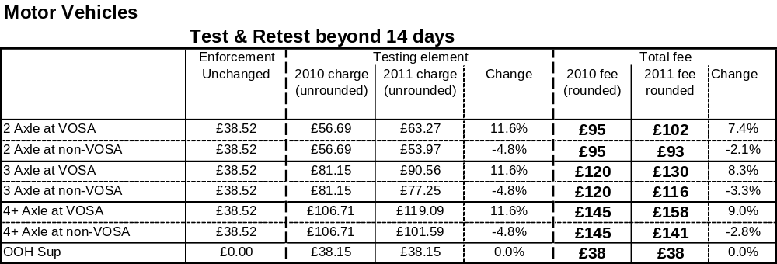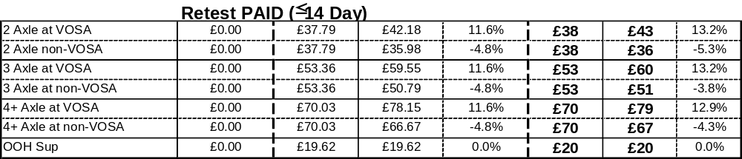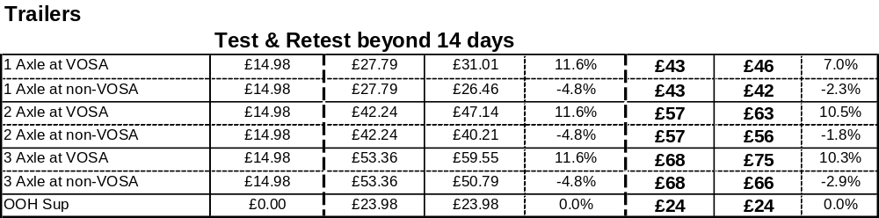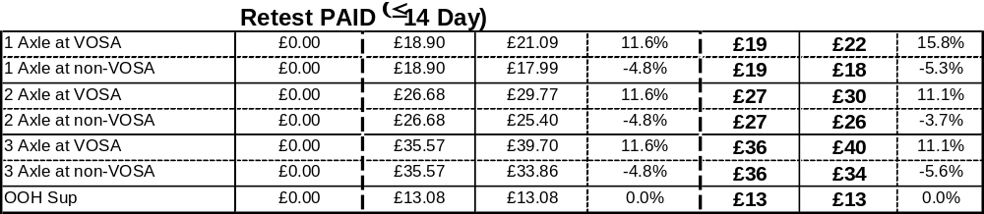
HGV Test Fees (continued)
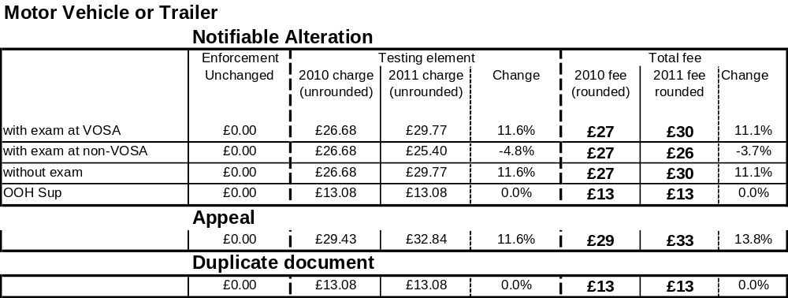

HGV and PSV fees for Reduced pollution Certificates and Low Emission Certificates

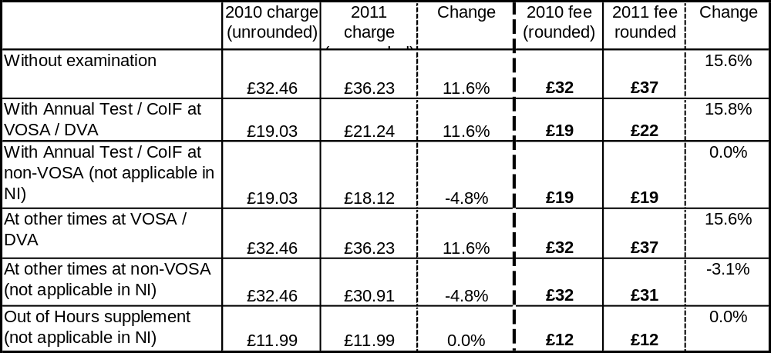
PSV Test Fees
NOTE: These fees may also be affected by proposed increases to operator licence fees to fund a National Register of operators and their transport managers required by EU law. The size of those increases will be affected by which option is adopted on how wide a pool of fees the cost is spread over. For illustrative purposes, the fees shown in the following tables include the highest level of increase bring considered.
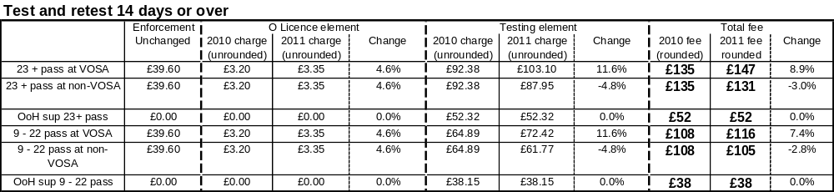
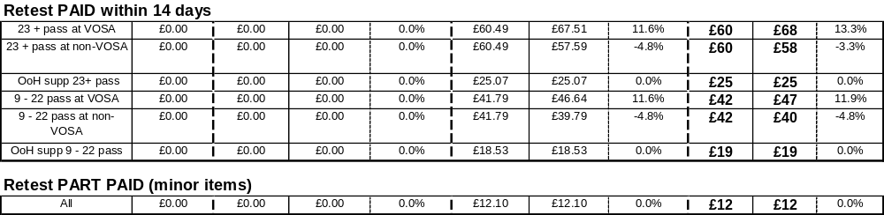
HGV Test Fees
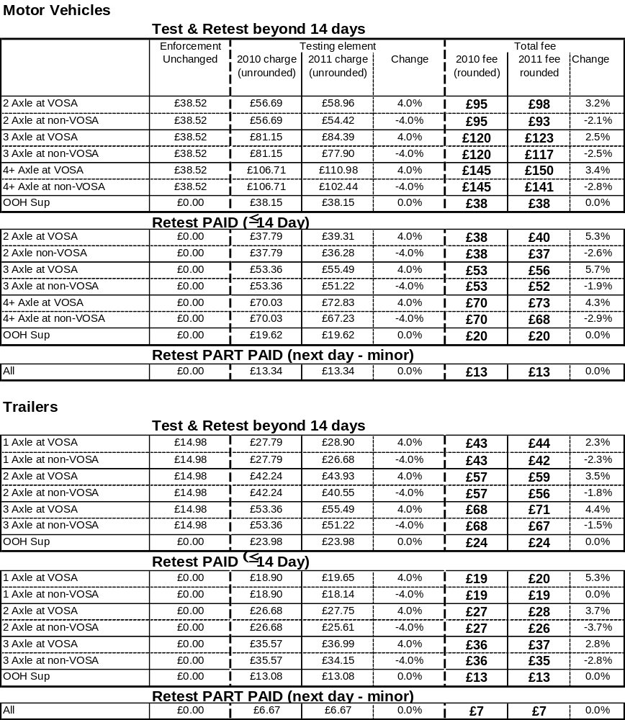

HGV Test Fees (continued)
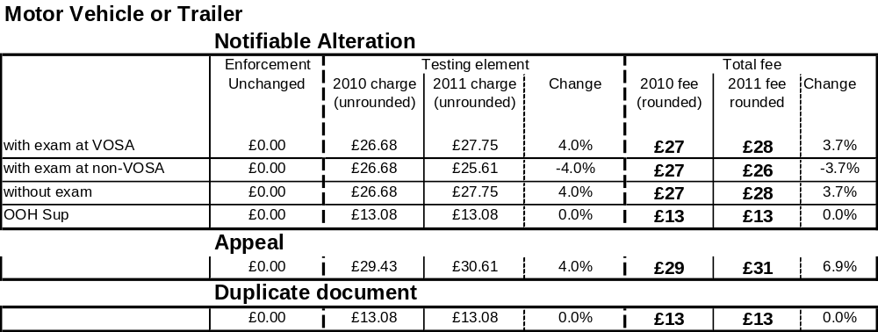

HGV and PSV fees for Reduced pollution Certificates and Low Emission Certificates

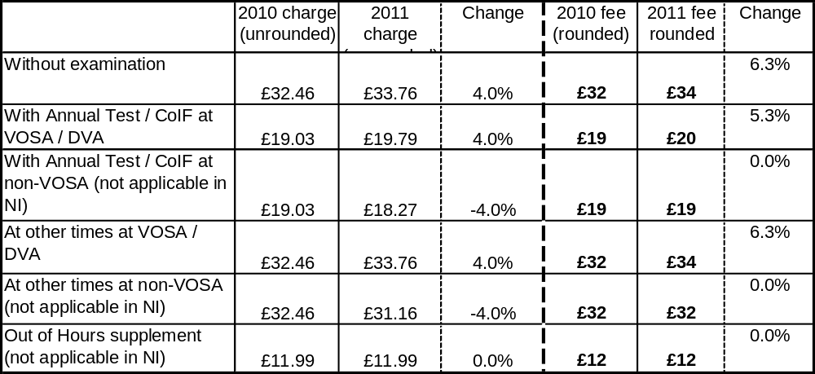
PSV Test Fees
NOTE: These fees may also be affected by proposed increases to operator licence fees to fund a National Register of operators and their transport managers required by EU law. The size of those increases will be affected by which option is adopted on how wide a pool of fees the cost is spread over. For illustrative purposes, the fees shown in the following tables include the highest level of increase bring considered.
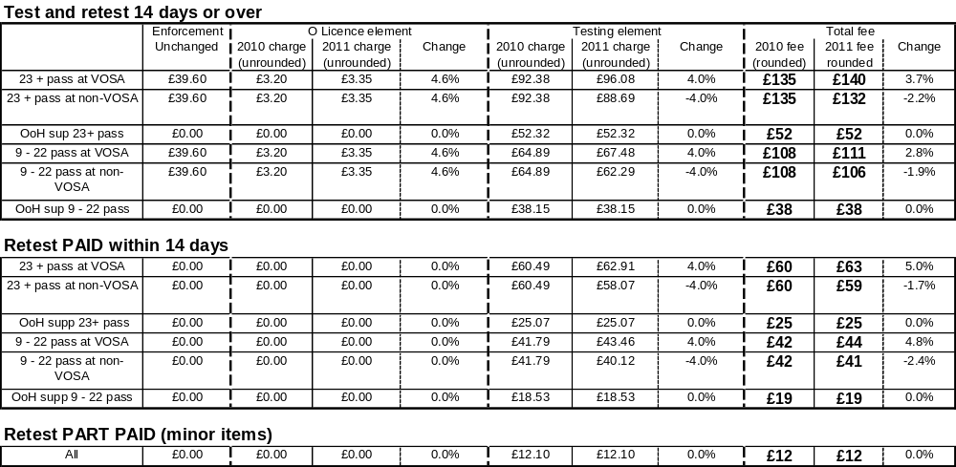

This Annex shows the data used and result of calculations of the effect of changes to HGV test fees as a result of location differentiation on the total amount paid in fees to VOSA and on the overall operating costs for HGV operating businesses of various sizes. To provide clarity on the effects of test fee differentiation, which is the subject of this Impact Assessment, operator licensing fees assumed not to change in this comparison.

Part 1 shows the source data. Vehicle operating costs are taken from data published by the Road Haulage Association at the beginning of 2010 – they represent average costs. However these costs will obviously vary depending on the business model of individual operators. It has not been possible to carry out modelling of the effect on PSV operators because we have been unable to obtain equivalent data on PSV operating costs.

Parts 2 and 3 show the effects on those who choose to have their vehicles tested at VOSA facilities and at non-VOSA facilities under options 1 and 2 respectively. Parts 2 and 3 also show the effects on the overall operating costs of the rental and leasing sub-sector of the road freight industry.

A spreadsheet showing the detailed calculations is available on request from the contact mentioned on the first page of this Impact Assessment.

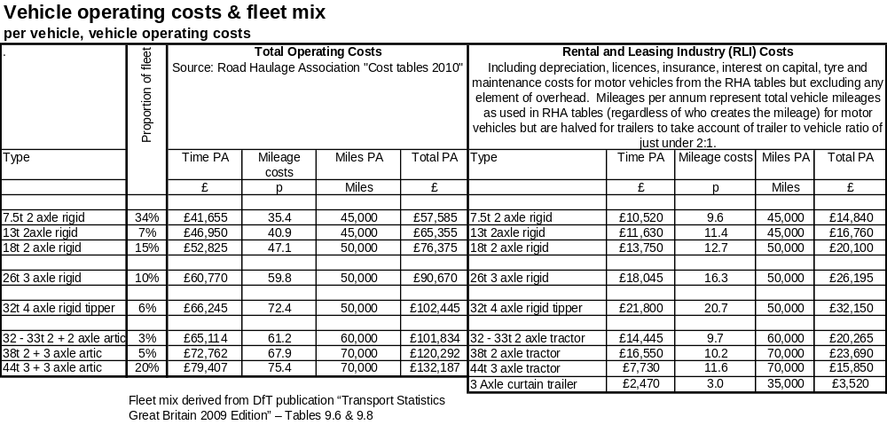

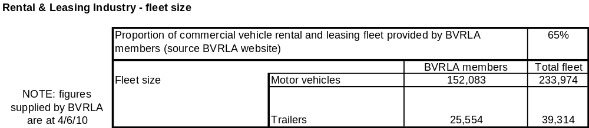

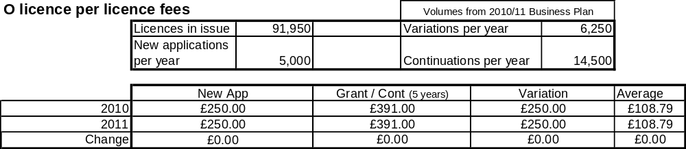

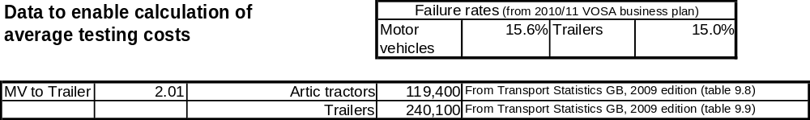

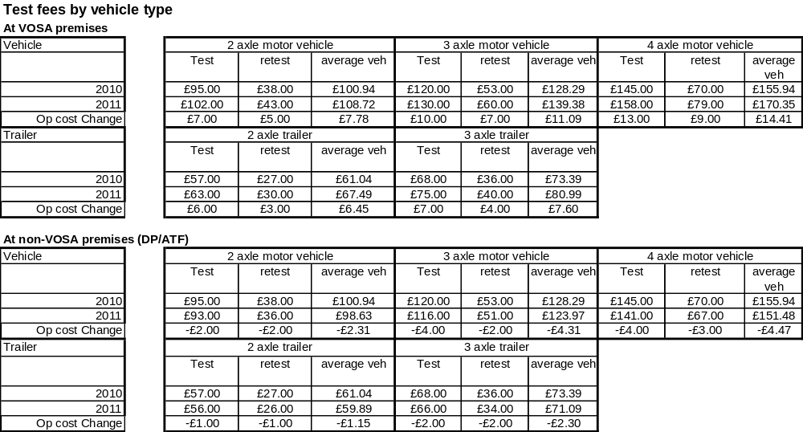

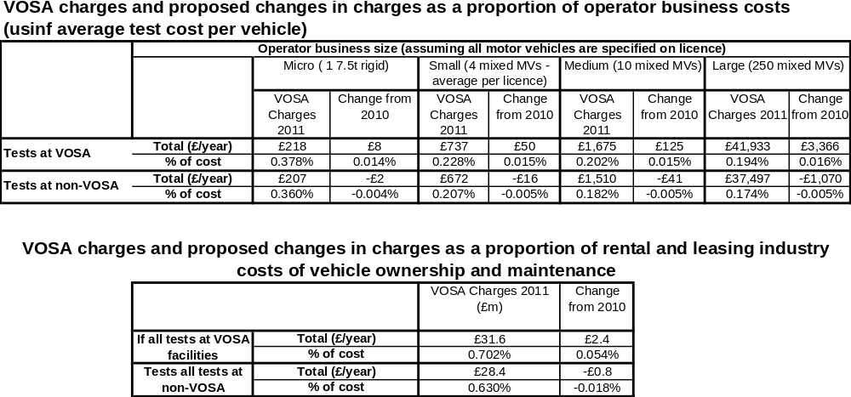

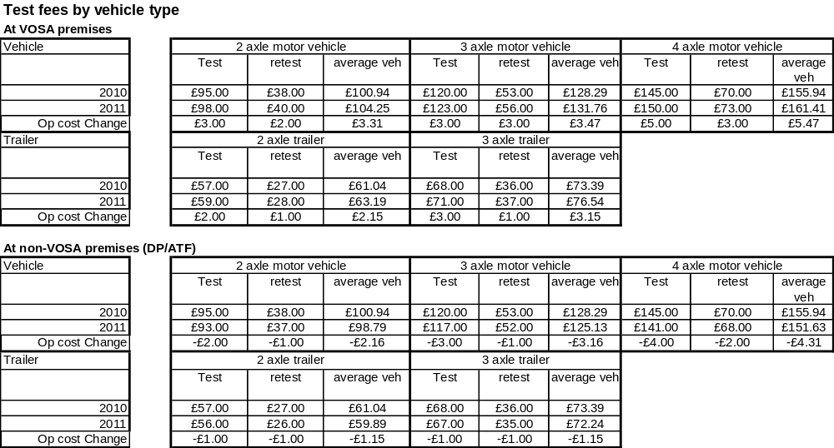

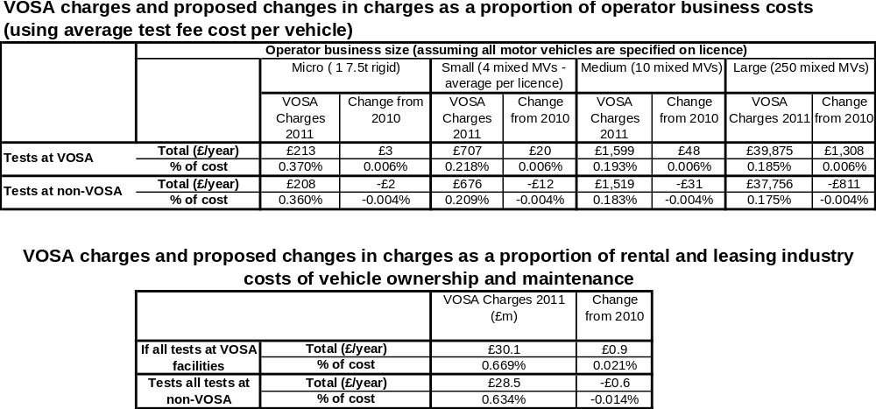

Public bodies including Whitehall departments are required to consider the impact of their policies and measures on race, disability and gender. It is intended to extend this consideration requirement under the Equality Act 2010 to cover age, sexual orientation, religion or belief and gender reassignment from April 2011 (to Great Britain only). The Toolkit provides advice on statutory equality duties for public authorities with a remit in Northern Ireland.
Public bodies including Whitehall departments are required to consider the impact of their policies and measures on race, disability and gender. It is intended to extend this consideration requirement under the Equality Act 2010 to cover age, sexual orientation, religion or belief and gender reassignment from April 2011 (to Great Britain only). The Toolkit provides advice on statutory equality duties for public authorities with a remit in Northern Ireland.
Published by the Office of national Statistics at http://www.statistics.gov.uk/instantfigures.asp

