Title:  Funding National Register of licensed operators of goods vehicles, buses and coaches.  Lead department or agency:  Vehicle and Operator Services Agency of the Department for Transport - VOSA  Other departments or agencies:
  Impact Assessment (IA)
  IA No: DfT00075
  Date: 20/04/2011
  Stage: Consultation
  Source of intervention:
  Type of measure:
  Contact for enquiries:
  John.MacLellan@vosa.gsi.gov.uk
  0117 954 2531

Summary: Intervention and Options

What is the problem under consideration? Why is government intervention necessary?
The purpose of licensing operators of buses, coaches and lorries is to ensure road safety and fair competition. The European Commission has found current rules on operator licensing inadequate because of a lack of consistency in the way that they are applied across Member States, resulting in unfair competition and issues around compliance and road safety. Intervention at EU level is necessary to provide the clarity and consistency required to address these problems given that this is a transnational issue. Intervention is then required at UK level in order to implement, enforce and monitor the new EU regulations. In particular, to meet EU law, Government intervention is necessary to create and fund a new National Register (NR) containing information about operators of buses, coaches and lorries.

What are the policy objectives and the intended effects?
The overall objective of the EU intervention is to ensure that consistent standards on operator licensing are applied and enforced across the EU. The intended effects are to create a more level competitive playing field for transport operations across the EU; raise the professional standards of the industry's transport managers; reduce the administrative burdens on regulators, enforcers and operators; enhance compliance with safety, social and technical rules; and, lessen the environmental impacts of road transport, notably through reducing empty running. The NR supports this aim by providing standardised information in support of future elements of the EU Regulation. The specific objective dealt with in this IA is to fund the creation and operating of the NR.

What policy options have been considered, including any alternatives to regulation? Please justify preferred option (further details in Evidence Base)
Doing nothing would not implement the NR requirement and would risk infraction proceedings.
Option 1: Fund NR by increasing fees for bus, coach and lorry operator licences. Within this option, there are a number of sub-options on which individual fees should contribute to the cost of the NR, such as whether to include ‘restricted licences’ and applications for ‘variations’ within the contributing pool. The choice of sub-option would not affect the overall cost to industry, although the more widespread the pool of payers, the less the effect would be on the individual fees. Consultees are invited to provide views on which sub-option should be adopted. Funding implementation of the NR from tax was also considered, but has not been pursued in view of spending constraints. The preferred option is Option 1 since it enables the UK to comply with EU law, but there is no preferred sub-option at this stage.

Will the policy be reviewed? It be reviewed. If applicable, set review date: /
What is the basis for this review? . If applicable, set sunset clause date: /
Are there arrangements in place that will allow a systematic collection of monitoring information for future policy review?

Sign-off For consultation stage Impact Assessments:
I have read the Impact Assessment and I am satisfied that, given the available evidence, it represents a reasonable view of the likely costs, benefits and impact of the leading options.
Signed by the responsible : | Mike Penning | Date: | 20 May 2011

Summary: Analysis and Evidence Policy Option 1
Description:
Fund the national register from operator licence fees.
Price Base Year 2010 | PV Base Year 2011 | Time Period Years 10 | Net Benefit (Present Value (PV)) (£m)
Price Base Year 2010 | PV Base Year 2011 | Time Period Years 10 | Low: n/a | High: n/a | Best Estimate: -1.4

COSTS (£m) | Total Transition  (Constant Price) Years |  | Average Annual  (excl. Transition) (Constant Price) | Total Cost  (Present Value)
Low | NA | 5 | NA | NA
High | NA | 5 | NA | NA
Best Estimate | 0.651 | 5 | 0.092 | 1.4
Description and scale of key monetised costs by ‘main affected groups’
1.) The transition costs of creating the National Register are estimated to cost £651,000 over 5 years, and the ongoing costs of the National Register are estimated at £92,000 per year. 2.) These costs would be passed on to operators through higher fees. The increase in operator license fees in 2011/12 is estimated at between 2% and 4.6% depending on how wide a pool of fees contribute.
Other key non-monetised costs by ‘main affected groups’
NA
BENEFITS (£m) | Total Transition  (Constant Price) Years |  | Average Annual  (excl. Transition) (Constant Price) | Total Benefit  (Present Value)
Low | NA | NA | NA | NA
High | NA | NA | NA | NA
Best Estimate | NQ | NA | NQ | NQ
Description and scale of key monetised benefits by ‘main affected groups’
None of the benefits of Option 1 have been monetised in this impact assessment.
Other key non-monetised benefits by ‘main affected groups’
The NR is a tool to enable the larger package of measures contained in the EU Road Transport Package. Without the NR, the benefits of the overall package that are explained in the Impact Assessment of the overall package (Reference 3) could not be delivered. These benefits arise from more targeted and effective enforcement activity; improving safety, and helping to create a more level playing field.
Key assumptions/sensitivities/risks Discount rate (%) |  |  |  |  | 3.5
1.) The main risk is the risk of infraction proceedings by the European Commission if the National Register is not implemented as required. 2.) Key assumptions are that predictions of volumes of activity are correct. 3.) Costs greater than plan or lower volumes, would mean a shortfall in VOSA's income leading to more pressure on costs and/or greater rises in future fees. Lower costs or higher volumes would have the reverse effect. 4.) The impact on the Heavy Goods Vehicles (HGVs) industry has been assessed. It is assumed that Impact on the Public Service Vehicle (PSV) industry will not be significantly different to the impact on the HGV industry.

Direct impact on business (Equivalent Annual) £m): |  |  | In scope of OIOO? | Measure qualifies as
Costs: N/A | Benefits: N/A | Net: N/A

Enforcement, Implementation and Wider Impacts
What is the geographic coverage of the policy/option?
From what date will the policy be implemented? |  |  | 2011
Which organisation(s) will enforce the policy? |  |  | VOSA
What is the annual change in enforcement cost (£m)? |  |  | Nil
Does enforcement comply with Hampton principles?
Does implementation go beyond minimum EU requirements?
What is the CO₂ equivalent change in greenhouse gas emissions?  (Million tonnes CO₂ equivalent) |  |  | Traded:  Nil |  | Non-traded:  Nil
Does the proposal have an impact on competition?
What proportion (%) of Total PV costs/benefits is directly attributable to primary legislation, if applicable? |  |  | Costs:  NA |  |  | Benefits:  NA
Distribution of annual cost (%) by organisation size  (excl. Transition) (Constant Price) | Micro  NQ | < 20  NQ | Small  NQ | Medium  NQ |  |  | Large  NQ
Are any of these organisations exempt?

Specific Impact Tests: Checklist
Set out in the table below where information on any SITs undertaken as part of the analysis of the policy options can be found in the evidence base. For guidance on how to complete each test, double-click on the link for the guidance provided by the relevant department.
Please note this checklist is not intended to list each and every statutory consideration that departments should take into account when deciding which policy option to follow. It is the responsibility of departments to make sure that their duties are complied with.
Does your policy option/proposal have an impact on…? | Impact | Page ref within IA
Statutory equality duties |  | 11

Economic impacts
Competition |  | 11
Small firms |  | 11

Environmental impacts
Greenhouse gas assessment |  | 11
Wider environmental issues |  | 11

Social impacts
Health and well-being |  | 11
Human rights |  | 11
Justice system |  | 11
Rural proofing |  | 11

Sustainable development |  | 12

Evidence Base (for summary sheets) – Notes
Use this space to set out the relevant references, evidence, analysis and detailed narrative from which you have generated your policy options or proposal. Please fill in References section.

References
Include the links to relevant legislation and publications, such as public impact assessments of earlier stages (e.g. Consultation, Final, Enactment) and those of the matching IN or OUTs measures.

No. | Legislation or publication
VOSA Annual Report 2009/10
http://www.dft.gov.uk/vosa/repository/2009%20-%202010%20VOSA%20Annual%20Report%20and%20Accounts.pdf
VOSA Business Plan 2010/11
http://www.dft.gov.uk/vosa/repository/2010-2011%20VOSA%20Business%20Plan.pdf
Link to consultation and IA on the EU Road Transport Package
http://www.dft.gov.uk/consultations/dft-2011-11
Impact Assessment on lorry, bus and coach examination fees- location differentiation at:
Annex A to this consultation
Impact Assessment on restructuring fees for applications for bus and coach operator licences at:
Annex C to this consultation

Evidence Base
Ensure that the information in this section provides clear evidence of the information provided in the summary pages of this form (recommended maximum of 30 pages). Complete the Annual profile of monetised costs and benefits (transition and recurring) below over the life of the preferred policy (use the spreadsheet attached if the period is longer than 10 years).
The spreadsheet also contains an emission changes table that you will need to fill in if your measure has an impact on greenhouse gas emissions.

Annual profile of monetised costs and benefits* - (£m) constant prices
 | Y₀ | Y₁ | Y₂ | Y₃ | Y₄ | Y₅ | Y₆ | Y₇ | Y₈ | Y₉
Transition costs | 0.13 | 0.13 | 0.13 | 0.13 | 0.13 | 0 | 0 | 0 | 0 | 0
Annual recurring cost | 0.092 | 0.092 | 0.092 | 0.092 | 0.092 | 0.092 | 0.092 | 0.092 | 0.092 | 0.092
Total annual costs | 0.222 | 0.222 | 0.222 | 0.222 | 0.222 | 0.092 | 0.092 | 0.092 | 0.092 | 0.092
Transition benefits
Annual recurring benefits
Total annual benefits | NQ | NQ | NQ | NQ | NQ | NQ | NQ | NQ | NQ | NQ
* For non-monetised benefits please see summary pages and main evidence base section

Evidence Base (for summary sheets)

GENERAL ISSUES

Overall context
  - These proposals for fee increases to fund the National Register form part of the Vehicle and Operator Services Agency (VOSA)’s wider financial management strategy which is outlined more fully in its published Business Plans and Annual Reports. Whilst work to produce the Business Plan for 2011/12, which is normally published around the start of the financial year, is in progress, the 2010/11 plan is to break even by reducing expenditure by about £5.6m (2.3%) compared to 2009/10. This, however, still leaves a retained deficit in VOSA’s accounts which must be cleared by a combination of further reductions in expenditure and/or increases in the general level of fees. However in view of the present economic situation, VOSA is not proposing to apply any increases to the general levels of statutory fees for 2011. Thus VOSA must make efficiency savings to absorb inflation but also to start recovering the retained deficit. This leaves no margin to absorb the costs of additional services such as the National Register.

Background
  - The EU has introduced a package of measures (the Road Transport Package) to address issues of unfair competition, compliance and road safety. One element of this package is the creation (by December 2011) of a National Register containing specified details about licensed road transport operators, their transport managers and certain offences committed by either. The Road Transport Package was subject to a separate Impact Assessment (at reference 3) which is the subject of a recent consultation by the DfT.
  - Later in the implementation of the package, these registers will be shared amongst Member States; amongst other things to inform risk based compliance monitoring. The cost of that sharing does not form part of this Impact Assessment.
  - Whilst in Great Britain (GB), VOSA, on behalf of Traffic Commissioners, already holds much of the required data in support of the GB operator licensing system, some additional data is required which means that the existing database has to be altered and additional data has to be collected. This additional service imposes additional costs on VOSA. In view of VOSA’s overall financial situation additional funding is needed to carry out this additional work.
  - The National Register would also contain data on operators based in other parts of the UK (i.e. Northern Ireland and Gibraltar). Administrations in those territories would be responsible for the cost of including their data in the register.

Rationale for intervention
  - The purpose of licensing operators of buses, coaches and lorries is to ensure road safety and fair competition by ensuring that operators have the financial resources and management systems to ensure that their vehicles are adequately maintained, not overloaded and their drivers are not over tired because of breaking drivers’ hours laws.
  - The EC has found current rules in respect of some aspects of licensing of operators of HGVs and PSVs inadequate because of a lack of consistency in the way that they are applied across Member States, resulting in unfair competition and issues around compliance and road safety. Intervention at EU level is necessary to provide the clarity and consistency required to address these problems given that this is a transnational issue. Intervention is then required at the UK level in order to implement, enforce and monitor the new regulations.
  - The objective of this intervention is to ensure that consistent standards are applied and enforced across the EU. The intended effects are to: create a more level playing field for international transport operations across the EU and reduce distortion of competition; raise the professional standards of the industry's transport managers; reduce the administrative burdens on regulators, enforcers and operators; enhance compliance with safety, social and technical rules; and, lessen the environmental impacts of road transport, notably through reducing empty running. To do this the EU has introduced a package of measures (the Road transport Package). This package is dealt with more fully in the Impact Assessment at reference 3.
  - One element of the package requires a National Register (NR) containing information about operators of lorries buses and coaches, which would provide the base information needed by various elements of the package. Much of the data is already held by VOSA on behalf of the Traffic Commissioners and it is more cost-effective to build on this existing data rather than duplicate it.
  - The changes to the database to hold the additional information required, and the collection and maintenance of that data mean extra costs for VOSA. VOSA is unable to absorb this extra cost and must therefore increase fees to pay for the National register. Since the fees are set in secondary legislation and VOSA is a Government Trading Fund, this can only be achieved by Government intervention.

Policy objective
  - The objective of the fee changes proposed in this IA is to fund the National Register in the most appropriate way and to ensure that the fees charged for particular services cover the costs of those services and are proportionate to the cost of providing the class of service concerned.
  - The objective of the National Register is to provide standardised information to support processes to ensure that consistent standards on operator licensing are applied and enforced across the EU. The intended effect of those processes is to create a more level competitive playing field for transport operations across the EU; raise the professional standards of the industry's transport managers; reduce the administrative burdens on regulators, enforcers and operators; enhance compliance with safety, social and technical rules; and, lessen the environmental impacts of road transport, notably through reducing empty running. The requirement for the NR and the processes is contained in EU Regulations (1071/2009/EC, 1072/2009/EC and 1073/2009/EC). More detail on this can be found in the Impact Assessment at reference 3.

Options Considered
  - If nothing were done the UK would be at risk of fines should the European Commission instigate infraction proceedings. . There would also be a reputation risk to the UK since the UK supported the Road Transport Package as a means of creating fairer competition; raising the professional standards of the industry's transport managers; reducing the administrative burdens on regulators, enforcers and operators; and enhancing compliance with safety, social and technical rules. In practice, “do nothing” is not an option since the UK is required by EU Regulations to implement a National register.
  - The following options have been considered:
- Create a National Register funded from taxation; and
- Create a National Register funded from fees charged to those authorised (or applying to become authorised) to operate Heavy Goods Vehicles (HGVs); and buses and coaches, known as Public Service Vehicles (PSVs).
  - However, the option to create a National register funded from taxation was not pursued since in present circumstances it was not considered appropriate to use general taxation to subsidise the operator licensing system.
  - Therefore, the only policy option considered in this impact assessment is a National Registered funded from fees (Option 1). However, within this option, there are a number of sub-options on which individual fees should contribute to the cost of the NR, such as whether to include ‘restricted licences’ and applications for ‘variations’ within the contributing pool.

Costs and benefits of Option 1

Direct impact on business and One In One Out (OIOO)
  - The direct cost to business of the additional fees to pay for the National Register has been estimated at around £222,000 per year over the 5 year transition period and around £92,000 per year in subsequent years.
  - The National Register is being created to comply with EU law. As such, it is exempt from OIOO.

Distribution of annual costs by business size
  - It has not been possible to complete these boxes on the “Summary: Analysis and Evidence” page because neither VOSA nor DfT holds any data on the size of businesses operating commercial vehicles. To gather such data would impose a disproportionate burden on businesses to supply the data and on government to collect and analyse the data.
  - To illustrate this, for HGV operators the data we hold relates to the maximum number of vehicles which a business is authorised to use; and the; and the number of vehicles which it currently operates which it intends to use for more than 1 month (which are “specified” on its licence).
  - An operator with 2 vehicles authorised on its licence and 2 “specified” could be:
- a business whose sole activity is vehicle operation with a handful of employees; or
- a large supermarket chain with thousands of employees which contracts out most of its transport activities but has a couple of vehicles of its own which it uses for special purposes.
  - An operator authorised to operate several hundred vehicles may only have 1 or 2 currently “specified” on its licence and could be:
- a business which is currently small with a handful of drivers but has contracted or hopes to expand;
- a business which employs several hundred drivers and other staff but, because of fluctuating demand or its business model, uses mainly vehicles on short term hire which do not need to be “specified” on its licence; or
- a business which employs only a few managers and 1 or 2 drivers, uses mainly vehicles on short term hire and uses mainly drivers employed by an employment agency rather than be itself.

Costs of Option 1
  - The preliminary business case for the project to create and operate the national register estimates the cost of setting up the National Register at £651,000. The estimate is based on our understanding at the time of preparing this IA of the scope of changes which would be needed and comprises:
  - an estimated capitalised cost, written off over 5 years, of £487,000 for
    - changes to the existing Operator Licensing Business System software and hardware to collect the additional data needed;
    - implementing connections to other systems (e.g. Courts) to enable more thorough and efficient checks of repute of transport managers; and
    - software development and hardware for the National Register database itself to pull together the data from the various sources
  - an estimated £131,000 for collection and entry for the additional data on existing operators and their transport managers; and
  - an estimated £33,000 interest on the loan to cover the above capital cost.
  - These costs are treated as “transition” costs in the “Summary: Analysis and Evidence and spread over 5 years. Five years was chosen as the transition period as the fairest way to spread the cost across the industry because some of the fees which are being increased to cover these transition costs are paid once every 5 years.
  - The ongoing costs of collecting entering the additional data and maintaining the National Register are estimated at £92,000 per year (£51,000 in maintenance costs for the additional software and hardware; and £41,000 staff costs to keep the additional data current) and are treated as “average annual” costs. This estimate is based on estimates of the cost of work involved in collecting the data, entering it on the register, updating the data over time and additional charges from VOSA’s Information Technology supplier for the ongoing maintenance of the enhanced system.
  - Thus, the total additional revenue needed by VOSA in each of the first 5 years is estimated as £222,000 and the total additional annual revenue needed in subsequent years is estimated at £92,000.
  - The project to implement the National Register is currently working on finalising the requirement. A Final Business Case is expected to be completed early in 2011, but had not been approved at the time that this consultation stage Impact Assessment was being prepared. It is expected that as the requirement stabilises the budget for the project can be reduced, allowing fee changes lower than shown in this Impact Assessment. However, until that work has been completed, the current estimates represent the best available evidence.
  - The fees over which this cost is spread cover the costs of:
  - determining applications for licences or to vary licences;
  - maintaining the operator licensing system;
  - identifying operators whose performance in maintaining compliance with the requirements for safe and legal operation of vehicles gives cause for concern; and
  - action by Traffic Commissioners to encourage them to improve or take action to limit or remove their licences.
  - Within Option 1, there are sub-options on how this cost is divided up amongst the potential pool of fee payers (the more in the pool the lower the percentage increase in fees that would be needed) and these are being explored in the consultation on the proposed fee changes – therefore, until the consultation results are taken into account, there is no preferred option. However, the estimated total costs to industry (which is shown on the ‘Summary: Analysis and Evidence’ sheet) would remain the same regardless of which sub-option is selected, so separate summary sheets have not been produced for the individual sub-options.
  - Whilst both HGV and PSV licences have standard and restricted licences, the criteria differ in that the distinction for HGVs is whether other people’s goods are carried, but there are no restraints on fleet size. Restricted HGV licence holders range from farmers with a single vehicle to move their own produce to large fleets operated by food retailers. Standard licences would range from the farmer with a single vehicle who also wanted to carry his neighbour’s produce to large multi-national haulage contractors.
  - For PSVs, restricted licences only allow the use of up to 2 vehicles. Normally each vehicle cannot carry more than 8 passengers, but in if used “otherwise than in the course of a passenger carrying business” or “by a person whose main occupation is not the operation of public service vehicles adapted to carry more than 8 passengers” vehicles can accommodate up to up to 16 passengers. Restricted licences are held by businesses such as hotels and car park operators who operator 1 or 2 courtesy buses.
  - It would be possible for different sub-options to be applied for HGVs and PSVs. However, as there are over 90,000 HGV licences in issue compared to around 9,000 PSV licences, by far the largest influence on the percentage change to fees in the contributing pool is the HGV option.
  - The following sub-options on which fees to include in the pool of fees from which the costs are recovery are:
    - standard licences only – fees for application for standard licences and those charged on grant of licences and every 5 years thereafter on continuation of the licence;
    - standard licences plus variations – as sub-option ‘a’ but with the addition of fees for applications for variation of specified conditions on licences in force;
    - all licences – as sub-option ‘b’ but including both standard and restricted licences; and
    - all licences plus variations - sub-option ‘b’ but including both licence types.
  - To raise £222,000 per year, our estimates are that under Sub-option ‘a’ we would need to increase the estimated income of around £4.8 million from fees within the pool by about 4.6%. To raise the same amount under Sub-option ‘d’ we would need to increase fees within the wider pool with an estimated income of about £11.1 million by about 2%. Other options would fall between the two illustrated above.
  - As an example, Annex 2 illustrates the calculations used to estimate the overall fee burden on HGV operators and to relate that to their overall operating costs. This takes account of the fact that grant/continuation fees for HGVs cover a 5 year period and includes an element for the proportion of new operators (who pay application fees) and of existing operators who pay variation fees. The estimates suggest that for the worst case (sub-option ‘a’) the overall annualised burden of fees would increase by £4.25 per operator on average in 2011/12. For the operator of a single HGV vehicle, the estimates suggest this change would add about 2% to the average annualised fees paid to VOSA in 2011/12, including vehicle test fees. However, based on operating cost data published by the Road Haulage Association at the beginning of 2010, this represents about 0.007% of their total vehicle operating cost.
  - Only HGV impact can be modelled since public domain data on PSV operating costs is not available; however, VOSA have no reason to believe that the effect on PSV operators would be significantly different.
  - Annex 3 illustrates the estimated impact on individual fees. As noted above, the percentage change to operator licence fees would vary depending on how widely the cost is spread. It should also be noted that the percentage change to individual fees would vary from that quoted above because fees are rounded to whole pounds.
  - For PSVs the picture is more complex, since part of the cost of operator licensing is funded from a small element on PSV annual test fees. In practice, because VOSA rounds the fees it charges to whole pounds, the small adjustment to test fees to fund the National Register would not affect the fee actually charged. This, and the interaction with other proposed fee changes, is explained more fully in paragraph 40 below.
These effects are illustrated in more detail in Annex 3.

Benefits of Option 1
  - The National Register is a tool to enable the larger package of measures contained in the EU Road Transport Package. The impact of the overall package is assessed in a separate Impact Assessment which has been published in a recent DfT consultation which can be found at reference 3. The benefits of the overall package could not be delivered without the NR. The monetised benefits are summarised as follows: “Improved compliance/ safety of foreign registered haulage vehicles would be expected to lead to a reduction in the number of fatal accidents that this type of vehicle is involved in. The main difference between the best estimate and high scenarios in terms of benefits is that the assumed reduction in the number of accidents is greater in the high than in the best-estimate scenario during the first 3 years. After that the assumed reduction is the same (10%, i.e., 3.5 fatalities) and, therefore, benefits are very similar.”

Other proposed changes in fees in 2011/12 not included in this IA
  - VOSA is also consulting on two other changes to some fees which would affect the cost of vehicle operation. These other proposals are explained in separate IAs (references 4 and 5). Together with the proposal in this IA, they make up the proposed changes from VOSA’s review of fees for 2011/12. The table below indicates which changes affect which fees.

 | VOSA fees in GB
 | VOSA / non-VOSA differentials  (IA reference 4) | National Register funding  (this IA) | PSV O licence application equalisation  (IA reference 5)
PSV O Licence |  | ☑ | ☑
PSV Test | ☑ | ☑
RPC (reduced pollution certificate) | ☑
Low Emission Certificate | ☑
Voluntary checks | ☑
HGV O Licence |  | ☑
HGV Test (including notifiable alterations) | ☑

  - For HGVs, changes in annual test fees to reduce the cost of tests at non-VOSA facilities and increase the cost of tests at VOSA test facilities are also proposed. These changes would have no direct impact on operator licence fees but would affect testing costs for operators either directly or indirectly by reducing costs for tests carried out at non-VOSA test facilities and increasing costs at VOSA facilities. The effects of the test fee changes are detailed in the IA at reference 4. Assuming that the preferred option on test fees is adopted and that the sub-option giving maximum percentage increases in this IA is adopted, it is estimated that the combined effect of the 2 changes would be to increase the average fee bill for the operator of a single 7.5 tonne lorry with a standard operator’s licence by:
  - £2 per year (0.004% of operating costs) if the vehicle was tested at non-VOSA test facilities; and
  - £7 per year (0.014% of operating costs) if tested at a VOSA test facility.
These estimates include the effect of average test failure rates; proportion of new licence applications and proportion of applications for variation of conditions on licences. If other sub-options on the distribution of the cost of the National Register were adopted, the effect on individual operators would be reduced, but a larger number of operators would be affected.
  - For PSVs the situation is more complex because:
  - It is proposed to reduce the fees for annual tests conducted at non-VOSA test facilities and increase fees for tests at VOSA facilities in the same way as HGVs. This is explained in the IA at reference 4.
  - A small element of the PSV test fee (£3.20) contributes to funding PSV operator licensing. Thus, the increase in fees to fund the national register of licensed operators of goods vehicles, buses and coaches covered in this IA would affect the calculation of fees for full PSV tests, although for most fees the effect on the fees actually charged would be lost because the fees charged are rounded to whole pounds.
  - Changes are also proposed to application fees for standard and restricted PSV operator licences to reflect more correctly the cost of processing applications. These proposed changes are explained more fully in the IA at reference 5. Under the preferred option, the application fees would be equalised. However a small differential may remain if PSV restricted licence applications do not contribute to the cost of the National Register.
  - Because of this complexity and the lack of data on mix of vehicles within fleets, it is difficult to produce a meaningful estimate of the effect on individual operators. Indicative estimates of the combined effects of all three changes are that the average annual fee bill for the operator of one small PSV on a restricted licence would increase by between £4 (if tested at a non-VOSA test facility) and £9 (if tested at a VOSA test facility) and that the average annual fee bill for the operator of one large PSV on a standard licence would either decrease by £6 (if tested at a non-VOSA test facility) or increase by £3 (if tested at a VOSA test facility).
  - The lack of public domain data on operating costs means that it is not possible to estimate the impact on their overall operating costs, but to put these changes into perspective, even the largest increase is the equivalent of less than 7 litres of Diesel at March 2011 forecourt prices.

Specific Impact Tests

Equality assessment
  - The proposed policy is a change to fee levels. It would not change who has access to services, how they access those services or how they communicate with the Agency. Thus the changes would have no effect on statutory equality duties.

Competition assessment
  - The proposed changes would not directly or indirectly limit the number or range of suppliers, limit the ability of suppliers to compete or reduce suppliers' incentives to compete vigorously. Therefore, a full competition assessment has not been carried out.

Small firms impact test
  - The changes covered by this Impact Assessment are related to the use made of the services provided and do not change the extent to which businesses are required to use the services. Fees are charged per transaction regardless of business size since business size has little influence on the cost of providing the service. Indicative estimates in this impact assessment (see Annex 2) suggest that the worst case impact would be to increase total vehicle operating costs (for the operator with a standard licence and a single 7.5 tonne HGV tested at VOSA test facilities) by about 0.007%. This is a minute proportion of the cost of operating even a single vehicle, so it is not considered that this would have a significant impact on small businesses. Small businesses and their representative bodies will be specifically informed of the consultation on the proposed changes.

Greenhouse gas impact assessment
  - These fee changes would have no effect on greenhouse gas emissions.

Wider environmental impact assessment
  - The fee changes proposed would have no predictable effects on wider environmental issues.

Health and wellbeing impact assessment
  - The fee changes proposed would have no effect on health or wellbeing.

Human rights
  - The proposals would have no human rights impact.

Justice impact test
  - The proposals would have no impact on the justice system.

Rural proofing
  - The proposals would have no significant impact on rural areas.

Sustainable development
  - The proposals would have no significant effect on sustainable development.

Annexes
Annex 1 should be used to set out the Post Implementation Review Plan as detailed below. Further annexes may be added where the Specific Impact Tests yield information relevant to an overall understanding of policy options.

Annex 1: Post Implementation Review (PIR) Plan
A PIR should be undertaken, usually three to five years after implementation of the policy, but exceptionally a longer period may be more appropriate. If the policy is subject to a sunset clause, the review should be carried out sufficiently early that any renewal or amendment to legislation can be enacted before the expiry date. A PIR should examine the extent to which the implemented regulations have achieved their objectives, assess their costs and benefits and identify whether they are having any unintended consequences. Please set out the PIR Plan as detailed below. If there is no plan to do a PIR please provide reasons below.
Basis of the review: [The basis of the review could be statutory (forming part of the legislation), i.e. a sunset clause or a duty to review , or there could be a political commitment to review (PIR)];
NA
Review objective: [Is it intended as a proportionate check that regulation is operating as expected to tackle the problem of concern?; or as a wider exploration of the policy approach taken?; or as a link from policy objective to outcome?]
NA
Review approach and rationale: [e.g. describe here the review approach (in-depth evaluation, scope review of monitoring data, scan of stakeholder views, etc.) and the rationale that made choosing such an approach]
NA
Baseline: [The current (baseline) position against which the change introduced by the legislation can be measured]
NA
Success criteria: [Criteria showing achievement of the policy objectives as set out in the final impact assessment; criteria for modifying or replacing the policy if it does not achieve its objectives]
NA
Monitoring information arrangements: [Provide further details of the planned/existing arrangements in place that will allow a systematic collection systematic collection of monitoring information for future policy review]
NA
Reasons for not planning a review: [If there is no plan to do a PIR please provide reasons here]
PIR will be of the Road Transport Package as a whole. The PIR plan for the package will be included in the update of the IA for the whole package being prepared by DfT, the most recent version of which is at Reference 3. The level of fees charged is reviewed annually as part of VOSA’s financial management process.

This Annex shows the data used and result of calculations of the effect of increases to HGV operator licence fees to fund the National Register on the total amount paid in fees to VOSA and on the overall operating costs for HGV operating businesses of various sizes. To provide clarity on the effects of the operator licence fees which are the subject of this Impact Assessment, test fees are assumed not to change in this comparison.

Part 1 shows the source data. Per annum (PA) vehicle operating costs are taken from data published by the Road Haulage Association at the beginning of 2010 – they represent average costs. However, these costs will obviously vary depending on the business model of individual operators. It has not been possible to carry out modelling of the effect on PSV operators because we have been unable to obtain equivalent data on PSV operating costs.

Part 2 shows the estimated impact of the National Register on operating costs under the 2 sub-options with the highest and lowest percentage increases (sub-options ‘a’ and ‘d’ respectively).

A spreadsheet showing the detailed calculations is available on request from the contact mentioned on the first page of this Impact Assessment.

Part 1: Source data

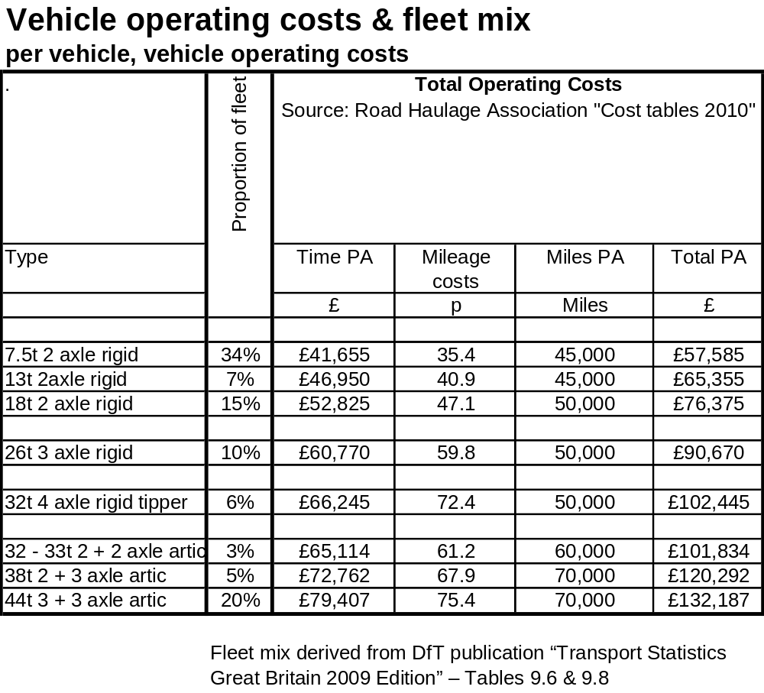
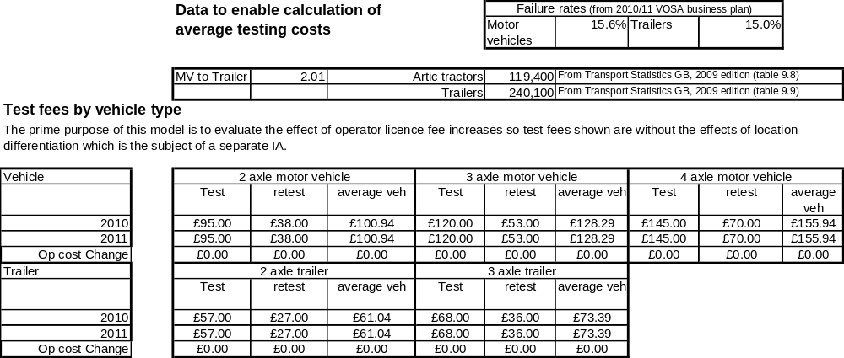

Impact on VOSA operator licence fees if sub-option ‘a’ is adopted
These fees are per licence or application to vary a licence regardless of the number of vehicles authorised on that licence.

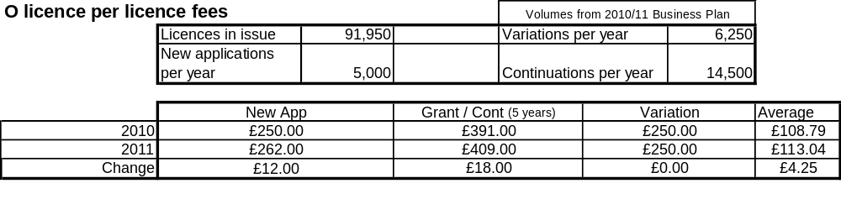
Impact on VOSA operator licence fees if sub-option ‘d’ is adopted

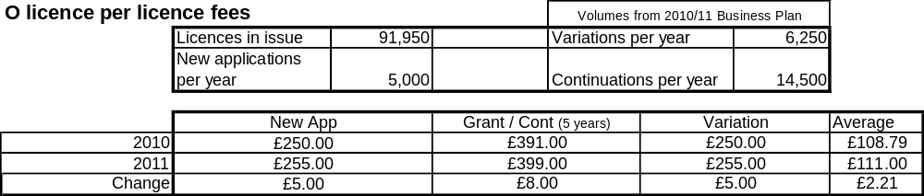

Part 2: Estimated impact on operating costs

Sub-option ‘a’
The impact on the operating costs of Standard licence holders is estimated to be as follows. Restricted licence holders would be unaffected

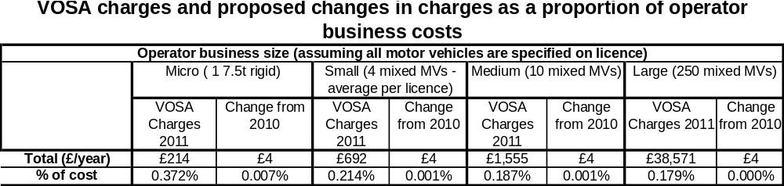

Sub-option ‘d’
The impact on the operating costs of both standard and restricted licence holders is estimated to be as follows.

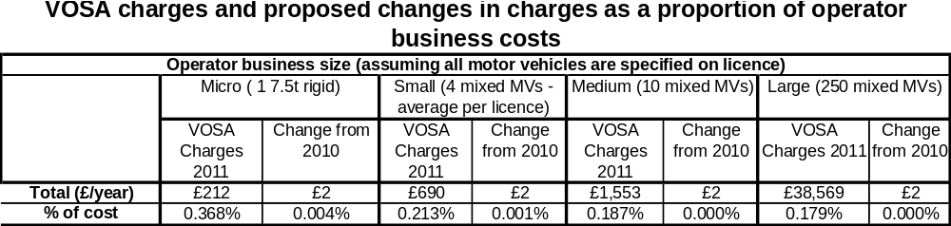

Estimated impact on HGVs – only operator licence fees would be affected by proposed changes to fund the National Register.
HGV O Licence Fees under the Goods Vehicles (Licensing of Operators) (Fees) Regulations 1995 (SI 1995/3000)

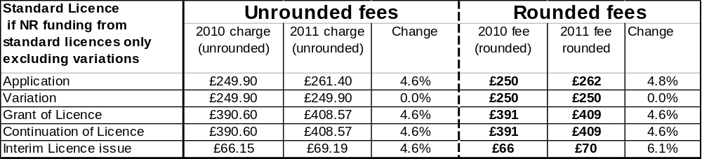In this scenario, restricted licence fees would be unchanged.

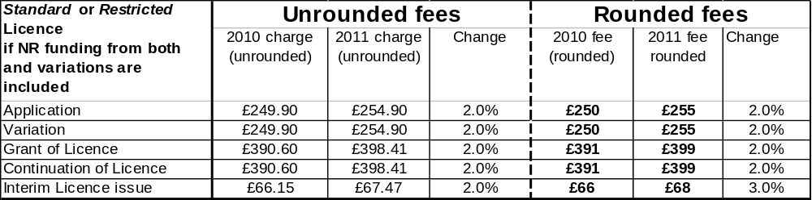

Estimated impact on PSVs – because the costs of maintaining PSV operator licences are now funded via PSV annual test fees, the proposed funding of the National Register would affect both operator licence fees and annual test fees.
The variarion fee would be affected only by increases to fund the National Register if the cost is spread over the widest pool of fees (see paragraph 34). These fees would be unchanged if the narrowest pool was adopted.
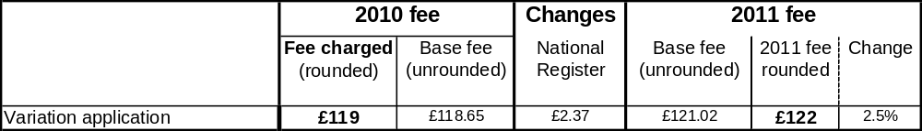
The following fees may also be affected by the proposed changes to equalise application fees for standard and restricted PSV operator licences.
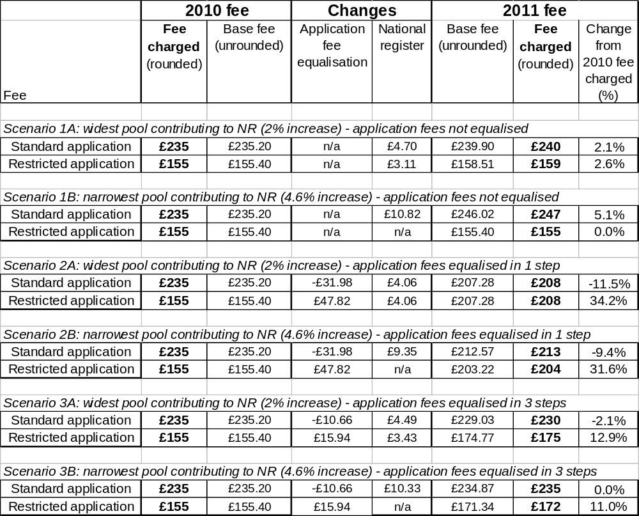

PSV Test Fees under the Motor Vehicles (Tests) Regulations 1981 (SI 1981/1694)
NOTE: These fees may also be affected by the proposed, revenue neutral changes to apply fees which differentiate between tests carried out at VOSA and non-VOSA test facilities. For illustrative purposes, the fees shown here include the highest level on increase being considered to fund the National Register and the preferred option for VOSA to non-VOSA differentiation.
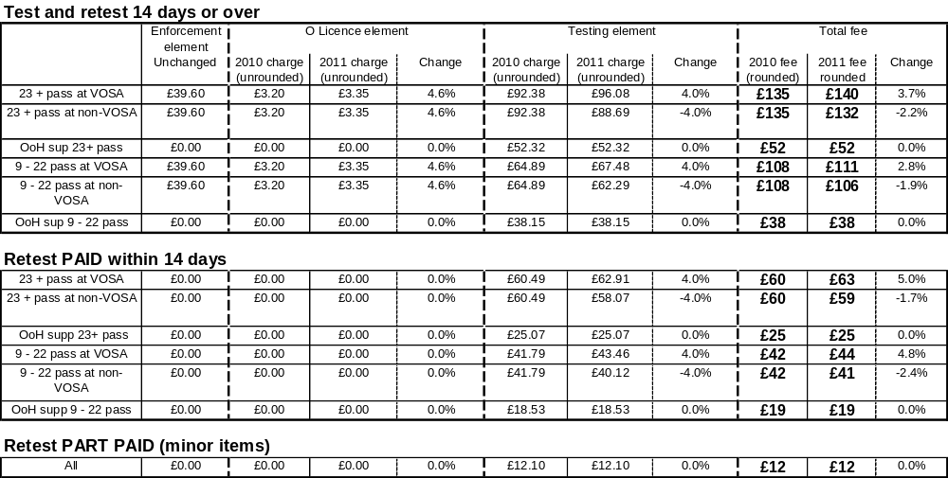

Public bodies including Whitehall departments are required to consider the impact of their policies and measures on race, disability and gender. It is intended to extend this consideration requirement under the Equality Act 2010 to cover age, sexual orientation, religion or belief and gender reassignment from April 2011 (to Great Britain only). The Toolkit provides advice on statutory equality duties for public authorities with a remit in Northern Ireland.

