ACTING SENIOR TRAFFIC COMMISSIONER

Revised Statutory Guidance and Statutory Directions
The reasons for the introduction of the Statutory Guidance and the Statutory Directions were highlighted in the consultation document which formed part of the original formal consultation that commenced in January 2011.
This consultation has arisen as a result of the introduction of the new EU Regulations relating to the road transport operator, which take effect on 4 December 2011. The amendments only apply to some of the documents that formed part of the original consultation and they also take account of responses received from that consultation.
The aim is to publish the statutory guidance and statutory directions by 4 December 2011 so that traffic commissioners and their deputies, support staff at the Office of the Traffic Commissioner, stakeholders and the wider industry are aware of the requirements and what is expected when applying for and maintaining an operator's licence.
In view of the limited time available before the introduction of the EU Regulations on 4 December 2011, this consultation has been limited to 3 weeks to enable time for responses to be considered and amendments made before final publication and implementation.
I reiterate the Senior Traffic Commissioner's comments from the previous consultation document that "any interpretation of the law can only be current as at the date of publication. The documents identify and apply principles extracted from case law. The footnotes cannot provide an exhaustive list of the relevant provisions and case law, for which it may be best to refer to the digest of the Administrative Appeals Chamber of the Upper Tribunal (www.transporttribunal.gov.uk)".

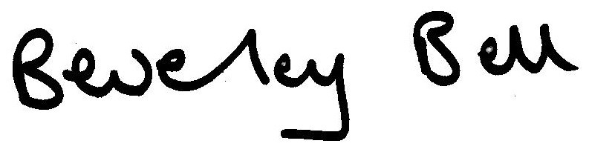
Beverley Bell
Acting Senior Traffic Commissioner
1 November 2011
PUBLIC CONSULTATION DOCUMENT ON THE SENIOR TRAFFIC COMMISSIONER’S STATUTORY GUIDANCE AND STATUTORY DIRECTIONS
PUBLIC CONSULTATION ON THE CONTENT OF THE SENIOR TRAFFIC COMMISSIONER’S STATUTORY GUIDANCE AND STATUTORY DIRECTIONS NUMBERS 1 - 12
INDEX
1. Introduction
1.1 Who should read this consultation document?
2. Background
3. Reason for change
4. Why is it important to respond?
5. How do I make my views known?
6. What happens next?
7. Draft guidance and directions
8. Replying to this consultation
8.1 Disclosure of responses
Annex A - Consultation response form

1. Introduction

1.1 Who should read this consultation document?
1.1.1 This consultation document will be particularly relevant to any of the following:
  - Those with a goods vehicle or public service vehicle (PSV) operator’s licence.
  - Those with a vocational entitlement to drive a bus or lorry.
  - Local authority representatives involved with the provision of bus services in England and Wales.
  - Bus and coach passengers or any groups which represent them.
  - Banking and financial service providers for the commercial vehicle operating industry
  - Those who responded to the initial consultation

2. Background
2.1 Historically, the Senior Traffic Commissioner and traffic commissioners have issued practice directions and guidance notes to assist those who deal with goods and public service vehicle operator licensing in understanding the practices and procedures that apply to the licensing and regulation of the industries concerned.
2.2 This guidance (in the form of a practice direction) is published on the Vehicle and Operator Services Agency’s website.

3. Reason for change
3.1 The Local Transport Act 2008 requires the statutory Senior Traffic Commissioner to provide guidance and directions as to the way in which traffic commissioners will approach the exercise of their statutory functions. The existing guidance notes and practice directions have been reviewed and provide revised guidance, which is the subject of this consultation. Guidance and directions which deal with the same topic are contained in one document.
3.2 All guidance and directions will be issued by the Senior Traffic Commissioner as prescribed by the Local Transport Act 2008.

3.3 Please note that the existing guidance notes for staff will become the Senior Traffic Commissioner’s statutory Directions and the existing practice directions for industry will become the Senior Traffic Commissioner’s statutory Guidance, as prescribed by the Local Transport Act 2008.

4. Why is it important to respond?
4.1 This consultation is an important opportunity for those subject to or affected by any of the traffic commissioners’ functions to express their views to the Senior Traffic Commissioner on the revisions that have arisen as a result of the introduction of the new EU Regulations.

5. How do I make my views known?
5.1 We welcome views from all who may be affected by the new proposals. The consultation closes on 22 November 2011. It would be helpful if you could reply using or including the consultation response form at Annex A; completing one response form for each statutory Guidance and Direction that you wish to comment on.
5.2 The consultation should be accessible online from 8 November 2011 at www.dft.gov.uk/consultations/open/. The consultation closes on 22 November 2011.

6. What happens next?
6.1 Following the closing date for responses, the Acting Senior Traffic Commissioner will publish and implement the statutory Guidance and Directions by 4 December 2011.
6.2 The traffic commissioners and support staff at the Office of the Traffic Commissioner will adopt the agreed processes and adhere to the guidance and directions to ensure there is a consistent approach to the licensing and regulation of the goods and public service vehicle industries.

7. Draft Guidance and Directions
7.1 The revised draft Guidance and Directions are attached separately. Comments are welcomed only with respect to the amendments as a result of the introduction of the new EU Regulations although questions that we are particularly seeking views on are listed in the response form at Annex A below. Please fill out a separate response form for each Statutory Guidance and Direction that you wish to comment on. You will notice there is a box and the start of the form where you can indicate to which Guidance and Direction the form relates.

8. Replying to this consultation
8.1 Disclosure of responses
8.1.1 Information provided in response to this consultation, including personal information, may be subject to publication or disclosure in accordance with the Freedom of Information Act 2000 (FOIA) or the Environmental Information Regulations 2004
8.1.2 If you want information that you provide to be treated as confidential, please be aware that, under the FOIA, there is a statutory Code of Practice with which public authorities must comply and which deals, amongst other things, with obligations of confidence.
8.1.3 In view of the above provisions it would be helpful if you could explain to us why you regard the information you have provided as confidential. If the Office of the Senior Traffic Commissioner receives a request for disclosure of the information it will take full account of your explanation, but cannot give an assurance that confidentiality can be maintained in all circumstances.
8.1.4 The Department for Transport and the Office of the Senior Traffic Commissioner will process your personal data in accordance with the Data Protection Act 1998 and in the majority of circumstances this will mean that your personal data will not be disclosed to third parties.
8.1.5 Although Traffic Commissioners are not bound by the Code of Practice on Consultations, (www.bis.gov.uk/policies/better-regulation/consultation-guidance), we have applied the guiding principles for this consultation.
Yours sincerely
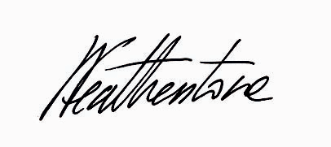
Linda M Featherstone
Manager, Office of the Senior Traffic Commissioner

Annex A

CONSULTATION RESPONSE FORM


Please fill in a separate form for each Direction and/or Guidance that you are responding to – thank you

This response relates to Guidance and/or Direction Number: | 1 2 3 4 5 6 7 8 9 10 11 12  PLEASE CIRCLE ONE (ONLY)

Name
Address
Postcode
Email address
Company name or organisation
(if applicable)
If you would like your response or personal details to be treated confidentially please explain why:

Question 1: Do the amendments to the documents relating to the EU Regulations meet the needs of all affected parties? | Yes | No
Answer 1:

Question 2: Do any parts of the guidance and/or directions relating to the EU Regulations require clarification? If so, please refer to the paragraph number and explain why. | Yes | No
Answer 2:

Question 3: Is the content of the guidance and directions relating to the EU Regulations easy to understand and follow? If not please refer to the paragraph number and explain why not. | Yes | No
Answer 3:

Question 4: Are there other provisions relating to the EU Regulations that are not included that should be included? If so, please explain what they are. | Yes | No
Answer 4:

Please send your completed form to: sstc@otc.gsi.gov.uk or by post to:

The deadline for responses is: 22 November 2011

July 2008 – Department for Business, Enterprise and Regulatory Reform

