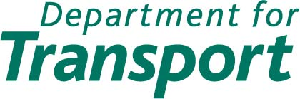

Consultation on the combined Thameslink, Southern and Great Northern franchise

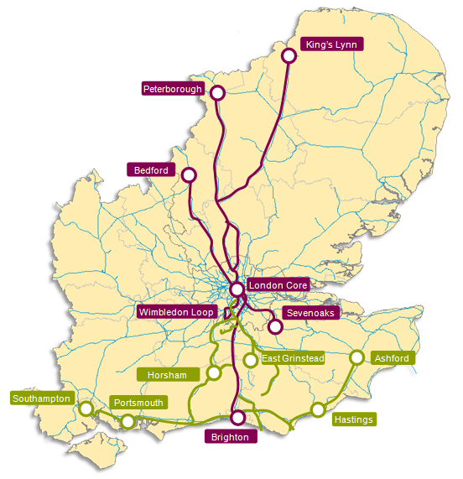

May 2012

The Department for Transport has actively considered the needs of blind and partially sighted people in accessing this document. The text will be made available in full on the Department’s website. The text may be freely downloaded and translated by individuals or organisations for conversion into other accessible formats. If you have other needs in this regard please contact the Department.
Department for Transport
Great Minster House
33 Horseferry Road
London SW1P 4DR
Telephone 0300 330 3000
Website www.dft.gov.uk
© Crown copyright 2012
Copyright in the typographical arrangement rests with the Crown.
You may re-use this information (not including logos or third-party material) free of charge in any format or medium, under the terms of the Open Government Licence. To view this licence, visit www.nationalarchives.gov.uk/doc/open-government-licence/ or write to the Information Policy Team, The National Archives, Kew, London TW9 4DU, or e-mail: psi@nationalarchives.gsi.gov.uk.
Where we have identified any third-party copyright information you will need to obtain permission from the copyright holders concerned.
Contents
1. Foreword
2. Purpose and policy
3. Process and timescales
4. The combined franchise
5. Objectives for the franchise
6. Schemes, stakeholders and other initiatives
7. The service specification
8. Consultation

Appendix 1: Map of current FCC franchise
Appendix 2: Map of current Southern franchise
Appendix 3: Consultation questions
Appendix 4: List of formal consultees
Appendix 5: Code of Practice on Consultation
Appendix 6: Service frequencies
1. Foreword
- The combined Thameslink, Southern and Great Northern franchise (referred to in this document as ‘the combined franchise’) will bring together all of the services currently operated by two franchisees: First Capital Connect (FCC), in 2013 and from July 2015 Southern (including Gatwick Express). In addition, some services will transfer from Southeastern in 2014 and 2018. The franchise will be responsible for delivering rail services across Bedfordshire, Cambridgeshire, Greater London, Hampshire, Hertfordshire, Kent, Norfolk, Surrey and Sussex. There will be a wide and diverse range of destinations served such as Ashford, Bedford, Brighton, Cambridge, Chichester, Eastbourne, East Croydon, Gatwick Airport, Hastings, Horsham, King’s Lynn, Lewes, Littlehampton, Luton, Luton Airport, Peterborough, Portsmouth, St Albans, Stevenage and Welwyn Garden City.
- There is significant change associated with the Government’s £6 billion investment in the Thameslink Programme, such as rebuilding London Bridge station and introducing new trains. As a result, the Government needs to ensure that programme and passenger benefits are fully realised. The Government believes that the most cost-effective way of managing the transition and its associated costs is to merge the existing FCC and Southern franchises. This approach was recommended by Sir Roy McNulty in his report Realising the Potential of GB Rail – Report of the Rail Value for Money Study, published in May 2011, as a way of making the industry more efficient.
- The combined franchise will be the biggest franchise that has ever been let. When all the services have been incorporated, it will have the largest income, the most trains and the most staff of any franchise in the UK rail market and present some significant challenges. These are:
- to deliver services which effectively manage passenger demand throughout the period of reconstruction of London Bridge station;
- to bring into service a new fleet of trains, which are equipped with new technology, to deliver additional capacity for passengers;
- to manage the integration of other franchises’ services (that is, FCC, Southern and some Southeastern) into this combined franchise;
- to manage the transition in a way that enables the benefits of the Government’s investment in the Thameslink Programme to be fully realised;
- to ensure focus across the whole franchise area whilst supporting delivery of the Thameslink Programme;
- to ensure that performance and customer satisfaction is maintained; and
- to create the biggest franchise that has ever been let in order to realise benefits for passengers and taxpayers.
- We are now consulting on what we should include in the specification for the combined franchise, which is due to start in September 2013 and run for a minimum of seven years. The consultation commences on 31 May 2012 and closes on 23 August 2012.
- The consultation exercise will help inform what we include in the Invitation to Tender (ITT) which is scheduled to be released in October 2012. The ITT will:
- require bidders to set out how they will successfully deliver the challenges in this franchise and integrate services to improve the overall service offered to passengers; and
- set out a framework of incentives to allow bidders to develop and enhance services, where appropriate but also strikes the right balance between commercial freedom for the franchise and ensuring that interests of passengers, taxpayers and the economy are suitably protected.
- We expect bidders will develop a suitable vision for this franchise. Developing a meaningful vision means that bidders will need to take into account value for money, affordability and the deliverability of their plans to address future challenges, whilst maintaining and potentially increasing passenger satisfaction.
- The new franchise will need to respond to current and future growth. The Government is committed to the Thameslink Programme which will deliver a step change in capacity and service on the franchise in addition to the investment that has already taken place on the FCC and Southern franchises in more vehicles and longer platforms. Bidders will be expected to build on this by responding to increased demand and exploiting the opportunity this investment provides.

2. Purpose and policy
2.1 The combined franchise is due to commence in September 2013. As explained in this document, this franchise initially will include all services operated by FCC. From April 2014 the services currently jointly operated by FCC and Southeastern will be added to the franchise, and from July 2015 all services currently operated by Southern (including Gatwick Express services) will be incorporated. In 2018 further Southeastern services will transfer to this franchise. The objectives for this franchise are set out in chapter 5 of this document. The consultation sets out what we are proposing to specify and explains the process and timescales for awarding the combined franchise.
This document:
- informs stakeholders of the process and timescales for awarding the combined franchise;
- gives stakeholders background information about the current services, infrastructure and capability on the combined franchise routes and the strategic planning and transport context of the new franchise;
- advises stakeholders and potential funders of the objectives and what we expect to include in the ITT for the franchise and the options under consideration; and
- invites potential funders to notify the Department for Transport (DfT) of any increments or decrements they may wish to purchase.
  - The closing date for consultation responses is 23 August 2012. The Department will publish a report following the consultation which will summarise stakeholder views and the Department’s conclusions on them. This will form a key reference document for the franchise bidders, and will be published at the same time as the ITT.
  - This consultation is taking place at a similar time to the consultations for the new South Eastern and Intercity East Coast franchises, due to the planned and potential service transfers between franchise areas. This is to give consultees a more detailed picture of each of the franchises and inform responses to the individual consultations.
  - We have considered whether the potential changes are likely to have any impact (adverse or differential) on race, disability or gender equality. It is not anticipated that any such impacts will occur. However, the Department takes its equalities responsibilities seriously and would welcome respondents' views on any issues that may affect equality of opportunities in these areas.
  - There are opportunities to improve services and increase the value of the franchise. The franchise will face new challenges over its seven year life. The specification for the new franchise will set a framework within which the new operator can deliver better services and greater value.
Franchising policy
  - In March 2012 the Government published a Command Paper - Reforming our Railways: Putting the Customer First, which set out the Government’s ambitions for Britain’s railways.
  - The Command Paper stated that future franchises will be longer, giving operators more responsibility and more flexibility in the services they provide, as well as more incentives to invest. The overall approach will be to treat operators as mature companies with a commercial interest in delivering a good service for their passengers.
  - The Command Paper also recognised that different approaches will be needed for different circumstances and areas. In general, specifications will be more flexible (particularly for long distance services) allowing franchisees to use their knowledge of passenger needs to develop service patterns. This freedom will be exercised within a framework set by the Government, relevant to the specific circumstances of the individual franchises, and will work in conjunction with licence obligations. This will be designed to protect the interests of passengers, taxpayers and the economy.
  - For this franchise, the Government’s priority is to ensure that the significant infrastructure work and the merging of services, staffing and business structures into one franchise is achieved in the most cost-effective way for passengers and taxpayers. A franchise term of seven years is being proposed in order to support this operational aim, ensuring that the winning bidder is selected on the strength of its proposition for meeting for the crucial short and medium term operational challenges. Once the Thameslink Programme is completed, a new franchise will be let in light of the changes that have taken place, at which point the bidding market will be able to develop an informed strategy for future services.
  - Sir Roy McNulty’s Realising the Potential of GB Rail – Report of the Rail Value for Money Study estimated the potential size of the savings available from greater efficiency within the industry and made recommendations about how they might be achieved. Getting those responsible for track and train to work more closely together, driving down costs to passengers and taxpayers, and improving the quality of services, are all priorities for the Government. Commitment to closer partnership working, which promotes efficiency with Network Rail, will be sought through the franchising process. It is expected that the successful franchise bidder will be required to set out, and commit to, reducing the cost of operating the franchise.
  - The Department is consulting on the future of fares and ticketing. More information can be found at http://www.dft.gov.uk/consultations/dft-2012-09/. Smart ticketing technology offers new opportunities to understand and manage the journeys that passengers make. Changes in the working arrangements of commuters present opportunities for the operator to make better use of the existing railway in ways such as rewarding passengers who choose to use less crowded trains, which allows the railway to make better use of capacity.
Wider rail and transport policy
  - This consultation document has been produced in the context of the broader transport policy environment. The following documents are a guide to this:
Periodic review 2013 Consultation on incentives ORR December 2011 http://rail-reg.gov.uk/pr13/PDF/pr13-first-consultation-incentives_141211.pdf
Reforming our railways: Putting the customer first Department for Transport March 2012 http://assets.dft.gov.uk/publications/reforming-our-railways/reforming-our-railways.pdf
Rail fares and ticketing review: Initial consultation Department for Transport March 2012 http://assets.dft.gov.uk/consultations/dft-2012-09/main-document.pdf
Rail Decentralisation, Devolving decision making on passenger rail services in England Department for Transport March 2012 http://assets.dft.gov.uk/consultations/dft-2012-10/main-document.pdf
Strategic Business Plan Network Rail October 2007 http://www.networkrail.co.uk/aspx/4355.aspx
CP4 Delivery Plan Network Rail March 2009 http://www.networkrail.co.uk/aspx/5500.aspx
CP5 Initial Industry Plan Network Rail September 2011 http://www.networkrail.co.uk/iip.aspx
Network Route Utilisation Strategy Stations Network Rail August 2011 http://www.networkrail.co.uk/browseDirectory.aspx?root=&dir=%5cRUS%20Documents%5cRoute%20Utilisation%20Strategies%5cNetwork%5cWorking%20Group%202%20-%20Stations
London and South East Route Utilisation Strategy Network Rail July 2011 http://www.networkrail.co.uk/browseDirectory.aspx?dir=%5CRUS%20Documents%5CRoute%20Utilisation%20Strategies%5CRUS%20Generation%202%5CLondon%20and%20South%20East
Realising the Potential of GB Rail – Report of the Rail Value for Money Study Sir Roy McNulty’s May 2011 http://www.dft.gov.uk/publications/realising-the-potential-of-gb-rail/
Rail Action Plan for Kent, Kent County Council, April 2011 https://shareweb.kent.gov.uk/Documents/council-and-democracy/have%20your%20say/rail-action-plan-for-kent.pdf
Response to the Reforming Rail Franchising Consultation Department for Transport January 2011 http://www.dft.gov.uk/news/statements/villiers-20110119/
Creating Growth, Cutting Carbon: Making Sustainable Local Transport Happen Department for Transport January 2011 http://www.dft.gov.uk/publications/making-sustainable-local-transport-happen/
Transport Strategy Mayor of London May 2010 http://www.london.gov.uk/publication/mayors-transport-strategy
Strategic Rail Freight Network: The Longer Term Vision Department for Transport September 2009; http://www.stopbig.org/downloads/Strategic%20Rail%20Freight%20Network%20-%20Long%20Term%20Vision.pdf
Alterations to the London Plan Greater London Assembly February 2008; http://www.london.gov.uk/priorities/planning/londonplan
Route Utilisation Strategy Network Rail December 2007 http://www.networkrail.co.uk/aspx/4449.aspx
Towards a Sustainable Transport System – Supporting Economic Growth in a Low Carbon World Department for Transport October 2007 http://www.official-documents.gov.uk/document/cm72/7226/7226.pdf
Rail Freight Strategy Transport for London August 2007 http://www.tfl.gov.uk/microsites/freight/documents/rail-freight-strategy-aug-2007.pdf
Freight Route Utilisation Strategy Network Rail March 2007 and http://www.networkrail.co.uk/browseDirectory.aspx?dir=%5CRUS%20Documents%5CRoute%20Utilisation%20Strategies%5CFreight
Transport 2025 Transport Challenges for a Growing world City Transport for London November 2006 http://tram.mcgill.ca/Teaching/URBP619/plans_case_studies/Londres%20Transport%20Vision%202025.pdf
A Rail Strategy for London’s Future Transport for London 2007 http://www.tfl.gov.uk/assets/downloads/Rail2025.pdf
Respondents may also like to refer to the InterCity East Coast Franchise Consultation and the South East Franchise Consultation documents, which will be published by the Department at a similar time to this combined franchise consultation document.
3. Process and timescales
3.1 The Department is developing the specification for the combined franchise, which will be informed by responses to this consultation. The Department has already met, and will continue to meet, with stakeholders, and will consider the responses to this consultation document before finalising the specification. In December 2011, we published a notice in the Official Journal of the European Union inviting organisations to express an interest in bidding for the franchise. Following our evaluation of the expressions of interest, we announced that the following companies had been shortlisted to bid for the franchise:
- Abellio Thameslink Limited (NV Nederlandse Spoorwegen);
- First Thameslink Limited (FirstGroup plc);
- Govia Thameslink Railway Limited (Go-Ahead Group plc and Keolis SA);
- MTR Corporation Thameslink Limited (MTR Corporation Limited); and
- Stagecoach Thameslink Trains Limited (Stagecoach Group plc).
  - The Department expects to issue an ITT to shortlisted applicants in October 2012. We plan to announce the winning bidder in May 2013, with the new franchise starting in September 2013. An outline of the proposed key dates is shown in Table 1.
  - The Department places great importance on protecting the interests of passengers. Passenger Focus research, therefore, has a significant role within the specification process, emphasising the importance the Department places on passenger needs. They will continue to provide the Secretary of State with advice on key issues that the new franchise should seek to address. We are grateful to them for their input, and discussions with Passenger Focus will continue as the specification develops.
  - The Department’s proposed approach to the specification is described in chapter 7 of this document. The final specification will take into account comments received from consultees, value for money, affordability, deliverability, robustness and operational impact. The final specification will be issued with the ITT. The specification may also be modified to reflect other emerging information including any increments and/or decrements that potential funders would like included in the franchise.

Table 1: Proposed key dates for the combined franchise
Stage | Stage dates
Franchise advertised and pre-qualification applications invited | December 2011 - February 2012  Completed
Bidders shortlisted from pre-qualification responses | February 2012 - April 2012  Completed
Stakeholder consultation period | May 2012 - August 2012
Tenders invited; bids prepared and submitted | October 2012 - January 2013
Bids evaluated, negotiated, approved and franchise award | January 2013 - May 2013
Franchise start | September 2013
Joint services from Southeastern become wholly operated by the combined franchise | April 2014
Southern services become part of the franchise | July 2015
Final transfer of services from Southeastern | By December 2018
Expiry of combined franchise | September 2020  NB: This can be extended by up to two years at the discretion of the Secretary of State

4. The combined franchise
The current franchises
- The combined franchise is a complex integration of two existing businesses (FCC in September 2013 and Southern (including Gatwick Express) from July 2015). Additionally, the franchise will include the existing jointly operated FCC and Southeastern services from April 2014, with further Southeastern services incorporated in 2018. This chapter outlines the services that are currently provided. Appendices 1 and 2 show the current franchise maps for FCC (this also includes the jointly operated services with Southeastern) and Southern.
First Capital Connect
- Services operated by FCC run on two routes:
- The Thameslink route runs between Bedford and Brighton via central London. In the north, trains run on the overhead electrified Midland Mainline route into St Pancras International (low level). These services then continue south via Farringdon, City Thameslink and Blackfriars to the Brighton Main Line (BML), via either London Bridge or Elephant & Castle and on to East Croydon, Gatwick Airport and Brighton. Other stopping services also run between Luton and St Albans in the north to Sutton and Wimbledon in south London, calling at stations in a suburban loop in south London, known as the Wimbledon loop.
- The Great Northern route runs to and from Kings Cross and London Moorgate serving destinations such as King’s Lynn, Cambridge, Stevenage, Hertford and Peterborough.
- FCC carried over 96 million passengers in 2010/11, employing around 2,300 staff and operating 77 stations.
- The geographic and service coverage of the franchise will change during its life to incorporate the impact of the Thameslink Programme in terms of the improved services available on completion and the operating needs of the network during construction work at London Bridge as well as the introduction of the combined rolling stock.
- The Thameslink Programme will improve services through the core Thameslink route and provide more trains and serve more destinations. There are three stages to the Programme:
- Key Output 0 (delivered in 2009) allowed for services through to Kent. These are currently jointly operated by FCC and Southeastern.
- Key Output 1 (delivered in 2011) allowed for enhanced capacity and new stations at Farringdon and Blackfriars.
- Key Output 2 (currently planned for delivery in 2018) will allow for more services, longer trains and more destinations.
- In preparation of Key Output 2, it is anticipated that new trains will be procured. These trains will provide additional capacity and the franchise will have an important role in delivering these new trains into passenger service.
- The completion of the combined programme will bring new and improved stations, along with new track and signalling and longer and more frequent trains. This will reduce overcrowding and enable better rail journeys.
Southern
- The current Southern services will become part of the combined franchise from July 2015 when the existing South Central franchise expires. Southern services are split into the following geographical service groups:
Service Group | Geographic route
Metro | South London suburban services
West London | Milton Keynes to East Croydon (via Clapham Junction)
Brighton Mainline | Brighton to London Victoria
Gatwick Express | Gatwick Airport to London Victoria (every 15 minutes, extended services to Brighton in the peak)
Mainline West | Southampton, Portsmouth, Bognor Regis, Littlehampton via Hove to London Victoria (and limited to London Bridge)
Mainline East | Ore, Hastings, Eastbourne and Seaford via Lewes to London Victoria (and limited to London Bridge)
Oxted | Uckfield and East Grinstead to London Victoria or London Bridge
Redhill | Tonbridge, Reigate and Horsham, via Redhill to London Victoria or London Bridge
Coastway West | Brighton to Littlehampton, Bognor Regis, Portsmouth, and Southampton
Coastway East | Brighton to Seaford, Eastbourne and Ashford International

4.9 Southern serves destinations such as Streatham, Sutton and Sydenham in south London and Ashford, Brighton, Eastbourne, East Croydon, Gatwick Airport, Hastings, Horsham, Littlehampton Portsmouth, Southampton, Worthing, and with trains serving London Victoria and London Bridge station. Southern also operates the separately branded Gatwick Express services from London Victoria to Gatwick Airport, extended to Brighton in the peak.
  - The franchise carried over 121 million passengers in 2010/11, employing around 4,100 staff and operating 158 stations.
  - The combined franchise will include some further services that will transfer from Southeastern in December 2018. Which services are transferred is subject to the results of the combined consultation (this document) and the South Eastern franchise consultation (released at a similar time).
  - The map of the current franchises is shown in Appendix 1 for FCC, which includes the scope of the jointly operated services with Southeastern and Appendix 2 for Southern.
Services
4.13 Both FCC and Southern are required to operate a minimum level of service which is specified in the Service Level Commitment (SLC) in their respective Franchise Agreement. It is our intention that, where possible and appropriate, we will specify the new franchise in a manner which allows the operator more commercial freedom. This is discussed in more detail in chapter 7 of this document. The current level of service frequency, and how that translates to the new franchise, is shown in the map in Appendix 6.
Passenger numbers and revenue
  - The graphs below show revenue and passenger growth on the FCC and Southern operations since 2005. The graph shows Southern including Gatwick Express where those sales have been possible to capture.
Figure 1: Annual passenger revenue growth FCC and Southern (Source: LENNON) 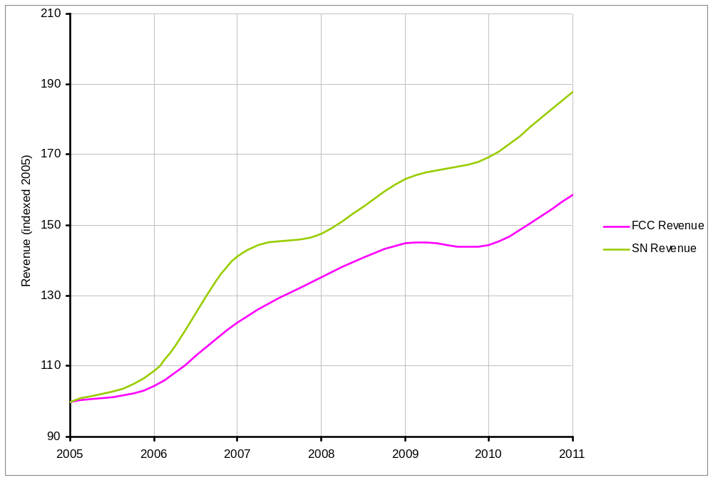
Figure 2: Annual passenger journeys growth FCC and Southern (Source: LENNON)
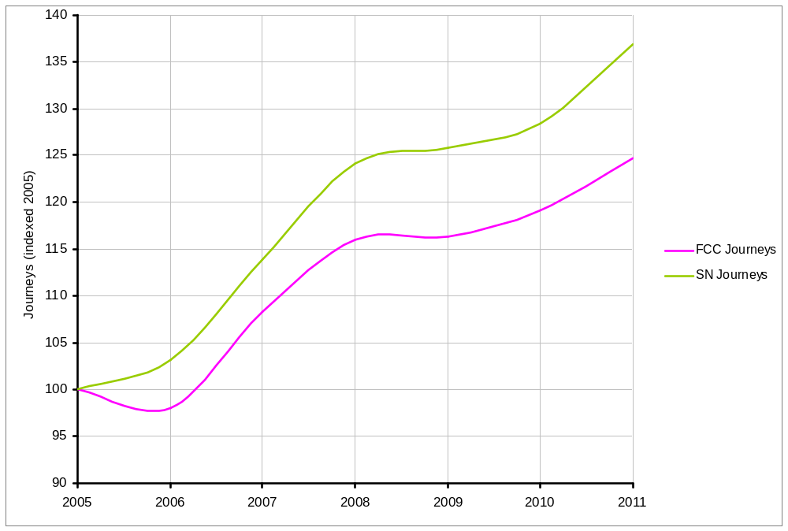

Reliability and performance
  - The graph below shows performance since 2001 for both operators compared to the London & South East averages. Performance over this time has shown a steady improvement. In the year to 31 March 2012, 90% of both operators’ services arrived at their destination within five minutes of the advertised time. It is important that the current levels of performance are maintained, and where possible, improved upon, especially in view of the scale of changes taking place in this franchise.
Figure 3: Performance of FCC and Southern on moving annual of trains arriving at destination within five minutes of their advertised time (PPM MAA)
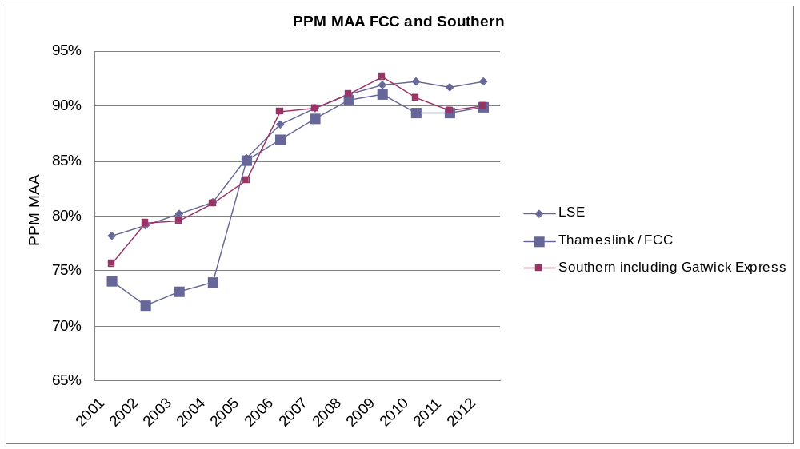
Notes:
- Thameslink / FCC is the 'old' Thameslink pre 2005; 2005 - 2007 is an average of FCC and Thameslink (FCC took over GN) and after 2007 is FCC.
- Southern including Gatwick Express is an average of Southern and Gatwick Express until 2010 when Gatwick Express is included within the Southern figures
Rolling stock
  - The tables below set out the types of rolling stock in use and the typical deployment on both the FCC and Southern operations.
Table 2: Stock currently used on FCC
Unit Type | Vehicles per unit | Total Seats per unit | Number of units | Current use of units
313/0  (Note 1) | 3 | 232 | 44 | Dual-voltage electric train which can work on both overhead lines and third rail, used on Great Northern inner-suburban Moorgate -Welwyn Garden City/Hertford North/Letchworth services. Also used on Kings Cross inner suburban services.
317/1 * | 4 | 269 | 12 | Electric unit that works on the overhead line electric system, used on Great Northern outer-suburban Peterborough, Cambridge services (also some Welwyn Garden City inner suburban services). Can be used on Kings Lynn services.
365/5 * | 4 | 243 | 40 | Electric unit that works on the overhead line electric system, used on Great Northern outer-suburban Kings Cross - Peterborough, Cambridge and Kings Lynn services.
319/0 | 4 | 316 | 13 | Dual-voltage electric train which can work on both overhead lines and third rail, usually used on Thameslink inner-suburban Luton/St Albans – Wimbledon loop services.
319/2 * | 4 | 241 | 7 | Dual-voltage electric train which can work on both overhead lines and third rail, usually used on Thameslink Bedford-Brighton services.
319/3 | 4 | 303 | 26 | Dual-voltage electric train which can work on both overhead lines and third rail, usually used on Thameslink Luton/St Albans – Wimbledon loop services.
319/4 * | 4 | 275 | 40 | Dual-voltage electric train which can work on both overhead lines and third rail, usually used on Thameslink Bedford-Brighton services.
321 *  (Note 1) | 4 | 299 | 13 | Electric unit that works on the overhead line electric system, used on Great Northern outer-suburban Peterborough, Cambridge services (also some Welwyn Garden City inner suburban services). Can be used on Kings Lynn services.
377/2 *  (Note 2) | 4 | 242 | 3 | Dual-voltage electric train which can work on both overhead lines and third rail, usually used on Thameslink outer Bedford-Brighton services.
377/5 *  (Note 2) | 4 | 243 | 23 | Dual-voltage electric train which can work on both overhead lines and third rail, usually used on Thameslink Bedford-Brighton services.

Note 1: Includes extra units introduced from December 2010
Note 2: These units are sub-leased from Southern to FCC and are expected to remain there until the end of the current FCC franchise
Table 3: Stock currently used on Southern
Unit Type | Vehicles per unit | Total Seats per unit | Number of units | Current use of units
171/7 * | 2 | 116 | 10 | Diesel train, used on Brighton-Ashford and London Bridge-Uckfield services.
171/8 * | 4 | 259 | 6 | Diesel train, used on London Bridge-Uckfield services.
313 | 3 | 196 | 19 | Used on Coastway East and West services, on Brighton-Hastings / Littlehampton / Bognor Regis / Portsmouth / Southampton routes.
377/1 *  (Note 3) | 4 | 231 | 19 | Used on outer-suburban Brighton Main Line services between London-Sussex Coast; also on South London ‘Metro’ services. Can be used on Coastway East and West services.
377/1 *  (Note 3) | 4 | 263 | 20
377/1 *  (Note 3) | 4 | 242 | 25
377/2 *  (Note 4) | 4 | 242 | 15 | Dual-voltage electric train which can work on both overhead lines and third rail, primarily used on East Croydon-Milton Keynes services via West London Line. Also used on outer-suburban Brighton Main Line services between London and the Sussex Coast. Can be used on inner-suburban South London ‘Metro’ services.
377/3 * | 3 | 169 | 28 | Used on outer-suburban Brighton Main Line services between London and the Sussex Coast; also on South London ‘Metro’ services. Can be used on Coastway East and West services.
377/4 * | 4 | 238 | 75 | Used on outer-suburban Brighton Main Line services between London and the Sussex Coast; also on South London ‘Metro’ services. Can be used on Coastway East and West services.
377/6 | 5 | 294 | 26 | New build units to be delivered into service by Southern during its current franchise as part of the HLOS capacity enhancement. For use on inner-suburban South London ‘Metro’ services.
442 * | 5 | 342 | 24 | Used on Brighton Main Line services between London Victoria and Gatwick Airport (‘Gatwick Express’) and Sussex Coast. Also used for peak London Bridge-Sussex Coast services.
455 | 4 | 307 | 46 | Used on inner-suburban South London ‘Metro’ services.
456  (Note 5) | 2 | 152 | 24 | Used on inner-suburban South London ‘Metro’ services. To be transferred to SouthWest Trains (SSWT), as part of DfT HLOS Phase 2 capacity enhancement.
460 * | 8 | 363 | 8 | Used on London Victoria – Gatwick Airport (‘Gatwick Express’) services. Being transferred to SSWT, as part of DfT HLOS Phase 1 capacity enhancement.

Note 3: Varying seating values for 377/1 units relate to different builds
Note 4: Excludes three units sub-leased from Southern to FCC which are expected to remain there until the end of the current FCC franchise
Note 5: These units come off lease in December 2013 and are returned to the Rolling Stock company who has leased them to the SSWT franchise. These are being replaced by the new build 377/6 units.
* Includes First Class seats
Investments in the existing franchises
  - FCC and Southern have invested in improving the stations and their services for passengers. These improvements include:
  - new automatic ticket gates;
  - installation of Help Points and Automatic Ticket Vending Machines;
  - enhancement of stations (including refurbishment of waiting rooms and toilets); and
  - improved passenger information.
  - The Department will expect bidders to set out how they will build on this investment to at least maintain passenger satisfaction and enhance the value of the franchise. We will make details available to bidders and ask them to build on the developments already delivered in the franchises. This, combined with respondents’ views will be used to inform our specification.

Passenger satisfaction
4.19 The National Passenger Survey (NPS) is a measure of how satisfied customers are with the operator. These surveys take place twice a year in the Spring and Autumn. Table 4 below shows the results for FCC, Southern and Southeastern in respect of overall customer satisfaction, performance against the individual categories and how this relates to the average for similar operators who serve London and South East.
Table 4: Percentage satisfied with Station and Train Facilities, Autumn 2011, FCC and Southern compared to London & South East overall (Source: Passenger Focus Surveys)
 | Overall Satisfaction
 | FCC | Southern | South-eastern | London & South East
Overall satisfaction | 80 | 83 | 83 | 83
Overall satisfaction with the station | 76 | 78 | 78 | 77
Ticket buying facilities | 68 | 73 | 66 | 72
Provision of information about train times/platforms | 77 | 81 | 80 | 80
The upkeep/repair of the station buildings/platforms | 63 | 67 | 64 | 65
Cleanliness | 70 | 72 | 72 | 71
The facilities and services | 50 | 50 | 51 | 49
The attitudes and helpfulness of the staff | 66 | 70 | 69 | 69
Connections with other forms of public transport | 73 | 73 | 75 | 74
Facilities for car parking | 45 | 44 | 47 | 49
Overall environment | 64 | 69 | 68 | 67
Your personal security whilst using | 65 | 68 | 63 | 66
The availability of staff | 55 | 58 | 56 | 57
How request to station staff was handled | 85 | 85 | 80 | 85
The frequency of the trains on that route | 76 | 76 | 75 | 77
Punctuality/reliability (i.e. the train arriving/departing on time) | 77 | 78 | 80 | 80
The length of time the journey was scheduled to take (speed) | 83 | 84 | 81 | 83
Connections with other train services | 76 | 76 | 71 | 75
The value for money for the price of your ticket | 38 | 42 | 36 | 42
Cleanliness of the train | 65 | 72 | 70 | 74
Upkeep and repair of the train | 63 | 71 | 72 | 75
The provision of information during the journey | 47 | 72 | 66 | 69
The helpfulness and attitude of staff on train | 32 | 61 | 52 | 57
The space for luggage | 44 | 48 | 48 | 52
The toilet facilities | 25 | 36 | 32 | 35
Sufficient room for all passengers to sit/stand | 60 | 66 | 63 | 67
The comfort of the seating area | 62 | 72 | 67 | 71
The ease of being able to get on and off | 74 | 76 | 79 | 80
Your personal security on board | 68 | 76 | 71 | 75
The cleanliness of the inside | 65 | 72 | 72 | 75
The cleanliness of the outside | 60 | 74 | 70 | 74
How well train company deals with delays | 33 | 35 | 26 | 36
Key:
Service same as, or better than, similar operators
Service is less than five percentage point worse than similar operators
Service is more than five percentage point worse than similar operators

5. Objectives for the franchise
5.1 A key starting point for the development of the franchise specification is the establishment of clear objectives. Six objectives have been endorsed by the Secretary of State. They are that the franchisee will be required to:
- take a leading role in enabling the successful delivery of the Thameslink Programme, and work collaboratively with the franchising authority (in this case, the DfT) and other industry partners to ensure that the envisaged programme benefits are fully realised on time. This will include but not be limited to: the introduction into service of new trains and depots; managing the return of displaced stock to the owning ROSCO; proactively supporting the integration of operations and new infrastructure and train control systems to deliver an enhanced train service;
- have an effective change management organisation for the Thameslink Programme, implementation of any rail value for money study recommendations and any other industry initiatives that may be required to enable successful delivery of this franchise;
- support the creation of the future long term franchise that will operate when the Government’s investment in the Thameslink Programme has been delivered;
- ensure the overall passenger experience improves through the life of the franchise subject to value for money and affordability. This will include but not be limited to improvements in: service quality; retailing; provision of information to customers particularly during times of planned and unplanned disruption; implementing ‘smart’ technology and integrated ticketing throughout the franchise on an interoperable basis; improving accessibility (including disabled access) and access to all stations and services; passenger security and improving the transparency of information about the franchise;
- ensure that train services perform to the highest practicable reliability and punctuality standards and continue to be amongst the most reliable and punctual services on the network; benchmark and optimise the overall environmental performance and minimise the carbon footprint for the franchise; and
- deliver services in the most cost-effective and efficient manner possible and where appropriate, consider improving alignment and better collaboration between Network Rail and other relevant industry partners.

6. Schemes, stakeholders and other initiatives
The Government's High Level Output Specification
  - The High Level Output Specification (HLOS) specifies the strategic national outputs on the Network Rail infrastructure that the Government wishes the rail industry to achieve, in areas such as reliability, safety and capacity, and the major projects that Government may wish to fund. These are then incorporated into delivery plans by the industry, reviewed and authorised by the ORR. During each Network Rail Control Period the Government can also agree variations to the HLOS, based on emerging industry needs. The first Control Period to use this process was CP4 which runs from April 2009 to March 2014. The process for CP5 has begun, and more details of this process can still be found at http://www.rail-reg.gov.uk/pr13/publications/index.php The rail industry has published its Initial Industry Plan detailing its processes: for more information please go to www.networkrail.co.uk/IIP.aspx.
Community rail partnerships
  - Within the combined franchise area there are existing community rail partnerships. There may be scope to develop a number of new community rail initiatives or enhance the existing partnerships. These are designed to support and develop the local rail network and create links between the community, businesses and the railway. They can also include seeking ways to improve facilities on stations through sponsorship of local stations.
  - The Department expects the bidders for the combined franchise to demonstrate a commitment to work with existing and any new partnerships that develop over time and to indicate how they propose to work with communities over the life of the franchise.
Decentralisation
  - The Government is now consulting on the feasibility of decentralising some responsibilities for local rail services. In the consultation, views are being sought on whether improved outcomes for passengers and transport users might be achieved in some cases if more decisions on local rail services were made closer to the communities they serve. Under the existing franchise arrangements services have been specified, funded and managed centrally by the Department. Further details can be found at http://www.dft.gov.uk/consultations/dft-2012-10/.
Passenger Focus and other consultees
6.5 Passenger Focus provides independent advice to the Secretary of State, based on research and consultation with wider stakeholders, on the key issues that the new franchise should consider.
6.6 Bidders will be encouraged to use Passenger Focus research to shape their proposals for the new franchise. The Department will continue to work with Passenger Focus in considering how best to incentivise bidders to develop services in a cost-effective, affordable and practical manner. In general, the Department is supportive of those elements that seek to improve service quality, passenger information and link improvements to monitored results.
  - The Department places a high value on the insight and knowledge that stakeholders bring to the franchise replacement process and appreciates the contributions already made. We will continue to engage positively with interested parties. Stakeholders are encouraged to discuss proposed responses to this consultation with the Department and its advisors early in the consultation period.
Freight
  - Rail freight is an important driver of UK economic growth, and the Department recognises that efficient and sustainable freight transport is important to the achievement of our environmental goals and for the growth of the UK’s national and regional economies. Rail freight is expected to grow by 30% between now and 2019. The combined franchise area contains some important and significant volumes of freight traffic. The Department expects that the industry will be able to provide a network that is capable of meeting the increased demands for both freight and passengers. We will consider the Strategic Rail Freight Network policy when we are developing the specification for this franchise.
Rail Value for Money Study
  - The Government is determined to secure a sustainable and efficient railway, as set out in the March 2012 Command Paper – Reforming our Railways: Putting the Customer first. A key element of the Government’s strategy is achieving a better alignment between TOCs and Network Rail. The aim is to encourage them to work more closely together to deliver better value by driving down the cost of running the railway and improving the quality of services to benefit passengers and taxpayers. One of the ORR’s proposals is for a Regional Efficiency Benefit Share, which would give TOCs a share in both the benefits and costs of Network Rail’s performance against its Operations, Maintenance and Renewal (OMR) efficiency targets. The Department is also considering whether a bespoke scheme would be appropriate for this franchise.
  - The Department will expect bidders to develop proposals in discussion with Network Rail to demonstrate how they would reduce industry unit costs and improve efficiency. The Department also expects that the franchisee will make its cost data available to the Department and the ORR. This data could be published and compared with unit costs in other franchises in order to encourage further reductions in the overall cost of the railway.

Q.1 | What improvements do stakeholders believe could be made on the combined franchise through partnership working between Network Rail and the new operator?

Crossrail
6.11 Crossrail will deliver a major new rail service for London and the South East. It will connect the City, Canary Wharf, the West End and Heathrow Airport to commuter areas east and west of the capital. It will provide easier, quicker and more direct travel opportunities across the capital, with 24 trains per hour operating in each direction at peak times, easing crowding levels on many existing tube and rail routes. Overall the project increases capacity on London’s rail network by around 10%.
  - Crossrail will meet the Thameslink core at Farringdon. Initial Crossrail services between Paddington and Abbey Wood are expected to commence in late 2018, with around 12 trains per hour serving Farringdon in each direction. During 2019, on a phased basis, full Crossrail services will be introduced between Maidenhead and Heathrow in the west and Shenfield and Abbey Wood in the east. At peak times, around 24 Crossrail trains per hour will serve Farringdon in each direction, with journey times of 31 minutes to Heathrow (Terminals 1, 2 and 3) and nine minutes to Canary Wharf.
  - The interaction of these two major infrastructure projects, plus existing London Underground services, is likely to make Farringdon a major interchange station and result in significant changes to existing journey patterns which may not stabilise for a number of years. In turn this could impact on demand levels to other stations, such as London Victoria.
Other initiatives
Chesterton station
6.14 Cambridgeshire County Council is developing a proposal for a new station to be built at Chesterton. The station would be situated north of Cambridge station, adjacent to Milton Road, and close to Cambridge Science Park. It is anticipated that this station would provide a service for passengers wishing to use the Cambridge Science Park and regional college.
Wixams station
6.15 A property developer is working with Network Rail on a proposal for a new station to be built in connection with a housing development in Bedfordshire. It is proposed that the new station would be called ‘Wixams’ and be situated on the Midland mainline between Bedford and Flitwick. Currently Network Rail is working through its planning stage for the proposed station and is due to reach GRIP4 (single option development) in June 2012.
Cricklewood and Brent Cross
6.16 Planning permission has been received for a development at Cricklewood and Brent Cross with a new station which would act as an interchange. Further development of this scheme is linked to the Thameslink Programme.
Other station developments
6.17 We are aware that there are other station proposals for either new stations or re-developments which are in various stages of development. We would expect that bidders to consider these, and where appropriate take them into account in their proposals for the franchise.
Q.2 | Do consultees have any other specific aspirations for the new franchise that they wish to bring to the Department's attention?

Q.3 | Are consultees aware of any other rail or non-rail development schemes that might affect the new franchise?

Q.4 | What increments or decrements to the specification would stakeholders wish to see and how would these be funded?

7. The franchise specification
  - This chapter sets out the Department’s proposed approach to the specification of the combined franchise. The final specification for the franchise will be confirmed in the ITT which is due to be issued in October 2012. Below we set out what the Department's current view is of what should be included in the specification and we seek respondents’ views.
This chapter covers:
- approach to specifying the train service;
- performance and reliability;
- improving customer experience;
- introducing Smartcards; and
- approach to ensuring connectivity with other transport modes.
  - The Department will need to ensure the specification is affordable, delivers value for money and fits with broader transport objectives. In keeping with the Government’s decentralisation agenda, we are prepared to consider including priced options in the specification to reflect increments or decrements that funders in local government would like to see.
Train service requirements
  - Our policy is that franchise operators should have more commercial freedom and flexibility to develop the train service to meet the needs of passengers. We believe that under the previous Government, too many detailed decisions on service specification were made centrally in Whitehall and that it would be better for the private sector specialists who actually run train services to have a greater say in how those services are configured. The Government therefore intends to set the train service specification so that operational and timetabling decisions are devolved to TOCs where possible, while protecting key outcomes for passengers, the economy, and the taxpayer.
  - In the case of the combined franchise, we need to strike the correct balance between ensuring that the full benefits of the Government's £6 bn investment in the Thameslink Programme are realised and offering the franchisee commercial freedom to determine how best to offer services. We must also be mindful that during this franchise, London Bridge station is being rebuilt as part of the Thameslink Programme. This will mean that fewer services can use the station and we must ensure that during the construction period the train service is planned in a way to maximise available capacity to enable people to get to and from central London. For these reasons there may be a case for producing a more detailed specification than would be the case on a franchise with less disruption. However, even if service frequency and key services features are rather more tightly defined than may be the case with other franchises, it would be for the operator to develop, consult on and deliver the timetable in line with normal industry practice.
7.5 We are seeking views on whether the train service specification for the franchise (or part of the franchise) should be made up of some or all of the following aspects:
- be specified by individual routes;
- set out the earliest and latest services on each route;
- specify the frequency of train services on individual routes. This would normally be defined as trains per hour but could, alternatively, be the number of trains per day;
- specify the number of station calls per day and, where appropriate, the frequency between calls. How station calls are matched to individual trains will normally be a matter for the train operator to decide; and
- specify the minimum number of vehicle arrivals that should be able to be accommodated at London terminal stations during peak hours; and
7.6 Some of these aspects could be specified in a number of different ways, for example, station calls per week, requirements for the evening peak or a specified number of passenger spaces arriving over the peak periods.
Q.5 | Which aspects of the specification, other than for those services operating through the Thameslink core route, would stakeholders wish to see mandated and which aspects of the specification could be left to the discretion of the operator?

Q.6 | Are there other approaches to train service specification which you would prefer?

Q.7 | What changes to services would stakeholders propose, what is the rationale for them and would these provide economic benefit?

Capacity and crowding
  - Our guideline is that passengers boarding a peak train should not have to wait more than 20 minutes to get a seat, and when boarding an off-peak service they should be able to get a seat immediately. However, on this franchise it is acknowledged that at certain times this guideline cannot be met. The franchisee will be required to plan a timetable and the deployment of its fleet to meet this guideline wherever it can, within the constraints of the number of train paths available to it.
  - The Thameslink Programme will deliver a significant increase in capacity across the franchise area. In the ITT, we will ask bidders to set out how they expect the business to grow throughout the life of the franchise and how they expect to respond to and manage that demand.
Q.8 | How might better use be made of the capacity currently available?

Q.9 | What steps might bidders be expected to take to meet passenger demand and what might be the most appropriate mechanisms for managing demand?

Train service proposal for this franchise
  - The most significant timetable changes in this franchise will come about as a result of the rebuilding of London Bridge station as part of the Thameslink Programme. This will mean that for three years Thameslink core trains will be unable to serve London Bridge.
  - Major changes to timetables will occur in January 2015 when Network Rail begins work on the re-building of the high level station at London Bridge (existing platforms 1 to 6) and the remodelling of the track layout in the Bermondsey and Southwark areas. There will be a significant impact on Southern services before 2015, and Southern, Network Rail and the Thameslink Programme will lead the communication about these changes. This does not form part of this consultation process
  - During the Christmas and New Year period 2014 to 2015, Network Rail will disconnect the Spa Road Junction (Bermondsey) and Metropolitan Junction (between London Bridge and Blackfriars). This means that no Thameslink core trains will be able to serve London Bridge for a period of three years, and that all services between Blackfriars and East Croydon and the Brighton Main Line will be diverted to run on the slower routes through south London (routes that are used by several peak-time Thameslink core trains today) adding some eight or nine minutes to journey times.
  - The Brighton Main Line timetable today is based on a pattern that recurs every 15 minutes through the key bottlenecks at London Bridge, East Croydon and Gatwick Airport. The fact that trains from the Thameslink core route will arrive at East Croydon nine minutes later means that this timetable pattern will need to be revised.
  - To achieve a satisfactory timetable pattern to last through this three-year period, the services operated independently today by FCC and by Southern will have to be redesigned as a single entity. This is one of the reasons for the merger of the FCC and Southern franchises. Some work has been done on this timetable revision by the rail industry already and the following conclusions are emerging. We believe this will inform how we specify the train service requirement for this section of the franchise.
- Direct trains to each London route (Victoria, London Bridge and Thameslink core route) must be maintained from the busiest stations on the BML route (Brighton, Haywards Heath, Gatwick Airport and East Croydon). Consideration must also be given to Mainline Coastway East and West destinations.
- The total number of trains on the predominantly two-track section between Balcombe Tunnel Junction (south of Three Bridges) and Keymer Junction (north of Burgess Hill) should not be increased as this would significantly increase the risk that the train service becomes unreliable.
- Thameslink core trains will be unable to serve London Bridge. The longer journey times mean that the specification will need to be changed as there will not be enough trains to continue to deliver the same service as today. The rail industry’s work on this suggests that the current pattern of four trains an hour from Brighton that serve both London Bridge and the Thameslink core will need to be replaced by two trains per hour to London Bridge (low level station) and two trains to the Thameslink core. There will be insufficient rolling stock and insufficient track capacity for all four trains (two from the Thameslink core and the two from London Bridge) to reach Brighton, so two trains per hour will have to turn back at Gatwick Airport or Three Bridges.
- In order to ensure that a sensible pattern of services can be achieved for stations south of Gatwick both to and from Victoria, it may be necessary to make greater use of the practice of operating the non-stop Victoria-Gatwick services (Gatwick Express) as through trains to and from Brighton. This may be best achieved by restoring the practice of detaching (southbound) and attaching (northbound) a portion of the train so that airport passengers can have more time to alight from the train (southbound) and to join (northbound). This work has not yet concluded yet, and alternative options are being examined. Airport services are discussed in more detail at 7.20.
  - During the Christmas and New Year period 2017-18, Network Rail will reconnect the Thameslink core route to the enhanced station and layout at London Bridge. This layout will enable up to 18 out of the planned 24 trains per hour through the Thameslink core route via London Bridge. The other six trains per hour will run via Elephant & Castle.
  - However, achievement of this density of service on the Thameslink core route is an extremely demanding challenge and the decision has been taken that the service will only operate reliably if Automatic Train Operation (ATO) technology is deployed between St Pancras International low level and London Blackfriars. Development of ATO cannot begin until the new Thameslink trains are available, so it will not be possible to introduce the 24 trains per hour service until December 2018 at the earliest. Therefore, the build-up to the 24 trains per hour full service will be achieved progressively during 2018. There are likely to be incremental changes to the timetable during 2018 to achieve this.
Transfer of services from Southeastern in April 2014
  - The services that are currently jointly operated between FCC and Southeastern will continue to be jointed operated until they transfer to the combined franchise in their entirety from 1 April 2014. Therefore, instead of Southeastern being responsible for the portion of the journey south of Blackfriars and FCC responsible for that north of Blackfriars, all of the service will be the responsibility of the combined franchise.
Transfer of services from Southeastern in 2018
  - We have yet to confirm the exact scope of services that we will transfer from Southeastern in 2018 and we are seeking respondents’ views as part of this consultation. Current thinking is that in addition to Thameslink core services serving Sevenoaks, these will be expanded to include Maidstone East. It is also possible that in peak hours this may include some services from Dartford and Orpington. The rail industry has recently been engaged in an exercise planning the timetable that could operate when the Thameslink Programme is completed. This work involves all the affected operators and Network Rail. One particular conclusion has emerged from this work: if services between Kent and the Thameslink core route run via London Bridge it becomes physically impossible, within the envisaged infrastructure available at that time, for the present level of service to continue to run into and out of London Cannon Street. In view of the high demand for Cannon Street services, we believe it may be best for services between Kent and the Thameslink core to run only via Elephant & Castle. We are seeking respondents’ views on this and the destinations in Kent that it would be appropriate for Thameslink core services to operate to and from. When considering these views and deciding whether or not to include this in the specification we will consider the affordability of proposals as well as balancing the needs of all users on the route.
Q.10 | What destinations on the current Southeastern network do respondents think should be served by the combined franchise’s services and what is the rationale for such proposals?

Brighton Main Line services
    - The BML timetable pattern will be dictated by the timings of trains as they enter and leave the Thameslink core. We intend to specify the numbers of trains that run on the BML and each of its feeder routes to and from London, but to leave bidders to determine the best pattern of service, and calling patterns, south of Gatwick. We doubt whether the existing infrastructure can support any greater number of trains than the number that operates today but a different distribution of stopping patterns might well prove beneficial to the majority of passengers. We are seeking respondents’ views on this.
Q.11 | How might better use be made of the capacity available on the Brighton Main Line?

Q.12 | What steps should bidders be expected to take to improve performance on the route?

Great Northern services
The current FCC franchise includes all suburban services on the Great Northern route. This route serves destinations such as Peterborough, Cambridge, King’s Lynn, Stevenage, Welwyn Garden City and Hertford into and out of London Kings Cross and London Moorgate. From 2018, up to eight trains per hour from the Great Northern route will run via the Thameslink core route. Work is currently underway to determine the optimal destinations for these trains. Whilst we do not have proposals as yet, we are considering whether or not it might be appropriate that services that are not serving the Thameslink core route should transfer to the new Intercity East Coast franchise.
Q.13 | What destinations on the Great Northern route do respondents consider would be appropriate to become destinations for trains which serve the core Thameslink route?

Q.14 | Do respondents believe Great Northern trains which do not serve the Thameslink core route should remain as part of this franchise or be transferred to the new Inter City East Coast franchise?

Q.15 | What improvements would respondents like to see made to Great Northern services as part of the combined franchise and what is the rationale for this?

Airport services
  - The Government believes good connectivity with our major airports is essential. This franchise serves two airports: Gatwick and Luton. If possible we would like to see improvements in these services. However, whether we can deliver such improvements depends on affordability and on striking the right balance between the needs of air passengers and those of commuters in relation to how we use limited capacity on lines which are amongst the busiest in the country. We are seeking respondents’ views on this.
Q.16 | What services would be appropriate to serve the Airport market?

Q.17 | What improvements could be made without adversely affecting the service provision on the remainder of the franchise?

Wimbledon loop and Thameslink core services via Elephant & Castle
  - Many stakeholders are aware that Network Rail has recommended, in both the South London and London and South East Route Utilisation Strategies, that Wimbledon loop services should start and terminate at Blackfriars. Network Rail wishes to see trains presented to the Thameslink core punctually, and it sees the crossing moves that the Wimbledon loop trains have to make south of Blackfriars as potential conflicts with other trains, and thus a threat to punctuality. At peak times, from December 2018, it will be possible for up to 16 trains per hour to approach Blackfriars from the south route via Elephant & Castle, but for no more than eight of these to proceed through the Thameslink core. The other eight must terminate in the new platforms on the west side of Blackfriars station. All these trains will approach Blackfriars either from the Denmark Hill direction (including Catford loop trains) or from Herne Hill (including Wimbledon loop trains). The question to be decided is which six or eight trains (depending on whether 16 or 18 approach from London Bridge) go through the Thameslink core and which terminate. Trains that use these routes today come from Sutton, Wimbledon, Ashford (via Maidstone East), Rochester, Sevenoaks, Orpington, Beckenham Junction and Kent House. We are seeking respondents’ views on which of these service groups should run through the Thameslink core and which should terminate at Blackfriars.
Q.18 | What services that run via Elephant & Castle do respondents think should run via the Thameslink core route?

Q.19 | Recognising that not all of these services can run via the Thameslink core route, what would be the most satisfactory way of managing the interchange at Blackfriars?

Improving journey times
  - Passenger Focus research has highlighted that improving journey times is a key priority for customers. We do not propose to specify any specific improvements in journey time, but we will encourage and welcome affordable proposals from bidders that deliver significant passenger benefit.
Coastway East and West services
  - From July 2015 this franchise will also serve Coastway East and West destinations such as Ashford, Bognor Regis, Chichester, Lewes, Eastbourne, Hastings, Littlehampton, Portsmouth, Seaford, Southampton and Worthing. We intend to specify a service in line with the specification principles set out at 7.5 above. However, we would be keen to understand if there are any aspirations for improvements that respondents wish to see. We will consider any suggestions in the context of affordability, customer satisfaction and overall capacity on the franchise.
Q.20 | What improvements would respondents like to see made to Coastway East and West services, the rationale for such proposals and the economic benefit expected to be delivered from these changes?

Other Southern services
  - Whilst we have not mentioned other specific parts of the existing Southern network, such as the South London metro services and services to Horsham and others, we are keen to hear respondents’ views on improving services in these areas.
Q.21 | What improvements would respondents like to see made to other Southern services as part of the combined franchise from 2015, what is the rationale for such proposals and the economic benefit expected to be delivered from these changes?

Q.22 | What are respondents’ views on the practice of splitting trains at stations such as Haywards Heath?

Newhaven Marine station
  - Newhaven Marine is on the Seaford branch of the East Coastway line. Network Rail is considering proposing that this station, which at present is not safe for passengers to use, should be formally closed, as it believes that it would not be cost-effective to undertake the necessary repair work. Such an action would need to follow the Closures Procedure. Under the Closures Procedure, the Secretary of State must take a view as to whether or not this should take effect. We are taking the opportunity to ask respondents’ views on whether this branch line and station should remain open. This would not pre-judge the statutory formal closure procedure that would need to be followed if Network Rail decides to pursue a closure application.
Q.23 | Do respondents feel that the Newhaven Marine branch line and station should be kept open and maintained or should the rail industry deploy the relevant funding elsewhere on the rail network?

Performance and reliability
  - We will contract performance criteria with the TOC to ensure it plays its part in the delivery of overall reliability on this franchise. Current industry processes are expected to deliver 9 out of 10 trains arriving at their destination within five minutes of the time advertised. This will be particularly challenging in view of the significant amount of change there is during the life of the franchise.
  - Currently, Network Rail and the train operators have a joint performance improvement process and this has led to improved levels of service performance over the past year. The obligations for this process are set out in the contractual arrangements that Network Rail use to grant access to train operators to run on the network. To support this, we intend to include in the franchise specification a maximum number of train operators’ delay minutes that would be acceptable.
Performance information in the franchise
7.28 The Department believes that greater disaggregation of performance data, in line with the drive to promote greater transparency from the rail industry, will encourage TOCs to achieve consistency across the different types of service they operate. We intend to specify how the TOC will publish performance data for trains arriving at their destinations within five minutes of the advertised time, on a more disaggregated basis.
Q.24 | How would you like to see performance information published?

Q.25 | How frequent should its publication be?

Q.26 | What level of disaggregation of performance do you believe is reasonable?

Improving customer experience
7.29 We will be inviting Passenger Focus to share their research with the bidders. We will ask bidders to propose how the quality of the service offer will meet passengers’ standards. Through this consultation we are seeking stakeholders’ views on how they would like to see the quality of service improving over time.
7.30 The Department may require bidders to make proposals aimed at improving the overall quality of service delivered to passengers. Bidders will be encouraged to find innovative ways to enhance the level of passenger satisfaction over and above that of today and will be free to propose alternative approaches. We would emphasise that, whilst we welcome ideas and proposals from stakeholders and bidders, only some of these issues may be suitable for inclusion in the franchise specification and/or the legally binding Franchise Agreement that will flow from it.
Q.27 | What are the priorities that respondents consider should be taken into account to improve the passenger experience of using these services?

Q.28 | What do stakeholders see as the most important factors in improving security (actual or perceived) and addressing any gap between the two?

Better stations and better connections
7.31 We want to see the stations improve in this franchise. We propose that the franchisee will have a greater involvement in the station management and in particular how the maintenance, repair and renewal arrangements are managed. This might be achieved by either revising the station leasing arrangements or by encouraging alliancing arrangements.
7.32 We will be interested to understand stakeholder views on priorities for investment in station facilities over the life of the new franchise.
7.33 A station travel plan is a strategy for managing the travel generated by an organisation, with the aim of reducing its environmental impact typically involving support for walking, cycling, public transport and car sharing. Such plans also provide a welcome focus on the whole end-to-end journey made by rail passengers including transit to the station. Stakeholders are encouraged to suggest stations at which station travel plans would be beneficial. FCC has piloted station travel plans at St Albans City station and Hatfield station. Southern has created Station Travel Plans at 30 of its stations and is delivering commitments against them. We would be interested to hear views on what more could be done on station travel plans during this franchise. More details and results can be found at http://www.stationtravelplans.com/view-the-pilots?pilot_id=11.
7.34 Many stations across the combined franchise have been enhanced through significant investment in recent years. Some of these investments have been funded by the existing franchisee (some in conjunction with Transport for London) – for example the deep clean of every station on the existing Southern network. Some of these investments have come from other Government schemes such as Access for All and the National Stations Improvement Programme (NSIP). NSIP, in particular, has funded work at Uckfield, Smitham, Potters Bar and West Hampstead. We expect bidders for this franchise to maintain these enhancements and look to continue to work with third party investors to make further improvement where appropriate.
Q.29 | What is important to stakeholders in the future use and improvements in stations?

Car parking and cycling facilities
  - It is important that there are suitable facilities at a station for those who wish to arrive by car and bicycle. Where such facilities are not adequate they act as a barrier to growth. In order to assess the needs of car and cycle users we will be asking bidders to present solutions to improve connectivity between all modes of transport. We would also expect that bidders would build on the work done by FCC and Southern in respect of improving the availability and security of using these facilities. We are seeking respondents’ views on current facilities and how they would like to see facilities for connectivity improve in the future.
Q.30 | What priorities would respondents give to car parking and cycling facilities at locations where these are fully used?

Fares, retailing and Smartcards
  - As we have noted in paragraph 2.12, the Department is currently consulting on a range of issues relating to rail fares and ticketing. This franchise consultation does not seek to replicate the fares and ticketing consultation or review. However, as the fares and ticketing consultation has already made clear, we want to see smart ticketing rolled out as widely and as soon as the technology permits. Southern, FCC and Southeastern already accept Oyster for use on their services in London. Southern will have delivered a far more wide ranging smart offer for passengers outside London (and coming into the capital), by the end of 2014. This will also be capable of linking in with smartcard schemes on South West Trains and Southeastern (both of which are also anticipated to participate in the South East Flexible Ticketing Scheme). Bidders should be aware that the majority of the Southern estate will have smart ticketing capability and will be likely to have a strong base of passengers using the system. They should anticipate maintaining the inherited Southern system and look to ways that they can enhance the success of it.
  - Smart ticketing technology offers great potential to make it easier for customers to buy and use tickets to travel by train. This presents an opportunity to the franchisee to plan and deliver its services in a much more flexible and efficient manner than currently. The combined franchise will be required to implement ITSO compliant smart ticketing. During the re-franchising process, bidders will be asked to propose new and innovative ways of implementing a smart ticketing strategy and new products that provide an attractive proposition to passengers and respond to their needs.
7.38 It is very important that bidders recognise the high priority which Government places on the emergence of an electronic ticketing system which is flexible and adaptable to modern travel requirements.
7.39 The introduction of smart ticketing means it is highly likely that the way in which rail ticketing products are retailed, delivered and validated will change over the life of this franchise. We will require bidders to consider this in their smart ticketing strategy and set out how they propose to take advantage of the opportunities that this offers.
Q.31 | What sort of ticketing products and services would you expect to see delivered through ‘smart’ technology on this franchise?

Equality Act 2010
  - The Department will expect bidders to ensure that their proposals comply with equalities and discrimination legislation, and include the production of a Disabled People’s Protection Policy (DPPP), which sets out accessibility and service levels that disabled people should expect. In particular, bidders will be requested to describe in detail their compliance strategies applicable to services, stations and trains. They will also need to detail how they will consult with relevant groups to ensure that the reasonable needs of all passengers are identified and addressed, both within existing facilities and where enhancements are planned. Bidders will also need to outline their plans for staff awareness training and detail their procedures for the sale of tickets, including the provision of a free assisted persons’ helpline.
  - Bidders will also be aware that from 1 January 2020, all trains must be accessible to persons with reduced mobility. As this franchise extends beyond that date, it is required that bidders should work with rolling stock leasing companies to identify in their bid opportunities during the franchise for any corrective works to take place, to enable applicable fleets to operate past 2019.
  - The Department has conducted a screening level assessment of the impact this franchise consultation will have on the promotion of equality and is satisfied that at this stage, a full Equality Impact Assessment is not required. Details of the screening level assessment can be obtained on request.
Q.32 | What local accessibility and mobility issues do stakeholders see and how they might be addressed?

Improving the environmental performance of the railway
  - Although rail is a relatively clean and efficient means of transport, it must still play its part in reducing its environmental impacts and in contributing to the Government’s broader sustainable development objectives. In addition, with large populations living near the railway, all TOCs have an important role to play in managing their activities to reduce noise, pollution and other disturbance to their line-side neighbours.
  - Consequently, the Department will expect bidders for this franchise to set out plans for measuring, monitoring and reducing the environmental impact of their rail activities. As part of this process, bidders will be encouraged to set annual targets to improve the environmental performance of the franchise and to ensure they have appropriate environmental management systems.
  - Bidders will be expected to reflect industry best practice in their proposals, in particular around measuring, monitoring and reducing traction and non-traction energy consumption. Where initiatives reduce energy bills or other costs, the Department would expect the benefits to be reflected in lower franchise costs. The Department may expect bidders to develop and implement a sustainable procurement policy to reduce the environmental impact of goods and services procured as part of the franchise.
Q.33 | What environmental targets would stakeholders like to see within the franchise specification?

8. Consultation
  - Consultees are requested to comment on aspects of the Department’s proposed approach to the combined franchise and in particular the questions posed through this consultation document and brought together in Appendix 3. The Department would also welcome formal notification of any specific increments or decrements that potential funders wish to pursue as part of the franchise.
  - Responses to the consultation will be examined by the Department and a report published summarising the responses and the Department’s conclusions. The report will form a key document for bidders to consider.
The consultation criteria
  - This consultation is being conducted in line with the Government’s Code of Practice on Consultation. The criteria are listed at Appendix 5, while a full version of the Code of Practice on Consultation is available on the Better Regulation Executive website at:
www.bis.gov.uk/files/file47158.pdf
  - If you consider that this consultation does not comply with the criteria or have comments about the consultation process, please contact:
Consultation Coordinator
Department for Transport
Zone 2/25
Great Minster House
London SW1P 4DR
Email address: consultation@dft.gsi.gov.uk
Impact assessment
  - The Department has conducted a screening level assessment of the impact this franchise consultation will have on the promotion of equality and is satisfied that, at this stage, a full Equality Impact Assessment is not required. Details of the screening level assessment can be obtained from the Department on request.
Action following consultation
  - Following the consultation period, the Department will consider the responses, and reach its conclusions on them which will inform the preparation of the ITT for the franchise.
  - The Department will produce a summary of the outcome of the consultation process as a Stakeholder Briefing Document and will publish this alongside the ITT which we plan to issue in October 2012.
Invitations to consultees
  - A list of bodies formally consulted is set out in Appendix 4.
  - Rail User Groups should send comments in the first instance to the Department for Transport and also provide copies to Passenger Focus as appropriate.
  - Members of the general public may also wish to copy their responses to their local district, county, unitary authority or London borough or Member of Parliament. Copies of comments can also be made available to Passenger Focus.
  - When responding, please state whether you are responding as an individual or representing the views of an organisation. If responding on behalf of a larger organisation please make it clear who the organisation represents and, where applicable, how the views of members were assembled.
Freedom of Information
  - Information provided in response to this consultation, including personal information, may be subject to publication or disclosure in accordance with the Freedom of Information Act 2000 (FOIA) or the Environmental Information Regulations 2004.
8.13 If you want information that you provide to be treated as confidential, please be aware that, under the FOIA, there is a statutory Code of Practice with which public authorities must comply and which deals, amongst other things, with obligations of confidence.
  - In view of this it would be helpful if you could explain to us why you regard the information you have provided as confidential. If we receive a request for disclosure of such information, we will take full account of your explanation, but we cannot give an assurance that confidentiality can be maintained in all circumstances. An automatic confidentiality disclaimer generated by your IT system will not, of itself, be regarded as binding on the Department.
  - The Department will process your personal data in accordance with the Data Protection Act 1998, and in the majority of circumstances this will mean that your personal data will not be disclosed to third parties.
  - It should be noted that submissions made will not in general receive an individual response.
  - This document can be made available in appropriate accessible formats on request.
  - Responses to this consultation should be sent to:
The Combined Franchise Replacement Sponsor
Department for Transport
Zone 3/15
Great Minster House
33 Horseferry Road
London SW1P 4DR

Or by email to: thameslink@dft.gsi.gov.uk
The deadline for responses is 1700 on 23 August 2012, but earlier replies will be very welcome.

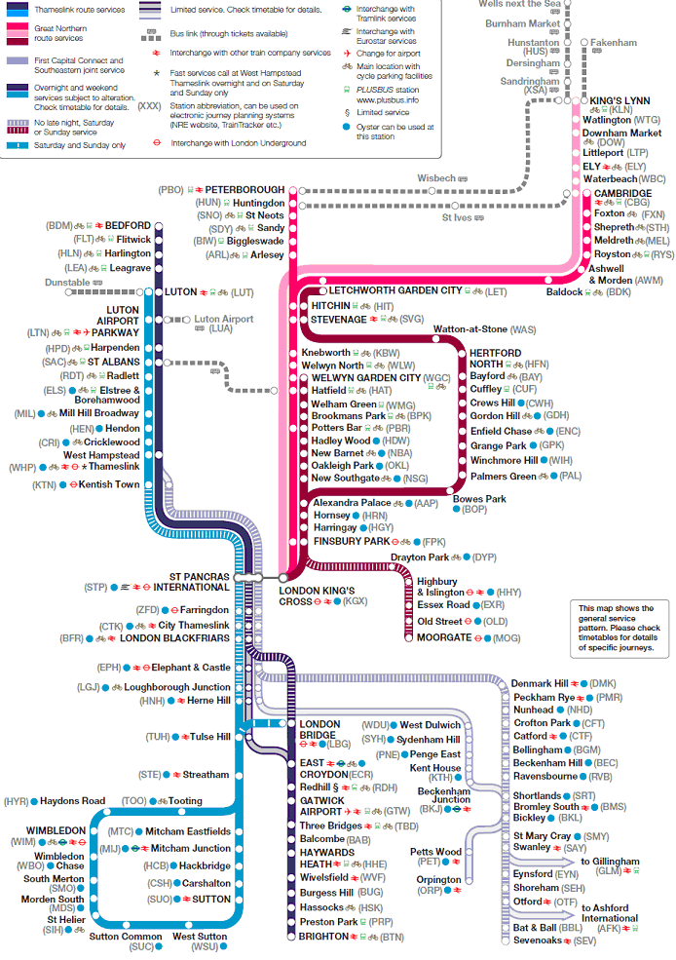
Appendix 1: Map of FCC services
Appendix 2: Map of Southern services
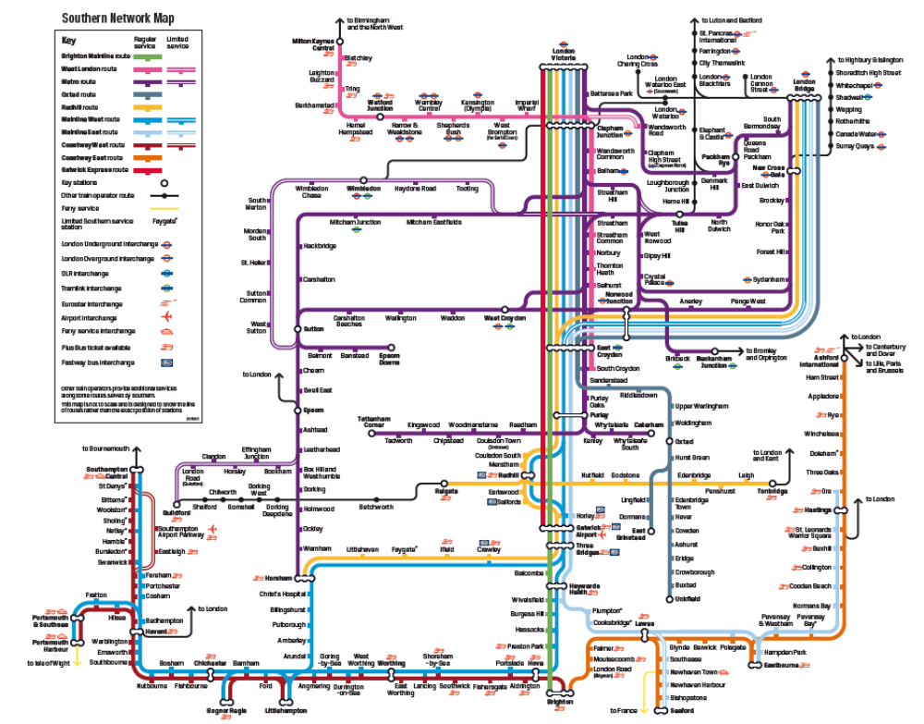
Appendix 3: Summary of consultation questions
Q.1 | What improvements do stakeholders believe could be made on the combined franchise through partnership working between Network Rail and the new operator?
Q.2 | Do consultees have any other specific aspirations for the new franchise that they wish to bring to the Department's attention?
Q.3 | Are consultees aware of any other rail or non-rail development schemes that might affect the new franchise?
Q.4 | What increments or decrements to the specification would stakeholders wish to see and how would these be funded?
Q.5 | Which aspects of the specification, other than for those services operating through the Thameslink core route, would stakeholders wish to see mandated and which aspects of the specification could be left to the discretion of the operator?
Q.6 | Are there other approaches to train service specification which you would prefer?
Q.7 | What changes to services would stakeholders propose, what is the rationale for them and would these provide economic benefit?
Q.8 | How might better use be made of the capacity currently available?
Q.9 | What steps might bidders be expected to take to meet passenger demand and what might be the most appropriate mechanisms for managing demand?
Q.10 | What destinations on the current Southeastern network do respondents think should be served by the combined franchise’s services and what is the rationale for such proposals?
Q.11 | How might better use be made of the capacity available on the Brighton Main Line?
Q.12 | What steps should bidders be expected to take to improve performance on the route?
Q.13 |  | What destinations on the Great Northern route do respondents consider would be appropriate to become destinations for trains which serve the core Thameslink route?
Q.14 |  | Do respondents believe Great Northern trains which do not serve the Thameslink core route should remain as part of this franchise or be transferred to the new Inter City East Coast franchise?
Q.15 |  | What improvements would respondents like to see made to Great Northern services as part of the combined franchise and what is the rationale for this?
Q.16 |  | What services would be appropriate to serve the Airport market?
Q.17 |  | What improvements could be made without adversely affecting the service provision on the remainder of the franchise?
Q.18 |  | What services that run via Elephant & Castle do respondents think should run via the Thameslink core route?
Q.19 |  | Recognising that not all of these services can run via the Thameslink core route, what would be the most satisfactory way of managing the interchange at Blackfriars?
Q.20 |  | What improvements would respondents like to see made to Coastway East and West services, the rationale for such proposals and the economic benefit expected to be delivered from these changes?
Q.21 |  | What improvements would respondents like to see made to other Southern services as part of the combined franchise from 2015, what is the rationale for such proposals and the economic benefit expected to be delivered from these changes?
Q.22 |  | What are respondents’ views on the practice of splitting trains at stations such as Haywards Heath?
Q.23 |  | Do respondents feel that the Newhaven Marine branch line and station should be kept open and maintained or should the rail industry deploy the relevant funding elsewhere on the rail network?
Q.24 |  | How would you like to see performance information published?
Q.25 |  | How frequent should its publication be?
Q.26 |  | What level of disaggregation of performance do you believe is reasonable?
Q.27 |  | What are the priorities that respondents consider should be taken into account to improve the passenger experience of using these services?
Q.28 |  | What do stakeholders see as the most important factors in improving security (actual or perceived) and addressing any gap between the two?
Q.29 |  | What is important to stakeholders in the future use and improvements in stations?
Q.30 |  | What priorities would respondents give to car parking and cycling facilities at locations where these are fully used?
Q.31 |  | What sort of ticketing products and services would you expect to see delivered through ‘smart’ technology on this franchise?
Q.32 |  | What local accessibility and mobility issues do stakeholders see and how they might be addressed?
Q.33 |  | What environmental targets would stakeholders like to see within the franchise specification?

Appendix 4: List of formal consultees inside the proposed service area
Association of Train Operating Companies
British Transport Police
Disabled Persons Transport Advisory Committee or successor
Equality and Human Rights Commission
Freight Operators
Freight Transport Association
Greater London Authority
Local Government Association
Local, Metropolitan, County and Unitary Authorities (within the franchise area)
London Boroughs (within the franchise area)
London TravelWatch
Mayor of London’s Office
Members of Parliament (within the franchise area)
National Rail Contractors Group
Network Rail
Office of Rail Regulation
Passenger Focus
Rail Freight Group
Rail Safety and Standards Board
Rolling Stock Leasing Companies
Train Operating Companies
Transport for London
Appendix 5: Code of Practice on Consultation
The Government has adopted a Code of Practice on consultations. The Code sets out the approach Government will take to running a formal, written public consultation exercise. While most UK Departments and Agencies have adopted the Code, it does not have legal force, and cannot prevail over statutory or other mandatory external requirements (e.g. under European Community Law).
The Code contains seven criteria. They should be reproduced in all consultation documents. Deviation from the code will at times be unavoidable, but the Government aims to explain the reasons for deviations and what measures will be used to make the exercise as effective as possible in the circumstances.
The seven consultation criteria
1. When to consult: Formal consultation should take place at a stage when there is scope to influence the policy outcome.
2. Duration of consultation exercises: Consultations should normally last for at least 12 weeks with consideration given to longer timescales where feasible and sensible.
3. Clarity of scope and impact: Consultation documents should be clear about the consultation process, what is being proposed, the scope to influence and the expected costs and benefits of the proposals.
4. Accessibility of consultation exercises: Consultation exercises should be designed to be accessible to, and clearly targeted at, those people the exercise is intended to reach.
5. The burden of consultation: Keeping the burden of consultation to a minimum is essential if consultations are to be effective and if consultees’ buy-in to the process is to be obtained.
6. Responsiveness of consultation exercises: Consultation responses should be analysed carefully and clear feedback should be provided to participants following the consultation.
7. Capacity to consult: Officials running consultations should seek guidance in how to run an effective consultation exercise and share what they have learned from the experience.
If you consider that this consultation does not comply with the criteria or have comments about the consultation process please contact:
Consultation Coordinator
Department for Transport
Zone 2/25 Great Minster House
33 Horseferry Road
London, SW1P 4DR
Email: consultation@dft.gsi.gov.uk
Appendix 6 – Service frequencies 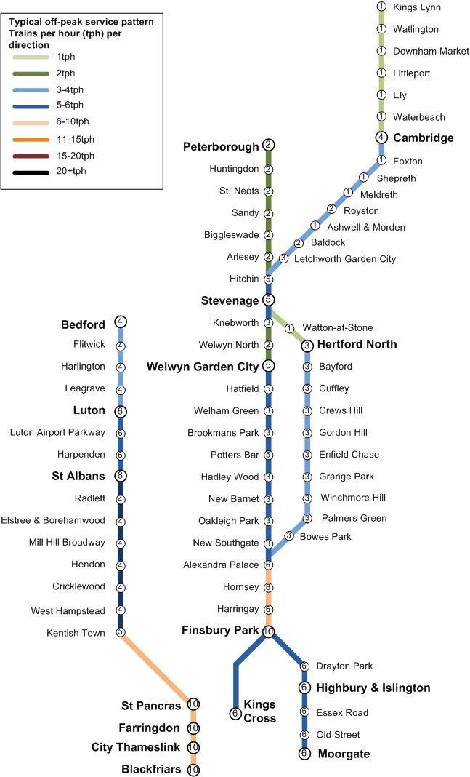
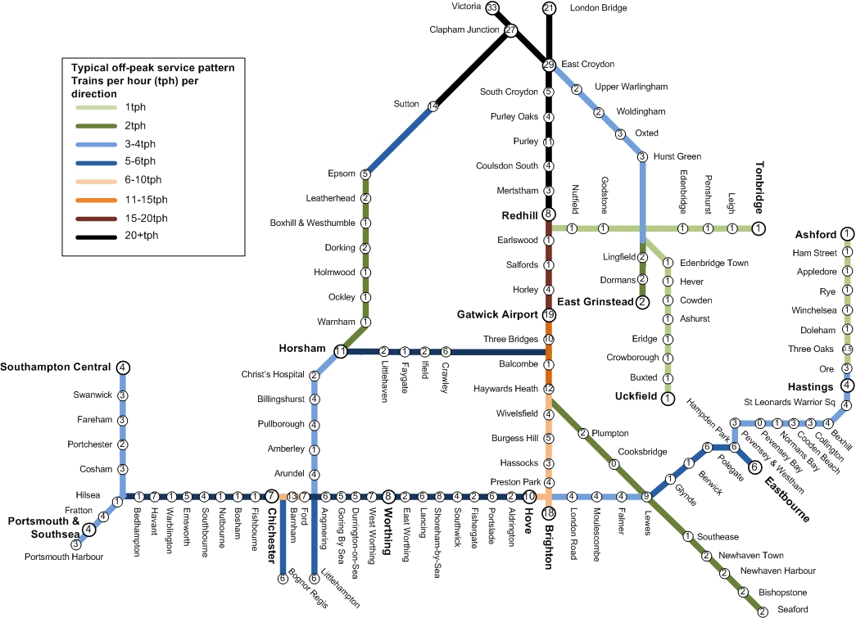

A separate consultation is also being published in relation to the associated South Eastern franchise. The geographical areas covered by the combined franchise are shown in the maps in appendices 1, 2 and 6.
The core Thameslink route is the line between St Pancras International low level and London Blackfriars via Farringdon.
This survey is carried out on two occasions each year and surveys passengers’ satisfaction. Further details can be found at http://www.passengerfocus.org.uk/research/nps/content.asp
ROSCO is the rolling stock company which owns the specific type of rolling stock and leases it to the franchise to use.
Thameslink core and Thameslink core trains means those trains that run between St Pancras International low level and London Blackfriars and vice versa.
ATO is the technology which allows services to be operated closer together safely

