

Investigating the potential health benefits of increasing cycling in the Cycling City and Towns

Nick Cavill (Cavill Associates) and Jenny Buckland (DfT)
April 2012
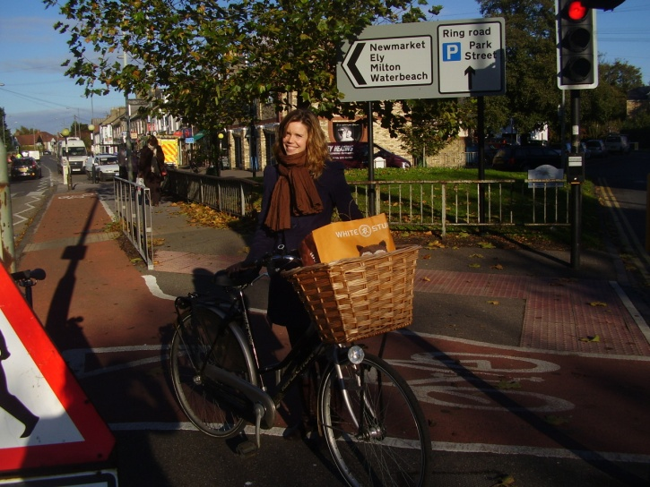
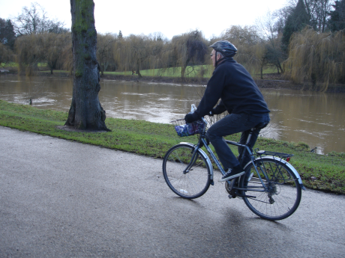
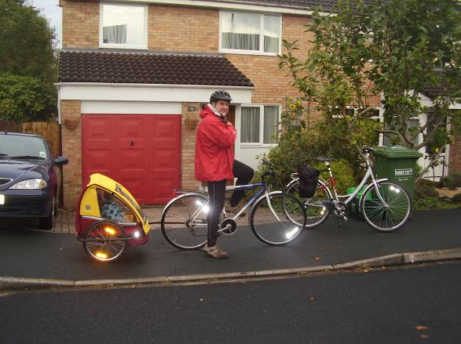

Disclaimer
Although this report was commissioned by the Department for Transport (DfT), the recommendations are those of the authors and do not necessarily represent the views of the DfT. While the DfT has made every effort to ensure the information in this document is accurate, DfT does not guarantee the accuracy, completeness or usefulness of that information; and it cannot accept liability for any loss or damages of any kind resulting from reliance on the information or guidance this document contains.

© Queen’s Printer and Controller of Her Majesty’s Stationery Office 2003
Copyright in the typographical arrangement and design rests with the Crown. This publication excluding logos may be reproduced free of charge in any format or medium provided that it is reproduced accurately and not used in a misleading context. The material must be acknowledged as Crown copyright and the title and source of the publication specified.
Investigating the potential health benefits of increasing cycling in the Cycling City and Towns

Contents

1. Executive summary 4
2. Objective of this report 6
3. Cycling and health: key messages from previous research 6
4. Background to the Cycling City and Towns programme 7
5. Methodology 7
6. Part A: decreasing the risk of all-cause mortality through cycling. 10
7. Part B. Exploring the likelihood of each group increasing their level of cycling 16
8. Discussion 19
9. Concluding comments 22

Executive summary

This report presents an exploratory analysis of data emerging from the evaluation of the Cycling City and Towns (CCT) programme, to investigate the potential for delivering public health benefits through increasing cycling amongst different population groups.

There is strong evidence from existing research for the health benefits to individuals of cycling as a form of physical activity. However, we do not yet know what the public health impacts might be of schemes to promote cycling amongst local populations.

Using data from a baseline survey conducted in the CCT areas in 2009, this analysis demonstrates that the public health impacts of the programme (in terms of annual risk of all-cause mortality) are likely to be highly dependent on who is successfully encouraged to increase their levels of physical activity through cycling.

- In the CCTs in 2009, 38% of the adult population was estimated to be inactive, 23% moderately inactive, 19% moderately active and 20% active.
- There is little potential public health benefit to be gained from encouraging the 39% of people who are already physically active/moderately active to start cycling or to cycle more.
- By contrast, there is a well-evidenced and quantifiable potential benefit to be gained from encouraging the 61% of people who are physically inactive/moderately inactive to start cycling or to cycle more.

The analysis then breaks down the CCT population by estimated responsiveness to intervention as well as reported physical activity levels, to identify what proportion of inactive and moderately inactive people may be easier or harder to reach.

- 21% of the CCT adult population was estimated to have a higher probability of being a regular cyclist in future, 24% a medium probability, and 55% a lower probability.
- The inactive and moderately inactive groups had proportionately more lower probability individuals than the active and moderately active groups. The largest population group (30% of adults) was Inactive Low Probability.
- However, 19% of the CCT population were estimated to be in the Inactive or Moderately Inactive groups AND to have a Higher or Medium Probability of cycling regularly in future.
- Thus, one fifth of the CCT population appear to be those who would benefit in health terms from increasing their levels of physical activity, and for whom there are likely to be relatively fewer barriers to cycling.
- If all of these individuals moved one category up the physical activity index through cycling, there would be an estimated 300 fewer deaths per year across the CCTs. Although this may be an unrealistic ambition, similar estimates could be made for successfully reaching fractions of the groups in question.

Finally, it is shown how barriers to cycling vary across the different groups, indicating that targeted interventions of different levels of intensiveness are likely to be required to reach those with most to gain in terms of health from cycling.

It is important to note that this analysis uses cross-sectional baseline data and a range of assumptions to estimate the likely public health impacts of a cycling programme amongst different groups. The hypotheses presented here need to be confirmed through the collection of post-intervention data in the CCT areas, which is scheduled for 2012.

Objective of this report
This report aims to bring together existing research evidence on the relationship between cycling and health outcomes, together with data collected by the Cycling Cities and Towns (CCT) baseline survey in 2009, in order to:

- explore the potential health benefits of increasing cycling among different groups of the CCT population;
- estimate the likelihood of each of these groups taking up cycling; and
- combine these to assess the potential for delivering public health benefits through increasing cycling amongst different population groups.

Cycling and health: key messages from previous research
There is strong evidence for the health benefits of cycling as a form of physical activity, notably through associated reductions in all-cause mortality, cardiovascular disease and some cancers as well as making contributions to other aspects of health such as weight control and mental health . Regular cycling contributes to an individual’s total physical activity, which is related to reduced risk of mortality. However, one of the largest prospective studies of cycling and physical activity found a 39% reduction in risk of all-cause mortality among regular cyclists, even when controlled for leisure time physical activity .

A number of comprehensive assessments have shown that the health benefits of cycling (through reduced mortality and morbidity as a result of increased energy expenditure) greatly outweigh the risks due to poor air quality and road traffic casualties. De Hartog et al (2010) found life years gained among individuals who shift from car to bicycle to be 3 to 14 months compared to 0.8 to 40 days lost through increased inhaled air pollution, and 5 to 9 days lost due to an increase in traffic ‘accidents’ . More recently, Rabl and de Nazelle compared risks and benefits and said “one can firmly conclude that by far the most important item is the health benefit due to the physical activity” .

The evidence is less strong on the effectiveness of interventions to increase cycling. A recent systematic review concluded that “community-wide promotional activities and improving infrastructure for cycling have the potential to increase cycling by modest amounts, but further controlled evaluative studies incorporating more precise measures are required” . In particular there is a need to understand how to promote cycling among groups that are currently sedentary, and therefore might have the greatest potential health benefit.

Background to the Cycling City and Towns programme
Between 2008 and 2011, the Department for Transport, Cycling England and the Department of Health invested £43m (plus local match funding) in the locally designed and delivered Cycling City and Towns (CCT) programme. Its aim was to encourage “more people to cycle, more safely and more often” in 12 urban areas of England, and to learn lessons for the future from the experience.

An evaluation of the programme is being led by AECOM in association with the University of the West of England and the Tavistock Institute. For more details and copies of published materials including methodological reports, see http://www.dft.gov.uk/publications/cycling-city-and-towns-programme. A copy of the baseline dataset on which this analysis is based can be downloaded from this site.

A key element of the evaluation was a 15,000 household baseline survey of cycling behaviour and physical activity conducted between July and November 2009 in CCT programme areas. This report analyses data from the baseline survey, as described below.

Methodology

Results from the following baseline survey elements have been analysed:

- Household interview. Data were collected from a representative sample of 15,000 households across programme areas using face-to-face interviews. The survey included questions on sociodemographic characteristics, current levels of physical activity, current transport behaviours (including cycling levels), and bicycle ownership. Although both adults and children were interviewed, this analysis focuses on adults.

The household survey included questions designed to categorise respondents into four physical activity categories as shown in Figure 1 below: inactive; moderately inactive; moderately active; and active.

Figure 1: Physical Activity Classifications Based on European Prospective Investigation into Cancer (EPIC) Physical Activity Index

 | Cycling and other physical exercise/sport (average hours per day)
Occupational physical activity | 0 | >=0 and <=0.5 | >0.5 and <=1.0 | >1.0
Sedentary or non-worker | Inactive | Moderately inactive | Moderately active | Active
Standing | Moderately inactive | Moderately active | Active | Active
Physical work | Moderately active | Active | Active | Active
Heavy manual | Active | Active | Active | Active

This classification was derived from answers to questions from the European Prospective Investigation into Cancer (EPIC) study questionnaire . The questions ask about occupational physical activity and time spent per week over the last year in six different types of non-occupational physical activity:

- Walking
- Cycling
- Gardening
- Housework
- DIY
- other physical exercise/sport

- Self completion questionnaire. A paper-based questionnaire eliciting respondents' views on a range of attitudinal and perceptual issues to do with cycling was placed with adult household survey respondents. It included the following question about the respondent’s relationship to regular cycling:

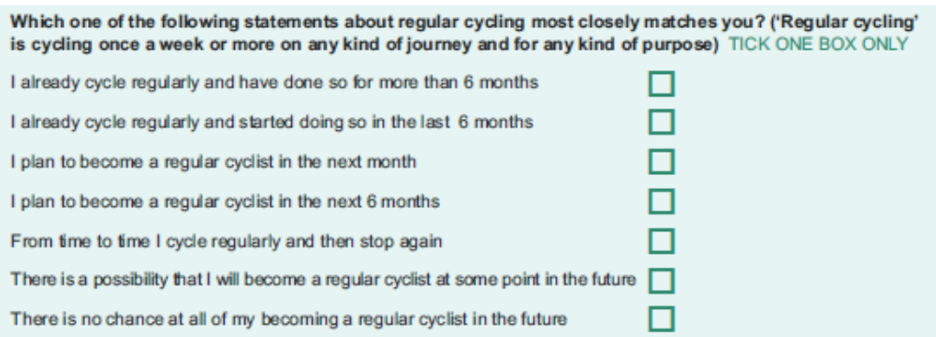

Responses from a total of 6,600 adults who completed all relevant questions on both of these survey instruments have been included in this analysis.

Data have been weighted to be representative of the population of the CCT programme areas. It is not possible to generalise statistically from this data to the national population. Result should be viewed as representative of the CCT programme areas and potentially indicative of similar medium-sized urban areas in England.

The analysis has been done in two parts, which are reported in Part A and Part B below:

Part A. Using the CCT baseline survey data together with the evidence on the risk of all-cause mortality in different physical activity groups, an assessment has been undertaken of the potential benefits to health of targeting cycling interventions towards individuals according to their current level of physical activity, based on a number of theoretical projections. The analysis focuses on all-cause mortality as the principal health outcome as a) it is the most tangible and ‘hardest’ measure and b) it can estimated using the physical activity data collected using the EPIC instrument during the CCT baseline survey. It should be noted that this therefore underestimates the potential benefits of cycling in other areas of physical health and mental wellbeing, and the consequent impact on factors such as absenteeism.

Part B. Using the CCT baseline survey data on the respondent’s stated relationship to regular cycling, the likelihood of individuals in each physical activity group (inactive; moderately inactive; moderately active; and active) increasing their level of cycling is estimated. The implications of this for the targeting of cycling interventions at different population groups are then discussed.

Part A: decreasing the risk of all-cause mortality through cycling.
Exploring relative risks

The EPIC physical activity index (which categorises individuals into one of four categories: inactive; moderately inactive; moderately active; and active) has been well validated against objectively measured energy expenditure More importantly, the index has been shown to have predictive validity: a large prospective study of adults found a relationship between decreasing levels of risk of all-cause mortality with increasing levels of activity

As Figure 1 above shows, an inactive person is classified as doing no physical activity on average per day, and being a sedentary worker or nonworker. A moderately inactive person is classified as being a sedentary worker or nonworker who does up to 30 minutes of physical activity on average per day, OR a "standing" worker who does no additional physical activity on average per day.

Figure 2 shows that compared to the inactive category, people classed as moderately active have a relative risk of dying in a given year of 0.83. This means that for every 100 inactive people who die in a given year, only 83 moderately inactive people will die. The relative risk for moderately active and active people compared to inactive people is 0.68. There is no risk reduction in the active category compared to the moderately active. This analysis controls for other risk factors (such as smoking and diabetes) to try to isolate the unique effect of the physical activity on mortality.

Figure 2
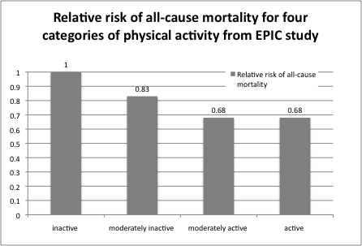

The EPIC study explored the risk among groups who reported their activity levels at one point in time and did not assess the reduction in risk through changing activity levels. However, if we make the assumption that people who change activity levels adopt the new level of relative risk, then based on the relative risks alone it is clear that there is a greater potential benefit to public health if individuals in the inactive and moderately inactive categories are encouraged to start cycling.

However, this does not take into account the size of each group (i.e. the prevalence of physical activity in the population). For example, if there were very few people in the inactive category and more in the moderately inactive category, this would have implications for the distribution of benefits.

Exploring the size of each population group

Figure 3 shows the distribution of the EPIC categories in the CCT data (all adult respondents). The largest group is the inactive (37%) with 23% classed as moderately inactive, and 19% moderately active and 21% active.

Figure 3
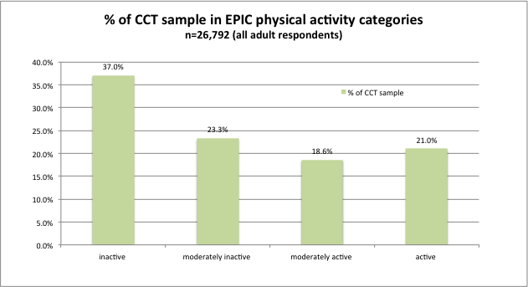
Source: CCT evaluation baseline survey.

We can combine the relative risk figures with the size of the population in each category to estimate the ‘population attributable risk’ for each level of physical activity. This gives a better indication of the importance to public health, and gives us clues about the priorities for targeting interventions.

The best way to illustrate this is with some scenarios, in which we project changes in physical activity due to cycling in each population group and estimate the resulting impact on all-cause mortality, using the relative risks outlined above. These scenarios are theoretical only: in many cases they are unrealistic, but they demonstrate the relative impact of moving members of each activity group into the next level of activity, in order to compare different strategies for targeting of interventions. Workings for all these scenarios are shown in Appendix 1.

In order for an inactive person to move up to moderately inactive on the EPIC index, they would need to start doing some physical activity. In order for a moderately inactive person to move up to moderately active, they would need to increase their physical activity to 30 minutes or more on average per day (for a sedentary or nonworker), or start doing some physical activity (for "standing" worker). For the purposes of this analysis, it is assumed that cycling represents additional physical activity, and does not displace any existing physical activity.

Scenario 1. Focus on the Inactive.

If all inactive people in the CCTs move up a level and become classed as moderately inactive, there would be around 600 fewer deaths within the CCTs per year.

Figure 4
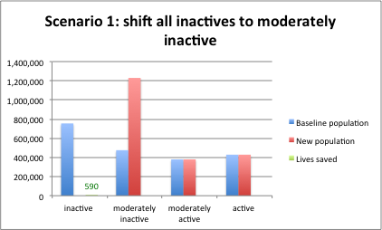

Scenario 2. Focus on moderately inactive

If all moderately inactive people in the CCTs move up a level, this would result in around 300 fewer deaths within the CCTs per year.

Figure 5
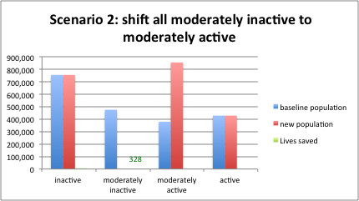

Scenario 3. Focus on moderately active

As there is no relative risk reduction between the moderately active and active categories, this does not lead to any reduction in deaths.

Figure 6
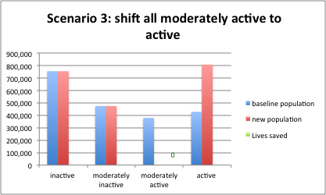

Thus it can be seen that from the public health point of view, more would be gained in terms of impact on all-cause mortality from increasing cycling (or sport/exercise in general) among those who are currently inactive, than would be from getting moderately inactive people to do more. This remains the case while the inactive group is larger than the moderately inactive group (the inactive group would have to be reduced from 38% to 28% of the population before the strategies were comparable). Nothing is gained in terms of all-cause mortality rates from increased activity levels amongst those who are already moderately active.

Figure 7 shows this, with the x-axis plotting the potential benefits to health (through reduced mortality) of achieving increases in cycling or other physical activity amongst specific groups. The size of the circle represents the size of the group in the CCT programme population.

It is worth noting that in this analysis no groups are on the left side of the y-axis, as it is assumed that an increase in cycling will not harm health in any way. This analysis does not take account of any possible increase in road traffic casualties through cycling or any other injury associated with cycling. As noted in section 3 above, there are some identifiable risks associated with cycling, but these are far outweighed by the health benefits. More evidence is required to assess whether the risks to an individual decrease as the population levels of cycling increase (the "critical mass" effect).

Figure 7

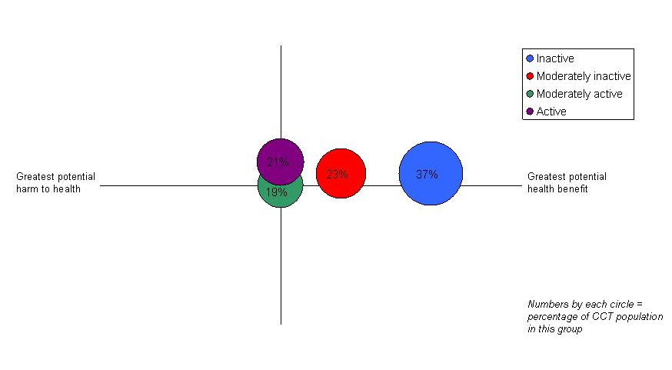
Source: CCT evaluation baseline survey, N=6,600 respondents who completed relevant survey items.

The potential health benefit has to be set against the challenge of achieving increased activity levels among sedentary people. Part B of this report will start to plot the y-axis by investigating the likelihood of different groups taking up cycling.

Part B. Exploring the likelihood of each group increasing their level of cycling

In this section of the report, the CCT baseline survey self-completion questionnaire data are explored to investigate relationships between physical activity levels and attitudes to cycling. The aim of this is to explore which of the physical activity groups might be more or less likely to take up cycling (and hence to develop the y-axis on the chart above).

Looking first at the broad relationships between physical activity levels and attitudes to cycling, it can be seen that less active people on average have less positive views than more active people (Figure 8).

Figure 8: attitudes to cycling amongst different physical activity groups
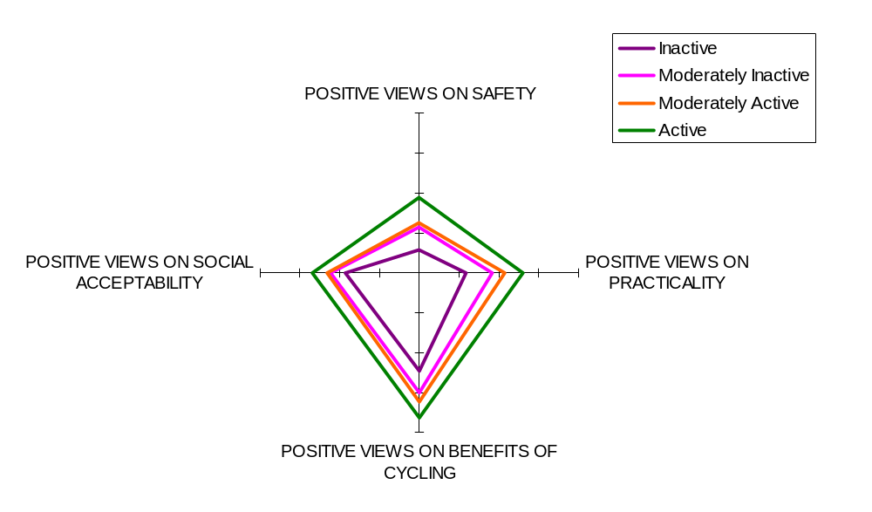
Source: CCT evaluation baseline survey (self completion module). Base varies by question.

This is consistent with the physical activity literature where attitude and beliefs towards activity have been show to be strongly correlated with behaviour .

Question B11 of the self-completion survey asked respondents to agree which of a number of statements about cycling most closely matched them. These statements were based on the transtheoretical model of behaviour change and combined a basic assessment of ‘regular’ cycling behaviour with intention to change. People who had earlier reported not knowing how to ride a bicycle were not asked this question, as it was assumed that this presented more of a barrier to cycling than their attitude to cycling.

For the purposes of this analysis, responses to this question have been categorised into three groups roughly representing higher, medium and lower probability of being a regular cyclist in future.

In the group of ‘higher probability of being a regular cyclist in future’ are people who agree:
- I already cycle regularly and have done so for more than six months (16% of the total CCT sample).
- I already cycle regularly and started doing so in the last six months (2%).
- I plan to become a regular cyclist in the next month (1%).
- I plan to become a regular cyclist in the next six months (2%).

In the group of ‘medium probability of being a regular cyclist in future’ are people who agree:
- From time to time I cycle regularly and then stop again (8% of total sample).
- There is a possibility that I will become a regular cyclist at some point in the future (16%).

In the group of ‘lower probability of being a regular cyclist in future’ are people who agree:

- There is no chance at all of me becoming a regular cyclist in the future (44% of the total CCT sample).
- Plus people who reported not knowing how to ride a bicycle (12%).

This allows us to split the EPIC physical activity categories into three sub-categories based on estimated probability of cycling regularly in future, and plot them on a y-axis of ‘probability of cycling regularly in future’ (Figure 9).

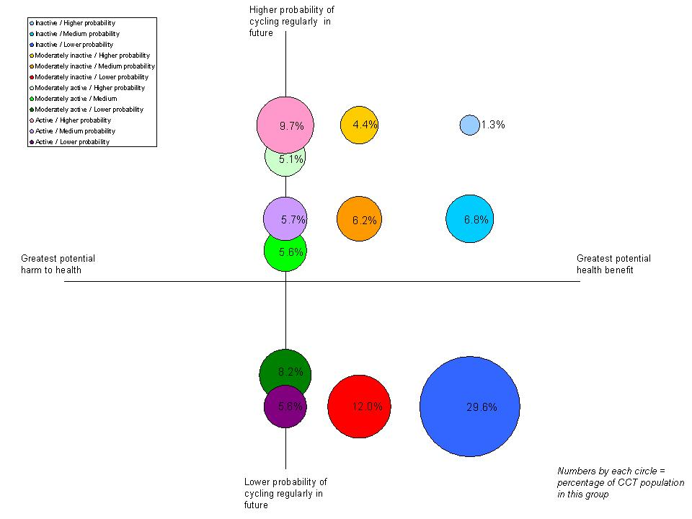
Figure 9

Source: CCT evaluation baseline survey, N=6,600 respondents who completed relevant survey items.

Discussion

According to this analysis, there are six groups that might be seen to be priorities for targeting from a health perspective due to their low current levels of physical activity. If cycling initiatives are to attempt to combine targeting of those most likely to benefit, with those most likely to change, then it could be argued that there are four groups of interest for targeted initiatives. The proportion of the CCT population in each of these groups is set out in the table below:

 | Medium probability | Higher probability
Inactive | 6.8% | 1.3%
Moderately inactive | 6.2% | 4.4%

Although each group is relatively small, they add up to nearly a fifth of the CCT population.
As above, for illustrative purposes only, we can model the impact of successfully targeting these groups, with the following assumptions:
- A cycling intervention that is explicitly targeted at the inactive and moderately inactive;
- Leads to uptake only by those groups deemed in the high or moderate probability category;
- Moves each group up one category only (i.e. inactives become moderately inactives; moderately inactives become moderately active). For inactive people this just means doing some activity; for moderately inactives it means doing 30 minutes per day for most (depending on their occupational activity – see Figure 1).

This leads to an estimate of 328 fewer deaths per year across the CCTs. This scenario gives the same projection as the one which assumed shifting all moderately inactive people to moderately active (figure 4; 328 deaths per year) but is much more realistic as the focus is on those who are more likely to change.

For targeting purposes, it is also helpful to explore what barriers might exist for each of these groups. Figure 10 below shows the characteristics of each of the inactive or moderately inactive groups identified in Figure 9. (N.b. the high probability groups have been combined into one group representing inactive and moderately inactive high probability respondents, due to small sample sizes.)

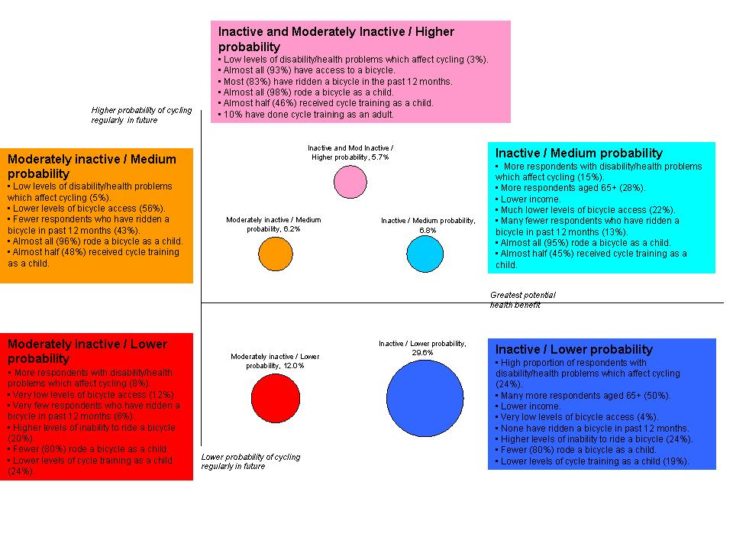
Figure 10

Source: CCT evaluation baseline survey, N=6,600 respondents who completed relevant survey items.

This analysis should be treated as exploratory only. Nevertheless, it does demonstrate the importance of considering the specific barriers faced by defined groups. Several themes arise for further exploration. For example:

Lapsed cyclists versus non-cyclists

Almost all the respondents in the High Probability group appear to be cyclists who have recently lapsed: they have a bicycle and have cycled in the past year, but at the time of the survey were not regular cyclists. The interventions required to restart cycling amongst this group could be assumed to be different (and probably less intensive) than the interventions required for the Medium Probability groups, who have lower levels of access to bicycles, less recent cycling experience, and (in the case of the Inactive Medium Probability group) lower income and more respondents aged 65 years and over.

Bicycle availability

Bicycle availability is low amongst the Inactive Medium Probability group compared to the Moderately Inactive Medium Probability group. With lower income on average, this group may be more likely to have financial barriers to acquiring a bicycle (although it is important to note that other barriers also exist in this group, such as older age and higher levels of disability and health problems).

Bicycle availability is not relevant to the High Probability group. It is also not the most relevant barrier to the Low Probability groups, who demonstrate more basic barriers in terms of ability to ride a bicycle, and much higher levels of disability and health problems.

Cycle training

Cycle training as a child is associated with higher probability of cycling in future amongst adult respondents. Only a minority of those in the Low Probability groups received cycle training as a child.

By contrast, the Inactive and Moderately Inactive High Probability group is characterised by much higher levels of adult cycle training (9% compared to almost none in other groups). It is not possible to assess whether there is a causal relationship here, but it is strongly indicative of the importance of adult cycle training for certain groups.

Concluding comments
This is only initial exploratory analysis of the CCT baseline survey dataset, looking at the data with a public health focus. It demonstrates clearly that the priority target audiences from a public health perspective are those in the groups with the lowest current physical activity levels, as that is where there is the maximum potential public health benefit. It also quantifies the size of each group within the CCT population, although nationally representative data are not available. It then gives some preliminary indications of possible barriers to cycling amongst groups with different potential health benefits and likelihood of cycling in future.

There are a number of limitations to this analysis that are important to consider.

- The death modelling approach is relatively crude and does not take account of some critical issues such as age-specific deaths rates (as death rates vary dramatically with age). It also only focuses on mortality and does not take account of the many benefits to other aspects of health and quality of life through cycling (and physical activity). Due to the use of EPIC it also uses only four categories of physical activity and so does not use the curvillinear dose-response relationship between physical activity and mortality found in most epidemiological studies. This produces relatively crude categories of physical activity: for example, high proportions of respondents are classed as inactive using this classification but they claim to be regular cyclists.
- The categorisation of respondents into the probability groups is based on some important assumptions about the correlation between stated intention to cycle in future and actual future behaviour, which have not as yet been confirmed by research. The extent to which individuals may move between the groups without intervention is unknown, as is the extent to which individuals may lapse back into less active groups after an initial increase in activity (and what might stop them from doing so).
- Finally, the variables included in the barriers analysis were selected based on crosstabulations, rather than the preferred approach of performing a logistic regression to see which factors accounted for the most variance in cycling/physical activity.

This paper has focused on using cross-sectional data from one time point to give insight to inform the targeting of cycling initiatives at specific groups. As a result, it has ignored one critical issue: that it may be more effective to invest in broad infrastructural change at a population level instead of or as well as delivering targeted interventions. Longitudinal data will be available once a post-intervention survey of cycling and physical activity levels in CCT areas is conducted during 2012. This will help to refine the assumptions about behaviour change used in this paper.

Although this paper focuses on cycling, walking is another form of physical activity which may be more achievable for some individuals, with similar benefits. However, evidence is more limited on walking and this kind of analysis is not yet possible using existing data.

Appendix 1. Calculations for scenarios analyses in part A

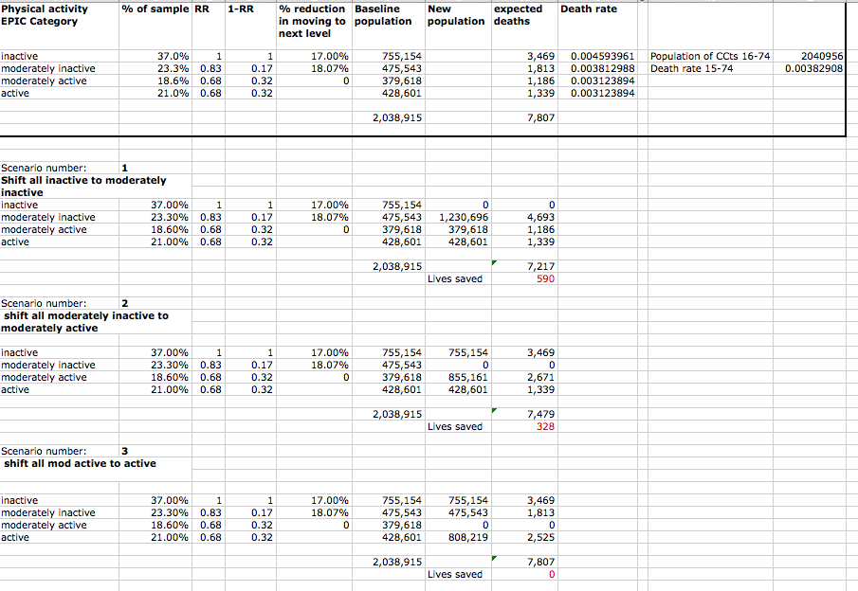

References

Andersen, L., P. Schnohr, et al. (2000). "All-cause mortality associated with physical activity during leisure time, work, sports, and cycling to work." Arch Intern Med 160(11): 1621-1628.
Cavill, N. and A. Davis (2007). Cycling and Health: what's the evidence? London, Cycling England.
Cust, A., B. Smith, et al. (2008). "Validity and repeatability of the EPIC physical activity questionnaire: a validation study using accelerometers as an objective measure." Int J Behav Nutr Phys Act 5: 33.
Johan de Hartog, J., H. Boogaard, et al. (2010). "Do the Health Benefits of Cycling Outweigh the Risks?" Environ Health Perspect 118(8).
Khaw, K. T., R. Jakes, et al. (2006). "Work and leisure time physical activity assessed using a simple, pragmatic, validated questionnaire and incident cardiovascular disease and all-cause mortality in men and women: The European Prospective Investigation into Cancer in Norfolk prospective population study." Int J Epidemiol 35(4): 1034-1043.
Oja, P., S. Titze, et al. (2011). "Health benefits of cycling: a systematic review." Scand J Med Sci Sports.
Rabl, A. and A. de Nazelle (2012). "Benefits of shift from car to active transport." Transport Policy 19(1): 121-131.
Trost, S., N. Owen, et al. (2002). "Correlates of adults' participation in physical activity: review and update." Med Sci Sports Exerc 34(12): 1996-2001.
Tuah, N. A., C. Amiel, et al. (2011). "Transtheoretical model for dietary and physical exercise modification in weight loss management for overweight and obese adults." Cochrane database of systematic reviews(10): CD008066.
Wareham, N. J., R. W. Jakes, et al. (2003). "Validity and repeatability of a simple index derived from the short physical activity questionnaire used in the European Prospective Investigation into Cancer and Nutrition (EPIC) study." Public Health Nutrition 6(4): 407-413.
Yang, L., S. Sahlqvist, et al. (2010). "Interventions to promote cycling: systematic review." BMJ 341: c5293.

Physical activity classifications based on European Prospective Investigation into Cancer (EPIC) Physical Activity Index.
Assuming that the physical activity achieved through cycling does not displace existing physical activity.
CCT population categorised into Higher, Medium and Lower Probability of being a regular cyclist in future, using survey questions on the respondent’s relationship to regular cycling and ability to ride a bicycle.
Greater Bristol, Blackpool, Cambridge, Chester, Colchester, Leighton Linslade, Shrewsbury, Southend, Southport, Stoke-on-Trent, Woking and York.
Moderate and vigorous intensity activity are grouped together – the relationship with mortality was found for ‘at least moderate’ intensity activity.
It is important to note that the relative risk data shown here are averages which do not differentiate between different ages and sexes. A more complex analysis could take account of age and sex.
This model groups people into stages of change from pre-contemplation through contemplation, preparation, action and maintenance. Tuah, N. A., C. Amiel, et al. (2011). "Transtheoretical model for dietary and physical exercise modification in weight loss management for overweight and obese adults." Cochrane database of systematic reviews(10): CD008066.
Total may not sum to 100 due to rounding.

