High Speed Rail:
Investing in Britain’s Future – Decisions and Next Steps

Presented to Parliament by the Secretary of State for Transport by Command of Her Majesty
January 2012

Cm 8247 £29.75

Photographic acknowledgements
Alamy: 10, 20, 54, 82, 87, 99, 109; Southeastern: 36, 39; Alstom: 46, 58

The Department for Transport has actively considered the needs of blind and partially sighted people in accessing this document. The text will be made available in full on the Department’s website. The text may be freely downloaded and translated by individuals or organisations for conversion into other accessible formats. If you have other needs in this regard please contact the Department.

© Crown copyright, 2012, except where otherwise stated
You may re-use this information (excluding logos) free of charge in any format or medium, under the terms of the Open Government Licence. To view this licence, visit http://www.nationalarchives.gov.uk/doc/open-government-licence/ or e-mail: psi@nationalarchives.gsi.gov.uk.
Where we have identified any third party copyright information you will need to obtain permission from the copyright holders concerned.
Any enquiries regarding this publication should be sent to us at: Department for Transport Great Minster House 33 Horseferry Road London SW1P 4DR
Telephone 0300 330 3000 Website www.dft.gov.uk General email enquiries FAX9643@dft.gsi.gov.uk
This publication is available for download at www.official-documents.gov.uk
This document is also available from our website at www.dft.gov.uk
ISBN: 9780101824729
Printed in the UK by The Stationery Office Limited on behalf of the Controller of Her Majesty’s Stationery Office
ID 2471606 01/12
Printed on paper containing 75% recycled fibre content minimum.

Contents
Foreword 5
Introduction 8
Part I – The Government’s High Speed Rail Strategy
and Summary of Decisions
Summary of High Speed 2 11
The Government’s High Speed Rail Strategy 16
Summary of Decisions 37
Part II – Review of Evidence from Consultation Responses
1 Introduction 40
2 Case for Action 42
3 Case for a National High Speed Rail Network 51
4 Phasing, Heathrow Airport and High Speed 1 74
5 Technical Specification and Route Selection for HS2 83
6 Line of Route for HS2 (London – West Midlands) 91
7 The Fair Property and Blight Deal 106
Part III – Next Steps
Next Steps 110
List of Supporting Documents 113
Glossary 115

Foreword

Britain is the country that gave birth to the railways. The Victorian railway pioneers left us an impressive legacy that clearly demonstrates the power of transport. By leading the first rail revolution, our industries flourished, our exports multiplied, and our economy grew wealthy. The railways are today as crucial to our current and future national well-being as they were to our past success. It is my responsibility to make sure they carry on providing the connections that help to link our communities, grow our economy and keep our country moving.
Looking around the world, the evidence is clear – nation after nation is planning, constructing or already using high rail speed lines. High speed rail is transforming their societies and their economies. Self-imposed exile from this new frontier in travel would mean that Britain loses out, while our global competitors gain. We face a straightforward choice. We can take the short-term option – leaving our rail networks over-stretched and over-burdened and risk paying the price in lost business, lower growth and fewer jobs. Or we can take the long-term option – investing in our global competiveness and our economic prosperity by pursuing high speed rail. High speed rail can transform our rail network in the same way that the motorways have transformed our road network.
It is vital that we invest in the transport connections necessary to enable faster and more convenient journeys between our major cities and international networks. That is how we will support our companies and wealth creators and make Britain the best place in the world to do business. The future success of our country relies not only on having a transport system that supports the economy, but on making sure that it also strengthens our society by better connecting communities. Our railways have a critical role to play in both these objectives.
To secure the future resilience of our rail network we need to take action. Growth in demand looks set to outstrip the pace at which upgrading existing lines can provide additional capacity. Further rounds of upgrades to our major north-south lines are a short term approach incapable of meeting the long term challenge. They could add only limited further capacity and would consign rail passengers and the vitally important rail freight industry to years, if not decades, of future engineering disruption, delay and unreliability. The choice is not, therefore, whether or not to build new lines but what type of new line to build. Any new line, if only built to enable conventional speeds, would certainly fail to reap the economic rewards offered by high speed.
As countries around the world are increasingly recognising, high speed rail is the next railway revolution. High Speed 2 (HS2) will, in the great tradition of British railways, represent a world-beating example of the opportunities and benefits high speed rail can offer, and will provide the foundation for a potential wider national network in the future. All the main political parties recognise these benefits. I wholeheartedly welcome this consensus, on the basis that it will ensure that the planning and construction of HS2 are carried through to fruition.
At its heart, HS2 is about the everyday but vital issue of making sure that the railway system of this country has enough capacity to enable people to make the journeys they choose. HS2 is the right answer for passengers – for those who travel on crowded inter-city trains, increasingly forced to stand for long parts of their journey, and for commuters who will eventually be unable even to get on their train at peak times. HS2 is about improving the connections between our major cities, and providing modern, efficient services that passengers can rely on. It will have further benefits beyond the railways, by releasing the capacity to enable a renaissance of rail freight, getting lorries off the roads and saving carbon.
There will be clear benefits not only for passengers and goods, but for the industries which deliver HS2. This country’s vibrant engineering sector is one of the major strengths of our economy and British engineering companies compete effectively in markets around the world. In high speed rail, many British firms are already active in developing, building and operating networks in many countries. HS2 will offer an exciting opportunity for British business to develop new experience and expertise, acting as a springboard for further work overseas. As countries around the world increasingly invest in new high speed rail systems we will all feel the benefit if British firms are able to get a slice of this boom industry.
But let me be clear that, in securing these benefits for our country, the Government is committed to developing a national high speed rail network with the lowest feasible impacts on local communities and the natural environment. I have been mindful that, especially in places such as the Chilterns Area of Outstanding Natural Beauty, we must safeguard the countryside and its wildlife as far as possible, both for the benefit of those living there today but also for future generations who will wish to continue to enjoy this beautiful countryside. The extent of the additional tunnelling added to the line – in the Chilterns and as the line passes through Ruislip in West London – but also the amendments to the alignment of the route in a number of places right along its length, demonstrate what we have been able to achieve.
In large part these changes are testament to the constructive and thoughtful responses we received to the consultation on high speed rail. Local people highlighted particular concerns and provided helpful comments about the route. These responses set my engineers a number of challenges and I welcome the positive ways in which they have been able to respond.
Given the extent of the improvements to the route between London and the West Midlands that have been achieved through the consultation, I want to see more engagement with local people as the project progresses and as further environmental assessment is undertaken. This document sets out the next steps for ensuring that people can continue to influence the project.
These are testing economic times and I recognise there are some who argue that we cannot afford a project like HS2. I want to reassure people that this project is affordable and can be delivered on time and to budget. In truth, if this country is to out-compete, out-produce and out-innovate the rest of the world then we cannot afford not to go ahead with HS2. Put simply, we must invest in our transport network, not in spite of the economic challenges we face, but as a means to overcome them and to secure our country’s economic future.
We in Britain are the heirs of the Victorian inventors and innovators who gave the world the railways and transformed this country’s fortunes. They had the vision to seize the moment and the ambition to meet the challenge. Our generation must follow their example by putting Britain on the high speed track to a better future.



The Rt Hon Justine Greening MP Secretary of State for Transport

Introduction

Purpose and background
1 On 28 February 2011 the Government launched a national consultation, High Speed Rail: Investing in Britain’s Future. The consultation set out the Government’s proposed strategy for a national high speed rail network for Britain and the route for an initial line between London and the West Midlands.
2 The consultation asked seven questions, covering the Government’s overall strategy, the proposed route for the London to West Midlands line, the environmental appraisal of this line, and options for supporting property owners affected by the proposals. The consultation closed on 29 July 2011. 54,909 responses were received.
3 The purpose of this document is to set out the decisions reached by the Government in the light of the consultation on these issues. It also outlines the programme for the immediate next stages of the project, including consultation on property and blight proposals and the development of the hybrid Bill for the London-West Midlands line.

Content
4 Part I of this document sets out the Government’s confirmed strategy for high speed rail. Over the long term, capacity pressure on the railways is forecast to escalate steadily. Demand for rail travel is growing in a number of markets, including long-distance travel but also for commuter and freight services. This section of the document demonstrates that a new national high speed rail network is the best option for dealing with these challenges. As well as providing vital capacity for passengers, High Speed 2 (HS2) will help to promote national economic growth, and support the Midlands and the North to fulfil their economic potential.
5 Part II discusses the key issues raised in consultation responses. Considerable support for high speed rail was expressed during the consultation. However, a range of criticisms were also presented which merited careful further investigation. Detailed further work has been undertaken to test these issues, including in relation to options for upgrading the existing rail network instead of constructing HS2. The responses, and further work undertaken in the light of them, have prompted alterations to how the project will be taken forward. For example, a range of amendments have been made to the London to West Midlands route, and the issues of timing and costs will be handled particularly carefully as the project is progressed.
6 Part III presents the next steps that the Government will pursue on the project. In particular, further consultation on property and blight proposals will be undertaken over the coming months, and detailed preparation will commence of a hybrid bill for seeking Parliamentary powers for the construction of the London to West Midlands line.

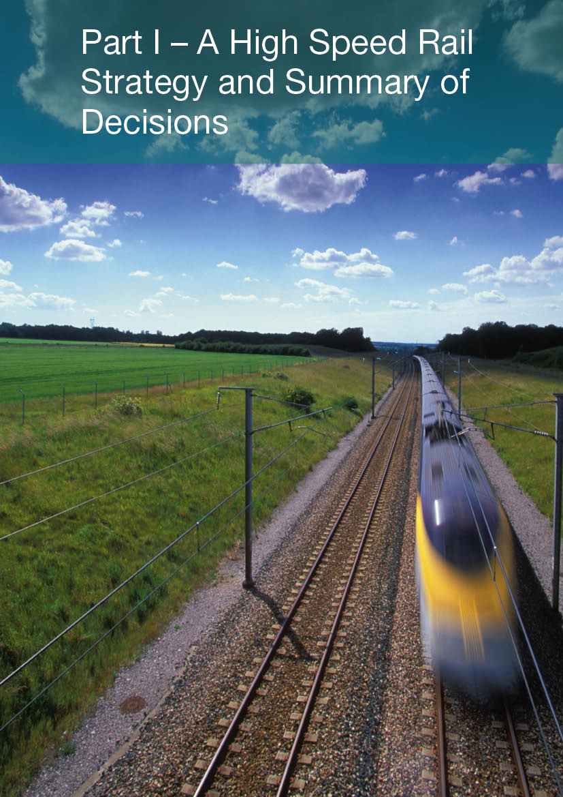
Part I – A High Speed Rail Strategy and Summary of Decisions

Summary of High Speed 2

The project
1 The aim of the HS2 project is to deliver hugely enhanced rail capacity and connectivity between Britain’s major conurbations. It is the largest transport infrastructure investment in the UK for a generation, and, with the exception of HS1, is the first major new railway line since the Victorian era.
2 The HS2 Y network (so named due to its shape) will provide direct high capacity, high speed links between London, Birmingham, Leeds and Manchester, with intermediate stations in the East Midlands and South Yorkshire. The network will be able to accommodate high capacity trains running initially at speeds of up to 225mph, with the potential to rise to 250mph in the future.
3 It will also carry high speed trains designed to run onto the existing rail network, continuing at conventional speed to a wide range of additional destinations in the UK, without the need to change trains, via links to the West Coast and East Coast main lines. This means that journeys to and from places not served directly by the Y network, such as Liverpool, Edinburgh, Glasgow and Newcastle, will also be quicker than they are today.
4 With long distance services and passengers increasingly using the new HS2 network, capacity will be freed up on the existing network, especially on the congested lines to the north of London, creating significant capacity for extra commuter and freight services.
5 The network will also provide improved links from the Midlands and the North to Heathrow Airport and the Channel Tunnel (via the existing High Speed 1 line). HS2 passengers will be able to travel directly to Heathrow and the Channel Tunnel without having to change trains.

Trains and stations
6 HS2 trains will be more spacious than the existing trains on today’s network. HS2 is being designed to accommodate the wider and taller trains used elsewhere in Europe. It would, therefore, be possible to run double-deck trains on HS2.
7 The new HS2 stations will create the opportunity for adding iconic new buildings to cities across the country. They will be modern and high quality environments for passengers, allowing them to efficiently move around and interchange with feeder networks. Working with cities, these stations will act as focal points for much wider regeneration opportunities – through the creation of new office, leisure and retail opportunities and stimulating new local jobs. In some cases, such as at Old Oak Common in West London and the Eastside area of Birmingham, regeneration strategies are already being developed to capitalise on the opportunities offered by new HS2 stations.

Constructing the Y network
8 The Y network will be built in two phases.
9 Phase 1 (expected opening 2026): Dedicated high speed services will run between London and the West Midlands. There will also be direct high speed services to the Channel Tunnel, via High Speed 1. Trains will also be able to run at high speed from London to the West Midlands and then onto the existing network at conventional speeds, to serve directly the North West and Scotland, reducing journey times by around 30 minutes and without needing change trains. This phase will include four high speed rail stations – in central London (Euston), West London (Old Oak Common), Birmingham Airport (Birmingham Interchange) and central Birmingham (Curzon Street)
10 Phase 2 (expected opening 2032-33): Dedicated high speed services extended beyond the West Midlands to Manchester and Leeds and direct high speed services to a new Heathrow Airport station. There will be no need to change trains to reach Heathrow. High speed trains will also serve directly Leeds and Manchester, as well as continuing onto the existing network at conventional speeds to serve directly the North East, North West and Scotland. This will enable further journey time savings – of up to one hour in total. Again, there will be no need to change trains. This second phase will add further stations in Manchester, the East Midlands, South Yorkshire, Leeds and Heathrow.
11 Phasing the construction of the network is the best way to manage its overall cost and deliverability. This means that the northern section of the network will follow in a second phase. But from the moment that the first phase opens well over half of all HS2 trains will continue to destinations in the North and Scotland.
12 The development and construction of the Y network will set a new standard in design, with a strong focus on mitigating the impacts of the line on the communities that it passes.

More capacity
13 HS2 is the most effective way to provide much-needed additional rail capacity. It will double capacity on the crowded West Coast Main Line corridor. Demand for rail travel is forecast to continue growing steadily for the next 20-30 years and many services will be full by the mid-2020s if we do not act now.
14 By moving a significant proportion of our current inter-city services from the existing railway onto the new HS2 lines, there would be space for additional commuter, regional and freight services. So there would be benefits for passengers both on and off the new high speed network. These wider benefits of increased capacity on existing lines would extend well beyond the towns and cities located on HS2. Towns such as Milton Keynes, Tamworth and Lichfield could see significant improvements in their rail services compared to today once HS2 opens. Released capacity could also be used to accommodate rising demand for rail freight services, especially in the container market, which would reduce road congestion and deliver reductions in carbon emissions.

Faster journeys
15 Trains on the new line will travel initially at up to 225mph and in the future at up to 250mph, as long as this can be achieved without additional noise impacts. The fastest trains on the conventional network in the UK currently operate at 125mph.
16 The Y network will enable significantly reduced journey times compared to today.
- Birmingham to London – 45 minutes (currently 1hr 24m).
- Manchester to London – 1 hour 08 minutes (currently 2hrs 8m).
- Leeds to London – 1 hour 28 minutes (currently 2hrs 20m).
- Glasgow/Edinburgh to London – around 3 hours 30 minutes (currently 4hrs 30m).
- Birmingham to Leeds – 57 minutes (currently 2hrs).
- Birmingham to Manchester – 41 minutes (currently 1hr 30m).
- Birmingham to Brussels/Paris – just over 3 hours (currently 4hrs).
- Leeds/Manchester to Brussels/Paris – 3 hours 30 minutes (currently 4hrs 30m).
17 We will work with local authorities to maximise the integration of HS2 with existing transport networks, such as local bus, train and metro services. This will create faster and easier end-to-end journeys:
- The Old Oak Common station in West London will enable passengers to interchange between HS2, Crossrail and with the Great Western Main Line.
- The London and Birmingham terminus stations are closely integrated with existing transport networks in those cities.
- The Birmingham Interchange station is located alongside Birmingham Airport as well as the M6, the M42 and the Birmingham International station on the West Coast Main Line.
- The direct link to Heathrow will significantly enhance its accessibility from the Midlands and the North and create a multi-modal transport ‘hub’ at the airport. HS2 passengers will not have to change trains to access Heathrow.
- The direct link to HS1 and the Channel Tunnel will create the opportunity for direct services to destinations on the European high speed rail network.

Wider benefits
18 HS2 will support economic growth across Britain. The monetised benefits of the network to business are forecast to be approximately £34-45 billion. These come both from faster, more comfortable and convenient journeys, and from businesses being able to operate more efficiently, increasing their productivity, accessing new markets and labour pools. These benefits extend far beyond areas directly on the HS2 network, as a result of through-running HS2 services to destinations on the conventional network and of people using the road and existing rail network to access HS2 stations.
19 Around 60 per cent of the benefits of the Y network accrue to non-London trips, demonstrating the significant potential benefits from improved connectivity between the wider UK regions and their key cities.
20 HS2 will also help to create jobs. There will be jobs in building and operating the railway, and, in the cities served by the network, HS2 will support job creation both through the regeneration opportunities it offers and through its wider economic effects. For the first phase alone it is estimated that HS2 could support around 40,000 jobs in the areas served by HS2. The second phase is expected to offer similar opportunities for the conurbations of Northern England.
21 HS2 will also bring reliability benefits. The High Speed 1 (HS1) line from London to the Channel Tunnel has an annual average of just 6.8 seconds delay per train due to infrastructure incidents.
22 HS2 will create the opportunity to reduce the overall emissions from transport by shifting journeys to rail from more polluting modes. HS2 will provide an attractive alternative to flying. Even the 30 minute journey time saving from the first phase of HS2 will be sufficient to prompt some travellers from Manchester, Glasgow, Edinburgh and elsewhere to make the switch. As the network expands this effect will build.
Journey time savings to and from London by raili
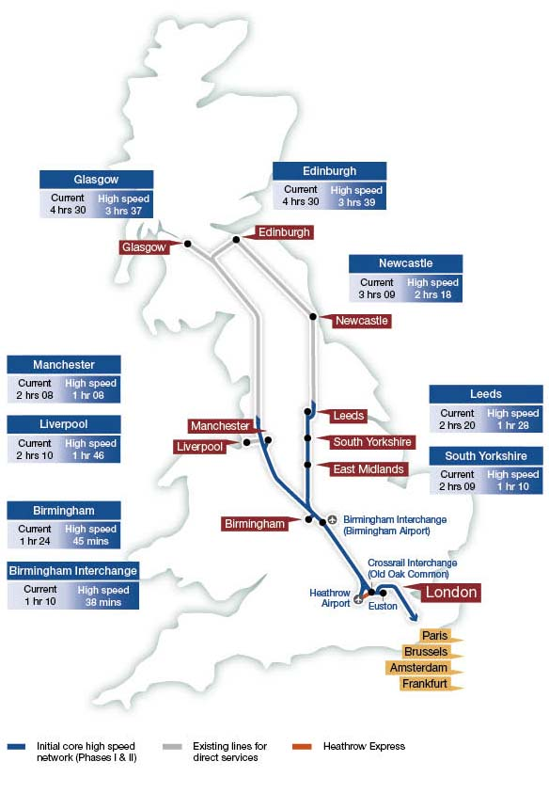
i The journey times shown are the standard times from HS2 Ltd’s current service specification. Optimising the service specification could provide faster journey times for some destinations. These will be further developed as part of HS2 Ltd’s further development of route options for the second phase of Y network.

The Government’s High Speed Rail Strategy
1 The Government’s vision is for a transport system which is an engine for economic growth, and which is safer, greener and improves quality of life in our communities.
2 The ability to make fast and efficient journeys between the UK’s productive urban centres is vital to business, as it is to communities. Rail is well suited to many inter-urban markets as it can provide rapid and reliable travel into the heart of city centres. This is reflected in the very substantial increases in demand for inter-city rail travel seen over recent decades. The number of inter-city journeys made on the UK’s rail network more than doubled between 1994 and 2009 and continued rising even through the recent recession.
3 The increasing economic importance of Britain’s major urban centres is likely to strengthen the role of these links in supporting productivity and growth. Recent research has provided no indication of any slowing in the pattern of increasing demand for inter-city rail travel. These trends will place increasing pressure on the rail network. If we fail to provide sufficient capacity for efficient and rapid journeys then the economy will suffer. In particular, the towns and cities of the Midlands and the North, which already consider their economic prospects to be constrained by poor connectivity, will be further hindered by future capacity pressures and isolation from other key centres of economic activity. High speed rail offers an opportunity to secure major economic benefits for these towns and cities, and to open up opportunities for valuable regeneration, new jobs and inward investment.
4 While other countries, such as France, Germany and Japan, have already invested heavily in new high speed links and networks to enhance capacity and performance on key inter-urban routes, the UK has focused on incremental improvements to existing lines. In fact, until the opening of the HS1 line to the Channel Tunnel in 2007, there had been no significant new line built in the UK since Victorian times. The previous major line to be built was the Great Central Railway in 1899 – 108 years earlier.
5 These incremental investments on existing lines have provided valuable, but ultimately limited, enhancements to capacity and connectivity, often at a cost of substantial disruption to passengers whilst works take place. And continuing demand growth is set to outstrip the capacity gains that have been achieved. Network Rail has forecast that by the mid-2020s all capacity for additional or lengthened services on the recently modernised West Coast Main Line will have been exhausted.
6 The Government has considered a range of options for tackling capacity constraints on the UK’s key north-south inter-city rail routes. Having reviewed the available evidence on demand forecasts and a range of other issues relating to the alternatives to high speed rail, we consider that even very major programmes of enhancements to existing lines would be unable fully to accommodate forecast demand growth and would lead to unacceptable levels of crowding on many routes. Since enhancements to the existing network cannot effectively address capacity constraints in these cases new infrastructure is required. And if new lines are to be built, then the Government broadly has two options – to build new infrastructure matching the speeds of current trains or build new infrastructure which can accommodate the high speed services seen in countries across Europe and Asia.
7 The evidence clearly favours high speed rail. The additional benefits in terms of connectivity and economic growth that come from new high speed rail lines, as opposed to constructing a new conventional speed line, exceed the additional costs by a factor of more than four to one. The greater potential of high speed rail to attract travellers from other, more polluting, modes creates opportunities for considerable reductions in carbon emissions. In the short-term rail travel will continue to be less polluting than competitor modes, and in the longer-term, as the carbon intensity of the grid reduces, these benefits are likely to increase. The quicker journey times that high speed rail systems can achieve are key to their competitive position in relation, in particular, to air travel. Providing an attractive and considerably lower-carbon alternative to much domestic and other short-haul aviation is an important objective.
8 Therefore, having considered the evidence submitted in consultation, the Government continues to support the development and delivery of a new national high speed rail network, as set out in the Coalition’s Our Programme for Government, which stated that:
“We will establish a high speed rail network as part of our programme of measures to fulfil our joint ambitions for creating a low carbon economy. Our vision is of a truly national high speed rail network for the whole of Britain.”
9 A new high speed rail network will support economic growth for the long-term. It is also, vitally, the right solution for passengers. Incidents of overcrowding are already intensifying, and this contributes to the growing challenge the rail network faces of providing a reliable service to passengers. Crowding is initially forecast to be most severe on suburban and commuter services but with growing problems on inter-city services. As well as providing a significant boost to inter-city capacity, HS2 will also potentially enable a significant increase in commuter services to a range of towns and cities across the UK by releasing capacity on the conventional network as long-distance trains and passengers switch to the new line.
10 A new high speed rail network will be the most significant enhancement to the country’s transport infrastructure for a generation. Britain’s rail network remains to a very great extent the product of Victorian ambition and energy. The Government believes strongly that the time has come to act with the same boldness as our Victorian predecessors. We are determined to show the same foresight, to plan ahead and to build for the future, rejecting short-term ‘make do and mend’ measures on these major lines in favour of a strategic approach which will deliver benefits for generations to come.

Role of the rail network
11 The Government’s Plan for Growth sets out its core objective of putting the UK on a path to sustainable, long-term economic growth. The Government has already taken decisive action to tackle the fiscal deficit and provide the ingredients for economic stability, which is an essential precondition for economic prosperity. But other actions are needed to create the right conditions for long-term success.
12 In order to achieve its economic objectives, Britain must have the right infrastructure in place to help boost productivity and reduce costs for business. The National Infrastructure Plan sets out the Government’s strategy for ensuring that the country is supported by the infrastructure it needs to attract investment and sustain long term economic growth. It recognises that the UK has a poor track record on planning for and investing in infrastructure. Although we have regained our position in the World Economic Forum top-10 most competitive nations, in 2011 the Forum ranked the UK as just 28th for the quality of its infrastructure.
13 The Government’s view is that continuing investment in steps to meet rising demand for inter-city travel is necessary, given the importance of these journeys to the success of the UK economy. Measures to address intensifying and more extensive crowding, growing rail congestion and the consequent increasing challenge of running a reliable railway for passengers are vital if the transport system is to continue to support economic growth.
14 As set out in consultation, the Government does not consider that there is a case for major new motorways, and therefore our roads strategy focuses on infrastructure schemes to address key pinch points and access to new developments, and also the continuing roll-out of the managed motorways programme as the means of enhancing the capacity and performance of the strategic road network. In aviation, the Government wants the UK to maintain its international hub status. It does not, however, support a new runway at Heathrow and wants to see modal shift away from domestic routes where possible. The Government is committed to producing a sustainable framework for UK aviation and in March 2011 published a scoping document to initiate a dialogue with a wide range of stakeholders on the future direction of aviation policy. It intends to issue a draft framework for consultation later in 2012.
15 Therefore, if the increases in demand for inter-urban travel that would be expected as the UK economy returns to a pattern of long-term and sustainable growth are to be accommodated, it is the rail network which needs to be in a position to play the lead role in delivering new capacity.
16 Rail is a highly efficient means of connecting cities and international gateways, as it is able to deliver large volumes of travellers reliably and directly into city centres, avoiding road congestion and the need to find parking space, and providing efficient interchanges with urban transport networks and airport terminals. Furthermore, rail is a comparatively carbon-efficient form of transport, with long-term potential for substantial further decarbonisation, as the carbon intensity of electricity generation decreases over time.
17 The fastest increase in demand on the rail network over recent years has been in long-distance travel, and this growth is forecast to continue. Growing demand is placing increasing pressure on the capacity of Britain’s key rail routes. The Government’s assessment is that the short-term fix of further upgrading of the existing network is not a sustainable long-term approach for our key north-south lines. A new strategic approach is required.
18 Given the limitations of Britain’s mixed-use rail network, which combines commuter, inter-city and freight services sharing the same tracks and results in a sub-optimal utilisation of track capacity, growing demand for rail services will have wide-ranging impacts on the passenger experience. Analysis by Network Rail indicates that the most significant pressures are likely to be seen first on commuter services, where the level of demand is highest and standing is already common, spreading to long-distance services as passenger numbers continue to grow. Any increases in passenger services on the most crowded lines will also limit the scope to respond to forecast growth in key rail freight markets, meaning that more lorries are likely to be seen on our roads and valuable decongestion and carbon reduction benefits will be foregone.
19 As crowding and congestion levels grow, passengers will find themselves spending more and more of their journeys in cramped conditions, often having to stand for a large part of their journey. As a result of the limited scope to run additional services on Britain’s main lines, train operators may have to focus increasingly on the largest markets, leading to fewer services being run between destinations other than the largest conurbations, and passengers more often facing the inconvenience of having to change trains to complete their journey. As supply becomes increasingly unable to meet demand at key times of the day, fares are also likely to rise.
20 These effects will have significant and unacceptable negative consequences for Britain’s economy and communities. Where business travellers are dissuaded by crowding, excessive cost, inconvenience or unreliability from making journeys which might otherwise lead to valuable sales, contracts or new contacts, then businesses and economic growth will suffer. As commuting becomes a less and less attractive option, labour markets will operate less efficiently, and as high fares and crowding levels spread out from peak periods across more of the day, the rail network will be increasingly unable to meet people’s aspirations for affordable and pleasant leisure travel.
21 Consultation responses broadly supported the Government’s view that there was a strong case for further investment in rail capacity on key inter-city lines. While in some cases alternatives to travel such as video-conferencing may offer an efficient solution, the Government would positively reject any policy framework which sought to prevent or limit passengers from making valuable journeys between the country’s major towns and cities. Travel of this kind has a central role to play in our economy and society and rail is generally the most appropriate and least polluting mode for these journeys. In addition, the exponential improvement over recent decades in communications technologies has not led, as some predicted, to declining demand for travel but has happened concurrently with an era of rapid growth in travel.
22 The Government considers that it is right to facilitate the travel necessary to support both economic growth and the fulfilment of people’s broader social aspirations. But the Government must fulfil its role in a way that is consistent with its wider carbon objectives. The Government rejects the false choice between supporting rail travel and meeting our carbon obligations. Rail travel in general, including high speed rail, is a comparatively low carbon mode of transport, which is well placed to support our environmental obligations.
23 The British Chambers of Commerce share the Government’s view of the importance of a modern and efficient rail network, stating that: “The railways are a key element of our transport infrastructure, impacting hugely on the development of the regions by increasing connectivity and driving long term economic growth.”
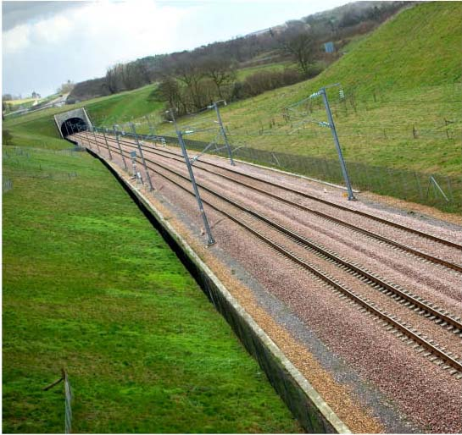

Case for high speed rail
24 Over recent years there have been a number of significant new investments in the inter-city rail network, including a major upgrade of the West Coast Main Line. Further investment is planned to manage forecast demand growth over the next decade, such as the introduction of new high capacity rolling stock on the Great Western and East Coast routes. But major enhancements to existing heavily used lines present significant challenges. The capacity and connectivity gains that can be achieved in this way are necessarily limited. Ultimately existing tracks can only bear so many trains and carriages, particularly when those services are a broad spread of long-distance, commuter, local and freight trains. The difficulty of carrying out works on an operating railway has led in a number of cases to significant cost overruns. And on mixed-use lines, the allocation of any additional capacity must be carefully balanced between inter-city, commuter and other services.
25 The most notorious example of this kind is the recent modernisation of the West Coast Main Line, which lasted for almost a decade and saw its costs soar from an original estimate of £2 billion to more than £8 billion, whilst delivering just one additional peak hour inter-city service, and failing to enable the 140mph running that had been a core objective when the project was first designed. Even allowing for its reduced scope, however, the completion of the West Coast Main Line modernisation programme and the introduction of an enhanced timetable has seen increased demand for inter-city rail travel, with passenger numbers on this route rising by more than 30 per cent in just three years.
26 This continuing growth in demand for rail travel is predicted to place increasing strain on network capacity. In terms of the major north-south inter-city lines, pressures over the next 20-30 years are anticipated to be greatest on the southern stretch of the West Coast Main Line. The additional capacity provided by the last modernisation programme on this route is expected to be effectively exhausted by the mid-2020s, with all available train paths in use and no significant further scope for train lengthening. Therefore, the West Coast Main Line, which is already one of the busiest mixed-use lines in Europe, will face the greatest need for additional capacity. In the longer-term, similar pressures are foreseen on other key north-south routes, and in assessing strategic options for relieving capacity constraints the Government has therefore focused on network-wide approaches.
27 Recent enhancements, by their very nature, have done relatively little to improve connectivity between the UK’s cities, especially where infrastructure is lacking. Although journey times to and from London have improved to some degree, where routes require trains to cross from one major north-south line to another journey times remain very poor. It is now as quick to travel by train from London to Brussels as from Birmingham to Leeds. This lack of inter-regional connectivity has been identified as a constraint on growth in the North, and was raised in consultation by a number of regional stakeholders.
28 Many other countries across Europe and Asia have taken a different approach from the UK and focused their investment on new high speed lines. These modern networks, serving the most important conurbations and routes for the national economy, have provided high levels of new dedicated capacity for inter-city services. They have improved reliability and radically reduced journey times. In many cases, links onto existing lines have also enabled through-running services to reach a broader range of destinations, ensuring that the benefits of such lines are widely distributed.
29 It is clear that further investment is needed if constraints on inter-city rail capacity and connectivity are not to risk becoming a brake on economic growth – particularly for the country’s major regional cities, which rely on these links for access to customers and suppliers in other conurbations and, particularly, in the important markets of London and the South East.
30 The Government does not consider that yet more rounds of incremental enhancements to existing lines will be sufficient to meet long-term capacity needs for passengers or freight. Nevertheless, in the light of the strong support for this approach from many consultation respondents, the Government undertook additional detailed assessment. The further analysis of the options presented by Network Rail has indicated that even very major enhancement packages simply cannot resolve the pressures on capacity anticipated on the West Coast Main Line over the coming decades. Under any of the scenarios tested, for example, 1,500 or more passengers would have to stand on commuter services out of Euston in the evening peak hour – compared to 800 currently.
31 The strong likelihood, therefore, is that even pushing the West Coast Main Line to the absolute limit, as the alternatives we have looked at do, would only delay rather than eliminate the need for new lines in the future. In the meantime, substantial disruption would have been imposed on passengers over a number of years as works were carried out and the additional strategic, economic and connectivity benefits that high speed rail is particularly capable of delivering would have been foregone. Part II of this document discusses in detail the additional work undertaken on these enhancement options following consultation, and the basis on which the Government has concluded that they would not offer an effective strategic approach to the long term development of Britain’s inter-city rail network.
32 Given that upgrading the existing north-south lines is not a viable long-term solution, the real choice, therefore, is not between high speed rail and further incremental upgrades. Only a new line is capable of providing the capacity that is required. The choice is then whether the long term need for additional capacity on the key inter-city routes should be met through a new conventional line, matching the speeds of the current network, or through new high speed infrastructure. The Government believes that a clear case exists for high speed.

New conventional lines
33 Building new conventional rail lines would not be significantly cheaper than new high speed lines, nor would their impacts on the environment and communities be significantly less than those of high speed rail. However, they would deliver far fewer benefits in terms of enhanced connectivity and support for long-term economic growth.
34 Analysis carried out by HS2 Ltd for consultation, and refreshed as part of its updated economic analysis in the Economic Case for HS2: Updated Appraisal of Transport User Benefits and Wider Economic Benefits, indicated that the net cost saving from building a new line along broadly the same route as HS2, but with a conventional line speed of 125mph, would only be around £1.4 billion. This is because regardless of the speed of a new line, similar tracks, viaducts, stations and tunnels would be needed, so savings would largely relate to the detailed specification of infrastructure and lower rolling stock and fuel costs, and also because a slower line would attract fewer passengers and hence generate reduced revenues. In contrast, the reduction in benefits as a result of slower journey times and reduced passenger numbers would be expected to be as high as £6.2 billion in net present value terms.
35 On this basis, the additional benefits generated by designing a new line to accommodate high speed services, compared to the only real long term alternative of a new conventional speed line, would outweigh the additional costs by a factor of more than four to one.
36 A number of responses to the consultation proposed that a new conventional speed line might be more likely to be designed to a different route from HS2, and, in particular to follow existing transport corridors more closely in an attempt to mitigate the impact on the natural environment.
37 HS2 Ltd has examined a range of potential lower speed routes, including options following close to the M1 and M40. All of these options would be longer in distance than the HS2 route, leading to significantly greater journey times and lower economic benefits, and also in some cases cost increases. Conversely, any environmental improvements that could be achieved would be relatively marginal. It must be recognised that building any new train line will have a substantial impact on the land and communities through which it passes.
38 The Government therefore does not consider that new conventional speed lines should be adopted as an alternative to the proposals for a national high speed rail network put forward in consultation.

A national high speed rail network
39 A new national high speed rail network provides the opportunity to rethink fundamentally how the national rail system should operate. The network will create a very significant increase in capacity to accommodate growth in inter-city travel over many decades, encouraging and accommodating modal shift to rail from more carbon-intensive modes, and enabling rail to increasingly serve as the mode of choice for long-distance business and leisure travellers.
40 The benefits of HS2 will reach well beyond the towns and cities on the network. The segregation of high speed long-distance services on to HS2 will also improve reliability and release valuable capacity on existing lines for new commuter and regional services. Released capacity could also be used to accommodate rising demand for rail freight services, especially in the container market, which would reduce road congestion by removing lorries from our roads, and deliver reductions in carbon emissions.
41 HS2 creates the opportunity to add iconic new buildings to cities across the country. With a national high speed rail network in place, passengers will benefit from modern, more comfortable and less crowded services – on the existing lines as well as HS2 – plus faster journey times to a wide range of destinations. The most significant improvements will be between those cities directly connected by the high speed network, but travellers from a much wider range of destinations will derive valuable benefits through high speed services running non-stop onto existing main lines. The experience of existing high speed rail networks suggests that there will also be reliability improvements of great value to passengers. On HS1 during 2010/11 less than one service in every 200 was delayed as a result of infrastructure issues.
42 Well-designed stations, integrated with local transport networks and development plans, will be able to provide attractive arrival and departure points for passengers, as well as providing a stimulus for local growth and potentially contributing to the regeneration of the areas in which they are located. Connections with key urban transport links such as Crossrail or the Midland and Manchester tram systems could see the benefits of a high speed rail network spread further through these conurbations and wider regions.
43 The Government’s vision, however, is that such a network could also play a wider role. As a project, it will be a clear sign of Britain’s intent and ambition to plan and invest for the long term in support of sustainable economic growth. It will demonstrate the Government’s commitment to enhancing and investing in crucial transport networks across the country, and expanding the level of major transport investment outside London and the South East, with the potential to deliver valuable economic benefits for many of Britain’s major regional cities.
44 The development and delivery of a national high speed rail network will provide a foundation for further expansion, with the potential to bring more towns and cities directly onto the high speed map. And it will provide evidence of decisive action to tackle the UK’s infrastructure deficit.

Government’s high speed rail strategy
45 The Government’s vision is for a high speed rail network enabling fast and reliable journeys between the country’s major cities and international gateways that is well-integrated with local transport networks.
46 A Y-shaped national network with links onto the East Coast and West Coast main lines will enable high speed services to link London, Birmingham, Manchester, the East Midlands, South Yorkshire and Leeds directly. Many of the trains running on HS2 will also be compatible with the existing railway and therefore able to run off the HS2 lines to serve a range of other towns and cities including Liverpool, Preston, York, Newcastle, Glasgow and Edinburgh. They will run at high speed on HS2 and at conventional speeds on the existing network. Nine out of the UK’s ten largest conurbations will be connected in this way, providing significant enhancements to inter-city rail capacity and connectivity between the vast majority of the country’s major urban economies.
47 Evidence in support of a range of alternative network configurations was produced in consultation responses. We assessed each of these proposals, but none was considered to offer a better approach than the proposed Y network. In comparison to other strategic options, the Y network offers shorter journey times to London from most key conurbations, strong inter-regional connectivity and enhanced access to key international gateways from across the country. As a result, HS2 Ltd’s analysis indicated that it will provide better value for money than the alternative options considered.
48 The network will be delivered in two phases. The initial phase will link London to the West Midlands, with a terminus at a rebuilt Euston station and at a new central Birmingham station in the Eastside regeneration area, which will have an entrance adjacent to the current Moor Street station. Phase one will also include two interchange stations. The first will be at Old Oak Common, linking to Crossrail for rapid and convenient access to and from key business destinations in the West End, the City and Canary Wharf, and to the Great Western Main Line, which will provide passengers from the Thames Valley, the South West and Wales with a convenient link to the new network. Old Oak Common will also enable passengers to interchange with Heathrow Express services to the airport. The second interchange station will be located to the east of Birmingham, close to the National Exhibition Centre and providing links to Birmingham Airport, the West Coast Main Line and the national motorway network. A direct connection close to Lichfield from the high speed lines to the West Coast Main Line will enable through-running high speed trains to reduce to conventional line speeds to serve Manchester, Liverpool, Glasgow and other stations on the West Coast Main Line. The estimated construction cost of this phase in 2011 prices is approximately £16.3 billion.
49 The case for Phase 1 is further reinforced by its role as the foundation for the second phase of the network, whose delivery would see the overall value for money of the project increase further. However, even as a stand-alone project, there is a strong case for proceeding with this initial line, as it provides the most effective solution to long-term capacity constraints on the congested southern end of the West Coast Main Line, and offers benefits in excess of its costs.
50 This second phase will extend the network north with two legs, one running to Manchester and the other via stations in the East Midlands and South Yorkshire to Leeds. Direct connections will be provided to the West Coast and East Coast main lines to support through-running services onto conventional speed lines. The estimated construction cost of this phase in 2011 prices is approximately £16.4 billion. HS2 Ltd is currently developing detailed route proposals for the second phase and these will be submitted to the Government for consideration in March 2012.
51 The Y network will be directly connected to key international gateways. Phase one will include a direct link to the Continent via the High Speed 1 line to the Channel Tunnel, creating the potential for rail passengers from the North and the Midlands to travel to Europe without the need to change trains. A direct link to Heathrow, via a spur from the main line, is also planned as part of phase two, providing significantly improved rail connectivity to the country’s major hub airport. There will be ready access to Heathrow even in Phase 1, as passengers will be able to easily interchange between HS2 and the Heathrow Express at the Old Oak Common station. This will enable significantly reduced rail journey times compared to today for those accessing Heathrow from the Midlands and the North.
52 Phasing the preparation and construction of the network is important to manage the delivery and affordability of the project, and to ensure that high speed rail is introduced as quickly as possible to Britain. Attempting to seek the construction powers or actually constructing the entire network in one stage would jeopardise the successful and timely delivery of the project.
53 The network will be built to European standards, enabling high capacity services operating on the new lines to make use of tried-and-tested international train designs. The network will be built to accommodate trains of up to 400 metres in length, with a potential capacity of up to 1100 passengers, and it is expected that signalling systems will be able to run up to 14 trains per hour initially, rising to 18 trains per hour with the opening of the second phase of the network to Leeds and Manchester. This will provide a very significant increase in long-distance capacity, whilst also releasing a substantial number of train paths on existing lines for new commuter, regional and freight services.
54 To ensure that travellers will be able to benefit from the most up-to-date train technology over the long-term, the line will be built to accommodate speeds of up to 250mph, similar to lines being designed elsewhere in Europe, although the expected maximum line speed at opening will be 225mph. This will see journey times from London to Birmingham reduced to just 45 minutes – less time than it takes to make a journey across London from Hackney to Wimbledon. Journey times to Leeds and Manchester will also fall significantly to around 88 and 68 minutes, respectively.
55 A high speed rail network of this kind will cost approximately £32.7 billion in 2011 prices over two decades to develop and construct, a total which includes significant allowances for risk and optimism bias. In addition, there will be rolling stock costs of around £8.2 billion in 2011 prices. It is estimated that the network will generate benefits with a net present value of up to £47 billion, as well as additional fares revenues with a net present value of up to £34 billion. Modelling and analysis carried out by HS2 Ltd indicate that its operating costs will be significantly lower than the revenues generated indicating that it will make an operating profit. As the Government progresses the development of the network, it will also seek to ensure that opportunities for attracting private sector investment are identified and taken forward.
56 The economic analysis carried out by HS2 Ltd indicates a benefit cost ratio for this network of 1.6 to 1.9 (see Economic Case for HS2: Updated Appraisal of Transport User Benefits and Wider Economic Benefits).
57 In addition, HS2 Ltd forecast that the Y network will generate significant additional wider economic benefits as it will enable businesses to operate more efficiently, increasing their productivity and accessing new markets and labour pools. The value of these additional benefits is estimated to be approximately £6 billion – £12 billion. Taking these into account, the benefit cost ratio for the network rises to 1.8 to 2.5, although it should be noted that there are also additional disbenefits, such as the impact on the natural landscape, which have not currently been quantified and which would need to be considered in assessing overall value for money.

Carbon case for high speed rail
58 The Government’s Carbon Plan sets out plans to decarbonise the UK economy over the next two decades and beyond to 2050. At the heart of the strategy for cutting transport’s emissions in the long term is a shift in the road transport sector to ultra-low emission technologies such as battery electric vehicles and hydrogen fuel cells. This is important because over 90 per cent of domestic transport emissions are currently generated by road transport; and road transport will continue over the long term to be the mode of choice for many journeys.
59 Inter-urban rail supports economically vital journeys between our cities, but it is also a key component of a low-carbon transport system. Conventional diesel trains provide a lower-carbon alternative to travel by road and electrified rail can deliver further benefits. As the electricity supply is likely to move towards near-zero emissions by 2050, there will be ever lower emissions from electrified rail travel, such as on HS2. Given rail travel’s key role in the transport system, particularly between urban centres, it is important to ensure that the rail network continues to deliver carbon efficiencies.
60 Rail is a comparatively carbon efficient mode, generally creating significantly fewer carbon emissions per passenger mile than either car travel or aviation. Even allowing for the fact that power usage increases with speed, the high levels of passenger usage that high speed services tend to attract mean that per passenger carbon emissions remain comparatively low, and as the grid decarbonises over the longer term the operation of high speed rail will be substantially decarbonised as well.
The High Speed 2 network
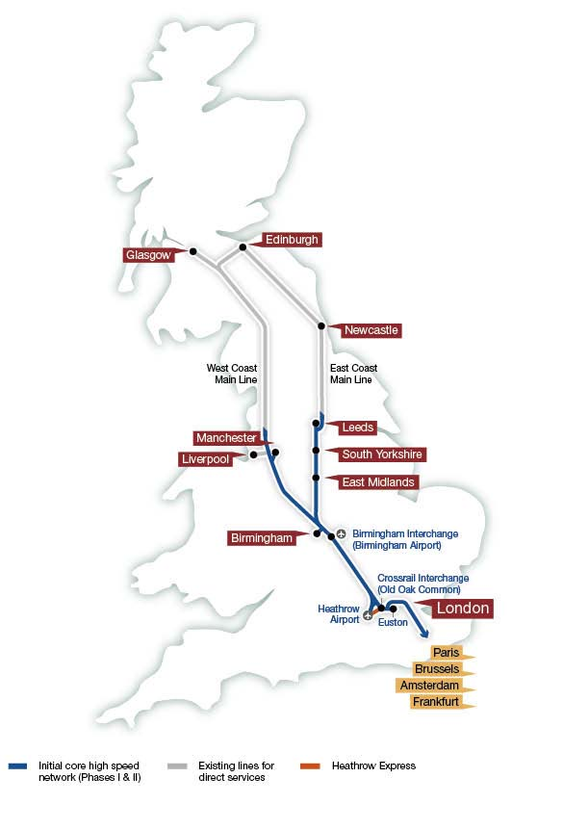

61 On a lifecycle basis, most of the carbon emissions associated with a rail network are those resulting from its operation. These can be mitigated in a variety of ways. The amount of carbon emitted during construction, and embodied in the infrastructure and trains, will be significant but can be managed and reduced by applying best practice. In addition, many of the carbon emissions from both building and running a high speed line are covered by the European Union Emissions Trading System, meaning much of the carbon impact of HS2 will be offset by emissions reductions elsewhere.
62 The Government is also working closely with the rail industry to improve energy efficiency and reduce emissions across the rail network more generally. Next year the rail industry will publish its second Rail Technical Strategy assessing how, over the longer term, technology can help deliver a more cost-effective, higher capacity, higher performance and lower carbon railway.
63 By enhancing inter-city rail capacity and connectivity HS2 could prompt significant modal shift from air and road to our railways. HS2 would encourage modal shift by making rail increasingly attractive for some journeys that would otherwise be made by plane or car. For aviation this is particularly true for the London to Scotland market. HS2 is forecast to carry up to 4.5 million passengers every year who might otherwise have travelled by air, as well as seeing up to 9 million passengers transfer from the national road network.
64 The high speed network will also present opportunities for modal shift of freight from our roads to our railways, by releasing capacity on key sections of the conventional network, for example along the West Coast Main Line, some of which could be used to provide additional freight services. The Rail Freight Group estimates that providing additional freight capacity on our railways could save some 500,000 tonnes of CO² per annum by removing around 200 trucks an hour that would otherwise be added to the M40, the M1 and parallel ‘A’ roads. The Government’s high speed rail strategy has been broadly supported by the rail freight industry in its responses to consultation.
65 An attractive, accessible rail network can lead to modal shift from more carbon-intensive forms of transport such as aviation and roads. Capacity improvements can meet new demand for travel, reduce crowding and improve journey times, connectivity and reliability. Enhancing inter-city rail capacity and performance through new high speed lines can support economic growth, provide an improved passenger experience and contribute to reducing carbon emissions.

Impacts of HS2 on local environments and communities
66 If a new high speed network is to be taken forward, it is absolutely crucial to take full and proper account not only of its significant benefits, but also its impacts on the environment and on communities. Therefore, in considering responses to consultation, the Government and HS2 Ltd have paid close attention to these issues in respect of the proposed route for the initial London to West Midlands phase of HS2.
67 As discussed, many consultation responses proposed that the line speed should be reduced or a different route chosen in order to reduce the impacts of the London to West Midlands line. In the light of these suggestions, HS2 Ltd has reviewed a range of potential changes including lower speed options and routes following existing transport corridors such as the M40 or M1 more closely. The conclusions of this review are set out in detail in the Review of HS2 London to West Midlands Route Selection and Speed.
68 There are, however, very considerable technical challenges in following existing transport corridors. Existing rail lines and motorways follow vertical and horizontal alignments not compatible with new high speed lines, making it impossible to closely follow them without significantly reducing line speeds and increasing journey times. Flyovers or tunnelling would also be required when passing motorway junctions, which could themselves be complex and expensive to construct and likely to cause disruption. Also, existing infrastructure often runs through or close to the populations it serves, entailing either substantial impacts on those communities, in terms of noise, ongoing disruption and severance, or the need for further expensive tunnelling.
69 One alternative which achieved particular prominence was an option for a direct route via Heathrow and the M40 corridor. The Government does not consider that this would offer a better solution than the route put forward for consultation. It would be impossible to locate a station close to one of Heathrow’s main terminals, with the key potential station locations being either adjacent to the airport’s Northern Perimeter Road, or some three miles further north, adjacent to the Great Western Main Line at Iver. Either of these possible locations would be some distance from Heathrow terminals and would entail new transit facilities to the terminal areas, providing a journey experience little better than an interchange. In addition, a direct route via Heathrow would entail increased construction costs and substantial journey time penalties for the great majority of HS2 passengers travelling to and from central London. For these reasons the Government does not support a route of this kind.
70 Compared to the Government’s favoured route, following the M40 would be longer as a result of taking a more westerly alignment, and also slower due to the constraints of the motorway corridor. This would lead to a journey time between London and Birmingham of 56 minutes, seven minutes slower than the Government’s favoured route. A surface alignment along the M40 corridor would encounter a much greater number of major population centres than the consultation route, including Gerrard’s Cross, Beaconsfield, High Wycombe and Princes Risborough. This would result in unacceptable impacts on communities through major demolitions, severance and noise impacts. Crossing the motorway junctions would require a mix of flyovers or tunnels, adding to the cost and potentially creating disruption to the road network during construction.
71 The cost of constructing this route would be £19.5 billion, compared to £16.5 billion for the consultation route. The M40 route would also mean significantly more communities would be at risk of isolation through being surrounded by transport infrastructure, including large clusters of residential dwellings. Although the types of impact differ across the broad range of sustainability themes, there would be minimal overall sustainability benefit from an M40 route compared to the route favoured by the Government.
72 HS2 Ltd also looked at an alignment for the M1 corridor, but with a maximum speed of 186mph. It would cover a longer distance in reaching Birmingham than the consultation route, and deliver a journey time between London and Birmingham of 55 minutes, six minutes slower than the Government’s favoured route. As with the M40 corridor, a surface alignment along the M1 route would encounter a very high number of major population centres, including Hemel Hempstead, Milton Keynes and, in particular, Luton, which would have unacceptable impacts on communities through major demolitions, severance and noise impacts.
73 Increased length and engineering complexity would mean that the cost of constructing this route would be £18.7 billion, around £2.2 billion more than the Government’s favoured route. Although this slower M1 alignment would perform better across some sustainability themes, it would result in significantly higher impacts on communities, particularly in terms of demolitions and potential for isolation and severance. For example, 14 communities would also be at risk of isolation or severance, as compared with three for the Government’s favoured route. In terms of landscape it would avoid impacts on the Chilterns Area of Outstanding Natural Beauty and deliver other limited local environmental benefits. However, the route would have a large impact on journey time, and any relatively small environmental gain could only be achieved at a substantial cost.
74 For these reasons, the Government does not consider that any of the alternatives considered would offer a better solution than the line put forward for consultation. None of the options were able to deliver significant improvements in environmental performance, even where the specific impacts on the Chilterns Area of Outstanding Natural Beauty could be lessened to some degree. Some of the options considered would also have entailed increased impacts on some communities, such as noise or high numbers of demolitions. On balance, these marginal environmental gains would not be sufficient to outweigh the very substantial reductions in overall benefits that would result from longer routes, slower line speeds and increased journey times involved. In some cases, particularly where route lengths would increase, the costs of the line would be higher as well. The Government considers that the preferred route put forward for consultation remains the best option and should be further developed with a view to introducing a hybrid bill later in this Parliament.
75 In reaching this view, the Government recognises the significant value of Britain’s natural heritage and its own role in protecting these landscapes and features. This is particularly the case for designated landscapes such as Areas of Outstanding Natural Beauty. Despite the sensitivities inherent in considering proposals such as HS2, the Government believes that in selecting a route it has struck the right balance between protecting our natural environment, protecting communities and wider considerations of the national interest, and has examined all of the alternative options before making a decision to proceed.
76 The proposed route for the London to West Midlands line was carefully designed to reduce local environmental effects wherever possible. For example, the route selection process has sought to avoid the most significant impacts on centres of population and to limit the numbers of properties required. The use of tunnelling, deep cuttings and, where feasible, existing transport corridors has reduced impacts on landscape. Even before consultation a number of changes were made to further improve the route’s environmental and sustainability performance, including moving the line away from some settlements and providing additional green tunnels in the Chilterns Area of Outstanding Natural Beauty. Environmental assessments appropriate to each stage of the project have been carried out and there will be an ongoing process of route refinement to help lessen still further its impacts on the landscape.
77 Even so, the Government’s view, reached in the light of the wide range of submissions made during the consultation regarding further potential improvements, is that there is still more that can be done to mitigate the effects of the route put forward for consultation. HS2 Ltd has reviewed options for altering the route in a number of different locations, and recommended a package of route refinements, including substantial additional tunnelling in the Chilterns Area of Outstanding Natural Beauty and around Ruislip. The Government has agreed with these recommendations, which are described in more detail in the Review of Possible Refinements to the Proposed HS2 London to West Midlands Route, and they will be incorporated into the route as it is developed in preparation for a hybrid bill. The ongoing process of detailed route refinement will also continue, in consultation with local communities and including a full Environmental Impact Assessment process, as part of that further development.

Mitigating the impacts of HS2 on local property markets
78 HS2 will have a significant positive impact on the UK transport network and economy, but we recognise that it will also affect homeowners, communities and businesses along the line. Throughout the consultation process people told us of their fears that Government would not do enough to prevent blight and protect property values and communities from the noise and disruption of HS2.
79 We have already taken a number of important decisions to limit these negative impacts. These include moving the line away from towns and villages, lowering it further into cutting, and increasing the length in tunnels. We have also worked to minimise uncertainty and blight by consulting on one line of route and by sharing information through a thorough public consultation.
Journey time savings to and from Birmingham by traini
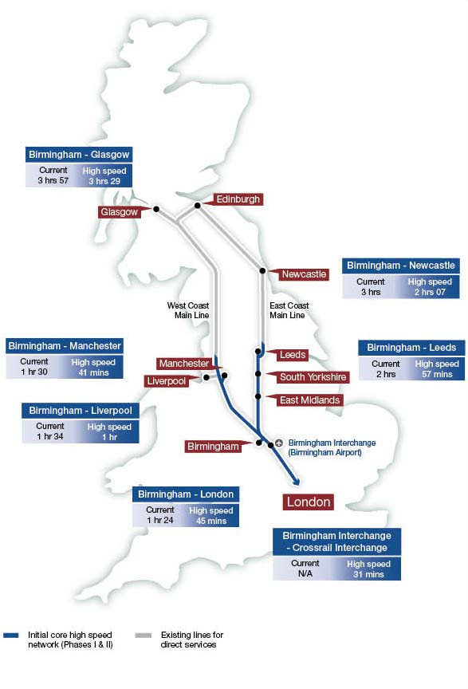
i The journey times shown are the standard times from HS2 Ltd’s current service specification. Optimising the service specification could provide faster journey times for some destinations. These will be further developed as part of HS2 Ltd’s further development of route options for the second phase of Y network.

80 Having considered the arguments made and the evidence put forward in the consultation, the Government has decided to introduce a package of measures over and above the statutory regime including a streamlined advance purchase scheme, a refreshed hardship scheme, support for those affected by construction, measures to reinforce confidence in properties above tunnels, and a sale and rent back scheme to give homeowners within the safeguarded area more flexibility. The existing hardship scheme helps owner-occupiers who urgently need to move and whose properties are blighted by the uncertainty around HS2 to sell to Government. In proceeding with a refreshed hardship scheme the Government will look carefully at the criteria and whether to review the existing process. This will be the subject of further consultation.
81 We have decided not to introduce either a compensation bond or a bond-based property purchase scheme.

Conclusions and next steps
82 HS2 is a project to deliver radically enhanced rail capacity between the cities of London, Birmingham and the North, running at significantly faster line speeds over a new Y-shaped set of lines built to international high speed gauge, able to accommodate 200mph plus double-decker trains and trains capable of running onto the current network to provide direct links to a wide range of destinations. It will free-up capacity on the existing network to the north of London creating significant capacity for extra commuter and freight services.
83 This network is a vital investment in Britain’s future. The Government is committed to taking the necessary action now to provide sufficient capacity to meet demand for rail travel, to enhance connectivity between Britain’s major cities, and to support sustainable economic growth over the long term.
84 The pace of growth for making journeys by rail has outstripped most industry forecasts. The rail industry, as it has made clear in its responses to the consultation, is increasingly concerned at how future growth can be accommodated. The clear consensus view of the industry is that a new north-south line serving London is needed.
85 Further enhancements of the existing network can produce only a finite amount of additional capacity, and at the cost of disruptive engineering works on lines that are intensively used day-in-day-out. The prospect for passengers of several years of simultaneous upgrading works on the West Coast, East Coast and Midland main lines would be concerning for those who remember the impact of the recent West Coast Route Modernisation programme.
86 Nor does the Government consider that there is a case for building a new main north-south line capable only of handling speeds that were the norm across the world at least 50 years ago. Instead, building new infrastructure that is capable of handling high speed services will involve only marginal incremental cost but will transform journey times between our largest urban economies, generating far greater benefits for the country and – crucially – promoting new economic opportunities for the Midlands and the North. The strong backing for HS2 from the major cities of the Midlands and the North reflects the scale of the benefits that they can see that HS2 will bring to their regions.
87 HS2 brings with it impacts for those living near the line and for the natural environment. In developing its proposals the Government has worked hard to minimise and mitigate the impacts of the line.
88 Since HS2 Ltd’s original route recommendation in 2009, the Government and HS2 Ltd have continued to revise the line to reduce its impacts on local communities and the environment. HS2 Ltd proposed a large number of adjustments to the alignment of the route, both horizontal and vertical, which resulted in beneficial changes for around half of its length. Specifically, the changes recommended took the route further away from a number of centres of population on the route, lowered the alignment to reduce running on viaduct and reduced local and visual noise impacts. A commitment was also made to plant two million trees along the route, to promote biodiversity and shield the railway further. It was this route that went to consultation in February 2011.
89 In the light of responses to the consultation, the route has been further amended in a number of respects to reduce and mitigate its impacts. A new tunnel as the line passes through Ruislip in West London will remove all noise and visual impacts in that section of the route, and extended tunnelling in the Chilterns will bring further benefits to that area.
90 In total, the changes made following consultation have increased the length of the line which is in tunnel or green tunnel by over 50 per cent, to around 22.5 miles. In addition, around 56.5 miles of the 140 mile route will be partially or totally hidden in cutting, and the amount on viaduct or embankment has been substantially reduced. This means that well over half of the route would be mitigated by tunnel or cutting.
91 The changes also offer more benefit to communities, with fewer than five properties experiencing high levels of noise and only 60 dwellings experiencing noise levels sufficiently high to qualify for statutory noise insulation, compared to 150 for the consultation route – a reduction of over 50 per cent. It also means that the number of properties that would experience a noticeable increase in noise would be reduced by a third, from 4700 to around 3100. There would be four fewer residential demolitions than the route that went to consultation and there would be a more substantial reduction in the number of dwellings at risk of land take, reducing from 342 to 172.
92 But we want to see further refinement and improvement of the route as we now prepare to seek construction powers from Parliament. A vital part of this process will be the completion of an Environmental Impact Assessment.
93 An important first stage during 2012 will be to consult on detailed proposals to support the property markets in the areas affected by HS2. The Government recognises its responsibility to assist homeowners significantly affected by the new line and will bring forward detailed proposals to do so.
94 During 2012 the Government will also undertake informal consultation on plans for phase two of the network, namely the routes and stations for the lines to Leeds and Manchester and for the spur to Heathrow Airport. These proposals will then be subject to a detailed public consultation.
95 The national consultation undertaken during 2011, the outcome of which forms the basis of this document, covered the Government’s proposed strategy for high speed rail and the proposed route from London to the West Midlands. We have fully reviewed the wide-ranging evidence that came back to us. The decisions set out below, and that are explained in further detail in the remainder of this document, draw on this evidence.

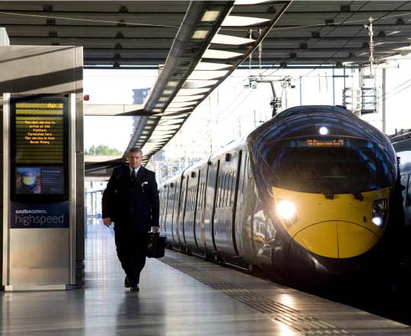

Summary of Decisions
The Government has reached decisions on each of the issues consulted on. These decisions draw on the evidence prepared ahead of the consultation, on that submitted in consultation responses, and further analysis undertaken in the light of these responses.
The Government considers that –

Strategy
- There is a compelling case for delivering a step-change in the capacity and performance of Britain’s inter-city rail network to support economic growth over the coming decades. Doing nothing is not an option.
- The construction of a national high speed rail network from London to Birmingham, Manchester and Leeds (the Y network) is the best means for enhancing rail capacity and performance on Britain’s key north-south corridors. The Y network should incorporate links to the West Coast and East Coast main lines to enable through-running services to additional destinations, as well as intermediate stations in the East Midlands and South Yorkshire. Such a network will also provide a foundation for potential future expansion.
- Further major upgrades to the existing lines in these corridors would not on their own be an effective long-term solution to capacity constraints on Britain’s key north-south inter-city lines, would cause substantial disruption to passengers, freight users and businesses, and would do little to support the Government’s broader strategic objectives. This decision was reached following detailed assessment of all the available alternatives, including proposals advanced in consultation responses.
- A phased approach to undertaking the necessary design, legislative and construction steps is the best way to ensure that the benefits of high speed rail are realised at the earliest opportunity. The Government will pursue a hybrid bill for each phase of the Y network. A single hybrid bill for the entire network would risk the overall delivery of the project.
- The Y network should incorporate a direct link to the Channel Tunnel via the HS1 line. This will create the potential for direct rail travel to Europe from the Midlands and the North without the need to interchange.
- Route options for a direct spur link to Heathrow Airport should be developed to form part of Phase 2 of the Y network. Diverting the main HS2 line via or close to Heathrow would be costly and would disadvantage the vast majority of HS2 passengers. The Government therefore favours a direct spur link to the airport, which could radically improve its accessibility from the major cities of the Midlands and the North. The options for such a spur link will be considered by the Government as part of Phase 2.

London – West Midlands line of route
- The technical specification for high speed rail employed by HS2 Ltd is robust, appropriate and deliverable. It relies largely on the use of existing technologies but also allows for a sensible degree of future-proofing.
- The route selection process was appropriate and rigorous. The recommended station options are the right ones, and there is no case for intermediate stations on the London to the West Midlands phase of the network.
- The proposed route corridor, including the approach for mitigating its impacts, is the best option for a new high speed line between London and the West Midlands. Many people expressed a view on the line of route in their local area. HS2 Ltd looked again at the route in light of the consultation responses and, subject to the alterations noted in Chapter 6, we believe this route remains the best option in terms of its overall benefits and costs, including impacts on sustainability.
- A package of alterations to the proposed route should be made to further reduce its impacts on the local environment and communities. These include substantial additional tunnelling in the Chilterns Area of Outstanding Natural Beauty and in the Northolt area of West London.
- The Appraisal of Sustainability was a robust document that was appropriate to inform the decision on whether to proceed with the proposed route. The document enabled an informed view to be taken on the impacts of the scheme.

Property and blight
- HS2 will affect homeowners, communities and businesses along the line. We will bring in a package of measures over and above what affected homeowners are already entitled to under law. This will include a streamlined advance purchase scheme, a refreshed hardship scheme, support for those affected by construction, measures to reinforce confidence in properties above tunnels, and a sale and rent back scheme.
- There is only a weak case to be made for introducing a compensation bond and the risks and costs associated with a bond-based property purchase scheme should not be discounted. We have therefore decided not to proceed with either scheme.
Each of these decisions is discussed in more detail in Part II of this document:
- Chapter 2 – Case for Action
- Chapter 3 – Case for a National High Speed Rail Network
- Chapter 4 – Phasing, Heathrow Airport and High Speed 1
- Chapter 5 – Technical Specification and Route Selection for HS2
- Chapter 6 – Line of Route for HS2 (London – West Midlands)
- Chapter 7 – The Fair Property and Blight Deal
The document concludes in Part III with an overview of the next steps for pursuing HS2.

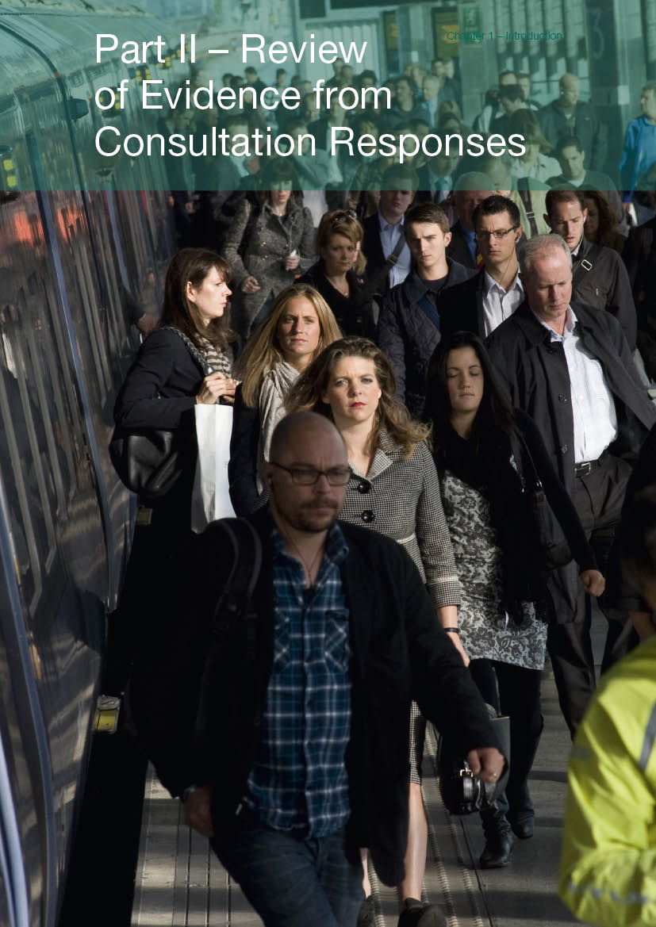
Part II – Review of Evidence from Consultation Responses

Chapter 1 – Introduction
1.1 The consultation on high speed rail asked seven questions, covering the Government’s overall strategy for high speed rail, the proposed route for the London to West Midlands line, its environmental appraisal, and options for supporting property owners affected by the proposals.
1.2 The questions asked were:

Strategy
1. Do you agree that there is a strong case for enhancing the capacity and performance of Britain’s inter-city rail network to support economic growth over the coming decades?
2. Do you agree that a national high speed rail network from London to Birmingham, Leeds and Manchester (the Y network) would provide the best value for money solution (best balance of costs and benefits) for enhancing rail capacity and performance?
3. Do you agree with the Government’s proposals for the phased roll-out of a national high speed rail network, and for links to Heathrow Airport and the High Speed 1 line to the Channel Tunnel?

London-West Midlands line of route
4. Do you agree with the principles and specification used by HS2 Ltd to underpin its proposals for new high speed rail lines and the route selection process HS2 Ltd undertook?
5. Do you agree that the Government’s proposed route, including the approach proposed for mitigating its impacts, is the best option for a new high speed rail line between London and the West Midlands?
6. Do you wish to comment on the Appraisal of Sustainability of the Government’s proposed route between London and the West Midlands that has been published to inform this consultation?

Property and blight
7. Do you agree with the options set out to assist those whose properties lose a significant amount of value as a result of any new high speed line?
1.3 The chapters that follow discuss the key issues raised in consultation responses. The chapters draw on a number of sources:
- An independent response analysis report prepared by Dialogue by Design;
- A series of detailed reviews of issues raised in consultation responses, each of which have been published alongside this document; and,
- Further work undertaken or commissioned by HS2 Ltd and the Government in the light of consultation responses. These are referenced in the respective chapters.
1.4 Each chapter presents the basis on which the decisions presented in Part I of this document have been reached. The chapters are structured according to the questions asked in the consultation.
1.5 A list of supporting material is presented at the end of this document. These documents set out in more detail the information and analysis on which the decisions presented in this document were reached.

Chapter 2 – Case for Action

Introduction
2.1 Britain has a proud railway heritage. The great railway engineers of the 19th century were not only responsible for supporting a technological and resulting economic revolution within these shores but also for exporting new railway technologies around the world. Britain’s railway legacy runs wide and deep, as a constant and enduring testament to the country’s engineering skill and economic vision.
2.2 The lines and stations pioneered by these Victorian and Edwardian visionaries have served this country well. For over a century-and-a-half they have helped to support economic prosperity and boost quality of life by opening up new journey opportunities. But other than the HS1 line to the Channel Tunnel, we have not built a major new railway line in Britain since the Great Central Line opened in 1899.
2.3 With trends of ever increasing demand for rail travel and in the face of the changing patterns of economic activity in the 21st century, the question Britain now faces is whether our Victorian heritage remains sufficient for the next 100 years.
2.4 This chapter sets out the Government’s analysis and decisions in light of the views and evidence submitted in relation to question 1 of the consultation:
Do you agree that there is a strong case for enhancing the capacity and performance of Britain’s inter-city rail network to support economic growth over the coming decades?
2.5 These issues are considered in more detail in the Review of the Government’s Strategy for High Speed Rail.

Summary of decisions
- There is a compelling case for delivering a step-change in the capacity and performance of Britain’s inter-city rail network to support economic growth over the coming decades. Doing nothing is not an option.

Enhancing the capacity of Britain’s inter-city rail network
2.6 The Government considers that there is a compelling case for enhancing the capacity of Britain’s inter-city rail network. This position was widely supported in responses to the consultation.
2.7 The present challenging economic circumstances should not deflect us from planning for a future return to stable, long-term economic growth. Long-term growth in the economy will prompt growing demand for both business and leisure travel between our major conurbations. The number of inter-city journeys made on the UK’s rail network more than doubled between 1994 and 2009 and continued rising even through the recent recession. Capacity constraints are already becoming apparent on the West Coast Main Line, and are forecast to worsen over the coming decades. Network Rail forecasts that by the mid-2020s all capacity for additional or lengthened services on this recently modernised line will have been exhausted. Both the Midland and East Coast main lines also face future capacity shortages.
2.8 There are already unacceptable levels of crowding on numerous peak time services on the West Coast Main Line, which will become an increasingly common occurrence as demand rises. Standing for an extended period of time on a busy train is not a pleasant experience, not least for elderly people, disabled people or those who are pregnant or travelling with children. Providing additional rail capacity will be vital to ensuring that the worsening disparities between supply and demand are tackled.
2.9 The Government has outlined an ambitious programme of investment for the railways. Record levels of investment are being targeted at projects and interventions to support economic growth and tackle some of the most pressing needs on the network. The current Thameslink and Crossrail projects will provide an unprecedented uplift in public transport capacity in London and enhance connectivity into and within the capital. The current lengthening of the Pendolino trains on the West Coast Main Line will provide additional capacity for long-distance passengers on this line.
2.10 Beyond this, the Government has recently confirmed its intention to invest in and upgrade significant sections of the inter-urban rail network right across the UK. We plan to electrify the Great Western Main Line and key lines in the North West, replace the ageing inter-city rolling stock on the Great Western and East Coast main lines, and fund the East West Rail project from Oxford to Milton Keynes. Additional measures will be considered through existing rail industry planning processes.
2.11 Despite this significant investment programme, continuing demand growth is predicted to place growing pressure on rail capacity over the coming decades. This includes both growth in the commuter and regional rail markets, as well as in demand for long-distance inter-city rail. Ongoing growth in rail freight, and particularly in the international container market, is also forecast.
2.12 The Government’s assessment of the long-term need for additional rail capacity on key inter-city lines, as presented for the consultation, is supported by Network Rail and the overwhelming majority of business and local government organisations which responded to the consultation. The capacity of our railways faces a large shortfall, which requires a proportional, strategic response, rather than short-term, tactical measures. Planning and developing major rail schemes is a lengthy process. Given the impending pressures on the rail network, it is vital that planning commences now to ensure that the network has sufficient capacity over the long term.
2.13 A number of responses to the consultation queried whether the demand forecasts for HS2 were overstated. Passenger demand forecasting is discussed in Chapter 3.
2.14 Some groups opposed to HS2 dispute the Government’s assessment of a growing capacity shortage on our inter-city railways. Some responses argued that improvements in communications technologies will reduce the need for travel. The impact of modern communication technologies on rail demand is complex, but on the basis of our analysis we consider that the argument that such advances will mean that significantly less additional rail capacity is required, is overstated. Despite communication devices becoming ever more sophisticated and affordable, recent decades have still seen increasing demand for travel, and particularly for rail travel. We expect communication technologies to exert a relatively modest impact on the demand for rail travel based on the evidence available, and this is reflected in our demand forecasts (see the Economic Case for HS2: Updated Appraisal of Transport User Benefits and Wider Economic Benefits). However, although we have assumed a conservative approach in our demand forecasting, it is possible that new communications technologies could have either no overall impact on travel demand or even increase it. This effect could arise from, for example, enhanced communications technologies encouraging firms to enter new or more distant markets, which, at some point, would be likely to generate some new demand for travel.
2.15 Accepting that we face a growing capacity shortage on our main inter-city rail routes, the Government has a choice: either to enable further growth in inter-city rail travel by providing additional rail capacity, through a range of possible options, or to make no provision for growth and see services become more crowded, with both passengers and freight increasingly forced to make journeys by other modes or not at all.
2.16 The Government supports the development of effective alternatives to travel, and a Department for Transport Minister has this role in his portfolio. However, even taking account of this, the Government remains of the view that increased rail capacity is necessary for economic prosperity. Given the substantial evidence that exists to demonstrate the important link between the speed, convenience and efficiency of travel between the UK’s productive urban centres and economic growth, the Government cannot allow a lack of inter-city rail capacity to act as a brake on our national prosperity. Consultation responses record strong support for this position, particularly amongst local authorities in the North and the Midlands. In addition, the Government does not consider that facilitating demand for travel is necessarily inconsistent with our statutory obligations for reducing carbon emissions.
2.17 In support of this approach, Sir Roy McNulty makes clear in his independent Rail Value for Money Study that investment in new infrastructure remains a necessity where existing system capacity is unable to meet growth in demand or to deliver required improvements in performance.
2.18 It is notable that relatively few responses to the consultation argued for prioritising increased road or air capacity (over rail) between our major urban centres to meet demand for inter-city travel. The Government concurs that inter-city rail travel as a means of serving these key routes offers valuable practical and sustainability benefits in comparison to road travel and domestic aviation. In terms of road infrastructure, the Government does not consider that there is a case for major new motorways, and therefore our strategic road strategy focuses on schemes to address key pinch points and improving access to the strategic road network, especially to serve new development, and also the continuing roll-out of the managed motorways programme as a means of enhancing the capacity and performance of the motorway network.
2.19 Rail is very well suited to serving many inter-urban markets, as it can provide rapid, safe and reliable travel into the heart of the city centre. City centre-to-city centre journey times can be considerably quicker by rail than by road, and traffic and parking difficulties are avoided. Furthermore, rising fuel prices are a growing incentive for travellers to use the railways rather than their cars, especially for longer distance journeys. In the very long term, the decarbonisation of road transport (which the Government is supporting through encouraging the uptake of ultra-low emission vehicles) may alter the case for road infrastructure investment, but it will not alter rail’s greater ability to serve these key city centre markets.
2.20 In aviation, although the Government strongly supports maintaining the UK’s aviation hub status, as set out in the National Infrastructure Plan, it has ruled out the provision of a third runway at Heathrow as a means of achieving this, and wants to see modal shift away from domestic routes where possible. The Government is committed to producing a sustainable framework for UK aviation and in March 2011 published a scoping document to initiate a dialogue with a wide range of stakeholders on the future direction of aviation policy. It intends to issue a draft framework for consultation later in 2012.
2.21 In sum, the Government sees a case for meeting growing inter-city travel demand through our railways, as rail offers both practical advantages for passengers in this sector and considerable sustainability benefits by comparison with other major forms of transport. We feel that such an approach is entirely consistent with the Government’s overall strategy for transport. Increasing the environmental efficiency of travel is fundamental to meeting our objectives for carbon emissions reductions, and rail generally offers lower carbon emissions per passenger mile than either road or air travel.
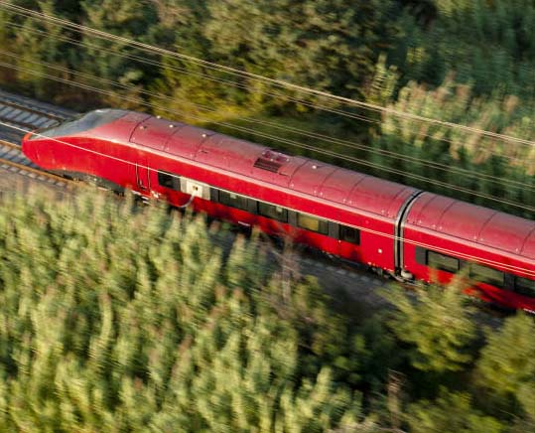

Enhancing the performance of Britain’s inter-city rail network
2.22 The Government wants to see a step-change in the performance of the inter-city rail network – not only in terms of speed but also, vitally, by increasing both the reliability and the connectivity offered by the railways.

Reliability
2.23 Reliable journeys are essential. Along with price, confidence in the reliability of a journey is amongst the highest priorities for passengers. The existence of a well connected network and the potential for attractive journey times have little meaning to passengers if their journey is significantly delayed or there are persistent, low-level reliability problems.
2.24 The track record of rail reliability in the UK is, on the whole, increasingly positive; punctuality has improved significantly since 2004, and between 2000 and 2010 overall passenger satisfaction has risen from 73 per cent to 84 per cent.
2.25 Whilst the rail industry has been very successful at improving reliability over recent years, maintaining these levels of performance is likely to be increasingly challenging on our most congested routes as more services are accommodated in response to growing demand. Accommodating steadily increasing passenger numbers on increasing numbers of services, particularly within the constraints of a mixed-use railway, will over time present growing challenges and make the running of an “on-time” railway ever more difficult. Any assessment of the case for improving inter-city rail reliability must take full account of the fact that the reliability of our more congested inter-city routes is likely to be challenged unless the Government takes action.
2.26 On account of the potential impacts on reliability of increasing capacity on our most congested routes, coupled with the importance attributed to reliability by passengers and rising passenger expectations, the Government considers that in assessing options to deliver a long-term increase in rail capacity, it is important to take into account their potential impacts on network reliability.

Connectivity
2.27 The connectivity of our inter-city rail network refers to the convenience and efficiency of the rail links available between our major cities. Good connectivity complements the speed and reliability of a rail journey, by offering a direct route from one location to another that allows passengers to travel with minimal interchanges. Direct connections between cities are of value to passengers as they offer convenience and, invariably, faster journey times. Passengers with reduced mobility particularly stand to benefit from avoiding the need to change trains. The Government strongly supports inter-city rail connectivity as there is clear evidence to demonstrate that better connectivity increases rail passenger numbers. And increased rail patronage can, in turn, give rise to wider environmental and economic benefits.
2.28 Growing demand for rail travel presents new opportunities but also new challenges. As demand grows over the coming years and capacity becomes more stretched, train operators are increasingly likely to focus on serving the main rail markets of Britain’s major urban centres. The expense of new infrastructure, as well as the operating costs, to enable smaller towns and cities to retain current service standards will in many instances be unjustifiable. As a result, smaller towns and cities are likely to see their rail services become less frequent and slower. This trade-off is already playing out on our busiest main lines, and, in particular, the recent timetable introduced following the West Coast Route Modernisation programme has seen a diminished service for a number of stations along the route. By contrast, with the majority of long distance north-south journeys expected to transfer to HS2, there is potential to use the capacity released on the existing network for new and better services, catering for a wider variety of markets which would improve the connectivity to places that could otherwise see a diminishing rail service.
2.29 An additional important connectivity benefit would be to enable journeys to be made more quickly and efficiently by better linking up Britain’s inter-city rail network with other key networks and transport hubs. The UK’s major hub airport is currently poorly connected to Britain’s main rail lines and the HS1 line is difficult to access by rail from much of the UK. These represent significant missed opportunities. Similarly, Crossrail, currently being constructed in London, does not include a direct connection with any of Britain’s current north-south inter-city rail lines. The opportunity to address this lack of connectivity through HS2 would create valuable benefits.
2.30 Connectivity is not only valuable to the individual, but to businesses and to the economy as a whole. By improving inter-city rail connections we bring our major cities closer together, allowing the businesses and economies of those cities greater opportunities for productive interaction. The benefits of enhanced rail connectivity to the UK economy are discussed in detail below.
2.31 A large number of local authorities and businesses support the Government’s intention to enhance inter-city rail connectivity. It is the Government’s objective to promote economic growth and improve the service offered to the rail passenger by enhancing the connectivity of Britain’s inter-city rail network.

Speed
2.32 Many consultation responses identified the need for improved journey times between the main urban centres in the UK, drawing unfavourable comparisons with elsewhere in Europe. Whilst some consultation responses indicated satisfaction with selected inter-city journey times, it would be naïve to ignore the general attraction of reduced journey times to the passenger, especially in the context of rising passenger expectations and rising performance standards on continental railways.
2.33 There is strong evidence to suggest that rail passengers, both business and leisure, value time-efficient journeys and reductions in journey times. Eurostar and West Coast Main Line express services have substantially increased their respective market share as journey time reductions have been achieved. The value of journey time savings to business travellers is discussed in further detail in the Economic Case for HS2: Value for Money Statement.
2.34 Although journey times to and from London have improved to some degree over recent decades, journey times between some major regional cities remain very poor. It is now as quick to travel by train from London to Brussels as from Birmingham to Leeds. This lack of inter-regional connectivity has previously been identified by the Northern Way as a constraint on growth in the North. Areas of poor connectivity are a result of minimal construction of new lines since the railways were built by the Victorians, during which time our cities have developed and their relative importance has evolved.

Supporting economic growth
2.35 The Government believes that enhancing inter-city rail capacity and performance will help create the right conditions for economic growth. There is compelling evidence that infrastructure has an important role to play in boosting productivity and reducing costs to business, yet the UK has suffered from a lack of planning for and investment in infrastructure over the long term. The World Economic Forum ranked the UK just 28th for the quality of its infrastructure in 2011.
2.36 The Government is committed to addressing this problem; our core objective, as set out in the Plan for Growth, is to put the UK on a path to sustainable, long-term economic growth. We have already taken decisive action to tackle the fiscal deficit and provide the ingredients for economic stability, which is an essential precondition for growth. But other actions are needed to create the right conditions for long-term growth.
2.37 The National Infrastructure Plan sets out the Government’s strategy for ensuring that the country is supported by the infrastructure it needs to attract investment and sustain long-term economic growth that is balanced across the country and across sectors. To contribute to the Government’s economic objectives, the National Infrastructure Plan identified the following long-term transport priorities:
- To improve the capacity, performance and resilience of roads, railways and international gateways;
- To improve integration between different transport modes;
- To support the move to a low carbon economy; and,
- To improve connectivity and capacity between main urban areas and between them and international gateways.
2.38 These priorities demonstrate the strength of the Government’s ambition for transport, and particularly inter-city transport, as a catalyst for economic growth. It is important that we improve connectivity between our major centres of economic activity to boost productivity, reduce costs, increase efficiency and expand business and labour markets.
2.39 The Government intends to put in place the necessary measures to meet future demand for inter-city rail travel and, in doing so, to enhance performance – in terms of journey time, reliability and connectivity – as part of a programme of measures to remove barriers to long term and balanced economic growth. Investment in inter-city rail capacity and performance will help to unlock the potential of the regional economies of the Midlands and the North – making them more attractive places to locate and do business. Supporting strong growth outside London and the South East is no longer optional; ensuring that Britain is able to compete effectively in the 21st-century will require that every region is fulfilling its potential.
2.40 The Government’s position has the support of businesses and their representative organisations across the country, who expressed their belief in the importance of improving our transport networks, and specifically our inter-city rail network, to enable higher economic productivity. Support for the Government’s proposition is particularly strong across the regions to be served by HS2, where opportunities to promote economic growth are especially welcome.

Government’s carbon objectives
2.41 The Government considers that its strategy for improving inter-city rail capacity is consistent with the UK’s objective to reduce net emissions of greenhouse gases. Domestic transport emissions make up nearly a quarter of UK emissions. By 2050, domestic transport will need to substantially reduce its emissions. Over the next decade, average emissions of new cars are set to fall by around a third, primarily through more efficient combustion engines. Sustainable biofuels can also deliver substantial emissions reductions. As deeper cuts are required, vehicles will run on ultra-low emission technologies such as electric batteries, hydrogen fuel cells, and plug-in hybrid technology.
2.42 However, even with almost completely decarbonised road transport in the long term, the challenge of road congestion will persist meaning that rail transport will remain best placed to serve the economically important city centre-to-city centre travel market.
2.43 Rail is a comparatively carbon efficient mode, generally producing lower carbon emissions per passenger mile than either car travel or aviation. Even allowing for the fact that power usage increases with speed, the high levels of passenger usage that high speed services tend to attract mean that per passenger carbon emissions remain comparatively low. There is widespread support amongst environmental organisations for the promotion of inter-city travel by rail.
2.44 Although there is a role for alternatives to travel in some cases, the Government does not consider that it is appropriate to prevent or limit economically and socially valuable inter-urban journeys. The challenge therefore is to ensure that capacity to accommodate these journeys is provided on more carbon-efficient modes.
2.45 Enhancing inter-city rail capacity and performance is consistent with the Government’s carbon objectives, as well as its objectives for the economy and for the passenger. It offers the potential for net carbon reductions through modal shift from more carbon-intensive forms of transport such as aviation and roads; reduced crowding, and improved journey times, connectivity and reliability are likely to contribute not only to increased passenger satisfaction amongst current users of the inter-city rail network, but to attracting new passengers from other modes.
2.46 Modal shift of freight, from our roads to our railways, presents another opportunity for reducing the UK’s net carbon emissions through enhancing inter-city rail capacity. The Rail Freight Group estimates that failing to provide additional freight capacity on our railways could add some 200 trucks an hour to the M40, the M1 and parallel ‘A’ roads, and, by consequence, some 500,000 tonnes CO² per year to our transport related carbon output.

Chapter 3 – Case for a National High Speed Rail Network

Introduction
3.1 The railways in Britain are a huge success, showing high levels of year-on-year demand growth over recent decades. New capacity is clearly needed to manage long-term demand growth, and this requires planning and development to commence now given the length of time involved in introducing major new infrastructure projects. Chapter 2 set out the Government’s ambition to provide additional inter-urban rail capacity. Failure to act to address this need would be to the detriment of passengers and Britain’s long-term economic competitiveness.
3.2 Providing additional inter-urban capacity by building a national high speed rail network is the best approach on our main north-south lines – not least due to the range of other benefits high speed rail can offer. Faster journey times, a more reliable network, new journey opportunities, and space to run additional commuter, regional and freight services on the existing network, would all benefit passengers and support the economy in Britain.
3.3 This chapter sets out the case for building a high speed rail network in Britain as the best answer to the challenges faced on our main north-south inter-city lines. The chapter discusses the evidence provided in consultation responses in relation to the second consultation question:
Do you agree that a national high speed rail network from London to Birmingham, Leeds and Manchester (the Y network) would provide the best value for money solution (best balance of costs and benefits) for enhancing rail capacity and performance?
3.4 The chapter also draws on further work undertaken to allow the issues raised in consultation responses to be considered in more detail. HS2 Ltd has updated its economic analysis for HS2 to reflect, for example, more recent GDP forecasts and demand data and new rail investment measures. The Department for Transport has undertaken a wider “value for money” assessment of the project. We have also reassessed the evidence in respect of transport’s strategic impacts on economic geography. In relation to the strategic alternatives to high speed rail, we have updated and extended the economic analyses and received advice from Network Rail on the cost, feasibility and operational impacts of these approaches.

Summary of decisions
- The construction of a national high speed rail network from London to Birmingham, Manchester and Leeds (the Y network) is the best means for enhancing rail capacity and performance on Britain’s key north-south corridors. The Y network should incorporate links to the West Coast and East Coast main lines to enable through-running services to additional destinations, as well as intermediate stations in the East Midlands and South Yorkshire. Such a network will also provide a foundation for potential future expansion.
- Further major upgrades to the existing lines in these corridors would not on their own be an effective long-term solution to capacity constraints on Britain’s key north-south inter-city lines, would cause substantial disruption to passengers, freight users and businesses, and would do little to support the Government’s broader strategic objectives. This decision was reached following detailed assessment of all the available alternatives, including proposals advanced in consultation responses.

Government’s strategy for a national high speed rail network
3.5 The Government’s plans for a national high speed rail network are consistent with its wider transport and economic objectives. It will provide vital capacity on key strategic transport routes, support economic growth and regeneration in towns and cities across Britain, ensure that a low-carbon option is in place for an increasing number of journeys, and create the potential for significant increases in both commuter services to tackle overcrowding and freight services to take lorries off the roads.
3.6 Consultation responses commented extensively on the fit between the Government’s proposed strategy for high speed rail and its wider transport objectives. In particular, responses claimed that the absence of a codified transport strategy precludes any firm decisions on the merits of high speed rail.
3.7 The Government does not agree with this view. We have set out in our Business Plan a clear vision for a transport system that is an engine for economic growth but one that is also greener and safer and improves quality of life in our communities, and we have explained how we plan to achieve this. This provides a clear context in which the Government’s high speed rail plans are being developed. However, in the light of points raised in consultation, as the HS2 project is developed the Government will seek to provide further information over the role that high speed rail will play in its wider objectives and strategies. That is already beginning to happen through, for example, the coordination of the National Infrastructure Plan, the Growth Review, and National Policy Statements – the national networks statement in particular relates to HS2 – and through local development plans and the work of Local Economic Partnerships.
3.8 The Government recognises that the benefits of HS2 will be maximised through the integration of planning activities across a range of government and non-government bodies. We will continue to work collaboratively to ensure that the opportunities offered by HS2 are fully reflected in work underway elsewhere in government, at local, regional and national levels. We recognise the particular importance, as stressed in consultation responses, of local development planning being able to take full account of the advent of HS2.
3.9 A further issue raised in consultation responses is the risk that investment in the existing rail network would diminish as a result of HS2. Rather than a threat, the Government sees HS2 as an opportunity for the existing network to continue to develop. This view is supported by consultation responses from the rail industry. HS2 will release very significant levels of capacity on existing lines, allowing new services to relieve crowding, better serve passengers and support economic growth.
3.10 With the Mayor of London, the Government is currently investing £14.5 billion in the Crossrail project in London. The construction of this strategic infrastructure project will conclude ahead of HS2 commencing. Even during the current construction of Crossrail the Government has been able to make record levels of investment in the existing rail network. Future investment decisions will have to be taken on their own merits at the time but HS2 will not deflect the Government from its intension to continue investing in the transport network. The Chancellor’s announcement in the 2011 Autumn Statement of a number of major transport infrastructure projects further demonstrates the Government’s commitment to the long-term success of the railways in Britain.

Economic case for HS2
3.11 Alongside the main 2011 consultation document, the Government published a detailed appraisal of the transport user benefits and wider impacts of HS2, which set out benefit cost ratios for both the full proposed Y network and for the initial London to West Midlands phase. The analysis set out in this report was a major theme of consultation responses, with supporters of the Government’s proposals arguing that the Government’s assessments were overly conservative and those challenging them raising a range of concerns regarding both the methodology and conclusions reached.
3.12 The key issues raised by objectors in relation to the economic analysis are discussed below, together with the Government’s response. These issues have also been considered in more detail in the Economic Case for HS2: Value for Money Statement, which has been published alongside this document.
3.13 The most frequently cited concerns related to the values associated with time savings for business travellers and the degree of demand growth being forecast. The first of these addresses the way in which the benefits of time savings are calculated, which uses a simplifying assumption under which all travelling time is treated as non-productive. Given that many business travellers may work on trains, it has been argued that this leads to the over-estimation of the value of time savings for such travellers. The second covers a range of arguments proposed in responses as to why the level of rail demand growth forecast by HS2 Ltd is unlikely to materialise.
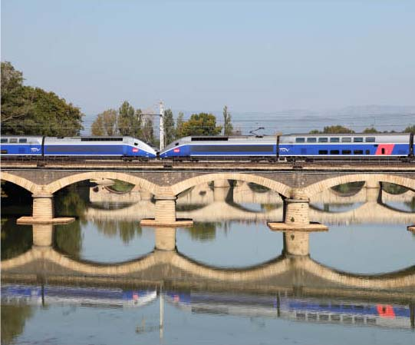

Valuing time savings for business travellers
3.14 In respect of the value of time for business travellers, the Department for Transport has reviewed the evidence on this issue in the light of concerns raised in the consultation. This review found no robust and consistent evidence for any alternative values of time. Although it was generally accepted that business travellers do often make some productive use of travel time, there was no apparent consensus as to the degree of productivity achieved and a range of countervailing factors were also identified which might balance any reduction in values of time savings resulting from a changed approach. These included the additional productivity gained where travellers transferred from crowded to uncrowded conditions, or from road or other comparatively non-productive modes to rail. There is also evidence which indicates that time savings on longer journeys are valued more highly than those for short trips (a finding already adopted in project appraisal by some countries). In the absence of a credible alternative to our existing methodology, the Government’s conclusion remains that the values of time used are robust and appropriate.
3.15 Nonetheless, given the high profile of this issue in the run up to consultation, HS2 Ltd did carry out a sensitivity test on its economic analysis using an alternative approach to valuing time savings for business travellers. This made a broad assumption that the value of time savings for business travellers are reduced by a half, but increased the value of crowding improvements for business travellers to reflect the additional productive time gained. This sensitivity test has been repeated as part of the updated economic analysis. In both cases, the overall benefit cost ratio for HS2 remained broadly the same. It should not be assumed that this sensitivity test presents a more accurate picture than the standard approach. It does, however, indicate that the case for HS2 is not significantly sensitive to changes in methodology in this area, when a range of potential effects are taken into account.

Passenger demand forecasting
3.16 A number of criticisms were made in consultation of the demand forecasts published by HS2 Ltd. The key arguments put forward were that recent and current demand growth is likely to come to an end as the market for long distance travel saturates, that the approach used for capping demand growth was inappropriate, and that an out of date forecasting methodology was used.
3.17 The key piece of evidence supporting the contention that the market for long distance rail travel will stop growing well before reaching the levels forecast by HS2 Ltd is the fact that growth in long distance travel appears to have already reached saturation when looked at across all modes. The Government, however, does not accept all of the inferences that have been drawn from this analysis. The rail market only accounts for a small proportion of total long distance travel and hence there would still be scope for very substantial rail growth purely as a result of modal shift even if total long distance travel ceases to grow; and despite recent slowdowns in demand growth for car and air travel, no similar pattern has been discerned in the rail market.
3.18 In addition, the Department for Transport’s analytical models indicate that the recent trends in overall long distance travel demand can be explained in large part by factors such as the recent recession, rising fuel prices, and road congestion and capacity constraints. It is unlikely, therefore, that the historical pattern of growing demand for travel linked to rising prosperity has come to an end in any mode, and the Department projects that demand will resume increasing as the economy returns to a long-term trajectory of growth.
3.19 With regard to the level and date at which demand is capped, and particularly the argument that a 2043 cap was too far into the future, the Government’s view remains that the approach taken was appropriate. The cap on demand acts as a proxy for eventual market saturation. It is reasonable to assume that this would relate to a set level of demand, rather than a specific year, and the level chosen, equivalent to a rough doubling of long distance demand of 2008 levels, is not unrealistic. In the updated economic analysis, this level is reached more quickly, by 2037. Given the inevitable uncertainty in relation to any long term forecast, however, the Government has also carried out, and now updated, sensitivity analysis in relation to this issue. This is reflected in its overall conclusions regarding the value for money offered by a national high speed rail network.
3.20 In terms of the forecasting methodology used, the analysis carried out by HS2 Ltd was based on the Government’s established guidance, which specifies the use of income elasticities for long-distance rail demand from version 4.1 of the Passenger Demand Forecasting Handbook (PDFH). A number of those responding to the consultation argued that this methodology is no longer current and the more recent PDFH 5 should have been used. Over recent years, rail demand has grown faster than either version of PDFH would have predicted. To address this issue, the Government in conjunction with the rail industry has specified a research project to enhance its overall approach to forecasting rail demand, the results of which it is currently considering (see Economic Case for HS2: Value for Money Statement). It should also be noted that the elasticities in PDFH 5 would only affect the rate at which demand, and particularly long-distance demand, grows, and so would only alter the timing and not the fundamental nature of the long-term challenges that demand growth poses and which the Government’s high speed rail strategy aims to address. Given the interest in this issue during consultation, HS2 Ltd has carried out sensitivity testing using the PDFH 5 methodology as part of its updated economic analysis, which sees a reduction in the BCR. However, in light of the issues noted above and also the fact that this test is likely to represent a lower bound for the BCR level using PDFH 5, it does not alter the Government’s view of the overall case for taking the scheme forward.
3.21 It should also be noted that, in contrast to these concerns, a number of consultation responses argued that HS2 Ltd’s demand growth forecasts were likely to prove conservative, particularly in the light of the very high levels of growth seen on long distance routes over recent years. The Government remains of the view that its forecasts have been appropriately derived, but notes that, as with any forecast, there is uncertainty in both directions.

Additional points raised in consultation
3.22 Many of the other criticisms of the economic case raised in consultation related to the comparative treatment of HS2 and alternatives to high speed rail. In the light of respondents’ views and proposals on this topic, the Government commissioned significant further work on these alternatives and has updated the economic analysis of the key alternatives, including the main additional option put forward in consultation. It also commissioned advice from Network Rail, as the custodian of the current network, on the costs, deliverability and operational impacts of these alternatives. Further detail on this work is presented later in this chapter.
3.23 The updating of the economic analysis for HS2 and for the alternatives has also enabled additional schemes to be incorporated into the base case, as suggested in some consultation responses, including the Evergreen III scheme, which is now a firm industry commitment, and changes to service patterns on the West Coast Main Line. The economic analyses published for consultation were also criticised by some respondents for using inconsistent base cases. As a result of the updated inputs to the modelling, it has proved possible to address these inconsistencies, which were necessary to address model convergence issues and were explicitly acknowledged in the published documentation.

Updated economic analysis of HS2
3.24 Following the completion of the consultation an updated analysis of the economic case for HS2 has been produced to inform Ministers’ decisions (see the Economic Case for HS2: Updated Appraisal of Transport User Benefits and Wider Economic Benefits). This reflects concerns raised in consultation and more recently released data. The most significant changes made are as follows:
- Economic forecasts – demand forecasts have been updated in light of revised economic forecasts from the Office for Budget Responsibility;
- Patterns of demand – modelling has been updated to incorporate recent changes in the demand for long distance travel;
- Y network development – the costs for the Y network, and separately costs for London – West Midlands, have been reviewed on the basis of further development of Y network station and route options; and,
- Forecast rail services without HS2 – updated assumptions have been produced for the rail services expected in the absence of HS2, as a result of increased information and the commitment by the Government to additional rail enhancement schemes.
3.25 The overall effect of these changes has been to increase the benefits and the revenues of both the full Y network and the initial London – West Midlands line, but this is counterbalanced, in the case of the Y network as a whole, by an increase in costs. On this updated basis the benefit cost ratio for the Y network is estimated to be 1.6 to 1.9; and that for the London – West Midlands line to be 1.4.
3.26 These BCRs rise to 1.8 to 2.5 and 1.7 respectively once wider economic impacts such as agglomeration are taken into account. These total £4 billion for the London to West Midlands line, rising to between approximately £6 billion and £12 billion for the Y network as a whole. Other factors which could further increase these BCRs include the additional benefits resulting from the redevelopment of Euston station, reductions in the cost of the scheme to the Government through private sector contributions, and the use of more sophisticated approaches to pricing.
3.27 However, additional disbenefits also need to be set against these including key environmental impacts such as the effect of new lines on the natural landscape. Assessments of the value of landscape impacts inevitably entail a significant degree of subjective judgement and can only be carried out on the basis of a detailed route proposal. As part of its value for money assessment process, the Department for Transport has made an initial estimate of the landscape impacts for the proposed London to West Midlands line, which indicates a value of approximately £1 billion. Including these factors in the appraisal reduces the BCR for the London – West Midlands line by approximately 0.1.
3.28 Any ‘single point’ BCR for HS2 will be sensitive to changes in a range of assumptions, including in particular those which affect the rate and level of demand growth. For this reason, as well as producing the central BCRs described above, HS2 Ltd has performed a range of sensitivity tests, the results of which are set out in the Economic Case for HS2: Updated Appraisal of Transport User Benefits and Wider Economic Benefits report published alongside this document. In addition, and in response to points made in consultation regarding the treatment of risk in the economic assessment of HS2, the Department for Transport has also undertaken a risk analysis. This analysis, which is described in more detail in the Economic Case for HS2: VfM Assessment, considers the potential combined impact on the value for money of the London to West Midlands line of changes in a number of key variables, including the rate of GDP growth and the responsiveness of rail passengers to changes in income and fares. It indicates that the BCR for the London to West Midlands scheme is most likely to fall into a range between 1.5 and 2, and that there is only a small likelihood of it falling below 1.
3.29 Even as a standalone project, the London to West Midlands phase of HS2 delivers economic benefits in excess of its costs, as well as valuable strategic benefits to the country. However over and above this, a key additional benefit is the foundation it provides for a future wider national high speed rail network. The cost of building this initial line opens up the opportunity for securing the much larger benefits of a wider network thereafter. Alongside its other benefits, this is a key reason that the Government supports this initial line.
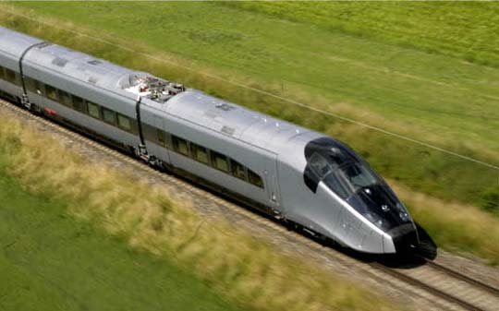

Enhancing rail capacity
3.30 The pressures of increasing demand for travel are already apparent on a number of parts of the rail network. Continued steady demand growth is forecast to intensify and spread these pressures over the coming decades. Given the modest but growing share that rail has in most key long distance markets there is considerable scope for rail travel to develop market share. The demand forecasts underpinning the HS2 proposals show ongoing growth, although at a pace below that seen over recent years.
3.31 Consultation responses widely welcomed the valuable additional capacity that HS2 would provide. Conversely, a number of responses contended that HS2 would provide levels of capacity that would ultimately prove unnecessary, particularly if the demand forecasts underpinning the proposals prove excessive. Clearly forecasting future demand levels necessarily involves a degree of uncertainty – although this can be managed by employing the best available underpinning data and conservative assumptions.
3.32 As noted above, as well as adopting such an approach, HS2 Ltd has also tested the case for HS2 against a range of possible future demand growth scenarios, including several lower growth scenarios. The Government considers that the further testing of the case for HS2 as set out in the Economic Case for HS2: Updated Appraisal of Transport User Benefits and Wider Economic Benefits document demonstrates a robust evidence base for proceeding with the project. The detailed testing of HS2 against a range of future scenarios demonstrates that in most conceivable scenarios there is still a case for proceeding with the project.
3.33 It should also be noted that other consultation responses suggested that, with a view to the long term, HS2 was not being designed to provide sufficient capacity. In support of this position it was noted that the continuation of current and recent demand growth for inter-city rail travel would eventually see the capacity provided by HS2 exhausted earlier than currently assumed. The Government considers that it is adopting a robust approach to providing additional capacity, particularly when capacity on both new and existing lines is taken into account, and is basing its decisions on the best available evidence. Furthermore, should it be the case that the capacity provided by the proposed network proves insufficient over the long-term, it may be possible to extend the proposed Y network to include, for example, a second north-south line from the capital.
3.34 By providing a new route for much of the current inter-city rail traffic, HS2 offers the opportunity to improve the operation and timetabling of services on the existing main north-south lines. This will be to the benefit of commuters but also local and regional passengers, as well as freight services. The opportunity to employ “released capacity” in this way, both by enabling additional services to be run and by creating more space on some existing trains, is a major benefit of HS2. Given that the existing lines and services are particularly full during the peak commuting hours each day, this opportunity will be of great value to commuters. At present the volume of commuter and freight services on a number of lines is constrained by the operation of a large number of fast inter-city services. The new long-distance capacity for such services provided by a new line is the best means of ensuring that additional capacity can also be created for commuters and new freight services.
3.35 These wider benefits of increased capacity on existing lines would extend well beyond the towns and cities located on HS2. Towns such as Milton Keynes, Tamworth and Lichfield could see significant improvements in their rail services compared to today once HS2 opens. Released capacity could also be used to accommodate rising demand for rail freight services, especially in the container market, which would reduce road congestion and deliver reductions in carbon emissions.
3.36 At its heart, HS2 provides an effective means of addressing the challenges of operating a wide mix of different service types on the same lines. The challenges posed by operating local stopping passenger services on the same infrastructure as inter-city services, as well as freight and regional trains, can work to the detriment both of passengers and freight, through reduced line capacity, worse reliability and slower journey times. By segregating inter-city services from other rail traffic, HS2 will work to the benefit of all rail users.

Enhancing rail performance
3.37 The Government supports a national high speed rail network primarily for the additional capacity it will provide. However, the relatively modest incremental cost of making new lines capable of supporting high speed services, as opposed to today’s conventional speed services, would create the opportunity for potentially valuable journey time savings. Many consultation responses supported the reduction of journey times between Britain’s key conurbations and international gateways. The benefits to businesses, as well as to leisure and other travellers, were widely recognised. It was felt that significant benefits would arise from ensuring the Midlands and the North had better access to the major markets of London and the South East and to the international opportunities offered by Heathrow Airport and the Channel Tunnel. This shift would help, it was suggested, with tackling the perception that these regions are relatively isolated from core markets and key international economic flows.
3.38 Some responses also noted that new high speed lines could help to address the slow rail journey times currently experienced on many routes between Britain’s regional cities – and particularly between those regions and conurbations which would be linked by the eastern leg of the HS2 network. It was felt that the current poor connectivity between these regions was a potential constraint on growth and, particularly, on the more effective integration of the city economies affected.
3.39 The key concerns raised by objectors to the Government’s proposals on this topic tended to relate not to the improvements in journey times themselves, but to the way in which these were valued in HS2 Ltd’s economic appraisal. This issue has been discussed earlier in this chapter.
3.40 There was also support for ensuring that HS2 stations were integrated with local transport networks to maximise accessibility and minimise overall journey times, and some concern that the current proposals did not fully achieve this. HS2 has been designed with this objective as a key principle and the network includes ready access to major local and regional transport systems at each of its stations. While the provision of urban transport networks are in the main the responsibility of the local authorities involved, HS2 Ltd will continue to take these issues into account as it develops its route proposals for the second phase of the proposed network and as it carries out more detailed design for the initial London to West Midlands line, including engaging with the authorities in question, to ensure that opportunities for effective integration are identified.
3.41 The final key performance issue covered in consultation responses related to reliability. International experience demonstrates that high speed systems can deliver extremely high levels of reliability, particularly on largely segregated networks. This is something that passengers value highly, as was noted in consultation responses. In this country, on the HS1 line to the Channel Tunnel less than one service out of every 200 is delayed as a result of problems with the infrastructure of the line. In large part this is due to the line having been designed to the most modern standards and employing the latest engineering systems and practices.
3.42 HS2 will also give rise to further reliability benefits on a number of fronts. First, as all services operating on it will employ relatively similar stopping patterns there will be less conflict between services than on the current mixed-use lines in operation in Britain. Second, the high speed network will become increasingly segregated from the existing network over time, with the majority of the services operating solely on the Y rail network. This type of relatively closed system railway is usually able to operate with higher levels of reliability. For example, the Tokaido Shinkansen in Japan achieves average delay of less than 40 seconds per train. Third, HS2 would add resilience to the rail system as a whole by acting as an alternative route for passengers at times of disruption on existing lines.
3.43 Some consultation responses raised concerns over the reliability implications of HS2 for the existing network, particularly arising from the infrastructure and operational interactions between these networks and also disruption arising during the construction of HS2. HS2 Ltd has tested these issues with Network Rail and others. Whilst it is not possible to be definitive at this early stage in the project, before detailed design has been completed, the Government is confident that careful planning can overcome any potential risks. In addition, as the current proposals would not exploit the full maximum potential capacity of the HS2 lines, even once the second phase of the network is in place, there would remain scope for operational flexibility on the line to accommodate and otherwise minimise delays on both HS2 and the existing network.

Costs of HS2
3.44 The issue of fares was raised frequently in consultation responses. The most notable concern was that the cost of using HS2 would be high, making the service potentially unaffordable for many. Responses sought greater clarity from the Government on the level at which fares would be set.
3.45 The Government recognises this concern. However, at this very early stage – with the first line not due to open for well over a decade – it is not possible or appropriate to specify exactly how the fares structure on HS2 will operate. In particular, at this stage in the project, no decisions have yet been taken on the operating and regulatory arrangements for HS2.
3.46 The economic modelling work undertaken by HS2 Ltd has demonstrated that HS2 would have a positive business case, and revenues in excess of its operating costs, by employing the fares structure in place on the existing railway and without the need to charge premium fares. The Government would expect a commercial operator to employ sophisticated yield management techniques to ensure the most effective use of capacity, which could see the business case for the project increase further still. Such an approach would be likely, as on the current railways, to see relatively higher fares at peak times, but significantly more affordable options at times when demand is less high, as has been seen in the approach to pricing followed by Eurostar.
3.47 Any failure to provide sufficient additional capacity on the rail network would be likely to create an upward pressure on fares through operators using price to manage demand. HS2 would alleviate this pressure on the main north-south routes into London, including in many instances in relation to commuter travel, for which the use of released capacity could enable valuable increases in peak service levels.
3.48 The Government has also made clear its intentions to reduce the cost of the railways in this country. Savings of up to 30 per cent are possible over the medium to long term. The Government expects that the benefits of any savings would be shared between farepayers and taxpayers. We will publish a strategy early in 2012 for delivering a better value railway for the benefit of passengers, taxpayers and the wider economy.
3.49 As well as the cost of the fares, consultation responses also recorded a more general concern at the overall cost of HS2 to the country. Three main points were raised.
3.50 First, the affordability of HS2 to the country was queried. It was suggested that HS2 did not sit well with the current efforts to reduce public spending, and that there may not be sufficient finances available to pay for the project. While ultimately the funding of HS2 will be subject to future Spending Reviews, it should be noted that the Government has repeatedly stressed the importance of maintaining investment in infrastructure as a means of supporting and enabling growth, and the Crossrail and Thameslink projects are currently being funded and constructed during this period of spending restraint. The construction costs of HS2 would be spread over two decades, and on this basis would involve an average level of annual spend of less than £2 billion a year. The Government’s view is that this level of investment would be broadly affordable on the basis of overall transport expenditure continuing at roughly equivalent levels to currently.
3.51 Second, responses suggested that HS2 would be beset by cost overruns. In fact, and in line with HM Treasury requirements, the costings prepared for HS2 include allowances of up to 64 per cent for cost overruns. HS1, the only current high speed line in Britain, was delivered on time and on budget. More recently, the £371 million Hindhead Tunnel on the A3 was opened in July 2011 on time and on budget, and the major construction programme for the London 2012 Olympic and Paralympic Games is similarly on target. However, the Government notes the concerns raised in consultation responses and is committed to ensuring the maximum value for taxpayer money. Therefore, we will continue to work with HS2 Ltd and Infrastructure UK and its range of private sector advisers to ensure that the costs of HS2 continue to be properly developed, managed and reviewed.
3.52 If this careful handling of costs leads to corresponding reductions in the public funding necessary for constructing and operating HS2 then this would further strengthen the economic case for the project. While the Government has correctly taken a prudent approach at this early stage in the project’s development, as it progresses it will strive to ensure that the smallest possible proportion of the sizeable contingency allowances included in the current quoted costs are in the event required.
3.53 Third, a number of responses suggested that greater involvement of private sector organisations in the development and delivery of HS2 would be the most effective means of managing costs. These benefits would arise from the imposition of private sector disciplines but also potentially drawing in private funding for the project to lessen the exposure of the taxpayer. The Government is keen to explore and implement these suggestions as the project develops.

Wider economic benefits of HS2

Impact on economic growth
3.54 Many consultation responses supported the Government’s view that a high speed rail network would help Britain remain economically competitive and would deliver significant economic benefits. There was a view that by reducing the journey times between major cities, thereby bringing them closer together, there would be more opportunities for businesses to grow by widening their markets. For example, the Transport for Greater Manchester Committee explained that, “increased inter-urban connectivity between Manchester and the nation’s other core cities will allow businesses in Greater Manchester to access new and diversified markets.” Local authorities in Birmingham, Manchester and Leeds all asserted that the estimates underpinning the HS2 economic case are too conservative.
3.55 In contrast, other responses were sceptical that high speed rail infrastructure would stimulate economic growth, with some also disputing the robustness of the quantified economic case for HS2. Key arguments made were that:
- The predicted benefits were over-stated or unlikely to materialise;
- Any new jobs or development would reflect a redistribution of economic activity rather than additional activity; and,
- Any agglomeration effects would be likely to be very small.
3.56 A paper on these issues submitted by the 51M group of local authorities opposed to HS2 as part of its response to the consultation, for instance, concludes that “the impacts of high speed rail investments on local and regional development are ambiguous at best and negative at worst.”
3.57 The Government recognises the complexity of these issues and notes the strongly contrasting attitudes adopted in consultation responses. In the light of these consultation responses, the Department for Transport has reviewed the evidence in respect of the impacts of transport infrastructure projects on economic growth. This has confirmed that major transport investments can have a significant stimulus on economic growth at the local, regional and national levels, and, where they form part of an effective overall strategy, can support local regeneration.
3.58 In the case of high speed rail, this conclusion is reflected in the changes that have been observed internationally following the completion of high speed rail projects. For example, Lille’s position at the heart of the European high speed network and the Euralille complex that has been developed around its high speed rail station are seen to have made a significant contribution to the city’s redevelopment and to progress towards its ambition to refocus its economy on the services sector.
3.59 On the basis of this review of evidence, the Government’s assessment is that it is likely that HS2 would provide a valuable stimulus to economic growth.
3.60 Putting a specific value on any impact of this kind, however, is more challenging. This is for a number of reasons. First, it is difficult to separate any growth impacts directly related to transport schemes from those caused by wider factors, such as non-transport Government spending programmes or changes in the national and international economic climate. Second, as well as supporting economic growth, major transport investment can lead to shifts in the location of economic activity, which makes it complex to identify, particularly at the national level, the specific additional effects of a scheme. Finally, it is possible in some types of modelling and appraisal that these impacts could be at least partly captured implicitly in the conventional transport analysis.
3.61 The benefits to business from HS2 captured in appraisal, however, would be very substantial. HS2 Ltd’s assessment is that the proposed Y network would deliver benefits for business totalling approximately £34-45 billion, including transport benefits for business travellers and wider economic benefits such as agglomeration. The evidence base also indicates that the enhanced capacity and connectivity provided by HS2 would be likely to facilitate and catalyse regional and local economic development. The questions of whether and to what extent those effects are additional to the monetisable economic benefits described above do not fundamentally alter the Government’s conclusion that the impacts on economic growth of HS2 would be positive and considerable, valued by local stakeholders and material to the case for a national high speed network of this kind. The case for HS2 is strong even if such effects are already captured in appraisal, and would be stronger still if they are to any degree additional.
Journey time savings via Crossrail Interchangei
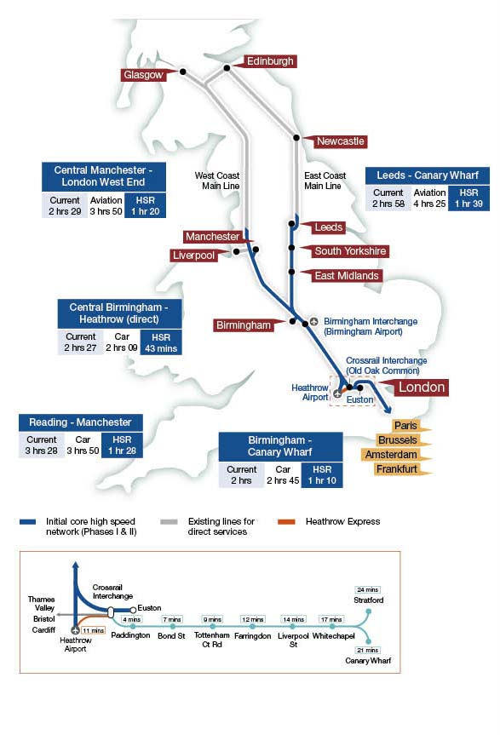
i The journey times shown are the standard times from HS2 Ltd’s current service specification. Optimising the service specification could provide faster journey times for some destinations. These will be further developed as part of HS2 Ltd’s further development of route options for the second phase of Y network.

3.62 Some consultation responses also raised the issue of whether new high speed rail links would lead to economic growth shifting away from those areas distant from the high speed network to those towns and cities more directly connected.
3.63 The Government agrees that the distributional impacts of new transport infrastructure projects of this kind on economic growth are hard to predict with precision. However, the academic evidence consistently identifies a number of key factors in maximising the local and regional effects of high speed rail, which include: effective integration of high speed rail into city centres and local transport networks, serving corridors where markets are well understood and where demand justifies providing a high frequency service, strong local leadership, and, most importantly, the integration of high speed rail with wider city planning.
3.64 The Government would seek to ensure that these principles are followed in developing its high speed rail strategy to maximise its local and regional impacts. Some of these factors, such as city centre stations and a focus on high demand routes, can already be seen in the proposals put forward for consultation. The Government’s broader local policy framework, including its support for city mayors, will further facilitate effective delivery in these areas. It should also be noted that support for the high speed network extends to those local authorities that would not have a high speed rail station but would benefit from integration with a high speed rail network. So it is clear that such authorities view high speed rail as positive for their economic development not a threat.

Regeneration and Jobs
3.65 A number of respondents supported the Government’s view that HS2 could support job creation, with some believing that the forecasts of new jobs which could be supported were underestimates. In contrast, some respondents did not believe that a high speed rail network would have any impact in terms of supporting the creation of additional jobs, or argued that HS2 would not support job creation in the Midlands or the North, with the majority of any new jobs being located in London.
3.66 The Department for Transport’s review of the evidence in respect of the impacts of major transport schemes on economic growth, together with evidence from HS1 and high speed rail projects in other countries, suggests that high speed rail services, when combined with supportive wider local and national strategies, can act as a catalyst for local regeneration and job creation. From the evidence provided there appear to be good prospects for HS2 to support economic regeneration around the station locations in phase 1, particularly at Old Oak Common and in Birmingham’s Eastside District. These views were strongly supported by the relevant local authorities for these areas, who see the HS2 proposals as supportive of their wider regeneration and development strategies.
3.67 It should also be noted that assessments of the employment and regeneration impacts of HS2 have only been made for phase 1 of the proposed network, and further such opportunities might be expected to be opened up by the completion of the second phase to Leeds and Manchester.

North-South divide
3.68 The view presented by the Government in consultation that a national high speed rail network could make a valuable contribution to addressing regional imbalances in productivity and prosperity (that it could help to tackle the North-South divide) provoked a large number of contradictory responses, often using academic reviews of high speed rail to support both points of view.
3.69 There is strong and widespread support from the Midlands and the North for HS2. Business and political leaders have identified the clear benefits of the project for their regions. They are particularly keen to have more rapid access to the major markets of London and the South East but also to see improved connectivity within and between their regions. Whilst the Government recognises that a proportion of the benefits of HS2 would be felt in the South, this does not alter the importance of HS2 for the rest of the country. Research previously undertaken by the Northern Way suggests that, given the relative size of their respective economies, there is potential for the benefits to the Midlands and the North to have a much larger proportionate impact. Evidence presented to the Government as part of the consultation also demonstrates the sizeable benefits from HS2 anticipated in the Midlands and the North.
3.70 It is clearly the case that new and improved transport links such as HS2 will open up new opportunities for businesses in the cities of the Midlands and the North, and that those opportunities are valued by those cities’ leaders. The Government believes that these ambitions should be supported. In doing so, it will be crucial for the cities concerned to ensure that they develop strategies to enable them to capitalise on the potential offered by new high speed links and to maximise their long-term positive impact on local and regional economic development.
3.71 The Government’s view is that the benefits of high speed rail links can extend well beyond the immediate vicinity of the stations served, and that the key to ensuring this is effective integration with local and regional planning frameworks and wider policies. The Government and HS2 Ltd will work with local authorities as detailed plans for the proposed high speed rail network are developed, but it will be for the authorities themselves to ensure that effective integration happens.

Government’s carbon objectives
3.72 Consultation responses contained strongly contrasting positions on carbon. Some argued that the appraisal assumptions employed were unnecessarily pessimistic and that HS2 would be likely to generate significant carbon savings. Others suggested that even the Government’s assessment of the London-West Midlands line as broadly carbon neutral was optimistic, and that in any case there was considerable uncertainty around the carbon implications of HS2 given the complexity of the issues involved.
3.73 HS2 Ltd has re-examined its carbon appraisal for Phase 1 in the light of consultation responses. HS2 Ltd has employed deliberately conservative assumptions on carbon and also presented the carbon implications of HS2 within a range to reflect the uncertainties involved. The Government considers that this is a robust basis on which to proceed with the project. It will continue to present the carbon implications of HS2 within a range, but will seek to continually narrow this down as further data become available and the project is developed in more detail.
3.74 In addition, the Government’s Carbon Plan sets out our plans to decarbonise the UK economy over the next two decades and beyond to 2050. Central to this is the need to move the electricity supply towards near-zero emissions by 2050. This shift will increase still further the carbon benefits of electrified rail travel, particularly relative to air travel.

A Y-shaped high speed rail network
3.75 Relatively few consultation responses discussed the merits of the particular network configuration supported by the Government. Where responses did discuss network options, most were supportive of the Government’s proposed Y network. However, a number of alternative network configurations were advanced by others. Each of these has significant draw backs compared to the Y network, particularly in terms of engineering feasibility and cost, but also the benefits they would deliver and the overall value for money of the proposition. Many of the network options that were suggested had been appraised previously by HS2 Ltd and the basis on which they were rejected in favour of the Y network had been published in previous work. For these reasons, the Government still considers that the Y network offers the most effective approach.
3.76 One issue, however, which did feature more prominently in consultation responses was whether the extent of the proposed network was sufficient or whether it should be extended, either now or in the future. This issue is reviewed in Chapter 4, but the Government considers that whilst the Government’s ambition is for a truly national network, its current strategy is the correct approach for developing an initial network.

Alternatives to high speed rail
3.77 To assess the case for a new national high speed network it is also necessary to compare it with alternative strategies. The Government has thoroughly tested the case for a range of alternative approaches, particularly in relation to upgrading the existing rail network. These options for upgrading the existing network attracted considerable comment in the consultation.

Enhancements to existing lines
3.78 Those supporting the construction of a high speed network argued that enhancements to existing lines can only deliver comparatively small improvements, and would be unlikely to be able to effectively accommodate potential growth in demand. They also suggested that this approach would not address the connectivity limitations of the existing network, nor would it have the same positive effect on economic growth as HS2, particularly in the major cities of the Midlands and the North.
3.79 In contrast, those opposing the Government’s proposals argued that the capacity increases that can be provided by enhancements to existing lines – either the Government’s published alternatives, or a further ‘optimised’ version, such as that proposed by the 51M group (‘51M’) of local authorities – would be sufficient to accommodate the level of growth forecast in the modelling carried out by HS2 Ltd. They also argued that an approach of this kind would have additional benefits, for example for travellers facing the earliest capacity constraints who it was claimed could benefit from enhancements more quickly, and that it would have much lower costs than new lines and a smaller impact on the environment.

Economic appraisal
3.80 Atkins has updated its appraisal of the economic case for the strategic alternatives to HS2. Its report is published alongside this document. Atkins work shows that the options for upgrading the West Coast Main Line between London and Birmingham to provide additional capacity would have strong benefit cost ratios. The West Coast Main Line is extremely heavily used and serves a large number of different rail markets. Given the high levels of forecast growth on this corridor, providing additional capacity for passengers is, therefore, likely to offer high benefits. However, as discussed below, the approach of upgrading the existing network would be incapable of matching the scale of the benefits that could be provided by a new high speed rail line, and would not be able to effectively address the high levels of crowding forecast on suburban services on this route.
3.81 Atkins also updated its appraisal of the alternatives to the Y shaped high speed rail network that the Government is proposing. The BCR of the best of these options is slightly below the low end of the range for the Y network. Again, this reflects significantly lower total benefits than could be achieved from HS2. Given that the Government’s high speed rail strategy is for a national network, rather than only a London-West Midlands line, the most direct comparator for HS2 should be enhancement alternatives relating to the full network. As with the West Coast Main Line alternatives, these enhancement scenarios also entailed other disadvantages, including in respect of suburban crowding.
3.82 It should be noted in considering this economic analysis, that the analysis carried out by Network Rail discussed below identified potentially significant additional costs in relation to all the packages under consideration which could not be included in Atkins’ work, although there may also be some scope for optimising service patterns, particularly in respect of the alternatives to the Y network.

Costs, deliverability and operational impacts
3.83 In addition to Atkins’s economic analysis, to inform its consideration, and given the strong interest in this issue shown in consultation responses, the Government commissioned advice from Network Rail, as the custodian of the existing network, on the costs, deliverability and impact of the main enhancement proposals developed by Atkins or proposed in consultation responses.
3.84 Network Rail’s assessment of the alternatives to HS2 prepared by Atkins and the 51M group found that:
- Neither proposal would provide sufficient capacity to meet forecast demand on the suburban commuter services at the south end of the West Coast Main Line;
- The intensive off-peak service pattern in the Atkins proposal means that freight growth could not be accommodated;
- Both proposals would necessitate a degree of remodelling at London Euston station;
- Both proposals would result in long periods of disruption along the current West Coast Main Line while the infrastructure interventions were constructed;
- The high utilisation of the fast lines in both proposals would negatively impact on route performance; and
- Although both service specifications would increase long distance high speed connectivity on some flows, this would often be at the expense of other intermediate flows, where connectivity would severely worsen. In some cases this would result in stations being left without a train service at all.
3.85 The analysis by Network Rail indicates that even if inter-city demand growth can be accommodated through an approach of this kind, albeit at some cost and with high levels of crowding on many peak services, doing so would squeeze out the potential for capacity enhancements vital in supporting suburban commuter markets. On the West Coast Main Line, for example, Network Rail’s analysis suggests that under any of the scenarios tested around 1,500-2,200 passengers would have to stand on commuter services out of London during the evening peak hour by 2035, compared to only 800 currently. This crowding would be likely to affect Milton Keynes, Rugby and Northampton, amongst others.
3.86 Network Rail’s analysis also highlights potential problems with crowding levels on long-distance services over the long term. Under Rail Package 2 peak load factors across all West Coast Main Line long-distance services are forecast by Network Rail to rise as high as 92 per cent. The load factors on long-distance services under the 51M proposal would be lower (though still higher than today), but this would be counterbalanced by higher levels of crowding on suburban services. Under both scenarios, many long-distance travellers would be forced to stand during the evening peak. This would be a particular problem for long-distance services calling at Milton Keynes Central and Watford Junction.
3.87 Since all of the approaches considered by Network Rail require the usage of all available train path capacity on the West Coast Main Line, the only viable solution to these suburban crowding issues would be to reallocate capacity away from long-distance services, further exacerbating crowding on those routes. The Government also considered more significant enhancement options on the West Coast corridor, which were based around generating additional capacity on the West Coast Main Line by upgrading the Chiltern Line to carry all London-Birmingham services, but none of these options were able to offer benefits even close to its high costs.
3.88 Continuing to invest in this way would cost less than a new high speed line, but the costs would still be significant. They would require major works, with major impacts on those living along the line, to grade separate junctions and four-track a number of route sections. Any proposal involving train lengthening beyond 11-cars would also require platform lengthening works at many major stations on the West Coast Main Line. And Network Rail’s analysis also suggests that it is likely that very substantial works would be required at Euston, costing substantially more than the low-cost approach considered by Atkins in its earlier report to Government, which Network Rail considers to be undeliverable.
3.89 Upgrades of this kind would also do little to improve connectivity for Britain’s major urban centres, as they would not tackle the historic limitations of the UK rail network. Similarly, they would provide little opportunity to enhance wider connectivity (for example, through new connections to the UK’s airports or to new urban networks such as Crossrail), nor any significant stimulus to the wider development and regeneration of the country’s cities.
3.90 An approach of this kind would also entail additional significant disbenefits. The more intensive service patterns involved could affect the long-term reliability and maintainability of the network. And any long-term capacity gains would come at a cost of substantial disruption for passengers and freight services while works are carried out. Network Rail’s analysis warns that any of the proposals under consideration would be highly disruptive to passengers ‘on routes which are more popular and are being used more intensively than ever before,’ and notes that the largest packages of enhancements across all three main north-south routes could have a cumulative impact ‘involving a sustained period of regular disruption … similar to that experienced for the West Coast Route Modernisation.’
3.91 Approaches which rely solely on enhancing existing rail routes would be expected to have lower sustainability impacts than entirely new lines, including smaller impacts on noise, landscape and townscape, although the impacts of any major package of enhancements (particularly where these include off-line works such as the proposed Stafford By-Pass) would not be negligible. The Government also accepts that the range of potential impacts of this approach on carbon emissions would not be as wide as that for new high speed lines, and therefore it would not carry the same risks of increases in overall transport emissions. However, nor would it have the same potential to deliver the significant savings that could come from the best-case high speed rail scenarios, particularly as the grid is increasingly decarbonised, generating significant net carbon savings from those who switch from flying to travelling by high speed rail.
3.92 The Government’s view is that any sustainability and cost advantages are outweighed by the substantial disbenefits of enhancing existing lines. Furthermore, even if some options may offer good value for money, they fail to offer an effective long-term solution to crowding issues and therefore cannot be considered a viable alternative to new lines. There is a significant risk that an approach of this kind would simply create years of delay and disruption for passengers and freight services, and even after that only give rise to a railway that it is still overcrowded, delaying but not avoiding the need for new lines. For these reasons, the Government does not favour this strategic approach to addressing the long term rail capacity constraints.

New conventional lines
3.93 Other responses argued that if a new line is necessary it should be designed for lower or even conventional speed services.
3.94 Building new conventional rail lines would not be significantly cheaper than new high speed lines, nor would their impacts on the environment and communities be significantly lower than those of high speed rail, but they would deliver far fewer benefits in terms of enhanced connectivity and support for long term economic growth.
3.95 Analysis carried out by HS2 Ltd for consultation, and refreshed as part of its updated economic analysis in the Economic Case for HS2: Updated Appraisal of Transport User Benefits and Wider Economic Benefits, indicated that the net cost saving from building a new line along broadly the same route as HS2, but with a conventional line speed of 125mph, would only be around £1.4 billion. This is because regardless of the speed of a new line, similar tracks, viaducts, stations and tunnels would be needed, so savings would largely relate to the detailed specification of infrastructure and lower rolling stock and fuel costs, and also because a slower line would attract fewer passengers and hence generate reduced revenues. In contrast, the reduction in benefits as a result of slower journey times and reduced passenger numbers would be expected to be as high as £6.2 billion in net present value terms.
3.96 On this basis, the additional benefits generated by designing a new line to accommodate high speed services, compared to the only real long term alternative of a new conventional speed line, would outweigh the additional costs by a factor of more than four to one.
3.97 Alternatively, a new conventional speed line might be designed to a different route from HS2, and, in particular might follow existing transport corridors more closely in an attempt to mitigate the impact on the natural environment, though it would also impact more heavily on densely populated areas. Adopting an approach of this kind was proposed by a number of respondents to the consultation.
3.98 HS2 Ltd has examined a range of potential lower speed routes, including options following the M1 and M40. All of these options would be longer than HS2, leading to significantly worse journey times and lower economic benefits, and also in some cases cost increases. Conversely, any environmental improvements that could be achieved would be relatively marginal. It must be recognised that building any new train line will have a substantial impact on the land and communities through it which passes. These options are discussed in more detail in Chapter 5.
3.99 The Government, therefore, does not consider that new conventional speed lines should be adopted as an alternative to the proposals for a national high speed rail network put forward in consultation.

Chapter 4 – Phasing, Heathrow Airport and High Speed 1

Introduction
4.1 Having discussed in the preceding chapters the capacity constraints that will need to be addressed as demand continues to grow over the next two or three decades, and having concluded that high speed rail is well suited to meeting this challenge, this chapter reviews the Government’s proposals for phasing the construction of the Y network and for building direct connections to Heathrow Airport and the High Speed 1 line to the Channel Tunnel.
4.2 In outlining the Government’s decisions on phasing and on connecting with Heathrow Airport and HS1, this chapter responds to evidence provided in consultation responses in relation to the third consultation question:
Do you agree with the Government’s proposals for the phased roll-out of a national high speed rail network, and for links to Heathrow Airport and the High Speed 1 line to the Channel Tunnel?

Summary of decisions
- A phased approach to undertaking the necessary design, legislative and construction steps is the best way to ensure that the benefits of high speed rail are realised at the earliest opportunity. The Government will pursue a hybrid bill for each phase of the Y network. A single hybrid bill for the entire network would risk the overall delivery of the project.
- The Y network should incorporate a direct link to the Channel Tunnel via the HS1 line. This will create the potential for direct rail travel to Europe from the Midlands and the North without the need to interchange.
- Route options for a direct spur link to Heathrow Airport should be developed to form part of Phase 2 of the Y network. Diverting the main HS2 line via or close to Heathrow would be costly and would disadvantage the vast majority of HS2 passengers. The Government therefore favours a direct spur link to the airport, which could radically improve its accessibility from the major cities of the Midlands and the North. The options for such a spur link will be considered by the Government as part of Phase 2.

Phasing the delivery of the Y network
4.3 The Government considers that its proposed phasing of the delivery of the national high speed rail network is the most effective way to ensure its overall success. Phasing will not only enable benefits to flow as quickly as possible but also manage the practical risks of delivering such a large programme.
4.4 Amongst those that support high speed rail, there was a clear consensus in consultation responses for pushing ahead on the quickest possible timetable with HS2.
4.5 The key issues raised in consultation responses are discussed below.

Seeking powers from Parliament to construct HS2
4.6 Consultation responses questioned the Government’s proposed approach to the seeking of parliamentary powers. We have given careful further consideration to this issue but remain firmly of the view that seeking powers through a hybrid bill is the right approach for a linear scheme of the scale of Phase 1. The hybrid Bill will enable the Government to seek all necessary statutory powers and authorisations, including any revisions to the rail regulatory regime and public finance provisions.
4.7 Seeking the powers for the network through two hybrid bills is the most effective course of action. It allows us to exploit the existing work that has been undertaken on phase 1 (London to West Midlands), enabling the network to start delivering benefits earlier, and also represents the most sensible approach to managing the necessary parliamentary processes.
4.8 Some have presented a single hybrid bill for the entire Y as the best means for the cities of the North to gain high speed rail at the earliest opportunity. While we understand the reasons why some, especially those representing communities in the North of England, favour a single hybrid bill, attempting to seek powers from Parliament in one go for the entire Y network would be counterproductive. Preparation of the draft Bill and then its consideration in Parliament would be extremely time consuming. The sheer scale of the task at both stages would add in substantial risk to the process if the whole network were presented at once. The Government cannot support an approach that would jeopardise the achievement of powers in the way that the single Bill approach certainly would.
4.9 The issue of affordability must also be considered. The phased approach to the roll-out of HS2 ensures that each stage of the project is affordable. Affordability is a key consideration during the years of main construction, and a phased approach can help to smooth the funding requirements as construction progresses, so that no more than £3.5 billion of public funding would be needed in any single year. The Government is not willing to countenance an approach that would further increase this and hence potentially jeopardise the flow of investment available to the existing rail network and to other transport projects. The most effective way of ensuring this is through phasing the construction process.

Making progress in delivering HS2
4.10 The Government considers that a key element to maintaining the overall pace of the project is to progress the first phase as rapidly as possible. There is a strong case for undertaking the London-West Midlands phase to an ambitious timetable. Whilst a number of factors support this approach, the most significant is that this part of the inter-urban rail network is forecast to face the earliest and most severe capacity constraints. This is not altogether surprising given that London and the West Midlands are Britain’s first and second most populous and economically productive conurbations. That the previous Government, which also recognised this issue of capacity, opted to push this phase first means that plans are already further progressed, supporting the earliest possible implementation of this section of the network.
4.11 The Government wants Britain to be able to reap the benefits of a national high speed rail network as quickly as possible. The timetable for the roll-out of the network therefore seeks to strike the optimal balance between three factors – maintaining a rapid pace to bring forward implementation, allowing for adequate consultation with the public, and ensuring that the proposals put forward are robust and based on the best possible technical assessment.
4.12 However, given the strength of consultation responses on the need to quicken the pace of delivery – or at least to avoid delays – the Government will review whether the process can be further accelerated. This review will focus on the second phase of the network – the lines to Leeds and Manchester – to examine options for building and opening these lines earlier. The Government will also undertake a detailed review of the planning, powers-seeking and construction phases of both the HS1 and Crossrail projects to ensure that HS2 can maximise its prospects for smooth and timely delivery.

Committing to both phases of the Y network
4.13 Some consultation responses advocated a commitment, in some form, as quickly as possible to the second phase of the Y network, if it was not to feature in the first hybrid Bill. Some acknowledged that any commitment made at this stage would not be binding on any future administration but still supported this approach.
4.14 The Government recognises the keenness of some to see clear commitments to the Leeds and Manchester lines. Therefore, we will explore what level of commitment to these lines can be included in the first hybrid Bill, to demonstrate the Government’s commitment to this transformative project.

Extensions to the Y network
4.15 Some consultation responses suggested that the initial phases of a high speed rail network should include connections to other places, particularly Scotland.
4.16 The Government’s vision is for a truly national high speed rail network serving all of the major cities of Britain. The Y network should, therefore, been seen as a foundation for subsequent phases and extensions. Scotland, in particular, would stand to benefit significantly from high speed rail. The initial phases of the network would significantly improve journey times to Scotland. The future extension of direct lines all the way to Scotland would build further on these, and would encourage increasing modal shift away from aviation and road.
4.17 The Government expects to work with its counterpart in Scotland on Scottish ambitions for high speed rail and to explore the means for increasing the benefit that Scotland receives from a new national high speed rail network.

Providing a pipeline of Government investment
4.18 Although already an important factor in the Government’s proposals for phasing HS2, an issue that has come across strongly from the consultation process is the need for a clear pipeline of investment commitments from the Government. This allows businesses to plan effectively for the long term with confidence. This is particularly true for businesses that might be involved with delivering HS2, but is equally true for businesses, large and small, which may use it once it is in operation.
4.19 In large part, this concern is sparked by the approach of previous governments to delay big infrastructure commitments, amend delivery schedules and alter scope. This makes it hard for businesses to plan with confidence, and so opportunities for expansion, entering new markets or creating new jobs are all lost.
4.20 In line with the findings of the recent McNulty review on rail costs, clarity over future investment pipelines could also deliver procurement cost efficiencies.
4.21 The consultation document acknowledges this issue, as does the recent National Infrastructure Plan. However, in the light of the strength of views expressed in the consultation, the Government will ensure that the issue of a clear pipeline informs its future planning on high speed rail.
4.22 HS2 could form a key element of a long-term pipeline enabling the private sector to plan for the future and have the confidence to invest in technology and skills. The Government agrees that it is important that the UK-based supply chain should be in a position to benefit as far as possible from HS2. The Government will therefore seek to open a dialogue with potential UK-based suppliers to ensure that they are well-placed to bid competitively for future contracts, including making better use of pre-procurement dialogue to encourage efficiency and innovation, and establish more sustainable supply chains. The additional capital investment and skills development which could be facilitated by HS2 may also help to ensure UK-based suppliers are increasingly well-placed to bid for contracts on high speed projects abroad.

Serving Heathrow Airport
4.23 The Government believes that there is a strong case for HS2 services to run directly into Heathrow. In particular, improved access to the country’s major hub airport for businesses in the Midlands and the North would create new opportunities for growth, and, by better linking these regions into the global reach of Heathrow, make them more attractive locations to invest and do business. The Government’s preferred option is for a spur running from the main HS2 line and for this to be built as part of the second phase of the high speed rail network. HS2 Ltd will continue to develop route options for a spur of this kind as part of its work on Phase 2.
4.24 However, as Heathrow is privately owned and operated, the Government expects to work further with the airport operator on plans for linking the airport into HS2 in this way. This work will include exploring the scope for securing third party contributions towards the cost of the new link.
4.25 Some consultation responses questioned the strength of the economic case for providing a direct link to Heathrow. The Government considers that its strong strategic case makes a direct Heathrow link the right approach to take, providing a properly integrated connection between the country’s major hub airport and HS2. The economic case of a project is only a single component in a much broader decision making process.
4.26 The National Infrastructure Plan set out the Government’s clear support for maintaining the UK’s aviation hub status in the light of the benefits this brings to the country. The forthcoming Aviation Framework will explore all of the options for achieving this – with the exception of a third runway at Heathrow. The Government’s view is that the strategic case for ensuring that Britain’s high speed rail and aviation hub strategies are effectively integrated will remain strong.

Regional access to Heathrow
4.27 HS2 represents a valuable opportunity to draw important strategic linkages between major components of Britain’s transport infrastructure. International experience points to the benefits of high speed rail networks serving major hub airports. France, Germany and the Netherlands are amongst the countries successfully integrating these modes to create optimum solutions for passengers in support of economic growth. Given Britain’s transport and economic geographies, the Government considers that there is a strong case for following this model in this country, ensuring that passengers can take advantage of the most efficient modal options.
4.28 The Government is particularly keen to see the economic opportunities that the country’s major international hub airport presents, in terms of access to international markets, opened up to wider parts of the country. Heathrow is currently relatively inaccessible by rail from everywhere except London. The economies of the major conurbations of the Midlands and the North could benefit substantially from improved access to the international economic opportunities which Heathrow’s substantial route network provides. Ensuring seamless rail access to the UK’s aviation hub from these regions is an important element of the Government’s overall strategy for high speed rail in Britain.
4.29 A key check on Heathrow’s current ability to properly serve the entire country is its poor rail connectivity. HS2 could provide the kick-start to change the rationale for further surface-access transport investment at Heathrow that would yield benefits right across the country. The establishment of Heathrow as a multi-modal transport hub would ease pressures on the busy transport systems of central London and provide significant benefits to passengers.

Delivering high speed to Heathrow
4.30 There is a strong strategic case for directly linking HS2 and Heathrow. However, this leaves two important questions – whether to serve the airport through a station on the main HS2 line or on a spur, and at which stage in the project to introduce direct connectivity to Heathrow, thereby removing the need for passengers to interchange.
4.31 The case for running the main HS2 line via Heathrow was raised in consultation responses. HS2 Ltd has carefully looked at the case for serving Heathrow in this way. This is discussed in more detail in Chapter 5. The outcome of this further consideration, coupled with the evidence presented in consultation responses, has not altered the Government’s conclusions. Whilst a through-route may bring benefits to the relatively small proportion of passengers who would use HS2 to access Heathrow, these would come at the loss of much larger benefits to the majority of passengers travelling into central London. HS2’s projected passenger mix shows that many more people would be using the service to access London than Heathrow.
4.32 HS2 Ltd’s analysis has also indicated that it is possible under the spur option to locate an HS2 station directly at one of Heathrow’s main terminals, which would not be the case if the main route was diverted to serve the airport more closely. In addition, the extra costs associated with routing the main HS2 line closer to Heathrow could be higher than the costs of a spur to the airport from the main line. For these reasons, the Government favours a spur rather than a through route as the best option for providing direct high speed access to Heathrow.
4.33 A spur of this kind could, however, be designed to be capable of extension in the future into a loop back onto the main HS2 line. This extension could be undertaken in the future if there was a requirement either for additional central London capacity or a higher frequency service to Heathrow. The Government favours an approach which incorporates flexibility of this kind. However, even before a loop was constructed HS2 Ltd’s illustrative service specification includes two trains per hour in each direction serving Heathrow and it would have the scope to carry more should there be a case for doing so.
4.34 In respect of the timing of the construction of a spur link to Heathrow, the consultation document set out the Government’s case for constructing the spur and new station at Heathrow as part of the second phase of HS2. There was some call for this to be brought forward. The Government’s strategy is that whilst only the London-West Midlands line is in operation, the Old Oak Common interchange would provide an appropriate solution for passengers wishing to access Heathrow. This demand would be likely to grow with the construction of the second phase due to the increased reach of the network, and so the case for a direct link to the airport at this stage would be likely to be stronger.
4.35 The Government remains of the view that this phased approach to providing HS2 connectivity with Heathrow is the most appropriate. It recognises that whilst air passengers would value a direct link from the earliest opportunity, such a link would not be viable considering the projected level of usage and the opportunity to interchange at Old Oak Common. It will also allow any outputs from the Government’s exploration of options for maintaining the UK’s aviation hub status to be taken properly into account as the Government considers HS2 Ltd’s work on route options for Phase 2 of the network.
4.36 Some responses misunderstood the Government’s proposals for direct services to Heathrow once the Y network is in place, believing that passengers would always have to use the Old Oak Common interchange to access Heathrow by changing trains. This is incorrect; under Phase 2 there will be trains direct to Heathrow from the Midlands and the North.

Overall Heathrow strategy and capacity
4.37 For the aviation sector to continue to support the British economy as effectively as possible, it is important that it offers the level of service and reliability that passengers expect, as well as sustaining a dense network of international routes to key economic centres across the world. Heathrow’s role as an international aviation hub generates wealth, creates economic opportunities for Britain, opens up access to international markets and supports jobs. Its benefits are felt right across the economy. It is vital that the UK’s broad and deep global route network is maintained and even grown in order that the aviation sector can continue to serve Britain in this way.
4.38 High speed rail services to Heathrow from Scotland and the North would provide an alternative to domestic and other short-haul aviation. Consultation responses debate the benefits to which this would give rise – in terms of increased scope for international services, or freeing-up capacity to improve the resilience of the airport and to reduce carbon emissions. The Government has committed to publishing a draft Aviation Framework during 2012, which will consider some of these issues in the context of the aviation sector more generally.
4.39 In addition, as the National Infrastructure Plan recognised, there is a clear case for maintaining the UK’s international aviation hub status. The Government will develop a long-term aviation strategy which will set out how we intend to address the UK’s airport capacity challenges, while ensuring aviation plays its part in delivering environmental goals and protecting the quality of life of local communities. The Government will publish a consultation on this strategy in spring 2012. This will explore all the options for maintaining the UK’s aviation hub status, with the exception of a third runway at Heathrow. There is will remain a strong strategic case for ensuring that Britain’s high speed rail and aviation hub strategies are effectively integrated. The Government will, therefore, continue to review how HS2 can best support its plans for maintaining the UK’s hub status. An important element of this will be the scope for third party funding contributions to the costs of linking HS2 to the country’s hub airport.
4.40 The Government has asked HS2 Ltd to develop detailed route options for a spur from the main HS2 line to serve Heathrow Airport. As outlined in Part III of this document, it is expected that plans for the spur will then be subject to public consultation. Depending on the conclusions of that consultation, the spur would be included in the hybrid Bill proposed for the second phase of the Y network.

Serving the High Speed 1 line to the Channel Tunnel
4.41 Enhancing the integration of Britain’s transport infrastructure is a vital objective. Integration increases the efficient movement of goods and people, directly supporting economic growth. On this basis, the economic and wider strategic benefits of seamless connectivity between HS2 and the HS1 line to the Channel Tunnel are potentially very important. The Government believes that a direct link between these two nationally-significant pieces of infrastructure is an important objective, and intends to implement the link in phase 1 of the project. This will enable trains to run directly between HS2 and HS1, without the need for passengers to change trains. There are clear strategic advantages from ensuring that a new national high speed rail network in Britain is integrated with the only existing high speed line in this country, particularly given that HS1 would then directly connect HS2 with Europe’s growing high speed rail network.
4.42 Engineering constraints dictate that a link to HS1 cannot be constructed once HS2 is operational. The portal of the tunnel forming the first section of the link between HS2 and HS1 would be located alongside the Old Oak Common interchange. Constructing this tunnel would be a major engineering project and would impinge on the site that would be used by the station. It would not be possible to excavate the tunnel once Old Oak Common was in use and HS2 trains were running.
4.43 It is clear from the consultation that businesses recognise and support the growth potential that would come from a direct link from the Midlands and the North into HS1. This rationale is only likely to strengthen given the plans that many European countries have for expanding and enhancing their high speed rail networks. With high speed rail becoming an increasingly prominent mode for medium and long-distance travel across Europe, there is a strong strategic case for ensuring that a high speed rail network in this country connects directly into the many thousands of miles of network in operation across Europe.
4.44 The HS2-HS1 link also offers other potential connectivity benefits. The HS1 line serves a number of important growth areas and economic centres in East London and Kent. Stratford and Ebbsfleet stations in particular are already configured for handling international services. In the future, as service specifications for HS2 are being developed, the Government will be keen to explore options for HS2 trains to serve these and other stations on HS1. Clearly this type of service would greatly enhance the connectivity of these places to the Midlands and the North, opening up new economic possibilities.
4.45 There is a range of potential options for creating this link. The Government supports a direct link via a new tunnel and the existing North London Line. This will be capable of carrying three trains per hour in each direction – equivalent to at least the service frequency currently offered by Eurostar out of St Pancras. This would provide sufficient capacity for international services from HS2 for the foreseeable future. The journey time from leaving the main HS2 line at Old Oak Common and joining HS1 immediately to the north of St Pancras station would be 10 minutes.
4.46 Some consultation responses questioned whether the speed and capacity of the proposed link were sufficient, and whether it would impact on existing services using the North London Line. HS2 Ltd has reviewed these issues following the consultation (see Review of HS2 London to West Midlands Route Selection and Speed). On the basis of this analysis, the Government remains content that the link provides sufficient capacity to meet likely demand for the foreseeable future. And, whilst initial work by HS2 Ltd suggested that existing services on the North London Line would not be impeded, the Government has commissioned HS2 Ltd to continue discussions with Network Rail and Transport for London to further test this position.
4.47 As with other elements of the HS2 network, as the project progresses, the Government will also explore opportunities for third party funding contributions for this link.
4.48 The Government considers that the HS2-HS1 link offers the right package of capacity and connectivity benefits to passengers, and that it will boost the benefits that high speed rail will bring to Britain. It is an important component of a high speed rail strategy for Britain.


Chapter 5 – Technical Specification and Route Selection for HS2

Introduction
5.1 HS2 Ltd devised principles and a technical specification for high speed rail in Britain designed to balance the costs and environmental impacts of the railway with the benefits that high speed rail can deliver. Central to this approach was the objective of developing a railway that will be safe and reliable. To achieve this HS2 Ltd drew on proven international standards, practices and technologies.
5.2 This specification underpinned the engineering design, economic appraisal and environmental assessment of HS2 Ltd’s proposals. It also informed the detailed route selection process that has been undertaken to select the most appropriate route for a line between London and the West Midlands.
5.3 In the light of evidence provided in consultation responses, this chapter sets out the Government’s decisions on the appropriateness of the technical specification for high speed rail and the route selection process that HS2 Ltd undertook. The fourth question in the consultation was:
Do you agree with the principles and specification used by HS2 Ltd to underpin its proposals for new high speed rail lines and the route selection process HS2 Ltd undertook?

Summary of decisions
- The technical specification for high speed rail employed by HS2 Ltd is robust, appropriate and deliverable. It relies largely on the use of existing technologies but also allows for a sensible degree of future-proofing.
- The route selection process was appropriate and rigorous. The recommended station options are the right ones, and there is no case for intermediate stations on the London to the West Midlands phase of the network.

Specification and principles of the London–West Midlands line
5.4 In the light of responses to the consultation, we have assessed HS2 Ltd’s six fundamental guiding principles and the underpinning detailed technical specification that informed the development of HS2. These principles were:
- Exploiting maximum benefit from high speed capacity;
- Long distance, city-to-city journeys;
- High speed trains only on HS2;
- Integration with the classic network;
- Greater segregation from the classic network over time; and,
- Integration with other transport networks.
HS2 Ltd’s detailed findings following the consultation can be found in the Review of the Technical Specification for High Speed Rail in the UK report.
5.5 Some respondents raised doubts about whether 18 trains per hour in each direction is achievable on the full Y network. As a result of these concerns, HS2 Ltd undertook additional analysis and independent verification to calculate in more detail the maximum capacity of the lines, which can be found in its Review of the Technical Specification for High Speed Rail in the UK document. On Day One services, when London – West Midlands infrastructure is brought into use, there will be 11 trains per hour in the peak and 10 trains per hour off-peak, with a maximum line capacity of 14 trains per hour. By the time the full Y network is operational, the majority of services running on the HS2 infrastructure will operate only on the high speed network. Coupled with the use of advanced network management tools to control real-time train operations, this means that running 18 trains per hour would be entirely feasible. Furthermore, by using a fleet of trains that are the same design and construction and with the same acceleration and braking characteristics, the route would become easier to operate than a route with mixed traffic, such as the current West Coast Main Line. Therefore, we are confident that 18 trains per hour is a robust assumption.
5.6 The capacity specification of the trains was also raised in consultation responses. HS2 Ltd specified the maximum capacity of the trains on HS2 as 1100 seats for a 400 metre train. A maximum train length of 400 metres is the common standard used on high speed networks across Europe and is specified in the European Technical Specification for Interoperability (TSI) which underpins both UK and European law. There are clear costs and deliverability benefits from adopting tried and tested designs for rolling stock. In addition, adopting the wider and taller European gauge would make it possible to run double-deck trains on HS2.
5.7 At the opening of the first phase of HS2 there would be two types of train operating: ‘captive’ high speed trains, which can only run on the high speed network; and ‘compatible’ trains which can run at high speed on the HS2 network but can also run on the existing electrified rail network at conventional speed. The majority of the compatible trains operating from the opening of HS2 would be single 200 metre trains, with a seating capacity of up to 550 seats. However, HS2 Ltd have confirmed that it would also be possible to operate 260 metre sets to provide additional seating capacity on key routes. In line with international practice, a number of the captive trains operating between London Euston and Birmingham Curzon Street would be 200 metre sets joined to form a single 400 metre train, also to provide additional capacity.
5.8 With the opening of the second phase of HS2 – the lines from the West Midlands to Manchester and to Leeds – captive trains would run on the HS2 lines in 200 metre and 400 metre formations as far north as Manchester and Leeds. Compatible trains would continue to run off HS2 to serve stations up the West Coast Main Line, but would also run via the line to Leeds to serve stations on the East Coast Main Line, including York and Newcastle.
5.9 Having looked again at the level of capacity and the overall cost efficiency of adopting these standard train length configurations, HS2 Ltd consider that the proposed train lengths and seating capacity are justified by the expected level of demand.
5.10 Consultation responses raised the issue of whether city centre-to-city centre journeys are a sufficiently important travel market on which to focus investment. The nature of existing transport demand, and inter-city rail travel in particular, suggests that the city centre market is extremely important. The continued strengthening of the importance of Britain’s major urban centres also points to the need to serve this market. HS2 Ltd’s modelling suggests that around 270,000 passengers a day would use the HS2 Y network to travel to or from central London.
5.11 It is important to note, however, that the benefits from the proposed high speed rail network will not be limited to inter-city rail passengers. The transfer of many long-distance services and passengers to the new HS2 network will free up space on existing lines to respond to growing demand in the commuter and regional markets – for instance, enabling a significant increase in capacity on the West Coast Main Line for key destinations such as Rugby, Milton Keynes and Watford. It will also enable additional rail freight services to be accommodated. These released capacity benefits will be of particular importance on the crowded southern stretches of the major north-south lines, where the scope to provide additional commuter capacity through train lengthening or infrastructure enhancements will become increasingly limited over the coming decades.
5.12 The connectivity of HS2 with local transport networks is also imperative. The Government is clear that HS2 must be integrated with other transport networks in the cities it serves in order to realise its full potential. Many of the consultation responses and statements from members of the public endorsed this view. The Government would expect HS2 Ltd to work closely with local and regional authority-led transport groups to ensure that the benefits of HS2 were maximised, through careful planning of development and integration with local transport systems.
5.13 Directly linking HS2 with the conventional rail network will enable high speed services to run to more destinations than just London and the West Midlands, spreading the benefits of high speed rail more widely. There was much support for this principle. However it is noted that concerns were raised in respect of potential delays on conventional lines spreading to high speed rail. HS2 Ltd has reviewed these issues and its Review of the Technical Specification for High Speed Rail in the UK report outlines its conclusions in respect of incorporating capacity to ensure these impacts can be absorbed.
5.14 Concerns were raised regarding the design speed of the railway, which included concerns about the environmental impact (covered in the route selection process section, below), safety and practicality of operation. There are already trains capable of running well in excess of 250mph and lines are being designed and built in other countries, such as Spain, to be capable of operating at these speeds. The planned initial operating speed of the proposed line is up to 225mph but, as this is infrastructure which we expect to have a life of many decades, it is important that it is sensibly future-proofed. We therefore consider that 250mph is the appropriate maximum design speed for the line, and on the basis of advice from HS2 Ltd, this does not rely on unproven technologies, as some consultation responses suggested.
5.15 There were no concerns raised in the consultation that challenged the Government’s view of operating hours. We consider that the proposed operating pattern of services from 05.00 – 23.59 hours Monday – Saturday and 08.00 – 23.59 hours on Sundays, which is in line with standard high speed rail practice, is the best approach for HS2. We would not expect that a full service pattern would be run in the earliest and latest parts of these periods. Closure overnight is required for essential maintenance, ensuring the safety and reliability of the route.
5.16 The specification and principles that underpin HS2 will ensure that the high speed rail network can deliver appropriate passenger and economic benefits. HS2 Ltd has demonstrated that the principles that informed its development of the scheme are appropriate.

Route selection process
5.17 As outlined in the consultation document, HS2 Ltd undertook a rigorous three-stage route selection process, which resulted in a long list of options that was gradually reduced as the level of information available about the options increased. Criteria relating to cost and engineering feasibility, demand and environmental impacts were adopted to allow the options to be sifted. This process identified the single recommended route, on which the Government consulted, as the most appropriate option.
5.18 As well as the construction and operating costs, a national high speed rail network would inevitably have some negative impacts on local communities and environments. The proposed route has been designed to reduce these effects wherever possible. The route selection process has sought to avoid the most significant impacts on centres of population and to limit the numbers of properties required for demolition. And the use of tunnelling, deep cuttings and existing transport corridors has reduced the impacts of the line on the landscape. Noise barriers and other forms of mitigation would further significantly reduce the numbers of properties affected by noise.
5.19 In response to consultation concerns, HS2 Ltd looked at possible routes following existing transport corridors to understand whether these routes would be less intrusive and also whether a lower design speed would reduce impacts. In the light of this further work, the Government remains confident that the preferred route is the most appropriate.
5.20 One alternative which achieved particular prominence during consultation was an alignment broadly following the M40 corridor. The Government does not consider that this would offer a better solution than the route put forward for consultation.
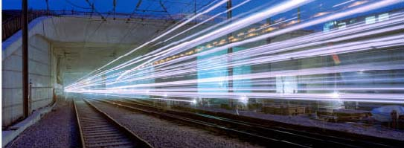
5.21 An M40 route would take a more westerly alignment than the consultation route, meaning it would cover a greater distance in reaching Birmingham than the consultation route. Combined with a lower maximum design speed as a result of limitations within the corridor, this option has a journey time between Euston and Birmingham Curzon Street of 56 minutes as opposed to 49 minutes for the consultation route. This would create substantial journey time penalties for the great majority of HS2 passengers travelling to and from central London.
5.22 An alignment along the M40 route would impact more population centres than the consultation route, including Gerrard’s Cross, Beaconsfield, High Wycombe and Princes Risborough, which have a combined population in excess of 110,000 people. This would result in unacceptable impacts on communities through major demolitions, severance and noise impacts, which could only be mitigated through extensive tunnelled sections. In addition, in running close to the M40 the route would need to avoid a number of motorway junctions through the use of flyovers or tunnels, adding to the engineering complexity and cost, and potential disruption to the road network during construction.
5.23 The cost of constructing this route would be £19.5 billion, compared to £16.5 billlion for the consultation route. It was also found that this route would mean significantly more communities would be at risk of isolation through being surrounded by transport infrastructure, including large clusters of residential dwellings, compared to the consultation route. It was noted, however, that there were few sustainability differences between this option and the consultation route, except that the types of impact differ across the broad range of sustainability themes.
5.24 HS2 Ltd also looked at an alignment broadly following the M1 corridor, but with a necessary maximum speed of 186mph. An M1 route would follow the consultation route from Euston to Old Oak Common, where it would then head due north following the M1 and M45/A45 towards Birmingham. The route would cover a longer distance in reaching Birmingham than the consultation route. Combined with the lower maximum design speed, this option has a journey time between Euston and Birmingham Curzon Street of 55 minutes as opposed to 49 minutes for the consultation route. As with the M40 corridor, a surface alignment along the M1 route would encounter a much greater number of major population centres than the consultation route, including Hemel Hempstead, Milton Keynes and Luton, with a combined population approaching 500,000 people. This would result in unacceptable impacts on communities through major demolitions, severance and noise impacts, and therefore this route would require significant sections of tunnelling. This makes it substantially more expensive than the consultation route. The cost of constructing this route would be £18.7 billion, £2.2 billion more than the consultation route.
5.25 In terms of specific impacts on communities, line speeds would mean that lower numbers of people would experience increased annoyance compared to the consultation route. It would also have lower impacts on nationally protected ecological sites, ancient woodlands and fewer Biodiversity Action Plan habitats. The surface sections of the new M1 alignment would, however, result in 150 residential dwellings being at risk of demolition, more than double the number of residential demolitions for the section between Old Oak Common and the Birmingham Interchange of the consultation route. Fourteen communities would also be at risk of isolation or severance, as compared with three communities for the consultation route. In terms of landscape it would avoid impacts on the Chilterns Area of Outstanding Natural Beauty due to passing under Luton in tunnel, but its impacts on registered parks and gardens would be broadly similar to the consultation route. The extensive tunnels needed for this option would pass under 6,400 dwellings compared to 350 for the consultation route, which would increase the complexity of construction and increase project risk. The M1 route would have a large impact on journey time, with relatively small environmental gain and at considerable cost.
5.26 Another alternative often mentioned during consultation was an option for a direct route via Heathrow with an interchange located nearby. The Government also does not consider that this would offer a better solution than the route put forward for consultation. It would be impossible to locate a station close to one of Heathrow’s main terminals, with the only viable potential station locations being either adjacent to the airport’s Northern Perimeter Road, or some three miles further north, adjacent to the Great Western Main Line at Iver. Either of these possible locations would be some distance from Heathrow’s terminals and would entail new transit facilities to the terminal areas. This option would not benefit the travelling public in a way that an on-airport station would do, made possible by the use of a spur. The Government therefore believes that a spur still remains the most feasible option, since it allows services to travel directly to a passenger terminal at Heathrow and also dedicated airport services that would not be possible on a through route.
5.27 HS2 Ltd has considered a range of potential alternative approaches, including following existing corridors and reduced speed options. The Government does not consider that any of the alternatives considered would offer a better solution than the line put forward for consultation. None of the options was able to deliver significant improvements in environmental performance, even where the specific impacts on the Chilterns Area of Outstanding Natural Beauty could be lessened to some degree. Some of the options considered would also have entailed significantly increased impacts on some communities, such as noise or high numbers of demolitions. On balance, these marginal environmental gains would not be sufficient to outweigh the very substantial reductions in overall benefits that would result from longer routes, slower line speeds and increased journey times. In some cases, particularly where route lengths would increase, the costs of alternative lines would be higher.
5.28 The Government considers that the route selection work undertaken by HS2 Ltd is robust and that the proposed route corridor most effectively balances the benefits of the project with the potential impacts on people and resources (including cultural and environmental). We are therefore clear that the proposed route represents the best option and, through further design work and the Environmental Impact Assessment, HS2 Ltd will seek to further reduce any impacts.

The case for alternative stations
5.29 HS2 Ltd’s station selection process considered 27 possible sites for a London terminus, including Old Oak Common and Stratford, which were the alternatives to Euston most commonly suggested in consultation responses. In light of the concerns raised, HS2 Ltd looked again at its station selection process. Stratford International could not easily accommodate an extra 10 platforms within its existing land footprint, nor is capacity on local networks sufficient for the additional numbers of passengers that would disembark here. Old Oak Common was discounted as a terminus for a number of reasons, including insufficient network capacity for onward passenger journeys.
5.30 A further concern raised was the potential impact of HS2 passengers on the London Underground at Euston station. In terms of network capacity for onward passenger travel, the number of passengers at Euston added by HS2 during the three hour morning peak is likely to be around 2% compared to the number of passengers already forecast to be on London Underground services passing through Euston. We are confident that Euston offers sufficient opportunity for accommodating these additional passengers; HS2 Ltd have advised us that they would work closely with TfL as part of its wider ongoing strategy for modernising and improving underground services.
5.31 Having reviewed the options again the Government’s conclusion remains that Euston is the right site for a London terminus, best serving passenger requirements and offering greater access to alternative onward travel networks than either Old Oak Common or Stratford. Any terminus other than Euston would offer a worse overall balance of costs and benefits.
5.32 Responses to the consultation touched on the case for the other proposed stations – the interchange station at Old Oak Common in West London, the Birmingham Interchange station, and the Birmingham terminus at Curzon Street. Responses were generally supportive of these stations, noting the regeneration benefits that they could bring. However, there was concern that the Birmingham terminus was not centrally located and was a considerable walk from the existing New Street station. HS2 Ltd has not undertaken further work on this issue as it is confident, having looked at other locations, that the original proposal is the most pragmatic. Curzon Street station would be roughly the same distance from New Street as Moor Street station is currently. The proposal that Curzon Street is connected to New Street via a walkway, tram or people mover is also considered appropriate for further consideration.
5.33 The Government, therefore, concludes that the four stations identified for the first phase of HS2 are the right options to deliver the desired benefits.

The case for intermediate stations
5.34 Some consultation responses suggested that intermediate stations between London and Birmingham would increase and spread the benefits of the project by opening up HS2 to new markets.
5.35 It is important to balance the benefits that an intermediate station could generate against its potential negative impacts on HS2 passengers and the capacity of the line. As the line between London and the West Midlands will be operating close to its maximum capacity, the negative impacts from additional stops would be high, as they would likely mean an overall loss of services. There would also be substantial journey-time penalties resulting from additional stops. Further, even without an intermediate station, many towns and cities between London and Birmingham will benefit from increased services on the conventional network as a result of the reuse of capacity released as a result of HS2. The Government does not therefore consider that an additional intermediate station is appropriate for the London to West Midlands phase.

Conclusion
5.36 Having carefully analysed the evidence available following the consultation, the Government is satisfied that HS2 Ltd’s technical specification for the line and its approach to route selection are robust. We, therefore, consider that the broad route on which we consulted and the stations identified are the most appropriate, providing the best overall balance of benefits, costs and environmental impacts.

Chapter 6 – Line of Route for HS2 (London – West Midlands)

Introduction
6.1 The route for HS2 between London and the West Midlands has been the subject of detailed engineering design and environmental assessment since 2009. These incremental rounds of design and assessment have significantly reduced the impacts of the line on the local environment and on local communities.
6.2 The consultation provided the opportunity for further challenge and refinement of the proposed line. Consultation responses proposed alternative alignments for the proposed route and set out a number of refinements that could be made. HS2 Ltd has examined these and undertaken a number of in-depth studies to test the case for making changes to the route. This chapter presents the decisions that the Government has reached on the London-West Midlands line and summarises the information on which these decisions have been reached.
6.3 The consultation asked two questions in relation to the London to West Midlands route. These were:
- Do you agree that the Government’s proposed route, including the approach proposed for mitigating its impacts, is the best option for a new high speed line between London and the West Midlands?
- Do you wish to comment on the Appraisal of Sustainability of the Government’s proposed route between London and the West Midlands that has been published to inform this consultation?
6.4 The previous chapter discussed whether the overall corridor being proposed was the most appropriate. As outlined in the consultation document, the routes for the lines to Leeds and Manchester have not yet been determined. These routes will be published during the course of 2012 and will the subject of separate public consultation arrangements.

Summary of decisions
- The proposed route corridor, including the approach for mitigating its impacts, is the best option for a new high speed line between London and the West Midlands. Many people expressed a view on the line of route in their local area. HS2 Ltd looked again at the route in light of the consultation responses and, subject to the alterations noted below, we believe this route remains the best option in terms of its overall benefits and costs, including impacts on sustainability.
- A package of alterations to the proposed route should be made to further reduce its impacts on the local environment and communities. These include additional tunnelling in the Chilterns Area of Outstanding Natural Beauty and in the Northolt area of West London.
- The Appraisal of Sustainability was a robust document that was appropriate to inform the decision on whether to proceed with the proposed route. The document enabled an informed view to be taken on the impacts of the scheme.

Background
6.5 The line of route from London to the West Midlands (“Route 3”) as set out in the consultation had been the subject of detailed analysis and refinement. The route was originally proposed by HS2 Ltd in its report High Speed Rail – London to the West Midlands and Beyond (December 2009). The previous Government requested a number of changes to the route, and the route was subsequently published in its revised form in March 2010.
6.6 Prior to the recent consultation, the Coalition Government announced a more far-reaching set of amendments to the route, mostly aimed at reducing the impacts of the line on local communities. These involved changes to approximately half the length of the preferred route. More than a mile and a half of ‘green tunnels’ were added to the scheme to maintain local access, minimise noise and visual impact and large sections of the route were lowered into deeper cuttings, which reduced the numbers of viaducts to cut down on visual intrusion. At the same time, several route alterations were made to avoid settlements and important heritage sites.
6.7 The 2011 consultation set out this route and invited responses on the appropriateness of the route and any changes that could be made.

Route of HS2
6.8 The issue of tunnelling was raised in consultation responses, with many in favour given the perceived lessening of environmental impacts to which tunnels can give rise. There was particular emphasis on the benefits of tunnelling in relation to built-up areas or to avoid major impacts on the Chilterns. Likewise, the use of green tunnels was also widely supported due to the mitigating effects they can have for communities and the local environment.
6.9 There was, however, concern that structures above tunnels would be affected by vibration during operation. Experience from other schemes has shown that technological interventions can be highly effective in dampening noise and vibration. With careful design and proper monitoring the Government, therefore, considers that vibration will not affect those living above tunnels. The Government understands that tunnels can be an important tool in mitigating impacts, but that the use of such infrastructure must be balanced against cost, spoil generation, practicality of construction and its integration with the design of the route, which is why not all sections of the line are suited to this type of structure.
6.10 Viaducts are an equally important part of the proposed infrastructure of HS2. The landscape along certain parts of the route necessitates the use of these structures. Consultation responses raised concerns over noise and visual intrusion from viaducts during both the construction and operational phases.
6.11 Where viaducts are necessary – for example, to cross the Colne Valley or at Wendover Dene – HS2 Ltd will develop the structures with the highest degree of sensitivity to the local landscape. In particular, we have asked HS2 Ltd to work with local people in the detailed design process and for this also to involve expert architectural input. We consider there is considerable scope for replicating on HS2 the visual benefits of the cherished and iconic structures of a number of the existing railway viaducts in this country. As part of this work, HS2 Ltd will also continue to assess the most appropriate means for mitigating noise impacts from viaducts, drawing on international best practice.
6.12 The Government also asked HS2 Ltd to review the issues raised in consultation about the impacts of the route in local areas. The company developed a programme of studies to consider options for mitigating impacts and enhancing the line of route that were raised during the consultation. HS2 Ltd undertook each study on the basis of engineering issues, environmental impacts, costs and benefits. The individual studies and the findings are discussed in greater detail in HS2 Ltd’s Review of Possible Refinements to the Proposed HS2 London to West Midlands Route report. Based on these responses the company recommended that several changes be incorporated into the preferred route, and that this amended route be taken forward to the detailed design stage. HS2 Ltd further proposed that the remaining study areas, which tended to relate more to detailed and localised amendments, be looked at in further detail during the subsequent Environmental Impact Assessment (EIA) stage.
6.13 The Government accepts all of the recommendations proposed by HS2 Ltd in response to concerns raised about the route.
6.14 These changes are to:
- Increase the clearance of HS2 over the Trent and Mersey Canal near Lichfield. The change is required to keep the canal navigable and would slightly improve flood management. However, it would result in marginally more noise and visual impacts. We would expect HS2 Ltd to look at ways of mitigating this during the detailed design stage. There would also be a very minor change to the route alignment to enable the onwards connection to Manchester in Phase 2;
- Move the route slightly further away from Middleton. The changes to the scheme in this area will result in fewer demolitions and reduced noise impacts;

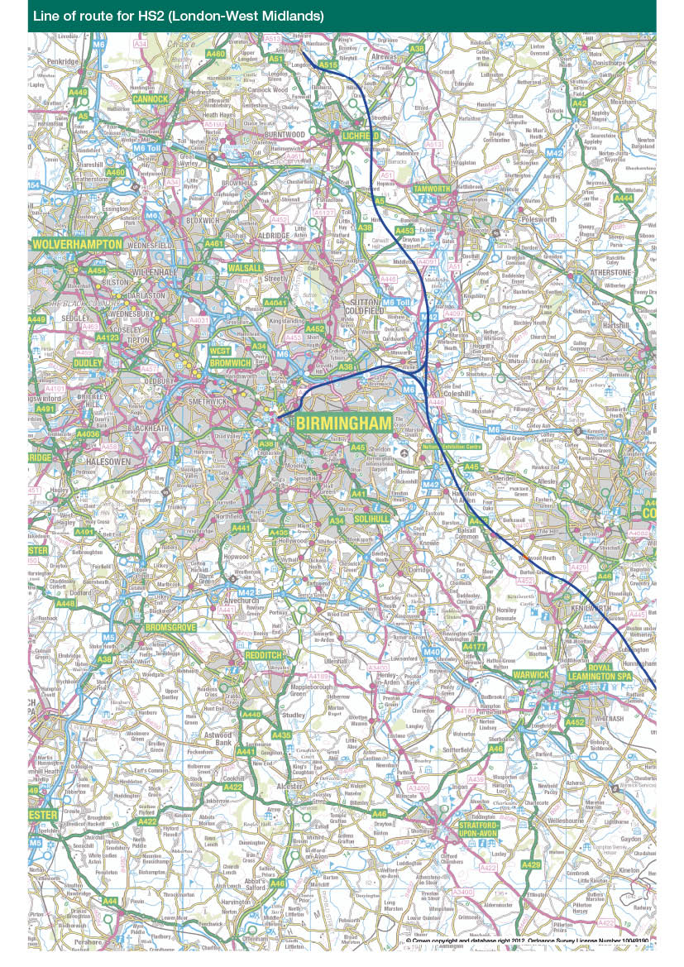

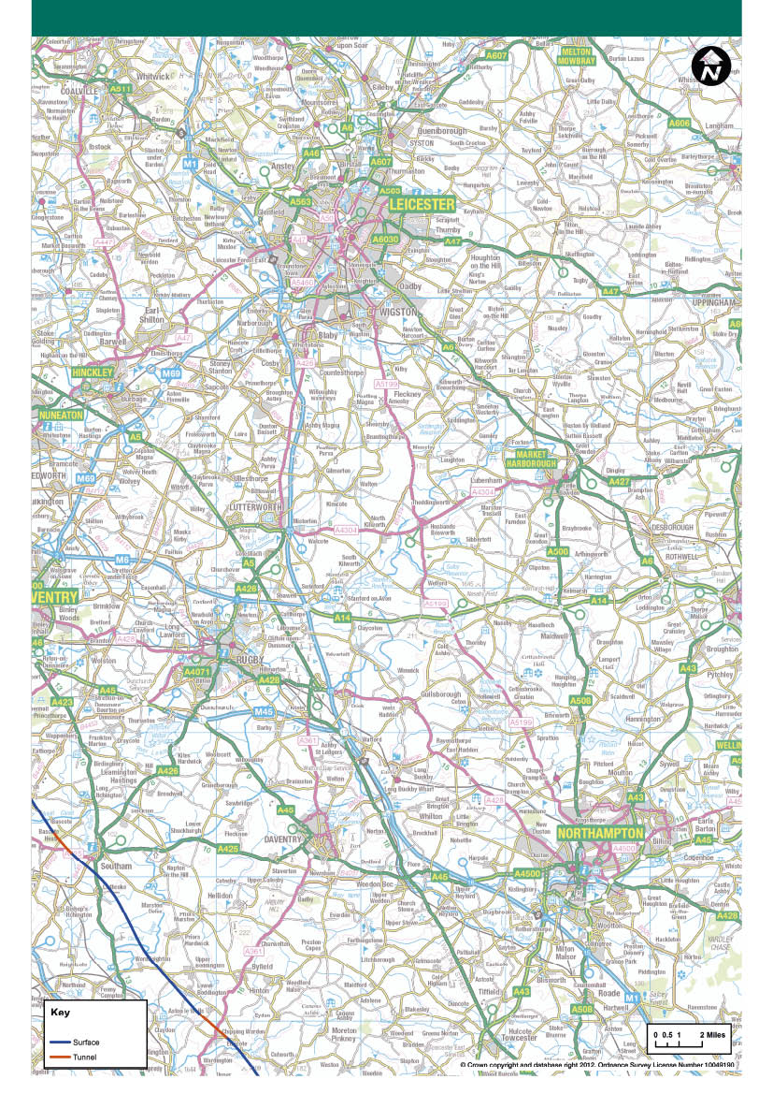

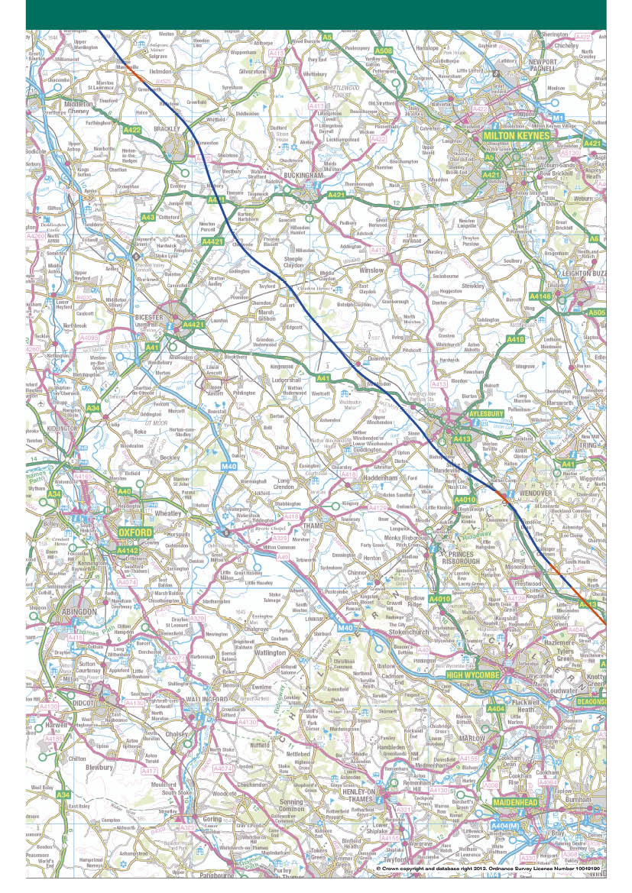

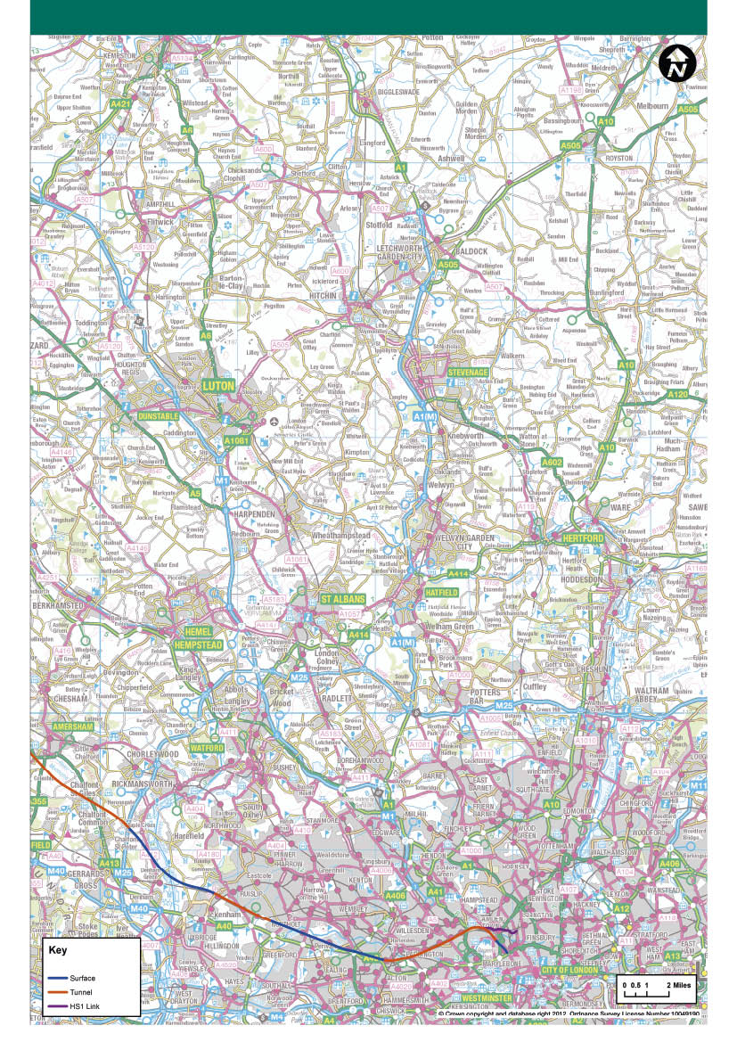

- Improve the mitigation of impacts on Balsall Common by moving the line further away from the community and lowering the height of the viaduct;
- Use a shallower cutting and longer green tunnel at Burton Green. Changes here include mitigating local impacts and reducing spoil generation, whilst still shielding the visual impact of the trains from the community;
- Avoid Kenilworth Golf Club, lower the line further into cutting through the National Agricultural Centre, and introduce a narrower, retained cutting through South Cubbington Wood. This will help mitigate the impacts in this area and also avoid the need for the demolition of a Grade II listed farmhouse at Kenilworth;
- Introduce a longer bored tunnel at Long Itchington Wood. This will reduce land take, noise, landscape and visual impacts significantly;
- Introduce a longer green tunnel past Chipping Warden and Aston le Walls, and to curve the route to move it away from a cluster of important heritage sites around Edgcote. These changes will provide additional mitigation for Aston le Walls, reduce setting impact on Grade I listed Edgcote House, avoid a Scheduled Monument (the Roman Villa site) and the possible location of the historic Edgcote Moor battlefield;
- Lower the alignment and introduce a green tunnel past Greatworth, and a short green tunnel at Turweston. These changes will help mitigate landscape, noise and visual impacts as well as remove the need for a viaduct;
- Move the route further away from Twyford. This will assist mitigating impacts on Twyford by making some land available between HS2 and the village that would allow for landscaped earthworks that would reduce noise and visual impacts;
- Lower the route past Aylesbury and Stoke Mandeville;
- This will reduce local impacts and the need for larger scale works to local roads and the Chiltern Line;
- Introduce a longer green tunnel to reduce impacts around Wendover, and extend the green tunnel at South Heath;
- Introduce a longer, continuous tunnel from Little Missenden to the M25 through the Chilterns AONB to reduce the need for deep cutting and to avoid an aquifer; and,
- Introduce a 2.75 mile (4.4 km) bored tunnel along the Northolt Corridor to avoid major works to the Chiltern Line and impacts on local communities in the Ruislip area. This will have the effect of removing all surface impacts apart from the need for an intervention shaft.
6.15 Changes to the line of the HS2 route following consultation mean that out of a total length of just under 140 miles, around 22.5 miles (not including the HS1 link) will be in tunnel or green tunnel. This is an increase of more than 50 per cent from the route consulted on. In addition, around 56.5 miles will be partially or totally hidden in cutting. Around 40 miles will be on viaduct or embankment – this is around 10 miles less than the consultation route. This means that around 79 miles (more than half of the route) will be mitigated by tunnel or cutting.
6.16 The revised tunnel alignment through the Chilterns will avoid an important aquifer, significantly reducing impacts on water resources, and the changes made also mean a reduction in the impacts on ancient woodlands along the route. There will also be a slight reduction in the length of route in flood zone. Important heritage sites will also benefit from the changes; for example the alignment change at Edgcote in Northamptonshire will substantially reduce impacts on a historic battlefield and the site of a Roman Villa, as well as Edgcote House and its grounds.
6.17 The changes also offer more benefit to communities, with fewer than five properties experiencing high levels of noise and only 60 dwellings experiencing noise levels sufficiently high to qualify for statutory noise insulation, compared to 150 for the consultation route – a reduction of over 50 per cent. It also means that the number of properties that will experience a noticeable increase in noise will be reduced by a third, from 4700 to around 3100. There will be four fewer residential demolitions than the route that went to consultation (338) and there will be a substantial reduction in the number of dwellings at risk of land take, reducing from 342 to 172.
6.18 The Government expects HS2 Ltd to continue to develop localised packages of mitigation through the detailed design phase to ensure that impacts are further reduced wherever practicable.
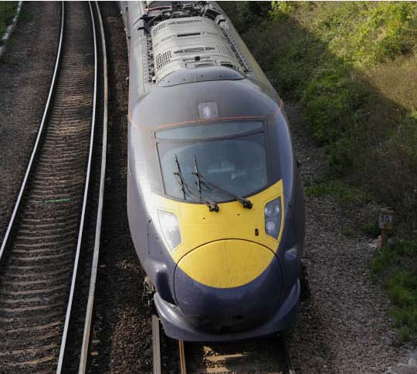

Appraisal of Sustainability
6.19 There were substantial numbers of comments received from the consultation in response to the Appraisal of Sustainability (AoS). Broadly speaking, these covered:
- The appropriateness of the approach adopted for assessing the impacts of HS2 on the environment and sustainability;
- Energy, greenhouse gas emissions, combating climate change and issues of modal shift in relation to the route;
- The protection and enhancement of natural and cultural resources in relation to the route;
- Specific impacts to species and habitats; and,
- Community-related route impacts.
6.20 The Government considers that the AoS undertaken for HS2 is appropriate for the stage of development of the proposals on which we consulted and that it forms a legitimate basis for current decisions on the scheme. We are of the view that the AoS was robust and gave sufficient information on matters of sustainability for a decision to be made on the future of the scheme. This conclusion was reached following consideration of the responses to the consultation and HS2 Ltd’s subsequent advice. HS2 Ltd submitted this advice to the Government in its report Review of HS2 London to West Midlands Appraisal of Sustainability.
6.21 Many respondents raised concerns that an Environmental Impact Assessment (EIA) was not undertaken before the consultation stage of the scheme development. An EIA is a more detailed process than the AoS for identifying, predicting, evaluating and mitigating the likely significant effects on the environment from a proposed project and for making this information public. This ensures that the importance of the predicted effects, and the scope for reducing them, are properly understood by the community and the decision maker, before a decision is taken on whether to authorise a scheme to be built.
6.22 As for any large infrastructure development, an EIA will be developed and submitted when seeking Parliamentary approval for HS2 London to West Midlands. The EIA for HS2 would include gathering detailed datasets held by local authorities and other bodies and undertaking site surveys, including land and wildlife surveys. This would allow detailed analysis of potential environmental impacts such as the effects on community and property, landscape and visual impacts, biodiversity, surface water, ground water, archaeology, traffic and transport, waste and resources and the development of appropriate mitigation. It will build on the consultation comments received and be subject to further stakeholder engagement. The Environmental Statement (ES) that would be produced at the end of this process for deposit before Parliament during the hybrid Bill would describe the project, the methods of environmental analysis used and the conclusions of the EIA including the proposed mitigation measures.
6.23 A number of consultation responses expressed the view that the AoS was not compliant with European requirements for Strategic Environmental Assessment (SEA) and that a SEA should have been carried out at this stage. We have been clear that the Government’s proposals for high speed rail did not constitute a programme or plan under the meaning of the SEA Directive 2001/42/EC and the 2004 regulations, and that, therefore, there was not a requirement to undertake a SEA. However, for a scheme of such magnitude, a decision was taken that it would be appropriate and beneficial to apply SEA principles to the AoS.
6.24 We consider that the AoS appropriately applied the principles of the SEA Directive to the degree necessary for this stage in the project. In line with the SEA Directive, which outlines that an assessment must be made of reasonable alternatives to a proposed project, HS2 Ltd investigated these and explained why the alternatives were rejected. These can be found in the Review of HS2 London to West Midlands Route Selection and Speed which explores different design speed and route options.
6.25 A prominent feature in responses to the consultation was concern that the Chilterns Area of Outstanding Natural Beauty (AONB) would be adversely affected. Responses challenged the legal and moral legitimacy of constructing a railway through this area. Section 85 of the Countryside and Rights of Way Act 2000 imposes a duty on the Government and other bodies to have regard to the purpose of conserving and enhancing the natural beauty of areas of outstanding natural beauty. The Government considers that HS2 is consistent with this duty and also with the Planning Policy Statement on sustainable development in rural areas (PPS 7).
6.26 PPS 7 outlines how nationally designated areas, such as AONBs, have the highest status of protection in relation to landscape and scenic beauty and how major developments should not take place in these designated areas, except in certain circumstances. It is required that major development proposals should be demonstrated to be in the national interest before being allowed to proceed. The Government considers that HS2 fulfils this criterion. The reasoning to support this assessment is set out in the document Review of the Government’s Strategy for a National High Speed Rail Network, which explains the need for this development, and also the accompanying Economic Case for HS2: Value for Money Statement. As part of this we have also looked at alternatives to the scheme, to ensure that there are no realistic alternatives. HS2 is compatible with extant policy on AONBs, because whilst acknowledging the need to conserve and maintain the beauty of AONBs generally, the Government and HS2 Ltd has:
- explored alternatives and discounted these as not appropriate; and,
- lessened the environmental impacts of the line by careful design and mitigation, including the use of tunnelling and cuttings, and by following existing transport corridors.
The Government is content that in respect of the route through the Chilterns AONB the scheme is consistent with its legal obligations at the national and international levels.
6.27 PPS 7 also ensures that any planning permission granted for major developments in these designated areas must be executed to high environmental standards through the application of appropriate conditions where necessary. We are clear that the highest levels of care will be applied during construction, that full compliance with appropriate construction codes of practice must be ensured, and that impacts must be mitigated wherever practicably possible in line with the mitigation hierarchy employed HS2 Ltd.
6.28 It should be noted that a consultation has recently been undertaken by the Department for Communities and Local Government which is intended to make the planning system less complex and more accessible. The Government will ensure that if changes are made to the planning system, HS2 will remain consistent with any new rules that are brought into force.
6.29 As noted in previous chapters, a range of views were expressed on the consistency of HS2 with the Government’s objectives for carbon emissions, including concerns that the proposals would not support the principles of combating climate change or contribute to the UK’s plans to reduce greenhouse gas emissions. The consultation set out a range of potential outcomes, based on various future scenarios, with HS2 increasing carbon emissions in some scenarios and reducing emissions in others. In either case, however, the change generated by HS2 would only be around 0.3 per cent of current total annual domestic transport emissions.
6.30 Under the Climate Change Act 2008 the Secretary of State has a duty to ensure that the net UK carbon account for the year 2050 is at least 80 per cent lower than the 1990 baseline. The Act aims to enable the UK to become a low-carbon economy. The Government has set out how it intends to achieve this target in its recent publication The Carbon Plan: Delivering our Low Carbon Future. As HS2 proceeds, we expect HS2 Ltd to undertake further assessment to more clearly define both the range and detail of variables and scenarios and to also look at ways of ensuring HS2 plays its part in a low-carbon future. We believe the proposed scheme is consistent with the Government’s ambition to reduce carbon emissions under the Climate Change Act.
6.31 Views were expressed in consultation that legal air quality limits for nitrogen dioxide would in future be breached around Euston station and that HS2 would exacerbate this problem. However by 2026 (when the railway is scheduled to open), the area around Euston station is not predicted to be in breach of air quality limits. Furthermore HS2 Ltd will work with the London Borough of Camden, Transport for London and other relevant agencies to develop a detailed package of mitigation that will be applied during the construction and operation phases to minimise air quality risks in this area. This procedure would also be applied to other stations on the network. We are content with this approach and will expect the developer of HS2 to adhere to it. The Secretary of State has a statutory duty under the Air Quality Standards Regulations 2010 to ensure that the limits on levels of pollution set out in the regulations are not exceeded and we are clear that this duty will be adhered to.
6.32 There were comments raised in consultation that the scheme might impact on aquifers. The EU Water Framework Directive 2003, which is reflected in the framework for the AoS, outlines that the Government must take all practicable steps to mitigate any adverse impact on the status of water bodies. HS2 Ltd looked at these issues, and consequently the tunnelled alignment through the Chilterns has been moved to avoid an aquifer of major importance to the local area. The Government is clear that it takes account of all relevant legislation in respect of the environment, and we would expect the developer of HS2 to further ensure that mitigation is applied to other bodies of water, where needed or practicable, to ensure compliance with the Directive.
6.33 Concern was raised in relation to potential impact on ancient woodlands. The Government recognises that these form an important part of our natural heritage and as such need to be protected wherever possible. The EIA process will identify in detail the true scope of any impacts and offer appropriate mitigation solutions, for example to transplant woodland to an adjacent site or to use narrower cuttings, wherever possible, to avoid unnecessary land take.
6.34 Consultation responses contained concerns that there would be detrimental impacts on listed buildings and scheduled monuments. Heritage assets are valuable resources that enrich the cultural and historical legacy of our country. Consequently a significant level of scrutiny was applied to heritage assets, undertaken in dialogue with English Heritage. The line of route changes that have been accepted by Government will, amongst other things, reduce impacts on important heritage assets. However, we expect further work to be undertaken to identify and, where possible, avoid or offset impacts upon heritage assets, including undesignated heritage assets and areas of archaeological potential. The EIA process will identify these heritage resources for due consideration.
6.35 The Government has a duty to consider whether the project may have a significant effect on a ‘European designated site’, or on any site to which the same protection is applied, under the Conservation of Habitats and Species Regulations 2010. There is a potential impact on a European designated site; Broadwater Lake. By running across the Mid-Colne Valley, it is possible that HS2 may indirectly affect Broadwater Lake, although the likelihood of this is low. Following discussion with Natural England, winter bird surveys will need to be undertaken in order to provide reliable conclusions. These surveys by the appointed environmental consultant will start in the Winter of 2012-13 as part of the EIA and any issues identified will be subject to appropriate mitigation measures. We expect further work to be undertaken to identify areas for enhancing biodiversity.
6.36 Agricultural land take, and associated food security issues, were raised in a number of consultation responses, along with concern at the severance of farming land. The Government is clear that all impacts on these important national resources will need to be understood. The AoS sought to look strategically at the issue and considered the area of grade 1 and 2 agricultural land through which the line passes. The EIA will include a detailed agricultural land classification and soil resources field survey. Further work will be undertaken during this period and in preparation for the hybrid Bill to examine the appropriate means for ensuring that as much land as possible is returned to full agricultural production once the construction of HS2 has finished.
6.37 We would also expect that, wherever possible, existing rights of way will be maintained through the design of HS2. The Government has already introduced green tunnels to ensure access across the line. Elsewhere, as part of the detailed design process, we expect work to be undertaken with local authorities and residents to identify the best method of maintaining rights of way; seeking to do this with as little disruption as possible by, for example, constructing bridges over cuttings or underpasses through embankments.
6.38 Some consultation responses expressed concerns regarding the noise assessment that accompanied the consultation. In particular, the absence of noise contour mapping was queried. The Government considers that the noise methodology employed for the AoS and the resulting information presented in the consultation was appropriate given the level of engineering design information available at that point in the project. Given the strategic nature of this stage of design, it was not appropriate to publish maps showing noise contours, as these could have misled residents into thinking that it was possible to indicate precise noise levels at specific properties. Instead, the noise maps that were prepared for consultation identified locations that would potentially be subject to noise effects. The approach to developing the noise maps of the proposed route included predicting noise levels at individual ‘receiver points’ which represented either individual dwellings close to the route or clusters of dwellings further from the route. As HS2 progresses, an EIA will be undertaken which will include a more detailed analysis of noise effects and further information will be made available to the public.
6.39 Spoil, including its removal, was considered to be problematic in some responses to the consultation. Spoil can be used to form embankments alongside the railway, to integrate the route within existing topography, and to create bunds and landscaping that reduce any noise and visual impacts from the line. We expect the construction of HS2 to comply with the waste hierarchy contained in the Waste Framework Directive (waste prevention, preparation for reuse, recycling, other recovery operations and disposal). Waste management should be undertaken in line with relevant construction best practice and legislation extant at the time of construction so as to avoid danger to human health and harm to the environment.
6.40 The Government expects that further mitigation and the final design of the route will be developed through ongoing public engagement as part of the EIA and hybrid Bill processes. The detailed design of the route and the EIA will allow an Environmental Statement to be produced and consulted on in Spring 2013. This process will involve extensive engagement with the communities and individuals affected by the railway. The concerns of local residents are an important priority for the Government and HS2 Ltd will ensure that local views are fed into the design process and that local communities are aware of the progress being made with the railway.

Chapter 7 – The Fair Property and Blight Deal

Introduction
7.1 HS2 will have a significant positive impact on the UK transport network and economy. The Government recognises that it will also affect homeowners, communities and businesses along the line.
7.2 Throughout the consultation homeowners and business people told us of their fears that the Government would not do enough to prevent blight and to protect property values and communities from the noise and disruption of HS2.
7.3 The Government has already taken a number of important decisions to limit these negative impacts. These include moving the line away from towns and villages, lowering it further into cutting, and increasing the length in tunnels. We have also worked to minimise uncertainty and blight by consulting on one line of route and by sharing information through a thorough public consultation. A clear lesson from the experience with the HS1 line to the Channel Tunnel was that publishing multiple routes spreads uncertainty and blight. The introduction of an Exceptional Hardship Scheme has also provided support for those who face the most challenging immediate circumstances.
7.4 The consultation document set out a range of options for compensating those negatively affected by HS2. The seventh question in the consultation document was:
Do you agree with the options set out to assist those whose properties lose a significant amount of value as a result of any new high speed line?
7.5 The consultation responses that we received dealing with property and blight issues have persuaded us that it is right to do still more to help those affected by HS2.

Summary of decisions
- HS2 will affect homeowners, communities and businesses along the line. We will bring in a package of measures over and above what affected homeowners are already entitled to under law. This will include a streamlined advance purchase scheme, a refreshed hardship scheme, support for those affected by construction, measures to reinforce confidence in properties above tunnels, and a sale and rent back scheme.
- There is only a weak case to be made for introducing a compensation bond and the risks and costs associated with a bond-based property purchase scheme should not be discounted. We have therefore decided not to proceed with either scheme.

Measures
7.6 The Government will introduce a range of further measures to address any blight caused by its proposals for HS2 and to reassure property owners. These are described in the Review of Property Issues, published alongside this document. In summary, the Government will:
- Introduce a streamlined purchase scheme to simplify the statutory blight process for property owners;
- Introduce a sale and rent back scheme to give homeowners within the safeguarded area more flexibility;
- Introduce a streamlined small claims scheme for construction damage. This will allow individuals and businesses who are entitled to compensation under existing law to claim it more quickly and more simply;
- Publish a package of measures to reinforce confidence in properties above tunnels. Homeowners will be offered before and after surveys, a thorough assessment of the impact of similar tunnels, an explanation of the measures that will be taken to prevent perceptible vibration impacts, financial compensation for the compulsory purchase of subsoil, and a legally binding promise that HS2 will be permanently responsible for resolving any related settlement or subsidence issues;
- Introduce a refreshed hardship-based property purchase scheme; and,
- Work constructively with local authorities along the line of route to minimise the negative consequences of HS2 and maximise the benefits.

Next steps
7.7 The Government recognises that to develop an effective set of policies on blight and compensation we have to understand the market impacts and local issues thoroughly.
7.8 That is why the Government will consult further on the detail of the policy proposals outlined above. We plan to open a 12 week consultation on blight policies in Spring 2012. We would like to take this opportunity to encourage all those affected and interested to respond to this consultation – your responses will shape what becomes Government policy. We will then announce the final property and blight deal later in the year.
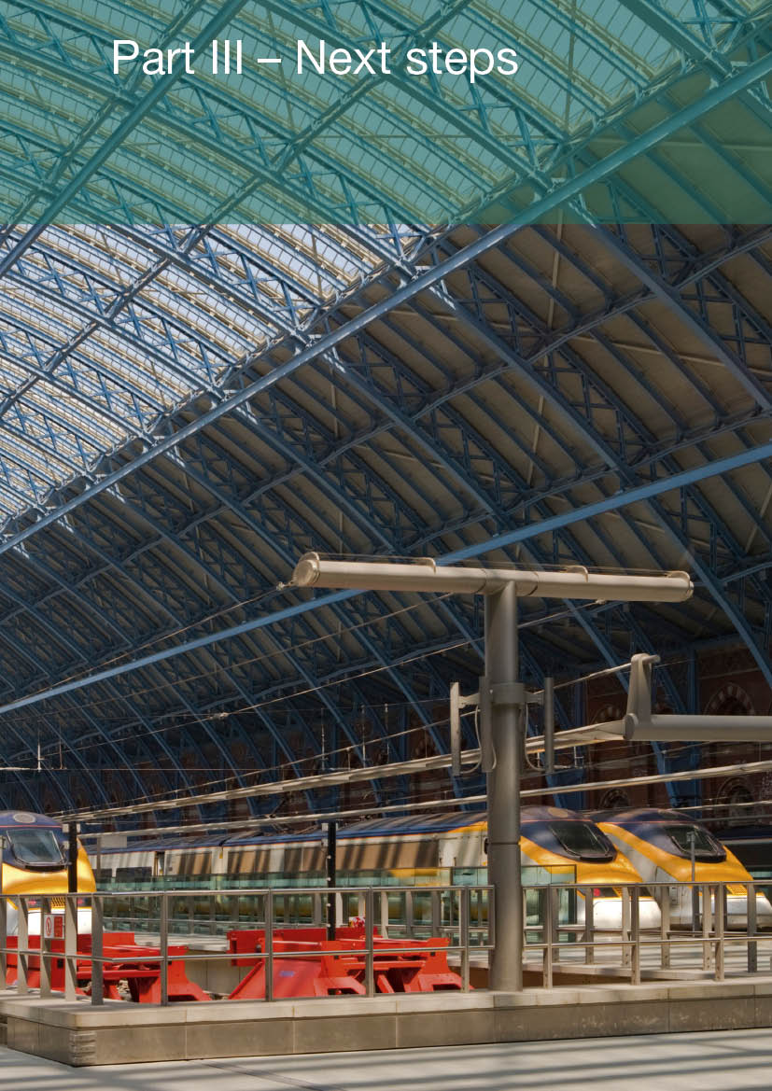
Part III – Next steps

Next Steps
1 High Speed Two is the most significant single transport infrastructure project in the UK since the building of the motorways. Now that we have taken the decision to progress the scheme we are committed to driving it forward as fast as is practicable to achieve early realisation of its significant benefits in terms of capacity, connectivity and support for economic growth, and to remove unwelcome uncertainty for those affected.
2 A key part of this will be to engage fully and actively with organisations, communities and individuals along the whole route of the Y network. It is clear from the consultation that HS2 generates strong feelings both in favour and against the scheme. People near the line of route presented very legitimate concerns about how it might affect them and, although we are sure that many of these concerns will be allayed through the detailed design work, we will work hard with local communities to ensure that as many issues are mitigated as possible.
3 This engagement activity will be a key component of the programme of work on both Phase 1 (London to West Midlands) and Phase 2 (Leeds, Manchester and Heathrow) that the Government and HS2 Ltd will need to undertake. This will include a significant change in the nature of HS2 Ltd, moving from a body advising Government to the promoter of a specific railway project. To effectively carry out this role will require a strengthening of the commercial, technical and project management skills of the organisation. Therefore, early in 2012 we will undertake the recruitment activity required to strengthen HS2 Ltd’s Board and Senior Executive team.
4 HS2 Ltd will now undertake a range of activities to prepare for and deliver the first and second phases of the HS2 network.

Phase 1 (London to West Midlands)
5 We intend to introduce a hybrid bill by the end of 2013 to provide the necessary powers to construct and operate the first phase of the railway from London to Birmingham. The hybrid bill process provides an opportunity for those affected by the proposed railway to petition Parliament. A Select Committee can recommend changes to the project, much in the same way as happens with a planning inquiry. Details of how and when to petition will be published on the Department’s website before a bill is introduced and advertised in national and local press in those areas affected. In order to achieve this timetable we plan to:
- Develop the detailed design of the route and the Environmental Impact Assessment to enable an Environmental Statement to be produced and consulted on in Spring 2013. This is a significant body of work, the first stage of which will be to procure a Development Partner to coordinate this work. We intend to do this during January 2012.
- Engage extensively with the communities and individuals affected by the railway. We realise that the project will have significant impacts on individuals and communities and are keen to ensure that these impacts are mitigated as far as possible through the detailed design work. Therefore, starting from early 2012 HS2 Ltd will undertake an extensive engagement programme along the line of route, to ensure that local views are fed into the design process and local communities are aware of the progress that is being made with the railway.
- Develop the Directions to safeguard the proposed route from London to West Midlands. The intention is to consult on the draft directions in Spring 2012 and, subject to the outcome of this consultation, bring final safeguarding directions into effect later in the year. From that point households in the safeguarding area will be able to serve a blight notice on the Government, which requires it to consider buying their property, for its unblighted value, in advance of any compulsory purchase. More information about compulsory purchase and statutory blight can be found on the Department for Communities and Local Government website. Alternatively, you can call the CLG publications line on 0300 123 1124 between 8am and 8pm, Monday to Friday and ask to be mailed a free copy of the compulsory purchase booklets.
- Develop and consult on the details of the proposed compensation package. We are very clear that the approach to compensation needs to be developed with the input of the communities and individuals affected. We plan to consult on detailed compensation proposals alongside the safeguarding consultation in Spring 2012 with the intention of having an agreed compensation policy in place by later in the year.

Phase 2 (Leeds, Manchester and Heathrow)
6 The intention is for Ministers to take a decision on the line of route for Phase 2, in the same way that the decision has been made on the route for Phase 1 in this document, no later than the end of 2014. In order to meet this timetable we plan to:
- Receive advice for the Secretary of State from HS2 Ltd on the route options for phase 2 by March 2012.
- We will then undertake a period of engagement and consultation to inform the choice of a preferred route. The Department’s Business Plan foresees a decision being made by Ministers on the preferred route by December 2014, following this consultation process. However, we will keep this timetable under review with a view to ensuring as swift a process as possible while recognising the need for extensive engagement.

Keeping in touch
7 Regularly updated news of ongoing work on high speed rail will be published on the HS2 website (www.hs2.org.uk). HS2 Ltd’s website will also shortly include a full programme of local and regional engagement events.
8 HS2 Ltd can be contacted directly via the enquiry line (020 7944 4908), email address (HS2enquiries@hs2.gsi.gov.uk) or by post;
HS2 Limited 2nd Floor Eland House Bressenden Place London SW1E 5DU
9 This is a very significant work programme and the Government is committed to moving it forward with pace and purpose. We are proposing an ambitious but realistic timetable to ensure that Britain can reap the benefits of this once in a generation project as soon as is practicable but one that will also dedicate significant time to understanding and addressing the concerns of those affected by the railway.

List of Supporting Documents
High Speed Rail: Investing in Britain’s Future Consultation Summary Report
An independent report providing a summary of the responses to the Government’s consultation High Speed Rail: Investing in Britain’s Future.
Review of the Government’s Strategy for a National High Speed Rail Network
A review by the Department for Transport of the Government’s strategy for a national high speed rail network in light of responses to the consultation. The document covers the key aspects of the Government’s strategy, including the case for action, the relative case for high speed rail and alternative strategies, and the phasing and configuration of the Government’s proposed network.
High Speed Rail Strategic Alternatives Study: Update Following Consultation
A report by Atkins examining the case for conventional rail alternatives to HS2. The Study updates the key elements of Atkins’ February 2011 reports: High Speed Rail Strategic Alternatives Study: Strategic Alternatives to the Proposed ‘Y’ Network and London to West Midlands Rail Alternatives – Updated of Economic Appraisal.
Review of the Strategic Alternatives to High Speed Two
A report by Network Rail on proposals to upgrade the existing rail network as alternative strategies to HS2. The report focuses on the outputs, feasibility, deliverability and costs of proposals considered by Atkins and suggested in responses to the consultation.
Economic Case for HS2: Updated Appraisal of Transport User Benefits and Wider Economic Benefits
HS2 Ltd’s update to the Economic Case for HS2: The Y Network and London – West Midlands, published in February 2011. It describes changes to forecasts of demand and the updated economic appraisal of HS2.
Economic Case for HS2: Value for Money Statement
The Department for Transport’s assessment of the value for money of HS2. This includes consideration of the economic impacts described in the Economic Case for HS2: Updated Appraisal of Transport User Benefits and Wider Economic Benefits, and additional monetised and non-monetised value for money impacts.
Review of the Technical Specification for High Speed Rail in the UK
A review by HS2 Ltd of the technical specification for HS2 in light of consultation responses, including for example, rolling stock specification.
Review of Possible Refinements to the Proposed HS2 London to West Midlands Route
A report by HS2 Ltd presenting its recommendations for line of route alignment changes to HS2 (London to West Midlands) in response to issues raised during consultation.
Summary of Effects of HS2 London to West Midlands Route Refinements
A report by HS2 Ltd focussing on the engineering, sustainability and cost effects of the changes made to the London to West Midlands route in response to issues raised in consultation.
Review of HS2 London to West Midlands Route Selection and Speed
A review by HS2 Ltd of its route selection process, and a number of route-related features, such as the maximum line speed, alternative route corridors, the location of stations and serving Heathrow Airport.
Review of HS2 London to West Midlands Appraisal of Sustainability
A review by HS2 Ltd of consultation responses regarding the Appraisal of Sustainability. It includes consideration of comments on the environment, greenhouse gas emissions, air quality, and species and habitats.
Review of Property Issues
A review by the Department for Transport of the property concerns raised during the consultation and the Government’s policies to minimise blight and support communities.
Revised Line of Route Maps
A series of maps reflecting the Government’s amendments to the London to West Midlands line of route.

Glossary
Appraisal of Sustainability (AoS) An appraisal of the economic, environmental, and social effects of a plan that allows decision-making in accord with sustainable development. Conducted in accordance with the principles of EU Directive 2001/42/EC on strategic environmental assessment
Area of Outstanding Natural Beauty (AONB) An area of countryside in England, Wales or Northern Ireland whose distinctive character and natural beauty are considered of sufficient value to be designated under the National Parks and Access to the Countryside Act of 1949
Benefit Cost Ratio (BCR) The ratio of the benefits of a project or proposal, relative to its costs, expressed in monetary terms
Biodiversity Action Plan (BAP) An internationally recognized programme addressing threatened species and habitats, designed to protect and restore biological systems
Captive train A train which can only run on the high speed rail network.
Carbon Dioxide (CO²) A greenhouse gas
Carbon Plan The Government’s plan of action, published in December 2011, for achieving the emissions reductions committed to in the Climate Change Act 2008 http://www.decc.gov.uk/en/content/cms/tackling/carbon_plan/carbon_plan.aspx
Classic or conventional railway/network The existing non-high speed railway in Britain
Compatible train A train which can run at high speed on the high speed rail network and also on the existing electrified rail network at conventional speed
Consultation, The The Government’s 2011 public consultation on a national high speed rail network, described in High Speed Rail: Investing in Britain’s Future http://highspeedrail.dft.gov.uk/sites/highspeedrail.dft.gov.uk/files/hsr-consultation.pdf
Day One A term used to describe the conditions on HS2 on the first day of operation of Phase 1
Directions A form of Delegated Legislation which may confer power on a Minister to give instructions to a public body which are not under the Minister’s direct control
East Coast Main Line (ECML) A major mixed-traffic railway route on the eastern side of Britain, linking London, the South East and East Anglia with Yorkshire, the North East Regions and Scotland
Environmental Impact Assessment (EIA) An assessment of the positive and negative effects that a significant project would have on the environment, including an appraisal of measures to mitigate against those impacts (provided for in Directive 85/337/EEC)
Environmental Statement (ES) A statement of the likely environmental effects of a significant project, which explains how these impacts would be mitigated
Exceptional Hardship Scheme (EHS) A scheme to help homeowners whose property value may be seriously affected by the ‘preferred route option’ of HS2 and who urgently need to sell http://www.hs2.org.uk/exceptional-hardship-scheme?pageid=1
European Union Emissions Trading System (EU ETS) (Formerly referred to as the EU Emissions Trading Scheme) A key policy introduced by the European Union to help meet its greenhouse gas emissions target. Under the system, emitters trade allowances for greenhouse gas emissions, in order to achieve the economically optimal means of reducing emissions http://ec.europa.eu/clima/policies/ets/index_en.htm
Grade Separation The alignment of a junction of two or more transport routes at different heights (grades), designed not to disrupt traffic flow on any route
Green Tunnel A cut and cover tunnel, which is a tunnel constructed in a shallow trench and then re-covered with the original surface. This allows for retention of rights of way and open space amenities
Gross Domestic Product (GDP) The market value of all final goods and services produced within a country in a given period
Growth Review A rolling programme managed by HM Treasury, to last the whole of the current Parliament, calling on business to challenge the Government to remove barriers to growth http://www.hm-treasury.gov.uk/ukecon_growth_index.htm
High Speed Rail (HSR) A type of passenger rail transport that operates at speeds higher than the normal speed of rail traffic
High Speed 1 (HS1) The high speed railway line running from London St Pancras through Kent to the Channel Tunnel (formerly Channel Tunnel Rail Link (CTRL))
High Speed 2 (HS2) The scheme for a national high speed rail network in Britain, serving London, Birmingham, Manchester and Leeds and a number of intermediate stations, with links to Heathrow Airport and the High Speed 1 line to the Channel Tunnel
High Speed 2 Limited (HS2 Ltd) The company tasked with providing advice to Government on the introduction of a national high speed rail network in Britain http://www.hs2.org.uk/
McNulty Review The Rail Value for Money Study, led by Sir Roy McNulty and published in May 2011. It was commissioned to examine the overall cost structure of all elements of the railway sector and to identify options for improving value for money to passengers and the taxpayer while continuing to expand capacity as necessary and drive up passenger satisfaction http://www.rail-reg.gov.uk/server/show/ConWebDoc.10401
Midland Main Line (MML) A major mixed-traffic railway route linking London and Sheffield via Luton, Bedford, Kettering, Leicester, Derby, Nottingham and Chesterfield
Mixed-use/mixed-traffic railway A railway used by a variety of different train services, which may include passenger inter-city, commuter and suburban services, and freight trains
National Exhibition Centre (NEC) An exhibition centre in Birmingham, near junction 6 of the M42 motorway. It is adjacent to Birmingham International Airport and Birmingham International railway station
National Infrastructure Plan (NIP) An action plan, managed by HM Treasury, outlining the Government’s vision for the future of UK economic infrastructure, first published in October 2010 http://www.hm-treasury.gov.uk/national_infrastructure_plan2011.htm
National Networks National Policy Statement (NN NPS) A policy framework within which to consider applications for planning consent for developments on the strategic road network, the rail network and for rail freight interchange facilities over a certain size. Designed for use by the Infrastructure Planning Commission (and its successor, the Planning Inspectorate)
National Planning Policy Framework (NPPF) A single document planned to replace the set of individual Planning Policy Statements (PPS) published by the Department for Communities and Local Government http://www.communities.gov.uk/planningandbuilding/planningsystem/planningpolicy/planningpolicyframework/
Network Rail The company that runs, maintains and develops Britain’s tracks, signalling system, rail bridges, tunnels, level crossings, viaducts and 18 key stations http://www.networkrail.co.uk/
North London Line A railway line running from Richmond to Stratford, passing through the inner suburbs of north London
Office of Rail Regulation (ORR) The independent safety and economic regulator for Britain’s railways http://www.rail-reg.gov.uk/
Passenger Demand Forecasting Handbook (PDFH) A summary of over 20 years of research on rail demand forecasting, providing guidance on aspects such as the effects of service quality, fares and external factors on rail demand. It is recognised within the industry as the key source of evidence in this area http://www.atoc.org/about-atoc/commercial-activities/passenger-demand-forecasting-council/the-passenger-demand-forecasting-handbook
Phase 1 (of the proposed HS2 network) A line from London to the West Midlands, including stations in central London (Euston), West London (Old Oak Common), outer Birmingham (Birmingham Interchange) and central Birmingham (Curzon Street). It includes a connection onto the High Speed 1 line to the Channel Tunnel
Phase 2 (of the proposed HS2 network) Lines from the West Midlands to Manchester and to Leeds, including stations in South Yorkshire and the East Midlands, and a direct link to Heathrow Airport
Planning Policy Statement 7 (PPS 7) Document produced by the Department for Communities and Local Government to advise local planning authorities on planning policies for rural areas http://www.communities.gov.uk/publications/planningandbuilding/pps7
Risk and optimism bias Allowances for risk and optimism bias are added to the appraisal costs of projects to take account of the tendency for appraisers to be over-optimistic about the costs and other key parameters of projects
Severance The separation of a piece of land or community from another, larger piece, through infrastructure construction
Spoil The plant and earth matter extracted from the existing landscape in the construction of cuttings or tunnels
Strategic Environmental Assessment (SEA) A system of environmental assessment of certain plans and programmes (provided for in Directive 2001/42/EC)
Technical Specification for Interoperability (TSI) Specifications drafted by the European Railway Agency and adopted in a Decision by the European Commission to ensure the interoperability of the trans-European rail system http://www.era.europa.eu/Core-Activities/Interoperability/Pages/TechnicalSpecifications.aspx
Transport Select Committee A group of MPs charged with examining the expenditure, administration and policy of the Department for Transport and its associated public bodies http://www.parliament.uk/transcom
Value for Money (VfM) A broad-based assessment of all the costs and benefits associated with a potential investment. The costs include not only the financial cost of making the investment but also the ‘non-monetised’ impacts in relation, for example, to the environment and the economy. The benefits include a range of monetised transport benefits (capacity, reliability and journey times, for example) and also wider non-monetised benefits relating, for example, to economic growth. The value for money of a project is considered in light of these and all other aspects of its business case
WebTAG Web-based Transport Appraisal Guidance, as issued by the Department for Transport http://www.dft.gov.uk/webtag/
West Coast Main Line (WCML) The busiest mixed-traffic railway route in Britain, serving London, the West Midlands, the North West, North Wales and the Central Belt of Scotland
Y network A national high speed rail network serving London, Birmingham, Manchester and Leeds, developed in two phases, and also including direct links to HS1 and Heathrow

http://cdn.hm-treasury.gov.uk/2011budget_growth.pdf
http://www.hm-treasury.gov.uk/ppp_national_infrastructure_plan.htm
Office of Rail Regulation, June 2011, HS1 Review 2010/11
See Report on Wider Network Options (HS2 Ltd, 2010), and the comparison of network options in HS2 Ltd’s 2009 report (http://webarchive.nationalarchives.gov.uk/+/http:/www.dft.gov.uk/pgr/rail/pi/highspeedrail/ hs2ltd/hs2report/)
http://www.decc.gov.uk/assets/decc/11/tackling-climate-change/carbon-plan/3702-the-carbon-plan-delivering-our-low-carbon-future.pdf
http://www.rail-reg.gov.uk/upload/pdf/rail-vfm-summary-report-may11.pdf
Passenger Focus, National Passenger Survey 2010
http://cdn.hm-treasury.gov.uk/2011budget_growth.pdf
http://www.hm-treasury.gov.uk/national_infrastructure_plan2011.htm
The Climate Change Act 2008 commits the UK Government to setting five-yearly carbon budgets consistent with achieving a reduction of greenhouse gas emissions of at least 80 per cent by 2050.
http://www.dft.gov.uk/publications/dft-business-plan-2011-2015/
This figure is based on an assumption that half of all time spent by business travellers on a train is used productively.
http://www.decc.gov.uk/en/content/cms/tackling/carbon_plan/carbon_plan.aspx
See High Speed Rail: London to the West Midlands and Beyond – A Report by HS2 Ltd (December 2009) and High Level Assessment of the Wider Network Options – Reverse ‘S’ and ‘Y’ network (October 2010).
http://www.51m.co.uk/sites/default/files/uploads/App%201%20-%20Optimised%20Alternative%20to%20HS2.pdf
See the Coalition document, Our Programme for Government, at http://www.cabinetoffice.gov.uk/news/coalition-documents
http://www.dft.gov.uk/publications/realising-the-potential-of-gb-rail/
http://www.hm-treasury.gov.uk/national_infrastructure_plan2011.htm
See Review of HS2 London to West Midlands Route Selection and Speed
See Review of HS2 London to West Midlands Route Selection and Speed report
http://www.communities.gov.uk/publications/planningandbuilding/draftframework
http://www.decc.gov.uk/assets/decc/11/tackling-climate-change/carbon-plan/3702-the-carbon-plan-delivering-our-low-carbon-future.pdf
Department for Environment, Food and Rural Affairs, 2011, Air quality plans for the achievement of EU air quality limit values for nitrogen dioxide (NO²) in the UK, http://uk-air.defra.gov.uk/library/no2ten/documents/110921_UK_overview_document.pdf
These regulations implement the EU Directive on Ambient Air Quality.
Directive 2008/98/EC on waste
http://www.communities.gov.uk/publications/planningandbuilding/compulsorypurchase

