Review of possible
refinements to the proposed HS2
London to West
Midlands Route
A report to Government
by HS2 Ltd
January 2012

Although this report was commissioned by the Department for Transport (DfT), the findings and recommendations are those of the authors and do not necessarily represent the views of the DfT. The information or guidance in this document (including third party information, products and services), is provided by DfT on an ‘as is’ basis, without any representation or endorsement made and without warranty of any kind whether express or implied.

The Department for Transport has actively considered the needs of blind and partially sighted people in accessing this document. The text will be made available in full on the Department’s website. The text may be freely downloaded and translated by individuals or organisations for conversion into other accessible formats. If you have other needs in this regard please contact the Department.

Department for Transport
Great Minster House
33 Horseferry Road
London SW1P 4DR
Telephone: 0300 330 3000
Website: www.dft.gov.uk
General email enquiries: FAX9643@dft.gsi.gov.uk

© Crown copyright, 2012, except where otherwise stated.

Copyright in the typographical arrangement rests with the Crown.

You may re-use this information (not including logos or third-party material) free of charge in any format or medium, under the terms of the Open Government Licence. To view this licence, visit www.nationalarchives.gov.uk/doc/ open-government-licence/or write to the Information Policy Team, The National Archives, Kew, London TW9 4DU, or e-mail: psi@nationalarchives.gsi.gov.uk.

Where we have identified any third-party copyright information you will need to obtain permission from the copyright holders concerned.
Contents
List of acronyms 4
Executive summary 5
1 Introduction 7
1.1 Background 7
1.2 Consultation responses 8
1.3 Developing mitigation through Environmental Impact Assessment 10
2 West Midlands 13
2.1 Trent and Mersey Canal and West Coast Main Line reconnection 13
2.2 Hints 13
2.3 Middleton 14
2.4 Water Orton and the West Midlands Delta Junction 16
2.5 River Tame, Bromford 18
2.6 Gilson and Chelmsley Wood 18
2.7 Hampton-in-Arden 18
2.8 Balsall Common 18
3 Warwickshire and Northamptonshire 21
3.1 Burton Green 21
3.2 Kenilworth, Stoneleigh, Cubbington and Offchurch 22
3.3 Southam to Ladbroke 22
3.4 Aston le Walls, Chipping Warden and Edgcote 24
3.5 Greatworth and Turweston 27
3.6 Newton Purcell and Twyford 27
4 Buckinghamshire 30
4.1 Quainton 30
4.2 Aylesbury and Stoke Mandeville 30
4.3 Wendover to the M25: The Chilterns AONB 30
5 Greater London 36
5.1 Colne Valley 36
5.2 Northolt Corridor 36
5.3 London Tunnel 39
5.4 HS2 – HS1 Link 39
5.5 Euston station 40
6 References 41

List of acronyms

AONB Area of Outstanding Natural Beauty
AoS Appraisal of Sustainability
BAP Biodiversity Action Plan
EA Environmental Agency
EH English Heritage
EIA
Environmental Impact Assessment
ES
Environmental Statement
HOAC
Hillingdon Outdoor Activity Centre
SEA Strategic Environmental Assessment
SPZ1 Source Protection Zone 1
SSSI Site of Special Scientific Interest
TfL Transport for London
WCML West Coast Main Line

Executive summary
1 This is HS2 Ltd’s report to Government on the outcomes of our studies into, and recommendations for, potential line of route alignment changes to HS2 London to West Midlands in response to issues raised during consultation. We used these to develop a programme of local studies to consider options for mitigating impacts and enhancing the line of route. The High Speed Rail: Investing in Britain’s Future consultation was launched on 28th February 2011 with a closing date for responses of 29th July 2011. That consultation covered both the Government’s strategy for high speed rail, and the proposed line of route for phase one from London to West Midlands.
2 Balancing engineering issues, environmental issues, costs and benefits we recommend that, if a decision is taken to proceed with HS2, the following changes be considered for inclusion in the line of route to be taken forward to preliminary design and Environmental Impact Assessment (EIA):
• increase the clearance of HS2 over the Trent and Mersey Canal near Lichfield to ensure that it remains navigable. We also recommend a slight alteration to the alignment to ensure that it would be compatible with a future extended high speed network;
• move the route slightly further away from Middleton to reduce local impacts;
• a shallower cutting and longer green tunnel at Burton Green to further mitigate local impacts and reduce spoil generation;
• mitigation of impacts on Balsall Common;
• move the route slightly further east to avoid Kenilworth Golf Club, lower it further into cutting through the National Agricultural Centre, and introduce a retained cutting through South Cubbington Wood to reduce impacts on this ancient woodland;
• introduce a longer bored tunnel at Long Itchington Wood;
• introduce a longer green tunnel past Chipping Warden and Aston le Walls, and to curve the route to avoid a cluster of important heritage sites at Edgcote;
• lower the alignment and introduce a green tunnel past Greatworth, and a short green tunnel at Turweston;
• move the route further away from Twyford;
• lower the alignment past Aylesbury and Stoke Mandeville to reduce local impacts and eliminate the need for larger scale works to local roads and the Chiltern Line;
• introduce a longer green tunnel to reduce impacts around Wendover, and an extension to the green tunnel at South Heath;
• introduce a longer, continuous tunnel from Little Missenden to the M25 through the Chilterns AONB to reduce the need for deep cutting and to avoid an aquifer; and
• introduce a 2.75 mile (4.4 km) bored tunnel along the Northolt corridor to reduce impacts on local communities and avoid major works to the Chiltern Line.
3 Taken together we consider that these changes would be a considerable enhancement to the consultation route. The number of properties that would be at risk of land take, either during or after construction, would be reduced. Noise impacts would be substantially lower. It would result in a small reduction in the number of properties that would be demolished, and a much larger reduction in the number that would be at risk of land take. There would be reduced impacts on communities and the landscape of the Chilterns AONB due to an increased length of tunnelling and green tunnels, while the adoption of additional green tunnels elsewhere along the route would reduce impacts on the landscape, biodiversity and local communities. Through the Chilterns AONB this would mean that seven and a half miles would be in tunnel or green tunnel. More than three and a half miles would be hidden in deep cutting, reducing visual impacts, meaning less than two miles would be visible.
4 These improvements can be achieved without impacting on journey times and with an overall reduction in construction costs compared to the consultation route.
5 Although the studies have identified an opportunity to improve the route in a number of places at this stage, this would not be the final opportunity to refine or mitigate the route. That would finally be decided through ongoing engagement as part of the EIA and through the hybrid bill process in Parliament. If a decision is taken to proceed with HS2 along this route we would use consultation responses to support preliminary design and inform the development of mitigation measures along the length of the route.

1 Introduction

1.1 Background
1.1.1 This is HS2 Ltd’s report to Government on the outcomes of our studies into, and recommendations for, potential line of route changes to HS2 London to West Midlands in response to issues raised during consultation.
1.1.2 Issues covering the technical specification for high speed rail in the UK, the Appraisal of Sustainability (AoS) and potential alternative corridors and stations to the proposed route are covered in other reports.
1.1.3 The High Speed Rail: Investing in Britain’s Future consultation was launched on 28th February 2011 with a closing date for responses of 29th July 2011. That consultation covered both the Government’s strategy for high speed rail, and the line of route for phase one from London to West Midlands.
1.1.4 The consultation asked seven questions:
• Do you agree that there is a strong case for enhancing the capacity and performance of Britain’s inter-city rail network to support economic growth over the coming decades?
• Do you agree that a national high speed rail network from London to Birmingham, Leeds and Manchester (the Y network) would provide the best value for money solution (best balance of costs and benefits) for enhancing rail capacity and performance?
• Do you agree with the Government’s proposals for a phased roll-out of a national high speed rail network, and for links to Heathrow Airport and to the High Speed 1 line to the Channel Tunnel?
• Do you agree with the principles and specification used by HS2 Ltd to underpin its proposals for new high speed rail lines and the route selection process that HS2 Ltd undertook?
• Do you agree that the Government’s proposed route, including the approach proposed for mitigating its impacts, is the best option for a new high speed line between London and the West Midlands?
• Do you wish to comment on the Appraisal of Sustainability of the Government’s proposed route between London and the West Midlands that has been published to inform this consultation?
• Do you agree with the options set out to assist those whose properties lose a significant amount of value as a result of any new high speed line?
1.1.5 Almost 55,000 consultation responses were submitted. These were analysed by an independent response analysis company. If a decision is taken to proceed with HS2 along this route corridor we would use these consultation responses to support preliminary design and inform the development of mitigation measures through the EIA. This would be the subject of further stakeholder engagement as the project develops.
1.2 Consultation responses
1.2.1 In March 2010 our report to Government High Speed Rail – London to the West Midlands and Beyond was published, including a recommended option for a line of route from London to the West Midlands (Route 3). We were asked by the then Secretary of State to further refine the assessment of, and proposals for, mitigation of impacts in particular in respect of noise and other sustainability impacts prior to public consultation.
1.2.2 In response to this we carried out a full review of the recommended line of route and in September 2010 we presented options for mitigating impacts. In October and November 2010 we were asked to carry out further studies to look at mitigating the impacts of certain sections of the route. Following this work the then Secretary of State announced his proposed route for consultation in December 2010, with further detailed information, such as the AoS, made available in February 2011.
1.2.3 Many local issues were raised concerning the line of route through consultation responses and at roadshow events. We used these to develop a programme of local studies to consider options for mitigating impacts and enhancing the line of route to support a decision on proposals. We received a number of specific proposals for changes to the alignment which we considered as part of these studies.
1.2.4 This report summarises the outcomes of these local studies and makes recommendations for enhancing the line of route.
1.2.5 Our analysis has been based on engineering issues, sustainability impacts, costs and benefits. Where appropriate, this report also indicates areas that would benefit from further development at EIA stage, should it be decided to proceed with HS2.
1.2.6 The strategic noise appraisal of the route carried out to inform this analysis is consistent with the approach documented in Appendix 5 of our AoS Technical Reports published in February 2011. This appraisal involves predicting noise levels at clusters of residential properties using the WebTAG method and reports the potential impacts using the HS2 noise appraisal criteria. These criteria include High HS2 Noise Levels, Noise Insulation and Noticeable Noise Increase as defined in Appendix 5 of the AoS Technical Reports.

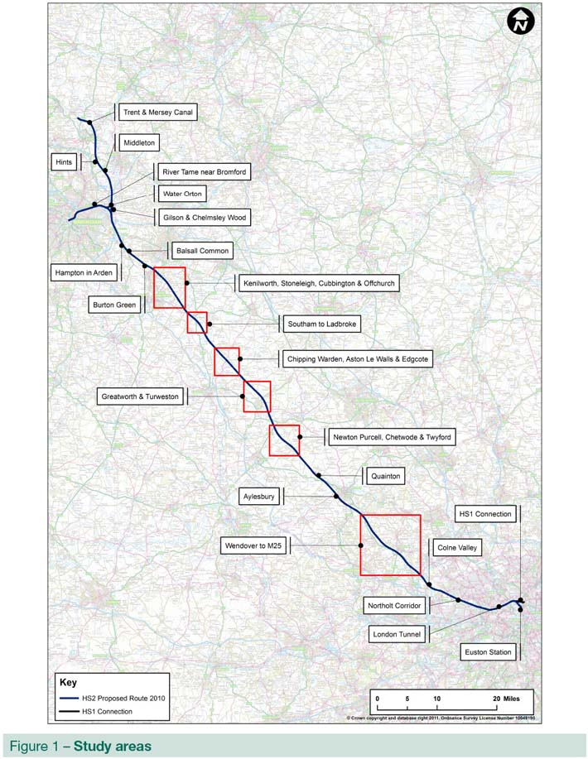

1.2.7 This is not the final opportunity to mitigate the route – that would finally be determined through ongoing engagement as part of the EIA and through the hybrid bill process in Parliament. We would expect preliminary design work and the EIA to drive further refinements and the development of further mitigation measures. Where the studies have not identified an enhanced alignment at this stage we would seek to develop localised packages of mitigation through the EIA phase.
A balanced approach to mitigation
Many consultation responses which raised concerns about the line of route included requests for additional mitigation, often for a tunnel or green tunnel, while some consultation responses highlighted concerns about spoil production.
Our approach to the environment has been to avoid impacts as far as practicable and, where this cannot be done, to seek to mitigate. Since we first reported our recommendations to Government in 2009 we have been working continually to enhance the route to avoid or mitigate impacts on communities and the environment. We have also been working to understand better the costs of constructing the route, in particular in relation to tunnelling, and mitigating its impacts.
In many places, this saw the line lowered into cutting which provides mitigation against noise, but additionally can also reduce visual and landscape impacts. A consequence of this, however, can potentially be increased generation of spoil, particularly from deep cuttings. Although spoil is very useful for local landscaping, over-production can require off-line disposal, which can be both expensive and disruptive to local communities.
We have therefore sought to develop a balanced approach to avoiding or mitigating impacts, taking each case on its own merits. This looks at likely costs and benefits, as well as other potential impacts on communities and environmental features, or the implications for disposal of spoil. Examples of this include:
• balancing the cost and benefits of constructing a deep cutting and removing significant quantities of spoil against that of creating a green tunnel, where the line in cutting is covered, providing an opportunity to re-use spoil locally; and
• balancing the costs and benefits of tunnelling against the impacts of a surface level route and the costs of mitigation.
In many cases, the proposed revisions we have developed reduce impacts and consequently the costs from their mitigation, resulting in both enhanced environmental performance and cost reductions compared to the consultation route.

1.3 Developing mitigation through Environmental Impact Assessment
1.3.1 The line of route presented at consultation indicated the horizontal and vertical alignment of the proposed new high speed line, including tunnels, cuttings, embankments and viaducts, and the proposed footprint of new stations and depots. It also included indicative representations of road realignments that would be required. The purpose of this was to enable a strategic assessment to be made of the likely costs and sustainability impacts of the new line to support consultation and Government decisions on high speed rail.
1.3.2 There remains a significant level of further design development to be undertaken before final decisions could be made on a proposal to take to hybrid bill. That would be undertaken through an EIA and would include gathering detailed datasets held by local authorities and other bodies and undertaking site investigations including land and wildlife surveys. This would allow detailed analysis of potential sustainability impacts and the development of appropriate mitigation.
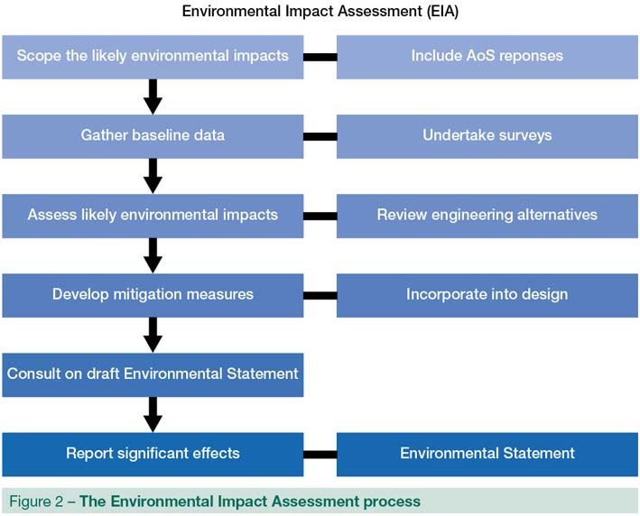

1.3.3 The Environmental Statement (ES) that would be prepared for deposit of the hybrid bill would include matters such as community and property, health and equality, landscape and visual impacts, biodiversity, surface water, ground water, archaeology, traffic and transport, waste and resources.
1.3.4 We would work with local authorities, communities and stakeholders to develop the design in a way which minimises potential impacts and to discuss the proposals for mitigation such as screening views of the railway, managing noise and reinstating highways and rights of way that would need to be diverted. We would also identify opportunities for community benefit.
1.3.5 As part of our engagement, we would set up an Environment Forum, Planning Forums and Community Forums.
• The Community Forums would enable local participation facilitating on-going discussions and building relationships, allowing us to identify local priorities and explore opportunities for further mitigation and local community benefits.
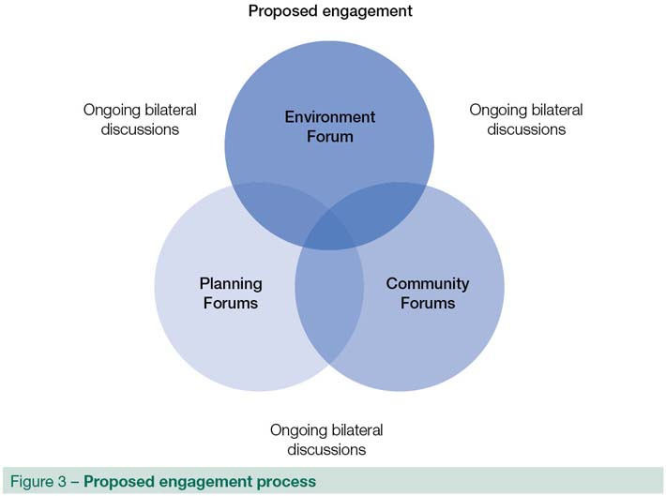

• The Planning Forums would be intended to facilitate discussion of design development, planning issues, environmental impacts and mitigation principles and would involve officers from local authorities and other transport and planning bodies.
• The Environment Forum would involve national representatives of environmental consultees and government departments. This group would assist the development of environmental policy for the next stage of development of HS2.

2 West Midlands
2.1 Trent and Mersey Canal and West Coast Main Line reconnection
2.1.1 It became clear through consultation that the height of the alignment over the Trent and Mersey Canal was not enough to allow proper navigability of the canal.
2.1.2 We have reviewed the vertical alignment over the canal and raised it to around five metres to enable navigable use of the canal. The adjustment would result in marginally more noise and visual impacts, although this change would affect only a small number of people. Landscaping and mitigation such as tree planting would assist in screening visual impacts of the embankments and railway. The change would also slightly improve flood management, providing marginal sustainability benefits.
2.1.3 The change would have no impact on journey times and only a marginal change in costs. Given that this adjustment is a requirement for canal navigability, we recommend that this change be included in the line of route.
2.1.4 To allow for a future extended network we have also slightly altered the line of route just north of Streethay, including a short straight section of track. This would avoid the need for substantial disruptive and expensive remodelling of the track in this area after HS2 London to West Midlands has opened. It would mean the alignment would be slightly amended from that shown on the consultation route over a distance of just over half a mile (around 1km), moving it laterally to the north east by around 100m to 150m at the greatest point. This would bring it closer to an industrial estate, affecting a small number of industrial buildings.
2.1.5 We have also amended the plan and profile drawings published during consultation for the West Coast Main Line (WCML) reconnection near Handsacre. While we have been clear that this would need to be a grade-separated junction, and this has been included in our costs, the drawings showed this junction being at grade. We will amend this in future drawings, however it does mean that the AoS may have marginally underestimated noise and visual impacts around the junction, although not such that it would alter our overall conclusions.
2.1.6 The adjustments would mean that the line would be continuously above ground level from the village of Streethay to the WCML reconnection north of Lichfield.
2.2 Hints
2.2.1 This area was the subject of considerable attention in developing the consultation route. In response to issues raised during consultation we looked again at the potential to mitigate impacts. We considered whether the line could be moved further away from Hints but found no means of making changes to the alignment in the area which offer any benefit overall in terms of impacts on people and the environment. Therefore we would not recommend any changes in this area at this stage. If a decision is taken to proceed with HS2 we would, however, consider options for landscaping in this area through future engagement with the local community as part of the EIA process.
2.2.2 We will present an enhanced alignment for the diversion of Rookery Lane, which was an issue raised during consultation, in publishing future maps. The revised road alignments presented in consultation maps were indicative only, and we would look in more detail at highway layouts with the relevant Highways Authorities in preparation for the EIA and hybrid bill if a decision is taken to proceed.
2.3 Middleton
2.3.1 Concerns were expressed during consultation about the route past the village of Middleton near Tamworth, including whether the route could be tunnelled to reduce impacts. The consultation route would pass around 200m east of Middleton at ground level, but as the land falls away to the south it would incorporate a 300m viaduct across the flood plain with a maximum height of 8.4m.
2.3.2 We do not consider that tunnelling would be appropriate in this area, and a green tunnel would not be practical, as the route would not be in a cutting and there would be little scope to cover the route. We have, however, developed a revised alignment that would move the route slightly to the east, passing approximately 50m further from the village, still at ground level. This would also enable a lower viaduct across the flood-plain, with a maximum height of 4.5m.
2.3.3 In terms of sustainability there would be a marginal preference for this revised route over the consultation route. It would result in a small reduction in noise impacts and demolitions including of a sewage treatment works. Longer viaducts would be required, making it more difficult to screen the railway (in noise and visual terms) using natural landscaping. Although the route would be slightly further from the Belfry golf course it would be closer to Aston Villa Football Club’s training ground on the opposite side of the road.
2.3.4 The change would have no impact on journey times and would result in a cost reduction of around £20 million to £30 million compared to the consultation route, primarily due to the lower viaduct.
2.3.5 We recommend including the revised alignment in the line of route.

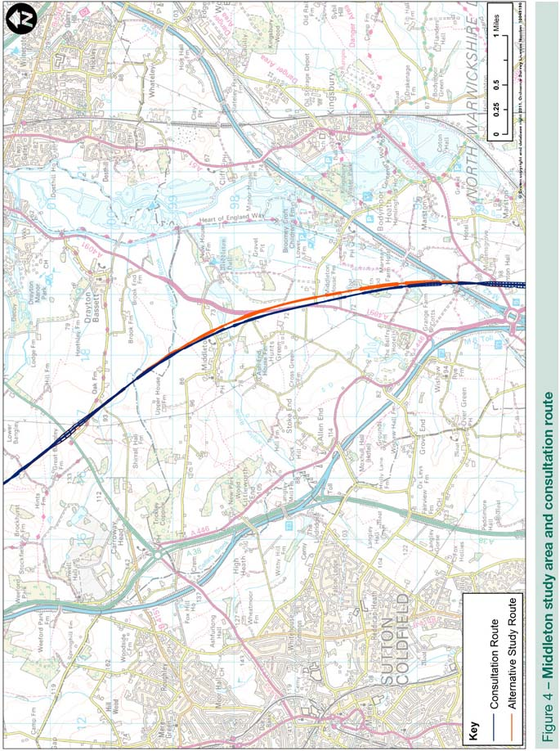
2.4 Water Orton and the West Midlands Delta Junction
2.4.1 Concerns were raised about the impacts of the West Midlands “Delta Junction”, the northern leg of which would pass close to the southern edge of Water Orton. The village is situated within a network of major transport infrastructure including the M6, M6 Toll and M42, and local roads and railway lines.
2.4.2 In response to issues raised during consultation, we investigated an alternative proposal which would move the northern leg of the junction around one mile (1.5km) further north to pass between the north of Water Orton and the village of Curdworth. This would be a substantial change in this area from the consultation route.
2.4.3 The change would result in numerous impacts on floodplains and river crossings and might require a river diversion. It is likely that there would be a marginal increase in the number of people (in a different section of the village) affected by noise. Elevated structures would also have an impact on the visual landscape and increase the sense of isolation for some people, although the area is already bounded by major motorway and rail infrastructure.
2.4.4 Overall this revision was considered to be worse in sustainability terms than the consultation route in this area and it would result in a cost increase of around £20 million to £30 million. We do not recommend including this revised alignment in the line of route. Instead, if a decision were taken to proceed with HS2 and the consultation route in this area, we would seek to develop a package of mitigation with the local community through the next stage of preliminary design and EIA.

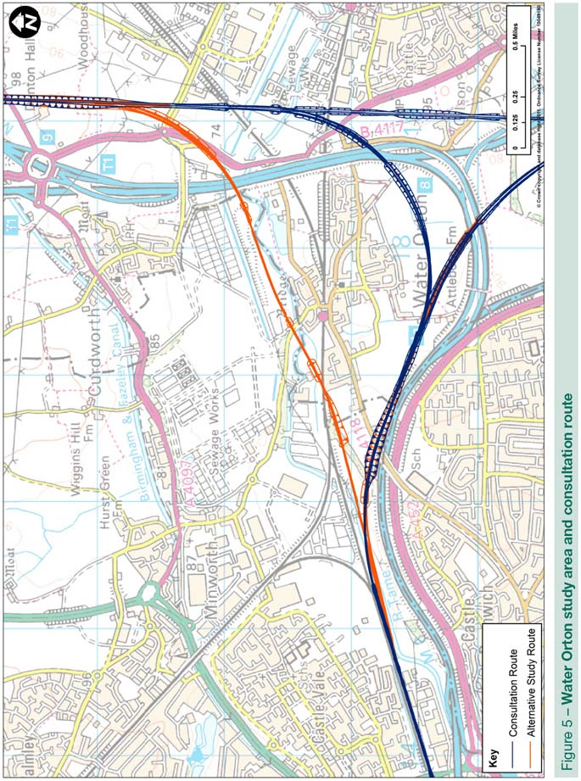
2.5 River Tame, Bromford
2.5.1 The spur from HS2 into Birmingham city centre would in part follow the M6 motorway, requiring the diversion of the River Tame (currently canalised beneath the motorway). Views were expressed during consultation that this could increase the risk of flooding around Bromford where flooding has been experienced in the past. The Environment Agency (EA) acknowledge there is an existing flood risk in this area and that, through the further design of HS2, there would be an opportunity to improve upon the current flood risk. The issue of flood risk in this location would be taken up through the EIA phase if a decision is taken to proceed.
2.6 Gilson and Chelmsley Wood
2.6.1 In response to concerns raised during consultation we considered options for green tunnels to reduce impacts on the communities of Gilson and Chelmsley Wood. In these areas the route passes over the existing motorway network, meaning that it would not be possible to achieve an alignment in cutting, making any green tunnel an expensive proposition and unlikely to be blended into the local landscape. While our assessment was that green tunnels could provide a degree of mitigation for a small number of properties in these areas, they would come at significant additional cost. We consider it would be more appropriate to develop a package of mitigation in these areas at EIA stage if a decision is taken to proceed.
2.7 Hampton-in-Arden
2.7.1 Concerns were raised with the diversion of Diddington Lane and Meriden Road on consultation maps. The revised road alignments presented on consultation maps were indicative only, and we would look in more detail at highway layouts with the relevant Highways Authorities in preparation for the EIA and hybrid bill if a decision is taken to proceed.
2.8 Balsall Common
2.8.1 Concern was expressed during consultation with impacts at Balsall Common and the historic Lavender Hall Farm, where the consultation route would pass over the WCML on a viaduct up to 10.2m high. We developed a revised option that would re-align the route up to 100m further east from Balsall Common, avoiding Lavender Hall Farm, with the maximum height of the viaduct reduced from 10.2m to 8.8m.
2.8.2 It would avoid demolition of two dwellings and one Grade II listed structure (a barn), and would slightly reduce the impacts on the setting of Lavender Hall Farm (Grade II*), and provide a marginal reduction in noise impacts at Balsall Common. However, a significantly longer viaduct would be required, making it more difficult to screen the railway (in noise and visual terms) using natural and hard landscaping.
2.8.3 Overall, the proposed refinement is marginally preferred in terms of sustainability and is estimated to cost around £10 million to £20 million more than the consultation route.
2.8.4 The case for this adjustment is very finely balanced. Although there is not a compelling case for recommending that this be included in the line of route at this stage, it would respond to views expressed during consultation. In any case we recommend that a package of mitigation should be developed through local engagement at the EIA stage if a decision is taken to proceed.

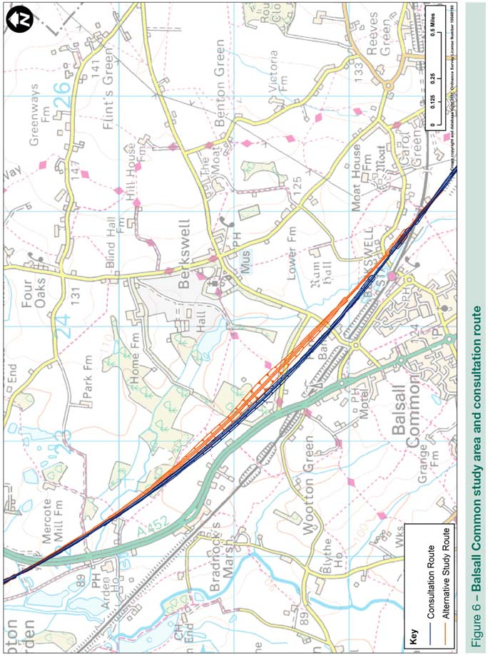
3 Warwickshire and Northamptonshire
3.1 Burton Green
3.1.1 Concerns were expressed about the impacts on Burton Green where the consultation route would follow the disused Berkswell to Kenilworth railway corridor into deep cutting, passing the village in a short section of green tunnel. Requests were made to lengthen the green tunnel to mitigate impacts on residential properties in the village and concerns were expressed about potential impacts on a local walking and cycling route along the disused Berkswell to Kenilworth line.
3.1.2 In reviewing the alignment through this area it became clear that we had lowered it more than necessary, creating a cutting of around 27m deep. Construction would lead to more local disruption and result in more spoil generation that would need to be re-used locally or removed from the site.
3.1.3 We have developed a proposal that would reduce the depth of the cutting to a maximum of 19m and increase the length of the green tunnel at Burton Green from 300m to 520m, taking it beyond residential properties in the village.
3.1.4 By extending the green tunnel northwards past the main residential area and grounds of the community hall this refinement would significantly reduce the impact of the scheme on Burton Green and its community facilities. Raising the alignment would reduce construction disruption and spoil generation whilst still reducing the impact of trains in the section of track in cutting.
3.1.5 Overall this option would perform better in terms of sustainability with moderate reductions in landscape and visual impact at Burton Green. The alignment change would result in a small decrease in the numbers of people who would experience a noticeable increase in noise and a reduction in the numbers who would experience the higher levels of noise that would qualify them for additional noise insulation. Largely due to the shallower cuttings and slightly higher embankment, the benefits obtained for Burton Green would be partially offset by marginal increases in noise elsewhere within the study area and within the vicinity of Broad Wells Wood. Through preliminary design we would seek to mitigate these impacts further. The proposed revision is preferred in terms of sustainability.
3.1.6 This would have no impact on journey times and, as a result of reducing the depth of the cutting, would result in a decrease in costs of around £20 million to £30 million compared to the consultation route. We would work with local stakeholders through the EIA to mitigate impacts on the walking and cycling route.
3.1.7 We recommend that this revision be included in the line of route.
3.2 Kenilworth, Stoneleigh, Cubbington and Offchurch
3.2.1 There was a range of issues raised in this area in consultation, including the impacts on Kenilworth Golf Club, the National Agricultural Centre at Stoneleigh, the village of Cubbington, South Cubbington ancient woodland and the Grade II listed Dalehouse Farm. The consultation route would also cut across a cycle route at Offchurch.
3.2.2 We have developed a revised alignment that would move the route around 100m further east to avoid Kenilworth Golf Club, and lower it into cutting through the National Agricultural Centre. The Grade II listed Dalehouse Farm would now no longer be directly impacted, but associated buildings would be demolished and there would be a significant effect on the setting of this building that would be difficult to mitigate. Should the project proceed, we would explore the potential for relocating this building during the preliminary design phase. It would, however, mean that the route would now run through other farm buildings, although it is likely that even the consultation route would have made these unviable.
3.2.3 To the south we have sought to minimise the impacts on South Cubbington Wood by reducing the depth of the cutting, removing the access track and incorporating a 1,250m long retaining wall to minimise the width of the railway through the woodland. This would also bring some benefits to Cubbington itself by reducing spoil generation, and local landscape and noise impacts.
3.2.4 Through Stoneleigh the proposed route refinement would slightly lower the railway, marginally reducing noise, landscape and visual effects, although this would marginally increase spoil creation. Overall, assuming the demolitions could be avoided, the proposed refinement is preferred in terms of sustainability. The route refinements and introduction of retaining walls at the cutting through South Cubbington Wood would reduce land take of the ancient woodland, though would still result in some fragmentation. It would be possible during preliminary design and EIA to investigate the possibility of saving any woodland soils so it could be used to provide new habitat and access opportunities to nearby adjacent land.
3.2.5 These revisions would have no impact on journey times and would result in an overall reduction in cost of around £10 million to £20 million compared to the consultation route.
3.2.6 We recommend that these changes be included in the line of route. The effect on the cycle route at Offchurch would be considered through EIA.
3.3 Southam to Ladbroke
3.3.1 The consultation route included a 0.6 mile (1km) bored tunnel beneath the hill at Long Itchington Wood. The tunnel would be approached from the south on an embankment up to 6.6m high leading into a cutting up to 30m deep as it approached the hill. It would pass very close to the office of Codemasters – an important local employer – and a polo ground.
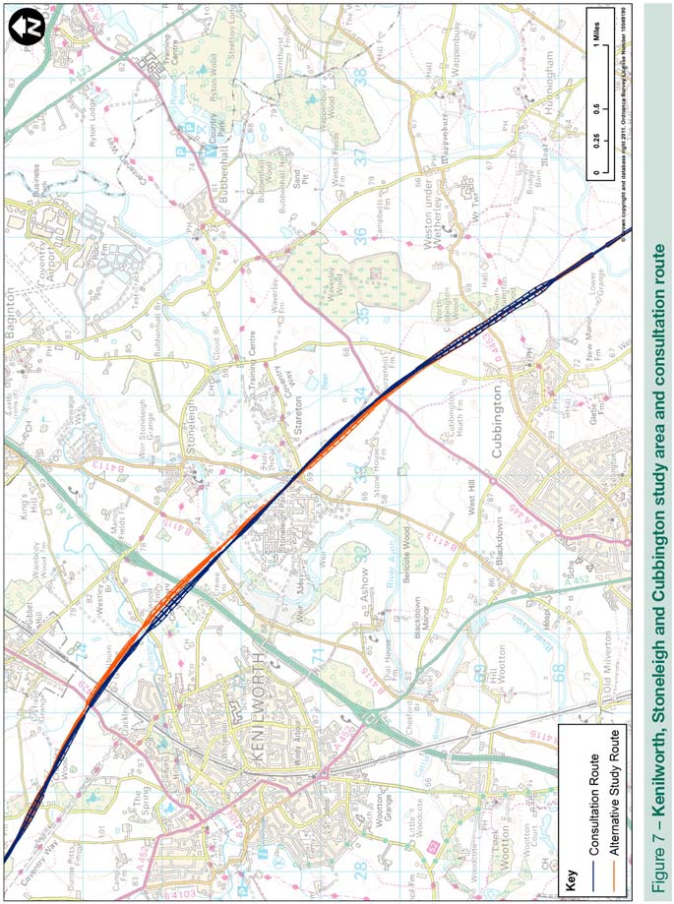

3.3.2 We have developed a revised alignment that would see the route moved slightly north-east with the bored tunnel extended to just under one mile (1.5km) exiting into a 400m green tunnel to the south. The southern approach to the tunnel would be along the consultation alignment but lowered, with the maximum height of the embankment reduced to 2.3m.
3.3.3 The proposed refinement would result in a slight north-easterly shift in the tunnel alignment and extend the length of bored tunnel southwards from the southern edge of Long Itchington and Ufton Woods Site of Special Scientific Interest (SSSI), replacing a large section of deep cutting. This would significantly reduce land take, severance, landscape and visual impacts in this area, and reduce spoil volume. There would be a marginal reduction in noise impacts. It would avoid any impact on the Codemasters site and, although the green tunnel would impact on the edge of the polo grounds during the construction period, overall it would be preferred in terms of sustainability.
3.3.4 This would have no impact on journey times and would result in reduced costs of around £130 million to £140 million compared to the consultation route. This is largely as a result of removing the long deep cutting.
3.3.5 The revised option would be preferable to the consultation route in environmental and engineering terms, and would significantly lower construction costs in this area. We recommend that this change be incorporated into the line of route.
3.4 Aston le Walls, Chipping Warden and Edgcote
3.4.1 Concerns were raised during consultation about the impacts on communities in this area where the consultation route would be in deep cutting and green tunnel past Chipping Warden and Aston le Walls.
3.4.2 Furthermore the route around Edgcote is of major concern for English Heritage, with the Grade I listed Edgcote House, the scheduled monument Roman Villa site and the approximate area of the Edgcote Moor battlefield which collectively form a cluster of heritage impacts. The consultation route would impact directly on both the battlefield and scheduled monument, and would have setting impacts on Edgcote House and its Park and Gardens.
3.4.3 We have developed an option that would see the route curve eastwards between Aston le Walls and Thorpe Mandeville to pass these features at Edgcote. This would see the route moved around 200m further from Chipping Warden. Past Chipping Warden itself we have extended the length of the green tunnel from 0.6 miles (1km) to 1.5 miles (2.5km). This would provide additional mitigation for Aston le Walls and enable the re-use of spoil in the area for mitigation purposes.
3.4.4 The revised route would avoid the site of the Roman Villa and the likely location of the battlefield, and push the alignment further away from Chipping Warden and Edgcote House Park and Garden. It would, however, put one Grade II listed building at risk of demolition.
3.4.5 The longer green tunnel, incorporating landscape and visual mitigation, would result in a moderate improvement requiring less additional landscaping. Given the already deep cuttings that would be replaced, the longer tunnel would not result in a substantial reduction in noise impacts. The total volume of spoil requiring off-line disposal would be reduced by reusing large volumes of cutting spoil to restore the surface over the top of the green tunnel, and the landscape is well suited to re-use of spoil locally. Overall, the revised alignment is strongly preferred in terms of sustainability.
3.4.6 The revision would have no impact on journey times and would see a reduction in costs of around £30 million to £40 million, primarily as a result of using green tunnel instead of deep cutting which reduces the need for expensive off-line spoil disposal.
3.4.7 We recommend that this revision is included in the line of route.

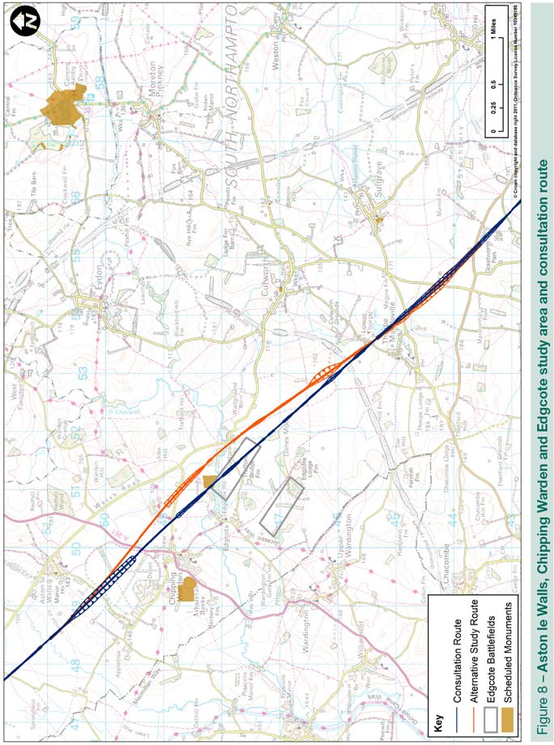
3.5 Greatworth and Turweston
3.5.1 The consultation route would pass Greatworth on an embankment up to six metres high, which would have noise and visual impacts on the village. It would also pass close to the village of Turweston in cutting.
3.5.2 We have looked again at the vertical alignment through this area and have developed a lower alignment including a 1.3 mile (2.1km) green tunnel past Greatworth village. This would remove the need for an embankment and provide an opportunity to reduce excess spoil near Greatworth from the route. We have also lowered the alignment and introduced a 150m section of green tunnel as the route passes Turweston.
3.5.3 The deeper cutting and green tunnel would help to reduce noise impacts for settlements, including Greatworth. It would significantly reduce visual impacts of the railway and increase opportunities for further landscaping to assist in minimising both noise and visual effects. By creating the 1.3 mile (2.1km) green tunnel the spoil generation would be less as soil could be landscaped back over the tunnel.
3.5.4 At Turweston the addition of a short green tunnel would be significantly more sustainable, reducing landscape and visual impacts as well as impacts on accessibility and the local community. Overall, the proposal would remove most impacts through this area and improve the sustainability of the route between these two areas.
3.5.5 The green tunnel at Greatworth would result in a reduction in costs of around £160 million to £170 million, while lowering the alignment and introducing a short green tunnel around Turweston would result in an increase in costs of around £20 million to £30 million compared to the consultation route. We recommend that these changes be included in the line of route.
3.6 Newton Purcell and Twyford
3.6.1 During consultation concern was expressed over the proximity of the route to Twyford where it enters Buckinghamshire and curves to follow the corridor of the disused Great Central Railway.
3.6.2 In response to this we applied a 7,000m reduced radius curve rather than the standard 8,200m radius curve past Twyford. This would enable an alternative alignment to be located up to 200m away from Twyford. It would then curve back towards Chetwode and rejoin the consultation route just north of Newton Purcell (Alternative Study Route 2 on Page 29).
3.6.3 This would assist in mitigating impacts on Twyford by making some land available between HS2 and the village that would allow for landscaped earthworks that would reduce noise and visual impacts. Specification of an exceptional curve in this area would result in a requirement for more intensive maintenance, which would be undertaken at night, but this needs to be balanced against the benefits of increased distance from Twyford. Whilst this refinement would cost around £10 million to £15 million more than the consultation route we recognise this location along the consultation route as being one of the more difficult places to mitigate and would recommend this change.
3.6.4 Further work was undertaken to investigate an alternative, straighter alignment that would pass 400m away from Twyford on an 800m viaduct to cross the adjacent flood plain. It would also pass 200m further from Newton Purcell, but would pass to the other side of the village of Chetwode and closer to Barton Hartshorn and Preston Bisset. It would require a slight change to the layout of the proposed Infrastructure Maintenance Depot at Calvert, but would remove the alignment from a viaduct, and therefore minimise impacts to the Calvert Jubilee Local Nature Reserve.
3.6.5 This route would perform better than the consultation route in terms of climatic factors and adaptability, principally because of the structure passing over the flood plain, and would result in moderately reduced impacts in terms of landscape and visual; soil and land resources; waste; and tranquillity. It would reduce the number of people who would experience a noticeable increase in noise levels by around 100 compared to the consultation route. It would, however, result in a small additional number of properties at risk of demolition. The revised route would be slightly shorter than the consultation route, although journey time benefits would be negligible. It would reduce costs by £30 million to £40 million compared to the consultation route.
3.6.6 This alignment would represent a substantial change, giving rise to impacts on communities and farmland that would otherwise have not been impacted by the consultation route. Whilst this alignment change offers some benefits we are not recommending it on the basis of those who would be newly affected and the potential for causing unnecessary blight within those communities.

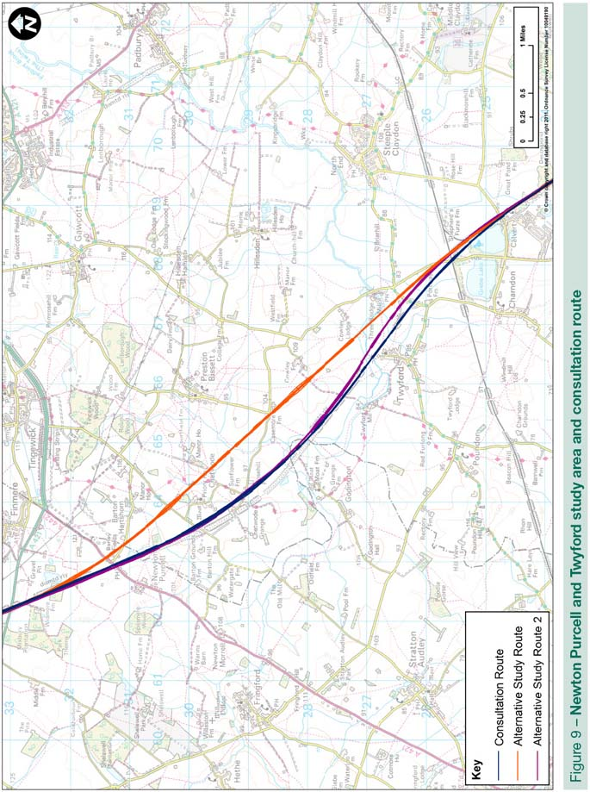
4 Buckinghamshire
4.1 Quainton
4.1.1 An issue was raised with the diversion of Station Road over HS2 at Quainton which, on the maps published alongside the consultation, would have cut across another local road. The revised road alignments presented on consultation maps were indicative only, and we would look in more detail at highway layouts with the relevant Highways Authorities and local authorities in preparation for the EIA and hybrid bill if a decision is taken to proceed.
4.2 Aylesbury and Stoke Mandeville
4.2.1 Heading south, the consultation route would pass Aylesbury and Stoke Mandeville at surface level. Concerns were raised about impacts to Hartwell House and associated grounds, and the impacts on local roads and railway lines, as well as local communities. At Hartwell House the consultation route sought to balance the impacts on the property and on the community of Aylesbury.
4.2.2 We have developed a revised alignment that would follow the consultation route past Aylesbury, although it would now be lowered in a cutting up to 6.5m deep, reducing impacts on Stoke Mandeville and Aylesbury. This would enable the Aylesbury to Princes Risborough railway to be reinstated over HS2 at around two metres above ground level, eliminating the requirement for larger scale works to local roads and the Chiltern Line.
4.2.3 In general, the lower alignment past Aylesbury and Stoke Mandeville would reduce noise impacts and allow the scheme to be better screened within the landscape. However, the more extensive cuttings would generate significantly more spoil; although some would be re-used locally for landscaping, some off-line disposal is also likely to be required. Overall this revision would not impact on journey times or construction cost.
4.2.4 We recommend that this revision is included in the line of route.
4.3 Wendover to the M25: The Chilterns AONB
4.3.1 Impacts on the Chilterns AONB and local communities received substantial comment during consultation. Some expressed the view that a different corridor be used to cross the AONB, while others expressed the view that additional mitigation, in particular tunnelling, should be used. The case for alternative corridors has been considered in the Review of HS2 London to West Midlands Route Selection and Speed, which concluded that the corridor of the consultation route was the most appropriate for HS2.
4.3.2 This section of the report deals with options for mitigating impacts of the consultation route through the Chilterns. Heading south, the consultation route would cross the AONB boundary at Nash Lee Road passing to the south-west of Wendover along the corridor of the A413 and the Chiltern Line. There would be a 300m section of green tunnel at Ellesborough Road, although it would require the road to be closed and a small number of dwellings to be demolished. Through Wendover Dean the route would be on a viaduct within the AONB and then from South Heath to Little Missenden it would be in green tunnel or deep cutting. It would then enter a short tunnel at Mantles Wood near Little Missenden, followed by a further section of deep cutting, before entering the long tunnel from Amersham to the M25.
Route revisions
4.3.3 We have developed a revised option that would further reduce impacts on the landscape and communities in and adjacent to the AONB while reducing overall construction costs.
Wendover
4.3.4 The revision would see the alignment run around 50m further to the south-west of Wendover, and be lowered in the landscape allowing the green tunnel at Ellesborough Road to be extended by around 800m to the north, taking it to more than three-quarters of a mile in length. That would ensure effective visual and noise screening alongside the main residential area of Wendover. The lowered alignment would allow existing road infrastructure to be reinstated, and avoid any permanent road diversion connecting Ellesborough Road with the A413 near Grove Farm.
Wendover Dean
4.3.5 Through Wendover Dean we considered a lowered option which placed the line on an embankment rather than a viaduct. However, this would come at considerable additional cost and would be unlikely to offer any overall benefits. We would seek to work closely with local representatives and the Chilterns Conservation Board on the design of the viaduct.
South Heath
4.3.6 The green tunnel past South Heath would be extended by 200m to the north, and between South Heath and Little Missenden the depth of the cutting would be reduced from about 15m to around nine metres deep. This would further reduce visual effects near South Heath, and reduce the amount of spoil needing to be excavated from the deep cutting and the overall footprint of the railway, while remaining deep enough to ensure similar performance in terms of noise impacts.

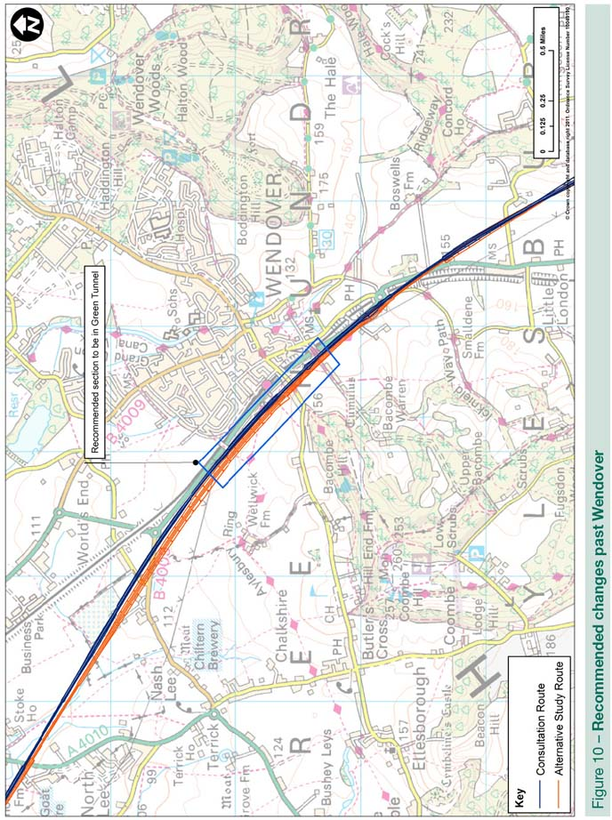
Chilterns Tunnels
4.3.7 Further investigation in response to consultation identified that the proposed tunnel from Amersham to the M25 would pass directly through an important aquifer. Whilst modern tunnel design can overcome many associated issues of construction within aquifers there would remain a risk to the drinking water supply during the construction phase. This revision would significantly re-align this tunnel below ground to avoid the aquifer, and merge the two tunnels in this section into a single longer tunnel, avoiding the need for a section of deep cutting to the north of Amersham.
4.3.8 The route would enter the tunnel at Mantles Wood, close to the location of the portal of the Little Missenden tunnel on the consultation route and emerge, as with the consultation route, inside the M25. The tunnel would pass underneath the River Misbourne, Shardeloes Registered Parks and Gardens and Chalfont St Giles. It would require the construction of up to six intervention shafts on the surface to provide ventilation and access in the event of an emergency. The exact locations for and the design of intervention shafts would form part of the next stage of design, should a decision be taken to proceed with this option.
4.3.9 The longer tunnel, and realignment below ground, would significantly reduce landscape and visual, cultural heritage, biodiversity and noise impacts, with moderate improvements in terms of accessibility and waste generation. In particular it would remove any impacts to the setting of the Grade I listed Shardeloes and its Registered Park and Garden. The tunnel realignment would help to reduce impacts on significant groundwater resources.
4.3.10 Although overall spoil would be reduced by avoiding the need for deep cuttings, the extended tunnel would result in significantly increased tunnel spoil which would need off-line disposal. It would also produce more embedded carbon emissions and moderately increase material consumption to construct.
4.3.11 With these revisions between Wendover and the M25, six miles (9.6km) of the route would be in tunnel and 1.5 miles (2.4km) in green tunnel. Of the open sections, three miles (4.8km) would be hidden in deep cutting, substantially reducing visual impacts, meaning that only 1.5 miles of the route would be visible. If it is decided to proceed with HS2 we would seek to mitigate visual impacts further by redistributing spoil away from cuttings to create landscaped earthworks to visually screen some surface sections of the route.
4.3.12 In total between Wendover and the M25 no properties would experience high levels of noise and fewer than ten would experience the higher noise levels that would qualify them for noise insulation. Around 110 properties would experience a noticeable increase in noise, compared to 300 for the consultation route. The number of residential properties that would need to be demolished would be 14. The route would impact on four ancient woodlands, one Grade II listed building and one scheduled monument (Grim’s Ditch). We consider this route revision to be a significant improvement from a sustainability perspective compared with the consultation route.
4.3.13 Journey time changes would be negligible. Overall this section would cost £1.86 billion to construct, around £250 million to £300 million less than the consultation route, largely due to eliminating the section of deep retained cutting, with associated spoil generation, between the two tunnels and avoiding unnecessarily deep cuttings north of the South Heath green tunnel. We recommend that this revision is included in the line of route.
4.3.14 We also considered a range of other options for more tunnelling through the Chilterns. However, we consider that the mitigation achieved on the route described above has avoided most impacts on communities and landscape in this area and additional landscaped earthworks and noise screening alongside surface sections of the route would substantially avoid the remaining impacts. The residual impact is therefore limited to a significant extent. Additional tunnelling would not achieve a significant improvement in sustainability and would come at a substantial increase in construction costs.

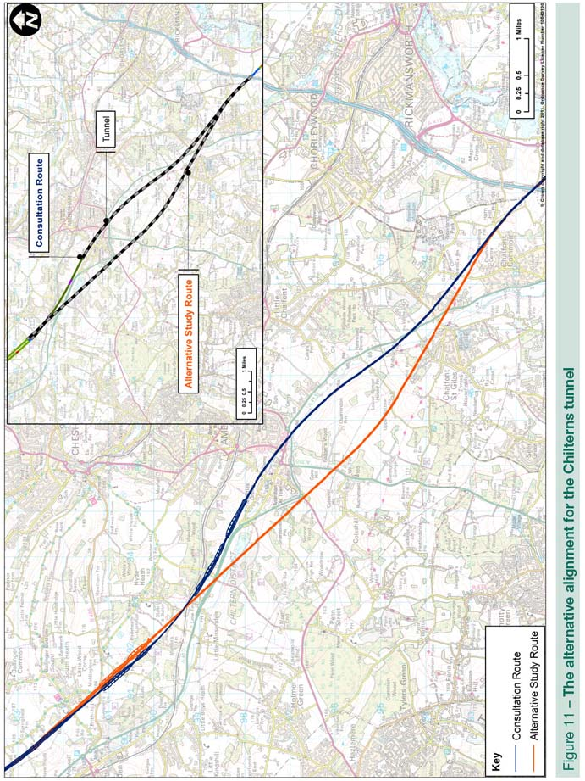

5 Greater London
5.1 Colne Valley
5.1.1 The Colne Valley viaduct and the impacts on the Hillingdon Outdoor Activity Centre (HOAC) over which the viaduct would pass attracted considerable comment during consultation.
5.1.2 We considered whether the viaduct could be realigned to reduce impacts on the lakes and the activity centre. We developed an alternative, more northerly, route that would align the viaduct around 50m further to the north-east of the HOAC’s buildings. This means that when crossing the lakes it would be around 100m closer to South Harefield and 100m further from Denham.
5.1.3 In sustainability terms, by passing more centrally through the Mid Colne Valley SSSI the revised route would moderately increase impacts to it and would also increase the visual impact of the railway on the valley, but at the same time would reduce impacts to fringing Biodiversity Action Plan (BAP) habitats. It would be unlikely to noticeably reduce noise impacts on any dwellings in the valley. It would require more extensive cuttings to the north of the valley, increasing potential impacts to groundwater and volume of generated spoil. It may also require one more demolition, although the potential for avoiding this could be investigated through further design. Overall, the route revision would be marginally less sustainable than the consultation route.
5.1.4 The revised alignment would result in an additional cost of around £45 million. On balance we do not recommend this revised alignment, but would carry out further work through EIA to mitigate impacts should a decision be taken to proceed with HS2.
5.2 Northolt Corridor
5.2.1 Between West Ruislip and Northolt Junction the consultation route would follow the Chiltern Line and the London Underground Central Line routes at surface level, running close to a significant number of properties and requiring some land to be taken from some of these. It would also require significant works to the existing road and rail infrastructure, causing disruption during the construction period.
5.2.2 Earlier studies considered an option for tunnelling in this area but this had not been included on grounds of high cost compared with the sustainability improvement it would offer. This attracted significant comment during consultation, including from the Mayor of London and the London Borough of Hillingdon.
5.2.3 We have looked again at a tunnelled option in this area, following the consultation alignment but entering a bored tunnel just before Ickenham High Road for about 2.75 miles (4.4 km), emerging just beyond Northolt Junction. This would remove all impacts at surface level along this stretch, other than for provision of an intervention shaft.
5.2.4 The majority of impacts of the consulted route along the Northolt corridor would relate to the increased intensity of train movements along the corridor; with some land take concentrated towards the western end of the corridor. By tunnelling part of this corridor, the noise effects of HS2 along that section of the corridor would be avoided.
5.2.5 Extensive cuttings would be required to transition between surface and tunnel sections. At the eastern end of the tunnel this would mean a small number of properties may need to be demolished, although these would already be at risk of land take from the consultation route. This needs to be balanced, however, against a much larger number of properties that would no longer be at risk of land take as a result of adopting a tunnel along this section of the route.
5.2.6 The adoption of HS2 noise barriers along the existing railway corridor, as proposed in the consultation route, would reduce both HS2 noise and noise from passenger and freight trains operating on existing lines along this corridor. If the revised alignment in tunnel were adopted, this potential for reducing wider rail noise would not exist. Nevertheless, HS2 trains would now be removed from this section of the corridor entirely meaning that around 400 fewer properties would experience a noticeable noise increase compared to the consultation route, and importantly around 60 fewer would experience the higher noise levels that would qualify them for noise insulation.
5.2.7 Tunnelling and associated cutting in this area would result in higher volumes of spoil. There would be limited opportunity for the re-use of spoil locally for landscaping, it is likely that some (including all of the tunnel spoil) would require off-line disposal.
5.2.8 When we considered a tunnelled option in 2010 we estimated that it would cost significantly more than a surface route. We have looked closely at this again, in particular the extensive remodelling of Northolt Junction that a surface route would require. Our study indicates that we previously underestimated the challenges this would present, making it both expensive and disruptive to the Chiltern Line and the West London Waste Transfer Site. Tunnelling would avoid this and the associated high compensation costs. Our study indicates that the additional cost of a tunnelled route in this area would be around £40 million to £50 million, much smaller than previously estimated.
5.2.9 We recommend that this tunnel be included in the line of route.

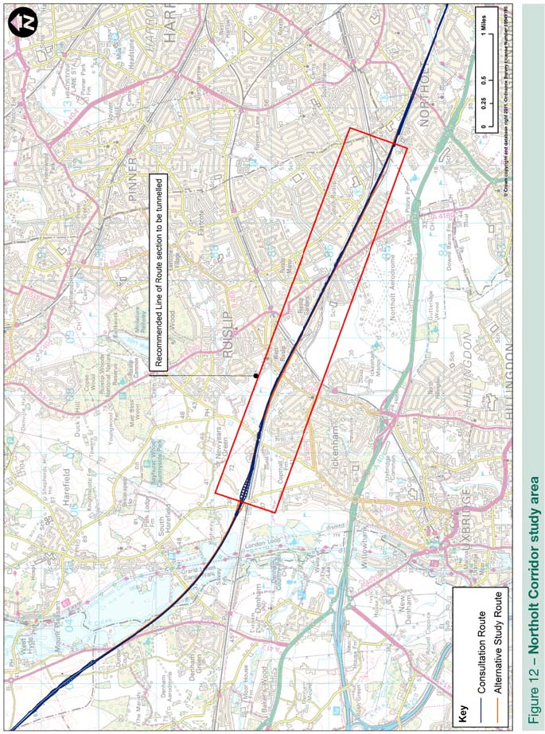
5.3 London Tunnel
5.3.1 A number of consultation responses requested that we look at whether the tunnel between Old Oak Common and Euston could be realigned to run beneath the existing WCML to avoid perceived risks of settlement or vibration effects on properties over the tunnel.
5.3.2 The tunnel would be generally 30m to 50m deep, track and tunnel design would be similar to HS1 tunnels and trains would be moving at conventional rail speeds. As a result vibration effects would be imperceptible. That said, we did look at changing the tunnel alignment to pass closer to, and in most cases below, the WCML. This would make the radius of the curve sharper which would result in a small increase in journey times. The existing WCML tunnels are old structures and constructing additional bored tunnels in proximity to these would increase the risk of impacts on these tunnels.
5.3.3 Given this, and that impacts on properties over the tunnel would be imperceptible, we do not recommend revising the alignment of the tunnel. All properties over tunnels would, however, be independently surveyed before and after construction to reassure residents and confirm that the tunnel has not caused any problems for the property.
5.3.4 An issue was raised with the proposed location of the intervention shaft at Salusbury Road on an area of land proposed for development. As the tunnel would run beneath a densely developed area of London, land available for a shaft is limited but we have considered whether an alternative site could be found at Coventry Close. It would be a suitable distance from the middle shaft at Alexandra Place West but would be just over 2 miles (3.5km) to the tunnel portal at Old Oak Common. If it were selected, it is very likely an additional shaft would be required between there and the tunnel portal at Old Oak Common. As there are no brownfield areas of land between Coventry Close and Old Oak Common, providing an additional shaft would require either demolition of houses or a community centre and sports pitch. It would also cost in the order of £10 million. We remain of the view that Salusbury Road is the most appropriate location for the shaft, but we would work with the London Borough of Brent to identify whether any additional development could take place on the site.
5.4 HS2 – HS1 Link
5.4.1 The consultation route includes a link from HS2 to HS1 in tunnel from Old Oak Common to emerge at Camden Junction and along an upgraded section of the North London Line to an existing link to HS1 just north of St Pancras. A significant number of consultation responses expressed concern about the impact of the connection on the operation of the North London Line.
5.4.2 We have been working with Network Rail and TfL to understand what modifications might be needed to the North London Line in this area. That work has identified a number of potential options that would ensure that existing North London Line services were not impacted, and we have factored this into our cost estimates for the link. If a decision is taken to proceed with HS2 we would continue to develop these and recommend a solution to be incorporated into our plans for the hybrid bill.
5.5 Euston station
5.5.1 The consultation proposal for Euston station requires demolition of a number of existing properties on the western side. The Royal College of General Practitioners (RCGP) are relocating their head office to two buildings on the corner of Euston Road and Melton Street. These were originally cited as Grade II and Grade II*. Discussion with the RCGP has made clear that the two separate buildings are in fact a single property and the listing status has subsequently been updated to Grade II* for the entire site, meaning that our current plans would now require the demolition of a Grade II* listed building.
5.5.2 We recognise that Euston would be one of the most complicated areas of HS2 to construct. We would need to investigate further the implications of constructing the station for properties in the area, including the RCGP and the significant number of dwellings around the station through preliminary design and EIA. We do not believe that this would change our overall view that an enlarged station at Euston is the most appropriate location for the London Terminus.

6 References
Booz & Co (UK) Ltd and Temple Group Ltd, 2011, HS2 London to the West Midlands Appraisal of Sustainability Appendix 5 – AoS Technical Reports, http://highspeedrail.dft.gov.uk/library/documents/appraisal-sustainability
Dialogue by Design, 2011, High Speed Rail: Investing in Britain’s Future Consultation Summary Report, a report for the Department for Transport
HS2 Ltd, 2011, Review of the Technical Specification for High Speed Rail in the UK, a report for the Department for Transport
HS2 Ltd, 2011, Review of HS2 London to West Midlands Appraisal of Sustainability, a report for the Department for Transport
HS2 Ltd, 2011, Review of HS2 London to West Midlands Route Selection and Speed, a report for the Department for Transport

See Review of the Technical Specification for High Speed Rail in the UK, Review of HS2 London to West Midlands Appraisal of Sustainability, and Review of HS2 London to West Midlands Route Selection and Speed.
Dialogue by Design, 2011, High Speed Rail: Investing in Britain’s Future Consultation Summary Report
See Booz & Co (UK) Ltd and Temple Group Ltd, 2011, HS2 London to the West Midlands Appraisal of Sustainability Appendix 5 – AoS Technical Reports, http://highspeedrail.dft.gov.uk/library/documents/appraisal-sustainability

