Review of HS2
London to West
Midlands Route
Selection
and Speed
A report to Government by HS2 Ltd
January 2012

Although this report was commissioned by the Department for Transport (DfT), the findings and recommendations are those of the authors and do not necessarily represent the views of the DfT. The information or guidance in this document (including third party information, products and services), is provided by DfT on an ‘as is’ basis, without any representation or endorsement made and without warranty of any kind whether express or implied.
The Department for Transport has actively considered the needs of blind and partially sighted people in accessing this document. The text will be made available in full on the Department’s website. The text may be freely downloaded and translated by individuals or organisations for conversion into other accessible formats. If you have other needs in this regard please contact the Department.
Department for Transport Great Minster House 33 Horseferry Road London SW1P 4DR Telephone 0300 330 3000 Website www.dft.gov.uk General email enquiries FAX9643@dft.gsi.gov.uk
© Crown copyright, 2012, except where otherwise stated
Copyright in the typographical arrangement rests with the Crown.
You may re-use this information (not including logos or third-party material) free of charge in any format or medium, under the terms of the Open Government Licence. To view this licence, visit www.nationalarchives.gov.uk/doc/open-government-licence/ or write to the Information Policy Team, The National Archives, Kew, London TW9 4DU, or e-mail: psi@nationalarchives.gsi.gov.uk.
Where we have identified any third-party copyright information you will need to obtain permission from the copyright holders concerned.
Contents
List of acronyms 5
Executive summary 6
1 Introduction 8
1.1 Background 8
1.2 This report 9
Part 1
2 Route selection process 10
Part 2
3 Alternative route corridors 12
3.1 Background 12
3.2 Chiltern Line and M40 alignment (Route 2) at a lower design speed 24
3.3 M1 alignment (Route 5) at a lower design speed 28
3.4 An alternative route corridor – directly serving Heathrow 31
4 Higher or lower design speed on the consultation route 36
4.1 Background 36
4.2 Higher design speed 36
4.3 Consultation route at a lower design speed 36
4.4 Consultation route at a conventional speed 53
Part 3
5 Alternative stations 55
5.1 Background 55
5.2 London Terminus Station – Euston 55
5.3 London Interchange Station – Old Oak Common 57
5.4 Birmingham Interchange Station 58
5.5 Birmingham Terminus Station – Curzon Street 58

6 Intermediate stations 59
7 Additional connections from the classic network to HS2 60
7.1 Background 60
7.2 Connections from lines that cross the London to West Midlands section 60
7.3 Connections to other lines from the London to West Midlands
section – the Midland Main Line 62
7.4 Linking Crossrail and the West Coast Main Line 63
8 Infrastructure Maintenance Depot 66
8.1 Background 66
8.2 Investigation of a new, alternative location 66
9 References 69

List of acronyms
AONB Area of Outstanding Natural Beauty
BCR Benefit Cost Ratio
ECML East Coast Main Line
EIA Environmental Impact Assessment
GWML Great Western Main Line
HS1 High Speed 1
IMD Infrastructure Maintenance Depot
kph Kilometres per hour
MML Midland Main Line
mph Miles per hour
SAC Special Area of Conservation
SAM Scheduled Ancient Monument
SPZ Source Protection Zone
SSSI Site of Special Scientific Interest
WCML West Coast Main Line

Executive summary
1 This is HS2 Ltd’s advice to Government which examines, following consultation, the route selection process we adopted leading to identification of the consultation route for the first phase of HS2 between London and the West Midlands.
2 It examines a number of components of the scheme such as station choice, the case for intermediate stations, options for connecting to Heathrow and the location of an infrastructure maintenance depot.
3 It also examines the view expressed during consultation that, by more closely following existing transport corridors, or adopting a lower design speed on the consultation route, the impacts between London and the West Midlands, in particular environmental impacts, could be reduced.
4 This report considers the case for alternative corridors. Comparisons are made with the consultation route. However, in addition to this advice we have recommended a number of revisions to the consultation route that would further reduce sustainability impacts and construction costs.
Route selection process
5 We consider that the route selection process we adopted was robust and appropriate for the purposes of selecting a route for consultation, taking into account our remit from Government and a need to minimise the corridor of blight on people and property.
Line of route and speed
6 We conclude that routes following, to a greater extent, existing transport corridors would have a substantial impact on many, often populous, communities. Extensive and complicated engineering and mitigation would be required to reduce these impacts, leading to higher costs. In some aspects these routes reduce impacts on the Chilterns Area of Outstanding Natural Beauty (AONB) and other countryside and landscapes compared to the consultation route. However, the recommended revisions to the consultation route further reduce these impacts and the construction cost of the consultation route. Overall, the consultation route corridor provides the best balance between considerations of benefits, costs and impacts.
7 Every alternative corridor considered would increase the costs and reduce the economic benefits of HS2, and none of them would result in significantly reduced impacts on the environment.
8 The only environmental improvements delivered by a lower maximum design speed would be a marginal reduction in noise impacts, which would be outweighed by a substantial reduction in economic benefits. We consider that mitigation of the consultation route, the approach we have taken, is a more appropriate way of reducing environmental impacts, particularly noise. This would also be the case for a line designed at a conventional speed. Adopting a lower business value of time would not alter our conclusions.
Stations
9 Following further examination we consider there is no reason to change our recommended stations as the consultation proposal of four stations, and their locations, would deliver the best balance between capacity of the line and benefits to passengers. In particular we confirm the opportunity for enhanced connectivity in London created by a station at Old Oak Common, which would be chosen by about a third of HS2 passengers thereby aiding passenger dispersal, and the case for a central London terminus at Euston.
10 The benefits of providing intermediate stations on the London to West Midlands route would be outweighed by their impact on capacity of HS2 and the wider network.
Connections with the classic network
11 There are a number of possible connections from the classic rail network to HS2 between London and the West Midlands, but we do not consider there is a case for providing these. We do not consider it is feasible to include a connection from the Midland Main Line (MML) to HS2 in phase one without significantly delaying the timetable.
12 There could be a case for providing a direct link for suburban trains between the West Coast Main Line (WCML) and Crossrail, although we consider that this should not alter the designs for Euston, and that if it were to be pursued it should be built after phase one of HS2.
Heathrow
13 Having reviewed the evidence we confirm our view that, given the expected passenger demand, Heathrow is best served by a spur from HS2 to a station integrated with existing airport passenger facilities at Terminal 5, as opposed to a station near to Heathrow as part of an HS2 through route.
Infrastructure Maintenance Depot
14 Having developed additional options in response to suggestions at consultation, we consider that the Infrastructure Maintenance Depot (IMD) is best located near Calvert as shown on the consultation route.

1 Introduction
1.1 Background
1.1.1 This is HS2 Ltd’s advice to Government which, in light of responses to the High Speed Rail: Investing in Britain’s Future consultation, covers:
• the route selection process;
• the case for following existing transport corridors;
• the maximum design speed of the route;
• alternatives for serving Heathrow;
• the case for alternative stations;
• the case for intermediate stations;
• the case for additional connections from the classic network to HS2;
• the case for a connection from the WCML to Crossrail; and
• the location of the IMD.
1.1.2 It presents the position at the time of the consultation, the comments that were received, and our consideration of them.
1.1.3 The consultation was launched on 28th February 2011 with a closing date for responses of 29th July 2011. It covered both the Government’s strategy for high speed rail, and the line of route for phase one from London to the West Midlands.
1.1.4 The consultation asked seven questions:
• Do you agree that there is a strong case for enhancing the capacity and performance of Britain’s inter-city rail network to support economic growth over the coming decades?
• Do you agree that a national high speed rail network from London to Birmingham, Leeds and Manchester (the Y network) would provide the best value for money solution (best balance of costs and benefits) for enhancing rail capacity and performance?
• Do you agree with the Government’s proposals for a phased roll-out of a national high speed rail network, and for links to Heathrow Airport and to the High Speed 1 line to the Channel Tunnel?
• Do you agree with the principles and specification used by HS2 Ltd to underpin its proposals for new high speed rail lines and the route selection process that HS2 Ltd undertook?
• Do you agree that the Government’s proposed route, including the approach proposed for mitigating its impacts, is the best option for a new high speed line between London and the West Midlands?
• Do you wish to comment on the Appraisal of Sustainability of the Government’s proposed route between London and the West Midlands that has been published to inform this consultation?
• Do you agree with the options set out to assist those whose properties lose a significant amount of value as a result of any new high speed line?
1.1.5 Almost 55,000 consultation responses were submitted. These were analysed by an independent response analysis company. Their report provides a summary of the responses received.
1.2 This report
1.2.1 We initiated a number of workstreams to examine in more detail the evidence presented during consultation. Some of these built on work we had previously undertaken in developing our proposals, while other work was new and a direct result of consultation responses.
1.2.2 Issues covering potential changes to the consulted route, reviews of the technical specification for HS2 and the Appraisal of Sustainability, and an update to the Economic Case are covered in other reports produced by HS2 Ltd.
1.2.3 Consultation comments regarding the consultation route raised two main issues:
• that a route following other transport corridors was passed over in favour of one which was more direct between London and Birmingham; and
• that the route proposed was designed at too high a speed.
1.2.4 Many responses to consultation expressed the view that this prioritised speed over environmental impacts and led to alternatives with lower environmental impacts being discounted.
1.2.5 These comments have been addressed by re-examining our original work from 2009, as well as developing detailed route options that more closely follow transport corridors at a lower speed, to enable a comparison with the consultation route.
1.2.6 We have re-examined the consultation route to investigate whether a lower design speed would allow an alignment that would have reduced environmental impacts. We have also considered the effects of reducing the line speed of the entire consultation route down to that of the classic network.
1.2.7 In our other advice, we have recommended a number of revisions to the consultation route that offer significant sustainability improvements by reducing noise and visual impacts along the route and lowering construction costs, without reducing the design speed.
1.2.8 Comments were also received on the route selection process, the stations that form part of the consultation proposal, the provision of alternative stations, the proposed approach to serving Heathrow Airport, additional connections to the existing network and the location of the IMD.

Part 1 – Route selection
2 Route selection process
2.1.1 The consultation documents described the route selection process we adopted in selecting and designing the consultation route. Using a three stage process, an initial long list of options covering stations and route sections was gradually reduced. A number of criteria were adopted during each stage, including cost and engineering feasibility, demand and environmental impacts. The level of information available about the options increased at each stage.

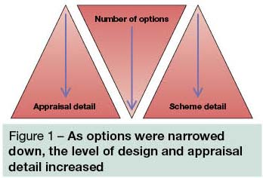
2.1.2 As a result of this process, we identified a single recommended route, referred to as Route 3, together with a number of main alternatives that followed different corridors but served all four stations and with the same maximum design speed.
2.1.3 Comments during consultation generally focussed on particular elements of the route selection process, namely that the process should have been more open and transparent, that greater prominence should have been given to environmental issues, and was limited by means of our remit and adopted technical specifications. The process as a whole, or our application of the process in selecting the route, attracted less comment.
2.1.4 An important consideration for the route selection process was avoiding unnecessary perceived property blight.
2.1.5 The experience from the early design development of High Speed 1 (HS1) showed that providing information on a variety of routes and corridors during development would lead to unnecessary blight. We followed a process that sought to minimise the risk of blight whilst working with local partners to ensure that our work was properly informed.
2.1.6 Having reconsidered our route selection process in light of the comments during consultation, we still believe it to be robust and appropriate for the purpose of designing a high speed rail route ready for public consultation, to meet our remit and minimise blight.
2.1.7 Some detailed refinements to the line of route have been extensively investigated in response to issues raised during consultation. These refinements are covered in our other advice and have been made in response to public participation.
2.1.8 The refinements are local in scope and would not undermine our confidence in the route selection process we undertook. Rather, they were in direct response to suggestions put forward during consultation by both individuals and representative groups.
2.1.9 We conclude that the route selection process used was robust and appropriate for this stage of the project.

Part 2 – The route between London and the West Midlands
3 Alternative route corridors
3.1 Background
3.1.1 The consultation route follows existing and disused transport corridors in part, for example along the Northolt corridor in London following the London Underground Central Line and the Chiltern Line, the A413 near Wendover, part of the former Great Central Railway, and the M6 and M42 corridors near Birmingham. Comments received during consultation argued that making greater use of other, existing transport corridors would minimise environmental impacts, in particular by following motorways between London and Birmingham.
Our design approach
3.1.2 In designing the consultation route, we took into consideration the four sustainability principles as set out in the 2005 UK sustainable development strategy Securing the Future. These principles are:
• reducing greenhouse gas emissions and combating climate change;
• natural resource protection and environmental enhancement (adapted by us to include the cultural as well as natural environment);
• creating sustainable communities; and
• sustainable consumption and production.
3.1.3 Following these four principles, we sought to, for example:
• avoid or, where this was not practicable, to mitigate direct or indirect harm to communities, the landscape, water and ecological resources and to maximise opportunities to enhance such features where possible; and
• avoid or, where this was not practicable, to mitigate direct or indirect harm to historic cultural resources and to maximise opportunities to enhance such features where possible.
3.1.4 Our general approach to route design is represented diagrammatically in Figure 2.

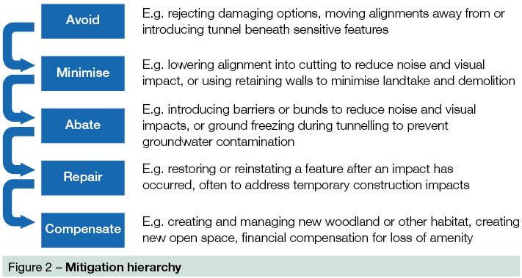
3.1.5 This hierarchy is widely accepted and used, and has assisted the development of a route for HS2 with an emphasis on avoiding impacts in the first instance, and minimising or mitigating those that cannot be avoided. Residual impacts would be dealt with through repair or compensation, with options investigated through further design and local engagement at the next stage, should proposals for a high speed rail line be pursued by Government.
3.1.6 Areas where people live were of particular concern in determining the route. Urban areas contain concentrated populations who would be at risk of unacceptable impacts, such as large scale demolition and noise impacts, which could only be avoided by following an existing transport corridor where space allowed, or by extensive tunnelling at significant cost. The consultation route through London and Birmingham is either along existing transport corridors or is in tunnel to minimise impacts on such communities.
3.1.7 An alternative route following, for example, the M40 corridor would encounter major population centres such as Gerrard’s Cross, Beaconsfield, High Wycombe and Princes Risborough and then on past Bicester, Banbury and Warwick. Such a route would incur either significant impact upon these communities or require extensive tunnelling at prohibitive cost to mitigate.
3.1.8 Through rural sections of the route we have endeavoured to keep the route low within the landscape, screening its visibility and reducing noise, and away from local towns and villages wherever practicable. This establishes a balance between avoiding impacts upon people and maintaining an effective high speed railway.
3.1.9 Particular consideration was given to the crossing of the Chilterns AONB. All transport and natural corridors between or across this landscape from the M40 corridor in the west to the MML corridor in the east were considered as potential routes.
3.1.10 These options present different challenges that affect environmental impact, mitigation, railway performance and cost.
3.1.11 We have re-examined our earlier work and undertaken new work to test whether alternative routes using M40 or M1 corridors, as put forward during consultation, would offer better environmental performance than the consultation route. We also considered the relative railway performance and cost of these alternatives.
Our work in 2009
3.1.12 Wherever practicable we examined routes following existing transport corridors. We indentified and appraised six main corridors through the Chilterns.
3.1.13 M40 corridor (this formed part of Route 1) – The M40 passes through comparatively hilly terrain, and would require much of the route to be in tunnel or viaduct. Given the geometry of the M40, little of the route would have been sufficiently close to the motorway to be described as within its corridor. This formed a route that was not pursued because it was found to perform least well in comparison with the other options, with major adverse impacts on landscape, biodiversity and water resources. It would have passed at surface across approximately nine miles of the Chilterns AONB, as well as passing close to the Cotswolds AONB for around five and a half miles. The route considered, whilst having some limited stretches theoretically capable of 250mph (400kph), was largely designed to lower speeds to achieve a balance between impacts and benefits.
3.1.14 Chiltern Line corridor via High Wycombe (this formed part of Route 2) – We tested a surface alignment in this corridor, and concluded it was not viable as it would require a large number of residential and commercial property demolitions, and many properties would be affected by the additional noise resulting from a combined conventional and high speed rail service. Adopting a tunnelled option for this corridor would introduce significant additional cost and direct the route on the surface through the AONB past Bradenham towards Princes Risborough.
3.1.15 WCML corridor (this formed part of Route 4) – This corridor provided a shorter route across the AONB but would need to be served by a 17 mile long tunnel from London which would be prohibitively expensive. The nature of a long tunnel carries with it certain requirements, for example ventilation shafts at regular intervals and additional arrangements for safe, emergency evacuation. Such a route would mean a substantially longer connection to Heathrow, further increasing costs.
3.1.16 M1 corridor (this formed part of Route 5) – This corridor provided a more northerly and therefore less direct route between London and the West Midlands. Variants of it would travel through significantly built up areas, particularly around Luton, Milton Keynes and Northampton, resulting in a longer route and large numbers of property demolitions, or mitigation in the form of extensive tunnelling. Conversely, avoiding these areas would have led to the route no longer following the motorway corridor. A corridor close to Hemel Hempstead was considered but not pursued given that it would cross a greater length of the AONB than the more favourable WCML option.
3.1.17 MML corridor (this formed part of Route 6) – This corridor required a very long tunnel from London before continuing through Luton and Bedford, and provided the most northerly and therefore least direct route option between London and Birmingham. Impacts on properties were considered to be significant, along with noise and severance impacts on a series of heavily populated towns and villages. This option was not pursued.
3.1.18 A413 arterial valley (this formed part of Route 3) – This corridor followed a long, broad valley across the Chilterns between the Chalfonts and Wendover that would, through a combination of surface and tunnel sections, provide a route that was economical and performed well as a high speed railway. This corridor crossed a greater length of the AONB but did so largely in either tunnel or cutting. Few properties would be directly affected by the route or receive operational noise due to tunnelling and positioning to avoid settlements. This option performed well and was taken forward in the consultation route option.
3.1.19 We also considered a hybrid corridor, combining elements of the Chiltern Line corridor and the A413 corridor (this formed part of Route 2.5). This option was found to be slightly inferior overall to the A413 corridor option, with key sustainability impacts including noise, increased spoil disposal from longer tunnelled sections of route, and community impacts through required land take and potential demolitions. It also involved crossing several miles of AONB, including the Hughenden Valley on a substantial viaduct, on the surface in an area remote from any existing transport corridor.
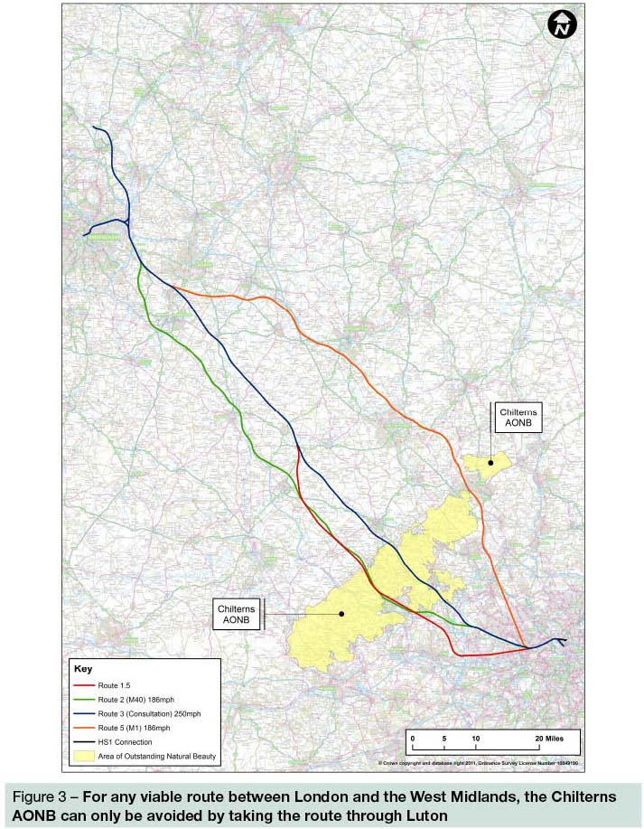
Our work responding to consultation
3.1.20 In line with consultation responses and the Transport Select Committee’s recommendations, we have examined the case for a lower design speed. The principal aim of the work undertaken was to establish a route aligning more closely to existing motorways. We have developed alignments for two corridor options, including an alignment along the Chiltern Line and M40 corridor (similar to the Route 2 corridor described at consultation), and an alignment along the M1 corridor (similar to the Route 5 corridor described at consultation). Both have the same maximum line speed as HS1 which is 186mph (300kph).
3.1.21 This has enabled us to examine the impacts a high speed rail route with a lower maximum design speed would have, and in particular whether it offers enough flexibility to avoid or minimise sustainability impacts. In response to consultation comments we have re-examined the case for a direct route through a Heathrow Airport station, described during consultation as Route 1.5. It should be noted that such a station would be some distance from any of the Heathrow terminals.
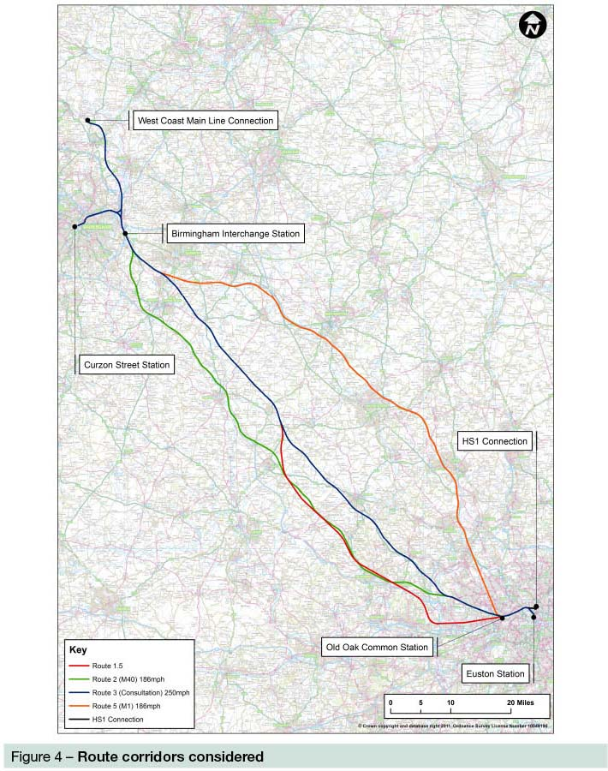
3.1.22 We have also reviewed the consultation route, looking at speed reductions in certain areas to either 225mph (360kph) or 186mph, as well as examining the impacts of running at a conventional speed of 125mph (200kph). This work is covered in the next chapter.
Transport corridor comparison: HS2 and HS1
Neither the M1 nor the M40 follow the most direct route from London to the West Midlands. Given this, they make any rail route following them longer both in terms of distance and journey time. As they serve other major towns and cities along the way, any route following these transport corridors would impact on populations and the existing infrastructure such as motorway junctions which would need to be avoided or mitigated. This would lead to higher costs. The major transport corridors between London and Birmingham also differ significantly from those between London and Folkestone, namely the M20, along which HS1 travels. It passes by fewer large population centres and takes a more direct route from London to its intended destination.

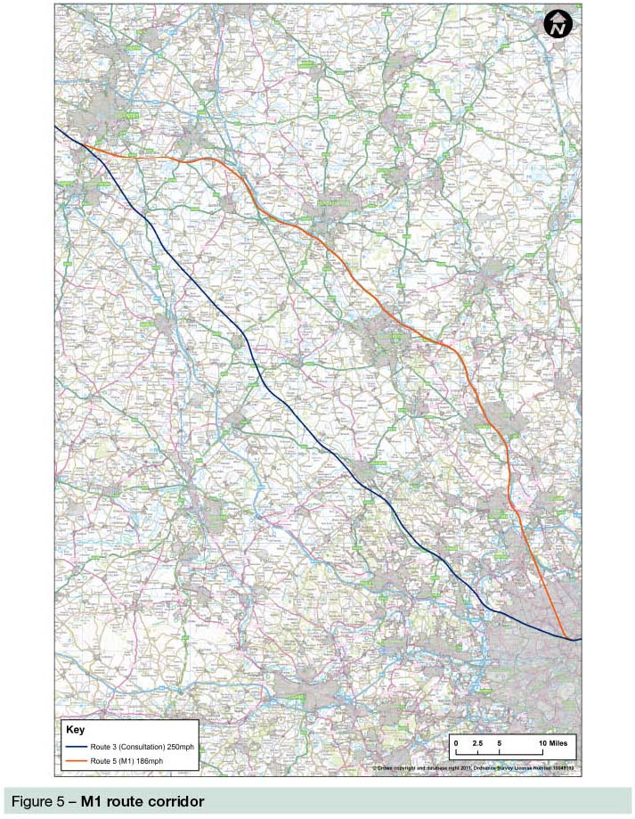
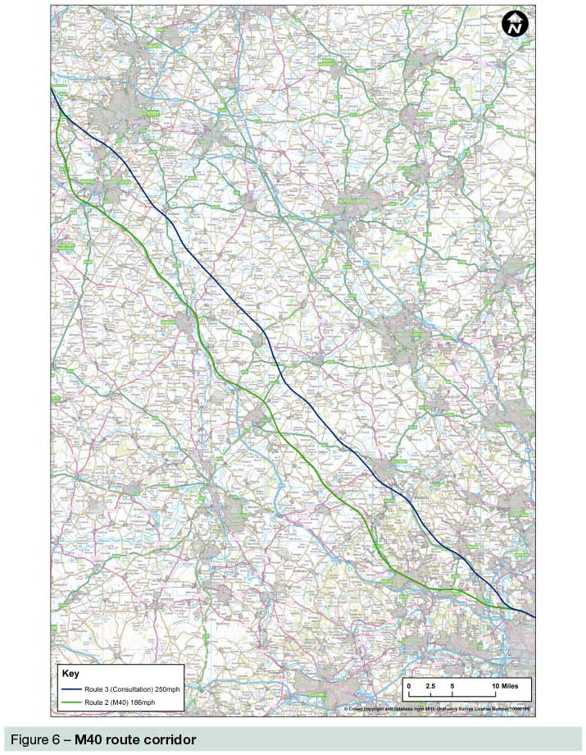
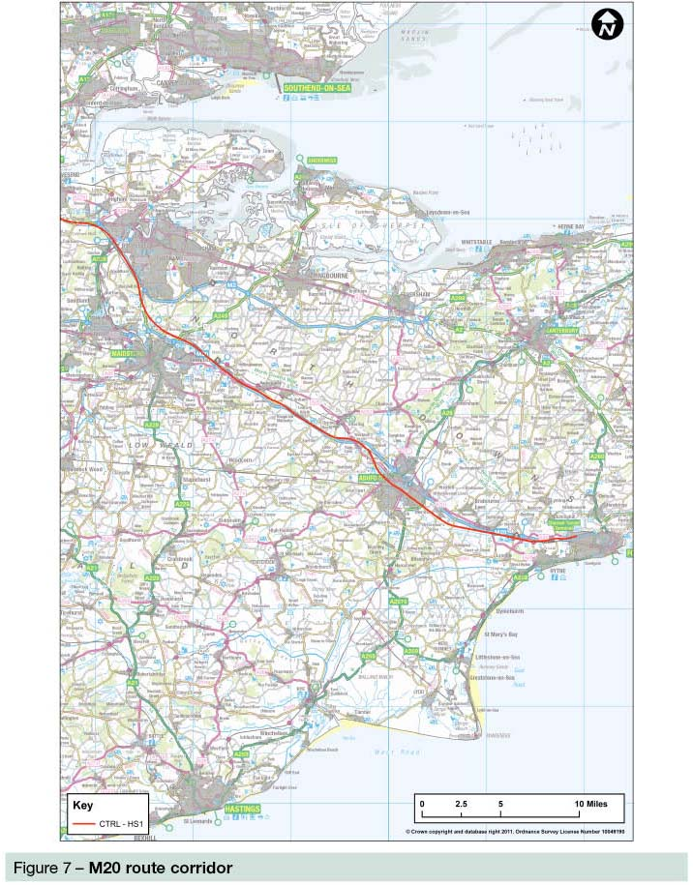

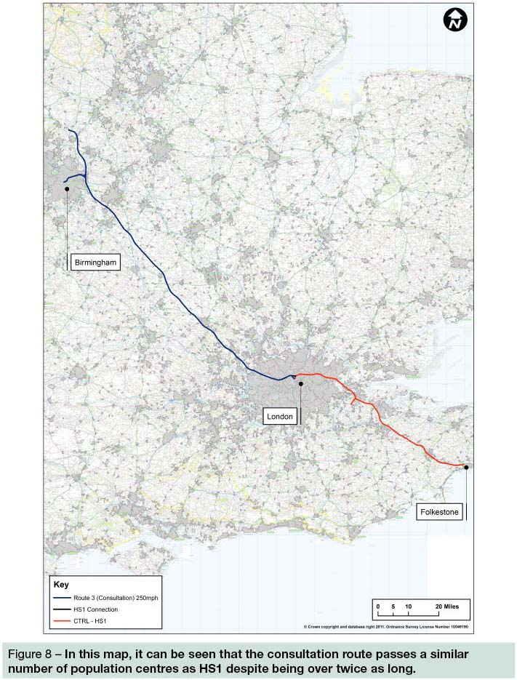

3.1.23 The following section presents the element of our work that has investigated the merits of the route corridor of the consultation route, by comparing it to other route corridors that follow transport corridors, namely the M40 and M1. The findings presented below show these options compared to the consultation route at the time of consultation, and lead us to conclude that the adopted route corridor presents the best balance of cost, sustainability impacts, journey times and benefits.
3.1.24 We have also undertaken a body of work to examine possibilities to improve the consultation route, based on consultation responses. This work has generated a number of areas where we recommend changes are made to the route alignment. These recommendations are covered in more detail in our other reports. The changes lead to a substantially improved route.
3.1.25 With these improvements, the advantages of the revised consultation route over the options presented below would be even greater.
3.2 Chiltern Line and M40 alignment (Route 2) at a lower design speed
3.2.1 Our original work showed that the speed of a practical route along this corridor would fluctuate between a maximum of 250mph and 150mph or less, meaning that actual maximum operating speeds would be at the lower end of this range. The journey time calculated reflected this. In considering further the corridor in the light of consultation responses we have developed an M40 Route with a maximum speed of 186mph whilst still accepting localised speed reductions in places where necessary to contain impacts.
Route description
3.2.2 This route would follow the consultation route from Euston to the Colne Valley, where it would divert to follow the Chiltern Main Line to Bicester and then the M40 towards the West Midlands, before skirting Warwick to pick up the consultation route south of the Birmingham Interchange. Taking a more westerly alignment, the route covers a longer distance in reaching Birmingham than the consultation route. Combined with the lower maximum design speed, this option has a journey time between Euston and Birmingham Curzon Street of 56 minutes as opposed to 49 minutes for the consultation route.
3.2.3 Importantly a surface alignment along this route would encounter a much greater number of major population centres than the consultation route, including Gerrard’s Cross, Beaconsfield, High Wycombe and Princes Risborough. These four locations alone have a combined population in excess of 110,000 people. This would result in unacceptable impacts on communities through major demolitions, severance and noise impacts. As an indication of the potential scale of impacts of a surface level route, our tunnelled route in this area had around 3,900 properties within 100m of the tunnel. With a surface route on the same horizontal alignment, a large number of properties would need to be demolished and there would be significant noise impacts.
3.2.4 As a result, this route would require substantial sections of tunnelling. For example, it would need to be tunnelled under Gerrard’s Cross, surfacing to pass through the area around Seer Green before entering a seven and a half mile long tunnel under both Beaconsfield and High Wycombe.
3.2.5 In addition, in running as close as is practicable to the M40 corridor the route would need to avoid six motorway junctions through the use of flyovers or tunnels, adding to the engineering complexity and cost. There would also inevitably be significant disruption to the road and motorway network during construction over two to three years.
3.2.6 This would contribute to total costs of £19.5 billion, making it a £3 billion more expensive option than the consultation route which would cost £16.5 billion.
Economic appraisal
3.2.7 On the basis of the additional £3 billion construction, other costs applied to the economic case and the seven minute journey time penalty between Euston and Birmingham Curzon Street, this would reduce the Benefit Cost Ratio of the scheme by 25% or more. More information on this is provided in our other advice.
3.2.8 The seven minute journey time penalty would also apply to all destinations further north, both initially for trains running onto the classic network and later on a wider network, even if the northern legs of the Y network were designed to a higher maximum speed. Designing a wider network with a similar maximum speed of 186mph would mean that further additional time would be added to journeys to all cities beyond Birmingham.
Sustainability appraisal
3.2.9 Even having incurred substantial additional costs through tunnelling, there would remain, on balance, little sustainability difference between this option and the consultation route, albeit that the types of impact differ across the broad range of sustainability themes.
3.2.10 In terms of landscape, we recognise that this option would cross the Chilterns AONB at a narrower point, with the surface sections of the route affecting around three and a half miles, compared to around eight and a half miles for the consultation route. However, in response to issues raised during consultation we have substantially reduced the amount of open running through the AONB through additional tunnels and green tunnels. It would see the sections of open running reduced to around six miles, three and a half of which would be in deep cutting, substantially reducing noise and visual impacts, leaving no more than two and a half miles of comparable surface route.
3.2.11 The M40 option does however also run close to the Cotswolds AONB for around five and a half miles. Impacts on SSSIs would be broadly comparable. Whilst the number of ancient woodlands subject to direct impacts would be lower, the route would pass within 750m of Chilterns Beechwoods SAC, a site of international importance for biodiversity that is protected under the EC Habitats Directive.
3.2.12 In terms of impacts on communities this route has some benefits, in particular a reduction in the number of people affected by noise compared to the consultation route, mostly due to the lower line speed this route requires. However, the recommended changes to the consultation route without any change in speed would reduce noise impacts on people below those of this option. The M40 route would also mean significantly more communities would be at risk of isolation and severance through being surrounded by transport infrastructure compared to the consultation route.
3.2.13 Overall, in light of the large impact on journey time and cost of this option, with little environmental gain achieved at a substantial cost, we remain of the view that the consultation route corridor is preferred to his option.

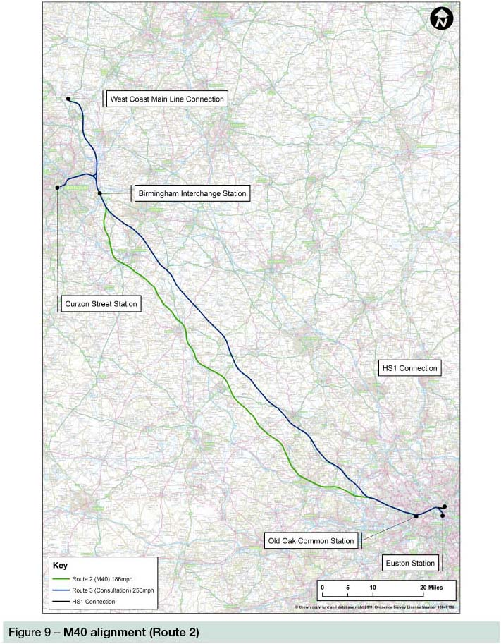
3.3 M1 alignment (Route 5) at a lower design speed
3.3.1 As with our work on Route 2, we have developed a viable alignment for the M1 corridor that broadly follows the Route 5 option developed as part of our early work in 2009, but with a maximum speed of 186mph.
Route description
3.3.2 It would follow the consultation route from Euston to Old Oak Common, where it would then head due north following the M1 and M45/A45 towards Birmingham. The route covers a longer distance in reaching Birmingham than the consultation route. Combined with the lower maximum design speed, this option has a journey time between Euston and Birmingham Curzon Street of 55 minutes as opposed to 49 minutes for the consultation route. Further additional time would be added to journeys to all other cities beyond Birmingham.
3.3.3 As with the M40 corridor, a surface alignment along the M1 route would encounter a much greater number of major population centres than the consultation route would, including in this case Hemel Hempstead, Milton Keynes and, in particular, Luton. These three locations have a combined population of over 480,000 people. This would result in unacceptable impacts on communities through major demolitions, severance and noise impacts and therefore this route would require substantial sections of tunnelling. This makes it a substantially more complicated and expensive option than the consultation route.
3.3.4 The cost of constructing this route would be £18.7 billion, £2.2 billion more than the consultation route.
Economic appraisal
3.3.5 On the basis of the latest construction and other costs applied to the economic case and the six minute journey time penalty between Euston and Birmingham Curzon Street, this would reduce the Benefit Cost Ratio of the scheme by 25% or more. More information on this is provided in our other advice.
3.3.6 As with Route 2, this journey time penalty would apply to all destinations further north, both initially for trains running onto the classic network and later on a wider network.
Sustainability appraisal
3.3.7 In comparison with the consultation route at 250mph, this slower M1 alignment would perform better across some sustainability themes, but would result in significantly higher impacts on communities in terms of demolitions and in terms of potential for isolation and severance.
3.3.8 In terms of impacts on communities, a combination of lower line speeds and an increased proportion of the route being in tunnel would also mean that relatively low numbers of people would experience increased annoyance compared to the consultation route. However, we consider that much of the benefits of lower line speeds in terms of noise – particularly in terms of the numbers worst affected – could be achieved by mitigation of the consultation route. Mitigation of the consultation route in response to issues raised at consultation has already substantially reduced the noise impacts of that route, and there is scope to achieve more through Environmental Impact Assessment (EIA).
3.3.9 Moreover other impacts on communities would be worse with an M1 route alignment. The surface sections of the new M1 alignment would result in 150 residential dwellings being at risk of demolition, more than double for the section between Old Oak Common and the Birmingham Interchange Station of the consultation route. Importantly, in seeking to avoid major demolitions we have moved the line away from the motorway at locations where there are communities close to the M1. This means that 14 communities would also be at risk of isolation or severance, as a result of being bounded by transport infrastructure, as compared with three communities at risk of isolation for the consultation route.
3.3.10 Tunnels for this option would pass under 6,400 dwellings compared to 350 for the consultation route, adding to the complexity of track design and construction, increasing project risk.
3.3.11 In terms of landscape it would, as a result of passing under Luton in tunnel, avoid impacts on the AONB, but its impacts on registered parks and gardens would be broadly similar to the consultation route (albeit impacting on different features). It would also have lower impacts on nationally protected ecological sites, ancient woodlands and fewer Biodiversity Action Plan habitats.
3.3.12 In light of the large impact on journey time and cost of this option, with relatively small environmental gain achieved at a substantial cost, we remain of the view that the consultation route is preferred to this option.
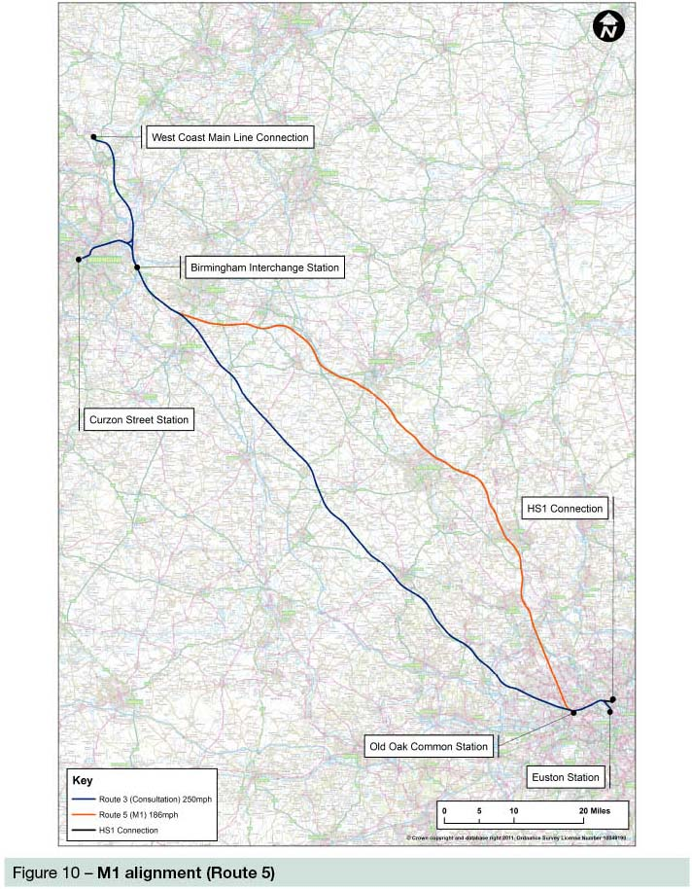
3.4 An alternative route corridor – directly serving Heathrow
3.4.1 Views were expressed during consultation that HS2 should follow an alignment via a new interchange at or near Heathrow, and that this could be cheaper and better in terms of sustainability than serving the airport directly via a spur from the consultation route. The Transport Select Committee also suggested a route via Heathrow should be considered further. We have therefore re-examined the proposal we designed for a route via Heathrow, described in the consultation as Route 1.5.
3.4.2 Route 1.5 would run west from Old Oak Common in a continuous tunnel to a through running station in the Heathrow area, before tunnelling under the M25 and turning north through Langley Park and Fulmer to meet the M40. It would then continue in tunnel under Beaconsfield and High Wycombe, surfacing near Braddenham in the Chilterns AONB. It would leave the AONB near Princes Risborough and rejoin the consulted route near Brackley.
3.4.3 The density of population in the areas surrounding Heathrow and in west and northwest London means that this option would need to be largely in tunnel to limit the environmental impact it would have. The extent of tunnels would significantly increase costs and mean noise impacts would be confined to a few residential properties, although a small number of dwellings and commercial buildings would be at risk of demolition. The tunnels would pass beneath suburban areas west of London then Gerrard’s Cross, Beaconsfield and High Wycombe.
3.4.4 The main sustainability impacts of this option would be on those areas of surface running beyond Heathrow. The Chilterns AONB would be crossed for two and a half miles at surface level and the Grade II Langley Park Registered Park and Garden and Black Park Country Park would be directly affected. The design would need to allow for four major river crossings and protection of important flood areas and groundwater resources. Land take of approximately 80ha of the best and most versatile agricultural land would also be required.
3.4.5 BAA, the owner and operator of Heathrow, made clear in response to consultation its preference for locating a high speed interchange on the airport in the Central Terminal Area or at Terminal 5. Options for near and off-airport stations were less favoured because of their distance from the airport terminals and the subsequent impacts on journey time and passenger experience including the possibility of airlines offering ‘codeshare’ services.
3.4.6 We undertook a review of our previous work and also carried out a further technical study of the feasibility of a station under the Central Terminal Area. Constructing a new station deep under the Central Terminal Area, to avoid other sub-surface facilities such as the Piccadilly Line, would be technically feasible but would be very challenging and expensive, in the order of £3 billion to £4 billion. Providing adequate emergency evacuation from a deep bored station under airport facilities and aircraft areas would be particularly challenging. A station at Terminal 5 could be constructed alongside the main terminal building, providing a high quality passenger experience, but the route would have to be aligned north to south meaning that a high speed curve back to Old Oak Common would be impractical. The route and journey time would be significantly longer as a result. Therefore we concluded that a through route could not realistically be constructed with stations at the main passenger terminals at the airport.
3.4.7 We believe, therefore, that a through route would only be practicable with a station remote from the main terminal areas. We had previously examined two options, one adjacent to the Northern Perimeter Road of the airport and one near Iver, some three miles further north adjacent to the Great Western Main Line (GWML). Neither could easily be integrated with passenger facilities and other public transport connectivity of Heathrow Airport. Passengers would need to be conveyed by a new system of people movers or bus-ways. Such an option would not match the passenger benefit of an on-airport station, integrated with airline passenger facilities.
3.4.8 We are confident therefore that in respect of serving the airport, the option for a spur to Heathrow from the consultation route to the airport itself performs better than a through route stopping close by the airport. Since it allows services to travel directly to a passenger terminal at Heathrow, it gives the opportunity of services in codeshare form with integrated luggage and ticketing. A spur route also allows dedicated airport services, which could be more suitable for such arrangements. A spur could take passengers to a station fully integrated into the passenger facilities of the future Heathrow itself making a more attractive proposition for interlining passengers.
3.4.9 The practical difficulties and cost of a deep Central Terminal Area option as discussed above mean we conclude that a HS2 station at Terminal 5, with direct access to Crossrail and the Piccadilly Line, as well as to the airport itself, would be the best option.
3.4.10 We have also considered the impact on HS2 passengers of adopting a direct route via Heathrow. Our work showed the large majority of HS2 passengers would be travelling to and from London itself, with the market for Heathrow Airport relatively small. As a direct route via Heathrow would be longer than the consultation route, and with a longer section of slower running in tunnel, we calculated non-stop trains would experience a four minute journey time penalty over the consultation route, with stopping services experiencing an eight minute penalty. This penalty would be suffered by all passengers not wishing to travel to Heathrow.
3.4.11 However, on a high capacity line such as HS2 it is questionable whether it would be feasible to operate a selective stopping pattern of services. Trains on HS2 are planned to be pathed at approximately three minute intervals. Selectively stopping trains would reduce overall HS2 capacity given that the train which stops takes up a path initially then, after stopping, takes up a second, later path which therefore cannot be used by another train.
3.4.12 Therefore, on a selective stopping pattern a complete train service would be lost each time a train calls at Heathrow, which would be a similar effect to running services along a spur to terminate at the airport. Such capacity loss could be avoided by stopping all trains. This would give a better service frequency for Heathrow passengers, but this would result in an eight minute journey time penalty for the large majority of passengers heading to and from London.
3.4.13 In addition, our analysis of passenger dispersal in London highlights the importance of the Crossrail interchange at Old Oak Common in supporting onward journeys from HS2, particularly to the West End, the City and Docklands, and reducing crowding on the underground at Euston. A station in the Heathrow area, even if it were on the GWML and Crossrail, would not provide an effective interchange and, being too far from London to provide an attractive overall journey time, could not deliver these benefits. Therefore we believe that any station near Heathrow would not be a substitute for the interchange.
3.4.14 While the cost estimate of £3.1 billion for a spur from HS2 to a new station at Terminal 5 was more than the £2.9 billion estimated incremental cost of a route through an interchange on the GWML at Iver, this excluded the substantial cost of a people mover between Iver and the main terminal areas. Such a people mover would not be required for a station at Terminal 5 which is well connected to the existing on airport transport links. Furthermore, the costs of a route via Iver would be borne in the first phase of construction as opposed to the spur option which would see the costs incurred as part of phase two, when demand for such a service would be greater.
3.4.15 Some responses to consultation suggested a route via Heathrow, which could then travel to Birmingham along an alignment that follows the M40. We consider a credible route would effectively combine Route 1.5 as described above through the Heathrow area as far as Beaconsfield, before joining our M40, Route 2 alignment. The additional journey time for trains not stopping in the Heathrow area would be, we estimate, some ten minutes. For trains stopping at Heathrow, this would increase to around 14 to 15 minutes. Such a route would cost approximately £4 billion to £5 billion more than the consultation route. Given the significantly longer journey times and higher costs of this proposal, which would be likely to result in a BCR of less than 1, we are of the view that such a route does not present a viable alternative compared to the consultation route.
3.4.16 In light of the work detailed above, we conclude that, should Heathrow be served by HS2, the best solution would be to operate trains to a station on a spur integrated with Terminal 5, because:
• for airport passengers it allows HS2 to serve an existing terminal, integrated with current and possible future rail connections;
• for the majority of passengers who would be travelling to and from London it provides better journey times, and associated greater benefits;
• the costs of a spur would be borne in the second phase of construction, and would not require an expensive on-airport people mover system, unlike a through route; and
• any environmental benefits of a through route would be small and insufficient to outweigh the above advantages of a spur.

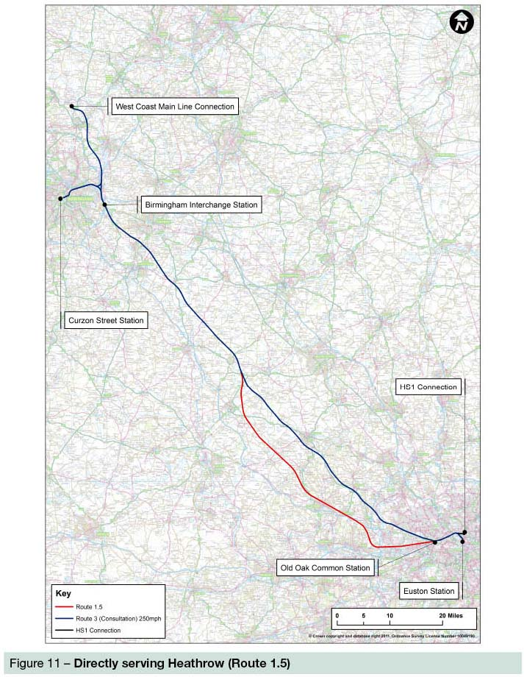

4 Higher or lower design speed on the consultation route
4.1 Background
4.1.1 The proposals for HS2 were developed to reduce journey times and improve connectivity and capacity between our major cities. We designed HS2 to permit speeds of up to 225mph initially, similar to routes currently being developed elsewhere in Europe for which there is proven technology. The maximum line speed was designed to be lower in built up areas reflecting environmental considerations and practical train operation.
4.1.2 We have, however, designed the route so that speeds of up to 250mph could be achieved should technical advances in high speed rail technology permit, although speeds above 225mph would only be permitted on the condition that there would be no unacceptable increase in noise levels.
4.1.3 Comments received during consultation on this issue most often argued that the maximum for design speed was too high requiring a straight route that increases environmental impacts, and causing higher noise impacts. A small number stated that the maximum design speed was too slow given potential technology development over the expected lifespan on the railway.
4.2 Higher design speed
4.2.1 We have considered the ability to achieve speeds in excess of 250mph between stations and other permanent restrictions of speed such as junctions and tunnels.
4.2.2 Given the distance taken to accelerate a train, speeds in excess of 250mph would only be possible for relatively short amounts of time, and the potential for further journey time reduction would be small. Accelerating to and running at these speeds would require more energy consumption, meaning higher carbon emissions and operating costs for low commercial benefit. Our view is that 250mph represents a reasonable maximum design speed, given likely technology development over the coming decades.
4.3 Consultation route at a lower design speed
4.3.1 While having a maximum design speed of 250mph with a maximum operating speed of 225mph on Day One, sections of the route have a lower design speed, such as in urban areas to minimise impacts on people, or when approaching stations. The consultation route has a maximum speed of 155mph between Old Oak Common Station and West Ruislip and a train leaving London would only reach maximum speed after 28 miles. Around 68 miles of the route has a maximum design speed of 250mph, limiting the extent of route that could potentially be improved by using a lower speed.
4.3.2 In response to consultation we have considered the scope for improvements to the route if the maximum design speed was reduced, to either 225mph or 186mph. We have considered the impact a lower design speed would have on journey times. There would be no impact on journey times with a maximum design speed of 225mph as this is also the maximum operational speed proposed on opening of HS2. Therefore reducing the design speed of the route to 225mph would cause no loss of benefits and no reduction in the BCR.
4.3.3 However the opportunity for a future reduction in journey time, potentially in the context of a greater high speed rail network in due course, would be permanently foregone.
186mph design speed – impact on journey time
4.3.4 The 186mph route has a journey time that is four and a half minutes longer than the consultation route between London and Birmingham, at 53 and a half minutes as opposed to 49 minutes. This would reduce the BCR by just under 15%. More information on this is provided in our other advice.
4.3.5 Adopting a lower design speed for the whole of the Y network would have an even greater impact on journey times to Manchester, Leeds and Scotland. With a Y shaped network journey times to Manchester would be an additional nine minutes, with journey times to Leeds an additional 10 minutes. Should in future years a wider network be developed at this lower speed the time penalties would further increase by, for example, about 20 minutes to Edinburgh or Glasgow.
4.3.6 Given the sizeable loss of benefits from lower speeds, and the scope to mitigate environmental effects, we remain of the view therefore that the current design speed is appropriate. However we recognise that there could be places where, selectively, a lower design speed is more appropriate. We have therefore considered speed reductions in individual sections of the route.

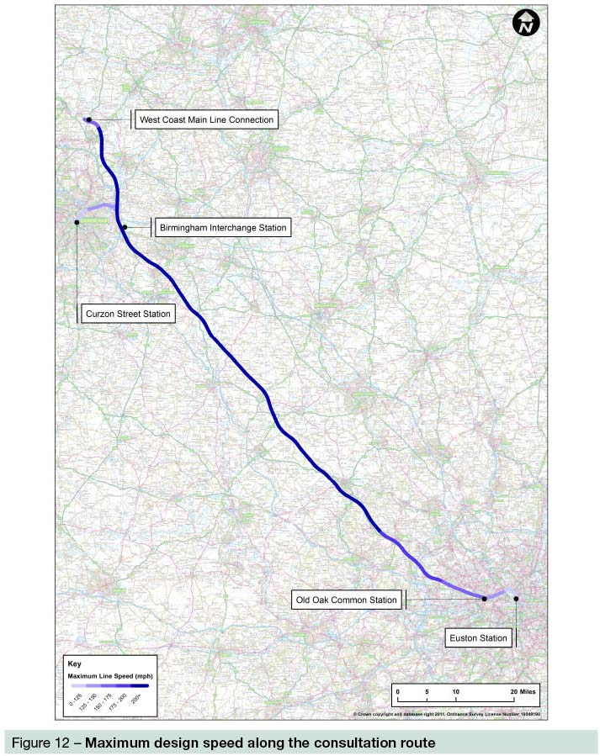
Our route revision work
4.3.7 Our work examined the route between Amersham and the Interchange Station near to the National Exhibition Centre at Birmingham, around 68 miles in total, which represents the section of route with the maximum design speed. We have examined this section to indentify the scope for reducing impacts through reduction in line speed to either 186mph or 225mph. Since this section covers the middle section of the route, where trains could reach their maximum speed, having sections at lower speeds would introduce a greater penalty to overall journey times, once allowance has been made for acceleration and deceleration. Given this, we consider that speed restrictions in this section of route should only be adopted if they offer substantial sustainability gains.
4.3.8 We identified six areas to consider in detail where there were environmental concerns and where there was potential to alter the route alignment as a result of speed reductions. In other areas a lower speed would have led to no change in the route.
4.3.9 In three of the areas, we found no additional benefits could be achieved by reducing the line speed down from 225mph to 186mph, given the topography and relative positioning of communities, and so only 225mph alignments were considered in those areas.
4.3.10 The six study areas are:
• Study area 1 – Balsall Common (225mph alignment);
• Study area 2 – South Cubbington Wood (225mph and 186mph alignments);
• Study area 3 – Chipping Warden to Turweston (225mph alignment);
• Study area 4 – Twyford to Chetwode (225mph and 186mph alignments);
• Study area 5 – Waddesdon (225mph and 186mph alignments); and
• Study area 6 – Wendover to South Heath (225mph alignment).

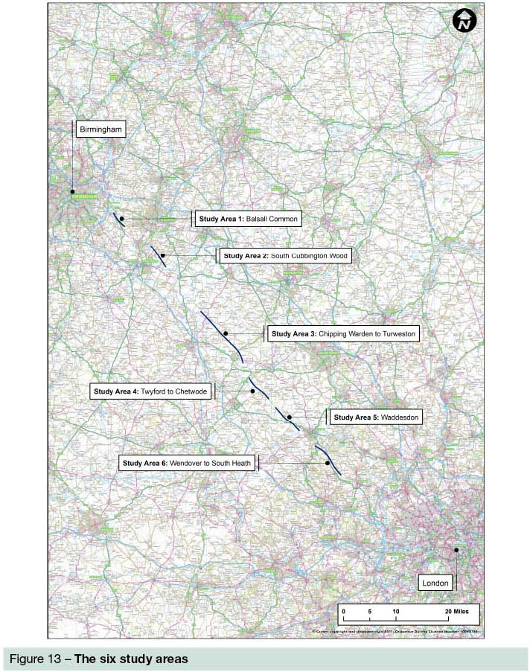
Study area 1 – Balsall Common (225mph revision)
4.3.11 The consultation route would pass close to communities at Balsall Common and would come within 20m of the Grade II* and Grade II listed building and barn at Lavender Hall Farm, in the village of Hampton-in-Arden. It would also clip the western corner of Marlowes Wood and Sixteen Acre Wood.
4.3.12 Concern was expressed during consultation in respect of impacts upon Balsall Common and the historic Lavender Hall Farm. Reducing the line speed to 225mph would allow the route to be moved 50m further from Lavender Hall Farm, although this would require a four metre high embankment to enable the line to cross an existing operational railway.
4.3.13 It would result in a direct impact to the Marlowes Wood ancient woodland – as a result of the requirement for a four to five metre deep cutting through the wood. It would reduce the number of demolitions from three down to two and would result in a small decrease in noticeable noise, at some parts of Balsall Common and some individual dwellings.
4.3.14 The realigned route would result in marginal improvements in respect of cultural heritage, soil and land resources and, by crossing less flood zone would marginally improve likely impacts to flooding. The route change would allow a reduction in the length of viaduct by around 100m, helping to slightly reduce visual impacts.
4.3.15 However, we also investigated a realignment of the route with a maximum speed of 250mph which could similarly mitigate the route. The difference in sustainability between these two options is marginal and we concluded that the slower speed alternative should not be pursued in this location.

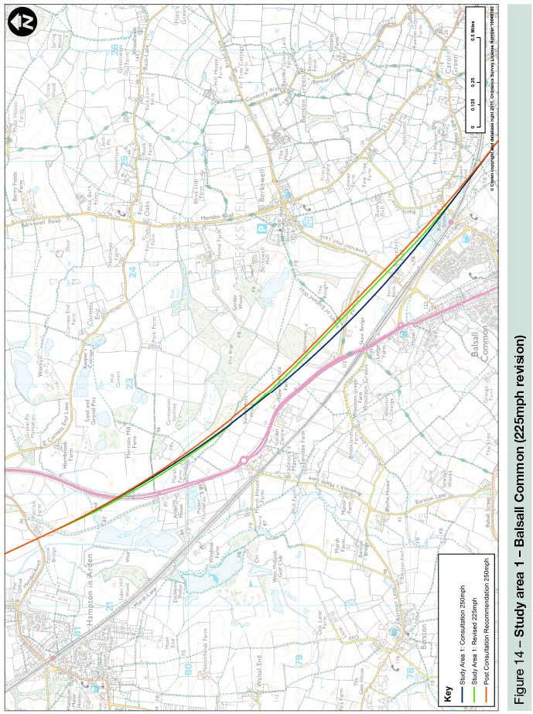
Study area 2 – South Cubbington Wood (225mph and 186mph versions)
4.3.16 The consultation route runs north-west from Offchurch, crossing the River Leam and bisecting the southern section of the ancient woodland and the BAP habitat of South Cubbington Wood before crossing the A445 towards Stareton. The route would bisect South Cubbington Wood and would pass around 500m from the village of Offchurch.
4.3.17 A key consideration for this option was to establish if it was possible to avoid or reduce the direct impacts to South Cubbington Wood. In addition consideration could be given to reducing impacts to a number of Grade II listed structures and possible reduction in noise at some properties.
4.3.18 Reducing the line speed under either the 225mph or 186mph option would mean that the route would avoid going through South Cubbington Wood, providing a significant improvement to local biodiversity. However to avoid the woodland the alignment would move closer to the community of Cubbington, albeit in cutting, resulting in a potential increase in localised airborne noise.
4.3.19 The 225mph option would avoid South Cubbington Wood entirely but would be 165m closer to the community of Cubbington, which has a population of around 4,000. The 186mph option would skirt the woodland and be 115m closer to that community. Each alternative would require a longer viaduct to cross the River Leam and associated flood plain where, because of the river’s meander, it would be more difficult to screen the railway in noise and visual terms.
4.3.20 Of the two alternatives the 186mph option would perform better in terms of noise, but would lead to a slower journey time. The 225mph route presents a route closer to the communities of Cubbington and Offchurch that would be less straightforward to mitigate where it passes on elevated structure and would compromise the ability at a future date to operate at a higher speed.
4.3.21 In both cases improvements would be gained through retaining the woodland, but with impacts upon local communities. Our Review of possible refinements to the proposed HS2 London to West Midlands Route report describes an alternative approach at 250mph, with use of retained cuttings, to minimise effects on Cubbington Wood without impacting upon Cubbington. We would recommend this improvement at 250mph over both lower speed options.

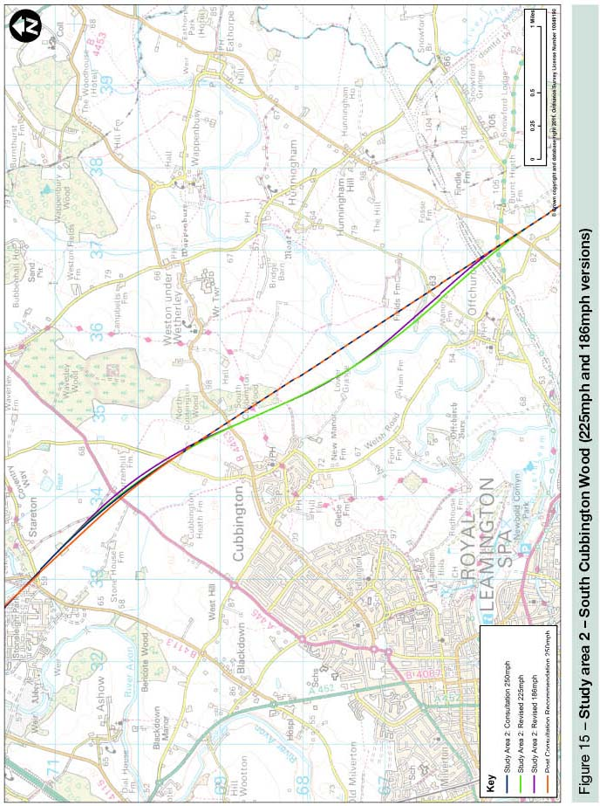

Study area 3 – Chipping Warden to Turweston (225mph version)
4.3.22 The consultation route at this location crosses the Great River Ouse north of Turweston and then runs predominantly in cutting past the settlement of Greatworth. It then runs in a series of cuttings and embankments past Thorpe Mandeville and Culworth before crossing the River Cherwell south east of Chipping Warden. The alignment would impact on a number of Grade II listed structures, and would likely mean demolition of eight properties. Noise impacts in this area are comparatively small and relate mainly to isolated properties in close proximity to the route at Chipping Warden, Edgcote and Thorpe Mandeville.
4.3.23 The route would also impact on a cluster of heritage assets of key importance to English Heritage. This includes impacts to the setting of Grade 1 listed Edgcote House, severance of a Scheduled Monument (Roman Villa) and, as confirmed during consultation, the likely site of the historic battlefield of Edgcote Moor. The route would impact the southern edge of the ancient woodland and Biodiversity Action Plan (BAP) habitat, Halse Copse and would intersect Helmdon Disused Railway (SSSI).
4.3.24 A key consideration for reviewing this section of the consultation route was to establish if it was possible to move away from Brackley and these features.
4.3.25 Reducing the line speed to 225mph would mean that a new alignment could be provided further away from Brackley by around 600m, creating a new railway corridor north of the consultation route between Brackley and Chipping Warden. This would pass to the north and slightly closer to the village of Radstone and communities in the villages of Helmdon, Sulgrave and Culworth. It would pass slightly further away from Greatworth, Thorpe Mandeville, Edgcote, and Chipping Warden.
4.3.26 This change would move the route further from Edgcote House, reducing impacts to its setting, avoid the direct intersection of the Roman Villa site, and minimise impacts upon the historic battlefield at Edgcote. It would provide a marginal reduction in noise impacts upon Brackley, Turweston, Greatworth and Thorpe Mandeville. It would provide improvements in terms of community integrity, and soil and land resources.
4.3.27 Whilst this option would increase impacts on woodland, other biodiversity impacts would be reduced by avoiding Halse Copse ancient woodland and BAP habitat. It would also mean fewer properties being at risk of demolition, and would affect less high quality farmland.
4.3.28 This would perform better than the consultation route in sustainability terms, largely as a result of the reduction in property demolitions and the marginal improvement in noise, and because of improvements in terms of cultural heritage. However, as described in our Review of possible refinement to the proposed HS2 London to West Midlands Route report, we have identified an option which maintains the design speed of 250mph and delivers similar overall sustainability improvements without compromising the operation of the railway, for example through the addition of a green tunnel at Greatworth.
4.3.29 We therefore do not recommend reducing the line speed in this area.
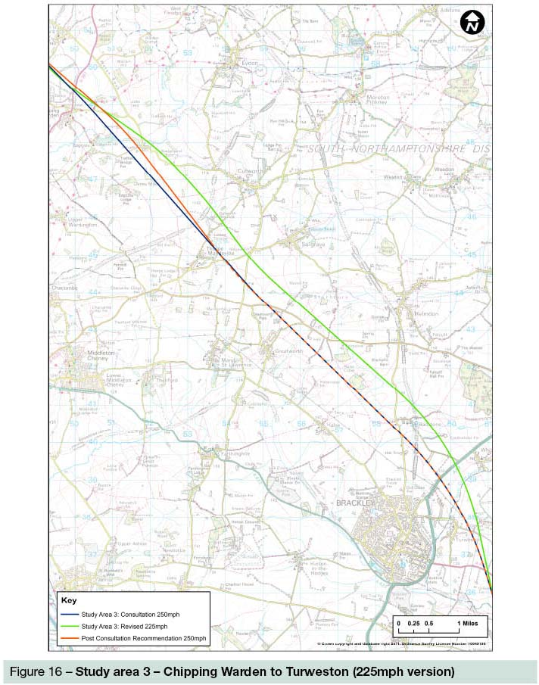
Study area 4 – Twyford to Chetwode (225mph and 186mph versions)
4.3.30 This study area covers the route alignment which runs close to the villages of Twyford and Chetwode. The consultation route followed the former Great Central Railway corridor in this location, from Grebe Lake at Calvert to south of Newton Purcell. The route is in close proximity to Twyford and Chetwode resulting in airborne noise effects at these locations as well as to some isolated properties. The route option is also likely to require around nine demolitions and come close to a number of listed properties. The alignment would also have a direct impact on the Wildlife Trust owned Grebe Lake nature reserve where it passes on a raised viaduct.
4.3.31 Two reduced speed alignment alternatives were considered in this location. Both followed very similar alignments. The 186mph route would pass 150m further from Twyford, compared to 100m for the 225mph option. Both route options would allow the viaduct and impacts on the nature reserve to be avoided. At Chetwode the 186mph option passes 200m further away from Chetwode, compared to 100m for the 225mph option.
4.3.32 We have also considered a line of route change in the vicinity of Twyford that maintains the design speed of 250mph, and is set out in our Review of possible refinements to the proposed HS2 London to West Midlands Route report. That option is similar to the reduced speed alternatives described above, making use of a reduced radius curve to move further away from Twyford. With the additional space provided between the village and the new railway, effective landscape earthworks can be provided that would minimise the impacts upon Twyford without affecting the operation of the railway. As a result we consider there is no need to adopt a slower speed alignment in this location.
4.3.33 Further northwards at Chetwode, little can be gained in alignment terms through reduced speed that would benefit that village or Newton Purcell.
4.3.34 As a result we recommend maintaining an alignment with a maximum design speed of 250mph.

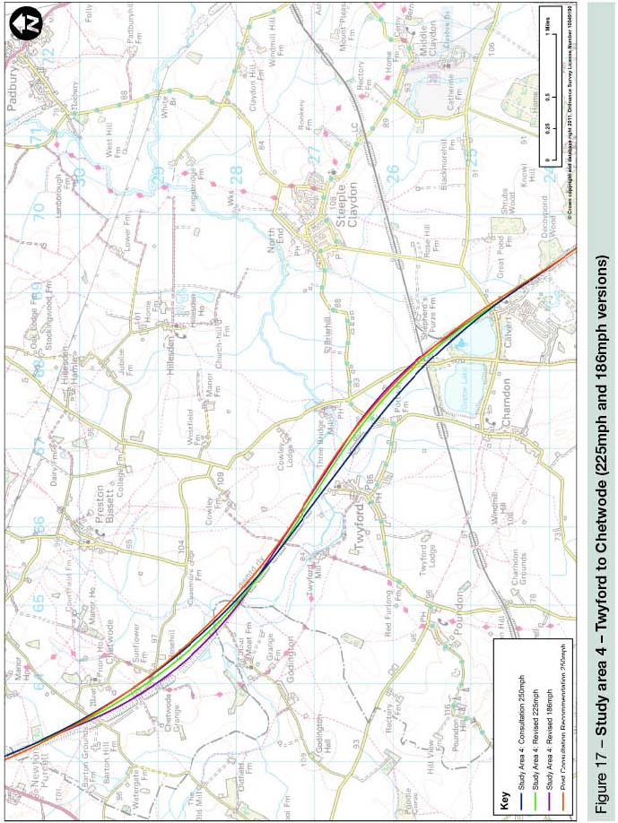
Study area 5 – Waddesdon (225mph and 186mph versions)
4.3.35 The study area considered is situated east of Waddesdon and incorporates the section between the River Thame and a point west of Shipton Lee. The route lies between Waddesdon and Quainton and is about a mile from the Grade I listed Waddesdon Manor and its Registered Parks and Garden.
4.3.36 The consultation route section at this location runs close to the village of Waddesdon, in part so that the route north of Waddesdon can then follow a disused railway line on embankment, in order to minimise sustainability impacts by following transport corridors. Although close to Waddesdon, our assessment indicates no noticeable noise impacts on the village but that noise impacts would be experienced at isolated properties in close proximity to the route.
4.3.37 A key consideration for reviewing this section was to establish if a move away from Waddesdon would further help to reduce noise to isolated properties and to reduce possible impacts to the setting of Waddesdon Parks and Gardens.
4.3.38 Both lower speed options would move the route approximately 230m further away from Waddesdon and closer to the existing railway corridor. The additional flexibility offered by the 186mph option over the 225mph option means that the shift in the alignment away from Waddesdon would not bring the route closer to other properties south of Waddesdon, or to cause alignment changes to the west of Quainton.
4.3.39 The 225mph option would be closer to Quainton which could increase noise impacts and would require the demolition of an industrial building associated with Buckinghamshire Railway Centre. The 186mph option would mean lower noise impacts than the consultation route, especially around Waddesdon, but would still result in the demolition of the Railway Centre’s industrial building.
4.3.40 At Waddesdon, either lower speed option would lead to some marginal environmental improvements over the consultation route that would benefit a relatively small number of people. Whilst some isolated properties would gain from such alignment changes others would be brought in and be affected as a result.
4.3.41 On balance we conclude that the marginal environmental improvements that could be made by compromising the speed in this location would not justify the route change. Similar environmental performance would be gained for a 250mph route through additional mitigation on the consultation route through the use of, for example, landscaped earthworks. This would be considered through EIA should a decision be taken to proceed with HS2.

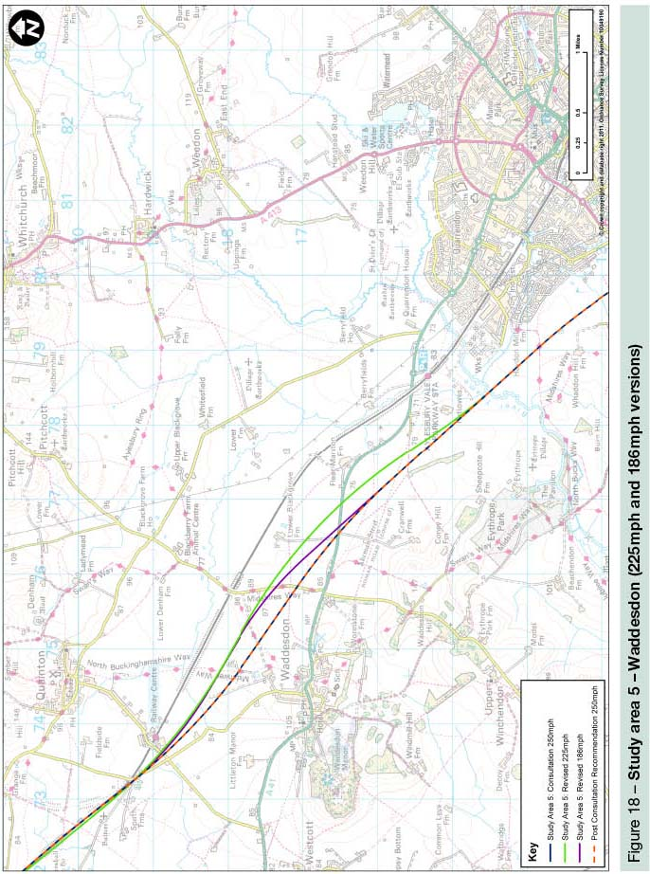
Study area 6 – Wendover to South Heath (225mph version)
4.3.42 The consultation route in this area is situated between Great Missenden and Wendover. The alignment crosses Wendover Dean on a viaduct 495m long and 17m high. It would pass alongside Wendover running parallel to the A413 road at a distance of around 135m. Further south the route would pass directly through the Scheduled Monument of Grim’s Ditch in a deep cutting. The appraisal of impacts for this consulted section showed noise impacts at Wendover. For the consultation route we proposed the stopping up of the Ellesborough Road into Wendover, due to the construction of a small section of green tunnel, and suggested a new road arrangement that would take vehicles away from the town and on to the A413.
4.3.43 Compared to the consultation route, a 225mph realignment would shift the horizontal alignment 150m eastwards in the vicinity of Woodlands Park, thereby avoiding Grim’s Ditch and result in a shorter, lower viaduct at Wendover Dean. It would shift the route 100m eastwards as it approaches Wendover, passing up to 215m further from the town, albeit on a higher embankment compared to the consultation route.
4.3.44 The proposed 225mph option would benefit cultural heritage largely as a result of avoiding Grim’s Ditch. The revised option would also provide significant benefits to community integrity and would result in a reduction of demolitions from eleven to nine. The option would also avoid the demolition of the sports pavilion and cricket pitches at Wendover.
4.3.45 Spoil would be increased due to an extended length of cutting and would only provide marginal improvements to ecology due to reduced impacts to local woodland and orchard area. Assessment of noise impacts indicated that the relatively small alignment change next to Wendover would not provide a clear reduction.
4.3.46 Our environmental appraisal shows a slight preference for the 225mph option over the consultation route, avoiding direct impacts on Grim’s Ditch and the need to demolish two community buildings. Grim’s Ditch would however still be indirectly impacted, and the noise impact would remain largely similar.
4.3.47 However, as set out in our Review of possible refinements to the proposed HS2 London to West Midlands Route report, we have also considered additional green tunnelling in the Wendover area.
4.3.48 Placing the route in green tunnel would largely eliminate noise impacts and significantly reduce visual impacts on Wendover, although the impacts on Grim’s Ditch would remain. Given this, we are of the view that the green tunnel option in this area is preferred.

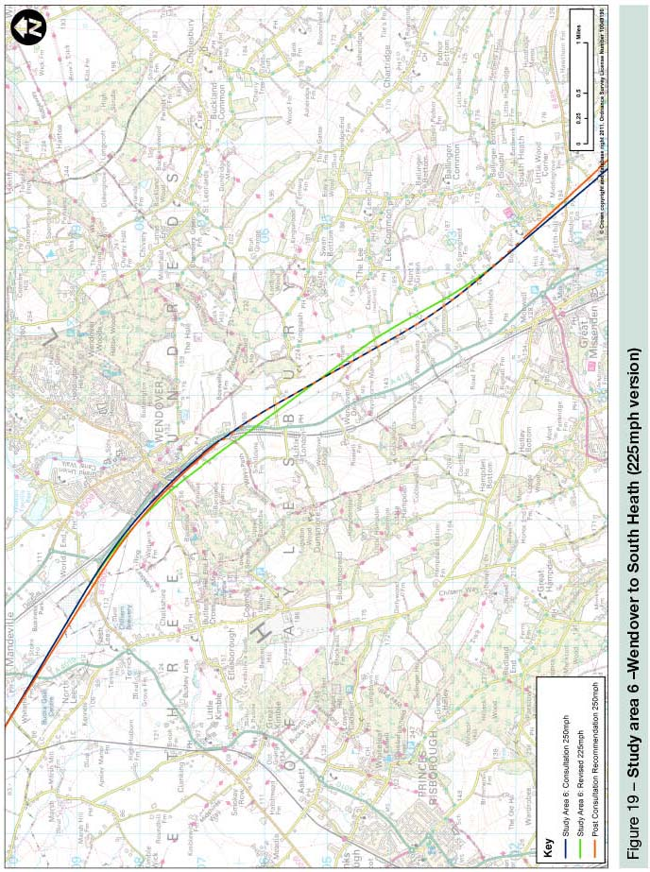
Conclusions
4.3.49 In summary, we have found that the sustainability benefits that could be achieved by adopting a lower design speed are, at best, marginal and restricted to a small number of locations along the route.
4.3.50 In part this is because sections at each end of the route, in London and Birmingham, already have a lower maximum speed. In the section where the consultation route was designed for the future possibility of 250mph operation, reductions are possible, but the small increases in flexibility of route alignment from a lower speed are not always sufficient to have a significant reduction in impacts. Impacts are generally moved from one area to another, as opposed to being eliminated in total, by adopting a lower design speed.
4.3.51 Any gains that can be achieved through a lower speed are, for the most part, not significantly greater than can be achieved through the changes we have identified in our Review of possible refinements to the proposed HS2 London to West Midlands Route report which maintain the design speed and so maintain benefits whilst allowing for future improvements in journey times.
4.4 Consultation route at a conventional speed
4.4.1 As well as examining high speed routes we have re-examined and carried out additional work on a railway designed to run at conventional speed, to assess the impacts of a railway at 125mph, the same speed as the WCML.
4.4.2 At consultation we stated the costs and benefits of building such a route. For the purposes of our work, the route followed the same alignment as the consultation route, with the same number of stations and the same service pattern.
4.4.3 We found that the costs of building such a railway would be around 9% less than that of a high speed line. Stations, structures, and earthwork costs would remain broadly the same, with the main savings generated from rail systems, power supply and smaller diameter tunnels.
4.4.4 Whilst costs would be 9% lower, the number of people travelling on the line would, due to the lower speed and therefore longer journey time, reduce by 19%, causing overall benefits to fall by 33%. Revenue would be 24% lower, resulting in a net cost saving (i.e. cost minus revenue) of £800 million (2009 Present Value) compared to a high speed line. The journey between London and Birmingham would take an extra 15 minutes over the high speed route.
4.4.5 Since consultation, we have re-run our noise assessment of a conventional speed route. The consultation route, if unmitigated and running at 225mph, would increase noise levels to such a level that just less than 1,400 properties would qualify for noise insulation. At 125mph, this number reduces to around 1,100 properties. However, when mitigated and including our recommended changes the impacts of the high speed option are reduced to such an extent that only approximately 60 properties experience such an increase in noise. It is likely that this figure would be further reduced during the EIA stage.
4.4.6 In light of the significant improvements achievable through mitigation, which do not affect journey times and therefore economic benefits, we consider that the case for maintaining a maximum speed of 225mph, with the potential at a future point in time to increase to 250mph, remains strong.
4.4.7 With all aspects considered, we remain of the view that a conventional speed route has a significantly worse economic case. Upgrading the line to high speed has a relatively small net cost to Government, but generates significant benefits to passengers on HS2. With a Y shaped network and longer distance journeys the impact of a conventional line speed would be even more critical, with longer journeys failing to contribute to closer connectivity between our major cities and therefore strengthening the rationale for the line to be high speed.

Part 3 – Route elements
5 Alternative stations
5.1 Background
5.1.1 The consultation presented a phase one network proposal that comprised four stations:
• a London terminus at a redeveloped Euston Station, offering onward connections to other parts of London via the London Underground network;
• a station at Old Oak Common, allowing an interchange between HS2 and Crossrail, the GWML and Heathrow Express;
• a Birmingham Interchange Station, linked to the National Exhibition Centre and Birmingham Airport via an Automated People Mover; and
• a Birmingham terminus at Curzon Street, a new station that would share a concourse with the existing Moor Street Station.
5.1.2 Phase one of the network would also include connections to the WCML north of Birmingham (allowing classic compatible services to run through to the north) and to HS1, allowing services to run from HS2 through the Channel Tunnel to the continent.
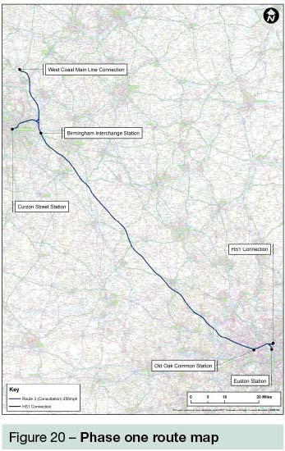
5.2 London Terminus Station – Euston
5.2.1 Of the four stations that make up the consultation route, Euston attracted the most comment. These were namely that an alternative London terminus station should have been proposed (typically either Old Oak Common or Stratford International), or that impacts at the station would be too great such that it should not have been considered in the first place (for example during construction, or in handling increased passenger numbers following the opening of HS2). The Transport Select Committee also recommended that the Government should reassess whether an alternate London terminus station would provide a better solution than Euston. Suggestions were also made that the station at Euston should be double-deck to reduce land take and impacts, or that options at stations such as St Pancras International, Waterloo or Paddington would be better.
5.2.2 The London station selection process in 2009 considered 27 possible sites in London and included Old Oak Common and Stratford options, along with other locations including St Pancras International, Waterloo and Paddington.
5.2.3 Stratford International was rejected, as locating the terminus outside of central London would have imposed significant journey time and interchange penalties on the majority of passengers who would be looking to travel to central London. Also the existing Stratford International station could not easily be expanded to accommodate an extra ten platforms and it would require a new tunnelled route from Old Oak Common. Passenger forecasts on the London Underground and Crossrail networks in the Stratford area showed little potential capacity for additional passengers transferring from HS2 at Stratford.
5.2.4 Paddington was rejected as a surface station option as it would require demolition of the Paddington Basin Development and a major hospital. A deep tunnel option was ruled out as being unfeasible and unaffordable, at a cost of around £6 billion.
5.2.5 A double deck station at Euston would, during construction, have major impacts on existing WCML services including partial closures of the station and cancellation of a proportion of services over several years.
5.2.6 The station could reach a height of 44 metres above ground level, leaving little room for further development above. For passengers, a double deck station could be more difficult to navigate. Costs would be around 15% to 20% higher, and such an option would create substantial visual and noise effects for residents to the East and West from the station throat and approach tracks.
5.2.7 Old Oak Common was rejected as the London terminus given that the journey time penalty for many central London passengers would reduce the benefits of HS2. Passenger dispersal would also be an issue, Crossrail being the only option for passengers to continue their journey rapidly into London. Any service interruption to Crossrail services would potentially result in having to close HS2 as passengers would have no adequate alternative onward connection option at Old Oak Common. A terminus station would also require more land than an intermediate station, and given constraints in the area such a proposition would be difficult. The additional land would include the Crossrail depot area and extend across the North London Line and central Line into a significant part of Park Royal.
5.2.8 The consultation set out our assessment that the number of passengers at Euston added by HS2 during the three hour morning peak is likely to be around 2% compared to the number of passengers already forecast to be on London Underground services passing through Euston. Should a decision be taken to proceed, we would work closely with Transport for London (TfL) as part of its wider ongoing strategy for modernising and improving Underground services given that the Northern and Victoria lines which stop at Euston are likely to be heavily crowded by this stage, even without HS2. This work would take into account any impacts from the wider Y network, in the design for phase one.
5.2.9 We would also continue to work with the London Borough of Camden to mitigate impacts in this area. Impacts on the listed building housing Royal College of General Practitioners are covered in our report Review of possible refinements to the proposed HS2 London to West Midlands Route.
5.2.10 We have also investigated the impact on Euston of linking Crossrail and the WCML. This work is detailed in section 7.4.
5.2.11 While we recognise that there are issues at Euston that would need further work in the next stage, we nonetheless conclude that a central London station is needed for HS2, and that Euston remains the best and indeed only feasible Central London location.
5.3 London Interchange Station – Old Oak Common
5.3.1 Aside from the question of Old Oak Common as a terminus station, which is discussed above, comment on Old Oak Common was largely focussed on the potential regeneration benefits it would bring, and on perceived poor connections with other forms of transport, or that a Heathrow connection would make such a station redundant.
5.3.2 Having considered the consultation responses, we remain of the view that a station at Old Oak Common should remain part of the proposed scheme. Our earlier work noted the potential of a station in this area to support the creation of a connection to Heathrow for phase one of the scheme, the new station would create a major interchange allowing passengers to change between HS2 services, the GWML, the Heathrow Express, and Crossrail which would run through to the West End, The City of London, Canary Wharf and into Essex. This enhances the journey time and attractiveness for passengers to and from these areas of London.
5.3.3 There are also opportunities for enhanced road access and connections to the West London Line and the London Underground, which could be investigated further in the next stage of design.
5.3.4 While Euston offers good onward connections for North and South London, Crossrail serves the East and West, and around one third of HS2 passengers are predicted to use Old Oak Common to change onto Crossrail, thus reducing the pressure and dependency on Euston.
5.4 Birmingham Interchange Station
5.4.1 Comment on Birmingham Interchange was focussed largely on the siting of the station and the implication that has for access to the exhibition centre and airport.
5.4.2 We have examined the station location, and conclude it is not practical to move it closer to the airport without having very significant knock-on impacts on communities to the north and south. However, we included as part of our proposals a people mover that would connect the station quickly and conveniently to the airport and National Exhibition Centre, and new local road access and car parking would be provided.
5.4.3 Alongside this, the area already enjoys good transport connections with the Greater West Midlands area with the M42 running north east to south west, and the A45 and A452 running around the eastern perimeter. Having considered the consultation responses, we remain of the view that with the large number of transport connections planned, the station location at Birmingham Interchange is correct.
5.5 Birmingham Terminus Station – Curzon Street
5.5.1 Positive comments noted the potential for a station to help regenerate the Eastside area. However criticisms regarding the proposed station in the centre of Birmingham focussed largely on the positioning of the station, often stating that it was not in the centre of Birmingham or was up to a 20 minute walk from Birmingham New Street.
5.5.2 With the Birmingham station being located close to the city centre, next to and sharing a concourse with Moor Street Station and with access to New Street provided either via a walkway, a proposed tram or a dedicated people mover, we have not undertaken any additional work on this issue. Curzon Street Station would be approximately an eight minute walk from New Street, the same as Moor Street currently.
5.5.3 We concluded in 2009 that Snow Hill Station was not a feasible option given that it would require the rebuilding of tunnels at either end and would need expansion into the existing city centre. The tunnel rebuilding may be impossible given the shallow nature of the southern tunnel and the existing infrastructure built above the tunnels on the surface.
5.5.4 A through station option at New Street was not taken forward given that it would require the removal of junctions to the east and west of the station, severely restricting regional rail access to the city centre. A terminal station was not pursued further for similar reasons following a detailed feasibility study.
5.5.5 In both cases, New Street Station capacity is already constrained with current schemes underway to expand Moor Street Station. We concluded that using New Street as the HS2 terminus would necessitate displacing up to 50% of the existing rail services to a newly built station.
5.5.6 We remain confident in our choice and that a station at Curzon Street could form part of an integrated transport complex. Local delivery partners, such as the local authority, concurred with our assessment. We would work closely with these partners and other relevant bodies should the decision be taken to proceed.

6 Intermediate stations

6.1.1 As covered above, the consultation route included four station options, with no so-called ‘intermediate stations’. We have previously looked at the case for an intermediate station in-between the proposed stations at Old Oak Common and Birmingham Interchange.
6.1.2 While benefits would be generated for the users of a station located at either Bicester (serving Oxford) or Milton Keynes, the impact on other HS2 passengers and total line capacity was found to be such that no intermediate station was included in the proposed scheme for consultation.
6.1.3 Many consultation responses stated that a lack of intermediate stations meant that local benefits did not accrue to areas along the route, assuming benefits would be focussed around the stations. A smaller number of responses made mention of specific proposals or locations for such a station. We have therefore re-examined our initial work, but have not undertaken new, additional work relating to a specific intermediate station option.
6.1.4 Stopping a train at an intermediate station would result in the loss of up to one following train path, so stopping three trains in each direction over the course of an hour would reduce capacity by around 20%. This would mean foregoing relatively full and high value services between London and Birmingham and Manchester during phase one of the network. This is particularly significant for the London to West Midlands section which acts as a trunk route both for phase one of operation and for the wider, longer term network.
6.1.5 In addition, many trains running on HS2 would be unlikely to have large numbers of spare seats when reaching an intermediate station, particularly during the peak hour. Therefore there would be no value in stopping already full HS2 trains at an intermediate station. Dedicated commuter trains could be run from an intermediate station but only by replacing a long distance train.
6.1.6 Having reconsidered the case for intermediate stations, we remain of the view that the phase one proposal should not include an intermediate station.
6.1.7 During our reconsideration of intermediate stations, we have also explored the option of spreading local benefits from HS2 by means of additional connections to the existing rail network between London and Birmingham. This is discussed in the next section.

7 Additional connections from the classic network to HS2
7.1 Background
7.1.1 Consultation responses suggested that another way in which the benefits of HS2 could be spread over a wider area would be through the provision of alternative connections from the classic network to HS2. With such connections, a HS2 classic compatible train (one that is capable of running on both the existing rail network and the new high speed rail network) could be used to offer services to an increased number of destinations to or from HS2 stations.
7.2 Connections from lines that cross the London to West Midlands section
7.2.1 We have studied these suggestions, and have identified a number of connections that could be made from lines that cross the London to West Midlands route section. These connections include:
• at Old Oak Common, a connection to the GWML allowing trains that had joined HS2 further north to access either Paddington or Crossrail;
• at Greenford, a connection to the existing railway (a branch off the GWML) allowing passenger trains which have joined the HS2 route further north to access London Paddington, Crossrail, and the westbound GWML towards Heathrow and Reading;
• at West Ruislip, a connection to the Chiltern Main Line allowing interchange of traffic between the two lines;
• south of Wendover, a connection with the Chilterns Aylesbury Line permitting a service from Aylesbury Vale and stations north of Wendover into London, also releasing capacity on the London Underground Metropolitan Line to Amersham and Chesham;
• near Aylesbury, a connection with the Chilterns Aylesbury to Princes Risborough line permitting a service for Aylesbury and Aylesbury Vale into London;
• near Calvert, a west facing connection into a reopened Oxford to Milton Keynes route;
• near Kenilworth, a south facing connection onto the Coventry to Royal Leamington Spa route offering an alternative route to London from either of those places; and
• at Berkswell, a connection with the Birmingham to Coventry line.
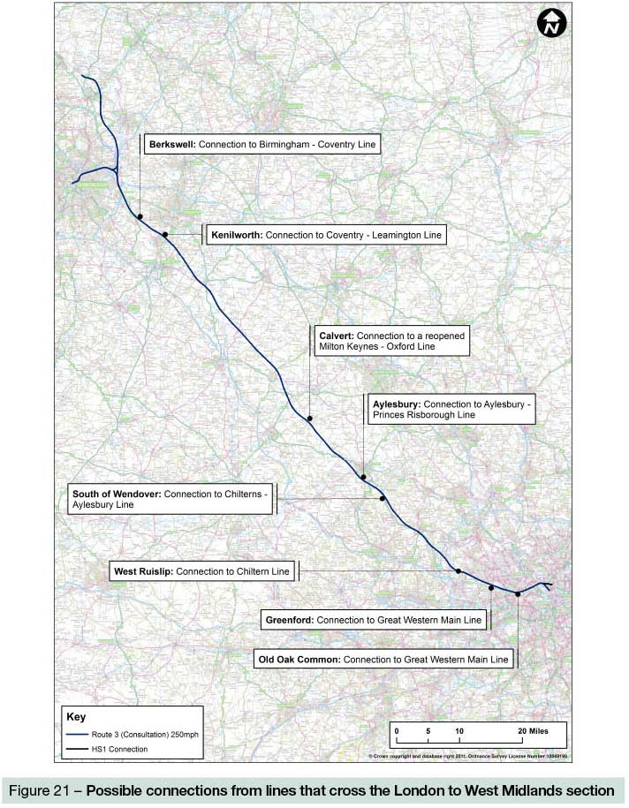
7.2.2 None of these connections would necessitate changes or specific provision during the development of the route between London and the West Midlands, and so can be given further consideration either during the detailed design stage or at a later date.
7.2.3 It should be noted, however, that any such connections would, if implemented, reduce capacity on the network between London and the West Midlands. Given our current predictions of demand and associated services, we therefore do not consider that such connections would provide the best use of the core London to West Midlands trunk.
7.2.4 They would also have environmental impacts, for example through requirements for grade-separated junctions. In the case of the three Chiltern Line options, electrification would also be required.
7.2.5 At this stage we do not consider there is a good case to provide additional connections from lines which cross HS2, although they could be investigated further at a later date if, contrary to our current view, there was sufficient capacity on the route to accommodate such services without detriment to the key inter-city services.
7.3 Connections to other lines from the London to West Midlands section – the Midland Main Line
7.3.1 Views were expressed during consultation and by the Transport Select Committee that some of the benefits of HS2 could be spread to the East Midlands and South Yorkshire as part of phase one by creating a connection to the MML. This is in the context of the phase one proposal including a connection to the WCML, meaning that classic compatible services could run from Euston onto the existing WCML north of Lichfield, offering journeys to Liverpool, Manchester, Preston and Glasgow.
7.3.2 We considered an option for a grade-separated junction in the Lichfield area, linking to the Lichfield – Wichnor Junction freight line to enable services to continue by way of Burton-on-Trent and Derby to Sheffield as part of our original work during 2009. This would, however, have required electrification of the MML at substantial additional cost, as well as electrification of the line between Lichfield and Derby. Therefore this option was not pursued given the consultation Y network proposal to extend HS2 to Manchester and Leeds, incorporating the East Midlands and South Yorkshire.
7.3.3 In response to consultation, we have re-examined the options for connecting to the MML as part of phase one, in particular given that there is greater likelihood that the MML would be electrified as part of the process that determines rail infrastructure work, the High Level Output Specification.
7.3.4 Our further work has found that the junction for such a connection would need to be a substantial construction in the area where it is likely that there would need to be junctions off the main spine of HS2 to Manchester as part of phase two. Given that the existing railways here are already on two different levels, it would not be possible, at least without significant local impact and expense, to have two grade-separated junctions in close proximity on the outskirts of Lichfield.
7.3.5 We have also considered the timing and deliverability of a connection to the MML as part of phase one, in advance of any examination of the potential costs and benefits.
7.3.6 Based on the published timeline for phase one of HS2, we believe that it is not possible to include a connection to the MML as part of the hybrid bill for the London to West Midlands line. Undertaking the necessary engineering and environmental work, followed by consultation and, subject to confirmation, further design and EIA, would extend beyond the proposed date of lodging the hybrid bill in 2013.
7.3.7 Delaying this first hybrid bill to include such a proposal would potentially bring a benefit to a relatively small number of people, compared to the larger number of people affected who would have to wait longer for additional capacity to be provided on the WCML. The benefit in any event would be shortlived, as on the current proposals the East Midlands would be served by HS2 in 2032 to 2033.
7.3.8 Given these timing considerations we have not undertaken detailed economic analysis of the potential costs and benefits of such a connection.
7.3.9 In conclusion, in light of the cost and impact of a connection towards the MML and the inability to design it in line with the phase one timetable we remain of the view that there is no case for this proposal to form part of phase one of the network.
7.4 Linking Crossrail and the West Coast Main Line
7.4.1 Consultation responses have suggested that providing a direct connection between Crossrail and the WCML would be beneficial for crowd dispersal at Euston, and potentially reduce the footprint of the station.
7.4.2 We have assumed that any such connection would need to retain the currently assumed frequency of Crossrail services at Old Oak Common to provide an attractive interchange for HS2 passengers. As such, the connection would need to be provided to the west of Old Oak Common station to ensure that all Crossrail services would continue to serve Old Oak Common.
Engineering
7.4.3 The connection would need to be in tunnel as there is no surface route available without significant property impact. From the Crossrail lines it would enter tunnel to pass under the existing Old Oak Lane, west of the proposed Old Oak Common station. The tunnel would then head northwards and emerge in the rail land at Wembley.
7.4.4 The tunnel would be about two and a half miles long and would take about two years to construct (advancing at 15m a day), with grade separated junctions onto WCML and GWML, taking another two years. As such, we estimate construction would take roughly four years. The link would displace the maintenance depots at Old Oak Common as well as several residential properties.
7.4.5 It is unlikely that the link could be built before HS2 construction would start in 2017. The powers for construction could not be granted much before HS2 powers as the process is broadly similar. It could not be constructed at the same time as HS2 but that would add some risk through extra complexity of simultaneous construction activity in the constrained Old Oak Common and Wembley area. It would be preferable to construct such a connection after the construction of phase one of HS2 but in advance of the opening of the full HS2 Y network, meaning this would be delivered before further increases in passenger numbers from HS2 at Euston. In terms of construction, we estimate it would cost in the region of £600 million.
Implications for rebuilding Euston
7.4.6 It is understood that Crossrail trains will be configured internally as inner-suburban trains, with minimal seating and large standing areas. As such, it is unlikely that these trains would run beyond the inner suburban areas and they are not expected to replace the longer distance Rugby or Northampton trains. For the purposes of this analysis, we have assumed that the two Tring services, two peak Watford services and two Milton Keynes services per direction per hour would migrate and become Crossrail trains using the link.
7.4.7 This would remove up to six trains an hour from Euston, requiring one less island platform on the classic side of the station. Theoretically this would allow the station width to be reduced by up to 16m.
7.4.8 However, the critical factor for the station size is the throat, which is constrained under Hampstead Road. Therefore we estimate that the overall footprint could only be reduced by six metres. We do not believe that this would make a substantial difference to the impacts of the expanded station on the local area. It would not reduce the number of demolitions required to construct the station.
7.4.9 If a Crossrail/WCML link could only be brought into service four years into the construction period of Euston, there would be few savings in the staging works necessary, therefore there would be no significant financial benefit.
Demand and crowding
7.4.10 In terms of economic impacts, there may some benefits to HS2 as a result of HS2 passengers travelling to or from places on the WCML being able to access HS2 or HS1 at Old Oak common instead of changing at Euston. Passengers might be expected to save around 15 minutes on such journeys by avoiding having to travel in to and out of London and having an easier interchange.
7.4.11 On the other hand there would be some disbenefits to HS2 as a result of Crossrail trains serving Old Oak Common having higher levels of crowding, although given that there is substantial capacity available on Crossrail west of Old Oak Common, this is unlikely to be a significant problem. Although we have not undertaken any detailed demand or economic analysis of this scheme, we would not expect either issue to have a significant impact on the business case for HS2.

Conclusion
7.4.12 In light of the potential benefits such a connection may bring including the potential for reducing passenger crowding at Euston, we recommend that this proposal should be studied further, involving the Department for Transport and TfL. However, given the discussion above we do not consider that the current HS2 designs for Euston should be changed, and that any construction of this link should follow after the construction of phase one of HS2.

8 Infrastructure Maintenance Depot
8.1 Background
8.1.1 Consultation responses suggested that the proposed location of the IMD at Calvert would be disruptive to the local community and that a better location could be found. In response to these comments, we have investigated whether an alternative, feasible site with reduced impacts could be adopted.
8.1.2 An IMD would be needed as a base for maintenance of the track, signalling equipment, cuttings and embankments, and other elements of the HS2 infrastructure. It would require access to the road network and must have access to the existing rail network so that heavy rail machinery and supplies could be brought to it. To allow reasonable access to all sections of the track, the depot would need to be located approximately midway between London and the West Midlands. Access to the rail network allows deliveries to the depot to be brought in by rail therefore avoiding the need to use local roads, thus reducing the impact on any nearby community, or on the proposed HS2 line which would affect services.
8.1.3 The proposed depot site at Calvert is sited alongside the proposed route and immediately north of the existing Oxford to Bletchely railway line. The depot would be connected by rail to the existing network and would be accessible by road.
8.1.4 Seven sites were considered, all of which were near Calvert and close to the East – West Line. For consultation the Government proposed a location in between Calvert and Steeple Claydon.
8.2 Investigation of a new, alternative location
8.2.1 Further examination of alternative locations for the IMD generated six possible options, all between Quainton and Fleet Marston, north of Aylesbury. Two preferred options, close to Fleet Marston, were considered in more detail.
8.2.2 The two alternative locations would be situated to the north-west of Aylesbury Vale Park Station, between Aylesbury and Waddesdon Village close to the A41.
8.2.3 One option, known as Option 5, would be situated immediately south of the former Great Central Railway line approximately one mile to the east of Waddesdon. Any connection to the existing railway line would need to be undertaken by two short spurs, although no detail relating to the spurs or required road infrastructure for this depot was considered for this level of assessment.
8.2.4 The other option, known as Option 6 would be situated immediately north of the main HS2 railway, approximately half a mile west of Aylesbury Vale Parkway station, connecting by two short spurs to the Great Central Railway corridor. Again, no detail relating to the required spurs or a linking road was considered at this level of assessment.
8.2.5 Both alternative options would be close to a main road. However, both are remote from the existing railway line at Calvert which is the access point for rail-based material and equipment supply.
8.2.6 For Option 5, materials and spoil trains could travel south from Calvert through Quainton Road to the proposed depot site. However new railway lines would be required to connect the depot to the HS2 line itself in the vicinity of Waddesdon. Option 5 would therefore cost around £123 million compared with £50 million for the consulted option.
8.2.7 Option 6, located alongside the HS2 tracks in Aylesbury Vale, is not adjacent to existing railway lines. It would be necessary to construct a new freight line for some four miles southwards from Quainton Road, the nearest point of existing railway. This new line could be aligned close beside the HS2 route but would increase the width of the new corridor by typically six to eight metres. The cost of Option 6 would be around £138 million.
8.2.8 Ideally the IMD would be located in the middle of the phase one route to minimise mileage travelled. Both the alternative options would involve higher train operation cost involving higher mileage for all freight trains supplying the depot. We have not undertaken a detailed assessment of such costs at this stage.
8.2.9 In terms of sustainability assessments, there was very little to distinguish between the three depot site options in terms of direct land take. All options would require approximately the same amount of land take for the depot.
8.2.10 In terms of close proximity to households, the options were very similar, although the nearest property to the Calvert depot would be approximately 100m away. However, given the proximity to large new housing development area of Berryfields both alternative options could result in greater impacts on land with potential for development.
8.2.11 Either alternative option is likely to have bigger visual impacts within the landscape in comparison to the Calvert proposal. Both options are surrounded by higher land and elevated viewpoints, such as Waddesdon Hill and Quainton Hill and are thus more visible in the Aylesbury Vale landscape which is more open and flat in comparison to Calvert.
8.2.12 Assessments of cultural heritage identified a marginal increase in impacts caused by Option 6, due to proximity to Eythrope Park Grade II Registered Park and Gardens. Whilst no designated archaeological features would be directly impacted by any option, Option 6 would bisect a known 500m length of the Akeman Street (Roman Road) which is part of a Planning Notification Area, indicative of the former location of Fleet Marston Roman Town.
8.2.13 Having considered in detail alternative locations for the IMD, we consider that our original proposal at Calvert Green is the best and most appropriate option. It offers the least disruption to communities and performs about the same in terms of sustainability principles. During the EIA stage and in response to consultation comments we would work with the local authority and others to minimise local impacts, in particular on the existing road network. In operational and cost terms, the Calvert site is also preferred.

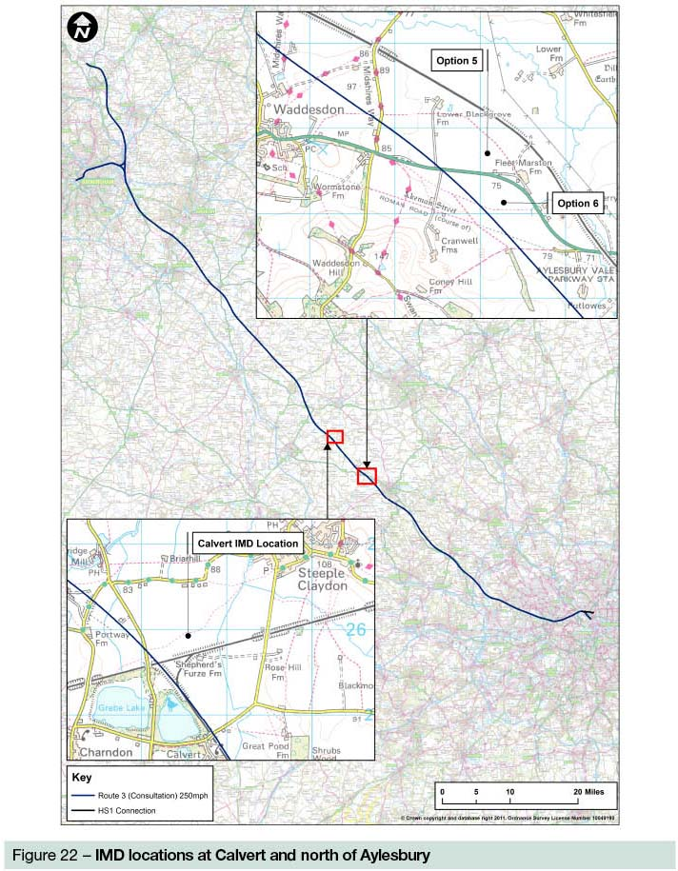
9 References
Department for Environment, Food and Rural Affairs, 2005, Securing the Future – delivering UK sustainable development strategy, http://www.defra.gov.uk/publications/2011/03/25/securing-the-future-pb10589/
Department for Transport, 2011, High Speed Rail: Investing in Britain’s Future Consultation, http://highspeedrail.dft.gov.uk/sites/highspeedrail.dft.gov.uk/files/hsr-consultation.pdf
Dialogue by Design, 2011, High Speed Rail: Investing in Britain’s Future Consultation Summary Report, a report for the Department for Transport
HS2 Ltd, 2009, High Speed Rail London to the West Midlands and Beyond – a report to Government by High Speed 2 Limited
HS2 Ltd, 2011, Economic Case for HS2: Updated appraisal of transport user benefits, a report for the Department for Transport
HS2 Ltd, 2011, Review of HS2 London to West Midlands Appraisal of Sustainability, a report for the Department for Transport
HS2 Ltd, 2011, Review of possible refinements to the proposed HS2 London to West Midlands Route, a report for the Department for Transport
HS2 Ltd, 2011, Review of the Technical Specification for High Speed Rail in the UK, a report for the Department for Transport

See High Speed Rail: Investing in Britain’s Future Consultation Summary Report
See Review of possible refinements to the proposed HS2 London to West Midlands Route, Review of the Technical Specifications for High Speed Rail in the UK, Review of HS2 London to the West Midlands Appraisal of Sustainability and Economic Case for HS2: updated appraisal of transport user benefits
Department for Transport (2011) High Speed Rail: Investing in Britain’s Future Consultation, pages 77 to 79
See Review of possible refinements to the proposed HS2 London to West Midlands Route report
Department for Environment, Food and Rural Affairs, 2005, Securing the Future – delivering UK sustainable development strategy, http://www.defra.gov.uk/publications/2011/03/25/securing-the-future-pb10589/
HS2 Ltd (2011), Economic Case for HS2: The Y Network and London West Midlands, pages 45 to 46
High Speed Rail London to the West Midlands and Beyond – A Report to Government by High Speed Two Limited, pages 53 to 68
HS2 Ltd (2009) High Speed Rail London to the West Midlands and Beyond – A Report to Government by High Speed Two Limited, pages 89 to 92

