



CASE STUDIES

BACKGROUND

Out-of-hours deliveries to retail premises, comprising quiet deliveries at night-time and also during the “shoulders” of the day (i.e. prior to opening, after closing), away from peak periods, potentially offer significant benefits to retailers and transport operators, in addition to wider social and environmental benefits:-

Operational Benefits | Wider Potential Benefits
Reduced round trip times | Improved local air quality
Reduced store turnaround times | Improved local road safety
Reduced fuel consumption | Reduced congestion
Improved shift productivity | Better accessibility
Increased product availability | Reduced carbon emissions

From both a logistics and retailing perspective, out-of-hours deliveries make sound operational sense. However, such deliveries may also have an adverse impact on local residents and local communities. Noise from vehicle manoeuvring and loading / unloading activity can impact on local residents, particularly at times of the day when ambient noise levels are low. HGV movements in urban areas are therefore often constrained during night-time and / or weekend periods by local curfew regulations put in place to avoid noise impacts. These include delivery curfew restrictions imposed by planning conditions, noise abatement notices or local agreements between retailers and the local authority / local residents.

If these regulations are to be relaxed, retailers need to be able to demonstrate that any out-of-hours delivery activity will be undertaken in a way that minimises disturbance and disruption to local residents, while continuing to meet the operational needs of the business.

QUIET DELIVERIES DEMONSTRATION SCHEME (QDDS)

In November 2009, the Department for Transport (DfT) established a consortium, in partnership with the Freight Transport Association (FTA) and the Noise Abatement Society (NAS), in order to investigate and promote the potential benefits from relaxation of delivery curfews for quiet deliveries. The QDDS consortium has overseen the whole scheme which has involved the setting up, running and reporting on quiet delivery demonstration trials at an intended six retail premises across England. The Scheme was managed by freight specialists at transport consultants, Transport & Travel Research Ltd (TTR).

Both retailers and local authorities were invited to participate and to submit applications for stores with delivery curfew restrictions, anywhere within England, to be the trial stores participating in the Scheme. Applicants were requested to complete an application form and submit relevant supporting information, advising the current restrictions in place. From the applications, a total of six trial sites were chosen by the consortium.

A standard methodology was developed, focusing on the formation of local trial working groups, involving both the retailer and the local authority working in partnership, with TTR acting as the trial facilitator. It was the responsibility of the local working group to oversee the trial and agree the working practices and necessary noise mitigation measures to be implemented at each trial site. As well as minimising disturbance to local residents, further aims of the trials were to demonstrate:-

- Improved journey times;
- Improved availability and sales of stock; and
- Improved fuel economy, emissions and air quality

The NAS were responsible for carrying out “site assessments”, offering recommendations on noise mitigation measures and providing a noise complaint telephone helpline for local residents to contact during the actual trials. On-site noise monitoring was also carried out both before and during the trial by the Transport Research Laboratory (TRL). The six trials, reported in detail in this document, consisted of the following participants:-

RETAILER | LOCAL AUTHORITY | LOCATION OF STORE | TYPE OF RESTRICTION
Sainsbury’s | Bournemouth Borough Council | Bournemouth, Dorset | No existing restriction but store ‘at risk’ of curfew
Marks & Spencer | Chichester District Council | Chichester, West Sussex | Voluntary agreement in place
Morrisons | Stafford Borough Council | Stone, Staffordshire | Voluntary agreement in place
Asda | Walsall Borough Council | Bloxwich, Walsall | Voluntary agreement in place
Superdrug Stores | City of Westminster | Westminster, London | Voluntary agreement in place
Tesco | Reading Borough Council | Reading, Berkshire | Statutory planning condition in place

Trial 1



INTRODUCTION

The Sainsbury’s Castlepoint store, located in Bournemouth, is a major retail supermarket located within a substantial shopping complex. The store is surrounded by residential properties and already has a set of Sainsbury’s “Respect our Neighbours” policies in place, overseen by Store Management, to help minimise disturbance to local residents. The store is serviced via a shared service yard, in close proximity to adjacent residential property, to which other retailers have access.

Bournemouth Borough Council had received on – going complaints from residents concerning alleged night-time delivery noise from the Sainsbury’s premises and it was felt that if steps were not taken to reduce the perceived disturbance to local residents, then enforcement action might be necessary. The history of the complaints relating to the site dated back a number of years and a local agreement had been put in place with Sainsbury’s undertaking not to move roll cages in the yard from 23.00 – 06.00 hours.

The initial inquiry to set up a QDDS trial was received from Bournemouth BC at the same time that the QDDS consortium was in discussion with Sainsbury’s in relation to the selection of proposed stores for participation in a trial. Hence, the decision was taken by the consortium to choose Sainsbury’s Castlepoint as one of its preferred trial stores, with Sainsbury’s recognising the opportunity to resolve current concerns at the store by introducing additional best practice in delivery operations.

In April 2010, a Sainsbury’s Bournemouth QDDS working group was formed, comprising the following representatives:-

- Environmental Health Officers, Bournemouth Borough Council
- Store Management, Sainsbury’s Castlepoint Store
- Logistics Management, Sainsbury’s
- Transport Night Shift Management, Sainsbury’s
- Logistics Environment Management, Sainsbury’s
- Working Group Facilitator, QDDS Project Team

PRE – TRIAL PROCEDURES

The deliveries that would form the focus of the QDDS trial were those undertaken at 23.00, 02.00 and 04.00 hours respectively. From a Sainsbury’s perspective, overnight deliveries were essential to the store’s operation, supporting the store being ready to trade at 07.00 hours.

The first Working Group meeting took place on 12 April 2010 and brought all the partners together to assess the potential for a trial, explain the background to the QDDS concept, understand each party’s objectives for participation in a trial and to agree the practicalities and timings of a trial. It was also agreed at the first meeting that direct suppliers of bread and milk (also currently delivering to the store through the night) should also be invited to participate in the trial and should be invited to subsequent working group meetings, along with representatives of Castlepoint Centre Management.

The NAS also attended the first meeting to gather important background information on the site and its complaint history. In addition, the NAS also undertook covert and overt site assessments, observing a daytime delivery to determine likely noise sources and to further review the delivery site.

The second Working Group meeting took place in late April 2010, primarily to discuss the findings in the NAS site assessment report, in particular the potential noise sources and recommendations for introducing noise mitigation measures. The key noise risk areas identified by NAS included:-

- Noise from roll cage movement;
- Noise from delivery vehicles (e.g. reversing alarms, engine noise, refrigeration equipment);
- Noise from unloading activity (e.g. use of pallet trucks)
- Noise from the delivery site (e.g. yard gates)
- Noise from staff involved in the operation (e.g. drivers, store employees)
- Noise from independent “direct” deliveries

A series of actions was agreed by the Working Group to further improve delivery practices and minimise associated noise. It was then agreed by all members that a trial would be feasible following implementation of simple noise mitigation measures.

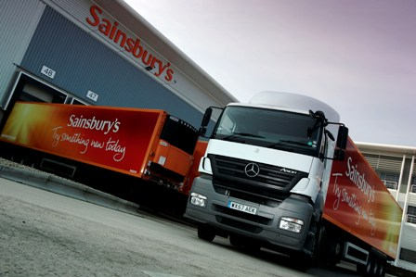

(FIG 1: Sainsbury’s delivery vehicle)

MEMORANDUM OF UNDERSTANDING / DRIVER CHARTER

The Working Group agreed that selected actions should be incorporated into a “Memorandum of Understanding” (MoU) which all parties were asked to approve and observe. Various drafts of the MoU were written before being finalised but the key operational issues / actions included were:-

- The trial start date (originally 7 June 2010 but subsequently amended to 31 May 2010) and expected duration (initially one month but ultimately extended to six weeks);
- The deliveries to be included for the QDDS trial (i.e. Sainsbury’s deliveries at 23.00 / 02.00 / 04.00 hours, plus inclusion of direct bread and milk deliveries);
- An undertaking by Bournemouth BC to brief elected members about the trial; reporting arrangements (both periodical and in the event of an issue, incident or complaint) among working group members; and
- A commitment by Sainsbury’s to brief and train store staff on practices to be adopted during the trial to minimise noise

In addition, a “driver charter” was developed by Sainsbury’s to brief drivers on required practices when delivering to the store during the trial; this included an explanation of the trial, its purpose and a set of required driver actions (e.g. do not sound horn, switch off reversing alarms, switch off engines when not manoeuvring).


(FIG 2: Sainsbury’s Castlepoint store)

KEY RESULTS / FINDINGS

After discussions amongst the working group, the live trial commenced on 31st May 2010, with the noise monitoring equipment in place and operational and the NAS helpline set up. During the trial, weekly progress reports were circulated and Bournemouth BC arranged for a local resident to complete noise logs, which were distributed to working group members. The members of the working group remained in contact during the trial, with a final working group meeting held on 6 July 2010 to review trial progress and agree next steps. The trial formally ceased on 12 July 2010.

It was agreed by all working group members that the trial was a success. The key success factors were:-

- No complaints had been received through the NAS helpline or by Store Management during the trial period;
- On – going protection of the existing night-time delivery profile (i.e. 23.00 / 02.00 / 04.00 hours)
- The establishment of an effective working relationship between Bournemouth BC and Sainsbury’s
- The introduction of best practice measures in line with the MoU which would continue post QDDS trial
- The involvement of local residents in completing noise logs and engaging with the Working Group, via the local authority
- The successful involvement of ‘direct deliverers’ (bread and milk) within the trial and their willingness to disseminate best practice (including the contents of the Driver Charter) within their own businesses
- The proactive involvement of Transport Shift Management to ensure drivers adhered to the agreed practices

The noise monitoring results indicated that the introduction of operational best practice can have a minor impact upon the whole delivery and loading / unloading procedure but the major contributor to noise levels remains the vehicle engine upon arrival, on-site manoeuvring and departure.

In terms of operational efficiency, Sainsbury’s reported improvements in fuel consumption of 5.7% for night – time operations compared to daytime equivalents. The store itself also reported trading benefits of night – time deliveries with improved stock replenishment and availability, as well as better utilisation of store staff.

The Sainsbury’s / Bournemouth BC trial has successfully demonstrated that night – time deliveries can be undertaken without adversely affecting neighbouring residents and, following the trial, the delivery times have remained as they were, overseen by both parties who continue to monitor store delivery performance.

“Sainsbury’s are a keen supporter of trials such as this, which promote the development of great working relationships between ourselves, local residents and local authorities. The successful outcome of the trial demonstrates that working together in this way can deliver sustained results which all parties can be satisfied with.”
(Environment Manager for Logistics, Sainsbury’s)

Trial 2



INTRODUCTION

The M&S store located in Chichester town centre is a general retail High Street store. The store is one of many within the main pedestrian shopping complex of Chichester but it has its own enclosed delivery bay located on a side street. Access to the delivery bay is undertaken via side roads / streets before a reversing manoeuvre has to be undertaken by the delivery vehicle into the delivery bay. The delivery bay itself is located directly opposite a small newsagent shop, which has residential flats located above it, less than 10 metres from the delivery bay doors.

No statutory restrictions had been imposed on the store by Chichester DC, although an informal local agreement did exist between the store and local residents, stipulating that the first daily delivery would take place at 06.30 hours and not before. The agreement was put in place to alleviate the concerns of a local resident who was familiar to and previously engaged with store management representatives.

The initial inquiry to set up a QDDS trial was received from the Logistics Department of M&S who indicated a preference to undertake the first delivery at the Chichester store at 06.00 hours, in order to assist the store in being ready to trade when opening for business. The decision to hold a QDDS trial involving M&S and Chichester DC was approved by the QDDS Consortium and the initial QDDS procedures were then put into place.

In June 2010, an M&S Chichester QDDS working group was formed comprising the following representatives:-

- Senior Environmental Health Officer, Chichester District Council
- City Centre Manager, Chichester District Council
- Finance & Operations Manager, M&S Chichester
- Logistics Manager, M&S Supply Chain
- Logistics Manager, GIST UK Ltd (M&S distribution contractor)
- Working Group Facilitator, QDDS Project Team

PRE – TRIAL PROCEDURES

The delivery that would form the focus of the QDDS trial was a 06.00 hours delivery previously undertaken at 06.30 hours. The first Working Group meeting took place on 21 June 2010, bringing all the parties together to assess the potential for a trial, discuss the history of store issues and previous complaints, assess the “delivery environment” and agree the practicalities and timings of a trial.

As per the QDDS trial methodology, the NAS attended the initial Working Group meeting to listen and input into the discussions but also to undertake the formal site assessments, both covert and overt, to determine likely noise sources and possible mitigation measures.

The second working group meeting took place on 12 July 2010 with the focus on discussing the findings provided by NAS in their site assessment report and the conclusions coming forward to introduce measures to reduce noise during the trial. The key noise risk areas identified by NAS included:-

- Noise from vehicles (e.g. engine idling while delivery bay doors are opened, vehicle reversing in close proximity to residential flats);
- Noise from the delivery bay (e.g. delivery bay doors, staff entry buzzer); and
- The vehicle not being fully enclosed within the delivery bay

Following discussions about the NAS report, members of the Working Group agreed and undertook to further improve delivery practices to minimise noise during the trial so as to avoid potential complaints from residents. Once these practices had been developed and introduced, members confirmed that a QDDS trial should proceed.
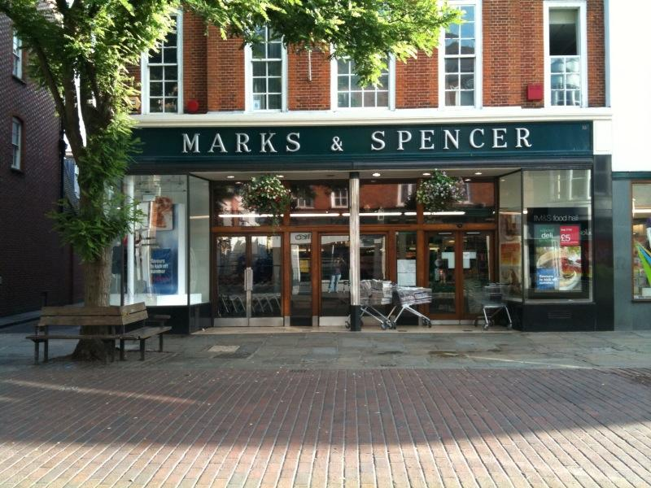

(FIG 3: The M&S store in Chichester)

MEMORANDUM OF UNDERSTANDING / DRIVER CHARTER

In compliance with QDDS procedures, an MoU was drafted incorporating the key operational elements of the trial. The key items were:-

- The trial start date (9 August 2010 but subsequently amended to 16 August 2010) and expected duration (6 weeks);
- The deliveries to be included, incorporating QDDS measures and procedures (i.e. 06.00 delivery Monday – Saturday);
- A commitment by all parties, most notably the store, to introduce noise mitigation measures ; and
- An undertaking by M&S / GIST to record operational data on journey times, fuel consumption, idling time, travelling speed and turnaround times prior to and during the trial.

Furthermore, M&S Supply Chain / GIST UK Ltd made a commitment to develop a “Charter” of required driver behaviour for both during and after the trial, including an explanation of the trial and its purpose and the importance to the commercial success of the Chichester store of maintaining out-of-hours deliveries.



(FIG 4: The access road to the M&S Chichester Delivery Bay)

KEY RESULTS / FINDINGS

The live trial commenced on 16 August 2010, by when the noise recording equipment was in place and operational, the NAS helpline was set up and signage was erected at the delivery bay, displaying the helpline number. Additional signage advertising the helpline was also affixed to the dedicated low noise trailer used to service the Chichester store.

All elements of the MoU had either been addressed or were to be addressed as the trial progressed and contact between working group members was maintained throughout the trial. A final Working Group meeting was arranged for 4 October 2010 to review the formal 6 week trial and agree next steps. The trial formally concluded on 27 September 2010.

The M&S Chichester QDDS trial was considered a success by all members of the Working Group, with the critical success factors highlighted below:-

- No formal complaints had been received through the NAS helpline, by Store Management or direct to Chichester DC during the trial;
- Additional best practice measures had been introduced in line with the MoU and Driver Charter documents, which would continue post trial;
- An agreement was reached by M&S and Chichester DC that M&S should continue with the 06.00 hours delivery beyond the trial period but that this would be subject to review over the coming months;
- The QDDS trial had provided a platform for both parties (i.e. M&S and Chichester DC) to work more closely together, to bring about further effective improvements in operational practice

In terms of the noise levels that occurred during the trial, the prime contributor to levels in excess of 75db (decibels) was the vehicle actually arriving at / leaving the delivery bay and the reversing manoeuvre that had to be undertaken. However, noise levels taken during the trial cannot be attributed solely to M&S early morning vehicle activity, as other vehicles of a similar size and noise level (e.g. refuse vehicles) were observed to operate in the area at similar times.

In terms of operational efficiency, M&S reported improvements in both fuel consumption and journey times from Regional Distribution Centre to store.

The store itself also reported benefits in terms of stock arriving and being made available on shelves in time for store opening, thus providing better customer service and an all-round improved shopping experience for customers.

The M&S / Chichester QDDS trial has demonstrated that early morning deliveries can be brought forward by small incremental amounts (30 minutes in this case) without causing undue disturbance to local residents. These incremental changes to delivery profiles can be of significant benefit to retailer’s transport and store operations.

The delivery time of 06.00 hours is still in place as a result of investment from M&S in measures to reduce noise (e.g. the use of under – slung refrigerated trailers). M&S will continue to operate best practice and identify continual improvements to reduce noise whilst being mindful of local resident sensitivity.

“The City Centre Partnership was pleased to be involved in this trial. The CCP facilitated the coordination of this trial with the County Council, District Council, Parish Council, residents and neighbouring businesses to support M&S in the successful implementation of this change to their operational procedures. In doing so, it helped M&S serve its own customers better, which benefits the City. Where appropriate, the CCP will work with businesses who wish to see developments in their operational procedures and help to minimise the conflict and effect on the City as a whole.”
(City Centre Manager, Chichester District Council)
Trial 3



INTRODUCTION

The Morrisons store located in Stone (Staffordshire) is a major retail supermarket located approximately 2 miles from the A34. The store itself is a purpose-built unit with its own service / delivery yard housed towards the rear of the store. Access to the yard is via a side road and vehicles perform a 180 degree turn in the yard before reversing onto one of two delivery bays. The service yard is located opposite blocks of residential flats which are approximately 40 metres away from the delivery bays and are elevated above the yard.

No statutory restrictions had been imposed by Stafford BC although noise complaints had previously been made about the store when trading under another name, in relation to deliveries arriving during the night. As a result, residents, the local authority and the retailer had reached a local agreement which meant that deliveries could only be undertaken between 07.00 – 22.00 hours. Morrisons inherited this curfew from the previous trader.

It was Stafford BC who originally suggested a possible QDDS trial at the Morrisons store in Stone. An approach was made to Morrisons who indicated that they would be keen to have the existing curfew relaxed, subject to agreement by all parties. The decision to proceed with a QDDS trial involving Morrisons and Stafford BC was ratified by the QDDS Consortium and the initial QDDS procedures were put into place.

In June 2010, a Morrisons Stone QDDS Working Group was assembled comprising the following representatives:-

- Environmental Health Officers, Stafford BC
- Store Management, Morrisons Stone
- Supply Chain / Transport Management, Morrisons
- Facilities Management, Morrisons
- Working Group Facilitator, QDDS Project Team

PRE – TRIAL PROCEDURES

The two deliveries that would form the focus of the QDDS trials were to be undertaken at 05.30 and 06.30 hours respectively. These would replace the two deliveries received at 07.00 hours. The first working group meeting took place on 11 June 2010 at the store itself, bringing all parties together for the first time to assess the potential for a trial, explain the background to QDDS and the methodology to be adopted, and agree the practicalities and timings of a trial.

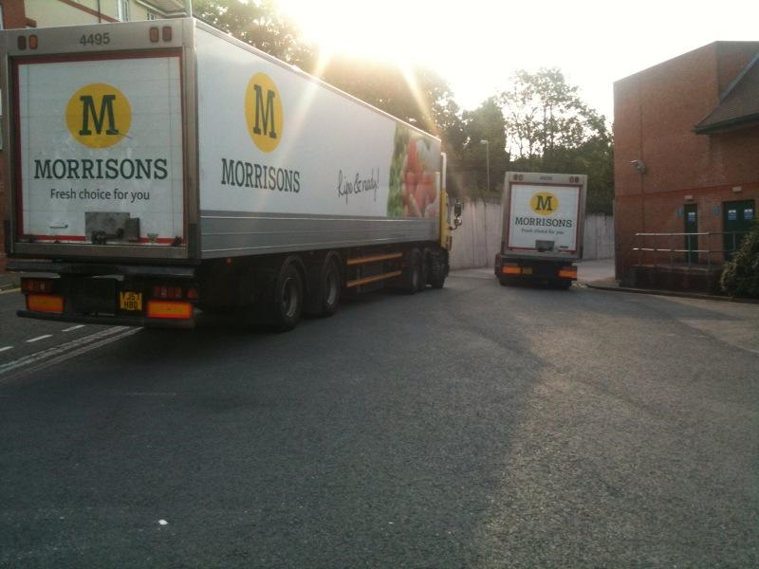

(FIG 5: Vehicles accessing the Morrisons Stone delivery yard)

As is normal for the first meeting, representatives of the NAS were in attendance to collate background information on the site and its complaint history. It also provided an opportunity for NAS to undertake its formal site assessment, supported by out – of – hours observations, to determine likely noise sources and to review the service yard procedures employed by Morrisons.

The second working group meeting took place on 14 July, with the prime focus on reviewing and discussing the findings provided by NAS in their report, and their recommendations on the measures to be introduced to minimise noise during the trial. The key noise risk area identified by NAS was specifically attributed to noise from the delivery vehicles themselves (e.g. reversing alarms, engine noise, noise from refrigeration units). However, the noise from pallet trucks was also included as an area that required action, especially when passing over metal, such as dock leveller plates.

After discussions within the Working Group, there was a consensus by all members to improve delivery practices to reduce noise during the trial. Once these practices had been implemented, members confirmed that a QDDS trial could take place.

MEMORANDUM OF UNDERSTANDING / DRIVER CHARTER

In compliance with normal QDDS methodology, an MoU was prepared, highlighting the key operational elements of the trial and the respective actions to be taken before a trial could start. The key items included in the MoU were:-

- The trial start date (originally scheduled for 4 October 2010 but then subsequently amended to 30 August 2010) and expected duration (i.e. 6 weeks);
- The deliveries to be undertaken using QDDS procedures (i.e. 05.30 and 06.30 deliveries);
- A commitment by Morrisons to arrange for their Facilities Management department to carry out noise mitigation measures (e.g. the purchase of quieter pallet trucks which were introduced during the second week of the trial, the use of rubber matting on the metal plates of the trailer floor); and
- The training of staff on the practices to be adopted during the trial to minimise noise.

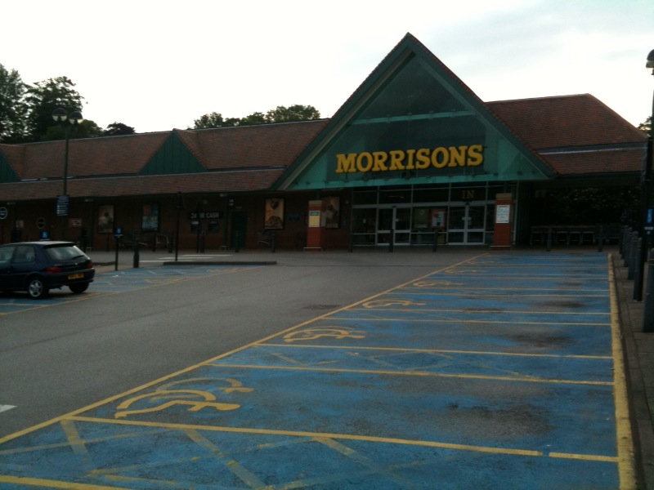
(FIG 6: Morrisons store, Stone)

In addition, Morrisons Transport Management prepared a “driver charter” of required driver behaviour both during and after the trial, emphasising the importance of the continuation of the new delivery times once the QDDS trial had ended.

KEY RESULTS / FINDINGS

The live QDDS trial commenced on 30 August 2010 with the noise monitoring equipment in place and the NAS telephone helpline operational. All actions highlighted in the MoU had been carried out and all processes for reporting issues, incidents and complaints were established.

The first 3 weeks of the trial progressed without complaints but during the final 3 weeks of the official trial, 3 complaints were received via the NAS helpline. Details of the complaints were logged by the NAS and passed initially to the Working Group Facilitator who then circulated the complaints to other members of the group. Upon investigation, the complainants all lived at the flats opposite the Morrisons service yard.

In terms of addressing the complaints, a representative from Stafford BC undertook to contact each complainant individually. Initial contact was attempted by telephone but without response, so individual letters were sent to the complainants advising them that a QDDS trial was taking place and requesting them to complete “noise logs” for the remainder of the trial. However, the official 6 week QDDS trial ended on 11 October before any responses were received. As a result of the complaints received, the Working Group Facilitator was on site at the Morrisons store on 7 October to monitor and observe the working practices for the QDDS deliveries. A complainant did respond after the trial stating that since the original complaint had been lodged, the noise disturbance appeared to have reduced. A final working group meeting was arranged for 14 October to review the formal 6 week trial and agree next steps.

The Morrisons Stone QDDS trial was considered a success with the key critical success factors highlighted below:-

- Although the trial had received 3 formal complaints, the necessary steps and action had been taken to address the concerns of local residents by all members of the Working Group and by Stafford BC in particular;
- The QDDS trial had facilitated the engagement and on – going relationship between Stafford BC and the Morrisons store; and
- The aforementioned relationship led to the continuation of the 05.30 and 06.30 delivery times post the QDDS trial; these are still in place.

In relation to noise levels, the key findings were:-

- Although loading/unloading noise was more distinguishable as a result of the earlier delivery times, it is still the arrival and manoeuvring of the delivery vehicles that caused the highest noise levels; and
- The introduction of quieter QDDS practices (e.g. low-noise pallet trucks) can have positive effects on noise associated with the whole delivery process.

Morrisons Transport Management confirmed that they experienced minor improvements in fuel economy resulting from the earlier QDDS delivery times. Linked to this, the journey time from the Regional Distribution Centre to the store in Stone was reduced by an average of more than 5 minutes per trip.

The Morrisons Stone QDDS trial has paved the way for earlier deliveries to take place as a result of the partnership that has been forged between the local authority and the store, with a template also in place for handling complaints should best practice measures lapse.

“The QDDS trial did result in some transport operational benefits as a result of having the capability to change the delivery times to the store in Stone. Although these benefits were not of great significance, in terms of the bigger picture, if the process was replicated for the whole Morrisons chain of stores, the impact would be very substantial.”
(Transport Manager, Morrisons plc)

Trial 4



INTRODUCTION

The Asda store in Bloxwich is a major retail supermarket located to the north of Walsall, West Midlands, just off the A34. The store itself is a purpose-built unit and is serviced via its own delivery yard, which is housed towards the rear of the store, with access gained via a side street. The gates to the service yard are located within 20 metres of an 8 storey block of residential flats, some of which overlook the delivery bay. The service yard doubles up as a storage area, with consumables stored in the yard under a canopy roof.

A voluntary agreement existed between the store, local residents and Walsall Council which stipulated that no deliveries could be undertaken before 07.00 hours or after 22.00 hours, in order to protect residents’ interests. However, Asda was keen to have this agreement relaxed in order to improve both transport operational and store performance.

The consortium had been engaged with Asda from the outset of the QDDS project to identify a suitable store where a trial could take place. Negotiations with other stores had not progressed to the point of setting up a trial. Following discussions with both Asda and Walsall BC, the decision to hold a trial at the Asda store in Bloxwich was approved by the QDDS Consortium and the initial QDDS procedures were put into place.

In October 2010, an Asda Bloxwich QDDS working group was formed comprising the following representatives:-

- Environmental Health Officers, Walsall Borough Council
- Store Management, Asda Bloxwich
- Supply Chain / Transport Management, Asda (Lutterworth RDC)
- Estates Management (Retail Development – Property), Asda
- Working Group Facilitator, QDDS Project Team

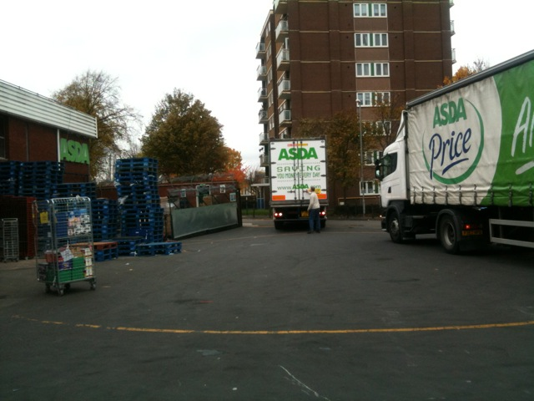

(FIG 7: The Asda Bloxwich delivery yard with residential flats opposite)

PRE – TRIAL PROCEDURES

The deliveries that would form the basis of the QDDS trial would be undertaken at 06.00 hours and 06.45 hours. The first Working Group meeting took place on 29 October 2010 involving all the key partners in order to discuss the previous store history in terms of complaints, to understand the delivery process and Asda transport practices when delivering to the store and to agree the practicalities and timings of a trial.

As was normal with initial Working Group meetings, the NAS also attended to provide input into the discussions and also to carry out their site assessment report to determine noise sources and possible mitigation measures to be introduced for the purposes of a trial.

The second working group meeting took place on 12 November 2010, with a presentation by NAS on the findings contained in their site assessment report. The key areas highlighted were:-

- Noise from vehicles reversing into the delivery yard from the side street which provides access to the store (e.g. reversing alarms, refrigeration unit, tyre scrub);
- Noise from other sources (e.g. other vehicular traffic in the vicinity of the delivery yard); and
- Noise from the delivery yard (e.g. use of hand-held pallet trucks moving goods across the yard)

Members of the Working Group agreed that the necessary actions could be taken to mitigate noise sources and improve delivery practices so that a trial could proceed.

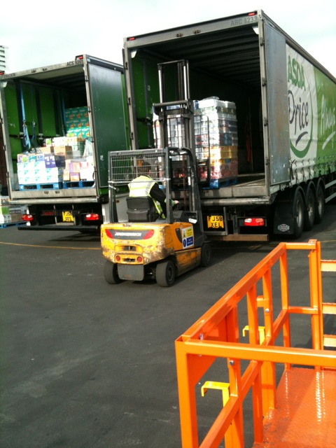

(FIG 8: Asda vehicles being unloaded)

MEMORANDUM OF UNDERSTANDING / DRIVER CHARTER

In accordance with QDDS procedures and methodology, the site’s MoU was prepared, incorporating the key operational elements of the trial. The key items within the MoU were:-

- The trial start date of 6 December 2010 and expected trial duration (6 weeks);
- The deliveries to be included using QDDS practices (06.00 and 06.45 deliveries);
- A commitment by Asda to carry out noise mitigation measures (e.g. maintenance of scissor lift); and
- An undertaking by representatives of Walsall BC to brief elected members that a QDDS trial would be taking place

In addition, Asda agreed to develop a “driver charter” detailing the role and responsibilities of drivers servicing the Bloxwich store. This included some background information about the trial and the importance of drivers adhering to the instructions provided.

KEY RESULTS / FINDINGS

The Asda Bloxwich trial commenced on 6 December 2010, by when noise recording equipment was in place, the NAS helpline was set up and signage had been erected at the store advertising the QDDS trial. A “residents’ notice” had been drafted and sent to the Store Manager to pass on to residents for display on the noticeboard in the block of flats opposite the service yard. A blank copy of a “residents’ noise log” had also been prepared and again sent to the Store Manager to pass on to the residents’ spokesperson for completion during the trial. It subsequently transpired that neither of the above actions had been undertaken by the Store Manager.

A post trial working group meeting was arranged for 25 January 2011 to review the trial and agree next steps.

The first week of the trial progressed without complaint but, during the second week of the trial, a complaint was lodged with the NAS helpline in relation to vehicles parking on adjoining streets prior to the 06.00 hours delivery. In addition, it soon became evident that there were issues of non-compliance with various elements of the MoU (e.g. non-submission of weekly store reports, lack of engagement by the store with local residents to advise them of QDDS trial). This was revisited at the post trial meeting, where it was re-emphasised that the Store Manager has a critical role to play in any trial in terms of complying with the tasks allocated in the MoU and maintaining good communication links with local residents.

Walsall Council and Asda agreed that, despite the complaint received and the non-compliance with MoU elements, sufficient progress with best practice implementation had been made and the Council granted permission for Asda to continue with the 06.00 and 06.45 deliveries, subject to review and monitoring. In addition, local residents now have a direct communication link to EHOs at Walsall Council to register any future concerns or reservations.

In terms of noise levels that occurred during the trial, increased noise levels occurred at the new delivery times as a result of the arrival and departure of vehicles. A key area to highlight is that the trial took place during the winter period and thus it is possible that there may be an increase in disturbance to residents with windows open during the summer months. Overall, from the noise levels measured both in the delivery yard and at the flats opposite the yard, it cannot be determined whether QDDS processes have had a beneficial effect on reducing noise from the delivery process.

Despite the explicit requirement for QDDS participating retailers to record and provide data, unfortunately, no appropriate operational or retail performance data sets were provided by the retailer for this trial, meaning fuel saving, vehicle emissions and store performance benefits could not be calculated.
Trial 5



INTRODUCTION

The Superdrug store in Marble Arch, located on Oxford Street in Central London, is a flagship store for the company. The store is neighboured by other retail outlets and a hotel, with luxury flats located opposite. The store does not have its own loading / unloading facilities and deliveries are made from the kerbside, through the customer entrance, with delivery vehicles stopping to the front of the store on Oxford Street.

In 2008, the store received deliveries in the evening from Sunday to Thursday at approximately 23.30 hours. However, this led to complaints from local residents, primarily relating to noise from roll cages and from the vehicle tail-lift being dropped to the ground. City of Westminster Council issued a noise abatement notice which was appealed, subsequently cancelled and replaced by a negotiated curfew from 21.00 – 06.30 hours.

Deliveries are currently undertaken at 06.30 hours from Monday to Friday. The QDDS application submitted by Superdrug was to undertake a trial to allow deliveries, made by their own in-house distribution company, to be received at the store from Sunday to Thursday between 20.00 – 23.00 hours.

The application was approved by the QDDS consortium and the Superdrug Marble Arch store was chosen as a preferred trial site. Further discussions were held with representatives of City of Westminster Council who confirmed their interest in participating in the scheme and engaging with Superdrug.

In May 2010, a Superdrug Marble Arch working group was formed comprising the following representatives:-

- Senior Environmental Health Officer, City of Westminster Council
- Store Manager, Superdrug Marble Arch
- Transport Manager, Superdrug Distribution
- Transport Planner, Superdrug Distribution
- Working Group Facilitator, QDDS Project Team

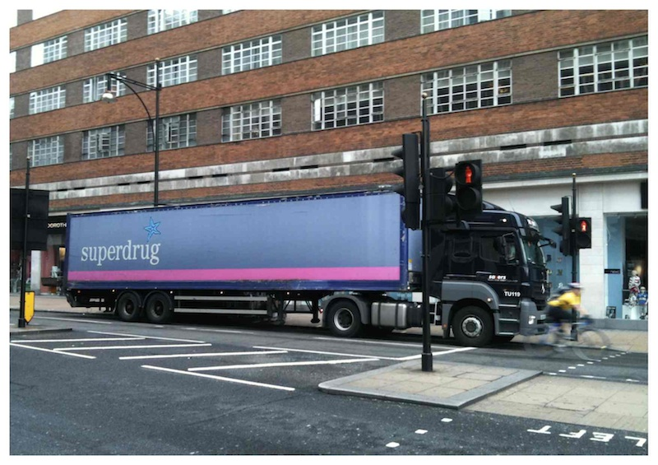

(FIG 9: Superdrug vehicle located outside Oxford St store)

PRE-TRIAL PROCEDURES

Superdrug had requested a delivery late evening (20.00 – 23.00) as their preference to replace their current early morning delivery, which took place at 06.30 hours.

The key reason for requesting an evening delivery was that deliveries to the Marble Arch store are made from the same vehicle that delivers to the Superdrug store in the Strand. Deliveries made to the store in the Strand are undertaken at approximately 00.00 hours and the delivery vehicle and crew then stay in Central London until the 06.30 hours delivery to the Marble Arch store. Thus, from a logistics perspective, it made much more sense to undertake the delivery to the Marble Arch store prior to proceeding to the store in the Strand. Once both deliveries have been undertaken, the vehicle could then return to base.

The first working group meeting took place towards the end of May 2010 and brought all the key stakeholders together to explain the QDDS project, assess the potential for a trial and pave the way for a QDDS trial to take place. In addition, the NAS undertook their site assessment and developed a report which highlighted the sensitivity of local residents to delivery activity in the area. The Working Group also noted that other, neighbouring retailers along Oxford Street used the same on-street loading / unloading bay as Superdrug, potentially at the same times of the new delivery profile being sought.

A second Working Group meeting took place towards the end of June 2010 to discuss the findings and recommendations from the NAS report and, in particular, the key noise risk areas identified by NAS, which included:-

- Noise from the delivery vehicle (e.g. engine not switched off upon arrival, reversing alarms)
- Noise generated from the handling of roll cages within the trailer;
- Delivery crew behaviour (e.g. marshalling of roll cages)

The possibility of neighbouring retailers delivering to their premises at similar times to the proposed trial times for Superdrug presented a serious issue. The loading/unloading space available at kerbside is only sufficient for one delivery vehicle to legally use at a time. However, work continued on agreeing a series of actions to further improve delivery practices and minimise noise and all parties agreed that a trial would be feasible.

MEMORANDUM OF UNDERSTANDING

Following the second meeting, it was agreed that a “mixture” of evening delivery times (to avoid conflict with neighbouring retailers) could be undertaken as part of the trial, as highlighted below:-

DAY | PROPOSED QDDS TRIAL DELIVERY TIME
Monday | 20.00 hours
Tuesday | 20.00 hours
Wednesday | 22.00 hours
Thursday | 20.00 hours
Friday | No Delivery
Saturday | No Delivery
Sunday | 19.00 hours

In addition, the transport department of Superdrug undertook the following pieces of work:-

- To investigate the sourcing of a dedicated delivery vehicle to be used for the trial at the Marble Arch store, and for this to be soundproofed, including an electronic rear access door and the fitting of foam matting within the trailer; and
- To investigate whether it would be possible for joint consolidated deliveries to be made with neighbouring retailers (e.g. Next, Mothercare) to their respective stores based on Oxford Street

An MoU was formulated containing the following key operational elements:-

- The QDDS trial was to commence on 8 August 2010;
- The QDDS trial was to consist of a “mixture” of delivery times as highlighted above;
- A commitment by Superdrug to carry out agreed noise mitigation measures; and
- The reporting arrangements to be used in the event of a complaint.

POSTPONEMENT OF QDDS TRIAL

Approximately one week before the trial was to commence, it was postponed at the request of the Superdrug Area Manager, who expressed concerns and reservations about the proposed QDDS trial delivery times and the fact that some of the proposed times could have created potential health and safety hazards when moving goods across busy public thoroughfares and into store.

Encouragingly, however, discussions started between Superdrug and Next to explore the possibility of joint consolidated deliveries to their respective stores on Oxford Street. These discussions continued for the remainder of 2010 and into the early part of 2011, with the focus on contractual and legal issues.

Unfortunately, an agreement could not be reached within the QDDS timescales for a trial to operate incorporating joint deliveries to both Next and Superdrug.

WHAT HAPPENED NEXT?

Throughout the discussions between Superdrug and Next in relation to shared deliveries, a dialogue continued between the QDDS consortium and Superdrug in order to monitor developments. In March 2011, it was confirmed that a “trial run” of joint deliveries between the two retailers had taken place. Superdrug later reported that although the “trial run” had been successful, it would not be taken forward on a permanent basis for operational reasons.

Superdrug are now exploring alternatives with the City of Westminster Council in relation to undertaking evening deliveries.

Trial 6



TESCO PLANNING APPLICATIONS

Reading Borough Council & Wirral Metropolitan Borough Council

INTRODUCTION

As part of the overall QDDS project, the Consortium expressed a wish to look at all forms of “delivery curfew” restrictions, including the possibility of submitting a request for a variation of a statutory planning condition that had been imposed on a store.

The purpose of this exercise was to gain an insight into the planning process and the steps that have to be taken when submitting an application to vary a planning condition. If such an application to vary a condition was successful (and timescales permitting), the QDDS methodology would be employed in order to set up a QDDS trial.

In February 2010, discussions took place with Tesco who had expressed an interest in participating in the QDDS project. It was agreed that Tesco would submit a retailer application for a store that had a delivery restriction which had been imposed through planning conditions. Tesco accordingly submitted a planning-based application for its store in Heswall, under the jurisdiction of Wirral Metropolitan Borough Council. In addition, Reading Borough Council also contacted the QDDS team and expressed an interest in the scheme and this matched a further store application that had been submitted by Tesco. It was agreed that planning applications should be submitted to the respective local authorities for each of the two stores to experience the process of applying for a variation to a planning-based delivery restriction.

APPLICATION 1: TESCO / READING BOROUGH COUNCIL

The Tesco Reading store is located on the outskirts of Reading town centre. The store has a fully enclosed delivery bay with access via a dedicated service road which backs on to residential properties.

Full planning permission for the Tesco Reading store was granted by Reading Borough Council in November 2006 but planning conditions were imposed in terms of delivery times. The main condition stipulated that “there shall be no deliveries to the food store between 23.00 and 07.00 on any day.” The reason for the condition was to protect the neighbours of the adjacent properties from any unreasonable disturbance from delivery vehicles.

Tesco wanted to secure a temporary relaxation to this condition for a QDDS trial to take place and expressed a desire to replace the existing delivery which took place at 07.00 hours with a delivery between 04.00 – 05.00 hours. The QDDS project team met with officers from Reading Borough Council in July 2010 to explain the QDDS scheme. The officers involved were keen to participate in a trial but also indicated that the application could prove to be very sensitive.

Tesco approved the preparation of the application and the QDDS project team continued to engage with officers at Reading Borough Council to seek guidance and advice on the information to be provided in the actual application and the supporting documents that were required. They were advised that a “Section 73” application (“Application for removal or variation of a condition following grant of planning permission – Town and Country Planning Act 1990 / Planning (Listed Buildings and Conservation Areas) Act 1990”) to vary the existing planning conditions would have to be submitted and progressed through the necessary process. However, as discussions continued, the Council indicated that a “Section 73” form might not in fact be the correct form to submit and that a “Section 96” application (“Application for a non-material amendment following grant of a planning permission – Town and Country Planning Act 1990”) should be prepared instead.

A completed “Section 96” application and supporting evidence were submitted to Reading Borough Council in December 2010. This included:-

- An original (and 3 copies) of a “Section 96” application form;
- Copies of the original planning decision notice granted by Reading Borough Council;
- Copies of the “Register of Title” from the Land Registry as proof of ownership of the store;
- Copies of a guidance note entitled “Tesco Reading - Proposed out-of-hours QDDS Trial” providing further details of the procedures / methodology to be adopted should a trial proceed; and
- Copies of an illustrative “Memorandum of Understanding”, outlining potential measures to be introduced and implemented for the purposes of the trial.

Correspondence was received from Reading Borough Council in mid-December 2010 explaining that there would have to be consultation with local residents who could be affected by the new proposed delivery times.

Then a further letter was received in early January 2011 stating that the wrong application form had been submitted and that a “Section 73” form was required; this was duly provided. Reading BC also requested a location plan clearly identifying the store, along with payment of £170 to process the application. This additional information and the fee payment were submitted by the end of January 2011.

Towards the end of January 2011, further correspondence from the Council was received stating that additional public consultation would have to take place and that this was now being treated as a “major” application.

As a result, the store was obliged to display “site notices”, both in-store and in the vicinity of the delivery bay for a period of 21 days, advertising the application for a change in delivery hours, to allow the public to submit representations. This additional exercise meant that the application could not be considered by the Planning Applications Committee of Reading Borough Council until early March 2011.

In early February, council officers recommended that the QDDS project team write to members of the Planning Applications Committee, ahead of their next planned meeting on 9 March 2011, and offer to meet them to explain the QDDS scheme in more detail and the procedures that would be undertaken both before and during any proposed trial. A meeting was arranged for 28 February 2011 with two members of the Committee in attendance.

Following the meeting, the members requested a visit to the Tesco Reading site so that they could undertake a tour of the store, and the delivery area in particular, in order to gain a better understanding of what was being proposed and to gain an insight into some of the objections that had been made by local residents. This tour took place on 25 March 2011 but it later transpired that no direct engagement took place with either the store manager or any member of staff employed by the store.

Throughout the application process, objections were raised by local residents and it became evident that the whole issue was becoming extremely sensitive. If the application was successful, the QDDS team would have to be extremely aware of local concerns and would have to engage with residents at the earliest opportunity.

RESULT OF TESCO READING PLANNING APPLICATION

The Tesco Reading planning application was considered at the Planning Applications Meeting on 6 April 2011.

The result was that the committee was minded to refuse the application unless further clarity on the QDDS management plan was provided. In effect, the committee wanted the QDDS methodology to be implemented prior to the application being submitted. In essence, Reading Borough Council was requesting additional technical information (e.g. current noise levels) in order to arrive at a more informed decision. However, due to project timescales and remaining resource, it was no longer possible to provide support for the application under QDDS.

In terms of next steps, at the time of reporting in May 2011, internal discussions are taking place within Tesco as to whether they should provide the additional supporting information that has been requested by Reading Borough Council.

APPLICATION 2: TESCO / WIRRAL METROPOLITAN BOROUGH COUNCIL

In addition to the Reading application above, the project team submitted a second QDDS application, to Wirral MBC, in relation to the Tesco Heswall store to enable a comparison to be made between local authority planning procedures.

Again, a “Section 73” application was submitted to vary a condition requesting a short-term, temporary relaxation in the hours during which deliveries are permitted. The condition currently in place was that Tesco were only able to use the service yard between 07.00 – 21.00 hours Monday – Friday, with additional restrictions imposed for weekend deliveries. The QDDS application requested deliveries to be undertaken at 23.00 hours and 05.00 hours.

Similar procedures were adopted as for the application submitted to Reading Borough Council, with all the necessary QDDS supporting evidence provided to Wirral Metropolitan Borough Council planning officers and a full application submitted in late January 2011. Public consultation was undertaken with local residents who could be affected by the new delivery times.

As time elapsed and dialogue continued, it became clear that the application was proving very sensitive; the Council received a number of objection letters and a petition signed by 30 separate households objecting to the proposed QDDS trial and the requested changes in delivery times. As a result, the project team were informed by officers at the beginning of April 2011 that they were going to recommend refusal of the application. The main reason provided was:-

“The site is sensitive due to the proximity of the neighbouring properties and, in this case, there is no evidence to show that disturbance will be prevented and it would be unacceptable to extend the hours, even for a trial period.”

Both Tesco and the QDDS Consortium were advised accordingly and it was left to Tesco’s discretion whether to take any further action outside the QDDS scheme.

PLANNING-BASED CURFEW RELAXATION: CONCLUSION

Submitting two applications to vary planning conditions in relation to delivery times provided some very useful results for the QDDS Consortium. It is clear that of all the types of restrictions that have been encountered during the project, the submission of planning applications and negotiating the legal planning process has been the most complex and time-consuming in terms of the steps that need to be taken to set up a trial.
The process of trying to temporarily lift existing statutory restrictions is complicated to non-planners and the following recommendations should be taken into account:-

- Early engagement with the relevant local authority planning officers to seek advice and guidance both before and during the application process;
- Development of a strong business case and clear supporting documentation containing key objectives of having an existing planning condition lifted / varied;
- Compliance with the various requirements of the planning process as instructed by the local authority;
- Allocation of significant time and resource required for the planning application process and, more importantly, realisation that the application may not be successful; and
- If the application is unsuccessful, consideration of the possibility that the store may come under closer scrutiny in terms of adherence to existing planning conditions.

The planning rules and regulations obviously exist for a purpose. In relation to store delivery times, the legislation serves to protect residents from excessive noise and disturbance. The QDDS project has highlighted that when submitting planning applications to vary existing conditions, the local authority has a duty to balance residents’ concerns against their wider objectives of reducing congestion, improving air quality, reducing greenhouse gases and increasing economic growth.

