



GUIDE FOR RETAILERS ON ‘OUT-OF-HOURS’ DELIVERIES

HGV deliveries in urban areas are often constrained during night-time and/or weekend periods; however, this increases traffic and carbon emissions at peak hours.

Out-of-hours deliveries to retail premises, comprising quiet deliveries at night-time and also during the “shoulders” of the day (i.e. prior to opening, after closing), away from peak periods, potentially offer significant benefits to retailers and associated transport operations:-

- Reduced round trip journey times;
- Reduced vehicle turnaround times at stores;
- Reduced fuel consumption from less time spent stationary, idling in congestion;
- Improved shift productivity from drivers and vehicles;
- Increased product availability within the store; and
- Less conflict between deliveries and customers on the shop floor

But retailers must also appreciate that noise from vehicle manoeuvring and loading / unloading activity can affect local residents, particularly at times of the day when ambient noise levels are low.

This guide is designed to help retailers work with Local Authorities and local residents to realise the benefits of changed delivery hours without creating disturbance.

“I welcome the launch of this guide, which shows how – through working collaboratively with Local Authorities - shop owners and supermarkets can receive deliveries out-of-hours without being a nuisance to residents. Less congestion, better air quality and safer roads means a win-win situation. I look forward to seeing more examples of retailers and local authorities working together to explore the mutual benefits of Quiet Deliveries.” - Mike Penning MP, Minister for Freight

BACKGROUND

The concept of ‘out-of-hours’ deliveries as a sustainable distribution initiative has been the focus of the “urban logistics” debate for many years. The subject appears as a desirable measure on local Freight Quality Partnership (FQP) action plans across the country, to help improve the efficiency, economy, safety and sustainability of urban freight movement. In recent years, even dating back to the Commission for Integrated Transport’s “Night-time Delivery Curfew Initiative” project in 2001 / 02, various attempts have been made to set up and run out-of-hours deliveries trials. These have involved bringing together retailers and interested local authorities to work together at specific trial sites. One of the most recent of these trials was the partnership that evolved between Sainsbury’s and Wandsworth Borough Council (2007 / 08), working with the Noise Abatement Society, which saw the development of a proposition to have the restrictions lifted at the Sainsbury’s store in Wandsworth for a period of 3 months. In addition, the Department for Transport has produced guidance on the subject, with support from the Freight Transport Association (FTA) and other industry bodies; and FTA has developed a toolkit for improving night-time deliveries.

However, many retailers remain unclear on how best to approach local authorities on the potentially contentious subject of out-of-hours delivery activity in a way that addresses local residents’ concerns and accommodates the needs of their core business. Therefore, this guide is specifically aimed at retailers as a means of engaging with local authorities and demonstrating that it is possible both to relax existing delivery restrictions, using the appropriate methodology, and to protect residents from significant noise through the application of low noise delivery techniques. The guide will assist industry in developing a better understanding of the measures required when adopting best practice for out-of-hours deliveries.

INTRODUCTION

Out-of-hours deliveries to retail premises, comprising quiet deliveries at night-time and also during the “shoulders” of the day (i.e. prior to opening, after closing), away from peak periods, potentially offer significant benefits to retailers and associated transport operations. The operational and commercial benefits to be derived from deliveries undertaken outside of peak periods can include:-

- Reduced round trip journey times;
- Reduced vehicle turnaround times at stores;
- Reduced fuel consumption from less time spent stationary, idling in congestion;
- Improved shift productivity from drivers and vehicles;
- Increased product availability within the store; and
- Less conflict between deliveries and customers on the shop floor

From a logistics and retailing perspective, out-of-hours deliveries make sound operational sense. Moving retail delivery activity out of peak periods removes HGVs from congested locations and can also assist local authorities in meeting their environmental and social targets, including reduced vehicle emissions and improvements in both local air quality and local road safety.

However, retailers must also appreciate that out-of-hours deliveries can have an impact on local residents and local communities. Noise from vehicle manoeuvring and loading / unloading activity can affect local residents, particularly at times of the day when ambient noise levels are low. As a result, HGV movements in urban areas are often constrained during night-time and / or weekend periods by local curfew regulations put in place to avoid excessive noise impacts. These include delivery restrictions imposed by planning conditions, noise abatement notices or voluntary local agreements between retailers and the local authority / local residents.

Therefore, if retailers want these restrictions to be relaxed, they need to be able to demonstrate to local authorities that any out-of-hours delivery activity will be undertaken in a way which minimises disturbance and disruption to local residents, while continuing to meet the operational needs of the business.

QUIET DELIVERIES DEMONSTRATION SCHEME (QDDS)

In November 2009, the Department for Transport (DfT) established a consortium, in partnership with the Freight Transport Association (FTA) and the Noise Abatement Society (NAS), in order to investigate and promote the potential benefits from the relaxation of delivery curfews for quiet deliveries.

The consortium has overseen the Quiet Deliveries Demonstration Scheme (QDDS), which has involved the setting up, running and reporting on quiet delivery demonstration trials at retail premises across England. In general, the trials involved the relaxation of restrictions at these selected retail sites for a specific time period, during which quiet deliveries were permitted and closely monitored. The Scheme was managed by freight specialists at transport consultants, Transport & Travel Research Ltd (TTR), with other members of the project team consisting of NAS, the Transport Research Laboratory (TRL) and AEA Technology.

Both retailers and local authorities were invited to participate and to submit applications for stores with delivery curfew restrictions, anywhere within England, to be the trial stores in the Scheme. Applicants were requested to complete an application form and submit relevant supporting information outlining the current restrictions in place. The applications were then assessed by the consortium and a shortlist of sites was identified, based upon the location of the store (it was felt only one store based in Greater London should be chosen to allow for a geographical spread of sites) and the type of existing restriction that was in place (i.e. whether planning, voluntary or noise abatement notice). From the applications received, six trial sites were chosen, consisting of the following participants:-

RETAILER | LOCAL AUTHORITY | LOCATION OF STORE | TYPE OF RESTRICTION
Sainsbury’s plc | Bournemouth Borough Council | Bournemouth, Dorset | No current curfew but store ‘at risk’
Marks & Spencer | Chichester District Council | Chichester, West Sussex | Voluntary Agreement in place
Morrisons plc | Stafford Borough Council | Stone, Staffordshire | Voluntary Agreement in place
Asda | Walsall Borough Council | Bloxwich, West Midlands | Voluntary Agreement in place
Superdrug Stores | City of Westminster | Westminster, London | Voluntary agreement in place
Tesco | Reading Borough Council | Reading, Berkshire | Statutory planning condition in place

QDDS METHODOLOGY

For each of the trial sites (with the exception of Tesco / Reading Borough Council which focused on the statutory planning process), the same methodology was adopted. Local trial working groups were set up involving the retailer and representatives of the local authority, with a trial facilitator appointed to oversee discussions and to act as a link between the two parties. It was the responsibility of the local working group to oversee the trial and to agree the working practices and necessary noise mitigation measures to be implemented. The aims of the trials were to demonstrate:-

- A comparison of noise levels between the existing delivery times and the new agreed delivery times;
- Improved journey times for the retailer;
- Improved sales / availability of stock; and
- Improved fuel economy, emissions and air quality

The NAS was appointed to carry out “site assessments” at each location, offering recommendations on noise mitigation measures, and to provide a noise complaint telephone helpline for local residents to contact during the actual trial. On-site noise monitoring was also undertaken both pre – trial and during the trial by specialist noise consultants, TRL.

RETAILER PARTICIPATION IN TRIALS

In all of the QDDS trials that took place, the stores chosen were principally represented by store management and the retailer’s own supply chain / transport function. At the beginning of the QDDS project, contact was made with a number of retailers (including via the FTA and NAS) seeking “expressions of interest” from retailers who were keen to participate. Retailers were then asked to provide a list of possible stores that they would like to see involved in a QDDS trial and to substantiate this by completing a “QDDS Retailer Application Form” (see Appendix 1) per store. The following information was requested:-

- General Information (e.g. name / address / primary contact / etc …)
- Details of Store proposed for QDDS trial
- General Store Information including:-

- description of store
- how deliveries are currently carried out
- type of delivery curfew restriction currently in place
- full details of store delivery curfew restriction
- history of resident complaints
- rationale for selecting the specific store for a QDDS trial
- proximity of store to residential properties (with a site plan / satellite map to illustrate)
- details of new delivery times being requested
- if the store has CCTV coverage in the delivery area
- details of the local planning / environmental health authority relevant to where the store is located
- details of previous discussions with local authority officers in relation to out-of-hours deliveries / delivery curfew restrictions
- the transport operational data that could be provided (e.g. delivery vehicle / type, journey times, average vehicle travelling speeds, MPG, etc …)

This application process provided a useful starting point for both the retailer and local authority and is recommended to be adopted as the appropriate mechanism for setting out a formal, business – like framework, upon which the proposed trial should be based.

    - It is recommended that, should a retailer express interest in setting up a trial, as much in-depth information as possible is provided to the local authority (in an application form) as outlined above, in order to move the process forward to the next phase of direct engagement

Once an application form has been submitted, it is then the responsibility of the local authority to analyse the information provided by the retailer and, in particular, verify the nature of the existing restriction and check previous store history in terms of complaints and other associated problems. It is at this stage that a local authority will decide whether to engage with a retailer, possibly via a ‘trial facilitator’, to explore the possibilities of a trial. If the local authority decides that a trial is of interest and could potentially meet local authority environmental objectives, it is likely that an initial working group meeting will be set up with the following objectives:-

- To encourage dialogue between both parties to assess the potential for a trial;
- To discuss the previous history of store issues and previous complaints;
- To discuss the proposed timings of any trial and its revised delivery profile;
- To understand the objectives of the other party for participation in a trial;
- To discuss who will fund a trial if following the QDDS methodology, including potentially setting up a telephone helpline and noise monitoring equipment; and
- To agree the actions to be undertaken prior to a trial taking place.

In addition, the local authority may request a “site assessment” report to be produced to determine likely noise sources, to review the delivery procedures employed by the retailer and to make recommendations on noise mitigation measures.

- It is recommended that retailers appoint a competent person to produce a “site assessment” report to review current store delivery practices and to implement improvements to existing methods, where required, so as to mitigate key sources of noise

It is the “site assessment” report that will assist both parties in identifying areas of the delivery process where improvements can be undertaken prior to any trial starting. Once a report is available, it is likely that the local authority will request a “Memorandum of Understanding” (MoU) (see Appendix 2 for an example) to be drawn up as an agreement between the retailer and local authority stipulating the areas and actions that need to be addressed before a trial can commence. An MoU should, as a minimum, cover the following features:-

- Start date, end date and proposed duration of the trial;
- The times of the new deliveries to be undertaken during the trial;
- Roles and responsibilities of the participating partners
- Reporting procedures to be undertaken in the event of complaints being received by local residents;
- Details of training / instructions to be given to store staff and drivers involved in the proposed trial;
- An undertaking by the retailer to record transport operational data both pre – trial and during the trial, to monitor fuel consumption, journey times from distribution centre to store, etc …; and
- telephone contact number to be set up and advertised in the store so that local residents can lodge complaints during the trial if necessary.

Importantly, the MoU will impose a series of actions upon the retailer that must be adhered to in order for a trial to be successful. This emphasises the importance of the role of the Store Manager in ensuring that all “store” elements incorporated in the MoU (e.g. submission of weekly reports, engagement with residents if complaints received) are adhered to and acted upon where necessary.

- It is essential that retailers comply with all elements of the MoU prepared for the trial and ensure that all store staff are made aware of the trial and its importance, to ensure that the new delivery times remain in place and benefit the overall operation of the store

A key issue for retailers to address is the information that is disseminated to drivers delivering to the store where the trial is taking place. Drivers of vehicles have a duty of care to adhere to when delivering to stores in terms of their obligation to use low-noise delivery techniques in order for the trial not to incur any complaints. Therefore, the production of a “driver charter” (see Appendix 3) is a means of providing drivers with a set of instructions that must be followed when delivering to the store. The instructions (e.g. switch off engine when stationary, turn off cab radios, do not slam doors) may look simple, and it could be argued that such delivery techniques should already be in place, but presenting these in a stand-alone document will serve as a reminder to drivers. Developing such a “Driver Charter” can also help to encourage best practice throughout the operation (not just for the purposes of the trial) and could also be distributed to third party ‘direct deliverers’ servicing the retailer’s stores.

- It is important that retailers produce a “driver charter” to be issued to drivers as a set of instructions reminding them of their obligations when delivering to the store where the trial is taking place, so that these can be followed without putting the trial in jeopardy and to minimise noise associated with delivery activity

A key element of any trial is to monitor noise levels at the revised delivery times and this will be of specific interest to local authorities to ensure that the change in times does not result in any significant disturbance to local residents. As such, both parties may need to reach an agreement regarding the installation of noise monitoring equipment and who funds this element of the trial. Noise levels will have to be monitored both pre-trial (i.e. the current delivery times) and during the trial (i.e. the proposed new delivery times) and a report produced after the trial comparing the relative levels.

- Retailers should liaise with the local authority to consider appointing a competent person to install noise monitoring equipment for the duration of the trial to demonstrate that noise levels are being monitored

Once all the pre-trial procedures have been addressed and the resulting actions carried out, a trial can then commence. It is during the actual trial that complaints could be made and, should this happen, the retailer (initially the Store Manager), must be in a position to act quickly: potentially by engaging with the complainant directly but also by advising other members of the working group on the outcome of any discussions. The main way to avoid complaints is for the retailer to ensure that delivery activity during the trial does not cause any unnecessary disturbance to local residents.

- Retailers should be prepared to engage with local residents before, during and after the trial in order to establish good communication links and keep residents informed of general store activity

Once a trial has been completed, there is an onus on the retailer to demonstrate the benefits of having earlier deliveries in relation to whether there were any resulting transport efficiency benefits (e.g. improved fuel consumption, reduced journey times) and whether store performance improved. As such, it is the responsibility of the retailer to produce evidence of the positive effects of the trial by collating data during the trial (e.g. miles per gallon, journey times) so that a full analysis can be undertaken of the situation pre-trial and during the trial. This information should be shared with members of the working group and, in particular, the local authority, before an agreement can be reached about making the new delivery times permanent.

- Retailers should collate key data both pre – trial and during the trial for analysis to assess and present the benefits of the new delivery times on store performance and transport operational efficiency

A quick step-by-step guide for retailers outlining the procedures described above and actions that should be taken in both setting up and running a trial can be found at Appendix 4.

REVIEW OF THE QDDS TRIALS

Six trials were identified by the QDDS Consortium, mainly focused on local / voluntary agreements that were in place between the local authority, retailer and local residents. The proposed trial involving Tesco and Reading Borough Council focused on the planning process and the necessary steps that have to be taken to vary planning conditions restricting delivery times. A summary of the trials undertaken follows:-

Sainsbury’s / Bournemouth Borough Council

The trial between Sainsbury’s and Bournemouth BC, for the Castlepoint store, took place mostly during June 2010. The local authority had previously received complaints from local residents concerning alleged night-time delivery noise from the store and felt that if steps were not taken to reduce the perceived disturbance to residents, enforcement action would ultimately be necessary. A local agreement was in place, with Sainsbury’s undertaking not to move roll cages in the yard from 23.00 – 06.00 hours.

In April 2010, a working group was formed consisting of representatives from both parties and it was agreed that the deliveries that would form the basis of the QDDS trial were those undertaken at 23.00, 02.00 and 04.00 hours respectively. Sainsbury’s already delivered at these times, so there were no changes to the delivery profile but the focus was on improving existing delivery practices and introducing low-noise measures (e.g. reducing noise from roll cage movement and unloading activity).

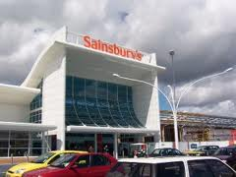
The QDDS methodology was introduced and all the necessary pre-trial steps were taken (e.g. development of an MoU, the introduction of a telephone helpline, set up of noise monitoring equipment) and the trial officially started on 31 May 2010. In addition, the trial also involved direct suppliers of products (e.g. bread, milk) to the store who were asked to introduce and comply with the same actions being undertaken by Sainsbury’s own staff in terms of implementing quieter delivery practices and training drivers accordingly. The trial ran for 6 weeks and officially finished on 12 July when a review meeting was held.
Figure 1: Sainsbury’s Castlepoint store

The trial was considered a success with the key factors being:-

- No complaints had been received through the telephone helpline or by Store Management during the trial period;
- The involvement of a local resident who was asked to keep noise logs and record instances of increased noise activity during the trial;
- On-going protection of the existing night-time delivery profile (i.e. deliveries at 23.00 / 02.00 / 04.00 hours);
- The establishment of an effective working relationship between Bournemouth BC and Sainsbury’s, which continues to evolve;
- The introduction of best practice measures in line with the MoU which have continued since the trial ended, including a ‘Driver Charter’; and
- Improvements in fuel consumption reported by Sainsbury’s of 5.7% for night-time operations compared to daytime equivalents.

Marks & Spencer / Chichester District Council

The trial between M&S and Chichester DC took place in August / September 2010. No statutory restrictions had been imposed by the local authority, although a local agreement was in existence between the store and local residents, stipulating that the first delivery would not take place before 06.30. M&S indicated a preference to undertake the first delivery at the Chichester branch at 06.00 hours, in order to assist the store in being ready to trade when opening for business.

In June 2010, a working group was formed consisting of representatives from both parties and it was agreed that the 06.00 hours delivery would be the focus of the QDDS trial. A series of working group meetings were held to discuss the relevant issues (e.g. main sources of noise, previous history of complaints, the “site assessment” report and mitigation measures) and all elements of the QDDS methodology were introduced and followed (e.g. development of an MoU, the introduction of a telephone helpline, set up of noise monitoring equipment).

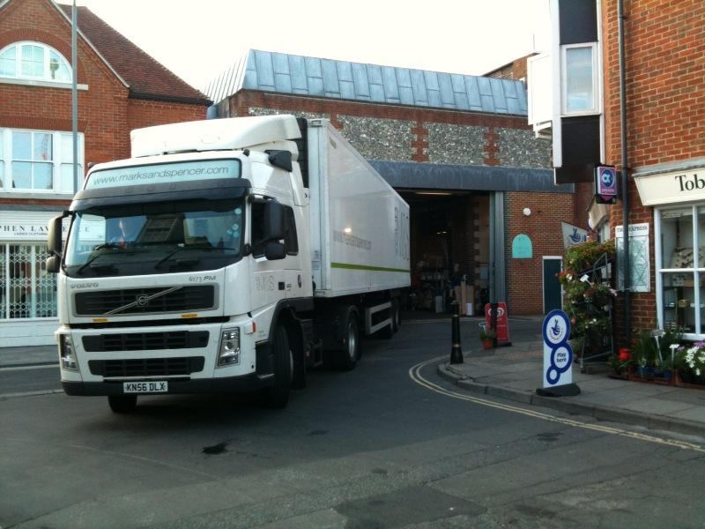
The trial officially started on 16 August 2010 with M&S Logistics Department and M&S store staff instructing and training staff on quieter delivery practices. The trial ran for 6 weeks and formally concluded on 27 September 2010, when a QDDS post-trial meeting was held to review the trial itself and to agree next steps.

The M&S Chichester QDDS trial was considered to be a success by members of the working group as a result of the following factors:-
Figure 2: M&S Chichester Store delivery

- No formal complaints had been received through the NAS helpline, by store management or direct to Chichester DC during the trial;
- Additional best practice measures had been introduced in line with the MoU and “Driver Charter” documents;
- An agreement was reached by both parties that M&S should continue with the 06.00 hours delivery, subject to on-going review; and
- The QDDS trial had provided a platform for both parties to work more closely together, to bring about further effective improvements in operational practice.

Morrisons / Stafford Borough Council

The trial between Morrisons and Stafford BC, for the retailer’s store in Stone, took place between August – October 2010. No statutory restrictions had been imposed by the local authority, although noise complaints relating to night-time delivery activity had previously been made about the store when trading under another name. As a result, a local agreement had been reached between residents, the local authority and the retailer which meant that deliveries could only be undertaken between 07.00 – 22.00 hours. Morrisons inherited this voluntary curfew when they took over the store from the previous retailer.

In June 2010, a working group was formed consisting of representatives from the retailer and the local authority. Morrisons were keen to undertake deliveries prior to 07.00 hours and it was agreed that two deliveries would form the focus of the QDDS trials and that these would be at 05.30 and 06.30 hours respectively.

The QDDS methodology was introduced and all the necessary pre-trial steps were undertaken (e.g. development of an MoU, the introduction of a helpline for local residents to contact if excessive noise occurred) and the trial officially started on 30 August 2010. During the trial, Morrisons introduced the use of quieter pallet trucks to assist with keeping noise to a minimum.

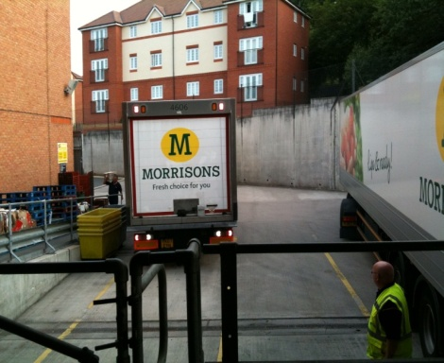
This QDDS trial was the first trial to generate complaints via the telephone helpline, with 3 complaints received from residents who lived in a block of flats located opposite the Morrisons delivery yard. In all instances, the complaints focused on noise from the delivery process (e.g. arrival of vehicle) and the necessary remedial procedures were taken to address the complaints. Details of each complaint were circulated to members of the working group and the representative from the local authority was tasked with contacting each complainant, to obtain further information and ask the resident in question to complete noise logs for the remainder of the trial. The fact that none of the residents took up this opportunity suggests they were satisfied with the steps taken to address their respective complaints.
Figure 3: Morrisons delivery yard

The trial ran for six weeks and officially finished on 11 October 2010 and a review meeting was held shortly afterwards. The trial was considered to be a success with the main results being:-

- Although the trial had generated 3 formal complaints, the necessary steps and actions had been taken to address the concerns of the local residents by all members of the working group;
- The trial had facilitated the engagement and on-going relationship between Stafford BC and the Morrisons store; and
- This relationship led to the continuation of the 05.30 and 06.30 delivery times post the QDDS trial and these remain in place

Asda / Walsall Council

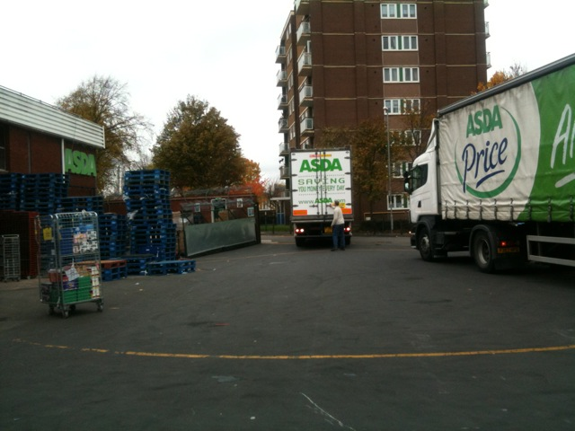
The trial between Asda and Walsall Council, for the Asda store in Bloxwich, took place from December 2010 to January 2011. Investigations showed that a voluntary agreement existed between the store, local residents and Walsall Council so that no deliveries should be undertaken before 07.00 hours and after 22.00 hours, to protect residents’ interests. However, Asda were keen to have this relaxed, subject to agreement by all parties, in order to improve both operational and store performance.
Figure 4: Asda delivery yard

In October 2010, a working group was formed consisting of representatives from both parties and it was agreed that the deliveries that would form the basis of the QDDS trial would be undertaken at 06.00 hours and 06.45 hours respectively. The QDDS methodology was implemented and all the necessary steps and measures were introduced (e.g. development of an MoU, the set up of a telephone helpline). The trial officially started on 6 December and would run over the busy Christmas and New Year period.

This trial also generated a complaint via the helpline in relation to vehicles arriving before the agreed QDDS trial delivery times and parking up in adjoining streets, thus causing nuisance and disturbance. Details of the complaint were circulated to the working group and advice sought, particularly from the Asda Store and the Asda Regional Distribution Centre. In addition, the trial facilitator met with residents after the trial to discuss the complaint and to listen to their concerns that they were not fully aware of the trial despite an undertaking given by Asda Bloxwich store management to engage with residents and advise them of the trial.

The trial ran for 6 weeks, finished on 17 January 2011 and a review meeting was held shortly afterwards. It emerged that various elements of the MoU had not been complied with by the retailer (e.g. non-submission of weekly store reports from the Store Manager to members of the Working Group advising of any contentious issues, failure of the Store Manager to engage with local residents to advise them of the QDDS trial (a residents’ notice that had been prepared was not passed on to local residents). These elements of non-compliance highlight the fact that the Store Manager has a critical role to play in any trial through engagement with residents to address concerns raised and to keep working group members informed of on-going developments at the store.

Despite these failings, the 06.00 and 06.45 deliveries that were the focus of the QDDS trial remain in place as a result of an agreement between Asda and Walsall Council, subject to on-going review and monitoring by the local authority as a result of residents’ concerns during the trial.

Superdrug / City of Westminster

A proposed trial between Superdrug (Marble Arch Store) and the City of Westminster was scheduled to take place August – September 2010. In 2008, the store used to receive deliveries in the evening from Sunday to Thursday at approximately 23.30. However, this led to complaints from local residents in flats in close proximity to the store in relation to noise levels. The City of Westminster issued a noise abatement notice, which was appealed, subsequently cancelled and replaced by a negotiated curfew from 21.00 – 06.30 hours. The application put forward by Superdrug was to undertake a trial to allow deliveries to be received by the store at approximately the times that the deliveries were previously carried out (i.e. Sunday to Thursday between 20.00 – 23.00 hours).

In May 2010, a working group was formed with representatives from both parties to start discussions on how to set up a QDDS trial. However, as talks continued, it emerged that other retailers (i.e. Mothercare and Next) used the same on-street delivery bay to undertake deliveries to their stores located next to the Superdrug store at similar times to those that Superdrug was seeking. This potentially presented a serious issue in that the loading space available was only sufficient for one delivery vehicle to legally use it at a time. As a result, a “mixture” of delivery times was proposed for inclusion in a Superdrug QDDS trial.
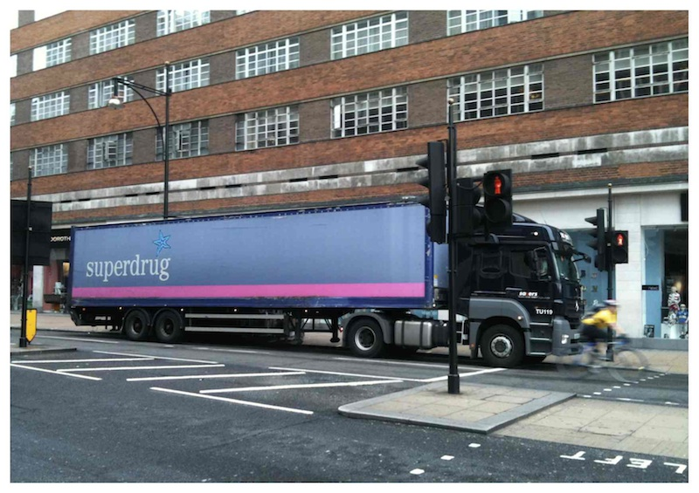
The QDDS methodology (e.g. development of the MoU) was adhered to throughout discussions by all members of the working group and a date of 8 August 2010 was earmarked for the start of the trial. However, one week prior to the trial commencing, it was postponed due to concerns over the potential health and safety hazards of delivering goods across the pavement during busy evening periods for pedestrian movements. In addition, it emerged that there could be scope for possible “joint consolidated deliveries” by Superdrug and Next. By the end of December 2010, positive discussions had taken place between these retailers and it was felt that consolidated deliveries could occur at some point, barring any contractual issues. It was not possible for this to be agreed within the timescales necessary for a trial to take place as part of the QDDS project.
Figure 5: Delivering to Superdrug Marble Arch

Communication channels remained in place with Superdrug and a “trial run” of joint deliveries by Superdrug and Next to their respective Marble Arch stores took place in March 2011, with both parties reporting positive benefits. However, for operational and commercial reasons, it has been decided not to proceed further with the initiative of joint deliveries and Superdrug is now exploring further alternatives for delivery times with the City of Westminster Council, building on the partnership approach established through the QDDS process.

Tesco / Reading Borough Council

The QDDS Consortium expressed a desire to look at all forms of “delivery curfew” and this included the possibility of submitting a request for a variation of a statutory planning condition that had been imposed upon a store. The purpose of this exercise was to gain more of an insight into the steps that need to be taken and the legislative procedures that have to be adhered to when submitting a planning application to have existing restricted delivery times amended.

Discussions took place with Tesco, who agreed to work with the QDDS project team on submitting an application to amend existing delivery times with a view to a QDDS trial taking place.

The initial intention was to pursue an application to amend existing planning conditions restricting delivery times at Tesco Heswall (Wirral Metropolitan Borough Council. However, following a direct expression of interest from Reading Borough Council to ‘host’ a trial, the Consortium decided to prioritise an application for Tesco Reading.

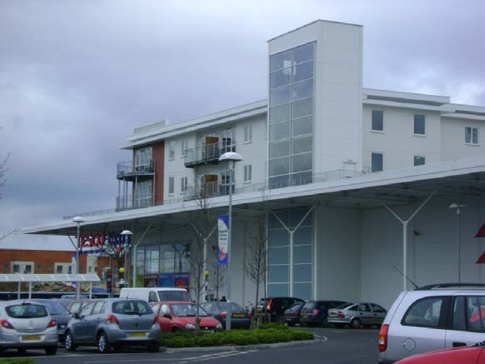
The store in question was a Tesco “Extra” store in Reading which had a restriction in place stating that deliveries were not permitted to the store between the hours of 23.00 – 07.00 in order to protect residents from any unreasonable disturbance from delivery vehicles. Tesco was keen to secure a temporary relaxation to this condition in order to undertake a delivery between 04.00 – 05.00 hours. Discussions were therefore held with officers of Reading Borough Council who were keen to participate in a trial and who offered guidance and advice in terms of submitting an application.
Figure 6: Tesco Reading with residential above

A “Section 73” application (“Application for removal or variation of a condition following grant of planning permission – Town and Country Planning Act 1990 / Planning (Listed Buildings and Conservation Areas) Act 1990”) and supporting documentation were submitted to Reading BC in December 2010. On-going dialogue was held with the relevant officers at the local authority who themselves had a duty to consult with local residents potentially affected by the changes to delivery times.

As time progressed, it became evident that the application was proving to be very sensitive, with objections raised and representations made by local residents. A recommendation was made by the officers that the QDDS project team should meet with members of the Planning Applications Committee to explain the trial in more detail and give additional assurances. This took place at the end of February 2011.

The application was eventually considered at a Planning Committee meeting on 6 April 2011. The outcome was that the application was deferred until further assurances could be given that the new delivery times would not have any impact on local residents. This meant that the Committee wanted a site assessment report to be produced, in addition to noise surveys being undertaken, before a final decision would be made. Tesco was advised of this decision and internal discussions took place to agree the next steps. Unfortunately, because of the time taken from submitting an application to receiving a decision, a QDDS trial was unable to take place.

In parallel with the application submitted to Reading BC, a second planning application was submitted by the project team on behalf of Tesco to Wirral Metropolitan Borough Council allowing comparison of the planning procedures and handling processes between authorities. The application was in relation to the Tesco store in Heswall and again called for earlier delivery times. A similar process and methodology was adopted for the second application as for Reading BC and submission occurred at a similar time. However, as a result of public consultation, objections, representations and a petition against revised delivery hours were raised by local residents. As such, the strength of feeling displayed led the officers to make a recommendation to the Wirral MBC Planning Committee to refuse the application based upon previous history and the obvious sensitivity involved.

It became evident during the process for both planning applications that the “planning route” is the most difficult in terms of setting up out-of-hours delivery trials. Nevertheless, valuable lessons were learned in terms of the steps that need to be taken to submit an application and the procedures that both a retailer and a local authority planning department have to undertake.

The inclusion of a site assessor and facilitator (ideally independent) and a visible complaint help-line can help to facilitate resident engagement, especially where there is historic bias against the retailer or the Local Authority.

It is essential that close communications between Local Authority, retailer, assessor and trial facilitator are established, followed by resident consultation. If there is co-operation between all these parties, then there is greater likelihood of a successful trial outcome, whatever noise mitigation measures are put in place.
In addition, it is important that the store’s history of resident complaints is considered, as any unresolved issues (not necessarily directly related to delivery activity), which arise during resident/elected member engagement, are likely to affect Council decisions.
The store manager’s role is vital in coordinating quiet delivery practice in the immediate and longer terms. Two of the most important factors for a successful quiet delivery are human behavioural best practice and the use of quiet vehicles and equipment.
It is important to have endorsement for ‘out-of-hours’ delivery trials at retailer board level and the committed involvement of transport and distribution managers, as well as the store manager.
CONCLUSION

A retailer has a key role to play in any proposed ‘out-of-hours’ delivery trial as it has a duty of care to demonstrate to a local authority and local residents that necessary steps have been taken to minimise noise when delivering at the new times. It is likely that changes in delivery times will bring about operational benefits for both the store and the distribution operation but these benefits must be carefully balanced against causing undue disturbance to residents. It is vital that retailers and distributors implement best practice low-noise delivery techniques at the outset to avoid any cause for complaint, as this can mean significant benefits in the long run with the new delivery times being made permanent.

Industry recognises that a wholesale blanket “lifting” of existing delivery restrictions by a local authority for the benefit of the private sector is neither likely nor sustainable. Applications submitted by retailers to undertake ‘out-of-hours’ deliveries will be dealt with on a case-by-case basis and, in some instances, it might be deemed inappropriate to set up trials due to existing local factors, which may be political or social. However, stores will exist where there is the potential to undertake a trial and there is a will from a retailer, (particularly through the store manager and the distribution / transport manager) to ensure that the QDDS methodology is adopted and maintained.

Undoubtedly, if a trial is successful, this will facilitate an improved working relationship between the retailer and the local authority that could have positive impacts in other areas.

SUMMARY OF RECOMMENDED ACTIONS AND LESSONS LEARNED

    - It is recommended that, should a retailer express interest in setting up a trial, as much in-depth information as possible is provided (in the structure of an application form) to the local authority, in order to move the process forward to the next phase of direct engagement

- It is recommended that retailers appoint a competent person to produce a “site assessment” report to review current store delivery practices and to implement improvements to existing methods where required, so as to mitigate key sources of noise

- It is essential that retailers comply with all elements of the MoU prepared for the trial and ensure that all store staff are made aware of the trial and its importance, to ensure that the new delivery times remain in place and benefit the overall operation of the store

- It is important that retailers produce a ‘driver charter’ to be issued to drivers as a set of instructions reminding them of their obligations when delivering to the store where the trial is taking place, so that these can be followed without putting the trial in jeopardy and to minimise noise associated with the delivery

- Retailers have the opportunity to influence the performance of their own operations and those of their suppliers and carriers through ‘driver charters’

- Retailers should liaise with the local authority to consider appointing a competent person to install noise monitoring equipment for the duration of the trial, to demonstrate that noise levels are being monitored

- Retailers should be prepared to engage with local residents before, during and after the trial in order to establish good communication links and keep residents informed of general store activity

- Retailers should collate key data both pre – trial and during the trial for analysis, to assess and present the benefits of the new delivery times on store performance and transport operational efficiency

- Retailers need to be responsive to local residents’ concerns and make efforts to address complaints (both related to delivery noise and other issues). If they are perceived to ignore local residents, then there is a significant likelihood of resistance to relaxation of restrictions

- Retailers should ensure that their own vehicles and those of suppliers do not arrive at the store too early, in advance of their agreed delivery window and should avoid waiting near to residential properties

- For delivery curfews imposed through planning restrictions, retailers need to be prepared to invest considerable time in completing application forms and assembling supporting documents, to ensure full compliance with the statutory processes. Retailers also need to be aware that despite their efforts, there is no certainty that restrictions will actually be revised

- When planning store developments, consideration needs to be given to the proximity of service yards and delivery bays to residential properties, effectively ‘designing out’ potential conflict as far as practicable

- Retailers need to be aware that breaches of existing restrictions or of those in place during the trial may lead to closer scrutiny of their activities by local authorities

- Retailers need to be aware of the different delivery curfew restriction types and develop an understanding of how to deal with each

Retailers should consider using the QDDS MoU and Driver Charters not just for stores requesting curfew relaxation but also for those unrestricted stores which are ‘at risk’ due to resident complaints

APPENDIX 1:Application Form for Retailers to vary existing delivery conditions and undertake a night-time delivery trial |  |  |  |  |  |  | Insert Local Authority Logo
Please note that detailed information on current store delivery curfew restrictions will be needed and we recommend that this information is sourced early on in the process of developing your application.
Please note that all completed application forms and supporting information must be received by (Insert time / date)
Please complete a separate application form for each site and provide as much detail as possible within the application form and, where necessary, provide separate supporting information. A plan of the site and/or satellite view using Google Maps UK would be particularly useful when reviewing the application.
All information provided within this application form will remain confidential and will only be used by (Insert name of Local Authority) for the purposes of this proposed trial. A copy of our data protection policy is available upon request.
General Information
Organisation name:
Contact name: |  |  |  | Position:
Address:
Telephone: |  |  |  | Mobile:
Email:
Details of Store Proposed for Trial
Name of store: |  |  |  | Name of Store Manager:
Address of store:
Type of store (convenience, out-of-town etc):
Store Information
General description of store location
(for example, in High Street, with underground car park, within retail park etc):
How are deliveries currently carried out?
(across kerb, rear service access yard etc):
What type of delivery curfew restrictions are currently in place?
(this could include delivery curfew restrictions imposed by planning conditions, noise abatement notices or through local agreements between retailers and the local authority/local residents – note: this is essential information and we recommend that it is sourced early on in the process of pulling together your application):
Please give full details of store delivery curfew restrictions
(including restricted hours during which deliveries cannot be carried out, detailed description and precise wording of restriction, date of imposition, basis for imposition, which local authority was involved etc - note: this is essential information and we recommend that it is sourced early on in the process of pulling together your application):
Does the store have a history of resident complaints, including non-noise related complaints?
(if yes, please give details):
What is your rationale for selecting this specific site for a quiet delivery trial?
(describe what the potential operational benefits might be):
How close is your store to residential properties?
(a site plan and/or satellite view using Google Maps UK would be very useful to illustrate proximity):
Which deliveries would you wish to carry out during the currently restricted time window?
(please describe current timings of these deliveries and desired new timings, as well as number and origin of vehicles and nature of goods delivered):
Does the store have CCTV covering the areas within which delivery activity takes place?
Which local planning/environmental health authority has jurisdiction for the area within which the store is located?
Have you previously had discussions with local authority officers concerning out-of-hours deliveries and the delivery curfew restrictions at this store? If so, with whom? (please name contacts, provide details on the outcome of those discussions and any relevant supporting information):
Do you (or can you) record key operational data for vehicle movements servicing this store, including:
Delivery vehicle type and specification |  |  |  |  |  | Yes |  |  |  | No
Journey times from depot to store and return |  |  |  |  |  | Yes |  |  |  | No
Vehicle turnaround times at store |  |  |  |  |  | Yes |  |  |  | No
Average vehicle travelling speeds |  |  |  |  |  | Yes |  |  |  | No
Idling time |  |  |  |  |  | Yes |  |  |  | No
MPG |  |  |  |  |  | Yes |  |  |  | No
Total fuel consumed per trip |  |  |  |  |  | Yes |  |  |  | No
If selected for a trial, would you be able and willing to provide this data and also data on store performance for analysis by the Project Team and for inclusion within a case study? |  |  |  |  |  | Yes |  |  |  | No
I confirm that all information provided is correct to my knowledge and I, the applicant, understand that there is no guarantee that the above mentioned store will be selected for a trial and that a trial is not guaranteed to run its full course or to lead to permanent relaxation of restrictions.

I can also confirm that, in the event of being selected for a trial, operational data will be recorded and made available to the local authority and that, if selected, I, the applicant would be willing to be a case study host.
Name |  |  |  | Position
Date |  |  |  | Signature
Once completed, please submit your Application Form and any supporting information by email to: (Insert local authority email address) or by post to:

(Insert local authority postal address)

All applications, either electronic or hard copy, should be received by (Insert time / date)

APPENDIX 2: Example Memorandum of Understanding

PROPOSED ‘Out-of-Hours’ DELIVERY TRIAL

NAME OF LOCAL AUTHORITY / NAME OF RETAILER

Draft Memorandum of Understanding –
Agreed Actions and Working Processes

(Add list of Working Group Members and contact details)

Agreed Specifics of Proposed Trial

- Start / finish dates of proposed trial and duration of trial
- Times of deliveries that will be the focus of the trial and whether any “direct deliveries” (e.g. bread, milk) are to be included;
- Possible involvement of local residents who have previously complained about the store to be involved in the working group and to keep noise log records during the trial;
- Inclusion of any planned / foreseen events that could impact upon the trial (e.g. store maintenance);
- Provision to meet during the trial to address any complaints or unforeseen circumstances;
- Arrangements for post – trial meeting and reporting requirements; and
- The collection of operational data (e.g. journey times, fuel consumption (mpg), idling time, average vehicle speeds, store turnaround times) and store performance data prior to and during the trial for use in subsequent post trial reporting

Agreed Responsibilities and Actions

- Arrangements for installation of noise monitoring equipment on site to record noise levels both pre–trial and throughout the planned duration of the trial;
- Arrangements for the set-up of the “out-of-hours” telephone helpline for resident complaints during the trial;
- Key reporting arrangements between all members of the working group if complaints received during trial period;
- Local authority to advise elected members of proposed trial;
- Local authority to carry out spot check visits during the trial;
- Retailer to record vehicle arrival / delivery times during trial for correlation with noise recordings;
- Retailer supply chain / transport department to produce a “driver charter” to ensure detailed briefing of drivers engaged in servicing the store during the trial;
- Retailer to invest in and deliver any relevant staff training needed for the trial;
- Retailer to circulate weekly report to all working group members, advising of any issues arising;
- Retailer to advise supply chain if any delivery is non – compliant with the agreed operational aspects of the trial; and
- All relevant noise mitigation measures emanating from the “site assessment” report to have been implemented prior to start of the trial (e.g. servicing of delivery bay doors, switch off tannoy system, etc ….)

APPENDIX 3: Example “Driver Charter”

PROPOSED ‘Out-of-Hours’ DELIVERY TRIAL

NAME OF RETAILER / NAME OF LOCAL AUTHORITY

“Driver Charter” Template

Retailer X is taking part in a night-time delivery trial in conjunction with Local Authority Y. The first delivery to the store will take place at …… (insert new delivery time / date) instead of …… (insert existing time), for an initial period of …… (number of weeks / months). The trial will end on …… (insert end date of trial). If the trial is successful, the opportunity to continue with the new delivery times will be discussed with the local authority and a joint decision reached.

WE NEED TO ENSURE THAT WE MAINTAIN OUR BEST WORKING / DRIVING / DELIVERY PRACTICES DURING THE TRIAL

If any complaints are made about increased noise levels during the trial then Retailer X will have its new delivery time of …… stopped which will have a big impact on store and operational performance.

Please note that this is a very noise sensitive area. Please ensure that for all OVERNIGHT / EARLY MORNING deliveries, the following guidelines are strictly adhered to:-

- If early for your delivery slot, do not park up and wait near to residential property
- Consideration to noise and local residents is shown as you approach the rear of the store and manoeuvre your vehicle on the road to access the delivery bay / yard;
- Do not sound your horn;
- Reversing bleepers are switched off if not subject to health and safety requirements;
- Engines are switched off when you are not manoeuvring;
- Radios are switched off and doors are not slammed when alighting from the cab;
- Be mindful of how far your voice can carry when talking to store employees;
- If opening a gate / roller shutter door to gain access, be sure to avoid excessive noise;
- No whistling or shouting to get the attention of store employees; and
- When collecting or returning items to the service yard, doors and shutters are not to be slammed and items carefully stowed to reduce noise

APPENDIX 4: Step-by-step trial guide for retailers

1. Completion of Retailer Application Form

2. Start of ‘Trial’ process

3. Consider appointment of ‘Trial Facilitator’

4. Set up ‘Trial Working Group’

5. Undertake a ‘Site Assessment’ Report

6. Develop a ‘Memorandum of Understanding’ and ‘Driver Charter’

7. Undertake noise monitoring

An application form must be completed by the retailer providing comprehensive information as requested.

Upon receipt of completed application form, it is at the discretion of the local authority whether to proceed with the application and engage with the retailer. If the local authority sees the benefits of setting up a trial, engagement with the retailer can begin.

Liaise with the local authority over the possible appointment of a ‘trial facilitator’ to oversee discussions/negotiations and act as a go-between for the retailer and local authority.

Establishment of a ‘Trial Working Group’ to include representatives from the retailer (e.g., Store Manager, Transport Manager), local authority (e.g. Environmental Health Officer) and possible resident involvement subject to previous store history.

The retailer must appoint a competent person to prepare a ‘site assessment’ report to assess current store delivery practices and to recommend improvements to existing methods so as to mitigate key sources of noise.

Production of an MoU to be agreed by all working group members, highlighting areas that require urgent attention prior to a trial commencing. A retailer must comply with all elements of the MoU. Production of a ‘driver charter’ as guidelines for drivers delivering to the store.

Agree that noise monitoring is undertaken by either the local authority or a noise specialist appointed by the retailer to monitor noise levels both pre and during the trial.

8. Handling resident complaints

9. Post trial Working Group meeting

10. Agree way forward with the local authority

If a retailer receives complaints during the trial, be prepared to engage directly with residents and establish good communication links in order to address concerns.

Hold a post trial working group meeting to hold a full review of the trial and to discuss the results. A retailer should be prepared to present results (e.g. improved fuel consumption) from the trial

Reach agreement with the local authority on how to proceed and whether the retailer can continue with the new delivery times subject to on-going review and monitoring.

