



GUIDE FOR LOCAL AUTHORITIES ON
’OUT-OF-HOURS’ DELIVERIES

HGV deliveries in residential areas are often constrained during night-time and/or weekend periods; however, this increases traffic and carbon emissions at peak hours.

The wider potential benefits from moving delivery activity out of peak periods include:-

- Reduced congestion;
- Improved road safety;
- Improved air quality; and
- Reduced carbon emissions

However, out-of-hours noise from vehicle manoeuvring and loading / unloading activity can impact on local residents, particularly at times of the day when ambient noise levels are low.

This guide is designed to help Local Authorities work with local businesses and local residents to realise the benefits of changed release hours without creating disturbance.

“I welcome the launch of this guide, which shows how Local Authorities can work with local retailers to allow deliveries out-of-hours without creating a nuisance to residents. The Guide also identifies some of the issues that Local Authorities may want to consider during the planning process, to avoid the need for delivery restrictions in the first pace. Less congestion, better air quality and safer roads means a win-win situation. I look forward to seeing more examples of retailers and local authorities working together to explore the mutual benefits of Quiet Deliveries.” - Mike Penning MP, Minister for Freight

BACKGROUND

The concept of ‘out-of-hours’ deliveries as a sustainable distribution initiative has been the focus of the “urban logistics” debate for many years. The subject appears as a desirable measure on local Freight Quality Partnership (FQP) action plans across the country to help improve the efficiency, economy, safety and sustainability of urban freight movement. In recent years, even dating back to the Commission for Integrated Transport’s “Night-time Delivery Curfew Initiative” project in 2001 / 02, various attempts have been made to set up and run out-of-hours deliveries trials. These have involved bringing together retailers and interested local authorities to work together at specific trial sites. One of the most recent of these trials was the partnership that evolved between Sainsbury’s and Wandsworth Borough Council (2007 / 08), working with the Noise Abatement Society, which saw the development of a proposition to have the restrictions lifted at the Sainsbury’s store in Wandsworth for a period of 3 months, which has continued successfully to date. In addition, the Department for Transport has produced guidance on the subject with support from the Freight Transport Association (FTA) and other industry bodies; and FTA has published a toolkit for improving night time deliveries.

However, the distinct lack of trials over the past decade suggests that many local authority officers remain unclear on how best to approach the issue in a way that addresses local residents’ concerns, whilst accommodating the needs of local businesses. Therefore, this guide is specifically aimed at local authority transport planning officers and environmental health officers as a means of demonstrating that it is possible both to relax existing delivery restrictions, using the appropriate methodology, and to protect residents from significant noise, through the application of low noise ‘out-of-hours’ delivery techniques and improved management practices.

INTRODUCTION

Out-of-hours deliveries to retail premises, comprising quiet deliveries at night-time and also during the “shoulders” of the day (i.e. prior to opening, after closing), away from peak periods, can potentially offer significant environmental and social benefits. Moving delivery activity out of peak periods removes HGVs from congested locations and can help reduce vehicle emissions and lead to improvements in both local air quality and local road safety. Doing so, in turn, lessens daytime disturbance and allows quiet deliveries to become the norm. The wider potential benefits include:-

- Reduced congestion;
- Improved road safety;
- Improved air quality; and
- Reduced carbon emissions

However, out-of-hours deliveries may also have an impact on local residents and local communities. Noise from vehicle manoeuvring and loading / unloading activity can impact on local residents, particularly at times of the day/night when ambient noise levels are low. HGV movements in urban areas are therefore often constrained during night-time and / or weekend periods by local curfew regulations put in place to avoid noise impacts. These include delivery curfew restrictions imposed by planning conditions, noise abatement notices or local agreements between retailers, the local authority and local residents.

If they wish these regulations to be relaxed, retailers need to be able to demonstrate to local authorities that any out-of-hours delivery activity will be undertaken in a way which minimises disturbance and disruption to local residents. Local authorities must be convinced that retailers have clearly taken into account the interests of residents who could be affected by changes in delivery times, and will implement and maintain the necessary protocols and procedures to lessen the impact.

QUIET DELIVERIES DEMONSTRATION SCHEME (QDDS)

In November 2009, the Department for Transport (DfT) established a consortium, in partnership with the Freight Transport Association (FTA) and the Noise Abatement Society (NAS) in order to investigate and promote the potential benefits from the relaxation of delivery curfews for quiet deliveries.

The consortium has overseen the whole Quiet Deliveries Demonstration Scheme (QDDS), which has involved the setting up, running and reporting on quiet delivery demonstration trials at retail premises across England. The trials involved the relaxation of restrictions at these selected retail sites for a specific time period, during which quiet deliveries were permitted and closely monitored. The Scheme was managed by freight specialists at transport consultants, Transport & Travel Research Ltd (TTR), with other members of the project team consisting of NAS, the Transport Research Laboratory (TRL) and AEA Technology.

Both retailers and local authorities were invited to participate and to submit applications for stores with delivery curfew restrictions, anywhere within England, to be the trial stores in the Scheme. Applicants were requested to complete an application form and submit relevant supporting information outlining the current restrictions in place. The applications were then assessed by the consortium and a shortlist of sites was identified based upon the location of the store (it was felt only one store based in Greater London should be chosen to allow for a geographical spread of sites) and the type of existing restriction that was in place (i.e. whether planning, voluntary or noise abatement notice). From the applications received, six trial sites were chosen, consisting of the following participants:-

RETAILER | LOCAL AUTHORITY | LOCATION OF STORE | TYPE OF RESTRICTION
Sainsbury’s plc | Bournemouth Borough Council | Bournemouth, Dorset | No current curfew but store ‘at risk’
Marks & Spencer | Chichester District Council | Chichester, West Sussex | Voluntary Agreement in place
Morrisons plc | Stafford Borough Council | Stone, Staffordshire | Voluntary Agreement in place
Asda | Walsall Borough Council | Bloxwich, Walsall | Voluntary Agreement in place
Superdrug Stores | City of Westminster | Westminster, London | Voluntary agreement in place
Tesco | Reading Borough Council | Reading, Berkshire | Statutory planning condition in place

QDDS METHODOLOGY

For each of the trial sites (with the exception of Tesco / Reading Borough Council which focused on the statutory planning process), the same methodology was adopted. Local trial working groups were set up involving the retailer and representatives of the local authority with a trial facilitator appointed to oversee discussions and act as a link between the two parties. It was the responsibility of the local working group to oversee the trial and agree the working practices and necessary noise mitigation measures to be implemented. The aims of the trials were to demonstrate:-

- A comparison of noise levels between the existing delivery times and the new agreed delivery times;
- Improved journey times for the retailer;
- Improved sales / availability of stock; and
- Improved fuel economy, emissions and air quality

The NAS was appointed to carry out “site assessments” at each location, offering recommendations on noise mitigation measures, and to provide a noise complaint telephone helpline for local residents to contact during the actual trial. On-site noise monitoring was also undertaken both pre – trial and during the trial by specialist noise consultants, TRL.

LOCAL AUTHORITY PARTICIPATION IN TRIALS

In each of the QDDS trials that took place, local authorities were principally represented by their Environmental Health Officer(s). Engagement with the officers was initiated upon receipt of an application from a retailer to set up a trial.

- It is recommended that, should a retailer express direct interest with a local authority in setting up a trial, the local authority requests that an application form be completed by the retailer providing as much detail as possible prior to moving to the next stage of direct engagement. (See example form in Appendix 1).

Once an application form had been received from the retailer and verified with the trial facilitator, contact was made with the local authority and an exploratory meeting arranged with the key personnel to assess the potential to “host” a trial within their area. In all of the QDDS trials undertaken, there was significant appetite from the EHOs and other council officers involved to participate in a trial.

Following the initial meetings with both the retailer and the local authority, the next stage was to set up an initial working group meeting, chaired by a “trial facilitator”, involving all parties.

- It is recommended that a “trial facilitator” be appointed to oversee discussions / negotiations and act as an impartial third party between the retailer and local authority to ensure that all procedures / protocols agreed for the proposed trial are carried out.

The objectives of an initial working group meeting are to:-

- Open dialogue between the retailer and local authority to assess the potential for a trial;
- Discuss the history of store issues and any previous complaints;
- Discuss proposed trial timings;
- Understand the objectives of the other party for participation in a trial; and
- Agree the actions and next steps to be undertaken prior to a trial taking place

A key element of any trial is to undertake a “site assessment” report to determine likely noise sources, to review the delivery process at the store and to make recommendations on possible noise mitigation measures. For the purposes of the QDDS trials, such reports were prepared and written by the NAS.

- A site assessment needs to be undertaken by a competent person at the discretion of the local authority to assess current store delivery practices and to recommend improvements to existing methods so as to mitigate key sources of noise.

The production of a “site assessment” report assists the working group in identifying areas of the delivery process where improvements can be undertaken, prior to any trial starting. It is these areas that then form the basis of a joint “Memorandum of Understanding” (MoU), prepared by the trial facilitator, between the retailer and local authority, stipulating the areas and actions that need to be addressed before a trial can commence. An MoU should include the following features as a base requirement:-

- Start date, end date and proposed timescales of the trial;
- The times of the new deliveries to be undertaken during the trial;
- Reporting procedures to be undertaken in the event of complaints being received from local residents;
- Details of training / instructions to be given to store staff and drivers involved in the proposed trial;
- An undertaking by the retailer to record transport operational data both pre – trial and during the trial, to monitor fuel consumption, journey times from distribution centre to store, etc …;
- Details of the trial to be communicated to local authority elected members; and
- Telephone helpline to be set up and advertised, so that local residents can lodge complaints during the trial if necessary.

The MoU should clearly indicate which party takes responsibility for each of the actions identified.

An example of an MoU can be found in Appendix 2.

- It is recommended that local authorities request a “Memorandum of Understanding” to be prepared, for all parties to sign up to and agree, highlighting the key areas that require urgent attention, prior to a trial commencing.

A key concern for local authorities with any proposed trial is the potential increase in noise resulting from revised delivery times. A prerequisite of all the QDDS trials that took place was the installation of noise monitoring equipment at specific site locations (in close proximity to the store delivery area) to monitor noise levels for a pre – trial set period and for the full duration of the trial, so that comparisons can be made once the noise data has been collated and the results analysed. For the purposes of the QDDS trials, noise monitoring was undertaken by TRL with individual reports containing the results produced for each trial.

- It is recommended that local authorities either undertake their own noise monitoring at specific times both pre – trial and during the trial or agree that the retailer arranges for noise monitoring equipment to be installed for the duration of a trial, to convince local residents that noise levels are constantly being monitored.

Once all elements of the MoU have been addressed and the resulting actions carried out, a trial can then take place with agreed start and finish dates. However, if, during the trial, a number of residential complaints are logged either with the telephone helpline, with the store, or with the local authority itself, there should be provision to call an “emergency” working group meeting to discuss progress and the nature of the complaints received. If the local authority is not satisfied with the way the trial is progressing and feels that the retailer is not adhering to what was agreed in the MoU, then it is at the discretion of the local authority, in consultation with the other working group members, to stop the trial either permanently or until such a time that the retailer can demonstrate a substantial improvement in delivery practices.

- The MoU should make clear that local authorities have the option to stop a trial at any given time, on receipt of appropriate evidence of nuisance, if they feel that the retailer is failing to meet its obligations outlined in the MoU.

Once a trial has run its course, it is helpful to hold a post trial working group meeting in order to hold a full review and for the results to be presented to both parties (e.g. results from the noise monitoring that was undertaken). It is at this stage that a trial report will be prepared containing all the key elements. The local authority can then decide whether or not to allow the retailer to continue with the new delivery times, subject to on-going review and monitoring.

A quick step-by-step guide outlining the necessary procedures for setting up and running a trial can be found in Appendix 3 to assist local authorities should a request be made by a retailer to undertake an ‘out-of-hours’ delivery trial.

REVIEW OF THE QDDS TRIALS

Six trials were identified by the QDDS Consortium, mainly focused on local / voluntary agreements that were in place between the local authority, retailer and local residents. The proposed trial involving Tesco and Reading Borough Council focused on the planning process and the necessary steps that have to be taken to vary planning conditions restricting delivery times. A summary of the trials undertaken follows:-

Sainsbury’s / Bournemouth Borough Council

The trial between Sainsbury’s and Bournemouth BC, for the Castlepoint store, took place mostly during June 2010. The local authority had previously received complaints from local residents concerning alleged night-time delivery noise from the store and felt that if steps were not taken to reduce the perceived disturbance to residents, enforcement action would ultimately be necessary. A local agreement was in place, with Sainsbury’s undertaking not to move roll cages in the yard from 23.00 – 06.00 hours.
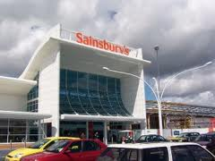
In April 2010, a working group was formed consisting of representatives from both parties and it was agreed that the deliveries that would form the basis of the QDDS trial were those undertaken at 23.00, 02.00 and 04.00 hours respectively. Sainsbury’s already delivered at these times, so there were no changes to the delivery times but the focus was on improving existing delivery practices and introducing low-noise measures (e.g. reducing noise from roll cage movement and unloading activity).
Figure 1: Sainsbury’s Castlepoint store

The QDDS methodology was introduced and all the necessary pre-trial steps were taken (e.g. development of an MoU, the introduction of a telephone helpline, set up of noise monitoring equipment) and the trial officially started on 31 May 2010. In addition, the trial also involved direct suppliers of products (e.g. bread, milk) to the store who were asked to introduce and comply with the same actions being undertaken by Sainsbury’s own staff in terms of implementing quieter delivery practices and training drivers accordingly. The trial ran for 6 weeks and officially finished on 12 July when a review meeting was held.

The trial was considered a success with the key factors being:-

- No complaints had been received through the telephone helpline or by Store Management during the trial period;
- The involvement of a local resident who was asked to keep noise logs and record instances of increased noise activity during the trial;
- On-going protection of the existing night-time delivery profile (i.e. deliveries at 23.00 / 02.00 / 04.00 hours);
- The establishment of an effective working relationship between Bournemouth BC and Sainsbury’s, which continues to evolve;
- The introduction of best practice measures in line with the MoU which have continued since the trial ended; and
- Improvements in fuel consumption reported by Sainsbury’s of 5.7% for night-time operations compared to daytime equivalents.

Marks & Spencer / Chichester District Council

The trial between M&S and Chichester DC took place in August / September 2010. No statutory restrictions had been imposed by the local authority although a local agreement was in existence between the store and local residents stipulating that the first delivery would not take place before 06.30 hours. An enquiry was received from M&S who indicated a preference to undertake the first delivery at the Chichester branch at 06.00 hours in order to assist the store in being ready to trade when opening for business.

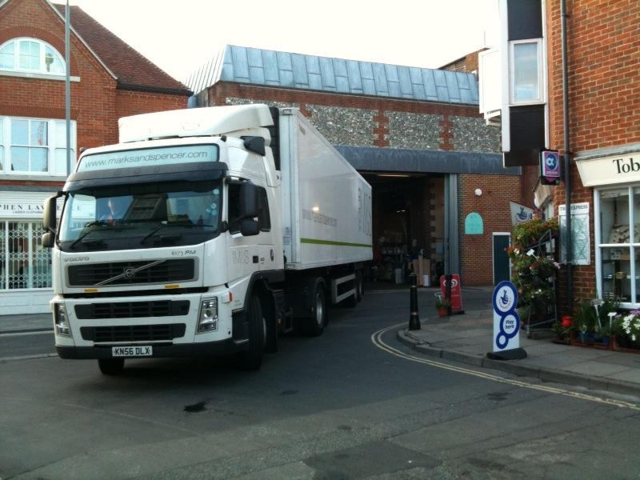
In June 2010, a working group was formed consisting of representatives from both parties and it was agreed that the 06.00 hours delivery would be the focus of the QDDS trial. A number of working group meetings were held to discuss the relevant issues (e.g. main sources of noise, previous history of complaints, the “site assessment” report that was prepared) and all elements of the QDDS methodology were introduced and followed (e.g. development of an MoU, the introduction of a telephone helpline, set up of noise monitoring equipment).
Figure 2: M&S Chichester Store delivery

The trial officially started on 16 August 2010 with M&S Logistics Department and M&S store staff instructing and training staff on quieter delivery practices. The trial ran for 6 weeks and formally concluded on 27 September 2010 when a QDDS post-trial meeting was held to review the trial itself and to agree next steps.

The M&S Chichester QDDS trial was considered to be a success by members of the working group as a result of the following factors:-

- No formal complaints had been received through the NAS helpline, by store management or direct to Chichester DC during the trial;
- Additional best practice measures had been introduced in line with the MoU and “Driver Charter” documents;
- An agreement was reached by both parties that M&S should continue with the 06.00 hours delivery which would be subject to on-going review; and
- The QDDS trial had provided a platform for both parties to work more closely together to bring about further effective improvements in operational practice.

Morrisons / Stafford Borough Council

The trial between Morrisons and Stafford BC, for the retailer’s store in Stone (Staffordshire), took place between August – October 2010. No statutory restrictions had been imposed by the local authority, although noise complaints relating to night-time delivery activity had previously been made about the store when trading under another name. As a result, a local agreement had been reached between residents, the local authority and the retailer which meant that deliveries could only be undertaken between 07.00 – 22.00 hours. Morrisons inherited this voluntary curfew when they took over the store from the previous retailer.

In June 2010, a working group was formed consisting of representatives from the retailer and the local authority. Morrisons were keen to undertake deliveries prior to 07.00 hours and it was agreed that two deliveries would form the focus of the QDDS trials and that these would be at 05.30 and 06.30 hours respectively.

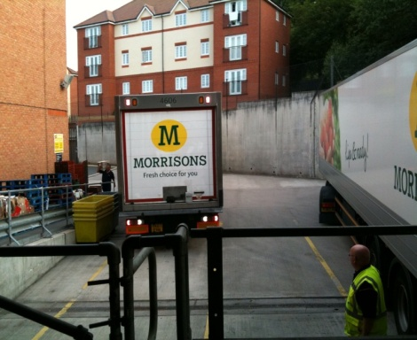
The QDDS methodology was introduced and all the necessary pre-trial steps were undertaken (e.g. development of an MoU, the introduction of a helpline for local residents to contact if excessive noise occurred) and the trial officially started on 30 August 2010. During the trial, Morrisons introduced the use of quieter pallet trucks to assist with keeping noise to a minimum.
Figure 3: Morrisons delivery yard
This QDDS trial was the first trial to generate complaints via the telephone helpline, with 3 complaints received from residents who lived in a block of flats located opposite the Morrisons delivery yard. In all instances, the complaints focused on noise from the delivery process (e.g. arrival of vehicle) and the necessary procedures were taken to address the complaints. Details of each complaint were circulated to members of the working group and the representative from the local authority was tasked with contacting each complainant to obtain further information and ask the resident in question to complete noise logs for the remainder of the trial. The fact that none of the residents took up this opportunity suggests they were satisfied with the steps taken to address their respective complaints.

The trial ran for six weeks and officially finished on 11 October 2010 and a review meeting was held shortly afterwards. The trial was considered to be a success with the main results being:-

- Although the trial had generated 3 formal complaints, the necessary steps and actions had been taken to address the concerns of the local residents by all members of the working group and especially the local authority;
- The trial had facilitated the engagement and on-going relationship between Stafford BC and the Morrisons store; and
- This relationship led to the continuation of the 05.30 and 06.30 delivery times post the QDDS trial and these remain in place

Asda / Walsall Council

The trial between Asda and Walsall Council, for the Asda store in Bloxwich, took place from December 2010 to January 2011. Investigations showed that a voluntary agreement existed between the store, local residents and Walsall Council that no deliveries should be undertaken before 07.00 hours and after 22.00 hours to protect residents’ interests. However, Asda were keen to have this relaxed subject to agreement by all parties, in order to improve both operational and store performance.

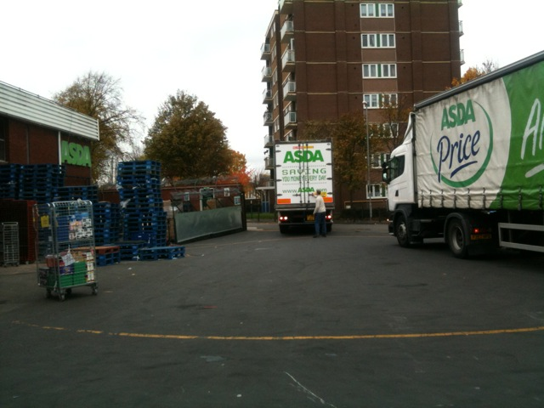
In October 2010, a working group was formed consisting of representatives from both parties and it was agreed that the deliveries that would form the basis of the QDDS trial would be undertaken at 06.00 hours and 06.45 hours respectively. The QDDS methodology was implemented and all the necessary steps and measures were introduced (e.g. development of an MoU, the set up of a telephone helpline). The trial officially started on 6 December and would run over the busy Christmas and New Year period.
Figure 4: Asda delivery yard

This trial also generated a complaint via the helpline in relation to vehicles arriving before the agreed QDDS delivery times and parking up in adjoining streets, thus causing nuisance and disturbance. Details of the complaint were circulated to the working group and advice sought, particularly from the Asda Store and the Asda Regional Distribution Centre. In addition, the trial facilitator met with the residents after the trial to discuss the complaint and to listen to their concerns that they were not fully aware of the trial despite an undertaking given from Asda Bloxwich store management to engage with residents and advise them of the trial.

The trial ran for 6 weeks, finished on 17 January 2011 and a review meeting was held shortly afterwards. It emerged that various elements of the MoU had not been complied with (e.g. non-submission of weekly store reports from the Store Manager to members of the Working Group advising of any contentious issues, non-engagement of Store Manager with local residents to advise them of the QDDS trial, a residents’ notice that had been prepared was not passed on to local residents). These elements of non-compliance highlight the fact that the Store Manager has a critical role to play in any trial through engagement with residents to address concerns raised and to keep working group members informed of on-going developments at the store.

The 06.00 and 06.45 deliveries that were the focus of the QDDS trial remain in place as a result of an agreement between Asda and Walsall Council but this is subject to on-going review and monitoring by the local authority as a result of residents’ concerns during the trial. In addition, the residents have a direct line of communication to the local authority should any issues arise in the future.

Superdrug / City of Westminster

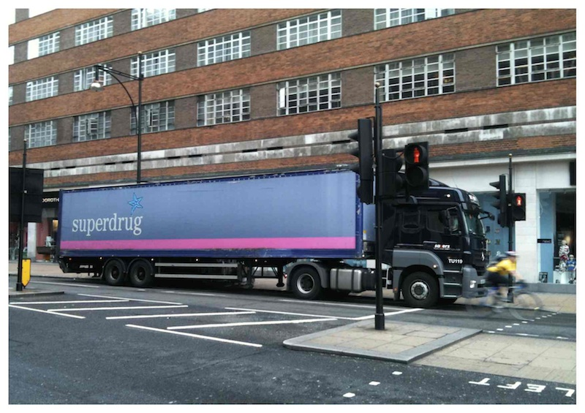
A proposed trial between Superdrug (Marble Arch Store) and the City of Westminster was scheduled to take place August – September 2010. In 2008, the store used to receive deliveries in the evening from Sunday to Thursday at approximately 11.30pm. However, this led to complaints from local residents in flats in close proximity to the store in relation to noise levels. The City of Westminster issued a noise abatement notice which was appealed, subsequently cancelled and replaced by a negotiated curfew from 21.00 – 06.30 hours. The application put forward by Superdrug was to undertake a trial to allow deliveries to be received by the store at the times that the deliveries were previously carried out (i.e. Sunday to Thursday between 20.00 – 23.00 hours).
Figure 5: Delivering to Superdrug Marble Arch

In May 2010, a working group was formed with representatives from both parties to start discussions on how to set up a QDDS trial. However, as talks continued, it emerged that other retailers (i.e. Mothercare and Next) used the same on-street delivery bay to undertake deliveries to their stores located next to the Superdrug store at similar times to those that Superdrug was seeking. This potentially presented a serious issue in that the loading space available was only sufficient for one delivery vehicle to legally use it at a time. As a result, a “mixture” of delivery times was proposed for inclusion in a Superdrug QDDS trial.

The QDDS methodology (e.g. development of the MoU) was adhered to throughout discussions by all members of the working group and a date of 8 August 2010 was earmarked for the start of the trial. However, one week prior to the trial commencing, it was postponed due to concerns over the potential health and safety hazards of delivering goods across the pavement during busy periods for pedestrian movements. In addition, it emerged that there could be scope for possible “joint consolidated deliveries” by Superdrug and Next. By the end of December 2010, positive discussions had taken place between these retailers and it was felt that consolidated deliveries could occur at some point barring any contractual issues. However, it was not possible for this to be agreed within the timescales necessary for a trial to take place as part of the QDDS project.

Communication channels remained in place with Superdrug and a “trial run” of joint deliveries by Superdrug and Next to their respective stores based in Marble Arch, London, took place in March 2011, with both parties reporting positive benefits. However, for operational and commercial reasons, it has been decided not to proceed further with the initiative of joint deliveries and Superdrug is now exploring further alternatives for delivery times with the City of Westminster Council, building on the partnership approach established through the QDDS process.

Tesco / Reading Borough Council (and Wirral Metropolitan Borough Council)

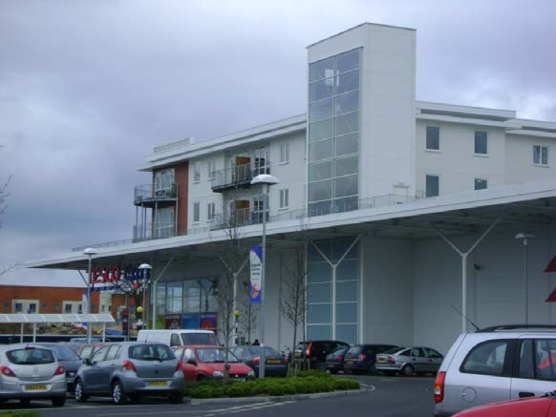
The QDDS Consortium expressed a wish to look at all forms of “delivery curfew” and this included the possibility of submitting a request for a variation of a statutory planning condition that had been imposed upon a store. The purpose of this exercise was to gain more of an insight into the steps that need to be taken and the legislative procedures that have to be adhered to when submitting a planning application to have existing statutory delivery times amended.
Figure 6: Tesco Reading with residential above

Discussions took place with Tesco who agreed to work with the QDDS project team on submitting an application to amend existing delivery times so that a QDDS trial could take place.

The initial intention was to pursue an application to amend existing planning conditions restricting delivery times at Tesco Heswall (Wirral Metropolitan Borough Council). However, Reading Borough Council made direct contact and expressed an interest in ‘hosting’ a trial. Reading BC officers were interested in investigating measures (including out-of-hours deliveries) to help address local air quality. The Consortium then decided to prioritise an application for Tesco Reading.

The store in question was a Tesco “Extra” store in Reading which had a restriction in place stating that deliveries were not permitted to the store between the hours of 23.00 – 07.00 in order to protect residents from any unreasonable disturbance from delivery vehicles. Tesco was keen to secure a temporary relaxation to this condition in order to undertake a delivery between 04.00 – 05.00 hours. Discussions were therefore held with officers of Reading Borough Council who were keen to participate in a trial and who offered guidance and advice in terms of submitting an application.

A “Section 73” application (“Application for removal or variation of a condition following grant of planning permission – Town and Country Planning Act 1990 / Planning (Listed Buildings and Conservation Areas) Act 1990”) and supporting documentation were submitted to Reading BC in December 2010. On-going dialogue was held with the relevant officers at the local authority who themselves had a duty to consult with local residents potentially affected by the changes to delivery times.

As time progressed, it became evident that the application was proving to be very sensitive, with objections raised and representations made by local residents. A recommendation was made by the officers that the QDDS project team should meet with members of the Planning Applications Committee to explain the trial in more detail and give additional assurances. This took place at the end of February 2011.

The application was eventually considered at a meeting on 6 April 2011. The outcome was that the application was deferred until further assurances could be given that the new delivery times would not have any impact on local residents. This meant that the Committee wanted a site assessment report to be produced, in addition to noise surveys being undertaken. Tesco was advised of this decision and internal discussions took place to agree the next steps. Unfortunately, because of the time taken from submitting an application to receiving a decision, a QDDS trial was unable to take place.

In parallel with the application submitted to Reading BC, a second planning application was submitted by the project team on behalf of Tesco to Wirral Metropolitan Borough Council allowing comparison of the planning procedures and processes between authorities. The application was in relation to the Tesco store in Heswall and again called for earlier delivery times. A similar process and methodology was adopted for the second application as for Reading BC and submission occurred at a similar time. However, as a result of public consultation, objections, representations and a petition against revised delivery hours were raised by local residents. As such, the strength of feeling displayed led the officers to make a recommendation to the Wirral MBC Planning Committee to refuse the application based upon previous history and the obvious sensitivity involved.

It became evident during the process for both applications that the “planning route” is the most difficult in terms of setting up ‘out-of-hours’ delivery trials. Nevertheless, valuable lessons were learned in terms of the steps that need to be taken to submit an application and the procedures that both a retailer and a local authority planning department have to undertake. These lessons included:

- The need for local authorities to give clear and reliable advice to retailers on the appropriate application process to vary an existing planning condition
- The need for local authorities to fully consider delivery issues and related impact at the time of considering planning consent
- The need for local authorities to fully consider the implications of co-locating retail and residential properties

CONCLUSIONS

A local authority has a key role to play in any proposed ‘out-of-hours’ delivery trials, as it has a duty of care to protect the interests of local residents from disturbance and noise. However, this duty of care must also be balanced against its obligations to improving air quality, reducing congestion, improving road safety and understanding the operational requirements of local businesses.

A wholesale blanket relaxation of existing night-time restrictions by a local authority for the benefit of the private sector is neither likely nor sustainable. Equally, from an environmental and economic perspective, local authorities should not routinely impose total blanket bans on out-of-hours deliveries. Therefore, the development control and planning process for new retail outlets is critical when designing the appropriate facilities (e.g. off-street or enclosed delivery facilities) as this has the potential to reduce local conflict and subsequently lead to increased efficiency for all parties.

Applications by retailers to undertake ‘out-of-hours’ deliveries must be dealt with on a case-by-case basis and, in some circumstances, it might simply be deemed inappropriate to set up trials due to existing local factors, which may be political or social. However, locations or stores will exist where there is the potential to undertake a trial and there is a will from a retailer and its store manager to ensure that the QDDS methodology is adopted and adhered to.

Undoubtedly, if a trial is successful, this will facilitate an improved working relationship between the local authority and retailer that could have positive impacts in other wider areas in the longer term. Effective partnership working is at the heart of successful trials.
The inclusion of a site assessor and facilitator (ideally both independent) and a visible complaint help-line can help to facilitate resident engagement, especially where there is historic bias against the retailer or the Local Authority.
It is essential to establish close communications between Local Authority, retailer, assessor and facilitator, followed by resident consultation. If there is co-operation between all these parties, then there is more likelihood of a successful trial outcome, whatever noise mitigation measures are put in place.
It is also essential to develop a good relationship with the store manager, whose role is vital in coordinating quiet delivery practice in the immediate and longer terms. Two of the most important factors for a successful quiet delivery are human behavioural best practice and the use of quiet vehicles and equipment.
There was significant interest in ‘out-of-hours’ deliveries shown by local authority officers during the Scheme, with air quality being a key driver.

SUMMARY OF RECOMMENDED ACTIONS AND LESSONS LEARNED

- It is recommended that, should a retailer express direct interest with a local authority in setting up a trial, the local authority request that an application form be completed by the retailer, providing as much detail as possible prior to moving to the next stage of direct engagement. (See example form in Appendix 1)

- It is recommended that a “trial facilitator” be appointed to oversee discussions / negotiations and act as an impartial third party between the retailer and local authority to ensure that all procedures / protocols agreed for the proposed trial are carried out

- A site assessment needs to be undertaken by a competent person at the discretion of the local authority to assess current store delivery practices and to recommend improvements to existing methods to mitigate key sources of noise

- It is recommended that local authorities request a “Memorandum of Understanding” to be prepared for all parties to sign up to and agree, highlighting the key areas that require urgent attention, prior to a trial commencing

- It is recommended that local authorities either undertake their own noise monitoring at specific times both pre – trial and during the trial or agree that the retailer arranges to install noise monitoring equipment for the duration of a trial, to convince local residents that noise levels are constantly being monitored

- The MoU should make clear that local authorities have the option to stop a trial at any given time, on receipt of appropriate evidence of nuisance, if they feel that the retailer is failing to meet its obligations outlined in the MoU.

- Local authorities need to understand the potential operational and environmental improvements of even a very minor adjustment to retailer delivery profiles

- Local authorities need to give clear and reliable advice to retailers on the appropriate application process to vary an existing planning condition

- Local authorities need to fully consider delivery issues and related impact at the time of considering planning consent, fully consider the implications of co-locating retail and residential and should also consider the QDDS approach when working with retailers on ‘at risk’ stores, where no current restrictions exist but complaints have been received.
APPENDIX 1:  Application Form for Retailers to vary existing delivery conditions and undertake an ‘out-of-hours’ delivery trial |  |  |  |  |  |  | Insert Local Authority Logo
Please note that detailed information on current store delivery curfew restrictions will be needed and we recommend that this information is sourced early on in the process of developing your application.
Please note that all completed application forms and supporting information must be received by (Insert time / date)
Please complete a separate application form for each site and provide as much detail as possible within the application form and, where necessary, provide separate supporting information. A plan of the site and/or satellite view using Google Maps UK would be particularly useful when reviewing the application.
All information provided within this application form will remain confidential and will only be used by (Insert name of Local Authority) for the purposes of this proposed trial. A copy of our data protection policy is available upon request.
General Information
Organisation name:
Contact name: |  |  |  | Position:
Address:
Telephone: |  |  |  | Mobile:
Email:
Details of Store Proposed for Trial
Name of store: |  |  |  | Name of Store Manager:
Address of store:
Type of store (convenience, out-of-town etc):
Store Information
General description of store location
(for example, in High Street, with underground car park, within retail park etc):
How are deliveries currently carried out?
(across kerb, rear service access yard etc):
What type of delivery curfew restrictions are currently in place?
(this could include delivery curfew restrictions imposed by planning conditions, noise abatement notices or through local agreements between retailers and the local authority/local residents – note: this is essential information and we recommend that it is sourced early on in the process of pulling together your application):
Please give full details of store delivery curfew restrictions
(including restricted hours during which deliveries cannot be carried out, detailed description and precise wording of restriction, date of imposition, basis for imposition, which local authority was involved etc - note: this is essential information and we recommend that it is sourced early on in the process of pulling together your application):

Does the store have a history of resident complaints, including non-noise related complaints?
(if yes, please give details):
What is your rationale for selecting this specific site for a quiet delivery trial?
(describe what the potential operational benefits might be):
How close is your store to residential properties?
(a site plan and/or satellite view using Google Maps UK would be very useful to illustrate proximity):
Which deliveries would you wish to carry out during the currently restricted time window?
(please describe current timings of these deliveries and desired new timings, as well as number and origin of vehicles and nature of goods delivered):
Does the store have CCTV covering the areas within which delivery activity takes place?
Which local planning/environmental health authority has jurisdiction for the area within which the store is located?
Have you previously had discussions with local authority officers concerning out-of-hours deliveries and the delivery curfew restrictions at this store? If so, with whom? (please name contacts, provide details on the outcome of those discussions and any relevant supporting information):
Do you (or can you) record key operational data for vehicle movements servicing this store, including:
Delivery vehicle type and specification |  |  |  |  |  | Yes |  |  |  | No
Journey times from depot to store and return |  |  |  |  |  | Yes |  |  |  | No
Vehicle turnaround times at store |  |  |  |  |  | Yes |  |  |  | No
Average vehicle travelling speeds |  |  |  |  |  | Yes |  |  |  | No
Idling time |  |  |  |  |  | Yes |  |  |  | No
MPG |  |  |  |  |  | Yes |  |  |  | No
Total fuel consumed per trip |  |  |  |  |  | Yes |  |  |  | No
If selected for a trial, would you be able and willing to provide this data and also data on store performance for analysis by the Project Team and for inclusion within a case study? |  |  |  |  |  | Yes |  |  |  | No
I confirm that all information provided is correct to my knowledge and I, the applicant, understand that there is no guarantee that the above mentioned store will be selected for a trial and that a trial is not guaranteed to run its full course or to lead to permanent relaxation of restrictions.

I can also confirm that, in the event of being selected for a trial, operational data will be recorded and made available to the local authority and that, if selected, I, the applicant would be willing to be a case study host.
Name |  |  |  | Position
Date |  |  |  | Signature
Once completed, please submit your Application Form and any supporting information by email to: (Insert local authority email address) or by post to:
(Insert local authority postal address)

APPENDIX 2: Example Memorandum of Understanding

PROPOSED ‘Out-of-Hours’ DELIVERY TRIAL

NAME OF LOCAL AUTHORITY / NAME OF RETAILER

Draft Memorandum of Understanding –
Agreed Actions and Working Processes

(Add list of Working Group Members and contact details)

Agreed Specifics of Proposed Trial

- Start / finish dates of proposed trial and duration of trial
- Times of deliveries that will be the focus of the trial and whether any “direct deliveries” (e.g. bread, milk) are to be included;
- Possible involvement of local residents who have previously complained about the store to be involved in the working group and to keep noise log records during the trial;
- Inclusion of any planned / foreseen events that could impact upon the trial (e.g. store maintenance);
- Provision to meet during the trial to address any complaints or unforeseen circumstances;
- Arrangements for post – trial meeting and reporting requirements; and
- The collection of operational data (e.g. journey times, fuel consumption (mpg), idling time, average vehicle speeds, store turnaround times) and store performance data prior to and during the trial for use in subsequent post trial reporting

Agreed Responsibilities and Actions

- Arrangements for installation of noise monitoring equipment on site to record noise levels both pre–trial and throughout the planned duration of the trial;
- Arrangements for the set-up of the “out-of-hours” telephone helpline for resident complaints during the trial;
- Key reporting arrangements between all members of the working group if complaints received during trial period;
- Local authority to advise elected members of proposed trial;
- Local authority to carry out spot check visits during the trial;
- Retailer to record vehicle arrival / delivery times during trial for correlation with noise recordings;
- Retailer supply chain / transport department to produce a “driver charter” to ensure detailed briefing of drivers engaged in servicing the store during the trial;
- Retailer to invest in and deliver any relevant staff training needed for the trial;
- Retailer to circulate weekly report to all working group members, advising of any issues arising;
- Retailer to advise supply chain if any delivery is non – compliant with the agreed operational aspects of the trial; and
- Retailer to have implemented all relevant noise mitigation measures emanating from the “site assessment” report prior to start of the trial (e.g. servicing of delivery bay doors, switch off tannoy system, etc ….)

APPENDIX 3: Key Stages for Local Authorities in Setting up Trials

1. Completion of Retailer Application Form

2. Start of ‘Trial’ process

3. Consider appointment of ‘Trial Facilitator’

4. Set up ‘Trial Working Group’

5. Undertake a ‘Site Assessment’ Report

6. Develop a ‘Memorandum of Understanding’

7. Undertake noise monitoring

If an ‘expression of interest’ in setting up an out-of-hours trial is received from a retailer, the local authority should request that an application form be completed providing comprehensive information.

Upon receipt of completed application form, it is at the discretion of the local authority whether to proceed with the application and engage with the retailer. If the local authority sees the benefits of setting up a trial, engagement with the retailer can begin.

Liaise with the retailer over the possible appointment of a ‘trial facilitator’ to oversee discussions/negotiations and act as a go-between for the retailer and local authority.

Establishment of a ‘Trial Working Group’ to include representatives from the retailer (e.g., Store Manager, Transport Manager), local authority (e.g. Environmental Health Officer) and possible resident involvement subject to previous store history.

Request that a ‘site assessment’ be undertaken by a competent person to assess current store delivery practices and to recommend improvements to existing methods so as to mitigate key sources of noise.

Production of a Memorandum of Understanding (MoU) to be agreed by all parties, highlighting areas that require urgent attention prior to a trial commencing.

Request that noise monitoring is undertaken by either the local authority or a noise specialist appointed by the retailer to monitor noise levels both pre and during the trial.

8. Handling resident complaints

9. Post trial Working Group meeting

10. Agree way forward

If the local authority receives complaints from residents during the trial, agree with the working group that a trial can be stopped at any given time if members of the working group are failing to meet their obligations.

Hold a post trial working group meeting to hold a full review of the trial and to discuss the results.

Reach agreement with the retailer on how to proceed and whether the retailer can continue with the new delivery times subject to on-going review and monitoring.

