Department for Transport

Pre-Qualification Questionnaire

Qualification to receive an Invitation to Tender for the following franchise:

GREATER ANGLIA

January 2011

Contents
Introduction | 3
Structure of the Pre-Qualification Questionnaire (PQQ) | 4
Terms and definitions used in the PQQ | 5
Who should provide the PQQ response | 6
Instructions | 6
PART A - APPLICANT INFORMATION | 8
1 Applicant lnformation | 8
1.1 Applicant Details | 8
1.2 Contact Person | 8
1.3 lncorporation | 9
1.4 Member Details | 10
1.5 Management Responsibility | 10
1.6 Other Applicant Information | 10
2 Governance Details | 11
2.1 Automatic Exclusions | 11
2.2 Discretionary Exclusions | 13
2.3 Bid Team and Advisers | 14
2.4 Conflicts of Interest | 14
PART B - SAFETY | 16
1 Corporate Safety | 16
2 Railway Safety | 16
3 Safety Record | 16
PART C – FINANCIAL STANDING | 17
1 Financial Information | 17
1.1 Financial Requirements | 17
1.2 Financial Information | 17
2 Funding Requirements | 18
PART D – TRANSPORT INDUSTRY PERFORMANCE AND EXPERIENCE | 20
1 Customer Results | 20
2 Key Results | 21
3 People Results | 21
4 Society Results | 22
PART E – FRANCHISE SPECIFIC | 23
DECLARATION | 24
ANNEX | 26

Introduction
This document is the Pre-Qualification Questionnaire (“PQQ”) and forms part of the ‘Pre-Qualification Documentation Pack’ for the Greater Anglia Franchise competition. This PQQ was referenced in the OJEU notice placed by the Department for Transport ("the Department"). Applicants wishing to receive an Invitation to Tender (“ITT”) for the Franchise competition must complete a PQQ in full and return it to Mr. Dale Ward by 10.00, 18 February 2011.
The Department plans to award the Greater Anglia Franchise. Details of the scope of the Franchise and the form of contract can be found in the Annex to this PQQ. Applicants are also referred to the Consultation Document for the Franchise that was published in January to April 2010. This can be found on the Department's website.
Further information on the pre-qualification process is given in the Pre-Qualification Process Document ("PPD").

Structure of the Pre-Qualification Questionnaire
The structure of the questionnaire including details of the measurement method and evaluation weighting criteria follows:

 | Contents and definition of Sections | Measurement method
Part A | Applicant Information | Pass / Fail
 | 1 Applicant Information
 | 2 Governance Details
Part B | Safety | Pass / Fail
Part C | Financial Standing | Pass / Fail
 | 1 Financial Information
 | 2 Funding Requirements
Part D | Transport Industry Performance and Experience | Maximum score 70 per cent
 | 1 Customer Results | 30 per cent (of Part D)
 | Question 1.1 | 75 per cent (of Q1)
 | Question 1.2 | 25 per cent (of Q1)
 | 2 Key Results | 30 per cent
 | Question 2.1 | 50 per cent (of Q2)
 | Question 2.2 | 50 per cent (of Q2)
 | 3 People Results | 20 per cent
 | Question 3.1 | 75 per cent (of Q3)
 | Question 3.2 | 25 per cent (of Q3)
 | 4 Society Results | 20 per cent
 | Question 4.1 | 50 per cent (of Q4)
 | Question 4.2 | 50 per cent (of Q4)
Part E | Franchise Specific  Approach to running the Franchise | Maximum score 30 per cent

Terms and definitions used in the PQQ
“Franchise” means the train franchise mentioned on page 3 of this document for which the Applicant would like to be considered.
“Applicant” means either of the following:-
a) an entity (whether or not incorporated) owned (or to be owned) by a single incorporated entity (the Parent);
b) a consortium or joint venture (whether or not incorporated) comprising two or more Members.
“Member” means a participant in a consortium or a shareholder in a joint venture (and where relevant the ultimate parent of any Member).
“Lead Operator” means the Member of a consortium or joint venture to whom effective control over day-to-day management of an element of the operation of the Franchise has been assigned by the consortium or joint venture.
"Parent" means the legal entity that owns (or will own) an Applicant falling within the provisions of sub clause a) of the definition of "Applicant" above (and the ultimate parent(s) where the corporate structure involves holding company(ies) which own the Parent).

Who should provide the PQQ response?
Where the Applicant falls within the provisions of sub clause a) of the definition of Applicant (i.e. not a consortium or joint venture) the Applicant should complete all sections of the PQQ. If the Applicant is not yet incorporated or has only recently been incorporated then the Parent must complete all sections of the PQQ.
Where the Applicant is a consortium or a joint venture the percentage of holding by each Member and the effective controlling structure must be stated. Where a Lead Operator has been defined by the Applicant for particular elements of the operation of the Franchise then the Lead Operator should complete the relevant part of the PQQ. Where no Lead Operator has been defined for any particular element of the operation of the Franchise each Member must complete the PQQ.
The Department may consider that the assignment of a Lead Operator by an Applicant does not accurately reflect the involvement of the Members of a consortium or joint venture. The Department may in this circumstance require additional Members to complete one or more parts of the PQQ and for an Applicant’s response to be evaluated on the evidence provided in relation to all Members the Department considers relevant.
The Parent, or Lead Operator, may use information in support of its PQQ submission from other entities within its control provided that it demonstrates how such information, support and/ or relevant experience will be available to the Applicant.
The following table sets out which party should complete which section:
Section | Completion by
Part A | Applicant and each Member and Parent
Part B | Lead Operator or Parent
Part C | Applicant and each Member and Parent
Part D | Lead Operator or Parent
Part E | Applicant, Lead Operator or Parent

Instructions
- All sections, including the introduction, must be completed in full.
- All responses must be in English.
- All financial information supplied on the form or in enclosures created for the Pre-Qualification Process must be clearly denominated in either Pounds Sterling or Euros. This requirement does not apply to any enclosures which are not created for the Pre-Qualification Process (e.g. company financial reports), which should use the original currency.
- If specific project financial information cannot be provided for reasons of contract confidentiality provisions please state this.
- The font size should be 11pt minimum, font type should be standard and the line spacing 13pt minimum.

PART A – APPLICANT INFORMATION
Part A is seeking information about the Applicant’s structure and the governance of the Applicant and/or Members and/or Parent of the Applicant.
Part A is divided into two Sections as follows:

Section | Completion By
1 Applicant Information | Applicant and each Member and Parent
2 Governance Details | Applicant and each Member and Parent

1 Applicant Information
The Applicant should complete Sections 1.1 to 1.3.

1.1 Applicant Details
Name (or if a consortium name of each member)

1.2 Contact Person
This person must be prepared to act as the single point of contact for all queries and correspondence relating to this exercise and any subsequent bid.

Contact Person
Company
Title
Role in team
Address
Telephone
Mobile
Ema Email

1.3 Incorporation
Provide the following details for the Applicant (if incorporated at the date of submission of this PQQ), each Member, and for the Parent:

Applicant
Full registered name
Country of registration
Year of incorporation
Company registration number
Registered address
Principal place of business
Nature of existing business
Amount of issued share capital:

Member 1
Full registered name
Country of registration
Year of incorporation
Company registration number
Registered address
Principal place of business
Nature of existing business
Amount of issued share capital:

Member 2
Full registered name
Country of registration
Year of incorporation
Company registration number
Registered address
Principal place of business
Nature of existing business
Amount of issued share capital:

Repeat the above table for each Member as appropriate

Parent
Full registered name
Country of registration
Year of incorporation
Company registration number
Registered address
Principal place of business
Nature of existing business
Amount of issued share capital:

Parent information table should be repeated for each Member as appropriate.

1.4 Member Details
To be completed by each Member of the Applicant, as applicable.

Name of Member | Role(s) within Applicant (e.g. equity provider, Lead Operator) | Percentage Shareholding and Type of Share
1.

2.

3.

1.5 Management Responsibility
If a consortium or joint venture, provide details of how it is intended that the Members would share management responsibility during the Franchise bidding stage and, if successful, throughout the operation of the Franchise.

1.6 Other Applicant Information
If incorporated then please supply the following information:
a) An organisation chart depicting its management structure;
b) A copy of its memorandum and articles of association or other constitutional documents (in English);
c) A list of its current and any prospective directors, positions held, home address and nationality;
Name of current / prospective Director | Position held in Applicant | Home Address | Nationality
d) A list of shareholders holding an interest of more than three per cent of the Applicant’s share capital or voting rights, together with a list of persons exercising directly or indirectly a dominant influence over the Applicant;
e) If the Applicant is a consortium, provide a copy of the Shareholder Agreement, or intended agreement, and any other relevant documentation, which sets out the following where applicable:
- shareholding proportions;
- board representation;
- voting arrangements at both shareholders meetings and board meetings (in particular any reserved matters, vetoes and super-majority decisions);
- rights in respect of the transfer of shares (in particular any put/call options);
- rights in respect of dividends and other distributions;
- any technical service agreement or similar arrangement under which any shareholder provides services to the consortium;
- Dividend policy; and
- Financing arrangements.

2 Governance Details
2.1 Automatic Exclusions

Important Notice:
In some circumstances the Department is required by law to exclude you from participating further in a procurement. If you cannot answer ‘no’ to every question in this section it is very unlikely that your application will be accepted, and you should contact us for advice before completing this form.
The Applicant, each Member and the Parent should separately complete this Section 2.
Please state ‘Yes’ or ‘No’ to each question.

Has your organisation or any director or partner or any other person who has powers of representation, decision or control been convicted of any of the following offences? | Answer
(a) conspiracy within the meaning of section 1 of the Criminal Law Act 1977 where that conspiracy relates to participation in a criminal organisation as defined in Article 2(1) of Council Joint Action 98/733/JHA (as amended);

(b) corruption within the meaning of section 1 of the Public Bodies Corrupt Practices Act 1889 or section 1 of the Prevention of Corruption Act 1906 (as amended);

(c) the offence of bribery;

(d) fraud, where the offence relates to fraud affecting the financial interests of the European Communities as defined by Article 1 of the Convention relating to the protection of the financial interests of the European Union, within the meaning of:

(i) the offence of cheating the Revenue;

(ii) the offence of conspiracy to defraud;

(iii) fraud or theft within the meaning of the Theft Act 1968 and the Theft Act 1978;

(iv) fraudulent trading within the meaning of section 458 of the Companies Act 1985 or section 993 of the Companies Act 2006;

(v) defrauding the Customs within the meaning of the Customs and Excise Management Act 1979 and the Value Added Tax Act 1994;

(vi) an offence in connection with taxation in the European Community within the meaning of section 71 of the Criminal Justice Act 1993; or

(vii) destroying, defacing or concealing of documents or procuring the extension of a valuable security within the meaning of section 20 of the Theft Act 1968;

(e) money laundering within the meaning of the Money Laundering Regulations 2003 or Money Laundering Regulations 2007; or

(f) any other offence within the meaning of Article 45(1) of Directive 2004/18/EC as defined by the national law of any relevant State.

  - Discretionary Exclusions

Important Notice.
The Department is entitled to exclude you from consideration if any of the following apply but may decide to allow you to proceed further. If you cannot answer ‘no’ to every question it is possible that your application might not be accepted. In the event that any of the following do apply, please set out (in a separate Annex) full details of the relevant incident and any remedial action taken subsequently. The information provided will be taken into account by the Department in considering whether or not you will be able to proceed any further in respect of this procurement exercise.

Please state ‘Yes’ or ‘No’ to each question.

Is any of the following true of your organisation? | Answer
(a) being an individual,
is bankrupt or has had a receiving order or administration order or bankruptcy restrictions order made against him or has made any composition or arrangement with or for the benefit of his creditors or has not made any conveyance or assignment for the benefit of his creditors or appears unable to pay or to have no reasonable prospect of being able to pay, a debt within the meaning of section 268 of the Insolvency Act 1986, or article 242 of the Insolvency (Northern Ireland) Order 1989, or in Scotland has granted a trust deed for creditors or become otherwise apparently insolvent, or is the subject of a petition presented for sequestration of his estate, or is the subject of any similar procedure under the law of any other state;

(b) being a partnership constituted under Scots law,
has granted a trust deed or become otherwise apparently insolvent, or is the subject of a petition presented for sequestration of its estate; or

(c) being a company or any other entity within the meaning of section 255 of the Enterprise Act 2002
has passed a resolution or is the subject of an order by the court for the company’s winding up otherwise than for the purpose of bona fide reconstruction or amalgamation, or had a receiver, manager or administrator on behalf of a creditor appointed in respect of the company’s business or any part thereof or is the subject of similar procedures under the law of any other state?

Has your organisation
(a) been convicted of a criminal offence relating to the conduct of your business or profession;

(b) committed an act of grave misconduct in the course of your business or profession;

(c) failed to fulfil obligations relating to the payment of social security contributions under the law of any part of the United Kingdom or of the relevant State in which you are established;

(d) failed to fulfil obligations relating to the payment of taxes under the law of any part of the United Kingdom or of the relevant State in which you are established; or

e) been guilty of serious misrepresentation in providing any information required of you under Regulation 23 of the Public Contracts Regulations 2006?

  - Bid Team and Advisers
Applicants must provide a management structure chart identifying the key members of the bid team who will have direct responsibility for the management, financial, technical and operational areas.
Applicants are also asked to identify any advisers, contractors or sub-contractors that will be used and your intended relationship with them. Any potential conflicts of interest should be addressed in your response to Section 2.4 below.

2.4 Conflicts of Interest
If any of the circumstances below apply to the Applicant, the Members or the Parent please provide details including how it is proposed to deal with such conflicts / obtain approvals.
The Department must be satisfied with the manner in which an Applicant proposes to deal with any conflicts or approvals as part of the award process.
a) Identify any conflict of interest or potential conflict of interest which might arise if the Applicant were to become the operator of the Franchise, including details of any material cross shareholdings (>5%), joint ventures, or contracts with, or investments in, any other train operator bidding for the Franchise, or any owner, operator or supplier of any railway services or any rolling stock manufacturer or provider of finance for rolling stock or any other material supplier of equipment or infrastructure to the railway industry which is or may be interested in any contracts awarded or to be awarded in respect of the Franchise where one or more Members and / or Parents are the same.
b) Provide details of whether any director, senior manager or other person who is involved in the Applicant’s proposal has within the last 2 years been employed by or worked as a consultant or otherwise (including as a professional advisor) for, or is related to, any officer of the Department.
c) Provide details of any requirements to obtain approval from shareholders or from any governmental or regulatory authority in any jurisdiction (except for the Office of Rail Regulation with respect to railway safety cases/certification) as a necessary condition for tendering for or being granted the Franchise.
Applicant confirmation – conflicts of interest
(Tick as appropriate)
None of the above circumstances apply
One or more of the above circumstances apply with details provided separately below on how this will be dealt with
Member 1 confirmation
(Tick as appropriate)
None of the above circumstances apply
One or more of the above circumstances apply with details provided separately below on how this will be dealt with
Member 2 confirmation
(Tick as appropriate)
None of the above circumstances apply
One or more of the above circumstances apply with details provided separately below on how this will be dealt with
Repeat the above Member confirmations as required
Parent confirmation
(Tick as appropriate)
None of the above circumstances apply
One or more of the above circumstances apply with details provided separately below on how this will be dealt with

PART B – SAFETY
Part B is seeking demonstrable evidence of the Applicant’s Safety and Health & Safety policies and experience of passenger transport service operation.
Sections 1 and 2 of Part B should be completed by the Applicant or designated Lead Operator. Where a Lead Operator has not been designated, the Parent or all Members with relevant experience must each complete this section.
Section 3 should be completed by the Applicant or Lead Operator and Parents/ Members.

Corporate Safety
Please provide a copy of your corporate Health and Safety Policy.

Railway Safety
Please provide either evidence that a Railway Safety Certificate/Authorisation (or overseas equivalent) is currently held, or details of the relevant health and safety policies in relation to a transport system which would be applied in order to obtain a Railway Safety Certificate/Authorisation.

Safety Record
Please provide details of any criminal convictions for offences and/or Improvement/ Prohibition Notices related to health and safety in the transport industry over the past 3 years.
Information provided should include an explanation of why the criminal conviction, Improvement Notice or Prohibition Notice was brought or issued; the date of the conviction or Notice; and what has been done to rectify the offence and/or mitigate against its reoccurrence.

PART C – FINANCIAL STANDING
Part C is seeking information about the Applicant’s financial history and is divided into two Sections as follows:

Section | Completion By
1 Financial Information | Applicant and each Member and Parent
2 Funding Requirements | Applicant

1 Financial Information

1.1 Financial Requirements
The Applicant must fall within Article 49(2) of the Financial Services and Markets Act 2000 (Financial Promotion) Order 2005. The information provided in 1.2 below will be used to assess this.
The Department will follow the guidance on the financial appraisal of suppliers issued by the Office of Government Commerce (“OGC”) and published at http://www.ogc.gov.uk/documents/commodities_database/Financial_Appraisal_Guidance_FINAL_28_April_08v2.pdf

Financial Information
For the Applicant, each Member and each Parent (each a “Relevant Company”) the following information should be provided SEPARATELY:
a) Copies of its audited accounts (or appropriate equivalent) for the past two financial years and any published interim accounts for the current or immediately preceding financial year;
b) A statement of the turnover (if any) of the Applicant, and the group of companies of which the Applicant forms part, derived from the operation and maintenance of passenger railway services and (separately) from the operation and maintenance of public transport networks specifying the type(s) of network operated;
c) Details of any material adverse change in the financial or trading position of any Relevant Company since the date of approval of its last audited financial statements together with information on any legal or arbitration proceedings (including any proceedings which are pending or threatened) which may have or have had in the past twelve months a significant effect on the financial or business position of the Relevant Company or, in either case, an appropriate negative statement;
d) Copies of each Relevant Company’s latest presentation to analysts/investors;
e) Details of any material post balance sheet event after the date of approval of its last audited financial statements and a statement whether the Relevant Company is contemplating, or likely to become subject to, any significant merger, share or business acquisition or disposal, or joint venture or partnership arrangement, which may have a material affect on its financial or technical ability to operate the Franchise, or, in either case, an appropriate negative statement;
f) If the Relevant Company is prevented from making any statement envisaged by the above by the rules of any recognised investment exchange, copies of any announcements made by or on behalf of the Relevant Company in relation to circumstances which prevent the making of such a statement;
g) A statement of any contingent liability or loss by any Relevant Company (where not otherwise reported) which would require disclosure in accordance with International Accounting Standard 10;
h) Listing particulars or announcements issued in the last 2 years under the listing rules of any recognised international stock exchange for any Relevant Company that are not reflected in the financial statements being submitted as part of this questionnaire. Include announcements made since the last available set of audited statements;
i) Details of any material event subsequent to the issuance of the most recent audited accounts that would require adjustment (where accounts not yet re-issued) or disclosure in accordance with the provisions of International Accounting Standards;
j) A description of any material, past, pending or threatened tax or regulatory investigations into the affairs of any Relevant Company;
k) A statement of any material pending or threatened litigation or other legal proceedings;
l) Any prospectus or credit rating issued in the last 2 financial years; and
m) Evidence of the Applicant’s ability to put in place suitable funding arrangements.

2 Funding Requirements
A successful franchisee must be able to support the funding requirements of the Franchise. Prospective bidders must have a facility to set up a performance bond and a season ticket bond. This document asks you to make a declaration to this effect. In the event of the Franchise failing and the franchisee defaulting, the settlement of any liabilities or obligations from the franchisee to the Secretary of State, and reimbursement of any additional costs incurred by the Secretary of State in connection with the early termination of the Franchise, will be met through the season ticket bond and/or the performance bond, without prejudice to any right of the Secretary of State to take action to recover any balance.
The Department will not accept more than one performance bond provider at any given point over the life of a Franchise. However, the performance bond provider may be changed during the franchise term, subject to the relevant provisions set out in the franchise agreement.
Applicants must also provide evidence that they can meet the funding needs of the franchise agreement. If the Applicant is a consortium, only the consortium, and not its members, needs to provide this evidence.
Evidence may include a bank letter of support agreeing to provide the facilities required. If assurances are provided then the Applicant will receive a pass in this section. For guidance, the template franchise agreement provides for:
a) A performance bond in force at any time from a single bond provider linked to the annual aggregate forecast operating costs of the Franchise. Applicants should note that the full level of performance bond will be required from the start of the franchise agreement. The indicative performance bond value for the Greater Anglia Franchise is:
£10 million.

b) A season ticket bond with an indicative value of:
£50 million.
c) A covenanted liquidity ratio for the Franchise duration in respect of the Applicant may be required.
Please sign the declaration that is towards the end of this document to confirm your ability to meet the funding requirements indicated above for the Greater Anglia Franchise.

PART D – TRANSPORT INDUSTRY PERFORMANCE AND EXPERIENCE
Part D is seeking comprehensive evidence of the Parent or Lead Operator’s ongoing ability to operate safe, reliable, profitable and sustainable passenger rail franchises. Evidence must include specific details of past performance based on the Applicant’s operational and commercial viability, including relevant experience of operating passenger transport services and / or rail operations.
Further instructions on the completion of this section of the PQQ can be found in section 5.3 of the PPD.

1 Customer Results
“Excellent organisations: develop and agree a set of performance indicators and related outcomes to determine the successful deployment of their strategy and supporting policies, based on the needs and expectations of their customers; set clear targets for Key Results based on the needs and expectations of their customers, in line with their chosen strategy; demonstrate positive or sustained good Customer Results over at least 2 years; clearly understand the underlying reasons and drivers of observed trends and the impact these results will have on other performance indicators and related outcomes; anticipate future performance and results; understand how the Key Results they achieve compare to similar organisations and use this data, where relevant, for target setting; and segment results to understand the experience, needs and expectations of specific customer groups.”
When answering these questions you should aim to supply at least 2 years worth of relevant supporting data.
With respect to existing passenger service activities (rail industry or other public transport operation):
  - Describe the criteria used to track and measure your customers’ perceptions of your organisation and service, and provide examples of results achieved.
  - What internal performance indicators does your organisation use in order to monitor, understand, predict and improve its performance and to predict the perceptions of customers and stakeholders? Provide examples of results achieved, and performance results for your operation's punctuality and service reliability over the same period.
For current operators of UK passenger rail franchises, National Passenger Survey results and industry performance data will be taken into consideration when evaluating responses to questions 1.1 and 1.2 respectively.

2 Key Results
Note: Key Results for Customers, People and Society are covered in questions 1, 3 and 4.
“Excellent organisations: develop and agree a set of key financial and non-financial results to determine the successful deployment of their strategy, based on the needs and expectations of their key stakeholders; set clear targets for Key Results based on the needs and expectations of their key stakeholders, in line with their chosen strategy; demonstrate positive or sustained good Key Results over at least 2 years; clearly understand the underlying reasons and drivers of observed trends and the impact these results will have on other performance indicators and related outcomes; anticipate future performance and results; understand how the Key Results they achieve compare to similar organisations and use this data, where relevant, for target setting; and segment results to understand the performance levels and strategic outcomes achieved within specific areas of the organisation.”
When answering the following questions you should aim to supply at least 2 years worth of relevant supporting data.
With respect to existing passenger service activities (rail industry or other public transport operation):
  - Describe the measures used to monitor your organisation's Key Strategic Outcomes and provide examples of results achieved against financial and non-financial outcomes which demonstrate the success of the organisation’s deployment of strategy. You should include descriptions of any breaches of contract, including those for non-rail and / or non-UK operations (these may be provided in separate Appendices to Part D, limited to a maximum of 5 printed A4 pages per breach).
  - What financial and non-financial Key Performance Indicators does your organisation use to monitor its operational performance against the business plan? Provide examples of results achieved against these KPIs.
For current operators of UK passenger rail franchises, evidence of contract breaches held by the Department, which occurred after October 2007, and the quality of financial reporting information provided to the Department will be taken into consideration when evaluating the response to questions 2.1 and 2.2 respectively. Results relating to operational and passenger safety should be included in your response to question 2.2.

3 People Results
“Excellent organisations: develop and agree a set of performance indicators and related outcomes to determine the successful deployment of their strategy and supporting policies, based on the needs and expectations of their people; set clear targets for Key Results based on the needs and expectations of their people, in line with their chosen strategy; demonstrate positive or sustained good People Results over at least 2 years; clearly understand the underlying reasons for and drivers of observed trends and the impact these results will have on other performance indicators and related outcomes; anticipate future performance and results; understand how the Key Results they achieve compare to similar organisations and use this data, where relevant, for target setting; and segment results to understand the needs and expectations of specific groups within their organisation.”
When answering these questions you should aim to supply at least 2 years worth of relevant supporting data.
  - How do you measure your employees’ perceptions of your organisation? Provide examples of results achieved.
  - Provide examples of the measures you use to monitor, understand, predict and improve the performance of your employees and evidence of results achieved.

4 Society Results
Excellent organisations: develop and agree a set of performance indicators and related outcomes to determine the successful deployment of their societal and environmental strategy and supporting policies, based on the needs and expectations of the relevant external stakeholders; set clear targets for Key Results based on the needs and expectations of their external stakeholders, in line with their chosen strategy; demonstrate positive or sustained good Society Results over at least 2 years; clearly understand the underlying reasons and drivers of observed trends and the impact these results will have on other performance indicators and related outcomes; anticipate future performance and results; understand how the Key Results they achieve compare to similar organisations and use this data, where relevant, for target setting; and segment results to understand the experience, needs and expectations of specific stakeholders.
When answering this question you should aim to supply at least 2 years worth of relevant supporting data.
  - How do you measure society’s perception of your organisation? Provide examples of results achieved.
  - Provide examples of the measures you use to monitor, understand, predict and improve the societal and environmental performance of your organisation and evidence of results achieved.

PART E – FRANCHISE SPECIFIC
Part E is seeking information which will be used to assess the Applicant's proposed approach to operation of the new Franchise.

Describe your vision for the Franchise. You should identify what you believe to be the key issues and risks associated with the operation of the Franchise and how you would address them. Applicants are encouraged to use evidence from relevant past experience to demonstrate their capability. Your response should outline the plans you would implement and the management structures, processes and resources you would utilise.

Your response should address all of the themes listed below in respect of the Franchise. Applicants should note that the Department has allocated the total marks available for Part E to each of the listed themes, weighted equally.

Greater Anglia Franchise Themes
- Controlling operational costs to deliver better value for money and required outputs.
- The actions that will be taken to maximise revenue.
- Delivering a quality of service for passengers for the entire rail journey.
- Working with the Department and other stakeholders to develop the long-term franchise, incorporating initiatives such as industry reform and unit cost reduction, to deliver better long term value for money to taxpayers and passengers.
- Set up a separable business unit for Crossrail services and provide management information to the Department and Transport for London.
- The Department is considering whether the franchisee should be provided with a 99 year full repairing lease of its SFO stations. On the assumption that this is achieved, your submission should discuss how you would approach these new responsibilities for the franchise operator.
- Working effectively with Network Rail to maintain and improve performance in line with the committed industry plans.
- Delivering the plans around the Olympics.
- Managing the introduction of the Class 379 HLOS vehicles and the allocation of rolling stock in general across the franchise.

DECLARATION - APPLICANT, MEMBER AND PARENT
Please ensure that:
- You have ticked the appropriate boxes to confirm that you have completed, and returned, all applicable questions in the following sections:
Part A
Part B
Part C
Part D
Part E
- You have attached all documents requested, identifying appendices by section number;
- Any additional sheets clearly identify the section and questions being answered; and
- You have read and signed the section below.

DECLARATION
- I certify that the information supplied is accurate to the best of my knowledge and I accept the conditions and give the undertakings requested in the PQQ. I understand and accept that false information could result in exclusion from the tendering process or rejection of our tender and that the Department may consult any public register, authority, any other person or its own records to verify the information or answers given. If requested by the Department, we undertake to provide the Department with any evidence it may reasonably request to verify the information or answers provided by us.

- I confirm that the Applicant is or will be a single purpose entity formed solely to undertake the operation of the Franchise.

- We confirm our ability to meet the funding requirement of the Franchise applied for.

THIS UNDERTAKING IS TO BE SIGNED BY AN AUTHORISED REPRESENTATIVE ON BEHALF OF THE APPLICANT.
Name of Applicant: ____________________________________________
Signed on behalf of Applicant: ___________________________________
Position/status in Applicant organisation: ___________________________
Date: __________________
Members' authorisation

I/ we confirm that the representative named above is authorised to act as the principal contact on behalf of all Members of the Applicant in dealings with the Department and is authorised to sign the Declaration above on behalf of the Members of the Applicant (this should be the same person that is named at Part A section 1.2 of this PQQ)
Signed (to be completed by all Members of the Applicant)
Signature | Name | Title | For and on behalf of (Member’s Name)

Parent's authorisation
I confirm that the representative named above is authorised to act as the principal contact on behalf of us in dealings with the Department and is authorised to sign the Declaration above on behalf of the Parent of the Applicant.
Signed (to be completed by Parent of the Applicant)
Signature | Name | Title | For and on behalf of (Parent’s Name)

ANNEX

Overview
The Greater Anglia franchise provides local, suburban and express train services from London Liverpool Street to north and east Greater London, Essex, Hertfordshire, Cambridgeshire, Suffolk and Norfolk. Greater Anglia combined train services previously operated by Anglia Railways, First Great Eastern and the West Anglia part of the WAGN (West Anglia and Great Northern) operation, including the Stansted Express in April 2004.

Infrastructure
The network of routes radiating from London Liverpool Street is based on two main lines: the ‘Great Eastern’ (GE) route to Norwich via Colchester, Ipswich and Stowmarket, and the ‘West Anglia’ (WA) route to Cambridge and King’s Lynn via Broxbourne and Bishop’s Stortford.
The GE route is four-track as far as Shenfield (20 miles) but the WA route is only four-track as far as Hackney Downs (three miles). Otherwise the network is predominantly two-track, but there are several single-track branches, including the lines to Braintree, Southminster and Sudbury, and the East Suffolk, Felixstowe Town and Cromer branches.
The GE main line to Norwich and all branches south of Ipswich (except the Sudbury line) are electrified with 25 kV AC overhead line equipment (OLE). Most of the equipment between London Liverpool Street and Colchester/Southend dates from the late 1950s. A programme of extensive renewal is being undertaken on the London Liverpool Street to Chelmsford/Southend section, with a view to completing work by 2012.
On the WA main line, the main line and southern branches are also electrified with 25 kV AC overhead line equipment (OLE). The oldest section of OLE (dating from the 1960s) is between London Liverpool Street and Bishop’s Stortford, with the remainder dating from the 1980s. The power supply limitations between Cambridge and King’s Lynn currently restrict services north of Cambridge.
Within the franchise, most routes on the GE route permit Driver Only Operation (DOO) south of Colchester (although not all allow 12-car operation), while none exists to the north. On the WA route, DOO is possible on the entire route, although some limitations exist on 12-car operation.
By December 2011 the following routes are expected to be capable of operating 12-car trains after Network Rail has completed a programme of platform lengthening at selected stations that, in the long term, will significantly increase the carrying capacity of the network into central London. On some routes, e.g. Braintree, Selective Door Opening (SDO) operates.
- InterCity services from London Liverpool Street to Norwich.
- Mainline services from London Liverpool Street to Chelmsford and Colchester.
- London Liverpool Street to Clacton.
- Shenfield to Southend Victoria and Southminster.
- Braintree branch.
- Stansted Express: London Liverpool Street to Stansted Airport.
- London Liverpool Street to Cambridge.

Rolling stock and depots
The current fleet size in the Greater Anglia franchise comprises 1,187 passenger carrying vehicles; it also includes 15 Class 90 electric locomotives and 15 MK3 Driving Brake Vans.
The passenger carrying vehicles are mostly multiple units, 55 being diesel and 1012 electric. The remaining 120 vehicles are loco-hauled MK3 coaches.

Depots and maintenance facilities
The franchise has a number of such facilities. The major maintenance facility for EMUs is located at Ilford in East London, whereas the locos and coaches for the Norwich main line and DMUs are maintained at Crown Point in Norwich. Trains are also stabled at the following main locations:
- Orient Way (Temple Mills) – loco hauled and EMUs.
- Gidea Park (East London) – EMUs.
- Southend Victoria – EMUs.
- Colchester – loco hauled and EMUs.
- Ipswich – DMUs.
- Cambridge – EMUs and DMUs.
- Chingford – EMUs.

Maps
Figure A1.1 The Greater Anglia franchise area
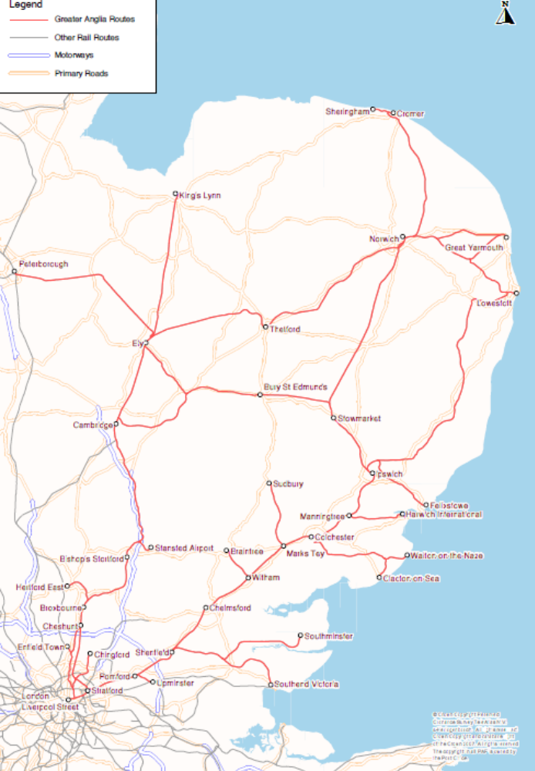

Figure A1.2
The Greater Anglia franchise service pattern
(Greater Eastern services)
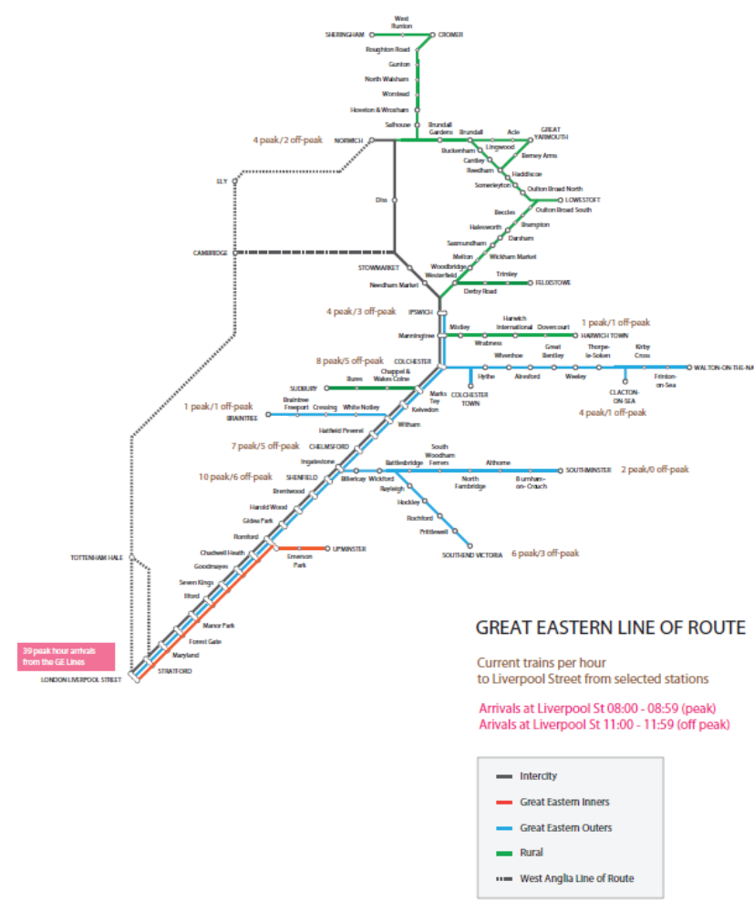

Figure A1.3
The Greater Anglia franchise service pattern
(West Anglia services)
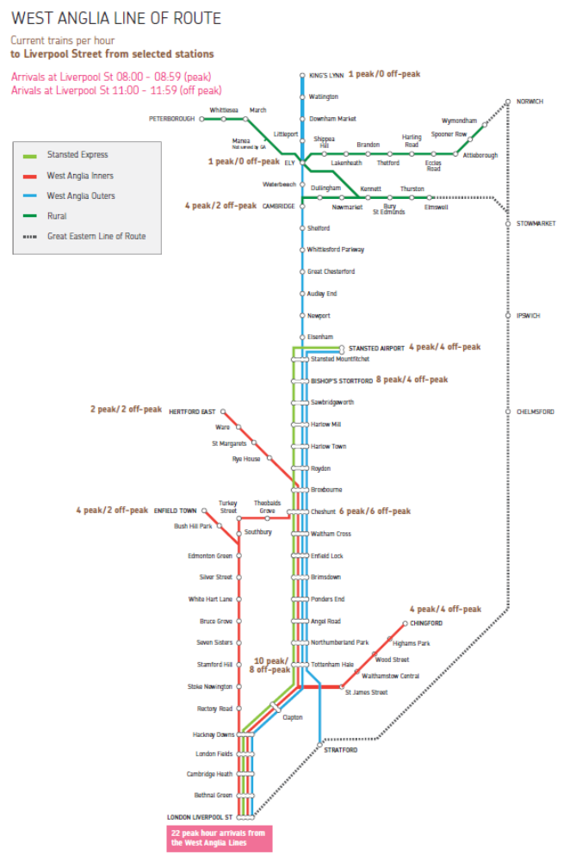

Copyright EFQM Excellence Model 2010
Copyright EFQM Excellence Model 2010
Copyright EFQM Excellence Model 2010
Copyright EFQM Excellence Model 2010

