
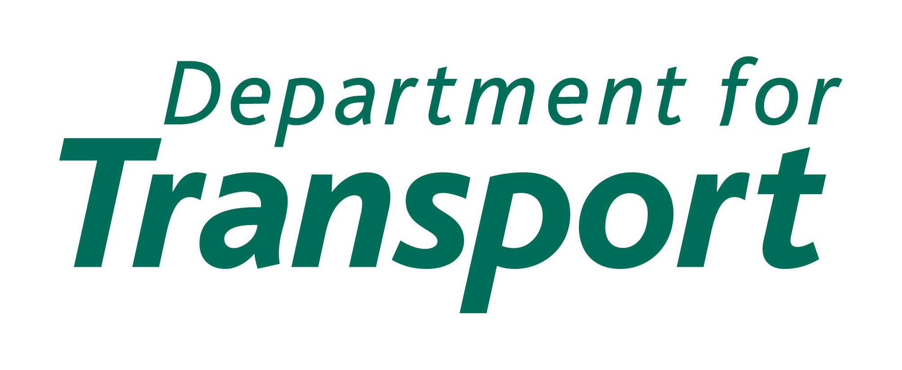

Secure Stations Scheme application form

Application process

Complete and return this BTP-endorsed application form (see overleaf), together with your

- completed design and management audit,
- passenger survey results,
- crime and incident data, and
- passenger throughput figures

to the Department for Transport (DfT) at the address below:

John Smith
Rail International & Safety Policy
Zone 3/19
Great Minster House
33 Horseferry Road
London
SW1P 4DR

Your application will be acknowledged within 5 working days of receipt. Once an award has been confirmed in writing you will be sent a certificate for display on the station and a publicity pack.

Membership of the scheme is for two years. After that time you may apply for a new certificate, following the same procedure. A station which has been awarded a certificate may be subject to a check within that two year period to verify that the standard is still adhered to. The Scheme's Steering Group reserves the right to withdraw a certificate at any time if there is a clear breach of the standard.

The operator agrees that, whether or not the application is accepted, the Secretary of State for Transport shall not have any liability whatsoever with regard to any loss, damage, expense or costs arising out of or in connection with the Scheme or its operation and shall indemnify the Secretary of State in relation to any claims made against him in respect of any such loss, damage, expense or costs.

Station operator signature __________________________ date _____ Station operator's details

Name ________________________________
Company _____________________________
Address _______________________________
_______________________________
_______________________________
_______________________________
Telephone _____________________________
Email _________________________________
MP's constituency _______________________
Name of local BTP CRO ____________________________
Endorsement by British Transport Police Independent Accreditor

I have examined the following documentation and agree that the operator complies with the standard for a Secure Station certificate:
1) design and management audit
2) passenger survey results
3) crime and incident data
4) passenger throughput figures
5) any other supporting documentation [please specify]

Accreditor's signature _____________________________ date _____
Accreditor's details

Name ________________________________
Address _______________________________
_______________________________
_______________________________
_______________________________
Telephone _____________________________
Email _________________________________

