Affordable Housing Supply,
England, 2009-10

Headlines………………………... 1

Introduction ………………….….. 2

National trends ….......... ……….. 2

Low Cost Home Ownership ...... 4

New build and acquisitions…….. 5

Regional trends …………….……7

Accompanying tables …............. 8

Uses of the data........................ 8

Data sources ………….…….…. 8

Data quality ……..……………… 9

Related statistics ………………. 9

Revisions policy ……………….. 10

Definitions ……….………….…... 11

User consultation ………………. 12

Enquiries………………………… 12

Responsible Statistician:
Jane Hinton
Statistical Enquiries:
Phone: 0303 444 4066
housing.statistics@communities.gsi.gov.uk
Press Enquiries:
Phone: 0303 444 1136
press.office@communities.gsi.gov.uk

Housing
Statistical Release

28 October 2010
using
Research
Summary
Number 239, 2007

- A total of 57,730 gross additional affordable homes were supplied in England in 2009-10. This is an increase of 4 per cent on the 55,570 (revised) affordable homes supplied in 2008-09 and the highest number since 1995-96.
- 33,120 new affordable homes were provided for social rent in 2009-10, an increase of 7 per cent on 2008-09. 24,610 homes were provided through intermediate housing schemes, including shared ownership and shared equity, nearly unchanged on 2008-09.
- There were 46,980 new build affordable homes in 2009-10 which is 81 per cent of the total supply of new affordable homes compared to 77 per cent last year.
- 51,140 homes were delivered with grant from the Homes and Communities Agency in 2009-10 (89 per cent of total supply). Around 82 per cent of these were new build homes, an increase on last year (78 per cent).
- Collectively, more than half of all new affordable homes were supplied in London (24 per cent), the South East (19 per cent) and the South West (11 per cent) in 2009-10.
- There was an increase in affordable housing supply in six of the nine regions in England. The North East saw the largest annual growth both in absolute (730) and percentage terms (52%).
Introduction
This statistical release presents data on gross additional affordable housing supply in England and its regions between 1999-00 and 2009-10. The figures for the period 2006-07 to 2008-09 have been updated to include revised estimates from the Homes and Communities Agency and from local authorities.
New affordable homes are additional housing units (or bed spaces) provided to specified eligible households whose needs are not met by the market. The figures in this release show the gross annual supply of affordable homes, which include new build and acquisitions but do not take account of losses through demolitions or sales.
National trends in new affordable homes
Table 1: Trends in the gross supply of affordable housing by type of scheme, England, 1999-00 to 2009-101,7
England | 2000-01 | 2001-02 | 2002-03 | 2003-04 | 2004-05 | 2005-06 | 2006-07^{R} | 2007-08^{R} | 2008-09^{R} | 2009-10
Social Rent, of which: | 27,090 | 26,810 | 23,960 | 22,660 | 21,670 | 23,630 | 24,670 | 29,640 | 30,970 | 33,120
Homes and Communities Agency (new build) | 17,300 | 17,510 | 16,590 | 16,600 | 16,560 | 17,400 | 18,180 | 21,700 | 23,420 | 27,270
Homes and Communities Agency (acquisitions) | 8,840 | 8,140 | 6,420 | 4,290 | 2,610 | 2,410 | 2,360 | 3,390 | 2,900 | 2,650
Other Homes and Communities Agency Schemes⁴ | - | - | - | - | 870 | 920 | 950 | 660 | 490 | 130
Local authorities (new build) | 180 | 60 | 200 | 190 | 100 | 300 | 250 | 310 | 570 | 270
Section 106 (nil grant) new build: total³ | . | 1,070 | 720 | 1,580 | 1,530 | 2,550 | 2,750 | 3,450 | 3,430 | 2,140
of which: IMS only | . | . | . | . | 40 | 260 | 290 | 440 | 320 | 250
Private Finance Initiative⁵ | 20 | 40 | 30 | - | 10 | 60 | 180 | 140 | 170 | 650
Intermediate Affordable Housing² | 6,070 | 6,210 | 8,970 | 15,410 | 15,800 | 22,350 | 19,630 | 23,530 | 24,600 | 24,610
Intermediate Rent, of which: | .. | .. | .. | 280 | 1,510 | 1,680 | 1,200 | 1,110 | 1,710 | 2,560
Homes and Communities Agency (new build) | .. | .. | .. | 260 | 680 | 1,370 | 1,110 | 1,050 | 1,690 | 1,910
Homes and Communities Agency (acquisitions) | .. | .. | .. | 30 | 830 | 310 | 90 | 60 | 20 | 650
Low Cost Home Ownership, of which: | 6,070 | 6,210 | 8,970 | 15,120 | 14,280 | 20,680 | 18,430 | 22,420 | 22,900 | 22,050
Homes and Communities Agency (new build) | 2,260 | 2,040 | 2,330 | 3,710 | 5,570 | 7,570 | 9,210 | 11,630 | 10,270 | 13,160
Homes and Communities Agency (acquisitions) | 2,380 | 2,270 | 4,550 | 8,850 | 5,800 | 7,710 | 3,050 | 3,510 | 6,640 | 5,640
Other Homes and Communities Agency Schemes⁴ | - | - | - | - | - | 490 | 570 | 130 | 40 | -
Section 106 (nil grant) new build: total³ | . | 1,060 | 1,250 | 1,550 | 1,900 | 3,810 | 4,440 | 4,910 | 3,440 | 1,590
of which: IMS only | . | . | . | . | 220 | 420 | 640 | 870 | 620 | 510
Assisted Purchase Schemes⁶ | 990 | 840 | 830 | 1,010 | 1,020 | 1,100 | 1,150 | 2,240 | 2,510 | 1,670
All affordable | 33,160 | 33,020 | 32,920 | 38,070 | 37,470 | 45,980 | 44,300 | 53,180 | 55,570 | 57,730
1. Affordable housing is the sum of social rent, intermediate rent and low cost home ownership.
2. Intermediate affordable housing is the sum of intermediate rent and low cost home ownership. It includes Mortgage Rescue Scheme.
3. Section 106 nil grant completions are from the Housing Strategy Statistical Appendix (HSSA) returns and the Homes and Communities Agency Investment Management System (IMS). Some Section 106 nil grant completions are included in both data sources and an adjustment has been made for double counting. The Section 106 nil grant completions recorded on IMS are excluded from the Homes and Communities Agency new build figures elsewhere in the table.
4. "Other Homes and Communities Agency schemes" include Homeless Capital Improvement Programme, Safer Communities, Recycled Capital Grant Funds, Disposal Proceeds Fund, and some remodelled units. The Homeless Capital Improvement Programme figures include some refurbishments as well as new builds, and the majority of these figures will be units but a small number of bedspaces are included. Recycled Capital Grant Fund figures and Disposal Proceeds Fund figures cannot be broken down below national level for 2005-06 and 2006-07, so the sum of the regional figures may not equal the England figure. The remodelled units are for supported housing up to 2007-08 and general needs from 2008-09.
5. Private Finance Initiative figures are mostly new build but include a small number of acquisitions.
R Revised.
"-" nil or less than half final digit.
"." not available.
".." not applicable.
Source: Homes and Communities Agency; Local Authorities.

Figure 1: Trends in the gross supply of affordable housing, England, 1999-00 to 2009-10
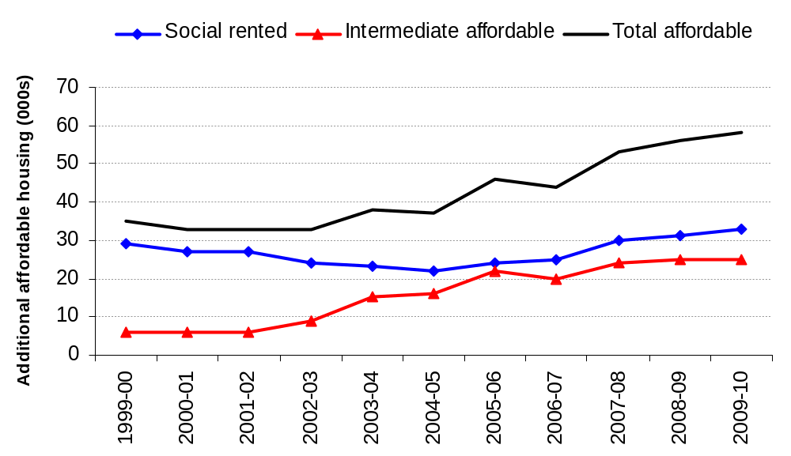

A total of 57,730 affordable homes were provided in England in 2009-10, an increase of 4 per cent compared to the 55,570 (revised) affordable homes supplied in 2008-09. This continues the upward trend in supply and is the highest number of new affordable homes provided in England since 1995-96.
33,120 affordable new homes were supplied in the social rented sector in 2009-10. This was an increase of 2,150 or 7 per cent on 2008-09. Gross new social rented supply has now increased for the fifth consecutive year.
A total of 24,610 new homes were delivered through intermediate rent and low cost home ownership schemes in 2009-10. This figure was broadly level on a year earlier which was the largest annual supply of new intermediate affordable homes recorded. The annual increase of 850 homes delivered for intermediate rent in 2009-10 was offset by a similar fall in the number of homes delivered for low cost home ownership.
The number of Section 106 nil grant completions fell by almost half to 3,730 in 2009-10. Of the 3,730 homes delivered under Section 106 without grant, 2,140 were for social rent and 1,590 were for low cost home ownership. The decrease in delivery under Section 106 without grant reflects the overall decrease in house building in 2009-10.

Low Cost Home Ownership
Table 2: Low Cost Home Ownership completions, by product, England, 2003-04 to 2009-10
England | 2003-04 | 2004-05 | 2005-06 |  | 2006-07^{R} | 2007-08^{R} | 2008-09^{R} | 2009-10
Low Cost Home Ownership, by product: | 15,120 | 14,280 | 20,680 |  | 18,430 | 22,420 | 22,900 | 22,050
Open Market HomeBuy | 2,550 | 5,140 | 7,360 |  | 2,510 | 2,880 | 6,220 | 5,350
New Build HomeBuy¹ | 3,620 | 5,860 | 8,700 |  | 10,960 | 14,880 | 11,820 | 9,110
HomeBuy Direct | .. | .. | .. |  | .. | .. | .. | 5,070
Social HomeBuy | .. | .. | .. |  | 50 | 160 | 100 | 80
Section 106 nil grant² | 1,550 | 1,470 | 2,640 |  | 3,160 | 2,730 | 2,290 | 850
Other | 7,410 | 1,810 | 1,980 |  | 1,760 | 1,780 | 2,470 | 1,600
1. New Build HomeBuy completions include Rent to HomeBuy.
2. Section 106 figures exclude S106 nil grant completions recorded in HCA IMS data.
R Revised.
".." not applicable.
Source: Homes and Communities Agency; Local Authorities.

There were 22,050 low cost home ownership completions in 2009-10, 4 per cent lower than in 2008-09. The largest component of low cost ownership was New Build HomeBuy (9,110), accounting for 41 per cent of completions, a decrease from a share of 54 per cent last year. Open Market HomeBuy (5,350) and HomeBuy Direct (5,070) each accounted for a further quarter.

New build homes and acquisitions
Table 3: Trends in the gross supply of affordable housing by new build and acquisitions, England, 1999-00 to 2009-10^{1,2,3}
England | 2000-01 | 2001-02 | 2002-03 | 2003-04 | 2004-05 | 2005-06 | 2006-07^{R} | 2007-08^{R} | 2008-09^{R} | 2009-10
Social Rent, of which: | 27,090 | 26,810 | 23,960 | 22,660 | 21,670 | 23,630 | 24,670 | 29,640 | 30,970 | 33,120
New Build | 18,230 | 18,640 | 17,510 | 18,370 | 18,790 | 20,510 | 21,440 | 25,660 | 27,670 | 30,330
Acquisitions | 8,860 | 8,170 | 6,450 | 4,290 | 2,890 | 2,460 | 2,450 | 3,390 | 2,900 | 2,650
Not Known² | - | - | - | - | - | 660 | 790 | 590 | 410 | 130
Intermediate Rent, of which: | .. | .. | .. | 280 | 1,510 | 1,680 | 1,200 | 1,110 | 1,710 | 2,560
New Build | .. | .. | .. | 260 | 680 | 1,370 | 1,110 | 1,050 | 1,690 | 1,910
Acquisitions | .. | .. | .. | 30 | 830 | 310 | 90 | 60 | 20 | 650
Not Known² | .. | .. | .. | - | - | - | - | - | - | -
Low Cost Home Ownership, of which: | 6,070 | 6,210 | 8,970 | 15,120 | 14,280 | 20,680 | 18,430 | 22,420 | 22,900 | 22,050
New Build | 2,710 | 3,100 | 3,590 | 5,260 | 7,460 | 11,380 | 13,660 | 16,540 | 13,710 | 14,740
Acquisitions | 3,370 | 3,100 | 5,380 | 9,860 | 6,820 | 8,810 | 4,180 | 4,830 | 7,920 | 6,480
Not Known² | - | - | - | - | - | 490 | 600 | 1,050 | 1,260 | 830
All affordable¹, of which: | 33,160 | 33,020 | 32,920 | 38,070 | 37,470 | 45,980 | 44,300 | 53,180 | 55,570 | 57,730
New Build | 20,940 | 21,740 | 21,100 | 23,890 | 26,930 | 33,260 | 36,200 | 43,260 | 43,070 | 46,980
Acquisitions | 12,220 | 11,280 | 11,830 | 14,180 | 10,540 | 11,570 | 6,720 | 8,280 | 10,840 | 9,790
Not Known² | - | - | - | - | - | 1,150 | 1,380 | 1,640 | 1,670 | 960
Percentages:
Social Rent:
New Build | 67% | 70% | 73% | 81% | 87% | 87% | 87% | 87% | 89% | 92%
Acquisitions | 33% | 30% | 27% | 19% | 13% | 10% | 10% | 11% | 9% | 8%
Not Known² | - | - | - | - | - | 3% | 3% | 2% | 1% | -
Intermediate Rent:
New Build | .. | .. | .. | 91% | 45% | 82% | 92% | 95% | 99% | 75%
Acquisitions | .. | .. | .. | 9% | 55% | 18% | 8% | 5% | 1% | 25%
Not Known² | .. | .. | .. | - | - | - | - | - | - | -
Low Cost Home Ownership:
New Build | 45% | 50% | 40% | 35% | 52% | 55% | 74% | 74% | 60% | 67%
Acquisitions | 55% | 50% | 60% | 65% | 48% | 43% | 23% | 22% | 35% | 29%
Not Known² | - | - | - | - | - | 2% | 3% | 5% | 6% | 4%
All affordable¹:
New Build | 63% | 66% | 64% | 63% | 72% | 72% | 82% | 81% | 77% | 81%
Acquisitions | 37% | 34% | 36% | 37% | 28% | 25% | 15% | 16% | 20% | 17%
Not Known² | - | - | - | - | - | 3% | 3% | 3% | 3% | 2%
1. Affordable housing is the sum of social rent, intermediate rent and low cost home ownership.
2. Figures for Recycled Capital Grant Fund, Disposal Proceeds Fund, and remodelled units cannot be broken down to show new build and acquisitions.
3. Figures shown represent our best estimate and may be subject to revisions. The figures have been rounded to the nearest 10, so the totals may not sum due to rounding.
R Revised.
"-" nil or less than half final digit.
".." not applicable.

Source: Homes and Communities Agency; Local Authorities.

Figure 2: Trends in the gross supply of affordable housing, England, 1999-00 to 2009-10
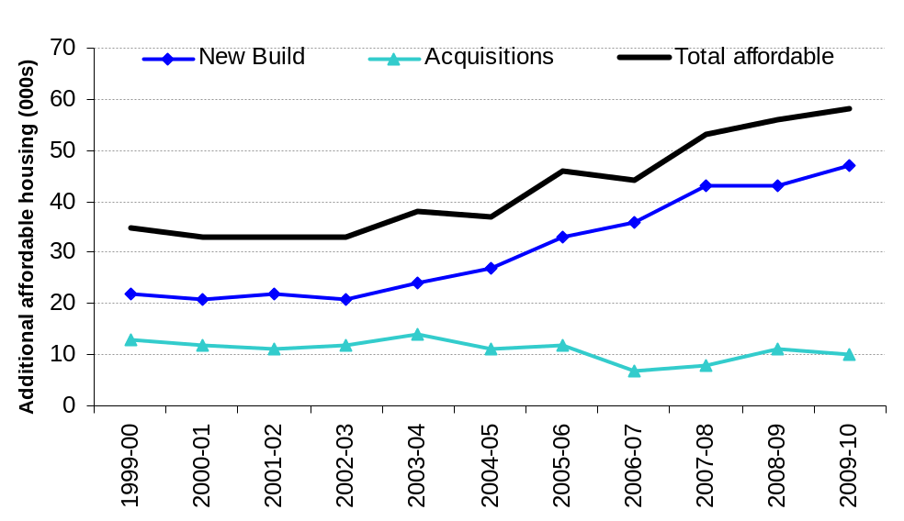
Total new build homes accounted for 46,980 or 81 per cent of all new affordable homes provided in 2009-10, a 9 per cent increase on 43,070 (77 per cent of total supply) in 2008-09.
Acquisitions of affordable homes have remained broadly level over the last three years. There were 9,790 acquisitions in 2009-10, 17 per cent of total supply.
Most affordable homes were in receipt of funding through the Homes and Communities Agency (89 per cent). New build homes funded through the Homes and Communities Agency accounted for 42,330 or 73 per cent of all new affordable homes in 2009-10.
Acquisitions with funding from the Homes and Communities Agency accounted for 8,940 new homes in 2009-10, or 15 per cent of total gross supply.
Regional trends
Figure 3a: Trends in gross supply of affordable housing in London, South East and the South West, 1999-00 to 2009-10
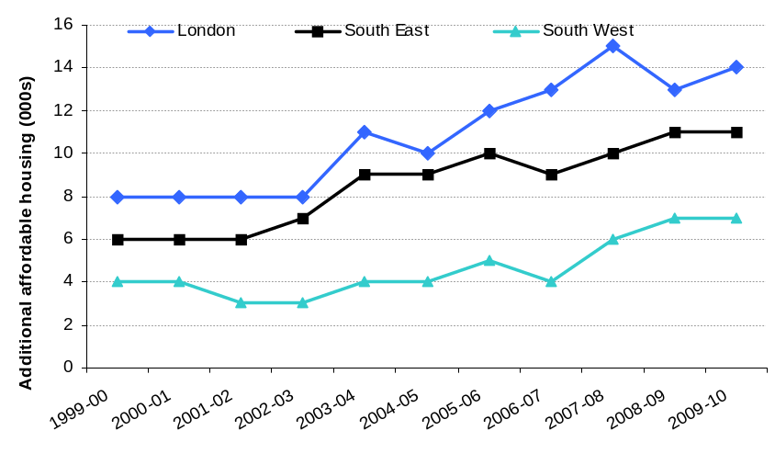
Figure 3b: Trends in gross supply of affordable housing in East of England, East Midlands and the West Midlands, 1999-00 to 2009-10
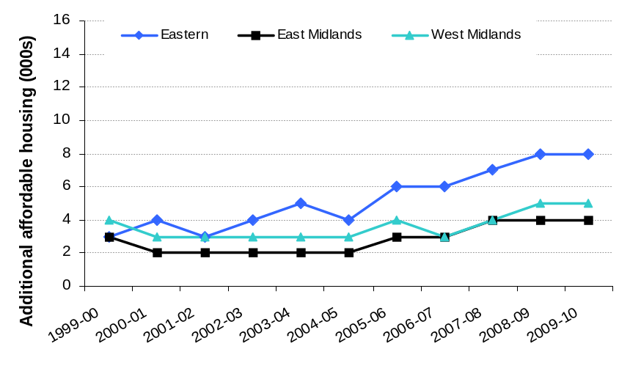
Figure 3c: Trends in gross supply of affordable housing in the North West, North East and Yorkshire & Humberside, 1999-00 to 2009-10
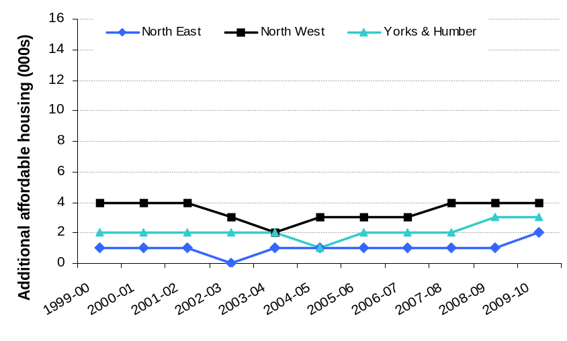
In 2009-10, London and the South East accounted for 24 per cent and 19 per cent respectively of national supply of new affordable homes provided in England. Only four per cent of the supply of new affordable homes in England was provided in the North East.
The number of new affordable homes supplied increased in six of the nine Government Office regions between 2008-09 and 2009-10. The largest absolute increase in supply was in the North East (730). The largest decrease was in the South West, of 310 (-5 per cent).
The increase in the national supply of new affordable housing in recent years has been driven by London and to a lesser extent other regions in the South and East of England. In the ten years between 2000-01 and 2009-10 26 per cent of all affordable homes provided in England were in London, 21 per cent were provided in the South East, whilst only 2 per cent were in the North East and 5 per cent in Yorkshire and the Humber.
Accompanying tables
The tables in this release and further tables showing gross affordable housing supply by region and for individual local authorities can be found in the Department for Communities and Local Government Housing Live Tables http://www.communities.gov.uk/housing/housingresearch/housingstatistics/housingstatisticsby/affordablehousingsupply
Uses of the data
The data are used for monitoring annual amounts and changes in the level of the gross supply of affordable housing nationally and regionally and inform government policy on affordable housing. The figures can also be used for monitoring and informing decisions on local delivery of affordable homes.
Data sources
There are several data sources on gross affordable housing supply which have been used in this Statistical Release:
- The Homes and Communities Agency’s Investment Management System (IMS);
- the Housing Strategy Statistical Appendix (HSSA) submitted to the Department for Communities and Local Government by Local Authorities;
- P2 quarterly house building return submitted to the Department for Communities and Local Government by Local Authorities;
- P1B quarterly social housing sales returns submitted to the Department for Communities and Local Government by Local Authorities
- Homes and Communities Agency figures on First Time Buyers Initiative (FTBI), London Wide Initiative (LWI) and delivery under the Private Finance Initiative.
Data quality
The majority of data are taken from the Homes and Communities Agency IMS which contains information provided by Registered Providers (RP) that have applied to receive grant. We also use figures submitted on the HSSA, P2 and P1B returns by each Local Authority and impute for a small number of missing returns.
For some new affordable homes only one source of data exists. When there are two or more alternative sources, the most reliable source is used. For example, where figures for new RP dwellings are available from the Homes and Communities Agency and Local Authority returns, we have used data from the Homes and Communities Agency IMS as this is linked to grant funding and so is the most reliable source.
Section 106 nil grant completions are taken from both the Housing Strategy Statistical Appendix (HSSA) returns and the Homes and Communities Agency IMS. Neither data source provides complete data on S106 nil grant completions and some are included in both data sources. An adjustment is made to avoid double counting. The Section 106 nil grant completions recorded on the Homes and Communities Agency IMS are excluded from the Homes and Communities Agency new build figures elsewhere in the release.
Related statistics
National Affordable Housing Programme
Information on the number of affordable homes delivered under the National Affordable Housing Programme (NAHP) is published by the Homes and Communities Agency. Delivery under the NAHP accounts for the majority of affordable housing completions in England. The HCA publishes figures twice a year and NAHP starts on site and completions for 2009-10 were reported on 15 June 2010. See the following link:
http://www.homesandcommunities.co.uk/statistics
House Building
The Department for Communities and Local Government publishes quarterly statistics on new house building starts and completions. Although the house building statistics do categorise new build into private, Registered Provider and local authority tenure, this is not the best source of information on the total amount of affordable housing being delivered as it is sometimes difficult for data providers to identify whether a dwelling is being built for a social housing provider or for a private developer. This may lead to an understatement of social sector starts and completions, and a corresponding overstatement of private enterprise figures recorded in the house building statistics. This problem is more likely to occur with starts than completions. House building statistics can be found at the following link:
http://www.communities.gov.uk/housing/housingresearch/housingstatistics/housingstatisticsby/housebuilding/publicationsonhousebuilding/
Dwelling stock estimates
The Department for Communities and Local Government also publishes statistics showing the total dwelling stock in England each year and estimates of stock by local authority district and tenure. They can be found at the following link:
http://www.communities.gov.uk/housing/housingresearch/housingstatistics/housingstatisticsby/stockincludingvacants/livetables/

Statistics for the devolved administrations can be found at:
Scotland (new build of affordable homes) - http://www.scotland.gov.uk/Topics/Statistics/Browse/Housing-Regeneration/HSfS/NewBuild
Wales (affordable housing provision) - http://wales.gov.uk/topics/statistics/headlines/housing2010/1005261/?lang=en
Northern Ireland (housing statistics) - http://www.dsdni.gov.uk/index/publications/housing_stats.htm
Revisions policy
This policy has been developed in accordance with the UK Statistics Authority Code of Practice for Official statistics and the Department for Communities and Local Government Revisions Policy. There are two types of revisions that the policy covers.

Scheduled Revisions
Changes to the component data sources used in this release will be incorporated in the next scheduled release of data.
Local Authorities can update each P2 house building quarterly return at any time up to two years after the initial publication of the figures for that quarter in order to maximise the response rate to the P2 return and enable late information to be included. Every quarter, the previous quarter is revised and once a year, in the June quarter statistical release, a longer revision is carried out to incorporate all remaining late data into the published statistics. In this release, provisional data for 2009-10 house building completions by local authorities have been used and these may be subject to revision.
Provisional figures from the Housing Strategy Statistical Appendix for 2009/10 have been used and may be subject to minor revision.
Occasionally, figures from the Homes and Communities Agency are re-stated. For example, if units originally intended for sale under LCHO are subsequently subject to further works and provided for social rent this would lead to a revision to the IMS data.
Other revisions to historic data (all data older than that currently due for scheduled revision) should only be made where there is a substantial revision, such as a change in methodology or definition.

Non-Scheduled Revisions
If a substantial error occurred as a result of the compilation, imputation or dissemination process, the statistical release, live tables and other accompanying releases would be updated with a correction notice as soon as is practical.
Revised figures are labelled with an “R”.
Revisions in this release
Figures for the number of completions under the First Time Buyers Initiative (FTBI) have been revised. In previous releases, completions have been reported on the basis of the physical completion of the unit. Due to the nature of the scheme, some units which were intended for sale under the FTBI were not ultimately sold to first time buyers. This was particularly the case given changing market conditions during the recession. Feedback from users has also suggested that it would be more appropriate to record delivery under the FTBI when these units are legally completed for sale. This has resulted in some movement of units between financial years for some local authorities. Overall there is a decrease of 200-300 units in 2006/7 and 2007/8 and a small increase of around 30 units in 2008/9, affecting 44 local authorities.
Minor revisions to 2008/9 data have been made due to incorporating revised figures from the HSSA return for some local authorities. There have also been small revisions to the number of units delivered under the Private Finance Initiative.
Definitions
- Affordable housing is the sum of social rent, intermediate rent and low cost home ownership. New affordable homes are defined in line with Planning Policy Statement 3 as additional housing units (or bed spaces) provided to specified eligible households whose needs are not met by the market.
- Social rented housing is rented housing owned and managed by local authorities and Registered Providers, for which guideline target rents are determined through the national rent regime. It may also include rented housing owned or managed by other persons and provided under equivalent rental arrangements to the above, as agreed with the local authority or with the Homes and Communities Agency as a condition of grant. Intermediate affordable housing is housing at prices and rents above those of social rent but below market price or rents, and which meet the criteria set out above. These can include shared equity (e.g. HomeBuy) and other low cost homes for sale, and intermediate rent. Further details are available at http://www.communities.gov.uk/publications/housing/deliveringaffordablehousing
- Definitions of the other main affordable housing terms cited in this release are:
  - Open Market HomeBuy is a flexible equity loan scheme designed to help households earning up to a maximum household income of £60,000 a year – subject to certain criteria – to buy their own homes on the open market. These are recorded as acquisitions in this release.
  - New Build HomeBuy is a shared ownership option offers brand new homes for sale on a part buy / part rent basis.
  - HomeBuy Direct offers equity loans towards the purchase of a new build home on selected developments.
  - Social HomeBuy offers some housing associations or local authority tenants the opportunity to buy a share in their rented home.
  - First Time Buyers' Initiative (FTBI) is a shared equity scheme for first time buyers. It enables key workers and other eligible groups to purchase a new build home on a designated FTBI development, with an affordable mortgage and government assistance.
  - Home ownership for people with long term disabilities (HOLD) is a specially tailored option to assist people with long-term disabilities to purchase a share in a property.
  - A Section 106 agreement is a legal agreement (similar to a covenant) which provides a means of ensuring that developers contribute towards the infrastructure that is required to make a development acceptable in planning terms. Contributions may be either financial or in kind and may be used to deliver affordable housing.
- The figures in this release show the gross supply of affordable homes each year; these include new build and acquisitions but do not take account of losses through demolitions and sales, and are presented for financial years ending in March. Acquisitions include properties which have been rehabilitated and completions under Open Market HomeBuy and HOLD. They represent our best estimate, and have been rounded to the nearest 10.
- Sources are shown at the foot of individual tables.
- Local authority gross affordable housing supply can be presented in terms of the local authority in which the new homes are located or according to which local authority funded the new homes. Tables in the Department for Communities and Local Government Housing Live Tables area show gross affordable housing supply by location and by funding local authority. The regional figures in this release have been calculated by aggregating local authority figures calculated on the basis of the local authority in which the new homes are located.
- We expect to publish the next annual release in October 2011; this will cover gross affordable housing supply in 2010-11.
User consultation
Users’ comments on any issues relating to this statistical release are welcomed and encouraged. Responses should be addressed to the "statistical enquiries" contact given in the "Enquiries" section below.
Enquiries
Media enquiries: office hours: 0303 444 1136
out of hours: 0303 444 1201
e-mail: press@communities.gsi.gov.uk
Statistical enquiries:
Steve Wellington (c/o)
e-mail: housing.statistics@communities.gsi.gov.uk
telephone: 0303 444 4066

Department for Communities and Local Government. © Crown Copyright, 2009

If you require this publication in an alternative format please email: alternativeformats@communities.gsi.gov.uk. Please note that the nature of content means that we may not be able to provide the Statistical series of publications in all requested formats.

October 2010

ISBN: 978-1-4098-2609-5

