

Housing
Statistical Release

5 October 2011
using
Research
Summary
Number 239, 2007

Affordable Housing Supply,
England, 2010-11

Contents

Headlines………………………... 1
Introduction ………………….….. 2
National trends ….......... ……….. 3
Low Cost Home Ownership ...... 5
New build and acquisitions…….. 6
Regional trends …………….……8
Accompanying tables …............. 9
Uses of the data........................ 9
Definitions ….………….…….…. 9
Data sources ……………………12
Related statistics ………………. 13
Revisions policy ……………….. 15
User consultation ………………. 17
Enquiries………………………… 17

Responsible Statistician:
Jane Hinton
Statistical Enquiries:
Phone: 0303 444 2276
housing.statistics@communities.gsi.gov.uk
Press Enquiries:
Phone: 0303 444 1136
press.office@communities.gsi.gov.uk

Responsible statistician:
Jane Hinton

Media Enquiries:
office hours: 0303 444 1157
0303 444 1159
out of hours: 0303 444 1201

press@communities.gov.uk

Statistical enquiries:
office hours: 0303 444 2270
housing.statistics@communities.gov.uk

- A total of 60,630 gross additional affordable homes were supplied in England in 2010-11. This is an increase of 5 per cent on the 58,010 (revised) affordable homes supplied in 2009-10 and the highest number since 1995-96.
- 39,170 new affordable homes were provided for social rent in 2010-11, an increase of 18 per cent on 2009-10. 21,460 homes were provided through intermediate housing schemes, including shared ownership and shared equity, down by 13 per cent on 2009-10.
- There were 53,380 new build affordable homes in 2010-11 which is 88 per cent of the total supply of additional affordable homes compared to 81 per cent last year and is the highest percentage recorded.
- 55,250 homes were delivered with grant from the Homes and Communities Agency in 2010-11 (91 per cent of total supply). Around 88 per cent of these were new build homes.
- Collectively, half of all additional affordable homes were supplied in London (23 per cent), the South East (15 per cent) and the South West (12 per cent) in 2010-11.
- There was an increase in affordable housing supply in seven of the nine regions in England. Yorkshire and the Humber saw the largest annual growth both in absolute (1,450) and percentage terms (50 per cent). Decreases were observed in the South East (-17 per cent) and East (-14 per cent).

Introduction
This statistical release presents data on gross additional affordable housing supply in England and its regions between 2001-02 and 2010-11. Small revisions to data for 2008-09 and 2009-10 have been made to due to updated figures being available from the Homes and Communities Agency and from local authorities.
New affordable homes are additional housing units (or bed spaces) provided to specified eligible households whose needs are not met by the market. The figures in this release show the gross annual supply of affordable homes, which includes new build and acquisitions from the private sector but does not take account of losses through demolitions or sales. Further details on the coverage of this release are given in the sections on Definitions and Data Sources towards the end of this document.
The data are used for monitoring annual amounts and changes in the gross supply of affordable housing nationally and regionally and to inform government policy on affordable housing. The data for 2010-11 are being used to calculate the enhancement for affordable housing under the New Homes Bonus (NHB), a grant for local authorities to incentivise new housing supply. Local authorities will be given the opportunity to provide evidence to challenge their NHB calculation as part of the provisional grant allocation. This process may lead to some revisions to the affordable housing statistics which will then be released alongside the final allocations early in 2012.

National trends in additional affordable housing
Table 1: Trends in the gross supply of affordable housing by type of scheme, England, 2001-02 to 2010-11^{1, 7, 8}
England | 2001-02 | 2002-03 | 2003-04 | 2004-05 | 2005-06 | 2006-07 | 2007-08 | 2008-09^{R} | 2009-10^{R} | 2010-11^{P}
Social Rent, of which: | 26,810 | 23,960 | 22,660 | 21,670 | 23,630 | 24,670 | 29,640 | 30,900 | 33,210 | 39,170
Homes and Communities Agency (new build) | 17,510 | 16,590 | 16,600 | 16,560 | 17,400 | 18,180 | 21,700 | 23,420 | 27,270 | 30,780
Homes and Communities Agency (acquisitions) | 8,140 | 6,420 | 4,290 | 2,610 | 2,410 | 2,360 | 3,390 | 2,900 | 2,650 | 3,200
Other Homes and Communities Agency Schemes | - | - | - | 870 | 920 | 950 | 660 | 490 | 130 | 250
Local authorities | 60 | 200 | 190 | 100 | 300 | 250 | 310 | 490 | 370 | 2,800
of which HCA grant funded (new build)³ | .. | .. | .. | .. | .. | .. | .. | .. | .. | 1,820
Section 106 (nil grant) new build: total ⁴ | 1,070 | 720 | 1,580 | 1,530 | 2,550 | 2,750 | 3,450 | 3,430 | 2,140 | 1,930
of which, reported on IMS | . | . | . | 270 | 960 | 900 | 1,450 | 1,030 | 820 | 510
Private Finance Initiative ⁵ | 40 | 30 | - | 10 | 60 | 180 | 140 | 170 | 650 | 210
Intermediate Affordable Housing ² | 6,210 | 8,970 | 15,410 | 15,800 | 22,350 | 19,630 | 23,530 | 24,600 | 24,800 | 21,460
Intermediate Rent, of which: |  |  | 280 | 1,510 | 1,680 | 1,200 | 1,110 | 1,710 | 2,560 | 4,520
Homes and Communities Agency (new build) | .. | .. | 260 | 680 | 1,370 | 1,110 | 1,050 | 1,690 | 1,910 | 2,380
Homes and Communities Agency (acquisitions) | .. | .. | 30 | 830 | 310 | 90 | 60 | 20 | 650 | 2,140
Low Cost Home Ownership, of which: | 6,210 | 8,970 | 15,120 | 14,280 | 20,680 | 18,430 | 22,420 | 22,900 | 22,240 | 16,940
Homes and Communities Agency (new build) | 2,040 | 2,330 | 3,710 | 5,570 | 7,570 | 9,240 | 12,550 | 11,490 | 14,170 | 13,980
Homes and Communities Agency (acquisitions) | 2,270 | 4,550 | 8,850 | 5,800 | 7,710 | 3,050 | 3,510 | 6,640 | 5,640 | 450
Other Homes and Communities Agency Schemes ⁶ | - | - | - | - | 490 | 570 | 130 | 40 | - | -
Section 106 (nil grant) new build: total | 1,060 | 1,250 | 1,550 | 1,900 | 3,810 | 4,440 | 4,910 | 3,440 | 1,590 | 1,570
of which, reported on IMS | . | . | . | 430 | 1,170 | 1,280 | 2,180 | 1,150 | 740 | 560
Assisted Purchase Schemes ⁷ | 840 | 830 | 1,010 | 1,020 | 1,100 | 1,130 | 1,320 | 1,290 | 850 | 940
All affordable ¹ | 33,020 | 32,920 | 38,070 | 37,470 | 45,980 | 44,300 | 53,180 | 55,500 | 58,010 | 60,630

1. Affordable housing is the sum of social rent, intermediate rent and low cost home ownership.
2. Intermediate affordable housing is the sum of intermediate rent and low cost home ownership. Mortgage Rescue Scheme has been included under Intermediate Rent Acquisitions.
3. Units funded through the HCA, primarily the Local Authority New Build programme as announced in the Housing Stimulus Programme in the April 2009 budget.
4. Section 106 nil grant completions are from the Housing Strategy Statistical Appendix (HSSA) returns and the Homes and Communities Agency Investment Management System (IMS). Some Section 106 nil grant completions are included in both data sources and an adjustment has been made for double counting. The Section 106 nil grant completions recorded on IMS are excluded from the Homes and Communities Agency new build figures elsewhere in the table. The line ‘of which, reported on IMS’ shows the total number of S106 nil grant units reported on IMS. This is different to that presented in previous releases which showed the number on IMS after excluding the overlap with HSSA.
5. Private Finance Initiative figures are mostly new build but may include a small number of acquisitions.
6. "Other Homes and Communities Agency schemes" include Homeless Capital Improvement Programme, Safer Communities, Recycled Capital Grant Funds, Disposal Proceeds Fund, and some remodelled units. The Homeless Capital Improvement Programme figures include some refurbishments as well as new builds, and the majority of these figures will be units but a small number of bedspaces are included. Recycled Capital Grant Fund figures and Disposal Proceeds Fund figures cannot be broken down below national level for 2005-06 and 2006-07, so the sum of regional figures may not equal the England figure. The remodelled units are for supported housing up to 2007-08, and general needs for 2008-09 onwards.
7. Assisted Purchase Schemes include instances where a social rent dwelling has been purchased through the Cash Incentive Scheme, Voluntary Purchase Grant, Right to Acquire and Social HomeBuy scheme. Completions under the First Time Buyers Initiative and London Wide Initiative scheme have been moved to the HCA (new build) line for the 2010/11 release.
8. The regional totals are aggregates of local authority figures calculated on the basis of the local authority in which the units are located. This occasionally differs from the local authority providing funding.
9. Figures shown represent our best estimate and may be subject to revisions. The figures have been rounded to the nearest 10 and therefore totals may not sum due to rounding.

R Revised. P Provisional.
"-" nil or less than half final digit.
"." not available.
".." not applicable.
Source: Homes and Communities Agency; Local Authorities.

Figure 1: Trends in the gross supply of affordable housing, England, 2001-02 to 2010-11
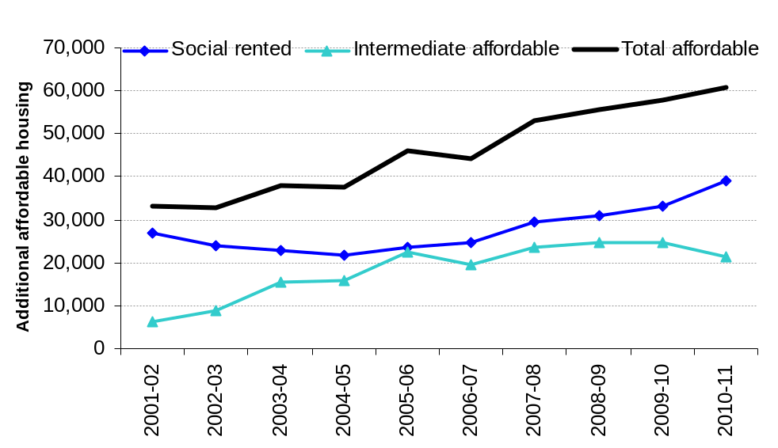
A total of 60,630 affordable homes were provided in England in 2010-11, an increase of 5 per cent compared to the 58,010 (revised) affordable homes supplied in 2009-10. This continues the upward trend in supply and is the highest number of additional affordable homes provided in England since 1995-96.
39,170 affordable new homes were supplied in the social rented sector in 2010-11. This was an increase of 5,960 or 18 per cent on 2009-10. Gross social rented supply has increased for the sixth consecutive year.
The 2,800 new affordable homes provided by local authorities for social rent is a significant increase on previous years and largely reflects the new funding made available for local authority new build through the housing stimulus programme as announced in the April 2009 budget.
A total of 21,460 new homes were delivered through intermediate rent and low cost home ownership schemes in 2010-11. This is a 13 per cent fall over last year and mainly reflects the low cost home ownership product, Open Market HomeBuy, finishing.
The number of affordable homes completed through planning obligations (Section 106) without grant fell slightly, by 6 per cent to 3,510. This follows a more notable decrease in supply through this route in 2009-10, reflecting general conditions in the housing market. Of the 3,510 homes delivered under Section 106 without grant, 1,930 were for social rent and 1,570 were for low cost home ownership.

Low Cost Home Ownership
Table 2: Low Cost Home Ownership completions, by product4, England, 2003-04 to 2010-11
 | 2003-04 | 2004-05 | 2005-06 | 2006-07 | 2007-08 | 2008-09^{R} | 2009-10^{R} | 2010-11^{P}
Product: | 15,120 | 14,280 | 20,680 | 18,430 | 22,420 | 22,900 | 22,240 | 16,940
Open Market HomeBuy | 2,550 | 5,140 | 7,360 | 2,510 | 2,880 | 6,220 | 5,350 | 140
New Build HomeBuy¹ | 3,620 | 5,860 | 8,700 | 10,960 | 14,880 | 11,820 | 9,110 | 8,680
HomeBuy Direct | .. | .. | .. | .. | .. | .. | 5,070 | 5,720
Social HomeBuy | .. | .. | .. | 50 | 160 | 100 | 80 | 110
Section 106 nil grant² | 1,550 | 1,470 | 2,640 | 3,160 | 2,730 | 2,290 | 850 | 1,010
Other³ | 7,410 | 1,810 | 1,980 | 1,760 | 1,780 | 2,470 | 1,780 | 1,280
1. New Build HomeBuy completions include Rent to HomeBuy.
2. Section 106 figures exclude S106 nil grant completions recorded in HCA IMS data.
3. Other includes Assisted Purchase Schemes and other grant funded schemes not specified above.
4. Figures shown represent our best estimate and may be subject to revisions. The figures have been rounded to the nearest 10 and therefore totals may not sum due to rounding.
R Revised. P Provisional.
".." not applicable.
Source: Homes and Communities Agency
There were 16,940 low cost home ownership completions in 2010-11, 24 per cent lower than in 2009-10. The largest component of low cost ownership was New Build HomeBuy (8,680), accounting for 51 per cent of completions, an increase from a share of 41 per cent last year. Funding under the Open Market HomeBuy product has ceased and therefore only residual completions occurred in 2010-11. HomeBuy Direct (5,720) accounted for a third of affordable home ownership completions in 2010-11. The new government shared equity scheme, FirstBuy, came into effect in 2011 and therefore completions under this scheme will not be observed until 2011-12.
New build homes and acquisitions
Table 3: Trends in the gross supply of affordable housing by new build and acquisitions, England, 2001-02 to 2010-111,2,3
 | 2001-02 | 2002-03 | 2003-04 | 2004-05 | 2005-06 | 2006-07 | 2007-08 | 2008-09^{R} | 2009-10^{R} | 2010-11^{P}
Social Rent, of which: | 26,810 | 23,960 | 22,660 | 21,670 | 23,630 | 24,670 | 29,640 | 30,900 | 33,210 | 39,170
New Build | 18,640 | 17,510 | 18,370 | 18,790 | 20,510 | 21,440 | 25,660 | 27,600 | 30,420 | 35,450
Acquisitions | 8,170 | 6,450 | 4,290 | 2,890 | 2,460 | 2,450 | 3,390 | 2,900 | 2,650 | 3,470
Not Known² | - | - | - | - | 660 | 790 | 590 | 410 | 130 | 250
Intermediate Rent, of which: |  |  | 280 | 1,510 | 1,680 | 1,200 | 1,110 | 1,710 | 2,560 | 4,520
New Build |  |  | 260 | 680 | 1,370 | 1,110 | 1,050 | 1,690 | 1,910 | 2,380
Acquisitions |  |  | 30 | 830 | 310 | 90 | 60 | 20 | 650 | 2,140
Low Cost Home Ownership, of which: | 6,210 | 8,970 | 15,120 | 14,280 | 20,680 | 18,430 | 22,420 | 22,900 | 22,240 | 16,940
New Build | 3,100 | 3,590 | 5,260 | 7,460 | 11,380 | 13,680 | 17,460 | 14,940 | 15,750 | 15,550
Acquisitions | 3,100 | 5,380 | 9,860 | 6,820 | 8,810 | 4,180 | 4,830 | 7,920 | 6,480 | 1,390
Not Known² | - | - | - | - | 490 | 570 | 130 | 40 | - | -
All affordable¹, of which: | 33,020 | 32,920 | 38,070 | 37,470 | 45,980 | 44,300 | 53,180 | 55,500 | 58,010 | 60,630
New Build | 21,740 | 21,100 | 23,890 | 26,930 | 33,260 | 36,220 | 44,180 | 44,220 | 48,090 | 53,380
Acquisitions | 11,280 | 11,830 | 14,180 | 10,540 | 11,570 | 6,720 | 8,280 | 10,840 | 9,790 | 7,000
Not Known² | - | - | - | - | 1,150 | 1,360 | 720 | 440 | 140 | 250
Social Rent percentages:
New Build | 70% | 73% | 81% | 87% | 87% | 87% | 87% | 89% | 92% | 91%
Acquisitions | 30% | 27% | 19% | 13% | 10% | 10% | 11% | 9% | 8% | 9%
Not Known² | 0% | 0% | 0% | 0% | 3% | 3% | 2% | 1% | 0% | 1%
Intermediate Rent percentages:
New Build |  |  | 91% | 45% | 82% | 92% | 95% | 99% | 75% | 53%
Acquisitions |  |  | 9% | 55% | 18% | 8% | 5% | 1% | 25% | 47%
Low Cost Home Ownership percentages:
New Build | 50% | 40% | 35% | 52% | 55% | 74% | 78% | 65% | 71% | 92%
Acquisitions | 50% | 60% | 65% | 48% | 43% | 23% | 22% | 35% | 29% | 8%
Not Known² | - | - | - | - | 2% | 3% | 1% | 0% | - | -
All affordable¹ percentages:
New Build | 66% | 64% | 63% | 72% | 72% | 82% | 83% | 80% | 83% | 88%
Acquisitions | 34% | 36% | 37% | 28% | 25% | 15% | 16% | 20% | 17% | 12%
Not Known² | - | - | - | - | 3% | 3% | 1% | 1% | 0% | 0%
1. Affordable housing is the sum of social rent, intermediate rent and low cost home ownership.
2. Figures for Recycled Capital Grant Fund, Disposal Proceeds Fund, and remodelled units cannot be broken down to show new build and acquisitions.
3. Figures shown represent our best estimate and may be subject to revisions. The figures have been rounded to the nearest 10, so the totals may not sum due to rounding.
R Revised. P Provisional.
"-" nil or less than half final digit.
".." not applicable.

Source: Homes and Communities Agency; Local Authorities.
Figure 2: Trends in the gross supply of affordable housing, England, 2001-02 to 2010-11
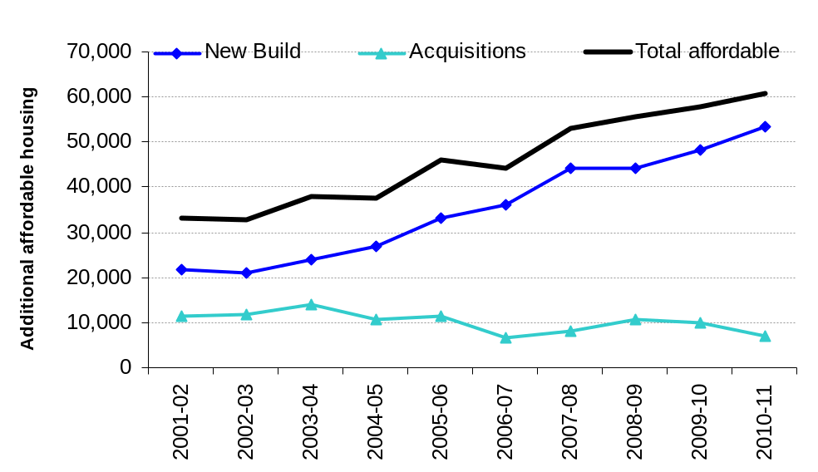
Newly built homes accounted for 53,380 or 88 per cent of all affordable homes provided in 2010-11, an 11 per cent increase on 48,090 (83 per cent of total supply) in 2009-10.
Acquisitions of affordable homes decreased slightly in 2010-11 after remaining broadly level over the previous three years. There were 7,000 acquisitions in 2010-11, 12 per cent of total supply.
Most affordable homes were in receipt of funding through the Homes and Communities Agency (91 per cent). New build homes funded through the Homes and Communities Agency accounted for 48,810 or 81 per cent of all additional affordable homes in 2010-11.
Acquisitions with funding from the Homes and Communities Agency accounted for 6,190 new homes in 2010-11, or 10 per cent of total gross supply.
Regional trends
Figure 3a: Trends in gross supply of affordable housing in London, South East and the South West, 2001-02 to 2010-11
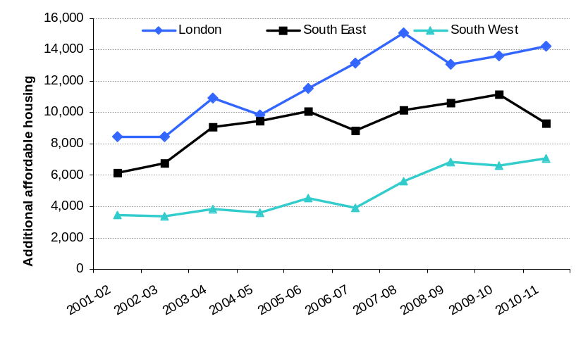
Figure 3b: Trends in gross supply of affordable housing in East of England, East Midlands and the West Midlands, 2001-02 to 2010-11
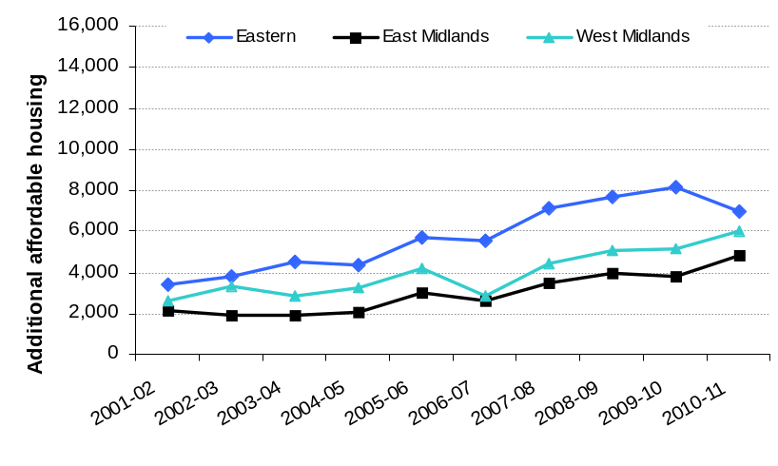
Figure 3c: Trends in gross supply of affordable housing in the North West, North East and Yorkshire & Humberside, 2001-02 to 2010-11
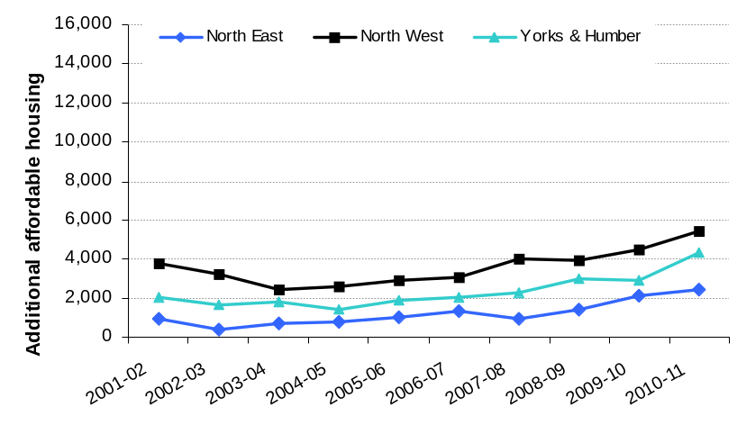
In 2010-11, London and the South East accounted for 23 per cent and 15 per cent respectively of national supply of new affordable homes provided in England. Only four per cent of the supply of new affordable homes in England was provided in the North East.
The number of affordable homes supplied increased in seven of the nine regions between 2009-10 and 2010-11. The largest absolute increase in supply was in Yorkshire and the Humber (1,450). The largest decrease was in the South East, of 1,840 (-17 per cent).
The increase in the national supply of additional affordable housing in recent years has been driven by London and to a lesser extent other regions in the South and East of England. In the ten years between 2001-02 and 2010-11 26 per cent of all affordable homes provided in England were in London, 20 per cent were provided in the South East, whilst only 3 per cent were in the North East and 5 per cent in Yorkshire and the Humber.
Accompanying tables
The tables in this release and further tables showing additional affordable housing supply by region and for individual local authorities can be found in the Department for Communities and Local Government Housing Live Tables. These tables present data back to 1991-92. http://www.communities.gov.uk/housing/housingresearch/housingstatistics/housingstatisticsby/affordablehousingsupply
Some of these tables may be subject to revision as part of the process for agreeing final grant allocations under the New Homes Bonus. This update would take place in early 2012.

Uses of the data
The data are used for monitoring annual amounts and changes in the level of the gross supply of affordable housing nationally and regionally and to inform government policy on affordable housing. The figures can also be used for monitoring and informing decisions on local delivery of affordable homes. From 2010-11 the data are being used to calculate the enhancement for affordable housing under the New Homes Bonus, a grant for local authorities to incentivise new housing supply. Further information on the New Homes Bonus is available at http://www.communities.gov.uk/housing/housingsupply/newhomesbonus/. Any enquiries regarding allocations should be made to the New Homes Bonus team at newhomesbonus@communities.gsi.gov.uk.

Definitions
Affordable housing is the sum of social rent, intermediate rent and low cost home ownership. New affordable homes are defined in line with Planning Policy Statement 3: Housing (published June 2011 http://www.communities.gov.uk/publications/planningandbuilding/pps3housing) as additional housing units (or bed spaces) provided to specified eligible households whose needs are not met by the market.
Social rented housing is rented housing owned and managed by Registered Providers, for which guideline target rents are determined through the national rent regime. It may also include rented housing owned or managed by other persons and provided under equivalent rental arrangements to the above, as agreed with the local authority or with the Homes and Communities Agency as a condition of grant.
Intermediate affordable housing is housing at prices and rents above those of social rent but below market price or rents, and which meet the criteria set out above. Shared equity and shared ownership are the two types of low cost home ownership offered through the government's range of HomeBuy products.
Under a shared equity scheme, the majority of the cost (usually at least 70 per cent) is funded by the purchaser through a mortgage and savings (deposit). The remaining cost of the home is paid for by the government and the house builder through an equity loan. The equity loan is provided without fees for the first five years of ownership. The property title is held by the home owner who can therefore sell their home at any time and upon sale should provide the government and the house builder the value of the same equity share of the property when it is sold.
Under a shared ownership scheme, the purchase pays for an initial share of between 25 per cent and 75 per cent of the home’s value. The housing association owns the remaining share and rent is paid on the landlord’s share. The rent is up to 3 per cent of the share’s value. Shared ownership properties are always leasehold homes.
Affordable Rent is a new, more flexible form of social housing tenure, which will form the main new type of social housing supply in future. Affordable rented homes will be made available to tenants at up to a maximum of 80% of market rent and allocated in the same way as social housing is at present. Additional homes delivered as Affordable Rent will also be included as affordable supply, but there were no units of this tenure type in the latest reporting period. Further details are available at http://www.homesandcommunities.co.uk/ourwork/affordable-rent.
The figures in this release show the gross supply of affordable homes each year; these include new build and acquisitions but do not take account of losses through demolitions and sales. Figures are presented for financial years ending 31 March. They represent our best estimate, and have been rounded to the nearest 10.
Definitions of the main affordable housing products and terms cited in this release are given in the Box below:
Box 1: Definitions of main products and terms used in this release:
Open Market HomeBuy was a flexible equity loan scheme designed to help households earning up to a maximum household income of £60,000 a year – subject to certain criteria – to buy their own homes on the open market. These are recorded as acquisitions in this release because existing private stock are being purchased. Funding for Open Market HomeBuy has now ceased and the only government funded shared equity schemes now available are FirstBuy (from 2011/12; see below) and HomeBuy Direct until June 2012.
New Build HomeBuy is a shared ownership option that offers brand new homes for sale on a part buy / part rent basis.
HomeBuy Direct offers equity loans towards the purchase of a new build home on selected developments.
Social HomeBuy offers some social tenants the opportunity to buy outright or a share in their rented home.
FirstBuy is a new shared equity product in the Government’s HomeBuy range which was announced in 2011. Under this scheme, equity loan funding of up to 20% of the purchase price is split equally between the HCA and a housebuilder, with purchasers being required to raise funding (a mortgage plus deposit) of at least 80% of the purchase price. Homes under FirstBuy are expected to become available from autumn 2011 and therefore are not included in the statistics presented here.
Right to Acquire helps social tenants purchase their home at a discount. These are included because the funds from their sale are recycled back into providing affordable housing.
Cash Incentive Scheme helps social tenants purchase a property on the open market. The number of grants provided is included because they help social tenants enter home ownership and release an affordable home.
In housing Private Finance Initiative (PFI) schemes, local authorities contract with private sector firms to build, improve, manage and maintain their social housing stock. New build local authority stock for social rent are included in the PFI line in the release.
First Time Buyers' Initiative (FTBi) was a shared equity scheme for first time buyers. It enabled key workers and other eligible groups to purchase a new build home on a designated FTBi development, with an affordable mortgage and government assistance. Funding has ceased and final FTBi schemes are expected to complete in 2011/12.
London Wide Initiative (LWI) was a shared ownership scheme for key workers.
Home ownership for people with long term disabilities (HOLD) is a specially tailored option to assist people with long-term disabilities to purchase a share in a property.
Mortgage Rescue Scheme (MRS) helps eligible persons at risk of repossession. Under this scheme, shared equity and mortgage to rent options are available. Most cases have been treated as mortgage to rent and are therefore reported as Intermediate Rent here.
A Section 106 agreement is a legal agreement (similar to a covenant) which provides a means of ensuring that developers contribute towards the infrastructure that is required to make a development acceptable in planning terms. Contributions may be either financial or in kind and may be used to deliver affordable housing. Affordable housing delivered under Section 106 agreements, with or without grant, is included here.
Additional affordable supply can come about through the acquisitions of properties bought on the open market for refurbishment or conversion or the rehabilitation of registered provider stock. Further details of the different routes funded by the HCA are available at http://www.cfg.homesandcommunities.co.uk/scheme-types-and-requirements
Data sources
There are several data sources on gross affordable housing supply which have been used in this Statistical Release:
- The Homes and Communities Agency’s Investment Management System (IMS), a grant administration system;
- Homes and Communities Agency figures on affordable homes delivered through the Property and Regeneration Programme, First Time Buyers Initiative (FTBi), London Wide Initiative (LWI) and the housing Private Finance Initiative;
- The Housing Strategy Statistical Appendix (HSSA) submitted to the Department for Communities and Local Government by Local Authorities;
- P2 quarterly house building return submitted to the Department for Communities and Local Government by Local Authorities;
- P1B social housing sales returns submitted to the Department for Communities and Local Government by Local Authorities.
Table A below shows the affordable housing products, by source, that are included in this release for 2010-11. Historic data will reflect the affordable housing products in operation at the time.
Table A: Affordable housing products included in 2010/11
Code¹ | Product Description | Source² | Build Type³ | Tenure⁴
LANB | New build local authority (social rented homes) | HCA IMS & P2 | NB | RENT
MFRENT | Mixed funding Rent | HCA IMS | NB/A | RENT
REMRENT | Re-improvements (sheltered and supported remodelling) | HCA IMS | A | RENT
ADREIMMF | Re-improvements | HCA IMS | A | RENT
SHMFR | Settled Homes Mixed Funded Rent | HCA IMS | A | RENT
TSH | Temporary Social Housing | HCA IMS | A | RENT
INTRENT | Rent - Intermediate | HCA IMS | NB/A | Int Rent
KWINTREN | KW Rent - Intermediate | HCA IMS | NB/A | Int Rent
MORTGAGE | Mortgage Rescue | HCA IMS | A | Int Rent
HBYDIR | HomeBuy Direct | HCA IMS | NB | LCHO
HBYNB | Newbuild Homebuy | HCA IMS | NB/A | LCHO
KWMFSALE | Keyworker - Sale | HCA IMS | NB/A | LCHO
MFSALE | Mixed funding Sale | HCA IMS | NB/A | LCHO
PnR | Social rent and low cost ownership units funded by Property and Regeneration Programme | HCA PCS | NB/A | LCHO/Rent
HBYOM | Open Market Homebuy | HCA IMS | A | LCHO
HOLD | Home Ownership for people with long-term disabilities | HCA IMS | A | LCHO
LEAREP | Leasehold Re-purchase | HCA IMS | A | LCHO
FTBi | First Time Buyers Initiative | HCA | NB | LCHO
LWI | London Wide Initiative | HCA | NB | LCHO
RTA | Right to Acquire | HCA IMS | A | LCHO
SHB | Social HomeBuy | HCA IMS P1B | A | LCHO
CIS | Cash Incentive Scheme number of grants | HSSA | A | LCHO
PFI | New build social rent funded by PFI | HCA | NB | RENT
S106 | Additional nil grant units | HSSA | NB | RENT/LCHO
LA Acq | Local authority acquisition nil grant | HSSA | A | RENT
1. Product code or acronym, as used in HCA system or LA data returns
2. System or survey providing data for each product. HCA IMS is the HCA’s Investment Management System. PCS is the HCA’s Project Control System used for monitoring the Property and Regeneration Programme. P2 is the quarterly statistical return on house building that Local Authorities submit to DCLG. P1B is the annual statistical form that Local Authorities report their sales to DCLG. HSSA is a local authority statistical return to DCLG. Sources are shown at the foot of individual tables.
3. New supply is either a new build (NB) or an acquisition (A) from existing non-affordable stock. Grant under some products can be used to deliver either newly built units or to fund acquisitions. Further detail on the scheme types funded by the HCA is given in the definitions section above.
4. Tenure; whether units delivered under each Product are allocated to social rent (RENT), intermediate rent (Int Rent) or low cost home ownership (LCHO).

Data quality
For some additional affordable homes only one source of data exists. When there are two or more alternative sources, the most reliable source is used. For example, where figures for new Registered Provider dwellings are available from the Homes and Communities Agency and Local Authority returns, we have used data from the Homes and Communities Agency IMS as this is linked to grant funding and so is the most reliable source.
Section 106 nil grant completions are taken from both the Housing Strategy Statistical Appendix (HSSA) returns and the Homes and Communities Agency IMS. Neither data source provides complete data on S106 nil grant completions and some are included in both data sources. An adjustment is made to avoid double counting. The Section 106 nil grant completions recorded on the Homes and Communities Agency IMS are excluded from the Homes and Communities Agency new build figures elsewhere in the release.
As part of the housing stimulus package in the 2009 budget, additional funding was made available for local authority new build. This was administered through the HCA and the number of grant funded local authority completions have been taken from the HCA’s IMS. Local authorities may also build without grant funding and so figures have been taken from the local authority house building returns (P2) for those areas not in receipt of grant. This approach may result in those non-grant funded units in granted LAs being missed by these statistics, but this number is expected to be small.

Related statistics

HCA Official Statistics on National Housing Programmes
Information on the number of affordable homes delivered under the Homes and Communities affordable housing programmes is published twice a year, normally in June and November. Starts on site and completions for 2010-11 were published by the HCA on 14 June 2011. See the following link: http://www.homesandcommunities.co.uk/statistics.
The objective of the HCA statistics is to report on affordable housing delivered through its programmes, whilst the DCLG statistics aim to provide a complete picture on affordable housing delivered, irrespective of funding mechanism. Whilst delivery through the HCA accounts for the majority of affordable housing supply (around 90% in 2010/11), the scope of the statistics reported here is wider than the HCA figures. The products shaded grey in Table A above are those which are included in both the DCLG and the HCA official statistics release.

House Building
The Department for Communities and Local Government publishes quarterly statistics on new house building starts and completions. Although the house building statistics do categorise new build into private, housing associations and local authority tenure, this is not the best source of information on the amount of newly built affordable housing as it is sometimes difficult for data providers to identify whether a dwelling is being built for a social housing provider or for a private developer. This may lead to an understatement of social sector starts and completions, and a corresponding overstatement of private enterprise figures recorded in the house building statistics. This problem is more likely to occur with starts than completions. House building statistics can be found at the following link: http://www.communities.gov.uk/housing/housingresearch/housingstatistics/housingstatisticsby/housebuilding/publicationsonhousebuilding/

Dwelling stock estimates
The Department for Communities and Local Government also publishes statistics showing the total dwelling stock in England each year and estimates of stock by local authority district and tenure. They can be found at the following link: http://www.communities.gov.uk/housing/housingresearch/housingstatistics/housingstatisticsby/stockincludingvacants/livetables/

Count of Gypsy and Traveller Caravans
The bi-annual Count of Gypsy and Traveller Caravans records the number of caravans and pitches on sites across England at January and July. It includes the number of permanent residential pitches provided by local authorities and registered providers. The change in the number of permanent affordable traveller pitches over the year to July will be included in the New Homes Bonus enhancement calculation but has not been included in the affordable housing statistics given here. This is because the data are not available at the time of this release and will be incorporated into the next release. The figures are expected to be very small. The latest count (January 2011) can be found at the following link: http://www.communities.gov.uk/publications/corporate/statistics/caravancountjan2010

Estimates in other UK countries
Statistics relating to the supply of affordable housing in the other UK countries are published by the devolved administrations. Wales is the only other country which provides a single statistical release on affordable housing. Their data is compiled by direct returns from local authorities and social landlords in line with a definition of affordable housing which is comparable to that in England. Data for newly built affordable dwellings in Scotland is readily available and is collected in the same way as data for England, through a combination of local authority data returns and grant administration data. However, there is limited information on conversions or acquisitions to social stock. Northern Ireland publish an annual compendium which includes data tables relating to changes to social stock. Further details for each country are given below.
The latest data on affordable housing supply for Wales can be found at http://wales.gov.uk/topics/statistics/headlines/housing2011/110330/?lang=en. Data are collected directly from local authorities and social landlords on their affordable housing provision. The data is based on the full Technical Advice Note (TAN) 2 definition for affordable housing and covers all additional affordable housing units of all tenures (including general needs, supported housing, sheltered accommodation and extra care units), whether through new build, purchase, acquisition, leasing or conversion of existing dwellings. The figures are based on additional affordable housing units only and do not take account of any reduction of affordable housing stock. The scope of the affordable housing statistics presented for Wales are therefore conceptually similar to those presented for England.
The Scottish Government do not publish a single release of data relating to all additional affordable housing. However, data on all new build dwellings started and completed by Local Authorities and Registered Social Landlords (housing associations) in Scotland is available at http://www.scotland.gov.uk/Topics/Statistics/Browse/Housing-Regeneration/HSfS. As in England, data on local authority new building are provided by quarterly returns from councils and data on new housing provided by housing associations are drawn from data on the administration of housing support grants. This includes properties built for social rent and low cost home ownership. Tables are also published on conversions, but these do not separately identify additions to the local authority or housing association stock.
The Department for Social Development in Northern Ireland publishes an annual compendium on housing statistics (see http://www.dsdni.gov.uk/index/stats_and_research/stats-publications/stats-housing-publications/housing_stats.htm. This includes tables on new build completions by housing associations and in the social rented sector and information on co-ownership sales (the equivalent of low cost home ownership HomeBuy schemes in Great Britain).

Revisions policy
This policy has been developed in accordance with the UK Statistics Authority Code of Practice for Official statistics and the Department for Communities and Local Government Revisions Policy. There are two types of revisions that the policy covers.

Scheduled Revisions
Changes to the component data sources used in this release will be incorporated in the next scheduled release of data.
Local authorities will be given the opportunity to provide evidence to challenge their New Homes Bonus calculation as part of the provisional grant allocation in the autumn. This process may lead to some revisions to the affordable housing statistics which will be released as updates to Live Tables alongside the final allocations early in 2012. These revisions will then be incorporated into the next Statistical Release.

Similarly, data on additional affordable permanent traveller pitches will become available later this year and will be incorporated into the NHB allocations and the next Statistical Release.
Local Authorities can update each P2 house building quarterly return at any time up to two years after the initial publication of the figures for that quarter in order to maximise the response rate to the P2 return and enable late information to be included. Every quarter, the previous quarter is revised and once a year, in the June quarter statistical release, a longer revision is carried out to incorporate all remaining late data into the published statistics. In this release, provisional data for 2010-11 house building completions by local authorities have been used as published on 20th August 2011 and these may be subject to revision.
Provisional figures from the Housing Strategy Statistical Appendix for 2010/11 have been used and may be subject to minor revision.
Occasionally, figures from the Homes and Communities Agency are re-stated. For example, if units originally intended for sale under LCHO are subsequently subject to further works and provided for social rent this would lead to a revision to the IMS data.
Other revisions to historic data (all data older than that currently due for scheduled revision) should only be made where there is a substantial revision, such as a change in methodology or definition.

Non-Scheduled Revisions
If a substantial error occurred as a result of the compilation, imputation or dissemination process, the statistical release, live tables and other accompanying releases would be updated with a correction notice as soon as is practical.

Revisions in this release
Revised figures are labelled with an “R”. Revisions have been made to figures for 2008-9 and 2009-10 to reflect additional information from the HCA and from local authority returns. Total supply for 2008-9 has been revised down by 72 units, whilst supply for 2009-10 has been revised upwards by 277 (0.5%). Figures for 2010-11 are labelled provisional (P) as these have used provisional HSSA data and may be subject to change as part of the New Homes Bonus provisional grant allocation process.
In order to improve the presentation of the statistics in this release we have made two modifications to the way data are grouped in the tables. These changes do not affect the overall total supply figures. The units completed under the FTBi and LWI products have been moved from the Assisted Purchase Schemes line in Table 1 to the HCA (new build) line. This is a more logical place for these units to sit as they receive grant funding from the HCA. The 'of which' line under Section 106 nil grant completions has been modified to show the number of these units reported on IMS. This differs from last year's release which only showed the number on IMS that were not identified through the HSSA return.

Other information
Details of officials who receive pre-release access to this Release up to 24 hours before release can be found at: http://www.communities.gov.uk/corporate/researchandstatistics/statistics/nationalstatistics/
We expect to publish the next annual release in September/October 2012; this will cover gross affordable housing supply in 2011-12.

User consultation
Users’ comments on any issues relating to this statistical release are welcomed and encouraged. Responses should be addressed to the "statistical enquiries" contact given in the "Enquiries" section below.
Enquiries regarding the New Homes Bonus and the use of this data in determining allocations should be made to the New Homes Bonus team at newhomesbonus@communities.gsi.gov.uk.

Enquiries
Media Enquiries:
office hours: 0303 444 1136
out of hours: 0303 444 1201
e-mail: press@communities.gsi.gov.uk
Statistical enquiries:
Jane Hinton (c/o)
e-mail: housing.statistics@communities.gsi.gov.uk
telephone: 0303 444 2276
New Homes Bonus enquiries:
e-mail: newhomesbonus@communities.gsi.gov.uk

Department for Communities and Local Government. © Crown Copyright, 2011

If you require this publication in an alternative format please email: alternativeformats@communities.gsi.gov.uk. Please note that the nature of content means that we may not be able to provide the Statistical series of publications in all requested formats.

October 2011

ISBN: 978-1-4098-3184-6

