

Communities
Statistical Release

29 June 2011
using
Research
Summary
Number 239, 2007

Gypsy and Traveller caravan count - January 2011

Contents

Headlines 1
Gypsy and Traveller
Caravan Count:
England 2
Regions 4

Tables 6
Data sources 6
Revisions Policy 7
Background notes 7
User consultation 7
Further information 7

Responsible statistician:
Mukund Lad

Media Enquiries:
office hours: 0303 444 1157
out of hours: 0303 444 1201

press@communities.gov.uk

Statistical enquiries:
office hours: 0303 444 3360
mukund.lad@communities.gov.uk

- The total number of Gypsy and Traveller caravans in England has remained broadly level at 18,383 caravans, a marginal increase of 46 caravans since the January 2010 count.
- A total of 6,942 caravans were on authorised public sites, a slight increase of 72 (1%) caravans since the January 2010 count – an average of 22.2 caravans per site.
- The number of caravans on authorised private sites was 8,332, an increase of 484 (6%) caravans since the January 2010 count – an average of 4.5 caravans per site.
- Caravans on unauthorised developments, on land owned by Gypsies and Travellers, decreased by 195 (8%) to 2,200 since the January 2010 count.
- Caravans on unauthorised encampments, on land not owned by Gypsies and Travellers, decreased by 315 (26%) to 909 since the January 2010 count.
- The average occupancy of an unauthorised encampment is 4.9 caravans per site compared with 3.6 caravans on unauthorised sites on land owned by Gypsies or Travellers.
- Overall, the January 2011 count indicates that 17% of Gypsy and Traveller caravans in England were on unauthorised land and 83% were on were on authorised land.

Introduction
This official statistics release provides summary information on local counts of Gypsy and Traveller caravan numbers in England. The Count records the number of caravans on both authorised and unauthorised sites across England and is carried out in order to provide local data on the number of caravans and the seasonal movement of caravans. This is a vital tool in identifying need for site provision and in tackling unauthorised encampments and developments.
The Gypsy and Traveller Caravan Count publication is compiled from information submitted by each local authority in England. Local authorities carry out a count of caravans on Gypsy and Traveller sites. This is conducted twice a year, in January and July, providing a snapshot of the number of caravans on the day of the count. Information is collected about caravans on authorised public sites, authorised private sites, unauthorised developments (sites on land owned by Gypsies and Travellers for which planning permission had not been granted) and unauthorised encampments (on land not owned by Gypsies and Travellers and which do not have planning permission).
We publish information in two tables:
- Table 1 contains the number of caravans on authorised and unauthorised sites for the last five counts by national, regional and local authority area;
- Table 2 contains details of the location and size of Gypsy and Traveller sites operated by local authorities.
Data from the count is used by other government departments, local authorities and essential services to plan service delivery. Biannual collection and publication is essential to reflect winter residence and summer travelling trends and demands on services. Due to the strong seasonal differences between the January and July counts, all comparisons refer to year-on-year changes.

Gypsy and Traveller caravan count - England
At the time of the January 2011 count, the total number of Gypsy and Traveller caravans in England remained broadly level at 18,383 caravans in England.
Figure 1: Total number of caravans in England (January counts only)
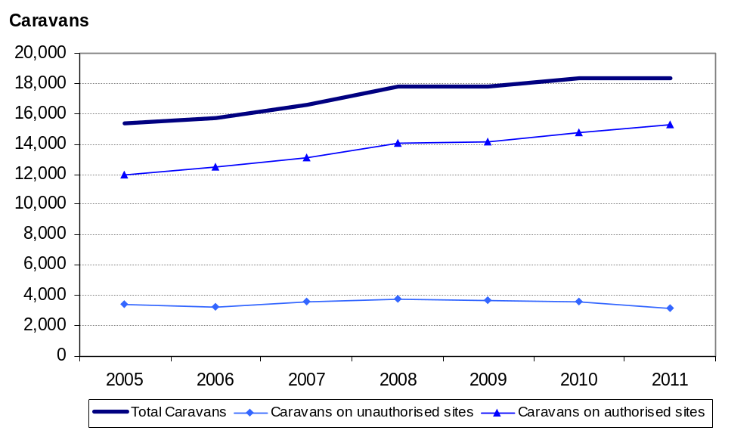
Overall, the number of Gypsy and Traveller caravans on authorised sites was 15,274, an increase of 556 (4%) caravans on the previous year, representing 83% of all caravans in England. This total comprised of 6,942 caravans on public sites operated by local authority and Registered Provider, a slight increase of 72 (1%) caravans, and 8,332 caravans on private sites, an increase of 484 (6%) caravans. The average occupancy of authorised public sites was 22.2 caravans and 4.5 caravans at private sites.
Figure 2: Number of caravans on authorised sites in England (January counts only)
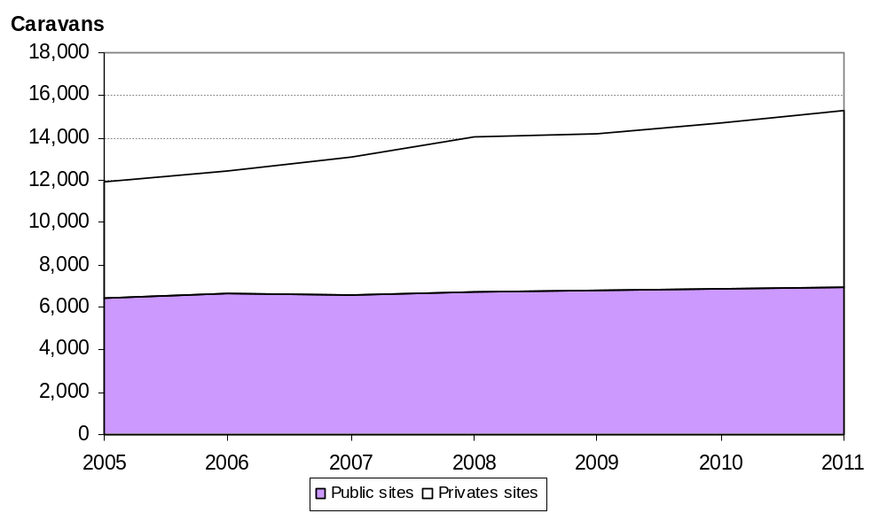
A total of 3,109 Gypsy and Traveller caravans were on unauthorised sites, a reduction of 510 (26%) caravans from the January 2010. These account for 17% of the total, a proportion that has been decreasing over recent years. The average occupancy of unauthorised sites was 3.9 caravans.
Figure 3: Number of caravans on unauthorised sites in England (January counts only)
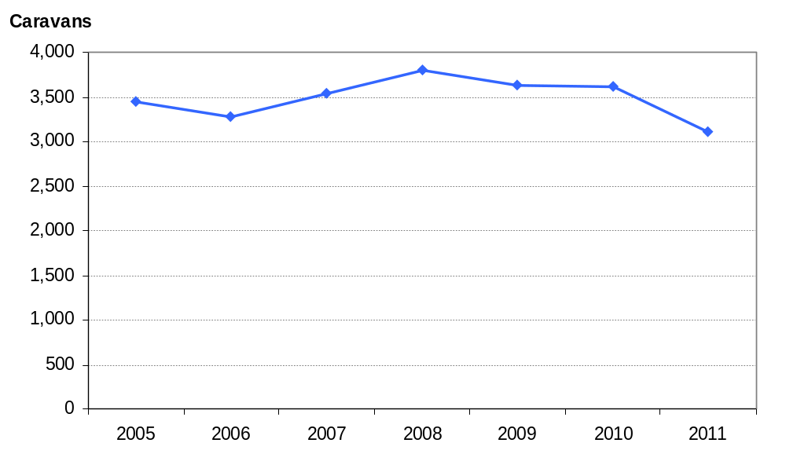

Gypsy and Traveller caravan count: Regions
The breakdown of caravans in England shows that the regions in the South, excluding London, recorded the highest numbers of caravans at the time of the January 2011 count. East of England had the highest number of caravans (4,417 – 24% of the total), followed by the South East (3,942 – 21% of the total) and the South West (2,586 – 14% of the total). Local authorities in the North East and London recorded the fewest caravans (491 and 779 respectively). The region with the highest proportion of caravans on unauthorised sites was the South West (28%).
Figure 4: Regional breakdown Gypsy and Traveller caravans (January 2011 count)
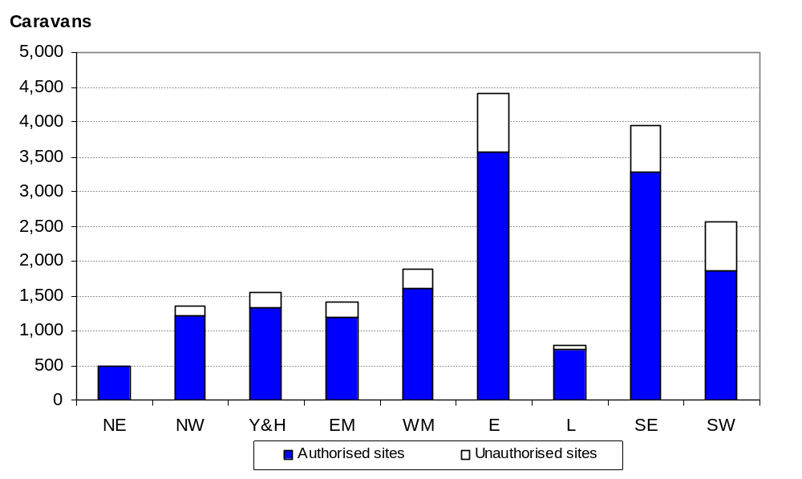
London had the lowest proportion of caravans on private sites (13%) whereas East Midlands had the highest proportion (73%).
Figure 5: Regional breakdown of authorised sites (January 2011 count)
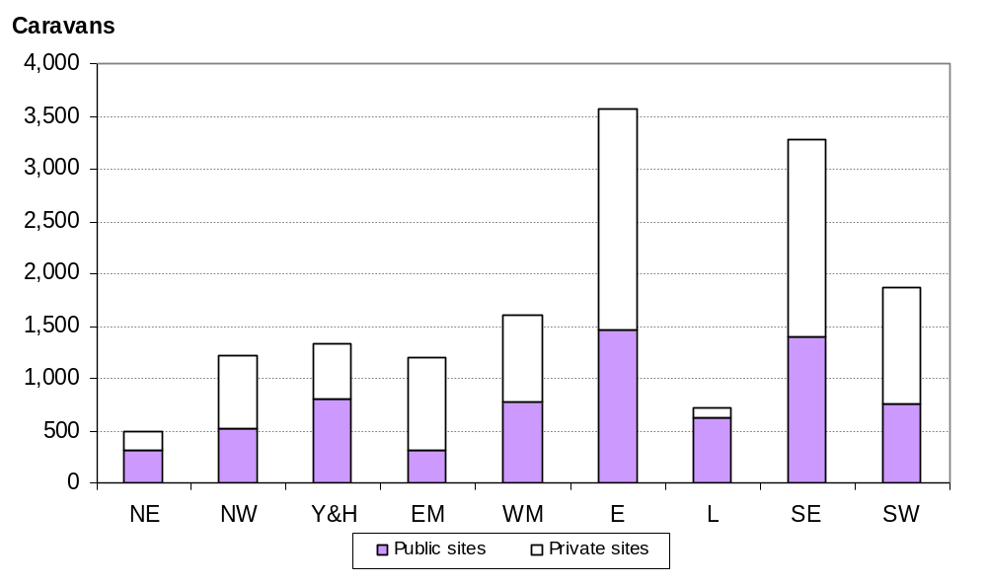
Of the caravans on all unauthorised sites without planning permission, the West Midlands (89%), North West (85%) and South East (84%) were the regions with the highest proportions of caravans on land owned by Gypsies or Travellers.
Figure 6: Regional breakdown of unauthorised sites in England (January 2011 count)
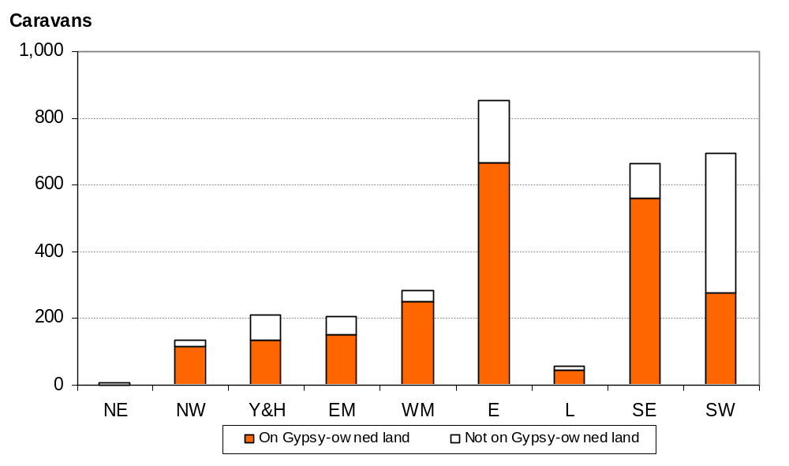

Accompanying tables
Tables refer to the latest count taken on 27th January 2011:
- Table 1 Count of Gypsy and Traveller caravans on authorised and unauthorised sites for the last five counts by national, regional and local authority area;
- Table 2 Location and size of Gypsy and Traveller sites operated by local authorities.
These tables are available at: www.communities.gov.uk/publications/corporate/statistics/caravancountjan2011
In addition to Gypsy and Traveller caravans, the January 2011 count also included a count of the caravans/moveable dwellings occupied by Travelling Showpeople in each local authority in England. The count of Travelling Showpeople’s caravans has been published on the Department’s website and released as ‘Experimental Statistics’. This was our first attempt to capture this information which achieved partial coverage of local authorities (achieving a response rate in the region of 73%). Further information about experimental statistics can be found on the Office for National Statistics website (http://www.statistics.gov.uk/cci/nugget.asp?id=173).

Data sources, definitions, quality and coverage
Local authorities carry out a count of caravans on Gypsy and Traveller sites in England which provide a snapshot of caravans on the day of the count. These take place twice a year, in January and July, to capture information about the number of caravans on:
- authorised public sites – operated by local authorities and Registered Providers;
- authorised private sites – privately funded sites with planning permission;
- unauthorised developments – sites on land owned by Gypsies and Travellers for which planning permission had not been granted; and
- unauthorised encampments – sites on land not owned by Gypsies and Travellers and which do not have planning permission).
The Gypsy and Traveller Caravan Count publication is compiled from information submitted by each local authority in England. These data are collated by the Department and undergo a process of scrutiny to ensure that the published Count is as accurate as possible. Any instances of discrepancies identified by our key partners between published data and their local knowledge will be followed-up with local authorities in order to resolve them. The count data is subject to the Pre-Release Access to Official Statistics Order which means that advance access to the statistics is controlled and publicised (see Background Notes). The number of persons granted pre-release access to these statistics is eight.
There is no statutory requirement on local authorities to submit data for the bi-annual Gypsy and Traveller Caravan Count. However the majority of local authorities do carry out the count and provide information to the Department, and those that do not are noted in the published tables. In total, 93 per cent of local authorities submitted returns in January 2011. Where local authorities have not submitted current counts, figures for the number of caravans in the area are imputed from the last available completed return.

Revisions policy
The Department for Communities and Local Government’s Revisions Policy has been developed in accordance with the UK Statistics Authority Code of Practice for Official Statistics (found at http://www.communities.gov.uk/publications/corporate/statisticalnoticerevisionspolicy). The policy covers two types of revisions.
Non-Scheduled Revisions
Where a substantial error has occurred as a result of the compilation, imputation or dissemination process, the statistical release, tables and other accompanying releases will be updated with a correction notice as soon as is practical.
Scheduled Revisions
Local authorities can update their returns following publication of the data. At the time of each count the previous returns will be reviewed for revision. Revisions to historic data (all data older than that currently due for scheduled revision) should only be made where there is a substantial revision, such as a change in methodology or definition. Where there are small changes that do not substantially change historic data, internal updates are maintained.

Background notes
- Details of officials who receive pre-release access to the Gypsy and Traveller caravan count up to 24 hours before release can be found at: www.communities.gov.uk/publications/corporate/statistics/caravancountjan2011
- The next count of Gypsy and Traveller caravans is due to take place on or around the 28 July 2011.

User consultation
Users’ comments on any issues relating to the Gypsy and Traveller caravan count statistical release are welcomed and encouraged. Responses should be addressed to the "statistical enquiries" contact given in the "Further Information" section below. We welcome, in particular, user comments on the count of Travelling Showpeople’s caravans which we have published for the first time as ‘experimental statistics’.

Further information
Media Enquiries: office hours: 0303 444 1157
0303 444 1159
out of hours: 0303 444 1201
e-mail: press@communities.gsi.gov.uk
Statistical enquiries: e-mail: Mukund Lad at mukund.lad@communities.gsi.gov.uk
telephone: 0303 444 3360

Department for Communities and Local Government. © Crown Copyright, 2011

If you require this publication in an alternative format please email: alternativeformats@communities.gsi.gov.uk. Please note that the nature of content means that we may not be able to provide the Statistical series of publications in all requested formats.

June 2011

ISBN: 978-1-4098-3026-9

