

Housing
Statistical Release

31 May 2012
using
Research
Summary
Number 239, 2007

Count of Gypsy and Traveller Caravans - January 2012

Contents

Headlines 1
Introduction 2
Count of Gypsy and Traveller
Caravans:
England 2
Regional totals 5
Historic data 6
Travelling Showpeople
caravans 6
Accompanying tables 7
Data sources 7
Revisions Policy 8
Background notes 8
User consultation 8
Further information 8

Responsible statistician:
Andrew Presland

Media Enquiries:
office hours: 0303 444 1157
out of hours: 0303 444 1201

press@communities.gov.uk

Statistical enquiries:
office hours: 0303 444 3510
housing.statistics@communities.gov.uk

- The total number of Gypsy and Traveller caravans in England in January 2012 was almost 18,750.This is about 400 more than the total in January 2011.
- Approximately 6,800 caravans were on authorised socially-rented sites, a decrease of about 150 since the January 2011 count.
- The number of caravans on authorised privately-financed sites was almost 9,100, an increase of about 750 since the January 2011 count.
- The number of caravans on unauthorised developments, on land owned by Gypsies and Travellers, was about 1,900, approximately 300 below the number in January 2011.
- The number of caravans on unauthorised encampments, on land not owned by Gypsies and Travellers, was about 950, approximately 50 more than in January 2011.
- The average numbers of caravans per site were 20.4 for socially-rented sites and 5.1 for privately-funded sites.
- Overall, the January 2012 count indicated that 85% of Gypsy and Traveller caravans in England were on authorised land and that 15% were on unauthorised land.

Introduction
This official statistical release provides summary information on local counts of Gypsy and Traveller caravans in England. These counts record the number of caravans on both authorised and unauthorised sites across England. They are carried out to provide local data on the number of caravans and the seasonal movement of caravans. This is a vital tool in identifying need for site provision and in tackling unauthorised encampments and developments.

The Count of Gypsy and Traveller Caravans publication is compiled from information submitted by local authorities in England. Local authorities carry out a count of caravans on Gypsy and Traveller sites twice a year, in January and July, providing a snapshot of the number of caravans on the day of the count. Information is collected about caravans on authorised socially-rented sites, authorised privately-funded sites, unauthorised developments (sites on land owned by Gypsies or Travellers for which planning permission had not been granted) and unauthorised encampments (on land not owned by Gypsies or Travellers and which do not have planning permission).

We publish information in four tables:

- Table 1 contains the number of caravans on authorised and unauthorised sites for the last five counts nationally and by region and local authority area;
- Table 2 contains details of the location and size of Gypsy/Traveller and Travelling Showpeople Caravan sites provided by local authorities and private registered providers;
- Table 3 gives national totals for the main categories of authorised and unauthorised sites for each count since January 1979; and
- Table 4 contains the number of Travelling Showpeople caravans on authorised and unauthorised sites for the 2011 and 2012 counts nationally and by region and local authority area. Further details of the count of Travelling Showpeople, which takes place each January, are below.
Data from the Gypsy and Traveller Caravan count are used by other Government departments, local authorities and essential services to plan service delivery. Collection and publication twice a year is essential to reflect winter residence and summer travelling trends and demands on services. Due to the strong seasonal differences between the January and July counts, all comparisons refer to year-on-year changes. Numbers quoted in this release have been rounded, given that estimates are made for non-responding local authorities and so quoting precise figures might be regarded as implying a spuriously high level of accuracy.

Count of Gypsy and Traveller caravans - England

Total numbers
At the time of the January 2012 count, the total number of Gypsy and Traveller caravans in England was almost 18,750. Of these, approximately 6,800 (36%) were on socially-rented sites; 9,100 (49%) were on privately-funded sites; 1,900 (10%) were in unauthorised developments on land owned by Gypsies or Travellers; and 950 (5%) were in unauthorised encampments on land not owned by Gypsies or Travellers. This information is shown in Figure 1.

Figure 1: Total number of caravans in England, by type of site
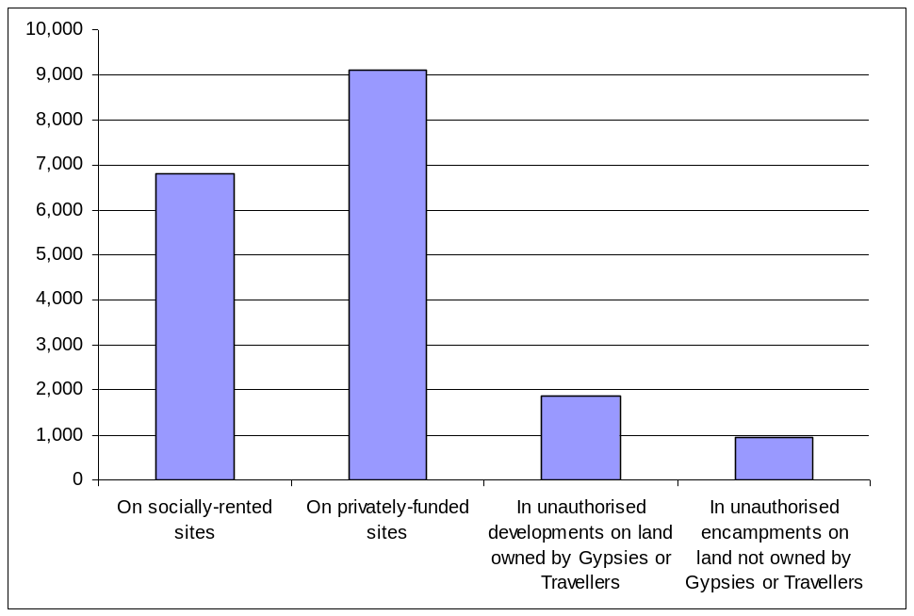

The total number of Gypsy and Traveller Caravans in England has increased in recent years - by 20% since 2006 - as shown in Figure 2.

Figure 2: Total number of caravans in England (January counts only)
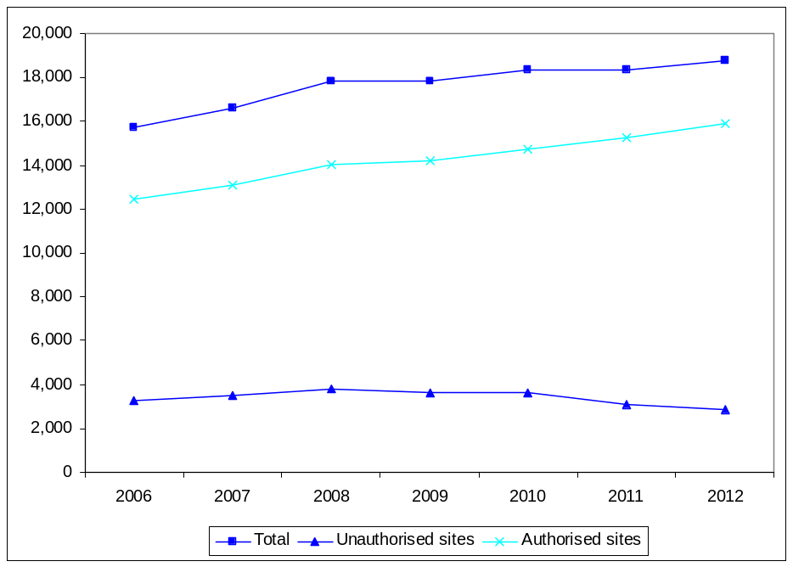

Numbers on authorised sites
As shown in Figure 3, the number of Gypsy and Traveller caravans on authorised sites in January 2012 was approximately 15,900, comprising approximately 6,800 caravans on socially-rented sites operated by local authorities and private Registered Providers (a decrease of about 150 since January 2011) and 9,100 caravans on privately-funded sites, an increase of about 750.

This represents an overall increase of about 600 caravans over the number of caravans on authorised sites in January 2011 and 85% of all Gypsy and Traveller caravans in England. The average numbers of caravans per site were 20.4 for socially-rented sites and 5.1 for privately-funded sites.

Figure 3: Number of caravans on authorised sites in England (January counts only)
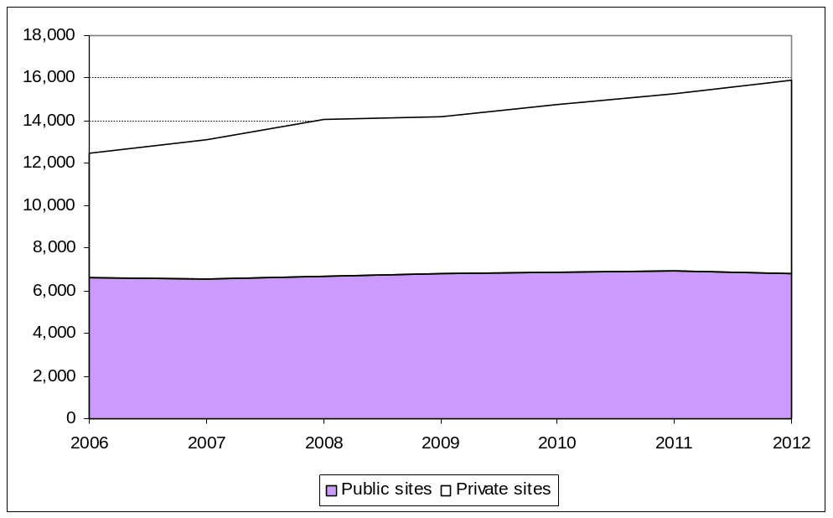

Numbers on unauthorised sites
About 2,850 Gypsy and Traveller caravans were on unauthorised sites, a decrease of about 250 from January 2011, as shown in Figure 4. Caravans on unauthorised sites accounted for 15% of the overall total, down from 17% in January 2011.

Figure 4: Number of caravans on unauthorised sites in England (January counts only)
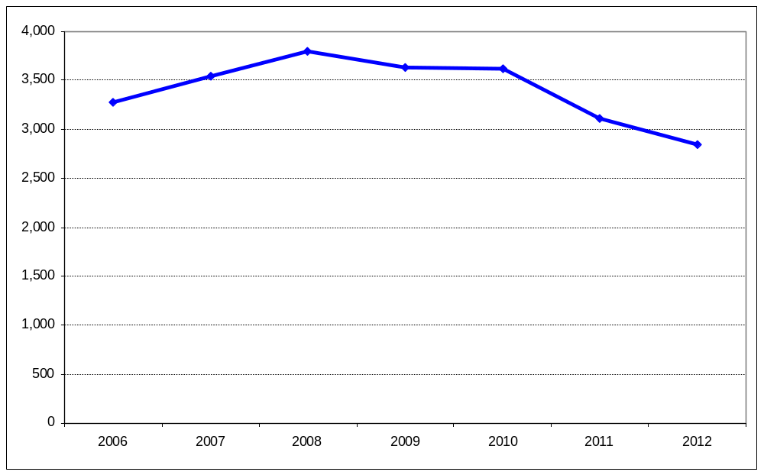

Regional totals
As shown in Figure 5, the regions in the south of England outside London, recorded the highest numbers of caravans at the time of the January 2012 count. East of England had the highest number of caravans (4,250, or 23% of the total), followed by the South East (4,150, or 22% of the total) and the South West (2,650, or 14% of the total). Local authorities in the North East and London recorded the fewest caravans (500 and 800 respectively). The region with the highest proportion of caravans on unauthorised sites was the South West (23%).

Figure 5: Regional breakdown of Gypsy and Traveller caravans (January 2012 count)
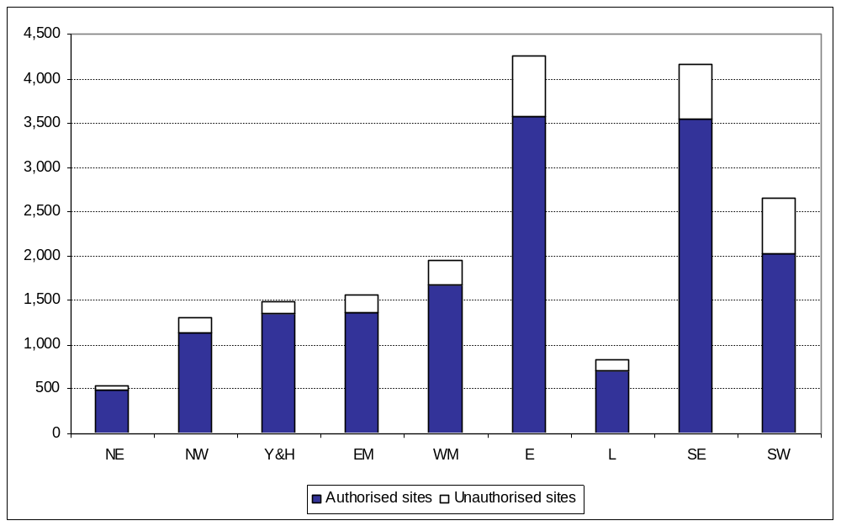

Figure 6 shows that the East of England and the South East have the most caravans on authorised sites, with just of 3,500 in each region. London had the lowest proportion of caravans on private sites (13%) and the East Midlands had the highest proportion (62%).

Figure 6: Regional breakdown of authorised sites (January 2012 count)
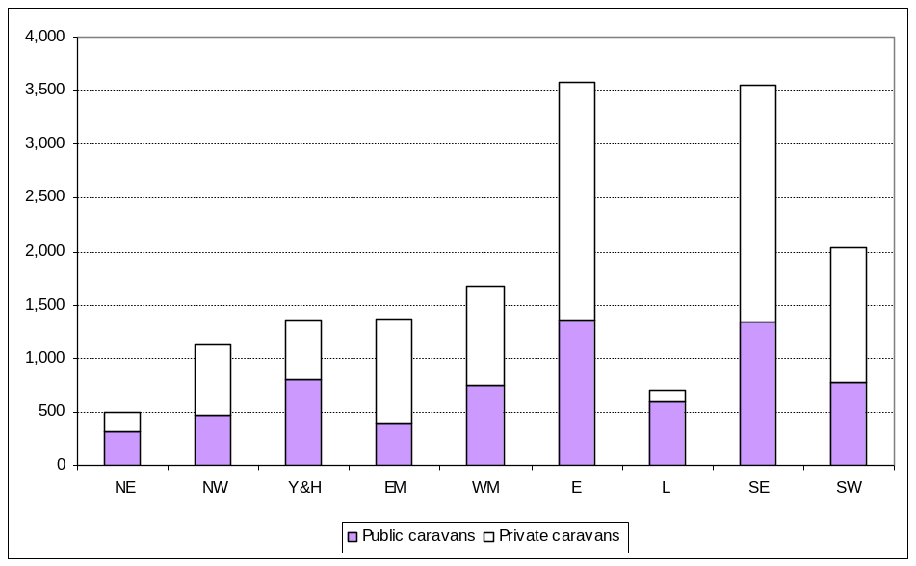

Figure 7 shows that the East of England, the South East and the South West have the most caravans on unauthorised sites, with over 600 in each region. Of all the caravans on unauthorised sites, the West Midlands (87%) and the North West (83%) were the regions with the highest proportions of caravans on land owned by Gypsies or Travellers.

Figure 7: Regional breakdown of unauthorised sites in England (January 2012 count)
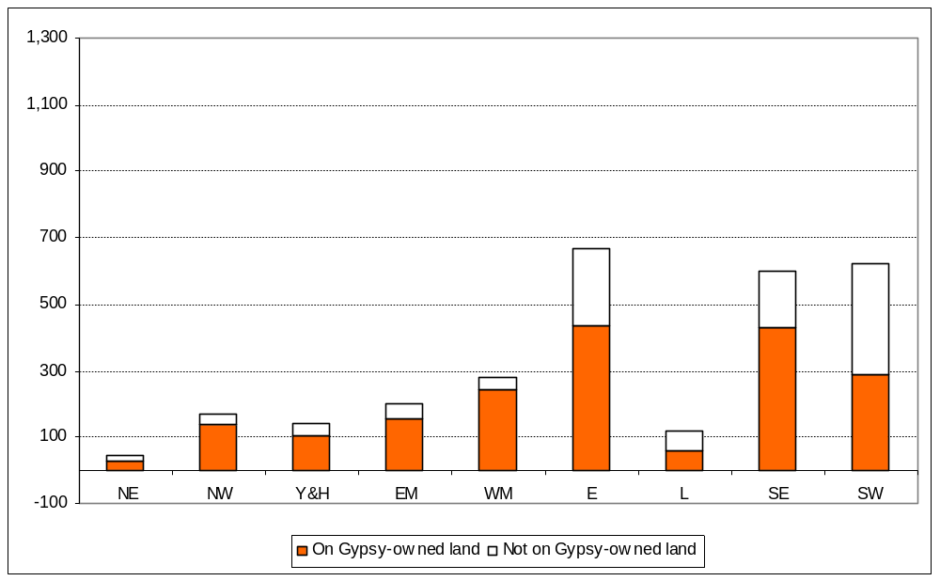

Historic data
The Gypsy and Traveller Caravan Count has taken place twice a year since January 1979. National totals from each count of the main categories of authorised and unauthorised sites are given in Table 3. This table has not previously been published as part of the statistical release. The figures show an increase in the overall total from just over 8,350 caravans in January 1979 to almost 18,750 in January 2012.

Travelling Showpeople caravans
The January 2012 count also included a count of the caravans/moveable dwellings occupied by Travelling Showpeople in each local authority area in England. The results are published as Table 4, as ‘experimental statistics’. This was the second year in which we have captured this information, which achieved partial coverage of local authorities. The overall number of Travelling Showpeople caravans counted in January 2012 was just over 2,550, up 10% from approximately 2,400 in January 2011. Further information about experimental statistics is available on the Office for National Statistics website at http://www.ons.gov.uk/ons/guide-method/method-quality/general-methodology/guide-to-experimental-statistics/index.html.

Accompanying tables
Tables refer to the latest count taken on or around 19 January 2012:

- Table 1: number of caravans on authorised and unauthorised sites for the last five counts nationally and by region and local authority area;
- Table 2: details of the location and size of Gypsy/Traveller and Travelling Showpeople Caravan sites provided by local authorities and private registered providers;
- Table 3: national totals for the main categories of authorised and unauthorised sites for each count since January 1979; and
- Table 4: number of Travelling Showpeople caravans on authorised and unauthorised sites for the 2011 and 2012 counts by national, regional and local authority area.
These tables are available at: www.communities.gov.uk/publications/corporate/statistics/caravancountjan2012.

No count of new affordable residential pitches took place in January 2012. The first such count took place in July 2011. This is an annual count, with the next one taking place in July 2012.

Data sources, definitions, quality and coverage
Local authorities carry out counts of caravans on Gypsy and Traveller sites in England which provide a snapshot of caravans on the day of the count. These take place twice a year, in January and July, to capture information about the number of caravans on:

- authorised public sites - operated by local authorities and private Registered Providers of social housing, including housing associations, trusts and cooperatives.
- authorised private sites - privately funded sites with planning permission;
- unauthorised developments - sites on land owned by Gypsies and Travellers for which planning permission had not been granted; and
- unauthorised encampments - sites on land not owned by Gypsies and Travellers and which do not have planning permission.

The Count of Gypsy and Traveller Caravans publication is compiled from information submitted by local authorities in England. These data are collated by the Department and undergo a process of scrutiny to ensure that the published Count is as accurate as possible. The count data are subject to the Pre-Release Access to Official Statistics Order, which means that advance access to the statistics is controlled and publicised (see Background Notes). The number of people granted pre-release access to these statistics is eight.

There is no statutory requirement on local authorities to submit data for the Count of Gypsy and Traveller Caravans, but the majority of local authorities do carry out the count and provide information to the Department, and those that do not are noted in the published tables. In total, 96 per cent of local authorities submitted returns containing at least some information in January 2012. Where local authorities have not submitted current counts, figures for the number of caravans in the area are taken from the last available completed return.

Revisions policy
The Department for Communities and Local Government’s Revisions Policy has been developed in accordance with the UK Statistics Authority Code of Practice for Official Statistics, available at http://www.communities.gov.uk/publications/corporate/statisticalnoticerevisionspolicy. The policy covers two types of revisions:

i) Non-Scheduled Revisions
Where a substantial error has occurred as a result of the compilation, imputation or dissemination process, the statistical release, tables and other accompanying releases will be updated with a correction notice as soon as is practical.
ii) Scheduled Revisions
Local authorities can update their returns following publication of the data. At the time of each count the previous returns will be reviewed for revision. Revisions to historic data (all data older than that currently due for scheduled revision) should be made only where there is a substantial revision, such as a change in methodology or definition. Where there are small changes that do not substantially change historic data, internal updates are maintained.

Background notes
- Details of officials who receive pre-release access to the Count of Gypsy and Traveller caravans up to 24 hours before release can be found at: http://www.communities.gov.uk/corporate/researchandstatistics/statistics/prereleaseaccess/

- The next count of Gypsy and Traveller caravans is due to take place on or around 19 July 2012. It will include the second annual count of new affordable residential pitches.

User consultation
Users’ comments on any issues relating to the Count of Gypsy and Traveller Caravans statistical release are welcomed and encouraged. Responses should be addressed to the "statistical enquiries" contact given in the "Further Information" section below.

Further information
Media Enquiries: office hours: 0303 444 1157
0303 444 1051
out of hours: 0303 444 1201
e-mail: press@communities.gsi.gov.uk

Statistical enquiries: e-mail: Andrew Presland at housing.statistics@communities.gov.uk
telephone: 0303 444 3510

Communities and Local Government © Crown Copyright, 2012

If you require this publication in an alternative format please email: alternativeformats@communities.gsi.gov.uk. Please note that the nature of content means that we may not be able to provide the statistical series of publications in all requested formats.

May 2012
ISBN: 978-1-4098-3524-0

