

Code for
Sustainable Homes and SAP ratings
Statistical Release
February 2012
using
Research
Summary
Number 239, 2007

Code for Sustainable Homes and Energy Performance of Buildings: Cumulative and Quarterly Data for England, Wales and Northern Ireland up to end of December 2011

Contents

1. Code for Sustainable Homes... 2
2. Key points……………………… 2
3. Regional trends……………….... 3
4. SAP ratings…………………….. 5
5. Data collection………………..… 5
6. Strengths and weaknesses
of the data…………………………. 6
7. Accompanying tables………..… 7
8. Background notes……………... 7
9. User consultation…………….... 8
10. Enquiries…………………........ 8

Responsible statistician:
James Denman

Media Enquiries:
office hours: 0303 444 1136
out of hours: 0303 444 1201

press@communities.gov.uk

Statistical enquiries:
Code: 0303 444 1271
thecode@communities.gsi.gov.uk

SAP ratings: 0303 444 2145
david.amos@communities.gsi.gov.uk

- There were 52,486 post construction stage certificates and 98,865 design stage certificates issued up to 31 December 2011.
- 16% of homes with post construction certificates and 26% of those with design stage certificates have been built for the private sector. 84% of homes with post construction certificates and 74% of those with design stage certificates have been built for the public sector.
- Between April 2007 and December 2011, 77,130 dwellings at the design stage received a three star rating and 331 dwellings received a six star rating.
- Between April 2007 and December 2011, 45,555 dwellings at post-construction stage received a three star rating and 128 dwellings received a six star rating.
- The majority of the certificates issued since April 2007 at design stage (78%) and at post construction stage (87%) have been awarded at three star rating.
- The average energy efficiency (SAP) rating of new homes was 79.2 in England and 78.5 in Wales for the quarter October - December 2011. This is a decrease of 2.5 points for England 2.1 points for Wales on the same quarter in 2010, from 81.7 and 80.6 respectively.

This is the seventh in the series of quarterly Statistical Releases dedicated to the publication of official statistics on the number of homes which meet the standards set out in the Code for Sustainable Homes (the Code) in England, Wales and Northern Ireland up to the October – December quarter 2011, and the average energy efficiency (SAP) rating of new homes in England and Wales up to the October - December quarter 2011 (there are no figures for Scotland because Code certificates are not issued in Scotland).

Code for Sustainable Homes
Statistics relating to the Code for Sustainable Homes (the Code) show the number of dwellings that have been certified to the standards set out in the Code Technical Guide, in which local authority area, at which Code level and whether the homes are registered as private or public sector homes. Code certificates are issued at two stages, the design stage (early in the design and build process) and post construction stage (when the home is completed or nearing completion).
The Code takes a whole house approach and measures the sustainability of a dwelling against nine different categories: energy/carbon; water; waste; materials; surface water run-off; and health and well being, which have mandatory performance standards; and pollution; ecology; and management. To achieve the levels of the Code, a number of points must be accumulated across all categories and the mandatory requirements must be met. Depending on the number of points gathered, a star rating is then awarded (one star being the lowest achievable level and six stars incorporating zero carbon). If a dwelling does not achieve the mandatory standards set out in the Technical Guide and/or does not reach the minimum score for a one star rating, it will receive a certificate with no stars. The assessment and certification of Code homes is undertaken by the 1491 assessors who are licensed by BRE Global Ltd, Stroma Accreditation Ltd and RDL Ltd.

The key points
- The Code came into operation in April 2007. It can take, on average, 18 months to two years to design and build a Code home. As a result the first homes built to the Code standard were not awarded a certificate until 2008. Figure 1 (overleaf) shows the general quarterly trend in the number of certificates issued since then.
- Between April 2007 and the end of December 2011, 77,130 dwellings have received a three star rating at the design stage and 331 dwellings have received a six star rating.
- Between April 2007 and the end of December 2011, 45,555 dwellings have received a three star rating at post-construction stage and 128 dwellings have received a six star rating.
- A total of 78 per cent of the certificates at design stage and 87 per cent of those at post-construction stage have been awarded at Code level 3 since April 2007.

Figure 1: Number of design stage and post construction stage certificates issued each quarter in England, Wales and Northern Ireland, up to and including the October - December quarter 2011
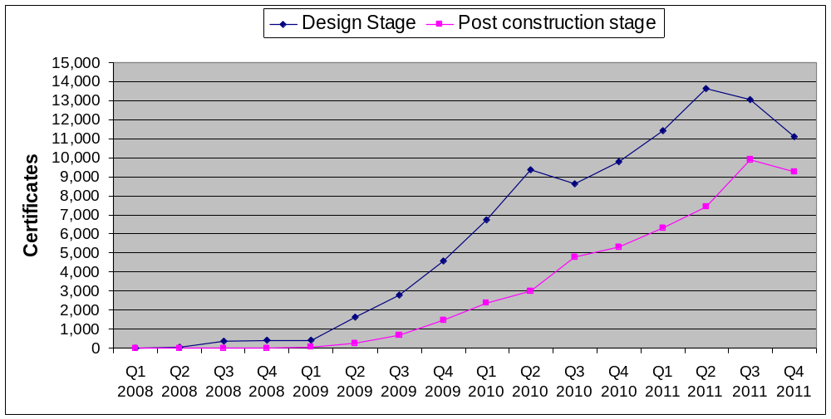

Regional trends
This publication updates the November release by incorporating data for October, November and December 2011. Information included is:
- the number of certificates issued in each local authority area;
- the proportion of certificates issued for developments registered by the Code assessor as private sector or public sector;
- the number of certificates in each region.

Breakdown by local authority and region in England, Wales and Northern Ireland
The statistics show that Code certificates have been issued in the majority of local authority areas across England as well as in most authorities in Wales and Northern Ireland. The largest total number of design and post construction Code certificates (combined) in the last quarter were issued in the London Borough of Newham, followed by the London Borough Greenwich. Regionally, London is where the largest number of design and post construction Code certificates have been issued, followed by the South-East (see Figure 2).

Figure 2: Cumulative Regional distribution of Code certificates at design and post-construction stage, issued in England up to and including the October – December quarter 2011.
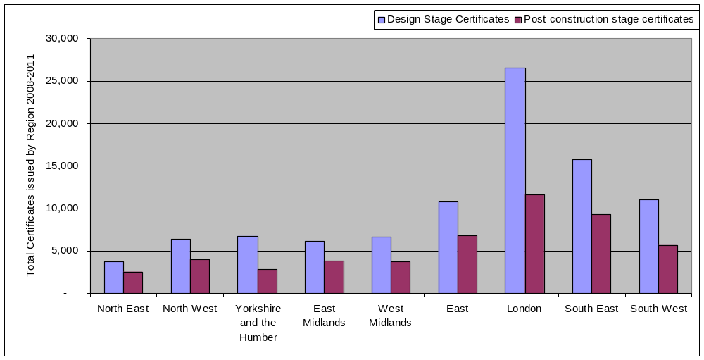
There were 735 design stage and 110 post construction certificates where the Code assessor did not register the local authority or region when completing the assessment. These are listed as ‘unknown’.

Breakdown between public and private sector certificates
The total number of certificates issued at Design Stage up to the end of December 2011 in England, Wales and Northern Ireland is 98,865, of which 25,804 (26%) were registered as private sector homes and 73,061 (74%) were public sector homes. At Post Construction Stage, there were 52,486 certificates issued of which 8,261 (16%) homes were registered as private sector and the remainder, 44,225 (84%) were registered as public sector.
Of the total number of Code level 3 homes at Design Stage up to the end of December 2011, 24% were built for the private sector and 76% for the public sector. At Code 3, Post Construction Stage, 16% were built for the private sector and 84% for the public sector.
Of the total number of Code level 6 homes at Design Stage, up to the end of December 2011, 64% were built by the private sector and 36% for the public sector. At Post Construction Stage, 8% were built by the private sector and 92% for the public sector.

Average energy efficiency (SAP) rating of new homes
SAP refers to the Government's 'Standard Assessment Procedure' for assessing the energy performance of dwellings. The SAP rating is based on the energy costs associated with space heating, water heating, ventilation and lighting, less cost savings from energy generation technologies. It is adjusted for floor area so that it is essentially independent of dwelling size for a given built form. The SAP rating is expressed on a scale of 1 to 100 - the higher the number, the lower the running costs. This release covers quarterly data for the regions of England and Wales for October - December 2011.

The key points
From October to the end of December 2011:
- The average energy efficiency (SAP rating) of new homes was 79.2 in England and 78.5 in Wales for the quarter October - December 2011. This is a decrease of 2.5 points for England and 2.1 points for Wales on the same quarter in 2010, from 81.7 and 80.6 respectively.
- Regionally, the average energy efficiency (SAP rating) of new homes varied from 76.3 in the North West to 81.3 in the West Midlands.
- By dwelling type, in England, the average energy efficiency (SAP rating) ranged from 77.0 in maisonettes to 80.1 in houses.
- In Wales, the average energy efficiency (SAP rating) by dwelling type ranged from 71.1 for bungalows to 80.3 for maisonettes.

Data collection

Code for Sustainable homes:
Data for each dwelling assessed under the Code are collected by one of three Code Service Providers of the scheme (BRE Global Ltd, Stroma Accreditation Ltd and RDL Ltd). Assessment is a two stage process - design and post construction stage and is carried out by licensed Code assessors. Assessors submit their reports to the Code Service Provider and after quality assurance checks have been made certificates are issued by the Code Service Provider.
Information regarding each certified dwelling is taken from the Code Service Provider’s databases and collated for the Department for Communities and Local Government by BRE Global Ltd on a monthly basis.

SAP ratings:
Figures for the Average Energy Efficiency of New Homes (SAP ratings) are held on the National Energy Performance Certificate Register, managed by Landmark Information Group. This database is subject to ad-hoc reporting, and as such, all figures at publication should be viewed as provisional. The figures may change in subsequent publications as revisions are made and previously incomplete entries are added to the database by Landmark.

Strengths and weaknesses of the data

Code for Sustainable homes:
The three current Code Service Providers operate schemes to train and license assessors through UKAS accredited procedures.
The data collected by Code Service Providers are based on the certificates issued, which are then reported to the Department for Communities and Local Government on a monthly basis. This process is audited by UKAS under certification standards EN 45011 and/or ISO 17024.

SAP ratings:
Average energy efficiency ratings, on a quarterly basis, are volatile due to a number of factors including the small number of new homes being assessed (in particular, maisonettes and bungalows), the mix of dwelling types, the mix of heating systems used in new developments and the location of those developments.

Revisions policy
This policy has been developed in accordance with the UK Statistics Authority Code of Practice for Official Statistics and the Department for Communities and Local Government Revisions Policy. There are two types of revisions that the policy covers.

Non-Scheduled Revisions
Where a substantial error has occurred as a result of the compilation, imputation or dissemination process, the statistical release, live tables and other accompanying releases will be updated with a correction notice as soon as is practical.

Scheduled Revisions
The next quarterly release will cover Code Statistics and SAP ratings for the January - March quarter 2012.

Accompanying tables
Accompanying tables are available to download alongside this release:

Tables:
1a. Code for Sustainable Homes statistics: Number of Code certificates issued in month by stage of construction in England, Wales and Northern Ireland from March 2008
1b. Code for Sustainable Homes statistics: Number of Code certificates issued by sector to date in England, Wales and Northern Ireland from March 2008
1c. Code for Sustainable Homes statistics: Number of Code certificates issued by Local Authority to date in England, Wales and Northern Ireland from March 2008
1d. Code for Sustainable Homes statistics: Number of Code certificates issued by region in England, Wales and Northern Ireland from March 2008 (quarterly)
2. Energy Performance of Buildings Statistics: Average energy efficiency (SAP rating) of new homes in England & Wales by region (quarterly)
3. Energy Performance of Buildings statistics: Average energy efficiency (SAP rating) of new homes in England & Wales by dwelling type (quarterly)

Notes to the tables
The following conventions have been used in the tables:
.. Not available;
^{p} Figure provisional and subject to revision;
^{r} Revised from previous release.

Background notes
- The statistics reported in this publication shows the number of dwellings that have been certified in England, Wales and Northern Ireland from March 2008 (quarterly)
to the standards set out in the Code Technical Guide, in which local authority area, at which Code level and whether the homes are registered as private or public sector homes.
- Figures in the accompanying tables are exact number of certificates issued.
- Sources are shown at the foot of individual accompanying tables.
- Official Statistics are produced to high professional standards set out in the Code of Practice for Official Statistics.
- The tables and charts accompanying this release are shown above in the ‘Accompanying tables’ section and are provided in Microsoft Excel format.
- Details of Ministers and officials who receive pre-release access to the Communities and Local Government quarterly Code for Sustainable Homes release up to 24 hours before release can be found at:
http://www.communities.gov.uk/corporate/researchandstatistics/statistics/nationalstatistics/
- The next quarterly release will cover Code Statistics for England, Wales and Northern Ireland up to the January - March quarter 2012 and the SAP ratings for England and Wales up to the January - March quarter 2012.

User consultation
Users’ comments on any issues relating to this statistical release are welcomed and encouraged. Responses should be addressed to the "statistical enquiries" contact given in the "Enquiries" section below.

Enquiries

Media enquiries
office hours: 0303 444 1136
out of hours: 0303 444 1201
email: press@communities.gov.uk

Statistical enquiries
Code:
email: thecode@communities.gsi.gov.uk
telephone: 0303 444 1271
SAP Ratings:
email: david.amos@communities.gsi.gov.uk
telephone: 0303 444 2145

Department for Communities and Local Government. © Crown Copyright, 2012
If you require this publication in an alternative format please email: alternativeformats@communities.gsi.gov.uk. Please note that the nature of content means that we may not be able to provide the Statistical series of publications in all requested formats.

February 2012

ISBN 978-1-4098-3360-4

The regions are classified as: East, East Midlands, London, North East, North West, South East, South West, West Midlands, Yorkshire and the Humber.
http://www.communities.gov.uk/publications/corporate/statisticalnoticerevisionspolicy

