2008 EHS Stock Report
Errata

January 2011 (2): Numbers of households including a person with a long term sickness or disability

Publications affected:
2008 English Housing Survey, Stock Report, October 2010

Description of the error:
The number of households including a person who has a long term sickness or disability was incorrect in the 2008 English Housing Survey Stock Report.
A small number of missing cases were not reattributed.

The 2008 EHS Stock Report stated 6.35 million households include someone who had a long term sickness or disability. The correct figure is 6.38 million. This error only affects the numbers of households quoted in Table 7.3. All percentages in the original table and text are correct.

A revised Table 7.3 is included below. The Summary Statistics Tables have also been revised to correct the error.

Table 7.3: Long term sick or disabled households by poor living conditions, 2008
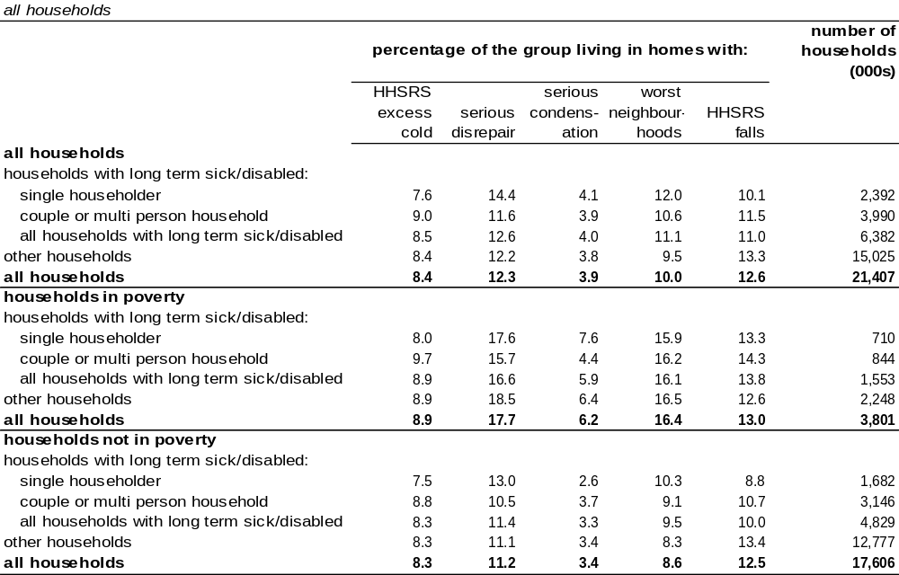
Source: English Housing Survey 2008, household sub-sample

January 2011 (1): Smoke Alarms

Publications affected:
2008 English Housing Survey, Stock Report, October 2010

Description of the error:
There was an error in the 2008 English Housing Survey Stock Report’s estimate of the number of households with working smoke alarms.

This was due to a computational error when bringing together data from the 2007-08 English House Condition Survey (EHCS) and the new 2008-09 English Housing Survey (EHS). This came about due to some differences in the design of the questions from the EHCS and those in the new survey (which originated in the Survey of English Housing).

A revised version of the section on smoke alarms (pp 49), and the associated annex table are included in below. The relevant Summary Statistics Tables (SST10 – SST12) have also been revised to correct the error.

Revised section on smoke alarms (pp49):

Smoke alarms

There has been a gradual increase in the percentage of households living in homes with one or more working smoke alarms, from 74% in 2001 to some 86% of households in 2008, Figure 2.16.

Figure 2.16: Percentage of households with smoke alarms, 2001 to 2008
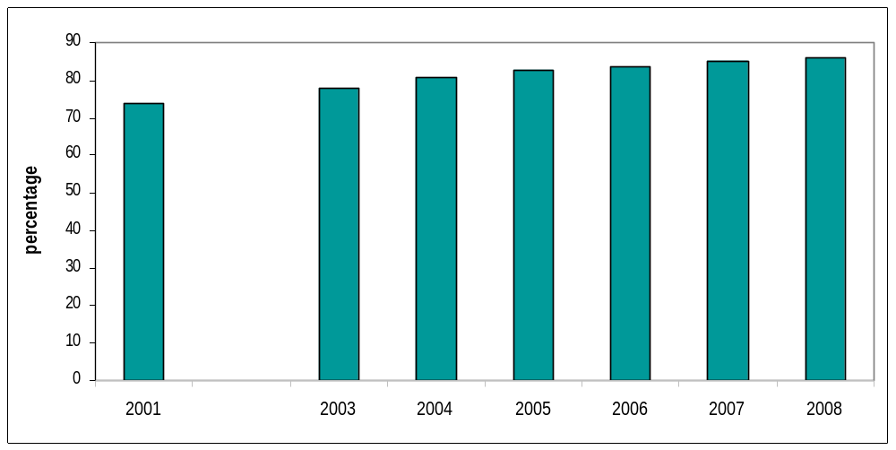
Base: all households
Note: underpinning data are presented in Annex Table 2.29
Source: English House Condition Survey 2001 to 2007 household samples and English Housing Survey 2008, household sub-sample

There were large variations in the presence of smoke alarms in relation to tenure. Private tenants were less likely to have these than those renting from housing associations (79% compared with 92%). Households in the newest dwellings built after 1990 were the most likely to have a smoke alarm (96%) and those in the oldest pre 1919 built dwellings the least likely (80%). Only 79% of those in purpose built high rise flats had smoke alarms compared with 91% in detached houses (see Summary Statistics Table SST 2.10).

Other groups that were less likely than average to possess smoke alarms were: households located in city centres (75%) together with ethnic minority households and one person households aged under 60 (78%) (see Summary Statistics Table SST 2.12).

Annex Table 2.29: Smoke alarms, 2001 - 2008

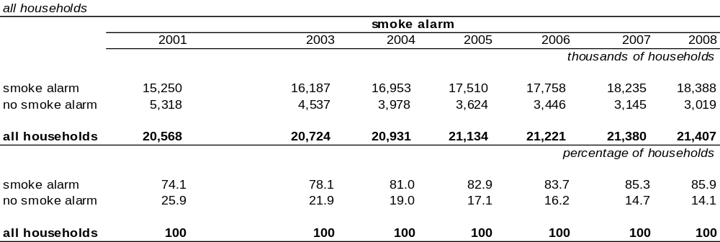Source: English House Condition Survey 2001-2007 & English House Survey 2008, household sub-sample

