

Housing
Statistical Release

10 June 2010
using
Research
Summary
Number 239, 2007

Statutory Homelessness:
March Quarter 2010 England


Contents  Introduction  Decisions  Acceptances  - Priority need  - Reason for loss  - Ethnicity and household type  - Age band  - Action taken  - Regional Acceptances  Temporary Accommodation  - Young people  - Accommodation type  - Household type & ethnicity  - Leaving TA  - Regional TA & length of stay  Scope  Homelessness targets  Data source and data quality  Revisions Policy  List of tables  Background notes  Enquiries | 2  2  3  3  4  5  6  6  7  9  10  10  11  12  13  16  16  16  17  19  19  21

Responsible Statistician:
Mark Pearson
Public Enquiries:
Phone: 030344 44172
homelessnessstats@communities.gsi.gov.uk
Press Enquiries:
Office hours: 0303 444 1136
Out of hours: 0303 444 1201 press.office@communities.gsi.gov.uk

Household acceptances¹
- 9,590 applicants were accepted as owed a main homelessness duty during January to March, 16 per cent lower than during the same period last year.
- On a seasonally-adjusted² basis, there were 9,550 acceptances, 3 per cent lower than the previous quarter and 72 per cent lower than the last peak in 2003.
Households in temporary accommodation³
- 51,310 households were in temporary accommodation on 31 March 2010, 20 per cent lower than the same date last year.
- On a seasonally-adjusted² basis, 51,230 households were in temporary accommodation, 5 per cent lower than the previous quarter and 50 per cent lower than the peak in 2004.
- 88 per cent of households were in self-contained accommodation⁴. 4 per cent were in bed and breakfast hotels.

Introduction
This release provides summary information on local housing authorities’ activities under homelessness legislation, collected through the quarterly P1E return. Data include the number of households accepted as owed a main homelessness duty (referred to as acceptances) during the quarter, and the number of households in temporary accommodation on the last day of the quarter. The background notes section provides more detail of terms used, as footnoted, within the release.

Decisions⁵ taken by local authorities on homeless applications
Between January and March, local housing authorities made 21,410 decisions on applications (by eligible households) for housing assistance, under the homelessness legislation of the Housing Act 1996. This is 17 per cent lower than the corresponding quarter in 2009 but a slight increase from 21,200 compared to last quarter. After seasonal adjustment the number of decisions was 21,240, 3 per cent lower when compared to last quarter and 72 per cent lower than the last peak in 2003.
Of the 21,410 applications made during January and March 2010:
- 45 per cent were accepted as owed a main homelessness duty;
- 28 per cent were found not to be homeless;
- 20 per cent were found to be homeless but not in priority need; and
- 8 per cent were found to be intentionally homeless and in priority need.
Chart 1: Total decisions made during January to March 2010 by decision outcome, England
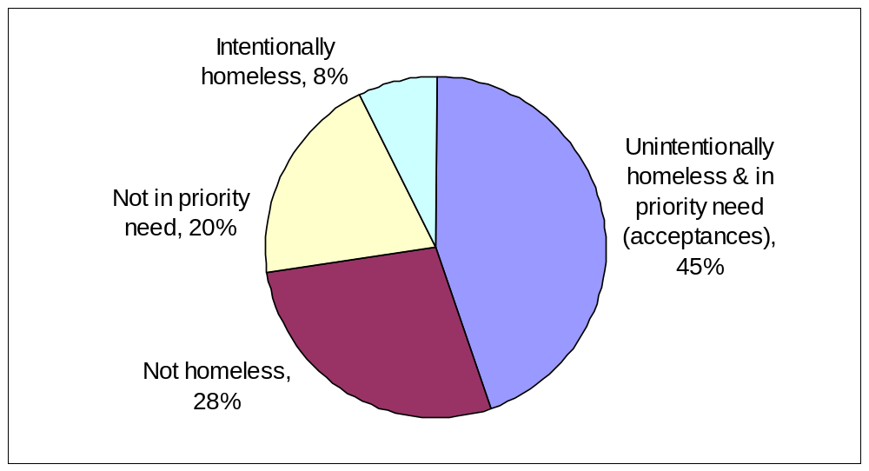
See Table 1: Decisions by outcome of decision

Households accepted¹ as owed a main homelessness duty (acceptances)
Between January and March, local authorities accepted 9,590 households as being owed a main homelessness duty (acceptances). This is 16 per cent lower when compared with the corresponding quarter last year but a slight increase from 9,430 in last quarter. After seasonal adjustment the number of acceptances during the first quarter of 2010 was 9,550, 3 per cent lower than the previous quarter and 72 per cent lower than the previous peak in 2003.
Chart 2: Households accepted by local authorities as owed a main duty each quarter, 1998 to January to March quarter 2010, England
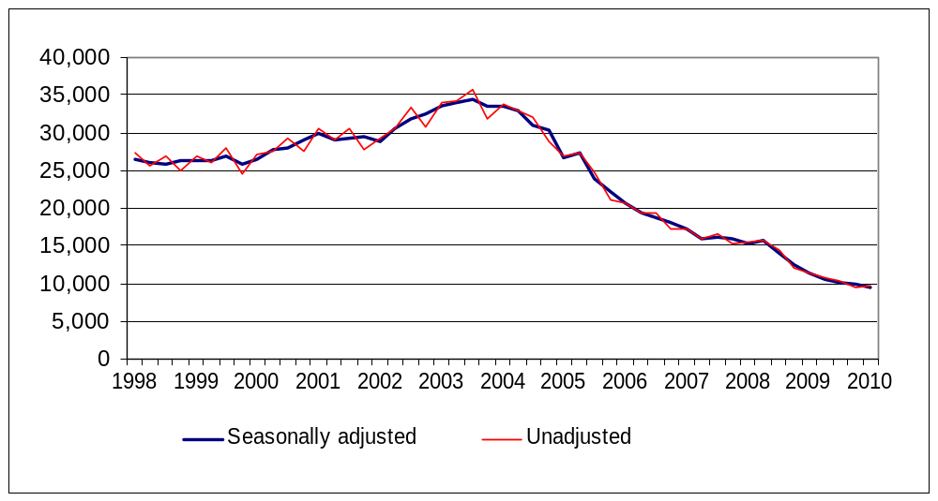
See Table 1: Decisions by outcome of decision

Acceptances by priority need⁶ category
Between January and March, in 58 per cent of acceptances the presence of dependent children in the household was the primary reason for priority need, and a further 10 per cent of households were in priority need because they included a pregnant woman.
The majority of the remainder were in priority need due to vulnerability, for example, mental illness (8 per cent) or physical disability (7 per cent). 6 per cent of acceptances were in priority need through being a young person (either 16 or 17 year olds, or 18 to 20 year olds formerly in care). Homeless in an emergency⁶ accounted for 1 per cent of all acceptances.
Chart 3: Acceptances by priority need category during January to March 2010, England
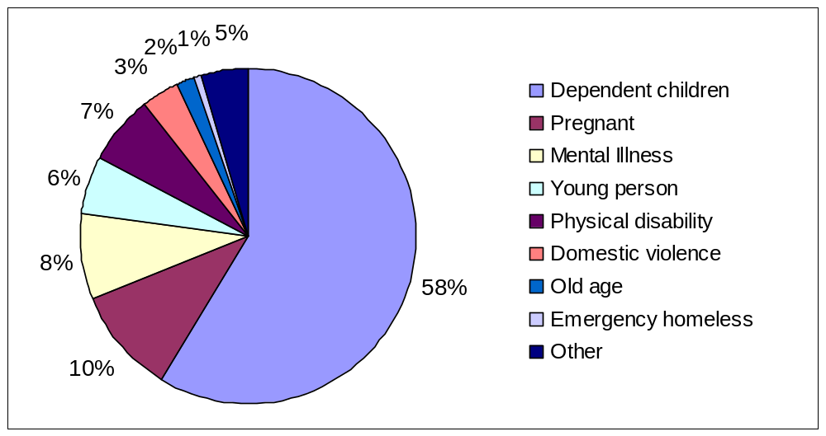
See Table 4: Acceptances by priority need category

Acceptances by reason for loss of last settled home
Between January and March, in 34 per cent of acceptances the reason for homelessness was because parents, relatives or friends (mostly parents) were no longer able, or willing, to accommodate applicants.
In a further 19 per cent of acceptances during January and March, the reason for homelessness was the breakdown of a relationship with a partner, 67 per cent of these cases involving violence.
In 13 per cent of acceptances the reason for homelessness was the ending of an assured short hold tenancy.
At 2 per cent, the proportion of acceptances where homelessness resulted from mortgage arrears (repossession or other loss of home) has fallen slightly having remained at 3 per cent the previous four quarters. In spite of a steady increase between 2003 and 2008, the proportion of acceptances due to mortgage arrears has remained much lower than the peak in the last downturn - 12 per cent during 1991.
Chart 4: Acceptances by reason for loss of last settled home during January to March 2010, England
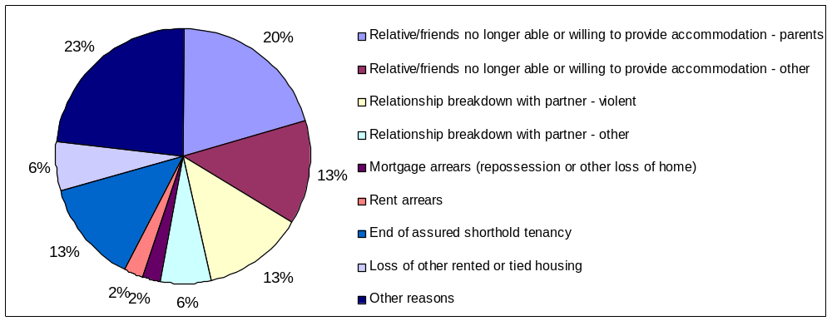
See Table 5: Acceptances by reason for loss of last settled home

Acceptances by ethnicity
Between January and March, 68 per cent of applicants accepted were White, and 27 per cent were from an ethnic minority group - 14 per cent Black, 7 per cent Asian, 3 per cent mixed and 4 per cent another ethnic group. The remainder did not state their ethnic origin. Compared to the population as a whole, there is a higher incidence of acceptances amongst ethnic minority groups than amongst the White population.
See Table 2: Acceptances by ethnicity

Acceptances by household type
Of the 9,590 acceptances between January and March, 44 per cent were lone mothers, and 19 per cent were couples with dependent children. One person households accounted for 28 per cent of acceptances, with a higher proportion male than female.

Chart 5: Acceptances by household type during January to March 2010, England
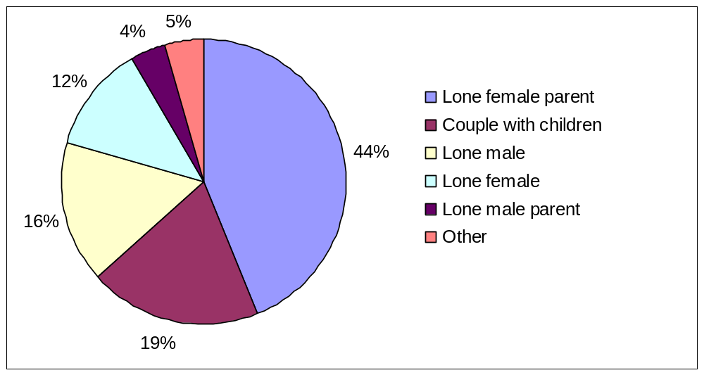
See Table 10: Homeless households in priority need accepted by local authorities, by household type

Acceptances by age band
Between January and March, 86 per cent of all acceptances were applicants under 45 years old. 49 per cent were aged between 25 and 44, and 37 per cent between 16 and 24.
See Table 11: Homeless households in priority need accepted by local authorities, by age of applicant

Action taken in respect of acceptances
Of the 9,590 acceptances between January and March, 62 per cent were placed in some form of temporary accommodation for a period of time. For a further 27 per cent of accepted households, arrangements were made for them, with consent, to remain in their existing accommodation (or to make their own arrangements), for the immediate future while awaiting the provision of alternative accommodation⁷.
9 per cent of acceptances were provided with settled accommodation, by being granted a secure tenancy in local authority or registered social landlord accommodation, or an assured short hold tenancy in the private rented sector. The remaining 2 per cent either made their own arrangements or had no further contact with the authority, thus bringing the homelessness duty to an end.
See Part 1 of Table 8: Outcomes: those accepted during the quarter, and those leaving temporary accommodation (or no longer recorded as “duty owed, no accommodation secured”⁷) during the quarter

Acceptances by region
The West Midlands and London had the highest incidences of acceptances per 1,000 households during the quarter, with 0.8 and 0.7 respectively, compared to 0.4 for England as a whole. The South East with slightly less than 0.3 per 1,000 households, had the lowest incidence.
With the exception of East Midland, all regions saw a reduction in acceptances compared to the same period last year, with the largest percentage drops in the North East and Yorkshire and the Humber (41 and 30 per cent respectively). East Midlands had an increase of 6 per cent.
Map 1: Homelessness Acceptance Rates by region, January to March 2010
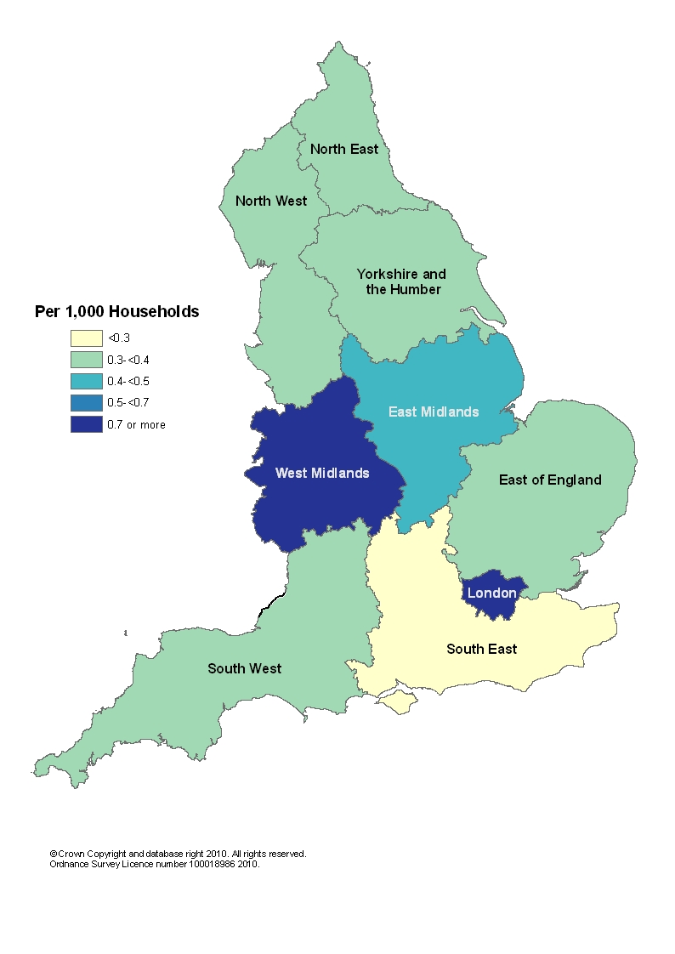
See Table 3: Acceptances by region
Acceptances by ethnicity and region
There is large variation in the ethnicity of accepted applicants across the regions. In London, 38 per cent of acceptances were White, partly reflecting the larger ethnic minority population in this region, while in the South West the proportion was 90 per cent. London had the highest proportion of acceptances from ethnic minority applicants with 55 per cent, followed by the West Midlands with 36 per cent. London had the highest percentage of acceptances from Black applicants at 33 per cent as well as from Asian applicants at 11 per cent. London also had the highest percentage of acceptances from the Mixed and ‘other’ ethnic groups (4 and 7 per cent respectively). The South East and South West reported the lowest proportion of acceptances in the Mixed ethnic group category at 1 per cent.
Chart 6: Proportion of acceptances during January to March 2010 by ethnicity, England and regions
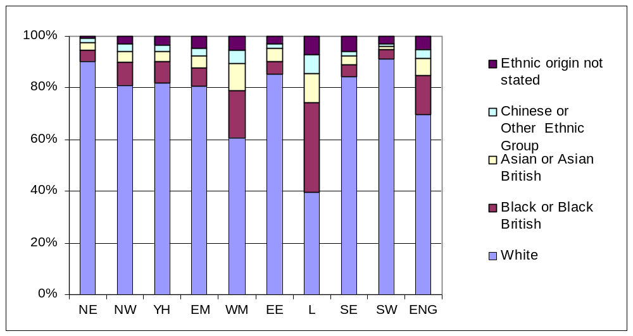

Households in temporary accommodation³
The number of households in temporary accommodation on 31st March 2010, arranged by local authorities under homelessness legislation, was 51,310. This is 12,690 (20 per cent) lower than the same date last year. After seasonal adjustment the number of households in temporary accommodation was 51,230, 5 per cent lower than last quarter (the same as the previous quarter on quarter change) and 50,230 (50 per cent) lower than the peak in 2004.
Of these 51,310 households, 87 per cent had been accepted as owed a main homelessness duty and were being housed in temporary accommodation by the authority until a settled home became available. The remainder were being accommodated pending a decision on their application, the outcome of a local authority review or an appeal to the county court on the authority's decision, or possible referral to another local authority, or had been found intentionally homeless and in priority need and subsequently were being accommodated for such a period as would give them a reasonable opportunity to find accommodation for themselves.
88 per cent of households in temporary accommodation were in self-contained⁴ accommodation (either in local authority or registered social landlord stock, or within the private sector) and 12 per cent were in accommodation with shared facilities (bed and breakfast style accommodation, or hostels and women’s refuges).
Chart 7: Households in temporary accommodation at the end of each quarter, by type, 1998 to 31 March 2010, England
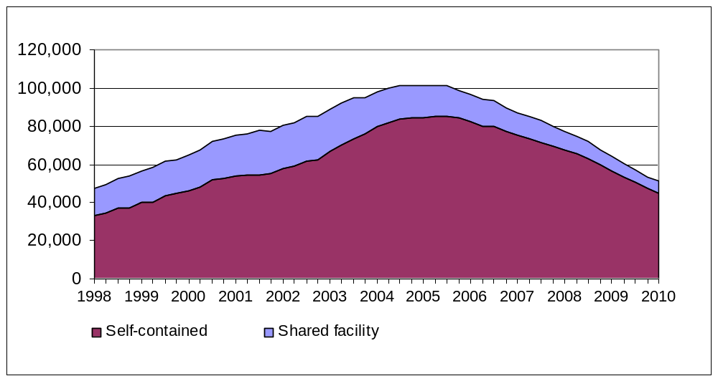

Young people in temporary accommodation
Of the 51,310 households in temporary accommodation on 31 March, 39,200 included dependent children and/or a pregnant woman (within which households there were 74,610 children or expected children).
Of these 39,200 households with children, 93 per cent were in self-contained accommodation. 630 (2 per cent) were in bed and breakfast style accommodation.
At the end of March, there were 180 households headed by 16 and 17 year old applicants in bed and breakfast style accommodation, of which 60 had been there for longer than six weeks (8 of these pending an appeal).

Households in temporary accommodation, by type of accommodation
There is a wide range of accommodation used to provide temporary accommodation, most of which (88 per cent) is self-contained.
Use of accommodation with shared facilities has declined over recent years, largely through reduced bed and breakfast usage. Within the last ten years, bed and breakfast style accommodation use peaked during 2002, when 16 per cent of households were in this form of temporary accommodation, compared to 4 per cent at the end of March 2010. The proportion of self-contained accommodation has increased over this period; in particular private sector accommodation leased short term by local authorities or housing associations, which has risen from under 30 per cent during 2002 to 60 per cent at the end of March 2010.
Chart 8: Households in temporary accommodation, by type, at the end of each quarter, 1998 to 31 March 2010, England
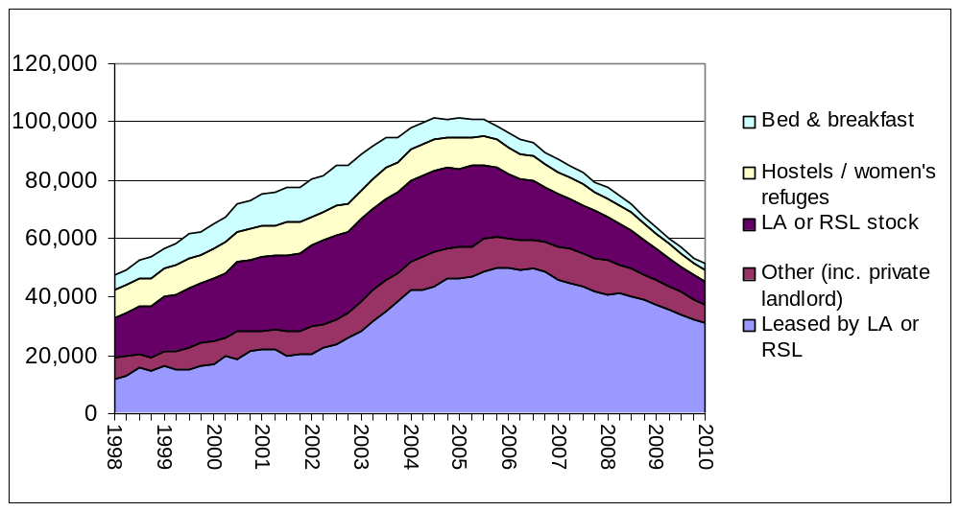
On 31 March 2010, of the 51,310 households in temporary accommodation:
37,240 households were in private sector accommodation (73 per cent of all households), most commonly in a property leased by the local authority or registered social landlord (RSL, or housing association), or in some cases let directly to the applicant as the tenant of a private sector landlord. This is a drop of 19 per cent since the 31 March last year, and a 35 per cent drop compared to the same date in 2005, the year in which temporary accommodation use peaked.
7,790 households were in accommodation owned by social landlords (15 per cent of all households), a fall of 26 per cent since last year and 71 per cent since the end of March 2005. Of these 7,790 households, 68 per cent were in local authority owned stock, and 32 per cent in RSL owned property.
4,240 households were in hostel accommodation and women's refuges (8 per cent of all households), a decrease of 18 per cent since this time last year and of 59 per cent since the end of March 2005.
2,050 households were in bed and breakfast style accommodation (4 per cent of all households), 16 per cent lower than this time last year, and 70 per cent lower than the same date in 2005. Historically, the use of bed and breakfast accommodation peaked in March 1987, when 47 per cent (England) and 59 per cent (London) of households in temporary accommodation were housed in this style of accommodation.
In addition to the 51,310 households in temporary accommodation on 31 March 2010, 3,710 households accepted as owed a main duty remained (with consent) in their existing accommodation (or made their own arrangements) while awaiting the provision of alternative accommodation⁷. This is 33 per cent lower than the same date last year and 76 per cent lower than at the end of March 2005.
See Table 6: Temporary accommodation, by type (plus households for whom a duty is owed, but no accommodation has been secured), of which with children

Households in temporary accommodation, by household type and ethnicity
Of the 51,310 households in temporary accommodation on 31 March, the biggest group (41 per cent) were lone female parent households with dependent children. Couples with dependent children accounted for over a quarter (26 per cent) of households. Single person households (with no dependent children) accounted for 22 per cent of households, the majority of which were male.
Over half of all households in temporary accommodation were headed by ethnic minority applicants. The vast majority of these households (93 per cent) were in London, reflecting the high usage of temporary accommodation and larger ethnic minority population in the region. Outside of London, ethnic minority applicants accounted for only 15 per cent of households in temporary accommodation.
Chart 9: Households in temporary accommodation by household type: 31 March 2010, England
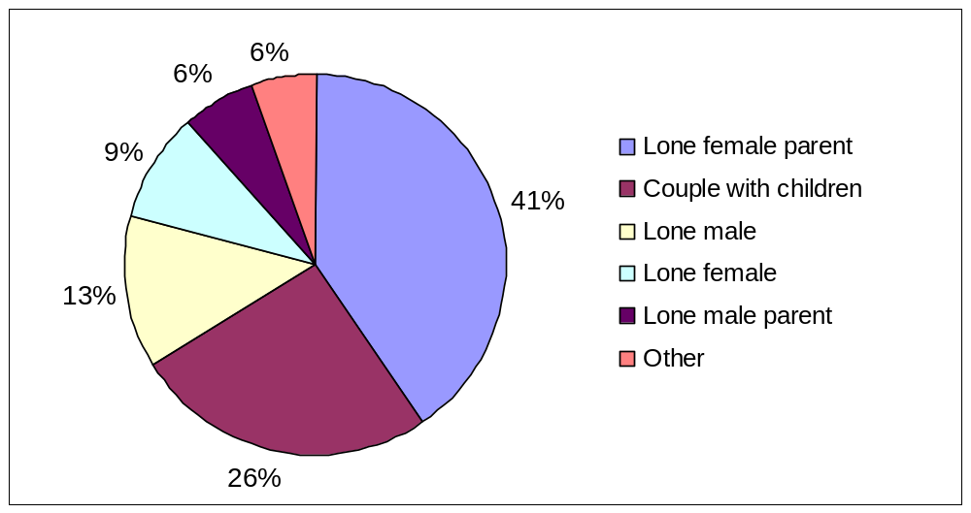
See Table 12: Homeless households in temporary accommodation by household type and applicants’ ethnicity

Households leaving temporary accommodation and other temporary arrangements
Between January and March, a main homelessness duty was ended for 10,560 households who had previously been in temporary accommodation (or had remained, with consent, in their existing accommodation while awaiting the provision of alternative accommodation).
7,040 (67 per cent) of these households were provided with settled accommodation, by accepting a “Part 6” offer of a secure tenancy in local authority or RSL accommodation, although a further 8 per cent refused such an offer. An additional 9 per cent accepted alternative offers of rented accommodation.
11 per cent of households voluntarily left the temporary accommodation or other temporary arrangement. The remaining households ceased to be eligible, or became intentionally homeless from the temporary accommodation provided for them.
See Part 2 of Table 8: Outcomes: those accepted during the quarter, and those leaving temporary accommodation (or no longer recorded as “duty owed, no accommodation secured”⁷) during the quarter

Households in temporary accommodation, by region
London had the highest number of households in temporary accommodation, at 39,030 on 31 March, accounting for over three quarters of the England total. The South East had the next highest number, with 7 per cent of the England total. The North East, with less than 1 per cent of the England total, had the lowest number of households in temporary accommodation.
Map 2: Households in Temporary Accommodation by region as at 31 March 2010
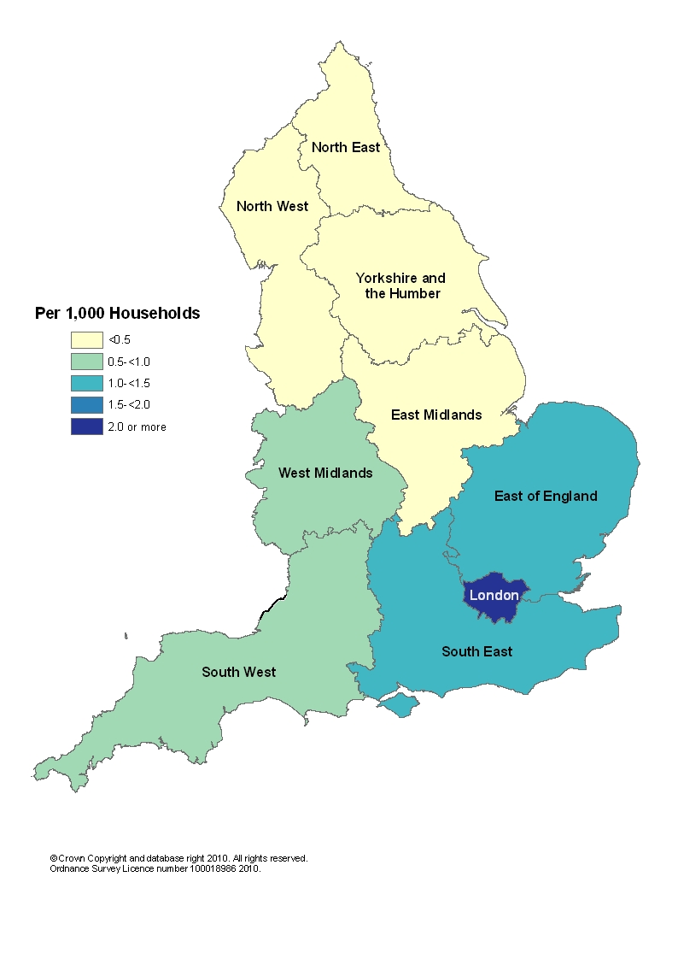
As at the end of March 2010, England had a rate of 2.4 households in temporary accommodation per 1,000 households. Of the regions, London had by far the highest rate at 12.3 per 1,000 households. The East had the next highest rate, at 1.1 per 1,000 households. The North East had the lowest rate at 0.2 per 1,000 households.
With the exception of the West Midlands, all regions experienced a fall in the number of households in temporary accommodation when compared to the same quarter last year, with the biggest drops in London (8,750) and the South East (1,090); the largest percentage fall was in the North East and Yorkshire and the Humber (36 per cent).
See Table 7: Temporary accommodation: by region

Length of time in temporary accommodation (and other temporary arrangements⁷), between acceptance and duty being ended
Of the 10,560 households who left temporary accommodation or other temporary arrangements⁷ during the quarter, 56 per cent had been in these temporary arrangements for less than six months, while 22 per cent had been so for two years or more. The increase seen over the last ten years, particularly in London, of the percentage of households who spend two or more years has slowed, with around 50 percent of households in London remaining in temporary accommodation for this amount of time in each of the last four quarters. After remaining stable at 19 per cent for four quarters, the England figure has risen to 20 per cent then 22 per cent in the last two quarters.
Lengths of time in temporary arrangements vary across the regions. Chart 10 compares the proportion of those spending 2 years or more in temporary arrangements before the main duty was ended, for the most recent quarter and the same quarter three years ago by region. London’s figures stand out with the longest stays - between January and March 2010, 51 per cent of households who left temporary arrangements had previously spent two or more years in such temporary arrangements, compared with 40 per cent in the same period during 2007. Yorkshire and the Humber and the North West were the only other regions to see an increase in the proportion of stays longer than two years over this period. After London, the South East and the South West have the next highest proportions of stays longer than two years, with 13 per cent and 10 per cent respectively; both of these proportions have decreased since 2007.
The Northern and Midland regions have a much lower proportion of longer stays. In the North East, no households stayed for two years or longer in the most recent quarter (compared to 3 per cent three years ago), followed by the North West and West Midlands at 1 per cent (compared to 1 per cent and 4 per cent three years ago).
See Table 9: Households leaving temporary accommodation (or no longer recorded as “duty owed, no accommodation secured”⁷): by length of stay, by region
Chart 10: Proportion of households that spent 2 years or more in temporary arrangements before the main duty was ended, England and regions: January to March, 2007 and 2010
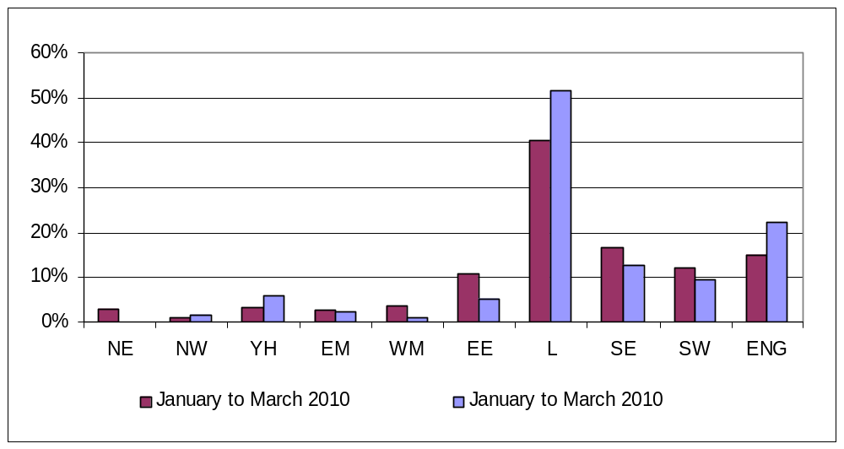

Scope
The scope of this data collection and statistical release is limited to English local housing authorities’ activities under homelessness legislation (Part 7 of the Housing Act 1996). This release does not contain data on other forms of homelessness, for example, rough sleeping. The devolved administrations publish their own statistics on statutory homelessness.
The most recent statutory homelessness statistics for Scotland are available at:
http://www.scotland.gov.uk/Publications/2010/03/23101633/0
http://www.scotland.gov.uk/Publications/2009/09/03122620/0
The most recent statutory homelessness statistics for Wales are available at:
http://wales.gov.uk/topics/statistics/headlines/housing2010/0113/?lang=en

Homelessness targets
Temporary accommodation figures are an important indicator for monitoring the 2007 Comprehensive Spending Review (CSR07) target to increase long term housing supply and affordability. The Government has set a national target to halve the number of households in temporary accommodation to 50,500 households by 2010. By the end of March 2010 there were 51,310 households in temporary accommodation.

Data source
Local housing authorities report their activities under Part 7 of the Housing Act 1996 to Communities and Local Government by completing the quarterly P1E statistical return. Statutory homelessness statistics are published around 51 working days after the end of each quarter, on a pre-announced date in accordance with the Official Statistics Code of Practice.

Data quality
All P1E returns submitted by local housing authorities undergo thorough validation and cross-checking, and late returns are pursued to ensure overall response is as complete and accurate as possible. Anomalous data are highlighted and verified by contacting the local authority.
Local authorities also provide details of any data checks they undertake. These can take the form of audits (by the National Audit Office or the authorities own auditors), periodic quality checks on data extracts, or random quality checks. For the period January to March 2010, most authorities reported some form of checking on all data items in the return.
The validation process typically takes around six weeks, after which estimates for missing data are calculated. The latest quarter's figures are based on full or partial returns for all 326 local authorities (100 per cent response).
Published figures may include estimates for a small amount of missing data. These estimates are calculated by an automated grossing procedure which either (i) updates previously reported data based on the changes observed in similar authorities in the same region or (ii) apportions totals based on ratios reported by these similar authorities.

Revisions policy
This policy has been developed in accordance with the UK Statistics Authority Code of Practice for Official statistics and the Communities and Local Government Revisions Policy. There are two types of revisions that the policy covers.

Non-Scheduled Revisions
Where a substantial error has occurred as a result of the compilation, imputation or dissemination process, the statistical release, live tables and other accompanying releases will be updated with a correction notice as soon as is practical.

Scheduled Revisions
Local Authorities can update their P1E returns following publication of the data. At the end of each financial year the figures for the four quarters of the previous year will be reviewed for revision. A decision on whether to revise will be made based on the impact of any change and the effect it has on the interpretation of the time series. Provisional figures are labelled in the tables with a “P”.
Revisions to historic data (all data older than that currently due for scheduled revision) should only be made where there is a substantial revision, such as a change in methodology or definition. Where there are small changes that do not substantially change historic data, internal updates are maintained.

Accompanying tables

Table 1 Decisions taken by local authorities under the 1996 Housing Act on applications from eligible households
Table 2 Homeless households in priority need accepted by local authorities, by ethnicity
Table 3 Homeless households in priority need accepted by local authorities, by Government Office Region
Table 4 Homeless households in priority need accepted by local authorities, by priority need category
Table 5 Homeless households in priority need accepted by local authorities, by reason for loss of last settled home
Table 6 Households in temporary accommodation (and households for whom a duty is owed, but no accommodation has been secured) arranged by local authorities under the homelessness provisions of the 1996 Housing Act, by type of accommodation, at the end of each quarter
Table 7 Households in temporary accommodation arranged by local authorities under the homelessness provisions of the 1996 Housing Act, by Government Office Region, at the end of each quarter
Table 8 Households accepted as owed a main homelessness duty, and households leaving temporary accommodation (or no longer recorded as “duty owed, no accommodation secured”), by outcome
Table 9 Households leaving temporary accommodation (or no longer recorded as “duty owed, no accommodation secured”) during each quarter, by length of stay, England and London
Table 10 Homeless households in priority need accepted by local authorities, by household type
Table 11 Homeless households in priority need accepted by local authorities, by age of applicant
Table 12 Homeless households in temporary accommodation by household type and applicants’ ethnicity
Background notes
Definition of terms
1. Acceptances: households found to be eligible for assistance, unintentionally homeless and falling within a priority need group (as defined by homelessness legislation- see paragraphs 8-10 below), during the quarter, are referred to as “acceptances”. These households are consequently owed a main homelessness duty by a local housing authority. The main duty is to secure settled accommodation.
2. Seasonal adjustment: the seasonally adjusted estimates have been produced using the X12-ARIMA model, in accordance with Official Statistics practices, which have then been constrained so that they are consistent with the unadjusted financial year totals. Historically, the number of decisions and acceptances tends to be lower in the second quarter than in the first and third quarters, and will also be affected by seasonal holiday periods, especially Christmas and the New Year. In quarter two 2009 seasonally adjustments were included for the households in temporary accommodation series, as this series was also found to be affected by seaonality.
3. Temporary accommodation: households in temporary accommodation (excluding those for whom a duty is owed, but no accommodation has been secured⁷) on the last day of the quarter, as arranged by a local housing authority as a discharge of their statutory homelessness functions. In most cases, the authority is discharging a main homelessness duty to secure suitable accommodation until a settled home becomes available for the applicant and his/her household. However, the numbers also include households provided with accommodation pending a decision on their homelessness application, households pending a review or appeal to the county court of the decision on their case, or possible referral to another local authority, and households found to be intentionally homeless and in priority need who were being accommodated for such period as would give them a reasonable opportunity to find accommodation for themselves.
4. Self-contained accommodation: this includes all temporary accommodation where the household has sole use of kitchen and bathroom facilities, including property held by local housing authorities, registered social landlords and private sector landlords. A distinction is made between this type of accommodation and accommodation where such facilities are shared with other households (i.e. bed and breakfast, hostels and women's refuges).
5. Decisions: these include only the decisions made by local housing authorities where the applicant has been found to be eligible for assistance and therefore excludes any households found to be ineligible (some persons from abroad are ineligible for assistance).
6. Priority need groups: include households with dependent children or a pregnant woman and people who are vulnerable in some way e.g. because of mental illness or physical disability. The priority need categories were extended by Order in January 2002 to include, additionally: applicants aged 16 or 17; applicants aged 18 to 20 who were previously in care; applicants vulnerable as a result of time spent in care, in custody, or in HM Forces, and applicants vulnerable as a result of having to flee their home because of violence or the threat of violence (in addition domestic violence which is one of the original priority need groups). It is not possible to establish precisely how much of the changed profile of acceptances is attributable to the Order. Previously, some local authorities would have accepted households who fall within the new categories as having a priority need because of "another special reason". This applies in particular to applicants such as vulnerable young people, and people fleeing domestic violence. Note that where applicants are accepted as homeless because of an emergency, for example fire or flood, this will always be recorded as the main priority need category.
7. Households for whom a duty is owed, but no accommodation has been secured: These are households who have been accepted as being owed a main homelessness duty and for whom arrangements have been made for them, with consent, to remain in their existing accommodation (or to make their own arrangements) for the immediate future. This was previously referred to as “Homeless at Home”. Prior to the second quarter of 2005, figures were also collected on those potentially in this category but whose application was still under consideration pending a decision. Both series are now presented in the final columns of Table 6.
Legislation
8. Part 7 of the Housing Act 1996 places statutory duties on local housing authorities to provide assistance to people who are homeless or threatened with homelessness. Authorities must consider all applications from people seeking accommodation or assistance in obtaining accommodation. A main homelessness duty (see below) is owed where the authority is satisfied that the applicant is eligible for assistance, unintentionally homeless and falls within a priority need group. The priority need groups are specified in the legislation, although paragraph 6 above provides a summary.
9. Where a main duty is owed, the authority must ensure that suitable accommodation is available for the applicant and his or her household until a settled home becomes available for them. Where households are found to be intentionally homeless or not in priority need, the authority must make an assessment of their housing needs and provide advice and assistance to help them find accommodation for themselves. Where the applicant is found to be intentionally homeless but falls in a priority need category the authority must also ensure that accommodation is available for long enough to give the applicant a reasonable opportunity to find a home.
Other
- Figures in the accompanying tables are presented rounded to the nearest 10 households or applicants.
- The maps are based upon Ordnance Survey material with the permission of Ordnance Survey on behalf of the Controller of Her Majesty's Stationery Office:
© Crown copyright 100018986 2010.
- Details of officials who receive pre-release access to the Communities and Local Government quarterly Statutory Homelessness Statistical Release up to 24 hours before release can be found at:
http://www.communities.gov.uk/corporate/researchandstatistics/statistics/nationalstatistics/
- The publication date for the 2nd Quarter (April to June) 2010 Statutory Homelessness Statistical Release is Thursday 9 September 2010.

Enquiries
1. This Statistical Release, as well as previous Releases, can be accessed and all text, tables and charts downloaded electronically, from the Communities and Local Government website at:
http://www.communities.gov.uk/housing/housingresearch/housingstatistics/housingstatisticsby/homelessnessstatistics/publicationshomelessness/
2. Further details on this Statistical Release are available from Alex Arulanandam, Communities and Local Government, Zone 2/H3, Eland House, Bressenden Place, London SW1E 5DU. Telephone 0303 444 2290. E-mail: homelessnessstats@communities.gsi.gov.uk.
Media Enquiries:
office hours: 0303 444 1136
out of hours: 0303 444 1201
e-mail: press.office@communities.gsi.gov.uk
Public enquiries:
telephone: 0303 444 4172

Information on Official Statistics is available via the UK Statistics Authority website: www.statistics.gov.uk.
Information about Communities and Local Government is available via the Department's website: www.communities.gov.uk.
Department for Communities and Local Government. © Crown Copyright, 2010

If you require this publication in an alternative format please email: alternativeformats@communities.gsi.gov.uk. Please note that the nature of content means that we may not be able to provide the Statistical series of publications in all requested formats.

June 2010

ISBN: 978-1-4098-2472-5

