Statutory Homelessness: January to March 2012 and 2011/12, England
Household acceptances
- 13,130 applicants were accepted as owed a main homelessness duty during January to March 2012, 16 per cent higher than the same quarter last year.
- On a seasonally-adjusted basis, there were 13,340 acceptances, an increase of 2 per cent from 13,100 in the previous quarter.
- During the 2011/12 financial year, there were 50,290 acceptances. This is an increase of 14 per cent from 44,160 in 2010/11.
Households in temporary accommodation
- 50,430 households were in temporary accommodation on 31 March 2012, 5 per cent more than at the same date last year.
- On a seasonally-adjusted basis, 50,510 households were in temporary accommodation on 31 March 2012, 2 per cent more than the figure of 49,430 in the previous quarter.
- 84 per cent of households were in self-contained accommodation - a decrease from 86 per cent at the end of the same quarter last year.
- 8 per cent of households were in bed and breakfast style accommodation. This is an increase from 2,750 to 3,960 (44 per cent) compared to the same date last year.
- The proportion of households leaving temporary accommodation or other temporary arrangements who had been in such arrangements for less than six months was 65 per cent, the same as during the same quarter last year.
- The proportion of households leaving temporary accommodation or other temporary arrangements who had been in such arrangements for two or more years has fallen from 14 per cent to 12 per cent compared to the same quarter last year.

Housing
Statistical Release

14 June 2012
using
Research
Summary
Number 239, 2007


Contents  Introduction  Decisions  Acceptances  - Priority need  - Reason for loss  - Ethnicity  - Household type  - Age band  - Action taken  - By region  - Foreign Nationals  Temporary Accommodation  - Accommodation type  - Young people  - Household type and ethnicity  - In another LA district  - Leaving temporary  accommodation  - By region  - Length of stay  List of accompanying tables  Definitions  Legislation  Methodology  Data source and scope  Related links  Data quality  Revisions policy  Uses of data  User consultation  Other information  Enquiries | 2  2  3  3  4  5  5  6  6  7  7  8  9  11  11  12  12  13  13  16  17  18  18  19  21  21  22  22  23  23  24
Responsible Statistician:
Andrew Presland
Phone: 030344 43510
homelessnessstats@communities.gsi.gov.uk
Media Enquiries:
Office hours: 0303 444 1159
Out of hours: 0303 444 1201 press.office@communities.gsi.gov.uk

Introduction
This release provides summary information on local housing authorities’ activities under homelessness legislation, collected through the quarterly P1E return. Data include the number of households accepted as owed a main homelessness duty (referred to as 'acceptances') during the quarter, and the number of households in temporary accommodation on the last day of the quarter. Accompanying tables are provided online alongside the release and are listed on pages 16 and 17. These form the underlying data used to produce the text and charts. The background notes section provides more detail of terms used within the release.

Decisions taken by local authorities on homeless applications
Between 1 January and 31 March 2012, local housing authorities made 27,880 decisions on applications (by eligible households) for housing assistance, under the homelessness legislation of the Housing Act 1996. This is 6 per cent higher than the corresponding quarter in 2011. After seasonal adjustment, the number of decisions was 28,080, 1 per cent higher than in the previous quarter.
During the 2011/12 financial year, 108,720 decisions were made by local authorities. This is an increase of 6 per cent from 102,200 in 2010/11.
Of the 27,880 decisions made between January and March 2012:
- 47 per cent were accepted as owed a main homelessness duty;
- 27 per cent were found not to be homeless;
- 19 per cent were found to be homeless but not in priority need; and
- 7 per cent were found to be intentionally homeless and in priority need.
The number of households found to be unintentionally homeless and in priority need ('acceptances') rose by 16 per cent compared with the same quarter in 2011, and the number of households found to be intentionally homeless and in priority need increased by 4 per cent. In contrast, the number of households found to be homeless but not in priority need fell by 4 per cent, and the number of households found not to be homeless fell by 2 per cent.
There has been an increase in the proportion of households accepted as owed a main homelessness duty as a percentage of decisions when compared to the same quarter last year – from 43 per cent to 47 per cent. Households accepted as owed a main homelessness duty are dealt with further in the next section.
Households accepted as owed a main homelessness duty (acceptances)
Between 1 January and 31 March 2012, local authorities accepted 13,130 households as being owed a main homelessness duty. This is a 16 per cent increase compared to the same quarter last year. After seasonal adjustment, the number of acceptances during the first quarter of 2012 was 13,340, an increase of 2 per cent from the seasonally-adjusted figure of 13,100 in the previous quarter.
During the 2011/12 financial year, 50,290 households were accepted by local authorities as being owed the main homelessness duty. This is an increase of 14 per cent from 44,160 in 2010/11.
Chart 1: Households accepted by local authorities as owed a main duty each quarter, 1998 to January to March 2012, England
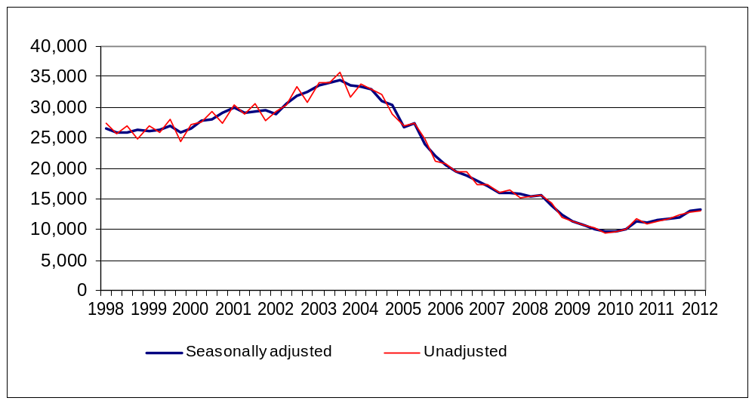
See Live Table 770: decisions taken by local authorities under the 1996 Housing Act on applications from eligible households
Acceptances by priority need category
Between 1 January and 31 March 2012, the presence of dependent children in the household was the primary reason for priority need in 63 per cent of acceptances, representing 8,330 households. This is an increase from 61 per cent in the same quarter last year. A further 10 per cent of households were in priority need because they included a pregnant woman, representing 1,280 households.
The majority of the remainder were in priority need due to vulnerability, for example, mental illness (8 per cent) or physical disability (7 per cent). Homeless in an emergency accounted for less than 1 per cent of all acceptances. 4 per cent of acceptances were in priority need through being a young person (either 16 or 17 year olds, or 18 to 20 year olds formerly in care).
Chart 2: Acceptances by priority need category during January to March 2012, England
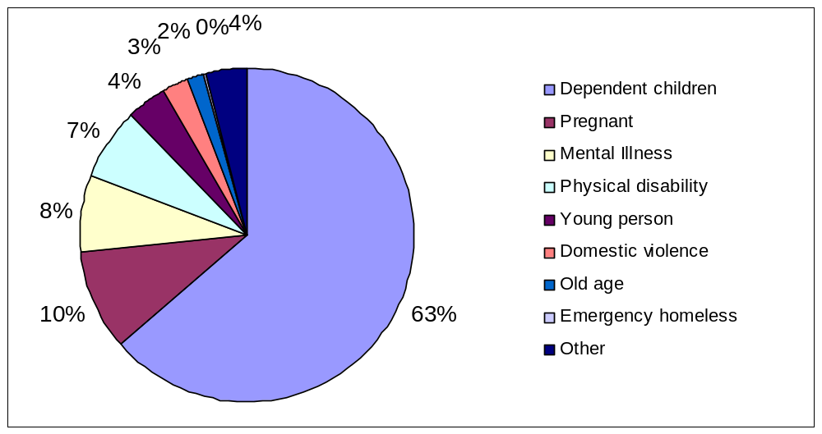
See Live Table 773: homeless households accepted by local authorities, by priority need category
Acceptances by reason for loss of last settled home
Between 1 January and 31 March 2012, in 34 per cent of acceptances the reason for homelessness was parents, relatives or friends (mostly parents) not being able, or willing, to accommodate applicants.
In a further 17 per cent of acceptances, the reason for homelessness was the breakdown of a relationship with a partner, 68 per cent of these cases involving violence.
In 19 per cent of acceptances the reason for homelessness was the ending of an assured shorthold tenancy. There has been a rise in acceptances for this reason, from 15 per cent in the same quarter in 2011.
The proportion of acceptances where homelessness resulted from mortgage arrears (repossession or other loss of home) was 3 per cent, the same as for the same quarter in 2011. The proportion of acceptances due to mortgage arrears has remained much lower than the peak in the last downturn: 12 per cent during 1991.
Chart 3: Acceptances by reason for loss of last settled home during January to March 2012, England
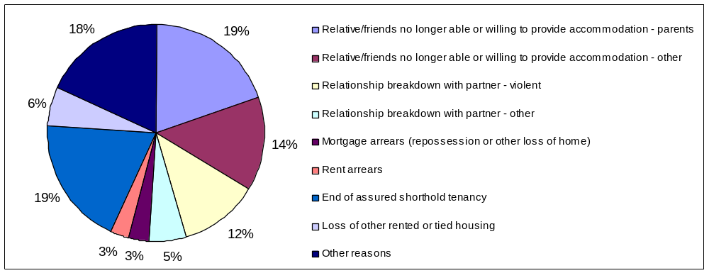
See Live Table 774: homeless households accepted by local authorities, by reason for loss of last settled home
Acceptances by ethnicity
Between 1 January and 31 March 2012, 65 per cent of applicants accepted were stated as being White and 30 per cent were stated as being from an ethnic minority group: 15 per cent Black, 7 per cent Asian, 3 per cent mixed and 5 per cent another ethnic group. The ethnic origin of the remaining 5 per cent was not stated. Compared to the population as a whole, there is a higher incidence of acceptances amongst ethnic minority groups than amongst the White population.
See Live Table 771: Homeless households accepted by local authorities, by ethnicity
Acceptances by household type
Of the 13,130 acceptances between 1 January and 31 March 2012, 52 per cent were lone parents (4 per cent male, 48 per cent female), and 20 per cent were couples with dependent children.
One person households accounted for 24 per cent of acceptances, of which 58 per cent were male.

Chart 4: Acceptances by household type during January to March 2012, England
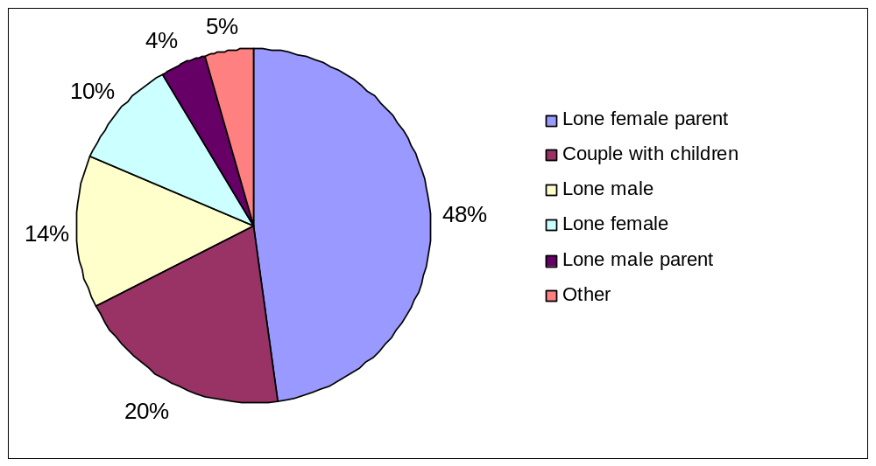
See Live Table 780: homeless households accepted by local authorities, by household type
Acceptances by age band
Between 1 January and 31 March 2012, 85 per cent of all acceptances were applicants under 45 years old: 51 per cent were aged between 25 and 44, and 33 per cent between 16 and 24.
See Live Table 781: homeless households accepted by local authorities, by age of applicant
Action taken in respect of acceptances
Of the 13,130 acceptances between 1 January and 31 March 2012, 8,020 (61 per cent) were placed in some form of temporary accommodation for a period of time. This is an increase from 58 per cent in the same quarter last year. For a further 3,970 accepted households (30 per cent), arrangements were made, with consent, to remain in their existing accommodation (or to make their own arrangements), for the immediate future while awaiting the provision of alternative accommodation. This is a small decrease from 31 per cent in the same quarter last year.
7 per cent of acceptances were provided with settled accommodation, by being granted a secure tenancy in local authority or registered social landlord accommodation, or an assured short hold tenancy in the private rented sector. The remaining 2 per cent either made their own arrangements or had no further contact with the authority, thus bringing the homelessness duty to an end.
See the first part of Live Table 778: homeless households accepted as owed a main homelessness duty, and households leaving temporary accommodation (or no longer recorded as “duty owed, no accommodation secured”), by outcome
Acceptances by region
Seven of the nine regions saw increases in numbers of acceptances compared to the same quarter last year. The size of these increases varied considerably, ranging from 12 per cent In Yorkshire and the Humber to 39 per cent in London. Numbers decreased In the North East (by 5 per cent) and the West Midlands (down 8 per cent).
London and the West Midlands had the highest incidence of acceptances per 1,000 households during the quarter, with 1.2 and 0.9 respectively, compared to the national figure of 0.6. The North East, North West, South East and South West, each with 0.4 per 1,000 households, had the lowest.
See Live Table 772: homeless households accepted by local authorities, by region. It also includes a map showing homelessness acceptance rates by region for January to March 2012.

Foreign national households
1,920 foreign national applicants were accepted as homeless between 1 January and 31 March 2012. Of these, 350 were European Economic Area (EEA) accession country nationals, 370 were from other EEA countries and 1,200 were from outside the EEA. During this period, foreign nationals accounted for 14 per cent of all acceptances, slightly down from the figure of 15% for the same quarter last year, when there were 1,700 acceptances.
See Live Table 785: Decisions taken by local authorities under the 1996 Housing Act on applications from eligible foreign national households; and Live Table 786: Homeless foreign national households accepted by local authorities, by reason for eligibility
Households in temporary accommodation
The number of households in temporary accommodation on 31 March 2012, arranged by local authorities under homelessness legislation, was 50,430: 5 per cent more than the same date last year. After seasonal adjustment, the number of households in temporary accommodation was 50,510 up 2 per cent from the figure of 49,430 at the end of the previous quarter. This is the third quarterly increase since the ending last year of the long-term downward trend in the seasonally-adjusted number of households in temporary accommodation, which started at the peak in 2004.
Historically there tends to be a lag between a change in direction in the number of acceptances and a change in direction in the number of households in temporary accommodation, as shown in Chart 5. Recent figures have also demonstrated that pattern, with the upward turn in the time series of acceptances that took place in 2010 now having been followed by an upward turn in the time series of households in temporary accommodation.
Chart 5: Households accepted by local authorities as owed a main duty, and households in temporary accommodation, quarterly 1998 to 2012
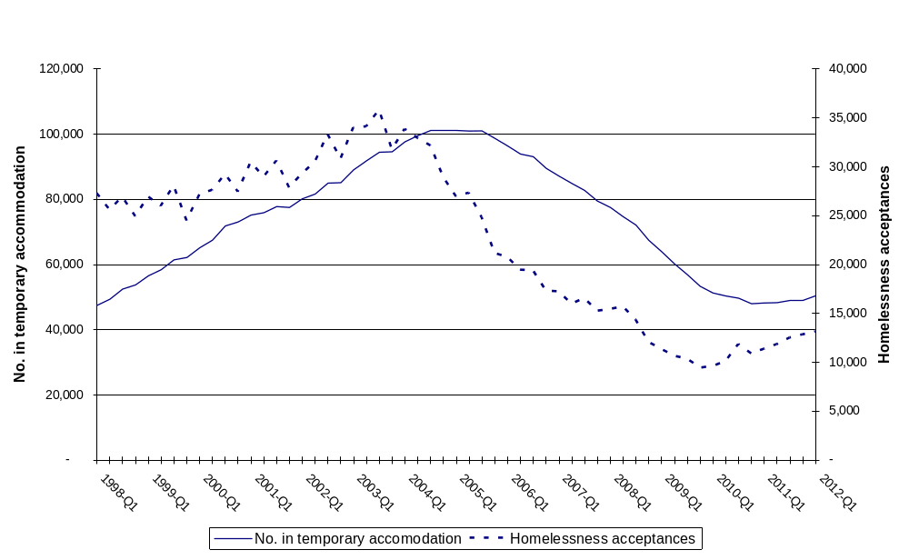

Of the 50,430 households in temporary accommodation at 31 March 2012, 82 per cent had been accepted as owed a main homelessness duty and were being housed in temporary accommodation by the authority until a settled home became available. The remaining 18 per cent were being accommodated pending a decision on their application, the outcome of a local authority review or an appeal to the county court on the authority's decision, or possible referral to another local authority, or had been found intentionally homeless and in priority need and subsequently were being accommodated for such a period as would give them a reasonable opportunity to find accommodation for themselves.
Chart 6: Households in temporary accommodation at the end of each quarter, by type, 1998 to 31 March 2012, England
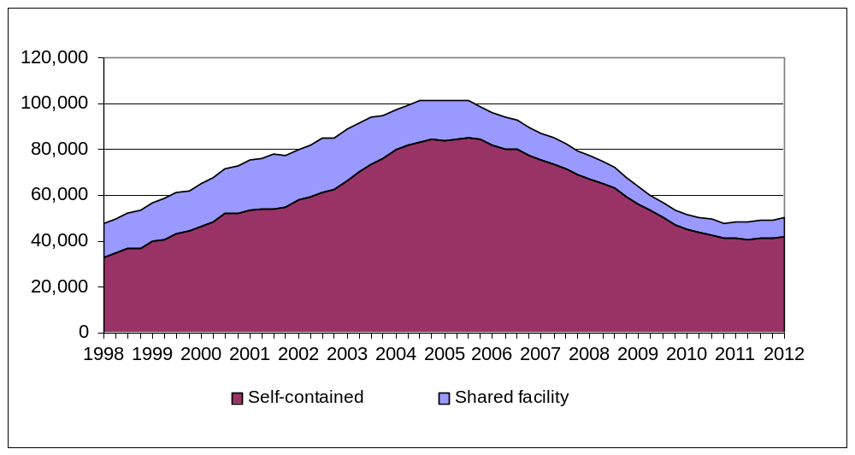
Households in temporary accommodation, by type of accommodation
There is a wide range of accommodation used to provide temporary accommodation, most of which is self-contained (either in local authority or housing authority stock, or within the private sector). At the end of March 2012, 84 percent of households in temporary accommodation were in self-contained accommodation – a decrease from 86 per cent at the same date last year.
Looked at the other way round, use of accommodation with shared facilities has increased slightly over recent quarters (16 per cent at the end of March 2012 compared with 14 per cent at the end of the same quarter last year) after a long period of decline since its peak in 2001, when 30 per cent of households were in this form of temporary accommodation. The recent increase is largely due to increased usage of bed and breakfast style accommodation. The number of households in bed and breakfast style accommodation has risen from 2,750 to 3,960 compared to the same quarter last year, up 44 per cent. London accounts for just under half the number of households in bed and breakfast style accommodation, where the number has increased by 41 per cent since the same quarter last year (1,330 to 1,880 households).
Chart 7: Households in temporary accommodation, by type, at the end of each quarter, 1998 to 31 March 2012, England
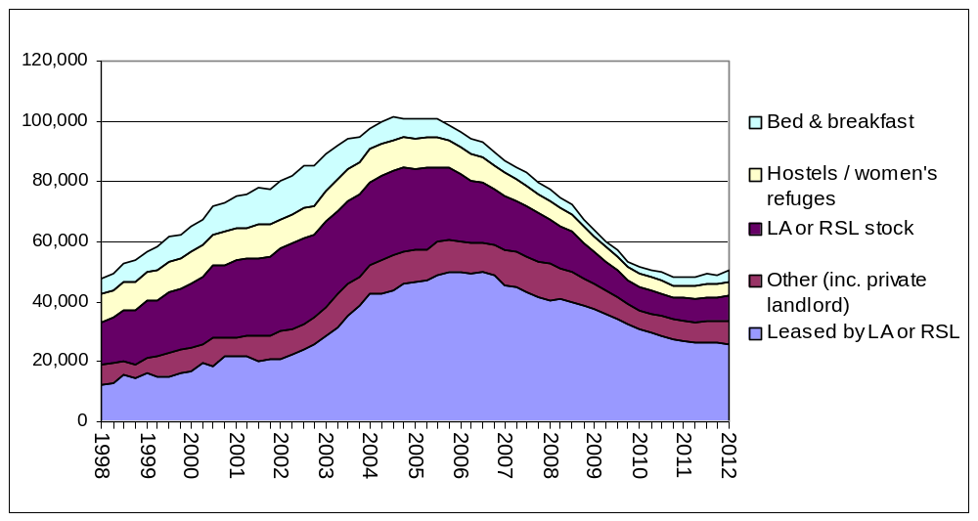
On 31 March 2012, of the 50,430 households in temporary accommodation:
- 33,850 households were in private sector accommodation (67 per cent of all households), most commonly in a property leased by the local authority or housing association, or in some cases let directly to the applicant as the tenant of a private sector landlord. This is similar to 31 March last year, when there were 33,750 such households.
- 8,270 households were in accommodation owned by social landlords (16 per cent of all households), an increase of 10 per cent since the same quarter last year. Of these 8,270 households, 73 per cent were in local authority owned stock, and 27 per cent in registered social landlord owned property.
- 4,360 households were in hostel accommodation and women's refuges (9 per cent of all households), similar to the same time last year.
- 3,960 households were in bed and breakfast style accommodation (8 per cent of all households), 44 per cent higher than the same time last year. Historically, the use of bed and breakfast accommodation peaked in March 1987, when 47 per cent (England) and 59 per cent (London) of households in temporary accommodation were housed in this style of accommodation.
In addition to the 50,430 households in temporary accommodation on 31 March 2012, 5,400 households accepted as owed a main duty remained (with consent) in their existing accommodation (or made their own arrangements) while awaiting the provision of alternative accommodation. This is 13 per cent higher than at the same date last year.
See Live Table 775: homeless households in temporary accommodation at the end of each quarter, by type of accommodation
Young people in temporary accommodation
Of the 50,430 households in temporary accommodation on 31 March 2012, 37,190 included dependent children and/or a pregnant woman (within which households there were 70,090 children or expected children). The number of children per household in temporary accommodation has remained stable since the data were first collected in 2007, at around 1.4.
Of these 37,190 households with children, 89 per cent were in self-contained accommodation. This has fallen slightly from 91 per cent at the end of the same quarter last year. 1,660 (4 per cent) were in bed and breakfast style accommodation, up from 1,030 at the end of the same quarter last year. Of these 1,660 households, 480 had been in bed and breakfast style accommodation for six or more weeks (60 of which were pending review).
At the end of March 2012, there were 150 households headed by 16 and 17 year old applicants in bed and breakfast style accommodation, of which 50 had been there for six or more weeks.
Households in temporary accommodation, by household type and ethnicity
Of the 50,430 households in temporary accommodation on 31 March 2012, the biggest group (42 per cent) were female lone parent households with dependent children. Couples with dependent children accounted for a quarter (24 per cent) of households. Single person households (with no dependent children) also accounted for 24 per cent of households, with a higher proportion of males than females.
50 per cent of all households in temporary accommodation were headed by ethnic minority applicants. The vast majority of these households (91 per cent) were in London, reflecting the high usage of temporary accommodation and larger ethnic minority population in the region. Outside London, ethnic minority applicants accounted for 17 per cent of households in temporary accommodation.
Chart 8: Households in temporary accommodation by household type: 31 March 2012, England
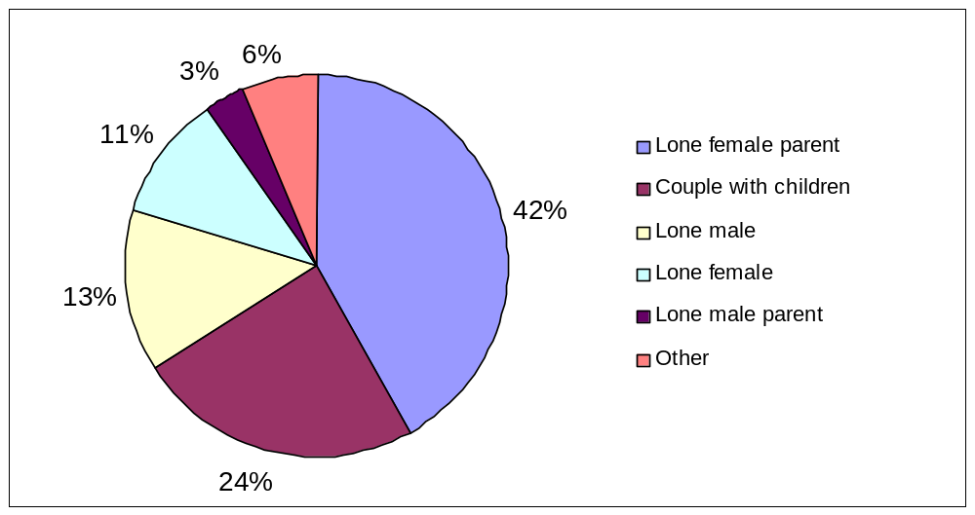
See Live Table 782: homeless households in temporary accommodation at the end of each quarter, by household type and applicant characteristics
Households in temporary accommodation in another local authority district
Of the 50,430 households in temporary accommodation on 31 March 2012, 7,870 were in accommodation in another local authority district. This is an increase of 25 per cent, from 6,300 at the same date last year.
Households leaving temporary accommodation and other temporary arrangements
Between 1 January and 31 March 2012, a main homelessness duty was ended for 10,450 households who had previously been in temporary accommodation or had remained, with consent, in their existing accommodation while awaiting the provision of alternative accommodation. This is an increase of 6 per cent compared to the same quarter last year.
7,440 (71 per cent) of these households were provided with settled accommodation, by accepting a “Part 6” offer of a secure tenancy in local authority or housing authority accommodation, although a further 6 per cent refused such an offer. A further 4 per cent accepted alternative offers of rented accommodation. This is a decrease from 6 per cent in the same quarter last year, mostly due to the decrease in households accepting an offer of an assured shorthold tenancy.
13 per cent of households voluntarily left the temporary accommodation or other temporary arrangement. The remaining 5 per cent of households ceased to be eligible, or became intentionally homeless from the temporary accommodation provided for them.
See the second part of Live Table 778: homeless households accepted by local authorities and households leaving temporary accommodation (or no longer recorded as “duty owed, no accommodation secured”), by outcome.
Households in temporary accommodation, by region
London had the highest number of households in temporary accommodation, with 36,740 on 31 March 2012, accounting for 73 per cent of the England total. The South East had the next highest number, with 4,280 households (8 per cent of the England total). The North East, with 210 households (less than 1 per cent of the England total), had the lowest number of households in temporary accommodation.
Seven of the nine regions had more households in temporary accommodation than at the same date last year, with the percentage increases ranging from 2 per cent (London) to 20 per cent (the North West). The two regions that had fewer households in temporary accommodation than at the same date last year were the North East (down 5 per cent) and the South West (down 2 per cent).
As at the end of March 2012, England had a rate of 2.3 households in temporary accommodation per 1,000 households. Of the regions, London had by far the highest rate at 11.3 per 1,000 households, up from 11.0 per 1,000 households at the same date last year. All the other regions were below the national average, with the East of England having the next highest rate, at 1.3 per 1,000 households, followed by the South East at 1.2 per 1,000 households. The North East had the lowest rate at 0.2 per 1,000 households.
See Live Table 776: homeless households in temporary accommodation at the end of each quarter, by region. It also includes a map showing households in temporary accommodation by region as at 31 March 2012.
Length of time in temporary accommodation (and other temporary arrangements), between acceptance and duty being ended
Of the 10,450 households who left temporary accommodation or other temporary arrangements during the quarter, 65 per cent had been in these temporary arrangements for less than six months, while 12 per cent had been so for two years or more. The percentage of households that had been in temporary accommodation for less than six months was unchanged from the same quarter last year, whilst the percentage of households that spend two or more years in temporary accommodation had fallen from 14 per cent.
Lengths of time in temporary arrangements vary across the regions, with the biggest differences being between London and the other eight regions. Chart 9a compares the proportion of those spending two years or more in temporary arrangements before the main duty was ended, for the most recent quarter and the same quarter last year for each region, and Chart 9b compares the proportion of those spending less than six months in temporary arrangements for each region. In London between January and March 2012, 32 per cent of households that left temporary arrangements had previously spent two or more years in such temporary arrangements. This is a decrease from 41 per cent in the same quarter last year. It compares with figures for the other eight regions ranging from less than one per cent (North east, North West and the East Midlands) to 7 per cent (South East).
Conversely, the regions outside London had a much higher proportion of shorter stays, with the proportion of households staying in temporary arrangements staying shorter than six months ranging from 61 per cent (South East) to 93% (East Midlands). In contrast, only 36 per cent of households in London had stayed for less than six months.
See Live Table 779: households leaving temporary accommodation (or no longer recorded as “duty owed, no accommodation secured”) during each quarter, by length of stay, England and London.
Chart 9a: Proportion of households that spent two years or more in temporary arrangements before the main duty was ended, England and regions: January to March, 2011 and 2012
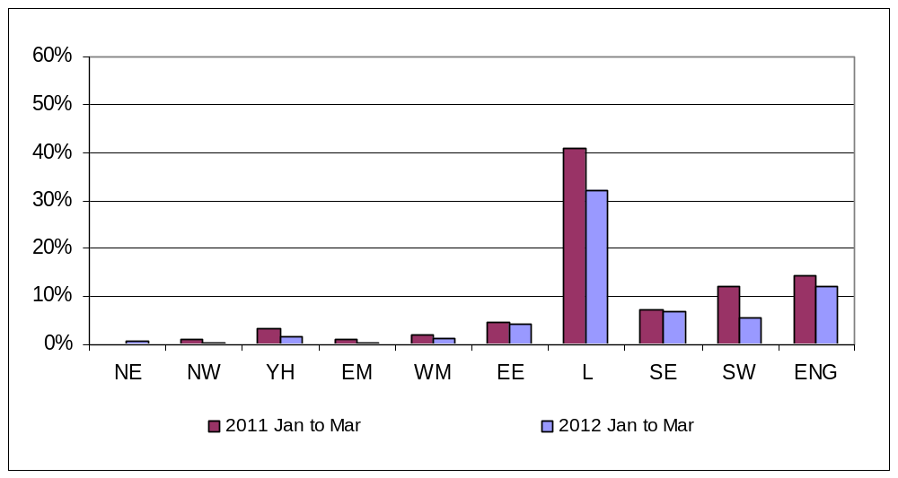
Chart 9b: Proportion of households that spent less than six months in temporary arrangements before the main duty was ended, England and regions: January to March, 2011 and 2012
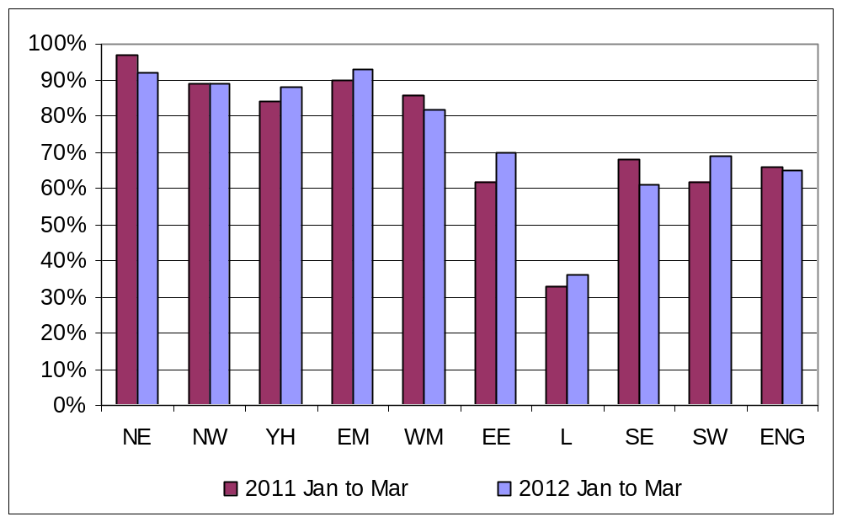
Accompanying live tables
The live tables on homelessness listed below can be found at the following link:
http://www.communities.gov.uk/housing/housingresearch/housingstatistics/housingstatisticsby/homelessnessstatistics/livetables/
Table 770 Decisions taken by local authorities under the 1996 Housing Act on applications from eligible households
Table 771 Homeless households accepted by local authorities, by ethnicity
Table 772 Homeless households accepted by local authorities, by region
Table 773 Homeless households accepted by local authorities, by priority need category
Table 774 Homeless households accepted by local authorities, by reason for loss of last settled home
Table 775 Homeless households in temporary accommodation at the end of each quarter, by type of accommodation
Table 776 Homeless households in temporary accommodation at the end of each quarter, by region
Table 777 Homeless households in temporary accommodation at the end of each quarter, London and England
Table 778 Homeless households accepted by local authorities, and households leaving temporary accommodation (or no longer recorded as “duty owed, no accommodation secured”), by outcome
Table 779 Households leaving temporary accommodation (or no longer recorded as “duty owed, no accommodation secured”) during each quarter, by length of stay, England and London
Table 780 Homeless households accepted by local authorities, by household type
Table 781 Homeless households accepted by local authorities, by age of applicant
Table 782 Homeless households in temporary accommodation at the end of each quarter, by household type and applicant characteristics
Table 783 Homeless households in temporary accommodation at the end of each quarter, by type of accommodation and region
Table 784 Local authorities' action under the homelessness provisions of the 1985 and 1996 Housing Acts, by local authority (financial years 2004/05 to 2011/12)
Table 784a Local authorities' action under the homelessness provisions of the 1985 and 1996 Housing Acts, by local authority (quarterly for each quarter of 2011/12)
Table 785 Decisions taken by local authorities under the 1996 Housing Act on applications from eligible foreign national households
Table 786 Homeless foreign national households accepted by local authorities, by reason for eligibility
Definitions
1. Decisions: all households that apply for assistance under the Housing and Homelessness Acts. However, these do not include households found to be ineligible for assistance (some persons from abroad are ineligible for assistance).
2. Acceptances: households found to be eligible for assistance, unintentionally homeless and falling within a priority need group (as defined by homelessness legislation - see paragraph 3 below), during the quarter, are referred to as “acceptances”. These households are consequently owed a main homelessness duty by a local housing authority. The main duty is to secure settled accommodation.
3. Priority need groups: include households with dependent children or a pregnant woman and people who are vulnerable in some way e.g. because of mental illness or physical disability. The priority need categories were extended by Order in January 2002 to include, additionally: applicants aged 16 or 17; applicants aged 18 to 20 who were previously in care; applicants vulnerable as a result of time spent in care, in custody, or in HM Forces, and applicants vulnerable as a result of having to flee their home because of violence or the threat of violence (in addition domestic violence which is one of the original priority need groups). It is not possible to establish precisely how much of the changed profile of acceptances is attributable to the Order. Previously, some local authorities would have accepted households who fall within the new categories as having a priority need because of "another special reason". This applies in particular to applicants such as vulnerable young people, and people fleeing domestic violence. Note: where applicants are accepted as homeless because of an emergency, for example fire or flood, this will always be recorded as the main priority need category.
4. Temporary accommodation: households in temporary accommodation (excluding those for whom a duty is owed, but no accommodation has been secured) on the last day of the quarter, as arranged by a local housing authority as a discharge of their statutory homelessness functions. In most cases, the authority is discharging a main homelessness duty to secure suitable accommodation until a settled home becomes available for the applicant and his/her household. However, the numbers also include households provided with accommodation pending a decision on their homelessness application, households pending a review or appeal to the county court of the decision on their case, or possible referral to another local authority, and households found to be intentionally homeless and in priority need who were being accommodated for such period as would give them a reasonable opportunity to find accommodation for themselves.
5. Self-contained accommodation: this includes all temporary accommodation where the household has sole use of kitchen and bathroom facilities, including property held by local housing authorities, registered social landlords and private sector landlords. A distinction is made between this type of accommodation and accommodation where such facilities are shared with other households (i.e. bed and breakfast, hostels and women's refuges).
6. Households for whom a duty is owed, but no accommodation has been secured: These are households who have been accepted as being owed a main homelessness duty and for whom arrangements have been made for them, with consent, to remain in their existing accommodation (or to make their own arrangements) for the immediate future. This was previously referred to as “Homeless at Home”.
Legislation
Part 7 of the Housing Act 1996 (http://www.legislation.gov.uk/ukpga/1996/52/contents) and the Homelessness Act 2002 (http://www.legislation.gov.uk/ukpga/2002/7/contents) place statutory duties on local housing authorities to provide assistance to people who are homeless or threatened with homelessness. Authorities must consider all applications from people seeking accommodation or assistance in obtaining accommodation. A main homelessness duty (see below) is owed where the authority is satisfied that the applicant is eligible for assistance, unintentionally homeless and falls within a priority need group. The priority need groups are specified in the legislation, although definition 3 above provides a summary.
Where a main duty is owed, the authority must ensure that suitable accommodation is available for the applicant and his or her household until a settled home becomes available for them. Where households are found to be intentionally homeless or not in priority need, the authority must make an assessment of their housing needs and provide advice and assistance to help them find accommodation for themselves. Where the applicant is found to be intentionally homeless but falls in a priority need category the authority must also ensure that accommodation is available for long enough to give the applicant a reasonable opportunity to find a home.
Methodology
1. The seasonally adjusted estimates have been produced using the X12-ARIMA model, in accordance with Official Statistics practices, which have then been constrained so that they are consistent with the unadjusted financial year totals. Historically, the number of decisions and acceptances tends to be lower in the second quarter than in the first and third quarters, and will also be affected by seasonal holiday periods, especially Christmas and the New Year. From the second quarter of 2009, seasonal adjustments were included for the households in temporary accommodation series, as this series was also found to be affected by seasonality.
2. Rates per 1,000 households have been calculated using the 2008-based household projections produced by the Department for Communities and Local Government. These projections were published on 26 November 2010 at the following link: http://www.communities.gov.uk/housing/housingresearch/housingstatistics/housingstatisticsby/householdestimates/
3. National and regional figures in the text and accompanying tables are presented rounded to the nearest ten households or applicants. Local authority figures provided in the live tables are unrounded.
4. The maps are based upon Ordnance Survey material with the permission of Ordnance Survey on behalf of the Controller of Her Majesty's Stationery Office:
© Crown copyright 100018986 2010.
Data Source and Scope
Local housing authorities report their activities under Part 7 of the Housing Act 1996 to the Department for Communities and Local Government by completing the quarterly P1E statistical return. A recent form and guidance note can be found in the “Notes and Definitions” section of the Department’s website:
http://www.communities.gov.uk/housing/housingresearch/housingstatistics/housingstatisticsby/homelessnessstatistics/notesdefinitions/
Statutory homelessness statistics are published around 50 working days after the end of each quarter, on a pre-announced date in accordance with the Official Statistics Code of Practice.
The scope of this data collection and statistical release is limited to English local housing authorities’ activities under homelessness legislation. This release does not contain data on other forms of homelessness, for example, rough sleeping. The devolved administrations publish their own statistics on statutory homelessness.
In Scotland, local authorities’ homelessness duties under the Housing (Scotland) Act 1987 have been substantially amended by the Housing (Scotland) Act 2001 and the Homelessness etc. (Scotland) Act 2003. The 2001 Act extended the duties towards non-priority homeless households, ensuring they are provided with a minimum of temporary accommodation, advice and assistance. The 2003 Act introduced many changes, of which the target to abolish the priority need test by 2012 is the most significant. The target states that by 31 December 2012 everyone assessed as being unintentionally homeless is entitled to settled accommodation.
The framework of the assessment process is similar to that in England. Local authorities currently make enquiries as to whether the person is homeless, whether they have a priority need, whether they made themselves homeless intentionally, and whether they have a local connection with the local authority. However, when fully enacted, the 2003 Act will remove or substantially amend the priority need, intentionality and local connection stages.
Data on applications are collected on the HL1 return, a continuous case level electronic data capture system. This case level data allows analysis of applications and breakdowns by combinations of characteristics which are not possible from the English local authority level P1E return. Cases can also be grouped to household level to identify instances of repeat homelessness.
Data on households in temporary accommodation at the end of each quarter are collected on the HL2 form which is completed by local authorities and records summary snapshot details in a similar way to the P1E. The HL2 return also contains information on households at risk of homelessness as defined under Section 11 of the Homelessness etc. (Scotland) Act 2003.
The most recent statutory homelessness statistics for Scotland are available at:
http://www.scotland.gov.uk/Publications/2012/02/7556/0
In Wales, local authorities are bound by the same statutory duties as those in England. The data are collected on a quarterly local authority level WHO12 return, similar to the P1E form in England. The most recent statutory homelessness statistics for Wales are available at:
http://wales.gov.uk/topics/statistics/theme/housing/homeless/?lang=en
In Northern Ireland statistics on homelessness are sourced from the Northern Ireland Housing Executive (NIHE). Under the Housing (NI) Order 1988, NIHE has a similar statutory responsibility to secure permanent accommodation for households who are unintentionally homeless and in priority need; to secure temporary accommodation in a variety of circumstances and to provide advice and assistance to those who are homeless or threatened with homelessness. The most recent statutory homelessness statistics for Northern Ireland are available at:
http://www.dsdni.gov.uk/index/publications/housing_bulletins.htm

Comparing between countries
Statutory homelessness statistics for Wales and Northern Ireland are comparable with the English figures. However, actions taken by Scottish authorities since the 2003 Act to meet the target to abolish priority need by the end of 2012 mean that caution should be exercised when comparing Scotland and England figures or deriving a UK figure over that time period.

Related links
The Department also releases information on Homelessness Prevention and Relief. The most recent publication relating to local authority actions in the 2010/11 financial year can be found at the following link:
http://www.communities.gov.uk/housing/housingresearch/housingstatistics/housingstatisticsby/homelessnessstatistics/homelessnesspreventionrelief/
Rough sleeping statistics can be found at the following link:
http://www.communities.gov.uk/housing/housingresearch/housingstatistics/housingstatisticsby/roughsleepingcounts/
Statistics on local authority revenue expenditure and financing in England can be found at the link below. The RO4 return relates to housing services and includes information on local authorities’ expenditure on homelessness activities:
http://www.communities.gov.uk/publications/corporate/statistics/revenue201011localdata
Data quality
All P1E returns submitted by local housing authorities undergo thorough validation and cross-checking, and late returns are pursued to ensure overall response is as complete and accurate as possible. Anomalous data are highlighted and verified by contacting the local authority.
Local authorities also provide details of any data checks they undertake. These can take the form of audits (by either internal or external auditors), periodic quality checks on data extracts, or random quality checks. For the period January to March 2012, most authorities reported some form of checking on all data items in the return.
The validation process typically takes around six weeks, after which estimates for missing data are calculated. Local authorities are split into groups based on the region they are in and by type of authority. For example, the West Midlands is split into two groups, one group of district and unitary authorities, the other of metropolitan districts. London is split into Inner and Outer London. Estimates are then calculated by an automated grossing procedure which either (i) updates previously reported data based on the changes observed in other authorities in the same group or (ii) apportions totals based on ratios reported by these similar authorities.
The latest quarter's figures are based on full or partial returns for all 326 local authorities (100 per cent response). Six local authorities provided only the two headline figures: the number of households accepted as owed a main homeless duty and number of households in temporary accommodation. Section 7 of the form, covering households leaving temporary accommodation or other temporary arrangements had the lowest rate of return, with 20 local authorities not providing any figures. Overall, 96 per cent of cells were filled in by local authorities.
The Department for Communities and Local Government’s statistical quality guidelines are published here:
http://www.communities.gov.uk/publications/corporate/statisticalnoticequalityguidance
Revisions policy
This policy has been developed in accordance with the UK Statistics Authority Code of Practice for Official statistics and the Department for Communities and Local Government Revisions Policy (found at http://www.communities.gov.uk/publications/corporate/statisticalnoticerevisionspolicy). There are two types of revisions that the policy covers:
Non-Scheduled Revisions
Where a substantial error has occurred as a result of the compilation, imputation or dissemination process, the statistical release, live tables and other accompanying releases will be updated with a correction notice as soon as is practical.
Scheduled Revisions
Local authorities can update their P1E returns following publication of the data. At the end of each financial year the figures for the four quarters of the previous year will be reviewed for revision. A decision on whether to revise will be made based on the impact of any change and the effect it has on the interpretation of the time series. No revisions were made this quarter to the 2010/11 figures. Provisional figures are labelled in the tables with a “P”.
Revisions to historic data (all data older than that currently due for scheduled revision) should be made only where there is a substantial revision, such as a change in methodology or definition. Where there are small changes that do not substantially change historic data, internal updates are maintained.
Uses of the data
The data in this Statistical Release form the basis of evidence on statutory homelessness. Acceptances, decisions, and numbers in temporary accommodation are core series describing homelessness in England, and are key series for international comparisons. They are used by ministers and officials in the Department for Communities and Local Government in the formulation and monitoring of policy, the allocation of resources, performance monitoring and to support bids for funding from the Treasury. The data are used to ensure democratic accountability in answers to Parliamentary Questions, ministerial correspondence, Freedom of Information Act cases and queries from the public.
The Departmental Business Plan, first published on 8 November 2010 and refreshed on 31 May 2012, includes an impact indicator on households in temporary accommodation. At the end of March 2012, there were 50,430 households in temporary accommodation. This is 5 per cent more than the same date last year. On a seasonally adjusted basis, 50,510 households were in temporary accommodation on 31 March 2012, 2 per cent more than the figure of 49,430 in the previous quarter. The refreshed Business Plan can be seen at: http://www.communities.gov.uk/corporate/about/howwework/corporatereports/businessplans/
Other Government departments also use the statistics, including DWP (monitoring those in temporary accommodation in receipt of housing benefit), DfE (Child poverty needs assessment toolkit for local authorities) and Defra (sustainable development indicators). Local housing authorities are both providers and users of the statistics and use the data extensively in order to plan services, allocate resources, monitor performance and benchmark against other authorities. The voluntary sector also uses the statistics to monitor and evaluate housing policy and for campaigning and fundraising purposes.
User consultation
Users are encouraged to provide feedback on how these statistics are used and how well they meet user needs. Comments on any issues relating to this statistical release are welcomed and encouraged. Responses should be addressed to the "Public enquiries" contact given in the "Enquiries" section below.
The Department’s engagement strategy to meet the needs of statistics users is published here:
http://www.communities.gov.uk/publications/corporate/statistics/engagementstrategystatistics
The Department's Statistics Plan 2011/12 (available at http://www.communities.gov.uk/publications/corporate/statistics/plan201112) sets out the Department’s intention to reduce the detail of the statutory homelessness quarterly releases to include only the most high profile and volatile data, with a more detailed publication at year end.
As a result, the first three quarterly releases for 2011/12 were in a shortened form, although there was no reduction in the number of tables and data published with the quarterly release, simply a reduction in the text. This release, covering the end of the financial year, contains a fuller commentary. The plan was available for user consultation from 13 April to 3 June 2011 and the final version of the plan (covering the year ending March 2012) was published on 7 March 2012.
Other information
Details of officials who receive pre-release access to the Department’s quarterly Statutory Homelessness Statistical Release up to 24 hours before release can be found at: http://www.communities.gov.uk/corporate/researchandstatistics/statistics/nationalstatistics/
The publication date for the second quarter (April to June) 2012 Statutory Homelessness Statistical Release is Thursday 6 September 2012.
Enquiries
This Statistical Release, as well as previous Releases, can be accessed and all text, tables and charts downloaded electronically, from the Department’s website at:
http://www.communities.gov.uk/housing/housingresearch/housingstatistics/housingstatisticsby/homelessnessstatistics/publicationshomelessness/

Further details on this Statistical Release are available from:

Media Enquiries:
office hours: 0303 444 1159
out of hours: 0303 444 1201
e-mail: press.office@communities.gsi.gov.uk

Public enquiries:
telephone: 0303 444 3510
e-mail: homelessnessstats@communities.gsi.gov.uk
Zone 4/J4, Eland House, Bressenden Place, London SW1E 5DU

Information on Official Statistics is available via the UK Statistics Authority website: www.statistics.gov.uk.

Information about DCLG is available via the Department's website: www.communities.gov.uk.

Department for Communities and Local Government. © Crown Copyright, 2012

If you require this publication in an alternative format please email: alternativeformats@communities.gsi.gov.uk. Please note that the nature of content means that we may not be able to provide the Statistical series of publications in all requested formats.

June 2012

ISBN: 978-1-4098-3551-6

