

Housing
Statistical Release

10 March 2011
using
Research
Summary
Number 239, 2007

Statutory Homelessness:
December Quarter 2010 England

Contents  Introduction  Decisions  Acceptances  - Priority need  - Reason for loss  - Ethnicity  - Household type  - Age band  - Action taken  - Regional Acceptances  - Ethnicity and region  Temporary Accommodation  - Accommodation type  - Young people  - Household type & ethnicity  - Leaving TA  - Regional TA  - Length of stay  List of accompanying tables  Related live tables  Definitions  Legislation  Methodology  Data source and scope  Related links  Data quality  Revisions Policy  Uses of data  User consultation  Other information  Enquiries | 2  2  3  3  4  5  5  6  6  7  8  9  10  11  12  12  13  14  16  18  19  20  20  21  22  22  23  24  24  24  24

Responsible Statistician:
Laurie Thompson
Phone: 030344 44131
homelessnessstats@communities.gsi.gov.uk
Media Enquiries:
Office hours: 0303 444 1136
Out of hours: 0303 444 1201 press.office@communities.gsi.gov.uk

Household acceptances
- 10,870 applicants were accepted as owed a main homelessness duty during October to December 2010, 15 per cent higher than the same quarter last year.
- On a seasonally-adjusted basis, there were 11,290 acceptances, similar to the previous quarter.
Households in temporary accommodation
- 48,010 households were in temporary accommodation on 31 December 2010, 10 per cent lower than the same date last year.
- On a seasonally-adjusted basis, 48,390 households were in temporary accommodation, 2 per cent lower than the previous quarter.
- 87 per cent of households were in self-contained accommodation - a decrease from 89 per cent at the end of the same quarter last year.
- 5 per cent of households were in bed and breakfast hotels. This is an increase from 1,880 to 2,310 compared to the same quarter last year.
- The percentage of households leaving temporary accommodation who had been in such arrangements for less than six months has increased from 56 per cent to 66 per cent compared to the same quarter last year.
- The percentage of households leaving temporary accommodation who had been in such arrangements for two or more years has fallen from 20 per cent to 16 per cent.

Introduction
This release provides summary information on local housing authorities’ activities under homelessness legislation, collected through the quarterly P1E return. Data include the number of households accepted as owed a main homelessness duty (referred to as acceptances) during the quarter, and the number of households in temporary accommodation on the last day of the quarter. Accompanying tables are provided online alongside the release and are listed on page 16. These form the underlying data used to produce the text and charts. The background notes section provides more detail of terms used within the release.

Decisions taken by local authorities on homeless applications
Between October and December 2010, local housing authorities made 26,060 decisions on applications (by eligible households) for housing assistance, under the homelessness legislation of the Housing Act 1996. This is 23 per cent higher than the corresponding quarter in 2009. After seasonal adjustment the number of decisions was 26,690, 4 per cent higher when compared to last quarter. Following a long term downward trend seasonally adjusted decisions have now increased in three consecutive quarters.
Of the 26,060 applications made during October and December 2010:
- 42 per cent were accepted as owed a main homelessness duty;
- 31 per cent were found not to be homeless;
- 20 per cent were found to be homeless but not in priority need; and
- 7 per cent were found to be intentionally homeless and in priority need.
Most of the increase seen when compared to the same quarter last year has been caused by households who were not owed a main homelessness duty. Whilst the number of households found to be unintentionally homeless and in priority need rose by 15 per cent, the number of households found to be homeless but not in priority need increased by 34 per cent. Further, the number of households found not to be homeless increased by 28 per cent and the number of households found to be intentionally homeless and in priority need increased by 21 per cent.
There has been a decrease in the proportion of households accepted as owed a main homelessness duty as a percentage of decisions when compared to the same quarter last year - from 44 per cent to 42 per cent. Households accepted as owed a main homelessness duty are dealt with further in the next section.

Households accepted as owed a main homelessness duty (acceptances)
Between October and December, local authorities accepted 10,870 households as being owed a main homelessness duty (acceptances). This is a 15 per cent increase compared to the same quarter last year. After seasonal adjustment the number of acceptances during the fourth quarter of 2010 was 11,290, similar to the seasonally adjusted figure of 11,330 in the previous quarter. This ends the run of consecutive increases seen in the past two quarters but it is too early to deduce a likely long term trend in the number of households being owed a main homelessness duty.
Chart 1: Households accepted by local authorities as owed a main duty each quarter, 1998 to October to December quarter 2010, England
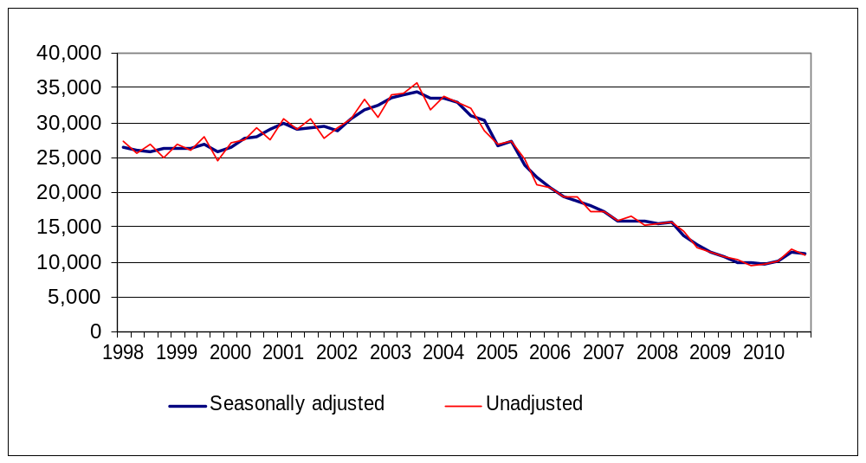
See Table 1: Decisions taken by local authorities under the 1996 Housing Act on applications from eligible households

Acceptances by priority need category
Between October and December, in 60 per cent of acceptances the presence of dependent children in the household was the primary reason for priority need, this represents 6,570 households. This is an increase from 57 per cent in the same quarter last year. A further 10 per cent of households were in priority need because they included a pregnant woman, this represents 1,060 households.
The majority of the remainder were in priority need due to vulnerability, for example, mental illness (8 per cent) or physical disability (7 per cent). Homeless in an emergency accounted for 1 per cent of all acceptances.
5 per cent of acceptances were in priority need through being a young person (either 16 or 17 year olds, or 18 to 20 year olds formerly in care).
Chart 2: Acceptances by priority need category during October to December 2010, England
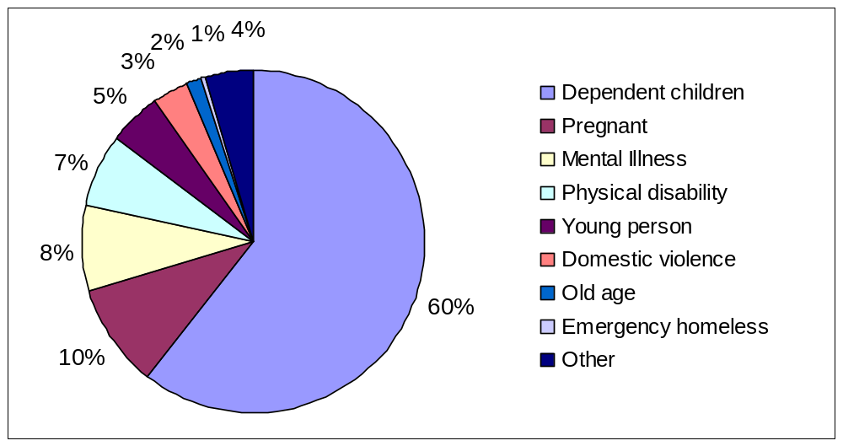
See Table 4: Homeless households accepted by local authorities, by Priority Need Category

Acceptances by reason for loss of last settled home
Between October and December, in 33 per cent of acceptances the reason for homelessness was because parents, relatives or friends (mostly parents) were no longer able, or willing, to accommodate applicants.
In a further 19 per cent of acceptances, the reason for homelessness was the breakdown of a relationship with a partner, 70 per cent of these cases involving violence.
In 15 per cent of acceptances the reason for homelessness was the ending of an assured short hold tenancy. There has been a rise in acceptances for this reason, from 11 per cent in the same quarter in 2009.
The proportion of acceptances where homelessness resulted from mortgage arrears (repossession or other loss of home) was 3 per cent, unchanged from the same quarter in 2009. The proportion of acceptances due to mortgage arrears has remained much lower than the peak in the last downturn - 12 per cent during 1991.
Chart 3: Acceptances by reason for loss of last settled home during October to December 2010, England
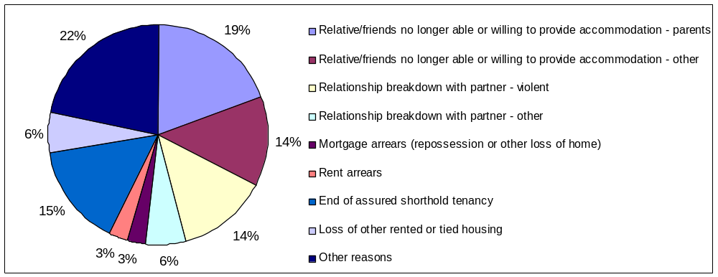
See Table 5: Homeless households accepted by local authorities, by Reason for Loss of Last Settled Home

Acceptances by ethnicity
Between October and December, 66 per cent of applicants accepted were White and 29 per cent were from an ethnic minority group - 15 per cent Black, 6 per cent Asian, 3 per cent mixed and 4 per cent another ethnic group. The remainder did not state their ethnic origin. Compared to the population as a whole, there is a higher incidence of acceptances amongst ethnic minority groups than amongst the White population.
See Table 2: Homeless households accepted by local authorities, by Ethnicity

Acceptances by household type
Of the 10,870 acceptances between October and December, 50 per cent were lone parents (4 per cent male, 46 per cent female), and 18 per cent were couples with dependent children.
One person households accounted for 27 per cent of acceptances, with a higher proportion male than female.

Chart 4: Acceptances by household type during October to December 2010, England
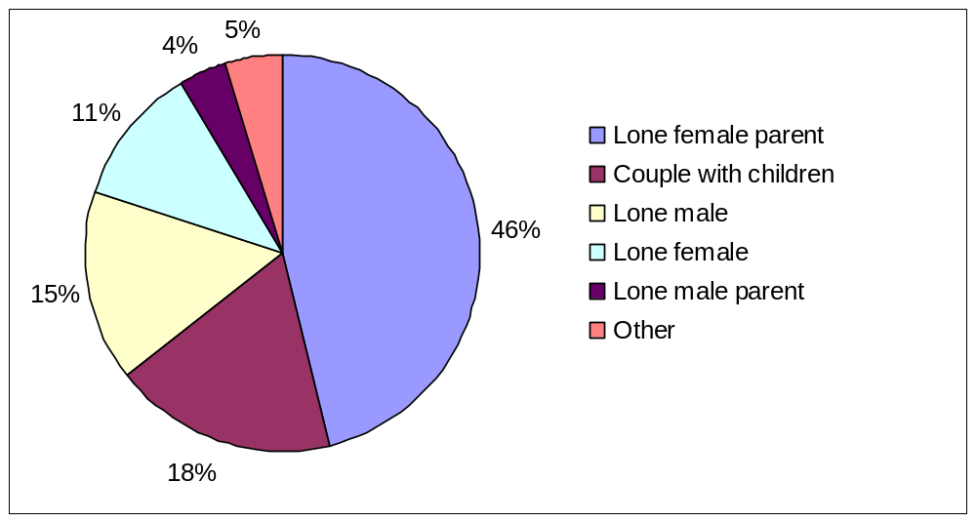
See Table 10: Homeless households accepted by local authorities, by Household Type

Acceptances by age band
Between October and December, 85 per cent of all acceptances were applicants under 45 years old. 49 per cent were aged between 25 and 44, and 36 per cent between 16 and 24.
See Table 11: Homeless households accepted by local authorities, by Age of Applicant

Action taken in respect of acceptances
Of the 10,870 acceptances between October and December, 6,170 (57 per cent) were placed in some form of temporary accommodation for a period of time. For a further 3,390 accepted households (31 per cent), arrangements were made, with consent, to remain in their existing accommodation (or to make their own arrangements), for the immediate future while awaiting the provision of alternative accommodation. This is an increase from 2,570 (27 per cent) in the same quarter last year.
9 per cent of acceptances were provided with settled accommodation, by being granted a secure tenancy in local authority or registered social landlord accommodation, or an assured short hold tenancy in the private rented sector. This was a decrease from 10 per cent in the same quarter last year.
The remaining 3 per cent either made their own arrangements or had no further contact with the authority, thus bringing the homelessness duty to an end.
See Part 1 of Table 8: Homeless households accepted by local authorities, and households leaving temporary accommodation (or no longer recorded as “duty owed, no accommodation secured”), by outcome

Acceptances by region
All regions except the North West saw increases in numbers of acceptances compared to the same quarter last year. The size of these increases varied considerably. The West Midlands had an increase of 32 per cent, the East of England had an increase of 18 per cent, the Yorkshire and the Humber had an increase of 17 per cent, the South East had an increase of 15 per cent, London had an increase of 11 per cent, the North East had an increase of 9 per cent and the South West had an increase of 7 per cent. The North West had a percentage drop of 3 per cent.
The West Midlands and London had the highest incidences of acceptances per 1,000 households during the quarter, with 1.0 and 0.8 respectively, compared to the National figure of 0.5. The North West, with under 0.3 per 1,000 households, had the lowest incidence.
Map 1: Homelessness acceptance rates by region, October to December 2010
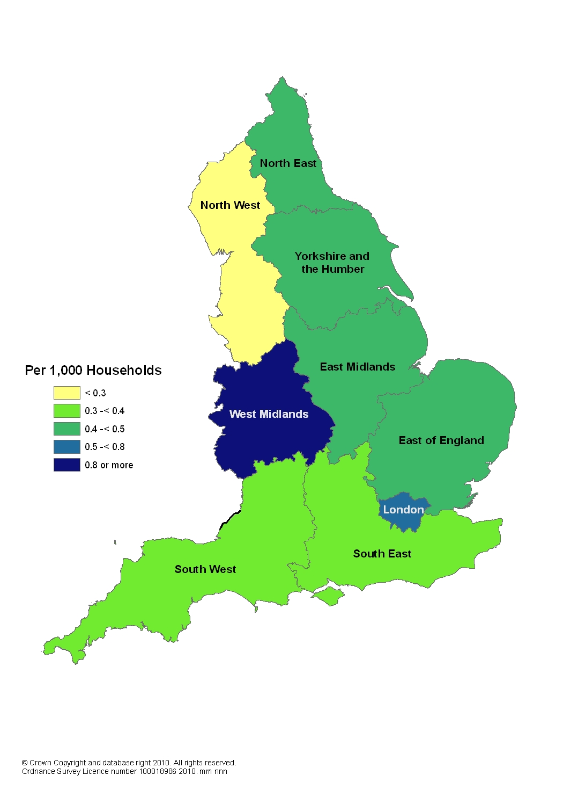
See Table 3: Homeless households accepted by local authorities, by Region

Acceptances by ethnicity and region
There is large variation in the ethnicity of accepted applicants across the regions. This variation has remained stable in recent quarters. In London, 35 per cent of acceptances were stated as White, partly reflecting the larger ethnic minority population in this region, while in the South West the proportion was 88 per cent.
Chart 5: Proportion of acceptances during October to December 2010 by ethnicity, England and regions
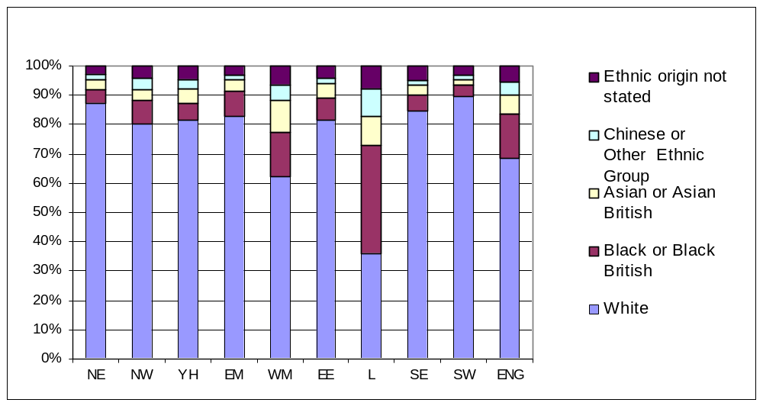

Households in temporary accommodation
The number of households in temporary accommodation on 31 December 2010, arranged by local authorities under homelessness legislation, was 48,010 - 10 per cent lower than the same date last year. After seasonal adjustment the number of households in temporary accommodation was 48,390, 2 per cent lower than the previous quarter. There has been a long term downward trend in the number of households in temporary accommodation with seasonally adjusted figures falling in each successive quarter since the peak in 2004. Chart 6 shows the historic trend and suggests that whilst in the last few quarters the decreasing trend has slowed; it has slightly accelerated against this quarter.
Historically there tends to be a lag between a change in direction in the number of acceptances and a change in direction in the number of households in temporary accommodation. If the increase in the number of acceptances we have seen recently is to continue, we would expect the number of households in temporary accommodation to increase in due course.
Of the 48,010 households in temporary accommodation, 85 per cent had been accepted as owed a main homelessness duty and were being housed in temporary accommodation by the authority until a settled home became available. The remainder were being accommodated pending a decision on their application, the outcome of a local authority review or an appeal to the county court on the authority's decision, or possible referral to another local authority, or had been found intentionally homeless and in priority need and subsequently were being accommodated for such a period as would give them a reasonable opportunity to find accommodation for themselves.
Chart 6: Households in temporary accommodation at the end of each quarter, by type, 1998 to 31 December 2010, England
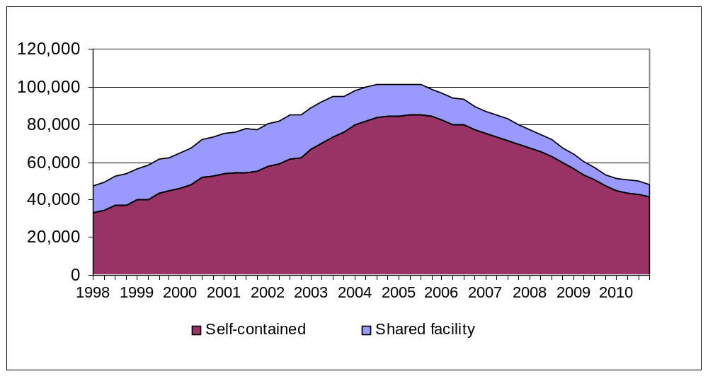

Households in temporary accommodation, by type of accommodation
There is a wide range of accommodation used to provide temporary accommodation, most of which is self-contained (either in local authority or housing authority stock, or within the private sector.) At the end of December 2010, 87 percent of households in temporary accommodation were in self-contained accommodation - a decrease from 89 per cent at the same date last year.
Use of accommodation with shared facilities has increased slightly over recent quarters after a long period of decline since its peak in 2001, when 30 per cent of households were in this form of temporary accommodation (compared to 13 per cent at the end of December 2010). The recent increase is largely due to increased usage of bed and breakfast style accommodation. The number of households in bed and breakfast hotels has risen from 1,880 to 2,310 compared to the same quarter last year.
Chart 7: Households in temporary accommodation, by type, at the end of each quarter, 1998 to 31 December 2010, England
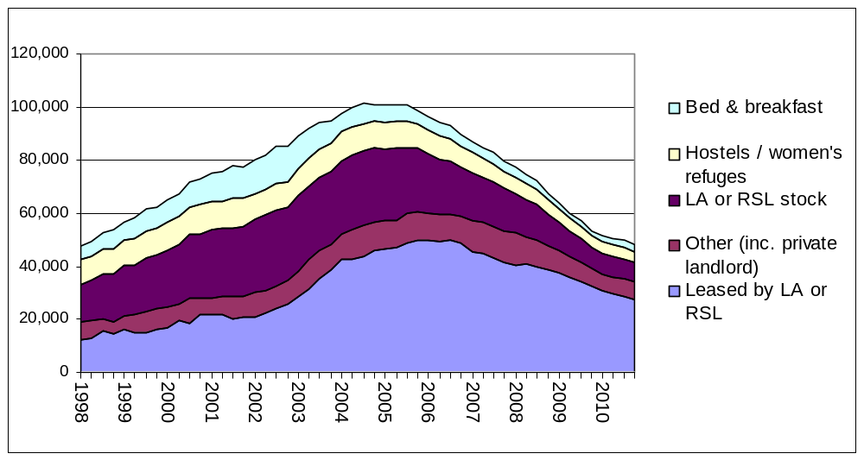

On 31 December 2010, of the 48,010 households in temporary accommodation:
34,110 households were in private sector accommodation (71 per cent of all households), most commonly in a property leased by the local authority or housing association, or in some cases let directly to the applicant as the tenant of a private sector landlord. This is a drop of 13 per cent since the 31 December last year.
7,430 households were in accommodation owned by social landlords (15 per cent of all households), a fall of 9 per cent since the same quarter last year. Of these 7,430 households, 70 per cent were in local authority owned stock, and 30 per cent in HA owned property.
4,160 households were in hostel accommodation and women's refuges (9 per cent of all households), similar to this time last year.
2,310 households were in bed and breakfast style accommodation (5 per cent of all households), 23 per cent higher than this time last year. Historically, the use of bed and breakfast accommodation peaked in March 1987, when 47 per cent (England) and 59 per cent (London) of households in temporary accommodation were housed in this style of accommodation.
In addition to the 48,010 households in temporary accommodation on 31 December 2010, 4,410 households accepted as owed a main duty remained (with consent) in their existing accommodation (or made their own arrangements) while awaiting the provision of alternative accommodation. This is 6 per cent higher than the same date last year.
See Table 6: Homeless households in temporary accommodation at the end of each quarter, by Type of Accommodation

Young people in temporary accommodation
Of the 48,010 households in temporary accommodation on 31 December, 36,230 included dependent children and/or a pregnant woman (within which households there were 69,050 children or expected children). The number of children per household in temporary accommodation has remained stable since the data was first collected in 2007 at around 1.4.
Of these 36,230 households with children, 92 per cent were in self-contained accommodation. This has fallen slightly from 94 per cent at the end of the same quarter last year. 660 (2 per cent) were in bed and breakfast style accommodation, up from 400 at the end of the same quarter last year. Of these 660 households, 150 had been in bed and breakfast style accommodation for six or more weeks (10 of which pending review).
At the end of December, there were 140 households headed by 16 and 17 year old applicants in bed and breakfast style accommodation, of which 80 had been there for six or more weeks.

Households in temporary accommodation, by household type and ethnicity
Of the 48,010 households in temporary accommodation on 31 December, the biggest group (42 per cent) were lone female parent households with dependent children. Couples with dependent children accounted for a quarter (25 per cent) of households. Single person households (with no dependent children) accounted for 22 per cent of households, with a higher proportion of males than females.
Over half of all households in temporary accommodation were headed by ethnic minority applicants. The vast majority of these households (93 per cent) were in London, reflecting the high usage of temporary accommodation and larger ethnic minority population in the region. Outside of London, ethnic minority applicants accounted for 16 per cent of households in temporary accommodation.
Chart 8: Households in temporary accommodation by household type: 31 December 2010, England
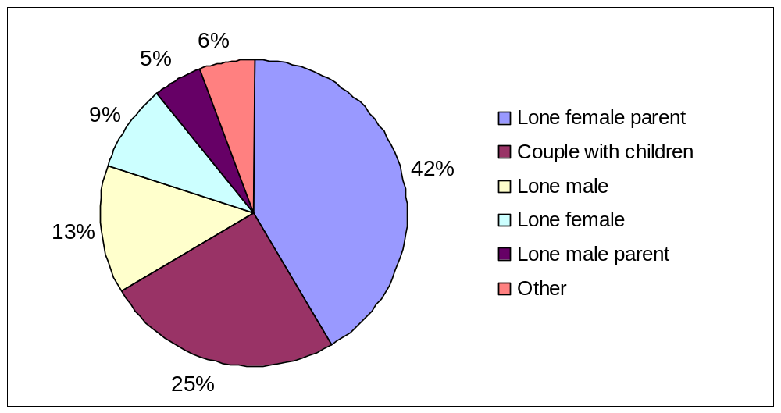
See Table 12: Homeless households in temporary accommodation at the end of each quarter, by Household Type and Ethnicity

Households leaving temporary accommodation and other temporary arrangements
Between October and December, a main homelessness duty was ended for 10,340 households who had previously been in temporary accommodation (or had remained, with consent, in their existing accommodation while awaiting the provision of alternative accommodation).
7,250 (70 per cent) of these households were provided with settled accommodation, by accepting a “Part 6” offer of a secure tenancy in local authority or housing authority accommodation, although a further 7 per cent refused such an offer. An additional 5 per cent accepted alternative offers of rented accommodation.
10 per cent of households voluntarily left the temporary accommodation or other temporary arrangement. The remaining households ceased to be eligible, or became intentionally homeless from the temporary accommodation provided for them.
See Part 2 of Table 8: Homeless households accepted by local authorities and households leaving temporary accommodation (or no longer recorded as “duty owed, no accommodation secured”), by outcome

Households in temporary accommodation, by region
London had the highest number of households in temporary accommodation, with 36,020 on 31 December, accounting for three quarters of the England total. The South East had the next highest number, with 7 per cent of the England total (3,530 households). The North East, with less than 1 per cent (200 households), had the lowest number of households in temporary accommodation.
Five regions have fewer households in temporary accommodation when compared to the same quarter last year. The largest percentage fall was in London with 13 per cent (41,190 to 36,020 households), followed by the South West with 10 per cent (2,210 to 2,000 households). The South East and East Midlands each had falls of 3 per cent (3,620 to 3,530 and 690 to 670 respectively) and the North West fell by 1 per cent (920 to 910 households).
The North East saw on increase of 50 (36 per cent) compared to the same quarter last year. The West Midlands saw an increase of 100 (9 per cent) whilst Yorkshire and the Humber and the East of England remained relatively stable.
As at the end of December 2010, England had a rate of 2.2 households in temporary accommodation per 1,000 households. Of the regions, London had by far the highest rate at 11.1 per 1,000 households - a decrease from 12.7 per 1,000 households at the end of the same quarter last year. The East of England had the next highest rate, at 1.1 per 1,000 households. The North East had the lowest rate at 0.2 per 1,000 households.
See Table 7: Homeless households in temporary accommodation at the end of each quarter, by region
Map 2: Households in Temporary Accommodation by region as at 31 December 2010
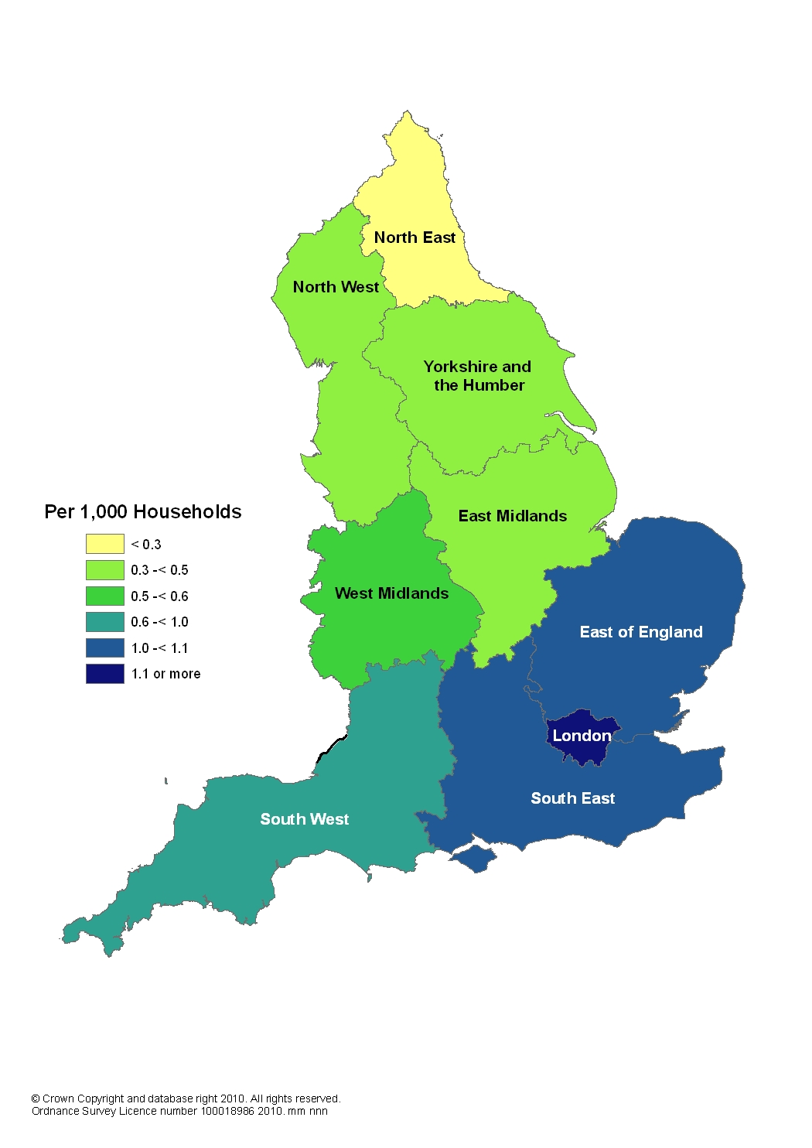

Length of time in temporary accommodation (and other temporary arrangements), between acceptance and duty being ended
Of the 10,340 households who left temporary accommodation or other temporary arrangements during the quarter, 66 per cent had been in these temporary arrangements for less than six months, while 16 per cent had been so for two years or more. The percentage of households who had been in temporary accommodation for less than six months has increase from 56 per cent in the same quarter last year whilst the percentage of households who spend two or more years in temporary accommodation has fallen from 20 per cent.
Lengths of time in temporary arrangements vary across the regions. Chart 9a compares the proportion of those spending 2 years or more in temporary arrangements before the main duty was ended, for the most recent quarter and the same quarter last year by region, and Chart 9b compares the proportion of those spending less than six months in temporary arrangements. London’s figures stand out with the longest stays - between October and December 2010, 45 per cent of households who left temporary arrangements had previously spent two or more years in such temporary arrangements. This is a decrease from 51 per cent compared to the same quarter last year. All other regions saw increases in the proportion of stays longer than two years over this period. After London, the South East and the South West have the next highest proportions of stays longer than two years, with 10 per cent and 8 per cent respectively.
The Northern and Midland regions have a much lower proportion of longer stays. In the North East, no households stayed for two years or longer in the most recent quarter, and in the East Midlands, North West and West Midlands only 1 per cent of households stayed for two years or longer in the most recent quarter.
See Table 9: Households leaving temporary accommodation (or no longer recorded as “duty owed, no accommodation secured”) during each quarter, by length of stay, England and London
Chart 9a: Proportion of households that spent 2 years or more in temporary arrangements before the main duty was ended, England and regions: October to December, 2009 and 2010
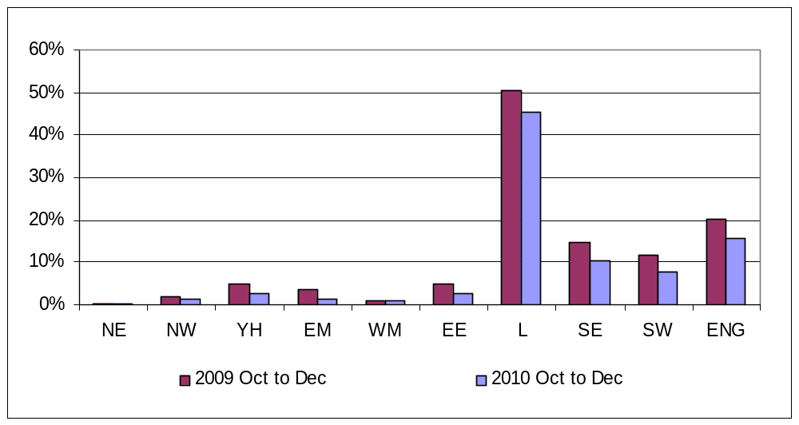
Chart 9b: Proportion of households that spent less than six months in temporary arrangements before the main duty was ended, England and regions: October to December, 2009 and 2010
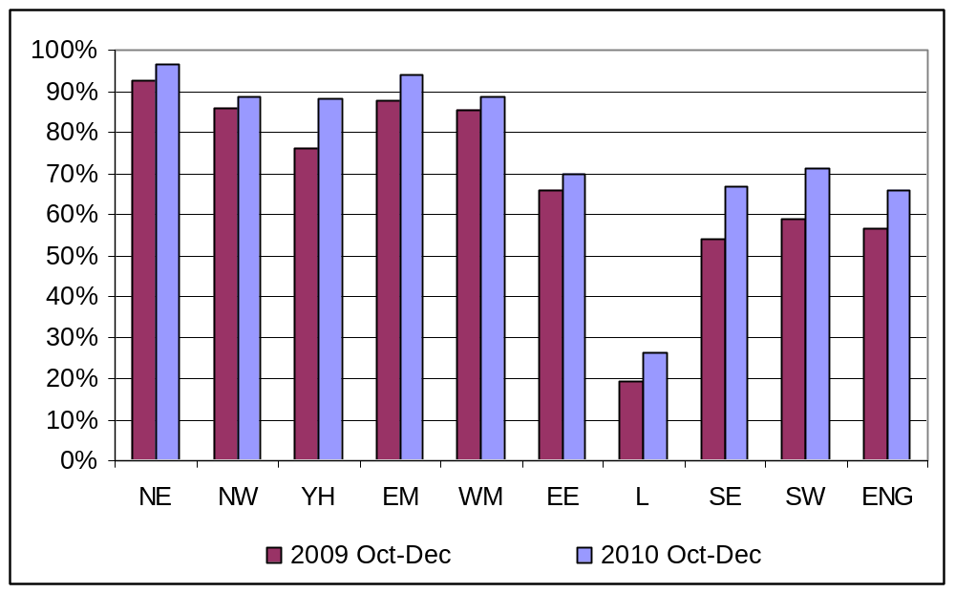
Accompanying tables
Table 1 Decisions taken by local authorities under the 1996 Housing Act on applications from eligible households
Table 2 Homeless households accepted by local authorities, by ethnicity
Table 3 Homeless households accepted by local authorities, by region
Table 4 Homeless households accepted by local authorities, by priority need category
Table 5 Homeless households accepted by local authorities, by reason for loss of last settled home
Table 6 Homeless households in temporary accommodation at the end of each quarter, by type of accommodation
Table 7 Homeless households in temporary accommodation at the end of each quarter, by region
Table 8 Homeless households accepted by local authorities, and households leaving temporary accommodation (or no longer recorded as “duty owed, no accommodation secured”), by outcome
Table 9 Households leaving temporary accommodation (or no longer recorded as “duty owed, no accommodation secured”) during each quarter, by length of stay, England and London
Table 10 Homeless households accepted by local authorities, by household type
Table 11 Homeless households accepted by local authorities, by age of applicant
Table 12 Homeless households in temporary accommodation at the end of each quarter, by household type and ethnicity
Supplementary tables giving Local Authority level information on their action under the homelessness provisions of the 1985 and 1996 Housing Acts are published electronically.
All accompanying tables can be found at the following link:
http://www.communities.gov.uk/publications/corporate/statistics/homelessnessq42010
Related live tables
The following live tables on homelessness are updated by the end of the month of each Statutory Homelessness publication and can be found at the following link:
http://www.communities.gov.uk/housing/housingresearch/housingstatistics/housingstatisticsby/homelessnessstatistics/livetables/
Table 770 Decisions taken by local authorities under the 1996 Housing Act on applications from eligible households
Table 771 Homeless households accepted by local authorities, by ethnicity
Table 772 Homeless households accepted by local authorities, by region
Table 773 Homeless households accepted by local authorities, by priority need category
Table 774 Homeless households accepted by local authorities, by reason for loss of last settled home
Table 775 Homeless households in temporary accommodation at the end of each quarter, by type of accommodation
Table 776 Homeless households in temporary accommodation at the end of each quarter, by region
Table 777 Homeless households in temporary accommodation at the end of each quarter, London and England
Table 778 Homeless households accepted by local authorities, and households leaving temporary accommodation (or no longer recorded as “duty owed, no accommodation secured”), by outcome
Table 779 Households leaving temporary accommodation (or no longer recorded as “duty owed, no accommodation secured”) during each quarter, by length of stay, England and London
Table 780 Homeless households accepted by local authorities, by household type
Table 781 Homeless households accepted by local authorities, by age of applicant
Table 782 Homeless households in temporary accommodation at the end of each quarter, by household type and ethnicity

Table 783 Homeless households in temporary accommodation at the end of each quarter, by type of accommodation and region
Table 784 Local authorities' action under the homelessness provisions of the 1985 and 1996 Housing Acts, by Local Authority
Table 785 Decisions taken by local authorities under the 1996 Housing Act on applications from eligible foreign national households
Table 786 Homeless foreign national households accepted by local authorities, by reason for eligibility

Definitions
1. Decisions: all households that apply for assistance under the Housing and Homelessness Acts. However, these do not include households found to be ineligible for assistance (some persons from abroad are ineligible for assistance).
2. Acceptances: households found to be eligible for assistance, unintentionally homeless and falling within a priority need group (as defined by homelessness legislation- see paragraphs 8-10 below), during the quarter, are referred to as “acceptances”. These households are consequently owed a main homelessness duty by a local housing authority. The main duty is to secure settled accommodation.
3. Priority need groups: include households with dependent children or a pregnant woman and people who are vulnerable in some way e.g. because of mental illness or physical disability. The priority need categories were extended by Order in January 2002 to include, additionally: applicants aged 16 or 17; applicants aged 18 to 20 who were previously in care; applicants vulnerable as a result of time spent in care, in custody, or in HM Forces, and applicants vulnerable as a result of having to flee their home because of violence or the threat of violence (in addition domestic violence which is one of the original priority need groups). It is not possible to establish precisely how much of the changed profile of acceptances is attributable to the Order. Previously, some local authorities would have accepted households who fall within the new categories as having a priority need because of "another special reason". This applies in particular to applicants such as vulnerable young people, and people fleeing domestic violence. Note: where applicants are accepted as homeless because of an emergency, for example fire or flood, this will always be recorded as the main priority need category.
4. Temporary accommodation: households in temporary accommodation (excluding those for whom a duty is owed, but no accommodation has been secured) on the last day of the quarter, as arranged by a local housing authority as a discharge of their statutory homelessness functions. In most cases, the authority is discharging a main homelessness duty to secure suitable accommodation until a settled home becomes available for the applicant and his/her household. However, the numbers also include households provided with accommodation pending a decision on their homelessness application, households pending a review or appeal to the county court of the decision on their case, or possible referral to another local authority, and households found to be intentionally homeless and in priority need who were being accommodated for such period as would give them a reasonable opportunity to find accommodation for themselves.
5. Self-contained accommodation: this includes all temporary accommodation where the household has sole use of kitchen and bathroom facilities, including property held by local housing authorities, registered social landlords and private sector landlords. A distinction is made between this type of accommodation and accommodation where such facilities are shared with other households (i.e. bed and breakfast, hostels and women's refuges).
6. Households for whom a duty is owed, but no accommodation has been secured: These are households who have been accepted as being owed a main homelessness duty and for whom arrangements have been made for them, with consent, to remain in their existing accommodation (or to make their own arrangements) for the immediate future. This was previously referred to as “Homeless at Home”. Prior to the second quarter of 2005, figures were also collected on those potentially in this category but whose application was still under consideration pending a decision. Both series are now presented in the final columns of Table 6.

Legislation
Part 7 of the Housing Act 1996 (http://www.legislation.gov.uk/ukpga/1996/52/contents) and the Homelessness Act 2002 (http://www.legislation.gov.uk/ukpga/2002/7/contents) place statutory duties on local housing authorities to provide assistance to people who are homeless or threatened with homelessness. Authorities must consider all applications from people seeking accommodation or assistance in obtaining accommodation. A main homelessness duty (see below) is owed where the authority is satisfied that the applicant is eligible for assistance, unintentionally homeless and falls within a priority need group. The priority need groups are specified in the legislation, although paragraph 6 above provides a summary.
Where a main duty is owed, the authority must ensure that suitable accommodation is available for the applicant and his or her household until a settled home becomes available for them. Where households are found to be intentionally homeless or not in priority need, the authority must make an assessment of their housing needs and provide advice and assistance to help them find accommodation for themselves. Where the applicant is found to be intentionally homeless but falls in a priority need category the authority must also ensure that accommodation is available for long enough to give the applicant a reasonable opportunity to find a home.

Methodology
1. The seasonally adjusted estimates have been produced using the X12-ARIMA model, in accordance with Official Statistics practices, which have then been constrained so that they are consistent with the unadjusted financial year totals. Historically, the number of decisions and acceptances tends to be lower in the second quarter than in the first and third quarters, and will also be affected by seasonal holiday periods, especially Christmas and the New Year. In the second quarter of 2009, seasonal adjustments were included for the households in temporary accommodation series, as this series was also found to be affected by seasonality.
2. Rates per 1,000 households have been calculated using the 2008-based household projections produced by the Department for Communities and Local Government. These projections were published on 26 November 2010 at the following link: http://www.communities.gov.uk/housing/housingresearch/housingstatistics/housingstatisticsby/householdestimates/
3. National and regional figures in the text and accompanying tables are presented rounded to the nearest 10 households or applicants. Local Authority figures provided in the supplementary tables are unrounded.
4. The maps are based upon Ordnance Survey material with the permission of Ordnance Survey on behalf of the Controller of Her Majesty's Stationery Office:
© Crown copyright 100018986 2010.

Data source and scope
Local housing authorities report their activities under Part 7 of the Housing Act 1996 to Communities and Local Government by completing the quarterly P1E statistical return. Statutory homelessness statistics are published around 50 working days after the end of each quarter, on a pre-announced date in accordance with the Official Statistics Code of Practice.
The scope of this data collection and statistical release is limited to English local housing authorities’ activities under homelessness legislation. This release does not contain data on other forms of homelessness, for example, rough sleeping. The devolved administrations publish their own statistics on statutory homelessness.
The most recent statutory homelessness statistics for Scotland are available at: http://www.scotland.gov.uk/Publications/2010/08/31093245/0
The most recent statutory homelessness statistics for Wales are available at: http://wales.gov.uk/topics/statistics/headlines/housing2011/110112/?lang=en
The most recent statutory homelessness statistics for Northern Ireland are available at: http://www.dsdni.gov.uk/index/publications/housing_bulletins.htm

Related links
The Department also releases information on Homelessness Prevention and Relief. The most recent publication relating to Local Authority actions in the 2009/10 financial year can be found at the following link:
http://www.communities.gov.uk/housing/housingresearch/housingstatistics/housingstatisticsby/homelessnessstatistics/homelessnesspreventionrelief/
Rough sleeping statistics can be found at the following link:
http://www.communities.gov.uk/housing/housingresearch/housingstatistics/housingstatisticsby/roughsleepingcounts/

Data quality
All P1E returns submitted by local housing authorities undergo thorough validation and cross-checking, and late returns are pursued to ensure overall response is as complete and accurate as possible. Anomalous data are highlighted and verified by contacting the local authority.
Local authorities also provide details of any data checks they undertake. These can take the form of audits (by the National Audit Office or the authorities own auditors), periodic quality checks on data extracts, or random quality checks. For the period October to December 2010, most authorities reported some form of checking on all data items in the return.
The validation process typically takes around six weeks, after which estimates for missing data are calculated. The latest quarter's figures are based on full or partial returns for all 326 local authorities (100 per cent response).
Published figures may include estimates for a small amount of missing data. These estimates are calculated by an automated grossing procedure which either (i) updates previously reported data based on the changes observed in similar authorities in the same region or (ii) apportions totals based on ratios reported by these similar authorities.
The Department for Communities and Local Government’s statistical quality guidelines are published here:
http://www.communities.gov.uk/publications/corporate/statisticalnoticequalityguidance

Revisions policy
This policy has been developed in accordance with the UK Statistics Authority Code of Practice for Official statistics and the Communities and Local Government Revisions Policy (found at http://www.communities.gov.uk/publications/corporate/statisticalnoticerevisionspolicy). There are two types of revisions that the policy covers:

Non-Scheduled Revisions
Where a substantial error has occurred as a result of the compilation, imputation or dissemination process, the statistical release, live tables and other accompanying releases will be updated with a correction notice as soon as is practical.

Scheduled Revisions
Local Authorities can update their P1E returns following publication of the data. At the end of each financial year the figures for the four quarters of the previous year will be reviewed for revision. A decision on whether to revise will be made based on the impact of any change and the effect it has on the interpretation of the time series. Provisional figures are labelled in the tables with a “P”.
Revisions to historic data (all data older than that currently due for scheduled revision) should only be made where there is a substantial revision, such as a change in methodology or definition. Where there are small changes that do not substantially change historic data, internal updates are maintained.

Uses of the data
The data in this Statistical Release form the basis of evidence on statutory homelessness. Acceptances, decisions, and numbers in temporary accommodation are core series describing homelessness in England, and are key series for international comparisons. They are used by ministers and officials in the Department for Communities and Local Government in the formulation and monitoring of policy, the allocation of resources, performance monitoring and to support bids for funding from the Treasury. The data is used to ensure democratic accountability in answers to PQs, ministerial correspondence, Freedom of Information Act cases and queries from the public.
The Departmental Business Plan, published on 8 November 2010, includes an impact indicator on households in temporary accommodation. By the end of December 2010 there were 48,010 households in temporary accommodation. This is 10 per cent lower than the same date last year. On a seasonally adjusted basis, 48,390 households were in temporary accommodation, 2 per cent lower than the previous quarter.
Other Government departments also use the statistics, including DWP (monitoring those in temporary accommodation in receipt of housing benefit), DfE (Child poverty needs assessment toolkit for local authorities) and DEFRA (sustainable development indicators). Local housing authorities are both providers and users of the statistics and use the data extensively in order to plan services, allocate resources, monitor performance and benchmark against other authorities. The voluntary sector also uses the statistics to monitor and evaluate housing policy and for campaigning and fundraising purposes.

User consultation
Users are encouraged to provide feedback on how these statistics are used and how well they meet user needs. Comments on any issues relating to this statistical release are welcomed and encouraged. Responses should be addressed to the "Public enquiries" contact given in the "Enquiries" section below.
The Department’s engagement strategy to meet the needs of statistics users is published here:
http://www.communities.gov.uk/publications/corporate/statistics/engagementstrategystatistics

Other information
Details of officials who receive pre-release access to the Department’s quarterly Statutory Homelessness Statistical Release up to 24 hours before release can be found at: http://www.communities.gov.uk/corporate/researchandstatistics/statistics/nationalstatistics/
The publication date for the 4th Quarter (October to December) 2010 Statutory Homelessness Statistical Release is Thursday 10 March 2011.

Enquiries
This Statistical Release, as well as previous Releases, can be accessed and all text, tables and charts downloaded electronically, from the Department’s website at: http://www.communities.gov.uk/housing/housingresearch/housingstatistics/housingstatisticsby/homelessnessstatistics/publicationshomelessness/
Further details on this Statistical Release are available from:

Media Enquiries:
office hours: 0303 444 1136
out of hours: 0303 444 1201
e-mail: press.office@communities.gsi.gov.uk

Public enquiries:
telephone: 0303 444 2290
e-mail: homelessnessstats@communities.gsi.gov.uk
Zone 4/J2, Eland House, Bressenden Place, London SW1E 5DU
Information on Official Statistics is available via the UK Statistics Authority website: www.statistics.gov.uk.
Information about DCLG is available via the Department's website: www.communities.gov.uk.

Department for Communities and Local Government. © Crown Copyright, 2011

If you require this publication in an alternative format please email: alternativeformats@communities.gsi.gov.uk. Please note that the nature of content means that we may not be able to provide the Statistical series of publications in all requested formats.

March 2011

ISBN: 978-1-4098-2907-2

