
House Building: March Quarter 2010, England
- There were 24,930 seasonally adjusted house building starts in England in the March quarter 2010. This is 13 per cent higher than in the previous quarter and 62 per cent above the trough in the March quarter 2009, but 49 per cent below their March quarter 2007 peak.
- Private enterprise housing starts (seasonally adjusted) were 16 percent higher than in the December quarter 2009. By comparison starts by registered social landlords remained unchanged on the previous quarter.
- Housing completions in England fell by six per cent to an estimated 26,090 (seasonally adjusted) in the March quarter 2010 compared to the previous quarter. This follows a seven per cent fall between the September 2009 and December 2009 quarters.
- Private enterprise housing completions (seasonally adjusted) were eight per cent lower in the March quarter 2010 than the December quarter 2009; completions by registered social landlords rose by three per cent over the same period.
- Annual housing completions in England totalled 113,420 in 2009-10, down by 15 per cent compared with the 2008-09 total.
- The average energy efficiency (SAP rating) of new homes in England was 79.0 and in Wales 78.8 in the March quarter 2010 (The SAP rating is expressed on a scale of 1 to 100 - the higher the number, the lower the running costs).



Contents
1. Starts and completions in England …………………….... 2
2. Seasonally adjusted…………..3
3. Non-seasonally adjusted …... 5
4. Regional trends…………….....7
5. Other Approved Inspectors....11
6. SAP ratings………………..….11
7 Code for Sustainable Homes..12
8. House building targets ….…..13
9. Data collection …………..…...13
10. Strengths and weaknesses
of the data……..…………..….14
11. Accompanying tables …......16
12.Background notes …………..17
13. User consultation…………...18
14. Enquiries……………………..18

Responsible statistician:
Richard Field

Media Enquiries:
office hours: 0303 444 1136
out of hours: 0303 444 1201

press@communities.gov.uk

Statistical enquiries:
office hours: 0303 444 2272
housing.statistics@communities.gov.uk

Housing
Statistical Release

May 2010
using
Research
Summary
Number 239, 2007

This quarterly Statistical Release presents National Statistics on new house building starts and completions in England and its regions up to the March quarter 2010. The figures in this release for the December quarter 2009 have been revised as usual to incorporate late information provided by local authorities.
Data for Scotland, Wales and Northern Ireland are also included in the accompanying tables. These data are published separately by the devolved administrations, and although the figures are correct at the time of this publication they may be superseded before the next England house building release.

Starts and completions in England
Improvements to the data
Revision of the starts historical time series

In the December quarter House Building release we explained that, together with the National House-Building Council (NHBC), we had reviewed the mechanism for reporting and incorporating the NHBC building control data which comprises roughly half of our house building source data. This review identified several changes that could be made to the way the data are processed which would improve the accuracy and timeliness of the starts series. In order to comply with the Code of Practise for Official Statistics we immediately implemented these improvements in the ongoing data supply, starting with the December quarter 2009 quarterly figure.

We have now also implemented these improvements retrospectively to the historical data and revised the starts time series accordingly. Figure 1a shows the effect of this revision on the quarterly series of non-seasonally adjusted house building starts in England from 1990 onwards.
Figure 1a: Effect of revision on total starts, 1990 onwards, 12mth rolling totals, England
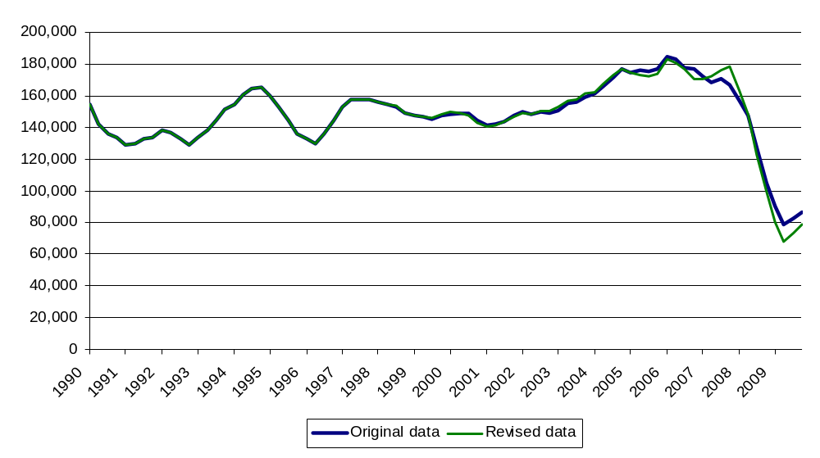

The effect of the revision is minor up until around the start of 2007. The main changes occur in the 12 months to the December quarter 2007, with 11,630 more starts than previously reported, and in the 12 months to March 2009, with 10,160 fewer starts than previously reported. Taken together with other smaller changes, the overall effect for the house building starts series is that there were 13,340 fewer starts across the period 1990 to 2009 than previously reported.
The review of the system for reporting and incorporating the NHBC building control data did not identify any improvements that should be made to the completions data. Therefore they are unaffected.
For further details, please see the chapter Strengths and weaknesses of the data later in this statistical release.
Seasonal adjustment
Until the December quarter 2009 only private enterprise figures were seasonally adjusted in the seasonally adjusted starts and completions series. In the December quarter House Building release we announced that we had found that a substantial degree of seasonality was also present in both the starts and completions series for Registered Social Landlords and that we intended to introduce seasonal adjustment for this tenure in our next release. We have now done so and seasonally adjusted the historic time series back to 1990. The Registered Social Landlord tenure accounts for only a minority of new house building so the effect on the overall seasonally adjusted series is relatively modest.

Starts and completions in England, seasonally adjusted
Figures for private enterprise and registered social landlords are seasonally adjusted. Local authority figures do not display seasonality and are therefore not seasonally adjusted. The seasonally adjusted series should be used for quarter on quarter comparisons. For annual comparisons the non-seasonally adjusted series should be used.
Seasonally adjusted housing starts in England rose by 13 per cent from 22,030 in the December quarter 2009 to 24,930 in the March quarter 2010. This is 13 per cent higher than in the previous quarter and 62 per cent above the trough in the March quarter 2009, but 49 per cent below their March quarter 2007 peak.

Figure 1: Seasonally adjusted trends in quarterly housing starts and completions, England
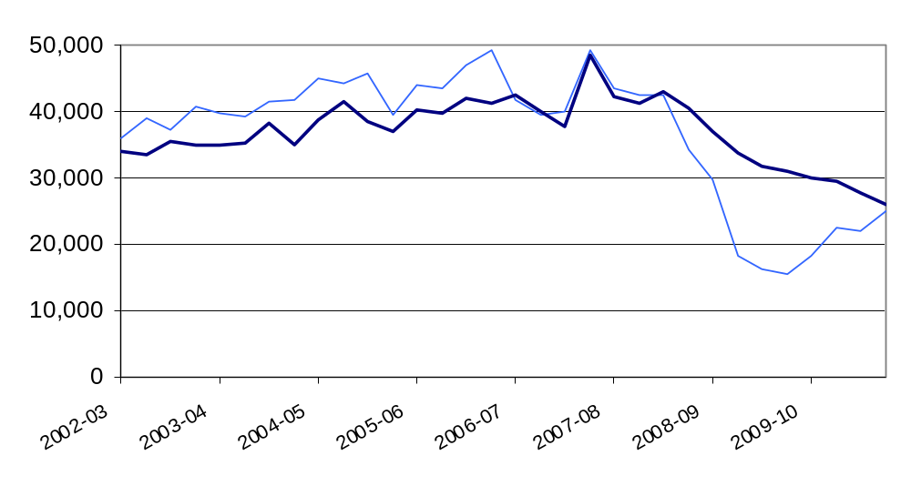

Seasonally adjusted private enterprise housing starts were 16 per cent higher in the March 2010 quarter than in the December 2009 quarter. By comparison, starts by Registered Social Landlords remained the same over the same period.

Table 1a: Quarterly housing starts by tenure, England, seasonally adjusted¹
 |  |  | Private  Enterprise |  | Registered  Social Landlords |  | Local  Authority | All  Tenures
 |  |  | Starts | % change on previous quarter | Starts | % change on previous quarter | Starts | Starts | % change on previous quarter
2006-07 | Apr-June | ^{R} | 37,230 | -13% | 4,430 | -30% | 90 | 41,750 | -15%
 | July-Sept | ^{R} | 34,520 | -7% | 4,860 | 10% | 30 | 39,400 | -6%
 | Oct-Dec | ^{R} | 34,320 | -1% | 5,600 | 15% | 30 | 39,950 | 1%
 | Jan-Mar | ^{R} | 43,260 | 26% | 6,000 | 7% | 50 | 49,300 | 23%
2007-08 | Apr-June | ^{R} | 38,140 | -12% | 5,380 | -10% | 70 | 43,590 | -12%
 | July-Sept | ^{R} | 36,610 | -4% | 5,910 | 10% | 30 | 42,550 | -2%
 | Oct-Dec | ^{R} | 36,330 | -1% | 6,110 | 3% | 10 | 42,450 | 0%
 | Jan-Mar | ^{R} | 27,810 | -23% | 6,460 | 6% | 80 | 34,350 | -19%
2008-09 | Apr-June | ^{R} | 23,140 | -17% | 6,490 | 0% | 120 | 29,750 | -13%
 | July-Sept | ^{R} | 12,960 | -44% | 5,310 | -18% | 10 | 18,290 | -39%
 | Oct-Dec | ^{R} | 11,740 | -9% | 4,390 | -17% | 160 | 16,290 | -11%
 | Jan-Mar | ^{R} | 11,580 | -1% | 3,820 | -13% | 20 | 15,420 | -5%
2009-10 | Apr-June | ^{R} | 14,310 | 24% | 3,940 | 3% | 50 | 18,300 | 19%
 | July-Sept | ^{R} | 17,340 | 21% | 5,050 | 28% | 30 | 22,420 | 23%
 | Oct-Dec | ^{R} | 17,320 | 0% | 4,650 | -8% | 60 | 22,030 | -2%
 | Jan-Mar | ^{P} | 20,080 | 16% | 4,650 | 0% | 200 | 24,930 | 13%
1. Because the number of local authority housing starts and completions is very small, quarterly comparisons can be very volatile. Accordingly percentage changes are not reported for this tenure.

Housing completions in England (seasonally adjusted) were down by six per cent to 26,090 in the March quarter 2010, from 27,640 in the previous quarter. This compares to a seven per cent fall between the September 2009 and the December 2009 quarters.
Seasonally adjusted private enterprise housing completions were eight per cent lower in the March 2010 quarter than in the December 2009 quarter. By comparison, completions by Registered Social Landlords rose by three per cent over the same period.

Table 1b: Quarterly housing completions by tenure, England, seasonally adjusted¹
 |  |  | Private  Enterprise |  | Registered  Social Landlords |  | Local  Authority | All  Tenures
 |  |  | Completions | % change on  previous quarter | Completions | % change on  previous quarter | Completions | Completions | % change on  previous quarter
2006-07 | Apr-June | ^{R} | 37,010 | 1% | 5,320 | 16% | 60 | 42,390 | 3%
 | July-Sept | ^{R} | 34,260 | -7% | 5,700 | 7% | 60 | 40,010 | -6%
 | Oct-Dec | ^{R} | 32,460 | -5% | 5,150 | -10% | 50 | 37,660 | -6%
 | Jan-Mar | ^{R} | 42,910 | 32% | 5,580 | 8% | 90 | 48,580 | 29%
2007-08 | Apr-June | ^{R} | 37,120 | -13% | 5,080 | -9% | 170 | 42,360 | -13%
 | July-Sept | ^{R} | 36,230 | -2% | 5,070 | 0% | 60 | 41,360 | -2%
 | Oct-Dec | ^{R} | 36,870 | 2% | 6,220 | 23% | 20 | 43,110 | 4%
 | Jan-Mar | ^{R} | 34,100 | -8% | 6,480 | 4% | 50 | 40,620 | -6%
2008-09 | Apr-June | ^{R} | 30,600 | -10% | 6,260 | -3% | 140 | 37,000 | -9%
 | July-Sept | ^{R} | 27,680 | -10% | 6,080 | -3% | 60 | 33,820 | -9%
 | Oct-Dec | ^{R} | 24,780 | -10% | 6,810 | 12% | 180 | 31,770 | -6%
 | Jan-Mar | ^{R} | 24,560 | -1% | 6,310 | -7% | 180 | 31,050 | -2%
2009-10 | Apr-June | ^{R} | 23,630 | -4% | 6,400 | 1% | 70 | 30,100 | -3%
 | July-Sept | ^{R} | 22,490 | -5% | 6,990 | 9% | 100 | 29,580 | -2%
 | Oct-Dec | ^{R} | 22,020 | -2% | 5,580 | -20% | 50 | 27,640 | -7%
 | Jan-Mar | ^{P} | 20,280 | -8% | 5,760 | 3% | 60 | 26,090 | -6%
1. Because the number of local authority housing starts and completions is very small, quarterly comparisons can be very volatile. Accordingly percentage changes are not reported for this tenure.
Starts and completions in England, non-seasonally adjusted
These series are not seasonally adjusted it may be misleading to draw conclusions from quarter on quarter changes. For quarter on quarter comparisons the seasonally adjusted series should be used.
Annual housing starts increased from 150,700 in the 12 months ending December 2002, reaching a peak of 183,360 in the 12 months ending March 2006. Starts then fell to 68,300 in the 12 months to June 2009 before rising to 87,360 in the 12 months to March 2010, 52 per cent below the peak.
Annual housing completions increased from 129,870 in the 12 months ending March 2002, reaching a peak of 174,900 in the 12 months ending December 2007. Completions have now fallen to 113,420 in the 12 months to March 2010, 33 per cent below the peak.

Figure 2: Trends in starts and completions, England, 12 month rolling totals
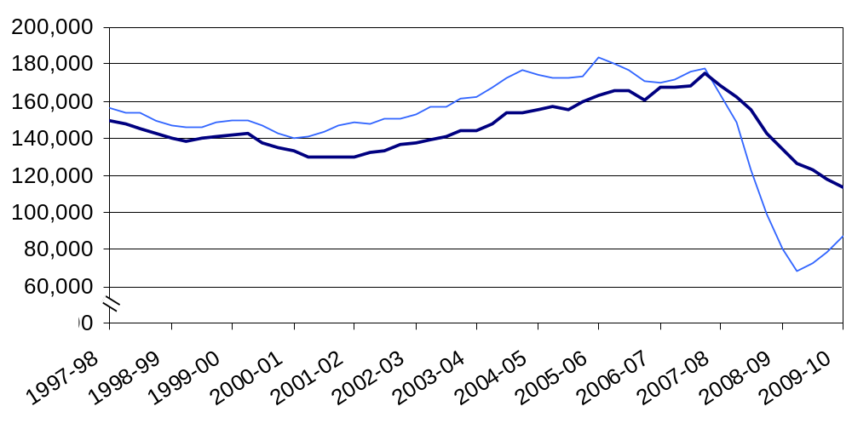
Housing starts were 60 per cent higher in the March quarter 2010 than in the March quarter 2009. This compares with a 36 per cent rise between the December 2008 and the December 2009 quarters.

Private enterprise housing starts were 72 per cent higher in the March 2010 quarter than in the March 2009 quarter. By comparison, starts by Registered Social Landlords rose by 22 per cent over the same period.

Table 2a: Quarterly housing starts by tenure, England, not seasonally adjusted¹
 |  |  | Private  Enterprise |  | Registered  Social Landlords |  | Local  Authority | All  Tenures
 |  |  | Starts | % change on same quarter previous year | Starts | % change on same quarter previous year | Starts | Starts | % change on same quarter previous year
2006-07 | Apr-June | ^{R} | 38,900 | -5% | 4,960 | -14% | 90 | 43,960 | -6%
 | July-Sept | ^{R} | 36,420 | -9% | 4,740 | -10% | 30 | 41,190 | -9%
 | Oct-Dec | ^{R} | 30,990 | -15% | 4,790 | -7% | 30 | 35,810 | -14%
 | Jan-Mar | ^{R} | 43,040 | 0% | 6,280 | -5% | 50 | 49,370 | -1%
2007-08 | Apr-June | ^{R} | 39,510 | 2% | 6,030 | 22% | 70 | 45,610 | 4%
 | July-Sept | ^{R} | 39,170 | 8% | 5,760 | 21% | 30 | 44,960 | 9%
 | Oct-Dec | ^{R} | 32,880 | 6% | 5,250 | 10% | 10 | 38,140 | 7%
 | Jan-Mar | ^{R} | 27,450 | -36% | 6,780 | 8% | 80 | 34,300 | -31%
2008-09 | Apr-June | ^{R} | 23,810 | -40% | 7,260 | 20% | 120 | 31,180 | -32%
 | July-Sept | ^{R} | 14,040 | -64% | 5,150 | -10% | 10 | 19,210 | -57%
 | Oct-Dec | ^{R} | 10,650 | -68% | 3,790 | -28% | 160 | 14,600 | -62%
 | Jan-Mar | ^{R} | 11,320 | -59% | 4,020 | -41% | 20 | 15,370 | -55%
2009-10 | Apr-June | ^{R} | 14,690 | -38% | 4,390 | -40% | 50 | 19,120 | -39%
 | July-Sept | ^{R} | 18,920 | 35% | 4,900 | -5% | 30 | 23,850 | 24%
 | Oct-Dec | ^{R} | 15,730 | 48% | 4,030 | 6% | 60 | 19,810 | 36%
 | Jan-Mar | ^{P} | 19,480 | 72% | 4,890 | 22% | 200 | 24,570 | 60%

1. Because the number of local authority housing starts and completions is very small, quarterly comparisons can be very volatile. Accordingly percentage changes are not reported for this tenure.

Housing completions were 16 per cent lower in the March quarter 2010 than in the March quarter 2009. This compares with a decline of 13 per cent between the December 2008 and the December 2009 quarters.

Private enterprise housing completions were 17 per cent lower in the March 2010 quarter than in the March 2009 quarter. By comparison, completions by Registered Social Landlords fell by nine per cent over the same period.

Table 2b: Quarterly housing completions by tenure, England, not seasonally adjusted¹
 |  |  | Private  Enterprise |  | Registered  Social Landlords |  | Local  Authority | All  Tenures
 |  |  | Completions | % change on same quarter previous year | Completions | % change on same quarter previous year | Completions | Completions | % change on same quarter previous year
2006-07 | Apr-June |  | 38,350 | 4% | 4,840 | 18% | 60 | 43,250 | 6%
 | July-Sept |  | 32,340 | -4% | 5,270 | 21% | 60 | 37,670 | -1%
 | Oct-Dec |  | 36,550 | -13% | 5,620 | 18% | 50 | 42,220 | -10%
 | Jan-Mar |  | 38,450 | 18% | 6,010 | 22% | 90 | 44,540 | 18%
2007-08 | Apr-June |  | 38,490 | 0% | 4,600 | -5% | 170 | 43,260 | 0%
 | July-Sept |  | 33,950 | 5% | 4,680 | -11% | 60 | 38,680 | 3%
 | Oct-Dec |  | 41,590 | 14% | 6,810 | 21% | 20 | 48,420 | 15%
 | Jan-Mar | ^{P} | 30,720 | -20% | 7,010 | 17% | 50 | 37,780 | -15%
2008-09 | Apr-June | ^{P} | 31,730 | -18% | 5,640 | 23% | 140 | 37,510 | -13%
 | July-Sept | ^{P} | 25,800 | -24% | 5,590 | 20% | 60 | 31,450 | -19%
 | Oct-Dec | ^{P} | 28,000 | -33% | 7,470 | 10% | 180 | 35,660 | -26%
 | Jan-Mar | ^{P} | 22,180 | -28% | 6,840 | -2% | 180 | 29,210 | -23%
2009-10 | Apr-June | ^{P} | 24,490 | -23% | 5,740 | 2% | 70 | 30,300 | -19%
 | July-Sept | ^{P} | 20,960 | -19% | 6,420 | 15% | 100 | 27,480 | -13%
 | Oct-Dec | ^{P} | 24,830 | -11% | 6,140 | -18% | 50 | 31,030 | -13%
 | Jan-Mar | ^{P} | 18,330 | -17% | 6,230 | -9% | 60 | 24,620 | -16%

1. Because the number of local authority housing starts and completions is very small, quarterly comparisons can be very volatile. Accordingly percentage changes are not reported for this tenure.

Regional trends
Comparisons between regional and national figures in this section are based on the non-seasonally adjusted series. It is our policy only to seasonally adjust England figures at national level.

Eight out of the nine regions experienced a rise in annual starts between 12 months ending March 2009 and 12 months ending March 2010. Only London experienced a fall in starts between these two periods (see Figures 3a, 3b and 3c below).
In the 12 month period ending March 2010, the number of housing starts was highest in the South East and lowest in the North East, accounting for 22 per cent and four per cent respectively of starts in England.

In all regions starts were higher in the March quarter 2010 than in the March quarter 2009. The largest increases were experienced in the East of England (124%), the North West (110%) and Yorkshire and the Humber (58%).

Figure 3a: Trends in housing starts in the North East, North West and Yorkshire and the Humber, 12 month rolling totals
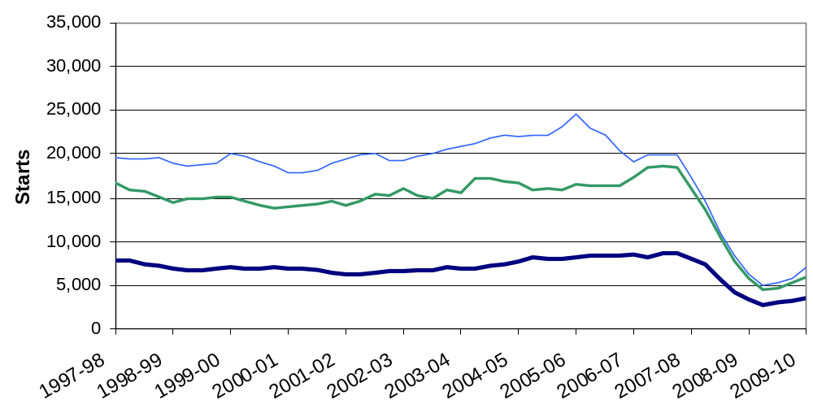

Figure 3b: Trends in housing starts in the East of England, East Midlands and West Midlands, 12 month rolling totals
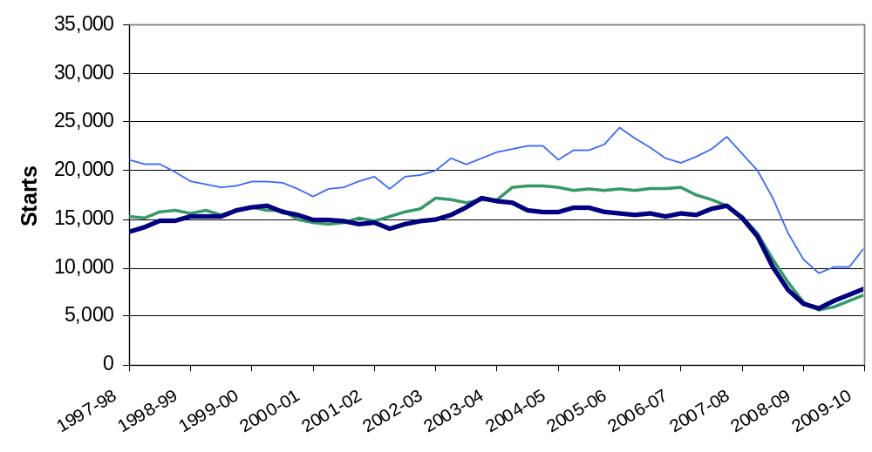

Figure 3c: Trends in housing starts in London, the South East and South West, 12 month rolling totals
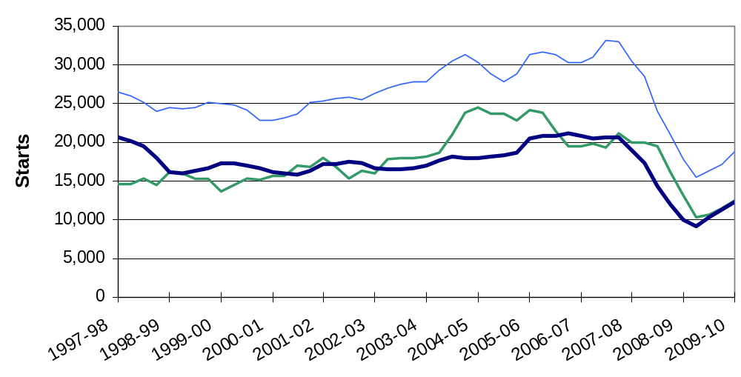

Eight out of the nine regions experienced a fall in annual completions between 12 months ending March 2009 and 12 months ending March 2010, only London experienced a rise of one per cent (see Figures 4a, 4b and 4c below).
In the 12 month period ending March 2010, the number of housing completions was highest in the South East and lowest in the North East, accounting for 21 per cent and four per cent respectively of completions in England.

Completions were higher in the North East (17%) and in the East Midlands (five per cent) in the March quarter 2010 than in the March quarter 2009. In all other regions completions were lower in the March quarter 2010 than in the March quarter 2009. The largest falls were experienced in the Yorkshire and the Humber (38%), the West Midlands (32%) and in the South East (22%).

Figure 4a: Trends in housing completions in the North East, North West and Yorkshire and the Humber, 12 month rolling totals
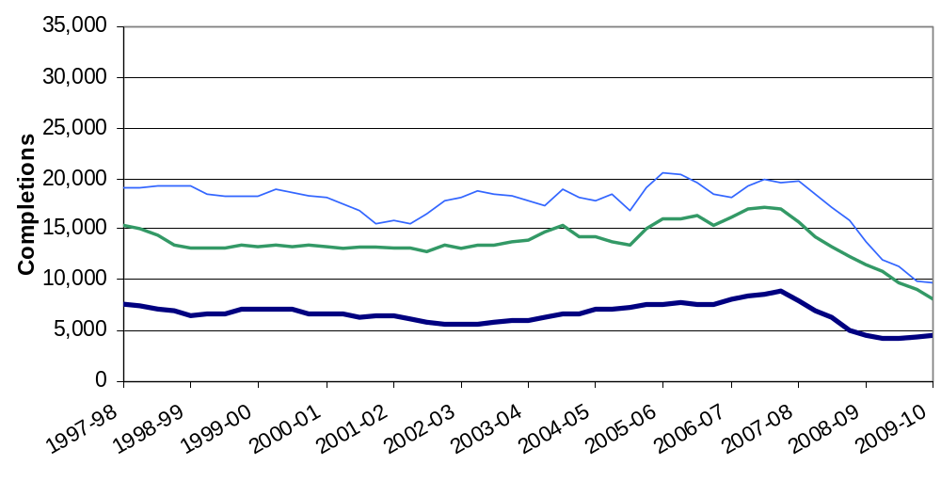

Figure 4b: Trends in housing completions in the East of England, East Midlands and West Midlands, 12 month rolling totals
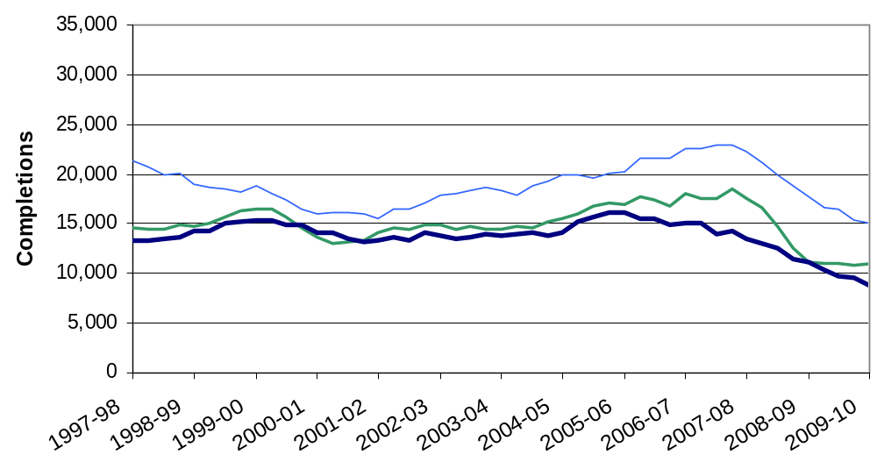

Figure 4c: Trends in housing completions in London, the South East and South West, 12 month rolling totals
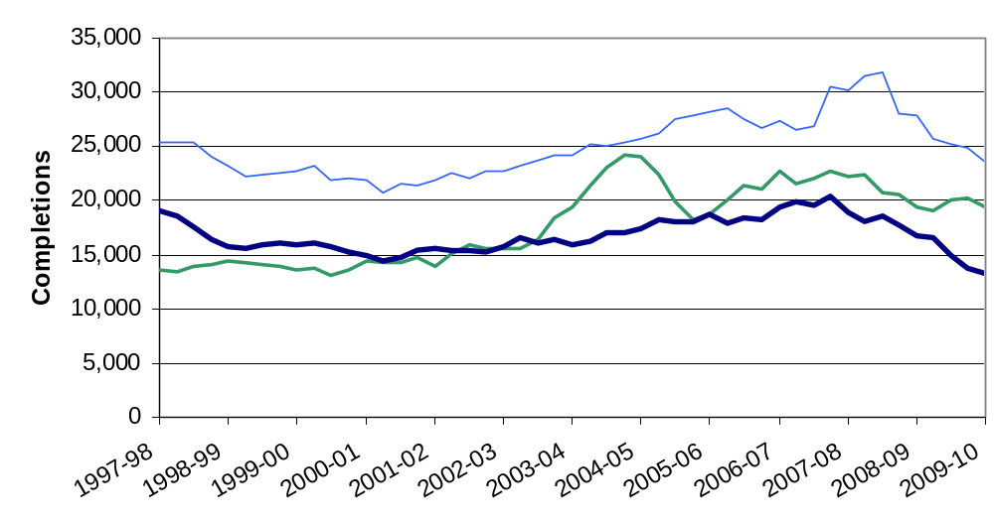

Other Approved Inspectors

In addition to local authorities and the National House-Building Council, house building starts and completions can be certified by other independent Approved Inspectors. The numbers in this release do not include activity for these other Approved Inspectors and, as such, are underestimates of the true level of house building starts and completions. We have now begun collecting information from other Approved Inspectors in order to gain a complete picture of house building activity.

In the 2008-09 financial year approximately six per cent of all starts and four per cent of completions were inspected by other independent Approved Inspectors. At national level this translates to approximately 6,000 extra house building starts and approximately 5,000 extra completions for the 2008-09 financial year.

SAP ratings
SAP refers to the Government's 'Standard Assessment Procedure' for assessing the energy performance of dwellings. The SAP rating is based on the energy costs associated with space heating, water heating, ventilation and lighting, less cost savings from energy generation technologies. It is adjusted for floor area so that it is essentially independent of dwelling size for a given built form. The SAP rating is expressed on a scale of 1 to 100 - the higher the number, the lower the running costs.
This release covers quarterly data for the Government Office Regions (GORs) of England and Wales for March quarter 2010.
The key points
In the March quarter 2010:
• The average energy efficiency, SAP rating, of new homes in England was 79.0 and in Wales 78.8.
• Regionally, the average energy efficiency (SAP rating) of new homes varied from 76.3 in the North West to 81.1 in the North East.
• By dwelling type, in England, the average energy efficiency (SAP rating) ranged from 77.3 for bungalows to 80.2 for maisonettes.
• In Wales, the average energy efficiency (SAP rating) by dwelling type ranged from 74.7 for bungalows, to 83.0 for maisonettes.

Code for Sustainable Homes
Statistics relating to the Code for Sustainable Homes’ (the Code) show the number of dwellings that have been certified to the standards set out in the Code Technical Guide and at which level. Certificates are issued at two stages, the design stage and post construction stage.
The Code takes a whole house approach and measures the sustainability of a dwelling against nine different categories. Energy/CO2, Water, Waste, Materials, Surface water run-off and Health and well being, which have mandatory performance standards, and Pollution, Ecology and Management. To achieve the levels of the Code a number of points must be accumulated across all categories and the mandatory requirements must be met. Depending on the number of points gathered, a star rating is then awarded (one star being the lowest achievable level and six stars being a zero carbon home). If a dwelling does not achieve the mandatory standards and/or does not reach the minimum score for a one star rating, it will receive a certificate with no stars.
The key points
- The Code came into operation in April 2007. Because it takes approximately 18 months to two years to design and build a Code home, the first homes built to the Code standard were not awarded a certificate until 2008. Since then there have been regular monthly increases in the number of certificates awarded.
- Since April 2007, 15,434 dwellings have received a three star rating at in the design stage and 104 dwellings have received a six star rating.
- Since April 2007, 4,384 dwellings have received a three star rating at post-construction stage and seven dwellings have received a six star rating.
- A total of 89% of the certificates at design stage and 90% of those at post construction stage have been awarded at Code level 3 since April 2007.

House building targets

House building:
House building figures are a leading indicator for monitoring the 2007 Comprehensive Spending Review (CSR07) target to increase the number of net additional homes provided per annum to 240,000 by 2016. Progress against the above target is published on an annual basis; the latest figures for 2008-09 show that the number of net additional homes reached 166,570 dwellings.
The new Government has set out its intention to abolish the current national house building target and will set out the detail for doing this in due course.
New build completions fell by 20 per cent between 2007-08 and 2008-09, and completions in financial year 2009-10 were 15 per cent lower than in financial year 2008-09. Thus, it is likely that the number of net additional homes will fall between 2008-09 and 2009-10.

SAP ratings:
The data have been used to measure the Departmental Strategic Objective 2.5: Average Energy Efficiency (SAP rating) of new homes.

Data collection

House building:
This release takes information from two data sources on building control:
- around half of the new build activity is recorded through P2 quarterly house building returns submitted to Communities and Local Government by local authority building control departments; and
- quarterly information from the National House-Building Council (NHBC) on the volume of building control inspections they undertake in each local authority.

SAP ratings:
Figures for the Average Energy Efficiency of New Homes (SAP ratings) are held on the National Energy Performance Certificate Register, managed by Landmark Information Group. This database is subject to ad-hoc reporting, and as such, all figures at publication should be viewed as provisional. The figures may change in subsequent publications as revisions are made and previously incomplete entries are added to the database by Landmark.

Code for Sustainable homes:
Data for each dwelling assessed under the Code are collected by one of two Code Service Providers of the scheme (BRE Global Ltd and Stroma Accreditation Ltd). Assessment is a two stage process – design and post construction stage and is carried out by licensed Code assessors. Assessors submit their reports to the Code Service Provider and after quality assurance checks have been made certificates are issued by the Code Service Provider.

Information regarding each certified dwelling is taken from the Code Service Provider’s databases and collated into a central database for Communities and Local Government by BRE Global Ltd on a monthly basis.

Strengths and weaknesses of the data
House building:
The P2 data received from local authorities record starts and completions inspected by local authority building control and include imputation for a small number of missing returns; in the March quarter 2010, a 93 per cent local authority response rate was achieved.
The NHBC figures record all starts and completions inspected by NHBC building control.
In recent months we have been working closely with the NHBC to review the mechanism for reporting and incorporating these data alongside the P2 data.

This review identified several changes that could be made to the way the data are processed which would improve the accuracy and timeliness of the starts series:

The change with the largest effect concerns the timing with which starts appear in the dataset but has a neutral overall effect on the number of starts reported. Previously, when the start of work on a new dwelling was inspected, if some of the information relating to it was not initially clear the reporting of the start was in some cases delayed, causing it to appear in the statistics several quarters later than its true date. Under the improved system this delay is eliminated.
- Another, lesser change relates to the total number of starts in the dataset. When an Approved Inspector is employed by a house-builder to carry out the building control ‘commencement’ inspection on a new start, the start is added to Communities and Local Government’s dataset together with the date at which the commencement inspection will take place. In a small minority of cases, the inspection is subsequently cancelled. The previous data supply arrangements meant that in some such cases this cancellation was not reported to Communities and Local Government resulting in a small overestimate of the number of starts reported in the statistics. Under the improved system most of these cancelled commencement inspections are eliminated.

We have now also implemented these improvements retrospectively to the historical data and revised the starts time series accordingly.
In addition to local authorities and the NHBC, house building starts and completions can be certified by other independent Approved Inspectors. This release does not include activity for these other Approved Inspectors and, as such, the numbers in this release are underestimates of the true level of starts and completions but represent our best estimates at this time. We have included an estimate of the number of house building starts and completions certified by these other Approved Inspectors in the 2008-09 financial year in a separate chapter. We have now begun collecting information from other Approved Inspectors in order to gain a complete picture of house building activity.
The house building data in this release are not used directly to monitor progress towards the Department’s net additional homes target, but the figures are used to provide an early indication of trends in net additional dwellings and more generally to provide information on the state of the housing market.

SAP ratings:
The energy efficiency rating, on a quarterly basis, is volatile due to a number of factors including the small number of new homes being assessed, the mix of dwelling types, the mix of heating systems used in new developments and the location of those developments.

Substantial revisions have been made to the data, by dwelling type, for Wales since publication for the last quarter. They have been updated to reflect the clearance of a backlog on the Certificate Register. A couple of minor revisions were also made to the regional data for England.

Code for Sustainable homes:
The two current Code Service Providers operate schemes to train and license assessors through UKAS accredited procedures.

The data collected by Code Service Providers are based on the certificates issued which are then reported to Communities and Local Government on a monthly basis. This process is audited by UKAS under certification standards EN 45011 and/or ISO 17024.

Data on the number of nil-rated certificates that have been included in Home Information Packs have not been collected. This sustainability certificate in HIPs could be in the form of a Code certificate if the home was built and assessed under the standards set out in the Code for Sustainable Homes or a ‘nil-rated’ certificate if the seller chooses not to have the dwelling assessed.

Accompanying tables
Accompanying tables are available to download alongside this release:

Tables:
1a House building starts and completions, including seasonally adjusted series: England;

1b House building starts and completions unadjusted: North East;
1c House building starts and completions unadjusted: North West;

1d House building starts and completions unadjusted: Yorkshire and the Humber;
1e House building starts and completions unadjusted: East Midlands;

1f House building starts and completions unadjusted: West Midlands;
1g House building starts and completions unadjusted: East of England;

1h House building starts and completions unadjusted: London;
1j House building starts and completions unadjusted: South East;

1k House building starts and completions unadjusted: South West;
2a House building starts and completions unadjusted: Wales;
2b House building starts and completions unadjusted: Scotland;
2c House building starts and completions unadjusted: Great Britain;
2d House building starts and completions unadjusted: Northern Ireland;
2e House building starts and completions unadjusted: United Kingdom;
3a House building average energy efficiency (SAP only) of new homes: England & Wales by region;
3b House building average energy efficiency (SAP only) of new homes: England & Wales by type;
4 Code for Sustainable Homes: England, Wales and Northern Ireland;
Additional tables, earlier quarterly data and historic series can be accessed in the 'Live tables' section ("Live tables on house building") at www.communities.gov.uk/housingstatistics.
All statistical releases on house building can be accessed on the Communities and Local Government website at http://www.communities.gov.uk/housing/housingresearch/housingstatistics/housingstatisticsby/housebuilding/publicationsonhousebuilding/.
More information about the Code for Sustainable Homes is available on our website at www.communities.gov.uk/thecode.

Notes to the tables
The following conventions have been used in the tables:
.. Not available;
- Fewer than 5 dwellings;
^{P} Figure provisional and subject to revision;
^{R} Revised from previous release.
Totals may not equal the sum of component parts due to rounding to the nearest 10.

Background notes
- The starts and completions reported in this publication are for new house building in England and exclude conversions and change of use.
- Figures in the accompanying tables are presented rounded to the nearest 10 dwellings.
- Sources are shown at the foot of individual accompanying tables and live tables.
- The charts give seasonally adjusted quarterly house building trends and give annual trends by showing a rolling 12 month total. Both the private enterprise and Registered Social Landlord England series are seasonally adjusted.
- Accompanying Table 1a gives non-seasonally adjusted and seasonally adjusted England figures. All figures for other countries and the English regions are shown on an unadjusted basis only.
- The Registered Social Landlord (RSL) category includes dwellings built for housing associations and Local Housing Companies that are registered with the Tenant Services Authority (previously the Housing Corporation) and also for unregistered social landlords.
- Figures on housing starts and completions are from records kept for building control purposes. It is sometimes difficult for data providers to identify whether a dwelling is being built for a housing association or for a private developer. This may lead to an understatement of Registered Social Landlord starts and completions recorded in these tables, and a corresponding overstatement of private enterprise figures. This problem is more likely to occur with starts than completions.
- National Statistics are produced to high professional standards set out in the Code of Practise for Official Statistics. They undergo regular quality assurance reviews to ensure that they meet customer needs. Following a review, we have made improvements to the compilation of house building starts; and we have introduced seasonal adjustment to the RSL starts and completions series.
- SAP data in this release are published as Official Statistics, they are not National Statistics.
- In the short-term interests of expanding the scope of official statistics, their timeliness, and their accessibility, the Department has included summary statistics on the Code for Sustainable Homes within this quarterly House Building release. The Code for Sustainable Homes data in this release are published as Official Statistics, they are not National Statistics. Thereafter, it is proposed that statistics on the Code for Sustainable Homes be released in more detail, and at a later date as a standalone publication. The date of release will be pre-announced in the usual way on Communities and Local Government's website and on the Release Calendar attached to the Publication Hub.
- The tables and charts accompanying this release are shown above in the ‘Accompanying tables’ section and are provided in Microsoft Excel format.
- Additional tables showing house building completions by type and size of property and starts and completions for individual local authorities can be found in the Communities and Local Government Housing Live Tables.
- Data in this release have been revised for the December quarter 2009 to incorporate any changes made by local authorities in their returns to Communities and Local Government. The data from the March quarter 2008 to the March quarter 2010 in this release are provisional and subject to revision.
- Details of officials who receive pre-release access to the Communities and Local Government quarterly House Building release up to 24 hours before release can be found at:
http://www.communities.gov.uk/corporate/researchandstatistics/statistics/nationalstatistics/
Separate lists for the SAP and the Code for Sustainable Homes releases have been drafted and published, officials on these lists only have access to the paragraphs on SAP ratings and on the Code for Sustainable Homes in this release.
- The next quarterly release will be published on Thursday 19 August 2010, and will cover house building up to the June quarter 2010.

User consultation
Users’ comments on any issues relating to this statistical release are welcomed and encouraged. Responses should be addressed to the "statistical enquiries" contact given in the "Enquiries" section below.

Enquiries

Media Enquiries:
office hours: 0303 44 41136
out of hours: 0303 44 41201
e-mail: press@communities.gov.uk

Statistical enquiries:
e-mail: housing.statistics@communities.gov.uk
telephone: 0303 444 2272
Department for Communities and Local Government. © Crown Copyright, 2010

If you require this publication in an alternative format please email: alternativeformats@communities.gsi.gov.uk. Please note that the nature of content means that we may not be able to provide the Statistical series of publications in all requested formats.

May 2010

ISBN: 978-1-4098-1193-0

