
House Building: March Quarter 2011, England
- Seasonally adjusted house building starts stood at 29,140 in the March quarter 2011. This is 26 per cent higher than in the December quarter 2010 and 88 per cent above the trough in the March quarter 2009, but 41 per cent below their March quarter 2007 peak.
- Private enterprise housing starts (seasonally adjusted) were 24 per cent higher than in the December quarter 2010. Starts by housing associations were also up, 37 per cent higher than the previous quarter.
- Housing completions in England (seasonally adjusted) also increased this quarter, up 25 per cent from 23,500 in December quarter 2010 to 29,380 in the March quarter 2011. This compares to a 12 per cent fall between the September 2010 and the December 2010 quarters.
- Private enterprise housing completions (seasonally adjusted) were 23 per cent higher in the March 2011 quarter than in the December 2010 quarter. Completions by housing associations increased by 29 per cent between the December quarter 2010 and March quarter 2011.
- Annual housing starts reached 106,590 in the 12 months to March 2011, up by 22 per cent compared with the 12 months to March 2010. Annual housing completions in England totalled 105,930 in the 12 months to March 2011, down by 7 per cent compared with the 12 months to March 2010.



Contents
1. | Seasonally adjusted results…………………..... | 2
2. | Non-seasonally adjusted results……………………... | 4
3. | Sub-national trends……… | ...6
4. | Other Approved  Inspectors………………... | .12
5. | Data collection………… | .13
6. | Data quality…………….... | .13
7. | Use of house building  data……………………….. | .15
8. | Related statistics……...… | .15
9. | Revisions policy…………. | 17
10. | Definitions………………... | .18
11. | Accompanying tables…... | .19
12. | Background notes............ | .20
13. | User consultation……….. | .20
14. | Enquiries………............... | .21

Responsible statistician:
Richard Field

Statistical enquiries:
office hours: 0303 44 42345
housing.statistics@communities.gov.uk

Media Enquiries:
office hours: 0303 44 41136
out of hours: 0303 44 41201

press@communities.gov.uk

Housing
Statistical Release

19 May 2011
using
Research
Summary
Number 239, 2007

This quarterly Statistical Release presents National Statistics on new house building starts and completions in England and its regions up to the March quarter 2011. The figures in this release have been revised back to the December quarter 2010 to incorporate late information provided by local authorities, in line with our regular revisions policy.
Data for Scotland, Wales and Northern Ireland are also included in the accompanying tables. These data are published separately by the devolved administrations, and although the figures are correct at the time of this publication they may be superseded before the next England house building release.
The Department for Communities and Local Government publishes two complementary statistical series on housing supply in England. A description of the relationship between the Net Supply of Housing statistics and the House Building statistics can be found in the “Related statistics” section of this publication.

Seasonally adjusted results
Figures for private enterprise and housing associations are seasonally adjusted. The seasonally adjusted series should be used for quarter on quarter comparisons. For annual comparisons the non-seasonally adjusted series should be used.

Figure 1: Seasonally adjusted trends in quarterly housing starts and completions, England
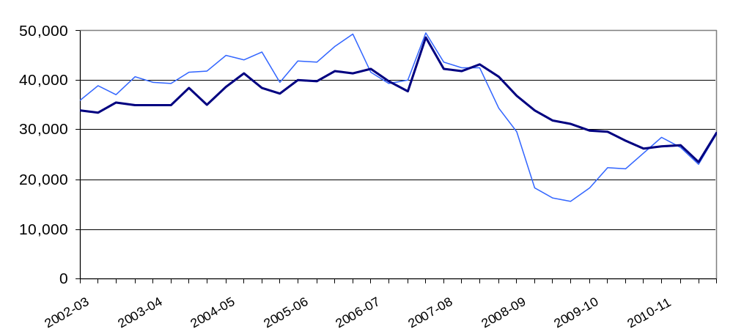

After a period of sustained growth from 2001 until late 2007, starts were strongly affected by the economic downturn and declined rapidly to a trough in March 2009. Completions responded much more gradually. Starts gradually began to recover from March 2009 and over the last three quarters the two series have converged and tracked each other closely. This indicates that the gradual recovery in starts is beginning to work its way through to completions, with new supply currently at approximately 60% of pre-downturn levels.
The ONS New Orders in Construction statistical series tracks the volume of new orders coming into the industry. This shows a gradual recovery in housing orders since the downturn which is broadly reflected in the trend displayed by the house building starts series.

Starts
Seasonally adjusted housing starts in England rose from 23,140 in the December quarter 2010 to 29,140 in the March quarter 2011. This is a 26 per cent quarter on quarter rise. Starts are still 41 per cent below their March quarter 2007 peak, but 88 per cent above the trough in the March quarter 2009.

Seasonally adjusted private enterprise housing starts were 24 per cent higher in the March 2011 quarter than in the December 2010 quarter and starts by housing associations grew even more strongly, by 37 per cent over the same period.

Table 1a: Quarterly housing starts by tenure, England, seasonally adjusted¹
 |  |  | Private  Enterprise |  | Housing  Associations |  | Local  Authority | All  Tenures
 |  |  | Starts | % change  on previous quarter | Starts | % change  on previous quarter | Starts | Starts | % change  on previous quarter
2008-09 | Apr-June |  | 23,120 | -17% | 6,470 | -1% | 120 | 29,710 | -14%
 | July-Sept |  | 13,030 | -44% | 5,270 | -18% | 10 | 18,310 | -38%
 | Oct-Dec |  | 11,830 | -9% | 4,400 | -17% | 160 | 16,380 | -11%
 | Jan-Mar |  | 11,640 | -2% | 3,850 | -12% | 20 | 15,510 | -5%
2009-10 | Apr-June | ^{P} | 14,260 | 22% | 3,930 | 2% | 50 | 18,240 | 18%
 | July-Sept | ^{P} | 17,350 | 22% | 5,030 | 28% | 30 | 22,410 | 23%
 | Oct-Dec | ^{P} | 17,340 | 0% | 4,680 | -7% | 50 | 22,070 | -2%
 | Jan-Mar | ^{P} | 20,360 | 17% | 4,750 | 1% | 200 | 25,300 | 15%
2010-11 | Apr-June | ^{P} | 22,320 | 10% | 5,570 | 17% | 560 | 28,460 | 12%
 | July-Sept | ^{P} | 21,330 | -4% | 4,790 | -14% | 280 | 26,400 | -7%
 | Oct-Dec | ^{R} | 18,990 | -11% | 3,790 | -21% | 350 | 23,140 | -12%
 | Jan-Mar | ^{p} | 23,580 | 24% | 5,180 | 37% | 380 | 29,140 | 26%
1. Because the number of local authority housing starts and completions is very small, quarterly comparisons can be very volatile. Accordingly percentage changes are not reported for this tenure.

Completions
Housing completions in England (seasonally adjusted) rose, up 25 per cent from 23,500 in the December quarter 2010 to 29,380 in the March quarter 2011. This compares to a 12 per cent fall between the September 2010 and the December 2010 quarters.
Seasonally adjusted private enterprise housing completions were 23 per cent higher in the March 2011 quarter than in the December 2010 quarter. Completions by housing associations also increased strongly; up by 29 per cent over the same period.

Table 1b: Quarterly housing completions by tenure, England, seasonally adjusted¹
 |  |  | Private  Enterprise |  | Housing  Associations |  | Local  Authority | All  Tenures
 |  |  | Comple-  tions | % change  on previous quarter | Comple-  tions | % change  on previous quarter | Comple-  tions | Comple-  tions | % change  on previous quarter
2008-09 | Apr-June |  | 30,500 | -11% | 6,280 | -3% | 140 | 36,920 | -9%
 | July-Sept |  | 27,840 | -9% | 6,050 | -4% | 60 | 33,950 | -8%
 | Oct-Dec |  | 24,900 | -11% | 6,850 | 13% | 180 | 31,930 | -6%
 | Jan-Mar |  | 24,770 | -1% | 6,260 | -9% | 130 | 31,160 | -2%
2009-10 | Apr-June | ^{P} | 23,440 | -5% | 6,400 | 2% | 130 | 29,960 | -4%
 | July-Sept | ^{P} | 22,540 | -4% | 7,070 | 10% | 80 | 29,690 | -1%
 | Oct-Dec | ^{P} | 22,050 | -2% | 5,660 | -20% | 30 | 27,740 | -7%
 | Jan-Mar | ^{P} | 20,430 | -7% | 5,790 | 2% | 60 | 26,280 | -5%
2010-11 | Apr-June | ^{P} | 20,800 | 2% | 5,710 | -1% | 80 | 26,600 | 1%
 | July-Sept | ^{P} | 21,880 | 5% | 4,810 | -16% | 140 | 26,830 | 1%
 | Oct-Dec | ^{R} | 17,860 | -18% | 5,230 | 9% | 420 | 23,500 | -12%
 | Jan-Mar | ^{P} | 22,050 | 23% | 6,720 | 29% | 610 | 29,380 | 25%
1. Because the number of local authority housing starts and completions is very small, quarterly comparisons can be very volatile. Accordingly percentage changes are not reported for this tenure.

Non-seasonally adjusted results
These series are not seasonally adjusted so it can be misleading to draw conclusions from quarter on quarter changes. For quarter on quarter comparisons the seasonally adjusted series should be used. Figure 2 uses 12-month rolling totals to show trends in non-seasonally adjusted results.
Figure 2: Trends in starts and completions, England, 12 month rolling totals
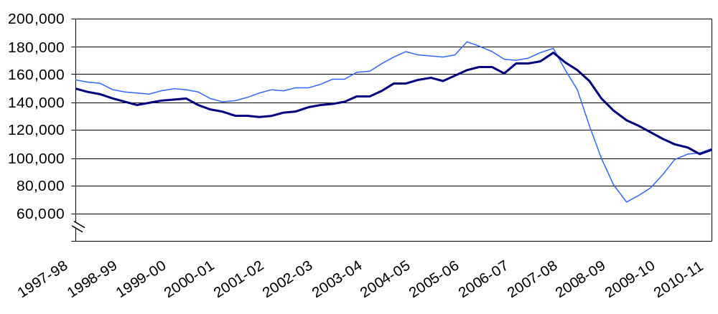
Annual housing starts increased from 150,700 in the 12 months ending December 2002, reaching a peak of 183,360 in the 12 months ending March 2006. Starts then fell to 68,450 in the 12 months to June 2009 before rising to 106,590 in the 12 months to March 2011, 42 per cent below the peak, but up by 56 per cent compared with the trough.
Annual housing completions increased from 129,870 in the 12 months ending March 2002, reaching a peak of 175,560 in the 12 months ending December 2007. Completions have now reached 105,930 in the 12 months to March 2011, 40 per cent below the peak.

Starts
Housing starts were 13 per cent higher in the March quarter 2011 than in the March quarter 2010. This compares with a three per cent rise between the December 2009 and December 2010 quarters.

Private enterprise housing starts were 14 per cent higher in the March 2011 quarter than in the March 2010 quarter. The positive trend was supported by housing associations new builds which rose by 8 per cent over the same quarter a year before.

Table 2a: Quarterly housing starts by tenure, England, not seasonally adjusted¹
 |  |  | Private  Enterprise |  | Housing  Associations |  | Local  Authority | All  Tenures
 |  |  | Starts | % change on same quarter previous year | Starts | % change on same quarter previous year | Starts | Starts | % change on same quarter previous year
2008-09 | Apr-June |  | 23,880 | -40% | 7,250 | 20% | 120 | 31,250 | -32%
 | July-Sept |  | 14,120 | -64% | 5,150 | -11% | 10 | 19,290 | -57%
 | Oct-Dec |  | 10,700 | -68% | 3,790 | -28% | 160 | 14,650 | -62%
 | Jan-Mar |  | 11,350 | -59% | 4,020 | -41% | 20 | 15,390 | -55%
2009-10 | Apr-June | ^{P} | 14,690 | -39% | 4,390 | -39% | 50 | 19,120 | -39%
 | July-Sept | ^{P} | 18,960 | 34% | 4,920 | -4% | 30 | 23,910 | 24%
 | Oct-Dec | ^{P} | 15,710 | 47% | 4,040 | 7% | 50 | 19,800 | 35%
 | Jan-Mar | ^{P} | 19,710 | 74% | 4,950 | 23% | 200 | 24,850 | 61%
2010-11 | Apr-June | ^{P} | 23,170 | 58% | 6,230 | 42% | 560 | 29,960 | 57%
 | July-Sept | ^{P} | 23,070 | 22% | 4,790 | -3% | 280 | 28,140 | 18%
 | Oct-Dec | ^{R} | 16,780 | 7% | 3,190 | -21% | 350 | 20,320 | 3%
 | Jan-Mar | ^{P} | 22,450 | 14% | 5,340 | 8% | 380 | 28,170 | 13%

1. Because the number of local authority housing starts and completions is very small, quarterly comparisons can be very volatile. Accordingly percentage changes are not reported for this tenure.

Completions

Housing completions were 13 per cent higher in the March quarter 2011 than in the March quarter 2010. This compares with a drop of 16 per cent between the December 2009 and the December 2010 quarters.

Private enterprise housing completions were eight per cent higher in the January 2011 quarter than in the January 2010 quarter. By comparison, completions by housing associations increased by 19 per cent over the same period.

Table 2b: Quarterly housing completions by tenure, England, not seasonally adjusted¹
 |  |  | Private  Enterprise |  | Housing  Associations |  | Local  Authority | All  Tenures
 |  |  | Comple-  tions | % change on same quarter previous year | Comple-  tions | % change on same quarter previous year | Comple-  tions | Comple-  tions | % change on same quarter previous year
2008-09 | Apr-June |  | 31,840 | -18% | 5,640 | 23% | 140 | 37,620 | -13%
 | July-Sept |  | 25,920 | -25% | 5,590 | 19% | 60 | 31,570 | -19%
 | Oct-Dec |  | 28,080 | -32% | 7,470 | 10% | 180 | 35,740 | -26%
 | Jan-Mar |  | 22,250 | -28% | 6,810 | -3% | 130 | 29,190 | -23%
2009-10 | Apr-June | ^{P} | 24,490 | -23% | 5,720 | 1% | 130 | 30,340 | -19%
 | July-Sept | ^{P} | 20,960 | -19% | 6,530 | 17% | 80 | 27,570 | -13%
 | Oct-Dec | ^{P} | 24,830 | -12% | 6,200 | -17% | 30 | 31,060 | -13%
 | Jan-Mar | ^{P} | 18,350 | -18% | 6,290 | -8% | 60 | 24,690 | -15%
2010-11 | Apr-June | ^{P} | 21,570 | -12% | 5,170 | -10% | 80 | 26,830 | -12%
 | July-Sept | ^{P} | 20,720 | -1% | 4,250 | -35% | 140 | 25,100 | -9%
 | Oct-Dec | ^{R} | 20,020 | -19% | 5,670 | -9% | 420 | 26,100 | -16%
 | Jan-Dec | ^{P} | 19,810 | 8% | 7,480 | 19% | 610 | 27,900 | 13%

1. Because the number of local authority housing starts and completions is very small, quarterly comparisons can be very volatile. Accordingly percentage changes are not reported for this tenure.

Sub-national trends

Comparisons between national, regional and district figures in this section are based on the non-seasonally adjusted series. It is our policy only to seasonally adjust England figures at national level. The graphs in this section use 12-month rolling totals to show trends in non-seasonally adjusted results.

Regional starts

For all regions, starts were higher in the financial year 2010/11 than in 2009/10. (See Figures 3a, 3b and 3c below). London saw the largest rise at 52 per cent.
In the 12 month period ending March 2011, the number of housing starts was highest in the South East (19,740) and lowest in the North East (4,600), accounting for 19 per cent and four per cent respectively of starts in England.
Comparing the March quarter 2011 with the March quarter a year before the picture is not quite so emphatic. In the North East, North West, Yorkshire and Humber and West Midlands starts were lower in the March quarter 2011 than in the March quarter 2010. The other regions saw a rise in starts over this period. The largest proportional increases were in London (73%) and the East Midlands (23%).

Figure 3a: Trends in housing starts in the North East, North West and Yorkshire and the Humber, 12 month rolling totals
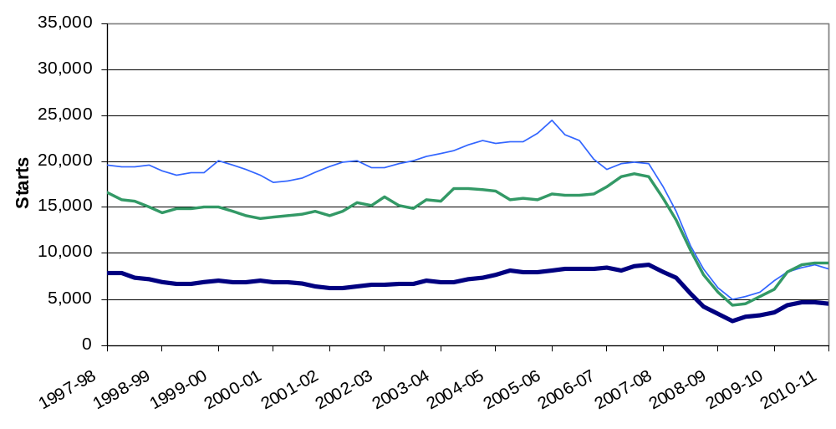

Figure 3b: Trends in housing starts in the East of England, East Midlands and West Midlands, 12 month rolling totals

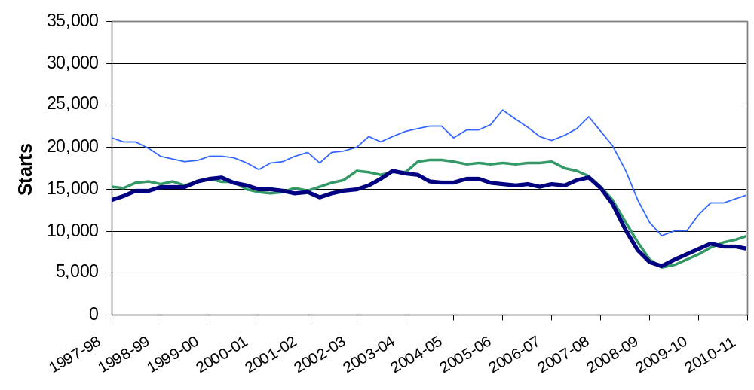

Figure 3c: Trends in housing starts in London, the South East and South West, 12 month rolling totals
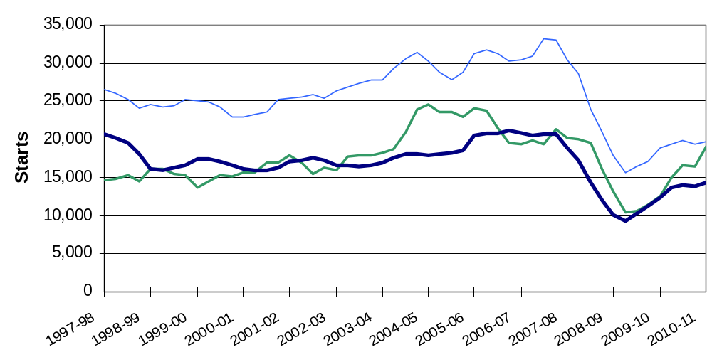

Regional completions

Most regions saw fewer completions in 2010/11 than in 2009/10. The SE saw the largest change, falling by 18 per cent. Yorkshire and Humber and the North East were the only exceptions showing increases of 10 per cent and 1 per cent respectively.

(see Figures 4a, 4b and 4c below).
In the 12 month period ending March 2011, the number of housing completions was highest in the South East (19,360) and lowest in the North East (4,610), accounting for 18 per cent and four per cent respectively of completions in England.

Completions were higher in all regions in the January quarter 2011 than in the January quarter 2010 with the exception of the North West, which fell by 22 percent.

Figure 4a: Trends in housing completions in the North East, North West and Yorkshire and the Humber, 12 month rolling totals
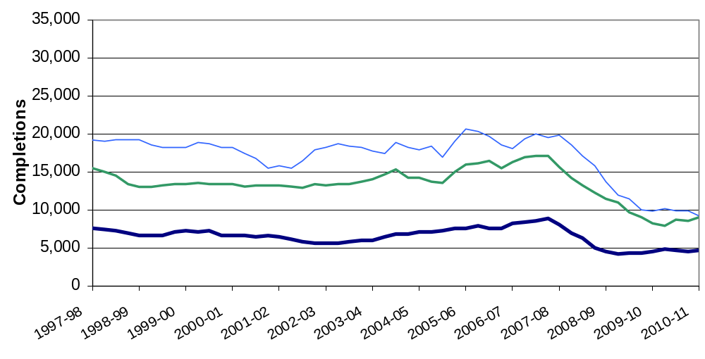

Figure 4b: Trends in housing completions in the East of England, East Midlands and West Midlands, 12 month rolling totals
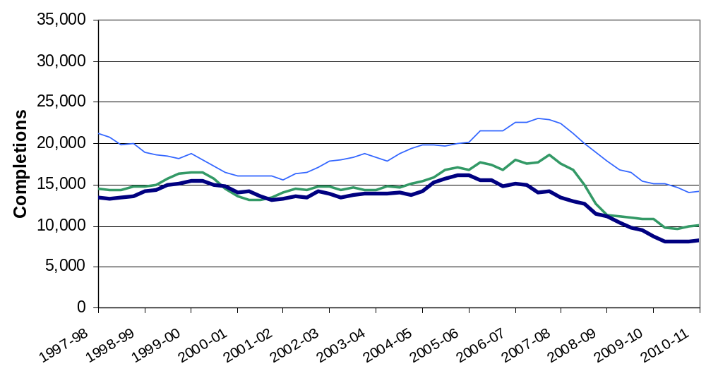

Figure 4c: Trends in housing completions in London, the South East and South West, 12 month rolling totals
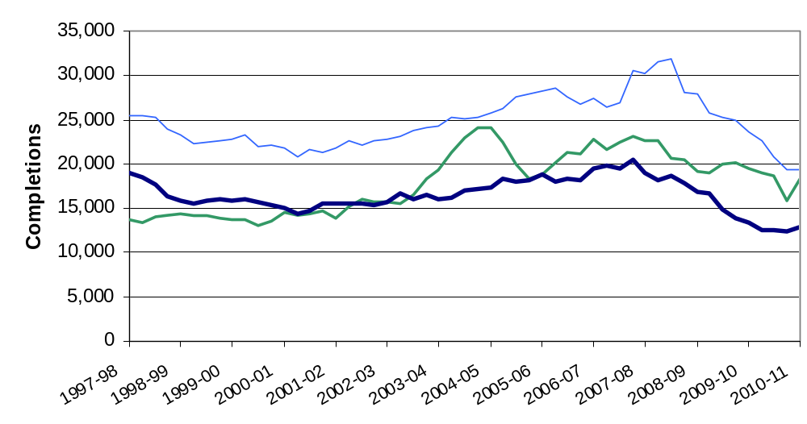

Geographic distribution of house building
The map below in figure 5a shows house building rates in each of the 326 local authority districts over the last 12 months. To show house building in proportion to the size of each LA we divide the number of completions in the year 2010/11 by the existing dwelling stock at the start of the year. The result is multiplied by 1000 to give a figure that is easier to interpret. Consider a hypothetical LA with 100,000 dwellings as at March 2010. Over the next year this figure increases by 200 new dwellings, representing 2 new dwellings per thousand of existing stock. This LA would therefore be shaded in light yellow in the coloured map.

Figure 5a: Completions per 1000 dwellings for each local authority district in 2010/11

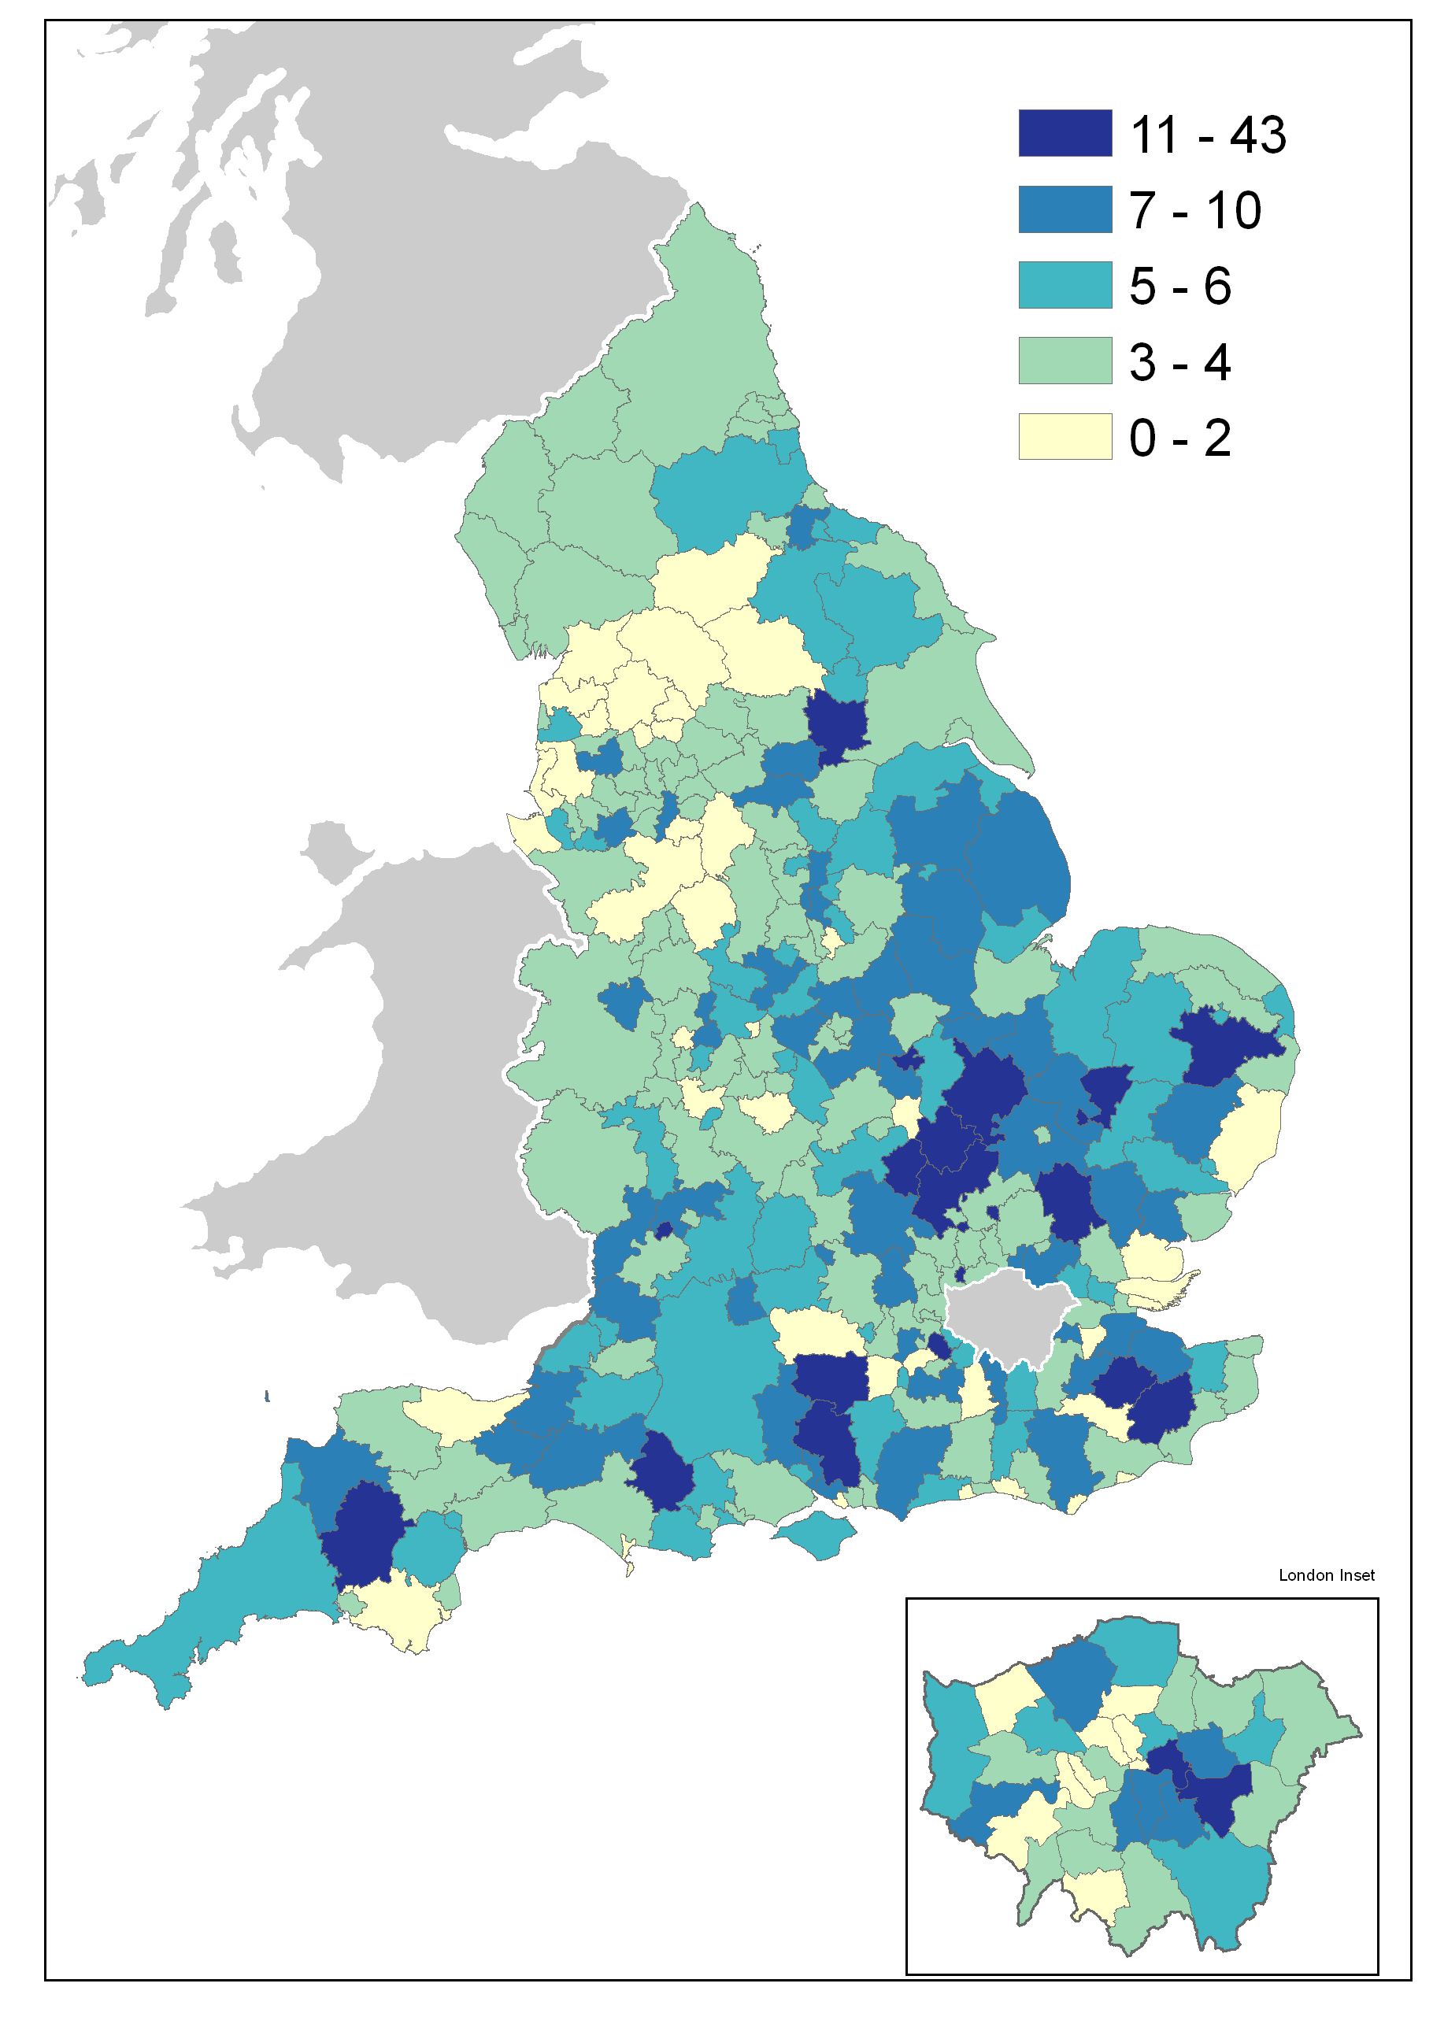 | There are pockets of high volume building across the South and East, with a concentration of high completion rates in the East Midlands.  The North and West of England saw proportionally less new house building over the last year.  There are smaller increases to the stock in green belt areas clustered around the northern perimeter of London.

Change in Starts and Completions from 2009/10 to 2010/11, by local authority district
The map on the left below shows for each local authority district how many house building starts there were in 2010/11 relative to 2009/10. The darker shades of blue indicate increase while the two palest shades of blue indicate authorities where there were fewer starts in 2010/11 than in 2009/10.
The map on the right shows the same comparison for completions. The same colour scale has been used for both maps to allow straightforward comparison. The generally darker colour of the starts map on the left reflects a recovery in starts from the historically low levels seen in 2009.
The lighter tone of the right hand map indicates that completions generally still show the lagged effect of the low level of starts in 2009.

Figure 5b: Change in starts (left) and completions (right) by LA from 2009/10 to 2010/11
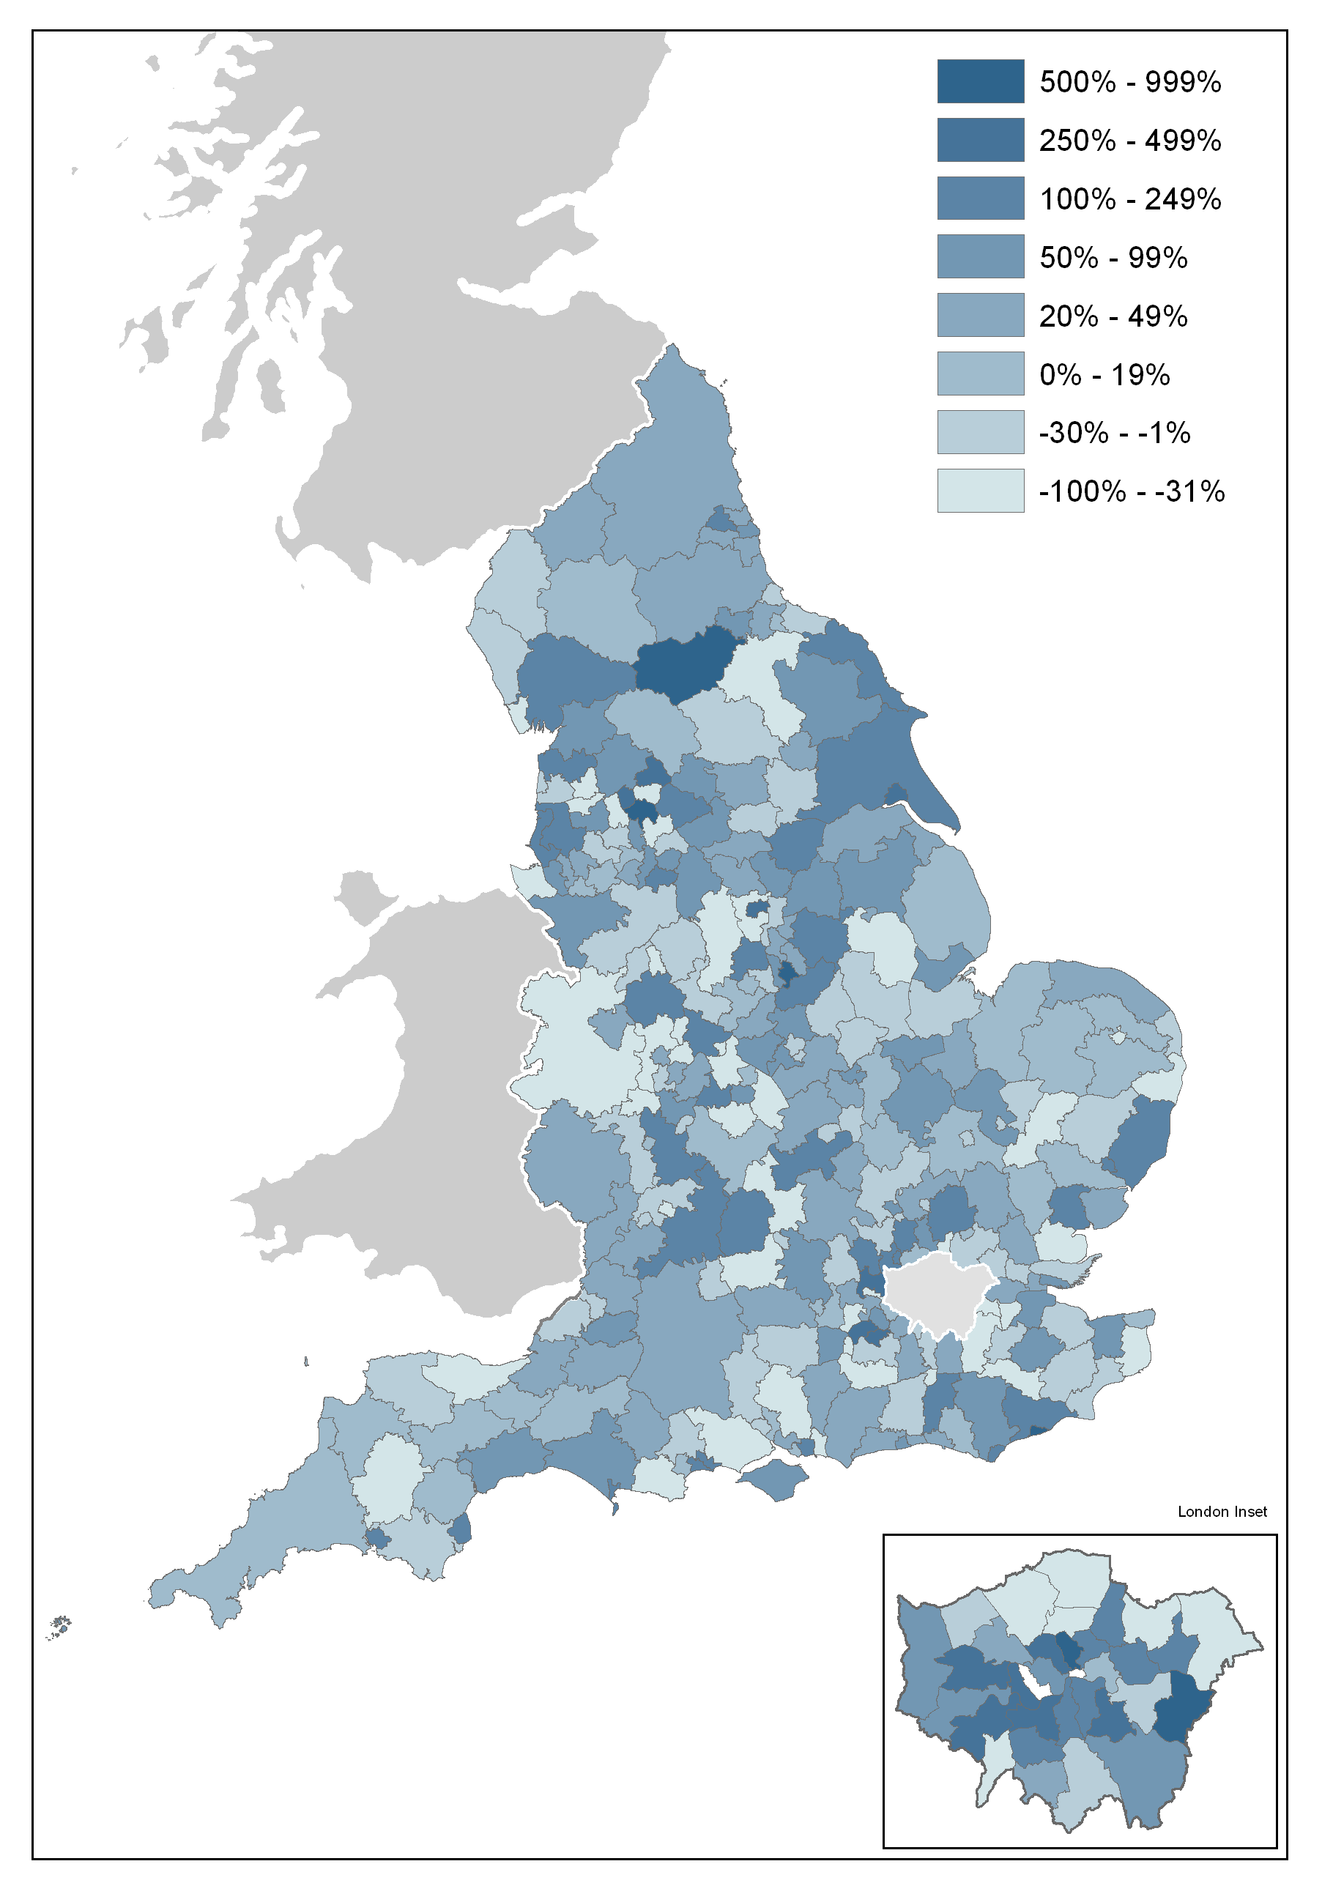 | 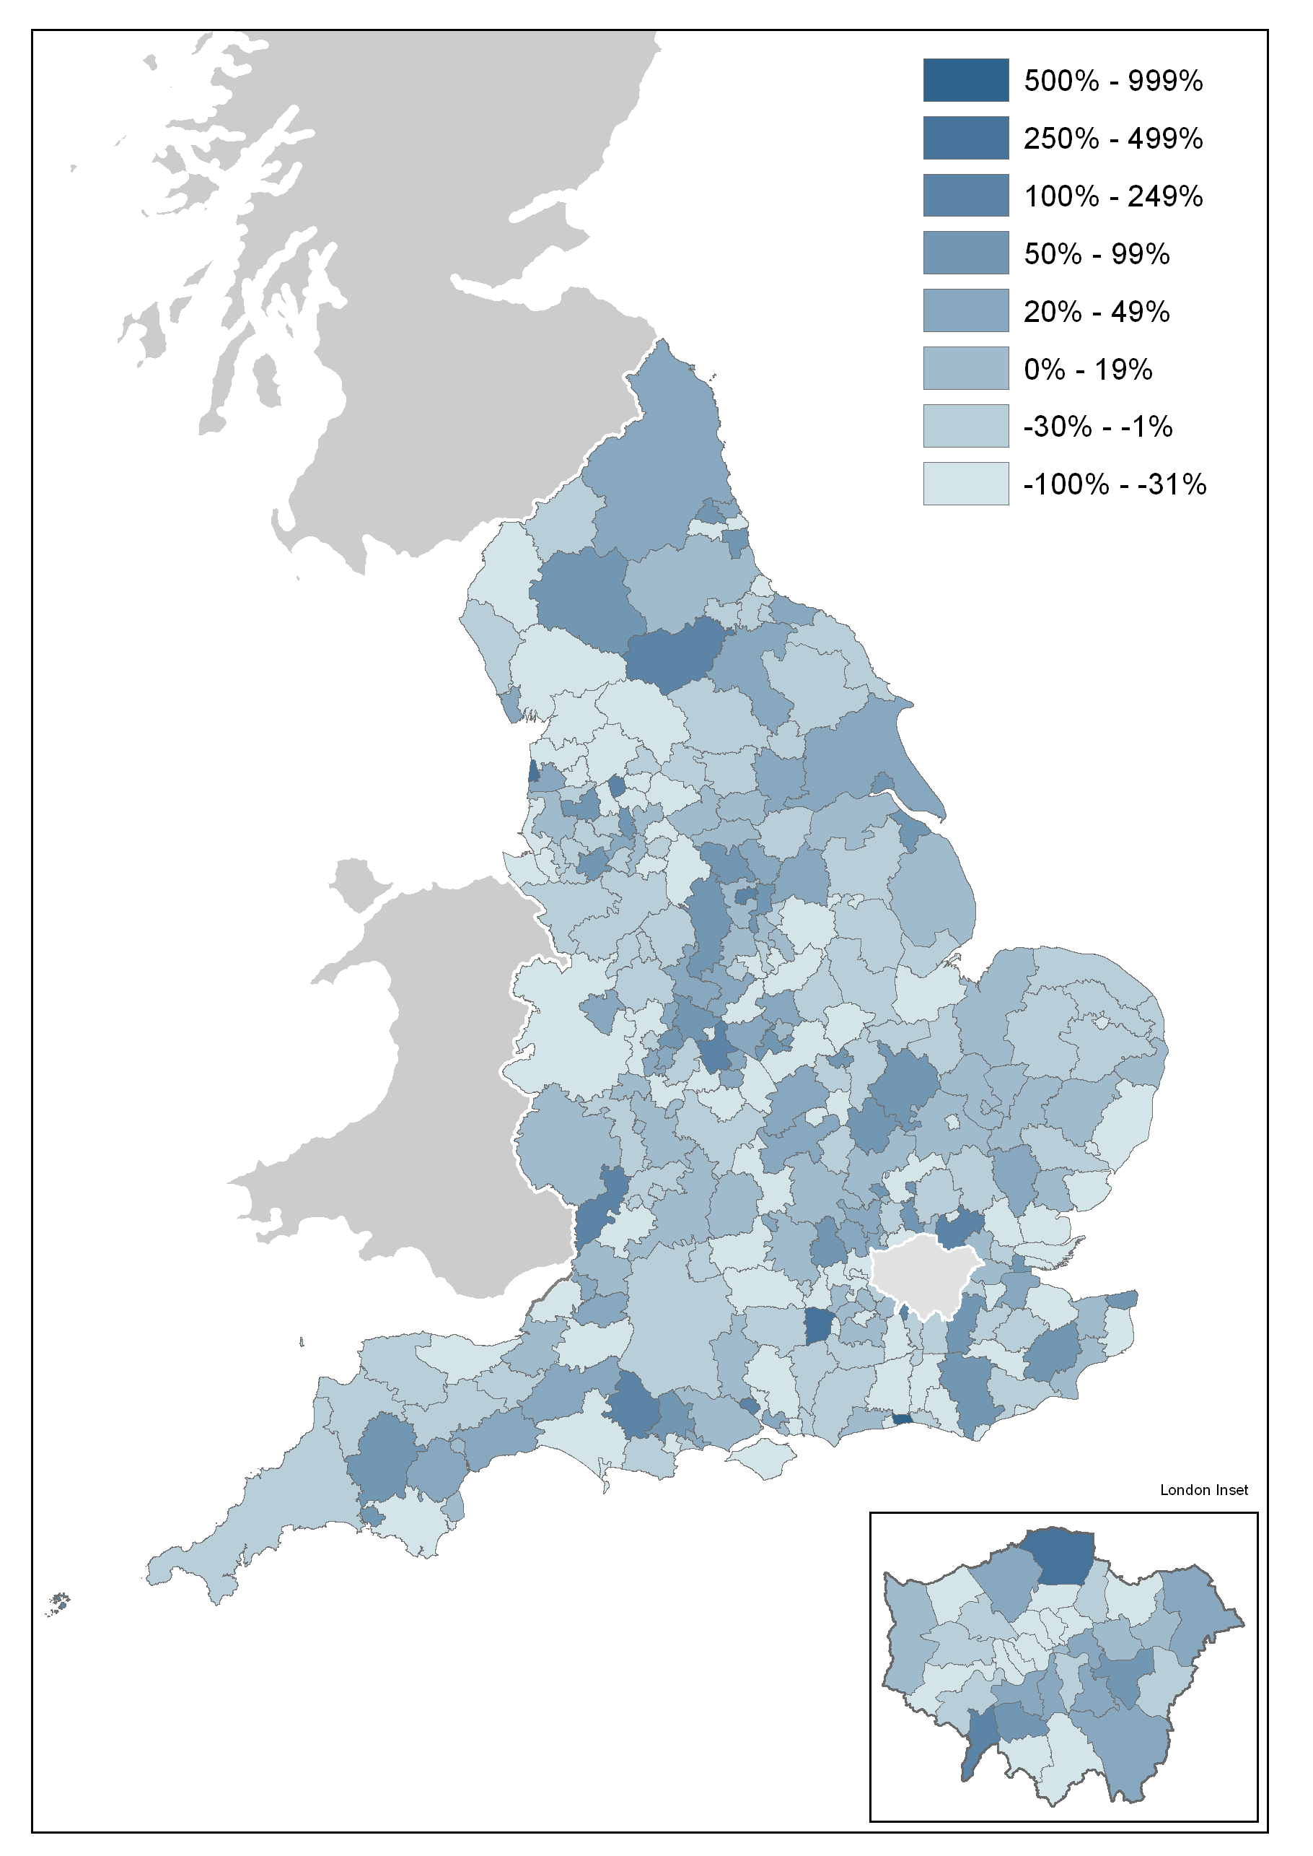

Other Approved Inspectors

In addition to local authorities and the National House-Building Council, house building starts and completions can be certified by other independent Approved Inspectors. The numbers in this release do not include activity for these other Approved Inspectors and, as such, are underestimates of the level of house building starts and completions. We now collect information from other Approved Inspectors to monitor the extent of this gap in coverage, and estimates for the last three financial years are given below.

We intend to move to incorporate these data in the headline statistics for England later this year. We will do this initially on an experimental basis and would very much welcome comments from users on this proposal, in particular on how best to present this change to minimise confusion and maintain users’ confidence in the statistics. Comments can be made via the “statistical enquiries” contact details shown on the front page of this release.

In the 2010-11 financial year approximately nine per cent of all starts and six per cent of completions were inspected by other independent Approved Inspectors. At the England level this translates to approximately 10,000 extra house building starts and approximately 7,000 extra completions.

In 2009-10 approximately eight per cent of all starts and four per cent of completions were inspected by other independent Approved Inspectors, translating to 7,000 extra house building starts and 5,000 extra completions.
In 2008-09 approximately eight per cent of starts and four per cent of completions were inspected by other independent Approved Inspectors, translating to 7,000 extra starts and 6,000 extra completions.

Data collection
This release takes information from two data sources on building control:
- ‘P2’ quarterly house building returns submitted to Department for Communities and Local Government by local authority building control departments; and
- monthly information from the National House-Building Council (NHBC) on the volume of building control inspections they undertake in each local authority area.


Data quality
Figures on housing starts and completions are from records kept for building control purposes. It is sometimes difficult for data providers to identify whether a dwelling is being built for a housing association or for a private developer. This may lead to an understatement of housing association starts and completions recorded in these tables, and a corresponding overstatement of private enterprise figures. This problem is more likely to occur with starts than completions. For more detailed statistics on affordable housing, including completions by housing associations, please refer to Department for Communities and Local Government’s affordable housing supply statistics at the following link.
http://www.communities.gov.uk/housing/housingresearch/housingstatistics/housingstatisticsby/affordablehousingsupply/.
In principle, a dwelling is regarded as completed when it becomes ready for occupation or when a completion certificate is issued whether it is in fact occupied or not. In practice, the reporting of some completions may be delayed and some completions may be missed if no completion certificate was requested by the developer or owner, although this is unusual.
The P2 data received from local authorities record starts and completions inspected by local authority building control and include imputation for a small number of missing returns; in the March quarter 2011, a 90 per cent local authority response rate was achieved.

The process to impute for a missing P2 local authority return works by picking up all data recorded in completed returns for that local authority over the previous five years and comparing it to data for other similar local authorities for the same periods. It then looks at the data provided for the current period by those other local authorities and imputes a figure for the missing local authority return which matches the proportion found in the comparison of data for the previous five years.
The NHBC figures record all starts and completions inspected by NHBC building control.
In addition to local authorities and the NHBC, house building starts and completions can be certified by other independent Approved Inspectors. The headline figures in this release do not include activity for these other Approved Inspectors and, as such, are underestimates of the true level of starts and completions but represent our best estimates at this time. We are now collecting information from other Approved Inspectors in order to gain a complete picture of house building activity and we intend to incorporate these data in the headline figures as soon as we are satisfied that we have established a data collection that is sustainable. We have included an estimate of the number of house building starts and completions certified by these other Approved Inspectors in each of the last three financial years in the “Other Approved Inspectors” section above.

Comparability between the countries of the UK

Each of the countries of the UK produces its own statistics on House Building (see “Related statistics” section below). The Department for Communities and Local Government is responsible for collecting and publishing data for England. However house building statistics for the devolved administrations of the UK, as well as for Great Britain and the UK as a whole, are included in the tables that accompany this statistical release. In this section the consistency of the data sources is discussed.
England and the devolved administrations use broadly consistent definitions for starts and completions in collecting house building data. Until now, all four countries have collected starts and completions data split into the three tenure types of private enterprise, housing association and local authority. From the June quarter 2011 onwards, this tenure split will no longer be available for Wales starts figures.
In England and Wales, some housing association starts and completions can be misreported as private enterprise starts because it is sometimes difficult for data providers to identify whether a dwelling is being built for a housing association or for a private developer (see above). This is not thought to be a problem in Northern Ireland and Scotland, where data on housing association house building are collected directly from housing association administrations, rather than from building inspection teams.
While a small proportion of the data for England are imputed for missing responses (see above), a full response is collected in Wales, Scotland and Northern Ireland.

Uses of house building statistics
The house building statistical series on starts and completions are a key part of the evidence base which informs the development and evaluation of housing policy by central and local government.
They are also used as evidence for other housing market analysts, forecasters and decision makers, for example at the Bank of England and in the construction and banking industries. They are used by the media in reports on the housing market, and by academics both in the UK and abroad.

Related statistics

Net supply of housing
The annual net additional dwellings figure, or net housing supply, is the absolute change in dwelling stock between 1 April and 31 March the following year. It comprises the number of new build permanent dwellings; plus the net gain from dwelling conversions; plus the net gain of non dwellings brought into residential use; plus net additions from other gains and losses to the dwelling stock (such as mobile and temporary dwellings); less any demolitions during the financial year.
The net additions statistical series is separate from and complementary to the Department for Communities and Local Government’s quarterly National Statistics series on new house building, providing a more comprehensive but less timely measure of total housing supply in England. Completions figures from the quarterly house building series are not used in the net additions statistics. Instead a separate set of data on the new build completions component of net additions is collected as part of the overall annual net additions data collection. This eliminates timing differences from the net supply series and provides a picture of the components of net change which can be reconciled for a given year.
The house building statistical series takes its data from the same sources throughout England, combining data from building control officers at local authorities and the National House-Building Council (NHBC), and is published within eight weeks after the end of each quarter. For net additions, all the data come from local authorities who in turn use whichever local data source they believe is most appropriate, and the data collection period for these statistics is relatively long, being annual and closing some five months after the end of the financial year. The longer data collection period makes it possible to incorporate data on the approximately five per cent of new build completions that are inspected by independent building control Approved Inspectors other than those at local authorities or the NHBC.
Users who need an early indication of house building activity or who intend to use housing supply statistics as an economic indicator are advised to use the quarterly house building starts and completions series. Those who require a long-running, consistent time series on housing supply should also use house building, in either a quarterly or annual basis. Users wanting a more complete picture of the overall supply of housing may find the net additions statistical series more appropriate.
The net supply of housing statistics can be found at the link below.
http://www.communities.gov.uk/housing/housingresearch/housingstatistics/housingstatisticsby/netsupplyhousing/ .

Dwelling stock estimates
Department for Communities and Local Government also publish statistics showing the total dwelling stock in England each year. These estimates are based on the latest census count plus the annual Net supply of housing statistics described above. They can be found at the following link.
http://www.communities.gov.uk/housing/housingresearch/housingstatistics/housingstatisticsby/stockincludingvacants/

Affordable housing
Although the house building statistics do categorise new build into private, housing associations (HA) and local authority tenure, this is not the best source of information on the total amount of affordable housing being delivered. A more detailed and accurate source is Department for Communities and Local Government’s Affordable housing supply statistics, which can be found at the following link. The affordable housing supply statistics include both new build supply and acquisitions for social rent and low cost home ownership. http://www.communities.gov.uk/housing/housingresearch/housingstatistics/housingstatisticsby/affordablehousingsupply/.

National Affordable Housing Programme
Information on the number of affordable homes delivered under the National Affordable Housing Programme (NAHP), as well as some other publicly funded programmes, is published by the Homes and Communities Agency. Delivery under the NAHP accounts for the majority of affordable housing completions in England. The HCA publishes figures twice a year and NAHP starts on site and completions for the six months to 30 September 2010 were reported on 30 November 2010.
http://www.homesandcommunities.co.uk/statistics

Devolved administrations
House building statistics for the devolved administrations of the UK are included alongside the England statistics in the tables that accompany this statistical release. These data are published separately by the devolved administrations, and although figures are correct at the time of this
publication they may be superseded before the next England house building release. Latest data and details on data sources and methods can be found at the following links:
Scotland (house building statistics)
http://www.scotland.gov.uk/Topics/Statistics/Browse/Housing-Regeneration/HSfS/NewBuild
Wales (house building statistics)
http://wales.gov.uk/topics/statistics/theme/housing/newbuild/;jsessionid=9bcQNK5GxLQv5p05StGJZsznPYpXL07L47Qh19JXKc22vq3nl9L8!475011280?lang=en
Northern Ireland (housing statistics)
http://www.dsdni.gov.uk/index/stats_and_research/housing_publications.htm

Revisions policy
This policy has been developed in accordance with the UK Statistics Authority Code of Practice for Official statistics and the Department for Communities and Local Government Revisions Policy. There are two types of revisions that the policy covers.

Scheduled Revisions
Local Authorities can update each quarterly return at any time up to two years after the initial publication of the figures for that quarter in order to maximise the response rate to the P2 return and enable late information to be included. Every quarter, as well as releasing figures for the latest quarter, we revise the previous quarter to incorporate any data that came in shortly after the previous data collection period. This captures most late data. Once a year, in the June quarter statistical release, a longer revision is carried out to incorporate all remaining late data into the published statistics. Therefore, until each quarterly return is permanently closed, figures for that quarter remain provisional. Provisional figures are labelled in the tables with a “P” and revised figures are labelled with an “R”.
In addition, where figures are seasonally adjusted, the adjustment factors for the whole series back to 1990 are recalculated annually, usually in the June quarter. This will result in small changes to seasonally adjusted figures across the whole period. These changes are not labelled with an “R”.
Other revisions to historic data (all data older than that currently due for scheduled revision) should only be made where there is a substantial revision, such as a change in methodology or definition. Where there are small changes that do not substantially change historic data, internal updates are maintained.

Non-Scheduled Revisions
Where a substantial error has occurred as a result of the compilation, imputation or dissemination process, the statistical release, live tables and other accompanying releases will be updated with a correction notice as soon as is practical.

Definitions
House building start - A dwelling is counted as started on the date work begins on the laying of the foundation, including 'slabbing' for houses that require it, but not including site preparation. Thus when foundation work commences on a pair of semi-detached houses two houses are counted as started, and when work begins on a block of flats all the dwellings in that block are counted as started. The starts of houses in building schemes are usually phased over a period of weeks or even, in very large schemes, months.
House building completion – In principle, a dwelling is regarded as completed when it becomes ready for occupation or when a completion certificate is issued whether it is in fact occupied or not. In practice, the reporting of some completions may be delayed and some completions may be missed if no completion certificate was requested by the developer or owner, although this is unusual.
Housing association - “Housing associations (HAs)” has been used as the generic name for all social landlords not covered by local authorities (see below). In previous editions HAs were referred to as Registered Social Landlords (RSL), although the term (private) Registered Provider (pRP) of social housing is commonly used by the Tenant Services Authority. The more all-encompassing description of ‘housing associations’ is now seen as more appropriate and helpful to users.

Accompanying tables
Accompanying tables are available to download alongside this release:

Tables:
1a House building starts and completions, including seasonally adjusted series: England;

1b House building starts and completions unadjusted: North East;
1c House building starts and completions unadjusted: North West;

1d House building starts and completions unadjusted: Yorkshire and the Humber;
1e House building starts and completions unadjusted: East Midlands;

1f House building starts and completions unadjusted: West Midlands;
1g House building starts and completions unadjusted: East of England;

1h House building starts and completions unadjusted: London;
1j House building starts and completions unadjusted: South East;

1k House building starts and completions unadjusted: South West;
2a House building starts and completions unadjusted: Wales;
2b House building starts and completions unadjusted: Scotland;
2c House building starts and completions unadjusted: Great Britain;
2d House building starts and completions unadjusted: Northern Ireland;
2e House building starts and completions unadjusted: United Kingdom;
Additional tables showing house building completions by type and size of property, starts and completions for individual local authorities as well as historic series can be accessed in the 'Live tables' section ("Live tables on house building") at the following link. http://www.communities.gov.uk/housing/housingresearch/housingstatistics/
All statistical releases on house building can be accessed on the Department for Communities and Local Government website at http://www.communities.gov.uk/housing/housingresearch/housingstatistics/housingstatisticsby/housebuilding/publicationsonhousebuilding/.

Notes to the tables
The following conventions have been used in the tables:
.. Not available;
- Fewer than 5 dwellings;
^{P} Figure provisional and subject to revision;
^{R} Revised from previous release.
Totals may not equal the sum of component parts due to rounding to the nearest 10.

Background notes
- The starts and completions reported in this publication are for new house building in England and exclude new dwellings created through conversions and the change of use of existing buildings.
- Figures in the accompanying tables are presented rounded to the nearest 10 dwellings.
- Sources are shown at the foot of individual accompanying tables and live tables.
- The charts give seasonally adjusted quarterly house building trends and give annual trends by showing a rolling 12-month total. Both the private enterprise and housing association England series are seasonally adjusted.
- Accompanying Table 1a gives non-seasonally adjusted and seasonally adjusted England figures. All figures for other countries and the English regions are shown on an unadjusted basis only.
- National Statistics are produced to high professional standards set out in the Code of Practice for Official Statistics. They undergo assessment by the UK Statistics Authority to ensure that they meet those standards.
- The tables and charts accompanying this release are shown above in the ‘Accompanying tables’ section and are provided in Microsoft Excel format.
- Details of officials and ministers who receive pre-release access to the Department for Communities and Local Government quarterly House Building release up to 24 hours before release can be found at:
http://www.communities.gov.uk/corporate/researchandstatistics/statistics/nationalstatistics/
- The next quarterly release will be published on Thursday 18 August 2011, and will cover house building up to the June quarter 2011.

User consultation
Users’ comments on any issues relating to this statistical release, in particular on the proposal to incorporate data from other Approved Inspectors in the headline statistics for England, are welcomed and encouraged. Responses should be addressed to the "statistical enquiries" contact given in the "Enquiries" section below.

Enquiries

Statistical enquiries:
e-mail: housing.statistics@communities.gov.uk
telephone: 0303 44 42345

Media Enquiries:
office hours: 0303 44 41136
out of hours: 0303 44 41201
e-mail: press@communities.gov.uk

Department for Department for Communities and Local Government. © Crown Copyright, 2011

If you require this publication in an alternative format please email: alternativeformats@communities.gsi.gov.uk. Please note that the nature of content means that we may not be able to provide the Statistical series of publications in all requested formats.

May 2011

ISBN: 978-1-4098-2980-5

