
House Building: March Quarter 2012, England
- Seasonally adjusted house building starts in England stood at 24,140 in the March quarter 2012. This is 11 per cent lower than in the December quarter 2011.
- Completions (seasonally adjusted) increased, up 6 per cent to 31,010 in the March quarter 2012.
- Private enterprise housing starts (seasonally adjusted) were 8 per cent lower in the March quarter 2012 than the previous quarter, whilst starts by housing associations were 21 per cent lower.
- Private enterprise and housing association completions (seasonally adjusted) both increased by 8 per cent from the previous quarter.
- Seasonally adjusted starts are currently 42 per cent above the trough in the March quarter 2009 but 50 percent below the December quarter 2005 peak. Completions are 36 per cent below their March quarter 2007 peak.
- Annual housing starts totalled 104,970 in the 12 months to March 2012, down by 6 per cent compared with the 12 months to March 2011. Annual housing completions in England reached 117,870 in the 12 months to March 2012, an increase of 6 per cent compared with the 12 months to March 2011.



Contents
1. | Quarterly figures………... | 3
2. | Annual figures…………... | 5
3. | Sub-national trends……… | 7
4. | Independent Approved  Inspectors……………….... | 11
5. | Data collection…………… | 14
6. | Data quality……………..... | 15
7. | Uses of house building  statistics….……………….. | 18
8. | Related statistics……....… | 18
9. | Revisions policy………….. | 22
10. | Revisions in this release... | 23
11. | Definitions……………….... | 23
12. | Accompanying tables….... | 24
13. | Background notes............. | 25
14. | User consultation………... | 26
15. | Enquiries………................ | 26

Responsible statistician:
Richard Field

Statistical enquiries:
office hours: 0303 44 42272
housing.statistics@communities.gov.uk

Media Enquiries:
office hours: 0303 44 41136
out of hours: 0303 44 41201

press@communities.gov.uk

Housing
Statistical Release

17 May 2012
using
Research
Summary
Number 239, 2007

Data change in this release
The figures in this release have been revised back to the June quarter 2007 to include extra data from independent approved inspectors. All data in this release and related tables now includes data from independent approved inspectors. This represents a substantial improvement to the coverage of these statistics. Because the data have been revised back to 2007 all quarterly and annual comparisons in this release are on a consistent basis. However, data from this release cannot be compared with data in previous releases.
As a result of the change there is a small discontinuity in the time series at the June quarter 2007. This is marked in the charts of this release and the accompanying tables. All live and accompanying tables have been updated to include independent approved inspector data from June 2007. More detail on the inclusion of independent approved inspectors and the size of the discontinuity is in the "Independent approved inspectors" section below.

Quarterly figures
Quarterly figures for house building starts and completions are given on a seasonally adjusted basis. Seasonally adjusted figures should be used for quarterly comparisons.

Figure 1: Seasonally adjusted trends in quarterly housing starts and completions, England
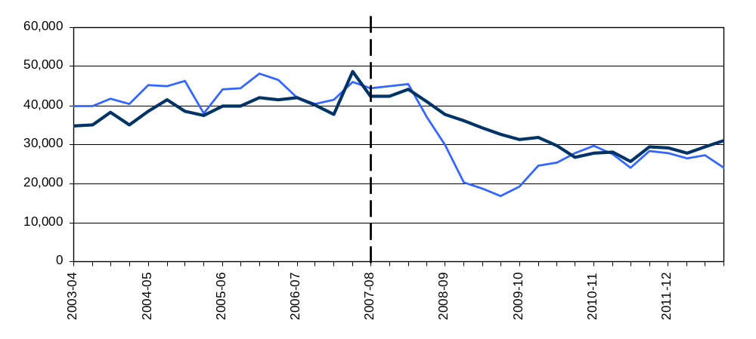
The chart includes data from independent approved inspectors from 2007-08 as marked by the vertical dashed line.
Starts experienced a period of sustained growth from 2001 until 2005, before levelling off, averaging around 44,000 units each quarter until late 2007. Starts were strongly affected by the economic downturn and from the start of 2008 there was a period of rapid decline to a trough in the March quarter of 2009. Completions responded more gradually to the downturn. From 2009 starts began to recover and over the last two years the two series have converged and levelled off. Since early 2010 both starts and completions have remained broadly stable with average starts of around 27,000 and average completions of 28,000 over the past 9 quarters. This indicates that the stabilisation of starts has worked its way through to completions. House building is currently at approximately 65 per cent of pre-downturn levels.
Starts - March quarter 2012
Seasonally adjusted housing starts in England fell to 24,140 in the March quarter 2012 from 27,240 in the December quarter 2011. This is an 11 per cent quarter on quarter fall. Starts are still 50 per cent below their December quarter 2005 peak, but 42 per cent above the trough in the March quarter of 2009.

Starts fell across all tenures but the fall was greatest in public house building where starts by housing associations fell 21% from the previous quarter. Starts by local authorities also fell but this sector is small and can be quite volatile. Private enterprise housing starts were 8 per cent lower in the March quarter 2012 than in the December quarter 2011 quarter.

Completions - March quarter 2012
Seasonally adjusted house building completions in England were 31,010 in the March quarter 2012. This is an increase of 6 per cent from the 29,360 completions in the December quarter 2011. Completions are 36 per cent below their March 2007 peak.
Seasonally adjusted private and housing association completions were each 8 per cent higher in the March quarter 2012 quarter than the December quarter 2011 quarter. Completions in the local authority tenure fell, reducing the overall increase.

Table 1a: Quarterly housing starts by tenure, England, seasonally adjusted1,2,3
 |  |  |  |  | Private  Enterprise |  |  |  | Housing  Associations |  | Local  Authority | All  Tenures
 |  |  |  |  | Starts |  | % change  on previous quarter |  | Starts | % change  on previous quarter | Starts | Starts |  | % change  on previous quarter
2009-10 |  | Apr-June |  | R | 14,460 |  | 17% |  | 4,690 | 2% | 50 | 19,210 |  | 13%
 |  | July-Sept |  | R | 19,000 |  | 31% |  | 5,580 | 19% | 30 | 24,620 |  | 28%
 |  | Oct-Dec |  | R | 19,650 |  | 3% |  | 5,710 | 2% | 50 | 25,400 |  | 3%
 |  | Jan-Mar |  | R | 21,800 |  | 11% |  | 5,950 | 4% | 200 | 27,960 |  | 10%
2010-11 |  | Apr-June |  | R | 22,380 |  | 3% |  | 6,880 | 15% | 560 | 29,810 |  | 7%
 |  | July-Sept |  | R | 20,970 |  | -6% |  | 6,400 | -7% | 280 | 27,650 |  | -7%
 |  | Oct-Dec |  | R | 19,040 |  | -9% |  | 4,680 | -27% | 350 | 24,070 |  | -13%
 |  | Jan-Mar |  | R | 21,530 |  | 13% |  | 6,620 | 42% | 380 | 28,520 |  | 18%
2011-12 |  | Apr-June |  | R | 21,980 |  | 2% |  | 5,400 | -18% | 590 | 27,970 |  | -2%
 |  | July-Sept |  | R | 21,340 |  | -3% |  | 4,960 | -8% | 270 | 26,570 |  | -5%
 |  | Oct-Dec |  | R | 21,860 |  | 2% |  | 5,010 | 1% | 380 | 27,240 |  | 3%
 |  | Jan-Mar |  | P | 20,080 |  | -8% |  | 3,950 | -21% | 100 | 24,140 |  | -11%

Table 1b: Quarterly housing completions by tenure, England, seasonally adjusted^{1,2,3}
 |  |  |  |  |  | Private  Enterprise |  |  | Housing  Associations |  | Local  Authority |  | All  Tenures
 |  |  |  |  |  | Comple-  tions |  | % change  on previous quarter | Comple-  tions | % change  on previous quarter | Comple-  tions |  | Comple-  tions |  | % change  on previous quarter
2009-10 | Apr-June |  | R |  |  | 24,580 |  | -6% | 6,600 | 3% | 130 |  | 31,310 |  | -4%
 | July-Sept |  | R |  |  | 23,710 |  | -4% | 8,180 | 24% | 90 |  | 31,980 |  | 2%
 | Oct-Dec |  | R |  |  | 23,590 |  | -1% | 6,210 | -24% | 30 |  | 29,830 |  | -7%
 | Jan-Mar |  | R |  |  | 20,860 |  | -12% | 5,840 | -6% | 110 |  | 26,810 |  | -10%
2010-11 | Apr-June |  | R |  |  | 21,590 |  | 3% | 6,100 | 4% | 100 |  | 27,790 |  | 4%
 | July-Sept |  | R |  |  | 22,720 |  | 5% | 5,320 | -13% | 140 |  | 28,180 |  | 1%
 | Oct-Dec |  | R |  |  | 19,650 |  | -13% | 5,650 | 6% | 440 |  | 25,740 |  | -9%
 | Jan-Mar |  | R |  |  | 22,090 |  | 12% | 6,760 | 20% | 630 |  | 29,490 |  | 15%
2011-12 | Apr-June |  | R |  |  | 22,320 |  | 1% | 6,330 | -6% | 660 |  | 29,310 |  | -1%
 | July-Sept |  | R |  |  | 21,390 |  | -4% | 6,100 | -4% | 390 |  | 27,870 |  | -5%
 | Oct-Dec |  | R |  |  | 21,770 |  | 2% | 6,910 | 13% | 680 |  | 29,360 |  | 5%
 | Jan-Mar |  | P |  |  | 23,480 |  | 8% | 7,430 | 8% | 110 |  | 31,010 |  | 6%
- Because the number of local authority housing starts and completions is very small, quarterly comparisons can be very volatile. Accordingly, percentage changes are not shown for this tenure.
- Data in this table have been revised to include independent approved inspectors
- Seasonally adjusted data have not been constrained to annual totals. Non-seasonally adjusted data are presented in the tables accompanying this release.
Annual figures
Annual figures are not seasonally adjusted and give the actual values for house building over 12 month periods. This data can be used to make year on year comparisons. For quarter on quarter comparisons the quarterly seasonally adjusted series should be used.

Figure 2: Trends in starts and completions, England, 12 month rolling totals
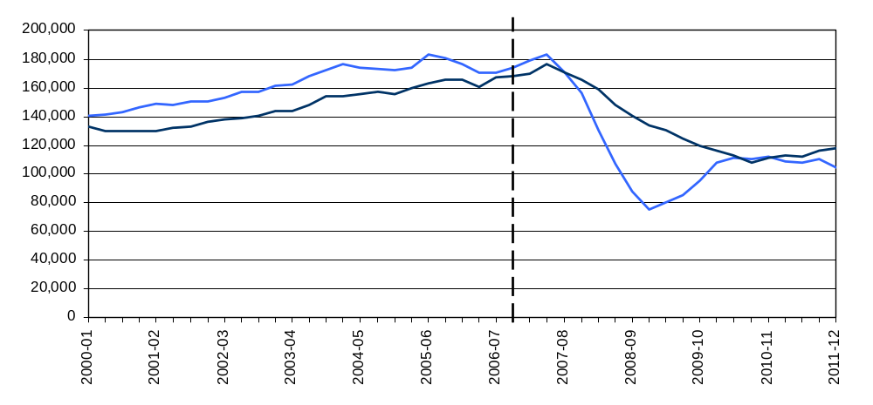
The chart includes data from independent approved inspectors from 2007-08 as marked by the vertical dashed line. Note that, because the graph shows rolling totals, the three quarters immediately following the dashed line will be a combination of quarters that do include approved inspector data and quarters that do not.
Annual housing starts increased from 140,000 in the 12 months ending March 2001 to a peak of 183,000 in the year ending March 2006. From 2006 the number of starts remained fairly stable until the beginning of 2008 but fell sharply during the downturn to a low of 75,000 in the year ending June 2009. Starts recovered somewhat during 2009 and 2010 reaching 112,000 in the 12 months to March 2011. However, since early 2010 starts have remained broadly stable.
Annual completions increased from 130,000 in the 12 months ending December 2001, reaching a peak of 177,000 in the year ending December 2007. Completions fell through 2008, 2009 and 2010 to 108,000 in December 2010. Since then they have increased slightly to stand at 118,000 in the 12 months to March 2012.
Starts - year ending March 2012
104,970 homes were started in the 12 months to March 2012, a 6 per cent decrease from the 12 months to March 2011. This is 43 per cent below the peak in the year to March 2006, but up 39 per cent compared with the trough in the year to June 2009.
Private enterprise starts were down 1 per cent compared with the previous year but most of the fall came from reduced starts by housing associations, down 24 per cent compared with a year before.

Completions - year ending March 2012

117,870 houses were completed in the 12 months to March 2012. This is 6 percent up on the previous year. The current level of completions is 33 per cent below the peak level of 2007.

Private enterprise housing completions were 4 per cent higher than in the year before whilst completions by housing associations increased by 12 per cent over the same period.

Table 2a: Annual total housing starts by tenure, England, not seasonally adjusted1,2,3
Starts |  |  | Private  Enterprise |  | Housing  Associations |  | Local  Authority | All  Tenures
 | Year to end |  | Starts in previous 12 months | % change on previous year | Starts in previous 12 months | % change on previous year | Starts in previous 12 months | Starts in previous 12 months | % change on previous year
2009-10 | June 2009 | R | 55,520 | -57% | 19,590 | -24% | 240 | 75,350 | -52%
 | Oct 2009 | R | 60,010 | -43% | 19,760 | -22% | 260 | 80,030 | -39%
 | Dec 2009 | R | 64,990 | -21% | 20,460 | -15% | 140 | 85,600 | -20%
 | March 2010 | R | 73,770 | 13% | 21,470 | -3% | 320 | 95,560 | 9%
2010-11 | June 2010 | R | 83,050 | 50% | 24,360 | 24% | 840 | 108,250 | 44%
 | Oct 2010 | R | 85,290 | 42% | 25,180 | 27% | 1,080 | 111,560 | 39%
 | Dec 2010 | R | 84,590 | 30% | 24,300 | 19% | 1,390 | 110,280 | 29%
 | March 2010 | R | 85,280 | 16% | 25,210 | 17% | 1,570 | 112,060 | 17%
2011-12 | June 2011 | R | 83,860 | 1% | 23,170 | -5% | 1,600 | 108,630 | 0%
 | Oct 2011 | R | 84,330 | -1% | 21,770 | -14% | 1,590 | 107,680 | -3%
 | Dec 2011 | R | 86,560 | 2% | 22,050 | -9% | 1,620 | 110,230 | 0%
 | March 2012 | P | 84,490 | -1% | 19,140 | -24% | 1,340 | 104,970 | -6%

Table 2b: Annual total housing completions by tenure, England, not seasonally adjusted^{1,2,3}
Completions |  |  | Private  Enterprise |  | Housing  Associations |  | Local  Authority | All  Tenures
 | Year to end |  | Completions in previous 12 months | % change on previous year | Completions in previous 12 months | % change on previous year | Completions in previous 12 months | Completions in previous 12 months | % change on previous year
2009-10 | June 2009 | R | 106,640 | -24% | 26,990 | 11% | 480 | 134,110 | -19%
 | Oct 2009 | R | 101,620 | -24% | 28,060 | 10% | 510 | 130,190 | -18%
 | Dec 2009 | R | 97,610 | -19% | 26,990 | 2% | 360 | 124,970 | -16%
 | March 2010 | R | 93,030 | -18% | 26,520 | -1% | 370 | 119,910 | -15%
2010-11 | June 2010 | R | 89,850 | -16% | 26,050 | -3% | 340 | 116,240 | -13%
 | Oct 2010 | R | 89,030 | -12% | 23,510 | -16% | 390 | 112,920 | -13%
 | Dec 2010 | R | 84,480 | -13% | 22,870 | -15% | 790 | 108,150 | -13%
 | March 2010 | R | 85,850 | -8% | 24,090 | -9% | 1,310 | 111,250 | -7%
2011-12 | June 2011 | R | 86,580 | -4% | 24,290 | -7% | 1,870 | 112,750 | -3%
 | Oct 2011 | R | 85,430 | -4% | 24,880 | 6% | 2,120 | 112,430 | 0%
 | Dec 2011 | R | 87,440 | 3% | 26,190 | 14% | 2,360 | 115,980 | 7%
 | March 2012 | P | 88,940 | 4% | 27,090 | 12% | 1,830 | 117,870 | 6%
- Because the number of local authority housing starts and completions is very small, quarterly comparisons can be very volatile. Accordingly, percentage changes are not shown for this tenure.
- Data in this table have been revised to include independent approved inspectors.
- Individual non-seasonally adjusted quarterly figures are available in the accompanying tables.

Sub-national trends

Comparisons between national, regional and district figures in this section are based on the non-seasonally adjusted series. It is our policy only to seasonally adjust figures at the national level. The graphs in this section use 12-month rolling totals to show trends in non-seasonally adjusted results.
Regional starts

In the 12 months to March 2012 starts fell in all regions except for the North West compared with a year earlier. In the North West starts increased 7 per cent. The biggest fall was in the Yorkshire and the Humber where starts fell 21 per cent. Starts fell by 13 per cent in the North East and by 12 per cent in London (See Figures 3a, 3b and 3c below).
In the 12 months to March 2012, the South East saw the greatest number of starts with 19,110, accounting for 18 per cent of all starts in England. The fewest starts were in the North East with 4,200 starts, 4 per cent of starts in England. This partly reflects the fact that the North East is the smallest region in terms of housing stock with only 5 per cent of English dwellings.

Regional completions

Completions increased in all but two regions, falling in the North West and East Midlands. The largest increase was in the South West where completions rose by 18 per cent in the 12 months to March 2012 compared with the previous year. The North East saw an increase of 14 per cent and the South East had 11 per cent more completions than the previous year. In the East Midlands annual completions fell by 6 per cent. (see Figures 4a, 4b and 4c below).
The South East saw the largest number of new build homes completed in the 12 months to March 2012 with 22,240 or 19 per cent of all completions in England. The North East was the region with the fewest housing completions with 5,290 completions accounting for 4 per cent of the England total.

Figure 3a: Trends in housing starts in the North East, North West and Yorkshire and the Humber, 12 month rolling totals
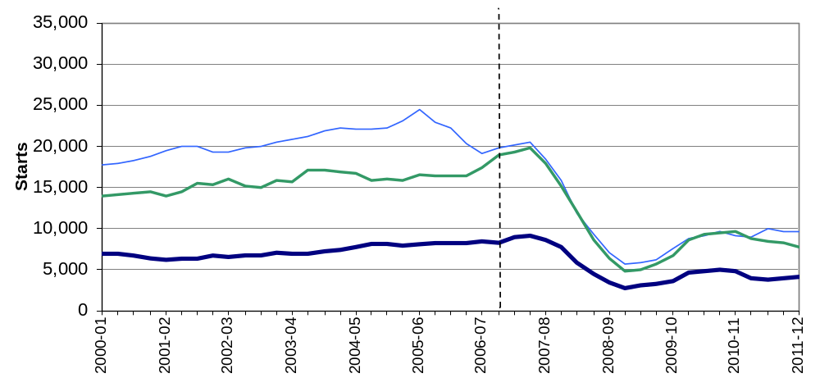

Figure 3b: Trends in housing starts in the East of England, East Midlands and West Midlands, 12 month rolling totals

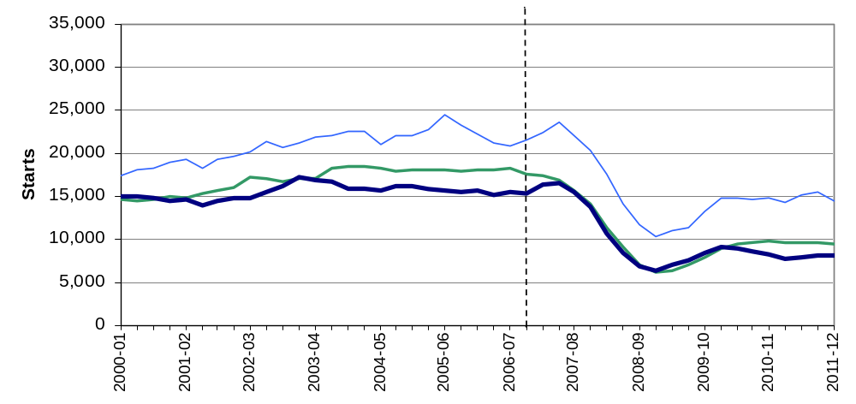

Figure 3c: Trends in housing starts in London, the South East and South West, 12 month rolling totals

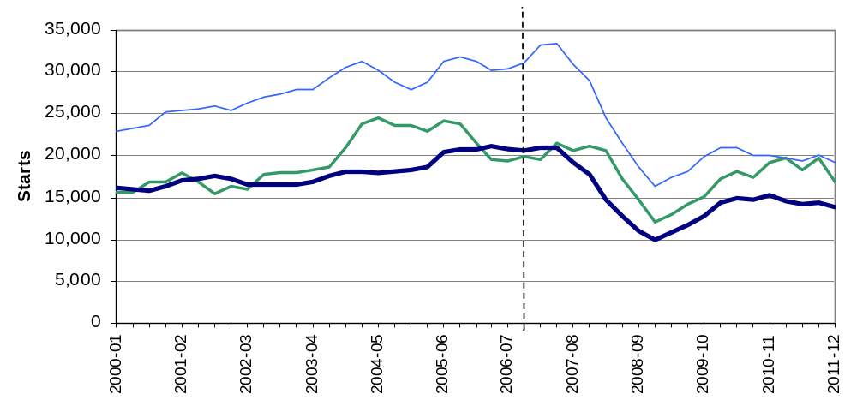

Figure 4a: Trends in housing completions in the North East, North West and Yorkshire and the Humber, 12 month rolling totals
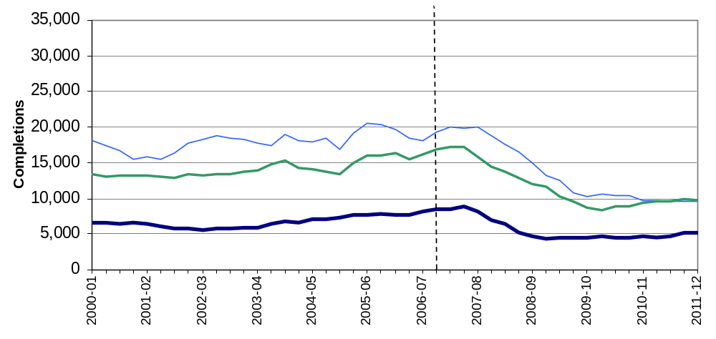

Figure 4b: Trends in housing completions in the East of England, East Midlands and West Midlands, 12 month rolling totals

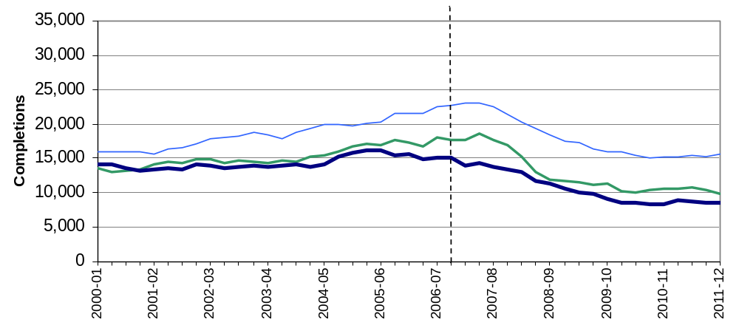

Figure 4c: Trends in housing completions in London, the South East and South West, 12 month rolling totals
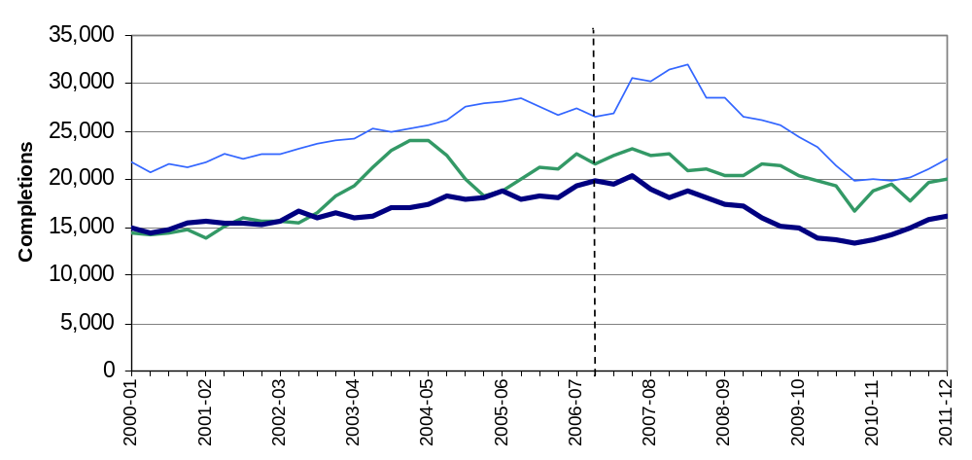

Geographic distribution of house building
The maps in figure 5 below shows start rates (left) and completion rates (right) in each of the 326 local authority districts over the year to March 2012. To show house building in proportion to the size of each district we divide the number of starts or completions in the year by the existing dwelling stock. The result is multiplied by 1000 to give a figure that is easier to interpret. Consider a hypothetical local authority district with 100,000 dwellings where, over the next year, 150 new dwellings are started. This would give a value of 1.5 new dwellings per thousand of existing stock and would therefore be shaded in light yellow in the coloured map for starts.
Figure 5: Starts per 1000 dwellings (left) and completions per 1000 dwellings (right) for each local authority district in the 12 months to March 2012
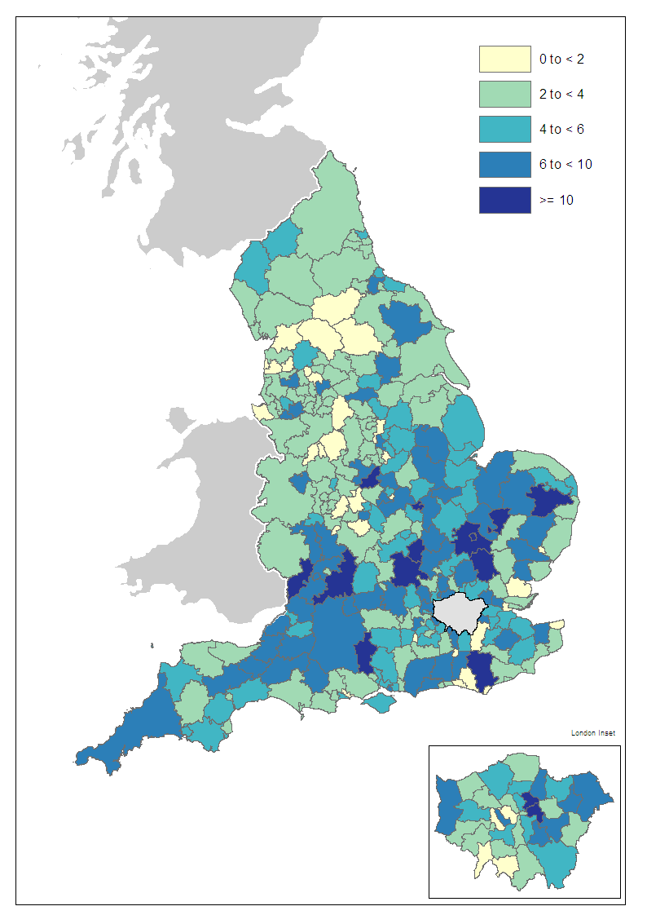 | 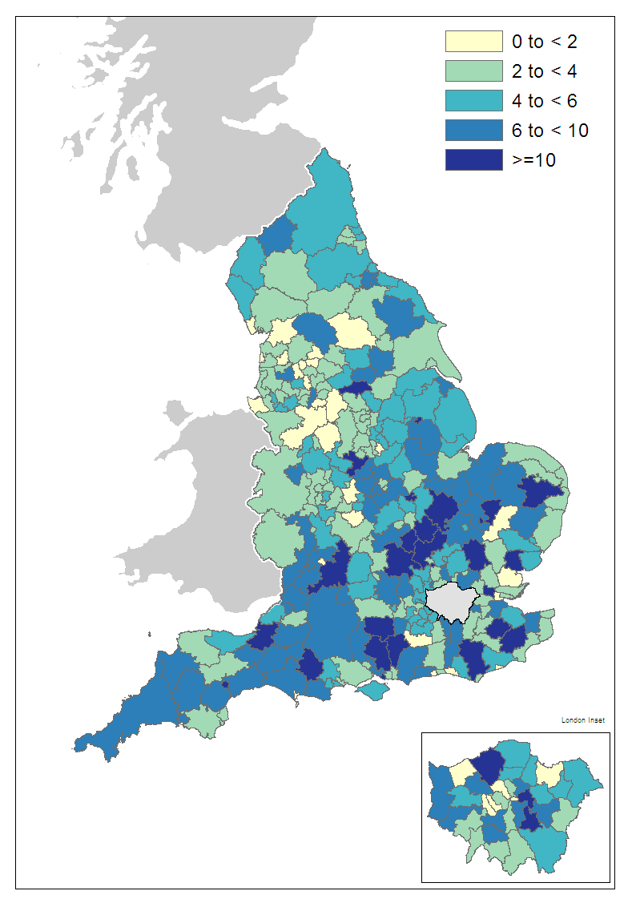
Nearly all of the local authority districts seeing the highest rates of building (in the darker shades of blue) are in the southern half of England. There is a pronounced band of building along the M5 corridor, extending east into Wiltshire and the Cotswolds. There are also relatively high levels of building activity along the M11 running up into the East Midlands. Areas around Buckinghamshire, Bedfordshire and Milton Keynes also show some of the strongest levels of building. The lowest building rates (in yellow) are most common in the West Midlands, North West and some south eastern coastal areas.

What types of homes are being built?
Approximately half of the data used to produce the house building statistics are supplied by the National House-Building Council (NHBC). These data contain additional detail on the size and type of new homes being completed and can be used to provide annual estimates of the proportion of new builds that are houses as opposed to flats.
Figure 6 shows the split of completions between houses and flats. The proportion of flats increased from 22 per cent in 2001-02 to 45 per cent from 2005-06, remaining at that level through to 2008-09. Since then, the proportion of flats has dropped sharply and in 2010-11 stood at 30 per cent. These data are published at the regional level in live table 254 which can be found at the following link. http://www.communities.gov.uk/housing/housingresearch/housingstatistics/housingstatisticsby/housebuilding/livetables/

Figure 6: Proportion of new build completions that are houses and flats
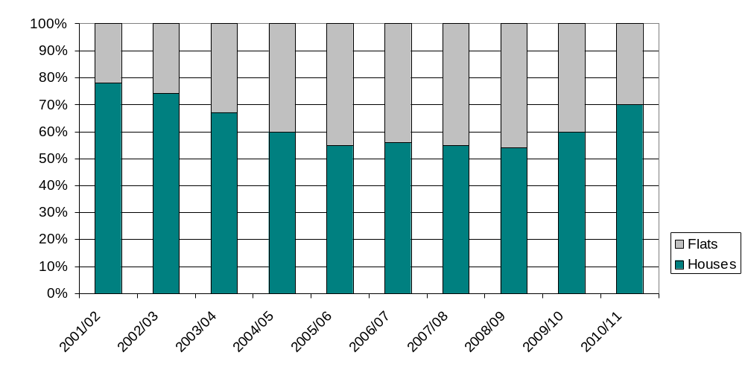

Independent Approved Inspectors

In addition to local authorities and the National House-Building Council house building starts and completions can be certified by other independent approved inspectors. The numbers in this release include data from these other approved inspectors for the first time.
History
Provision for building control inspections to be carried out by private sector approved inspectors has been in place since 1984, but various barriers to their full participation remained. The first of these barriers was removed in 2002 with the provision of specialised insurance products to cover their work. This enabled approved inspectors to participate in the residential building control inspection market but with the exception of housing for private sale or rental, which comprises the bulk of new housing.
Following the change in 2002 a survey of Approved Inspectors was conducted to discover their level of involvement in the housing association and local authority house building markets. The survey revealed very small numbers of starts and completions. Based on the results of this survey it was decided the numbers were so small that the burden of data collection was unnecessary.
In 2005 a further regulatory change introduced the warranty link rule which allowed approved inspectors to participate in the market for private house building provided that they ensured each new home inspected was covered by a new home warranty from a list of government-approved insurance products. Following this change a second survey of approved inspectors was conducted in 2006/07. The results of the survey suggested that, while activity was not of a sufficient level to be worth changing the statistics, it was now worth collecting data regularly from approved inspectors to monitor the number of starts and completions. A quarterly data collection was begun from the June quarter of 2007; initially by email then later through an online form.
Results from this data collection, reported in previous editions of this statistical release, show that the approved inspector share of the building control market in new house building has been increasing. This share has now reached a level where these data represent a substantial proportion of the numbers of new dwellings and the data are worth adding to the statistics.
Impact of inclusion
Considerable work has been done to ensure the data are of sufficient quality to be included into the house building statistics and the time series have been revised back to include approved inspector data from the June quarter of 2007.
By revising back to 2007 the impact on the time series is minimised and in fact the overall effect on the trend is slight. Revising back to 2007 also ensures that comparisons of figures and trends within the last five years can continue be made on a like-for-like basis. However, there is inevitably a step change at the point of first inclusion. For completions this step change is small, with an estimated 216 completions inspected by independent Approved Inspectors in the quarter. The change in the starts series is more pronounced with 1,855 additional starts in Q2 of 2007. Figures 7a and 7b show the impact of the approved inspector data on the trend in starts and completions since 2006-07.
Figure 7a: Impact of including approved inspectors on 12 month rolling total starts
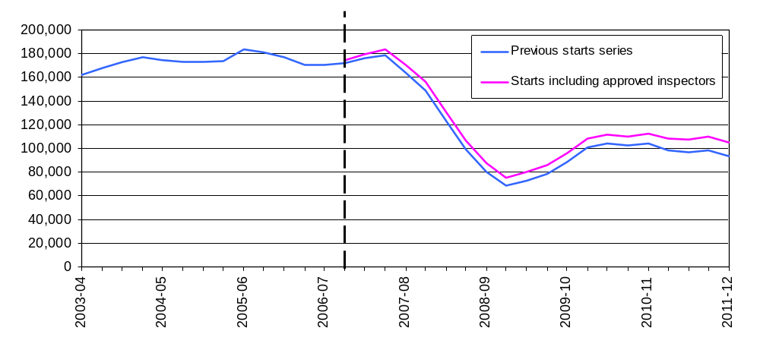
Figure 7b: Impact of including approved inspectors on 12 month rolling total completions
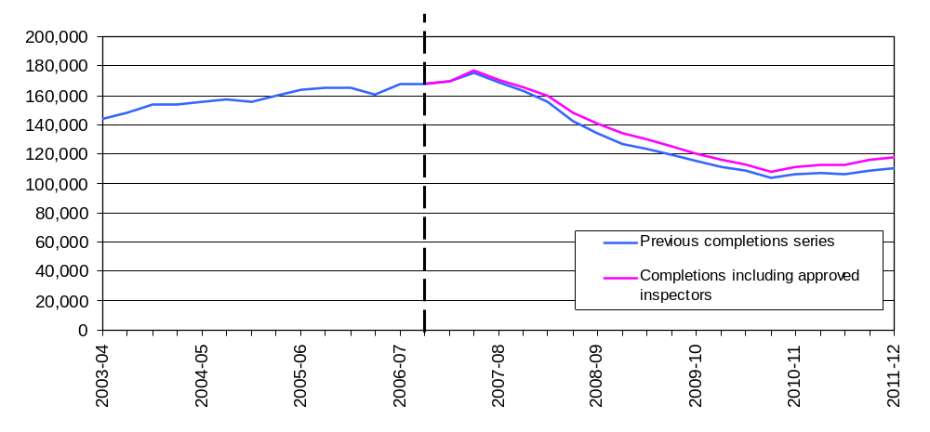
The inclusion of the approved inspectors is an improvement to the coverage of these statistics in response to the relatively recent growth of this sector of the market but not a fundamental change to the methodology. The inclusion of the approved inspector data should bring coverage back in to line with the statistics from before 2005 and the entry of approved inspectors into the building control market for private housing. Although in the charts of this release the change is marked at the June quarter 2007, in fact it could be argued that the section of the series which differs from the rest is the 18-month portion after the introduction of the warranty link rule in 2005, until the point in April 2007 from which the approved inspectors data are included.
Figure 8 shows that the percentages of all starts and completions reported by approved inspectors have increased since 2007, with both showing particular increases during the early period. Approved inspector completions were less than 1 per cent of total completions in the June quarter of 2007 while starts comprised around 4 per cent of the total.
Figure 8: Approved inspector reported starts and completions as a proportion of total starts and completions
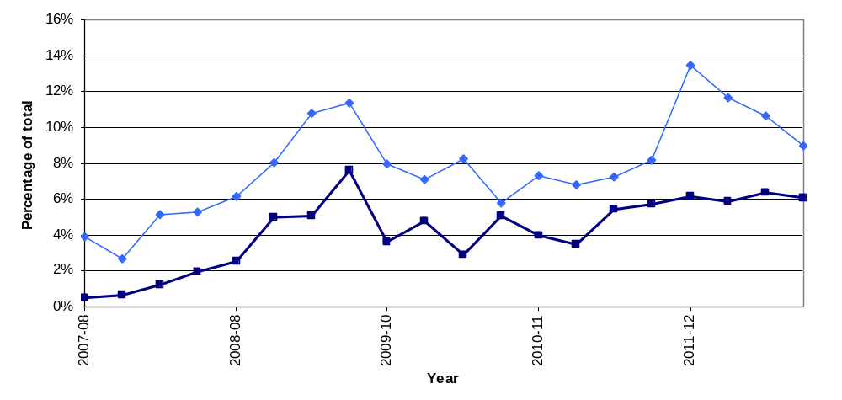
With the opening of the market in 2005 and the time lag between starts and completions it is to be expected that starts would increase before completions. A residential building development can take any time from a few months through to several years to progress from start through to completion. It is likely that the 2007 data collection picked up very early activity for completions but that inspections relating to starts were already more advanced by the time of the collection began. Partial data from the survey of approved inspectors for 2006/07 supports this conclusion.
Recently the approved inspector share of building control starts peaked at 13 per cent in the second quarter of 2011 although this has dropped back to 9 per cent in the most recent quarter. The market share in completions has been more stable, running at around 6 per cent of all completions for the past year.

For further information on the data collection and quality of the statistics see the ‘Data quality’ section of this release below.

Comments on these changes can be made via the “statistical enquiries” contact details shown on the front page of this release.

Data collection
This release takes information from three data sources on building control:
- ‘P2’ quarterly house building returns submitted to Department for Communities and Local Government by local authority building control departments;
- monthly information from the National House-Building Council (NHBC) on the volume of building control inspections they undertake in each local authority area; and


- quarterly data collection from other approved inspectors (AIs).
Data on starts and completions by individual building control organisation are not published.

Data quality
District level data
House building data are collected at local authority district level, but it is important to treat figures at this level with care. House building is unevenly distributed both geographically and over time and patterns of housing development can produce clusters of new homes which make the figures at a low geographic level volatile and difficult to interpret.
Consider a district averaging 100 starts in a quarter: one or two major residential developments starting in that district would produce a large increase in starts in a year. Similarly once work on the developments has started those starts would drop out of the statistics which could at first glance be interpreted as a large fall in housing supply in that district. In the next year a new development might occur in a neighbouring district and produce similar effects. Neither of these events would in themselves be unusual but in both cases it would be unwise to infer any form of trend from the figures. A better interpretation might be to look at both districts together with neighbouring areas.
In addition, the precise timing with which starts and completions are recorded in the statistics can vary from one housing development to the next, depending on factors such as the timing of building control inspections or differences between data providers’ administrative systems. Such factors tend to cancel out over time or when figures are aggregated to higher geographic levels, but can be acute at the individual district level.
District level data are available in live table 253 which includes annual district level data back to 1998-99. For more information about live tables see "Accompanying tables" section below.
Response rate
The P2 data received from local authorities records starts and completions inspected by local authority building control. This data also includes imputation for a small number of missing returns. In the March quarter 2012 a 97 per cent local authority response rate was achieved.
Other approved inspector data is collected from independent building control companies. In the March quarter 2012 an 81 per cent response rate was achieved. Where an approved inspector company has previously provided returns but has not provided a return for the current period the data includes imputed values for that company.
The NHBC data include all starts and completions inspected by NHBC building control.
Imputation
The process to impute for a missing P2 local authority return works by picking up all data recorded in completed returns for that local authority over the previous five years and comparing it to data for other similar local authorities for the same periods. It then looks at the data provided for the current period by those other local authorities and imputes a figure for the missing local authority return which matches the proportion found in the comparison of data for the previous five years.
Imputation for other approved inspectors is performed using post stratification. Stratification is on the basis of the most recent previous total of starts and completions reported. Once approved inspectors have been stratified non-response weights are calculated and these weights applied to all responding approved inspectors for the quarter. Where insufficient recent data exists to sensibly include a response or non-response in the stratification (for example where there is no recent data) or where the status of the approved inspector is unclear for that period (for instance it is not certain that they were operating in the that period or are a duplicate entry) the approved inspector is not included in the post stratification process. This may result in a small level of under coverage but ensures that only genuine non-response is weighted for and minimises the risk of overestimating the numbers of starts and completions inspected by approved inspectors.
Non-response weighting for approved inspectors is used only at an England level.
Tenure
Figures on housing starts and completions are from records kept for building control purposes. It is sometimes difficult for the building control officers who record the data to identify whether a dwelling is being built for a housing association, a local authority or for a private developer. This may lead to an understatement of housing association and local authority starts and completions recorded in these tables, and a corresponding overstatement of private enterprise figures. This problem is more likely to affect starts than completions.

There are two other sources of official statistics on affordable housing supply which should be considered as an alternative by users interested specifically in the affordable sector. Please refer to the “Related statistics” section of this publication for further information.
From start to completion
A wide range of factors can influence the length of time it takes for a new home to be constructed from start to completion. This period can vary from just a few months to several years.
There are some circumstances in which starts might exceed completions. Information gathered from data providers indicates that the most common of these is where a new dwelling is started but never completed because the developer is no longer able or willing to complete the development.
Also, in principle a dwelling is regarded as completed when it becomes ready for occupation or when a completion certificate is issued, whether it is in fact occupied or not. In practice the reporting of some completions may be delayed and some completions may be missed if no completion certificate was requested by the developer or owner; this is unusual because most property owners would want to have a completion certificate for the purposes of selling the property on.
These circumstances do not disproportionately affect particular regions or types of area, although private housing development may be more likely to be affected than public.
In general the number of starts will be a strong indicator of the likely trend in completions in the near future but we have seen differences over the short and medium term. It sometimes appears that an imbalance exists in the statistics when the overall number of starts differs from the overall number of completions over a number of years. For example, over the period from 1997 – 2007 there were 1,760,000 starts but only 1,630,000 completions – a difference of 7 per cent.
However, a comparison of starts and completions over the long term shows that such differences tend to balance out over time – the years before 1997 and the years since 2007 both saw substantially more completions than starts, and over the 20 years from 1990 to 2010 there were in fact 1 per cent more completions than starts. These shorter term imbalances can be understood as a feature of the economic cycle.
Comparability between the countries of the UK

Each of the countries of the UK produces its own statistics on House Building (see “Related statistics” section below). The Department for Communities and Local Government is responsible for collecting and publishing data for England. However house building statistics for the devolved administrations of the UK, as well as for Great Britain and the UK as a whole, are included in the tables that accompany this statistical release. In this section the consistency of the data sources is discussed.
England and the devolved administrations use broadly consistent definitions for starts and completions in collecting house building data. Until now, all four countries have collected starts and completions data split into the three tenure types of private enterprise, housing association and local authority. From the June quarter 2011 onwards, this tenure split is no longer available for Welsh starts figures.
In England and Wales some housing association starts and completions can be misreported as private enterprise starts because it is sometimes difficult for data providers to identify whether a dwelling is being built for a housing association or for a private developer (see above). This is not thought to be a problem in Northern Ireland and Scotland where data on housing association house building are collected directly from housing association administrations rather than building inspection teams. It is because of this issue that statistics for house building starts in Wales no longer include a breakdown by tenure.
While a very small proportion of the data for England are imputed for missing responses (see above), a full response is generally collected in Wales, Scotland and Northern Ireland so imputation is seldom necessary.
Currently approved inspectors data is included in the statistics for Scotland and Northern Ireland. Approved inspector data is not used in the current Welsh house building data. However an investigation is currently underway to determine the level of approved inspector activity in Wales with a view to including approved inspectors if it is found to be appropriate.

Uses of house building statistics
The house building statistical series on starts and completions are a key part of the evidence base which informs the development and evaluation of housing policy by central and local government. They are also used as evidence for other housing market analysts, forecasters and decision makers, for example at the Bank of England and in the construction and banking industries. The statistics are also used for market research by a wide range of other businesses. They are used by the media in reports on the housing market, and by academics both in the UK and abroad.

Related statistics
Net supply of housing
The annual Net supply of housing statistics, also known as ‘net additions’, show the absolute change in dwelling stock between 1 April and 31 March the following year. They comprise the number of new build permanent dwellings; plus the net gain from dwelling conversions; plus the net gain of non dwellings brought into residential use; plus net additions from other gains and losses to the dwelling stock (such as mobile and temporary dwellings); less any demolitions.
The net supply of housing statistical series is separate from and complementary to the Department for Communities and Local Government’s quarterly series on new house building. The net supply of housing provide a more comprehensive but less timely measure of total housing supply in England. Completions figures from the quarterly house building series are not used in the net supply of housing statistics. Instead a separate set of data on the new build completions component of housing supply is collected as part of the overall annual net supply of housing data collection. This eliminates timing differences from the net additions series and provides a picture of the components of net change which can be reconciled for a given year.
The house building statistical series takes its data from the same source throughout England, combining data from building control officers at local authorities, the National House-Building Council (NHBC) and other independent building control inspectors. Data for the net supply of housing all come from local authorities, who in turn use whichever local data source they believe is most appropriate.
The house building series is published within eight weeks after the end of each quarter, providing a timely measure of house building activity. The data collection period for net supply of housing is relatively long, being annual and closing some five months after the end of the financial year. The longer data collection period makes it possible to compile a more complete picture of housing supply over the period; including conversions, change of use and demolitions.
The new build component of the net supply of housing statistics is generally slightly larger than the corresponding annual total from house building data, despite the fact that they are measuring the same thing. Over the year to March 2011 the new build component of the net supply of housing statistics was 6 per cent greater than the corresponding figure from the quarterly house building statistics. This is probably due largely to the much longer data collection period for the net supply of housing. However, other possible factors include the fact that net supply of housing will pick up the small minority of dwellings which are finished and in which people are living but where a completion certificate has not been issued. In such cases a completion may not have been recorded in the building control data used for the quarterly house building statistics.
Users who need an early indication of house building activity or who intend to use housing supply statistics as an economic indicator are advised to use the quarterly house building starts and completions series. Those who require a long-running, consistent time series on housing supply should also use house building, in either a quarterly or annual basis. Users wanting a more complete picture of the overall supply of housing may find the net supply of housing statistical series more appropriate.
The net supply of housing statistics can be found at the link below.
http://www.communities.gov.uk/housing/housingresearch/housingstatistics/housingstatisticsby/netsupplyhousing/ .
Council tax valuation lists
The Valuation Office Agency (VOA) compiles and maintains lists of all domestic properties in England and Wales to support the collection of council tax, and these lists are constantly updated to reflect the creation of new dwellings and losses of dwellings.
The VOA’s definition of a dwelling differs somewhat from that used by the census. The Department for Communities and Local Government’s House Building statistics, Net supply of housing and Dwelling stock estimates statistics all use the census definition (see ‘Definitions’ section below). This means that a number of dwelling units may be included in one set of statistics but not the other. In general the VOA‘s definition is broader and includes communal establishments such as student halls of residence or care homes where the definition used by the Department for Communities and Local Government does not.
The Valuations Office Agency now publishes statistics on these lists which can be found at the following link.
http://www.voa.gov.uk/corporate/Publications/statistics.html
New Homes Bonus
The New Homes Bonus allocates grants to local authorities according to the number of new homes delivered and empty homes brought back into use in their area. The growth in their council taxbase is used as a proxy measure for the number of new homes delivered because this provides information about council tax bands which are required as part of the calculation of New Homes Bonus allocations. The number of long-term empty homes in each area is also collected as part of the council tax system.
As the New Homes Bonus is based on council tax data, which is itself derived from the Valuation Office Agency’s valuation list, it is collected using the same, broader definition of a dwelling as used by the Valuation Office Agency (see ‘Council tax valuation lists’ above).
The council taxbase data return is made by local authorities to the Department for Communities and Local Government in November giving details of their council tax base at September. Therefore the period over which the change in taxbase is measured for the New Homes Bonus (the year to September) is different from the period over which the net supply of housing is measured (the year to April).
The combination of timing and definitional differences means that it is not possible to reconcile the New Homes Bonus numbers fully to the National Statistics on housing supply (House Building and Net Supply of Housing). The different sources will inevitably give different figures, though trends over time are likely to be similar. In addition, the New Homes Bonus headline allocations figures also include a component for empty homes brought back in to use.
Users of housing supply statistics should note that the New Homes Bonus figures are a by-product of the data used to administer the council tax system and are not primarily designed as a measure of housing supply. The National Statistics on House Building and on Net supply of housing are designed to give a comprehensive measure of housing supply which can be used to make consistent comparisons over time. They have been assessed and endorsed by the UK Statistics Authority (see ‘National Statistics’ section below).
The New Homes Bonus allocations for 2012/13 were published on 1 February 2012. Details can be found at the following link.
http://www.communities.gov.uk/housing/housingsupply/newhomesbonus/
Dwelling stock estimates
Department for Communities and Local Government also publish statistics showing the total dwelling stock in England each year. These estimates are based on the latest census count plus the annual Net supply of housing statistics described above. They can be found at the following link.
http://www.communities.gov.uk/housing/housingresearch/housingstatistics/housingstatisticsby/stockincludingvacants/
Affordable housing
New affordable homes are defined as additional housing units (or bed spaces) provided to specified eligible households whose needs are not met by the market and can be categorised into social rent, intermediate rent and low cost home ownership. Total additional affordable supply includes both new build supply and acquisitions of existing private sector homes.
There are three main sources of official figures on affordable housing supply which are summarised in the table below:
Statistical source | Included | Not included | Frequency | Timeseries
House Building statistics: Housing Association and Local Authority tenures combined | New build housing for social rent. | Most affordable ownership supply and acquisitions from existing private housing. | Quarterly | From 1946
Affordable Housing Supply statistics | All supply (new build and acquisitions) of affordable housing | May be some small gaps in coverage (see release) | Annual | From 1991/92
Homes and Communities Agency National Housing Statistics | All supply (new build and acquisitions) of affordable housing delivered through HCA grant funding programmes | Some housing delivered without HCA grant funding. | Six monthly | From 2009/10
The house building statistics in this publication are categorised by tenure into private enterprise, housing association (HA) and local authority (LA). However, this tenure split has its limitations (see “Data quality” section) and is not the best source of information on new build specifically in the affordable housing sector.
A more detailed and complete source is Department for Communities and Local Government’s Affordable housing supply statistics, which can be found at the following link, along with detail on definitions and sources. http://www.communities.gov.uk/housing/housingresearch/housingstatistics/housingstatisticsby/affordablehousingsupply/.
Although the HA and LA tenures of the house building statistics attempt to measure the entire new build component of affordable housing supply, including social rent, shared ownership and other affordable housing products, in practice much new build shared ownership housing and some new build social rent housing may be mis-recorded within the ‘private enterprise’ tenure of the house building statistics.
This means that the house building statistics underestimate the total new build supply of affordable housing in the LA and HA tenure categories. Users requiring the best annual estimate for new build affordable housing should refer to the “New build and acquisitions” section of the affordable housing supply statistical release and live table 1009, both accessible from the link above.
Despite this, the tenure split reported in the house building statistics continues to have practical uses as they provide more frequent and timely estimates of starts as well as completions, and are available back to 1946.
The Homes and Communities Agency’s National Housing Statistics can be found at the following link – http://www.homesandcommunities.co.uk/statistics - and show delivery through the HCA funding programmes for housing.
Devolved administrations
House building statistics for the devolved administrations of the UK are included alongside the England statistics in the tables that accompany this statistical release. These data are published separately by the devolved administrations, and although figures are correct at the time of this publication they may be superseded before the next England house building release. Latest data and details on data sources and methods can be found at the following links:
Scotland (house building statistics)
http://www.scotland.gov.uk/Topics/Statistics/Browse/Housing-Regeneration/HSfS/NewBuild
Wales (house building statistics)
http://wales.gov.uk/topics/statistics/theme/housing/newbuild/;jsessionid=9bcQNK5GxLQv5p05StGJZsznPYpXL07L47Qh19JXKc22vq3nl9L8!475011280?lang=en
Northern Ireland (housing statistics)
http://www.dsdni.gov.uk/index/stats_and_research/housing_publications.htm

Revisions policy
This policy has been developed in accordance with the UK Statistics Authority Code of Practice for Official statistics and the Department for Communities and Local Government Revisions Policy. There are two types of revisions that the policy covers.
Scheduled revisions
In order to maximise the response rate from local authorities and enable late information to be included, each quarterly P2 return can be updated at any time up to two years after the initial publication of the figures for that quarter. Every quarter, as well as releasing figures for the latest quarter, we revise the previous quarter to incorporate any data that came in shortly after the previous data collection period. This captures most late local authority data, but in order to incorporate the remainder a longer revision is carried out once a year, in the June quarter statistical release. Therefore, until each quarterly return is permanently closed, figures for that quarter remain provisional. Provisional figures are labelled in the tables with a “P” and revised figures are labelled with an “R”.
The starts data provided by NHBC, which are monthly, can also be subject to some changes after their initial inclusion, and to address this the NHBC starts data for the previous two quarters are now also revised in each release. In particular, the information on the tenure can often change when a start gets closer to completion and this tends to result in a net shift in starts from the private enterprise tenure to the housing association tenure.
In addition, where figures are seasonally adjusted, the adjustment factors for the whole series back to 2000 are recalculated annually, usually in the June quarter. This will result in small changes to seasonally adjusted figures across the whole period. These changes are not labelled with an “R”.
Other revisions to historic data (all data older than that currently due for scheduled revision) should only be made where there is a substantial revision, such as a change in methodology or definition. Where there are small changes that do not substantially change historic data, internal updates are maintained.
Non-scheduled revisions
Where a substantial error has occurred as a result of the compilation, imputation or dissemination process, the statistical release, live tables and other accompanying releases will be updated with a correction notice as soon as is practical.
Revisions in this release
The data in this release has been revised back to June quarter 2007 to include data from other approved inspectors. Detailed information on this revision can be found in the "Approved inspectors" section above.
As scheduled, starts and completions data provided by local authorities, and starts data provided by NHBC, have been revised in this release back to the September quarter 2011 to incorporate late data. As a result, 20 starts have been added to the September quarter and 170 starts have been subtracted from the December quarter; 20 completions have been subtracted from the December quarter. This is in addition to the revision to include approved inspectors from 2007 (see ‘Independent approved inspectors’ section above).

Definitions
Dwelling - A home or dwelling in these statistics is defined in line with the Census definition, which defines a dwelling as a self-contained unit of accommodation. Self-containment is where all the rooms (including kitchen, bathroom and toilet) in a household's accommodation are behind a single door which only that household can use. Non-self contained household spaces at the same address should be counted together as a single dwelling. Therefore a dwelling can consist of one self-contained household space or two or more non-self-contained household spaces at the same address.
Ancillary dwellings (eg 'granny annexes') are included provided they are self-contained, pay separate council tax from the main residence, do not share access with the main residence (eg a shared hallway) and there are no conditional restrictions on occupancy.
Communal establishments, ie establishments providing managed residential accommodation, are not counted in overall housing supply. These cover university and college student, hospital staff accommodation, hostels/homes, hotels/holiday complexes, defence establishments (not married quarters) and prisons. However, purpose-built (separate) homes (eg self-contained flats clustered into units with 4 to 6 bedrooms for students) are included, with each self-contained unit counted as a dwelling.
Non permanent (or 'temporary') dwellings are included if they are the occupant's main residence and council tax is payable on them as a main residence. These include caravans, mobile homes, converted railway carriages and houseboats. Permanent Gypsy and Traveller pitches should also be counted if they are, or likely to become, the occupants' main residence.
House building start - A dwelling is counted as started on the date work begins on the laying of the foundation, including 'slabbing' for houses that require it, but not including site preparation. Thus when foundation work commences on a pair of semi-detached houses two houses are counted as started, and when work begins on a block of flats all the dwellings in that block are counted as started. The starts of houses in building schemes are usually phased over a period of weeks or even, in very large schemes, months.
House building completion – In principle, a dwelling is regarded as complete when it becomes ready for occupation or when a completion certificate is issued whether it is in fact occupied or not. In practice, the reporting of some completions may be delayed and some completions may be missed if no completion certificate was requested by the developer or owner, although this is unusual.
Tenure – For the purposes of these statistics, the term tenure refers to the nature of the organisation responsible for the development of a new housing start or completion. It does not necessarily describe the terms of occupancy for the dwelling on completion. For example, some housing associations develop homes for sale on the open market. Such homes would be reported in the Housing Association tenure of these statistics, but would ultimately most likely be owned and occupied in the private sector.
Housing association - “Housing associations (HAs)” has been used as the generic name for all social landlords not covered by local authorities (see below). In previous editions HAs were referred to as Registered Social Landlords (RSL), and the technical term (private) Registered Provider (pRP) of social housing is also sometimes used. The more all-encompassing description of ‘housing associations’ is now seen as more helpful to users of these statistics.

Accompanying tables
Accompanying tables are available to download alongside this release:

Tables:
1a House building starts and completions, including seasonally adjusted series: England;

1b House building starts and completions unadjusted: North East;
1c House building starts and completions unadjusted: North West;

1d House building starts and completions unadjusted: Yorkshire and the Humber;
1e House building starts and completions unadjusted: East Midlands;

1f House building starts and completions unadjusted: West Midlands;
1g House building starts and completions unadjusted: East of England;

1h House building starts and completions unadjusted: London;
1j House building starts and completions unadjusted: South East;

1k House building starts and completions unadjusted: South West;
2a House building starts and completions unadjusted: Wales;
2b House building starts and completions unadjusted: Scotland;
2c House building starts and completions unadjusted: Great Britain;
2d House building starts and completions unadjusted: Northern Ireland;
2e House building starts and completions unadjusted: United Kingdom;
Additional tables showing house building completions by type and size of property, starts and completions for individual local authorities as well as historic series can be accessed in the 'Live tables' section ("Live tables on house building") at the following link. http://www.communities.gov.uk/housing/housingresearch/housingstatistics/
All statistical releases on house building can be accessed on the Department for Communities and Local Government website at http://www.communities.gov.uk/housing/housingresearch/housingstatistics/housingstatisticsby/housebuilding/publicationsonhousebuilding/.

Notes to the tables
The following conventions have been used in the tables:
.. Not available;
- Fewer than 5 dwellings;
^{P} Figure provisional and subject to revision;
^{R} Revised from previous release.
Totals may not equal the sum of component parts due to rounding to the nearest 10.

Background notes
- The starts and completions reported in this publication are for new house building in England and exclude new dwellings created through conversions and the change of use of existing buildings.
- Figures in the accompanying tables are presented rounded to the nearest 10 dwellings.
- The charts give seasonally adjusted quarterly house building trends and give annual trends by showing a rolling 12-month total. The private enterprise and housing association England series are seasonally adjusted.
- Accompanying Table 1a gives non-seasonally adjusted and seasonally adjusted England figures. All figures for other UK countries and English regions are shown on an unadjusted basis only.
- The tables and charts accompanying this release are shown above in the ‘Accompanying tables’ section and are provided in Microsoft Excel format.
- Details of officials and ministers who receive pre-release access to the Department for Communities and Local Government quarterly House Building release up to 24 hours before release can be found at:
http://www.communities.gov.uk/corporate/researchandstatistics/statistics/prereleaseaccess/
- The next quarterly release will be published on Thursday 16 August 2012, and will cover house building up to the June quarter 2012.

User consultation
Users’ comments on any issues relating to this statistical release are welcomed and encouraged. Responses should be addressed to the "statistical enquiries" contact given in the "Enquiries" section below.
National Statistics
The United Kingdom Statistics Authority has designated these statistics as National Statistics, in accordance with the Statistics and Registration Service Act 2007 and signifying compliance with the Code of Practice for Official Statistics.
Designation can be broadly interpreted to mean that the statistics:
- meet identified user needs;
- are well explained and readily accessible;
- are produced according to sound methods, and
- are managed impartially and objectively in the public interest.

Once statistics have been designated as National Statistics it is a statutory requirement that the Code of Practice shall continue to be observed.

Enquiries

Statistical enquiries:
e-mail: housing.statistics@communities.gov.uk
telephone: 0303 44 42272

Media Enquiries:
office hours: 0303 44 41136
out of hours: 0303 44 41201
e-mail: press@communities.gov.uk

ISBN: 978-1-4098-3493-9

Department for Communities and Local Government. © Crown Copyright, 2012

If you require this publication in an alternative format please email: alternativeformats@communities.gsi.gov.uk. Please note that the nature of content means that we may not be able to provide the Statistical series of publications in all requested formats.

May 2012

