
House Building: June Quarter 2010, England
- There were 28,590 seasonally adjusted house building starts in England in the June quarter 2010. This is 13 per cent higher than in the previous quarter and 84 per cent above the trough in the March quarter 2009, but 42 per cent below their March quarter 2007 peak.
- Private enterprise housing starts (seasonally adjusted) were ten percent higher than in the March quarter 2010. By comparison starts by registered social landlords were 17% higher over the same period.
- Housing completions in England rose by one per cent to an estimated 26,550 (seasonally adjusted) in the June quarter 2010 compared to the previous quarter. This is the first quarterly rise since the final quarter of 2007, and follows a five per cent fall between the December 2009 and March 2010 quarters.
- Private enterprise housing completions (seasonally adjusted) were one per cent higher in the June quarter 2010 than the March quarter 2010; completions by registered social landlords remained the same over the same period.
- Annual housing starts reached 98,500 in the 12 months to June 2010, up by 44 per cent compared with the 12 months to June 2009. Annual housing completions in England totalled 110,210 in the 12 months to June 2010, down by 13 per cent compared with the 12 months to June 2009.
- All regions experienced a rise in annual starts between the 12 months ending June 2009 and the 12 months ending June 2010.



Contents
1. Starts and completions, seasonally adjusted…………2
2. Starts and completions, non-seasonally adjusted………...4
3. Regional trends……………...6
4. Other Approved Inspectors
................................................10
5. Data collection………….…..10
6. Strengths and weaknesses
of the data……..…………....11
7. Related statistics.................11
8. Revisions policy……...….…12
9. Accompanying tables…...…13
10. Background notes.............14
11. User consultation…....…...15
12. Enquiries….……….….…...15

Responsible statistician:
Richard Field

Media Enquiries:
office hours: 0303 444 1136
out of hours: 0303 444 1201

press@communities.gov.uk

Statistical enquiries:
office hours: 0303 444 2272
housing.statistics@communities.gov.uk

Housing
Statistical Release

August 2010
using
Research
Summary
Number 239, 2007

This quarterly Statistical Release presents National Statistics on new house building starts and completions in England and its regions up to the June quarter 2010. The figures in this release have been revised back to the June quarter 2007 to incorporate late information provided by local authorities, in line with our regular revisions policy.
Data for Scotland, Wales and Northern Ireland are also included in the accompanying tables. These data are published separately by the devolved administrations, and although the figures are correct at the time of this publication they may be superseded before the next England house building release.

Starts and completions in England, seasonally adjusted
Figures for private enterprise and registered social landlords are seasonally adjusted. Local authority figures do not display seasonality and are therefore not seasonally adjusted. The seasonally adjusted series should be used for quarter on quarter comparisons. For annual comparisons the non-seasonally adjusted series should be used.
Seasonally adjusted housing starts in England rose from 25,300 in the March quarter 2010 to 28,590 in the June quarter 2010. This is 13 per cent higher than in the previous quarter and 84 per cent above the trough in the March quarter 2009, but 42 per cent below their March quarter 2007 peak.

Figure 1: Seasonally adjusted trends in quarterly housing starts and completions, England
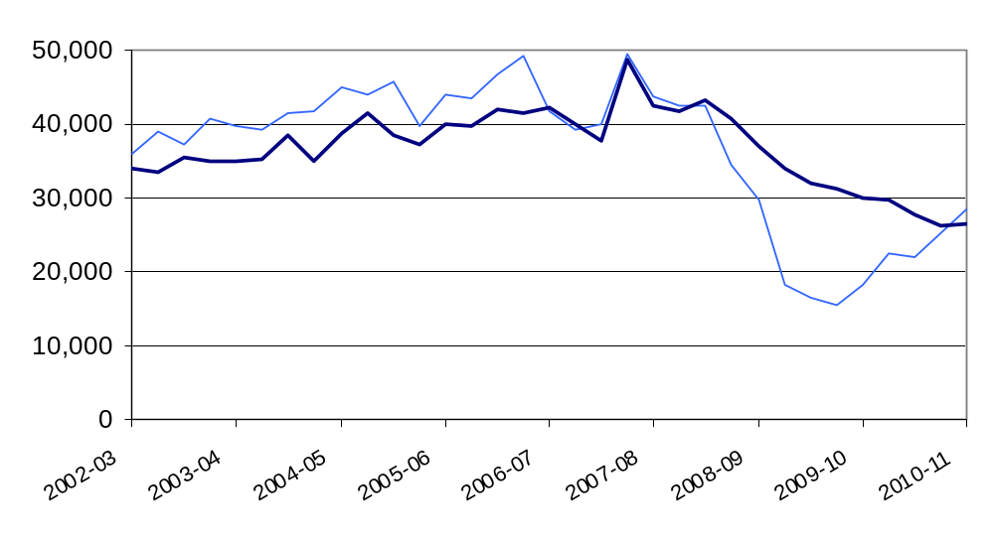

Seasonally adjusted private enterprise housing starts were ten per cent higher in the June 2010 quarter than in the March 2010 quarter. By comparison, starts by Registered Social Landlords were 17% higher over the same period.

Table 1a: Quarterly housing starts by tenure, England, seasonally adjusted¹
 |  |  | Private  Enterprise |  | Registered  Social Landlords |  | Local  Authority | All  Tenures
 |  |  | Starts | % change on previous quarter | Starts | % change on previous quarter | Starts | Starts | % change on previous quarter
2006-07 | Apr-June |  | 37,160 | -13% | 4,430 | -30% | 90 | 41,680 | -16%
 | July-Sept |  | 34,490 | -7% | 4,830 | 9% | 30 | 39,350 | -6%
 | Oct-Dec |  | 34,320 | -1% | 5,610 | 16% | 30 | 39,950 | 2%
 | Jan-Mar |  | 43,390 | 26% | 6,030 | 8% | 50 | 49,460 | 24%
2007-08 | Apr-June | ^{R} | 38,190 | -12% | 5,390 | -11% | 60 | 43,640 | -12%
 | July-Sept | ^{R} | 36,690 | -4% | 5,890 | 9% | 30 | 42,610 | -2%
 | Oct-Dec | ^{R} | 36,430 | -1% | 6,130 | 4% | 10 | 42,570 | 0%
 | Jan-Mar | ^{R} | 27,910 | -23% | 6,510 | 6% | 80 | 34,500 | -19%
2008-09 | Apr-June | ^{R} | 23,120 | -17% | 6,470 | -1% | 120 | 29,710 | -14%
 | July-Sept | ^{R} | 13,030 | -44% | 5,270 | -18% | 10 | 18,310 | -38%
 | Oct-Dec | ^{R} | 11,830 | -9% | 4,400 | -17% | 160 | 16,380 | -11%
 | Jan-Mar | ^{R} | 11,640 | -2% | 3,850 | -12% | 20 | 15,510 | -5%
2009-10 | Apr-June | ^{R} | 14,260 | 22% | 3,930 | 2% | 50 | 18,240 | 18%
 | July-Sept | ^{R} | 17,350 | 22% | 5,030 | 28% | 30 | 22,410 | 23%
 | Oct-Dec | ^{R} | 17,340 | 0% | 4,680 | -7% | 50 | 22,070 | -2%
 | Jan-Mar | ^{R} | 20,360 | 17% | 4,750 | 1% | 200 | 25,300 | 15%
2010-11 | Apr-June | ^{P} | 22,480 | 10% | 5,550 | 17% | 570 | 28,590 | 13%
1. Because the number of local authority housing starts and completions is very small, quarterly comparisons can be very volatile. Accordingly percentage changes are not reported for this tenure.

Housing completions in England (seasonally adjusted) were up by one per cent to 26,550 in the June quarter 2010, from 26,280 in the previous quarter. This compares to a five per cent fall between the December 2009 and the March 2010 quarters; and it is the first rise in seasonally adjusted house building completions since the December 2007 quarter.
Seasonally adjusted private enterprise housing completions were also one per cent higher in the June 2010 quarter than in the March 2010 quarter. By comparison, completions by Registered Social Landlords remained the same over the same period.

Table 1b: Quarterly housing completions by tenure, England, seasonally adjusted¹
 |  |  | Private  Enterprise |  | Registered  Social Landlords |  | Local  Authority | All  Tenures
 |  |  | Completions | % change on  previous quarter | Completions | % change on  previous quarter | Completions | Completions | % change on  previous quarter
2006-07 | Apr-June |  | 36,870 | 0% | 5,330 | 15% | 60 | 42,260 | 2%
 | July-Sept |  | 34,180 | -7% | 5,670 | 6% | 60 | 39,910 | -6%
 | Oct-Dec |  | 32,550 | -5% | 5,150 | -9% | 50 | 37,740 | -5%
 | Jan-Mar |  | 43,050 | 32% | 5,590 | 9% | 90 | 48,730 | 29%
2007-08 | Apr-June | ^{R} | 37,190 | -14% | 5,100 | -9% | 110 | 42,410 | -13%
 | July-Sept | ^{R} | 36,660 | -1% | 5,050 | -1% | 30 | 41,740 | -2%
 | Oct-Dec | ^{R} | 36,980 | 1% | 6,240 | 24% | 20 | 43,240 | 4%
 | Jan-Mar | ^{R} | 34,230 | -7% | 6,470 | 4% | 50 | 40,750 | -6%
2008-09 | Apr-June | ^{R} | 30,500 | -11% | 6,280 | -3% | 140 | 36,920 | -9%
 | July-Sept | ^{R} | 27,840 | -9% | 6,050 | -4% | 60 | 33,950 | -8%
 | Oct-Dec | ^{R} | 24,900 | -11% | 6,850 | 13% | 180 | 31,930 | -6%
 | Jan-Mar | ^{R} | 24,770 | -1% | 6,260 | -9% | 130 | 31,160 | -2%
2009-10 | Apr-June | ^{R} | 23,440 | -5% | 6,400 | 2% | 130 | 29,960 | -4%
 | July-Sept | ^{R} | 22,540 | -4% | 7,070 | 10% | 80 | 29,690 | -1%
 | Oct-Dec | ^{R} | 22,050 | -2% | 5,660 | -20% | 30 | 27,740 | -7%
 | Jan-Mar | ^{R} | 20,430 | -7% | 5,790 | 2% | 60 | 26,280 | -5%
2010-11 | Apr-June | ^{P} | 20,690 | 1% | 5,770 | 0% | 80 | 26,550 | 1%
1. Because the number of local authority housing starts and completions is very small, quarterly comparisons can be very volatile. Accordingly percentage changes are not reported for this tenure.
Starts and completions in England, non-seasonally adjusted
These series are not seasonally adjusted so it may be misleading to draw conclusions from quarter on quarter changes. For quarter on quarter comparisons the seasonally adjusted series should be used.
Annual housing starts increased from 150,700 in the 12 months ending December 2002, reaching a peak of 183,360 in the 12 months ending March 2006. Starts then fell to 68,450 in the 12 months to June 2009 before rising to 98,500 in the 12 months to June 2010, 35 per cent below the peak, but up by 44 per cent compared with the 12 months to June 2009.
Annual housing completions increased from 129,870 in the 12 months ending March 2002, reaching a peak of 175,560 in the 12 months ending December 2007. Completions have now fallen to 110,210 in the 12 months to June 2010, 37 per cent below the peak.

Figure 2: Trends in starts and completions, England, 12 month rolling totals
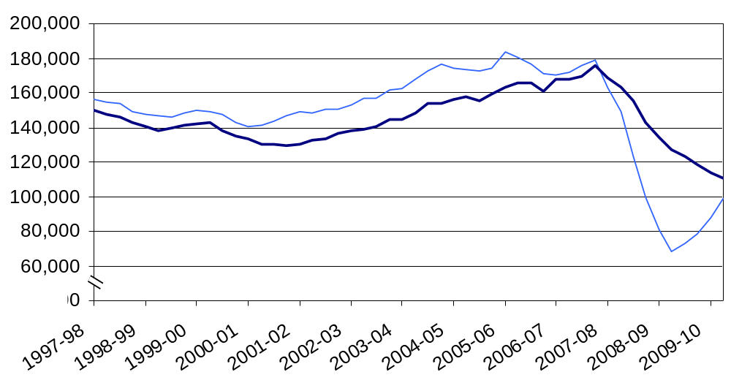
Housing starts were 57 per cent higher in the June quarter 2010 than in the June quarter 2009. This compares with a 61 per cent rise between the March 2009 and the March 2010 quarters.

Private enterprise housing starts were 58 per cent higher in the June 2010 quarter than in the June 2009 quarter. By comparison, starts by Registered Social Landlords rose by 41 per cent over the same period.

Table 2a: Quarterly housing starts by tenure, England, not seasonally adjusted¹
 |  |  | Private  Enterprise |  | Registered  Social Landlords |  | Local  Authority | All  Tenures
 |  |  | Starts | % change on same quarter previous year | Starts | % change on same quarter previous year | Starts | Starts | % change on same quarter previous year
2006-07 | Apr-June |  | 38,900 | -5% | 4,960 | -14% | 90 | 43,960 | -6%
 | July-Sept |  | 36,420 | -9% | 4,740 | -10% | 30 | 41,190 | -9%
 | Oct-Dec |  | 30,990 | -15% | 4,790 | -7% | 30 | 35,810 | -14%
 | Jan-Mar |  | 43,040 | 0% | 6,280 | -5% | 50 | 49,370 | -1%
2007-08 | Apr-June | ^{R} | 39,680 | 2% | 6,040 | 22% | 60 | 45,790 | 4%
 | July-Sept | ^{R} | 39,300 | 8% | 5,770 | 22% | 30 | 45,090 | 9%
 | Oct-Dec | ^{R} | 32,940 | 6% | 5,260 | 10% | 10 | 38,200 | 7%
 | Jan-Mar | ^{R} | 27,440 | -36% | 6,770 | 8% | 80 | 34,290 | -31%
2008-09 | Apr-June | ^{R} | 23,880 | -40% | 7,250 | 20% | 120 | 31,250 | -32%
 | July-Sept | ^{R} | 14,120 | -64% | 5,150 | -11% | 10 | 19,290 | -57%
 | Oct-Dec | ^{R} | 10,700 | -68% | 3,790 | -28% | 160 | 14,650 | -62%
 | Jan-Mar | ^{R} | 11,350 | -59% | 4,020 | -41% | 20 | 15,390 | -55%
2009-10 | Apr-June | ^{R} | 14,690 | -39% | 4,390 | -39% | 50 | 19,120 | -39%
 | July-Sept | ^{R} | 18,960 | 34% | 4,920 | -4% | 30 | 23,910 | 24%
 | Oct-Dec | ^{R} | 15,710 | 47% | 4,040 | 7% | 50 | 19,800 | 35%
 | Jan-Mar | ^{R} | 19,710 | 74% | 4,950 | 23% | 200 | 24,850 | 61%
2010-11 | Apr-June | ^{P} | 23,180 | 58% | 6,200 | 41% | 570 | 29,940 | 57%

1. Because the number of local authority housing starts and completions is very small, quarterly comparisons can be very volatile. Accordingly percentage changes are not reported for this tenure.

Housing completions were 11 per cent lower in the June quarter 2010 than in the June quarter 2009. This compares with a decline of 15 per cent between the March 2009 and the March 2010 quarters.

Private enterprise housing completions were 12 per cent lower in the June 2010 quarter than in the June 2009 quarter. By comparison, completions by Registered Social Landlords fell by ten per cent over the same period.

Table 2b: Quarterly housing completions by tenure, England, not seasonally adjusted¹
 |  |  | Private  Enterprise |  | Registered  Social Landlords |  | Local  Authority | All  Tenures
 |  |  | Completions | % change on same quarter previous year | Completions | % change on same quarter previous year | Completions | Completions | % change on same quarter previous year
2006-07 | Apr-June |  | 38,350 | 4% | 4,840 | 18% | 60 | 43,250 | 6%
 | July-Sept |  | 32,340 | -4% | 5,270 | 21% | 60 | 37,670 | -1%
 | Oct-Dec |  | 36,550 | -13% | 5,620 | 18% | 50 | 42,220 | -10%
 | Jan-Mar |  | 38,450 | 18% | 6,010 | 22% | 90 | 44,540 | 18%
2007-08 | Apr-June | ^{R} | 38,760 | 1% | 4,610 | -5% | 110 | 43,470 | 1%
 | July-Sept | ^{R} | 34,390 | 6% | 4,680 | -11% | 30 | 39,100 | 4%
 | Oct-Dec | ^{R} | 41,610 | 14% | 6,820 | 21% | 20 | 48,440 | 15%
 | Jan-Mar | ^{R} | 30,700 | -20% | 7,010 | 17% | 50 | 37,760 | -15%
2008-09 | Apr-June | ^{R} | 31,840 | -18% | 5,640 | 23% | 140 | 37,620 | -13%
 | July-Sept | ^{R} | 25,920 | -25% | 5,590 | 19% | 60 | 31,570 | -19%
 | Oct-Dec | ^{R} | 28,080 | -32% | 7,470 | 10% | 180 | 35,740 | -26%
 | Jan-Mar | ^{R} | 22,250 | -28% | 6,810 | -3% | 130 | 29,190 | -23%
2009-10 | Apr-June | ^{R} | 24,490 | -23% | 5,720 | 1% | 130 | 30,340 | -19%
 | July-Sept | ^{R} | 20,960 | -19% | 6,530 | 17% | 80 | 27,570 | -13%
 | Oct-Dec | ^{R} | 24,830 | -12% | 6,200 | -17% | 30 | 31,060 | -13%
 | Jan-Mar | ^{R} | 18,350 | -18% | 6,290 | -8% | 60 | 24,690 | -15%
2010-11 | Apr-June | ^{P} | 21,640 | -12% | 5,160 | -10% | 80 | 26,890 | -11%

1. Because the number of local authority housing starts and completions is very small, quarterly comparisons can be very volatile. Accordingly percentage changes are not reported for this tenure.

Regional trends
Comparisons between regional and national figures in this section are based on the non-seasonally adjusted series. It is our policy only to seasonally adjust England figures at national level.

Regional starts

All regions experienced a rise in annual starts between 12 months ending June 2009 and 12 months ending June 2010. (See Figures 3a, 3b and 3c below).
In the 12 month period ending June 2010, the number of housing starts was highest in the South East and lowest in the North East, accounting for 17 per cent and five per cent respectively of starts in England.

In all regions starts were higher in the June quarter 2010 than in the June quarter 2009. The largest increases were experienced in the Yorkshire and the Humber (151%), the London (124%) and in the North East (123%).

Figure 3a: Trends in housing starts in the North East, North West and Yorkshire and the Humber, 12 month rolling totals
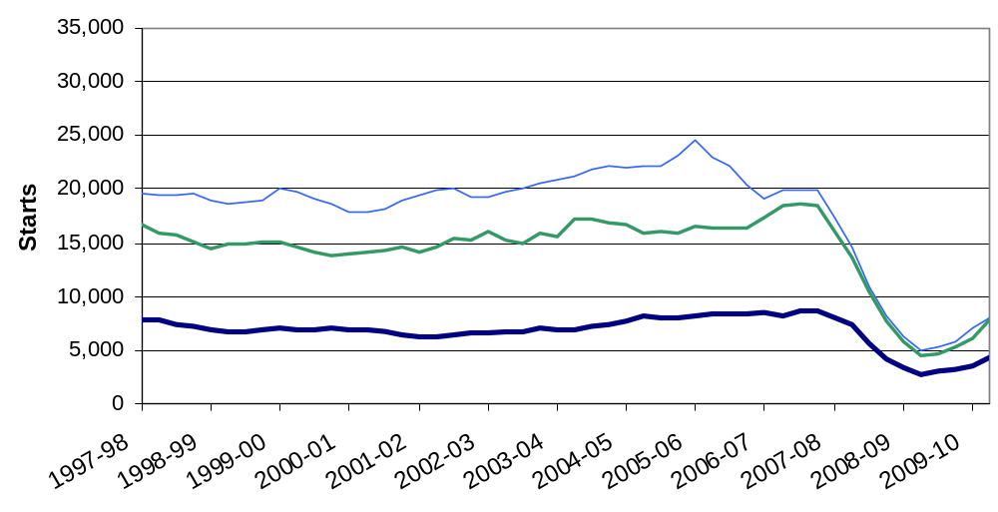

Figure 3b: Trends in housing starts in the East of England, East Midlands and West Midlands, 12 month rolling totals
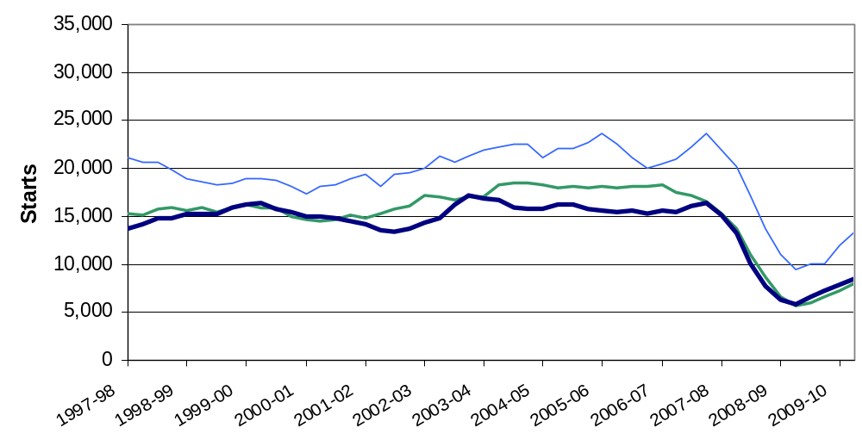

Figure 3c: Trends in housing starts in London, the South East and South West, 12 month rolling totals
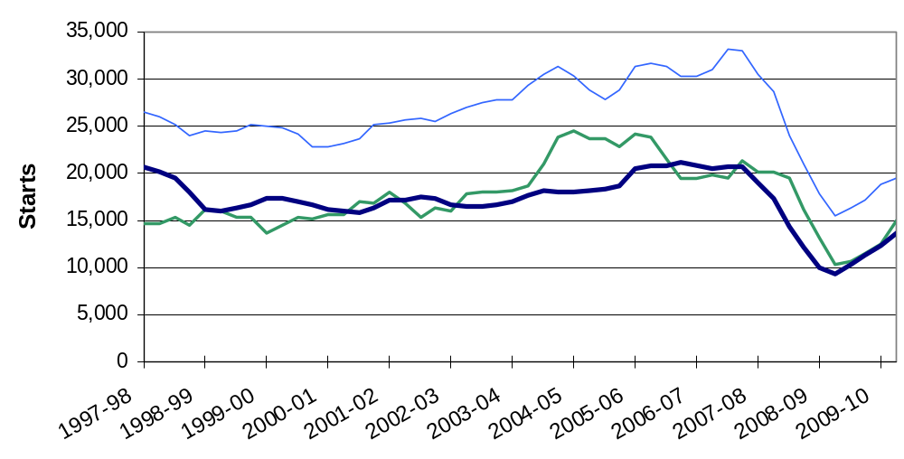

Regional completions

Seven out of the nine regions experienced a fall in annual completions between 12 months ending June 2009 and 12 months ending June 2010; completions in London remained the same over that period and the North East experienced a rise of 14 per cent (see Figures 4a, 4b and 4c below).
In the 12 month period ending June 2010, the number of housing completions was highest in the South East and lowest in the North East, accounting for 20 per cent and four per cent respectively of completions in England.

Completions were higher in the North East (23%), in the North West (11%) and in the East of England (two per cent) in the June quarter 2010 than in the June quarter 2009. In all other regions completions were lower in the June quarter 2010 than in the June quarter 2009. The largest falls were experienced in the East Midlands (31%), the West Midlands (23%) and in the South West (20%).

Figure 4a: Trends in housing completions in the North East, North West and Yorkshire and the Humber, 12 month rolling totals
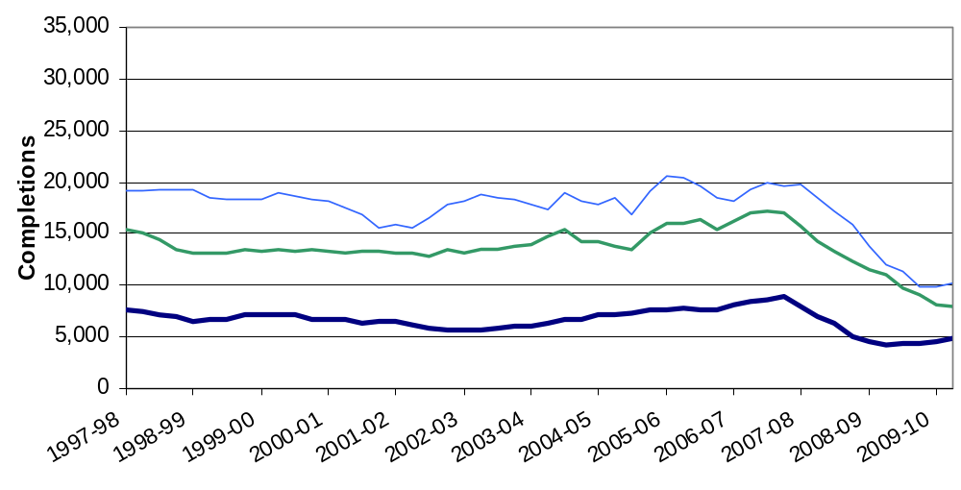

Figure 4b: Trends in housing completions in the East of England, East Midlands and West Midlands, 12 month rolling totals
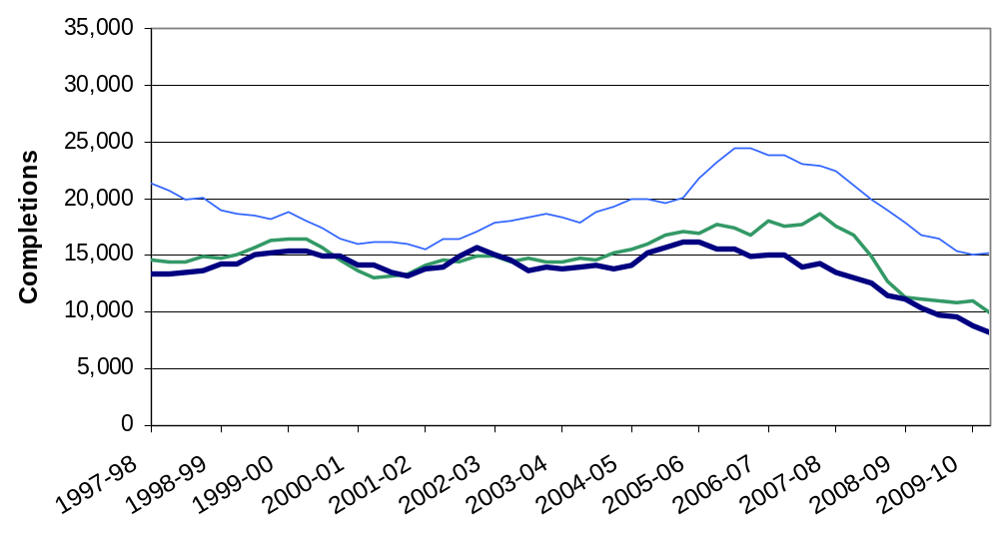

Figure 4c: Trends in housing completions in London, the South East and South West, 12 month rolling totals
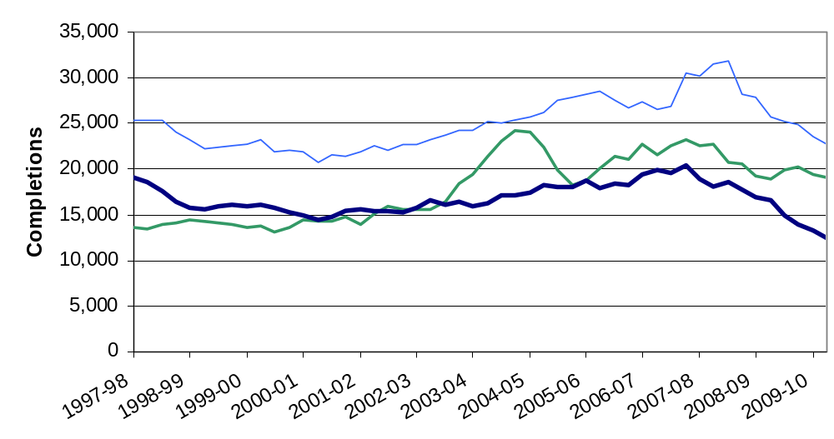

Other Approved Inspectors

In addition to local authorities and the National House-Building Council, house building starts and completions can be certified by other independent Approved Inspectors. The numbers in this release do not include activity for these other Approved Inspectors and, as such, are underestimates of the true level of house building starts and completions. We have now begun collecting information from other Approved Inspectors in order to gain a complete picture of house building activity.

In the 2009-10 financial year approximately eight per cent of all starts and four per cent of completions were inspected by other independent Approved Inspectors. At national level this translates to approximately 7,000 extra house building starts and approximately 5,000 extra completions for the 2009-10 financial year. This compares to eight per cent of starts and four per cent of completions in 2008-09, when this represented approximately 7,000 extra house building starts and approximately 6,000 extra completions.

Data collection
This release takes information from two data sources on building control:
- P2 quarterly house building returns submitted to Communities and Local Government by local authority building control departments; and

- monthly information from the National House-Building Council (NHBC) on the volume of building control inspections they undertake in each local authority area.

Strengths and weaknesses of the data
The P2 data received from local authorities record starts and completions inspected by local authority building control and include imputation for a small number of missing returns; in the June quarter 2010, a 92 per cent local authority response rate was achieved.
The NHBC figures record all starts and completions inspected by NHBC building control.
In addition to local authorities and the NHBC, house building starts and completions can be certified by other independent Approved Inspectors. The headline figures in this release do not include activity for these other Approved Inspectors and, as such, are underestimates of the true level of starts and completions but represent our best estimates at this time. We have included an estimate of the number of house building starts and completions certified by these other Approved Inspectors in the 2009/10 financial year in a separate paragraph. We have now begun collecting information from other Approved Inspectors in order to gain a complete picture of house building activity.

Related statistics
Net supply of housing
As well as these quarterly statistics, which cover new-build housing only, Communities and Local Government also publishes another, more comprehensive set of statistics on overall housing supply. The Net supply of housing statistics are an annual measure that aim to capture the total net change to the dwelling stock, through new-build, conversions, change of use of existing buildings and losses through demolition. These statistics can be found at the link below.
http://www.communities.gov.uk/housing/housingresearch/housingstatistics/housingstatisticsby/stockincludingvacants/nethousingsupply/.

As the more comprehensive measure, the Net supply of housing statistics have a much longer data collection period than the quarterly House building statistics in order to get as complete a dataset as possible. As a result, these annual statistics are less timely. Quarterly House building statistics can be used as a more timely but less comprehensive leading indicator of total housing supply.
Dwelling stock estimates
Communities and Local Government also publish statistics showing the total dwelling stock in England each year. These estimates are based on the latest census count plus the annual Net supply of housing statistics described above. They can be found at the following link.
http://www.communities.gov.uk/publications/corporate/statistics/housingstock2009.

Affordable housing
Although the house building statistics do categorise new build into private, Registered Social Landlord (RSL) and local authority tenure, this is not the best source of information on the total amount of affordable housing being delivered. A more detailed and accurate source is Communities and Local Government’s Affordable housing supply statistics, which can be found at the following link. The affordable housing supply statistics include both new build supply and acquisitions for social rent and low cost home ownership. http://www.communities.gov.uk/housing/housingresearch/housingstatistics/housingstatisticsby/affordablehousingsupply/.

Revisions policy
This policy has been developed in accordance with the UK Statistics Authority Code of Practice for Official statistics and the Communities and Local Government Revisions Policy. There are two types of revisions that the policy covers.

Scheduled Revisions
Local Authorities can update each quarterly return at any time up to two years after the initial publication of the figures for that quarter in order to maximise the response rate to the P2 return and enable late information to be included. Every quarter, as well as releasing figures for the latest quarter, we revise the previous quarter to incorporate any data that came in shortly after the previous data collection period. This captures most late data. Once a year, in the June quarter statistical release, a longer revision is carried out to incorporate all remaining late data into the published statistics. Therefore, until each quarterly return is permanently closed, figures for that quarter remain provisional. Provisional figures are labelled in the tables with a “P” and revised figures are labelled with an “R”.
In addition, where figures are seasonally adjusted, the adjustment factors for the whole series back to 1990 are recalculated annually, usually in the June quarter. This will result in small changes to seasonally adjusted figures across the whole period. These changes are not labelled with an “R”.
Other revisions to historic data (all data older than that currently due for scheduled revision) should only be made where there is a substantial revision, such as a change in methodology or definition. Where there are small changes that do not substantially change historic data, internal updates are maintained.

Non-Scheduled Revisions
Where a substantial error has occurred as a result of the compilation, imputation or dissemination process, the statistical release, live tables and other accompanying releases will be updated with a correction notice as soon as is practical.

Accompanying tables
Accompanying tables are available to download alongside this release:

Tables:
1a House building starts and completions, including seasonally adjusted series: England;

1b House building starts and completions unadjusted: North East;
1c House building starts and completions unadjusted: North West;

1d House building starts and completions unadjusted: Yorkshire and the Humber;
1e House building starts and completions unadjusted: East Midlands;

1f House building starts and completions unadjusted: West Midlands;
1g House building starts and completions unadjusted: East of England;

1h House building starts and completions unadjusted: London;
1j House building starts and completions unadjusted: South East;

1k House building starts and completions unadjusted: South West;
2a House building starts and completions unadjusted: Wales;
2b House building starts and completions unadjusted: Scotland;
2c House building starts and completions unadjusted: Great Britain;
2d House building starts and completions unadjusted: Northern Ireland;
2e House building starts and completions unadjusted: United Kingdom;
Additional tables showing house building completions by type and size of property, starts and completions for individual local authorities as well as historic series can be accessed in the 'Live tables' section ("Live tables on house building") at the following link. http://www.communities.gov.uk/housing/housingresearch/housingstatistics/
All statistical releases on house building can be accessed on the Communities and Local Government website at http://www.communities.gov.uk/housing/housingresearch/housingstatistics/housingstatisticsby/housebuilding/publicationsonhousebuilding/.

Notes to the tables
The following conventions have been used in the tables:
.. Not available;
- Fewer than 5 dwellings;
^{P} Figure provisional and subject to revision;
^{R} Revised from previous release.
Totals may not equal the sum of component parts due to rounding to the nearest 10.

Background notes
- The starts and completions reported in this publication are for new house building in England and exclude new dwellings created through conversions and the change of use of existing buildings.
- Figures in the accompanying tables are presented rounded to the nearest 10 dwellings.
- Sources are shown at the foot of individual accompanying tables and live tables.
- The charts give seasonally adjusted quarterly house building trends and give annual trends by showing a rolling 12 month total. Both the private enterprise and Registered Social Landlord England series are seasonally adjusted.
- Accompanying Table 1a gives non-seasonally adjusted and seasonally adjusted England figures. All figures for other countries and the English regions are shown on an unadjusted basis only.
- The Registered Social Landlord (RSL) category includes dwellings built for housing associations and Local Housing Companies that are registered with the Tenant Services Authority (previously the Housing Corporation) and also for unregistered social landlords.
- Figures on housing starts and completions are from records kept for building control purposes. It is sometimes difficult for data providers to identify whether a dwelling is being built for a housing association or for a private developer. This may lead to an understatement of Registered Social Landlord starts and completions recorded in these tables, and a corresponding overstatement of private enterprise figures. This problem is more likely to occur with starts than completions. For more detailed statistics on affordable housing please refer to Communities and Local Government’s affordable housing supply statistics at the following link. http://www.communities.gov.uk/housing/housingresearch/housingstatistics/housingstatisticsby/affordablehousingsupply/
- National Statistics are produced to high professional standards set out in the Code of Practice for Official Statistics. They undergo assessment by the UK Statistics Authority to ensure that they meet those standards.
- The tables and charts accompanying this release are shown above in the ‘Accompanying tables’ section and are provided in Microsoft Excel format.
- Details of officials and ministers who receive pre-release access to the Communities and Local Government quarterly House Building release up to 24 hours before release can be found at:
http://www.communities.gov.uk/corporate/researchandstatistics/statistics/nationalstatistics/
- The next quarterly release will be published on Thursday 18 November 2010, and will cover house building up to the September quarter 2010.

User consultation
Users’ comments on any issues relating to this statistical release are welcomed and encouraged. Responses should be addressed to the "statistical enquiries" contact given in the "Enquiries" section below.

Enquiries

Media Enquiries:
office hours: 0303 44 41136
out of hours: 0303 44 41201
e-mail: press@communities.gov.uk

Statistical enquiries:
e-mail: housing.statistics@communities.gov.uk
telephone: 0303 444 2278
Department for Communities and Local Government. © Crown Copyright, 2010

If you require this publication in an alternative format please email: alternativeformats@communities.gsi.gov.uk. Please note that the nature of content means that we may not be able to provide the Statistical series of publications in all requested formats.

August 2010

ISBN: 978-1-4098-2531-9

