
House Building: June Quarter 2011, England
- Seasonally adjusted house building starts stood at 23,400 in the June quarter 2011. This is nine per cent lower than in the March quarter 2011. It is 62 per cent above the trough in the March quarter 2009, but 51 per cent below the December quarter 2005 peak.
- Private enterprise housing starts (seasonally adjusted) were five per cent lower than in the March quarter 2011. Starts by housing associations were also down, 26 per cent lower than the previous quarter.
- Housing completions in England (seasonally adjusted) also decreased this quarter, down four per cent from 29,020 in March quarter 2011 to 27,750 in the June quarter 2011. This compares to a 23 per cent rise between the December 2010 and the March 2011 quarters.
- Private enterprise housing completions (seasonally adjusted) were three per cent lower in the June 2011 quarter than in the March 2011 quarter. Completions by housing associations decreased by nine per cent between the March quarter 2011 and June quarter 2011.
- Annual housing starts reached 98,300 in the 12 months to June 2011, down by two per cent compared with the 12 months to June 2010. Annual housing completions in England totalled 107,220 in the 12 months to June 2011, down by four per cent compared with the 12 months to June 2010.



Contents
1. | Seasonally adjusted results……………………... | 2
2. | Non-seasonally adjusted results……………………... | 4
3. | Sub-national trends……… | 6
4. | House Building in Context  …………………………….. | 11
5. | Other Approved  Inspectors……………….... | 12
6. | Data collection…………… | 13
7. | Data quality……………..... | 13
8. | Use of house building  data……………………….. | 15
9. | Related statistics……....… | 15
10. | Revisions policy………….. | 17
11. | Revisions in this release... | 18
12. | Definitions……………….... | 19
13. | Accompanying tables….... | 20
14. | Background notes............. | 21
15. | User consultation………... | 21
16. | Enquiries………................ | 22

Responsible statistician:
Richard Field

Statistical enquiries:
office hours: 0303 44 42345
housing.statistics@communities.gov.uk

Media Enquiries:
office hours: 0303 44 41136
out of hours: 0303 44 41201

press@communities.gov.uk

Housing
Statistical Release

18 August 2011
using
Research
Summary
Number 239, 2007

This quarterly Statistical Release presents National Statistics on new house building starts and completions in England and its regions up to the June quarter 2011. The figures in this release have been revised back 10 quarters to the March quarter 2009. This is to incorporate late information provided by local authorities and updates to NHBC data. For details, see the “Revisions in this release” section of this publication.
Data for Scotland, Wales and Northern Ireland are also included in the accompanying tables. These data are published separately by the devolved administrations, and although the figures are correct at the time of this publication they may be superseded before the next England house building release. The Department for Communities and Local Government publishes two complementary statistical series on housing supply in England. A description of the relationship between the Net Supply of Housing statistics and the House Building statistics can be found in the “Related statistics” section of this publication.

Seasonally adjusted results
Figures for private enterprise and housing associations are seasonally adjusted. The seasonally adjusted series should be used for quarter on quarter comparisons. For annual comparisons the non-seasonally adjusted series should be used.

Figure 1: Seasonally adjusted trends in quarterly housing starts and completions, England
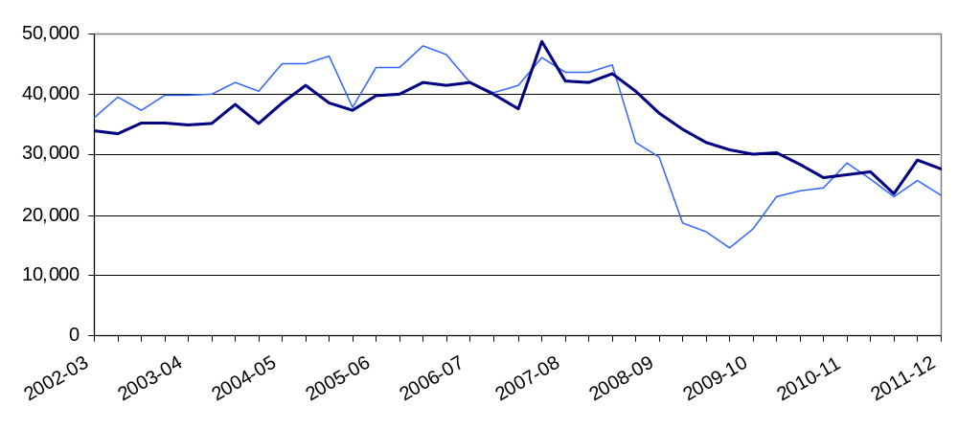
Starts experienced a period of sustained growth from 2001 until 2005. Delivery then levelled for 10 quarters, averaging at 44,000 units each quarter until late 2007. Starts were strongly affected by the economic downturn and from the start of 2008 there was a period of rapid decline to a trough in the first quarter of 2009. Completions responded more gradually to the downturn. From 2009 starts began to recover and over the last three quarters the two series have converged and tracked each other closely. This indicates that the stabilisation of starts has worked its way through to completions. New supply is currently at approximately 60% of pre-downturn levels.

Starts
Seasonally adjusted housing starts in England fell from 25,680 in the March quarter 2011 to 23,400 in the June quarter 2011. This is a nine per cent quarter on quarter fall. Starts are still 51 per cent below their December quarter 2005 peak, but 62 per cent above the trough in the March quarter of 2009.

Seasonally adjusted private enterprise housing starts were five per cent lower in the June 2011 quarter than in the March 2011 quarter and starts by housing associations fell more strongly, by 26 per cent over the same period.

Table 1a: Quarterly housing starts by tenure, England, seasonally adjusted¹
 |  |  | Private  Enterprise |  | Housing  Associations |  | Local  Authority | All  Tenures
 |  |  | Starts | % change  on previous quarter | Starts | % change  on previous quarter | Starts | Starts | % change  on previous quarter
2008-09 | Apr-June |  | 22,800 | -11% | 6,640 | 5% | 120 | 29,560 | -8%
 | July-Sept |  | 13,480 | -41% | 5,300 | -20% | 10 | 18,790 | -36%
 | Oct-Dec |  | 12,810 | -5% | 4,370 | -18% | 160 | 17,330 | -8%
 | Jan-Mar | ^{R} | 10,680 | -17% | 3,770 | -14% | 20 | 14,470 | -17%
2009-10 | Apr-June | ^{R} | 13,740 | 29% | 4,020 | 7% | 50 | 17,820 | 23%
 | July-Sept | ^{R} | 17,800 | 29% | 5,110 | 27% | 30 | 22,940 | 29%
 | Oct-Dec | ^{R} | 18,550 | 4% | 5,530 | 8% | 50 | 24,120 | 5%
 | Jan-Mar | ^{R} | 18,870 | 2% | 5,450 | -1% | 200 | 24,520 | 2%
2010-11 | Apr-June | ^{R} | 21,590 | 14% | 6,510 | 19% | 560 | 28,650 | 17%
 | July-Sept | ^{R} | 19,920 | -8% | 5,710 | -12% | 280 | 25,910 | -10%
 | Oct-Dec | ^{R} | 18,420 | -8% | 4,270 | -25% | 350 | 23,040 | -11%
 | Jan-Mar | ^{R} | 19,360 | 5% | 5,940 | 39% | 380 | 25,680 | 11%
2011-12 | Apr-June | ^{P} | 18,440 | -5% | 4,400 | -26% | 560 | 23,400 | -9%
1. Because the number of local authority housing starts and completions is very small, quarterly comparisons can be very volatile. Accordingly percentage changes are not reported for this tenure.

Completions
Housing completions in England (seasonally adjusted) fell four per cent from 29,020 in the March quarter 2011 to 27,750 in the June quarter 2011. This compares to a 23 per cent rise between the December 2010 and the March 2011 quarters.
Seasonally adjusted private enterprise housing completions were three per cent lower in the June 2011 quarter than in the March 2011 quarter. Completions by housing associations fell by nine per cent over the same period.

Table 1b: Quarterly housing completions by tenure, England, seasonally adjusted¹
 |  |  | Private  Enterprise |  | Housing  Associations |  | Local  Authority | All  Tenures
 |  |  | Comple-  tions | % change  on previous quarter | Comple-  tions | % change  on previous quarter | Comple-  tions | Comple-  tions | % change  on previous quarter
2008-09 | Apr-June |  | 30,480 | -11% | 6,190 | -3% | 140 | 36,800 | -9%
 | July-Sept |  | 27,840 | -9% | 6,220 | 1% | 60 | 34,130 | -7%
 | Oct-Dec |  | 24,970 | -10% | 6,930 | 11% | 180 | 32,090 | -6%
 | Jan-Mar | ^{R} | 24,580 | -2% | 6,100 | -12% | 110 | 30,780 | -4%
2009-10 | Apr-June | ^{R} | 23,680 | -4% | 6,330 | 4% | 130 | 30,140 | -2%
 | July-Sept | ^{R} | 22,700 | -4% | 7,490 | 18% | 90 | 30,280 | 0%
 | Oct-Dec | ^{R} | 22,400 | -1% | 5,900 | -21% | 30 | 28,330 | -6%
 | Jan-Mar | ^{R} | 20,510 | -8% | 5,690 | -4% | 110 | 26,320 | -7%
2010-11 | Apr-June | ^{R} | 20,840 | 2% | 5,650 | -1% | 100 | 26,590 | 1%
 | July-Sept | ^{R} | 22,100 | 6% | 4,880 | -13% | 140 | 27,120 | 2%
 | Oct-Dec | ^{R} | 17,880 | -19% | 5,320 | 9% | 440 | 23,640 | -13%
 | Jan-Mar | ^{R} | 21,680 | 21% | 6,710 | 26% | 630 | 29,020 | 23%
2011-12 | Apr-June | ^{P} | 20,960 | -3% | 6,120 | -9% | 660 | 27,750 | -4%
1. Because the number of local authority housing starts and completions is very small, quarterly comparisons can be very volatile. Accordingly percentage changes are not reported for this tenure.

Non-seasonally adjusted results
These series are not seasonally adjusted so it can be misleading to draw conclusions from quarter on quarter changes. For quarter on quarter comparisons the seasonally adjusted series should be used. Figure 2 uses 12-month rolling totals to show trends in non-seasonally adjusted results.

Figure 2: Trends in starts and completions, England, 12 month rolling totals
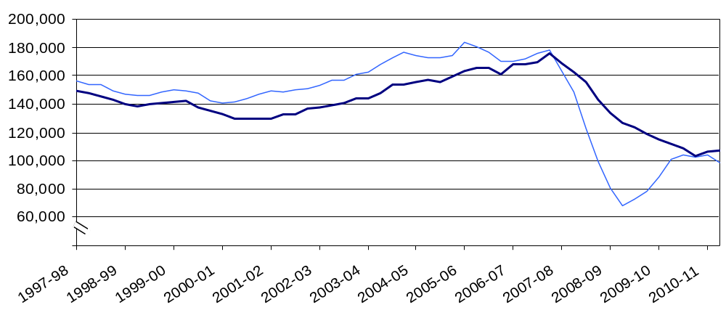
Annual housing starts increased from 150,700 in the 12 months ending December 2002, reaching a peak of 183,360 in the 12 months ending March 2006. Starts then fell to 68,280 in the 12 months to June 2009 before rising to 103,740 in the 12 months to September 2010. The three quarters since September 2010 have seen a slight drop, with the 12 months to June 2011 totalling 98,300 Starts. This is 46 per cent below the peak, but up by 44 per cent compared with the trough.
Annual housing completions increased from 136,800 in the 12 months ending March 2002, reaching a peak of 175,560 in the 12 months ending December 2007. Completions have now reached 107,220 in the 12 months to June 2011, 39 per cent below the peak.

Starts
Housing starts were 17 per cent lower in the June quarter 2011 than in the June quarter 2010. This compares with a four per cent rise between the March 2010 and March 2011 quarters.

Private enterprise housing starts were 13 per cent lower in the June 2011 quarter than in the June 2010 quarter. Housing association starts fell by 32 per cent over the same quarter a year before.

Table 2a: Quarterly housing starts by tenure, England, not seasonally adjusted¹
 |  |  | Private  Enterprise |  | Housing  Associations |  | Local  Authority | All  Tenures
 |  |  | Starts | % change on same quarter previous year | Starts | % change on same quarter previous year | Starts | Starts | % change on same quarter previous year
2008-09 | Apr-June |  | 23,880 | -40% | 7,250 | 20% | 120 | 31,250 | -32%
 | July-Sept |  | 14,120 | -64% | 5,150 | -11% | 10 | 19,290 | -57%
 | Oct-Dec |  | 10,700 | -68% | 3,790 | -28% | 160 | 14,650 | -62%
 | Jan-Mar | ^{R} | 11,310 | -59% | 4,020 | -41% | 20 | 15,360 | -55%
2009-10 | Apr-June | ^{R} | 14,550 | -39% | 4,390 | -39% | 50 | 18,980 | -39%
 | July-Sept | ^{R} | 18,800 | 33% | 4,990 | -3% | 30 | 23,820 | 24%
 | Oct-Dec | ^{R} | 15,330 | 43% | 4,810 | 27% | 50 | 20,180 | 38%
 | Jan-Mar | ^{R} | 19,750 | 75% | 5,750 | 43% | 200 | 25,700 | 67%
2010-11 | Apr-June | ^{R} | 23,190 | 59% | 7,130 | 62% | 560 | 30,880 | 63%
 | July-Sept | ^{R} | 21,090 | 12% | 5,610 | 12% | 280 | 26,980 | 13%
 | Oct-Dec | ^{R} | 15,150 | -1% | 3,710 | -23% | 350 | 19,210 | -5%
 | Jan-Mar | ^{R} | 20,030 | 1% | 6,210 | 8% | 380 | 26,620 | 4%
2011-12 | Apr-June | ^{P} | 20,060 | -13% | 4,870 | -32% | 560 | 25,490 | -17%
1. Because the number of local authority housing starts and completions is very small, quarterly comparisons can be very volatile. Accordingly percentage changes are not reported for this tenure.

Completions
Housing completions were four per cent higher in the June quarter 2011 than in the June quarter 2010. This compares with a rise of 11 per cent between the March quarter 2010 and the March quarter 2011.

Private enterprise housing completions in the June 2011 quarter were one per cent higher than in the June 2010 quarter. By comparison, completions by housing associations increased by nine per cent over the same period.

Table 2b: Quarterly housing completions by tenure, England, not seasonally adjusted¹
 |  |  | Private  Enterprise |  | Housing  Associations |  | Local  Authority | All  Tenures
 |  |  | Comple-  Tions | % change on same quarter previous year | Comple-  tions | % change on same quarter previous year | Comple-  tions | Comple-  tions | % change on same quarter previous year
2008-09 | Apr-June |  | 31,840 | -18% | 5,640 | 23% | 140 | 37,620 | -13%
 | July-Sept |  | 25,920 | -25% | 5,590 | 19% | 60 | 31,570 | -19%
 | Oct-Dec |  | 28,080 | -32% | 7,470 | 10% | 180 | 35,740 | -26%
 | Jan-Mar | ^{R} | 22,170 | -28% | 6,810 | -3% | 110 | 29,090 | -23%
2009-10 | Apr-June | ^{R} | 24,650 | -23% | 5,800 | 3% | 130 | 30,580 | -19%
 | July-Sept | ^{R} | 21,200 | -18% | 6,620 | 18% | 90 | 27,910 | -12%
 | Oct-Dec | ^{R} | 25,110 | -11% | 6,340 | -15% | 30 | 31,480 | -12%
 | Jan-Mar | ^{R} | 18,570 | -16% | 6,410 | -6% | 110 | 25,100 | -14%
2010-11 | Apr-June | ^{R} | 21,640 | -12% | 5,190 | -10% | 100 | 26,940 | -12%
 | July-Sept | ^{R} | 20,690 | -2% | 4,280 | -35% | 140 | 25,110 | -10%
 | Oct-Dec | ^{R} | 20,020 | -20% | 5,690 | -10% | 440 | 26,150 | -17%
 | Jan-Mar | ^{R} | 19,630 | 6% | 7,590 | 18% | 630 | 27,850 | 11%
2011-12 | Apr-June | ^{P} | 21,780 | 1% | 5,670 | 9% | 660 | 28,100 | 4%

1. Because the number of local authority housing starts and completions is very small, quarterly comparisons can be very volatile. Accordingly percentage changes are not reported for this tenure.

Sub-national trends
Comparisons between national, regional and district figures in this section are based on the non-seasonally adjusted series. It is our policy only to seasonally adjust England figures at the national level. The graphs in this section use 12-month rolling totals to show trends in non-seasonally adjusted results.

Regional starts
Starts were up by 11 per cent in London in the 12 months to June 2011 compared with the 12 months to June 2010. The East Midlands saw a small increase of three per cent and the North West of two per cent. In all other regions starts declined over this period. The West Midlands saw the largest fall at -14 per cent. (See Figures 3a, 3b and 3c below).
In the 12 month period ending June 2011, the number of housing starts was highest in the South East (18,450) and lowest in the North East (3,930), accounting for 19 per cent and four per cent respectively of Starts in England.

Figure 3a: Trends in housing starts in the North East, North West and Yorkshire and the Humber, 12 month rolling totals
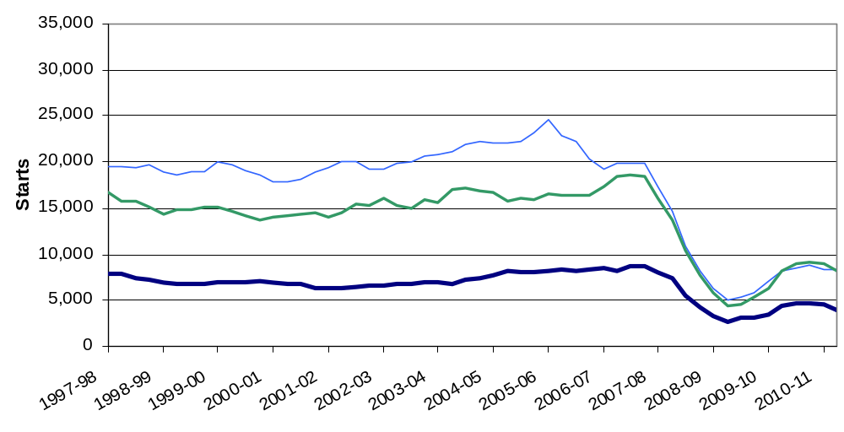

Figure 3b: Trends in housing starts in the East of England, East Midlands and West Midlands, 12 month rolling totals

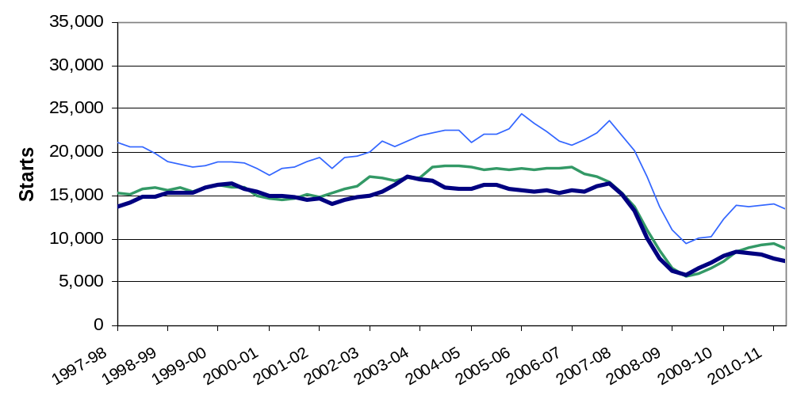

Figure 3c: Trends in housing starts in London, the South East and South West, 12 month rolling totals
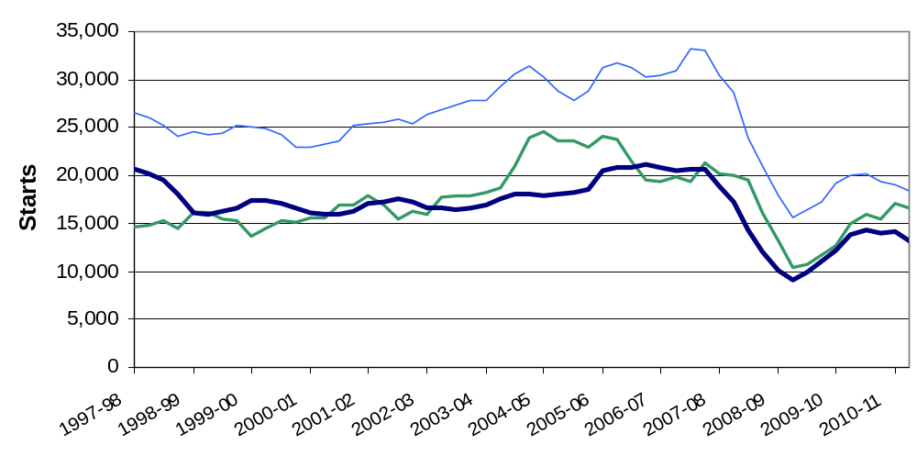

Regional completions
Completions in Yorkshire and Humberside rose by 15 per cent for the 12 months to June 2011 relative to the same 12 month period a year before and represented the largest percentage gain of all regions. The West Midlands saw an eight per cent rise, and the East Midlands and the South West saw smaller gains of four per cent and one per cent respectively.
In other regions annual completions fell, with the South East seeing the largest reduction at -16 per cent. (see Figures 4a, 4b and 4c below).
Despite delivery falling in the South East it was still the region that delivered the largest number of units at 19,270, accounting for 18 per cent of completions in England. In the North East housing completions were lowest of all regions, accounting for just four per cent of the national total. This partly reflects the fact that the North East is the smallest region in terms of housing stock with only five per cent of English dwellings.

Figure 4a: Trends in housing completions in the North East, North West and Yorkshire and the Humber, 12 month rolling totals
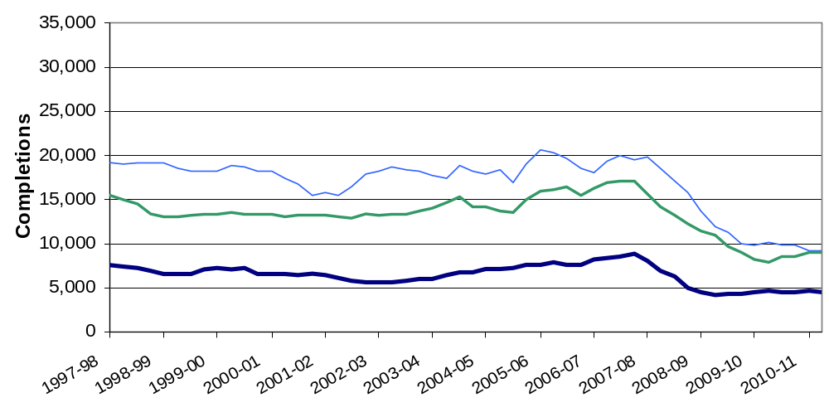

Figure 4b: Trends in housing completions in the East of England, East Midlands and West Midlands, 12 month rolling totals
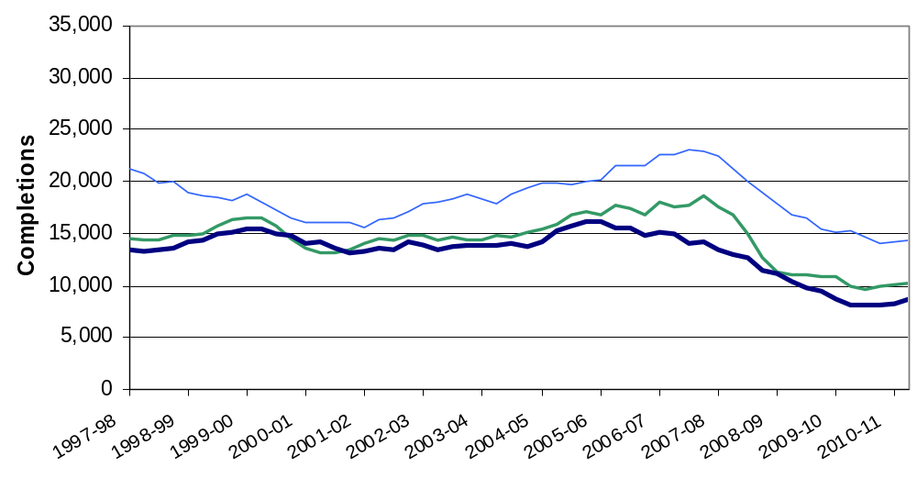

Figure 4c: Trends in housing completions in London, the South East and South West, 12 month rolling totals

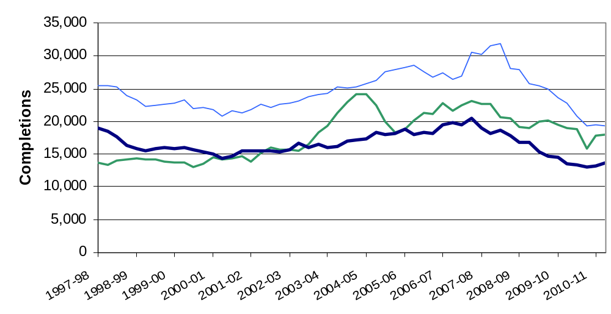

Geographic distribution of house building

The map on the left in figure 5 below shows start rates in each of the 326 local authority districts over the year to June 2011. The map on the right shows completion rates. To show house building in proportion to the size of each district we divide the number of starts (or completions) in the year twelve months to June 2011 by the existing dwelling stock. The result is multiplied by 1000 to give a figure that is easier to interpret. Consider a hypothetical local authority district with 100,000 dwellings as at June 2010. Over the next year 200 new dwellings are started, representing two new dwellings per thousand of existing stock (rounded). This district would therefore be shaded in light yellow in the coloured map for starts.

Figure 5: Starts per 1000 dwellings (left) and completions per 1000 dwellings (right) for each local authority district in the 12 months to June 2011

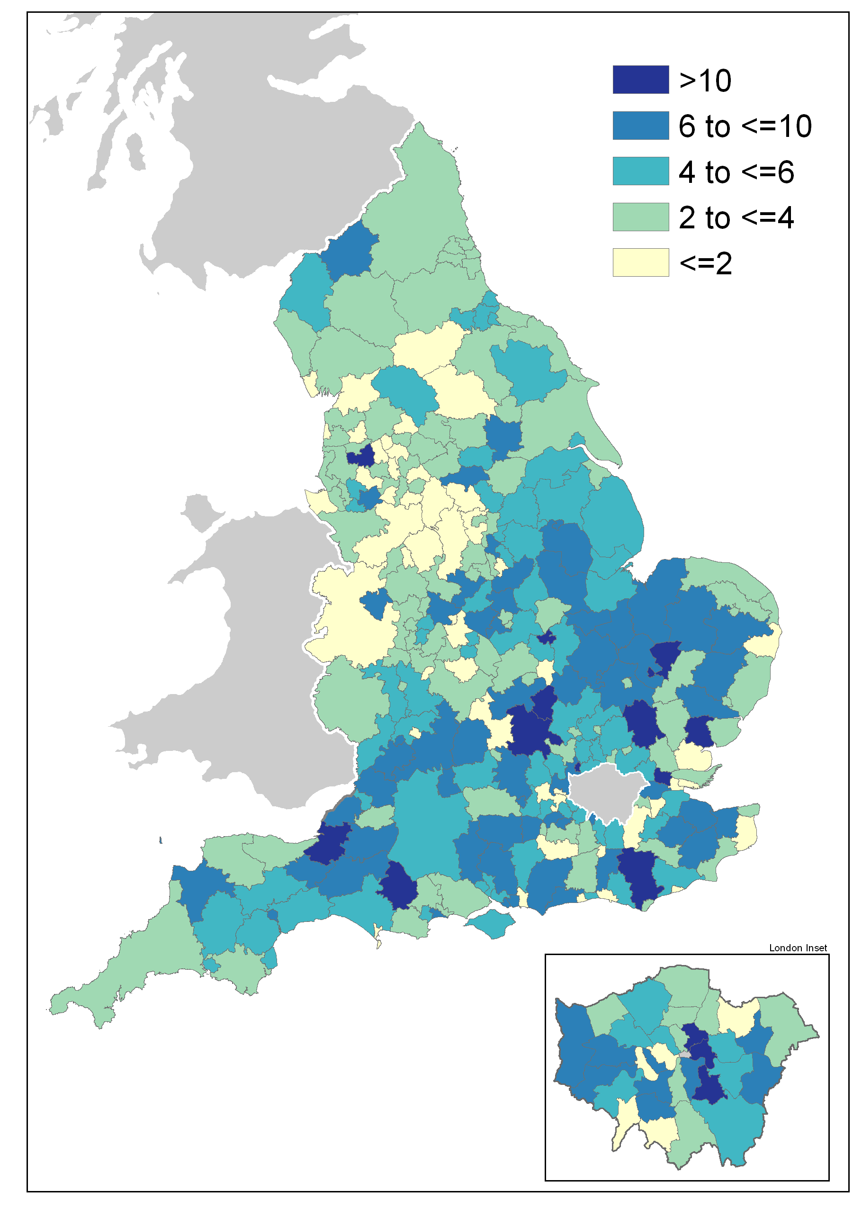 | 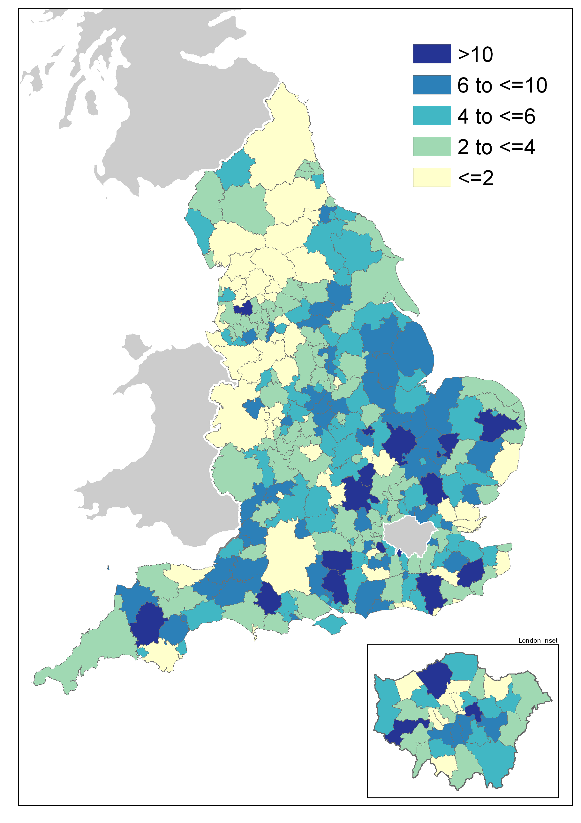

Many of the local authority districts seeing the highest rates of building (in the darkest shade of blue) are in the south-eastern half of England. The lowest building rates (in yellow) are in the West Midlands and the North. Many coastal areas, particularly those furthest from London, also see lower rates of building. Districts to the south of Bristol and in the East Midlands along the M11 corridor and around the A1 have higher rates of building.

What types of homes are being built?
Approximately half of the data used to produce the house building statistics are supplied by the National House-Building Council (NHBC). These data contain additional detail on the size and type of new homes being completed and can be used to provide annual estimates of the proportion of new builds that are houses as opposed to flats.
Figure 8 shows the split of completions between houses and flats. The proportion of flats increased from 28 per cent in 2002-03 to over 40 per cent from 2004-05, remaining at that level through to 2008-09. Since then, the proportion of flats has dropped sharply and in 2010-11 stood at 30 per cent. These data are published at the regional level in live table 254 which can be found at the following link. http://www.communities.gov.uk/housing/housingresearch/housingstatistics/housingstatisticsby/housebuilding/livetables/

Figure 6: Proportion of new build completions that are houses and flats
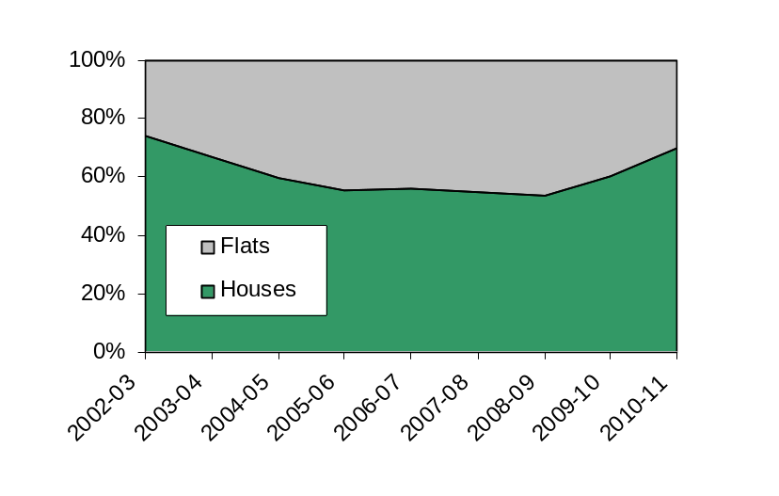

Other Approved Inspectors
In addition to local authorities and the National House-Building Council, house building starts and completions can be certified by other independent Approved Inspectors. The numbers in this release do not include activity for these other Approved Inspectors and, as such, are underestimates of the level of house building starts and completions. We now collect information from other Approved Inspectors to monitor the extent of this gap in coverage, and estimates for the last three financial years are given below.
We intend to move to incorporate these data in the headline statistics for England in our next quarterly statistical release, scheduled for 17 November. We will do this initially on an experimental basis and would very much welcome comments from users on this proposal, in particular on how best to present this change to minimise confusion and maintain users’ confidence in the statistics. Comments can be made via the “statistical enquiries” contact details shown on the front page of this release.
In the 2010-11 financial year approximately nine per cent of all starts and six per cent of completions were inspected by other independent Approved Inspectors. At the England level this translates to approximately 10,000 extra house building starts and approximately 7,000 extra completions.
In 2009-10 approximately eight per cent of all starts and four per cent of completions were inspected by other independent Approved Inspectors, translating to 7,000 extra house building starts and 5,000 extra completions.
In 2008-09 approximately eight per cent of starts and four per cent of completions were inspected by other independent Approved Inspectors, translating to 7,000 extra starts and 6,000 extra completions.

Data collection
This release takes information from two data sources on building control:
- ‘P2’ quarterly house building returns submitted to Department for Communities and Local Government by local authority building control departments; and
- monthly information from the National House-Building Council (NHBC) on the volume of building control inspections they undertake in each local authority area.



Data quality

Response rate
The P2 data received from local authorities record starts and completions inspected by local authority building control and include imputation for a small number of missing returns; in the June quarter 2011, a 90 per cent local authority response rate was achieved.
The process to impute for a missing P2 local authority return works by picking up all data recorded in completed returns for that local authority over the previous five years and comparing it to data for other similar local authorities for the same periods. It then looks at the data provided for the current period by those other local authorities and imputes a figure for the missing local authority return which matches the proportion found in the comparison of data for the previous five years.
The NHBC figures record all starts and completions inspected by NHBC building control.

Coverage
In addition to local authorities and the NHBC, house building starts and completions can be certified by other independent Approved Inspectors. The headline figures in this release do not include activity for these other Approved Inspectors and, as such, are underestimates of the true level of starts and completions but represent our best estimates at this time. We are now collecting information from other Approved Inspectors in order to gain a complete picture of house building activity. For further information please see the “Other Approved Inspectors” section above.

Tenure
Figures on housing starts and completions are from records kept for building control purposes. It is sometimes difficult for the building control officers who record the data to identify whether a dwelling is being built for a housing association, a local authority or for a private developer. This may lead to an understatement of housing association and local authority starts and completions recorded in these tables, and a corresponding overstatement of private enterprise figures. This problem is more likely to affect starts than completions.
There are two other sources of official statistics on affordable housing supply which should be considered as an alternative by users interested specifically in the affordable sector. Please refer to the “Related statistics” section of this publication for further information.

From start to completion
A wide range of factors can influence the length of time it takes for a new home to be constructed from start to completion, and this period can vary from just a few months to several years.
There are some circumstances in which starts might exceed completions. Information gathered from data providers indicates that the most common of these is where a new dwelling is started but never completed because the developer is no longer able or willing to complete the development.
Also, in principle a dwelling is regarded as completed when it becomes ready for occupation or when a completion certificate is issued whether it is in fact occupied or not. In practice, the reporting of some completions may be delayed and some completions may be missed if no completion certificate was requested by the developer or owner, although this is unusual because most property owners would want to have a completion certificate for the purposes of selling the property on.
These circumstances do not disproportionately affect particular regions or types of area, although private housing development may be more likely to be affected than public.
In general the number of starts will be a strong indicator of the likely trend in completions in the near future but we have seen differences over the short and medium term. It sometimes appears that an imbalance exists in the statistics when the overall number of starts differs from the overall number of completions over a number of years. For example, over the period from 1997 – 2007 there were 1,760,000 starts but only 1,630,000 completions – a difference of seven per cent.
However, a comparison of starts and completions over the long term shows that such differences tend to balance out over time – the years before 1997 and the years since 2007 both saw substantially more completions than starts, and over the 20 years from 1990 to 2010 there were in fact one per cent more completions than starts. These shorter term imbalances can be understood as a feature of the economic cycle.

Comparability between the countries of the UK
Each of the countries of the UK produces its own statistics on House Building (see “Related statistics” section below). The Department for Communities and Local Government is responsible for collecting and publishing data for England. However house building statistics for the devolved administrations of the UK, as well as for Great Britain and the UK as a whole, are included in the tables that accompany this statistical release. In this section the consistency of the data sources is discussed.
England and the devolved administrations use broadly consistent definitions for starts and completions in collecting house building data. Until now, all four countries have collected starts and completions data split into the three tenure types of private enterprise, housing association and local authority. From the June quarter 2011 onwards, this tenure split will no longer be available for Wales starts figures.
In England and Wales, some housing association starts and completions can be misreported as private enterprise starts because it is sometimes difficult for data providers to identify whether a dwelling is being built for a housing association or for a private developer (see above). This is not thought to be a problem in Northern Ireland and Scotland, where data on housing association house building are collected directly from housing association administrations, rather than from building inspection teams.
While a small proportion of the data for England are imputed for missing responses (see above), a full response is generally collected in Wales, Scotland and Northern Ireland so imputation is seldom necessary.

Uses of house building statistics
The house building statistical series on starts and completions are a key part of the evidence base which informs the development and evaluation of housing policy by central and local government. They are also used as evidence for other housing market analysts, forecasters and decision makers, for example at the Bank of England and in the construction and banking industries, and for market research by a wide range of other businesses. They are used by the media in reports on the housing market, and by academics both in the UK and abroad.

Related statistics

Net supply of housing
The annual net additional dwellings figure, or net housing supply, is the absolute change in dwelling stock between 1 April and 31 June the following year. It comprises the number of new build permanent dwellings; plus the net gain from dwelling conversions; plus the net gain of non dwellings brought into residential use; plus net additions from other gains and losses to the dwelling stock (such as mobile and temporary dwellings); less any demolitions.
The net additions statistical series is separate from and complementary to the Department for Communities and Local Government’s quarterly National Statistics series on new house building, providing a more comprehensive but less timely measure of total housing supply in England. Completions figures from the quarterly house building series are not used in the net additions statistics. Instead a separate set of data on the new build completions component of net additions is collected as part of the overall annual net additions data collection. This eliminates timing differences from the net supply series and provides a picture of the components of net change which can be reconciled for a given year.
The house building statistical series takes its data from the same sources throughout England, combining data from building control officers at local authorities and the National House-Building Council (NHBC), and is published within eight weeks after the end of each quarter. For net additions, all the data come from local authorities who in turn use whichever local data source they believe is most appropriate, and the data collection period for these statistics is relatively long, being annual and closing some five months after the end of the financial year. The longer data collection period makes it possible to incorporate data on the approximately five per cent of new build completions that are inspected by independent building control Approved Inspectors other than those at local authorities or the NHBC.
Users who need an early indication of house building activity or who intend to use housing supply statistics as an economic indicator are advised to use the quarterly house building starts and completions series. Those who require a long-running, consistent time series on housing supply should also use house building, in either a quarterly or annual basis. Users wanting a more complete picture of the overall supply of housing may find the net additions statistical series more appropriate.
The net supply of housing statistics can be found at the link below.
http://www.communities.gov.uk/housing/housingresearch/housingstatistics/housingstatisticsby/netsupplyhousing/ .

Dwelling stock estimates
Department for Communities and Local Government also publish statistics showing the total dwelling stock in England each year. These estimates are based on the latest census count plus the annual Net supply of housing statistics described above. They can be found at the following link.
http://www.communities.gov.uk/housing/housingresearch/housingstatistics/housingstatisticsby/stockincludingvacants/

Affordable housing
Although new build housing is categorised into private enterprise, housing associations (HA) and local authority tenure within the house building statistics, this tenure split is not the best source of information on new build in the affordable housing sector. A more detailed and accurate source is Department for Communities and Local Government’s Affordable housing supply statistics, which can be found at the following link. http://www.communities.gov.uk/housing/housingresearch/housingstatistics/housingstatisticsby/affordablehousingsupply/.
These include both new build supply and acquisitions for social rent and low cost home ownership, but the new build components of affordable supply are separately identified within the tables.
The affordable housing supply statistics make use of several data sources, but the majority of data are taken from the Homes and Communities Agency’s (HCA) Investment Management System which contains information provided by registered providers of social housing that have applied to receive grant. The fact that these data are linked to grant funding makes them a more robust measure of affordable housing supply than the tenure categories in the House building statistics.
A further series of official statistics on the supply of affordable homes is the Homes and Communities Agency’s National Housing Statistics. These are published twice a year and can be found at the following link. http://www.homesandcommunities.co.uk/statistics
Like the Department for Communities and Local Government’s Affordable housing supply statistics, these are based largely on the HCA’s own Investment Management System, but the format is different because it is based on the various schemes through which the HCA delivers housing.

Devolved administrations
House building statistics for the devolved administrations of the UK are included alongside the England statistics in the tables that accompany this statistical release. These data are published separately by the devolved administrations, and although figures are correct at the time of this publication they may be superseded before the next England house building release. Latest data and details on data sources and methods can be found at the following links:
Scotland (house building statistics)
http://www.scotland.gov.uk/Topics/Statistics/Browse/Housing-Regeneration/HSfS/NewBuild
Wales (house building statistics)
http://wales.gov.uk/topics/statistics/theme/housing/newbuild/;jsessionid=9bcQNK5GxLQv5p05StGJZsznPYpXL07L47Qh19JXKc22vq3nl9L8!475011280?lang=en
Northern Ireland (housing statistics)
http://www.dsdni.gov.uk/index/stats_and_research/housing_publications.htm

Revisions policy
This policy has been developed in accordance with the UK Statistics Authority Code of Practice for Official statistics and the Department for Communities and Local Government Revisions Policy. There are two types of revisions that the policy covers.

Scheduled Revisions
In order to maximise the response rate from local authorities and enable late information to be included, each quarterly P2 return can be updated at any time up to two years after the initial publication of the figures for that quarter. Every quarter, as well as releasing figures for the latest quarter, we revise the previous quarter to incorporate any data that came in shortly after the previous data collection period. This captures most late local authority data, but in order to incorporate the remainder a longer revision is carried out once a year, in the June quarter statistical release. Therefore, until each quarterly return is permanently closed, figures for that quarter remain provisional. Provisional figures are labelled in the tables with a “P” and revised figures are labelled with an “R”.
The starts data provided by NHBC, which are monthly, can also be subject to some changes after their initial inclusion, and to address this the NHBC data for the previous quarter are now also revised in each release. In particular, the information on the tenure can often change when a start gets closer to completion and this tends to result in a net shift in starts from the private enterprise tenure to the housing association tenure.
In addition, where figures are seasonally adjusted, the adjustment factors for the whole series back to 2000 are recalculated annually, usually in the June quarter. This will result in small changes to seasonally adjusted figures across the whole period. These changes are not labelled with an “R”.
Other revisions to historic data (all data older than that currently due for scheduled revision) should only be made where there is a substantial revision, such as a change in methodology or definition. Where there are small changes that do not substantially change historic data, internal updates are maintained.

Non-Scheduled Revisions
Where a substantial error has occurred as a result of the compilation, imputation or dissemination process, the statistical release, live tables and other accompanying releases will be updated with a correction notice as soon as is practical.
Revisions in this release
As scheduled, data provided by local authorities have been revised in this release back to the March quarter 2009 to incorporate late data. This has resulted in little change to the number of starts over this period and an uplift of around 1,500 completions, mostly concentrated in the financial year 2009/10.
In addition, NHBC data on starts have been revised back to the December quarter 2009. This is the final stage of incorporating a regular update of these data in the statistics (see “Revisions policy” section above. This has resulted in a reduction of around 1,800 starts over the 18-month period, consisting of a larger reduction in the second half of the period partially offset by a small uplift in the first half. It has also resulted in a net transfer of around 4,000 starts out of the private enterprise tenure and into the housing association tenure.

Definitions
House building start - A dwelling is counted as started on the date work begins on the laying of the foundation, including 'slabbing' for houses that require it, but not including site preparation. Thus when foundation work commences on a pair of semi-detached houses two houses are counted as started, and when work begins on a block of flats all the dwellings in that block are counted as started. The starts of houses in building schemes are usually phased over a period of weeks or even, in very large schemes, months.
House building completion - In principle, a dwelling is regarded as complete when it becomes ready for occupation or when a completion certificate is issued whether it is in fact occupied or not. In practice, the reporting of some completions may be delayed and some completions may be missed if no completion certificate was requested by the developer or owner, although this is unusual.
Housing association - “Housing associations (HAs)” has been used as the generic name for all social landlords not covered by local authorities (see below). In previous editions HAs were referred to as Registered Social Landlords (RSL), although the term (private) Registered Provider (pRP) of social housing is commonly used by the Tenant Services Authority. The more all-encompassing description of ‘housing associations’ is now seen as more appropriate and helpful to users.

Accompanying tables
Accompanying tables are available to download alongside this release:

Tables:
1a House building starts and completions, including seasonally adjusted series: England;

1b House building starts and completions unadjusted: North East;
1c House building starts and completions unadjusted: North West;

1d House building starts and completions unadjusted: Yorkshire and the Humber;
1e House building starts and completions unadjusted: East Midlands;

1f House building starts and completions unadjusted: West Midlands;
1g House building starts and completions unadjusted: East of England;

1h House building starts and completions unadjusted: London;
1j House building starts and completions unadjusted: South East;

1k House building starts and completions unadjusted: South West;
2a House building starts and completions unadjusted: Wales;
2b House building starts and completions unadjusted: Scotland;
2c House building starts and completions unadjusted: Great Britain;
2d House building starts and completions unadjusted: Northern Ireland;
2e House building starts and completions unadjusted: United Kingdom;
Additional tables showing house building completions by type and size of property, starts and completions for individual local authorities as well as historic series can be accessed in the 'Live tables' section ("Live tables on house building") at the following link. http://www.communities.gov.uk/housing/housingresearch/housingstatistics/
All statistical releases on house building can be accessed on the Department for Communities and Local Government website at http://www.communities.gov.uk/housing/housingresearch/housingstatistics/housingstatisticsby/housebuilding/publicationsonhousebuilding/.

Notes to the tables
The following conventions have been used in the tables:
.. Not available;
- Fewer than 5 dwellings;
^{P} Figure provisional and subject to revision;
^{R} Revised from previous release.
Totals may not equal the sum of component parts due to rounding to the nearest 10.

Background notes
- The starts and completions reported in this publication are for new house building in England and exclude new dwellings created through conversions and the change of use of existing buildings.
- Figures in the accompanying tables are presented rounded to the nearest 10 dwellings.
- Sources are shown at the foot of individual accompanying tables and live tables.
- The charts give seasonally adjusted quarterly house building trends and give annual trends by showing a rolling 12-month total. Both the private enterprise and housing association England series are seasonally adjusted.
- Accompanying Table 1a gives non-seasonally adjusted and seasonally adjusted England figures. All figures for other countries and the English regions are shown on an unadjusted basis only.
- National Statistics are produced to high professional standards set out in the Code of Practice for Official Statistics. They undergo assessment by the UK Statistics Authority to ensure that they meet those standards.
- The tables and charts accompanying this release are shown above in the ‘Accompanying tables’ section and are provided in Microsoft Excel format.
- Details of officials and ministers who receive pre-release access to the Department for Communities and Local Government quarterly House Building release up to 24 hours before release can be found at:
http://www.communities.gov.uk/corporate/researchandstatistics/statistics/nationalstatistics/
- The next quarterly release will be published on Thursday 17 November 2011, and will cover house building up to the September quarter 2011.

User consultation
Users’ comments on any issues relating to this statistical release, in particular on the proposal to incorporate data from other Approved Inspectors in the headline statistics for England (see “Other Approved Inspectors” section above), are welcomed and encouraged. Responses should be addressed to the "statistical enquiries" contact given in the "Enquiries" section below.

Enquiries

Statistical enquiries:
e-mail: housing.statistics@communities.gov.uk
telephone: 0303 44 42345

Media Enquiries:
office hours: 0303 44 41136
out of hours: 0303 44 41201
e-mail: press@communities.gov.uk

Department for Department for Communities and Local Government. © Crown Copyright, 2011

If you require this publication in an alternative format please email: alternativeformats@communities.gsi.gov.uk. Please note that the nature of content means that we may not be able to provide the Statistical series of publications in all requested formats.

August 2011

ISBN: 978-1-4098-3084-9

