
House Building: December Quarter 2010, England
- Seasonally adjusted house building starts stood at 23,000 in the December quarter 2010. This is 11 per cent lower than in the September quarter 2010 and 54 per cent below their March quarter 2007 peak, but 48 per cent above the trough in the March quarter 2009.
- Private enterprise housing starts (seasonally adjusted) were nine per cent lower than in the September quarter 2010. By comparison starts by housing associations were 20 per cent lower over the same period.
- Housing completions in England (seasonally adjusted) fell this quarter, down thirteen per cent from 26,760 in September quarter 2010 to 23,190 in the December quarter 2010. This compares to a one per cent rise between the June 2010 and the September 2010 quarters.
- Private enterprise housing completions (seasonally adjusted) were 18 per cent lower in the December 2010 quarter than in the September 2010 quarter. By comparison, completions by housing associations increased by three per cent between the September and December quarters 2010.
- Industry commentators point to the unusually poor weather conditions in December as having had a noticeable negative impact on construction. It is likely that this affected house building starts and completions. Unusual weather is not accounted for by seasonal adjustment of the figures.
- Annual housing starts reached 103,140 in the 12 months to December 2010, up by 32 per cent compared with the 12 months to December 2009. Annual housing completions in England totalled 102,570 in the 12 months to December 2010, down by 13 per cent compared with the 12 months to December 2009.



Contents
1. | Seasonally adjusted results…………………..... | 2
2. | Non-seasonally adjusted results……………………... | 4
3. | Subnational trends………. | ...6
4. | Other Approved  Inspectors………………... | .12
5. | Data collection………… | .12
6. | Data quality…………….... | .12
7. | Use of house building  data……………………….. | .13
8. | Related statistics……...… | .14
9. | Revisions policy…………. | .15
10. | Definitions………………... | .16
11. | Accompanying tables…... | .16
12. | Background notes............ | .17
13. | User consultation……….. | .18
14. | Enquiries………............... | .18

Responsible statistician:
Richard Field

Statistical enquiries:
office hours: 0303 44 42345
housing.statistics@communities.gov.uk

Media Enquiries:
office hours: 0303 44 41136
out of hours: 0303 44 41201

press@communities.gov.uk

Housing
Statistical Release

17 February 2011
using
Research
Summary
Number 239, 2007

This quarterly Statistical Release presents National Statistics on new house building starts and completions in England and its regions up to the December quarter 2010. The figures in this release have been revised back to the September quarter 2010 to incorporate late information provided by local authorities, in line with our regular revisions policy.
Data for Scotland, Wales and Northern Ireland are also included in the accompanying tables. These data are published separately by the devolved administrations, and although the figures are correct at the time of this publication they may be superseded before the next England house building release.
The Department for Communities and Local Government publishes two complementary statistical series on housing supply in England. A description of the relationship between the Net Supply of Housing statistics and the House Building statistics can be found in the related statistics section of this publication.

Seasonally adjusted results
Figures for private enterprise and housing associations are seasonally adjusted. The seasonally adjusted series should be used for quarter on quarter comparisons. For annual comparisons the non-seasonally adjusted series should be used.
Figure 1: Seasonally adjusted trends in quarterly housing starts and completions, England
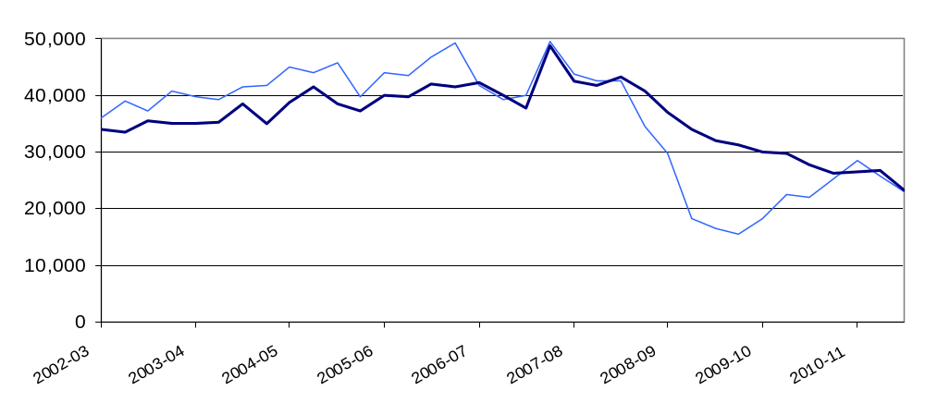
After a period of sustained growth until late 2007, starts were strongly affected by the economic downturn and declined rapidly to a trough in March 2009. They have since gradually begun to recover. Completions responded much more gradually and have not yet begun to recover.
Industry commentators point to the unusually poor weather conditions in December as having had a noticeable negative impact on construction. It is likely that this affected house building starts and completions. Unusual weather is not accounted for by seasonal adjustment of the figures.

Starts
Seasonally adjusted housing starts in England fell from 25,780 in the September quarter 2010 to 23,000 in the December quarter 2010. This is 11 per cent lower than in the September quarter 2010 and 54 per cent below their March quarter 2007 peak, but 48 per cent above the trough in the March quarter 2009.

Seasonally adjusted private enterprise housing starts were nine per cent lower in the December 2010 quarter than in the September 2010 quarter. By comparison, starts by housing associations fell by 20 per cent over the same period.

Table 1a: Quarterly housing starts by tenure, England, seasonally adjusted¹
 |  |  | Private  Enterprise |  | Housing  Associations |  | Local  Authority | All  Tenures
 |  |  | Starts | % change  on previous quarter | Starts | % change  on previous quarter | Starts | Starts | % change  on previous quarter
2008-09 | Apr-June |  | 23,120 | -17% | 6,470 | -1% | 120 | 29,710 | -14%
 | July-Sept |  | 13,030 | -44% | 5,270 | -18% | 10 | 18,310 | -38%
 | Oct-Dec |  | 11,830 | -9% | 4,400 | -17% | 160 | 16,380 | -11%
 | Jan-Mar |  | 11,640 | -2% | 3,850 | -12% | 20 | 15,510 | -5%
2009-10 | Apr-June |  | 14,260 | 22% | 3,930 | 2% | 50 | 18,240 | 18%
 | July-Sept |  | 17,350 | 22% | 5,030 | 28% | 30 | 22,410 | 23%
 | Oct-Dec |  | 17,340 | 0% | 4,680 | -7% | 50 | 22,070 | -2%
 | Jan-Mar |  | 20,360 | 17% | 4,750 | 1% | 200 | 25,300 | 15%
2010-11 | Apr-June |  | 22,320 | 10% | 5,570 | 17% | 560 | 28,460 | 12%
 | July-Sept | ^{R} | 20,720 | -7% | 4,780 | -14% | 280 | 25,780 | -9%
 | Oct-Dec | ^{P} | 18,920 | -9% | 3,810 | -20% | 270 | 23,000 | -11%
1. Because the number of local authority housing starts and completions is very small, quarterly comparisons can be very volatile. Accordingly percentage changes are not reported for this tenure.

Completions
Housing completions in England (seasonally adjusted) were lower, down 13 per cent from 26,760 in the September quarter 2010 to 23,190 in the December quarter 2010. This compares to a one per cent rise between the June 2010 and the September 2010 quarters.
Seasonally adjusted private enterprise housing completions were 18 per cent lower in the December 2010 quarter than in the September 2010 quarter. This follows an increase in completions of five per cent from June to September 2010. By comparison, completions by housing associations rose by three per cent between the September and December quarters 2010.

Table 1b: Quarterly housing completions by tenure, England, seasonally adjusted¹
 |  |  | Private  Enterprise |  | Housing  Associations |  | Local  Authority | All  Tenures
 |  |  | Comple-  tions | % change  on previous quarter | Comple-  tions | % change  on previous quarter | Comple-  tions | Comple-  tions | % change  on previous quarter
2008-09 | Apr-June |  | 30,500 | -11% | 6,280 | -3% | 140 | 36,920 | -9%
 | July-Sept |  | 27,840 | -9% | 6,050 | -4% | 60 | 33,950 | -8%
 | Oct-Dec |  | 24,900 | -11% | 6,850 | 13% | 180 | 31,930 | -6%
 | Jan-Mar |  | 24,770 | -1% | 6,260 | -9% | 130 | 31,160 | -2%
2009-10 | Apr-June |  | 23,440 | -5% | 6,400 | 2% | 130 | 29,960 | -4%
 | July-Sept |  | 22,540 | -4% | 7,070 | 10% | 80 | 29,690 | -1%
 | Oct-Dec |  | 22,050 | -2% | 5,660 | -20% | 30 | 27,740 | -7%
 | Jan-Mar |  | 20,430 | -7% | 5,790 | 2% | 60 | 26,280 | -5%
2010-11 | Apr-June |  | 20,800 | 2% | 5,710 | -1% | 80 | 26,600 | 1%
 | July-Sept | ^{R} | 21,790 | 5% | 4,830 | -16% | 140 | 26,760 | 1%
 | Oct-Dec | ^{P} | 17,960 | -18% | 4,970 | 3% | 260 | 23,190 | -13%
1. Because the number of local authority housing starts and completions is very small, quarterly comparisons can be very volatile. Accordingly percentage changes are not reported for this tenure.

Non-seasonally adjusted results
These series are not seasonally adjusted so it can be misleading to draw conclusions from quarter on quarter changes. For quarter on quarter comparisons the seasonally adjusted series should be used. Figure 2 uses 12 month rolling totals to show trends in non-seasonally adjusted results.
Figure 2: Trends in starts and completions, England, 12 month rolling totals
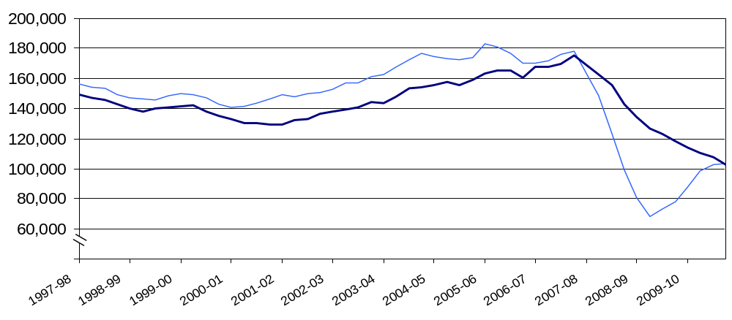
Annual housing starts increased from 150,700 in the 12 months ending December 2002, reaching a peak of 183,360 in the 12 months ending March 2006. Starts then fell to 68,450 in the 12 months to June 2009 before rising to 103,140 in the 12 months to December 2010, 44 per cent below the peak, but up by 32 per cent compared with the 12 months to December 2009.
Annual housing completions increased from 129,870 in the 12 months ending March 2002, reaching a peak of 175,560 in the 12 months ending December 2007. Completions have now fallen to 102,570 in the 12 months to December 2010, 42 per cent below the peak.

Starts
Housing starts were two per cent higher in the December quarter 2010 than in the December quarter 2009. This compares with an 18 per cent rise between the September 2009 and September 2010 quarters.

Private enterprise housing starts were seven per cent higher in the December 2010 quarter than in the December 2009 quarter. By comparison, starts by housing associations fell by 22 per cent over the same period.

Table 2a: Quarterly housing starts by tenure, England, not seasonally adjusted¹
 |  |  | Private  Enterprise |  | Housing  Associations |  | Local  Authority | All  Tenures
 |  |  | Starts | % change on same quarter previous year | Starts | % change on same quarter previous year | Starts | Starts | % change on same quarter previous year
2008-09 | Apr-June |  | 23,880 | -40% | 7,250 | 20% | 120 | 31,250 | -32%
 | July-Sept |  | 14,120 | -64% | 5,150 | -11% | 10 | 19,290 | -57%
 | Oct-Dec |  | 10,700 | -68% | 3,790 | -28% | 160 | 14,650 | -62%
 | Jan-Mar |  | 11,350 | -59% | 4,020 | -41% | 20 | 15,390 | -55%
2009-10 | Apr-June |  | 14,690 | -39% | 4,390 | -39% | 50 | 19,120 | -39%
 | July-Sept |  | 18,960 | 34% | 4,920 | -4% | 30 | 23,910 | 24%
 | Oct-Dec |  | 15,710 | 47% | 4,040 | 7% | 50 | 19,800 | 35%
 | Jan-Mar |  | 19,710 | 74% | 4,950 | 23% | 200 | 24,850 | 61%
2010-11 | Apr-June |  | 23,170 | 58% | 6,230 | 42% | 560 | 29,960 | 57%
 | July-Sept | R | 23,070 | 22% | 4,790 | -3% | 280 | 28,140 | 18%
 | Oct-Dec | P | 16,780 | 7% | 3,150 | -22% | 270 | 20,190 | 2%

1. Because the number of local authority housing starts and completions is very small, quarterly comparisons can be very volatile. Accordingly percentage changes are not reported for this tenure.

Completions

Housing completions were 16 per cent lower in the December quarter 2010 than in the December quarter 2009. This compares with a decline of nine per cent between the September 2009 and the September 2010 quarters.

Private enterprise housing completions were 19 per cent lower in the December 2010 quarter than in the December 2009 quarter. By comparison, completions by housing associations fell by nine per cent over the same period.

Table 2b: Quarterly housing completions by tenure, England, not seasonally adjusted¹
 |  |  | Private  Enterprise |  | Housing  Associations |  | Local  Authority | All  Tenures
 |  |  | Comple-  tions | % change on same quarter previous year | Comple-  tions | % change on same quarter previous year | Comple-  tions | Comple-  tions | % change on same quarter previous year
2008-09 | Apr-June |  | 31,840 | -18% | 5,640 | 23% | 140 | 37,620 | -13%
 | July-Sept |  | 25,920 | -25% | 5,590 | 19% | 60 | 31,570 | -19%
 | Oct-Dec |  | 28,080 | -32% | 7,470 | 10% | 180 | 35,740 | -26%
 | Jan-Mar |  | 22,250 | -28% | 6,810 | -3% | 130 | 29,190 | -23%
2009-10 | Apr-June |  | 24,490 | -23% | 5,720 | 1% | 130 | 30,340 | -19%
 | July-Sept |  | 20,960 | -19% | 6,530 | 17% | 80 | 27,570 | -13%
 | Oct-Dec |  | 24,830 | -12% | 6,200 | -17% | 30 | 31,060 | -13%
 | Jan-Mar |  | 18,350 | -18% | 6,290 | -8% | 60 | 24,690 | -15%
2010-11 | Apr-June |  | 21,570 | -12% | 5,170 | -10% | 80 | 26,830 | -12%
 | July-Sept | ^{R} | 20,720 | -1% | 4,250 | -35% | 140 | 25,100 | -9%
 | Oct-Dec | ^{P} | 20,060 | -19% | 5,640 | -9% | 260 | 25,950 | -16%

1. Because the number of local authority housing starts and completions is very small, quarterly comparisons can be very volatile. Accordingly percentage changes are not reported for this tenure.

Sub-national trends

Comparisons between national, regional and district figures in this section are based on the non-seasonally adjusted series. It is our policy only to seasonally adjust England figures at national level. The graphs in this section use 12 month rolling totals to show trends in non-seasonally adjusted results.

Regional starts

All regions saw a rise in annual starts between 12 months ending December 2009 and 12 months ending December 2010. (See Figures 3a, 3b and 3c below).
In the 12 month period ending December 2010, the number of housing starts was highest in the South East and lowest in the North East, accounting for 19 per cent and five per cent respectively of starts in England.
In the West Midlands, London, South East and South West starts were lower in the December quarter 2010 than in the December quarter 2009. All other regions saw a rise in starts over this period. The largest proportional increases were in the North West (26%) and the East region (19%).
Figure 3a: Trends in housing starts in the North East, North West and Yorkshire and the Humber, 12 month rolling totals
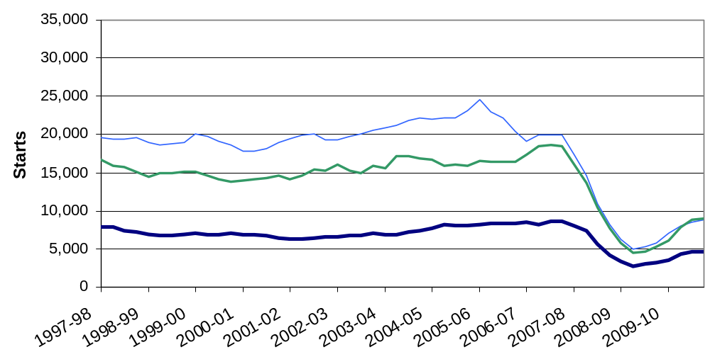
Figure 3b: Trends in housing starts in the East of England, East Midlands and West Midlands, 12 month rolling totals
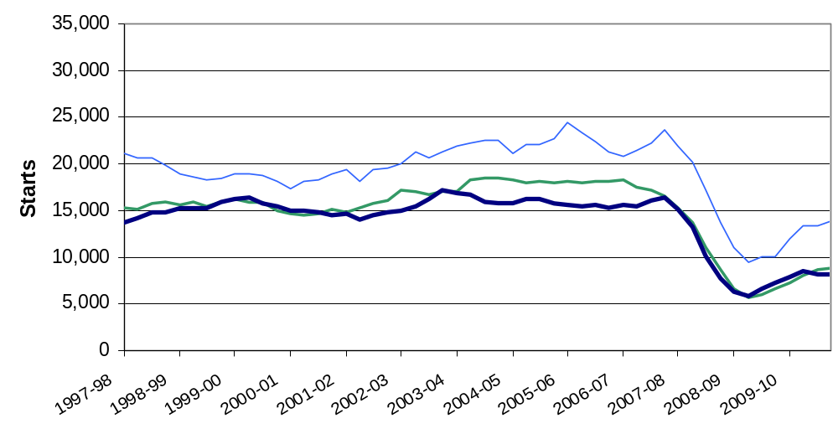
Figure 3c: Trends in housing starts in London, the South East and South West, 12 month rolling totals
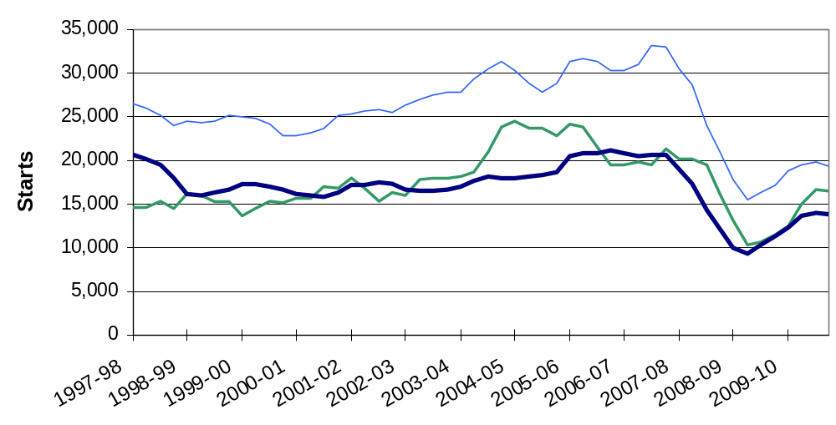

Regional completions

The North East saw a small rise of three per cent in annual completions between 12 months ending December 2009 and 12 months ending December 2010; in all other regions completions fell over this period (see Figures 4a, 4b and 4c below).
In the 12 month period ending December 2010, the number of housing completions was highest in the South East and lowest in the North East, accounting for 19 per cent and four per cent respectively of completions in England.

Completions were higher in the East Midlands in the December quarter 2010 than in the December quarter 2009. In all other regions completions were lower in the December quarter 2010 than in the December quarter 2009. The largest falls were in London (-51%) and the South East (-22%).

Figure 4a: Trends in housing completions in the North East, North West and Yorkshire and the Humber, 12 month rolling totals
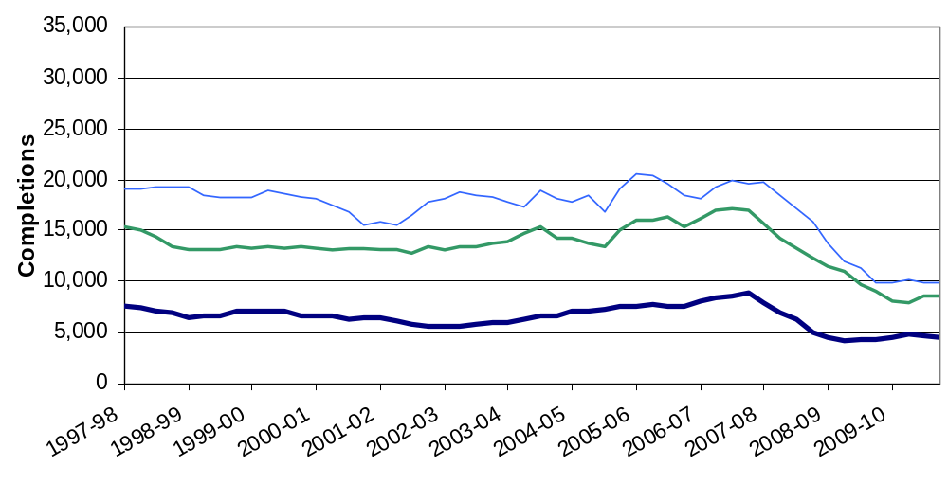

Figure 4b: Trends in housing completions in the East of England, East Midlands and West Midlands, 12 month rolling totals
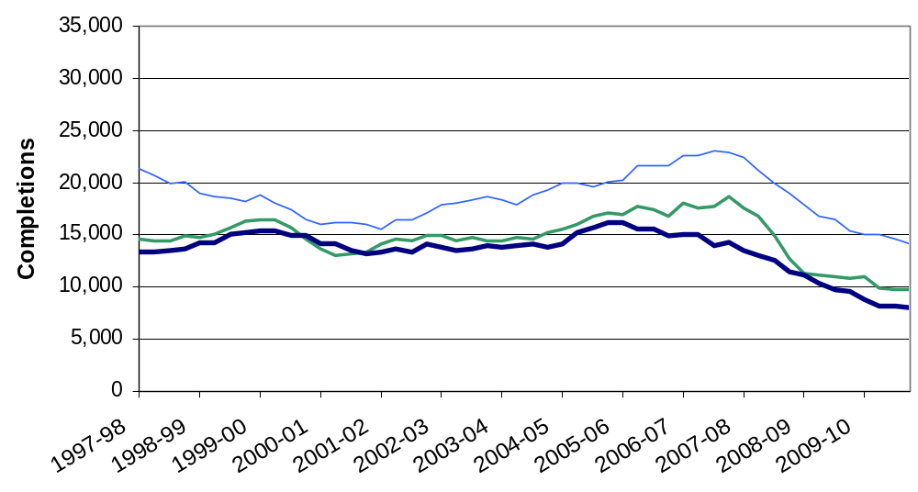
Figure 4c: Trends in housing completions in London, the South East and South West, 12 month rolling totals
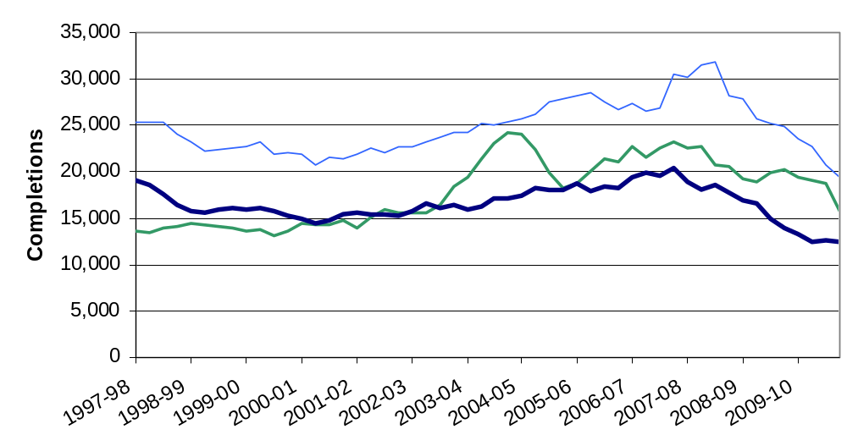

Geographic distribution of house building
Figure 5a: Level of completions for each local authority district in 2010
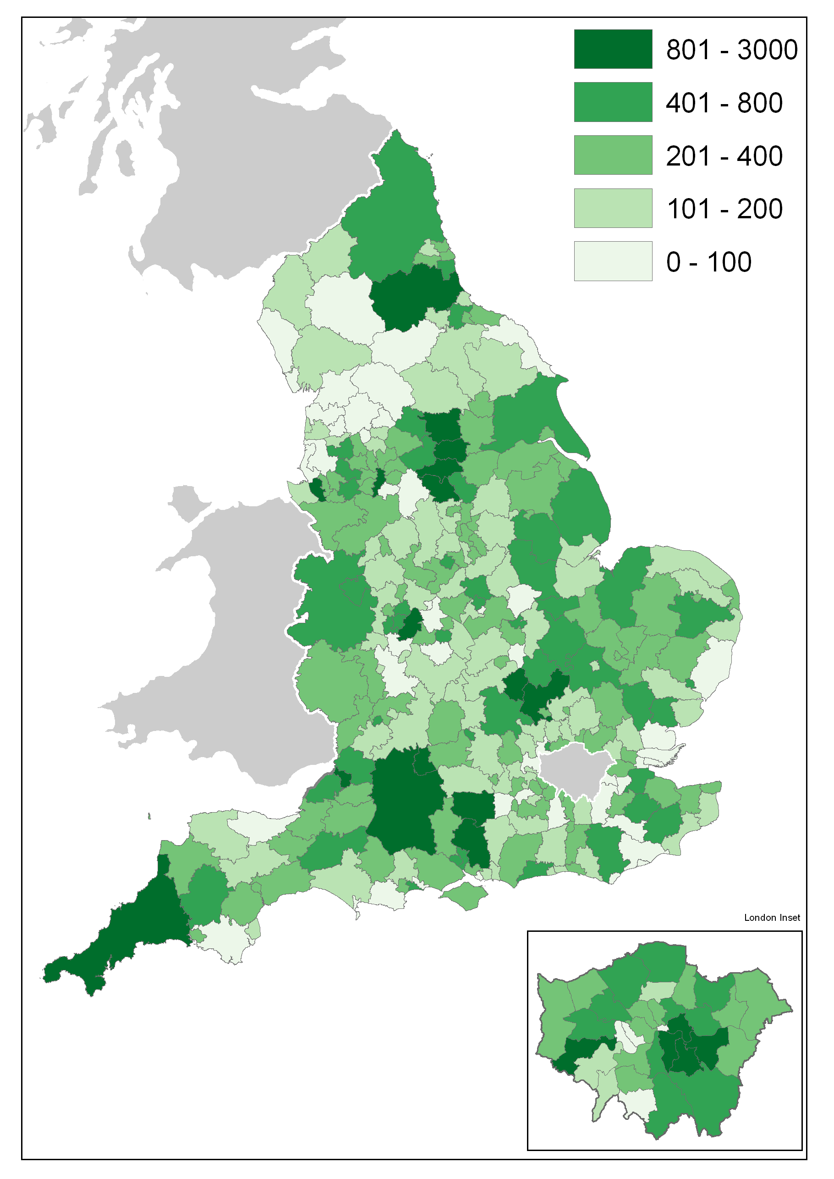

In 2010 there were 102,570 completions in England. The map in figure 5a above shows how these completions were distributed amongst the 326 local authority districts. As local authorities vary greatly by size, the number of completions achieved cannot be taken as a performance measure. The inset in the bottom right hand corner contains a blow-up of the London boroughs.
The darkest green shade is used to indicate places that had more than 800 completions. The lightest green indicates places where completions were in the range 0-100.

Change in Starts and Completions from 2009 to 2010, by local authority district

The map on the left below shows for each local authority district how many house building starts there were in 2010 relative to 2009. The darker shades of blue indicate increase while the two palest shades of blue indicate authorities where there were fewer starts in 2010 than in 2009.
The map on the right shows the same comparison for completions. The same colour scale has been used for both maps to allow straightforward comparison. The generally darker colour of the starts map on the right reflects a recovery in starts from the historically low levels seen in 2009.
The lighter tone of the right hand map shows that completions generally still show the lagged effect of the low level of starts in 2009.
Figure 5b: Change in starts (left) and completions (right) by LA from 2009 to 2010
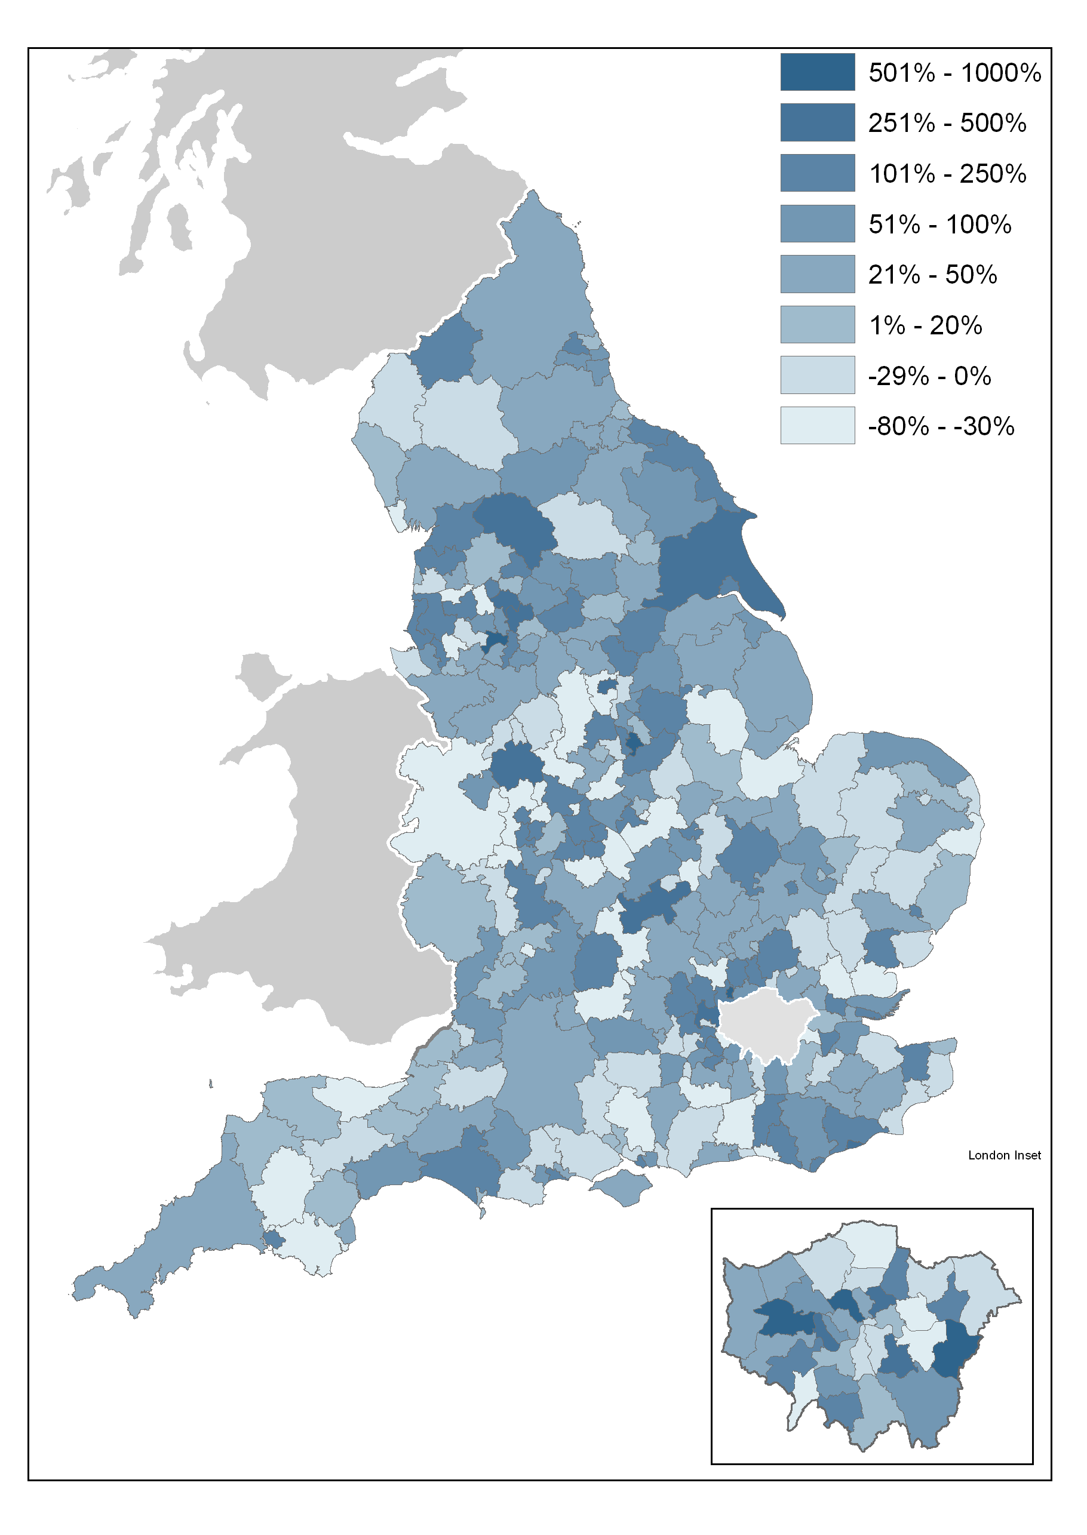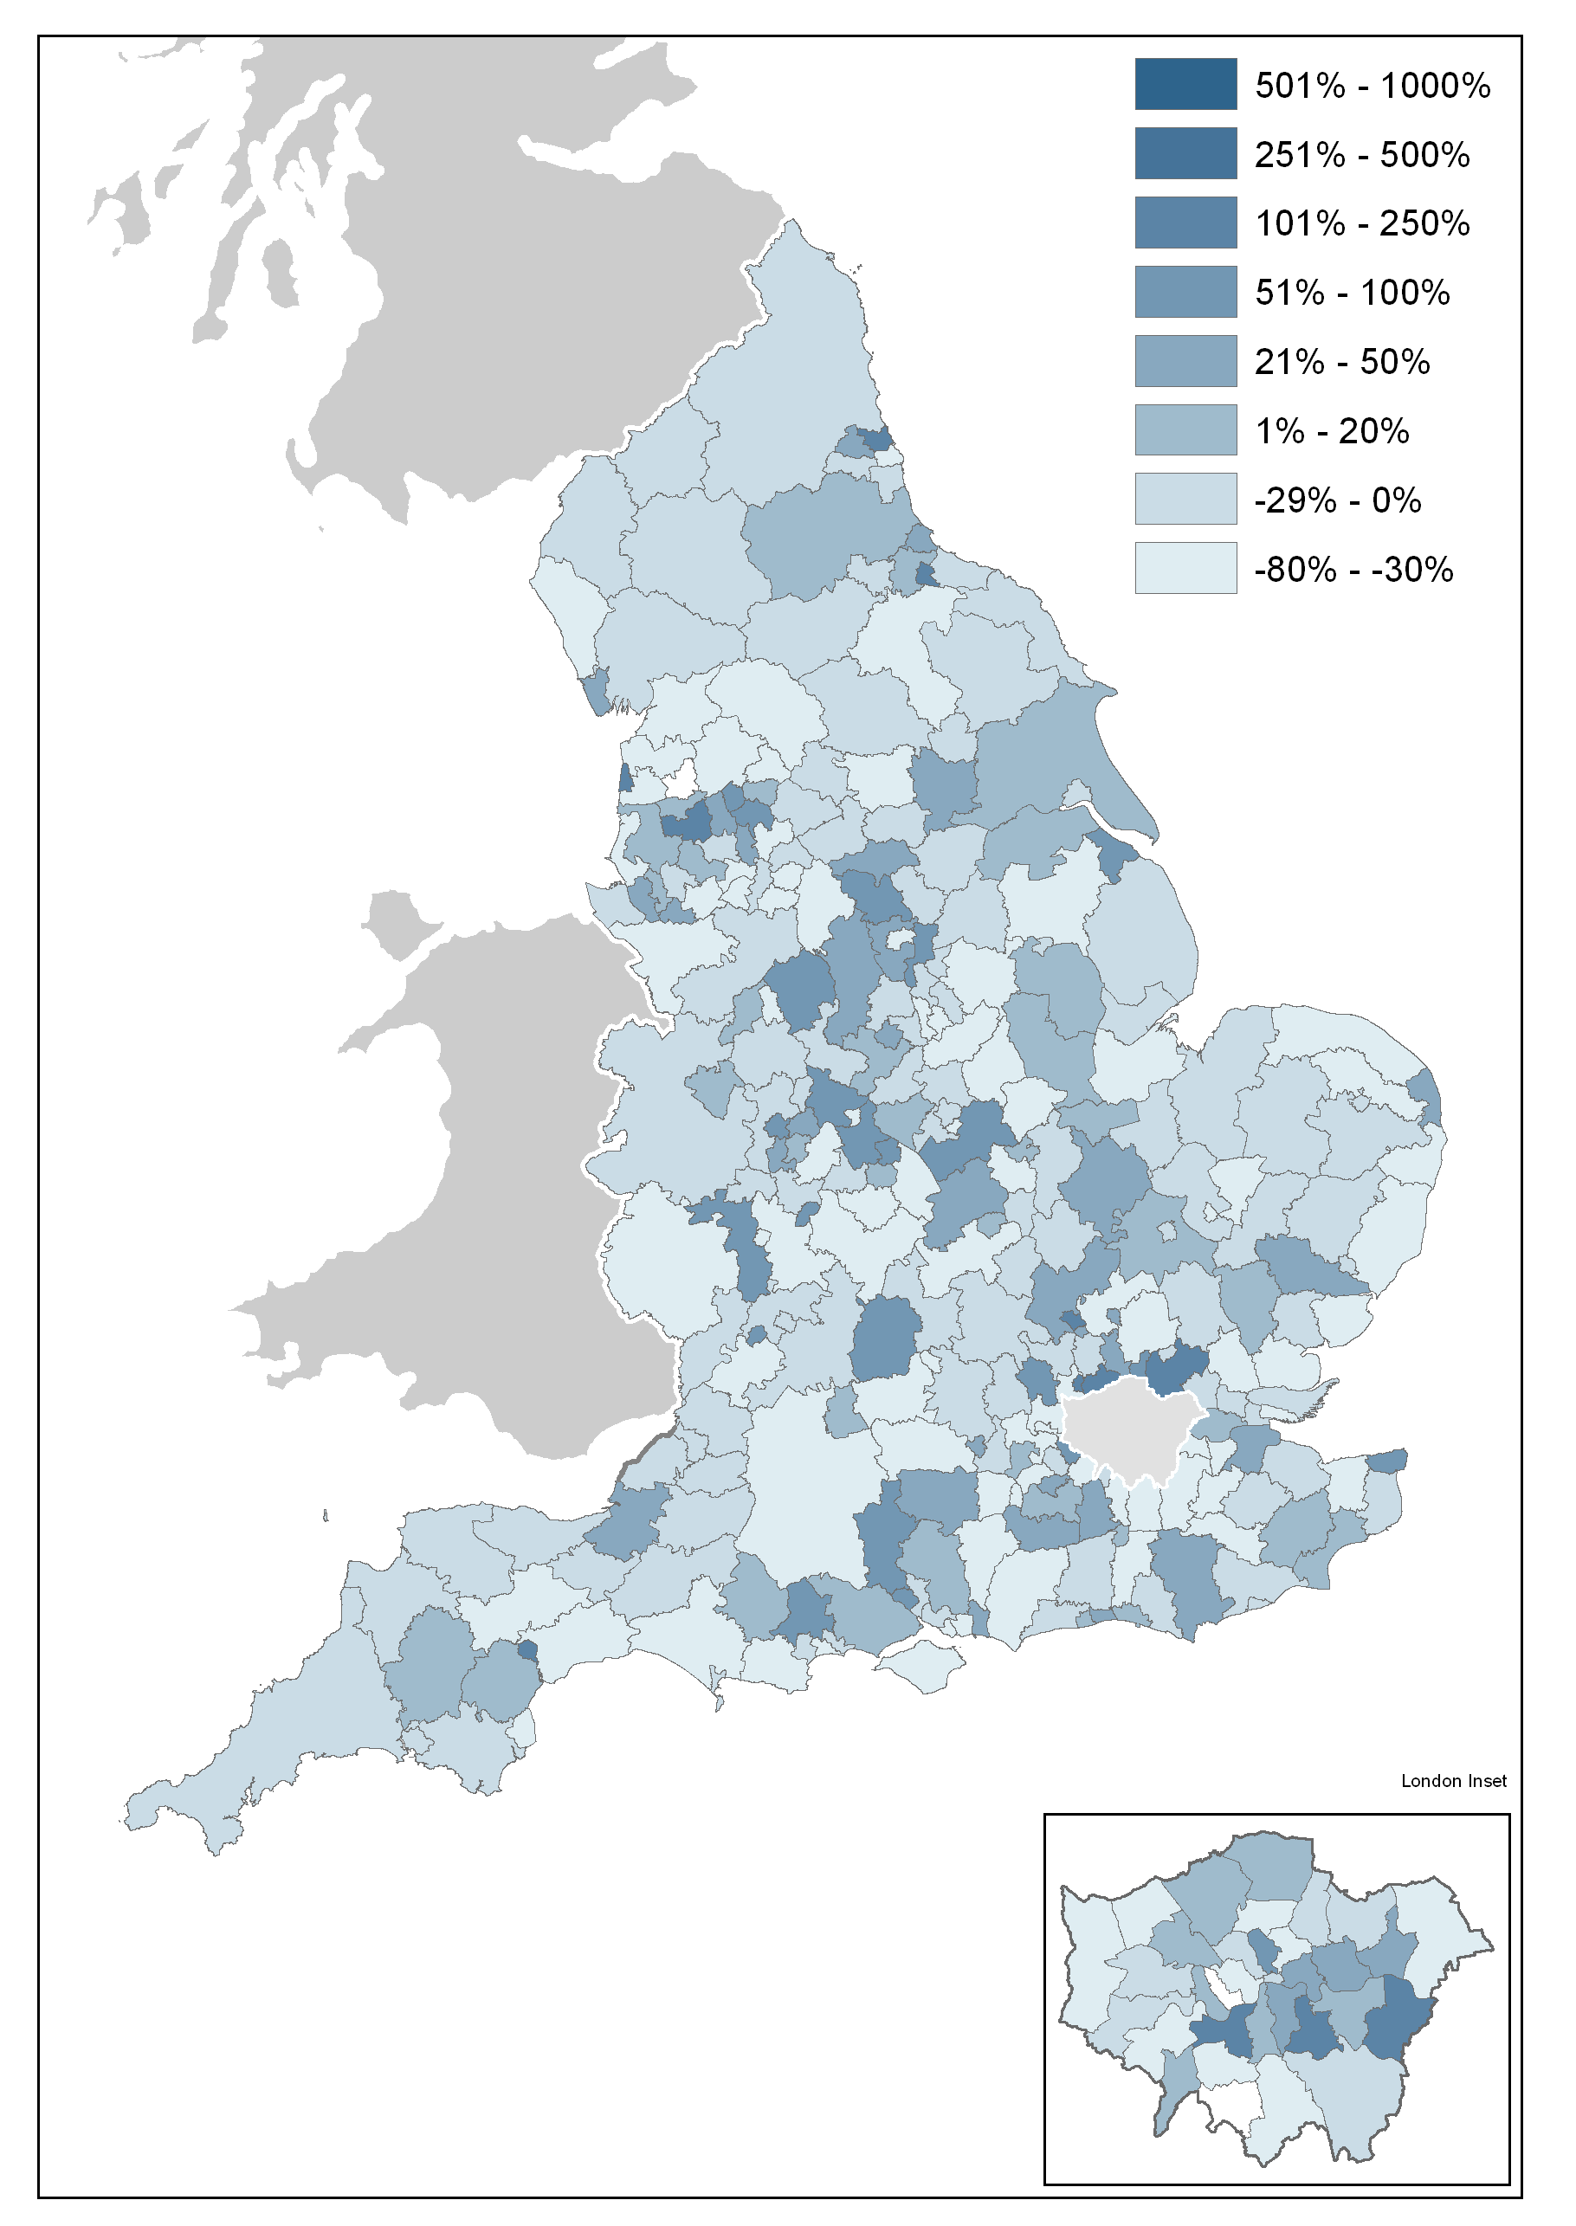

Other Approved Inspectors

In addition to local authorities and the National House-Building Council, house building starts and completions can be certified by other independent Approved Inspectors. The numbers in this release do not include activity for these other Approved Inspectors and, as such, are underestimates of the true level of house building starts and completions. We are now collecting information from other Approved Inspectors in order to monitor the extent of this gap in coverage. We aim to incorporate these data as soon as we have established a data collection that is sustainable.

In the 2009-10 financial year approximately eight per cent of all starts and four per cent of completions were inspected by other independent Approved Inspectors. At national level this translates to approximately 7,000 extra house building starts and approximately 5,000 extra completions for the 2009-10 financial year. This compares to eight per cent of starts and four per cent of completions in 2008-09, when this represented approximately 7,000 extra house building starts and approximately 6,000 extra completions.

Data collection
This release takes information from two data sources on building control:
- ‘P2’ quarterly house building returns submitted to Department for Communities and Local Government by local authority building control departments; and
- monthly information from the National House-Building Council (NHBC) on the volume of building control inspections they undertake in each local authority area.



Data quality
Figures on housing starts and completions are from records kept for building control purposes. It is sometimes difficult for data providers to identify whether a dwelling is being built for a housing association or for a private developer. This may lead to an understatement of housing association starts and completions recorded in these tables, and a corresponding overstatement of private enterprise figures. This problem is more likely to occur with starts than completions. For more detailed statistics on affordable housing please refer to Department for Communities and Local Government’s affordable housing supply statistics at the following link. http://www.communities.gov.uk/housing/housingresearch/housingstatistics/housingstatisticsby/affordablehousingsupply/.

The P2 data received from local authorities record starts and completions inspected by local authority building control and include imputation for a small number of missing returns; in the December quarter 2010, a 93 per cent local authority response rate was achieved.
The process to impute for a missing P2 local authority return works by picking up all data recorded in completed returns for that local authority over the previous five years and comparing it to data for other similar local authorities for the same periods. It then looks at the data provided for the current period by those other local authorities and imputes a figure for the missing local authority return which matches the proportion found in the comparison of data for the previous five years.
The NHBC figures record all starts and completions inspected by NHBC building control.
In addition to local authorities and the NHBC, house building starts and completions can be certified by other independent Approved Inspectors. The headline figures in this release do not include activity for these other Approved Inspectors and, as such, are underestimates of the true level of starts and completions but represent our best estimates at this time. We are now collecting information from other Approved Inspectors in order to gain a complete picture of house building activity and we intend to incorporate these data as soon as we are satisfied that we have established a data collection that is sustainable. We have included an estimate of the number of house building starts and completions certified by these other Approved Inspectors in the 2009/10 financial year in a separate section above.

Uses of house building statistics
The house building statistical series on starts and completions are a key part of the evidence base which informs the development and evaluation of housing policy by central and local government. They are also used as evidence for other housing market analysts, forecasters and decision makers, for example at the Bank of England and in the construction and banking industries. They are used by the media in reports on the housing market, and by academics both in the UK and abroad.

Related statistics

Net supply of housing
The annual net additional dwellings figure, or net housing supply, is the absolute change in dwelling stock between 1 April and 31 March the following year. It comprises the number of new build permanent dwellings; plus the net gain from dwelling conversions; plus the net gain of non dwellings brought into residential use; plus net additions from other gains and losses to the dwelling stock (such as mobile and temporary dwellings); less any demolitions during the financial year.
The net additions statistical series is separate from and complementary to the Department for Communities and Local Government’s quarterly National Statistics series on new house building, providing a more comprehensive but less timely measure of total housing supply in England. Completions figures from the quarterly house building series are not used in the net additions statistics. Instead a separate set of data on the new build completions component of net additions is collected as part of the overall annual net additions data collection. This eliminates timing differences from the net supply series and provides a picture of the components of net change which can be reconciled for a given year.
The house building statistical series takes its data from the same sources throughout England, combining data from building control officers at local authorities and the National House-Building Council (NHBC), and is published within eight weeks after the end of each quarter. For net additions, all the data come from local authorities who in turn use whichever local data source they believe is most appropriate, and the data collection period for these statistics is relatively long, being annual and closing some five months after the end of the financial year. The longer data collection period makes it possible to incorporate data on the approximately five per cent of new build completions that are inspected by independent building control Approved Inspectors other than those at local authorities or the NHBC.
Users who need an early indication of house building activity or who intend to use housing supply statistics as an economic indicator are advised to use the quarterly house building starts and completions series. Those who require a long-running, consistent time series on housing supply should also use house building, in either a quarterly or annual basis. Users wanting a more complete picture of the overall supply of housing may find the net additions statistical series more appropriate.
The net supply of housing statistics can be found at the link below. http://www.communities.gov.uk/housing/housingresearch/housingstatistics/housingstatisticsby/stockincludingvacants/nethousingsupply/.

Dwelling stock estimates
Department for Communities and Local Government also publish statistics showing the total dwelling stock in England each year. These estimates are based on the latest census count plus the annual Net supply of housing statistics described above. They can be found at the following link.
http://www.communities.gov.uk/publications/corporate/statistics/housingstock2009.

Affordable housing
Although the house building statistics do categorise new build into private, housing associations (HA) and local authority tenure, this is not the best source of information on the total amount of affordable housing being delivered. A more detailed and accurate source is Department for Communities and Local Government’s Affordable housing supply statistics, which can be found at the following link. The affordable housing supply statistics include both new build supply and acquisitions for social rent and low cost home ownership. http://www.communities.gov.uk/housing/housingresearch/housingstatistics/housingstatisticsby/affordablehousingsupply/.

Revisions policy
This policy has been developed in accordance with the UK Statistics Authority Code of Practice for Official statistics and the Department for Communities and Local Government Revisions Policy. There are two types of revisions that the policy covers.

Scheduled Revisions
Local Authorities can update each quarterly return at any time up to two years after the initial publication of the figures for that quarter in order to maximise the response rate to the P2 return and enable late information to be included. Every quarter, as well as releasing figures for the latest quarter, we revise the previous quarter to incorporate any data that came in shortly after the previous data collection period. This captures most late data. Once a year, in the June quarter statistical release, a longer revision is carried out to incorporate all remaining late data into the published statistics. Therefore, until each quarterly return is permanently closed, figures for that quarter remain provisional. Provisional figures are labelled in the tables with a “P” and revised figures are labelled with an “R”.
In addition, where figures are seasonally adjusted, the adjustment factors for the whole series back to 1990 are recalculated annually, usually in the June quarter. This will result in small changes to seasonally adjusted figures across the whole period. These changes are not labelled with an “R”.
Other revisions to historic data (all data older than that currently due for scheduled revision) should only be made where there is a substantial revision, such as a change in methodology or definition.
Where there are small changes that do not substantially change historic data, internal updates are maintained.

Non-Scheduled Revisions
Where a substantial error has occurred as a result of the compilation, imputation or dissemination process, the statistical release, live tables and other accompanying releases will be updated with a correction notice as soon as is practical.

Definitions
House building start - A dwelling is counted as started on the date work begins on the laying of the foundation, including 'slabbing' for houses that require it, but not including site preparation. Thus when foundation work commences on a pair of semi-detached houses two houses are counted as started, and when work begins on a block of flats all the dwellings in that block are counted as started. The starts of houses in building schemes are usually phased over a period of weeks or even, in very large schemes, months.
House building completion - In principle, a dwelling is regarded as completed when it becomes ready for occupation or when a completion certificate is issued whether it is in fact occupied or not. In practice, there are instances where the timing could be delayed and some completions may be missed for example as no completion certificate was requested by the owner.
Housing association - “Housing associations (HAs)” has been used as the generic name for all social landlords not covered by local authorities (see below). In previous editions HAs were referred to as Registered Social Landlords (RSL), although the term (private) Registered Provider (pRP) of social housing is commonly used by the Tenant Services Authority. The more all-encompassing description of ‘housing associations’ is now seen as more appropriate and helpful to users.

Accompanying tables
Accompanying tables are available to download alongside this release:

Tables:
1a House building starts and completions, including seasonally adjusted series: England;

1b House building starts and completions unadjusted: North East;
1c House building starts and completions unadjusted: North West;

1d House building starts and completions unadjusted: Yorkshire and the Humber;
1e House building starts and completions unadjusted: East Midlands;

1f House building starts and completions unadjusted: West Midlands;
1g House building starts and completions unadjusted: East of England;

1h House building starts and completions unadjusted: London;
1j House building starts and completions unadjusted: South East;

1k House building starts and completions unadjusted: South West;
2a House building starts and completions unadjusted: Wales;
2b House building starts and completions unadjusted: Scotland;
2c House building starts and completions unadjusted: Great Britain;
2d House building starts and completions unadjusted: Northern Ireland;
2e House building starts and completions unadjusted: United Kingdom;
Additional tables showing house building completions by type and size of property, starts and completions for individual local authorities as well as historic series can be accessed in the 'Live tables' section ("Live tables on house building") at the following link. http://www.communities.gov.uk/housing/housingresearch/housingstatistics/
All statistical releases on house building can be accessed on the Department for Communities and Local Government website at http://www.communities.gov.uk/housing/housingresearch/housingstatistics/housingstatisticsby/housebuilding/publicationsonhousebuilding/.

Notes to the tables
The following conventions have been used in the tables:
.. Not available;
- Fewer than 5 dwellings;
^{P} Figure provisional and subject to revision;
^{R} Revised from previous release.
Totals may not equal the sum of component parts due to rounding to the nearest 10.

Background notes
- The starts and completions reported in this publication are for new house building in England and exclude new dwellings created through conversions and the change of use of existing buildings.
- Figures in the accompanying tables are presented rounded to the nearest 10 dwellings.
- Sources are shown at the foot of individual accompanying tables and live tables.
- The charts give seasonally adjusted quarterly house building trends and give annual trends by showing a rolling 12 month total. Both the private enterprise and housing association England series are seasonally adjusted.

- Accompanying Table 1a gives non-seasonally adjusted and seasonally adjusted England figures. All figures for other countries and the English regions are shown on an unadjusted basis only.
- National Statistics are produced to high professional standards set out in the Code of Practice for Official Statistics. They undergo assessment by the UK Statistics Authority to ensure that they meet those standards.
- The tables and charts accompanying this release are shown above in the ‘Accompanying tables’ section and are provided in Microsoft Excel format.
- Details of officials and ministers who receive pre-release access to the Department for Communities and Local Government quarterly House Building release up to 24 hours before release can be found at:
http://www.communities.gov.uk/corporate/researchandstatistics/statistics/nationalstatistics/
- The next quarterly release will be published on Thursday 19 May 2011, and will cover house building up to the March quarter 2011.

User consultation
Users’ comments on any issues relating to this statistical release are welcomed and encouraged. Responses should be addressed to the "statistical enquiries" contact given in the "Enquiries" section below.

Enquiries

Statistical enquiries:
e-mail: housing.statistics@communities.gov.uk
telephone: 0303 44 42345

Media Enquiries:
office hours: 0303 44 41136
out of hours: 0303 44 41201
e-mail: press@communities.gov.uk

Department for Department for Communities and Local Government. © Crown Copyright, 2011

If you require this publication in an alternative format please email: alternativeformats@communities.gsi.gov.uk. Please note that the nature of content means that we may not be able to provide the Statistical series of publications in all requested formats.

February 2011

ISBN: 978-1-4098-2830-3

