
- Seasonally adjusted house building starts stood at 25,240 in the December quarter 2011. This is 6 per cent higher than in the September quarter 2011. It is 74 per cent above the trough in the March quarter 2009, but 48 per cent below the December quarter 2005 peak.
- Private enterprise housing starts (seasonally adjusted) were 6 per cent above the September quarter 2011. Starts by housing associations were 1 per cent higher than the previous quarter.
- Housing completions in England (seasonally adjusted) also increased this quarter, up 2 per cent from 26,180 in September quarter 2011 to 26,730 in the December quarter 2011.
- Completions by housing associations (seasonally adjusted) increased by 12 per cent between the September quarter 2011 and December quarter 2011. However, private enterprise housing completions were 2 per cent lower in the December 2011 quarter than in the September 2011 quarter.
- Annual housing starts reached 98,250 in the 12 months to December 2011, down by 4 per cent compared with the 12 months to December 2010. Annual housing completions in England totalled 109,020 in the 12 months to December 2011, an increase of 6 per cent compared with the 12 months to December 2010.

Housing
Statistical Release

16 February 2012
using
Research
Summary
Number 239, 2007

House Building: December Quarter 2011, England



Contents
1. | Seasonally adjusted results……………………... | 2
2. | Non-seasonally adjusted results……………………... | 4
3. | Sub-national trends……… | 6
4. | Other Approved  Inspectors……………….... | 12
5. | Data collection…………… | 19
6. | Data quality……………..... | 20
7. | Uses of house building  statistics….……………….. | 23
8. | Related statistics……....… | 23
9. | Revisions policy………….. | 26
10. | Revisions in this release... | 27
11. | Definitions……………….... | 27
12. | Accompanying tables….... | 28
13. | Background notes............. | 29
14. | User consultation………... | 30
15. | Enquiries………................ | 30

Responsible statistician:
Richard Field

Statistical enquiries:
office hours: 0303 44 42272
housing.statistics@communities.gov.uk

Media Enquiries:
office hours: 0303 44 41136
out of hours: 0303 44 41201

press@communities.gov.uk

This quarterly Statistical Release presents National Statistics on new house building starts and completions in England up to the December quarter 2011. The figures in this release have been revised as usual to incorporate late information provided by local authorities and updates to NHBC data. For details, see the “Revisions” section of this publication.
Data for Scotland, Wales and Northern Ireland are also included in the accompanying tables. These data are published separately by the devolved administrations, and although the figures are correct at the time of this publication they may be superseded before the next England house building release.
These statistics are one of two complementary statistical series on housing supply in England published by the Department for Communities and Local Government, the other being the annual Net supply of housing statistics. A description of the relationship between these two series can be found in the ‘Related statistics’ section of this publication.

Seasonally adjusted results
Figures for private enterprise and housing associations are seasonally adjusted. The seasonally adjusted series should be used for quarter on quarter comparisons. For annual comparisons the non-seasonally adjusted series should be used.

Figure 1: Seasonally adjusted trends in quarterly housing starts and completions, England
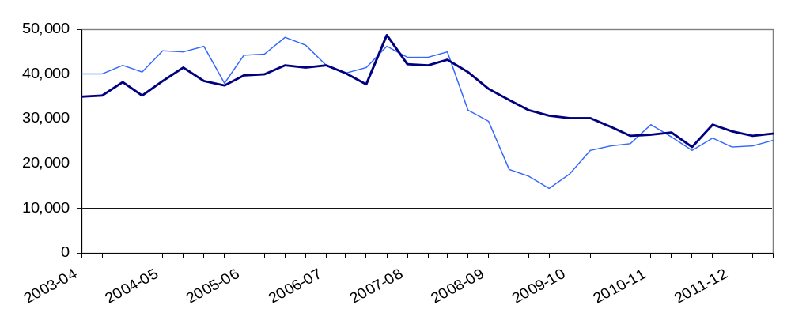
Starts experienced a period of sustained growth from 2001 until 2005, before levelling off, averaging around 44,000 units each quarter until late 2007. Starts were strongly affected by the economic downturn and from the start of 2008 there was a period of rapid decline to a trough in the March quarter of 2009. Completions responded more gradually to the downturn. From 2009 starts began to recover and over the last two years the two series have converged and levelled off. This indicates that the stabilisation of starts has worked its way through to completions. New supply is currently at approximately 60 per cent of pre-downturn levels.
Starts
Seasonally adjusted housing starts in England increased from 23,880 in the September quarter 2011 to 25,240 in the December quarter 2011. This is a 6 per cent quarter on quarter rise. Starts are still 48 per cent below their December quarter 2005 peak, but 74 per cent above the trough in the March quarter of 2009.

Seasonally adjusted private enterprise housing starts were 6 per cent higher in the December 2011 quarter than in the September 2011 quarter but starts by housing associations increased by only 1 per cent over the same period.

Table 1a: Quarterly housing starts by tenure, England, seasonally adjusted¹
 |  |  | Private  Enterprise |  | Housing  Associations |  | Local  Authority | All  Tenures
 |  |  | Starts | % change  on previous quarter | Starts | % change  on previous quarter | Starts | Starts | % change  on previous quarter
2008-09 | Apr-June |  | 22,800 | -11% | 6,640 | 5% | 120 | 29,560 | -8%
 | July-Sept |  | 13,480 | -41% | 5,300 | -20% | 10 | 18,790 | -36%
 | Oct-Dec |  | 12,810 | -5% | 4,370 | -18% | 160 | 17,330 | -8%
 | Jan-Mar |  | 10,680 | -17% | 3,770 | -14% | 20 | 14,470 | -17%
2009-10 | Apr-June |  | 13,740 | 29% | 4,020 | 7% | 50 | 17,820 | 23%
 | July-Sept |  | 17,800 | 29% | 5,110 | 27% | 30 | 22,940 | 29%
 | Oct-Dec |  | 18,550 | 4% | 5,530 | 8% | 50 | 24,120 | 5%
 | Jan-Mar |  | 18,870 | 2% | 5,450 | -1% | 200 | 24,520 | 2%
2010-11 | Apr-June |  | 21,590 | 14% | 6,510 | 19% | 560 | 28,650 | 17%
 | July-Sept |  | 19,920 | -8% | 5,710 | -12% | 280 | 25,910 | -10%
 | Oct-Dec |  | 18,420 | -8% | 4,270 | -25% | 350 | 23,040 | -11%
 | Jan-Mar |  | 19,310 | 5% | 6,030 | 41% | 380 | 25,720 | 12%
2011-12 | Apr-June | R | 18,500 | -4% | 4,610 | -24% | 590 | 23,710 | -8%
 | July-Sept | R | 19,250 | 4% | 4,430 | -4% | 200 | 23,880 | 1%
 | Oct-Dec | P | 20,370 | 6% | 4,490 | 1% | 380 | 25,240 | 6%
1. Because the number of local authority housing starts and completions is very small, quarterly comparisons can be very volatile. Accordingly, percentage changes are not reported for this tenure.

Completions
House building completions in England (seasonally adjusted) increased 2 per cent from 26,180 in the September quarter 2011 to 26,730 in the December quarter 2011. This compares to a 4 per cent fall between the June 2011 and the September 2011 quarters.
Seasonally adjusted housing association completions were 12 per cent higher in the December 2011 quarter than in the September 2011 quarter. However, private enterprise completions fell by 2% per cent over the same period.

Table 1b: Quarterly housing completions by tenure, England, seasonally adjusted¹
 |  |  | Private  Enterprise |  | Housing  Associations |  | Local  Authority | All  Tenures
 |  |  | Comple-  tions | % change  on previous quarter | Comple-  tions | % change  on previous quarter | Comple-  tions | Comple-  tions | % change  on previous quarter
2008-09 | Apr-June |  | 30,480 | -11% | 6,190 | -3% | 140 | 36,800 | -9%
 | July-Sept |  | 27,840 | -9% | 6,220 | 1% | 60 | 34,130 | -7%
 | Oct-Dec |  | 24,970 | -10% | 6,930 | 11% | 180 | 32,090 | -6%
 | Jan-Mar |  | 24,580 | -2% | 6,100 | -12% | 110 | 30,780 | -4%
2009-10 | Apr-June |  | 23,680 | -4% | 6,330 | 4% | 130 | 30,140 | -2%
 | July-Sept |  | 22,700 | -4% | 7,490 | 18% | 90 | 30,280 | 0%
 | Oct-Dec |  | 22,400 | -1% | 5,900 | -21% | 30 | 28,330 | -6%
 | Jan-Mar |  | 20,510 | -8% | 5,690 | -4% | 110 | 26,320 | -7%
2010-11 | Apr-June |  | 20,840 | 2% | 5,650 | -1% | 100 | 26,590 | 1%
 | July-Sept |  | 22,100 | 6% | 4,880 | -13% | 140 | 27,120 | 2%
 | Oct-Dec |  | 17,880 | -19% | 5,320 | 9% | 440 | 23,640 | -13%
 | Jan-Mar |  | 21,530 | 20% | 6,700 | 26% | 630 | 28,860 | 22%
2011-12 | Apr-June | R | 20,610 | -4% | 5,970 | -11% | 660 | 27,240 | -6%
 | July-Sept | R | 20,280 | -2% | 5,550 | -7% | 350 | 26,180 | -4%
 | Oct-Dec | P | 19,840 | -2% | 6,200 | 12% | 680 | 26,730 | 2%
1. Because the number of local authority housing starts and completions is very small, quarterly comparisons can be very volatile. Accordingly, percentage changes are not reported for this tenure.

Non-seasonally adjusted results
These series are not seasonally adjusted so it can be misleading to draw conclusions from quarter on quarter changes. For quarter on quarter comparisons the seasonally adjusted series should be used. Figure 2 uses 12-month rolling totals to show trends in non-seasonally adjusted results.

Figure 2: Trends in starts and completions, England, 12 month rolling totals
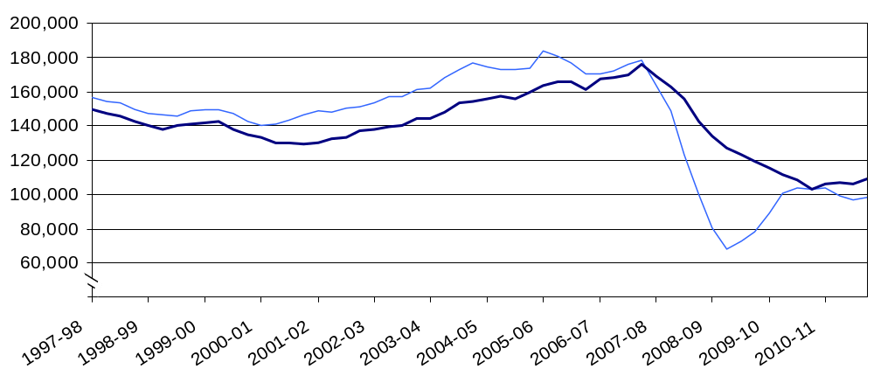

Annual housing starts increased from 150,700 in the 12 months ending December 2002, reaching a peak of 183,360 in the 12 months ending March 2006, remaining fairly stable until the beginning of 2008 when they fell sharply to 68,280 in the 12 months to June 2009. Starts then recovered somewhat to 103,740 in the 12 months to September 2010. In the 12 months to December 2011 the figures are slightly below this, totalling 98,250 starts. This is 46 per cent below the peak, but up by 44 per cent compared with the trough.
Annual housing completions increased from 129,510 in the 12 months ending December 2001, reaching a peak of 175,560 in the 12 months ending December 2007. Completions totalled 109,020 in the 12 months to December 2011, 38 per cent below the peak.

Starts
Housing starts were 9 per cent higher in the December quarter 2011 than in the December quarter 2010. This compares with an 8 per cent fall between the September 2010 and September 2011 quarters. Private enterprise housing starts were 10 per cent higher in the December 2011 quarter than in the December 2010 quarter. Housing association starts increased by 5 per cent compared with the same quarter a year before.

Table 2a: Quarterly housing starts by tenure, England, not seasonally adjusted¹
 |  |  | Private  Enterprise |  | Housing  Associations |  | Local  Authority | All  Tenures
 |  |  | Starts | % change on same quarter previous year | Starts | % change on same quarter previous year | Starts | Starts | % change on same quarter previous year
2008-09 | Apr-June |  | 23,880 | -40% | 7,250 | 20% | 120 | 31,250 | -32%
 | July-Sept |  | 14,120 | -64% | 5,150 | -11% | 10 | 19,290 | -57%
 | Oct-Dec |  | 10,700 | -68% | 3,790 | -28% | 160 | 14,650 | -62%
 | Jan-Mar |  | 11,310 | -59% | 4,020 | -41% | 20 | 15,360 | -55%
2009-10 | Apr-June |  | 14,550 | -39% | 4,390 | -39% | 50 | 18,980 | -39%
 | July-Sept |  | 18,800 | 33% | 4,990 | -3% | 30 | 23,820 | 24%
 | Oct-Dec |  | 15,330 | 43% | 4,810 | 27% | 50 | 20,180 | 38%
 | Jan-Mar |  | 19,750 | 75% | 5,750 | 43% | 200 | 25,700 | 67%
2010-11 | Apr-June |  | 23,190 | 59% | 7,130 | 62% | 560 | 30,880 | 63%
 | July-Sept |  | 21,090 | 12% | 5,610 | 12% | 280 | 26,980 | 13%
 | Oct-Dec |  | 15,150 | -1% | 3,710 | -23% | 350 | 19,210 | -5%
 | Jan-Mar |  | 20,030 | 1% | 6,280 | 9% | 380 | 26,680 | 4%
2011-12 | Apr-June | R | 20,210 | -13% | 5,070 | -29% | 590 | 25,870 | -16%
 | July-Sept | R | 20,200 | -4% | 4,340 | -23% | 200 | 24,740 | -8%
 | Oct-Dec | P | 16,700 | 10% | 3,880 | 5% | 380 | 20,950 | 9%

1. Because the number of local authority housing starts and completions is very small, quarterly comparisons can be very volatile. Accordingly, percentage changes are not reported for this tenure.

Completions

Housing completions were 12 per cent higher in the December quarter 2011 than in the December quarter 2010. This compares with a fall of 4 per cent between the September quarter 2010 and the September quarter 2011. Private enterprise housing completions in the December 2011 quarter were 10 per cent higher than in the September 2010 quarter. Completions by housing associations increased by 16 per cent over the same period.

Table 2b: Quarterly housing completions by tenure, England, not seasonally adjusted¹
 |  |  | Private  Enterprise |  | Housing  Associations |  | Local  Authority | All  Tenures
 |  |  | Comple-  tions | % change on same quarter previous year | Comple-  tions | % change on same quarter previous year | Comple-  tions | Comple-  tions | % change on same quarter previous year
2008-09 | Apr-June |  | 31,840 | -18% | 5,640 | 23% | 140 | 37,620 | -13%
 | July-Sept |  | 25,920 | -25% | 5,590 | 19% | 60 | 31,570 | -19%
 | Oct-Dec |  | 28,080 | -32% | 7,470 | 10% | 180 | 35,740 | -26%
 | Jan-Mar |  | 22,170 | -28% | 6,810 | -3% | 110 | 29,090 | -23%
2009-10 | Apr-June |  | 24,650 | -23% | 5,800 | 3% | 130 | 30,580 | -19%
 | July-Sept |  | 21,200 | -18% | 6,620 | 18% | 90 | 27,910 | -12%
 | Oct-Dec |  | 25,110 | -11% | 6,340 | -15% | 30 | 31,480 | -12%
 | Jan-Mar |  | 18,570 | -16% | 6,410 | -6% | 110 | 25,100 | -14%
2010-11 | Apr-June |  | 21,640 | -12% | 5,190 | -10% | 100 | 26,940 | -12%
 | July-Sept |  | 20,690 | -2% | 4,280 | -35% | 140 | 25,110 | -10%
 | Oct-Dec |  | 20,020 | -20% | 5,690 | -10% | 440 | 26,150 | -17%
 | Jan-Mar |  | 19,630 | 6% | 7,590 | 18% | 630 | 27,850 | 11%
2011-12 | Apr-June | R | 21,510 | -1% | 5,570 | 7% | 660 | 27,740 | 3%
 | July-Sept | R | 19,080 | -8% | 4,760 | 11% | 350 | 24,190 | -4%
 | Oct-Dec | P | 21,950 | 10% | 6,610 | 16% | 680 | 29,240 | 12%

1. Because the number of local authority housing starts and completions is very small, quarterly comparisons can be very volatile. Accordingly, percentage changes are not reported for this tenure.

Sub-national trends

Comparisons between national, regional and district figures in this section are based on the non-seasonally adjusted series. It is our policy only to seasonally adjust England figures at the national level. The graphs in this section use 12-month rolling totals to show trends in non-seasonally adjusted results.

Regional starts

Starts were up by 3 per cent in the East region and by 1 per cent in the North West and London regions in the 12 months to December 2011 compared with the 12 months to December 2010. In all other regions starts declined over this period. Yorkshire and the Humber saw the largest fall at -17 per cent. (See Figures 3a, 3b and 3c below).
In the 12 month period ending December 2011, the number of housing starts was highest in the South East (18,430) and lowest in the North East (3,930), accounting for 19 per cent and 4 per cent respectively of starts in England.

Figure 3a: Trends in housing starts in the North East, North West and Yorkshire and the Humber, 12 month rolling totals
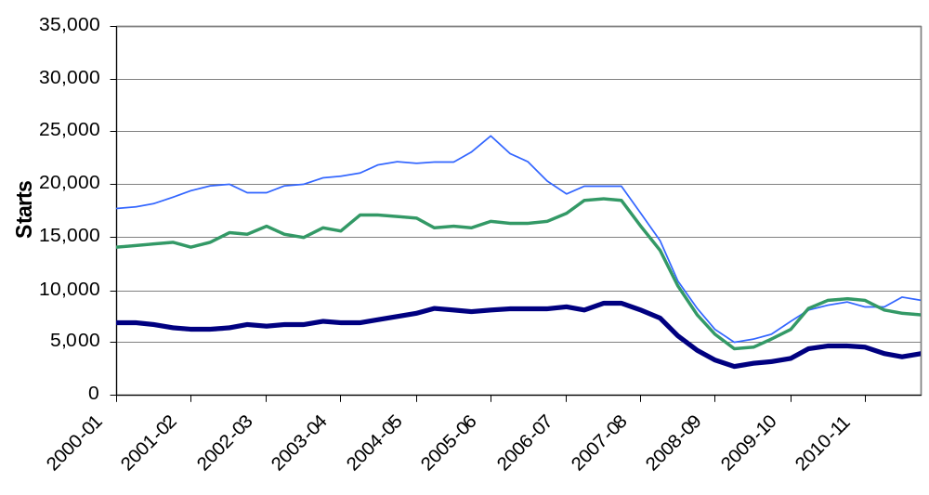

Figure 3b: Trends in housing starts in the East of England, East Midlands and West Midlands, 12 month rolling totals

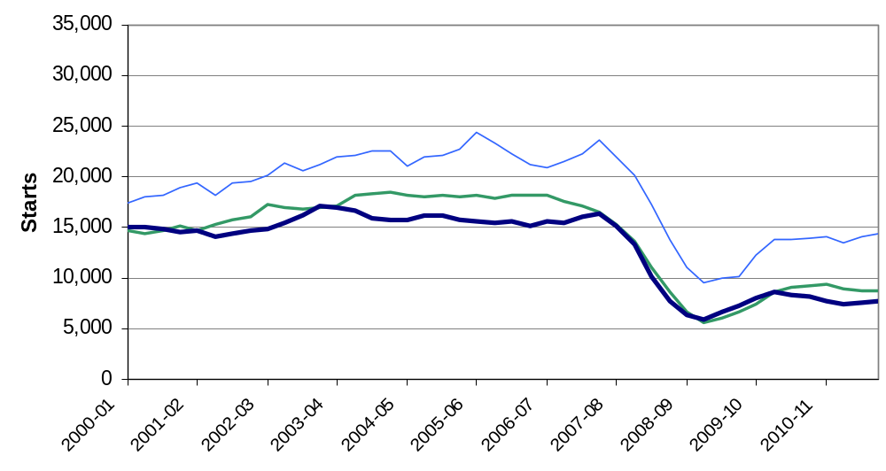

Figure 3c: Trends in housing starts in London, the South East and South West, 12 month rolling totals
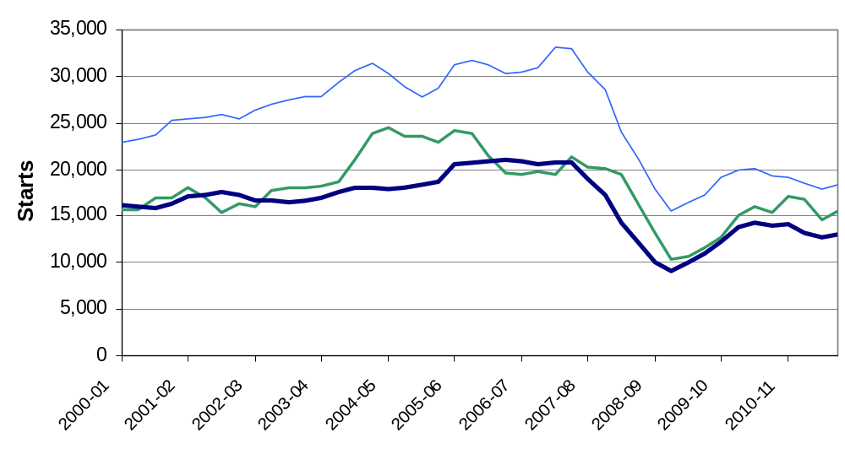

Regional completions
Completions increased in all regions except the North West. The largest increase was in the North East where completions rose by 13 per cent in the 12 months to September 2011 relative to the previous 12 month period. London saw an increase of 11 per cent and Yorkshire and the Humber had 8 per cent more completions than the previous year. In the North West annual completions fell by 9 per cent. (see Figures 4a, 4b and 4c below).
The South East region saw the largest number of new build homes completed (20,300), accounting for 19 per cent of completions in England. The North East was the region with the fewest housing completions (5,090), accounting for 5 per cent of the England total. This partly reflects the fact that the North East is the smallest region in terms of housing stock with only 5 per cent of English dwellings.

Figure 4a: Trends in housing completions in the North East, North West and Yorkshire and the Humber, 12 month rolling totals
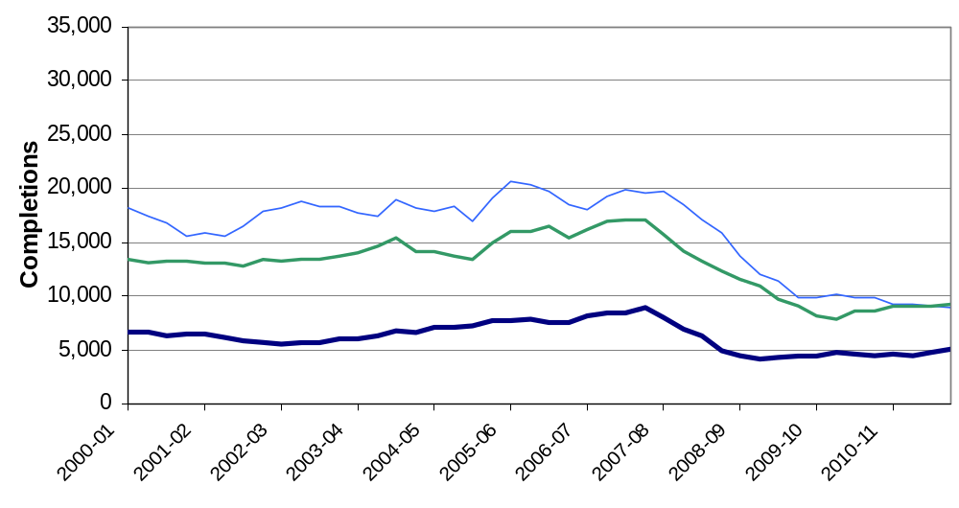

Figure 4b: Trends in housing completions in the East of England, East Midlands and West Midlands, 12 month rolling totals
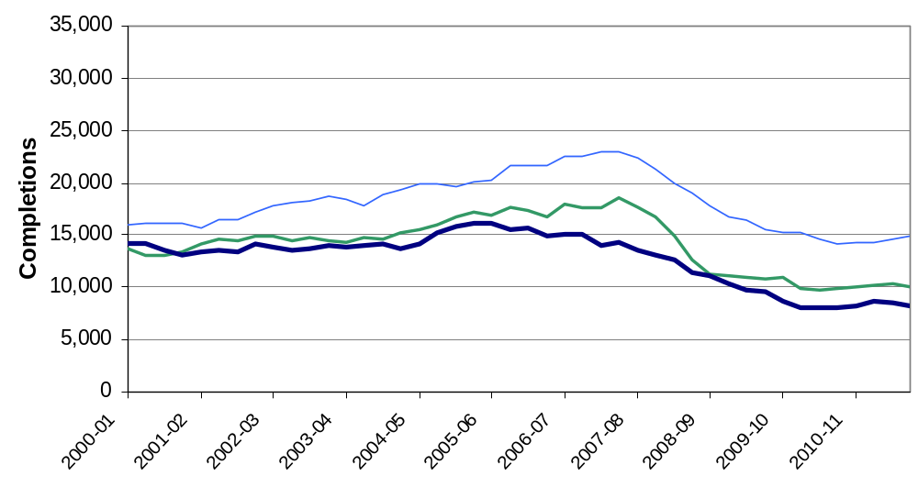

Figure 4c: Trends in housing completions in London, the South East and South West, 12 month rolling totals

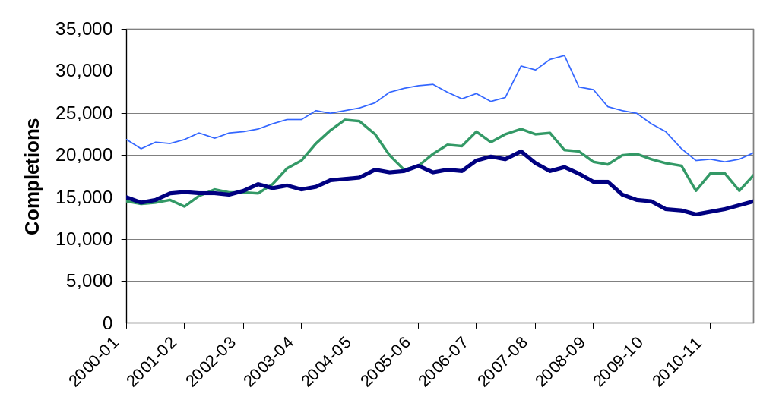

Geographic distribution of house building
The map on the left in figure 5 below shows start rates in each of the 326 local authority districts over the year to June 2011. The map on the right shows completion rates. To show house building in proportion to the size of each district we divide the number of starts (or completions) in the year 12 months to June 2011 by the existing dwelling stock. The result is multiplied by 1000 to give a figure that is easier to interpret. Consider a hypothetical local authority district with 100,000 dwellings as at June 2010. Over the next year 150 new dwellings are started, representing 1.5 new dwellings per thousand of existing stock. This district would therefore be shaded in light yellow in the coloured map for starts.

Figure 5: Starts per 1000 dwellings (left) and completions per 1000 dwellings (right) for each local authority district in the 12 months to September 2011
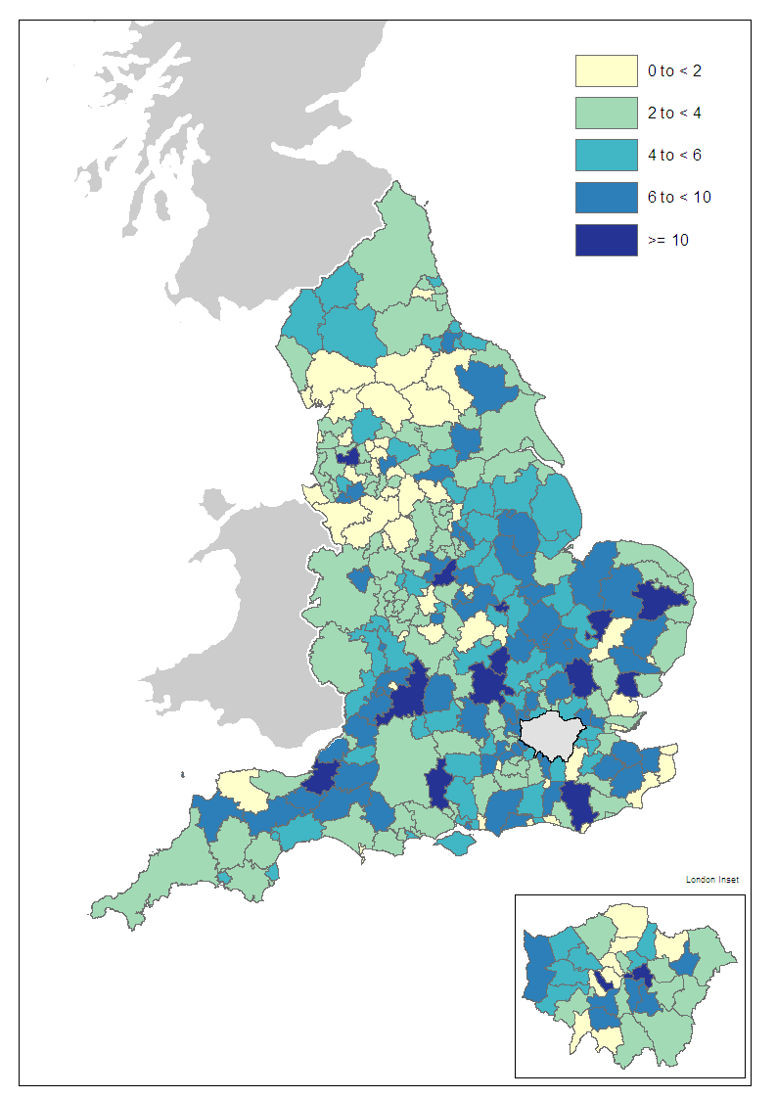 | 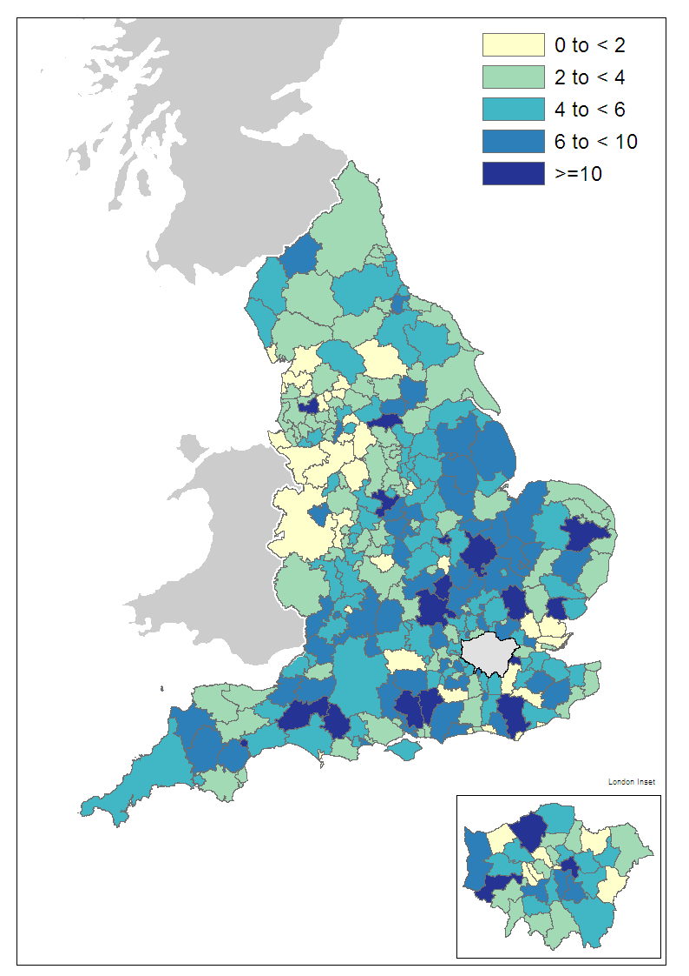
Nearly all of the local authority districts seeing the highest rates of building (in the darker shades of blue) are in the southern half of England. The most pronounced areas of building are districts south of Bristol and districts north of the M4. There are also higher levels of building in the East Midlands along the M11 and A1. The lowest building rates (in yellow) are most common in the West Midlands and the North West.

What types of homes are being built?
Approximately half of the data used to produce the house building statistics are supplied by the National House-Building Council (NHBC). These data contain additional detail on the size and type of new homes being completed and can be used to provide annual estimates of the proportion of new builds that are houses as opposed to flats.
Figure 6 shows the split of completions between houses and flats. The proportion of flats increased from 28 per cent in 2002-03 to over 40 per cent from 2004-05, remaining at that level through to 2008-09. Since then, the proportion of flats has dropped sharply and in 2010-11 stood at 30 per cent. These data are published at the regional level in live table 254 which can be found at the following link. http://www.communities.gov.uk/housing/housingresearch/housingstatistics/housingstatisticsby/housebuilding/livetables/

Figure 6: Proportion of new build completions that are houses and flats
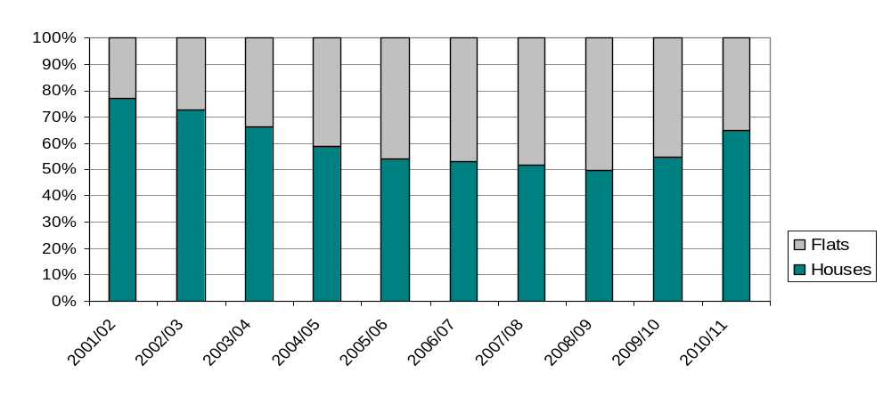

Other Approved Inspectors

Background
In addition to local authorities and the National House-Building Council, house building starts and completions can be certified by other independent approved inspectors (referred to here as AIs). The numbers in the main results sections of this release (above) do not include activity for these other approved inspectors and therefore are underestimates of the level of house building starts and completions.
From the next statistical release (March quarter 2012) we intend to incorporate the data from AIs fully in the house building statistics. In advance of that, this section describes the background to the role of AIs in the building control market and contains provisional versions of the national tables and charts from in the main results sections of this release as they would be if they included the AI data. These tables and charts are included as an advance indication of how the change will affect the statistics from next quarter.

History
Provision for building control inspections to be carried out by private sector approved inspectors has been in place since 1984, but various barriers to their full participation remained. The first of these barriers was removed in 2002 with the provision of specialised insurance products to cover their work. This enabled AIs to participate in the residential building control inspection market but with the exception of housing for private sale or rental (which comprises the bulk of new housing).
Following the change in 2002 a survey of AIs was conducted relating to their involvement in the housing association and local authority house building markets. Based on the results of this survey it was decided the numbers were so small that the burden of data collection was an unnecessary one.
In 2005 a further regulatory change introduced the warranty link rule which allowed approved inspectors to participate in the market for private sale and rental house building provided that they ensured that each new home they inspected was covered by a new home warranty from a list of government-approved insurance products. Following this a second survey was conducted in 2006/07, and the results suggested that it was now worth collecting data regularly from AIs to monitor the number of starts and completions that were being missed by the main data collection for the house building statistics. A quarterly data collection was begun from the June quarter of 2007, initially by email and then later through an online form.
Results from this data collection, reported in previous editions of this statistical release, show that the AI share of the building control market in new house building has been increasing and it has now reached a level where these data represent a substantial proportion of the numbers of new dwellings. Considerable work has been done to ensure the data are of sufficient quality to be included into the house building statistics, and the time series will be revised back to 2007 to minimise the one-off step change effect of the change and ensure that comparisons of figures and trends within the last five years can continue be made on a like-for-like basis.

National data series including approved inspectors
These tables are the equivalent of figures 1 and 2 and tables 1a, 1b, 2a and 2b including the data for approved inspectors revised back to 2007.
Figure 7: Seasonally adjusted trends in quarterly housing starts and completions, England including approved inspectors
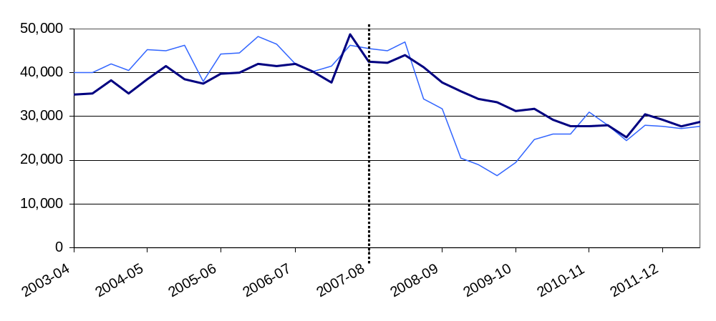
Figure 7 is the equivalent of figure 1 but including approved inspector data. Approved inspectors are included from 2007-08 as marked by the vertical dotted line.

Table 3a: Quarterly housing starts by tenure, England, seasonally adjusted, including approved inspectors^{1,2}
 |  |  | Private  Enterprise |  | Housing  Associations |  | Local  Authority | All  Tenures
 |  |  | Starts | % change  on previous quarter | Starts | % change  on previous quarter | Starts | Starts | % change  on previous quarter
2008-09 | Apr-June |  | 24,340 | -12% | 7,180 | 12% | 120 | 31,640 | -7%
 | July-Sept |  | 15,050 | -38% | 5,430 | -24% | 10 | 20,490 | -35%
 | Oct-Dec |  | 13,940 | -7% | 4,780 | -12% | 160 | 18,880 | -8%
 | Jan-Mar |  | 11,830 | -15% | 4,540 | -5% | 20 | 16,400 | -13%
2009-10 | Apr-June |  | 14,550 | 23% | 4,860 | 7% | 50 | 19,460 | 19%
 | July-Sept |  | 19,160 | 32% | 5,570 | 15% | 30 | 24,760 | 27%
 | Oct-Dec |  | 20,210 | 6% | 5,680 | 2% | 50 | 25,940 | 5%
 | Jan-Mar |  | 20,380 | 1% | 5,520 | -3% | 200 | 26,100 | 1%
2010-11 | Apr-June |  | 23,010 | 13% | 7,470 | 35% | 560 | 31,050 | 19%
 | July-Sept |  | 21,230 | -8% | 6,380 | -15% | 280 | 27,890 | -10%
 | Oct-Dec |  | 19,550 | -8% | 4,640 | -27% | 350 | 24,540 | -12%
 | Jan-Mar |  | 21,250 | 9% | 6,490 | 40% | 380 | 28,120 | 15%
2011-12 | Apr-June | R | 21,560 | 1% | 5,630 | -13% | 590 | 27,770 | -1%
 | July-Sept | R | 21,940 | 2% | 4,930 | -12% | 270 | 27,140 | -2%
 | Oct-Dec | P | 22,510 | 3% | 4,820 | -2% | 380 | 27,710 | 2%

Table 3b: Quarterly housing completions by tenure, England, seasonally adjusted, including approved inspectors^{1,2}
 |  |  | Private  Enterprise |  | Housing  Associations |  | Local  Authority | All  Tenures
 |  |  | Comple-  tions | % change  on previous quarter | Comple-  tions | % change  on previous quarter | Comple-  tions | Comple-  tions | % change  on previous quarter
2008-09 | Apr-June |  | 31,350 | -10% | 6,260 | -2% | 140 | 37,750 | -9%
 | July-Sept |  | 29,150 | -7% | 6,590 | 5% | 60 | 35,800 | -5%
 | Oct-Dec |  | 26,570 | -9% | 7,200 | 9% | 180 | 33,950 | -5%
 | Jan-Mar |  | 26,470 | 0% | 6,560 | -9% | 110 | 33,140 | -2%
2009-10 | Apr-June |  | 24,620 | -7% | 6,540 | 0% | 130 | 31,290 | -6%
 | July-Sept |  | 23,710 | -4% | 7,900 | 21% | 90 | 31,690 | 1%
 | Oct-Dec |  | 23,010 | -3% | 6,240 | -21% | 30 | 29,280 | -8%
 | Jan-Mar |  | 21,460 | -7% | 6,070 | -3% | 110 | 27,650 | -6%
2010-11 | Apr-June |  | 21,600 | 1% | 6,000 | -1% | 100 | 27,700 | 0%
 | July-Sept |  | 22,800 | 6% | 5,080 | -15% | 140 | 28,020 | 1%
 | Oct-Dec |  | 19,010 | -17% | 5,690 | 12% | 440 | 25,140 | -10%
 | Jan-Mar |  | 22,790 | 20% | 7,130 | 25% | 630 | 30,550 | 22%
2011-12 | Apr-June | R | 22,370 | -2% | 6,160 | -14% | 660 | 29,180 | -4%
 | July-Sept | R | 21,440 | -4% | 5,860 | -5% | 390 | 27,690 | -5%
 | July-Sept | P | 21,080 | -2% | 6,950 | 19% | 680 | 28,710 | 4%

- Because the number of local authority housing starts and completions is very small, quarterly comparisons can be very volatile. Accordingly percentage changes are not reported for this tenure.
- Data in these tables is illustrative of numbers including approved inspectors. For the current house building national statistics data see tables 1a and 1b.

Figure 8: Trends in starts and completions, England, 12 month rolling totals including approved inspectors
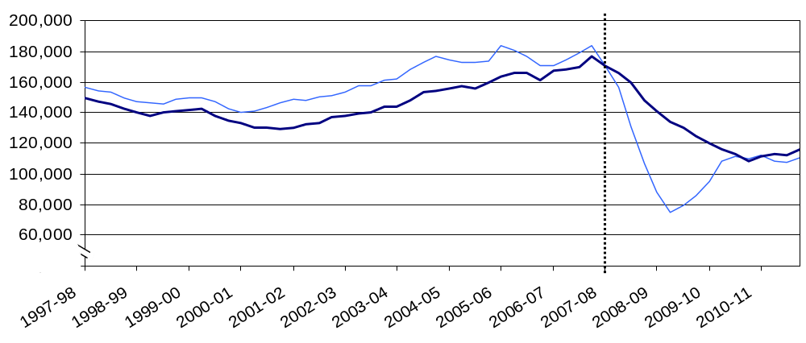
Figure 8 is the equivalent of figure 2 but with approved inspector data included from the June quarter 2007. Unlike the seasonally adjusted series the effect of the inclusion in the 12 month totals is graduated as, during the year 2007-08, one further quarter of AI data is included into the total with each new quarter.
Table 4a: Quarterly housing starts by tenure, England, not seasonally adjusted^{1,2}
 |  |  | Private  Enterprise |  | Housing  Associations |  | Local  Authority | All  Tenures
 |  |  | Starts | % change on same quarter previous year | Starts | % change on same quarter previous year | Starts | Starts | % change on same quarter previous year
2008-09 | Apr-June |  | 25,420 | -39% | 7,800 | 28% | 120 | 33,340 | -30%
 | July-Sept |  | 15,690 | -61% | 5,290 | -10% | 10 | 20,990 | -55%
 | Oct-Dec |  | 11,830 | -66% | 4,210 | -21% | 160 | 16,190 | -60%
 | Jan-Mar |  | 12,470 | -57% | 4,790 | -30% | 20 | 17,280 | -52%
2009-10 | Apr-June |  | 15,360 | -40% | 5,220 | -33% | 50 | 20,630 | -38%
 | July-Sept |  | 20,160 | 28% | 5,460 | 3% | 30 | 25,630 | 22%
 | Oct-Dec |  | 16,990 | 44% | 4,960 | 18% | 50 | 21,970 | 36%
 | Jan-Mar |  | 21,260 | 71% | 5,830 | 22% | 200 | 27,280 | 58%
2010-11 | Apr-June |  | 24,610 | 60% | 8,100 | 55% | 560 | 33,270 | 61%
 | July-Sept |  | 22,400 | 11% | 6,280 | 15% | 280 | 28,960 | 13%
 | Oct-Dec |  | 16,280 | -4% | 4,080 | -18% | 350 | 20,710 | -6%
 | Jan-Mar |  | 21,960 | 3% | 6,740 | 16% | 380 | 29,050 | 6%
2011-12 | Apr-June | R | 23,260 | -5% | 6,080 | -25% | 590 | 29,940 | -10%
 | July-Sept | R | 22,890 | 2% | 4,840 | -23% | 270 | 28,000 | -3%
 | Oct-Dec | P | 18,840 | 16% | 4,210 | 3% | 380 | 23,410 | 13%
- Because the number of local authority housing starts and completions is very small, quarterly comparisons can be very volatile. Accordingly percentage changes are not reported for this tenure.
- Data in this table is illustrative of numbers including approved inspectors. For the current house building national statistics data see table 2a.

Table 4b: Quarterly housing completions by tenure, England, not seasonally adjusted¹
 |  |  | Private  Enterprise |  | Housing  Associations |  | Local  Authority | All  Tenures
 |  |  | Comple-  Tions | % change on same quarter previous year | Comple-  tions | % change on same quarter previous year | Comple-  tions | Comple-  tions | % change on same quarter previous year
2008-09 | Apr-June |  | 32,710 | -16% | 5,720 | 23% | 140 | 38,570 | -12%
 | July-Sept |  | 27,230 | -21% | 5,960 | 27% | 60 | 33,250 | -16%
 | Oct-Dec |  | 29,680 | -30% | 7,740 | 13% | 180 | 37,600 | -23%
 | Jan-Mar |  | 24,070 | -23% | 7,270 | 3% | 110 | 31,450 | -18%
2009-10 | Apr-June |  | 25,590 | -22% | 6,010 | 5% | 130 | 31,730 | -18%
 | July-Sept |  | 22,210 | -18% | 7,020 | 18% | 90 | 29,320 | -12%
 | Oct-Dec |  | 25,720 | -13% | 6,680 | -14% | 30 | 32,390 | -14%
 | Jan-Mar |  | 19,520 | -19% | 6,800 | -7% | 110 | 26,430 | -16%
2010-11 | Apr-June |  | 22,400 | -12% | 5,550 | -8% | 100 | 28,050 | -12%
 | July-Sept |  | 21,390 | -4% | 4,480 | -36% | 140 | 26,010 | -11%
 | Oct-Dec |  | 21,150 | -18% | 6,060 | -9% | 440 | 27,650 | -15%
 | Jan-Mar |  | 20,890 | 7% | 8,020 | 18% | 630 | 29,540 | 12%
2011-12 | Apr-June | R | 23,270 | 4% | 5,750 | 4% | 660 | 29,680 | 6%
 | July-Sept | R | 20,240 | -5% | 5,070 | 13% | 390 | 25,690 | -1%
 | Oct-Dec | P | 23,190 | 10% | 7,360 | 21% | 680 | 31,220 | 13%
- Because the number of local authority housing starts and completions is very small, quarterly comparisons can be very volatile. Accordingly percentage changes are not reported for this tenure.
- Data in this table is illustrative of numbers including approved inspectors. For the current house building national statistics data see table 2b.
Figure 9a: Quarterly impact of including approved inspectors on total starts
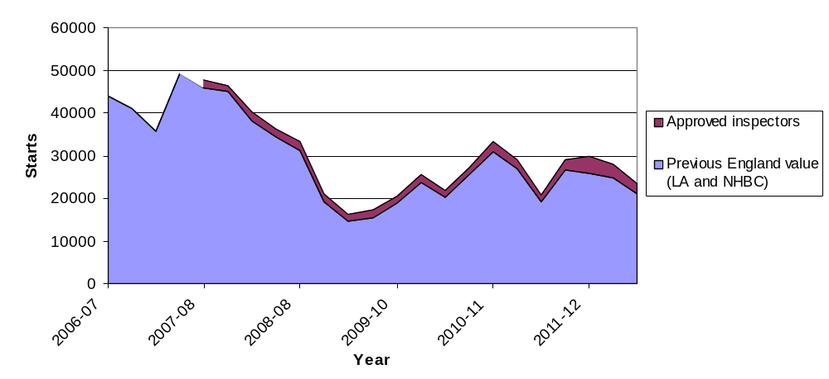
Figure 9b: Quarterly impact of including approved inspectors on total completion
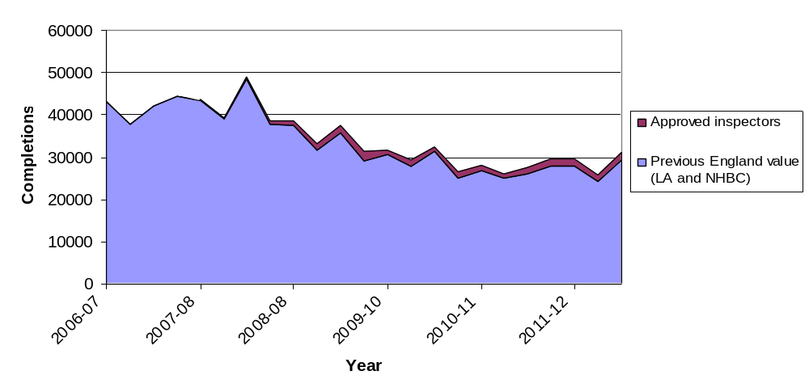
Figures 9a and 9b show the effect each quarter of the incorporation of the approved inspectors data on starts and completions. The original quarterly data is shown in blue with the additional approved inspector in purple data stacked on top.
By revising back to 2007 the impact on the time series is made as small as possible. It can be seen that the overall effect on the trend is slight. However there is inevitably a step change at the point of first inclusion. For completions this step change is small at 216 in the quarter. The change in the starts series is more pronounced with 1,855 additional starts in Q2 of 2007.
Figure 10: Approved inspector reported starts and completions as a proportion of total starts and completions
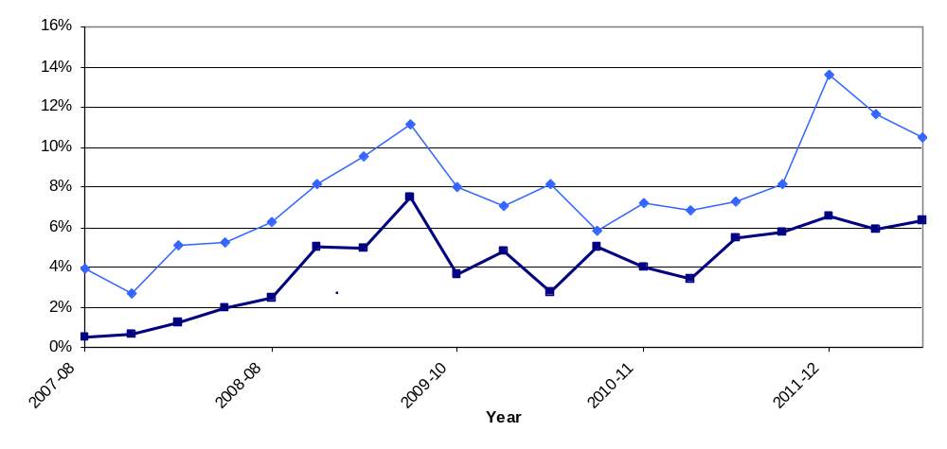
Figure 10 shows that the percentage of starts and completions reported by AIs have both tended to increase during the period, with both showing particular increases during the early period. AI completions increase from less than 1 per cent of total completions while AI starts already comprise around 4 per cent of total starts at the beginning of the period.
It is to be expected that starts would increase before completions, and a residential building development can take any time from a few months through to several years to progress from start through to completion. With the opening of the market in 2005 and the time taken between starts and completions it is likely that the 2007 data collection picked up very early activity for completions but that inspections relating to starts were already more advanced by the time of the collection began. Partial data from the survey of AIs collected for 2006/07 supports this conclusion.
Recently the AI share of building control starts peaked at 14 per cent in the second quarter of 2011 although this has dropped back to 11 per cent in the most recent quarter. The market share in completions has been more stable, running at around 6 per cent to 7 per cent of all completions for the past year.
Table 5 below shows the market share of AIs as a group in each quarter since the data collection began. The numbers of starts and completions reported by the existing data sources for the house building statistics (local authority and National House-Building Council) and AIs are shown side by side, along with the percentage they make up of the new total.

Table 5: Starts and completions, quarterly by source of data 2007 Q2 to present
 |  | Starts - All Tenures |  |  |  |  | Completions - All Tenures
 |  | NHBC + LA ¹ |  | Approved Inspector |  | Total | NHBC + LA ¹ |  | Approved Inspector |  |  | Total
2007-08 | Q2 | 45,790 | 96% | 1,860 | 4% | 47,640 | 43,470 | 100% |  | 220 | 0% | 43,690
 | Q3 | 45,090 | 97% | 1,240 | 3% | 46,330 | 39,100 | 99% |  | 260 | 1% | 39,360
 | Q4 | 38,200 | 95% | 2,060 | 5% | 40,260 | 48,440 | 99% |  | 610 | 1% | 49,050
 | Q1 | 34,290 | 95% | 1,900 | 5% | 36,190 | 37,760 | 98% |  | 750 | 2% | 38,510
2008-08 | Q2 | 31,250 | 94% | 2,080 | 6% | 33,340 | 37,620 | 98% |  | 950 | 2% | 38,570
 | Q3 | 19,290 | 92% | 1,700 | 8% | 20,990 | 31,570 | 95% |  | 1,680 | 5% | 33,250
 | Q4 | 14,650 | 90% | 1,540 | 10% | 16,190 | 35,740 | 95% |  | 1,860 | 5% | 37,600
 | Q1 | 15,360 | 89% | 1,920 | 11% | 17,280 | 29,090 | 93% |  | 2,360 | 7% | 31,450
2009-10 | Q2 | 18,980 | 92% | 1,650 | 8% | 20,630 | 30,580 | 96% |  | 1,150 | 4% | 31,730
 | Q3 | 23,820 | 93% | 1,800 | 7% | 25,630 | 27,910 | 95% |  | 1,410 | 5% | 29,320
 | Q4 | 20,180 | 92% | 1,790 | 8% | 21,970 | 31,480 | 97% |  | 910 | 3% | 32,390
 | Q1 | 25,700 | 94% | 1,590 | 6% | 27,280 | 25,100 | 95% |  | 1,330 | 5% | 26,430
2010-11 | Q2 | 30,880 | 93% | 2,390 | 7% | 33,270 | 26,940 | 96% |  | 1,120 | 4% | 28,050
 | Q3 | 26,980 | 93% | 1,980 | 7% | 28,960 | 25,110 | 97% |  | 900 | 3% | 26,010
 | Q4 | 19,210 | 93% | 1,500 | 7% | 20,710 | 26,150 | 95% |  | 1,500 | 5% | 27,650
 | Q1 | 26,680 | 92% | 2,370 | 8% | 29,050 | 27,850 | 94% |  | 1,690 | 6% | 29,540
2011-12 | Q2 | 25,870 | 86% | 4,060 | 14% | 29,940 | 27,740 | 93% |  | 1,950 | 7% | 29,680
 | Q3 | 24,740 | 88% | 3,260 | 12% | 28,000 | 24,190 | 94% |  | 1,510 | 6% | 25,690
 | Q4 | 20,950 | 89% | 2,460 | 11% | 23,410 | 29,240 | 94% |  | 1,980 | 6% | 31,220
1. NHBC + LA - National House-Building Council and Local Authority data. This is the total value currently used in the statistics.

For further information on the data collection and quality of the statistics see the ‘Data quality’ section of this release below.
Comments on these changes can be made via the “statistical enquiries” contact details shown on the front page of this release.

Data collection
This release takes information from three data sources on building control:
- ‘P2’ quarterly house building returns submitted to Department for Communities and Local Government by local authority building control departments;
- monthly information from the National House-Building Council (NHBC) on the volume of building control inspections they undertake in each local authority area; and


- quarterly data collection from other approved inspectors (AIs).

Data quality

Response rate
The P2 data received from local authorities record starts and completions inspected by local authority building control and include imputation for a small number of missing returns; in the December quarter 2011, a 97 per cent local authority response rate was achieved.
The process to impute for a missing P2 local authority return works by picking up all data recorded in completed returns for that local authority over the previous five years and comparing it to data for other similar local authorities for the same periods. It then looks at the data provided for the current period by those other local authorities and imputes a figure for the missing local authority return which matches the proportion found in the comparison of data for the previous five years.
The NHBC data include all starts and completions inspected by NHBC building control.

Coverage
In addition to local authorities and the NHBC, house building starts and completions can be certified by other independent Approved Inspectors. The headline figures in this release do not include activity for these other Approved Inspectors and, as such, are underestimates of the true level of starts and completions but represent our best estimates at this time. We propose to address this by incorporating data from other Approved Inspectors in the House Building statistics from next quarter’s release. For further information please see the “Other Approved Inspectors” section above and the section on "Approved Inspectors Data Quality" below.

Approved Inspectors Data Quality
Since Q2 2009 the data for approved inspectors has been collected using a web based form. Before Q2 2009 data was collected on spreadsheet returned by email.
Response rates have generally been good. Since the introduction of web form response rates have been in the range 65% to 85% with the most recent quarters being towards the top end of the range. Response rates for the earlier email form range from around 50% to 75%. Response rates are based on the total number of registered AIs minus those who do not take residential work. Due to some incomplete approved inspector registers from the early years of the data collection, response rates from before the introduction of the web form are only estimates. This incomplete information only affects the number of non-responding AIs and does not affect the quality of the data reported.
Adjustment for non-response is done by post stratification. Stratification is performed on the basis of the most recent previous total of starts and completions reported. Once AIs have been stratified non-response weights are calculated for the missing AIs. These weights are applied to all responding AIs.
Where insufficient recent data exists to sensibly include a non-response in the stratification (for example where there is no recent data) or where the status of the AI is unclear for that period (for instance it is not certain that they were operating in the that period or are a duplicate entry) the AI is not included in the post stratification process. This may result in a small level of under coverage but ensures that only genuine non-response is weighted for and minimises the risk of overestimating the numbers of starts and completions inspected by AIs.
Non-response weighting is used only at an England level. Regional and LA level data is not weighted for non-response as the numbers involved are too small and too volatile for the process to be used sensibly.
For further background on AIs data see the ‘Other Approved Inspectors’ section above.

Tenure
Figures on housing starts and completions are from records kept for building control purposes. It is sometimes difficult for the building control officers who record the data to identify whether a dwelling is being built for a housing association, a local authority or for a private developer. This may lead to an understatement of housing association and local authority starts and completions recorded in these tables, and a corresponding overstatement of private enterprise figures. This problem is more likely to affect starts than completions.
There are two other sources of official statistics on affordable housing supply which should be considered as an alternative by users interested specifically in the affordable sector. Please refer to the “Related statistics” section of this publication for further information.

From start to completion
A wide range of factors can influence the length of time it takes for a new home to be constructed from start to completion, and this period can vary from just a few months to several years.
There are some circumstances in which starts might exceed completions. Information gathered from data providers indicates that the most common of these is where a new dwelling is started but never completed because the developer is no longer able or willing to complete the development.
Also, in principle a dwelling is regarded as completed when it becomes ready for occupation or when a completion certificate is issued whether it is in fact occupied or not. In practice, the reporting of some completions may be delayed and some completions may be missed if no completion certificate was requested by the developer or owner, although this is unusual because most property owners would want to have a completion certificate for the purposes of selling the property on.
These circumstances do not disproportionately affect particular regions or types of area, although private housing development may be more likely to be affected than public.

In general the number of starts will be a strong indicator of the likely trend in completions in the near future but we have seen differences over the short and medium term. It sometimes appears that an imbalance exists in the statistics when the overall number of starts differs from the overall number of completions over a number of years. For example, over the period from 1997 - 2007 there were 1,760,000 starts but only 1,630,000 completions - a difference of 7 per cent.
However, a comparison of starts and completions over the long term shows that such differences tend to balance out over time - the years before 1997 and the years since 2007 both saw substantially more completions than starts, and over the 20 years from 1990 to 2010 there were in fact 1 per cent more completions than starts. These shorter term imbalances can be understood as a feature of the economic cycle.

Comparability between the countries of the UK
Each of the countries of the UK produces its own statistics on House Building (see “Related statistics” section below). The Department for Communities and Local Government is responsible for collecting and publishing data for England. However house building statistics for the devolved administrations of the UK, as well as for Great Britain and the UK as a whole, are included in the tables that accompany this statistical release. In this section the consistency of the data sources is discussed.
England and the devolved administrations use broadly consistent definitions for starts and completions in collecting house building data. Until now, all four countries have collected starts and completions data split into the three tenure types of private enterprise, housing association and local authority. From the June quarter 2011 onwards, this tenure split is no longer available for Wales starts figures.
In England and Wales, some housing association starts and completions can be misreported as private enterprise starts because it is sometimes difficult for data providers to identify whether a dwelling is being built for a housing association or for a private developer (see above). This is not thought to be a problem in Northern Ireland and Scotland, where data on housing association house building are collected directly from housing association administrations, rather than from building inspection teams. For this reason, statistics for house building starts in Wales from April 2011 no longer include a breakdown by tenure.
While a very small proportion of the data for England are imputed for missing responses (see above), a full response is generally collected in Wales, Scotland and Northern Ireland so imputation is seldom necessary.
Currently approved inspectors data is included in the statistics for Scotland and Northern Ireland. Approved inspector data is not used in the current Welsh house building data. However an investigation is currently underway to determine the level of approved inspector activity in Wales with a view to including approved inspectors if it is found to be appropriate.

Uses of house building statistics
The house building statistical series on starts and completions are a key part of the evidence base which informs the development and evaluation of housing policy by central and local government. They are also used as evidence for other housing market analysts, forecasters and decision makers, for example at the Bank of England and in the construction and banking industries, and for market research by a wide range of other businesses. They are used by the media in reports on the housing market, and by academics both in the UK and abroad.

Related statistics

Net supply of housing
The annual net additional dwellings figure, or net housing supply, is the absolute change in dwelling stock between 1 April and 31 March the following year. It comprises the number of new build permanent dwellings; plus the net gain from dwelling conversions; plus the net gain of non dwellings brought into residential use; plus net additions from other gains and losses to the dwelling stock (such as mobile and temporary dwellings); less any demolitions.
The net additions statistical series is separate from and complementary to the Department for Communities and Local Government’s quarterly National Statistics series on new house building, providing a more comprehensive but less timely measure of total housing supply in England. Completions figures from the quarterly house building series are not used in the net additions statistics. Instead a separate set of data on the new build completions component of net additions is collected as part of the overall annual net additions data collection. This eliminates timing differences from the net supply series and provides a picture of the components of net change which can be reconciled for a given year.
The house building statistical series takes its data from the same sources throughout England, combining data from building control officers at local authorities and the National House-Building Council (NHBC), and is published within eight weeks after the end of each quarter. For net additions, all the data come from local authorities who in turn use whichever local data source they believe is most appropriate, and the data collection period for these statistics is relatively long, being annual and closing some five months after the end of the financial year. The longer data collection period makes it possible to incorporate data on the approximately five per cent of new build completions that are inspected by independent building control Approved Inspectors other than those at local authorities or the NHBC (for further information please see the “Other Approved Inspectors” section above).
Users who need an early indication of house building activity or who intend to use housing supply statistics as an economic indicator are advised to use the quarterly house building starts and completions series. Those who require a long-running, consistent time series on housing supply should also use house building, in either a quarterly or annual basis. Users wanting a more complete picture of the overall supply of housing may find the net additions statistical series more appropriate.
The net supply of housing statistics can be found at the link below.
http://www.communities.gov.uk/housing/housingresearch/housingstatistics/housingstatisticsby/netsupplyhousing/ .

Council tax valuation lists
The Valuation Office Agency compiles and maintains lists of all domestic properties in England and Wales to support the collection of council tax, and these lists are constantly updated to reflect the creation of new dwellings and losses of dwellings.
The Valuation Office Agency’s definition of a dwelling differs somewhat from that used by the census. The Department for Communities and Local Government’s House Building statistics, Net supply of housing and Dwelling stock estimates statistics all use the census definition (see ‘Definitions’ section below). This means that a small proportion of dwelling units may be included in the valuation lists but not the other statistics, and vice-versa.
The Valuations Office Agency now publishes statistics on these lists which can be found at the following link.
http://www.voa.gov.uk/corporate/Publications/statistics.html

New Homes Bonus
The New Homes Bonus allocates grants to local authorities according to the number of new homes delivered and empty homes brought back into use in their area. The growth in their council taxbase is used as a proxy measure for the number of new homes delivered, and the number of long-term empty homes in each area is also collected as part of the council tax system.
The New Homes Bonus allocations for 2012/13 were published on 1 February 2012. Details can be found at the following link.
http://www.communities.gov.uk/housing/housingsupply/newhomesbonus/

Dwelling stock estimates
Department for Communities and Local Government also publish statistics showing the total dwelling stock in England each year. These estimates are based on the latest census count plus the annual Net supply of housing statistics described above. They can be found at the following link.
http://www.communities.gov.uk/housing/housingresearch/housingstatistics/housingstatisticsby/stockincludingvacants/

Affordable housing
New affordable homes are defined as additional housing units (or bed spaces) provided to specified eligible households whose needs are not met by the market and can be categorised into social rent, intermediate rent and low cost home ownership. Total additional affordable supply includes both new build supply and acquisitions of existing private sector homes.
There are three main sources of official figures on affordable housing supply which are summarised in the table below:
Statistical source | Included | Not included | Frequency | Timeseries
House Building statistics: Housing Association and Local Authority tenures combined | New build housing for social rent. | Most affordable ownership supply and acquisitions from existing private housing. | Quarterly | From 1946
Affordable Housing Supply statistics | All supply (new build and acquisitions) of affordable housing | May be some small gaps in coverage (see release) | Annual | From 1991/92
Homes and Communities Agency National Housing Statistics | All supply (new build and acquisitions) of affordable housing delivered through HCA grant funding programmes | Some housing delivered without HCA grant funding. | Six monthly | From 2009/10

The house building statistics in this publication are categorised by tenure into private enterprise, housing association (HA) and local authority (LA). However, this tenure split has its limitations (see “Data quality” section) and is not the best source of information on new build specifically in the affordable housing sector.
A more detailed and complete source is Department for Communities and Local Government’s Affordable housing supply statistics, which can be found at the following link, along with detail on definitions and sources. http://www.communities.gov.uk/housing/housingresearch/housingstatistics/housingstatisticsby/affordablehousingsupply/.
Although the HA and LA tenures of the house building statistics attempt to measure the entire new build component of affordable housing supply, including social rent, shared ownership and other affordable housing products, in practice much new build shared ownership housing and some new build social rent housing may be mis-recorded within the ‘private enterprise’ tenure of the house building statistics.
This means that the house building statistics underestimate the total new build supply of affordable housing in the LA and HA tenure categories. Users requiring the best annual estimate for new build affordable housing should refer to the “New build and acquisitions” section of the affordable housing supply statistical release and live table 1009, both accessible from the link above.
Despite this, the tenure split reported in the house building statistics continues to have practical uses as they provide more frequent and timely estimates of starts as well as completions, and are available back to 1946.
The Homes and Communities Agency’s National Housing Statistics can be found at the following link - http://www.homesandcommunities.co.uk/statistics - and show delivery through the HCA funding programmes for housing.

Devolved administrations
House building statistics for the devolved administrations of the UK are included alongside the England statistics in the tables that accompany this statistical release. These data are published separately by the devolved administrations, and although figures are correct at the time of this publication they may be superseded before the next England house building release. Latest data and details on data sources and methods can be found at the following links:
Scotland (house building statistics)
http://www.scotland.gov.uk/Topics/Statistics/Browse/Housing-Regeneration/HSfS/NewBuild
Wales (house building statistics)
http://wales.gov.uk/topics/statistics/theme/housing/newbuild/;jsessionid=9bcQNK5GxLQv5p05StGJZsznPYpXL07L47Qh19JXKc22vq3nl9L8!475011280?lang=en
Northern Ireland (housing statistics)
http://www.dsdni.gov.uk/index/stats_and_research/housing_publications.htm

Revisions policy
This policy has been developed in accordance with the UK Statistics Authority Code of Practice for Official statistics and the Department for Communities and Local Government Revisions Policy. There are two types of revisions that the policy covers.

Scheduled Revisions
In order to maximise the response rate from local authorities and enable late information to be included, each quarterly P2 return can be updated at any time up to two years after the initial publication of the figures for that quarter. Every quarter, as well as releasing figures for the latest quarter, we revise the previous quarter to incorporate any data that came in shortly after the previous data collection period. This captures most late local authority data, but in order to incorporate the remainder a longer revision is carried out once a year, in the June quarter statistical release. Therefore, until each quarterly return is permanently closed, figures for that quarter remain provisional. Provisional figures are labelled in the tables with a “P” and revised figures are labelled with an “R”.
The starts data provided by NHBC, which are monthly, can also be subject to some changes after their initial inclusion, and to address this the NHBC starts data for the previous two quarters are now also revised in each release. In particular, the information on the tenure can often change when a start gets closer to completion and this tends to result in a net shift in starts from the private enterprise tenure to the housing association tenure.
In addition, where figures are seasonally adjusted, the adjustment factors for the whole series back to 2000 are recalculated annually, usually in the June quarter. This will result in small changes to seasonally adjusted figures across the whole period. These changes are not labelled with an “R”.
Other revisions to historic data (all data older than that currently due for scheduled revision) should only be made where there is a substantial revision, such as a change in methodology or definition. Where there are small changes that do not substantially change historic data, internal updates are maintained.

Non-Scheduled Revisions
Where a substantial error has occurred as a result of the compilation, imputation or dissemination process, the statistical release, live tables and other accompanying releases will be updated with a correction notice as soon as is practical.

Revisions in this release
As scheduled, starts and completions data provided by local authorities, and starts data provided by NHBC, have been revised in this release back to the June quarter 2011 to incorporate late data. As a result, 40 starts have been added to the June quarter and 390 starts have been added to the June quarter; 70 completions have been subtracted from the September quarter.

Definitions
House building start - A dwelling is counted as started on the date work begins on the laying of the foundation, including 'slabbing' for houses that require it, but not including site preparation. Thus when foundation work commences on a pair of semi-detached houses two houses are counted as started, and when work begins on a block of flats all the dwellings in that block are counted as started. The starts of houses in building schemes are usually phased over a period of weeks or even, in very large schemes, months.
House building completion - In principle, a dwelling is regarded as complete when it becomes ready for occupation or when a completion certificate is issued whether it is in fact occupied or not. In practice, the reporting of some completions may be delayed and some completions may be missed if no completion certificate was requested by the developer or owner, although this is unusual.
Tenure - For the purposes of these statistics, the term tenure refers to the nature of the organisation responsible for the development of a new housing start or completion. It does not necessarily describe the terms of occupancy for the dwelling on completion. For example, some housing associations develop homes for sale on the open market. Such homes would be reported in the Housing Association tenure of these statistics, but would ultimately most likely be owned and occupied in the private sector.
Housing association - “Housing associations (HAs)” has been used as the generic name for all social landlords not covered by local authorities (see below). In previous editions HAs were referred to as Registered Social Landlords (RSL), although the term (private) Registered Provider (pRP) of social housing is commonly used by the Tenant Services Authority. The more all-encompassing description of ‘housing associations’ is now seen as more appropriate and helpful to users.

Accompanying tables
Accompanying tables are available to download alongside this release:

Tables:
1a House building starts and completions, including seasonally adjusted series: England;

1b House building starts and completions unadjusted: North East;
1c House building starts and completions unadjusted: North West;

1d House building starts and completions unadjusted: Yorkshire and the Humber;
1e House building starts and completions unadjusted: East Midlands;

1f House building starts and completions unadjusted: West Midlands;
1g House building starts and completions unadjusted: East of England;

1h House building starts and completions unadjusted: London;
1j House building starts and completions unadjusted: South East;

1k House building starts and completions unadjusted: South West;
2a House building starts and completions unadjusted: Wales;
2b House building starts and completions unadjusted: Scotland;
2c House building starts and completions unadjusted: Great Britain;
2d House building starts and completions unadjusted: Northern Ireland;
2e House building starts and completions unadjusted: United Kingdom;
Additional tables showing house building completions by type and size of property, starts and completions for individual local authorities as well as historic series can be accessed in the 'Live tables' section ("Live tables on house building") at the following link. http://www.communities.gov.uk/housing/housingresearch/housingstatistics/
All statistical releases on house building can be accessed on the Department for Communities and Local Government website at http://www.communities.gov.uk/housing/housingresearch/housingstatistics/housingstatisticsby/housebuilding/publicationsonhousebuilding/.

Notes to the tables
The following conventions have been used in the tables:
.. Not available;
- Fewer than 5 dwellings;
^{P} Figure provisional and subject to revision;
^{R} Revised from previous release.
Totals may not equal the sum of component parts due to rounding to the nearest 10.

Background notes
- The starts and completions reported in this publication are for new house building in England and exclude new dwellings created through conversions and the change of use of existing buildings.
- Figures in the accompanying tables are presented rounded to the nearest 10 dwellings.
- The charts give seasonally adjusted quarterly house building trends and give annual trends by showing a rolling 12-month total. The private enterprise and housing association England series are seasonally adjusted.
- Accompanying Table 1a gives non-seasonally adjusted and seasonally adjusted England figures. All figures for other countries and English regions are shown on an unadjusted basis only.
- National Statistics are produced to high professional standards set out in the Code of Practice for Official Statistics. They undergo assessment by the UK Statistics Authority to ensure that they meet those standards.
- The tables and charts accompanying this release are shown above in the ‘Accompanying tables’ section and are provided in Microsoft Excel format.
- Details of officials and ministers who receive pre-release access to the Department for Communities and Local Government quarterly House Building release up to 24 hours before release can be found at:
http://www.communities.gov.uk/corporate/researchandstatistics/statistics/prereleaseaccess/
- The next quarterly release will be published on Thursday 17 May 2012, and will cover house building up to the March quarter 2012.

User consultation
Users’ comments on any issues relating to this statistical release, in particular on the proposal to incorporate data from other Approved Inspectors in the headline statistics for England (see “Other Approved Inspectors” section above), are welcomed and encouraged. Responses should be addressed to the "statistical enquiries" contact given in the "Enquiries" section below.

Enquiries

Statistical enquiries:
e-mail: housing.statistics@communities.gov.uk
telephone: 0303 44 42272

Media Enquiries:
office hours: 0303 44 41136
out of hours: 0303 44 41201
e-mail: press@communities.gov.uk

Department for Communities and Local Government. © Crown Copyright, 2012

If you require this publication in an alternative format please email: alternativeformats@communities.gsi.gov.uk. Please note that the nature of content means that we may not be able to provide the Statistical series of publications in all requested formats.

February 2012

ISBN: 978-1-4098-3353-6

