Housing
Statistical Release

30 November 2011
using
Research
Summary
Number 239, 2007

Local Authority Housing Statistics, England, 2010-11

Contents

Introduction | 2 | xx
Local authority housing stock | 4 | xx
Households on local authority waiting lists | 5 | xx
Participation in Choice-Based Lettings | 7 | xx
Local authority lettings | 8 | xx
Decent homes delivery | 9 | xx
Programme of work on HRA stock | 11 | xx
Possessions and evictions | 13 | xx
Anti-social behaviour injunctions | 14 | xx
Scope, Data Collection and Data Quality | 15 | xx
Uses of the data | 16 | xx
Revisions Policy | 16 | xx
Related Statistics | 18 | xx
Supplementary information | 20 | xx
Accompanying tables | 22 | xx
Enquiries | 28 | xx

Responsible Statistician:
Jane Hinton

Statistical Enquiries:
Phone : 0303 444 4172
housing.statistics@communities.gov.uk

Media Enquiries:
Office hours: 0303 444 1136
Out of hours: 0303 444 1201
press.office@communities.gsi.gov.uk
Housing Strategy Statistical Appendix (HSSA) & Business Plan Statistical Appendix (BPSA)
- Local authorities in England owned 1.73 million dwellings on 1 April 2011, continuing a general decline from 2.81 million on 1 April 2001 (Chart 1).
- There were 1.84 million households on local authority waiting lists on 1 April 2011, an increase of 4.5 per cent on 1.76 million on 1 April 2010 (Chart 2). Changes in waiting list numbers can reflect administrative and policy changes as well as changes in the demand for social housing.
- 87 per cent of local authorities in England participated in Choice-Based Lettings on 1 April 2011, an increase from 80 per cent on 1 April 2010 (Chart 3).
- Local authority landlords in England made 146,400 lettings during 2010-11, decreasing from 153,000 during 2009-10. This follows a general decline from 326,600 in 2000-01 (Chart 4).
- The number of non-decent local authority dwellings across England was 217,100 on 1 April 2011, a 26 per cent decrease from 291,600 on 1 April 2010 (Chart 5).
- In 2010/11 there were nearly 23,000 possession orders obtained by local authority landlords and nearly 6,000 evictions carried out by court bailiffs. In both cases, the vast majority (85-90 per cent) were due to rent arrears (Table 8).
- Local authority landlords in England were granted approximately 1,180 anti-social behaviour injunctions in 2010-11, a similar level to 2009-10 (Table 9).

Introduction

This statistical release provides summary information from local authority housing data returns collected in the annual Housing Strategy Statistical Appendix (HSSA) and Business Plan Statistical Appendix (BPSA). This release presents information for the following topics areas from 2000-01 to 2010-11 for England:
- local authority housing stock;
- local authority waiting lists;
- participation in choice-based lettings;
- local authority lettings;
- decent homes delivery;
- programme of work on Housing Revenue Account stock;
- evictions and anti-social behaviour injunctions carried out by local authority landlords.

A full set of HSSA and BPSA data collected from local authorities can be found on the Department’s website by following the accompanying links from the summary web page:
http://www.communities.gov.uk/housing/housingresearch/housingstatistics/housingstatisticsby/localauthorityhousing/dataforms/
Associated live tables which are updated with HSSA and BPSA data alongside this release can be accessed from the summary web page:
http://www.communities.gov.uk/housing/housingresearch/housingstatistics/livetables/
The following live tables can be found within live tables on stock:
Live table 100: Number of Dwellings by Tenure and district; England; 2008-09 – 2010-11 (Provisional)
Live table 116: Local authority stock, by district; England; from 1994
Live table 119: Stock of non-decent homes in the Social Rented Sector; England 2001- 2011
Live table 313: Number and amount of total renewal grants paid under the 1996 Act, by region; England; 1996/97- 2010-11
Live table 611: Local authority vacant dwellings, by region; England; 1989 – 2011
Chart 612: Local authority vacant dwellings, by region; England; 1989 – 2011
The following live tables can be found within live tables on rents, lettings and tenancies:
Live table 600: Rents, lettings and tenancies: numbers of households on local authorities' housing waiting lists, by district; England; from 1997
Live table 601: Local authority lettings, by region: England; from 1988-89
Updates to related Live Tables on local authority average weekly rents taken from the Housing Revenue Account subsidy claim forms (Tables 701, 702) and on Private Registered Provider average weekly rents from the Tenant Services Authority’s Regulated Statistical Return (Tables 703, 704) have also been published at the same time as this Statistical Release.
Important Note: The focus of this statistical release is on social housing that is owned and managed by local authorities. It should be noted this is only part of the story for social housing because other registered providers such as housing associations also own and manage social housing stock. Information on data sources for private registered providers can be found in the ‘Supplementary Information’ section of this statistical release.
The Department is planning to publish a public consultation on a proposed rationalisation of housing data collected from local authorities. This aims to ensure data are collected centrally on only the highest priority and most relevant data items in order to reduce burden on local government whilst maintaining a national evidence base for monitoring and developing policy. It will cover the existing collections through the Housing Strategy Statistical Appendix, the Business Plan Statistical Appendix and Local Authority Housing Sales Monitoring (P1B form) along with consideration of other key data collections that have or are shortly due to cease. It will be proposed that these collections are replaced by a single annual “English Local Authority Statistics on Housing” (ELASH) data collection from April 2012. All users of these statistics are encouraged to respond and the consultation papers will be available on the Department’s website at http://www.communities.gov.uk/corporate/publications/consultations/

Local authority housing stock
Chart 1: Number of local authority owned dwellings in England, 2001 - 2011
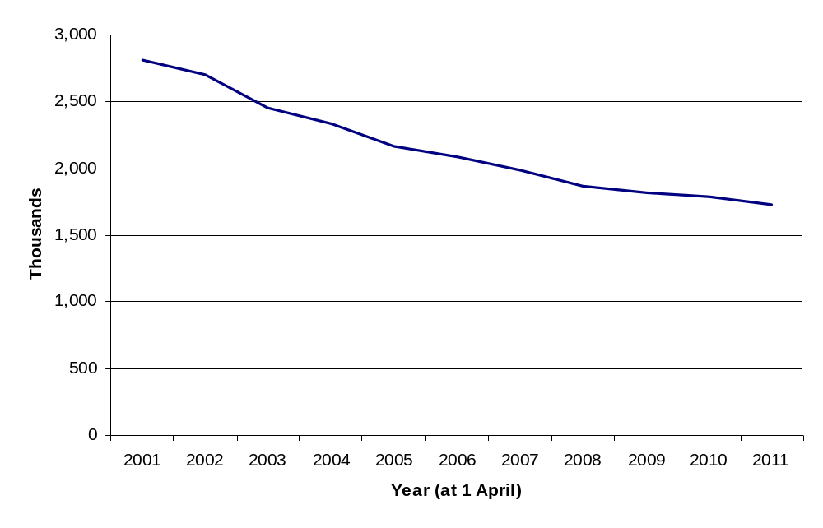
Source: Housing Strategy Statistical Appendix (HSSA) or its predecessor, the Housing Investment Programme (HIP) Returns.

Local authorities in England owned 1.73 million dwellings on 1 April 2011, following a general decline from 2.81 million on 1 April 2001 (see Chart 1). This has been associated with Right to Buy and large-scale voluntary transfer (LSVT) of local authority stock to registered social landlords. (See the ‘Supplementary Information’ at the back of this release for further details).
Between 2010 and 2011, there was a decrease in local authority owned stock in all regions (see Accompanying Table 1 at the back of this release). The largest decrease was in the North West of 26 per cent, reflecting the LSVT of stock by three local authorities. The North East reported the next largest decrease of 9.3 per cent again due mainly to LSVT of stock in one authority. Other regions reported small decreases in stock of less than one per cent.

Households on local authority housing waiting lists
Chart 2: Number of households on local authority housing waiting lists in England, 2001 - 2011
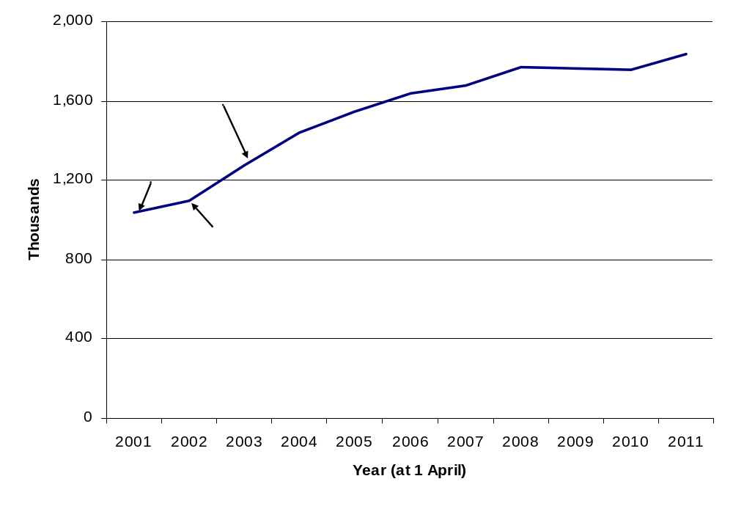
Source: Housing Strategy Statistical Appendix (HSSA) or its predecessor, the Housing Investment Programme (HIP) returns.
There were 1.84 million households on local authority waiting lists on 1 April 2011, an increase of 4.5 per cent over 1.76 million on 1 April 2010 (see Chart 2). Changes in the number of households registered on local authority waiting lists can reflect administrative and policy changes as well as changes in the demand for social housing. For example, the most common explanations given for increases this year are that an additional Private Registered Provider has joined the authorities Choice Based Letting scheme and the registers have been merged, or no review of the waiting list has been carried out during 2010/11 (see below).
Local authorities from time to time, conduct a review of their lists to remove the names of those who no longer want housing. This can lead to a large year-on-year reduction in the size of their list. However, the frequency with which local authorities carry out these reviews varies considerably. Consequently the total number of households on waiting lists can rise year-on-year if only a few LAs have updated their list but can decline if a lot of LAs have updated their lists. This indicates that the figure for the total number of households on waiting lists is likely to overstate the numbers of households who still require housing assistance.
The South West reported the largest increase in their waiting lists and the North West reported the largest decreases (see Accompanying Table 2) during 2010-11.
From 2003 local authorities have maintained open waiting lists whereby anyone can apply to go on any local authority waiting list. The introduction of open waiting lists coincided with the rise of waiting list numbers. Waiting list figures may also be influenced by the introduction of Choice-Based Lettings schemes (see next section) which can stimulate demand for social housing through advertising and bidding systems for social housing.
The size of the waiting list is not an indicator of absolute need; it is only useful as a broad indicator of housing demand in an area. Waiting lists may not be wholly accurate and not everyone on the waiting list will necessarily be in urgent housing need. It will also include those who consider social housing as their preferred choice, or one of a number of housing options, and those who decide to get onto the waiting list ladder before they need or want to move house - particularly where the priority system is heavily based on waiting time. Where local authorities and housing associations operate a common register, households registered with the housing association will be included in the data. However, housing associations are independent bodies and can keep their own waiting lists.

Participation in Choice Based Letting schemes
Choice Based Lettings (CBL) schemes were introduced in England through the Homelessness Act 2002. CBL replaces the traditional way of allocating housing where housing officers seek to match applicants with priority on the waiting list to available vacancies. Instead, CBL allows applicants for social housing (and existing tenants seeking a move) to apply for available vacancies which are advertised widely. Applicants can see the full range of available properties and can bid for any home to which they are matched. The successful bidder is the one with the highest priority under the scheme. (See the ‘Supplementary Information’ for further details).

Chart 3: Participating local authorities in CBL schemes in England, 2002 - 2011
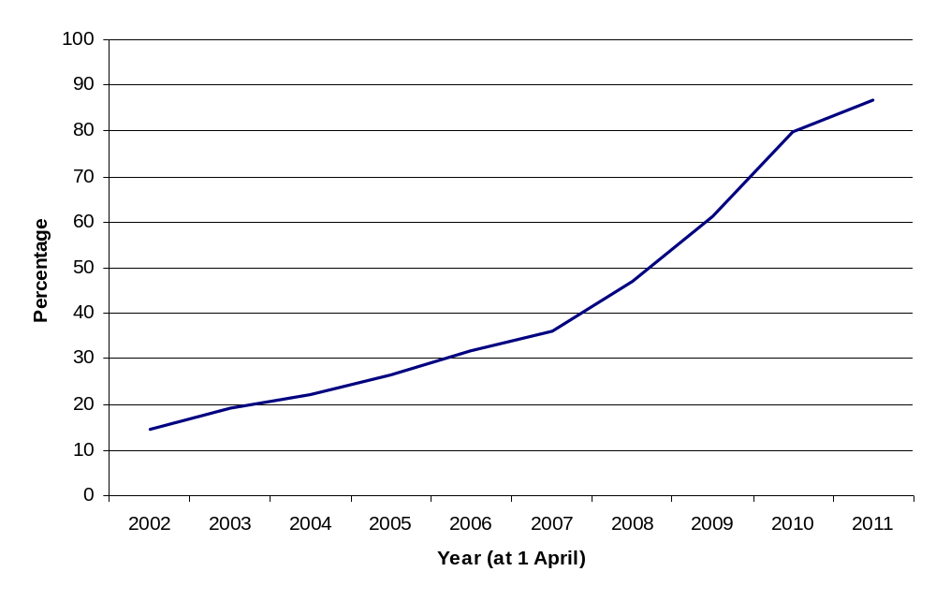
Source: Housing Strategy Statistical Appendix (HSSA) returns.

On 1 April 2011, there were 283 of 326 local authorities participating in Choice Based Letting schemes across England. This is 87 per cent of local authorities, an increase from 80 per cent on 1 April 2010 (see Chart 3).
In the West Midlands, all local authorities are participating in CBL. Yorkshire and the Humber had the lowest proportion of participating local authorities at 67 per cent (see Accompanying Table 3).

Social lettings made by local authority landlords

Chart 4: Number of local authority lettings¹ made to local authority-owned dwellings, 2000-01 – 2010-11⁴
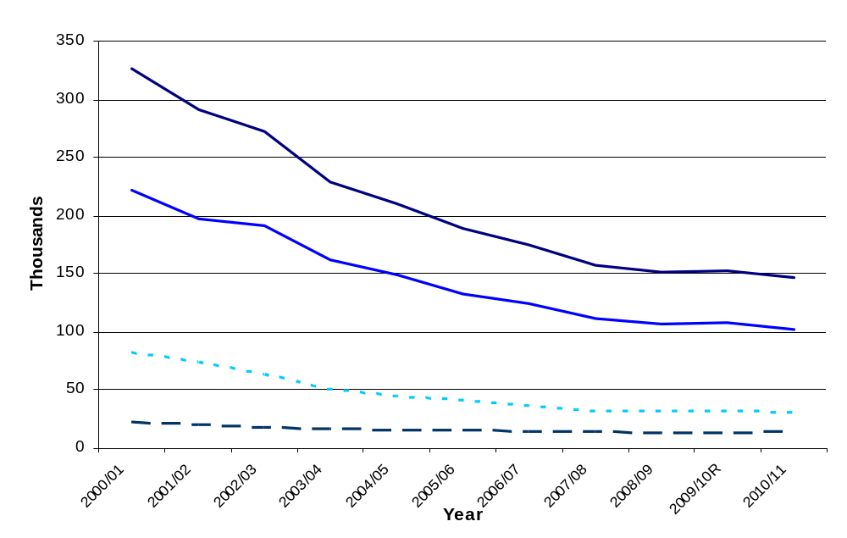
Source: Housing Strategy Statistical Appendix (HSSA) or its predecessor, the Housing Investment Programme (HIP) returns.
Notes:
1. The falling number of lettings is associated with local authorities transferring their stock to Private Registered Providers through large scale voluntary transfers, Right to Buy and other sales, and demolitions.
2. In the HSSA an existing let is defined as an internal transfer (i.e. a dwelling let to a tenant moving within a specific local authority's housing stock). New tenants are therefore defined as tenants new to a particular local authority (and not to local authority housing or social housing more generally).
3. Total lets includes mutual exchanges.
4. Information was collected from 2009-10 using questions which had been restructured from questions asked in previous years. As a result there may be a discontinuity between 2008-09 and 2009-10 and the increase in the number of lettings reported may not represent a true increase. Some data returns for 2009-10 were revised downwards during reporting for 2010-11.

Local authority landlords in England made 146,400 lettings in 2010-11. This was a decrease of 4.3 per cent compared with 2009-10, and follows a general decline from 326,600 in 2000-01 (see Chart 4). During the last few years local authority new lets have remained fairly stable at around 8.5 per cent of local authority owned stock (see Accompanying Table 4).
From 2009-10, the questions on lettings on the HSSA form were redesigned to improve consistency with the definitions used in CORE (Continuous Recording of Lettings – see the ‘Related Statistics’ section for further details). This may have led to a discontinuity in the figures compared to previous years. There were some downward revisions made to data returns for 2009-10 during the submission of 2010-11 data.
During 2010-11, 102,000 local authority lettings were made to tenants new to the local authority, 30,300 local authority lettings were made to transferring tenants and 14,100 local authority lettings were made through mutual exchange schemes (see Accompanying Table 4).

Decent homes delivery
The decent homes standard was established in 2001 and applies to all social housing (see the ‘Supplementary Information’ for further details). In order to be ‘decent’ a home should be warm, weatherproof and have reasonably modern facilities.
Chart 5: Number of non-decent local authority owned dwellings: England 2002 - 2011
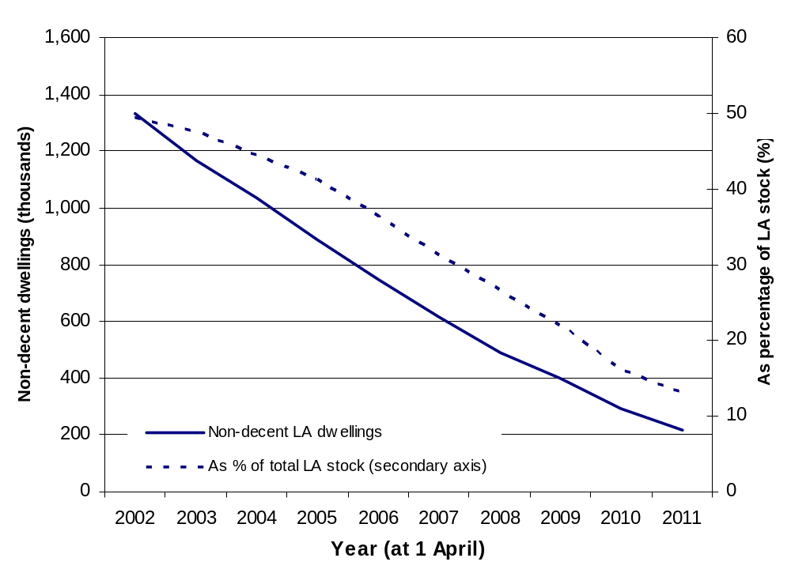
Source: Business Plan Statistical Appendix (BPSA).

As at 1 April 2011, there were 217,000 non-decent local authority owned dwellings across England, a fall from 292,000 on 1 April 2010 (see Chart 5). The proportion of non-decent local authority dwellings continued to decline. At 1 April 2011, 13 per cent of local authority dwellings were non-decent, a reduction of 3.8 percentage points on the previous year (see Accompanying Table 5).
From the 2010-11 BPSA returns, local authorities have forecast that around 219,000 dwellings (13 per cent of current local authority stock) will be non-decent by 1 April 2012, reducing to around 180,000 non-decent dwellings (10 per cent of current local authority stock) by 1 April 2014.
The decent homes programme has brought about considerable energy efficiency improvements with 1.28 million homes receiving new central heating systems since 2001 (see Table 6). The number of homes that have received double-glazing or improvements to existing windows is similar at 1.11 million and 936,430 dwellings have acquired insulation works.
Since 2001, 991,770 homes have been rewired to meet fire and safety requirements. Over this 10 year period replacement bathrooms and kitchens have been fitted to 721,360 homes and 980,510 homes respectively (see Table 6).
Table 6: Housing Revenue Account (HRA) dwellings and expenditure on selected components¹, England, 2001-2 – 2010-11
(1 April - 31 March, each year)
 |  | 2001/02 | 2002/03 | 2003/04 | 2004/05 | 2005/06 | 2006/07 | 2007/08² | 2008/09² | 2009/10² | 2010/11² | Total
Central Heating
No. of Dwellings |  | 127,580 | 125,680 | 133,730 | 140,070 | 139,490 | 135,480 | 113,520 | 114,680 | 126,220 | 125,570 | 1,282,020
Expenditure (£m) |  | 261 | 279 | 326 | 380 | 426 | 426 | 379 | 391 | 399 | 356 | 3,624
Insulation
No. of Dwellings |  | 105,570 | 119,260 | 138,120 | 111,630 | 89,820 | 81,560 | 64,980 | 59,140 | 73,430 | 92,920 | 936,430
Expenditure (£m) |  | 58 | 54 | 59 | 44 | 35 | 33 | 29 | 27 | 44 | 72 | 455
Windows
No. of Dwellings |  | 146,000 | 152,970 | 132,860 | 132,250 | 116,080 | 105,860 | 92,650 | 79,760 | 81,750 | 71,660 | 1,111,820
Expenditure (£m) |  | 342 | 341 | 326 | 340 | 353 | 290 | 266 | 229 | 253 | 202 | 2,943
Rewiring
No. of Dwellings |  | 67,100 | 80,870 | 95,020 | 93,450 | 105,480 | 116,630 | 109,410 | 107,880 | 110,470 | 105,470 | 991,770
Expenditure (£m) |  | 86 | 106 | 123 | 160 | 211 | 246 | 207 | 240 | 258 | 209 | 1,845
Bathrooms
No. of Dwellings |  | 29,420 | 40,550 | 53,910 | 76,610 | 90,330 | 94,970 | 87,390 | 81,910 | 84,020 | 82,250 | 721,360
Expenditure (£m) |  | 48 | 79 | 107 | 163 | 228 | 240 | 215 | 218 | 226 | 178 | 1,700
Kitchens
No. of Dwellings |  | 40,600 | 56,320 | 76,320 | 105,560 | 119,220 | 124,250 | 113,630 | 117,020 | 117,710 | 109,880 | 980,510
Expenditure (£m) |  | 93 | 152 | 239 | 359 | 500 | 519 | 463 | 480 | 500 | 432 | 3,739
Source: Business Plan Statistical Appendix (BPSA).
Notes:
1. Improvement work includes works of a capital nature: installation, replacement or major repair.
2. LA figures for 2007-08 to 2010-11 include imputation for missing/inaccurate data.
3. Totals may not equal the sum of components because of rounding (to the nearest 10).

Table 7: Capital works on Housing Revenue Account stock (HRA) (installation, replacement or major repairs), England, 2010-11
(1 April - 31 March)
 | Dwellings² | Spend (£m) ³ | Average per dwelling (£)⁴
Rewiring | 105,470 | 209 | 2,000
Roof Structure | 10,690 | 29 | 2,700
Roof Covering | 33,830 | 107 | 3,200
Chimneys | 11,720 | 4 | 400
Windows | 71,660 | 202 | 2,800
Doors | 79,370 | 76 | 1,000
Structural Works | 36,640 | 104 | 2,800
Central Heating | 125,570 | 356 | 2,800
Insulation | 92,920 | 72 | 800
Kitchens | 109,880 | 432 | 3,900
Bathrooms | 82,250 | 178 | 2,200
Common Areas | 93,940 | 124 | 1,300
Environmental Works | 63,240 | 66 | 1,000
Other⁵ | 205,980 | 497 | 2,400
Total spend⁶ |  | 2,418
Source: Business Plan Statistical Appendix (BPSA), 2010-11
Notes:
- Dwellings can receive works to a number of components in the same year. Where this occurs, dwellings will be counted in each category.
Totals may not equal the sum of components because of rounding:
- Rounded to the nearest 10.
- Rounded to the nearest £million.
- Rounded to nearest £hundred.
- Includes security works and disabled/elderly adaptations.
- The components do not sum to the total expenditure due to imputations used for missing values. Imputations have been made to component parts where either the expenditure or the number of dwellings receiving work for a local authority is known. As a result of this methodology, imputations may not have been made for every component of spend.
More dwellings received ‘Other’ works (including security and disabled adaptations) than any other category during 2010-11 and this category had the largest amount of total spend overall (£497 million) (see Table 7). The highest amount of spend per dwelling was for kitchens (£3,900), followed by roof covering (£3,200). The lowest amount of spend per dwelling was for chimneys (£400). This was also the least common capital works on stock.

Possession orders and evictions carried out by local authority landlords in 2010-11

Table 8: Possession orders obtained and evictions carried out, by reason, by the courts for local authority landlords in England, 2010-11

(1 April - 31 March)

 | Possession Orders |  | Evictions
 | Numbers | As a % of stock | Numbers | As a % of stock
Total | 22,830 | 1.33% | 5,950 | 0.35%
of which, for:
Rent Arrears | 20,680 | 1.20% | 5,100 | 0.30%
Anti-Social Behaviour | 660 | 0.04% | 400 | 0.02%
Both | 80 | .. | 70 | ..
Source: Business Plan Statistical Appendix, 2010-11
Notes:
Components will not sum to the total as evictions may be carried out for other reasons not specified.
Totals may not equal the sum of components because of rounding (to the nearest 10).

Possession orders and evictions of local authority housing tenants can be obtained by Local Authority Landlords under Sections 82 and 82A of the Housing Act 1985, and section 127 of the Housing Act 1996.
Local authorities are asked to report all possession orders (whether outright, suspended or postponed) that have been granted by the courts during the financial year, regardless of the grounds upon which possession was sought and regardless of the financial year in which the possession proceedings were initiated. Notices of seeking possession should be excluded.
In 2010-11 there were nearly 23,000 possession orders obtained by local authority landlords, the vast majority (90 per cent) were for rent arrears. This represents around 1 per cent of all local authority stock. Information on the availability of other official statistics relating to Possessions Orders by social housing landlords can be found in the “Related Statistics” section.
The total number of evictions includes only properties recovered following the execution of a warrant of possession by the court bailiffs. It does not include abandonment, even where a property is abandoned in the period between a warrant of possession and the execution of that warrant.
In 2010-11 local authorities reported that nearly 6,000 evictions were carried out by court bailiffs. The majority (86 per cent) of these were for rent arrears.

Local authority landlords granted anti-social behaviour injunctions

Table 9: Anti-social behaviour injunctions granted by the courts to Local Authority Landlords in England, 2009-10 & 2010-11

(1 April - 31 March)
 | Numbers and percentage
 | 2009-10 | 2010-11 | 2010-11  as % of LA stock
North East | 40 | 30 | 0.03%
North West | 300 | 270 | 0.24%
Yorkshire and the Humber | 120 | 170 | 0.07%
East Midlands | 280 | 240 | 0.13%
West Midlands | 50 | 90 | 0.04%
East | 60 | 40 | 0.02%
London | 160 | 200 | 0.05%
South East | 40 | 50 | 0.03%
South West | 90 | 90 | 0.08%
England | 1,120 | 1,180 | 0.07%

Source: Business Plan Statistical Appendix
Totals may not equal the sum of components because of rounding (to the nearest 10).

Anti-social behaviour injunctions are granted under Section 153 of the Housing Act 1996. The court may grant an injunction on application of the landlord against different types of unacceptable behaviour. A landlord can apply for an injunction against an individual who is causing nuisance or annoyance to any person and directly or indirectly relates to, or affects, the housing management functions of the landlord.

In 2010-11, around 1,180 anti-social behaviour injunctions were granted on behalf of local authority landlords in England (see Table 9). This is similar to 2009-10 and equates to less than 0.1 per cent of local authority owned stock.

Scope
The scope of this statistical release is limited to the annual Housing Strategy Statistical Appendix (HSSA) and Business Plan Statistical Appendix (BPSA).

Data collections
The information collected in the HSSA and BPSA is a combination of snapshot and financial year information. The snapshot information refers to 1 April following the end of the financial year. For example, in the 2010-11 data collections, this is 1 April 2011. Other information refers to financial years, so for the 2010-11 data collection, the reporting period is 1 April 2010 to 31 March 2011.
Both the HSSA and BPSA data collections are non-statutory annual returns. The HSSA is collected from all local authorities (LAs) in England that were in existence over the 2010-11 financial year (326 LAs) while the BPSA is collected from all LAs that owned stock during the year - including ALMOs (171 LAs). Since 2001, the number of LAs that complete the BPSA has become smaller each year because of large scale voluntary transfers of stock from local authorities to housing associations.

Data Quality
The response rates for 2010-11 were as follows.
  - 98 per cent of local authorities provided complete returns for the HSSA. Of the 326 LAs asked to complete the HSSA, 320 completed a full return and 6 did not submit a return.
  - 95 per cent of local authorities provided returns for the BPSA. Of the 171 LAs that owned stock (as at 1 April 2011), 163 completed a full return and 8 did not submit a return.
Both the HSSA and the BPSA contain mandatory and voluntary questions. Where there are mandatory questions, these are completed by all local authorities that submit a return. Some authorities may not report data for all voluntary parts of the return.
All returns undergo validation and cross-checking, and late returns are chased to ensure overall response is as complete and accurate as possible. Anomalous data are highlighted and verified by contacting the local authority. Where the local authority has not responded to the query, an assessment has been made as to the likelihood of the data being correct. Where the figures are highly likely to be incorrect, an imputation has been included for the purposes of producing the regional and national totals, where possible.
Imputations attempt to take into account missing or incorrect data in order to provide regional and national aggregates. This method has been used in the HSSA data collection process for many years. Since 2008-09, imputation work has been carried out on key parts of the BPSA in order to provide more representative regional and national figures.
All of the national and regional totals reported in this statistical release include imputed data for missing returns.
In total, around half of the individual questions in the HSSA and around a fifth in the BPSA are imputed for non-response. The accompanying reference guides (“Reference for HSSA Imputation Procedure, 2010-11” and “Reference for BPSA Imputation Procedure, 2010-11”) set out which items are imputed and the broad method for imputation. In general terms, one of three approaches to imputation are taken; direct carry over of the value reported in 2009-10, based on the authority’s estimate for 2010-11 reported in 2009-10, based on values reported by similar authorities in 2010-11. The latter approach is particularly taken when calculating items which are sub-components of other reported items. For the BPSA some related information received through other routes on Decent Homes is also used to impute Section B.
Data published for individual local authorities are as reported by each local authority.
In 2009 a reconciliation project was initiated to improve consistency between information collected on lettings, nominations and mobility in section D of the HSSA and information collected by the Continuous Recording of Letting (CORE), which is based on information from tenants starting new social tenancies. Section D of the HSSA was restructured in 2009-10. One of the most significant changes to section D on the 2009-10 form was that it asked local authorities to indicate the number of dwellings let to tenants that are new to social housing (i.e., the tenant’s last tenancy was in non-social housing). Section D no longer asked for information on tenancies which are neither non-secure nor non-introductory however these may still be captured indirectly within the restructured section D. Following these changes the number of lettings reported increased slightly and cross-checks with the previous year’s data (2008-09) revealed a few cases of double counting on the new form, which were corrected. We reviewed the guidance notes, in consultation with local authorities, for the 2010-11 data collection and some authorities reported revised data for 2009-10 during reporting for 2010-11.

Uses of the Data
The data in this Statistical Release are important for a number of different purposes. They meet the requirements of informed decision-making by the Secretary of State for Communities and Local Government, other government departments, local authorities, other public services, business, researchers and the public. The data collected on the HSSA and BPSA forms provide an important part of the evidence base for the assessment of future housing requirements and are used to inform evidence-based policy decisions and as a basis for answering Parliamentary Questions and other requests for information by Ministers, local authorities and the general public.

Revisions Policy
This policy has been developed in order to comply with the National Statistician’s Guidance on the UK Statistics Authority Code of Practice introduced in January 2009.
Where a significant error has occurred as a result of the compilation, imputation or dissemination process, the live tables, annual dataset and statistical release will be updated with a correction notice.
Any revisions made by local authorities to their figures after the dataset has been frozen, due to either errors found in their submission or failure to meet the deadline, will be validated and kept internally but no changes will be made to the published statistical release. When the statistical release, annual datasets and accompanying live tables for the following year are published, these revisions will be incorporated. Revisions will normally only be made to one year prior to the year that is being published.
Where revisions have been made, a revised annual dataset will be published on the Department’s website alongside the original. This will be done at the same time as the following year’s statistical release, annual dataset and live tables are published. So alongside this 2010-11 statistical release, a revised 2009-10 dataset has been published. This incorporates any revisions that have been made following the publication of the 2009-10 Statistical Release on 30 November 2010, that were received in time for this publication. All of the charts and tables in this Statistical Release and associated live tables have been updated to incorporate the revised 2009-10 figures.
Where HSSA or BPSA data are kept in live tables, these tables will be updated annually at the same time as the publication of this statistical release. The exception to this is when a significant error has been identified as described previously. In this case, these tables will be updated as soon as the error is found and a note will be placed on the table to notify users of the reason for the change.
Revisions to historic data (all years before the year previously published) should only be made where there is a substantial revision, such as a change in methodology or definition. Where there are small revisions that do not significantly change historic data, internal updates are maintained.

National Statistics
This Statistical Release is published at 9.30am on a date which has been pre-announced on the United Kingdom Statistics Authority Publication Hub.
The statistics contained within this Statistical Release and other statistics collected in the HSSA and BPSA were assessed by the UK Statistics Authority to become National Statistics. The assessment report was published on 30 June 2011 and can be found on the UKSA website: http://www.statisticsauthority.gov.uk/assessment/assessment/assessment-reports/assessment-report-117---statistics-on-housing-in-england.pdf The requirements set out in this report have now been addressed and therefore this release is badged as a National Statistic.
A list of officials who have received pre-release access to this Statistical Release up to 24 hours in advance of publication is available on the Department’s website alongside this Statistical Release.

Related Statistics – England
The Ministry of Justice publishes quarterly National Statistics on possession actions issued in county courts by mortgage lenders and social and private landlords in England and Wales. Whilst the BPSA collects information on the number of possession orders obtained from Local Authority landlords, corresponding information is not collected from housing associations. Therefore, where a breakdown by type of social landlord is not required, the best source would be the Ministry of Justice’s statistics on possession actions (see table 3 of their statistical tables.)
Please note that there are some differences as 1) the Ministry of Justice publishes data on the number of possession claims and number of possession claims leading to an order rather than the number of orders; 2) the information is taken from courts administrative data rather than local authority returns; and 3) the Ministry Of Justice’s published tables include both England and Wales. A link to the latest Statistical Release can be found at:
http://www.justice.gov.uk/publications/statistics-and-data/civil-justice/mortgage-possession.htm

Related Statistics – Devolved Administrations
Statistics relating to social housing stock in the other UK countries are published by the devolved administrations. In all countries, data are collected from returns made by the stock owning authority (local authority, housing association or equivalent).
- The Scottish Government publishes statistics on social housing which are available through their website. http://www.scotland.gov.uk/Topics/Statistics/Browse/Housing-Regeneration/HSfS In particular, they produce an annual Key Trend Summary. The 2011 edition can be accessed at: http://www.scotland.gov.uk/Publications/2011/08/30084023/0
- The Welsh Assembly Government also publishes statistics on social housing which are available at: http://wales.gov.uk/topics/statistics/headlines/housing2011/?lang=en
- In Northern Ireland, the Department for Social Development produces an annual publication which bring together housing statistics collected by the Department including statistics on social housing: http://www.dsdni.gov.uk/index/stats_and_research/stats-publications/stats-housing-publications/housing_stats.htm

There are a number of differences between the statistics that are collected and published for local authorities in England through the HSSA and BPSA collections and the other UK countries. These differences can arise for a number of reasons, but the majority are a result of different legislation, methodology or coverage. Details describing these differences can be found at the following link.
http://www.communities.gov.uk/housing/housingresearch/housingstatistics/housingstatisticsby/localauthorityhousing

The table below shows the main topics collected from the Housing Strategy Statistical Appendix and Business Plan Statistical Appendix and provides links to the corresponding statistics published by the devolved administrations:

Figure 1: Links to related statistics in the devolved administrations
Topic | Scotland | Wales | Northern Ireland
Council Housing Stock | http://www.scotland.gov.uk/Topics/Statistics/Browse/Housing-Regeneration/HSfS/Stock | http://wales.gov.uk/topics/statistics/headlines/housing2011/111116/?lang=en | http://www.dsdni.gov.uk/housing_stats
Decent Homes programmes | Scottish Housing Quality Standard  http://www.scotland.gov.uk/Topics/Built-Environment/Housing/16342/shqs/progress | Welsh Housing Quality Standard  http://wales.gov.uk/docs/desh/publications/110330housingwhqsen.pdf | http://www.nihe.gov.uk/index/sp_home/research-2/house_condition_survey.htm
Stock Condition & Fitness Standards | http://www.scotland.gov.uk/Topics/Statistics/SHCS | http://wales.gov.uk/topics/statistics/headlines/housing2011/110824/?lang=en | http://www.dsdni.gov.uk/housing_stats
Council House Vacant Stock | http://www.scotland.gov.uk/Topics/Statistics/Browse/Housing-Regeneration/HSfS/StockManagement | http://wales.gov.uk/topics/statistics/headlines/housing2010/1011171/?lang=en | http://www.dsdni.gov.uk/housing_stats
Energy Efficiency / SAP Ratings | http://www.scotland.gov.uk/Topics/Statistics/SHCS | Not collected | http://www.dsdni.gov.uk/housing_stats
Houses of Multiple Occupations | http://www.scotland.gov.uk/Topics/Statistics/Browse/Housing-Regeneration/HSfS/HMO | http://wales.gov.uk/topics/statistics/headlines/housing2011/110824/?lang=en | Not collected
Private Sector Renewal / Assistance | http://www.scotland.gov.uk/Topics/Statistics/Browse/Housing-Regeneration/HSfS/Improvements | http://wales.gov.uk/topics/statistics/headlines/housing2011/110907/?lang=en | http://www.dsdni.gov.uk/housing_stats
Affordable Housing Provision | http://www.scotland.gov.uk/Topics/Statistics/Browse/Housing-Regeneration/HSfS/NewBuild | http://wales.gov.uk/topics/statistics/headlines/housing2011/111019/?lang=en | Not collected
Lettings / Allocations | http://www.scotland.gov.uk/Topics/Statistics/Browse/Housing-Regeneration/HSfS/StockManagement | http://wales.gov.uk/topics/statistics/headlines/housing2010/1011171/?lang=en | http://www.dsdni.gov.uk/housing_stats
Waiting Lists | http://www.scotland.gov.uk/Topics/Statistics/Browse/Housing-Regeneration/HSfS/StockManagement | Not Collected | http://www.dsdni.gov.uk/housing_stats
Landlord Possessions / Evictions | http://www.scotland.gov.uk/Topics/Statistics/Browse/Housing-Regeneration/HSfS/StockManagement | http://wales.gov.uk/topics/statistics/headlines/housing2010/1009291/?lang=en | Not collected
Rent Arrears | http://www.scotland.gov.uk/Topics/Statistics/Browse/Housing-Regeneration/HSfS/HRA2008-09 | http://wales.gov.uk/topics/statistics/headlines/housing2010/101117/?lang=en | http://www.dsdni.gov.uk/housing_stats

Supplementary information
Housing stock data: Further information on ‘Notes and definitions for housing stock data’ is available from the Department’s website at: http://www.communities.gov.uk/housing/housingresearch/housingstatistics/housingstatisticsby/stockincludingvacants/notesdefinitions/
This information explains the different data sources used to calculate total stock figures for England and stock figures by tenure, as well as the associated data sources. For total local authority stock figures, the HSSA is the preferred data source. Live table 100 (see Introduction) provides the number of local authority dwelling in each LA district by tenure.
Social housing stock in an area is made up of local authority owned stock and stock owned by housing associations. The Tenant Services Authority’s Regulatory Statistical Return (RSR) is the preferred data source - see http://www.tenantservicesauthority.org/server/show/nav.15039. Since the Tenant Services Authority (TSA) took over as the regulator for social housing on 1 April 2010 local authorities and housing associations have been termed as Registered Providers by the TSA. A new register of social housing providers was formed and housing associations automatically moved on to the new register without the need to apply. Successful applicants for voluntary registration, as well as those organisations which moved across from the previous register, are commonly termed by the TSA as "private registered providers" of social housing. The decline in local authority housing stock has been associated with Right to Buy (RTB) and large scale voluntary transfer (LSVT) of local authority stock to private registered providers, as well as other sales and demolitions (though on a smaller scale).
Further information about local authority LSVT to private registered providers can be found at: http://www.homesandcommunities.co.uk/ourwork/existing-stock##lsvt
Further information and data about Right To Buy and other sales of social stock can be found in the Live Tables at http://www.communities.gov.uk/housing/housingresearch/housingstatistics/housingstatisticsby/socialhousingsales/livetables/
Both the HSSA and BPSA collect information on LA social housing stock but with different definitions and for different purposes. Figures presented here (for chart 1) relate to the HSSA. HSSA data are based on the Census definition of stock and report LA owned stock including those owned by other local authorities in the reporting local authority’s area. In contrast, the BPSA is based on the Housing Revenue Accounts (HRA) definition and collects information on all stock owned by the LA irrespective of its location.
Waiting lists: The English Housing Survey (EHS) asks questions on the number of households on housing waiting lists. The numbers reported by households on the EHS are much lower than those reported by local authorities on the HSSA. See the EHS household report, chapter 3: http://www.communities.gov.uk/publications/corporate/statistics/ehs200809householdreport
Choice Based Lettings: The initiative by which new and existing social tenants in England are given greater choice in housing. Choice-based lettings normally involve advertised properties that applicants can bid for. It does not include schemes that solely allow applicants to express preferences, for example with regard to the area or type of property. For more information see: http://www.direct.gov.uk/en/HomeAndCommunity/Councilandhousingassociationhomes/Councilhousing/DG_188698
Social lettings data: Local authority lettings information is reported on the Housing Strategy Statistical Appendix, and most local authorities, as well as all housing associations, are reporting information on the CORE (Continuous Recording of Lettings and Sales) data collection system - see https://core.tenantservicesauthority.org/.
Lettings made by Private Registered Providers are collected on CORE returns and the Tenant Services Authority’s Regulatory Statistical Return (RSR) - see http://www.tenantservicesauthority.org/server/show/nav.15039.
Decent homes programme: In 2001 the previous government established the decent homes standard for all social housing (set out in guidance, updated in 2006), see link to decent homes guidance: http://www.communities.gov.uk/documents/housing/pdf/138355.pdf
Local authorities report information on decent homes activity through the BPSA. Private Registered Providers report similar information through the Tenant Services Authority’s Regulatory Statistical Return (RSR). In the BPSA, non-decent local authority housing stock includes stock owned by local authorities in other areas (see notes on Housing stock data above).
Estimates on the numbers of non-decent homes are also available from the English Housing Survey - see http://www.communities.gov.uk/publications/corporate/statistics/ehs2009stockreport
Decent homes figures from different sources are summarised in live table 119:
http://www.communities.gov.uk/housing/housingresearch/housingstatistics/housingstatisticsby/stockincludingvacants/livetables/
There are some differences in definitions between the survey and landlord returns. Further information is available in a research note - see http://www.communities.gov.uk/publications/housing/decenthomessocialsector

Accompanying tables
Table 1 Local authority owned stock by Region, England 2000 - 2011
Table 2 Numbers of households on local authority housing waiting lists, by Region, England 2000 - 2011
Table 3 Participating local authorities in Choice-Based Letting (CBL) schemes, by Region, England 2002 - 2011
Table 4 Local authority lettings made to local authority owned dwellings, by Region, England 1999-00 – 2010-11
Table 5 Numbers of non-decent local authority dwellings: England, 2001 - 2011
Table 1: Local authority owned stock¹ by region, England, 2001 - 2011²
(As at 1 April each year)
Numbers³ | 2001 | 2002 | 2003 | 2004 | 2005 | 2006 | 2007 | 2008 | 2009 | 2010 | 2011
North East | 233,240 | 226,590 | 207,310 | 189,680 | 169,760 | 165,140 | 154,260 | 139,640 | 129,320 | 128,160 | 116,200
North West | 415,660 | 405,060 | 326,110 | 307,600 | 267,110 | 241,170 | 206,530 | 180,590 | 153,600 | 153,030 | 113,390
Yorkshire and the Humber | 397,060 | 386,130 | 344,220 | 326,330 | 273,260 | 264,640 | 248,150 | 242,850 | 240,980 | 239,820 | 238,040
East Midlands | 256,980 | 241,680 | 225,530 | 218,260 | 214,410 | 211,490 | 208,520 | 193,890 | 187,980 | 186,080 | 185,710
West Midlands | 315,770 | 300,770 | 256,750 | 238,370 | 232,000 | 221,600 | 217,920 | 213,160 | 211,540 | 210,750 | 209,820
East | 272,620 | 251,500 | 230,730 | 225,930 | 205,620 | 195,650 | 187,600 | 164,320 | 164,080 | 163,430 | 162,990
London | 530,020 | 515,980 | 499,710 | 482,840 | 468,320 | 456,760 | 450,880 | 435,540 | 432,940 | 421,650 | 417,720
South East | 234,650 | 225,770 | 220,880 | 205,890 | 198,900 | 202,210 | 193,370 | 182,740 | 182,080 | 181,220 | 180,500
South West | 155,920 | 152,560 | 145,690 | 139,740 | 136,150 | 128,780 | 120,100 | 117,630 | 117,180 | 101,730 | 101,550
England | 2,811,930 | 2,706,040 | 2,456,920 | 2,334,630 | 2,165,530 | 2,087,460 | 1,987,340 | 1,870,370 | 1,819,700 | 1,785,850 | 1,725,910
Source: Housing Strategy Statistical Appendix (HSSA) or its predecessor the Housing Investment Programme (HIP) returns.
Notes:
1. Local Authority owned stock, including stock owned by other Local Authorities in the reporting area.
2. Data before 2004 are more prone to errors as they were validated less rigorously.
3. Rounded to the nearest 10.

Table 2: Numbers of households on local authority housing waiting lists^{1,2} by region, England, 2001 – 2011

(As at 1 April each year)
Numbers³ and percentages
 | 2001 | 2002 | 2003 | 2004 | 2005 | 2006 | 2007 | 2008 | 2009 | 2010^{R} | 2011 | Percentage of all households in area on waiting list⁴ in 2011
North East | 57,020 | 62,260 | 85,420 | 105,950 | 89,750 | 95,360 | 90,570 | 95,400 | 82,520 | 79,590 | 91,910 | 8.3
North West | 112,410 | 121,210 | 160,190 | 177,840 | 200,600 | 217,400 | 212,600 | 234,560 | 237,850 | 253,520 | 233,900 | 8.0
Yorkshire and the Humber | 150,390 | 162,370 | 195,740 | 197,650 | 227,430 | 247,500 | 270,070 | 288,110 | 289,100 | 258,700 | 272,410 | 12.4
East Midlands | 100,610 | 102,050 | 111,100 | 129,270 | 141,040 | 133,820 | 134,420 | 136,550 | 120,900 | 123,780 | 116,440 | 6.2
West Midlands | 92,980 | 95,020 | 107,540 | 120,430 | 137,820 | 126,630 | 121,050 | 150,010 | 161,140 | 160,950 | 183,950 | 8.2
East | 94,850 | 99,490 | 110,970 | 134,310 | 129,180 | 135,440 | 146,250 | 147,850 | 153,480 | 155,900 | 160,270 | 6.7
London | 211,470 | 226,790 | 242,390 | 279,730 | 309,070 | 331,230 | 333,860 | 352,950 | 354,390 | 362,290 | 366,610 | 11.3
South East | 129,920 | 129,230 | 146,880 | 168,730 | 181,200 | 195,700 | 208,420 | 203,160 | 205,370 | 215,370 | 225,250 | 6.5
South West | 89,630 | 94,920 | 110,450 | 123,850 | 131,190 | 151,220 | 157,180 | 161,350 | 158,400 | 148,420 | 186,310 | 8.3
England | 1,039,270 | 1,093,340 | 1,270,680 | 1,437,740 | 1,547,280 | 1,634,300 | 1,674,420 | 1,769,940 | 1,763,140 | 1,758,520 | 1,837,040 | 8.5

Source: Housing Strategy Statistical Appendix (HSSA) or its predecessor the Housing Investment Programme (HIP) returns.
Notes:
1. Excludes households looking for transfers
2. LAs sometimes maintain a common waiting list with Private Registered Providers (PRPs) in their district. No information is available where a PRP maintains a separate list to the LA.
3. Numbers rounded to nearest 10.
4. Latest available mid-year household figures for the districts used i.e. 2011 from the 2008-based household projections. See Live Table 406.
R. Two authorities submitted revised figures for 2010.
Table 3: Participating Local Authorities in Choice-Based Letting¹ (CBL) schemes by region, England, 2002 - 2011

(As at 1 April each year)
 | 2002 | 2003 | 2004 | 2005 | 2006 | 2007 | 2008 | 2009³ | 2010³ | 2011^{3,4} | % of LAs participating in CBL in 2011^{2, 3}
North East | 1 | 4 | 2 | 2 | 6 | 5 | 6 | 7 | 11 | 11 | 92
North West | 12 | 13 | 17 | 20 | 19 | 19 | 21 | 23 | 26 | 29 | 74
Yorkshire and the Humber | 4 | 5 | 5 | 6 | 6 | 8 | 10 | 10 | 11 | 14 | 67
East Midlands | 6 | 7 | 7 | 8 | 8 | 11 | 12 | 17 | 18 | 31 | 78
West Midlands | 4 | 5 | 7 | 7 | 11 | 10 | 16 | 22 | 29 | 30 | 100
East | 2 | 4 | 7 | 8 | 10 | 10 | 24 | 34 | 43 | 43 | 91
London | 11 | 17 | 18 | 21 | 23 | 28 | 28 | 30 | 29 | 30 | 91
South East | 8 | 7 | 7 | 12 | 16 | 20 | 32 | 45 | 58 | 60 | 90
South West | 3 | 6 | 8 | 10 | 13 | 17 | 18 | 29 | 35 | 35 | 95
England | 51 | 68 | 78 | 94 | 112 | 128 | 167 | 217 | 260 | 283 | 87
Source: Housing Strategy Statistical Appendix (HSSA).
Notes:
1. Choice-Based Lettings were introduced though the Homelessness Act 2002.
2. The nature of CBL means schemes often cross local authority boundaries and may therefore also cross regional boundaries.
3. The number of local authorities (LAs) in England reduced from 354 in 2009 to 326 in 2010 following local government reorganisation when 37 LAs were reorganised into 9 new LAs. Each of the nine LAs formed in 2010 reported that they were participating in CBL schemes whereas not all of the respective LAs which were reorganised had reported participation on 1 April 2009.
4. Data for 6 non-responding local authorities in 2011 were imputed using responses in 2010.

Table 4: Local authority lettings¹ made to local authority owned dwellings, England, 2000-01 – 2010-11
(1 April - 31 March, each year)
 |  |  |  | Numbers and percentage
 | New lets | Existing lets² | Mutual exchanges | Total lets^{3,4} | Total lets as % of LA stock (at year end)
2000/01 | 221,800 | 81,900 | 22,400 | 326,600 | 11.6%
2001/02 | 197,500 | 73,500 | 20,100 | 291,100 | 10.8%
2002/03 | 191,000 | 64,000 | 17,800 | 272,800 | 11.1%
2003/04 | 161,900 | 50,700 | 16,000 | 228,600 | 9.8%
2004/05 | 149,100 | 45,000 | 15,800 | 209,900 | 9.7%
2005/06 | 133,300 | 40,600 | 14,900 | 188,800 | 9.0%
2006/07 | 124,300 | 35,900 | 14,600 | 174,900 | 8.8%
2007/08 | 111,400 | 32,100 | 14,300 | 157,800 | 8.4%
2008/09 | 106,900 | 31,700 | 13,000 | 151,700 | 8.3%
2009/10^{R} | 107,700 | 31,800 | 13,500 | 153,000 | 8.6%
2010/11 | 102,000 | 30,300 | 14,100 | 146,400 | 8.5%

Source: Housing Strategy Statistical Appendix (HSSA) or its predecessor the Housing Investment Programme (HIP) returns.
Notes:
1. The falling number of lettings is associated with local authorities transferring their stock to private registered providers (PRPs) through large scale voluntary transfers (LSVT), Right to Buy (RTB) and other sales, and demolitions. Information was collected from 2009-10 using questions which had been restructured from questions asked in previous years. As a result the quality of data is less certain for 2009-10. Revisions were also received to 2009-10 data during submission of 2010-11 data.
2. In the HSSA an existing let is defined as an internal transfer (i.e. a dwelling let to a tenant moving within a specific local authority's housing stock). New tenants are therefore defined as tenants new to a particular local authority (and not to local authority housing or social housing more generally).
3. Totals may not equal the sum of components because of rounding (to the nearest 100).
4. Total lets includes mutual exchanges.

Table 5: Numbers of non-decent local authority dwellings, England, 2001 - 2011
(as at 1 April each year)
Thousands and percentages
 | 2002 | 2003 | 2004 | 2005 | 2006 | 2007 | 2008 | 2009 | 2010 | 2011
Non-decent local authority stock | 1,335 | 1,168 | 1,036 | 889 | 746 | 618 | 492 | 397 | 292 | 217
As percentage of total local authority stock | 49 | 48 | 44 | 41 | 36 | 31 | 26 | 22 | 16 | 13
Source: Business Plan Statistical Appendix (BPSA) or its predecessor the Housing Investment Programme (HIP) returns.

Enquiries

Media Enquiries: office hours: 0303 444 1136
out of hours: 0303 444 1201
e-mail: press.office@communities.gsi.gov.uk
Statistical enquiries about the figures contained in this Release:
e-mail: housing.statistics@communities.gov.uk
telephone: 0303 444 4172

Information on National Statistics is available via the UK Statistics Authority website: www.statistics.gov.uk.
Information about the Department for Communities and Local Government is available via the Department's website: www.communities.gov.uk

Department for Communities and Local Government. © Crown Copyright, 2011

If you require this publication in an alternative format please email: alternativeformats@communities.gsi.gov.uk. Please note that the nature of content means that we may not be able to provide the Statistical series of publications in all requested formats.

November 2011

ISBN: 978-1-4098-3243-0

In previous years, local authorities have been asked for their “target” number of non-decent homes. In 2008-09, this question was changed to “forecast” in order to reflect the need for local authorities to supply their best estimates.

