

Statistical Release

13 October 2010

LOCAL GOVERNMENT PENSION SCHEME FUNDS ENGLAND 2009-10

- Local Government Pension Scheme expenditure on benefits in 2009-10 was £6.3xbillion, compared with £5.6 billion in 2008-09, an increase of 13%

- Income from employees’ contributions to the Local Government Pension Scheme in 2009-10 was £2.0 billion, an increase of 3% on 2008-09. Income from employers’ contributions to the scheme rose by 7% to £5.8 billion in the same period.

- Income from investments fell by 10% on 2008-09 to £2.6 billion.

- The market value of the funds at end of March 2010 was £132 billion. This represents an increase of 17% on March 2006 and an increase of 10% on March 2008.

- There were nearly 1.7 million employees in the Local Government Pension Scheme at the end of March 2010, almost no change on March 2009.

- The number of former employees entitled to deferred benefits rose to 1.2 million in 2009-10, an increase of 46% over 2005-06. Over the same period the number of pensioners has increased by 16%. The number of former employees entitled to deferred benefits exceeds the number of pensioners.

This release provides information on Local Government Pension Scheme Funds (SF3) forms submitted by all 81 Administering Authorities in England that provide information on Local Government Pension Funds and associated information for the financial year 2009-10 and changes over previous years.

The release has been compiled by the Local Government Finance – Data Collection, Analysis and Accountancy division of Communities and Local Government.

Responsible Statisticians:  Steve Melbourne & Mike Young | Email: sf3.statistics@communities.gsi.gov.uk
Contact points:
Press enquiries:
Telephone 0303 444 0444
Email press.office@communities.gsi.gov.uk
Other enquiries:
Telephone 0303 444 2116
Email: sf3.statistics@communities.gsi.gov.uk
Website: www.communities.gov.uk

Web-link (pensions statistics) : http://www.communities.gov.uk/localgovernment/localregional/ localgovernmentfinance/statistics/pensionscheme/

Local Government Pension Scheme Funds England 2009-10
Contents |  | Page
Table 1 | Local Government Pension Scheme expenditure 2005-06 to 2009-10 | 3
Chart A | Local Government Pension Scheme expenditure in 2009-10 | 4
Table 2 | Local Government Pension Scheme income 2005-06 to 2009-10 | 5
Chart B | Local Government Pension Scheme income in 2009-10 | 5
Chart C | Local Government Pension Scheme total expenditure and income 2005-06 to 2009-10 | 6
Table 3 | Number of Local Government Pension Scheme members and market value of fund at the end of each year 2005-06 to 2009-10 | 7
Chart D | Membership of the Local Government Pension Scheme 2005-06 to 2009-10 | 7
Table 4 | Type of retirements from the Local Government Pension Scheme 2005-06 to 2009-10 | 8
Chart E | Type of retirement from the Local Government Pension Scheme 2005-06 to 2009-10 | 8
Terminology used in this release |  | 9
Data quality |  | 10
Uses made of data |  | 11
Background Notes |  | 11

Local Government Pension Scheme Funds England 2009-10

Expenditure: 2005-06 to 2009-10

- Table 1 and Chart A provide figures for Local Government Pension Scheme expenditure from 2005-06 to 2009-10.

- Local Government Pension Scheme expenditure on benefits in 2009-10 was
£6.3 billion, compared with £5.6 billion in 2008-09, an increase of 13%.

- In 2009-10, 83% of Local Government Pension Scheme expenditure in England was on benefits in the form of pensions and annuities or lump sums, for retired members and their dependants.

- Expenditure on lump sums paid on retirement in 2009-10 was £1,323 million. This compares with £1,047 million in 2008-09.

Table 1: Local Government Pension Scheme expenditure 2005-06 to 2009-10
 |  |  |  |  |  |  |  |  |  |  | £ million
 |  | 2005-06 | 2006-07 | 2007-08 |  | 2008-09 |  |  |  |  | 2009-10
 | Total expenditure on benefits | 4,272 | 4,757 |  | 5,222 |  |  | 5,600 |  |  | 6,317
 | of which:
 | Pensions or annuities | 3,611 | 3,816 |  | 4,100 |  |  | 4,388 |  |  | 4,774
 | Lump sums paid on retirement^{(a)} | 581 | 859 | || | 1,038 |  |  | 1,047 |  |  | 1,323
 | Lump sums paid on death^{(b)} | 78 | 81 |  | 84 |  | || | 123 |  |  | 137
 | Optional lump sum^{(c)} | - | - |  | - |  |  | 41 |  |  | 82
 | Other benefits | 2 | 1 |  | 1 |  |  | 1 |  |  | 1
 | Disposal of Liabilities | 896 | 629 |  | 563 |  |  | 523 |  |  | 858
 | of which:
 | Transfer values | 853 | 598 |  | 540 |  |  | 502 |  |  | 846
 | Pensions Act premiums | 29 | 26 |  | 19 |  |  | 21 |  |  | 12
 | Refunds of contributions^{(d)} | 14 | 5 |  | 4 |  | || | 0 |  |  | 0
 | Costs charged to the funds | 290 | 349 |  | 375 |  |  | 359 |  |  | 384
 | of which:
 | Fund Management costs | 199 | 254 |  | 270 |  |  | 245 |  |  | 271
 | Administration costs | 91 | 95 |  | 105 |  |  | 114 |  |  | 115
 | Other expenditure | 15 | 19 |  | 27 |  |  | 19 |  |  | 19
 | Total expenditure | 5,473 | 5,754 |  | 6,187 |  |  | 6,502 |  |  | 7,578
Source: SF3 forms
(a) The rules governing the payment of lump sums on retirement changed in 2006-07 and now allow beneficiaries to take more of their pension as a lump sum and less as a continuing pension.
(b) The rules changed from 1 April 2008. Prior to this date death benefit was twice salary, after this date it is three times salary.
(c) This was introduced from 1 April 2008
(d) The rules changed from 1 April 2008. See Terminology used in this release for further details

Chart A: Local Government Pension Scheme expenditure in 2009-10
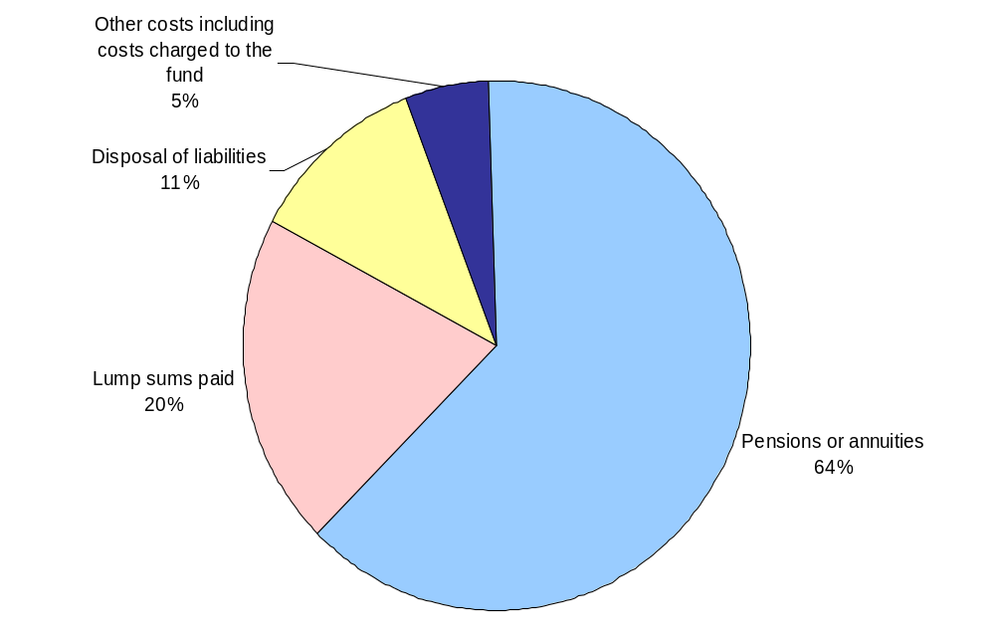

Income: 2005-06 to 2009-10

- Table 2 and Chart B provide figures for Local Government Pension Scheme income from 2005-06 to 2009-10.

- In 2009-10, 69% of Local Government Pension Scheme income came from employers’ and employees’ contributions whilst income from investments provided 23% of the total.

- Income from employees’ contributions to the Local Government Pension Scheme in 2009-10 was £2.0 billion, an increase of 3% on 2008-09. Income from employers’ contributions to the scheme rose by 7% to £5.8 billion in the same period.

- Income from investments fell by 10% on 2008-09 to £2.6 billion. This fall followed a fall of 9% in 2008-09..

Table 2: Local Government Pension Scheme income 2005-06 to 2009-10
 |  |  |  |  |  | £ million
 |  | 2005-06 | 2006-07 | 2007-08 | 2008-09 | 2009-10
 | Contributions (including those from admitted authorities)
 | Employees^{(a)} | 1,576 | 1,605 | 1,680 | 1,926 | 1,974
 | Employers^{(b)} | 4,124 | 4,626 | 5,009 | 5,400 | 5,759
 | Investment income (gross) | 2,639 | 3,019 | 3,165 | 2,873 | 2,572
 | of which:
 | Dividends receivable | 1,646 | 1,959 | 2,080 | 1,999 | 1,754
 | Interest receivable | 501 | 561 | 638 | 546 | 385
 | Income from property | 247 | 283 | 303 | 302 | 305
 | Other investment income | 244 | 216 | 144 | 25 | 128
 | Transfer values | 1,044 | 754 | 707 | 557 | 800
 | Other income | 43 | 59 | 50 | 50 | 58
 | Total income | 9,426 | 10,063 | 10,610 | 10,806 | 11,163
Source: SF3 forms
(a) The rate of employee's contribution to the scheme changed from 1 April 2008 from a flat rate for all employees to a variable rate dependent on salary.
(b) Includes employers secondary contributions

Chart B: Local Government Pension Scheme income in 2009-10
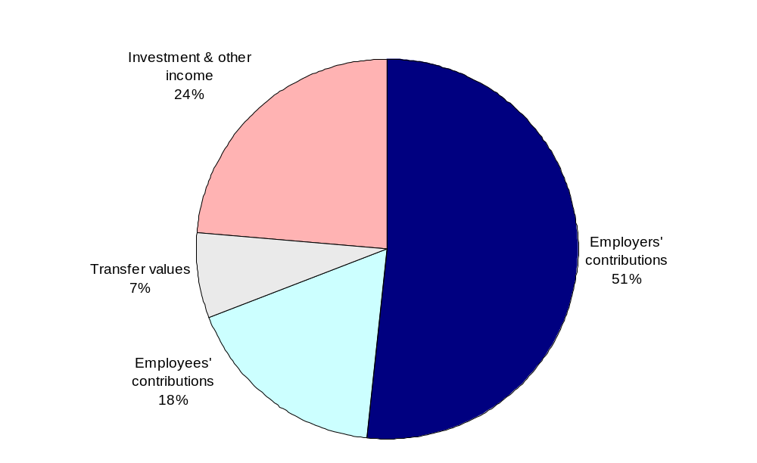

- Chart C provides a comparison of total Local Government Pension Scheme expenditure and income from 2005-06 to 2009-10.

Chart C: Local Government Pension Scheme total expenditure and income
2005-06 to 2009-10
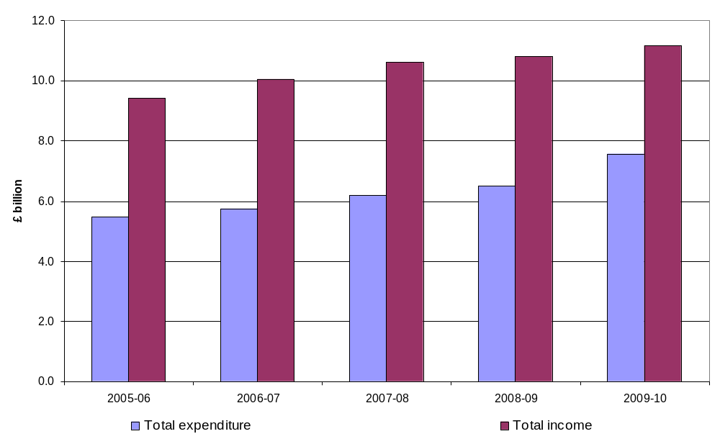

Membership and market value: 2005-06 to 2009-10

- Table 3 and Chart D provide figures of the membership and the market value of the Local Government Pension Scheme from 2005-06 to 2009-10.

- There were nearly 1.7 million employees in the Local Government Pension Scheme at the end of March 2010, almost no change on the figure for March 2009.

- The number of former employees entitled to deferred benefits rose to 1.2 million in 2009-10, an increase of 46% over 2005-06. Over the same period the number of pensioners has increased by 16%. The number of former employees entitled to deferred benefits exceeds the number of pensioners.

- The market value of the funds at end of March 2010 was £132 billion. This represents an increase of 17% on March 2006 and an increase of 10% on March 2008.

Table 3: Number of Local Government Pension Scheme members and market value of funds
at the end of each year 2005-06 to 2009-10
 |  |  |  |  |  | Thousand
 |  | 2005-06 | 2006-07 | 2007-08 | 2008-09 | 2009-10
 | Number of scheme members
 | Employees | 1,617 | 1,638 | 1,656 | 1,685 | 1,684
 | Pensioners | 973 | 1,019 | 1,049 | 1,088 | 1,131
 | Former employees entitled to deferred benefits | 851 | 942 | 1,055 | 1,149 | 1,245
 | Former members to whom Regulation 18 of the 2007 Benefit Regulations (flexible retirees) applies | – | 0 | 1 | 2 | 4
 |  |  |  |  |  | £ million
 | Market value of funds at end of year | 112,967 | 122,402 | 119,959 | 97,272 | 132,012
Source: SF3 forms

Chart D: Membership of the Local Government Pension Scheme

2005-06 to 2009-10
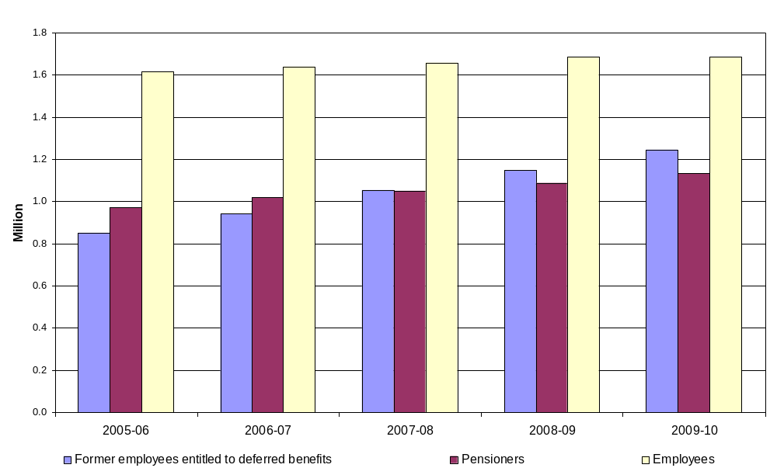

Retirements from the Local Government Pension Scheme: 2005-06 to 2009-10

- Table 4 and Chart E provide figures of the type of retirement from the Local Government Pension Scheme from 2005-06 to 2009-10.

Table 4: Type of retirements from the Local Government Pension Scheme 2005-06 to 2009-10
 |  | 2005-06 | 2006-07 | 2007-08 | 2008-09 |  | 2009-10
 | Number of scheme members
 | Redundancy | 8,146 | 9,923 | 7,927 |  | 9,346 | 12,637
 | Ill health retirement  (pre April 2008) | 4,686 | 4,279 | 4,134 | || | 1,470 | -
 | Tier 1,2 & 3 ill health retirement awards under LGPS^{(a)} | - | - | - | || | 2,475 | 2,952
 | Early payment of deferred benefits | 9,255 | 14,804 | 17,867 |  | 18,952 | 19,150
 | Normal retirements | 16,151 | 19,038 | 21,393 |  | 20,967 | 22,180
 | Total retirements | 38,238 | 48,044 | 51,321 |  | 53,210 | 56,919
Source: SF3 forms
(a) This was introduced on 1 April 2008. See Terminology used in this release for further details

Chart E: Type of retirement from the Local Government Pension Scheme
2005-06 to 2009-10
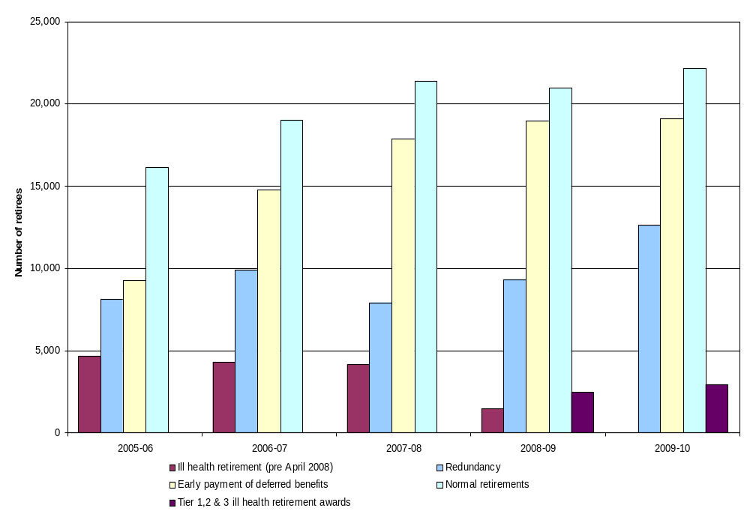

Terminology used in this release

A list of terms relating to local government finance is given in the glossary at Annex G to Local Government Financial Statistics England No. 20 2010. This is accessible at
www.communities.gov.uk/publications/corporate/statistics/financialstatistics202010
The most relevant terms for this release are explained below.

Administering authority
A body responsible for administering a Local Government Pension Scheme fund on behalf of its members who may be drawn from a number of local authorities.

Admitted bodies
Administering authorities may admit employees of non-scheme employers to the scheme under an admission agreement.

Former employees entitled to deferred benefits
Members who leave the scheme having completed the minimum period of service but who are not entitled to the immediate payment of a pension benefit, are awarded a deferred benefit which, under normal circumstances, becomes payable when the person reaches their normal retirement age.

Grant payable on death
This is payable to the estate of a scheme member who dies in service. Prior to 1 April 2008 this was 2 times final pay. Since 1 April 2008, when the Local Government Pension Scheme (Benefits, Membership and Contributions) Regulations 2007 and the Local Government Pension Scheme (Administration) Regulations 2008 came into effect, this has increased to 3 times final pay. This accounts for the significant increase shown in Table 1 for 2008-09 compared to earlier years.

Ill Health retirement
Under the Local Government Pension Scheme (Benefits, Membership and Contributions) Regulations 2007 and the Local Government Pension Scheme (Administration) Regulations 2008 which came into effect on 1 April 2008, there are now three levels of ill-health retirement pension payable. These levels depend on the extent to which the incapacitating condition which gave rise to the termination of employment in local government prevents the scheme member from obtaining gainful employment in the general workforce.

Local Government Pension Scheme
The pension funds in the Local Government Pension Scheme operate under regulations made under the Superannuation Act 1972. Schedules to the regulations list the scheme employers, most of these are local authorities. In England there are 81 pension funds in the Local Government Pension Scheme, each administered by an administering authority.

The assets of the pension funds are for meeting the future pension liabilities of the funds, and are part of the financial corporations sector in the National Accounts, not part of the local government sector. Pensions paid out under the scheme are therefore part of the expenditure of the pension funds, not of the local authorities that administer them. Employers’ and employees’ contributions, part of the income of the funds, are recorded as expenditure by local authorities in their revenue accounts, either directly or indirectly under employees' expenses.

On 1 April 2008, the Local Government Pension Scheme (Benefits, Membership and Contributions) Regulations 2007 and the Local Government Pension Scheme (Administration) Regulations 2008 came into effect. The new Scheme included some new and different provisions which may affect comparison with previous data sets.

Lump sum on retirement
Prior to 1 April 2006-07, scheme members on retirement became entitled to both an annual pension based on 1/80th of pensionable pay for each year of membership and a lump sum of three times that amount. Under the new regulations, entitlement is to a pension only based on a higher accrual rate of 1/60th but with the option to commute pension into lump sum.

Pension arrangements for fire fighters, police and teachers
Separate arrangements apply for the pensions of the police, fire fighters and teachers. The police and fire fighters' pensions are provided through unfunded schemes administered locally, and the cost of police and fire fighters' pensions are therefore included in local authority expenditure. Teachers’ pensions are provided through a notionally funded scheme administered by the Department for Education (DfE). There is no fund of assets, and teachers’ pensions are paid by the DfE. Employers' and employees' contributions are paid by local authorities to the DfE and are recorded as expenditure in their revenue accounts.

It should be noted that non-operational staff in the police, fire and rescue service support staff, and non-teaching staff in the education sector are covered by the Local Government Pension Scheme.

Refunds of contributions
Contributions refunded when a person leaves a pension scheme before completing a minimum period of service. Under earlier schemes, a refund of contributions could be paid to those leaving the scheme with less than 2 years service. Under the 2008 scheme, a refund of contributions can only be made to a person who has been a member of the scheme for less than 3 months.

Transfer Values
A cash value assigned to a person’s pension pot that is transferred with them when they move from one pension fund to another.

Data quality

The information in this release is based on data returned to Communities and Local Government by all 81 administering authorities in England on Local Government Pension Funds and associated information for the financial year 2009-10 (SF3) forms.

Figures are subjected to rigorous pre-defined validation tests both within the form itself, while the form is being completed by the authority and also in Communities and Local Government as the data are received and stored.

Finally, the release document, once prepared, is also subject to intensive peer review before being cleared as fit for the purposes of publication.
Uses made of the data

The data in this statistical release are essential for a number of different purposes. A central and immediate purpose is to provide Ministers with information about the Local Government Pension Scheme. The data are also used by local authorities, their associations and regional bodies.

In addition, the data provides a benchmark on the administration and fund management of the Local Government Pension Scheme. The data are also used in compiling the National Accounts and to show the role of pension funds in the economy.

Background Notes

- Statistical Releases are produced to high professional standards set out in the National Statistics Code of Practice. They undergo regular quality assurance reviews to ensure that they meet customer demands.

- The information for 2009-10 in this Statistical Release is derived from Local Government Pension Scheme Fund (SF3) forms submitted by all 81 Administering Authorities in England only.

- The pension funds in the Local Government Pension Scheme provide pensions for most local authority employees. In England and Wales there are 89 pension funds in the Local Government Pension Scheme. The assets of the pension funds are for meeting the future pension liabilities of the funds, and are part of the financial corporations sector in the National Accounts, not part of the local government sector. Pensions paid out under the scheme are therefore part of the expenditure of the pension funds, not of the local authorities that administer them. Separate arrangements apply for the pensions of the police, fire fighters and teachers.

- For press enquiries about this Statistical Release please contact the Local Government press desk on 0303 444 0444 or email press.office@communities.gsi.gov.uk. For other enquiries please telephone John Farrar on 0303 444 2116 or email sf3.statistics@communities.gsi.gov.uk.

- The responsible statisticians for this release are Steven Melbourne or Mike Young who can be contacted on 0303 444 2116

- This Statistical Release can be found at the following web address:
http://www.communities.gov.uk/localgovernment/localregional/localgovernmentfinance/statistics/pensionscheme/

- Timings of future releases are regularly placed on the Department’s website, www.communities.gov.uk and on the National Statistics website, www.statistics.gov.uk/hub/release-calendar/index.html

- Further information is also available on the department’s website www.communities.gov.uk/localgovernment/localgovernmentfinance/

- For a fuller picture of recent trends in local government finance, readers are directed to Local Government Financial Statistics England No.20 2010 which is available in hard copy from Wetherby Publications Centre at communities@twoten.com (Tel. 0870 1226 236) and electronically from the Communities and Local Government website www.communities.gov.uk/publications/corporate/statistics/financialstatistics192009 .

- In addition to data for England, CLG also collect data for 8 administering authorities in Wales. Data for 2009-10 and comparisons with previous years can be found at:

www.communities.gov.uk/localgovernment/localregional/localgovernmentfinance/statistics/pensionscheme/summarydata/

- The Scottish Government also collect local government pension fund data. Their information can be found at the following website:

www.scotland.gov.uk/Publications/2010/03/23110606/5

Symbols and convention used in this release

 | (R) | = | some data have been revised since the last statistical release
 | … | = | not available
 | – | = | not relevant
 | - | = | negative
 | 0 | = | zero or negligible
 | || | = | discontinuity in data
Rounding
Where figures have been rounded, there may be a slight discrepancy between the total and the sum of constituent items

Department for Communities and Local Government. © Crown Copyright, 2009

October 2010

ISBN: 978-1-4098-2588-3

