Land Use Change Statistics (England) 2009 - provisional estimates (May 2010)



Headlines | 1
Changes on previously-developed land | 2
Density of new dwellings | 3
Changes within the Green Belt | 5
Changes within areas of high flood risk | 6
Land changing to residential use | 7
Changes to developed uses | 8
Strengths and weaknesses of the data | 9
Background notes | 9
Further information | 11

Planning
Statistical Release

May 2010
using
Research
Summary
Number 239, 2007

Land Use Change Statistics (LUCS) are annual data. This release provides the first estimates for 2009 of changes on previously-developed land and the average density of new dwellings. For some topics (see below) 2009 data are not yet robust and so the latest robust data available is presented. This Statistical Release covers information on:
- Changes on previously-developed land  - Density of new dwellings  - Changes within the Green Belt | - Changes within areas of high flood risk  - Land changing to residential use  - Changes to developed uses.
In 2009, on a provisional estimate:
- 80 per cent of dwellings (including conversions) were built on previously-developed land, unchanged from 2008.
- new dwellings were built at an average density of 45 dwellings per hectare, compared to 43 dwellings per hectare in 2008.
In 2008, on a provisional estimate:
- 2 per cent of dwellings were built within the Green Belt (unchanged since 2004) and 7 per cent of land changing to residential use (from any use) was within the Green Belt (an increase from 5 per cent in 2007).
- 9 per cent of dwellings were built within areas of high flood risk (unchanged since 2006) and 6 per cent of land changing to residential use was within areas of high flood risk (unchanged from 2007).

Changes on previously-developed land
The latest national and regional estimates for changes on previously-developed land are for 2009, while the latest local authority estimates are for 2005-08. The land use categories defined as previously-developed can be found in the background notes.
- In 2009, on a provisional estimate, 80 per cent of dwellings (including conversions) were built on previously-developed land. This is unchanged from the 2008 figure.
- Since 1997 the proportion of dwellings (including conversions) built on previously-developed land has increased by 24 percentage points from 56 per cent to 80 per cent, while the proportion of previously-developed land changing to residential use has increased by 21 percentage points from 47 per cent to 68 per cent.
Figure 1: Proportion of new dwellings on previously-developed land and previously-developed residential land, 1989 to 2009
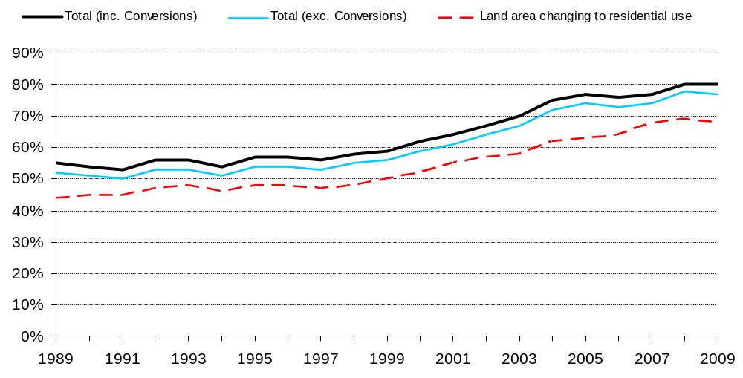
- Compared to 2003, in 2008 every region except London showed an increase in the proportion of dwellings (including conversions) built on previously-developed land (see Figure 2).
- London has the greatest proportion of dwellings (including conversions) built on previously-developed land (95 per cent in 2008), whereas the East of England has the smallest proportion (68 per cent in 2008).

Figure 2: Proportion of dwellings on previously-developed land, by region, 2003 and 2008
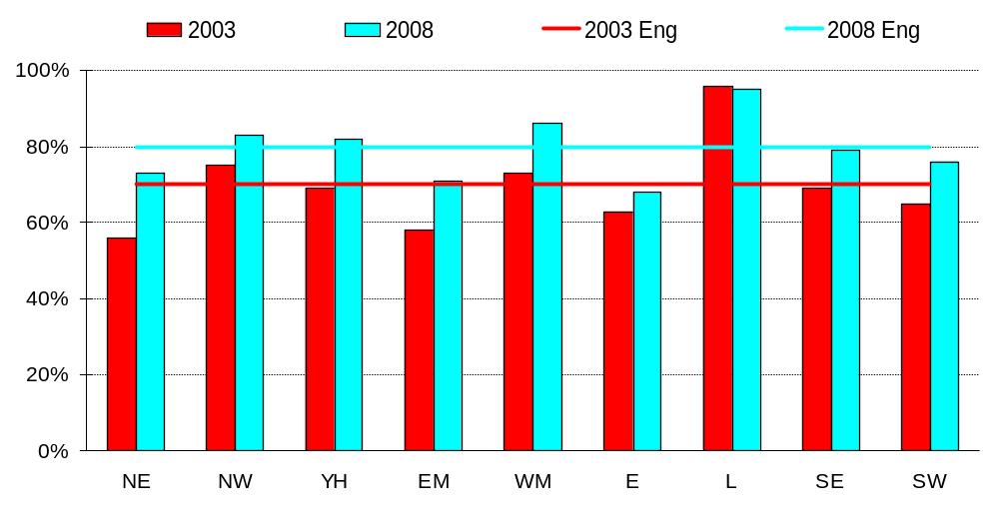
Detailed statistics on changes on previously-developed land (including data at a local authority level) can be found in the Land Use Change Statistics Live Tables¹, numbers 211 to 213.
Density of new dwellings
The latest national estimates for the density of new dwellings are for 2009, while the latest regional estimates are for 2008. Density is measured in dwellings per hectare. PSA6 (from the 2004 Spending Review) stated that, by 2008, new housing development in each region should avoid developments of less than 30 dwellings per hectare and encourage those between 30 to 50 dwellings per hectare.
- In 2009, on a provisional estimate, new dwellings were built at an average density of 45 dwellings per hectare, an increase from the 2008 estimate of 43 dwellings per hectare. The density of new dwellings has increased by 80 per cent between 2001 (when it stood at 25 dwellings per hectare) and 2009 (see Figure 3).
- In 2009, on a provisional estimate, new dwellings on previously-developed land were built at an average density of 51 dwellings per hectare, compared to 49 dwellings per hectare in 2008.
- In 2009, on a provisional estimate, new dwellings on non previously-developed land were built at an average density of 32 dwellings per hectare, compared to 31 dwellings per hectare in 2008.
Figure 3: Density of new dwellings, by previous land type, 1989 to 2009
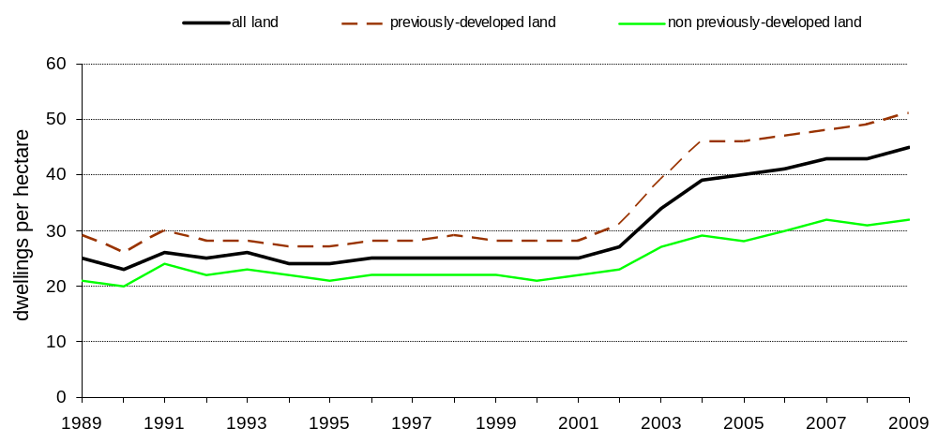
- Compared to 2000, in 2008 every region showed an increase in the density of new dwellings (see Figure 4).
- London showed the greatest percentage increase (116 per cent) over this period. Density in London increased from 56 to 121 dwellings per hectare.
- The South West showed the smallest percentage increase (44 per cent) in density over this period, increasing from 25 to 36 dwellings per hectare.

Figure 4: Density of new dwellings, by region, 2000, 2003 and 2008
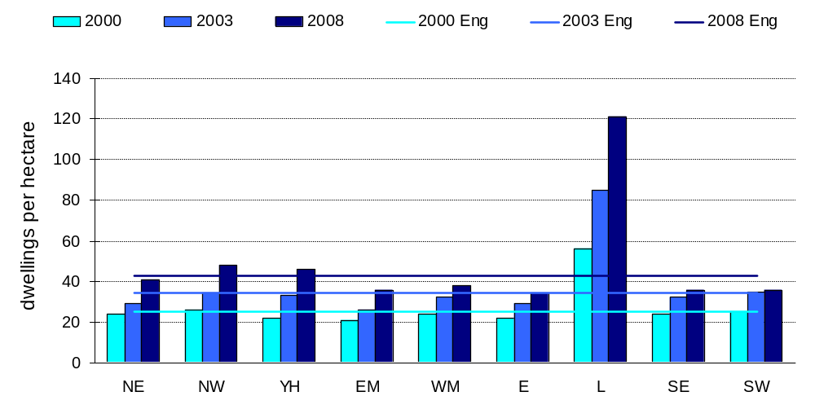
Detailed statistics on the average density of new dwellings (including data at a local authority level) can be found in the Land Use Change Statistics Live Tables¹, numbers 231 to 232.
Changes within the Green Belt⁴
The latest estimates for changes within the Green Belt are for 2008².
- In 2008 on a provisional estimate, 2 per cent of dwellings were built within the Green Belt. This percentage has remained unchanged since 2004 (see Figure 5).
- In 2008, on a provisional estimate, 7 per cent of land changing to residential use was within the Green Belt. This figure has increased by 2 percentage points since 2007 (see Figure 5).
- In 2008, on a provisional estimate, 72 per cent of dwellings built within the Green Belt were built on previously-developed land. This compares to 77 per cent in 2007, 79 per cent in 2006 and 69 per cent in 2005.
- In 2007 42 per cent of land changing to a developed use within the Green Belt was previously-developed. This compares to 44 per cent in 2006.

Figure 5: Proportion of new dwellings built and land changing to residential use within the Green Belt, 1989 to 2008
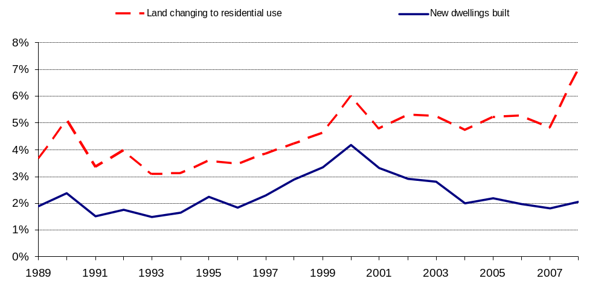
Detailed statistics on changes within the Green Belt can be found in the Land Use Change Statistics Live Tables¹, numbers 241 to 246.
Changes within areas of high flood risk⁵
The latest estimates for changes within high flood risk areas are for 2008.
- In 2008, on a provisional estimate, 9 per cent of new dwellings were built within areas of high flood risk⁵. This has remained unchanged since 2006.
- In 2008, on a provisional estimate, 6 per cent of land changing to residential use was within areas of high flood risk⁵. This is unchanged from 2007.

Figure 6: Proportion of new dwellings built and land changing to residential use within areas of high flood risk⁵, 1989 to 2008
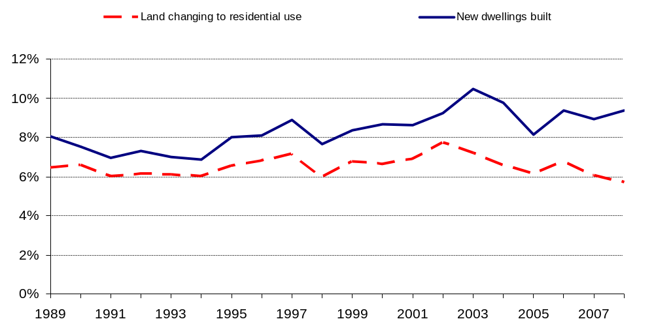
Detailed statistics on changes within areas of high flood risk can be found on the Land Use Change Statistics Live Tables¹, numbers 251 to 252.
Land changing to residential use
Most of the latest figures for land changing to residential use are for 2008. There are 24 land use categories used in LUCS³ and 58 per cent of dwellings were built on land previously classed as residential, agricultural, "vacant" or "derelict" in 2008. The remaining 42 per cent of dwellings were built on land previously classed as one of the remaining 20 land use categories.
- In 2008, on a provisional estimate, 24 per cent of dwellings were built on previously-residential land³. This compares to 27 per cent in 2007.
- In 2008, on a provisional estimate, 12 per cent of dwellings were built on previously-agricultural land³. This compares to 14 per cent in 2007.
- In 2008, on a provisional estimate, 23 per cent of dwellings were built on previously-developed vacant or derelict land³. This compares to 24 per cent in 2007.

Figure 7: Proportion of new dwellings built on previously-residential, agricultural and vacant or derelict land, 1989 to 2008
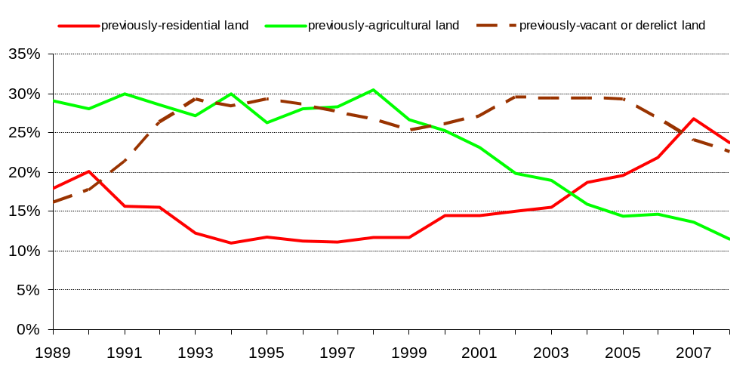
Detailed statistics on land changing to residential use can be found in the Land Use Change Statistics Live Tables¹, numbers 221 to 226.
Changes to developed uses
The latest figures for changes to developed uses are for 2007².
- In 2007, on a provisional estimate 55 per cent of land changing to a developed use was previously-developed, while 35 per cent was previously agricultural land³ or agricultural buildings³.
- In 2004-2007 an average of 57 per cent of land changing to Industry and Commerce³ was previously developed.
Detailed statistics on changes to developed uses can be found in the Land Use Change Statistics Live Tables¹, numbers 261 to 265.

Strengths and weaknesses of the data
These statistics are based on changes in land use recorded for Communities and Local Government by Ordnance Survey during their map revision work between 1985 and December 2009. They relate to the new and previous uses of the land. This means the data set for each year is, eventually, very comprehensive. However there is a time-lag between a land use change occurring and it being recorded. Thus, figures are liable to revision. Estimates for 2009 contained in this statistical release are provisional and will be revised in future releases.
Because of this time-lag some series take longer to become robust than others, and hence are not published as quickly. Thus, statistics showing area (in hectares) are published later than the corresponding percentages and regional figures are sometimes published later than the national total of the same series.
Local Authority data are only published as a four year average. At this level investigation has shown that annual figures are highly volatile and not robust.
For further information please see the LUCS Guidance, which is available here.
Background notes
1. Live Tables give further detail and regional breakdowns of the key results presented in this statistical release. They are available here.

2. The time-lag in LUCS data (see strengths and weaknesses of the data above) means that some regional data are published later than the national figure for that series. It also means that some series based on smaller geographies, such as Green Belt or areas of high flood risk, are published later than other series while Local Authority data are published as a four year average. Series measuring areas (in hectares) are also affected.

3. The land use categories used in compiling LUCS data are shown below in Table BN1. For full details on what are included in these groups and categories please refer to the LUCS Guidance.

Table BN1: Land use categories, groups and divisions.
Previously developed land |  |  |  |  | Non-previously developed land
Group |  | Category (codes) |  |  | Group |  | Category (codes)
Residential | • | Residential | (R) |  | Agriculture | • | Agricultural land | (A)
 | • | Institutional and communal | (Q) |  |  | • | Agricultural buildings | (B)
 |  | accommodation
 |  |  |  |  | Forestry, open | • | Forestry and woodland | (F)
Transport and | • | Highways and road transport | (H) |  | land and water | • | Rough grassland and | (G)
Utilities | • | Transport (other) | (T) |  |  |  | Bracken
 | • | Utilities | (U) |  |  | • | Natural and semi-natural | (N)
 |  |  |  |  |  |  | Land
Industry and | • | Industry | (I) |  |  | • | Water | (W)
Commerce | • | Offices | (J)
 | • | Retailing | (K) |  | Outdoor | • | Outdoor recreation | (O)
 | • | Storage and warehousing | (S) |  | recreation
Community | • | Community buildings | (C) |  | Vacant | • | Urban land not previously | (X)
Services | • | Leisure and recreational | (L) |  |  |  | developed³
 |  | buildings
Vacant | • | Vacant land previously | (V)
 |  | developed
 | • | Derelict land | (Z)
Minerals and | • | Minerals² | (M)
landfill¹ | • | Landfill waste disposal² | (Y)
Defence | • | Defence² | (D)
Notes:
Unless otherwise stated, ‘previously developed land’ corresponds with ‘urban land use’ and ‘non-previously developed land’ with ‘rural land use’.
1. Some mineral and landfill sites may be classed as non-previously developed land (see 4.4)
2. Classified as ‘rural’ land use
3. Classified as ‘urban’ land use

4. The Green Belt covers approximately 13 per cent of the land area of England. Change of land use, including to a developed use, does not mean the removal of the land from the Designated Green Belt. Land can only be removed from the Green Belt through the local planning process.

5. The flood risk analysis in LUCS is based on annually updated data sets of digitised boundaries provided by the Environment Agency. The areas of high flood risk used cover approximately ten per cent of England. They reflect the river and coastal floodplains and provide indicative flood risk areas. They are areas estimated to be at risk of at least a one in one hundred chance of flooding each year from river areas or at least a one in two hundred chance of flooding from the sea. These are approximate boundaries and do not take into account any flood defences.

6. National Statistics are produced to high professional standards set out in the National Statistics Code of Practice. They undergo regular quality assurance reviews to ensure they meet customer needs.

7. Details of officials who receive pre-release access to LUCS up to 24 hours before release can be found at: http://www.communities.gov.uk/documents/statistics/pdf/1131535.pdf
8. The next LUCS release in July 2010 will contain updated provisional estimates for 2009.
Further information
Media Enquiries
email: press@communities.gsi.gov.uk
office hours: 0303 444 1156
out of hours: 0303 444 1051
Public Enquiries
email: lucs@communities.gsi.gov.uk
telephone: 0303 444 2280
Responsible Statistician
Grant Kelly
email: lucs@communities.gsi.gov.uk

Department for Communities and Local Government. © Crown Copyright, 2010

If you require this publication in an alternative format please email: alternativeformats@communities.gsi.gov.uk. Please note that the nature of content means that we may not be able to provide the Statistical series of publications in all requested formats.

May 2010

ISBN: 978-1-4098-2458-9

