Net supply of housing: 2009-10, England

Contents
1. | National trends in housing supply…….......................... | 2
2. | Breakdown of net housing supply…….......................... | 3
3. | Regional trends in housing supply…….......................... | 4
4. | Data collection…………….. | 7
5. | Strengths and weaknesses of the data…………………. | 7
6. | Related statistics………….. | 8
7. | Revisions policy..…………. | 9
8. | Definitions………………….. | 10
9. | Accompanying tables…….. | 10
10. | Background notes…………. | 11
11. | User consultation…………. | 12
12. | Enquiries…………………… | 12

Responsible statistician:
Richard Field

Media Enquiries:
office hours: 0303 444 1136
out of hours: 0303 444 1201

press@communities.gov.uk

Statistical enquiries:
office hours: 0303 444 2272
housing.statistics@communities.gov.uk

Housing
Statistical Release

October 2010
using
Research
Summary
Number 239, 2007

- Annual housing supply in England reached 128,680 net additional dwellings in 2009-10. This is a 23 per cent decrease on the 166,570 net additional homes supplied in the previous year, and the lowest annual level of net housing supply since 2000-01.
- In 2009-10 97 per cent of net additional dwellings were accounted for by new build completions, similar to last year when new build completions comprised 95 per cent of net additional dwellings.
- Fewer net additional dwellings were supplied in the 2009-10 financial year than in the previous year in every English region. The North West saw the largest annual decrease (38 per cent), followed by the South East (32 per cent).
This Statistical Release presents figures on net additional dwellings in England and its regions up to 2009-10.

Annual net housing supply, also referred to as net additional dwellings, measures the absolute change in the dwelling stock between 1 April and 31 March the following year. The absolute change in the dwelling stock is the number of new house building completions plus any gains or losses through conversions, demolitions and changes of use.

National trends in housing supply

Figure 1: Trends in net additional dwellings 2000-01 to 2009-10, England
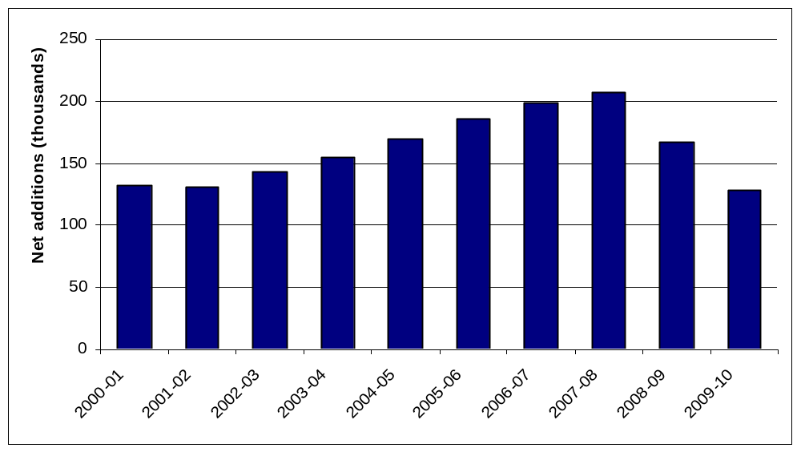

Table 1: Annual net additional dwellings 2000- 01 to 2009-10, England
Financial year | England | % change to previous year
2000-01 | 132,000 | -
2001-02 | 130,510 | -1%
2002-03 | 143,680 | 10%
2003-04 | 154,770 | 8%
2004-05 | 169,450 | 9%
2005-06 | 186,380 | 10%
2006-07 | 198,770 | 7%
2007-08 | 207,370 | 4%
2008-09 | 166,570 | -20%
2009-10 | 128,680 | -23%
After falling slightly between 2000-01 and 2001-02, net housing supply increased for six consecutive years, reaching a peak of 207,370 net additional dwellings in 2007-08 before falling to 166,570 in 2008-09. In 2009-10 net supply fell again to 128,680, a decrease of 23 per cent compared to 2008-09. This is the lowest annual level of net housing supply since this data collection began in 2000-01.
Breakdown of net housing supply
Table 2: Components of net housing supply, 2006-07 to 2009-10, England
Components of net housing supply | 2006-07 | 2007-08 | 2008-09 | 2009-10 | Change 2008-09 to 2009-10
New build completions | 193,080 | 200,300 | 157,630 | 124,200 | -33,430
plus
Net conversions | 7,600 | 9,020 | 8,640 | 6,230 | -2,400
plus
Net change of use | 20,150 | 17,640 | 16,640 | 13,600 | -3,030
plus
Net other gains | 460 | 1,020 | 270 | 970 | 700
less
Demolitions | 22,290 | 20,500 | 16,590 | 16,330 | -270
gives
Net additional dwellings | 198,770 | 207,370 | 166,570 | 128,680 | -37,900

In 2009-10 97 per cent of net additional dwellings were accounted for by new build completions, this is two percentage points more than in the previous year. The next largest components of net additional dwellings were demolitions (minus 13 per cent) and the net change of non-residential buildings brought into residential use (11 per cent).
Figure 2: Components of net additions 2009-10, England
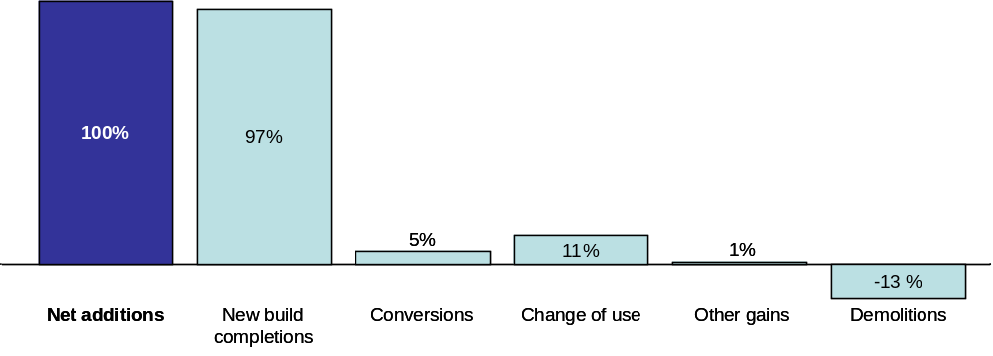

Net housing supply decreased by 23 per cent (37,900 dwellings) between 2008-09 and 2009-10. This fall was driven by decreases in the numbers of new build completions (-33,430), net conversions (-2,400) and the number of additional dwellings resulting from changes of use (-3,030) but marginally offset by an increase in net gains of other types of dwellings such as mobile homes and temporary dwellings (700) and a fall in the number of demolitions (-270).
Regional trends in housing supply
All English regions experienced a decrease in the number of net additional dwellings supplied in the 2009-10 financial year compared with the previous year. The North West experienced the largest proportional annual decrease (38 per cent), followed by the South East (32 per cent), but in numerical terms the largest decrease was in the South East where 10,240 fewer new homes were supplied in 2009-10 than in 2008-09. The East Midlands and the North East experienced the lowest annual decrease in 2009-10 (ten per cent and 13 per cent respectively).
Figure 3a: Trends in net additional dwellings in the North East, the North West and Yorkshire and the Humber.
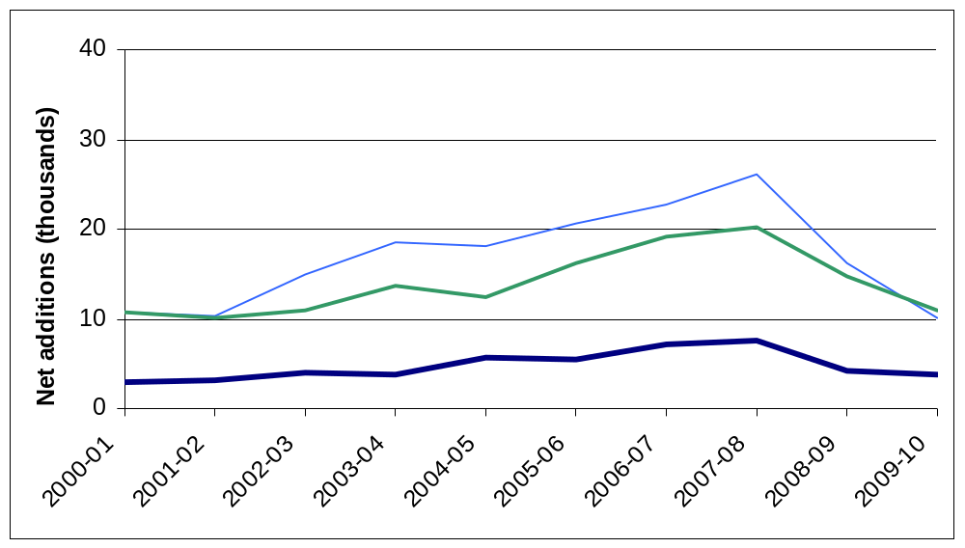
Figure 3b: Trends in net additional dwellings in the East Midlands, the West Midlands and the East of England.
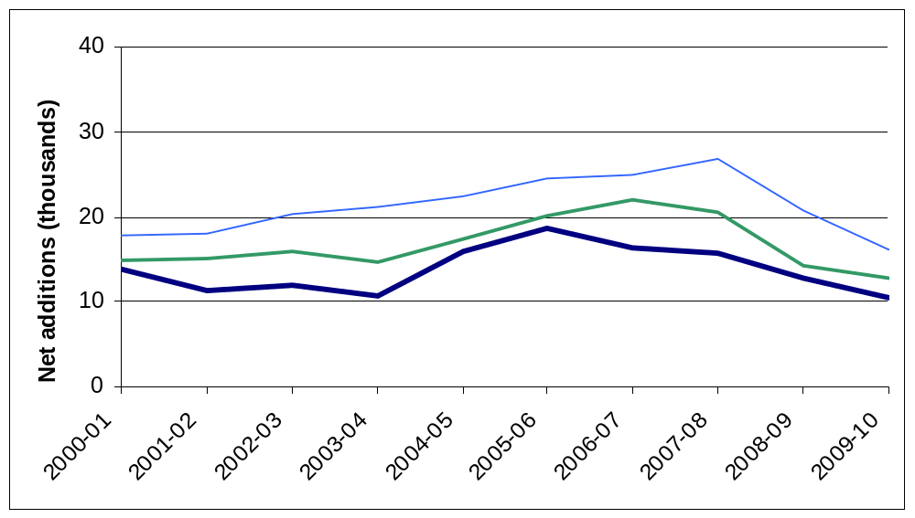
Figure 3c: Trends in net additional dwellings in London, the South East and the South West.
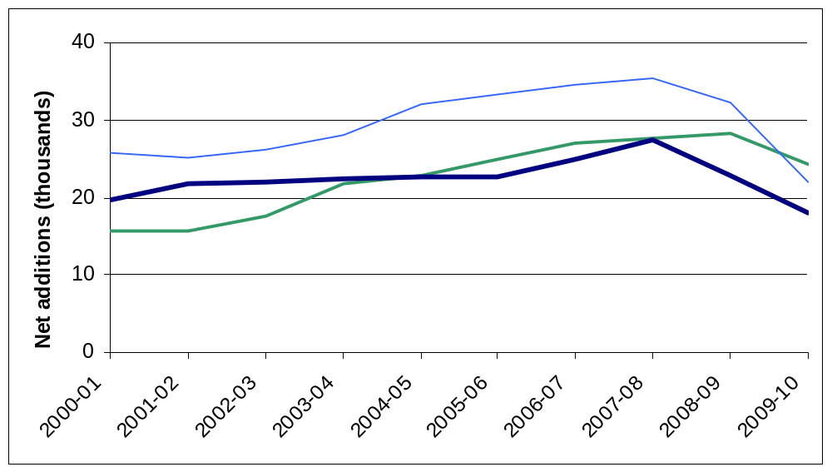
In 2009-10 six regions experienced the lowest levels of annual net housing supply since this data collection began in 2000-01. Only in the North East, Yorkshire and the Humber and London was annual net housing supply still higher than in 2000-01. (See figures 3a, 3b and 3c below).
In 2009-10, net housing supply was highest in London (24,340 dwellings) and lowest in the North East (3,740 dwellings).
Table 3: Components of net supply by region, 2009-10
Region | New build completions |  | Net conversions |  | Net change of use |  | Net other gains |  | Demolitions |  | Net  additional dwellings
 | Units | % of total net supply | Units | % of total net supply | Units | % of total net supply | Units | % of total net supply | Units | % of total net supply
North East | 5,080 | 136% | 110 | 3% | 420 | 11% | 10 | 0% | - 1,880 | - 50% | 3,740
North West | 12,330 | 122% | 360 | 4% | 1,480 | 15% | 30 | 0% | - 4,050 | - 40% | 10,140
Yorks & Humber | 10,570 | 96% | 450 | 4% | 1,230 | 11% | 850 | 8% | - 2,060 | - 19% | 11,030
East Midlands | 11,990 | 94% | 280 | 2% | 1,260 | 10% | -60 | 0% | - 680 | - 5% | 12,790
West Midlands | 11,180 | 107% | 240 | 2% | 1,250 | 12% | 30 | 0% | - 2,260 | - 22% | 10,440
East | 15,270 | 94% | 420 | 3% | 1,220 | 8% | 100 | 1% | - 800 | - 5% | 16,220
London | 21,340 | 88% | 2,120 | 9% | 2,780 | 11% | 0 | 0% | - 1,890 | - 8% | 24,340
South East | 20,760 | 94% | 1,250 | 6% | 1,910 | 9% | 30 | 0% | - 1,870 | - 8% | 22,080
South West | 15,700 | 88% | 1,010 | 6% | 2,070 | 12% | -20 | 0% | - 840 | - 5% | 17,910
England | 124,200 | 97% | 6,230 | 5% | 13,600 | 11% | 970 | 1% | - 16,330 | - 13% | 128,680
New build completions as a percentage of net additional dwellings were the highest in the North East (136 per cent) followed by the North West (122 per cent). London and the South West had the lowest percentages of new build completions as a percentage of net additional dwellings (both 88 per cent). At England level, 97 per cent of net additions to dwellings were accounted for by new build completions.
Demolitions as a percentage of net additional dwellings were the highest in the North East (minus 50 per cent) followed by the North West (minus 40 per cent). The East Midlands, East of England and the South West had the lowest percentages of demolitions as a percentage of net additional dwellings (minus five per cent). This compares to minus 13 per cent demolitions as a percentage of net additional dwellings at England level.
Figure 4a: Net additions as a proportion of England total by region, 2009-10
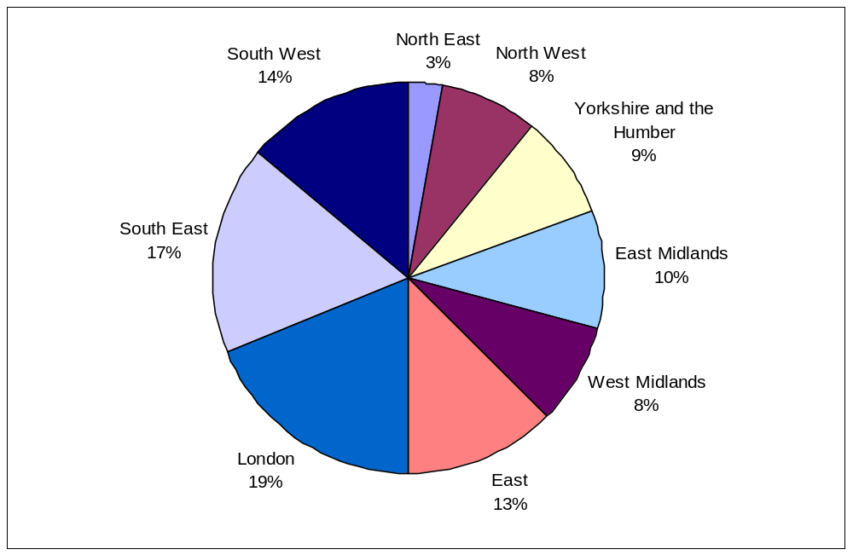
Figure 4b: New build completions as a proportion of England total by region, 2009-10 |  | Figure 4c: Demolitions as a proportion of England total by region, 2009-10
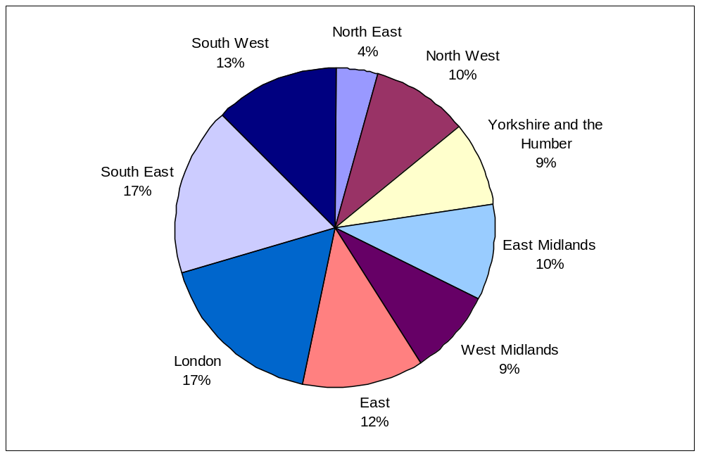 |  | 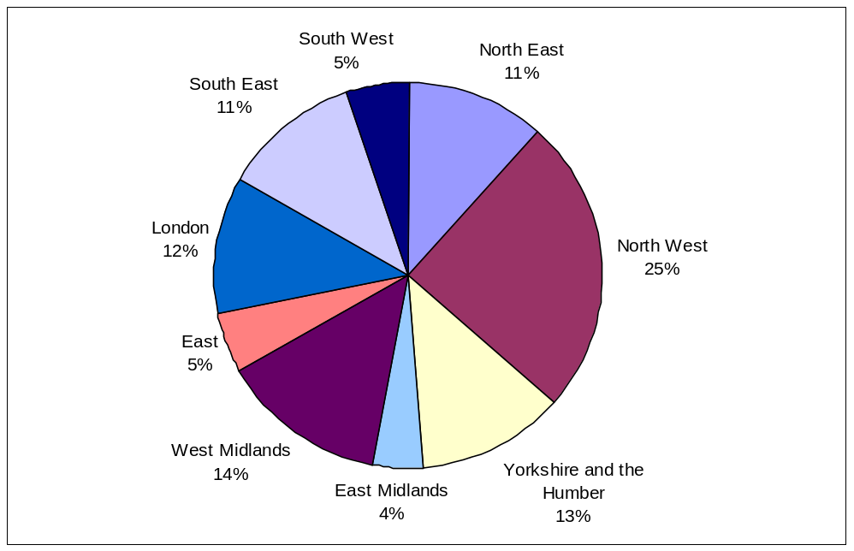
Compared to the other regions the South East and London accounted for the largest share of new build completions (17 per cent each), while the North East accounted for the smallest (4 per cent).
Compared to the other regions the North West had the highest percentage share of demolitions in England in 2009-10 (25 per cent), followed by the West Midlands (14 per cent). The East Midlands had the lowest percentage of demolitions (four per cent).

Data collection
This release takes annual figures on net housing supply in England from two data sources:
- information submitted to Communities and Local Government (CLG) by local authorities in all regions except London through the Housing Flows Reconciliation (HFR) form; and
- information collected by the Greater London Authority (GLA) for London Boroughs.
From 2000-01 to 2003-04, all local authorities submitted data to Communities and Local Government through the HFR form. Between 2004-05 and 2008-09, Communities and Local Government worked jointly with Regional Planning Bodies in some regions on joint returns to ensure consistency between the net housing supply figures reported at various geographical levels.
In 2010 the abolition of Regional Planning Bodies prompted a return to submission through the HFR for all local authorities outside London. Because of the unique status of the GLA, London Boroughs continue to supply their data through the GLA. Users should note that the London figures are provisional at this stage and may be subject to change before they are reported in the GLA’s Annual Monitoring Report in February 2011. Local authorities have until early September, five months after the end of the financial year, to complete the HFR form.
This change to the data collection process has enabled Communities and Local Government to publish the net supply of housing statistical release for 2009-10 four months earlier than in previous years.

Strengths and weaknesses of the data
The HFR form collects data from local authorities in eight regions and the figures include imputation for a small number of missing returns. In 2009-10, a 96 per cent response rate was achieved. Only 14 out of the 293 English local authorities who submit through the HFR did not finalise their return. Imputations for these 14 local authorities account for 2.6 per cent of the total net additions figure for 2009-10.
For imputation the ratio of the number of house building completions on quarterly P2 house building returns to the net additions figure was calculated at regional level, using data from all local authorities that finalised their 2009-10 HFR return. For local authorities which failed to submit a HFR return, these ratios were applied to their number of house building completions reported on their P2 quarterly house building return for 2009/10.
The response rates shown in table 4 are the sum of the responses to both the HFR and the joint returns. The percentage represents the number of finalised returns received by Communities and Local Government, although some may not contain all of the requested data.

Table 4: Overall response rates
2006-07 | 97%
2007-08 | 99%
2008-09 | 98%
2009-10 | 96%
The HFR return requires local authorities to submit a full break down of housing flows by tenure over the previous year; this includes figures for new house building, conversions, demolitions, changes of use and transfers between tenures.
The GLA collects, collates and validates data from London Boroughs before passing the information on to Communities and Local Government. This return does not contain the same depth of information on housing flows as collected directly from local authorities through the HFR form, for example it does not supply a breakdown by tenure. The response rate from London boroughs for the 2009-10 financial year was 100 per cent.

Net supply statistics provide a more complete picture of new build completions than Communities and Local Government’s quarterly release on new house building. In contrast to the data in the quarterly house building release, new build completions in the net supply statistics include dwellings inspected by Independent Approved Inspectors as well as by the NHBC and local authority building control. In addition, the data collection period for net supply to dwelling stock is much longer, giving data suppliers more time to assemble the information.

Related statistics
House building starts and completions
New house building completions are largest component of net housing supply. Communities and Local Government also publish a quarterly series on new build starts and completions based on quarterly returns by local authorities and the National House-Building Council (NHBC). This quarterly house building completions statistic is a key leading indicator for the annual net additions to dwelling stock figure in this release.
Links to the latest house building quarterly releases can be found at
http://www.communities.gov.uk/housing/housingresearch/housingstatistics/housingstatisticsby/housebuilding/publicationsonhousebuilding/.

Dwelling stock estimates
Communities and Local Government also publish statistics showing the total dwelling stock in England each year. These estimates are based on the latest census count plus the annual Net supply of housing statistics shown in this release. They can be found at the following link.
http://www.communities.gov.uk/publications/corporate/statistics/housingstock2009.

Affordable housing
Communities and Local Government’s annual Affordable housing supply statistics can be found at the following link. The affordable housing supply statistics include both new build supply and acquisitions for social rent and low cost home ownership. http://www.communities.gov.uk/housing/housingresearch/housingstatistics/housingstatisticsby/affordablehousingsupply/.

Devolved administrations
The Scottish Government does not publish a similar series on net supply to dwelling stock, but time series showing demolitions and conversions in Scotland are available. These series were last updated in August 2010 and show demolitions and conversions data at local authority level up to 2009-10.
http://www.scotland.gov.uk/Topics/Statistics/Browse/Housing-Regeneration/HSfS/ConDem.
Northern Ireland and Wales do not publish net supply statistics in the same format as Communities and Local Government, but they do publish annual stock statistics calculated using net supply to dwelling stock data. The Northern Ireland and Welsh stock statistics can be found at http://www.dsdni.gov.uk/index/stats_and_research/stats-publications/stats-housing-publications/housing_stats.htm and http://wales.gov.uk/topics/statistics/headlines/housing2010/100401/?lang=en respectively.

Revisions policy
This policy has been developed in accordance with the UK Statistics Authority Code of Practice for Official statistics and the Communities and Local Government Revisions Policy. There are two types of revisions that the policy covers.

Scheduled Revisions
Local authorities may not revise the data they supply for these statistics after the original deadline for submission as this is an annual series with a relatively long data collection period. The exception is London, for which the figures in this release are currently provisional. If the GLA make any changes to these before they are published in the GLA Annual Monitoring Report they will be incorporated in the next Net supply of housing release.
These statistics are compared against the census on its release every ten years to ensure that the sum of net additions over that period matches the difference between the latest census dwelling count and the previous one. The net additions figures are then adjusted, with any difference spread evenly across the ten years since the previous census. When this adjustment was carried out following the 2001 census it amounted to around 8,000 dwellings per year at the England level.

Non-Scheduled Revisions
Where a substantial error has occurred as a result of the compilation, imputation or dissemination process, the statistical release, live tables and other accompanying releases will be updated with a correction notice as soon as is practical.

Definitions
Completion – A dwelling is regarded as completed when it becomes ready for occupation or when a completion certificate is issued whether it is in fact occupied or not. In practice, there are instances where the timing could be delayed and some completions are missed for example as no completion certificate is was requested by the owner.
Conversion – A conversion is a conversion of one dwelling into multiple dwellings, or vice versa.
Change of use – This is the changing of a residential dwelling to non-residential use, or changing a non-residential building to residential use.
GLA – The Greater London Authority.
HFR – The Housing Flows Reconciliation is an annual data collection where local authorities report net additional dwellings within their boundaries directly to Communities and Local Government. In 2010 all local authorities except for the London Boroughs were asked to submit their data through the HFR.
Net additional dwellings - A measure of the absolute change in dwelling stock between 1 April and 31 March of the following year. The absolute change in the dwelling stock is the number of new house building completions plus any gains or losses through conversions, demolitions and changes of use (also referred to as net housing supply).

Accompanying tables and charts
Tables and charts accompanying this release are available to download alongside this release. Tables and charts are provided in MS Excel. Sources are shown at the foot of individual tables and charts and all figures are presented rounded to the nearest 10 dwellings.

Tables:
1a Annual net additional dwellings: England and the regions, 2000-01 to 2009-10;
1b Annual net additional dwellings and annual percentage change: England and the regions, 2000-01 to 2009-10;
1c Components of net housing supply: England, 2006-07 to 2009-10;
1d Components of net housing supply: by region, 2009-10;
1e Net additional dwellings: by local authority district, 2004-05 to 2009-10.

Charts:
2a Trends in net additional dwellings: England, 2000-01 to 2009-10;
2b Trends in net additional dwellings: the regions, 2000-01 to 2009-10.

In addition, four live tables showing net additions to the dwelling stock in England can be accessed in the 'Live tables' section ("Live tables on stock")

Table 118: Annual net additional dwellings: England and the regions, 2000-01 to 2009-10;

Table 120: Components of net housing supply: England, 2006-07 to 2009-10;

Table 121: Components of net housing supply: by region, 2009-10;

Table 122: Net additional dwellings: by local authority district, 2004-05 to 2009-10

at www.communities.gov.uk/housingstatistics.

Notes to the tables
The following conventions have been used in the tables:
.. Not available;
- Fewer than five dwellings;
^{P} Figure provisional and subject to revision;
^{R} Revised from previous release.

Background notes
- Prior to 2000-01 it had been possible to make estimates of annual net supply since the late 1960s simply by looking at changes in annually-produced housing stock figures. In 2000-01 a new data collection was introduced to improve estimates of net supply and collect information on the components of supply.
- For the 2009-10 financial year eight out of the nine regions used the HFR to submit their net supply data to Communities and Local Government. These HFR returns provide a tenure breakdown; we are currently investigating whether the completeness and quality of these tenure data are adequate to allow the production and publication of a tenure breakdown for net supply of housing statistics.
- Missing local authority HFR returns for 2009-10 have been imputed using data from Communities and Local Government’s quarterly house building statistics.
- Details of officials who receive pre-release access to the Communities and Local Government annual ‘Net Supply of Housing’ release up to 24 hours before release can be found at:
http://www.communities.gov.uk/corporate/researchandstatistics/statistics/nationalstatistics/
- The next net additions release is provisionally scheduled for autumn 2011 and will include net additional dwellings up to 2010-11.
User consultation
Users’ comments on any issues relating to this statistical release are welcomed and encouraged. Responses should be addressed to the "statistical enquiries" contact given in the "Enquiries" section below.
Enquiries

Media Enquiries:
office hours: 0303 44 41136
out of hours: 0303 44 41201
e-mail: press@communities.gov.uk

Statistical enquiries:
e-mail: housing.statistics@communities.gov.uk telephone: 0303 44 42272
Department for Communities and Local Government. © Crown Copyright, 2010

If you require this publication in an alternative format please email: alternativeformats@communities.gsi.gov.uk. Please note that the nature of content means that we may not be able to provide the Statistical series of publications in all requested formats.

October 2010

ISBN: 978-1-4098-2595-1

