Net supply of housing: 2010-11, England


Contents
1. | National trends in housing supply……......................... | 2
2. | Breakdown of net housing supply……......................... | 3
3. | Sub-national trends…….... | 5
4. | Data collection……………. | 11
5. | Data quality……………….. | 11
6. | Related statistics…………. | 12
7. | Revisions policy..………… | 14
8. | Definitions…………………. | 15
9. | Accompanying tables……. | 16
10. | Background notes………… | 16
11. | User consultation………… | 17
12. | Enquiries………………… | 17

Responsible statistician:
Richard Field

Media Enquiries:
office hours: 0303 444 1136
out of hours: 0303 444 1201

press@communities.gov.uk

Statistical enquiries:
office hours: 0303 444 2345
housing.statistics@communities.gov.uk

Housing
Statistical Release

2 November 2011
using
Research
Summary
Number 239, 2007

- Annual housing supply in England amounted to 121,200 net additional dwellings in 2010-11. This is a six per cent decrease on the 128,680 net additional homes supplied in the previous year, and compares with a 23 per cent fall between 2008-09 and 2009-10.
- The 121,200 net additions figure for 2010-11 is composed of 117,700 new build homes, 5,050 additional homes resulting from conversions, 11,540 additional homes resulting from change of use, 1,810 other gains and a loss of 14,890 homes through demolitions.
- London saw the largest decrease (27 per cent), falling from 24,340 net additional homes in 2009-10 to 17,830 in 2010-11, and the North West showed the next largest decrease (16 per cent). The North East saw the largest increase (26 per cent), from 3,740 in 2009-10 to 4,710 in 2010-11, and the East of England showed the next largest increase (five per cent). Similar numbers of new homes were added in Yorkshire and Humber, the West Midlands, the South East and South West in 2010-11 as in 2009-10.

This annual Statistical Release presents figures on the net supply of housing in England and its regions up to 2010-11. Net supply of housing, also referred to as net additional dwellings, measures the absolute change in the dwelling stock between 1st April and 31st March the following year. The absolute change in the dwelling stock is the number of house building completions plus any gains or losses through conversions and changes of use, minus demolitions. Definitions of these terms are given in the ‘Definitions’ section of this publication.
These statistics are one of two complementary statistical series on housing supply in England published by the Department for Communities and Local Government, the other being the quarterly House Building statistics. A description of the relationship between these two series can be found in the ‘Related statistics’ section of this publication.

National trends in housing supply

Figure 1: Trends in net additional dwellings 2000-01 to 2010-11, England
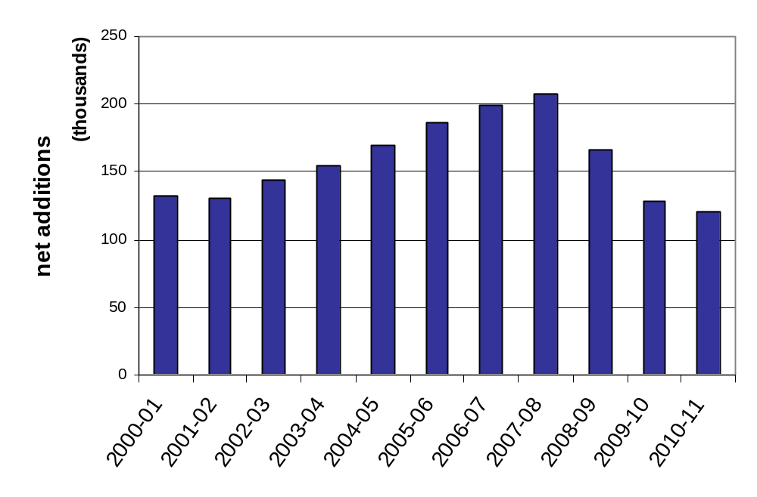
After falling slightly between 2000-01 and 2001-02, net housing supply increased for six consecutive years, reaching a peak of 207,370 net additional dwellings in 2007-08 before falling to 166,570 in 2008-09. In 2009-10 net supply fell again to 128,680, a decrease of 23 per cent compared to the previous year. In 2010-11 the level fell to 121,200, equating to a six per cent decrease on 2009-10.

Table 1: Annual net additional dwellings 2000-01 to 2010-11, England

Financial year | England | % change from  previous year
2000-01 | 132,000
2001-02 | 130,510 | -1%
2002-03 | 143,680 | 10%
2003-04 | 154,770 | 8%
2004-05 | 169,450 | 9%
2005-06 | 186,380 | 10%
2006-07 | 198,770 | 7%
2007-08 | 207,370 | 4%
2008-09 | 166,570 | -20%
2009-10 | 128,680 | -23%
2010-11 | 121,200 | -6%

Breakdown of net housing supply
Table 2: Components of net housing supply, 2007-08 to 2010-11, England
Components of  net housing supply | 2007-08 | 2008-09 | 2009-10 | 2010-11 | Change 2009-10 to 2010-11
New build completions | 200,300 | 157,630 | 124,200 | 117,700 | -6,500
plus
Net conversions | 9,020 | 8,640 | 6,230 | 5,050 | -1,180
plus
Net change of use | 17,640 | 16,640 | 13,600 | 11,540 | -2,060
plus
Net other gains | 1,020 | 270 | 970 | 1,810 | 840
less
Demolitions | 20,500 | 16,590 | 16,330 | 14,890 | -1,440
gives
Net additional dwellings | 207,370 | 166,570 | 128,680 | 121,200 | -7,480

Net housing supply decreased by six per cent (7,480 dwellings) between 2009-10 and 2010-11. This fall resulted from decreases in the numbers of new build completions (-6,500), net conversions (-1,180) and the number of additional dwellings resulting from changes of use (-2,060) but marginally offset by an increase in net gains of other types of dwellings such as mobile homes and temporary dwellings (840) and a fall in the number of demolitions (-1,440).
Figure 2: Components of net additions 2010-11, England
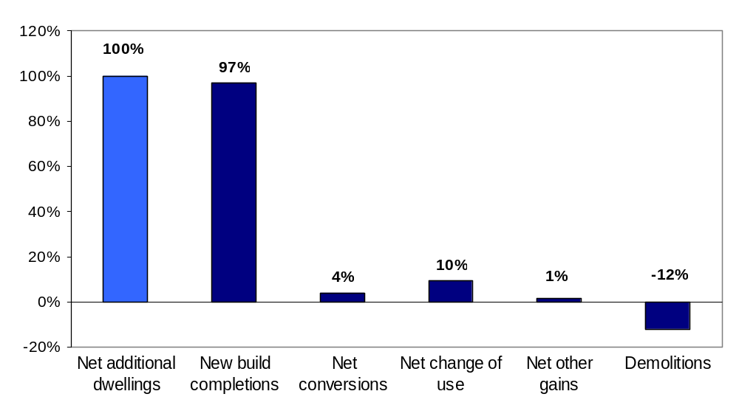

In 2010-11 97 per cent of the net change in the dwelling stock was accounted for by new build completions. The next largest components of change were demolitions (minus 12 per cent) and the net gain from non-residential buildings brought into residential use (10 per cent).
An alternative way of considering the components of the change in the dwelling stock is as a proportion of the gross additions to the dwelling stock. For further explanation see table 3 on page 9.

Sub-national trends
Recent trends in net supply of housing for regions of England are shown in the charts below. Please note that the regions vary in the size of their populations and existing dwelling stocks.
Figure 3a: Trends in net additional dwellings in the North East, the North West and Yorkshire and the Humber.
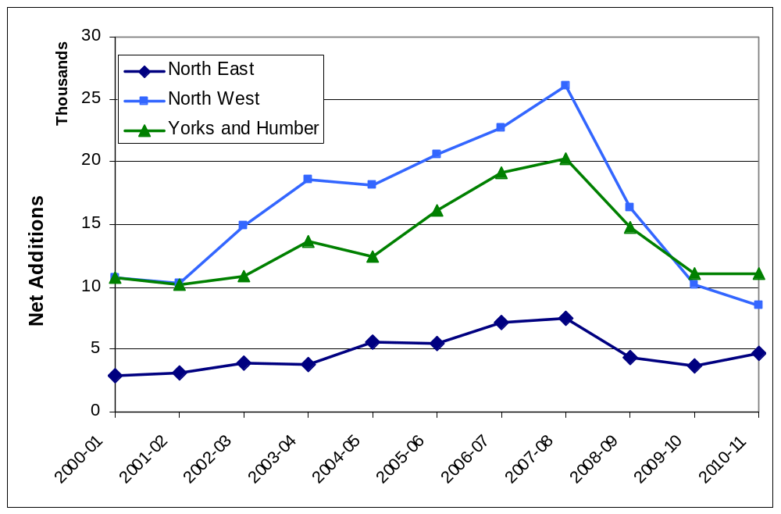
Figures for the three most northern regions are displayed in Figure 3a. All three regions experienced an increase from 2000-01 to a peak in 2007-08. The North East and North West are the regions that peaked most strongly, with 160 per cent and 143 per cent more new homes added respectively in 2007-08 than they did in 2000-01. Net additions in Yorkshire and the Humber followed a similar trend but with a peak only 88 per cent higher than the level in 2000-01. Following the downturn, the supply of new homes in the North West and Yorkshire and the Humber fell back to approximately the level at the start of the decade. The North East saw an increase in 2010-11 compared to 2009-10, with housing supply at its highest since the peak in 2007-08.
Figure 3b: Trends in net additional dwellings in the East Midlands, the West Midlands and the East of England.
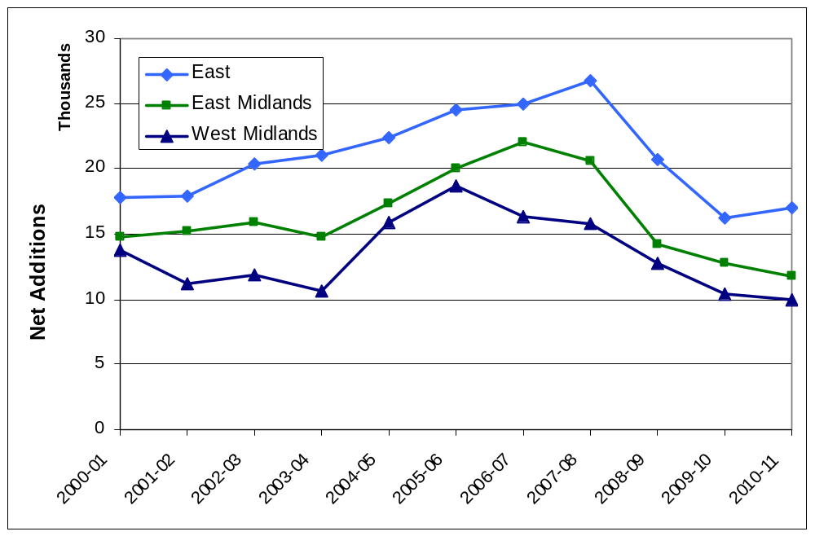

In figure 3b net additions data are displayed for the East and West Midlands, and the East of England. All regions saw an upward trend for the early years of the decade but less steep than that shown in the northern regions in figure 3a. The peak for the East, in 2007-08, was 50 per cent above the 2000-01 level while the East Midlands peaked in 2006-07 at 49 per cent above the 2000-01 level. Net supply in the West Midlands peaked in 2005-06 at 35 per cent above the 2000-01 level and fell in each of the following five years. The East saw a slight recovery in 2010-11 with an increase of five per cent over the level in 2009-10.

Figure 3c: Trends in net additional dwellings in London, the South East and the South West.
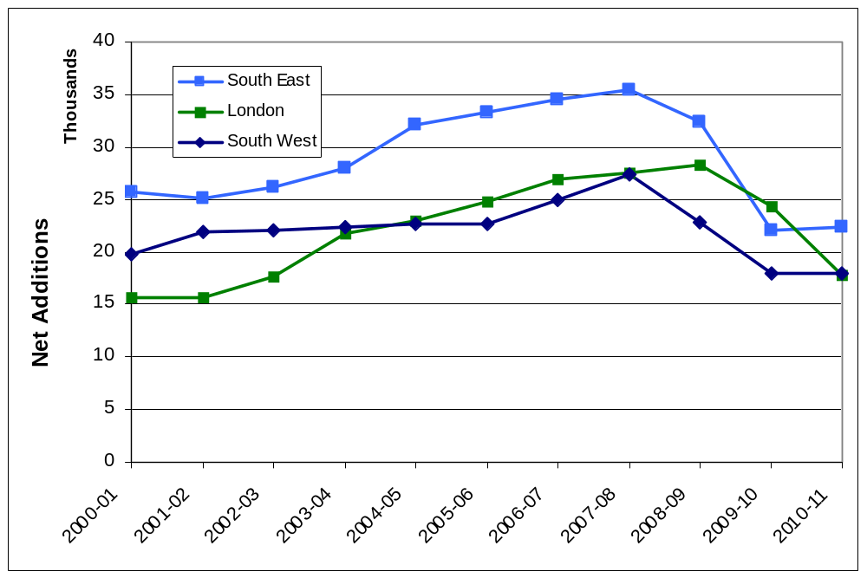
Figure 3c presents net additional dwellings data for London, the South East and South West. Net additions in London peaked in 2008-09, 80 per cent above the 2000-01 level. Supply then fell back in both of the following two years and in 2010-11 stood at 13 per cent above the level at the start of the decade. Net additions in both the South East and South West peaked in 2007-08, and then fell in 2008-09 and 2009-10. In 2010-11 both levelled off, remaining below their 2000-01 levels.

Figure 4a: Net additions as a proportion of England total by region, 2010-11
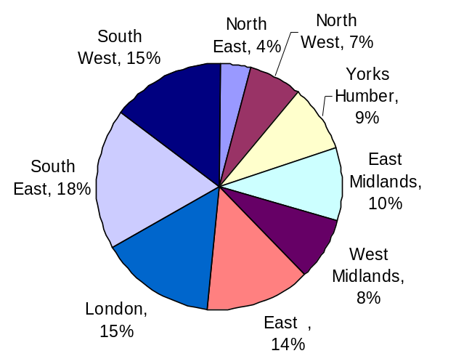 | Figure 4a shows the proportion of the total net additions for England in each region. The South East accounted for 18% (22,360) of the total 121,200 dwellings, with London and the South West each representing 15% of the total (17,830 and 17,920 respectively)
Figure 4b: New build completions as a proportion of England total by region, 2010-11
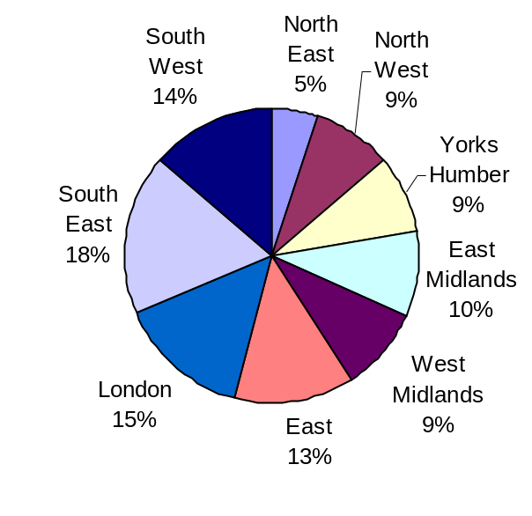 | Figure 4b focuses on the new build completions component of net additions. The 2010-11 total for this component for England was 117,700 new dwellings. The chart shows proportion of this total accounted for by each region. The South East has the largest proportion, with 18% (20,980) of the total.
Figure 4c: Demolitions as a proportion of England total by region, 2010-11
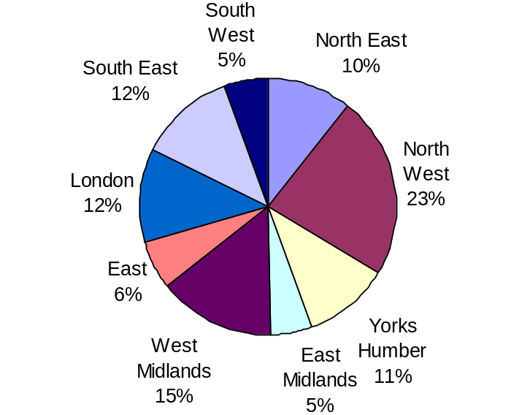 |  | Figure 4c shows a breakdown of the total number of demolitions in England by region. There were 14,890 demolitions in total in 2010-11 in England. The North West accounted for 23% of these, the West Midlands accounted for 15% and London and the South East 12% each.
Table 3: Components of net supply by region, 2010-11

Region | New build completions | Net conversions | Net change of use | Net other gains | Gross Additions | Demolitions | Net additional dwellings
North East | 5,800 | 30 | 440 | 10 | 6,280 | -1,560 | 4,710
North West | 10,440 | 350 | 1,170 | 30 | 11,990 | -3,460 | 8,530
Yorks and the Humber | 10,180 | 410 | 960 | 1,100 | 12,650 | -1,610 | 11,040
East Midlands | 11,300 | 280 | 880 | 40 | 12,500 | -760 | 11,730
West Midlands | 10,740 | 260 | 1,160 | 30 | 12,190 | -2,180 | 10,010
East | 15,790 | 290 | 1,520 | 390 | 17,990 | -930 | 17,050
London | 16,250 | 1,410 | 1,920 | 0 | 19,580 | -1,750 | 17,830
South East | 20,980 | 1,300 | 1,740 | 170 | 24,190 | -1,820 | 22,370
South West | 16,220 | 730 | 1,740 | 30 | 18,720 | -810 | 17,920
Total England | 117,700 | 5,050 | 11,540 | 1,810 | 136,100 | -14,890 | 121,200

Table 3 shows components of net additions for each region, focusing first on those that add to the dwelling stock. It should be noted that conversions, change of use and the ‘other’ category can all, in theory, result in a net loss to the number of homes. However high demand for residential property means that conversions and change of use currently lead to gains in the stock, especially when observed in aggregate at the regional or national level.
To illustrate the meaning of table 3 consider the components for the North East. In this region there was a 5,800 net increase in the dwelling stock due to new build completions, a 30 home net increase due to conversions, a 440 home increase due to change of use and an increase of 10 from other gains (for example of mobile or temporary homes). The increase in the dwelling stock totals 6,280 before demolitions are taken into account. Therefore in the North East new build completions are 92 per cent of the gross additions in the dwelling stock (before deduction of demolitions). Change of use forms seven per cent of the gross increase and net conversions accounts for less than one per cent of this figure.
By way of contrast, the 16,250 new build completions in London account for only 83 per cent of its 19,580 gross additions. London has a relatively high proportion of net conversions at seven per cent (1,410 homes), and of change of use at 10 per cent (1,920 homes).
Demolitions as a proportion of gross additions also vary considerably in different parts of England, highest in the North West (29 per cent) followed by the North East (25 per cent) and lowest in the South West (four per cent).

Geographic distribution of net housing supply
The map in figure 5 below shows net additions rates in each of the 326 local authority districts over the year 2010/11. To show net housing supply in proportion to the size of each district we divide the number of net additions in the 12 months to March 2011 by the existing dwelling stock. The result is multiplied by 1000 to give a figure that is easier to interpret. Consider a hypothetical local authority district with 100,000 dwellings as at 31 March 2010. Over the next year 200 new dwellings are completed, representing two new dwellings per thousand of existing stock (rounded). This district would therefore be shaded in light yellow in the coloured map.
Figure 5: Net Additions per 1000 dwellings for each local authority district in the 12 months to March 2011
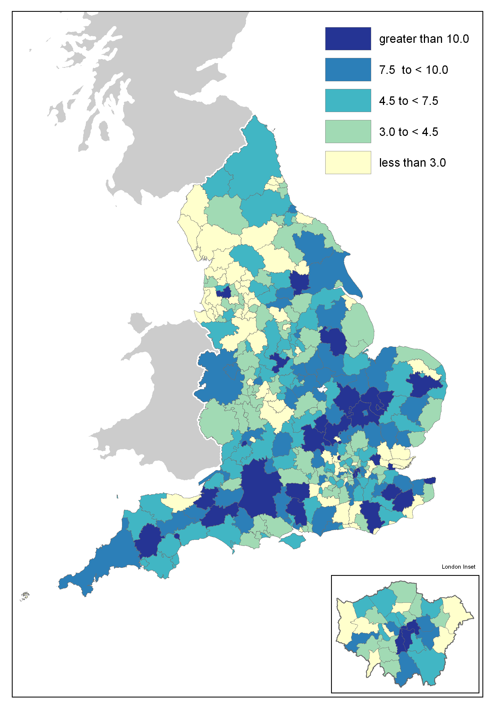 | The local authorities seeing the highest rates of net additions are coloured dark blue. A number of these can be seen in a cluster North West of Greater London. In addition higher rates can be seen in the South West and in a few local authorities in the South East.  The lighter colours signify lower rates and these predominate in the North West and West Midlands. Many coastal authorities across the country have seen lower rates in 2010-11, although Cornwall is an exception.  London is a mixed picture with some higher rates in central areas but generally lower rates in the peripheral boroughs.

Data collection
This release takes annual figures on net housing supply in England from two data sources:
- information submitted to Communities and Local Government (CLG) by local authorities in all regions except London through the Housing Flows Reconciliation (HFR) form; and
- information collected by the Greater London Authority (GLA) for London Boroughs.
From 2000-01 to 2003-04, all local authorities submitted data to Communities and Local Government through the HFR form. Between 2004-05 and 2008-09, Communities and Local Government worked jointly with Regional Planning Bodies in some regions on joint returns to ensure consistency between the net housing supply figures reported at various geographical levels.
In 2010 the abolition of Regional Planning Bodies prompted a return to submission through the HFR for all local authorities outside London. Because of the unique status of the GLA, London Boroughs continue to supply their data through the GLA. Users should note that the London figures are provisional at this stage and may be subject to change before they are reported in the GLA’s Annual Monitoring Report. Local authorities have until early September, five months after the end of the financial year, to complete the HFR form.

Data quality
The HFR form collects data from local authorities in eight regions and the figures include imputation for a number of missing returns. In 2010-11, a 93 per cent response rate was achieved. 24 out of the 293 English local authorities who submit through the HFR did not finalise their return. Imputations for these 24 local authorities account for six per cent of the total net additions figure for 2010-11.
As a basis for imputation for non-response, the ratio of the number of house building completions on quarterly P2 house building returns to the net additions figure was calculated at regional level, using data from all local authorities that finalised their 2010-11 HFR return. For local authorities which failed to submit a HFR return, these ratios were applied to the number of house building completions reported on their P2 quarterly house building returns for 2010-11.
The response rates shown in table 4 are the sum of the responses to the HFR, the joint returns and GLA data. The percentage represents the number of finalised returns received by the Department for Communities and Local Government, although some may not contain every item of requested data.

Table 4: Overall response rates

2006-07 | 97%
2007-08 | 99%
2008-09 | 98%
2009-10 | 96%
2010-11 | 93%
The HFR return requires local authorities to submit a full break down of housing flows by tenure over the previous year; this includes figures for new house building, conversions, demolitions, changes of use and transfers between tenures.
The GLA collects, collates and validates data from London Boroughs before passing the information on to Communities and Local Government. This return does not contain the same depth of information on housing flows as collected directly from local authorities through the HFR form, for example it does not supply a breakdown by tenure.

Net supply of housing statistics provide a more complete picture of new build completions than Communities and Local Government’s quarterly release on new house building. In contrast to the data in the quarterly house building release, new build completions in the net supply statistics include dwellings inspected by Independent Approved Inspectors as well as by the NHBC and local authority building control. In addition, the data collection period for net supply to dwelling stock is much longer, giving data suppliers more time to assemble the information.

Related statistics
House building starts and completions
New house building completions are largest component of net housing supply. The Department for Communities and Local Government also publish a quarterly National Statistics series on new build starts and completions based on quarterly data returns by local authorities and the National House-Building Council (NHBC). This quarterly house building completions statistic is a key leading indicator for the annual net supply of housing figures in this release.
The quarterly house building statistical series is separate from and complementary to the annual Net supply of housing series, providing a more timely but less comprehensive measure of total housing supply in England. Completions figures from the quarterly house building series are not used in the net supply of housing statistics. Instead a separate set of data on the new build completions component of housing supply is collected as part of the overall annual net additions data collection (see ‘Data collection’ above). This eliminates timing differences from the net supply series and provides a picture of the components of net change which can be reconciled for a given year.
The house building statistical series takes its data from a consistent source throughout England, combining data from building control officers at local authorities and the National House-Building Council (NHBC), and is published within eight weeks after the end of each quarter. For net additions, all the data come from local authorities who in turn use whichever local data source they believe is most appropriate, and the data collection period for these statistics is relatively long, being annual and closing some five months after the end of the financial year. The longer data collection period makes it possible to incorporate data on the approximately five per cent of new build completions that are inspected by independent building control Approved Inspectors other than those at local authorities or the NHBC.
Users who need an early indication of house building activity or who intend to use housing supply statistics as an economic indicator are advised to use the quarterly house building starts and completions series. Those who require a long-running, consistent time series on housing supply should also use house building, on either a quarterly or annual basis. Users wanting a more complete picture of the overall supply of housing may find the net additions statistical series more appropriate.
The House Building statistics can be found at the link below.
http://www.communities.gov.uk/housing/housingresearch/housingstatistics/housingstatisticsby/housebuilding/

Dwelling stock estimates
The Department for Communities and Local Government also publish statistics showing the total dwelling stock in England each year. These estimates are based on the latest census count plus the annual Net supply of housing statistics shown in this release, and can be found at the following link. http://www.communities.gov.uk/housing/housingresearch/housingstatistics/housingstatisticsby/stockincludingvacants/
Estimates of the tenure split of the dwelling stock are also published in the suite of live tables on dwelling stock. They can be found at the following link.
http://www.communities.gov.uk/housing/housingresearch/housingstatistics/housingstatisticsby/stockincludingvacants/livetables/

Council tax valuation lists
The Valuation Office Agency compiles and maintains lists of all domestic properties in England and Wales to support the collection of council tax, and these lists are constantly updated to reflect the creation of new dwellings and losses of dwellings.
The Valuation Office Agency’s definition of a dwelling differs somewhat from that used by the census. The Department for Communities and Local Government’s Net supply of housing and Dwelling stock estimates statistics use the census definition (see ‘Definitions’ section below). This means that a small proportion of dwelling units may be included in the valuation lists but not the other statistics, and vice-versa.
The Valuations Office Agency now publishes statistics on these lists which can be found at the following link.
http://www.voa.gov.uk/corporate/Publications/statistics.html

New Homes Bonus
The New Homes Bonus allocates grants to local authorities according to the number of new homes delivered and empty homes brought back into use in their area. The growth in their council taxbase is used as a proxy measure for the number of new homes delivered, and the number of long-term empty homes in each area is also collected as part of the council tax system.
The final allocations for Year One (2011/12) of the New Homes Bonus were published on 4 April 2011. Details can be found at the following link.
http://www.communities.gov.uk/housing/housingsupply/newhomesbonus/

Affordable housing supply
The Department for Communities and Local Government’s annual Affordable housing supply statistics can be found at the following link. The affordable housing supply statistics include both new build supply and acquisitions for social rent and low cost home ownership. http://www.communities.gov.uk/housing/housingresearch/housingstatistics/housingstatisticsby/affordablehousingsupply/

Devolved administrations
The Scottish Government does not publish a similar series on net supply of housing, but time series showing demolitions and conversions in Scotland are available. These series were last updated in August 2011 and show demolitions and conversions data at local authority level up to 2010-11. They can be accessed at the following link.
http://www.scotland.gov.uk/Topics/Statistics/Browse/Housing-Regeneration/HSfS/ConDem
Wales and Northern Ireland do not publish net supply statistics in the same format as the Department for Communities and Local Government, but they do publish annual stock statistics calculated using net supply to dwelling stock data. These can be found at the following links.
Wales
http://wales.gov.uk/topics/statistics/headlines/housing2010/100401/?lang=en
Northern Ireland
http://www.dsdni.gov.uk/index/stats_and_research/stats-publications/stats-housing-publications/housing_stats.htm

Revisions policy
This policy has been developed in accordance with the UK Statistics Authority Code of Practice for Official statistics and the Communities and Local Government Revisions Policy. There are two types of revisions that the policy covers.

Scheduled Revisions
Local authorities may not revise the data they supply for these statistics after the original deadline for submission as this is an annual series with a relatively long data collection period.
These statistics are compared against the census on its release every ten years to ensure that the sum of net additions over that period matches the difference between the latest census dwelling count and the previous one. The net additions figures are then adjusted, with any difference spread evenly across the ten years since the previous census. When this adjustment was carried out following the 2001 census it amounted to around 6,600 dwellings per year at the England level. Data from the census dwelling stock count should be available in the second half of 2012.

Non-Scheduled Revisions
Where a substantial error has occurred as a result of the compilation, imputation or dissemination process, the statistical release, live tables and other accompanying releases will be updated with a correction notice as soon as is practical.

Definitions
Completion – A dwelling is regarded as completed when it becomes ready for occupation or when a completion certificate is issued whether it is in fact occupied or not.
Conversion – A conversion is a conversion of one dwelling into multiple dwellings, or vice versa.
Change of use – This is the changing of a residential dwelling to non-residential use, or changing a non-residential building to residential use.
A dwelling is defined (in line with the 2001 Census) as a self-contained unit of accommodation. Self-containment is where all the rooms (including kitchen, bathroom and toilet) in a household’s accommodation are behind a single door which only that household can use. Non-self contained household spaces at the same address should be counted together as a single dwelling. Therefore a dwelling can consist of one self-contained household space or two or more non-self-contained household spaces at the same address.
Communal establishments are not included within these estimates. These cover university and college student, hospital staff accommodation, hostels/homes, hotels/holiday complexes, defence establishments (not married quarters) and prisons. However, purpose-built, separate homes (e.g. self-contained flats clustered into units with 4 to 6 bedrooms for students) should be included. Each self-contained unit should be counted as a dwelling; however some dwellings of this type may have been excluded due to changes in this part of the dwelling definition during the last ten years.
HFR – The Housing Flows Reconciliation is an annual data collection in which local authorities report on changes to the size of the dwelling stock within their boundaries directly to the Department for Communities and Local Government. In 2011 all local authorities except for the London Boroughs were asked to submit their data through the HFR.
Net additional dwellings - A measure of the absolute change in dwelling stock between 1 April and 31 March of the following year. The absolute change in the dwelling stock is the number of new house building completions plus any gains or losses through conversions, demolitions and changes of use (also referred to as net supply of housing).

Accompanying tables and charts
Tables and charts accompanying this release are available to download alongside this release. Tables and charts are provided in MS Excel. Sources are shown at the foot of individual tables and charts and all figures are presented rounded to the nearest 10 dwellings.

Tables:
1a Annual net additional dwellings: England and the regions, 2000-01 to 2010-11;
1b Annual net additional dwellings and annual percentage change: England and the regions, 2000-01 to 2010-11;
1c Components of net housing supply: England, 2006-07 to 2010-11;
1d Components of net housing supply: by region, 2010-11;
1e Net additional dwellings: by local authority district, 2004-05 to 2010-11.

Charts:
2a Trends in net additional dwellings: England, 2000-01 to 2010-11;
2b Trends in net additional dwellings: the regions, 2000-01 to 2010-11.

In addition, four live tables showing net additions to the dwelling stock in England can be accessed in the 'Live tables' section ("Live tables on stock") at the link below.

Table 118: Annual net additional dwellings: England and the regions, 2000-01 to 2010-11;

Table 120: Components of net housing supply: England, 2006-07 to 2010-11;

Table 121: Components of net housing supply: by region, 20010-11;

Table 122: Net additional dwellings: by local authority district, 2004-05 to 2010-11

http://www.communities.gov.uk/housing/housingresearch/housingstatistics/housingstatisticsby/netsupplyhousing/livetablesnet/

Notes to the tables
The following conventions have been used in the tables:
.. Not available;
- Fewer than five dwellings;
^{P} Figure provisional and subject to revision;
^{R} Revised from previous release.

Background notes
- Prior to 2000-01 it had been possible to make estimates of annual net supply since the late 1960s simply by looking at changes in annually-produced housing stock figures. In 2000-01 a new data collection was introduced to improve estimates of net supply and collect information on the components of supply.
- For the 2010-11 financial year eight out of the nine regions used the HFR to submit their net supply data to Communities and Local Government. These HFR returns request a tenure breakdown, which has been provided by many local authorities; however data on tenure are missing from many other local authorities’ HFR returns and we do not believe the completeness and quality of these tenure data are adequate to allow the production and publication of a tenure breakdown for net supply of housing official statistics.
- Details of officials who receive pre-release access to the Communities and Local Government annual ‘Net Supply of Housing’ release up to 24 hours before release can be found at:
http://www.communities.gov.uk/corporate/researchandstatistics/statistics/nationalstatistics/
- The next net additions release is provisionally scheduled for autumn 2012 and will include net additional dwellings up to 2011-12.
User consultation
Users’ comments on any issues relating to this statistical release are welcomed and encouraged. Responses should be addressed to the "statistical enquiries" contact given in the "Enquiries" section below.
Enquiries

Media Enquiries:
office hours: 0303 44 41136
out of hours: 0303 44 41201
e-mail: press@communities.gov.uk

Statistical enquiries:
e-mail: housing.statistics@communities.gov.uk telephone: 0303 44 42345
Department for Communities and Local Government. © Crown Copyright, 2011

If you require this publication in an alternative format please email: alternativeformats@communities.gsi.gov.uk. Please note that the nature of content means that we may not be able to provide the Statistical series of publications in all requested formats.

November 2011

ISBN: 978-1-4098-3219-5

