

Statistical Release

11 November 2010
PARISHES AND CHARTER TRUSTEES IN ENGLAND – 2010-11
- The total number of local precepting authorities in England in 2010-11 is 9,938, of which 9,920 are parishes, 16 are Charter Trustees and 2 are the Temples of London.

- Of the 9,936 parishes and Charter Trustees in England, 9,135 are charging a non-zero precept in 2010-11.

- The average Band D parish precept in England in 2010-11 is £44.55.
This release provides accurate information for the first time on local precepting authorities in England for the financial year 2010-11. This information is derived from the Local Precepting Authorities section (lines 23, 24 and 25) and line 4 of the Budget Requirement (BR1) forms submitted by all 326 billing authorities in England. This is the first year for which the section on local precepting authorities has been included on the form. The release has been compiled by the Local Government Finance - Data Collection, Analysis and Accountancy division of Communities and Local Government.

Responsible Statisticians:
Steven Melbourne and Mike Young Email: br.statistics@communities.gsi.gov.uk
Contact points:  Press enquiries:  Telephone 0303 444 0444  Email press.office@communities.gsi.gov.uk | Other enquiries:  Telephone 0303 444 2116  Email br.statistics@communities.gsi.gov.uk
Website: www.communities.gov.uk

Parishes and Charter Trustees in England 2010-11
Contents |  | Page
Table 1 | Local precepting authorities in England 2010-11 | 4
Table 2 | Total number and tax base of parishes and Charter Trustees by region 2010-11 | 5
Chart A | Total tax base of parishes and Charter Trustees by region 2010-11 | 5
Table 3 | Average Band D parish precept by region 2010-11 | 6
Chart B | Average Band D parish precept by region 2010-11 | 6
Additional table (this is available via the following web-link -
www.communities.gov.uk/localgovernment/localregional/localgovernmentfinance/statistics/counciltax/

Table 4 | Local authority level information on local precepting authorities - all billing authorities 2010-11 | 7
Terminology used in this release |  | 7
Data quality |  | 9
Uses made of data |  | 10
Background Notes |  | 10
Parishes and Charter Trustees in England 2010-11

- Data on the number and tax base of parishes and Charter Trustees were collected from billing authorities for the first time in March 2010, as part of the Budget Requirement (BR1) forms.

- The numbers provided by billing authorities have been subjected to rigorous quality assurance checks which are outlined in more detail in the Data quality section of this release. These checks indicate that all billing authorities have provided information of an acceptable standard. This information is being published for the first time in this format. This information will continue to be collected on future BR1 forms and it is planned that this release will become part of the annual Council Tax Levels in England statistical release. The 2010-11 Council Tax Levels in England release can be found at:
www.communities.gov.uk/publications/corporate/statistics/counciltax201011

- Parishes and Charter Trustees are known as local precepting authorities, and are the most local level of government in England. They have the power to raise a precept on those properties in their area to finance the functions that they perform. This amount is included within the council tax of the constituent billing authority and is known as a parish precept. The functions that they have the power to carry out are limited. Examples of services provided by parishes are parks and playgrounds, cemeteries and crematoria, litter control, footpaths, and acquisition and maintenance of rights of way.

- Parishes vary greatly in their size and in the functions that they perform. They represent populations ranging from less than 100 up to 70,000, although the majority have small populations. Annual budgets range from less than £100 to £2m.

- London is the only part of England which currently does not have parishes, following their abolition in the 1963 London Government Act. However the Local Government and Public Involvement in Health Act 2007 has devolved the power to create new parishes to district councils and London boroughs.

- Further information is provided in the Terminology used in this release section of this release.

- There are two further local precepting authorities known as the Inner and Middle Temples of London (“the Temples”) situated within the Temple area of the City of London. The Temples are different from parishes and Charter Trustees in that they perform functions within their area that are performed by the City of London authority (“the City”) in the rest of the City. In exchange for performing these functions, the City pays to the Temples an annual precept, which is apportioned from the council tax raised by the City. Due to this unique arrangement, the Temples of London have been excluded from all calculations unless otherwise stated.

- Table 1 shows the total number of local precepting authorities in England, as well as the combined tax base of the areas covered by them.

- The total number of local precepting authorities in England in 2010-11 is 9,938, of which 9,920 are parishes, 16 are Charter Trustees and 2 are the Temples of London.

- Of the 9,936 parishes and Charter Trustees, 9,135 have set a non-zero precept in 2010-11, covering a tax base of 8.0 million Band D equivalent properties.

Table 1: Local precepting authorities in England 2010-11
 |  | Number |  | Tax base
 |  |  |  | (thousands)
Parishes |  | 9,920 |  | 7,926.7
Charter Trustees |  | 16 |  | 305.0
TOTAL |  | 9,936 |  | 8,231.7
of which:
setting their own council tax precept |  | 9,135 |  | 8,000.7
Temples of London |  | 2 |  | 0.1

- Table 2 gives a breakdown of the number of parishes and Charter Trustees by Government Office Region

- The number of parishes and Charter Trustees outside London varies from 338 in the North East to 1,832 in the South West.

- The tax base covered by parishes and Charter Trustees outside London varies from 0.3 million in the North East to 2.0 million in the South East.

- The tax base covered by parishes represents 45% of the total tax base for England, or 54% of the total tax base outside London.

Table 2: Total number and tax base of parishes and Charter Trustees by region 2010-11 ^{(a)}
 |  | Total parishes and Charter Trustees |  |  | Region total | Parish
 |  | Number | Tax base |  | tax base | tax base
 |  |  | (thousands) | % of total | (thousands) | % of total
England |  | 9,936 | 8,231.7 | 100% | 18241.9 | 45%
North East | NE | 338 | 333.1 | 4% | 792.0 | 42%
North West | NW | 754 | 743.3 | 9% | 2236.8 | 33%
Yorkshire and the Humber | YH | 1,104 | 751.6 | 9% | 1642.0 | 46%
East Midlands | EM | 1,548 | 923.4 | 11% | 1441.6 | 64%
West Midlands | WM | 968 | 752.6 | 9% | 1794.4 | 42%
East of England | EE | 1,799 | 1,397.0 | 17% | 2116.3 | 66%
London |  | 0 | 0.0 | 0% | 2983.2 | 0%
South East | SE | 1,593 | 1,982.2 | 24% | 3302.3 | 60%
South West | SW | 1,832 | 1,348.5 | 16% | 1933.4 | 70%
^{(a)} Excludes the Temples of London.

- Chart A below gives a breakdown of the combined tax base of parishes and Charter Trustees in each Government Office Region.

Chart A: Total tax base of parishes and Charter Trustees by region 2010-11
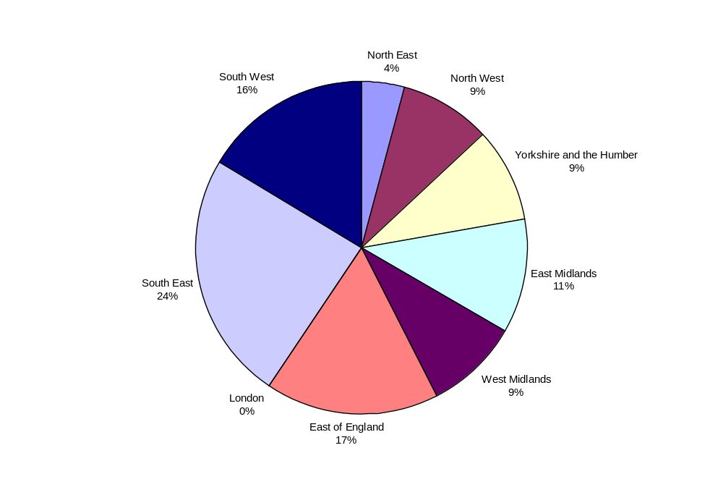

- Table 3 gives the average parish precept per Band D property within the area of a parish or Charter Trustee that is charging a non-zero precept in 2010-11.

- The average Band D parish precept in England for 2010-11 is £44.55.

- The average Band D parish precept in each region outside London for 2010-11 varies from £24.43 in the North West to £54.33 in the North East.

- The aggregate of local precepts, at £356m, represents 1.4% of the total council tax requirement for England of £26.3bn.

Table 3: Average Band D parish precept by region 2010-11 ^{(a)}
 |  | Parishes and Charter Trustees charging a non-zero precept
 |  | Total number |  | Tax base |  | Aggregate of local precepts ^{(b)} |  | Average parish precept per Band D
 |  |  |  | (thousands) |  | (£ ,000) |  | (£)
England |  | 9,135 |  | 8,000.7 |  | 35 356,452 |  | 44.55
North East |  | 311 |  | 311.7 |  | 16,935 |  | 54.33
North West |  | 707 |  | 727.5 |  | 17,771 |  | 24.43
Yorkshire and the Humber |  | 948 |  | 726.5 |  | 23,176 |  | 31.90
East Midlands |  | 1,351 |  | 820.0 |  | 39,329 |  | 47.96
West Midlands |  | 921 |  | 750.3 |  | 29,099 |  | 38.78
East of England |  | 1,692 |  | 1,357.6 |  | 65,400 |  | 48.17
London |  | 0 |  | 0.0 |  | 0.0 |  | 0
South East |  | 1,487 |  | 1,969.0 |  | 96,302 |  | 48.91
South West |  | 1,718 |  | 1,338.2 |  | 68,440 |  | 51.14
(a) Excludes the Temples of London
(b) This is the total amount collected by the constituent billing authorities on behalf of parishes and Charter Trustees.

- Chart B shows the average Band D parish precept level within each Government Office Region.

Chart B: Average Band D parish precept by region 2010-11
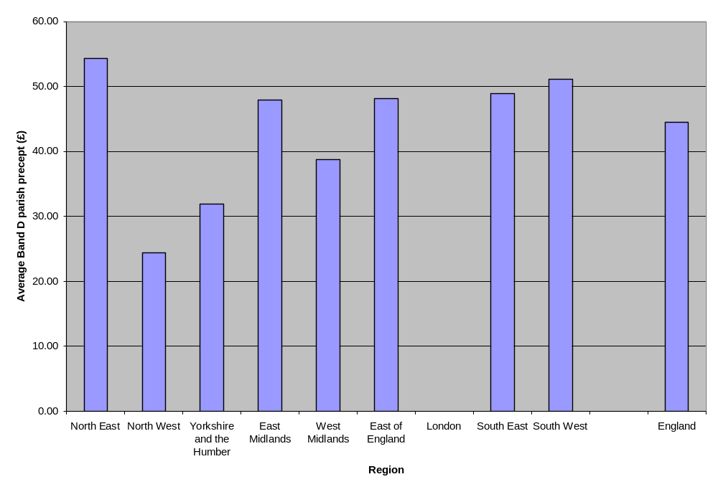

- Historical information on the estimated national average parish precept per Band D property is provided in Annex A3 of Local Government Financial Statistics England No.20 2010. This publication can be viewed at
http://www.communities.gov.uk/publications/corporate/statistics/financialstatistics202010

Additional table

There is one additional table containing data for all authorities that, owing to its size, is not included in the printed version of this release. It is available on the Department’s website and can be found at: http://www.communities.gov.uk/localgovernment/localregional/localgovernmentfinance/statistics/counciltax/

Below is a brief description of the data contained in the table:

- Table 4 compiles the data reported by local authorities alongside a calculation of the average Band D parish precept paid by those within the area of a parish or Charter Trustee that has set a non-zero precept. The data are taken from the Budget Requirement (BR1) forms supplied by local authorities in England to Communities and Local Government in March 2010. Totals are also shown for England and by region.

Table 4 shows that average band D parish precepts by local authority range from £4.55 in Middlesborough to £116.38 in North West Leicestershire.

Terminology used in this release

A list of terms relating to local government finance is given in the glossary at Annex G to Local Government Financial Statistics England No. 20 2010. This is accessible at http://www.communities.gov.uk/publications/corporate/statistics/financialstatistics202010.

The terms most relevant to this release are defined below:

Aggregate of Local Precepts – This is the total amount collected by billing authorities on behalf of local precepting authorities in their area.

Average Band D parish precept – The aggregate amount collected on behalf of parishes and Charter Trustees (local precepts) divided by the total tax base of those parishes and Charter Trustees that have set a non-zero precept. These amounts are averages over all parishes in an area and will not represent the actual amount paid towards individual parishes or Charter Trustees in those areas.

Band D council tax - This is the council tax payable on a Band D dwelling occupied as a main residence by two adults, before any reductions due to discounts, exemptions or council tax benefit. This definition is widely regarded as a benchmark when comparing council tax levels in different areas or over time.

Billing Authorities - Billing authorities are the 326 authorities (354 before 1 April 2009) that are empowered to set and collect council taxes, and manage a Collection Fund, on behalf of themselves and other local authorities in their area. In England, district councils (metropolitan and shire), the Council of the Isles of Scilly, unitary authorities, London boroughs, and the City of London are billing authorities. These are also sometimes known as lower-tier authorities.

Budget Requirement (BR) forms - A return completed by all billing and precepting authorities in England giving details of how their council tax requirement is calculated and what council tax a Band D two-adult dwelling should pay.

BR1 forms are completed by billing authorities, BR2 forms by precepting authorities and the BR3 form is completed by the Greater London Authority. The data used in this release were collected on the BR1 forms.

Charter Trustee - A body of councillors charged with preserving the historic property, privileges, rights, status and traditions of areas which have been subsumed within larger authorities as a result of local government reform. Charter Trustees cease to exist when a parish council is formed for the area.

Council tax - This is a local charge (or charges) set by the billing authority in order to collect sufficient revenue to meet their demand on the collection fund and the precepts issued by the precepting authorities. It replaced the community charge on 1 April 1993 and is calculated based on the council tax band assigned to the dwelling. The Valuation Office Agency assesses the properties in each district area and assigns each dwelling to one of eight valuation bands; A to H. The tax is set on the basis of the number of Band D equivalent properties. Tax levels for dwellings in other bands are set relative to the Band D baseline.

Council Tax Band - There are eight council tax bands, A to H. Each domestic dwelling is assigned a council tax band by the Valuation Office Agency (VOA). Council tax bands are based on the value of the dwelling as at 1 April 1991. Any dwelling built after this date is given a notional 1991 value for council tax purposes.

Parish - The term parish means an English civil parish. A parish council can resolve to have the status of a town and can have city status conferred on it by royal prerogative. A parish council or parish meeting may resolve to adopt the style of a community, neighbourhood or village.

Parish precepts – Parish councils can raise a precept on the principal council (the billing authority). This is the main source of a parish council’s income and the level of the precept is at the discretion of the parish. Parishes and Charter Trustees are local precepting authorities.

Precept - The amount of money (council tax) that a local or major precepting authority has instructed the billing authority to collect and pay over to it in order to finance its net expenditure, i.e. budget requirement less income from revenue support grant, redistributed non-domestic rates, principal formula police grant and general GLA grant.

Tax base - This is the number of Band D equivalent dwellings in a local authority area. To calculate the tax base for an area, the number of dwellings in each council tax band is reduced to take account of discounts and exemptions. The resulting figure for each band is then multiplied by its proportion relative to Band D (from 6/9 for Band A to 18/9 for Band H) and the total across all eight bands is calculated. An adjustment is then made for the collection rate. The tax base figure that is used by a local authority when it sets its council tax uses an adjustment for the collection rate and the actual discount for second homes.

Temples of London – The Inner and Middle Temples are self-governing bodies located in the west of the City of London. The Temples were defined as local authorities with many of the same powers and responsibilities as the Inner London boroughs under the London Government Act 1963, except in relation to housing. The Inner Temple and Middle Temple, through powers vested in the Under Treasurer and Sub-Treasurer of the Middle and Inner Temple respectively, exercise a small number of local authority functions. All other functions fall under the responsibility of the City of London.

Data quality

The information in this release is based on data returned to Communities and Local Government by English local authorities on the Budget Requirement (BR1) forms.

The data on this form (with the exception of the Local Precepting Authorities section) are collected using legislative powers that require all billing authorities to return completed forms within seven days of setting their final budget for the coming year. This effectively ensures a 100% response rate.

Figures are subjected to rigorous validation tests in Communities and Local Government as the data are received and stored.

The release document, once prepared, is also subject to intensive peer review before being cleared as fit for the purposes of publication.

Uses made of the data

This information will be used to inform the development of policy on council tax levels and to evaluate existing policies.

Background Notes

- For press inquiries about this Statistical Release please contact the Local Government press desk on 0303 444 0444 or email press.office@communities.gsi.gov.uk.

- For other inquiries please telephone John Farrar on 0303 444 2116 or email br.statistics@communities.gsi.gov.uk.

- Future releases of this information will be as part of the annual Council Tax Levels in England statistical release, published towards the end of March each year for the following financial year.

- Further information is also available on the Department’s website at www.communities.gov.uk/localgovernment/localregional/localgovernmentfinance/statistics/counciltax/

Information on council tax levels can be found at
http://www.communities.gov.uk/localgovernment/localregional/localgovernmentfinance/statistics/counciltax/rates/

Information on council tax collection rates can be found at
www.communities.gov.uk/localgovernment/localregional/localgovernmentfinance/statistics/counciltax/collectionrates/ .

- For a fuller picture of recent trends in local government finance, readers are directed to Local Government Financial Statistics England No.20 2010 which is available in hard copy from Cambertown Limited at product@communities.gsi.gov.uk (Tel: 0300 123 1124) and electronically in PDF format via the Department’s web site: www.communities.gov.uk/publications/corporate/statistics/financialstatistics202010

Symbols and conventions used in this release

 | – | = | not relevant
 | 0 | = | zero or negligible
Rounding
Where figures have been rounded, there may be a slight discrepancy between the total and the sum of constituent items

Department for Communities and Local Government © Crown copyright, 2010

If you require this publication in an alternative format please e-mail:
alternativeformats@communities.gsi.gov.uk.

Please note that the nature of content means that we may not be able to provide the Statistical series of publications in all requested formats.

November 2010
ISBN: 978-1-4098-2642-2

