

Statistical Release

26 April 2012
PARISHES AND CHARTER TRUSTEES IN ENGLAND, 2012-13
- In England in 2012-13 there are 9,967 parishes, 17 charter trustees and 2 Temples of London. This gives a total of 9,986 local precepting authorities.

- Of the 9,984 parishes and charter trustees in England, 9,065 are charging a non-zero precept in 2012-13, 50 fewer than the previous year, or a decrease of 0.5%.

- The average Band D parish precept in England in 2012-13 is £47.74. This is an increase of £1.76, or 3.8%, over 2011-12.

- The aggregate of local precepts (excluding City of London), at £384m, represents 1.4% of the total council tax requirement for England of £26.7bn.
This release provides information on local precepting authorities in England for the financial year 2012-13 and revised figures for 2011-12 and 2010-11. The revisions to previous years arise from a number of authorities correcting previously reported data. This release also updates the headline data for parishes published in the Council Tax Levels set by Local Authorities in England 2012-13 statistical release published on 21 March 2012.
The information in this release is derived from the local precepting authorities section (lines 23, 24 and 25) and line 3 of the Council Tax Requirement (CTR1) forms submitted by all 326 billing authorities in England. These forms replaced Budget Requirement (BR1) forms from 2012-13. The release has been compiled by the Local Government Finance - Data Collection, Analysis and Accountancy division of the Department for Communities and Local Government.

Responsible Statisticians:
Steven Melbourne and Mike Young Email: br.statistics@communities.gsi.gov.uk
Contact points:  Press enquiries:  Telephone 0303 444 1201  Email press.office@communities.gsi.gov.uk | Other enquiries:  Telephone 0303 444 4355  Email br.statistics@communities.gsi.gov.uk
Website: www.communities.gov.uk

Parishes and Charter Trustees in England, 2012-13
Contents |  | Page
Table 1 | Local precepting authorities in England, 2010-11 to 2012-13 | 4
Table 2 | Number, tax base and coverage of local precepting authorities by region, 2012-13 | 5
Chart A | Tax base of local precepting authorities, by region, as a percentage of the total regional tax base, 2012-13 | 6
Table 3 | Parish precepts by region and by class of authority, 2011-12 and 2012-13 | 7
Chart B | Average Band D parish precept by region, 2011-12 and  2012-13 | 8
Additional table - this is available via the following web-link:
http://www.communities.gov.uk/localgovernment/localregional/localgovernmentfinance/statistics/counciltax/parisheschartertrustees/
Table 4 | Local authority level information on local precepting authorities - all billing authorities, 2012-13
Terminology used in this release |  | 9
Data quality |  | 11
Revisions |  | 11
Uses made of data |  | 11
Background Notes |  | 12
Parishes and Charter Trustees in England, 2012-13

- There are over 11,000 civil parishes in England. Of these 9,967 are represented by bodies which may raise precepts. In this release ‘parish’ refers to a parish represented by such a body. A parish may be represented by a parish council, a town council or community council. In the case of small parishes, the parish meeting (an annual meeting of all electors in a parish) can take on the role of parish council. In a handful of cases, such as Wells, parishes have been granted city status and the parish council may call itself a city council. Parishes represent the most local level of Government in England - the third tier of local government.

- Parishes (together with charter trustees and the two Temples of London as described below) are collectively known as local precepting authorities. This means they have the power to raise a precept on properties in their area in order to finance the functions that they perform. Parish precepts are included separately on council tax bills and are collected by the billing authority on behalf of the parish.

- Parishes vary widely in the populations they represent and the functions they perform. They can represent populations of less than 100 up to tens of thousands of people, with budgets ranging from very modest amounts to over £1 million. The role they play also varies widely. Some have a very limited, local role while others are more active, carrying out activities similar to that of a smaller district council. Typical parish responsibilities include village halls, war memorials, cemeteries, allotments, open spaces, leisure facilities, playgrounds, maintenance of public footpaths and cultural projects.

- Parishes do not exist across the whole of England. Un-parished areas currently include London, where parishes were abolished by the London Government Act 1963. However, the Local Government and Public Involvement in Health Act 2007 makes provision for the setting up of new local councils, including in London.

- In a small number of the un-parished areas bodies called “charter trustees” exist. These bodies exist to administer ceremonial functions, such as the appointment of a mayor, where there is no parish to administer them. There are currently 17 such bodies in England.

- There are two further local precepting authorities: the Inner and Middle Temples of London (“the Temples”) situated within the Temple area of the City of London. The Temples are different from parishes and charter trustees in that they perform the functions within their area that are performed by the City of London authority (“the City”) in the rest of London. In exchange for performing these functions the City pays the Temples an annual precept apportioned from the council tax raised by the City. Due to this unique arrangement the Temples of London have been excluded from all calculations unless otherwise stated.

- Further information is provided in the Terminology used in this release section of this release.

- Table 1 shows the total number of local precepting authorities in England, as well as the combined tax base of the areas covered by them.

- In England in 2012-13 there are 9,967 parishes, 17 charter trustees and 2 Temples of London. This gives a total of 9,986 local precepting authorities.

- Of the 9,984 parishes and charter trustees, 9,065 have set a non-zero precept in 2012-13. This number is 50 fewer than in 2011-12, or a decrease of 0.5%.

- The parishes and charter trustees setting non-zero precepts cover a tax base of 8.0 million Band D equivalent properties, an increase of 0.8% over the previous year despite the number of parishes and charter trustees setting non-zero precepts having reduced.

 | Table 1: Local precepting authorities in England, 2010-11 to 2012-13
 |  |  |  |  |  |  |  |  | Annual change (%)
 |  |  | 2010-11 (R) |  | 2011-12 (R) |  | 2012-13 |  | 2011-12 | 2012-13
 | Parishes | Number | 9,927 |  | 9,945 |  | 9,967 |  | 0.2 | 0.2
 |  | Tax base (thousands) | 7,860.0 |  | 7,898.2 |  | 7,997.4 |  | 0.5 | 1.3
 | Charter trustees | Number | 17 |  | 17 |  | 17 |  | 0.0 | 0.0
 |  | Tax base (thousands) | 301.6 |  | 303.7 |  | 305.2 |  | 0.7 | 0.5
 | Total | Number | 9,944 |  | 9,962 |  | 9,984 |  | 0.2 | 0.2
 |  | Tax base (thousands) | 8,161.6 |  | 8,201.9 |  | 8,302.6 |  | 0.5 | 1.2
 | of which: | Number | 9,065 |  | 9,115 |  | 9,065 |  | 0.6 | -0.5
 | setting their own precept | Tax base (thousands) | 7,917.1 |  | 7,984.1 |  | 8,046.2 |  | 0.8 | 0.8
 | Temples of London | Number | 2 |  | 2 |  | 2 |  | 0.0 | 0.0
 | Temples of London | Tax base (thousands) | 0.1 |  | 0.1 |  | 0.1 |  | -0.1 | 4.0
 | Source: CTR1 & BR1 forms

- Table 2 gives a breakdown of the number and tax base of parishes and charter trustees by region.

- The number of parishes and charter trustees outside London varies from 333 in the North East to 1,836 in the South West.

- The tax base covered by parishes and charter trustees outside London varies from 34% of the total tax base in the North West to 70% of the total tax base in the South West.

- The tax base covered by parishes and charter trustees represents 45% of the total tax base for England, or 54% of the total tax base excluding London.

 | Table 2: Number, tax base and coverage of local precepting authorities
 | by region, 2012-13 ^{(a)}
 |  |  | Number |  | Tax base |  | Regional total  tax base |  | Parish  tax base
 |  |  |  |  | (thousands) |  | (thousands) |  | (% of total)
 | England |  | 9,984 |  | 8,302.6 |  | 18,498.8 |  | 45
 | North East |  | 333 |  | 337.7 |  | 800.1 |  | 42
 | North West |  | 783 |  | 764.8 |  | 2,254.7 |  | 34
 | Yorkshire & Humber |  | 1,110 |  | 758.8 |  | 1,661.0 |  | 46
 | East Midlands |  | 1,561 |  | 888.3 |  | 1,461.0 |  | 61
 | West Midlands |  | 965 |  | 761.8 |  | 1,811.8 |  | 42
 | East of England |  | 1,804 |  | 1,407.4 |  | 2,148.5 |  | 66
 | London |  | 0 |  | 0 |  | 3,053.3 |  | 0
 | South East |  | 1,592 |  | 2,014.9 |  | 3,346.2 |  | 60
 | South West |  | 1,836 |  | 1,369.0 |  | 1,962.3 |  | 70
 | Source: CTR1 form
 | ^{(a)} Excludes the Temples of London

- Chart A shows the percentage of the total tax base covered by parishes and charter trustees by region.

Chart A: Tax base of local precepting authorities, by region, as a percentage of the total regional tax base, 2012-13
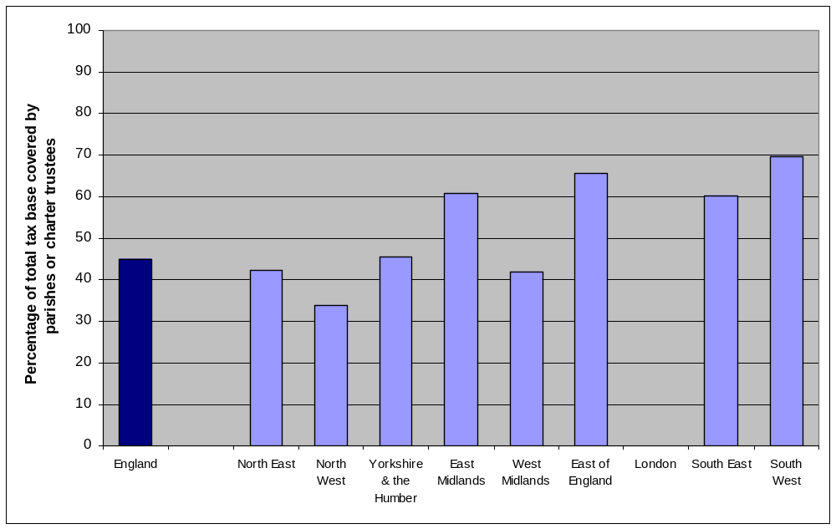
Source: CTR1 form

- Table 3 gives by region and by class of authority the tax base and average Band D parish precept within the area of a parish or charter trustee that is charging a non-zero precept in 2011-12 and 2012-13.

- The average Band D parish precept in England for 2012-13 is £47.74. This is an increase of £1.76, or 3.8%, from 2011-12.

- The aggregate of local precepts (excluding City of London), at £384m, represents 1.4% of the total council tax requirement for England of £26.7bn.

- The average Band D parish precept in each region outside London for 2012-13 varies from £27.56 in the North West to £61.36 in the North East.

- The change in parish precepts from 2011-12 to 2012-13 varies from an increase of £0.94 (1.9%) in the South East to an increase of £3.39 (5.8%) in the North East. The largest percentage increase in parish precept is of 9.9% (£2.48) in the North West.

- Almost three-quarters (74%) of parishes charging a non-zero precept are in shire districts.

- The greatest increase in parish precept is for unitary authorities with an average Band D parish precept increase of 4.8% (£2.39) from 2011-12 to 2012-13.

 | Table 3: Average Band D parish precept by region and by class of authority, 2011-12 and 2012-13 ^{(a)}
 |  |  | Parishes and charter trustees charging a non-zero precept
 |  |  | Total number |  |  | Tax base |  |  | Aggregate of local precepts ^{(b)} |  |  | Average parish precept per Band D
 |  |  |  |  |  | (thousands) |  |  | (£000) |  |  | (£)
 |  |  | 2011-12 (R) | 2012-13 |  | 2011-12 (R) | 2012-13 |  | 2011-12 (R) | 2012-13 |  | 2011-12 (R) | 2012-13 | Change | % change
 | England |  | 9,115 | 9,065 |  | 7,984.1 | 8,046.2 |  | 367,056 | 384,104 |  | 45.97 | 47.74 | 1.76 | 3.8
 | North East |  | 304 | 305 |  | 305.0 | 309.5 |  | 17,684 | 18,991 |  | 57.97 | 61.36 | 3.39 | 5.8
 | North West |  | 724 | 724 |  | 734.4 | 737.2 |  | 18,422 | 20,319 |  | 25.08 | 27.56 | 2.48 | 9.9
 | Yorkshire & Humber |  | 958 | 939 |  | 728.3 | 728.7 |  | 23,766 | 24,743 |  | 32.63 | 33.96 | 1.33 | 4.1
 | East Midlands |  | 1,293 | 1,296 |  | 818.8 | 823.7 |  | 40,140 | 41,873 |  | 49.02 | 50.84 | 1.82 | 3.7
 | West Midlands |  | 924 | 919 |  | 755.7 | 759.6 |  | 29,742 | 30,702 |  | 39.36 | 40.42 | 1.06 | 2.7
 | East of England |  | 1,695 | 1,680 |  | 1,324.5 | 1,332.7 |  | 67,598 | 70,517 |  | 51.04 | 52.91 | 1.88 | 3.7
 | London |  | 0 | 0 |  | 0.0 | 0.0 |  | 0 | 0 |  | - | - | - | -
 | South East |  | 1,494 | 1,482 |  | 1,969.1 | 1,994.1 |  | 98,625 | 101,747 |  | 50.09 | 51.02 | 0.94 | 1.9
 | South West |  | 1,723 | 1,720 |  | 1,348.2 | 1,360.8 |  | 71,078 | 75,212 |  | 52.72 | 55.27 | 2.55 | 4.8
 | London Boroughs |  | 0 | 0 |  | 0 | 0 |  | 0 | 0 |  | - | - | - | -
 | Metropolitan Areas |  | 230 | 229 |  | 459.0 | 461.7 |  | 15,198 | 15,749 |  | 33.11 | 34.11 | 1.00 | 3.0
 | Unitary Authorities |  | 2,120 | 2,116 |  | 2,216.8 | 2,245.7 |  | 109,502 | 116,304 |  | 49.40 | 51.79 | 2.39 | 4.8
 | Shire Districts |  | 6,765 | 6,720 |  | 5,308.3 | 5,338.8 |  | 242,356 | 252,051 |  | 45.66 | 47.21 | 1.55 | 3.4
 | Source: CTR1 & BR1 forms
 | ^{(a)} Excludes the Temples of London
 | ^{(b)} This is the total amount to be collected by billing authorities on behalf of parishes and charter trustees

- Chart B shows the average parish precept by region for 2011-12 and 2012-13.

Chart B: Average Band D parish precept by region, 2011-12 and 2012-13
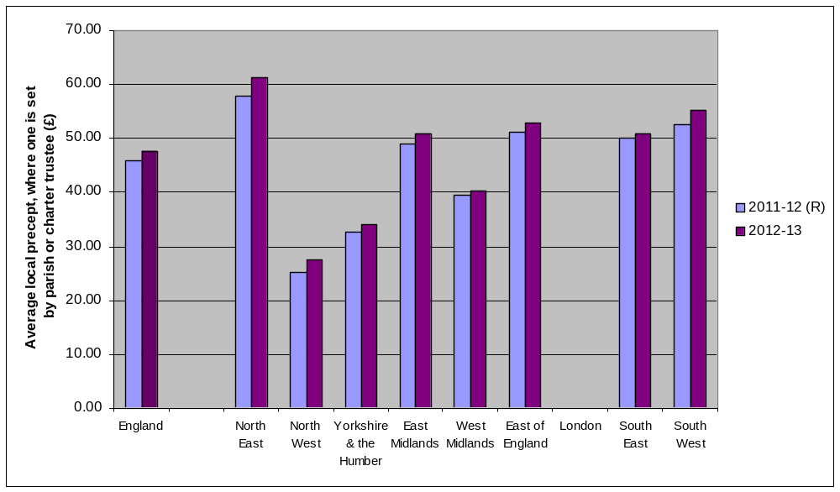
Source: CTR1 form

- Historical information on the estimated national average parish precept per Band D property is provided in Annex A2 of Local Government Financial Statistics England No.21 2011. This publication can be viewed at:
http://www.communities.gov.uk/publications/corporate/statistics/financialstatistics212011

Additional table

There is one additional table containing data for all billing authorities that, owing to its size, is not included in the printed version of this release. It is available on the Department’s website and can be found at:
http://www.communities.gov.uk/localgovernment/localregional/localgovernmentfinance/statistics/counciltax/parisheschartertrustees/

Below is a brief description of the data contained in the table:

- Table 4 compiles the data reported by local authorities alongside a calculation of the average Band D parish precept paid by those within the area of a parish or charter trustee that has set a non-zero precept. The data are taken from the Council Tax Requirement (CTR1) forms supplied by local authorities in England to the Department for Communities and Local Government in March 2012. Totals are also shown for England and by region, at the top of the table.

- Table 4 shows that average band D parish precepts by local authority range from £5.31 in Middlesbrough to £111.21 in Bolsover.

The equivalent revised tables for 2010-11 and 2011-12 are also available at the above link.

Terminology used in this release

The terms used in this release are defined below. A list of further terms relating to local government finance is given in the glossary of Local Government Financial Statistics England No. 21 2011. This is accessible at www.communities.gov.uk/publications/corporate/statistics/financialstatistics212011.

Aggregate of local precepts – This is the total amount collected by billing authorities on behalf of local precepting authorities in their area.

Average Band D parish precept – The aggregate amount collected on behalf of parishes and charter trustees (local precepts) divided by the total tax base of those parishes and charter trustees that have set a non-zero precept. These amounts are averages over all parishes in an area and will not represent the actual amount paid towards individual parishes or charter trustees in those areas. Calculations of average parish precepts exclude precepts for the City of London. Council tax is set on the basis of the number of Band D equivalent properties.

Band D council tax - This is the council tax payable on a Band D dwelling occupied as a main residence by two adults, before any reductions due to discounts, exemptions or council tax benefit. This definition is widely regarded as a benchmark when comparing council tax levels in different areas or over time.

Billing authority - Billing authorities are the 326 authorities (354 before 1 April 2009) that are empowered to set and collect council taxes, and manage the collection fund, on behalf of itself and other local authorities in its area. In England, metropolitan and shire districts, the Council of the Isles of Scilly, unitary authorities, London boroughs and the City of London are billing authorities. These are also sometimes known as lower-tier authorities.

Budget requirement (BR) forms – The predecessor to the current CTR forms, they were superseded in 2012-13. Similarly, they were a return that was completed by all billing and precepting authorities in England, giving information on the calculation of their council tax requirement and council tax.

BR1 forms were completed by billing authorities, BR2 forms by major precepting authorities and the BR3 form was completed by the Greater London Authority. Some historical data used in this release were collected on the BR1 forms.

Charter trustee - A body of councillors charged with preserving the historic property, privileges, rights, status and traditions of areas which have been subsumed within larger authorities as a result of local government reform. Charter trustees cease to exist when a parish council is formed for the area.

Council tax - This is a local charge (or charges) set by the billing authority in order to collect sufficient revenue to meet their demand on the collection fund and the precepts issued by the precepting authorities. It replaced the community charge on 1 April 1993 and is based on the value of the property and the number of residents. The Valuation Office Agency assesses the properties in each district area and assigns each dwelling to one of eight valuation bands, A to H. The tax is set on the basis of the number of Band D equivalent properties. Tax levels for dwellings in other bands are set relative to the Band D baseline.

Council tax band - There are eight council tax bands, A to H. Each domestic dwelling is assigned a council tax band by the Valuation Office Agency (VOA). Council tax bands are based on the value of the dwelling as at 1 April 1991. Any dwelling built after this date is given a notional 1991 value for council tax purposes.

Council tax requirement (CTR) forms - A return completed by all billing and precepting authorities in England giving details of information on the calculation of their council tax requirement and council tax

CTR1 forms are completed by billing authorities, CTR2 forms by major precepting authorities and the CTR3 form is completed by the Greater London Authority. The data used in this release were collected on the CTR1 forms.

Local precepting authority – parish / town / neighbourhood councils, chairmen of parish meetings, charter trustees and the treasurers of the Inner and Middle Temples. These local authorities can make a precept on the billing authority’s general fund.

Parish - The term parish used in this release means an English civil parish represented by a body able to raise a precept on council tax. A parish may be represented by a parish council or parish meeting. A parish council can resolve to have the status of a town council and can have city status conferred on it by royal prerogative. A parish council or parish meeting may resolve to adopt the style of a community, neighbourhood or village. They are local precepting authorities.

Parish precepts – Parish councils can raise a precept on the principal council (the billing authority). For the majority of parish councils this is the main source of income and the level of the precept is at the discretion of the parish. Parishes and charter trustees are local precepting authorities.

Precept - The amount of money (council tax) that a precepting authority has instructed the billing authority to collect and pay over to it in order to finance its net expenditure.

Tax base - This is council tax base as defined by the 1992 Local Government Finance Act and is the number of Band D equivalent dwellings in a local authority’s area. An authority’s taxbase is taken into account when it calculates its council tax, and when central government calculates allocations of formula grant. To calculate the tax base for an area, the number of dwellings in each council tax band is reduced to take account of any discounts and exemptions, such as for second homes. The resulting figure for each band is then multiplied by its proportion relative to Band D (from 6/9 for Band A to 18/9 for Band H) and the total across all eight bands is calculated. For example, as the ratio for Band H is 18/9, the number of Band D equivalent dwellings in Band H is twice the number of actual dwellings (after exemptions). An adjustment is then made for the collection rate to give the final tax base.

Temples of London – The Inner and Middle Temples are self-governing bodies located in the west of the City of London. The Temples were defined as local authorities with many of the same powers and responsibilities as the Inner London boroughs under the London Government Act 1963, except in relation to housing. The Inner Temple and Middle Temple, through powers vested in the Under Treasurer and Sub-Treasurer of the Middle and Inner Temple respectively, exercise a small number of local authority functions. All other functions fall under the responsibility of the City of London.

Data quality

The information in this release is based on data returned to the Department for Communities and Local Government by English local authorities on the Council Tax Requirement (CTR1) forms.

The data on the CTR1 form (with the exception of the Local Precepting Authorities section) are collected using legislative powers that require all billing authorities to return completed forms within seven days of setting their final budget for the coming year. This effectively ensures a 100% response rate.

Data on the number and tax base of parishes and charter trustees were collected from billing authorities for the first time in March 2010, as part of the Budget Requirement (BR1) forms. 2012-13 is the third year for which these data have been collected.

Figures provided by billing authorities are subjected to rigorous validation tests and quality assurance checks in Department for Communities and Local Government as the data are received and stored. The statistics release document, once prepared, is also subject to intensive peer review before being cleared as fit for the purposes of publication. These checks indicate that all billing authorities have provided information of an acceptable standard. This is the third time this information is being published in this format.

Revisions

The 2010-11 and 2011-12 data in this release differ from that in the previous Parishes and Charter Trustees in England statistical releases due to a number of authorities revising their parish numbers for 2010-11 and 2011-12. This release also updates the data for parishes published in the Council Tax Levels set by Local Authorities in England 2012-13 statistical release published on 21 March 2012.

Further information on council tax levels in England can be found in the 2012-13 Council Tax Levels in England release at: www.communities.gov.uk/publications/corporate/statistics/counciltax201213

Uses made of the data

This information will be used to inform the development of policy on council tax levels and to evaluate existing policies.

Background Notes

- For press inquiries about this Statistical Release please contact the Local Government press desk on 0303 444 0444 or email press.office@communities.gsi.gov.uk.

- For other inquiries please telephone Jenny Allan on 0303 444 4355 or email br.statistics@communities.gsi.gov.uk.

- Further statistical information relating to council tax is available on the Department’s website at www.communities.gov.uk/localgovernment/localregional/localgovernmentfinance/statistics/counciltax/

Information on council tax levels can be found at
http://www.communities.gov.uk/localgovernment/localregional/localgovernmentfinance/statistics/counciltax/rates/

Information on council tax collection rates can be found at
www.communities.gov.uk/localgovernment/localregional/localgovernmentfinance/statistics/counciltax/collectionrates/ .

- For a fuller picture of recent trends in local government finance, readers are directed to Local Government Financial Statistics England No.21 2011 which is available in hard copy from Cambertown Limited at product@communities.gsi.gov.uk (Tel: 0300 123 1124) and electronically in PDF format via the Department’s web site: www.communities.gov.uk/publications/corporate/statistics/financialstatistics212011

Symbols and conventions used in this release

 | – | = | not relevant
 | 0 | = | zero or negligible
 | (R) | = | These figures have been revised from the previous release in light of new data received from authorities.
Rounding
Where figures have been rounded, there may be a slight discrepancy between the total and the sum of constituent items

Department for Communities and Local Government © Crown copyright, 2012

If you require this publication in an alternative format please e-mail:
alternativeformats@communities.gsi.gov.uk.

Please note that the nature of content means that we may not be able to provide the Statistical series of publications in all requested formats.

April 2012
ISBN: 978 1 4098 3459 9

