Planning Applications:

Planning
Statistical Release

30 June 2010
using
Research
Summary
Number 239, 2007

March Quarter 2010 (England)



Headlines 1
Introduction 2
Authorities undertaking
district level planning 2
Planning applications 2
Planning decisions 2
Applications granted 2
Residential decisions 4
Planning applications for Gypsy and Traveller pitches 5
Householder developments 5 Speed of applications 5
Local Authority performance 6
Enforcement action 7
Regulation 3 and 4 consents 7
Applications for determination 7
Delegated applications 7
Authorities undertaking
county level planning 8
Planning applications 8
Planning decisions 8
Speed of decisions 8
Regulation 3 and 4 consents 9
Enforcement action 9
Development control targets 11
Environmental Impact Assessments and the 16 week target for non ‘county matter’ applications 11
Data collection 11 Data quality 12
Accompanying tables 12
Background notes 13
Further information 14
Enquiries 14
In the period January to March 2010 local authorities undertaking district level planning

- received 118,400 applications, up by around 6 per cent when compared with the March 2009 quarter;
- decided (granted or refused) 95,700 applications, an increase of 3 per cent when compared with the March 2009 quarter;
- decided 12,000 applications for residential developments, down by 3 per cent compared with March 2009 quarter;
- decided 1,400 major residential developments applications (10 or more dwellings) up by 8 per cent compared with the March 2009 quarter;
- decided 71 per cent of major applications within 13 weeks;

Authorities undertaking ‘county level’ planning decided 312 applications, a decrease of 21 per cent when compared with the same quarter a year ago.

In 2009/10, local planning authorities received 466,400 district level planning applications, compared to 689,000 applications in 2004/05

Introduction
This quarterly Statistical Release presents National Statistics on authorities that undertake district and county level planning activities in England. It covers information on planning applications received and decided including decisions on applications for residential developments (dwellings) and enforcement activities. Data are provided at national, regional and local authority level and are based on information for the March quarter 2010 reported to Communities and Local Government as at 27th May 2010. The Background Notes section provides more detail of the terms used within this release.

Due to seasonal variation, quarterly figures in this release are compared with the corresponding quarter in the previous year.

Authorities undertaking district level planning
Planning applications
In the March quarter 2010, authorities undertaking district level planning in England received 118,400 applications for planning permission (Table 1). This represents an increase of 6 per cent compared with the corresponding quarter in 2009. In the year ending March 2010, authorities received 466,400 applications, an 8 per cent decrease from the year ending March 2009 figures and compares with a peak of 689,000 in 2004/05.

Planning decisions
District level planning authorities decided 95,700 planning applications in the March quarter 2010, 3 per cent higher than in the same quarter last year. Seven regions and the National Park authorities saw an increase in the number of applications decided compared to the March quarter 2009, whilst the number fell in Yorkshire and the Humber and the North East. The largest increases were in the East of England, the South East and London (all 6 per cent). The National Parks saw an overall increase of 10 per cent. (Table 2). The largest decrease was in the North East (6 per cent).

In the year ending March 2010, 417,600 applications were decided, a decrease of 15 per cent compared with the corresponding period a year ago. All regions, including the National Park authorities, saw a decrease in the number of applications determined compared to the year ending March 2009. The largest decreases were in the North East (18 per cent) and Yorkshire and the Humber (17 per cent). The National Parks saw an overall decrease of 8 per cent (Table 2YE)

Applications granted
85 per cent of all decisions in the March quarter 2010 were granted, an increase of 2 percentage points when compared with the March quarter 2009. Approval rates across the regions ranged from 78 per cent in London to 92 per cent in the North East (Table 2). These percentages represent a 2 percentage point increase in the approval rate for authorities in both regions when compared with the same quarter a year ago.

In the year ending March 2010, 85 per cent of all decisions were granted, an increase of 2 percentage points when compared with the year ending March 2009. Approval rates across the regions ranged from 78 per cent in London to 92 per cent in the North East (Table 2YE). These percentages represent a 3 percentage point increase in the approval rate for authorities in London and a 1 percentage point increase in the approval rate for authorities in the North East compared to the year ending March 2009.

Table 1: District level planning applications received, decided and granted
 |  |  | Received |  | Decided |  | Granted¹
Financial Year | Quarter |  | Number ('000s) | % change on corresponding quarter last year | Number ('000s) | % change on corresponding quarter last year | Number ('000s) | % change on corresponding quarter last year
2005-06 | June |  | 170 | -8% | 164 | -5% | 130 | -6%
 | Sept |  | 161 | -8% | 158 | -11% | 125 | -11%
 | Dec |  | 147 | -8% | 143 | -8% | 112 | -9%
 | Mar |  | 165 | -3% | 134 | -4% | 105 | -5%
2006-07 | June |  | 170 | 0% | 155 | -5% | 123 | -5%
 | Sept |  | 157 | -2% | 155 | -2% | 122 | -2%
 | Dec |  | 149 | 1% | 141 | -1% | 111 | -1%
 | Mar |  | 168 | 2% | 136 | 1% | 107 | 3%
2007-08 | June |  | 174 | 2% | 156 | 1% | 124 | 1%
 | Sept |  | 166 | 6% | 160 | 3% | 126 | 2%
 | Dec |  | 151 | 1% | 148 | 5% | 116 | 5%
 | Mar |  | 158 | -6% | 132 | -3% | 102 | -5%
2008-09^{P} | June |  | 150 | -14% | 144 | -8% | 114 | -8%
 | Sept |  | 135 | -19% | 136 | -15% | 108 | -14%
 | Dec |  | 111 | -26% | 116 | -22% | 91 | -21%
 | Mar |  | 111 | -29% | 93 | -29% | 73 | -28%
2009-10^{P} | June |  | 118 | -21% | 105 | -27% | 84 | -27%
 | Sept |  | 119 | -12% | 112 | -18% | 90 | -17%
 | Dec |  | 111 | 0% | 105 | -9% | 85 | -7%
 | Mar |  | 118 | 6% | 96 | 3% | 77 | 5%
Year to Mar 2010^{P} |  |  | 466 | -8% | 418 | -15% | 335 | -13%
¹ Excludes planning applications which can neither be granted nor refused.
Figures are rounded and the components do not necessarily sum to the independently rounded totals.
Percentages are calculated using unrounded figures.
P Provisional.

Figure 1: Number of planning applications received, decided and granted by district authorities
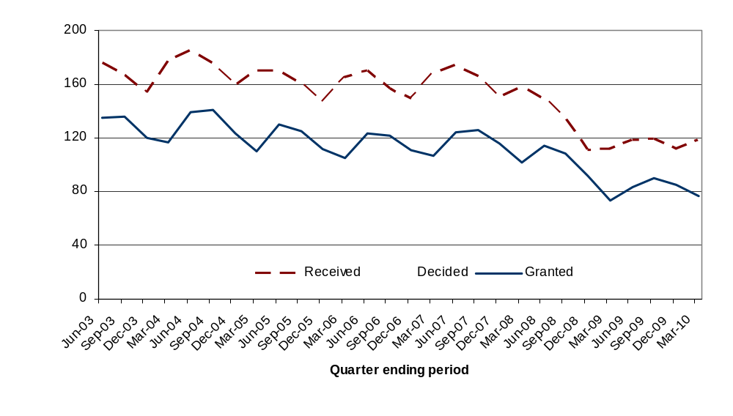
Residential Decisions

Decisions on all applications for residential developments decreased from 12,300 in the March quarter 2009 to 12,000 in the March quarter 2010, a decrease of 4 per cent, although major residential development increased by around 4 per cent compared to the March quarter 2009 (Table 3).

The number of residential developments decided decreased by 24 per cent from 64,700 in the year ending March 2009 to 49,400 in the year ending March 2010 (Table 3YE).

In the March quarter 2010, authorities granted 79 per cent of major residential applications and determined 65 per cent of them within 13 weeks. 71 per cent of decisions on minor residential applications were granted and 70 per cent determined within 8 weeks.

In the year ending March 2010, authorities granted 76 per cent of major residential applications and determined 66 per cent of them within 13 weeks. 70 per cent of decisions on minor residential applications were granted and 73 per cent determined within 8 weeks.

Planning Applications for Gypsy and Traveller Pitches
From April 2008, local authorities have been required to provide information on decisions relating to planning applications for Gypsy and Traveller pitches. Information on Gypsy and Traveller pitches are shown in Table 8A/Table 8A YE and are as reported by local planning authorities.

In the March quarter 2010, local planning authorities determined 15 major applications and granted 47 per cent of those applications with 33 per cent being determined within 13 weeks. Also, in the March quarter 2010 authorities determined 46 minor applications on Gypsy and Traveller pitches and granted 52 per cent with 35 per cent of those applications being determined within 8 weeks.

In the year ending March 2010, authorities determined 40 major applications for Gypsy and Traveller pitches. 48 per cent of the major applications were granted and 41 per cent were determined within 13 weeks. Also, authorities determined 190 minor applications on Gypsy and Traveller pitches. 50 per cent of the minor applications were granted and 44 per cent were determined within 8 weeks.

The highest number of applications for major Gypsy and Traveller pitches determined in the year ending March 2010 was in the East Midlands (11 applications), with 64% granted and 27% determined in 13 weeks. Authorities in the South East determined the highest number of minor applications (58 applications), with 48 per cent of those applications granted and 43 per cent determined within 8 weeks.

Householder Developments
Householder developments are those developments to a house which require planning permission such as extensions, loft conversions, conservatories, and so on. Decisions made on householder developments increased by 6 per cent from 39,900 in the March quarter 2009 to 42,200 in the March quarter 2010 (accounting for 44 per cent of all decisions), while the number of householder developments decided decreased by 19 per cent from 234,400 in the year ending March 2009 to 190,500 in the year ending March 2010 (accounting for 46 per cent of all decisions).

Speed of applications
In the March quarter 2010, the number of applications processed within 13 weeks was 70 per cent compared with 71 per cent in the March 2009 quarter (Table 2). Also, 77 per cent of minor applications and 86 per cent of other applications were processed within 8 weeks.

In the year ending March 2010, 71 per cent of major applications were processed within 13 weeks. Also, 79 per cent of minor applications and 88 per cent of other applications were processed within 8 weeks. (Table 2 YE).

Figure 2: Percentage of major applications processed within 13 weeks
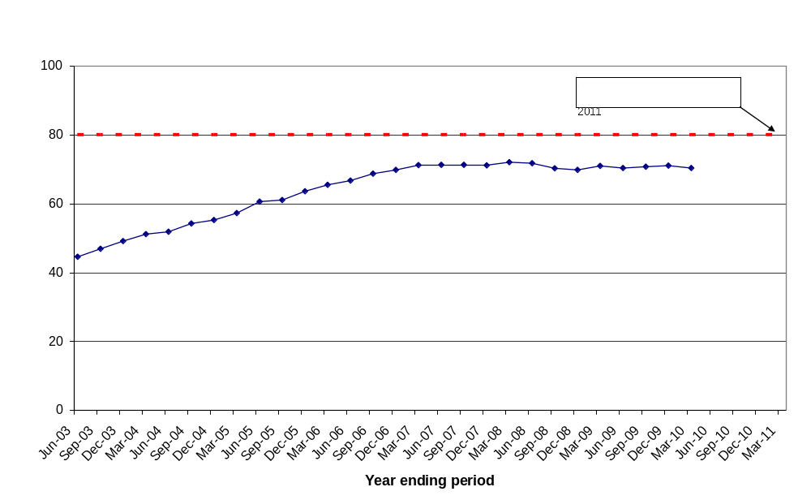

In the quarter ending March 2010, district level planning authorities decided 60 per cent of large-scale major applications, and 72 per cent of small-scale major applications within 13 weeks (Table 3A).

In the year ending March 2010, district level planning authorities decided 62 per cent of large-scale major applications, and 73 per cent of small-scale major applications within 13 weeks (Table 3A YE).

Local Authority performance (Table 7)
National Indicator 157 a, b and c reports on the speed at which major, minor and other planning applications are processed by district level planning authorities (for more information see page 8 of this release).

The March quarter 2010 saw 237 authorities (70 per cent of all authorities) make at least 60 per cent of their decisions on major applications within the 13 week period; 292 authorities (86 per cent) made at least 65 per cent of their decisions on minor applications within the statutory 8 week period; and 284 authorities (84 per cent) made at least 80 per cent of their decisions on other applications within the statutory 8 week period.

In the year ending March 2010, the percentage of authorities meeting the target on major applications was 80 per cent (272 authorities), for minors 93 per cent (316 authorities) and for other applications was 91 per cent (308 authorities).

Enforcement action
Table 4 shows statistics on formal enforcement action taken by responding authorities in each year since 2000/01. In the March quarter 2010, authorities issued 1,341 Enforcement Notices and served 1,319 Planning Contravention Notices, 222 Breach of Condition Notices, 20 Stop Notices and 51 Temporary Stop Notices. In the March quarter 2010 19 Enforcement Injunctions were granted by the High/County Court.

In the year ending March 2010, authorities issued 5,009 Enforcement Notices and served 4,975 Planning Contravention Notices, 920 Breach of Condition Notices, 108 Stop Notices and 238 Temporary Stop Notices. In the year ending March 2010 62 Enforcement Injunctions were granted by the High/County Court and 1 was refused.

Regulation 3 and 4 consents
Table 5 shows the number of Regulation 3 and 4 Consents granted since 1999-00. Under Regulation 3 of the Town and Country Planning General Regulations 1992, SI 1992/1492, a local planning authority makes an application to itself for permission to develop land within its area, and determines that application. Regulation 4 is concerned with planning permission for development of land in which the local planning authority has an interest but which it does not itself propose to carry out.

In the March 2010 quarter, 1,094 Regulation 3 consents and 74 Regulation 4 consents were granted. In the year ending March 2010 4,146 Regulation 3 consents and 354 Regulation 4 consents were granted.

Applications for determination
Authorities received 1,386 applications for determination on whether local authority approval is required for certain works in the March quarter 2010 (Table 5). Local authorities decided to intervene in 193 cases (14 per cent).

Authorities received 5,250 applications for determination on whether local authority approval is required for certain works in the March quarter 2010 (Table 5). Local authorities decided to intervene in 754 cases (14 per cent).

Applications decided under delegated powers
Table 7A shows the percentage of applications decided by planning officers under a scheme of delegation and without referral to committee or councillors on such decisions. 328 authorities (out of 339) provided information on delegated decisions in this quarter. On average, authorities delegated 91 per cent of decisions to planning officers.

Authorities undertaking county level planning
Authorities that undertake county level planning activity – which includes counties, unitary authorities, London boroughs, metropolitan districts, urban development corporations and National Parks - received around 1,600 ‘county matters’ applications in the year ending March 2010. This compares with the 467,000 planning applications received by authorities that undertake district level planning activities. Figures for ‘county matters’ decisions are therefore likely to be much more variable than those for districts because of the smaller numbers of such decisions.

Planning applications
In the March quarter 2010, authorities received 408 ‘county matter’ applications, a decrease of 5 per cent compared with the same quarter last year. County councils accounted for 76 per cent of total applications, unitary authorities for 19 per cent and metropolitan districts for 5 per cent (Table 9). The highest number of applications was received by Lancashire and Norfolk (22 applications each). (Table 12)

In the year ending March 2010, authorities received 1,575 ‘county matter’ applications. County councils accounted for 77 per cent of total applications, unitary authorities for 17 per cent and metropolitan districts for 5 per cent (Table 9). The highest number of applications was received by Lancashire (86 applications) and Norfolk (84 applications). (Table 12YE).

Planning decisions
County matter authorities determined 312 planning applications in the March quarter 2010, a decrease of 21 per cent compared with the same quarter last year. Of these, 94 per cent were granted, an increase of 3 percentage points when compared with the same quarter last year (Table 9). Hampshire determined the highest number of planning applications (22 applications) followed by Lancashire (18 applications) (Table 12). Waste developments accounted for 69 per cent of the total decisions and minerals developments accounted for 26 per cent (Table 10).

In the year ending March 2010, county matter authorities determined 1,337 planning applications in the March quarter 2010, a decrease of 11 per cent compared with the year ending March 2009. Of these, 92 per cent were granted, the same as the year ending March 2009 (Table 9). Cumbria determined the highest number of planning applications (80 applications) followed by Lancashire (63 applications) (Table 12YE). Waste developments accounted for 70 per cent of the total decisions and minerals developments accounted for 25 per cent (Table 10YE).

Speed of decisions

In the March quarter 2010, 17 per cent of all decisions on ‘county matters’ applications were made within 8 weeks. County-level planning authorities also determined 63 per cent of applications within 13 weeks (Table 12).

In the year ending March 2010, 14 per cent of all decisions on ‘county matters’ applications were made within 8 weeks. County-level planning authorities also determined 59 per cent of applications within 13 weeks (Table 12YE).

Regulation 3 and 4 consents

Table 12 shows the number of permissions granted by authorities under Regulations 3 and 4 of the Town and Country Planning General Regulations 1992. In the March quarter 2010, a total of 627 Regulation 3 consents were granted. The highest numbers of consents were granted by Kent (59 consents) and Suffolk (56 consents). In the year ending March 2010, a total of 2,845 Regulation 3 consents were granted. The highest numbers of consents were granted by Kent (262 consents) and North Yorkshire (242 consents).

In order to better reflect the workload of authorities, information on the total number of decisions on applications for consent, agreement or approval of details or schemes required by conditions, as defined by Article 21 of the General Development Procedure Order 1995 have been collected from April 2000 and is also published in this table.

In the March quarter 2010, 353 decisions were made under Article 21, with the highest number reported by Lincolnshire (48 decisions). The number of determinations under the review of mineral planning permissions was also collated, however only 9 were determined by county level planning authorities.

In the year ending March 2010, 1,447 decisions were made under Article 21, with the highest number reported by Lincolnshire (130 decisions). The number of determinations under the review of mineral planning permissions was also collated, however only 23 were determined by county level planning authorities.

Enforcement action
In the March quarter 2010 county level planning authorities issued 33 Enforcement Notices and served 4 Stop Notices, 5 Temporary Stop Notices, 40 Planning Contravention Notices and 16 Breach of Condition Notices.

In the year ending March 2010 county level planning authorities issued 92 Enforcement Notices and served 9 Stop Notices, 25 Temporary Stop Notices, 161 Planning Contravention Notices and 38 Breach of Condition Notices (Table 13).

Table 2: County level planning applications granted, received and decided

 |  | Planning Applications |  | Planning Decisions |  | Applications Granted
Financial Year | Quarter | Number | % change on corresponding quarter last year | Number | % change on corresponding quarter last year | Number | % change on corresponding quarter last year
2005-06 | June | 466 | -14% | 390 | -3% | 353 | -4%
 | Sept | 510 | -6% | 416 | -17% | 375 | -19%
 | Dec | 398 | -22% | 458 | -1% | 417 | 0%
 | Mar | 483 | -7% | 419 | -1% | 386 | 0%
2006-07 | June | 450 | -3% | 416 | 7% | 376 | 7%
 | Sept | 448 | -12% | 389 | -6% | 347 | -7%
 | Dec | 441 | 11% | 399 | -13% | 349 | -16%
 | Mar | 466 | -4% | 387 | -8% | 363 | -6%
2007-08 | June | 464 | 3% | 393 | -6% | 364 | -3%
 | Sept | 446 | 0% | 375 | -4% | 348 | 0%
 | Dec | 444 | 1% | 389 | -3% | 357 | 2%
 | Mar | 473 | 2% | 341 | -12% | 317 | -13%
2008-09 | June | 392 | -16% | 374 | -5% | 344 | -13%
 | Sept | 439 | -2% | 379 | 1% | 347 | -1%
 | Dec | 405 | -9% | 361 | -7% | 334 | -6%
 | Mar | 431 | -9% | 393 | 15% | 358 | 13%
2009-10^{P} | June | 355 | -9% | 313 | -16% | 293 | -15%
 | Sept | 406 | -8% | 336 | -11% | 304 | -12%
 | Dec | 406 | 0% | 376 | 4% | 343 | 3%
 | Mar | 408 | -5% | 312 | -21% | 294 | -18%
Year to Mar 2010^{P} |  | 1575 | -6% | 1337 | -11% | 1234 | -11%
P Provisional.

Development control targets

The Department reports on National Indicator 157 - Processing of Planning Applications and the targets for individual local planning authorities are as follows:

- 60% of major (large-scale and small-scale) applications to be processed within 13 weeks;
- 65% of minor applications to be processed within 8 weeks; and
- 80% of other applications to be processed within 8 weeks.

For authorities that undertake county level planning activity, the target is:

- 60% of all applications to be processed within 13 weeks.

Environmental Impact Assessments and the 16 week target for non ‘county matter’ applications

Local authorities have been encouraged to decide 60 per cent, not 100 per cent, of major applications within 13 weeks in order to achieve the target. This flexibility provides for cases where an EIA is required and this is to continue. Provided less than forty per cent of its casework comes into that category, the authority would not be penalised by abatement of grant.

In respect of large-scale major applications the introduction of the Planning Performance Agreement (PPA) provides a further opportunity to agree a determination period more suited to the character and complexity of a scheme. The PPA is a voluntary agreement between a local planning authority and an applicant to provide a project management framework for handling a large-scale major planning application. This framework should improve and speed up the planning process by committing both parties to an agreed timetable containing ‘milestones’, by clarifying in advance what level of evidence, resources and community engagement are required, and by ensuring that all relevant aspects such as sustainability assessments and design standards are properly considered. The timetable devised for each Agreement means that local authorities are no longer under pressure to determine the application within 13 weeks as applications with PPAs are excluded from this target if the agreed timescale has been adhered to.

Data collection

Statistics of planning applications received and decided by authorities that undertake district level planning activity have been collated, on a quarterly basis, since April 1979 on the PS1 and PS2 General Development Control statistical returns (District). From the March quarter 2008, the PS1, PS2 and the Fee1 (revenue collected in respect of PS1 and PS2) returns, are now combined as a single return, the PSF return. Information on planning applications for authorities that undertake county level planning activities are collated on the CPS1/2 General Development Control statistical returns (County Matters). These are reported to the department via Interform – the department’s housing and planning electronic data collection system.
In April 2009, local government reorganisation has reduced the number of authorities that undertake district level planning activities from 367 to 339 while the number of authorities that undertake county level planning activities has increased from 161 to 163.

Data quality

Both the PSF and CPS1/2 returns submitted by local planning authorities undergo thorough validation and checks. Inconsistent data highlighted during validation and checks are verified by contacting the local authority. Late returns are pursued to ensure the overall response rate is as high as possible. Where a response rate of 100% is not achieved estimates are imputed for non-responding authorities.

328 (97 per cent) of authorities that undertake district level planning activities and 153 (94 per cent) of authorities that undertake county level planning activities submitted data in time for this publication. Also, authorities for which partial or no data has been received over the year (i.e. they did not submit information for one or more quarters) are not shown in annual tables. Therefore the data includes imputation for the small number of non-responding authorities and are included in Tables 1-3 where national and regional totals are presented. Performances of individual local authorities are presented in tables 7, 7YE, 8 and 8YE.

All figures included in the commentary have been calculated using unrounded data. As a result, there may be some apparent discrepancy with figures shown in the accompanying tables.

From April 2007 an indication on the level of quality assurance undertaken by the local authority is recorded as part of the final sign-off for these returns.

Accompanying tables

Accompanying tables are available to download alongside this release. These are:

Tables:
1 Planning applications and decisions of district planning authorities by speed of decision
2 / 2YE Planning decisions of district planning authorities by speed of decision, Government Office Region and type of authority
3 / 3YE Planning decisions of district planning authorities by speed of decision, type and size of development
3A / 3A YE District Planning Authorities: Major planning decisions by speed, type and size of development
4 Enforcement actions by district planning authorities
5 Regulation 3 and 4 Consents granted and applications for determination by district planning authorities
6 Enforcement action by district planning authority

7 / 7YE Planning decisions, by development type and speed of decision – Quarter ending and Year ending
7A / 7A YE Planning applications, decisions, Environmental Statements and percentage of decisions delegated
8 / 8YE Planning decisions on Major and Minor residential development by district authority – Quarter ending and Year ending
8A / 8A YE Planning decisions on Major and Minor Gypsies and Travellers Pitches by district authority – Quarter ending and Year ending
9 ‘County matters’ planning applications and decisions
10 / 10YE 'County Matters' planning decisions by type and size of development
11 ‘County matters’ decisions by speed of decision
12 / 12YE 'County matter' planning applications received and decided
13 Enforcement actions of county planning authorities
14 Decisions on minerals applications of 'County Matters' authorities by type of development
15 Decisions on waste planning applications of 'County Matters' authorities, by type of development
16 'County Matters' applications decided and granted by nature of site, type of development and nature of application
17 Decisions on ‘County Matters’ planning applications, by speed of decision, size of site and type of development
18 All reasons given for 'County Matters' decisions taking over 8 weeks

Additional tables, earlier quarterly data and historic series can be accessed in the ‘Live Tables’ section (“Live Tables on Development Control Statistics”) at

http://www.communities.gov.uk/planningandbuilding/planningbuilding/planningstatistics/livetables/livetablesondevelopmentcontrolst/

Background notes

- County level planning applications are predominantly concerned with minerals extraction and waste disposal developments, as set out in Schedule 1 of the Town and Country Planning Act 1990 and in the Town and Country Planning (Prescription of County Matters) (England) Regulations 2003 (SI 2003/1033).
- Authorities undertaking county level planning include county councils, metropolitan districts, unitary authorities, London boroughs, national park authorities and urban development corporations. However, because of the nature of county matters applications, the large majority are handled by the county councils.

- District level planning is undertaken by metropolitan and non-metropolitan districts, unitary authorities, national park authorities and urban development corporations. These authorities deal with all other planning applications that are not classified as county matters and mainly include applications for planning permissions on residential, offices, industrial, retail and householder developments.

- Householder Developments: Householder developments are defined as those within the curtilage of a dwellinghouse which require an application for planning permission and are not a change of use. Included in householder developments are extensions, conservatories, loft conversions, dormer windows, alterations, garages, car ports or outbuildings, swimming pools, walls, fences, domestic vehicular accesses including footway crossovers, porches and satellite dishes. Excluded from householder developments are applications relating to any work to one or more flats, applications to change the number of dwellings (flat conversions, building a separate house in the garden), changes of use to part or all of the property to non-residential (including business) uses, anything outside the garden of the property (including stables if in a separate paddock).

- This Release is a web-only publication.

- Details of officials who receive pre-release access to this statistical release 24 hours before publication can be found at http://www.communities.gov.uk/corporate/researchandstatistics/statistics/nationalstatistics/

- National Statistics are produced to high professional standards set out in the National Statistics Code of Practice. They undergo regular quality assurance reviews to ensure they meet customer needs.
Further Information
Date of next publication

The next update of this Statistical Release will be published in September 2010.
Enquiries
1. This Statistical Release, as well as previous Releases, can be accessed from the Communities and Local Government website at:
www.communities.gov.uk/publications/corporate/statistics/planningapplicationsq12010

2. Any query regarding this Release should be addressed to: Development Control Statistics Branch, Housing Markets and Planning Analysis Division, Communities and Local Government, Zone 2/J3, Eland House, Bressenden Place, London SW1E 5DU.
Email: developmentcontrol@communities.gov.uk

Media enquiries:

Office hours: 0303 444 1156
0303 444 1051
Email: press@communities.gov.uk

Public enquiries:

Telephone: 0303 444 0000

Responsible Statistician:
Grant Kelly
Email: developmentcontrol@communities.gsi.gov.uk
Information on Official Statistics is available via the UK Statistics Authority website:
www.statistics.gov.uk

Information about Communities and Local Government is available via the Department’s website:
www.communities.gov.uk
Department for Communities and Local Government. © Crown Copyright, 2010

If you require this publication in an alternative format please email: alternativeformats@communities.gsi.gov.uk. Please note that the nature of content means that we may not be able to provide the Statistical series of publications in all requested formats.

June 2010

ISBN: 978-1-4098-2489-3

