Planning Applications:

Planning
Statistical Release

24 June 2011
using
Research
Summary
Number 239, 2007

March Quarter 2011 (England)


Headlines 1
Introduction 2
Authorities undertaking
district level planning 2
Planning applications 2
Planning decisions 2
Applications granted 2
Seasonal adjustment 4 Speed of applications 5 Residential decisions 5
Householder developments 6
Planning applications for Gypsy and Traveller pitches 6
Enforcement action 6
Regulation 3 and 4 consents 6
Applications for determination 7
Delegated applications 7
Authorities undertaking
county level planning 8
Planning applications 8
Planning decisions 8
Speed of decisions 8
Regulation 3 and 4 consents 9
Enforcement action 9
Data collection 11 Data quality 11
Revisions policy 11
User consultation 12
Accompanying tables 13
Background notes 14 Date of next publication 15 Enquiries 15

Responsible Statistician:
Grant Kelly
Statistical enquiries:
office hours: 0303 444 42277
planning.statistics@communities.gov.uk

Media Enquiries:
0303 444 1201
press@communities.gov.uk

In the period January to March 2011 local authorities undertaking district level planning

- received 119,400 applications, an increase of around 1 per cent when compared with the March 2010 quarter;

- decided (granted or refused) 96,800 applications, an increase of 1 per cent when compared with the March 2010 quarter;

- granted 78,500 applications, an increase of 2 per cent when compared with the March 2010 quarter;

- decided 12,000 residential applications, unchanged from the March 2010 quarter;

In the 12 months to March 2011, district level local authorities

- received 483,500 applications, an increase of 4 per cent on the 12 months to March 2010

- decided 439,900 applications, 5 per cent up on the 12 months to March 2010

- granted 355,800 permissions, 6 per cent up on the 12 months to March 2010

- decided 51,800 residential applications, an increase of 5 per cent on the 12 months to March 2010

Authorities undertaking ‘county level’ planning decided 1,285 applications, a decrease of 4 per cent when compared with the 12 months to March 2010.

Introduction
This quarterly Statistical Release presents National Statistics on authorities that undertake district and county level planning activities in England. It covers information on planning applications received and decided including decisions on applications for residential developments (dwellings) and enforcement activities. Data are provided at national, regional and local authority level and are based on information for the March quarter 2011 reported to Communities and Local Government as at 11th May 2011. The Background Notes section provides more detail of the terms used within this release.

Authorities undertaking district level planning
A summary of the trends in applications, decisions and permissions granted is provided in Table A. More detailed figures are available in the accompanying Live Tables (P120-P138).

Planning applications
In the March quarter 2011, authorities undertaking district level planning in England received 119,400 applications for planning permission (Table P120). This represents an increase of 1 per cent compared with the corresponding quarter in 2010. In the year ending March 2011, authorities received 483,500 applications, an increase of 4 per cent on the year ending March 2010 figure.

Planning decisions
District level planning authorities decided 96,800 planning applications in the March quarter 2011, 1 per cent higher than in the same quarter last year. In the year ending March 2011 authorities decided 439,900 applications, an increase of 5 per cent on the year ending March 2010. (Table P121)

In the year ending March 2011, all regions apart from the North East saw an increase in the number of decisions. The largest increases were in London (10 per cent) and the South East (8 per cent). (Table P122)

Applications granted
In the March quarter 2011, 78,500 permissions were granted, up 2 per cent on the same quarter in 2010. 86 per cent of all decisions were granted between January and March 2011, an increase of 1 percentage point when compared with the March quarter 2010. (Table P121)

Over the 12 months to March 2011, 355,800 applications were granted, 6 per cent up on the year to March 2010. 86 per cent of all decisions were granted in the year to March 2011 compared with 85 per cent in the year to March 2010.

In the year ending March 2011, approval rates across the regions ranged from 80 per cent in London to 93 per cent in the North East. These percentages represent a 2 percentage point increase for authorities in London and a 1 percentage point increase for authorities in the North East compared to the year ending March 2010. (Table P122)

Table 1: District level planning applications received, decided and granted
 |  | Received |  | Decided |  | Granted¹
Financial Year | Quarter | Number ('000s) | % change on corresponding quarter last year | Number ('000s) | % change on corresponding quarter last year | Number ('000s) | % change on corresponding quarter last year
2005-06 | Jun | 170 | -8% | 164 | -5% | 130 | -6%
 | Sep | 161 | -8% | 158 | -11% | 125 | -11%
 | Dec | 147 | -8% | 143 | -8% | 112 | -9%
 | Mar | 165 | -3% | 134 | -4% | 105 | -5%
2006-07 | Jun | 170 | 0% | 155 | -5% | 123 | -5%
 | Sep | 157 | -2% | 155 | -2% | 122 | -2%
 | Dec | 149 | 1% | 141 | -1% | 111 | -1%
 | Mar | 168 | 2% | 136 | 1% | 107 | 3%
2007-08 | Jun | 174 | 2% | 156 | 1% | 124 | 1%
 | Sep | 166 | 6% | 160 | 3% | 126 | 2%
 | Dec | 151 | 1% | 148 | 5% | 116 | 5%
 | Mar | 158 | -6% | 132 | -3% | 102 | -5%
2008-09^{P} | Jun | 150 | -14% | 144 | -8% | 114 | -8%
 | Sep | 135 | -19% | 136 | -15% | 108 | -14%
 | Dec | 111 | -26% | 116 | -22% | 91 | -21%
 | Mar | 111 | -29% | 93 | -29% | 73 | -28%
2009-10^{P} | Jun | 118 | -21% | 105 | -27% | 84 | -27%
 | Sep | 119 | -12% | 112 | -18% | 90 | -17%
 | Dec | 111 | 0% | 105 | -9% | 85 | -7%
 | Mar | 118 | 6% | 96 | 3% | 77 | 5%
2010/11^{P} | Jun | 127 | 8% | 113 | 8% | 91 | 9%
 | Sep | 126 | 6% | 120 | 7% | 97 | 8%
 | Dec | 111 | -1% | 110 | 5% | 89 | 5%
 | Mar | 119 | 1% | 97 | 1% | 78 | 2%
Year to Mar 2010 |  | 466 |  | 418 |  | 335
Year to Mar 2011^{P} |  | 483 | 4% | 440 | 5% | 356 | 6%
¹ Excludes planning applications which can neither be granted nor refused.
Figures are rounded and the components do not necessarily sum to the independently rounded totals.
Percentages are calculated using unrounded figures.
P Provisional.

Figure 1: Number of planning applications received, decided and granted by district authorities

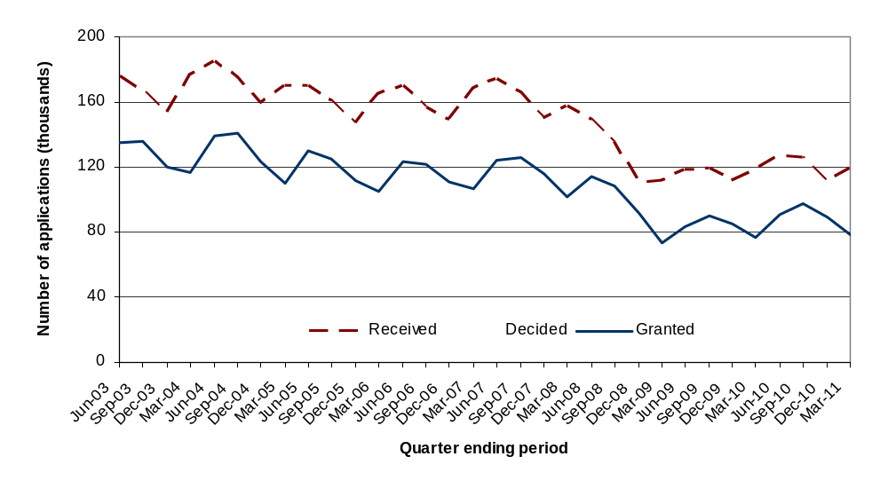
Seasonal adjustment
We have also calculated a seasonally adjusted time series of the numbers of planning applications received, decided and granted.

Figure 2: Number of planning applications received, decided and granted by district authorities (seasonally adjusted)
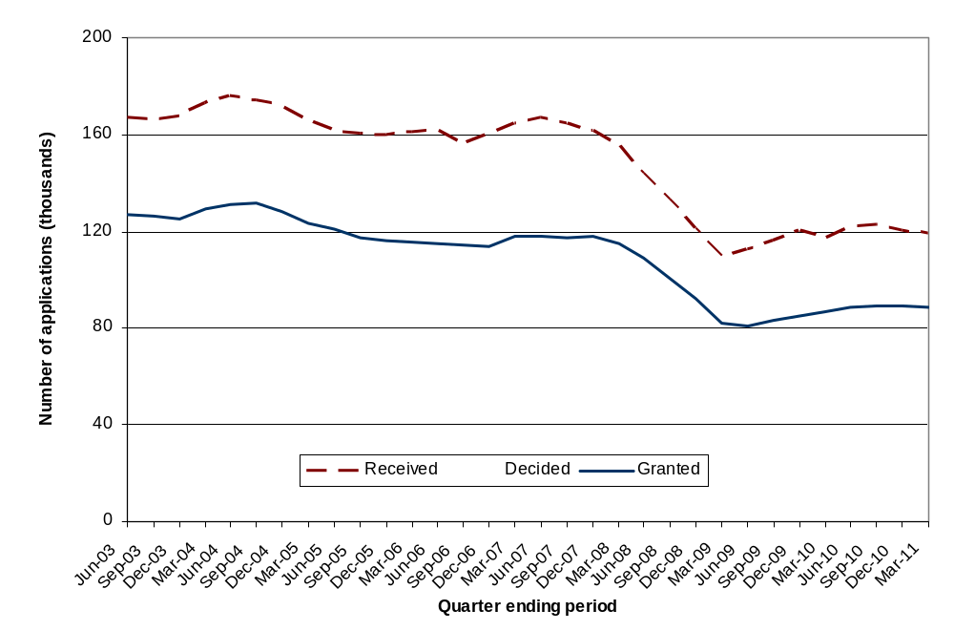
The effect of the market slowdown from the end of 2007 onwards can be clearly seen.

Further investigation has shown that only the ‘Other’ element of these series are actually seasonal in nature – these include such applications as householder applications (which covers loft conversions, extensions etc which are likely to be affected by the weather). Major and minor applications do not demonstrate a seasonal component.

Speed of applications
In the March quarter 2011, 62 per cent of major applications were processed within 13 weeks compared with 70 per cent in the March 2010 quarter. Also, 72 per cent of minor applications and 83 per cent of other applications were processed within 8 weeks (Table P121).

In the year ending March 2011, 66 per cent of major applications were processed within 13 weeks, compared with 71 per cent in the year ending March 2010. Also, 75 per cent of minor applications and 86 per cent of other applications were processed within 8 weeks (Table P122).

In the quarter ending March 2011, district level planning authorities decided 57 per cent of large-scale major applications, and 63 per cent of small-scale major applications within 13 weeks. Also, 92 per cent of all major decisions were within 52 weeks. (Table P125).

In the year ending March 2011, district level planning authorities decided 59 per cent of large-scale major applications, and 68 per cent of small-scale major applications within 13 weeks. Also 92 per cent of all major decisions were within 52 weeks (Table P126).

Residential Decisions
The number of decisions on all applications for residential developments remained unchanged from the March quarter 2010 to the March quarter 2011 at 12,000 decisions. The number of major residential decisions decreased by around 7 per cent compared to the March quarter 2010 (Table P123).

In the year to March 2011, residential decisions increased by 5 per cent from 49,400 to 51,800 compared with the 12 months to March 2010. (Table P124). Major and minor residential decisions increased respectively by 6 per cent and 5 per cent.

In the March quarter 2011, authorities granted 81 per cent of major residential applications, compared with 79 per cent in the March quarter 2010, and determined 53 per cent of them within 13 weeks. 73 per cent of decisions on minor residential applications were granted and 65 per cent determined within 8 weeks.

In the year ending March 2011, authorities granted 80 per cent of major residential applications, compared with 76 per cent in the year ending March 2010, and determined 59 per cent of them within 13 weeks. 72 per cent of decisions on minor residential applications were granted and 68 per cent determined within 8 weeks.

Householder Developments
Householder developments are those developments to a house which require planning permission such as extensions, loft conversions, conservatories, and so on. The number of decisions on householder developments remained unchanged between the March quarter 2010 and the March quarter 2011 at 42,200 decisions (accounting for 44 per cent of all decisions), while the number of householder developments decided increased by 6 per cent from 190,500 in the year ending March 2010 to 201,000 in the year ending March 2011 (accounting for 46 per cent of all decisions) (Table P123/P124).

Planning Applications for Gypsy and Traveller Pitches
From April 2008, local authorities have been required to provide information on decisions relating to planning applications for Gypsy and Traveller pitches. Information on Gypsy and Traveller pitches are shown in Table P137/Table P138 and are as reported by local planning authorities.

In the March quarter 2011, local planning authorities determined 8 major applications and granted 63 per cent of those applications with 38 per cent being determined within 13 weeks. Also, in the March quarter 2011 authorities determined 58 minor applications on Gypsy and Traveller pitches and granted 52 per cent with 36 per cent of those applications being determined within 8 weeks.

In the year ending March 2011, authorities determined 34 major applications for Gypsy and Traveller pitches. 68 per cent of the major applications were granted and 53 per cent were determined within 13 weeks. Also, authorities determined 259 minor applications on Gypsy and Traveller pitches. 53 per cent of the minor applications were granted and 37 per cent were determined within 8 weeks.

The highest number of applications for major Gypsy and Traveller pitches determined in the year ending March 2011 was in the South East (11 applications), with 64 per cent granted and 45 per cent determined in 13 weeks. Authorities in the South East also determined the highest number of minor applications (87 applications), with 47 per cent of those applications granted and 41 per cent determined within 8 weeks.

Enforcement action
Table P127 shows statistics on formal enforcement action taken by responding authorities. In the March quarter 2011, authorities issued 1,409 Enforcement Notices and served 1,287 Planning Contravention Notices, 301 Breach of Condition Notices, 33 Stop Notices and 49 Temporary Stop Notices, while 13 Enforcement Injunctions were granted by the High/County Court.

Regulation 3 and 4 consents
Table P128 shows the number of Regulation 3 and 4 Consents granted since 2000-01. Under Regulation 3 of the Town and Country Planning General Regulations 1992, SI 1992/1492, a local planning authority makes an application to itself for permission to develop land within its area, and determines that application.

Regulation 4 is concerned with planning permission for development of land in which the local planning authority has an interest but which it does not itself propose to carry out.

In the March 2011 quarter, 783 Regulation 3 consents and 71 Regulation 4 consents were granted.

Applications for determination
Authorities received 1,745 applications for determination on whether local authority approval is required for certain works in the March quarter 2011 (Table P128). Local authorities decided to intervene in 292 cases (17 per cent).

Applications decided under delegated powers
Table P133 shows the percentage of applications decided by planning officers under a scheme of delegation and without referral to committee or councillors on such decisions. 332 authorities (out of 339) provided information on delegated decisions in the March quarter 2011 and on average, in this period authorities delegated 91 per cent of decisions to planning officers.

Authorities undertaking county level planning
Authorities that undertake county level planning activity – which includes counties, unitary authorities, London boroughs, metropolitan districts, urban development corporations and National Parks - received around 1,600 ‘county matters’ applications in the year ending March 2011. This compares with over 483,000 planning applications received by authorities that undertake district level planning activities. Statistics for ‘county matters’ decisions are therefore likely to be much more volatile than those for districts because of the smaller numbers of such decisions.

Summary statistics on numbers of applications, decisions and permissions granted are shown in Table B. More detailed figures are in the accompanying Live Tables (P139 - P150).

Planning applications
In the March quarter 2011, authorities received 395 ‘county matter’ applications, a decrease of 3 per cent compared with the same quarter last year. County councils accounted for 75 per cent of total applications, unitary authorities for 16 per cent and metropolitan districts for 7 per cent (Table P139). The highest number of applications was received by Lancashire (27 applications). (Table P143)

In the year ending March 2011, authorities received 1,576 ‘county matter’ applications. County councils accounted for 76 per cent of total applications, unitary authorities for 16 per cent and metropolitan districts for 7 per cent. The highest number of applications was received by Norfolk (106 applications) (Table P144).

Planning decisions
County matter authorities determined 362 planning applications in the March quarter 2011, an increase of 16 per cent compared with the same quarter last year. Of these, 92 per cent were granted, a decrease of 2 percentage points when compared with the same quarter last year (Table P139). Lancashire determined the highest number of planning applications (30 applications) followed by Hampshire (22 applications) (Table P143). Waste developments accounted for 70 per cent of the total decisions and minerals developments accounted for 26 per cent (Table P140).

In the year ending March 2011, county matter authorities determined 1,285 planning applications, 4 per cent down on the number in the 12 months to March 2010. Of these, 92 per cent were granted. Hampshire, Lancashire and Nottinghamshire determined the highest number of planning applications (61 applications each) (Table P144). Waste developments accounted for 68 per cent of the total decisions and minerals developments accounted for 28 per cent (Table P141).

Speed of decisions
In the March quarter 2011, county-level planning authorities determined 63 per cent of applications within 13 weeks (Table P143). In the year ending March 2011, county-level planning authorities also determined 63 per cent of applications within 13 weeks (Table P144).

Regulation 3 and 4 consents

Table P143 and P144 show the number of permissions granted by authorities under Regulations 3 and 4 of the Town and Country Planning General Regulations 1992. In the March quarter 2011, a total of 478 Regulation 3 consents and 8 Regulation 4 consents were granted. The highest numbers of consents were granted by Lancashire (46 consents) and Kent (45 consents). In the year ending March 2011, a total of 2,595 Regulation 3 consents were granted. The highest numbers of consents were granted by Kent (217 consents) and Lancashire (211 consents). Also in the year ending March 2011, there were 10 Regulation 4 consents granted.

In order to better reflect the workload of authorities, information on the total number of decisions on applications for consent, agreement or approval of details or schemes required by conditions, as defined by Article 21 of the General Development Procedure Order 1995 has been collected from April 2000 and is also published in this table.

In the March quarter 2011, 460 decisions were made under Article 21, with the highest number reported by Derbyshire (59 decisions). The number of determinations under the review of mineral planning permissions was also collated, however only 3 were determined by county level planning authorities.

In the year ending March 2011, 1,894 decisions were made under Article 21, with the highest number reported by Cambridgeshire (200 decisions). The number of determinations under the review of mineral planning permissions was also collated, however only 30 were determined by county level planning authorities.

Enforcement action
In the March quarter 2011 county level planning authorities issued 21 Enforcement Notices, served 1 Temporary Stop Notice, 36 Planning Contravention Notices, and 14 Breach of Condition Notices and granted 2 Enforcement injunctions (Table P145).

Table B: County level planning applications granted, received and decided

 |  | Planning Applications |  | Planning Decisions |  | Applications Granted
Financial Year | Quarter | Number | % change on corresponding quarter last year | Number | % change on corresponding quarter last year | Number | % change on corresponding quarter last year
2005-06 | Jun | 466 | -14% | 390 | -3% | 353 | -4%
 | Sep | 510 | -6% | 416 | -17% | 375 | -19%
 | Dec | 398 | -22% | 458 | -1% | 417 | 0%
 | Mar | 483 | -7% | 419 | -1% | 386 | 0%
2006-07 | Jun | 450 | -3% | 416 | 7% | 376 | 7%
 | Sep | 448 | -12% | 389 | -6% | 347 | -7%
 | Dec | 441 | 11% | 399 | -13% | 349 | -16%
 | Mar | 466 | -4% | 387 | -8% | 363 | -6%
2007-08 | Jun | 464 | 3% | 393 | -6% | 364 | -3%
 | Sep | 446 | 0% | 375 | -4% | 348 | 0%
 | Dec | 444 | 1% | 389 | -3% | 357 | 2%
 | Mar | 473 | 2% | 341 | -12% | 317 | -13%
2008-09 | Jun | 392 | -16% | 374 | -5% | 344 | -13%
 | Sep | 439 | -2% | 379 | 1% | 347 | 0%
 | Dec | 405 | -9% | 361 | -7% | 334 | -6%
 | Mar | 431 | -9% | 393 | 15% | 358 | 13%
2009-10 | Jun | 355 | -9% | 313 | -16% | 293 | -15%
 | Sep | 406 | -8% | 336 | -11% | 304 | -12%
 | Dec | 406 | 0% | 376 | 4% | 343 | 3%
 | Mar | 408 | -5% | 312 | -21% | 294 | -18%
2010-11^{P} | Jun | 355 | 0% | 314 | 0% | 291 | -1%
 | Sep | 400 | -1% | 299 | -11% | 275 | -10%
 | Dec | 426 | 5% | 310 | -18% | 286 | -17%
 | Mar | 395 | -3% | 362 | 16% | 332 | 13%
Year to Mar 2011^{P} |  | 1576 | 0% | 1285 | -4% | 1184 | -4%

Data collection

Statistics of planning applications received and decided by authorities that undertake district level planning activity have been collated, on a quarterly basis, since April 1979 on the PS1 and PS2 General Development Control statistical returns (District). From the March quarter 2008, the PS1, PS2 and the Fee1 (revenue collected in respect of PS1 and PS2) returns, are now combined as a single return, the PSF return. Information on planning applications for authorities that undertake county level planning activities are collated on the CPS1/2 General Development Control statistical returns (County Matters). These are reported to the department via Interform – the department’s housing and planning electronic data collection system.

Data quality

Both the PSF and CPS1/2 returns submitted by local planning authorities undergo thorough validation and checks. Inconsistent data highlighted during validation and checks are verified by contacting the local authority. Late returns are pursued to ensure the overall response rate is as high as possible. Where a response rate of 100% is not achieved estimates are imputed for non-responding authorities.

332 out of 339 (98 per cent) of authorities that undertake district level planning activities and 156 out of 163 (96 per cent) of authorities that undertake county level planning activities submitted data in time for this publication. Also, authorities for which partial or no data has been received over the year (i.e. they did not submit information for one or more quarters) are not shown in annual tables. The data includes imputation for the small number of non-responding district level authorities and are included in Tables P120-P124 where national and regional totals are presented. Performances of individual local authorities are presented in tables P124A, P131, P132, P135 and P136.

All figures included in the commentary have been calculated using unrounded data. As a result, there may be some apparent discrepancy with figures shown in the accompanying tables.

From April 2007 an indication on the level of quality assurance undertaken by the local authority is recorded as part of the final sign-off for these returns.

Revisions policy
This policy has been developed in accordance with the UK Statistics Authority Code of Practice for Official statistics and the Department for Communities and Local Government Revisions Policy (found at http://www.communities.gov.uk/publications/corporate/statisticalnoticerevisionspolicy). There are two types of revisions that the policy covers:

Non-Scheduled Revisions
Where a substantial error has occurred as a result of the compilation, imputation or dissemination process, the statistical release, live tables and other accompanying releases will be updated with a correction notice as soon as is practical.
Scheduled Revisions
Local authorities can update their PSF and CPS 1/2 returns following publication of the data. At the end of each financial year the figures for the four quarters of the previous year will be reviewed for revision. A decision on whether to revise will be made based on the impact of any change and the effect it has on the interpretation of the time series. Provisional figures are labelled in the tables with a “P”.
Revisions to historic data (all data older than that currently due for scheduled revision) should only be made where there is a substantial revision, such as a change in methodology or definition. Where there are small changes that do not substantially change historic data, internal updates are maintained.
User consultation
Users are encouraged to provide feedback on how these statistics are used and how well they meet user needs. Comments on any issues relating to this statistical release are welcomed and encouraged. Responses should be addressed to the "Public enquiries" contact given in the "Enquiries" section below.

The Department’s engagement strategy to meet the needs of statistics users is published here:
http://www.communities.gov.uk/publications/corporate/statistics/engagementstrategystatistics

The Department’s Draft Statistics Plan for 2011/12 (see link below) was available for user consultation from 13 April to 3 June and describes proposals for collecting and publishing official statistics over the period April 2011 to March 2012. Following the consultation, the Department will publish a summary of the responses received and those responses will inform the final published version of the Statistics Plan covering the year ending March 2012. The next Planning Application Statistics publication (particularly whether it changes to an annual release) will reflect the changes set out in the final Statistics Plan.

http://www.communities.gov.uk/publications/corporate/statistics/plan201112consultation

Accompanying tables

Accompanying tables are available to download alongside this release. These are:

P120 District planning authorities – Planning applications received and decided by speed of decision
P121/P122 District planning authorities – Planning decisions by Region, type of authority and speed of decision
P123/P124 District planning authorities – Planning decisions by speed, performance agreements and type of development
P124A District planning authorities – Planning decisions by development type and authority
P125/P126 District planning authorities – Major planning decisions by speed, performance agreements and type of development
P127 District planning authorities – Enforcement action
P128 District planning authorities – Regulation 3 and 4 consents granted and applications for determination
P129/P130 District planning authorities – Enforcement action by authority
P131/P132 District planning authorities – Planning decisions, by development type, speed of decision and authority
P133/P134 District planning authorities – Applications received, decided, granted and delegated, environmental statements received and flow of applications by authority
P135/P136 District planning authorities – Planning decisions on Major and Minor residential development by authority
P137/P138 District planning authorities – Planning decisions on Major and Minor Gypsy and Traveller Pitches by authority
P139 ‘County matters’ planning authorities – Planning applications received, decided and granted by type of authority
P140/P141 ‘County matters’ planning authorities – Planning decisions decided and granted by type of authority and type and size of development
P142 ‘County matters’ planning authorities – Planning decisions by speed of decision
P143/P144 'County matter' planning authorities – Planning applications received, decided and granted and Regulation 3 and 4 consents by authority
P145 'County matter' planning authorities – Enforcement action
P146 'County matters' planning authorities – Decisions on minerals applications by type of development
P147 'County matters' planning authorities – Decisions on waste planning applications by type of development
P148 'County matters' planning authorities – Planning decisions decided and granted by nature of site, type of development and nature of application
P149 ‘County matters’ planning authorities – Planning decisions by speed, size of site and type of development
P150 'County matters' planning authorities – Reasons given for decisions taking over 8 weeks

These tables can be accessed in the ‘Live Tables’ section (“Live Tables on Development Control Statistics”) at

http://www.communities.gov.uk/planningandbuilding/planningbuilding/planningstatistics/livetables/livetablesondevelopmentcontrolst/

Background notes

1. County level planning applications are predominantly concerned with minerals extraction and waste disposal developments, as set out in Schedule 1 of the Town and Country Planning Act 1990 and in the Town and Country Planning (Prescription of County Matters) (England) Regulations 2003 (SI 2003/1033).

2. Authorities undertaking county level planning include county councils, metropolitan districts, unitary authorities, London boroughs, national park authorities and urban development corporations. However, because of the nature of county matters applications, the large majority are handled by the county councils.

3. District level planning is undertaken by metropolitan and non-metropolitan districts, unitary authorities, national park authorities and urban development corporations. These authorities deal with all other planning applications that are not classified as county matters and mainly include applications for planning permissions on residential, offices, industrial, retail and householder developments.

4. Householder Developments: Householder developments are defined as those within the curtilage of a dwellinghouse which require an application for planning permission and are not a change of use. Included in householder developments are extensions, conservatories, loft conversions, dormer windows, alterations, garages, car ports or outbuildings, swimming pools, walls, fences, domestic vehicular accesses including footway crossovers, porches and satellite dishes. Excluded from householder developments are: applications relating to any work to one or more flats, applications to change the number of dwellings (flat conversions, building a separate house in the garden), changes of use to part or all of the property to non-residential (including business) uses, anything outside the garden of the property (including stables if in a separate paddock).

5. This Release is a web-only publication.

6. Details of officials who receive pre-release access to this statistical release 24 hours before publication can be found at http://www.communities.gov.uk/corporate/researchandstatistics/statistics/prereleaseaccess/

7. National Statistics are produced to high professional standards set out in the National Statistics Code of Practice. They undergo regular quality assurance reviews to ensure they meet customer needs.

Date of next publication
The next update of this Statistical Release is currently under review.
Enquiries
1. This Statistical Release can be accessed from the Communities and Local Government website at:
http://www.communities.gov.uk/publications/corporate/statistics/planningapplicationsq12011

2. Previous publications can be accessed at:
http://www.communities.gov.uk/planningandbuilding/planningbuilding/planningstatistics/statisticsplanning/

3. Any query regarding this Release should be addressed to: Planning and Land Use Statistics, Neighbourhoods Analysis Division, Communities and Local Government, Zone 4/J4, Eland House, Bressenden Place, London SW1E 5DU.
Email: planning.statistics@communities.gov.uk

Media enquiries:

Telephone: 0303 444 1201
Email: press@communities.gov.uk

Public enquiries:

Telephone: 0303 444 0000

Responsible Statistician:
Grant Kelly
email:planning.statistics@communities.gsi.gov.uk
Information on Official Statistics is available via the UK Statistics Authority website:
www.statistics.gov.uk

Information about Communities and Local Government is available via the Department’s website:
www.communities.gov.uk

ISBN: 9781 4098 3018 4

