

Planning Applications:
September Quarter 2010 (England)



Headlines 1
Introduction 2
Authorities undertaking
district level planning 2
Planning applications 2
Planning decisions 2
Applications granted 2
Seasonal adjustment 4 Speed of applications 5 Residential decisions 5
Householder developments 6
Planning applications for Gypsy and Traveller pitches 6
Enforcement action 6
Regulation 3 and 4 consents 6
Applications for determination 7
Delegated applications 7
Authorities undertaking
county level planning 8
Planning applications 8
Planning decisions 8
Speed of decisions 8
Regulation 3 and 4 consents 9
Enforcement action 9
Data collection 11 Data quality 11 Accompanying tables 12
Background notes 13 Date of next publication 13 Enquiries 13

Planning
Statistical Release

17 December 2010
using
Research
Summary
Number 239, 2007

In the period July to September 2010 local authorities undertaking district level planning
- received 126,200 applications, up by around 6 per cent when compared with the September 2009 quarter;
- decided (granted or refused) 120,200 applications, an increase of 7 per cent when compared with the September 2009 quarter;
- granted 97,100 applications, an increase of 8 per cent when compared with the September 2009 quarter;
- decided 13,500 applications for residential developments, up by 7 per cent compared with the September 2009 quarter
- decided 1,300 major residential developments applications (10 or more dwellings), up by 8 per cent compared with the September 2009 quarter;
- decided 69 per cent of major applications within 13 weeks;
Authorities undertaking ‘county level’ planning decided 297 applications, a decrease of 12 per cent when compared with the same quarter a year ago.

Introduction
This quarterly Statistical Release presents National Statistics on authorities that undertake district and county level planning activities in England. It covers information on planning applications received and decided including decisions on applications for residential developments (dwellings) and enforcement activities. Data are provided at national, regional and local authority level and are based on information for the September quarter 2010 reported to Communities and Local Government as at 12 November 2010. The Background Notes section provides more detail of the terms used within this release.

Authorities undertaking district level planning
A summary of the trends in applications, decisions and permissions granted is provided in Table A. More detailed figures are available in the accompanying Live Tables (P120-P138).

Planning applications
In the September quarter 2010, authorities undertaking district level planning in England received 126,200 applications for planning permission (Table P120). This represents an increase of 6 per cent compared with the corresponding quarter in 2009. In the year ending September 2010, authorities received 482,900 applications, an increase of 5 per cent on the year ending September 2009 figure.

Planning decisions
District level planning authorities decided 120,200 planning applications in the September quarter 2010, 7 per cent higher than in the same quarter last year. All regions as well as the National Park authorities saw an increase in the number of applications decided compared to the September quarter 2009. The largest increases were in London and the East of England (both 11 per cent). (Table P121).
In the year ending September 2010, 433,600 applications were decided, an increase of 2 per cent compared with the corresponding period a year ago. The North East, North West and Yorkshire and the Humber saw a decrease in the number of applications determined compared to the year ending September 2009, while all other regions as well as the National Park authorities saw an increase. The largest increases were in London (6 per cent) and the South East (5 per cent) (Table P122).

Applications granted
86 per cent of all decisions in the September quarter 2010 were granted, an increase of 1 percentage point when compared with the September quarter 2009. Approval rates across the regions ranged from 81 per cent in London to 93 per cent in the North East (Table P121). These percentages represent a 2 percentage point increase for authorities in London but no change for authorities in the North East when compared with the same quarter a year ago.

In the year ending September 2010, 86 per cent of all decisions were granted, an increase of 2 percentage points when compared with the year ending September 2009. Approval rates across the regions ranged from 79 per cent in London to 93 per cent in the North East (Table P122). These percentages represent a 2 percentage point increase in the approval rate for authorities in both regions compared to the year ending September 2009.
Table A: District level planning applications received, decided and granted
 |  | Received |  | Decided |  | Granted¹
Financial Year | Quarter | Number ('000s) | % change on corresponding quarter last year | Number ('000s) | % change on corresponding quarter last year | Number ('000s) | % change on corresponding quarter last year
2005-06 | Jun | 170 | -8% | 164 | -5% | 130 | -6%
 | Sep | 161 | -8% | 158 | -11% | 125 | -11%
 | Dec | 147 | -8% | 143 | -8% | 112 | -9%
 | Mar | 165 | -3% | 134 | -4% | 105 | -5%
2006-07 | Jun | 170 | 0% | 155 | -5% | 123 | -5%
 | Sep | 157 | -2% | 155 | -2% | 122 | -2%
 | Dec | 149 | 1% | 141 | -1% | 111 | -1%
 | Mar | 168 | 2% | 136 | 1% | 107 | 3%
2007-08 | Jun | 174 | 2% | 156 | 1% | 124 | 1%
 | Sep | 166 | 6% | 160 | 3% | 126 | 2%
 | Dec | 151 | 1% | 148 | 5% | 116 | 5%
 | Mar | 158 | -6% | 132 | -3% | 102 | -5%
2008-09^{P} | Jun | 150 | -14% | 144 | -8% | 114 | -8%
 | Sep | 135 | -19% | 136 | -15% | 108 | -14%
 | Dec | 111 | -26% | 116 | -22% | 91 | -21%
 | Mar | 111 | -29% | 93 | -29% | 73 | -28%
2009-10^{P} | Jun | 118 | -21% | 105 | -27% | 84 | -27%
 | Sep | 119 | -12% | 112 | -18% | 90 | -17%
 | Dec | 111 | 0% | 105 | -9% | 85 | -7%
 | Mar | 118 | 6% | 96 | 3% | 77 | 5%
2010-11^{P} | Jun | 127 | 8% | 112 | 7% | 91 | 9%
 | Sep | 126 | 6% | 120 | 7% | 97 | 8%
Year to Sep 2009 |  | 459 |  | 425 |  | 338
Year to Sep 2010^{P} |  | 483 | 5% | 434 | 2% | 349 | 3%
¹ Excludes planning applications which can neither be granted nor refused.
Figures are rounded and the components do not necessarily sum to the independently rounded totals.
Percentages are calculated using unrounded figures.
P Provisional.
Figure 1: Number of planning applications received, decided and granted by district authorities
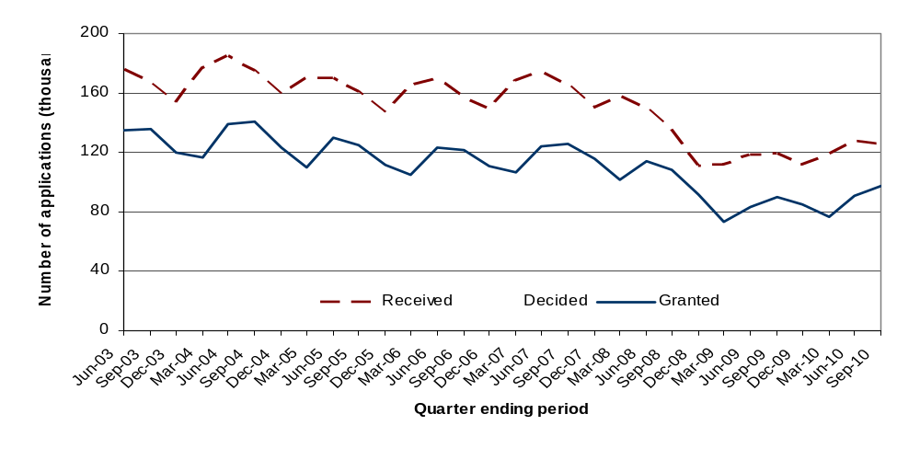

Seasonal adjustment
For the first time we have calculated a seasonally adjusted time series of the numbers of planning applications received, decided and granted.

Figure 2: Number of planning applications received, decided and granted by district authorities (seasonally adjusted)
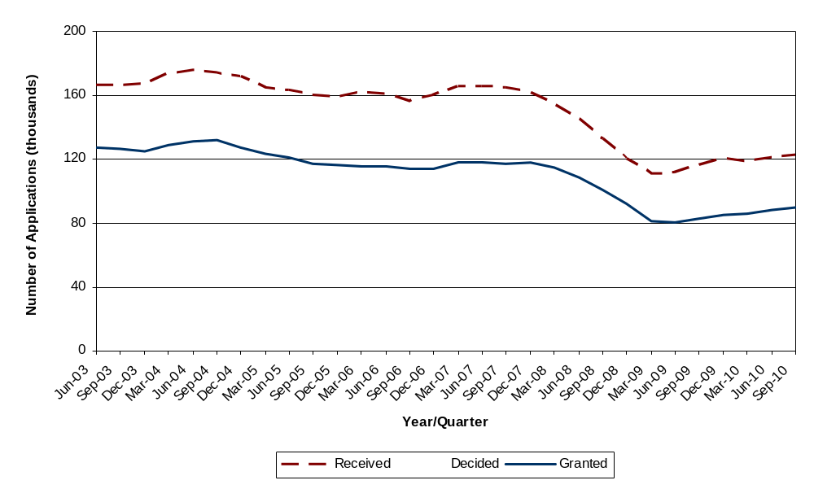

The effect of the economic slowdown from the end of 2007 onwards can be clearly seen, with a moderate recovery from March 2009.
The seasonality stems largely from the category of applications including householder applications (e.g. loft conversions, extensions etc) which are likely to be affected by the weather. Major and minor applications do not demonstrate a significant seasonal component.

Speed of applications
In the September quarter 2010, 69 per cent of major applications were processed within 13 weeks compared with 71 per cent in the September 2009 quarter (Table P121). Also, 76 per cent of minor applications and 86 per cent of other applications were processed within 8 weeks.
In the year ending September 2010, 70 per cent of major applications were processed within 13 weeks. Also, 77 per cent of minor applications and 87 per cent of other applications were processed within 8 weeks (Table P122).
In the quarter ending September 2010, district level planning authorities decided 55 per cent of large-scale major applications, and 72 per cent of small-scale major applications within 13 weeks (Table P125).
In the year ending September 2010, district level planning authorities decided 60 per cent of large-scale major applications, and 72 per cent of small-scale major applications within 13 weeks (Table P126).

Residential decisions
Decisions on all applications for residential developments increased from 12,600 in the September quarter 2009 to 13,500 in the September quarter 2010, an increase of 7 per cent. Major residential development increased by around 8 per cent compared to the September quarter 2009 (Table P123).
The number of residential developments decided decreased by 3 per cent from 52,700 in the year ending September 2009 to 50,900 in the year ending September 2010 (Table P124).
In the September quarter 2010, authorities granted 80 per cent of major residential applications and determined 62 per cent of them within 13 weeks. 70 per cent of decisions on minor residential applications were granted and 69 per cent determined within 8 weeks.
In the year ending September 2010, authorities granted 79 per cent of major residential applications and determined 65 per cent of them within 13 weeks. 71 per cent of decisions on minor residential applications were granted and 71 per cent determined within 8 weeks.

Householder Developments
Householder developments are those developments to a house which require planning permission such as extensions, loft conversions, conservatories, and so on. Decisions made on householder developments increased by 8 per cent from 51,900 in the September quarter 2009 to 55,900 in the September quarter 2010 (accounting for 47 per cent of all decisions), while the number of householder developments decided increased by 2 per cent from 193,700 in the year ending September 2009 to 198,500 in the year ending September 2010 (accounting for 46 per cent of all decisions) (Table P123/P124).

Planning Applications for Gypsy and Traveller Pitches
From April 2008, local authorities have been required to provide information on decisions relating to planning applications for Gypsy and Traveller pitches. Information on Gypsy and Traveller pitches are shown in Table P137/Table P138 and are as reported by local planning authorities.
In the September quarter 2010, local planning authorities determined 7 major applications and granted 71 per cent of those applications with 43 per cent being determined within 13 weeks. Also, in the September quarter 2010 authorities determined 69 minor applications on Gypsy and Traveller pitches and granted 52 per cent with 38 per cent of those applications being determined within 8 weeks.
In the year ending September 2010, authorities determined 42 major applications for Gypsy and Traveller pitches. 55 per cent of the major applications were granted and 44 per cent were determined within 13 weeks. Also, authorities determined 249 minor applications on Gypsy and Traveller pitches. 53 per cent of the minor applications were granted and 41 per cent were determined within 8 weeks.
The highest number of applications for major Gypsy and Traveller pitches determined in the year ending September 2010 was in the South West (11 applications), with 45 per cent granted and 45 per cent determined in 13 weeks. Authorities in the South East determined the highest number of minor applications (77 applications), with 51 per cent of those applications granted and 47 per cent determined within 8 weeks.

Enforcement action

Table P127 shows statistics on formal enforcement action taken by responding authorities in each year since 2000-01. In the September quarter 2010, authorities issued 1,421 Enforcement Notices and served 1,362 Planning Contravention Notices, 246 Breach of Condition Notices, 37 Stop Notices and 71 Temporary Stop Notices, while 16 Enforcement Injunctions were granted by the High/County Court.

Regulation 3 and 4 consents
Table P128 shows the number of Regulation 3 and 4 Consents granted since 2000-01. Under Regulation 3 of the Town and Country Planning General Regulations 1992, SI 1992/1492, a local planning authority makes an application to itself for permission to develop land within its area, and
determines that application. Regulation 4 is concerned with planning permission for development of land in which the local planning authority has an interest but which it does not itself propose to carry out.
In the September 2010 quarter, 1,037 Regulation 3 consents and 108 Regulation 4 consents were granted.

Applications for determination
Authorities received 1,522 applications for determination on whether local authority approval is required for certain works in the September quarter 2010 (Table P128). Local authorities decided to intervene in 199 cases (13 per cent).

Applications decided under delegated powers
Table P133 shows the percentage of applications decided by planning officers under a scheme of delegation and without referral to committee or councillors on such decisions. 331 authorities (out of 339) provided information on delegated decisions in the September quarter 2010 and on average, in this period authorities delegated 91 per cent of decisions to planning officers.

Authorities undertaking county level planning
Authorities that undertake county level planning activity – which includes counties, unitary authorities, London boroughs, metropolitan districts, urban development corporations and National Parks - received just under 1,600 ‘county matters’ applications in the year ending September 2010. This compares with the 483,000 planning applications received by authorities that undertake district level planning activities. Figures for ‘county matters’ decisions are therefore likely to be much more volatile than those for districts because of the smaller numbers of such decisions.
Summary statistics on numbers of applications, decisions and permissions granted are shown in Table B. More detailed figures are in the accompanying Live Tables (P139 - P145).

Planning applications
In the September quarter 2010, authorities received 397 ‘county matter’ applications, a decrease of 2 per cent compared with the same quarter last year. County councils accounted for 73 per cent of total applications, unitary authorities for 17 per cent and metropolitan districts for 8 per cent (Table P139). The highest number of applications was received by Norfolk (27 applications). (Table P143)
In the year ending September 2010, authorities received 1,563 ‘county matter’ applications. County councils accounted for 75 per cent of total applications, unitary authorities for 17 per cent and metropolitan districts for 7 per cent (Table P139). The highest number of applications was received by Norfolk (97 applications) (Table P144).

Planning decisions
County matter authorities determined 297 planning applications in the September quarter 2010, a decrease of 12 per cent compared with the same quarter last year. Of these, 92 per cent were granted, an increase of 2 percentage points when compared with the same quarter last year (Table P139). Nottinghamshire determined the highest number of planning applications (16 applications) followed by Leicestershire (15 applications) (Table P143). Waste developments accounted for 67 per cent of the total decisions and minerals developments accounted for 27 per cent (Table P140).
In the year ending September 2010, county matter authorities determined 1,291 planning applications in the September quarter 2010. Of these, 92 per cent were granted. Cumbria determined the highest number of planning applications (77 applications) followed by Nottinghamshire (56 applications) (Table P144). Waste developments accounted for 70 per cent of the total decisions and minerals developments accounted for 25 per cent (Table P141).

Speed of decision
In the September quarter 2010, 15 per cent of all decisions on ‘county matters’ applications were made within 8 weeks. County-level planning authorities also determined 58 per cent of applications within 13 weeks (Table P143).

In the year ending September 2010, 18 per cent of all decisions on ‘county matters’ applications were made within 8 weeks. County-level planning authorities also determined 62 per cent of applications within 13 weeks (Table P144).

Regulation 3 and 4 consents
Tables P143/P144 show the number of permissions granted by authorities under Regulations 3 and 4 of the Town and Country Planning General Regulations 1992. In the September quarter 2010, a total of 805 Regulation 3 consents were granted. The highest numbers of consents were granted by Lancashire (65 consents) and North Yorkshire (63 consents). In the year ending September 2010, a total of 2,833 Regulation 3 consents were granted. The highest numbers of consents were granted by North Yorkshire (243 consents) and Kent (233 consents).
In order to better reflect the workload of authorities, information on the total number of decisions on applications for consent, agreement or approval of details or schemes required by conditions, as defined by Article 21 of the General Development Procedure Order 1995 have been collected from April 2000 and is also published in this table.
In the September quarter 2010, 497 decisions were made under Article 21, with the highest number reported by Essex (73 decisions). The number of determinations under the review of mineral planning permissions was also collated, however only 12 were determined by county level planning authorities.
In the year ending September 2010, 1,704 decisions were made under Article 21, with the highest number reported by Cambridgeshire (180 decisions). The number of determinations under the review of mineral planning permissions was also collated, however only 33 were determined by county level planning authorities.

Enforcement action
In the September quarter 2010 county level planning authorities issued 28 Enforcement Notices and served 2 Stop Notices, 6 Temporary Stop Notices, 35 Planning Contravention Notices and 16 Breach of Condition Notices (Table P145).
Table B: County level planning applications granted, received and decided
 |  | Planning Applications |  | Planning Decisions |  | Applications Granted
Financial Year | Quarter | Number | % change on corresponding quarter last year | Number | % change on corresponding quarter last year | Number | % change on corresponding quarter last year
2005-06 | Jun | 466 | -14% | 390 | -3% | 353 | -4%
 | Sep | 510 | -6% | 416 | -17% | 375 | -19%
 | Dec | 398 | -22% | 458 | -1% | 417 | 0%
 | Mar | 483 | -7% | 419 | -1% | 386 | 0%
2006-07 | Jun | 450 | -3% | 416 | 7% | 376 | 7%
 | Sep | 448 | -12% | 389 | -6% | 347 | -7%
 | Dec | 441 | 11% | 399 | -13% | 349 | -16%
 | Mar | 466 | -4% | 387 | -8% | 363 | -6%
2007-08 | Jun | 464 | 3% | 393 | -6% | 364 | -3%
 | Sep | 446 | 0% | 375 | -4% | 348 | 0%
 | Dec | 444 | 1% | 389 | -3% | 357 | 2%
 | Mar | 473 | 2% | 341 | -12% | 317 | -13%
2008-09 | Jun | 392 | -16% | 374 | -5% | 344 | -13%
 | Sep | 439 | -2% | 379 | 1% | 347 | 0%
 | Dec | 405 | -9% | 361 | -7% | 334 | -6%
 | Mar | 431 | -9% | 393 | 15% | 358 | 13%
2009-10 | Jun | 355 | -9% | 313 | -16% | 293 | -15%
 | Sep | 406 | -8% | 336 | -11% | 304 | -12%
 | Dec | 406 | 0% | 376 | 4% | 343 | 3%
 | Mar | 408 | -5% | 312 | -21% | 294 | -18%
2010-11^{P} | Jun | 352 | -1% | 306 | -2% | 283 | -3%
 | Sep | 397 | -2% | 297 | -12% | 273 | -10%
Year to Sep 2010^{P} |  | 1563 | -2% | 1291 | -8% | 1193 | -7%
P Provisional.

Data collection
Statistics of planning applications received and decided by authorities that undertake district level planning activity have been collated, on a quarterly basis, since April 1979 on the PS1 and PS2 General Development Control statistical returns (District). From the March quarter 2008, the PS1, PS2 and the Fee1 (revenue collected in respect of PS1 and PS2) returns, are now combined as a single return, the PSF return. Information on planning applications for authorities that undertake county level planning activities are collated on the CPS1/2 General Development Control statistical returns (County Matters). These are reported to the department via Interform - the department’s housing and planning electronic data collection system.

Data quality
Both the PSF and CPS1/2 returns submitted by local planning authorities undergo thorough validation and checks. Inconsistent data highlighted during validation and checks are verified by contacting the local authority. Late returns are pursued to ensure the overall response rate is as high as possible. Where a response rate of 100 per cent is not achieved estimates are imputed for non-responding authorities.
332 (98 per cent) of authorities that undertake district level planning activities and 158 (96 per cent) of authorities that undertake county level planning activities submitted data in time for this publication. Also, authorities for which partial or no data has been received over the year (i.e. they did not submit information for one or more quarters) are not shown in annual tables. The data includes imputation for the small number of non-responding district level authorities and are included in Tables P120-P124 where national and regional totals are presented. Performances of individual local authorities are presented in tables P131, P132, P135 and P136.
All figures included in the commentary have been calculated using unrounded data. As a result, there may be some apparent discrepancy with figures shown in the accompanying tables.
From April 2007 an indication on the level of quality assurance undertaken by the local authority is recorded as part of the final sign-off for these returns.

Accompanying tables
Accompanying tables are available to download alongside this release. These are:
Tables:
P120 Planning applications and decisions of district planning authorities by speed of decision
P121/P122 Planning decisions of district planning authorities by speed of decision, Government Office Region and type of authority
P123/P124 Planning decisions of district planning authorities by speed of decision, type and size of development
P125/P126 District Planning Authorities: Major planning decisions by speed, type and size of development
P127 Enforcement actions by district planning authorities
P128 Regulation 3 and 4 Consents granted and applications for determination by district planning authorities
P129/P130 Enforcement action by district planning authority
P131/P132 Planning decisions, by development type and speed of decision – Quarter ending and Year ending
P133/P134 Planning applications, decisions, Environmental Statements and percentage of decisions delegated
P135/P136 Planning decisions on Major and Minor residential development by district authority - Quarter ending and Year ending
P137/P138 Planning decisions on Major and Minor Gypsies and Travellers Pitches by district authority - Quarter ending and Year ending
P139 ‘County matters’ planning applications and decisions
P140/P141 'County Matters' planning decisions by type and size of development
P142 ‘County matters’ decisions by speed of decision
P143/P144 'County matter' planning applications received and decided
P145 Enforcement actions of county planning authorities

Additional tables, earlier quarterly data and historic series can be accessed in the ‘Live Tables’ section (“Live Tables on Development Control Statistics”) at
www.communities.gov.uk/planningandbuilding/planningbuilding/planningstatistics/livetables/livetablesondevelopmentcontrolst/

Background notes
1. County level planning applications are predominantly concerned with minerals extraction and waste disposal developments, as set out in Schedule 1 of the Town and Country Planning Act 1990 and in the Town and Country Planning (Prescription of County Matters) (England) Regulations 2003 (SI 2003/1033).
2. Authorities undertaking county level planning include county councils, metropolitan districts, unitary authorities, London boroughs, national park authorities and urban development corporations. However, because of the nature of county matters applications, the large majority are handled by the county councils.
3. District level planning is undertaken by metropolitan and non-metropolitan districts, unitary authorities, national park authorities and urban development corporations. These authorities deal with all other planning applications that are not classified as county matters and mainly include applications for planning permissions on residential, offices, industrial, retail and householder developments.
4. Householder Developments: Householder developments are defined as those within the curtilage of a dwellinghouse which require an application for planning permission and are not a change of use. Included in householder developments are extensions, conservatories, loft conversions, dormer windows, alterations, garages, car ports or outbuildings, swimming pools, walls, fences, domestic vehicular accesses including footway crossovers, porches and satellite dishes.
Excluded from householder developments are: applications relating to any work to one or more flats, applications to change the number of dwellings (flat conversions, building a separate house in the garden), changes of use to part or all of the property to non-residential (including business) uses, anything outside the garden of the property (including stables if in a separate paddock).
5. This Release is a web-only publication.
6. Details of officials who receive pre-release access to this statistical release 24 hours before publication can be found at: www.communities.gov.uk/corporate/researchandstatistics/statistics/nationalstatistics/
7. National Statistics are produced to high professional standards set out in the National Statistics Code of Practice. They undergo regular quality assurance reviews to ensure they meet customer needs.

Date of next publication
The next update of this Statistical Release will be published in March 2011.

Enquiries
1. This Statistical Release, as well as previous Releases, can be accessed from the Communities and Local Government website at:
http://www.communities.gov.uk/publications/corporate/statistics/planningapplicationsq32010
2. Any query regarding this Release should be addressed to: Development Control Statistics Branch, Housing Markets and Planning Analysis Division, Communities and Local Government, Zone 4/J4, Eland House, Bressenden Place, London SW1E 5DU.
Email: developmentcontrol@communities.gov.uk
Media enquiries:
Office hours: 0303 444 1156
Out of hours: 0303 444 1051
Email: press@communities.gov.uk
Public enquiries:
Telephone: 0303 444 0000
Responsible Statistician:
Grant Kelly
Email: developmentcontrol@communities.gsi.gov.uk
Information on Official Statistics is available via the UK Statistics Authority website: www.statistics.gov.uk
Information about Communities and Local Government is available via the Department’s website: www.communities.gov.uk

Department for Communities and Local Government. © Crown Copyright, 2010

If you require this publication in an alternative format please email: alternativeformats@communities.gsi.gov.uk. Please note that the nature of content means that we may not be able to provide the Statistical series of publications in all requested formats.

December 2010

ISBN: 978-1-4098-2721-4

