 | 

Statistical Release

27 August 2010

LOCAL AUTHORITY REVENUE EXPENDITURE AND FINANCING

ENGLAND 2009-10 PROVISIONAL OUTTURN

- Total net current expenditure by local authorities in England was estimated to be £121.3 billion in 2009-10 compared with £113.1 billion in 2008-09, an increase of 7%.

- 37% of net current expenditure in 2009-10 was on education, 17% on social care, 14% on housing benefits and 10% on police.

- 56% of revenue expenditure (on a non-Financial Reporting Standard 17 basis) in 2009-10 was funded by government grants, 25% by council tax and 19% by redistributed non-domestic rates.

This release provides provisional outturn estimates of local authority revenue expenditure and financing for the financial year April 2009 to March 2010. These estimates are on a non-Financial Reporting Standard 17 (FRS17) and PFI “Off Balance Sheet” basis except where stated otherwise.

Headline figures for previous years were published on a FRS17 basis.

This information is derived from Communities and Local Government Revenue Summary (RS) Outturn returns submitted by local authorities in England. The estimates in this release are calculated from 439 valid returns of the 443 local authorities that complete the return. Estimate have been made for the 4 missing or invalid returns. The 2 authorities that did not submit a completed form in time for this release were Leicester City UA & Central Bedfordshire.

The release has been compiled by the Local Government Finance - Data Collection Analysis and Accountancy division of Communities and Local Government.

Responsible Statistician:

Steve Melbourne

We welcome comments and suggestions for further improvement or about your experiences with this product. This may include comments on data quality, timing and the format of the statistics. Please contact us at:
lgf1.revenue@communities.gsi.gov.uk

Contact points:

Press enquiries:
Telephone 0303 44 40444
Email press.office@communities.gsi.gov.uk

Other enquiries:
Telephone 0303 44 44228
Email lgf1.revenue@communities.gsi.gov.uk
Website: www.communities.gov.uk

Local authority revenue expenditure and financing England 2009-10 provisional outturn

Contents Page

Table 1 Net current expenditure by service 2008-09 and 2009-10 4

Chart A Provisional total net current expenditure by service 5
2009-10

Table 2 Revenue expenditure and financing 2009-10 6

Table 3 Financing of revenue expenditure since 2004-05 7

Chart B Provisional financing of revenue expenditure by service 7 2009-10

Annex A Provisional Revenue Outturn Summary 8
(RS) 2009-10

Annex B Provisional Revenue Outturn Service Expenditure 11
Summary (RSX) 2009-10

Annex C Derivation of service lines used in Table 1 12

Terminology used in this release 13

Data quality 16

Uses made of the data 16

Background Notes 16

Symbols and conventions 17

Provisional net current expenditure by service

- Provisional net current expenditure in 2009-10 is summarised in Table 1 and Chart A. Table 1 also shows net current expenditure in 2008-09 and the percentage change to 2009-10. Service expenditure is based on information from the RS forms, which can be found in Annex A. The service breakdowns have been created from this detailed information, according to Annex C of this release. It should be noted that year on year comparisons may not be valid due to local government changes in function and responsibility.

- Total net current expenditure by local authorities in England was estimated to be £121.3 billion in 2009-10 compared with £113.1 billion in 2008-09, an increase of 7%.

- The definition of total net current expenditure has changed for this year to include revenue expenditure funded from capital by statue (RECS). Removing RECS, the 2009-10 net current expenditure figure is £119.4 billion. If compared to the 2008-09 figure of £113.1 billion, this is an increase of 6%.

- 37% of net current expenditure in 2009-10 was on education, 17% on social care, 14% on housing benefits and 10% on police.

Table 1: Net current expenditure by service 2008-09 and 2009-10 ^{(a)}
 |  |  |  |  |  |  | £ million
 | Net current |  |  |  | Net current
 | expenditure |  |  |  | expenditure |  | %
 | 2008-09 |  |  |  | 2009-10 |  | Change
 | (R) |  |  |  | (P)
Education | 42,379 |  |  | ║ | 44,476 |  | 5
Highways and transport | 5,787 |  |  | ║ | 6,542 |  | 13
Social care | 19,629 |  |  | ║ | 20,976 |  | 7
Housing (excluding Housing Revenue Account) | 2,360 |  |  | ║ | 2,671 |  | 13
Cultural, environmental and planning | 10,546 |  |  | ║ | 11,045 |  | 5
of which:
Cultural | 3,315 |  |  | ║ | 3,460 |  | 4
Environmental | 5,105 |  |  | ║ | 5,308 |  | 4
Planning and development | 2,125 |  |  | ║ | 2,277 |  | 7
Police | 11,638 |  |  | ║ | 11,979 |  | 3
Fire and rescue | 2,162 |  |  | ║ | 2,157 |  | 0
Central services ^{(b)} | 3,266 |  |  | ║ | 3,838 |  | 18
Other services | 650 |  |  | ║ | 297 |  | -54
Mandatory rent allowances | 10,263 |  |  | ║ | 12,818 |  | 25
Mandatory rent rebates to non-HRA tenants | 772 |  |  | ║ | 857 |  | 11
Mandatory rent rebates to HRA tenants | 3,600 |  |  | ║ | 3,617 |  | 0
Total net current expenditure | 113,050 |  |  | ║ | 121,273 |  | 7
(a) Net current expenditure estimates after 2008-09 are not fully comparable against previous years owing to revenue expenditure
from capital by statute (RECS) distributed across all services. This amounts to £1,847 million (see Table 2, Page 6)
(b) Court services were previously included as a separate service and have now been integrated with Central Services for
2009-10

Chart A: Provisional total net current expenditure by service 2009-10
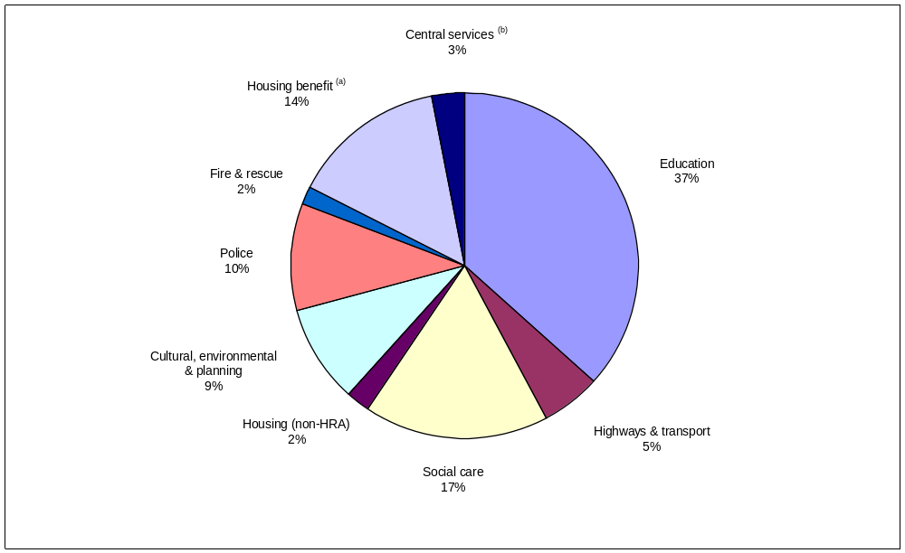
(a) Housing benefit includes mandatory rent allowances and mandatory rent rebates
(b) Central services includes courts and other services

Provisional revenue expenditure and financing

- Table 2 shows the link between the definitions of net current and revenue expenditure and how revenue expenditure was financed in 2009-10 compared to 2008-09. A more detailed breakdown of this information can be found in Annex A.

- Revenue expenditure on a non-FRS17 basis was £103.3 billion in 2009-10, compared with £98.1 billion in 2008-09, an increase of 5%.

- Non-current expenditure in 2009-10 includes the payment of council tax benefit of £4.0 billion, but this is netted off by income from specific grants outside Aggregate External Finance (AEF).

- Specific grants outside AEF increased from £21.7 billion in 2008-09 to £24.8 billion in 2009-10, an increase of 14%.

Table 2: Revenue expenditure and financing 2009-10
 |  | £ million
 |  | 2009-10
 |  | (P)
Total net current expenditure |  | 121,273
plus non-current expenditure
Capital financing ^{(a)} |  | 3,386
Capital expenditure charged to Revenue Account |  | 1,958
Council tax benefit |  | 3,955
Discretionary Non-Domestic Rate relief |  | 30
Bad debt provision |  | 62
Flood defence payments to Environment Agency |  | 29
Private Finance Initiative (PFI) schemes - difference from service charge |  | 17
Appropriations to(+)/ from(-) financial instruments adjustment account ^{(b)} |  | 25
Appropriations to(+)/ from(-) unequal pay back pay account ^{(c)} |  | 25
less Reversal of Revenue expenditure funded from capital by statute (RECS) |  | 1,847
less interest receipts |  | 783
less specific grants outside AEF ^{(d)} |  | 24,781
Revenue expenditure (Non-FRS17) |  | 103,349
financed by:
Specific grants inside AEF ^{(d)} |  | 45,684
Area Based Grant (ABG) |  | 3,330
Transfers and adjustments ^{(e)} |  | -1
Appropriations to (-) / from (+) revenue reserves |  | 320
Formula grant |  | 28,269
of which:
Revenue Support Grant |  | 4,501
Redistributed non-domestic rates |  | 19,515
Police grant |  | 4,253
General Greater London Authority (GLA) grant |  | 48
Other items |  | 65
Council tax |  | 25,633
(a) Includes capital charges accounted for in External and Internal Trading Accounts, provision for repayment of principal, leasing payments, external interest payments and HRA item 8 interest payments and receipts
(b) Adjustments permitted by regulation to the revenue account charges for financial instruments.
(c) The deferral of revenue account charges for unequal pay back pay as permitted by regulation and the reversal of the deferral in the year that payment of the back pay is due.
(d) Aggregate External Finance; see page 13 for definition
(e) Inter-authority transfers in respect of reorganisation

Financing of revenue expenditure

- Table 3 shows the funding of revenue expenditure in terms of government grants, redistributed non-domestic rates and council taxes from 2004-05 onwards. All years are produced on a non-FRS17 basis. This is because local authorities set their council tax with regard to their expenditure on a non-FRS17 basis. A fuller definition of FRS17 can be found in the Terminology used in this release section.

- In 2009-10, 56% of revenue expenditure on a non-FRS17 basis was funded by government grants (including Revenue Support Grant, specific grants inside Aggregate External Finance and police grant), 25% by council tax and 19% by redistributed non-domestic rates.

Table 3: Financing of revenue expenditure since 2004-05 ^{(a)}
 | Revenue |  | Government |  | Redistributed |  | Council
 | expenditure |  | grants | % of | non-domestic rates | % of | tax | % of
 | (£ million) |  | (£ million) | total | (£ million) | total | (£ million) | total
2004-05 | 79,303 |  | 45,258 | 57 | 15,004 | 19 | 20,299 | 26
2005-06 | 84,422 |  | 45,838 | 54 | 18,004 | 21 | 21,315 | 25
2006-07 | 88,172 |  | 49,093 | 56 | 17,506 | 20 | 22,453 | 25
2007-08 | 92,384 |  | 51,656 | 56 | 18,506 | 20 | 23,608 | 26
2008-09 (R) | 98,121 |  | 53,015 | 54 | 20,506 | 22 | 24,759 | 25
2009-10 (P) | 103,349 |  | 57,816 | 56 | 19,515 | 19 | 25,633 | 25
(a) Produced on a Non-Financial Reporting Standard 17 basis. Sum of government grants, redistributed non-domestic rates and council tax does not normally exactly equal revenue expenditure because of the use of reserves

Chart B: Provisional financing of revenue expenditure by service 2009-10
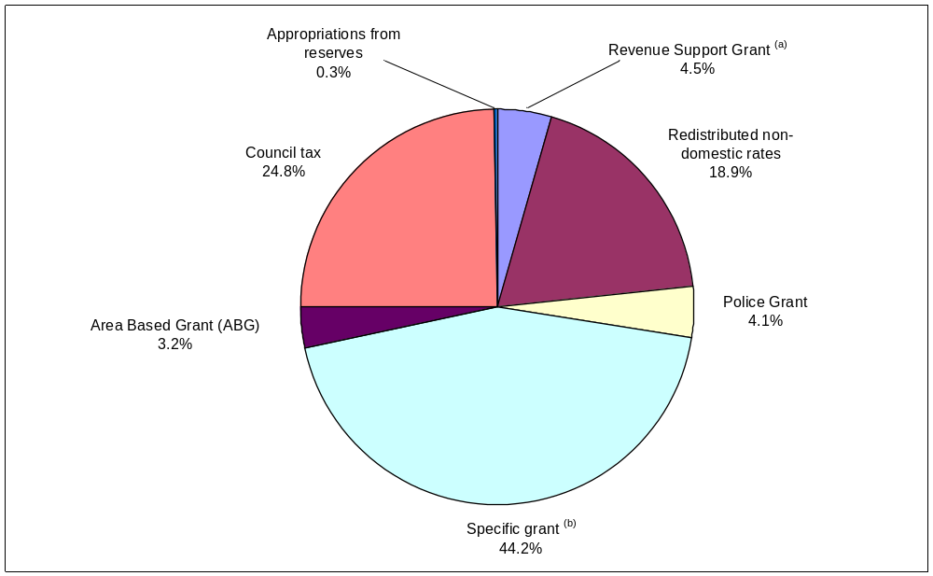
  - Revenue Support Grant includes General GLA grant and ‘Other items’
  - Specific and special grants inside AEF

Detailed outturn information

- Annex A (RS) and Annex B (RSX) show a detailed breakdown of the outturn information provided. The RS forms the basis of Table 1 and Table 2 in this release. The RSX forms should be read in conjunction with the FRS17 note on page 11 of this Statistical Release.

Annex A: Provisional Revenue Outturn Summary (RS) 2009-10
 |  | £ million
 |  | Net current
 |  | expenditure
190 | Education services | 44,476
290 | Highways and transport services | 6,542
390 | Social care | 20,976
490 | Housing services (GFRA only) | 2,688
509 | Cultural and related services | 3,460
590 | Environmental and regulatory services | 5,308
599 | Planning and development services | 2,277
601 | Police services | 11,979
602 | Fire and rescue services | 2,157
690 | Central services | 3,468
698 | Other services | 240
699 | TOTAL SERVICE EXPENDITURE (TOTAL OF LINES 190 TO 698) | 103,570
701 | Education: student support - mandatory awards | 0
711 | Housing benefits: rent allowances - mandatory payments | 12,818
712 | Housing benefits: non-HRA rent rebates - mandatory payments | 857
713 | Housing benefits: rent rebates to HRA tenants - mandatory payments | 3,617
714 | Housing benefits: subsidy limitation transfers from HRA | -20
715 | Housing benefits: transfers to/from HRA under transitional measures | -4
718 | Contribution to the HRA re items shared by the whole community | 7
721 | Parish precepts | 340
722 | Integrated Transport Authority levy | 0
724 | Waste Disposal Authority levy | 0
727 | London Pensions Fund Authority levy | 30
728 | Other levies | 30
731 | External Trading Accounts net surplus(-)/ deficit(+) | -53
732 | Internal Trading Accounts net surplus(-)/ deficit(+) | 64
748 | Adjustments to net current expenditure | 15
749 | NET CURRENT EXPENDITURE (TOTAL OF LINES 699 TO 748) | 121,273
754 | Local tax collection: Council tax benefit paid to the Collection Fund | 3,955
757 | Local tax collection: Non-domestic rate relief - discretionary payments | 30
759 | Levy: Environment Agency flood defence | 29
761 | Capital charges accounted for in External Trading Accounts | -219
762 | Capital charges accounted for in Internal Trading Accounts | -113
765 | Capital expenditure charged to the GF Revenue Account (CERA) | 1,958
767 | Reversal of Revenue expenditure funded from capital by statute (RECS) - excluding trading (TSR) | -1,828
768 | Reversal of Revenue expenditure funded from capital by statute (RECS) - trading (TSR) only | -19
771 | Provision for bad debts | 62
773 | Provision for repayment of principal | 1,634
776 | Leasing payments | 22
781 | Interest payable and similar charges | 2,730
783 | Interest: HRA item 8 payments and receipts | -669
785 | SUB-TOTAL (total of lines 749 to 783) | 128,847
786 | Interest and investment income (-): external receipts and dividends | -783
788 | Private Finance Initiative (PFI) schemes - difference from service charge | 17
789 | Appropriations to(+)/ from(-) financial instruments adjustment account | 25
790 | Appropriations to(+)/ from(-) unequal pay back pay account | 25
791 | Specific and special revenue grants outside AEF | -24,781
795 | REVENUE EXPENDITURE (TOTAL OF LINES 785 TO 791) | 103,349
 |  | continued

Annex A: Provisional Revenue Outturn Summary (RS) 2009-10 (continued)
 |  |  | £ million
 |  | Net current
 |  | expenditure
797 | Specific and special revenue grants inside AEF | -45,684
798 | Area Based Grant (ABG) | -3,330
799 | NET REVENUE EXPENDITURE (TOTAL OF LINES 795 TO 798) | 54,335
801 | Inter-authority transfers in respect of reorganisation | 1
811 | Appropriations to(+)/ from(-) schools' reserves | -43
815 | Appropriations to(+)/ from(-) other earmarked financial reserves | -277
816 | Appropriations to(+)/ from(-) unallocated financial reserves | -1
830 | THE BUDGET REQUIREMENT (TOTAL OF LINES 799 TO 816) | 54,016
851 | Revenue Support Grant | -4,501
856 | Police grant | -4,253
858 | General GLA grant | -48
870 | Redistributed non-domestic rates | -19,515
880 | Other items | -65
890 | COUNCIL TAX REQUIREMENT (TOTAL OF LINES 830 TO 880) | 25,633
Financial reserves levels at start and end of 2009-10 |  | At 1 April 2009 | At 31 March 2010
911 | Schools reserves level | 1,859 | 1,816
915 | Other earmarked financial reserves level | 9,190 | 8,914
916 | Unallocated financial reserves level | 3,424 | 3,423
920 | Prior Year Adjustments | -362
Capital charges |  | 2009-10
931 | Depreciation | 5,102
933 | Loss on impairment of assets | 6,068
934 | Amortisation of deferred charges | -2,131
939 | Total capital charges (TOTAL OF LINES 931 TO 935) | 9,040
Equal pay costs
941 | One off equal pay costs - falling on the schools budget | 30
942 | One off equal pay costs - chargeable to any other revenue account | 100
Icelandic bank impairment
951 | Interest payable and similar charges ^{(a)} | 55
952 | Interest and investment income (-): external receipts and dividends ^{(b)} | -30
953 | Appropriations to(+)/ from(-) financial instruments adjustment account ^{(C)} | 51
954 | Reversal of Revenue expenditure funded from capital by statute (RECS) ^{(d)} | -28
 |  |  | continued

Annex A: Provisional Revenue Outturn Summary (RS) 2009-10 (continued)
Net current expenditure on an FRS17 basis and |  |  |  | £ million
Net Current expenditure - PFI on an "On Balance Sheet" basis
 |  | Net current | Net current | Net Current
 |  | expenditure | expenditure | expenditure - PFI
 |  |  | on an FRS17 | "On Balance
 |  |  | basis | Sheet" basis
961 | Education services | 44,476 | 43,870 | 44,264
962 | Highways and transport services | 6,542 | 6,467 | 6,434
963 | Social care | 20,976 | 20,732 | 20,959
964 | Housing services (GFRA only) | 2,688 | 2,648 | 2,688
965 | Cultural and related services | 3,460 | 3,393 | 3,445
966 | Environmental and regulatory services | 5,308 | 5,241 | 5,284
967 | Planning and development services | 2,277 | 2,215 | 2,278
971 | Police services | 11,979 | 11,693 | 11,956
972 | Fire and rescue services | 2,157 | 2,042 | 2,145
975 | Central services (excluding Non-distributed costs: retirement benefits ) | 2,913 | 2,716 | 2,899
976 | Non-distributed costs: retirement benefits | 554 | 540 | 554
978 | Other services | 240 | 249 | 240
981 | External Trading Accounts net surplus(-)/ deficit(+) | -53 | -61 | -53
982 | Internal Trading Accounts net surplus(-)/ deficit(+) | 64 | 30 | 65
983 | Provision for repayment of principal | 1,634 | 1,636 | 1,730
984 | Interest payable and similar charges | 2,730 | 2,772 | 3,074
985 | Private Finance Initiative (PFI) schemes - difference from service charge | 17 | 35 | 0
986 | Pensions interest cost and expected return on pensions assets | 0 | 7,673 | 0
987 | Appropriations to(+)/ from(-) pensions reserve | 0 | -5,930 | 0
989 | TOTAL (TOTAL OF LINES 961 TO 987) | 107,963 | 107,963 | 107,963
(a) Change to the impairment charge initially calculated in 2008-09
(b) Interest credited in respect of impaired Icelandic investments (from April 2009 to March 2010)
(c) The reversal of any impairment charge and the reversal of any interest credited in reliance on regulation 30G (see terminology). Any Voluntary write back of the credit permitted by the regulation is also included.
(d) Any impairment charge capitalised under the authority of a direction under section 16(2)(b) of the Local Government Act 2003

Annex B: Provisional Revenue Outturn Service Expenditure Summary (RSX) 2009-10
 |  |  |  |  |  |  |  |  |  | £ million
 |  |  |  |  |  |  |  |  |  | Net total cost
 |  |  | Running | Total | Sales, fees | Other | Total | Net current | Capital | (excluding
 |  | Employees | expenses | expenditure | & charges | income | income | expenditure | charges | specific grants)
 |  | (1) | (2) | (3) | (4) | (5) | (6) | (7) | (8) | (9)
 |  |  |  | = (1) + (2) |  |  | = (4) + (5) | = (3) - (6) |  | = (7) + (8)
190 | Education services | 32,195 | 17,831 | 50,026 | 2,231 | 3,319 | 5,550 | 44,476 | 4,048 | 48,523
290 | Highways and transport services | 1,363 | 8,213 | 9,577 | 2,198 | 837 | 3,034 | 6,542 | 1,113 | 7,656
390 | Social care | 7,283 | 19,195 | 26,478 | 2,522 | 2,980 | 5,503 | 20,976 | 415 | 21,390
490 | Housing services (GFRA only) | 799 | 3,127 | 3,926 | 671 | 567 | 1,238 | 2,688 | 115 | 2,802
509 | Cultural and related services | 1,870 | 3,044 | 4,915 | 936 | 519 | 1,455 | 3,460 | 949 | 4,409
590 | Environmental and regulatory services | 1,773 | 5,138 | 6,911 | 938 | 665 | 1,603 | 5,308 | 274 | 5,582
599 | Planning and development services | 1,270 | 2,211 | 3,481 | 650 | 554 | 1,204 | 2,277 | 154 | 2,432
601 | Police services | 10,656 | 2,351 | 13,007 | 426 | 602 | 1,028 | 11,979 | 476 | 12,455
602 | Fire and rescue services | 1,731 | 502 | 2,232 | 23 | 52 | 75 | 2,157 | 154 | 2,311
690 | Central services | 6,291 | 7,528 | 13,819 | 1,160 | 9,192 | 10,352 | 3,468 | 1,220 | 4,688
698 | Other services | 209 | 388 | 597 | 100 | 257 | 357 | 240 | 121 | 361
699 | Total service expenditure (total of lines 190 to 698) | 65,441 | 69,528 | 134,969 | 11,856 | 19,543 | 31,399 | 103,570 | 9,040 | 112,609

Annex C: Derivation of service lines used in Table 1
 | Line Reference | Levies/transfers
Education | RS line 190
 | RS line 701 | Mandatory student awards
Highways and transport | RS line 290
 | RS line 722 | Integrated transport authority levy
Social care | RS line 390
Housing (excluding Housing | RS line 490
Revenue Account) | RS line 714 | Subsidy limitation transfers from HRA
 | RS line 715 | Transfers to/from HRA under transitional measures
 | RS line 718 | Contribution to HRA re items shared by whole community
Cultural | RS line 509
Environment | RS line 590
 | RS line 724 | Waste disposal authority levy
Planning | RS line 599
Police | RS line 601
Fire and rescue | RS line 602
Central services | RS line 690
 | RS line 721 | Parish precepts
 | RS line 727 | London Pensions Fund Authority levy
Mandatory rent allowances | RS line 711
Mandatory rent rebates to non-HRA tenants | RS line 712
Mandatory rent rebates to HRA tenants | RS line 713
Other | RS line 698
 | RS line 728 | Other levies
 | RS line 731 | External Trading Accounts net surplus/deficit
 | RS line 732 | Internal Trading Accounts net surplus/deficit
 | RS line 748 | Adjustments
Total net current expenditure | RS line 749

Terminology used in this release

A list of terms relating to local government finance is given in the glossary at Annex G of Local Government Finance Statistics England No. 20 2010. This is accessible at http://www.communities.gov.uk/documents/statistics/pdf/1622442.pdf. The most relevant terms for this release are explained below.

Aggregate External Finance - is the total amount of grant provided to finance all local government expenditure, excluding that subject to separate arrangements under statutory schemes, rent allowances and rebates and council tax benefit, which are funded by specific grants outside Aggregate External Finance.

Current expenditure - is the cost of running local authority services within the financial year. This includes the costs of staffing, heating, lighting and cleaning, together with expenditure on goods and services consumed within the year. This expenditure is offset by income from sales, fees and charges and other (non-grant) income, which gives total net current expenditure (line 749). Total net current expenditure also includes payments made by local authorities on behalf of central government, under statutory schemes and the payment of rent allowances and rebates. Such payments are fully funded by central government through specific grants outside Aggregate External Finance.

Dedicated Schools Grant (DSG) – there was a change in the funding of specific and formula grants in 2006-07 largely due to changes in the way that expenditure on schools is funded. From 2006-07, local authorities receive school funding through specific grant rather than funding previously included in formula grant.

Appropriations to/from financial instruments adjustment account (line 789)
Appropriations to/from unequal pay back pay account (line 790)
These are two new lines connected with the adjustments permitted or required by our regulations. The accounts show figures fully compliant with accounting standards, but regulations made by CLG provide for adjustments to those figures to prevent excessive increases in council tax. The first line allows for adjustments connected with borrowing and investments, including the regulation on Icelandic banks investments. The second allows for the regulation that permits a charge for unequal pay back pay to be deferred until payments are due to be made (accounting requires a charge as soon as the liability is established).

Financial Reporting Standard 17 (FRS17) - Local authorities account for retirement benefits (pensions) in their service expenditure in accordance with FRS17. This requirement is enshrined in the Code of Practice on Local Authority Accounting in the UK, published by the Chartered Institute of Public Finance and Accountancy (CIPFA) and in CIPFA’s Best Value Accounting Code of Practice (BVACOP). The estimates in this release are on a FRS17 basis except where stated otherwise.

Under FRS17 most of the pension schemes covering local government employees are classed as defined benefit schemes. The main implication of defined benefit status is that retirement benefits are accounted for on the basis of the retirement benefit entitlement to which employment in the year gives rise, rather than the cash amounts of employer’s contribution or pension due for the year. The major exception to defined benefit status is the teachers’ pension scheme, which is administered centrally; local authorities account for this on a defined contribution basis, and the charges to service expenditure equal the employer’s contribution.

The defined benefit charges are not allowed to impact on council tax payers, the charge that must ultimately be carried by taxpayers is the employer’s contributions due for the year. Consequently, the effects on the revenue account are that the net current expenditure service lines are on a defined benefit basis, but the Budget Requirement is based on the cash contributions due. This neutrality is achieved by reversing out the impact of FRS17. In the analysis this is shown - after taking account of a further element of the FRS17 charge, "Pensions interest cost and expected return on pensions assets" (line 787) - by the entry "Appropriations to/from pensions reserves" (line 788). Line 787 is a small difference between two large numbers and hence can show volatile movements from year to year. More than three quarters of line 787 relates to police and fire authorities, where most employees belong to the unfunded pension schemes for police and firefighters. The appropriation in line 788 equals the difference between the FRS17 charges (including Line 787) and the employer’s contributions for the year.

PFI schemes in accordance with the International Financial Reporting Standards (IFRS)

Under the International Financial Reporting Standards (IFRS) the PFI schemes are brought ‘on balance sheet’. Local authorities have been required to account for their PFI schemes on the IFRS basis as from 2009-10.

For National Accounts purposes, however, PFI schemes should be accounted for ‘on balance sheet’ basis only where economic ownership of the asset rests with the Authority.

Economic ownership for national accounts purposes is determined by the same test as applies under UK accounting standards and hence that local authorities applied in preparing their 2008-09 accounts. The basis of that test was set out in Appendix E to the 2008 SORP, and depends on whether the local authority or the contractor has an asset of the property used to provide the contracted services. A party has an asset of the property where that party has access to the benefits of the property and exposure to the risks inherent in those benefits.

Formula Grant – the main channel of government funding. This includes Redistributed non-domestic rates, Revenue Support Grant and Police grant. The distribution is determined by the Formula spending shares formulae, also taking account of authorities’ relative ability to raise council tax and the floor damping mechanism. There are no restrictions on what local government can spend it on.

Redistributed non-domestic rates – non-domestic rates which, having been paid into the non-domestic rating pool, are redistributed between local authorities on the basis of population, as part of Formula Grant.

Revenue expenditure (line 795) - is equal to total net current expenditure (line 749), plus capital financing costs and a few minor adjustments, but excludes expenditure financed by grants outside Aggregate External Finance. Revenue expenditure is financed by grants inside Aggregate External Finance, council tax and authorities' reserves.

Revenue Expenditure funded from Capital under Statue (RECS) - This is expenditure that is revenue under normal accounting principles but which legislation allows to be financed as capital expenditure. Examples are grants given to local residents for capital purposes. RECS is entered in Revenue Outturn (RO) suite of forms under the relevant service line for Net Current Expenditure, and the total amount reversed out appears in Line 767 of the RS part of the RO suite of forms, which will continue to be entered in the Capital Outturn Return (COR). These entries replace the amortisation of deferred charges, which previously formed one element of capital charges.

Revenue Support Grant – a general grant which replaced rate support grant in 1990-91. Now it is distributed as part of Formula Grant.

Icelandic bank investments
Where an authority holds investments in Icelandic banks that were affected by the defaults in Autumn 2008 it would normally be the case that the impairment loss would be charged in the 2008-09 accounts. In the RO suite the entries appear in the RS form. The impairment was entered in line 781 and any interest credited in respect of the investment in line 786. Where the authority has taken advantage of regulation 30G in the Local Authorities (Capital Finance and Accounting) (England) Regulations 2003 (inserted by SI 2009 No 321) entries permitted or required by the regulations appear in line 789. These entries are shown separately in lines 951-953 of the RS form. Figures are generally calculated using CIPFA methodology published in their LAAP bulletins.

Regulation 30G
Regulation 30G allows, authorities to neutralise the debits for the impairment losses required by accounting practice in the 2008-09 account. However, an authority taking advantage of that relief will be required to make a debit in the 2010-11 accounts equal to the total of all the credits made under the regulation. Thus, the benefit conferred by the regulation is temporary – it simply postpones the effect of the impairment loss.
Data quality

- This Statistical Release contains National Statistics and as such has been produced to the high professional standards set out in the National Statistics Code of Practice. National Statistics products undergo regular quality assurance reviews to ensure that they meet customer demands.

- The information for 2009-10 in this Statistical Release is derived from Communities and Local Government Revenue Outturn (RO) forms and is based on 439 valid returns out of the 443 authorities that complete their returns. Estimates have been made of the 4 missing or invalid returns. The 2 authorities that did not submit a completed form in time for this release were Leicester City UA & Central Bedfordshire.

- Figures are subjected to rigorous pre-defined validation tests both within the form itself, while the form is being completed by the authority, and also as the data are received and stored.

- Finally, the release document, once prepared, is also subject to intensive peer review before being cleared as fit for the purposes of publication.

- Please note that the figures in this release have not been adjusted to take into account changes of responsibility between 2008-09 and 2009-10.

Uses made of the data

- The data in this Statistical Release are essential for a number of different purposes. A central and immediate purpose is to provide the Secretary of State, Ministers, HM Treasury and the Office for National Statistics with the most up to date information available on local authority revenue spending for decision making. In particular, the data are provided to HM Treasury to inform the Chancellor's Pre Budget Report.

- The data are also important sources for various evidence based policy and financial decisions and answering numerous parliamentary questions. In addition they are used by local authorities and their associations, regional bodies, members of the business community and the general public.

- Further uses of this data are made internally by CLG users, such as the Value for Money (VfM) analysis - where unitised expenditure figures for each service area (e.g. education) are derived to make comparisons against local authorities performance

- Comments and feedback from the end users for further improvement or about your experiences with this product will be welcomed. Please send all views to:
lgf1.revenue@communites.gsi.gov.uk

Background Notes

- This Statistical Release can be found at the following web address:
http://www.communities.gov.uk/localgovernment/localregional/localgovernmentfinance/statistics/revenueexpenditure/

- For press enquiries about this Statistical Release, please contact the Local Government press desk on 0303 444 0444 or email press.office@communities.gsi.gov.uk. For other enquiries, please contact Osman Beg on 0303 444 4228 or email LGF1.REVENUE@communities.gsi.gov.uk.

- Timings of future releases are regularly placed on the Department's website, http://www.communities.gov.uk/corporate/researchandstatistics/statistics/publicationschedule/ and on the National Statistics website, www.statistics.gov.uk/press_release/currentreleases.asp

- Final Revenue Outturn figures will be published in a further Statistical Release later this year.

- The notes, which accompany each form sent to local authorities, can be found at: http://www.communities.gov.uk/localgovernment/localregional/localgovernmentfinance/statistics/usefulinformation/formstimetable/revenueforms/

- For a fuller picture of recent trends in local government finance, readers are directed to Local Government Finance Statistics England No. 20 2010, which is available in hard copy from Communities and Local Government Publications, Cambertown House at product@communities.gsi.gov.uk (Tel. 0300 123 1124) and electronically from the Communities and Local Government website:
http://www.communities.gov.uk/publications/corporate/statistics/financialstatistics202010

- Both the Scottish Government and the Welsh Assembly Government also collect revenue outturn data. Their information can be found at the following websites:

Scotland:
http://www.scotland.gov.uk/Topics/Statistics/Browse/Local-Government-Finance

Wales:
http://wales.gov.uk/topics/statistics/headlines/localgov2010/100623/?lang=en

Symbols and conventions
… = not available
0 = zero or negligible
n/a = not applicable
|| = discontinuity
(P) = provisional
(R) = revised since the last statistical release

Rounding
Where figures have been rounded, there may be a
slight discrepancy between the total and the sum of
constituent items.

Department for Communities and Local Government. © Crown Copyright, 2010
If you require this publication in an alternative format please email: alternativeformats@communities.gsi.gov.uk. Please note that the nature of content means that we may not be able to provide the Statistical series of publications in all requested formats.
August 2010

ISBN: 978 1-4098-2548-7

