

Housing
Statistical Release

23 February 2012
using
Research
Summary
Number 239, 2007

Rough Sleeping Statistics England - Autumn 2011 Experimental Statistics

Contents  Introduction Rough Sleeping in England  Rough Sleeping by region  Accompanying tables  Map  Rough Sleeping in London  Definitions  Methodology  Data source and scope  Data quality  Revisions Policy  Uses of the data  User consultation  Other information  Enquiries | 2  2  2  3  4  5  7  7  8  9  9  10  10  10  11

Responsible Statistician:
Andrew Presland
Phone: 030344 43510
roughsleepingstatistics@communities.gsi.gov.uk
Media Enquiries:
Office hours: 0303 444 1159
Out of hours: 0303 444 1201 press.office@communities.gsi.gov.uk

- This is the second annual statistical release following the introduction of revised guidance on evaluating the extent of rough sleeping in September 2010.
- The Autumn 2011 total of rough sleeping counts and estimates in England was 2,181.
- This is up 413 (23%) from the Autumn 2010 total of 1,768.
- All 326 local housing authorities in England provided a figure. The total comprises counts provided by 53 local authorities and estimates provided by 273 local authorities.
- London, the South East and the South West had the highest number of rough sleepers with 446, 430 and 337 respectively. The North East had the lowest number with 32.

Introduction
This is the second annual statistical release presenting rough sleeping counts and estimates following the introduction of revised guidance in September 2010 on evaluating the extent of rough sleeping.
Rough sleeping counts and estimates are single night snapshots of the number of people sleeping rough in local authority areas. Local authorities decide whether to carry out a count or an estimate based upon their assessment of whether the local rough sleeping problem justifies counting. They are encouraged to gain intelligence for street counts and estimates from local agencies such as outreach workers, the police, the voluntary sector and members of the public who have contact with rough sleepers on the street.
The release provides national and regional summary information on rough sleeping counts and estimates carried out by local authorities between 1 October and 30 November 2011.
Two accompanying tables, showing figures at regional and local authority levels, are provided online alongside this release.

Rough Sleeping in England
The Autumn 2011 total of street counts and estimates in England was 2,181. This comprises a figure from every local housing authority in England, with 53 authorities conducting a count and 273 providing an estimate.

Rough Sleeping by region
London had 446 rough sleepers, the highest number of all of the regions and 20 per cent of the national total. The South East and the South West had the next highest numbers with 430 and 337 rough sleepers respectively. These three regions between them had 56 per cent of the total of all rough sleepers in England. The North East had 32 rough sleepers, the lowest number of all the regions and 1.5 per cent of the national total.

Table A: total of rough sleeping counts and estimates, by region, Autumn 2011
Region | Total | Percentage of England total | Rate per 1,000 households¹
North East | 32 | 1.5 | 0.03
North West | 149 | 6.8 | 0.05
Yorkshire and the Humber | 150 | 6.9 | 0.07
East Midlands | 188 | 8.6 | 0.10
West Midlands | 207 | 9.5 | 0.09
East of England | 242 | 11.1 | 0.10
London | 446 | 20.4 | 0.13
South East | 430 | 19.7 | 0.12
South West | 337 | 15.5 | 0.15
England | 2,181 | 100.0 | 0.10

1. Calculated using DCLG 2008-based household projections for 2011

The South West had the highest incidence of rough sleepers per 1,000 households with 0.15, followed by London and the South East, with 0.13 and 0.12 respectively, with these three regions all being above the England average of 0.10. The North West, with 0.03, had the lowest incidence of rough sleepers per 1,000 households. Within each region there is significant variation in the concentration of rough sleepers within each local authority area. Figures reported by each local authority are provided in Table 2, published online alongside this release.

Accompanying tables
Table 1 – Total of rough sleeping counts and estimates, by region, Autumn 2010 and Autumn 2011
Table 2 – Rough sleeping counts and estimates, by local authority, Autumn 2011
Both accompanying tables can be found at the following link:
http://www.communities.gov.uk/publications/corporate/statistics/roughsleepingautumn2011
Map: rough sleeping rates by region, Autumn 2011
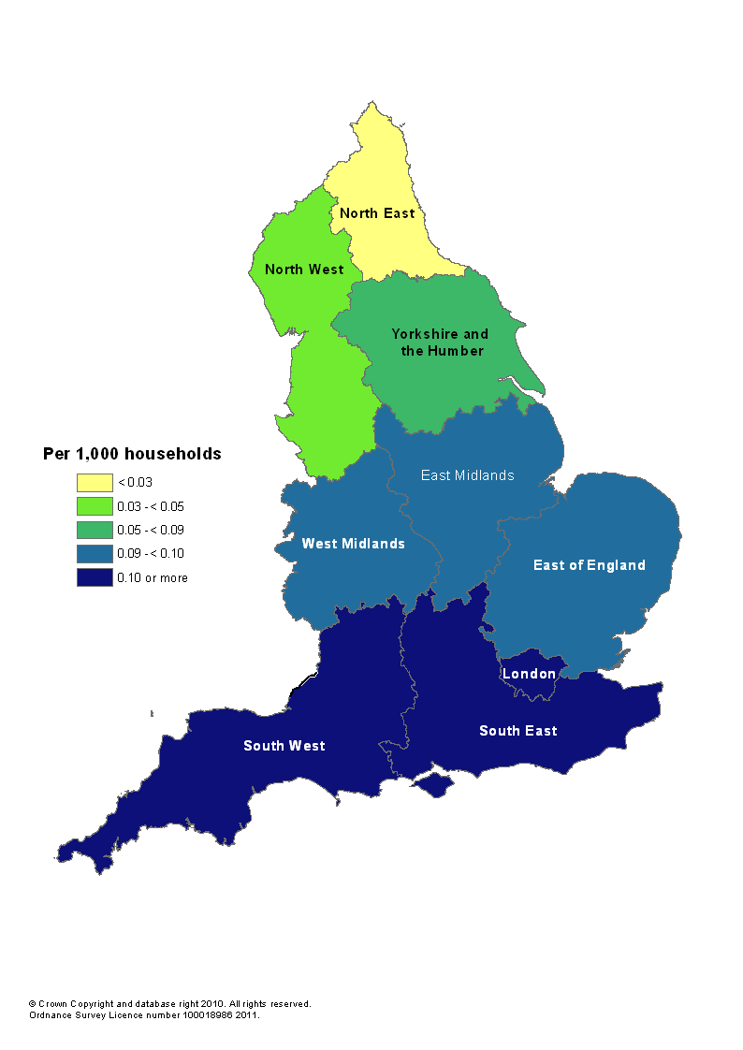
Rough Sleeping in London
The Combined Homelessness and Information Network (CHAIN) database contains information about rough sleepers in London who have been contacted by outreach teams or who have accessed accommodation for rough sleepers in London. CHAIN is used by people working with rough sleepers in London and it is maintained by Broadway, a London-based homeless charity.
The latest report for a full financial year shows that a total of 3,975 rough sleepers were contacted by outreach workers or building based teams in London in 2010-11. The nationality breakdown of this total is as follows:
Nationality (or continent) | Number | %
United Kingdom | 1,744 | 48
Rest of Europe
Poland | 404 | 11
Romania | 210 | 6
Lithuania | 121 | 3
Republic of Ireland | 105 | 3
Czech Republic | 73 | 2
Portugal | 62 | 2
Slovakia | 58 | 2
Latvia | 54 | 1
Hungary | 45 | 1
Bulgaria | 34 | 1
Estonia | 15 | 0
Slovenia | 2 | 0
Other Europe | 240 | 7
Of which:
CEE countries that joined the EU in 2004 or 2007 ^{(a)} | 1,016 | 28
Rest of the world
Africa (excluding Eritrea) | 189 | 5
Asia | 185 | 5
America | 32 | 1
Eritrea | 30 | 1
Australasia | 4 | 0
Total non-UK | 1,863 | 52
Total for which information exists | 3,607 | 100
Missing data | 268 | -
Not known | 100 | -
TOTAL | 3,975
(a) Central and Eastern European Countries joining the EU in 2004 or 2007 are also known as the A10 countries. They are all the individual countries listed under 'Rest of Europe' except the Republic of Ireland and Portugal.
These figures show that 1,744 rough sleepers in London were recorded as having United Kingdom as their nationality. This group represents just under half (48%) of all rough sleepers recorded on the CHAIN database in 2010-11 for whom nationality information was available. 28% were from Central and Eastern European countries that joined the EU in 2004 or 2007.
Figures for other parts of the country (i.e. outside London) are not collected on a comparable basis. Latest figures from CHAIN are published at http://broadway.jamkit.com/CHAIN/Reports.

Data coverage
The CHAIN figure of 3,975 rough sleepers in London compares with a figure of 415 which was compiled and published last year by the Department in its Rough Sleeping England - Autumn 2010 statistical release (available at http://www.communities.gov.uk/publications/corporate/statistics/roughsleepingautumn2010) using figures supplied by London boroughs and the City of London. These two numbers are different because the CHAIN figure is a count of all individuals who were seen sleeping rough on the streets of London on at least one night during the entire year between 1 April 2010 and 31 March 2011, whereas the DCLG figure is a snapshot of the number of rough sleepers in London as counted or estimated by each London borough and the City of London on a single night in between 1 October and 30 November 2010.

Data collection
People who work with rough sleepers record information on CHAIN about people who have been seen ‘bedded down’ on the streets by outreach workers. This group is known as ‘Verified Rough Sleepers’. It is important to note that CHAIN does not cover ‘hidden homeless’ groups, such as those who are squatting or staying in places which are inaccessible to outreach workers.
Information is recorded onto the CHAIN database by people who work directly with rough sleepers in London (e.g. workers in outreach teams, day centres, hostels, resettlement teams).

Definitions
Rough Sleepers are defined as follows for the purposes of rough sleeping counts and estimates:
People sleeping, about to bed down (sitting on/in or standing next to their bedding) or actually bedded down in the open air (such as on the streets, in tents, doorways, parks, bus shelters or encampments). People in buildings or other places not designed for habitation (such as stairwells, barns, sheds, car parks, cars, derelict boats, stations, or “bashes”).
The definition does not include people in hostels or shelters, people in campsites or other sites used for recreational purposes or organised protest, squatters or travellers.
Bedded down is taken to mean either lying down or sleeping. About to bed down includes those who are sitting in/on or near a sleeping bag or other bedding.

Methodology
Since 1998, rough sleeping has been measured by street counts in areas with a known or suspected rough sleeping problem. Local authorities had been asked to conduct an annual count if they estimated there were more than ten rough sleepers in the area. In June 2010, to supplement the counts, local authorities that had not conducted a street count were asked to provide an estimate of the number of rough sleepers on a given night. Results of the June 2010 estimates and a time series of rough sleeping counts since 1998 are published here:
http://www.communities.gov.uk/publications/corporate/statistics/roughsleepingcount2010
Following the publication of these figures, a public consultation on evaluating the extent of rough sleeping was run over the Summer 2010, and new guidance for local authorities was published in September 2010 explaining how to carry out rough sleeping counts and estimates:
http://www.communities.gov.uk/documents/housing/pdf/1713784.pdf
The changes that were made to the methodology and the definition of rough sleepers mean that figures produced in line with the September 2010 guidance are not directly comparable with previous statistics because we cannot separate the impact of these methodological changes from changes in the level of rough sleeping between Autumn 2010 and earlier time periods. A technical note setting out and explaining the differences between the Autumn 2010 rough sleeping statistics and previously published figures was published alongside the Autumn 2010 release on the DCLG website: http://www.communities.gov.uk/publications/corporate/statistics/roughsleepingautumn2010.

Rates per 1,000 households have been calculated using the 2008-based household projections produced by the Department. These projections were published on 26 November 2010 at the following link: http://www.communities.gov.uk/housing/housingresearch/housingstatistics/housingstatisticsby/householdestimates/
Data source and scope
Local housing authorities report their annual rough sleeping count or estimated figures by completing the rough sleeping statistical return:
http://www.communities.gov.uk/documents/housing/xls/1713802.xls
These figures have been published approximately two months after the 16 December deadline for local authorities to submit their forms, on a pre-announced date in accordance with the Official Statistics Code of Practice.
The scope of this data collection and release is limited to a single night snapshot of rough sleeping in England. This release does not contain data on other forms of homelessness, for example local authorities’ actions under homelessness legislation. The Department publishes quarterly statistics on Statutory Homelessness and these can be found here:
http://www.communities.gov.uk/housing/housingresearch/housingstatistics/housingstatisticsby/homelessnessstatistics/publicationshomelessness/
The Department also published statistics on homelessness prevention and relief. The most recent publication relating to Local Authority actions in 2009-10 can be found at the following link:
http://www.communities.gov.uk/housing/housingresearch/housingstatistics/housingstatisticsby/homelessnessstatistics/homelessnesspreventionrelief/
The devolved administrations publish their own statistics on homelessness and details of their releases which contain information on rough sleeping are provided below.
The Scottish Government publishes figures on the number of households applying for assistance under homelessness legislation who say they have slept rough the previous night or have reported their housing situation as ‘long term roofless’. The latest annual figures are published here: http://www.scotland.gov.uk/Publications/2011/08/30083716/0.
In 2007 and 2008, local authorities in Wales undertook rough sleeping street counts to gauge the extent of rough sleeping in Wales. Results of these counts can be found at the following link:
http://wales.gov.uk/docs/statistics/2009/090917roughsleep2007en.pdf.
The Combined Homelessness and information Network (CHAIN) contains information about people seen contacted by outreach teams and those who have accessed accommodation for rough sleepers in London. Information on the nationality of rough sleepers in London in 2010-11 is summarised in this release, and other figures are published here:
http://www.broadwaylondon.org/CHAIN/NewsletterandReports
Data quality
All rough sleeping returns submitted by local authorities undergo thorough validation and checking, and late returns are pursued to ensure overall response is as complete and accurate as possible. Anomalous data are highlighted by the Department and verified by contacting the local authority.
Homeless Link independently verifies all rough sleeping counts. Local authorities providing estimates are asked to provide details of agencies that have been consulted in deriving the estimate. 97% of authorities that provided estimates reported that they had consulted with at least one type of local agency. Of the 266 authorities that consulted in this way, the numbers consulting with particular types of agency were, in descending order:
Voluntary sector 228
Police 205
Outreach workers 187
Faith groups 153
Substance misuse agencies 144
Mental health agencies 128
Drugs and alcohol treatment teams 98
Local residents/businesses 77

The Autumn 2011 figures are based on returns for all 326 local authorities (100 per cent response).
The Department’s statistical quality guidelines are published here:
http://www.communities.gov.uk/publications/corporate/statisticalnoticequalityguidance
Revisions policy
This policy has been developed in accordance with the UK Statistics Authority Code of Practice for Official statistics and the Department’s Revisions Policy (found at http://www.communities.gov.uk/publications/corporate/statisticalnoticerevisionspolicy).
Where a substantial error has occurred as a result of the compilation, imputation or dissemination process, the statistical release, tables and other accompanying releases will be updated with a correction notice as soon as is practical.
Where a local authority notifies DCLG of an error in the information they have submitted after publication of the release a decision on whether to revise will be made based upon the impact of any change and the effect it has on the interpretation of the data.

Uses of the data
The data in this statistical release form the basis of evidence on rough sleeping in England. They will be used by ministers and officials in the Department for Communities and Local Government in the formulation and monitoring of policy, the allocation of resources, performance monitoring and to support bids for funding from the Treasury. The data will be used to ensure democratic accountability in answers to Parliamentary Questions, ministerial correspondence, Freedom of Information Act cases and queries from the public.
Local housing authorities are both providers and users of the statistics and will use the data to track progress, benchmark against other authorities and plan and commission services to prevent and tackle rough sleeping. The voluntary sector will also use the statistics to monitor and evaluate housing policy and for campaigning and fundraising purposes.

User consultation
Users are encouraged to provide feedback on how these statistics are used and how well they meet user needs. Comments on any issues relating to this statistical release are welcomed and encouraged. Responses should be addressed to the "Public enquiries" contact given in the "Enquiries" section below. The Department’s engagement strategy to meet the needs of statistics users is published here:
http://www.communities.gov.uk/publications/corporate/statistics/engagementstrategystatistics

Other information
Details of officials who receive pre-release access to the Department’s rough sleeping statistical release up to 24 hours before release can be found at: http://www.communities.gov.uk/corporate/researchandstatistics/statistics/nationalstatistics/
The publication of the Autumn 2012 Rough Sleeping Statistics will be in early 2013. The date will be pre-announced on the UK Statistics Authority publication release calendar.

Enquiries
This Statistical Release, as well as previous Releases, can be accessed and all text, tables and charts downloaded electronically, from the Department’s website at:
http://www.communities.gov.uk/publications/corporate/statistics/roughsleepingautumn2011
Further details on this Statistical Release are available from:

Media Enquiries:
office hours: 0303 444 1159
out of hours: 0303 444 1201
e-mail: press.office@communities.gsi.gov.uk

Public enquiries:
telephone: 0303 44 43510
e-mail: roughsleepingstatistics@communities.gsi.gov.uk
Zone 4/J4, Eland House, Bressenden Place, London SW1E 5DU

Information on Official Statistics is available via the UK Statistics Authority website: www.statistics.gov.uk.
Information about the Department is available via its website: www.communities.gov.uk
Department for Communities and Local Government. © Crown Copyright, 2012
If you require this publication in an alternative format please email: alternativeformats@communities.gsi.gov.uk. Please note that the nature of content means that we may not be able to provide the Statistical series of publications in all requested formats.

February 2012

ISBN 978-1-4098-3362-8

